**NASA DEVELOP National Program**



NOAA National Centers for Environmental Information

*Summer 2016*

Coastal US Health & Air Quality

Understanding the Temporal and Spatial Variation of Air Quality to Support the Use of NASA Earth Observations

 **Technical Report**

Final Draft – August 11, 2016

Christie Stevens (Project Lead)

Toni Strauch

Alec Courtright

Annette Hollingshead, Global Science & Technology, Inc. (Science Advisor)

Dr. L. DeWayne Cecil, Global Science & Technology, Inc. (Mentor)

Dr. Jesse Bell, Centers for Disease Control and Prevention (Mentor)

# 1. Abstract

Outdoor air pollution can have severe impacts on human health, endangering the lives of vulnerable children and adults. Particulate matter (PM) air pollution is particularly hazardous, contributing to an estimated 800,000 premature deaths every year, as recorded by the World Health Organization (WHO). Organizations such as the Environmental Protection Agency (EPA) and the Centers for Disease Control and Prevention (CDC) have an increasing need to provide accurate air quality assessments to properly mitigate adverse health effects. The EPA monitors air quality levels for the United States with AirNow, an on-line tool that uses *in situ* data to calculate an Air Quality Index (AQI) for real-time air quality updates. This product allows for reliable air quality estimates but is limited to the specific location of monitoring stations and to terrestrial regions within the contiguous United States. Though current projections estimate that approximately 48% of the US population will live in coastal regions by the year 2020, there is no long-term record of air quality measurements for the coastal United States. This project utilized the National Aeronautics and Space Administration’s (NASA) Aerosol Optical Depth (AOD) and the National Oceanic and Atmospheric Administration’s (NOAA) Aerosol Optical Thickness (AOT) datasets to create a long-term analysis of Hawaii and coastal Florida air quality from January 1981 to December 2015. This analysis will be used to identify anomalous months, seasons, and other periods as well as identify trends in aerosol concentrations and patterns. Satellite and ground station data verification will provide statistical and quantitative support for incorporating satellite data into both the EPA’s and CDC’s current air quality reporting efforts and further serve their needs by building the foundation for further air quality studies.

**Keywords**

AVHRR, MODIS, Aerosol Estimates, Air Pollution, Particulate Matter, Environment and Public Health, Aerosol Optical Thickness / Depth

# 2. Introduction

Air quality variation has many impacts on human and environmental health. Good air quality is vital in order to maintain the balance of Earth’s many processes and the biota it supports. As toxic pollutants become more concentrated, air quality levels worsen and create a burden on human health through ailments such as cardiovascular disease and coronary artery disease (WHO, 2013), as well as contribute to environmental disruptions such as ozone depletion or disturbances in the hydrologic cycle (Pöschl, 2005). Particulate matter (PM) air pollution is especially hazardous, with no evidence of a safe exposure level (WHO, 2013). PM air pollution is the 13th leading cause of mortality worldwide (Anderson et al., 2011). Because the negative effects of air pollution remain significant at low concentrations, there is an increasing demand for better, more successful health and air quality management practices. As a result, accurate and reliable atmospheric aerosol measurements are a vital part of improving health and well-being in a world where pollutants have grown more numerous and complex in recent decades.

The term aerosol refers to solid or liquid particles suspended in a gas (Particulate Matter, 2016). Most readily defined by size, smaller PM aerosols observe greater negative health consequences (Particulate Matter, 2016). Finer particles (1) have a higher chance of entering the alveoli of the lungs and (2) can reside in the troposphere for longer periods of time than larger particles. PM10 are particles with diameter <10µm, while PM2.5 represents particles with diameter <2.5µm (Particulate Matter, 2016). PM2.5 particles are much smaller than the diameter of one strand of human hair (Hawaii 24/7, 2016). These particles originate primarily from natural sources, such as volcanic eruptions or the wind-driven atmospheric dispersal of desert dust, soil, pollen, and sea salt; and anthropogenic sources, such as the burning of fossil fuels and other industrial processes (Pöschl, 2005).

Within the United States, air quality measurements are collected using *in situ* monitoring stations and forecasts. The Environmental Protection Agency (EPA) seeks to mitigate the effects of air pollutants to improve both human and environmental health with publicly accessible products. One such product is AirNow, a useful on-line tool that uses *in situ* measurements to record a daily Air Quality Index (AQI) for pollutants such as particulate matter, ground-level ozone, carbon monoxide, and sulfur dioxide. The highest index value is reported as the AQI value of that day. Ground station PM monitoring sites supply precise, real-time measurements essential for proper air quality oversight, but their spatial coverage is too limited for maximum efficiency. AirNow only covers the terrestrial United States, leaving the coastlines susceptible to large variability and data gaps (AirNow, 2016).

Current projections estimate that approximately 48% of the United States’ population will live in coastal regions by the year 2020, yet there is no long-term record of air quality measurements for the coastal US (National Ocean Service, 2016). Hawaii and Florida are two states with high coastal population density. These locations experience their own unique pollution events such as volcanic smog, also known as VOG, and the seasonal effects of sugar cane burning, respectively. These two states represent good case studies for improving United States air quality reporting. This project addresses the National Aeronautics and Space Administration (NASA)’s Applied Sciences Program national application area of Health & Air Quality through assessment of satellite and *in situ* aerosol data, specifically focusing on the Hawaii and Florida coasts from January 1981 to December 2015.

The project focused on aiding the Environmental Protection Agency’s (EPA) and Centers for Disease Control and Prevention’s (CDC) current air quality reporting and human health mitigation efforts. Organizations like the EPA and CDC have an increasing need to provide accurate air quality assessments so as to properly mitigate the negative repercussions PM air pollution has on human and environmental health. In the past, the EPA has funded projects that sought to integrate satellite data into surface PM2.5 measurements, such as the AirNow Satellite Data Processor (ASDP). While there is currently no integration of satellite data into public AirNow products, this much needed step will improve the capabilities and spatial coverage of air quality estimates. The utility of satellite data is identified as highly beneficial for assessing air quality problems on a broad scale. This project utilized the NASA Aerosol Optical Depth (AOD) and the National Oceanic and Atmospheric Administration’s (NOAA) Aerosol Optical Thickness (AOT) datasets in addition to *in situ* aerosol measurements to create long-term climatologies of Hawaii and Florida and to preform statistical verification to enhance and support the use of remotely sensed data in the EPA’s and CDC’s current air quality approaches. The End-Users were provided with climatologies, validation maps and figures, and a replicable methodology so that this data may be used to further analyze aerosol levels in comparison with other environmental and human health trends.

# 3. Methodology

***3.1 Data Acquisition***

This project required incorporation of both *in situ* and satellite data for a more comprehensive and accurate air quality report. AOT data collected from NOAA’s Advanced Very High Resolution Radiometer (AVHRR) sensor were acquired through NOAA’s Climate Data Record. This dataset has a spatial resolution of 0.1° by 0.1° (approximately 10 km by 10 km), and a monthly temporal resolution, from 1981 to 2015. This dataset is limited to regions covered by water. AOD data collected from NASA Terra and Aqua Moderate Resolution Imaging Spectroradiometer (MODIS) sensor’s were downloaded and subset through NASA’s Level 1 and Atmosphere Archive and Distribution System (LAADS). This dataset has a spatial resolution of 0.1° by 0.1° (approximately10 km by 10 km), gathered daily, ranging from 2000 to 2016. *In situ* air quality data for Hawaii and Florida PM10 and PM2.5 measurements were acquired from the EPA’s air quality website, AirNow, and from contacts at the Hawaii and Florida State Health Departments.

|  |  |  |  |
| --- | --- | --- | --- |
| Data Set | Spatial Resolution | Temporal Resolution | Available Study Period |
| NOAA AVHRR, AOT | 0.1° or ~ 10 km | Monthly | January 1981 - 2015 |
| NASA MODIS – Terra, AOD | 0.1° or ~ 10 km | Daily | January 2000 - 2016 |
| NASA MODIS – Aqua, AOD | 0.1° or ~ 10 km | Daily | January 2002 - 2016 |
| EPA *in situ* air quality data PM2.5 | Station-dependent | Daily | 1999 - 2016 |

***3.2 Data Processing***

After acquiring our datasets from their respective sources, all were subset both spatially and temporally. AVHRR AOT data were compiled into global monthly and seasonal HDF files and provided to the team by Dr. Tom Zhao. In conjunction with the Interface Definition Language Development Environment (IDL DE), these files were used to create global 30-year seasonal and monthly climatologies. These serve as baselines for assessing normal aerosol levels for our study areas so that further analysis can be performed to identify seasonal trends, anomalous pollution events, and periods of heightened aerosol activity. Monthly averages for the location of several air quality stations in both Hawaii and Florida were also extracted through IDL to be used for further statistical verification. The data consisted of averaged pixel values from a four pixel by four pixel (or 0.4° by 0.4°) bounding box surrounding each station. Values had to be averaged over a bounding box to include enough data from nearby water since AOT does not measure aerosols over land.

MODIS AOD data files required conversions from HDF to GeoTIFF. These were subset manually by state and year before being batch converted using the HDF-EOS to GeoTIFF (HEG) conversion tool. To do this, a sample HDF file is imported into the conversion tool. After selecting the desired field for conversion, in this case “Optical_Depth_Land_And_Ocean,” which uses a combined algorithm to retrieve AOD values over both land and ocean, global values are input for the subset selection. By choosing “Accept”and then “Batch Run,” the HEG conversion tool creates parameter files for each of the like files located in the same directory as the sample file. The tool then proceeds to execute the conversion for each file.



Figure 1 HDF-EOS to GeoTIFF (HEG) conversion tool platform with input parameters used for this project.

After all of the files were converted, they were processed using R Statistical Program to be subset into daily and monthly folders. Utilizing ArcGIS and the model builder tool, we created a model which would perform a batch run for each subset monthly folder within a year to create monthly averaged mosaicked files through the Mosaic Data Management tool. This tool mosaics all input files into an empty target raster created by the model. This process uses a mosaic operator, set to “Mean” in this case, and Ignore Background Value and No Data Values set to -9999. This process resulted in daily and monthly average AOD raster files for each Hawaii and Florida for both the Aqua MODIS and Terra MODIS sensors for the years 2000 (Terra) and 2002 (Aqua) through December 2015.

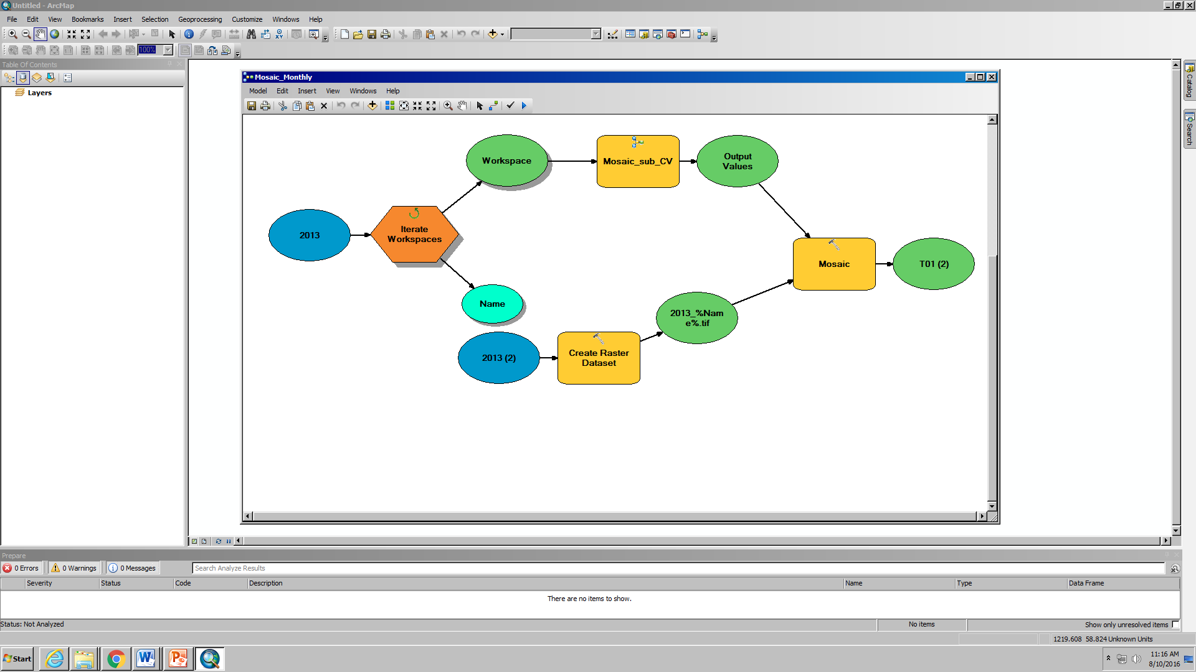

Figure 2 ArcMap model used to process MODIS data and create monthly averaged raster files.

*In situ* PM10 and PM2.5 measurements, collected at varying degrees of spatial and temporal resolution required reorganization and compilation into monthly averaged files for comparison with AOT and AOD data. Using R script, the data was subset into individual station files and further processed to result in monthly averaged data points for all active months for each station.

***3.3 Data Analysis***

The first step in analyzing aerosol estimates was to create monthly and seasonal 30-year climatology maps utilizing NOAA’s AVHRR AOT data. Though this dataset does not cover land, it provides an overall picture of typical aerosol patterns on a global scale. We used IDL to extract global monthly and seasonal climatologies for our partners to study aerosol trends and incorporate various health and environmental variables. We also extracted AOT as point data by matching latitude and longitude values of several ground stations in Hawaii and Florida. This 30-year record of AOT values was later compared to AOD and *in situ* data.

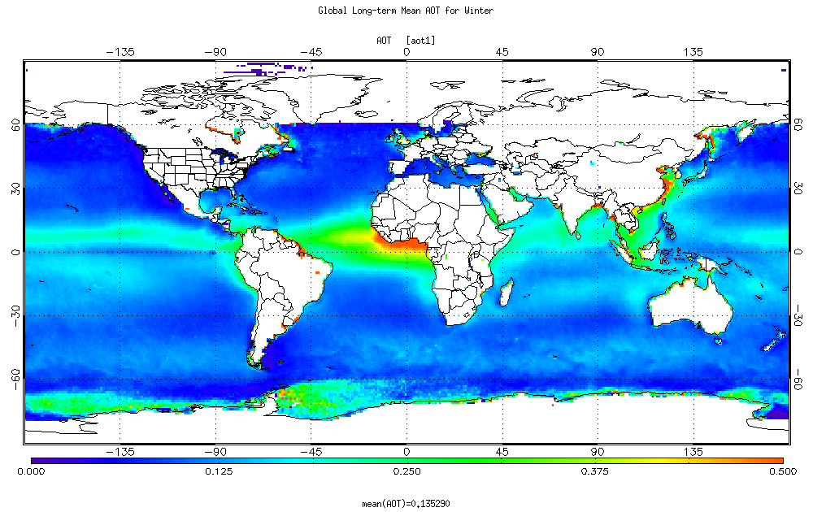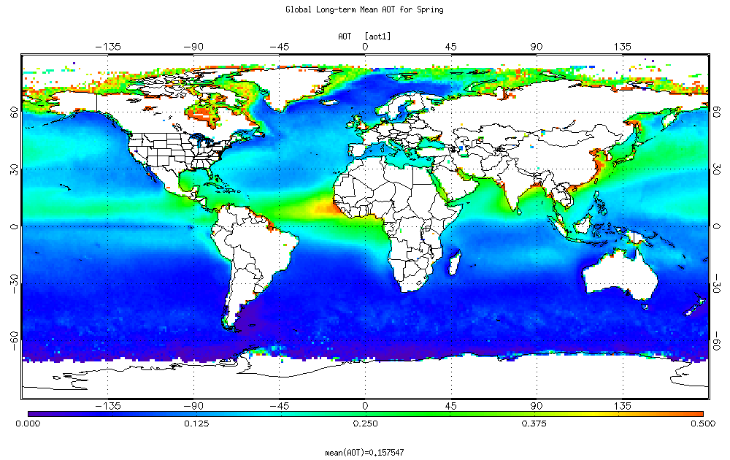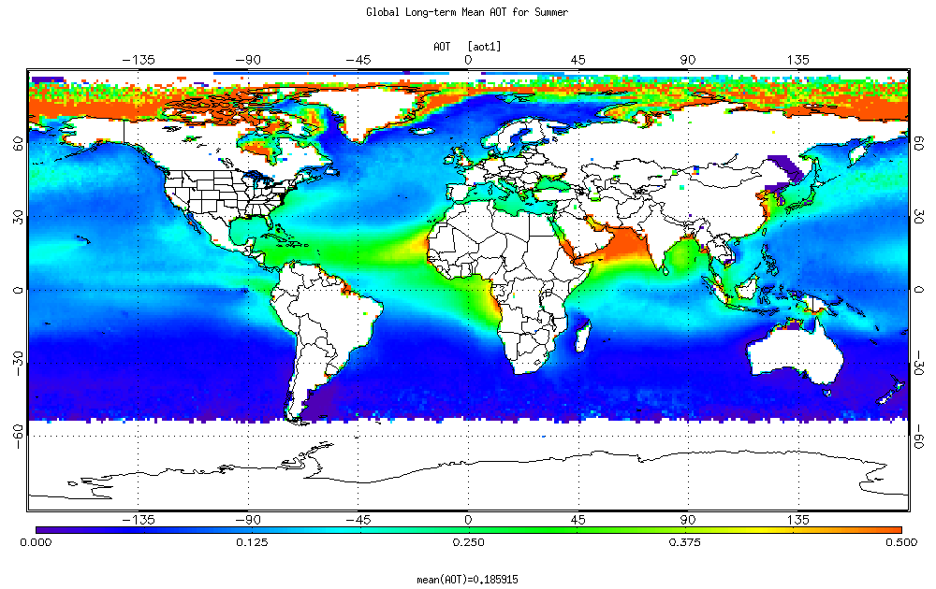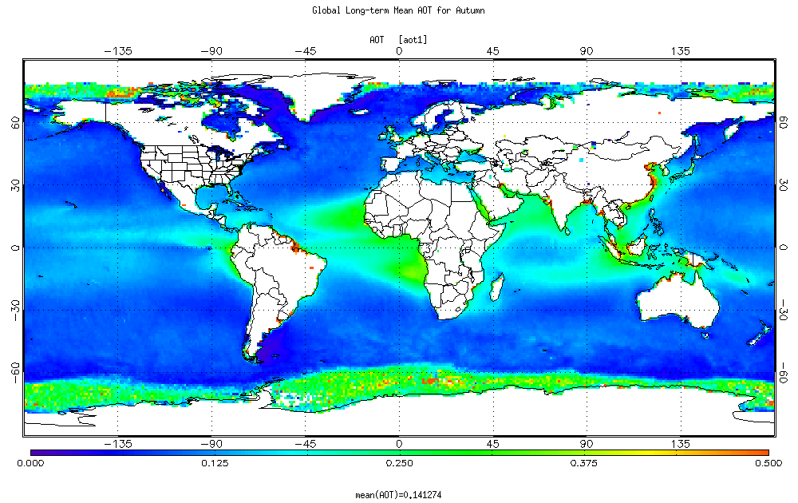

**Figure 3** AOT global climatology map displaying (clockwise) Winter (DJF), Spring (MAM), Summer (JJA), and Fall (SON) displaying AOT monthly averages from January 1981 – December 2015.

We used the processed monthly averaged values from NASA MODIS AOD datasets to create 15-year monthly and seasonal climatologies from both Aqua and Terra satellites. These satellites, which have an approximate 3-hour gap between passes, provide a glimpse into diurnal patterns for our study areas. Using the ArcMap Mosaic Data Management tool, we created 15-year monthly and seasonal AOD climatologies, subset to Hawaii and Florida. These were created by compiling raster files for each month into averaged monthly and seasonal raster datasets. Further, using the Extract Multi Values to Points Spatial Analyst tool in ArcGIS, we extracted the point data from each individual monthly file for the locations for each of the ground stations from our *in situ* dataset. This resulted in an average monthly AOD value for each month from 2000 and 2015. This 15-year record of AOD was later compared to AOT and *in situ* data.

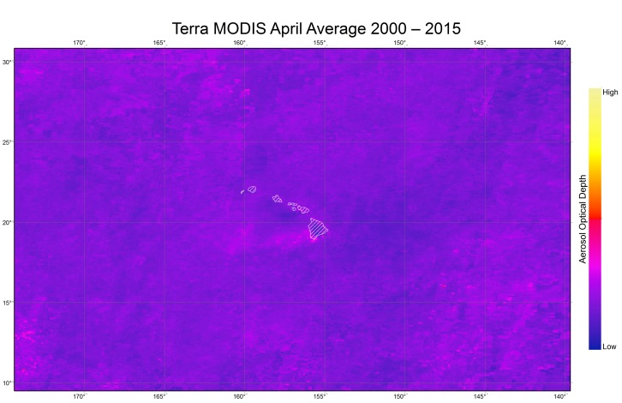

**Figure 4** AOD monthly climatology map for Hawaii, displaying April Terra MODIS AOD monthly averages from 2000 – 2015.

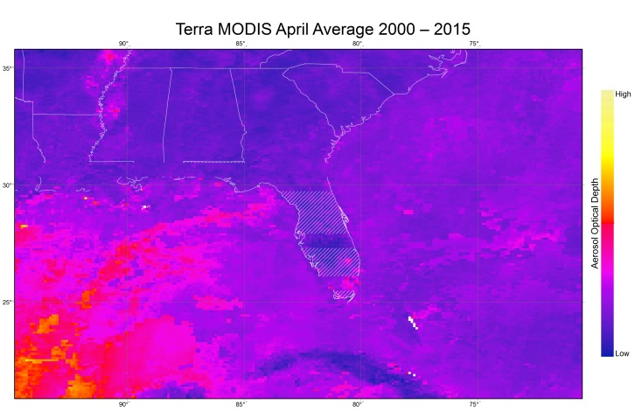

**Figure 5** AOD monthly climatology map for Florida, displaying April Terra MODIS AOD monthly averages from 2000 – 2015.

In our final data analysis steps, we compared NASA MODIS AOD, NOAA AVHRR AOT, and *in situ* aerosol data to provide statistical support for the reliability of filling in gaps in ground station PM2.5 data with satellite aerosol data. Statistical methods were applied to calculate correlation coefficient values for individual ground stations and monthly averaged AOD values in Hawaii and Florida to assess seasonal and monthly relationships between satellite and *in situ* data. 30- and 15-year time-series plots were created in addition to accuracy maps for our two study areas. Time series plots were created in Microsoft Excel displaying multiple trend lines and the linear variation of monthly averages among our three datasets. To easily discern overall trends, moving averages were also applied to the graphs.

Linear regression analysis was used to assess the basic relationship between averaged monthly values for ground station PM2.5 and AOD measurements. These were further subset into 90-day seasons (DJF, etc.) to discern seasonal correlation patterns between the two datasets. These averaged monthly values were also used to assess the correlation coefficient between *in situ* and AOD for each PM2.5 station within our study area. The correlation coefficient values were then plotted in ArcMap to show possible patterns in the spatial distribution of correlation values. This project provided replicable methodology centered on incorporating both satellite and *in situ* aerosol measurements for analysis of reliability of integrating both satellite and ground station data into air quality reports.

# 4. Results & Discussion

This project created long-term climatologies for both Hawaii and Florida as well as verification analyses and coding scripts for statistical comparison. Three sets of climatology maps were produced using Terra MODIS AOD, Aqua MODIS AOD, and AVHRR AOT datasets using ArcGIS and IDL, respectively. With seasonal and monthly climatologies, we analyzed trends to inform our end-users how aerosols have changed spatially and temporally in Hawaii and Florida. 30-year climatology maps allow for long-term comparisons of aerosol measurements through assessment of normal aerosol behavior across seasonal variations and anomalous events. These long-term climatologies may be useful for urban planning, capacity building, and risk assessment, as well as further statistical comparison with other related variables.

Aerosol Optical Depth

**Figure 6** Monthly aerosol time-series comparing *in situ*, MODIS, and AVHRR data for a ground station located near Honolulu.

**Figure 7** Monthly aerosol time-series comparing *in situ* PM2.5 observations with MODIS AOD data for a ground station located near Honolulu.

**Figure 8** Monthly aerosol time-series comparing *in situ*, MODIS, and AVHRR data for a ground station located near Miami Beach.

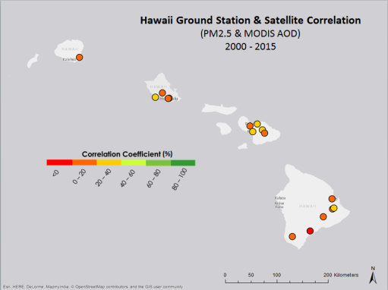

**Figure 9** Monthly aerosol time-series comparing *in situ* PM2.5 observations with MODIS AOD data for a ground station located near Miami Beach.

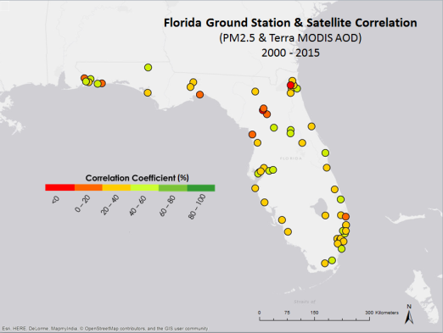Through verification analysis, we assessed the reliability of satellite aerosol observations by comparing NASA MODIS AOD, NOAA AVHRR AOT, and *in situ* PM2.5 measurements. We found that overall AOD and AOT values follow seasonal trends similar to *in situ* measurements, although satellite sensors fail to capture particularly high and particularly low aerosol levels seen in *in situ* measurements. Furthermore, linear regression analysis shows that the correlation coefficient values between AOD and *in situ* measurements are significantly low, with overall values for Hawaii and Florida calculated to be approximately 16% and 24%, respectively, with the highest station value measuring 57%, near central Florida.

Figure 10 Map showing correlation coefficient values for stations in Hawaii which measure PM2.5.

Figure 11 Map showing correlation coefficient values for stations in Florida which measure PM2.5.

Hawaii shows more inconsistency between AOD and *in situ* values, possibly due to higher variability in the region and less available station data. Florida presents flatter topography and higher data availability, factors that possibly contribute to stronger overall correlation values. Further analysis incorporating other variables including wind regime, or the relationship of upper atmospheric aerosol trends as compared to tropospheric values may prove to result in stronger correlation trends.

# 5. Conclusions

This project aimed to establish a foundational statistical analysis comparing MODIS AOD measurements to *in situ* PM2.5 observations along coastal Florida and Hawaii. After performing a correlation analysis we found that correlation values are generally higher in Florida than in Hawaii, possibly due to a number of factors including climate, topography, and data availability. A lot of variation may have been lost when comparing station point data to extracted pixel values from MODIS AOD which provides the average AOD over a 0.1° by 0.1° area.

*In situ* PM2.5 observations and both AVHRR AOT as well as MODIS AOD highlighted similar seasonal trends. All three datasets measured higher aerosol levels during the warmer months, peaking during summer (June, July, and August) and lower aerosol levels in the colder months. MODIS AOD followed annual overall increases better in Florida than in Hawaii. However, in both regions AOD did not capture extreme peak aerosol events captured by the *in situ* measurements. After comparing station point measurements directly to remotely sensed AOD measurements, this project highlighted some of the limitations of assessing PM2.5 levels at the surface using satellite derived AOD. Future projects should include other important factors such as meteorological climatologies (i.e. wind regimes, precipitation…etc.).

The results of this project will provide both the EPA and CDC with a foundational analysis to build upon with future studies. The CDC is hoping to continue this work and incorporate public health data on issues related to air quality like asthma attacks and rates.

# 6. Acknowledgments

We wish to thank our center lead, Alec Courtright, assistant center lead, Emma Baghel, and our science advisor, Annette Hollingshead, for their guidance and expertise through the entire project. We would also like to thank all of the people at NCEI who gave us advice along the way (list people here).

Any opinions, findings, and conclusions or recommendations expressed in this material are those of the author(s) and do not necessarily reflect the views of the National Aeronautics and Space Administration.

This material is based upon work supported by NASA through contract NNL11AA00B and cooperative agreement NNX14AB60A.

# 7. References

Anderson, Jonathan O., Thundiyil, Josef G., Stolback, Andrew. (2011). Clearing the Air: A review on the

effects of particulate matter air pollution on human health. *American College of Medical Toxicology*. 166–175.<http://dx.doi.org/10.1007/s13181-011-0203-1>

AirNow. (2016). *Environmental Protection Agency*. https://airnow.gov/index.cfm?action=topics.about_airnow

Baucum, L.E., Rice, R.W. (2009). An Overview of Florida sugarcane. *University of Florida.*

Dawes, S. S., Burke, G. B., Pasch, A. N., & Dye, T. S. (2013, October 4). Socioeconomic benefits of adding

NASA Satellite Data to AirNow. 1-87. http://appliedsciences.nasa.gov/system/files/docs/Socioeconomic Benefits of Adding NASA Satellite Data to AirNow.pdf

Grabowski, M. (2015, November 6). Modeling vog for Hawai’i. *University of Hawai’i News.*

Hawaii 24/7. (2016, March 17). Volcano Watch: Dual nature of vog results in air quality variety show. *Hawaii*

*24/7.* <http://www.hawaii247.com/2016/03/17/volcano-watch-dual-nature-of-vog-results-in-air->quality-variety-show/

National Ocean Service (2016). What percentage of the American population lives near the coast? *National*

*Oceanic and Atmospheric Administration*.

http://oceanservice.noaa.gov/facts/population.html

Particulate Matter (PM) and Aerosol. (2016). *The International Volcanic Health Hazard Network*. <http://www.ivhhn.org/index.php?option=com_content&view=article&id=87>

Pöschl, Ulrich. (2005). Atmospheric Aerosols: Composition, Transformation, Climate and Health Effects. *Angewandte Chemie International Edition.* 44(46). 7520-7540.

doi:10.1002/anie.200501122

WHO. (2013). Review of evidence on health aspects of air pollution - REVIHAAP Project. *World Health*

*Organization Regional Office for Europe.*

# 8. Content Innovation

**Content Innovation #1**

Featured Multimedia

“Clearing the Air: Investigating Aerosol Estimates in the Coastal United States”

The project Virtual Poster Session will be linked to the title at the beginning of the technical paper.

**Content Innovation #2**

Inline Supplementary Material

* **Figure 1** HDF-EOS to GeoTIFF (HEG) conversion tool platform with input parameters used for this project.
* **Figure 2** ArcMap model used to process MODIS data and create monthly averaged raster files.
* **Figure 3** Global 30-Year AOT Climatology: Winter (DJF).
* **Figure 4** 15-Year Terra MODIS AOD Climatology for Florida: April 2000-2015
* **Figure 5** 15-Year Terra MODIS AOD Climatology for Hawaii: April 2000-2015
* **Figure 6 & 7** Monthly Aerosol Time-series comparing in situ, MODIS, and AVHRR data for the location of a ground station near Honolulu.
* **Figure 8 & 9** Monthly Aerosol Time-series comparing in situ, MODIS, and AVHRR data for the location of a ground station near Miami Beach.
* **Figure 10** Map showing correlation coefficient values for stations in Hawaii which measure PM2.5.
* **Figure 11** Map showing correlation coefficient values for stations in Florida which measure PM2.5.

**Content Innovation #3**

Glossary

* **Aerosol**—Natural or artificial solid or liquid particles suspended in the atmosphere or another gas.
* **AirNow**—A publicly accessible online tool which allows the user to find an AQI rating or a specific location at any given time.
* **AOD**—Aerosol Optical Depth
* **AOT**—Aerosol Optical Thickness
* **AQI**—Air Quality Index; a standardized index of air quality ratings which informs the public of how hazardous the air is on a particular day.
* **ASDP**—AirNow Satellite Data Processor; a system that enables the blending of satellite and ground station PM2.5 measurements.
* **AVHRR—**Advanced Very High Resolution Radiometer
* **CDC** — Centers for Disease Control and Prevention; a public institution which protects public health through the control and prevention of disease and other ailments.
* **EPA** —Environmental Protection Agency; an agency which protects human and environmental health through research and enforcement.
* **MODIS—**Moderate Resolution Imaging Spectroradiometer
* **NASA—**National Aeronautics and Space Administration
* **NOAA—**National Oceanic and Atmospheric Administration
* **PM**—Particulate Matter; mixture of solid and liquid particles found in the atmosphere. Derived from natural and anthropogenic sources.
  + PM2.5—Particulate matter sized 2.5µm or less
  + PM10— Particulate matter sized between 10 µm and 2.5µm
* **VOG**—Volcanic smog; a form of air pollution resulting from the gasses and particulate matter emitted when a volcano erupts.
* **WHO** —World Health Organization; an agency governed by the World Health Agency of the United Nations which focuses on international public health.

# 9. Appendices

MODIS Climatology Maps

|  |  |  |
| --- | --- | --- |
|  |  |  |
| Terra MODIS AOD Climatologies for Hawaii, 2000-2015, arranged by season. Top row: winter, bottom row: spring. |  |  |

|  |  |  |
| --- | --- | --- |
|  |  |  |
|  |  |  |

Terra MODIS AOD Climatologies for Hawaii, 2000-2015, arranged by season. Top row: Summer, bottom row: Fall.

|  |  |  |
| --- | --- | --- |
|  |  |  |
| Aqua MODIS AOD Climatologies for Hawaii, 2002-2015, arranged by season. Top row: Winter, bottom row: Spring. |  |  |

|  |  |  |
| --- | --- | --- |
|  |  |  |
|  |  |  |

Aqua MODIS AOD Climatologies for Hawaii, 2002-2015, arranged by season. Top row: Summer, bottom row: Fall.

|  |  |  |
| --- | --- | --- |
|  |  |  |
|  |  |  |

Terra MODIS AOD Climatologies for Florida, 2000-2015, arranged by season. Top row: Winter, bottom row: Spring.

|  |  |  |
| --- | --- | --- |
|  |  |  |
|  |  |  |

Terra MODIS AOD Climatologies for Florida, 2000-2015, arranged by season. Top row: Summer, bottom row: Fall.

|  |  |  |
| --- | --- | --- |
|  |  |  |
|  |  |  |

Aqua MODIS AOD Climatologies for Florida, 2002-2015, arranged by season. Top row: Winter, bottom row: Spring.

|  |  |  |  |  |  |  |  |  |
| --- | --- | --- | --- | --- | --- | --- | --- | --- |
| |  |  |  | | --- | --- | --- | |  |  |  | |  |  |  | |  |  |
|  |  |  |

Aqua MODIS AOD Climatologies for Florida, 2002-2015, arranged by season. Top row: Summer, bottom row: Fall.

Linear Regression Graphs

Linear regression analysis for all stations in Hawaii comparing *in situ* to MODIS AOD measurements for Spring.

Linear regression analysis for all stations in Hawaii comparing *in situ* to MODIS AOD measurements for Winter.

Linear regression analysis for all stations in Hawaii comparing *in situ* to MODIS AOD measurements for Summer.

Linear regression analysis for all stations in Hawaii comparing *in situ* to MODIS AOD measurements for Autumn.

Linear regression analysis for all stations in Florida comparing *in situ* to MODIS AOD measurements for Winter.

Linear regression analysis for all stations in Florida comparing *in situ* to MODIS AOD measurements for Spring.

Linear regression analysis for all stations in Florida comparing *in situ* to MODIS AOD measurements for Summer.

Linear regression analysis for all stations in Florida comparing *in situ* to MODIS AOD measurements for Autumn.