**NASA DEVELOP National Program**

Langley Research Center and Patrick Henry Building



**Fall 2013**

**Virginia Agriculture**

*Identifying Suitable Growing Conditions with NASA Earth Observations and Model Output for Expansion of Viticulture*

**Team Lead:** Taylor Hotchkiss (University of Richmond), [taylor.c.hotchkiss@nasa.gov](mailto:taylor.c.hotchkiss@nasa.gov)

Merna Saad (Christopher Newport University), [merna.n.saad@nasa.gov](mailto:merna.n.saad@nasa.gov)

**Team Members:**

Alexander Nelson (Middlebury College)

David Arabyan (University of California Los Angeles)

Joseph Miller (Old Dominion University)

**Advisors & Mentors:**

Dr. Kenton Ross (NASA DEVELOP National Science Advisor)

**Past or Other Contributors:**

Virginia Agriculture Summer 2013 team

Quinten Geddes (Former DEVELOP Geospatial Programmer)

Dr. Tony Wolf (Virginia Tech Agriculture Research and Extension Center)

**Applied Sciences National Applications Addressed:**

Agriculture

**Study Area:** The Commonwealth of Virginia

**Study Period:** January 2002 through September 2013

**Community Concerns**

* An increase in consumer demand for locally-grown specialty products has created shifts in agricultural crop production from traditional cash crops such as tobacco to grapes for wine production
* More grapes must be grown in the state to meet growing consumer demand for Virginia wine
* Need for a product that can identify suitable temperature zones for new vineyards and forecast shifts in temperature zones as climate regimes change
* Encourage viticulture in new regions with grape growing potential

**80-100 Word Blurb**

New techniques for efficient and successful expansion of the Commonwealth’s vineyards are becoming increasingly important as economic and societal interest in Virginia’s wine industry is growing. Domestic and international markets are beginning to recognize the successes of the Virginia wine industry, and increasing grape production may be a sustainable solution for mitigating the decline in demand for other products of Virginia’s agricultural economy. Temperature and land-use data derived from NASA’s Earth observations were used to create location suitability and growth-potential maps to help Virginia growers make spatially-informed decisions.

**Abstract**

The agriculture industry is the most economically significant industry in Virginia. However, it has seen significant transformation in recent years as the growth of traditional crops, such as tobacco, has declined. Recently, the Virginia wine industry has gained national and international recognition by attracting consumers and providing a substantial contribution to Virginia’s economy. The Virginia Department of Agriculture and Consumer Services recognizes that producing enough crops to keep up with consumer demand is a large obstacle the state will face as these industries continue to grow. Temperature plays a vital role in agricultural crop production since it directly affects plant processes including growth rate, maturity, and ripening. It is also the key parameter in determining growing degree-days, spring frost indices, fall frost indices, growing season length, and other factors important to vineyard owners.

In the summer of 2013, DEVELOP’s Virginia Agriculture team collaborated with the Secretary of Agriculture and Forestry to work on improving current temperature data in The Virginia Viticulture Site Suitability Investigative Tool (VVSSIT) developed at the Virginia Tech Center for Geospatial Information Technology (CGIT). This was achieved by using Land Surface Temperature (LST) data derived from the Moderate Resolution Imaging Spectroradiometer (MODIS) aboard NASA’s Aqua satellite. Daily low temperature values were derived from LST and daily high temperature values were interpolated from National Oceanic and Atmospheric Association (NOAA) weather stations. In the fall of 2013, several temperature-based map products were recreated with a larger selection of NOAA weather stations to increase the accuracy of estimated high temperature. In addition, a linear regression model created by previous studies was used to estimate maximum air temperature data from MODIS daytime land surface data. Datasets were compared and validated using multiple analyses. Both methods were assessed to determine the best estimation of temperature to be used in grape varietal selection and temperature-based disease susceptibility.

**Partners/Collaborators**

Virginia Department of Agriculture and Consumer Services (Secretary Todd Haymore)

Virginia Cooperative Extension (Dr. Tony Wolf)

**Current Management Practices & Policies**

Virginia’s wine industry plays a vital role in the state’s economy. The Virginia Department of Agriculture and Consumer Services is involved in funding and promoting research that will improve viticulture practices used in the state. Current and prospective viticulturalists in Virginia rely on personal knowledge and expertise, shared information across the viticulture community, and research experts at academic institutions for information regarding successful grapevine growth. The Virginia Cooperative Extension, a partnership between Virginia Tech and Virginia State University, created The Virginia Viticulture Site Suitability Investigative Tool (VVSSIT) to assist grape growers with vineyard site selection to improve crop yields, quality, and vineyard profitability. The tool incorporates topographic and climatological data that is imperative to grapevine growth, including temperature data derived from NOAA weather stations located at discrete points across the state. MODIS LST enhances the current spatially interpolated weather station data by providing continuous data while taking elevation into account, rather than an interpolation for the space between weather stations. This project aimed to encourage state agencies to provide subsidies or tax credits to landowners interested in growing grapevines in suitable regions. Additionally, viticulturalists may decide to experiment with alternative grape varietals or improve their vineyard’s lifespan by planning for potential changes in temperature. The success of the wine industry has brought attention to other up-and-coming industries, including the craft beer and hard cider industries. The methodology developed in this study has the potential to be adapted to other crops, such as hard cider apples. Temperature suitability maps are extremely useful as these industries begin to take off in ensuring more crops are grown locally.

**Benefit to End-User:**

* Provide Virginia growers with a resource regarding temperature parameters important in crop growth
* Improve the accuracy of and validate temperature inputs used to create maps of ideal temperature zones for vineyards and specific grape varieties
* Offer recommendations for the best-suited grape varieties to different areas, based on established indices
* Adapt temperature-based tools to other crops of interest
* Expand agricultural production to new regions in Virginia

**Decision Support Tools**

* Temperature Zones for Specific Grape Varieties in Virginia
* Potential for Late Spring or Early Fall Frost in Virginia
* Potential Temperature Zones for 2050 in Virginia
  + Same, but specific to grape varietals
* Temperature Zones for Threat of Pierce’s Disease to Grapevines in Virginia

**Earth Observations & Parameters**

Aqua MODIS - Land Surface Temperature (LST)

Aqua MODIS - Yearly Land Cover Type Product

**Future Applicable NASA Missions**

Orbiting Carbon Observatory-2 - Fluorescence

**Models Utilized**

Intergovernmental Panel on Climate Change (IPCC) Climate Change models

**Ancillary Datasets Utilized**

USGS National Land Cover Dataset (NLCD)

NOAA Weather Stations - Virginia

**Software Utilized**

ArcGIS - Raster Manipulation/Analysis, Image Enhancement & Map Creation of Aqua MODIS Land Surface Temperature data

**Imagery & Captions**

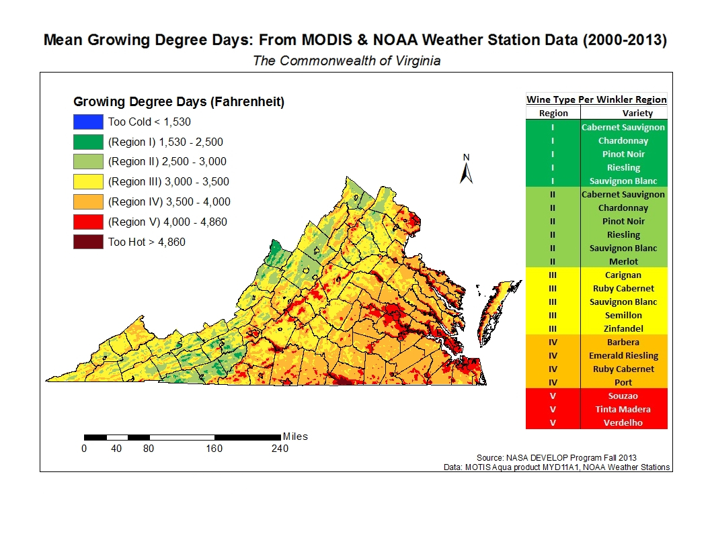

Image A: Mean growing degree days of the Commonwealth of Virginia derived from MODIS Land Surface Temperature (LST) and NOAA Weather Station data sets combined from the year of 2000 to 2013.