Mojave Desert Ecological Forecasting
Monitoring Bighorn Sheep Habitat by Assessing Vegetation, Topography, and Soil Moisture


Technical Report
Final Draft – November 15th, 2018

Brigitte Moneymaker (Project Lead)
Manda Au
Gisela Beltran
Neda Kasraee

Kenton Ross, NASA Langley Research Center (Science Advisor)
Natasha Stavros, NASA Jet Propulsion Laboratory, California Institute of Technology (Science Advisor)
Joseph Spruce, Science Systems & Applications, Inc. (Science Advisor)

Previous Contributors:
Jacob Ramthun
Devon Burks
Mariah Heck

1. Abstract
Bighorn sheep are a charismatic desert species that have enormous ecological and cultural significance to the Mojave Desert region in California. After overcoming large population losses in the late 1900s, further habitat degradation and fragmentation has continued to affect the livelihood of remaining bighorn sheep (BHS) herds. Past studies have shown that the habitat selection of remaining BHS metapopulations is extremely selective, requiring very specific forage and topographic conditions. A previous DEVELOP project used remotely sensed precipitation data to characterize vegetation greenness within known BHS habitat and found that additional parameters were needed to more accurately assess and predict herd placement. In partnership with the National Park Service, the California Department of Fish and Wildlife, Oregon State University, and the Sierra Nevada Bighorn Sheep Foundation, the fall 2018 NASA DEVELOP Alaska Ecological Forecasting team utilized data from various NASA Earth observations, including Soil Moisture Active Passive (SMAP), Terra Moderate Resolution Imaging Spectroradiometer (MODIS), Terra Advanced Spaceborne Thermal Emission and Reflection Global Digital Elevation Map (ASTER GDEM), along with National Agriculture Imagery Program (NAIP) aerial imagery to further evaluate spatiotemporal vegetation characteristics in relation to BHS habitat.

Keywords: Remote sensing, bighorn sheep (Ovis canadensis), Mojave Desert, Landsat, MODIS, SMAP, Terra ASTER GDEM V2, habitat modeling, Software for Assisted Habitat Modeling (SAHM)

2. Introduction
  - Background Information
The Mojave Desert is primarily located in southeastern California and stretches more than 152,000 km² through portions of Nevada, Utah, and Arizona (Figure 1). The Mojave’s arid desert climate is defined by an extreme variation in daily temperature and low annual precipitation of 300 millimeters a year (Hereford, Webb, & Longre, 2005). The terrain is characterized by a typical mountain and basin topography with sparse vegetation varying by elevation. One of the Mojave’s most prominent species is the desert bighorn sheep (BHS) (Ovis canadensis) that provides countless experiences for tourists, hunters, and native peoples throughout the region (Longshore, 2018). Historically, BHS populations have been jeopardized by increasing anthropogenic threats, such as the construction of highways, groundwater pumping, and loss of food from livestock grazing. In the last century, nearly one-third of BHS populations in California alone have died out, and the remaining herds have congregated into disconnected metapopulations (Epps, Mccullough, Wehausen, Bleich, & Rechel, 2004). In addition to already fragmented habitat, past studies have shown that the habitat selection of remaining BHS metapopulations is extremely selective, requiring very specific forage and topography conditions (Gedir, Cain, Krausman, Allen, Duff, & Morgart, 2016). These factors contribute to the difficulties that local management units face when trying to effectively monitor and predict herd movement (Creech, Monello, Epps, & Wehausen, 2014). This project addressed the need for a comprehensive vegetation classification and habitat model that can more effectively predict BHS habitat and aid project partners’ management efforts. This project built upon the work completed by the spring 2017 NASA DEVELOP Mojave Desert Water Resources team, which compared seasonal vegetation indices with precipitation. This current project focused on investigating the relationship between the Normalized Difference Vegetation Index (NDVI) and several additional parameters, including soil type, topography, and soil moisture data within known BHS habitat from 2015 to present. The study area for this project included twelve mountain ranges in the Mojave Desert National Preserve (Appendix Figure A1): North Bristol, South Bristol, Bullion, Cady, Clipper, Cowhole, Granite, Kelso, Providence, South Soda, and Woods.

  - Project Partners & Objectives
Our partners for this project include the National Park Service (NPS) at Mojave National Preserve, the Wildlife Health Branch of the NPS Biological Resources Division, and the Wildlife Branch Game Management of the California Department of Fish and Wildlife (CDFW). The CDFW utilize NASA Earth observations and GPS collar data to evaluate the foraging locations and habitat selection of BHS. The Department of Fisheries and Wildlife at Oregon State University employ a similar methodology to study the population dynamics of BHS, including the relationship between BHS survival, reproduction, and movement with the variations of the Mojave Desert ecosystem. Additionally, in situ monitoring is used in the assessment of vegetation and BHS habitat ranges.
The current habitat models used for BHS management are reliant on aerial and ground field surveys to evaluate vegetation types. Vegetation classification maps derived from remote sensing data could provide higher quality products for our partners to incorporate into their habitat models. Our objectives were to create vegetation maps incorporating NDVI, green up trends, soil moisture, and elevation, and to include these parameters to model habitat probability for BHS.
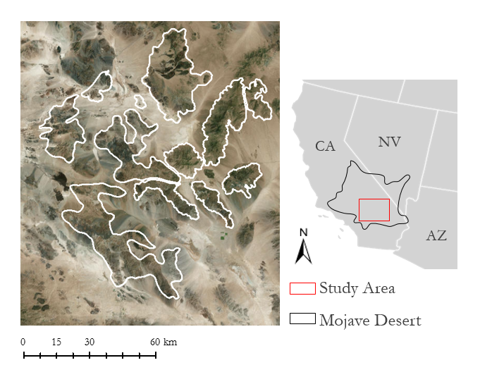
Figure 1. Study area map depicting the Mojave Desert and project boundaries including known bighorn sheep habitat ranges.

3. Methodology
3.1 Data Acquisition
Terra’s Moderate Resolution Imaging Spectroradiometer (MODIS) was utilized to examine the rate of green up events in the Mojave Desert. The data acquired through the United States Geological Survey (USGS) EarthExplorer portal fell between January 2016 and December 2016. MODIS/Terra Vegetation Indices 16-Day L3 Global 250 m SIN Grid V006 provided the best results. The Normalized Difference Vegetation Index (NDVI) data were comprised of two 8-day composites. Soil Moisture Active Passive (SMAP) data were obtained for the Mojave Desert region through the USGS EarthExplorer portal from March 2015 to September 2018. SMAP Level 4 3-hourly 9 km Surface and Rootzone Soil Moisture Version 4 products provided the volumetric percent of soil moisture for surface soil (0-5 cm), root zone (0-100 cm), and soil profile (0 cm to bedrock)(Reichle, Lannoy, Koster, Crow, Kimball, & Liu, 2018). Global topography data were acquired through the Land Processes Distributed Active Archive Center (LP DAAC) from Terra’s Advanced Spaceborne Thermal Emission and Reflection Radiometer (ASTER) Global Digital Elevation Model (GDEM) Version 2. GDEM images are preprocessed and distributed as GeoTiff files at 30 m resolution and referenced to the 1984 World Geodetic System (WGS84). The images for the vegetation classifications were downloaded from the USGS EarthExplorer and were collected between January 2015 and December 2017. In situ GPS collar data from 2015 to 2018 were provided by the CDFW along with shapefiles of the specific locations for vegetation species of interest.

3.2 Data Processing
3.2.1 In Situ Data
The sheep GPS data were exported from an Excel workbook as multiple comma-separated values sheets (CSVs) using Visual Basic for Applications (VBA) excel macro. The CSV was loaded into ArcMap 10.6 for visual analysis and to determine the extent of the coverage. The vegetation shapefiles were loaded into Google Earth Engine as references for creating additional vegetation training points.

3.2.2 Vegetation Classification
A project partner from the CDFW provided shapefiles of twelve known mountain ranges within the Mojave Desert known to contain herds of BHS (Appendix A1). The shapefiles were simplified using MapShaper and used as boundaries for downloading NAIP aerial imagery. An additional shapefile was created in ArcMap to create a bounding box around all twelve mountain ranges in order to facilitate data processing for additional products. Google Earth Engine was used to manually identify sand and vegetation classes for the entire study area, and these two classes were merged together to be used as a training class over the NAIP imagery and then to classify the vegetation and sand points for the entire study area.

3.2.3 Topography
Terra ASTER’s GDEM provides a product that has already been processed to remove clouds and correct anomalies before being distributed as Geographic Tagged Image File Format (GeoTIFF) files. These GeoTiffs were loaded into ArcMap and the spatial analyst tool was used to process slope percentage and elevation in meters for the entire study area.

3.2.4 NDVI
While MODIS has a coarser resolution of 250m for vegetation classification, it provided daily coverage of the Mojave Desert making it most ideal for detecting vegetation change. A 16-day composite dataset was used to resolve the issue with cloud interference, which collects the best pixel from the time interval to give more accuracy of what is observed on the ground. NDVI was utilized to assess both the amount and health of present vegetation. The equation (Appendix Table C1) uses both red and near-infrared wavelengths that are reflected from the vegetation to assign it a value. It is scaled from 1 to -1, where the higher values best represent dense forest and lowest values equate to water and cloud cover. Being in a desert environment, vegetation is sparse and much of the reflectance is coming from the soils. The NDVI values fell between 0.1 and 0.3, but there were a few outliers in the rasters. NDVI alone could not show green up events, so the data were processed to be normalized (Appendix Table C1).

3.2.5 Soil Moisture
Soil moisture surface, root zone, and profile data contained eight rasters for each day. These rasters were grouped together into 16-day time periods corresponding to the MODIS NDVI composite dates. The mean of each set of 16-day data rasters was found to more easily compare soil moisture trends with NDVI.

3.2.6 SAHM Model
The template layer for SAHM consisted of a Terra ASTER GDEM raster clipped to each individual range in ArcMap using the data management tools. This raster was used as the template for projection and processing boundaries for the model inputs. The predictor list module included a mean NDVI raster for 2015-2018, a mean soil moisture raster for 2015-2018, an elevation raster in meters, and a vegetation classification raster. The field data module included the 2015 bighorn sheep presence data using GPS coordinates from sheep collars. SAHM ran its own preprocessing, which includes the PARC module that projected, aggregated, resampled, and clipped the data to the template layer. The merged data set builder (MDS Builder) then extracted the raster data for each point. The covariate and correlation selection module assessed if each variation exhibited too high a correlation with each other, and gave the user the option to disregard that parameter (Figure 2).
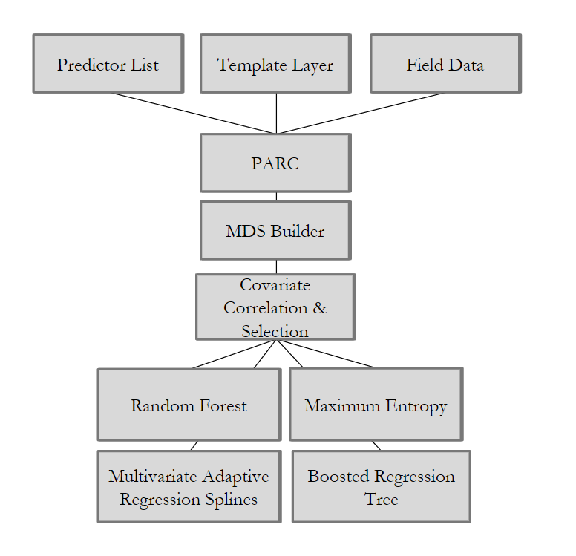
Figure 2. Flowchart of SAHM inputs, processing, and model selections.

3.3 Data Analysis
3.3.1 Vegetation Classification and SAHM
For the vegetation classification, we ran a random forest and confusion matrix on the on the supervised vegetation classification created in Google Earth Engine to determine its accuracy. SAHM ran four regression model modules, including random forest (RF), boosted regression tree (BRT), maximum entropy (MaxEnt), and multivariate adaptive regression splines (MARS). Each model output into separate subfolders containing the results as a combination of excel files, TIFF rasters, and images. These raster results were input into ArcMap for visual analysis and manipulation, and the results of the model validation and variables were compiled into excel tables for each range.

3.3.2 NDVI
Dividing every NDVI raster by the overall mean raster for the times series assisted in detecting the seasonal vegetation bloom. Any value above the mean, 1, was indicated to be in a growing season. This method was calculated per pixel for each scene in the time series. ArcMap then processed zonal statistics over the study area, and the average pixel value per mountain range was computed into a table. Once converted into excel, the values were turned into points on a graph that produced a time series. Normalizing the data made it more efficient to process for factors such as length of green up, the start date of the growing season, and rate to reach the peak values. By reclassifying pixels into growing (>1) and not growing (<1), different computations using raster calculator provided the information on patterns of the growing season.

3.3.3 Soil Moisture
The overall mean per pixel was calculated for the time period with available SMAP data. Each 16-day mean was normalized by dividing each by the overall mean (Appendix Table C1). Time series graphs were created with zonal statistics for each mountain range to determine the soil moisture trends for each region. These trends provided additional information that assisted in the assessment of the relationship between soil moisture and the vegetation growing season.

4. Results & Discussion
4.1 Analysis of Results
4.1.1 Vegetation Classification
The results of the vegetation classification (Figure 3) resulted in an accuracy percentage of 79%, which is moderately high (Table 1). This could be the result of having to narrow down the classes used to only two, which could overestimate the accuracy of the supervised classification. Overall, the model did a much better job at predicting sand by classifying 65 of 71 points correctly. This could be explained by the similarity of sand or bare land cover, as opposed to a more variable vegetation cover that would contain multiple species with different spectral signatures. This vegetation model could be improved by incorporating a higher amount of ground truth data or even visiting the site itself and collecting species information. Unfortunately this term, our project partners were unable to provide any additional ground truth due to their own field season schedules and lack of email access.
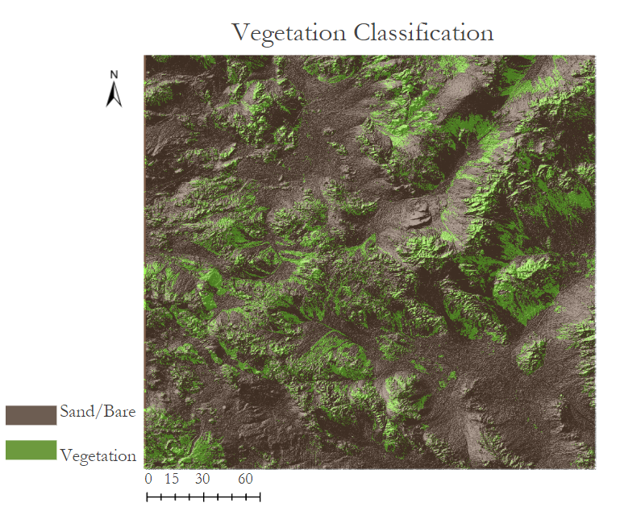

Figure 3. The results of a two class supervised vegetation classification.

Table 1
Random forest and confusion matrix results for the supervised vegetation classification
n = 155 | Predicted Veg | Predicted Sand
Actual Veg | 58 | 26
Actual Sand | 6 | 65
Random Forest Accuracy = 0.79

4.1.2 Topography
The topography of the study area is characterized as a mountain basin environment, which was prominently shown in the derived slope and elevation maps (Appendix Tables B1 & B2). The highest elevation reached an upwards of 2,000 meters in the Granite, Woods, and Providence mountain ranges while the lower elevation mountain ranges near North Bristol and Cady Mountains were around roughly 9545 meters high. Bighorn sheep are known to have specific elevation and slope preferences in their favored habitat ranges, which is why elevation was included as an input parameter in the SAHM model (Figure 2) (Gedir et al., 2016).

4.1.3 NDVI
Every year from 2015 to 2018, there were periods of consecutive months with NDVI values above the mean, representing that the Mojave Desert was experiencing temporal vegetation bloom. In Figure 4, every year has a corresponding growing and non-growing season. The time series shows how there is wide variability in the desert growing season with every year reflecting different patterns. The 2017 green up events reached higher levels of NDVI, which could be due to the fact that California experienced large volumes of precipitation following a several-years-long drought (Di Liberto, 2017). While the time series reflected the overall mean values, every mountain range reflected their own growing seasons (Appendix Figure C2). The majority followed similar green up patterns, but some mountain ranges, like Woods, peaked at several different times during the year. This may be because a few ranges are occupied by evergreen trees in higher elevations. It can be inferred that the beginning of the vegetation bloom occurs sometime between late October to January. A decade worth of data would have been beneficial to analyze the trends in green up events.

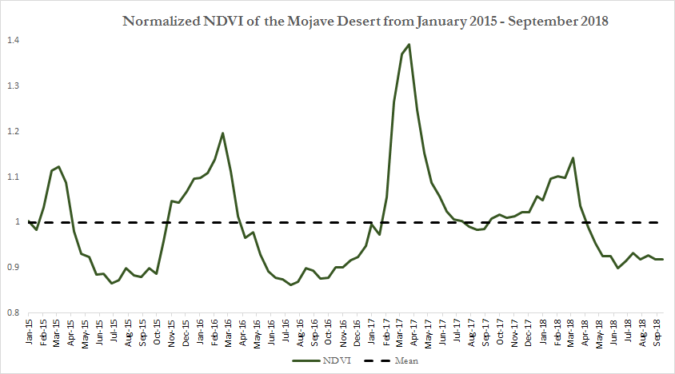
Figure 4. Mojave Desert time series of the normalized NDVI depicting temporal events of green up in the overall study area.

4.1.4 SMAP
The growing season observed from NDVI began near the same time that the root zone soil moisture was above average for most of the mountain ranges, including Kelso (Figure 5). Surface soil moisture had higher variability for when soil moisture peaked and dropped over time. This may be indicative of the sudden precipitation events common in the Mojave Desert (P. Prentice, personal communication, November 14, 2018). Mountain ranges that do not follow the trend of vegetation growth periods occurring with higher soil moisture may have vegetation species that have a later green up period.

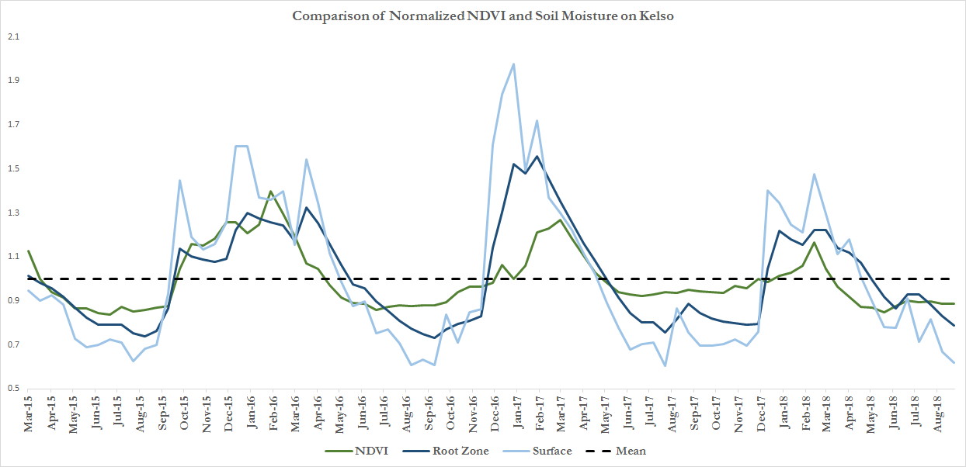
Figure 5. Time series comparison of soil moisture and green up events on the Kelso mountain range.

4.1.5 SAHM
The results of the SAHM output regression variables for each model included sensitivity, specificity, true skills stat (TSS), Cohen’s Kappa, area under the curve (AUC), and the percent correctly classified (PCC). Explanations of the SAHM model output variables are in Appendix Table D5. Each variable provides a method to investigate the model’s performance for producing a species distribution map and a receiver operating characteristic plot (ROC) (Appendix Figures D1 through D4). The average of all the ranges for each variable found that the boosted regression tree had the highest values across the board, including an 81.4% correctly classified and a 96% area under the curve (Table 2). The next highest model result was the random forest with a 95% area under the curve and 80.4% correctly classified. The resulting Granite mountain bighorn sheep probability map for the boosted regression tree model showed a high 95% probability of bighorn sheep distribution throughout some of the higher elevations (Appendix Figure D1). There seemed to be some pockets within the mountain range that dipped to almost 0% distribution, which could be accounted for the fact that the project partners have reported that the Granite mountain range has some of the lowest amounts of sheep GPS collar locations. It was also reported by our project partners that some of the higher elevations within this mountain range have considerable tree coverage, which is not a preferred forage type for bighorn sheep. Additional processing of these probability maps would be beneficial to see the changes in distribution among the models, including the addition of a detailed vegetation map that would result in identifying areas of high vegetation types not favored by bighorn sheep. The SAHM model output results for the other mountain ranges can be found in Appendix Tables D6 through D15.

Table 2
The average SAHM model output for each mountain range
Average of All Ranges | MaxEnt | Random Forest | MARS | Boosted Regression Tree
Sensitivity | 0.85 | 0.89 | 0.85 | 0.90
Specificity | 0.77 | 0.81 | 0.77 | 0.81
True Skills Stat | 0.70 | 0.77 | 0.70 | 0.82
Cohen’s Kappa | 0.56 | 0.62 | 0.56 | 0.74
Percent Correctly Classified | 77.4% | 80.4% | 76.9% | 81.4%
AUC | 0.92 | 0.95 | 0.92 | 0.96

4.2 Future Work
The lack of ground truth data locating specific vegetation classes proved to be a hindrance to this project. It was not possible to create a detailed supervised classification for specific vegetation species using satellite imagery, and only about ten to fifteen ground truth points were provided by our project partners at the CDFW. An unsupervised classification was also unreliable due to the fact that the majority of the vegetation species in the study area appeared to be to spectrally similar. The varied topography of the study area also proved to be a challenge when trying to accurately classify vegetation. The shading inside ridges and valleys obscured the appearance of vegetation on the aerial images, which made it difficult to distinguish species because ENVI was not able to pick up a spectral signature denoting greenness when running classifications. The incorporation of NDVI with the vegetation classification can help bypass some of the issues with surface conditions and shadows. BHS habitat may potentially be correlated with vegetation species as well as presence, and a more detailed vegetation classification map may be helpful in further investigating the relationship between vegetation and BHS habitat.

There are uncertainties on the ability to which desert soils can retain water following sudden extreme precipitation events. The addition of precipitation data will be informative for assessing localized monsoon and flash floods that may explain irregularities between NDVI and soil moisture trends at specific mountain ranges. The Ecosystem Spaceborne Thermal Radiometer Experiment on Space Station (ECOSTRESS) mission, launched recently this year, could also provide higher resolution data to assess water availability and vegetative water stress.

The project partners have also expressed interest in creating a comprehensive geology map for the region. With more time and help from a local Mojave Desert geologist, an in-depth geology map could prove a valuable resource for improving vegetation classification. A comprehensive geology map could help with a more accurate land cover classification map, which could further explore additional factors influencing BHS habitat such as habitat loss and livestock grazing.

5. Conclusions
The results of this project showed that the SAHM model provided valuable insight into predicted BHS distribution. The model factored in soil moisture, topology, NDVI, and BHS collar data, which ultimately provided highly probable results for suspected BHS habitat. The output of the model also provided a better understanding of how different environmental factors can create favorable conditions for preferred BHS ranges. BHS were found to most likely select areas of higher elevation, which was also correlated with a higher NDVI and vegetation cover. It is important to note that this may be due to other factors, such as lambing and predation, which was not studied in this project. Additionally, a high NDVI may be the result of evergreen or deciduous tree cover, which is not a preferred forage type for BHS. We also found that soil moisture and green up events were positively correlated and higher soil moisture resulted in higher NDVI values. This project found that green up events were immensely variable between each mountain range in the Mojave Desert, potentially because of the highly localized precipitation in the area.

This project provides our partners the ability to integrate the resulting BHS probability distribution maps with their own field data, including bighorn sheep population surveys and onsite vegetation monitoring. Using the information provided by these distribution maps, our partners will be able to examine their own management plans to identify if areas predicted as having a high probability of distribution translates to more accurate bighorn sheep monitoring. Additionally, the partners were provided a detailed layout of the SAHM model for their own use, including the ability to add additional predictor layers and adjust the model parameters depending on their specific interests. This information, in combination with the time series for soil moisture and NDVI, will provide the partners will a more comprehensive look at the overall factors influencing potential bighorn sheep habitat.

6. Acknowledgments

Thank you to the following people for their input and guidance on this project:

Science Advisors
- Kenton Ross, NASA Langley Research Center
- Natasha Stavros, NASA Jet Propulsion Laboratory, California Institute of Technology
- Joseph Spruce, Science Systems & Applications, Inc.

Partners
- Debra Hughson, National Park Service, Mojave National Preserve
- Nathan Galloway, National Park Service, Biological Resources Division, Wildlife Health Branch
- David German, California Department of Fish and Wildlife, Wildlife Branch, Game Management
- Paige Prentice, California Department of Fish and Wildlife, Wildlife Branch, Game Management
- Jeff Villepique, California Department of Fish and Wildlife, Wildlife Branch, Game Management
- John Wehausen Nevada Bighorn Sheep Foundation
- Clinton Epps, Oregon State University

Additionally, we would like to thank
- Amanda West, Colorado State University
- Jacob Ramthun, NASA DEVELOP VA – Wise County
- Devon Burks, NASA DEVELOP VA – Wise County
- Mariah Heck, NASA DEVELOP VA – Wise County

Any opinions, findings, and conclusions or recommendations expressed in this material are those of the author(s) and do not necessarily reflect the views of the National Aeronautics and Space Administration.

This material is based upon work supported by NASA through contract NNL16AA05C.

7. Glossary
ASTER GDEM - Terra Advanced Spaceborne Thermal Emission and Reflection Global Digital Elevation Map; NASA Earth observation product
Bighorn sheep (Ovis canadensis) - Species of sheep native to North America named for their distinctively large horns
In situ - “On-site” observations
Earth observations - Satellites and sensors that collect information about the Earth’s physical, chemical, and biological systems over space and time
ECOSTRESS - The ECOsystem Spaceborne Thermal Radiometer Experiment on Space Station; a NASA Earth observation
Green up - Temporal event where the vegetation begins to bloom in the growing season usually observed in the spring
NAIP - National Agriculture Imagery Program; imagery with a high spatial resolution of 1 meter
NDVI - Normalized Difference Vegetation Index; an indicator of green vegetation abundance derived from visual and near-infrared spectral bands
Metapopulation - Group of spatially separated populations of the same species
MODIS - Terra Moderate Resolution Imaging Spectroradiometer; NASA Earth observation
SMAP - Soil Moisture Active Passive; NASA Earth observation
Soil root zone - The depth within the soil profile where roots can effectively utilize water and nutrients for growth

8. References
Creech, T., Monello, R.J., Epps, C. W., & Wehausen, J.D. (2014). Using network theory to prioritize management in a desert bighorn sheep metapopulation. Landscape Ecology, 29(4), 605-619. doi: 10.1007/s10980-014-0016-0
Di Liberto, T. (2017, October 10). Very wet 2017 water year ends in California. Retrieved from https://www.climate.gov/news-features/featured-images/very-wet-2017-water-year-ends-california
Didan, K. (2015). MODIS/Terra Vegetation Indices 16-Day L3 Global 250m SIN Grid V006 [MOD13Q1]. NASA EOSDIS LP DAAC. doi: 10.5067/MODIS/MOD13Q1.006
Epps, C. W., Mccullough, D. R., Wehausen, J. D., Bleich, V. C., & Rechel, J.L. (2004). Effects of climate change on population persistence of desert-dwelling mountain sheep in California. Conservation Biology, 18, 102–113. doi:10.1111/j.1523-1739.2004.00023.x
Gedir, J.V., Cain III, J.W., Krausman, P.R., Allen, J.D., Duff, G.C., & Morgart, J.R. (2016). Potential foraging decisions by a desert ungulate to balance water and nutrient intake in a water-stressed environment. PLoS ONE, 11(2), e0148795. doi:10.1371/journal.pone.0148795
Hereford, R., Webb, R.H., & Longre, C.I. (2005). United States Geological Survey: Precipitation History of the Mojave Desert Region, 1893-2001. Accessed 2 October 2018. Retrieved from https://pubs.usgs.gov/fs/fs117-03/
Longshore, K. (2018). United States Geological Survey: Ecology and Conservation of Desert Bighorn Sheep. Accessed 25 September 2018. Retrieved from https://www.usgs.gov/centers/werc/science/ecology-and-conservation-desert-bighorn-sheep?qt-science_center_objects=0#qt-science_center_objects
NASA/METI/AIST/Japan Spacesystems, and U.S./Japan ASTER Science Team (2009). ASTER Global Digital Elevation Model [ASTGTM V002]. NASA EOSDIS Land Processes DAAC. doi: 10.5067/ASTER/ASTGTM.002
Reichle, R., G. De Lannoy, R. D. Koster, W. T. Crow, J. S. Kimball, and Q. Liu. (2018). SMAP L4 Global 3-hourly 9 km EASE-Grid Surface and Root Zone Soil Moisture Geophysical Data, Version 4. [sm_profile]. Boulder, Colorado USA. NASA National Snow and Ice Data Center Distributed Active Archive Center. doi:10.5067/KPJNN2GI1DQR.
Reichle, R., G. De Lannoy, R. D. Koster, W. T. Crow, J. S. Kimball, and Q. Liu. (2018). SMAP L4 Global 3-hourly 9 km EASE-Grid Surface and Root Zone Soil Moisture Geophysical Data, Version 4. [sm_rootzone]. Boulder, Colorado USA. NASA National Snow and Ice Data Center Distributed Active Archive Center. doi:10.5067/KPJNN2GI1DQR.
Reichle, R., G. De Lannoy, R. D. Koster, W. T. Crow, J. S. Kimball, and Q. Liu. (2018). SMAP L4 Global 3-hourly 9 km EASE-Grid Surface and Root Zone Soil Moisture Geophysical Data, Version 4. [sm_surface]. Boulder, Colorado USA. NASA National Snow and Ice Data Center Distributed Active Archive Center. doi:10.5067/KPJNN2GI1DQR.

9. Appendices
Appendix A
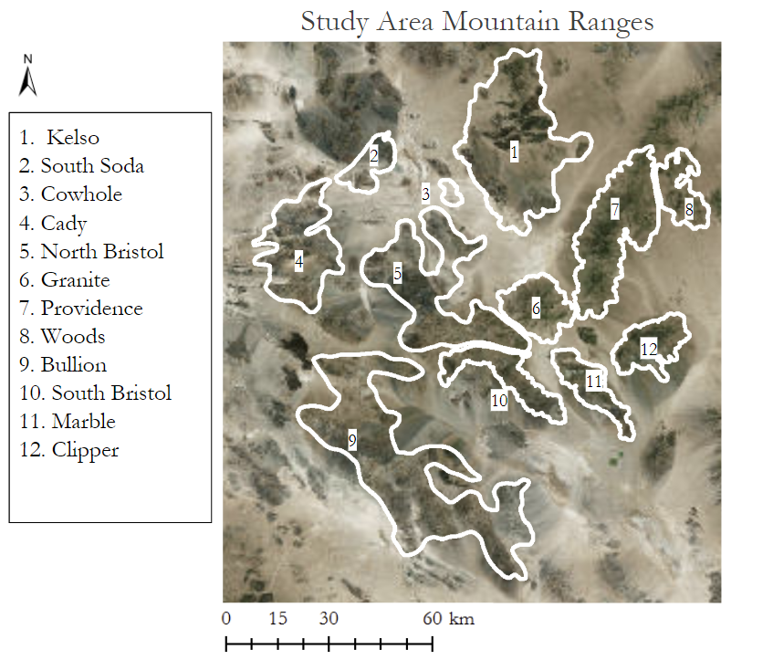
Figure A1. Mountain range boundaries used for data processing and analysis.

Appendix B
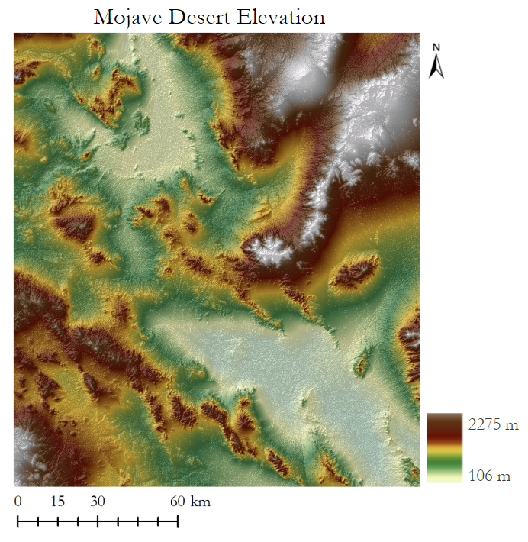
Figure B1. Study area elevation in meters derived from Terra ASTER.
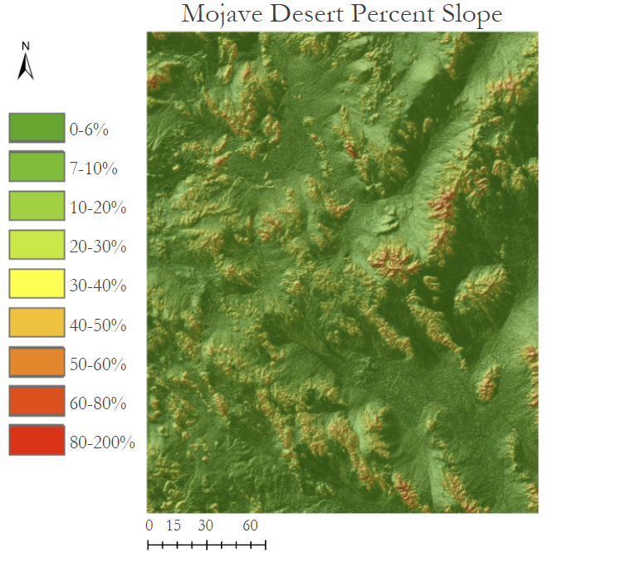
Figure B2. Study area percent slope derived from Terra ASTER.

Appendix C
Table C1
NDVI and soil moisture equations
$$\text{NDVI =}\frac{\left(\text{NIR - R}\right)}{\text{(NIR + R)}}$$
$$\text{Normalized NDVI }\text{=}\frac{\text{NDVI}}{\text{μ} \text{NDVI}}$$
$$\text{Normalized Soil Moisture }\text{=}\frac{\text{16 Day Mean Soil Moisture}}{\text{μ }\text{16 Day Mean Soil Moisture}}$$

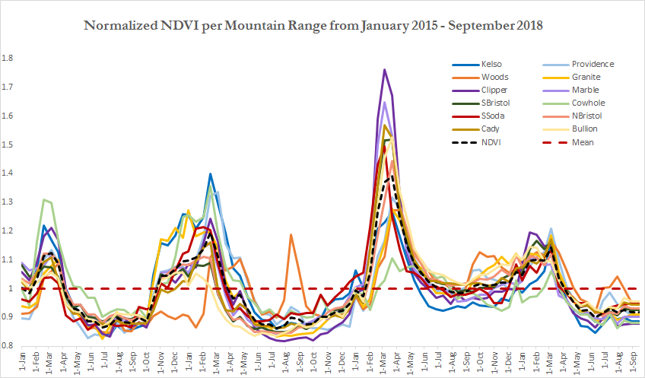Figure C2. Normalized NDVI per Mountain Range from January 2015 - September 2018.

Appendix D
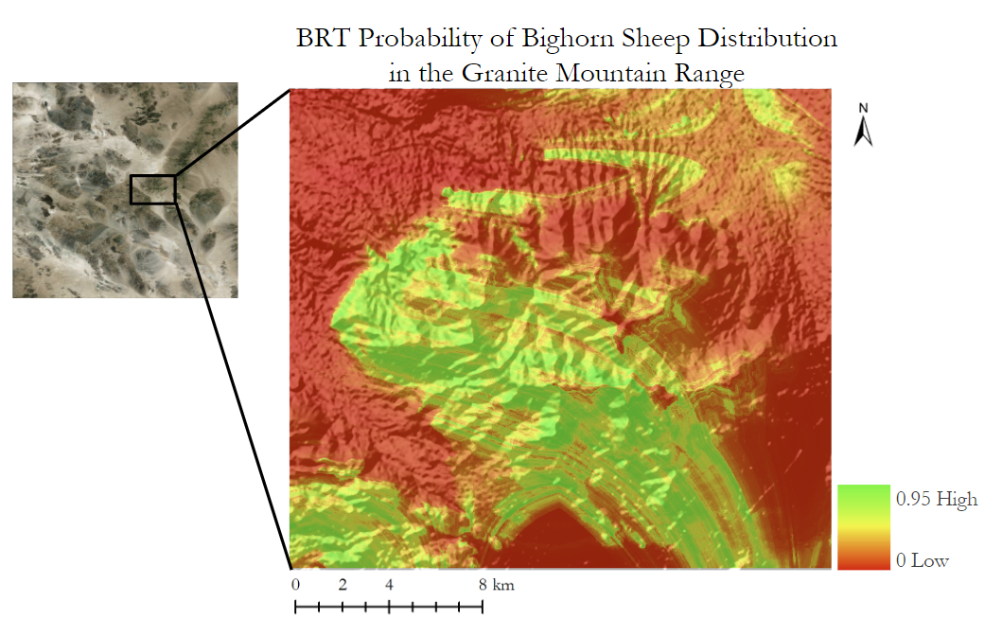Figure D1. The probability of bighorn sheep distribution in the Granite mountain range, as output from the boosted regression tree model in SAHM.
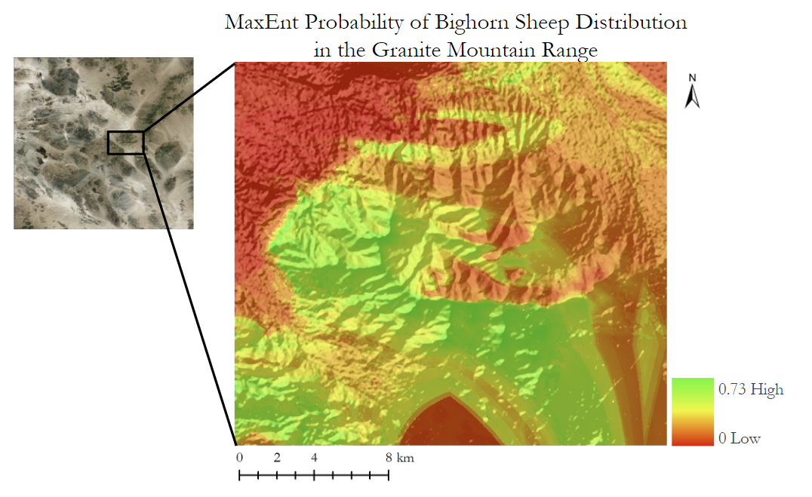Figure D2. The probability of bighorn sheep distribution in the Granite mountain range, as output from the maximum entropy model in SAHM.
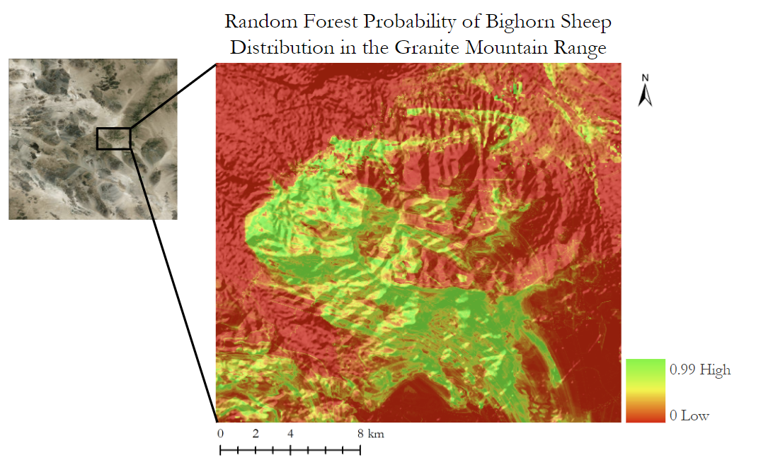
Figure D3. The probability of bighorn sheep distribution in the Granite mountain range, as output from the random forest model in SAHM.

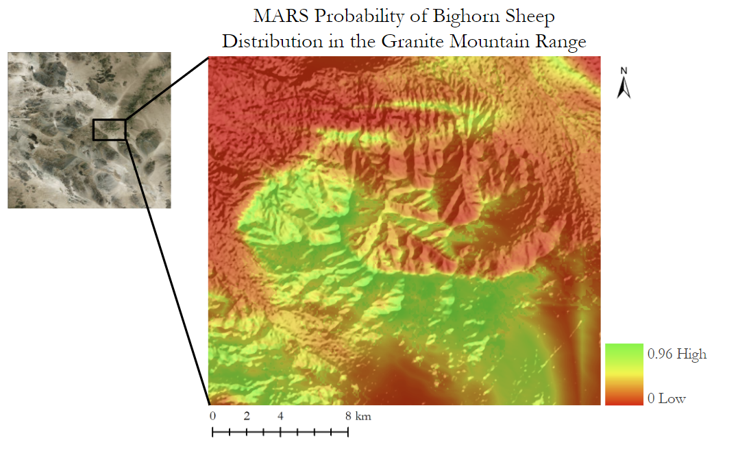Figure D4. The probability of bighorn sheep distribution in the Granite mountain range, as output from multivariate adaptive regression splines model in SAHM.
Table D5
Explanation of SAHM model output variables
Variable | Definition
Sensitivity | The probability that a result will be “presence” when a sheep is present.
Specificity | The probability that a result will be “absence” when a sheep is absent.
Cohen’s Kappa | A value below 0 indicate the model’s performance is no better than random, and a value towards 1 indicates a perfect agreement.
True Skills Stat (TSS) | A value below 0 indicate the model’s performance is no better than random, and a value towards 1 indicates a perfect agreement.
Area Under the Curve (AUC) | This percentage shows the ability of the model to accurately distinguish between “presence” and “background” points. A value from .7 to .8 indicates a reasonably moderate performance.

Table D6
SAHM model outputs for Providence mountain range
Providence | MaxEnt | Random Forest | MARS | Boosted Regression Tree
Sensitivity | 0.96 | 0.96 | 0.98
Specificity | 0.96 | 0.96 | 0.98
True Skills Stat | 0.92 | 0.91 | 0.96
Cohen’s Kappa | 0.31 | 0.28 | 0.46
Percent Correctly Classified | 96.2% | 95.7% | 97.9%
AUC | 0.99 | 0.99 | 0.99

Table D7
SAHM model outputs for South Bristol mountain range
South Bristol | MaxEnt | Random Forest | MARS | Boosted Regression Tree
Sensitivity | 0.82 | 0.86 | 0.82 | 0.9
Specificity | 0.83 | 0.86 | 0.82 | 0.9
True Skills Stat | 0.65 | 0.72 | 0.65 | 0.8
Cohen’s Kappa | 0.6 | 0.69 | 0.6 | 0.77
Percent Correctly Classified | 82.2% | 86.0% | 82.3% | 90.0%
AUC | 0.9 | 0.93 | 0.91 | 0.97

Table D8
SAHM model outputs for South Soda mountain range
South Soda | MaxEnt | Random Forest | MARS | Boosted Regression Tree
Sensitivity | 0.92 | 0.93 | 0.92 | 0.97
Specificity | 0.93 | 0.93 | 0.92 | 0.96
True Skills Stat | 0.85 | 0.86 | 0.84 | 0.93
Cohen’s Kappa | 0.54 | 0.55 | 0.5 | 0.72
Percent Correctly Classified | 92.6% | 92.9% | 91.7% | 96.3%
AUC | 0.97 | 0.97 | 0.96 | 0.99

Table D9
SAHM model outputs for Cady mountain range
Cady | MaxEnt | Random Forest | MARS | Boosted Regression Tree
Sensitivity | 0.80 | 0.86 | 0.79 | 0.88
Specificity | 0.80 | 0.86 | 0.8 | 0.88
True Skills Stat | 0.60 | 0.71 | 0.59 | 0.76
Cohen’s Kappa | 0.60 | 0.71 | 0.59 | 0.76
Percent Correctly Classified | 80.0% | 85.5% | 79.4% | 87.8%
AUC | 0.87 | 0.93 | 0.86 | 0.95

Table D10
SAHM model outputs for Woods mountain range
Woods | MaxEnt | Random Forest | MARS | Boosted Regression Tree
Sensitivity | 0.91 | 0.92 | 0.89 | 0.93
Specificity | 0.91 | 0.92 | 0.9 | 0.93
True Skills Stat | 0.81 | 0.83 | 0.8 | 0.86
Cohen’s Kappa | 0.54 | 0.58 | 0.51 | 0.63
Percent Correctly Classified | 90.6% | 91.6% | 89.6% | 93.1%
AUC | 0.96 | 0.97 | 0.94 | 0.98

Table D11
SAHM model outputs for North Bristol mountain range
North Bristol | MaxEnt | Random Forest | MARS | Boosted Regression Tree
Sensitivity | 0.79 | 0.86 | 0.78 | 0.88
Specificity | 0.8 | 0.86 | 0.79 | 0.88
True Skills Stat | 0.58 | 0.72 | 0.57 | 0.76
Cohen’s Kappa | 0.57 |  |  | 0.75
Percent Correctly Classified | 79.0% | 85.5% | 78.2% | 88.2%
AUC | 0.87 | 0.93 | 0.86 | 0.95

Table D12
SAHM model outputs for Kelso mountain range
Kelso Mountains | MaxEnt | Random Forest | MARS | Boosted Regression Tree
Sensitivity | 0.87 | 0.9 | 0.83 | 0.96
Specificity | 0.85 | 0.91 | 0.83 | 0.96
True Skills Stat | 0.71 | 0.81 | 0.66 | 0.91
Cohen’s Kappa | 0.7 | 0.81 | 0.65 | 0.91
Percent Correctly Classified | 85.8% | 90.7% | 83.0% | 95.5%
AUC | 0.92 | 0.97 | 0.91 | 0.99

Table D13
SAHM model outputs for Clipper range
Clipper Mountains | MaxEnt | Random Forest | MARS | Boosted Regression Tree
Sensitivity | 0.86 | 0.88 | 0.86 | 0.89
Specificity | 0.86 | 0.88 | 0.86 | 0.9
True Skills Stat | 0.72 | 0.75 | 0.72 | 0.79
Cohen’s Kappa | 0.68 | 0.71 | 0.67 | 0.75
Percent Correctly Classified | 86.3% | 87.7% | 86.0% | 89.5%
AUC | 0.93 | 0.94 | 0.93 | 0.96

Table D14
SAHM model outputs for Granite range
Granite Mountains | MaxEnt | Random Forest | MARS | Boosted Regression Tree
Sensitivity | 0.74 | 0.82 | 0.74 | 0.83
Specificity | 0.74 | 0.82 | 0.74 | 0.83
True Skills Stat | 0.49 | 0.643 | 0.47 | 0.66
Cohen’s Kappa | 0.43 | 0.58 | 0.41 | 0.6
Percent Correctly Classified | 74.6% | 82.2% | 73.4% | 83.0%
AUC | 0.89 | 0.89 | 0.91 | 0.91

Table D15
SAHM model outputs for Marble range
Marble Mountains | MaxEnt | Random Forest | MARS | Boosted Regression Tree
Sensitivity | 0.84 | 0.87 | 0.84 | 0.9
Specificity | 0.84 | 0.87 | 0.84 | 0.9
True Skills Stat | 0.68 | 0.74 | 0.69 | 0.91
Cohen’s Kappa | 0.62 | 0.69 | 0.63 | 0.81
Percent Correctly Classified | 84.0% | 87.0% | 84.4% | 90.5%
AUC | 0.92 | 0.93 | 0.92 | 0.97

