NASA DEVELOP National Program
NASA Jet Propulsion Laboratory
Spring 2016

Bolsa Chica Ecological Forecasting
Analyzing the Success of the Bolsa Chica Wetland Restoration Using Multi-spectral NASA Earth Observations


Technical Report
Final Draft

Christine Elowitt (Project Lead)
Steven Kerns
Nick Rousseau

Cedric Fichot, NASA Jet Propulsion Laboratory (Science Advisor)
Benjamin Holt, NASA Jet Propulsion Laboratory (DEVELOP Mentor)

I. Abstract
The Bolsa Chica Ecological Reserve in Huntington Beach, California, consists of 1550 acres of undeveloped coastal wetland and is home to several endangered species, including Rallus longirostris levipes and Sterna antillarum browni, which fly along the Pacific flyway. Since the 1800’s, farming, land subsidence, resource extraction, and land development have impacted these wetlands, affecting the habitat’s biodiversity. The Amigos de Bolsa Chica advocacy group has made a 40-year effort to preserve, restore, and maintain the wetlands through volunteer work and public outreach, impacting public policy and management practices. However, there has been no previous attempt to assess the success of the restoration using aerial imagery. This project utilized NASA Earth observations, USDA National Agriculture Imagery Program (NAIP) imagery, USGS High Resolution Orthoimagery and Digital Orthographic Quadrangles, and GIS analysis and statistics to highlight the changes in habitat and tidal water extent from 2002 to 2015, with a specific focus on the changes that ensued from the opening of a channel connecting the site to the ocean in 2006. Our results show a 164% increase in wetlands vegetation, a 146% increase in tidal waters, and a 37% decrease in man-made features and non-tidal wetlands. Using a before and after time series based off of our analysis and vegetation maps of the current site, the Amigos de Bolsa Chica will be able to enhance their education and outreach, create more effective tools to engage the community, and strengthen their management of the wetlands to better prioritize areas of future concern.
Keywords
Biodiversity Hotspot, Pacific Flyway, Department of Fish and Wildlife, AVIRIS, Landsat, Endangered Species, Amigos de Bolsa Chica, California

II. Introduction
During the last two centuries, the contiguous United States has lost over half of its wetland habitats; averaging a rate of 60 acres lost per hour (Dahl 1990). California leads the nation in this historic loss of wetlands, sustaining as much as 91% of environmental degradation and human–induced changes to wetland habitats (Zedler 1996). The San Francisco Bay and the southern regions of the state are home to the most significant losses in wetland habitats (Larson 2001, Goodwin et al. 2001). Wetlands such as Bolsa Chica have value beyond their rarity, as they provide a large number of ecosystem services, including: acting as a nursery for breeding fish, carbon sequestration, and providing habitat for endangered species (Noss 1995). In an effort to mitigate wetland loss in the Bolsa Chica Ecological Reserve, several conservation and restoration projects have been created. Thanks to the actions of organizations like the Amigos de Bolsa Chica, the Bolsa Chica wetlands have been steadily increasing in size since they were acquired by the state of California in 1997. Efforts in management and maintenance practices have greatly improved the reserve, allowing its expansion to over 1200 acres and the 2006 restoration of direct tidal inflow for the first time in over 100 years.
The objective of this project is to enhance the information available to the Amigos de Bolsa Chica advocacy group, founded in 1976, by incorporating NASA Earth observations. This information, delivered in the form of time series maps for water extent and vegetation cover as well as land cover change statistics, allows the Amigos to assess the success of the restoration efforts. Our results will also provide the Amigos a means to help educate and engage the public while establishing a current baseline to compare future changes within the ecological reserve.

The Bolsa Chica Wetlands are home to several endemic species such as the western snowy plover, Charadrius alexandrinus nivosus, and they provide critical habitat for migratory and endangered avifauna. Migratory bird populations traveling along the Pacific Flyway were once estimated at 60 million, but now oscillate between 2-4 million waterfowl and 1-2 million shorebirds (Bryant 2003, Larson 2001). Given the dramatic drop in avifauna population, wetlands such as Bolsa Chica serve an increasingly important role in sustaining migratory bird populations along the Pacific Flyway.
The Bolsa Chica wetlands are a biodiversity hotspot and are home to many threatened plant species including Zostera, commonly known as eel-grass. Eel-grass is a key metric for the California Rapid Assessment Method for Wetlands (CRAM), which is employed to quantify wetlands health and restoration. Eel-grass serves as an important primary producer in coastal marine ecosystems and is an essential habitat for breeding fish such as the Cheekspot Goby, Ikypnus gilberti and the Barred Sandbass, Paralabrax nebulifer (Lee et al. 2001, Mann 1982, Valle et al. 1998, Rosales-Casián 1997). The presence of eel-grass allows a more stable and diverse ecosystem to develop (Heck 1995, Lee et al. 2001). Southern California wetlands also sequester significant amounts of carbon dioxide (CO₂) by creating new plant biomass. Wetlands are responsible for globally sequestering close to 830 Tg/year of carbon and despite their methane production, they function as important net carbon sinks. (Mitsch et al. 2012). Further ecosystem services include: high net primary productivity, ground-water recharge, nutrient cycling, and overall human benefit (Butchart et al. 2005). Given their endangered status and immense ecological value, support for wetland restoration efforts is currently a major environmental concern within the United States.
This project was centered on NASA’s Applied Science’s Ecological Forecasting National Application Area and used NASA remote sensing technologies to determine the restoration success of the Bolsa Chica Ecological Reserve, as well as provided satellite-based educational and public outreach materials for the project partner. This project was created via a joint proposal between former DEVELOP Center Lead Gwen Miller, and partner organization Amigos de Bolsa Chica, led by President Jerry Donohue and Joana Tavares Reager. The results of the project are of interest to the Amigos as it allows them to better inform the public on the wetland’s restoration success, as well as expand their citizen scientist education program. The Amigos will decide how to best implement the end products into their education programs and public outreach campaigns. Findings will be shared with the CA Department of Fish and Wildlife; the management organization responsible for the Bolsa Chica Ecological Reserve. The Amigos will directly benefit from being provided with NASA remote sensing data, enabling them to better understand, share, and protect the Bolsa Chica Ecological Reserve.
The study area consists of the 2.67 square mile Bolsa Chica Ecological Reserve in Huntington Beach, California (Figure 1). The site lies at approximately 33.7°N, 118.04°W along the Pacific Coast in the northern part of Orange County in Southern California. The study period is between 2002 and 2015. The outline in the map represents the boundary of the reserve.

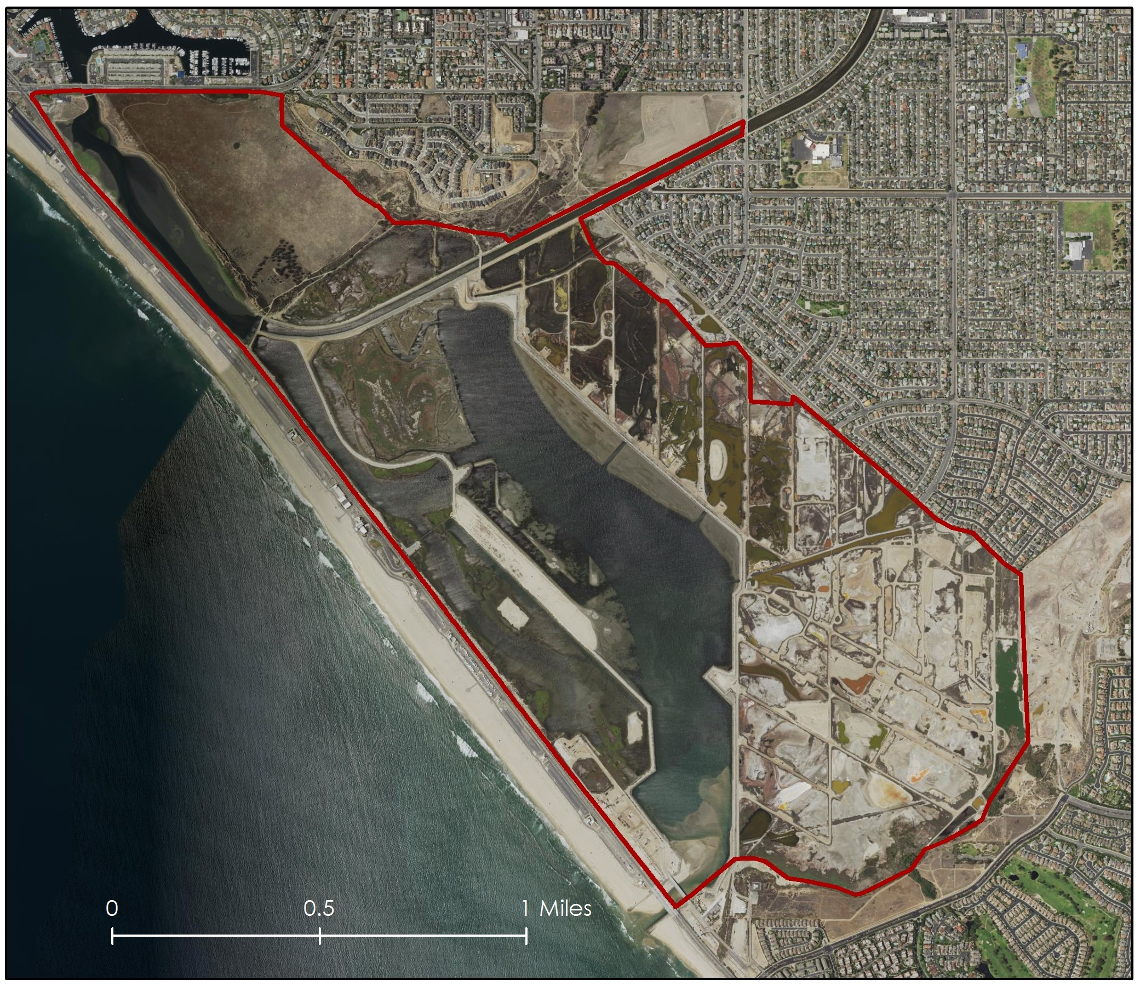 Figure 1. Bolsa Chica Ecological Reserve – Huntington Beach, CA.
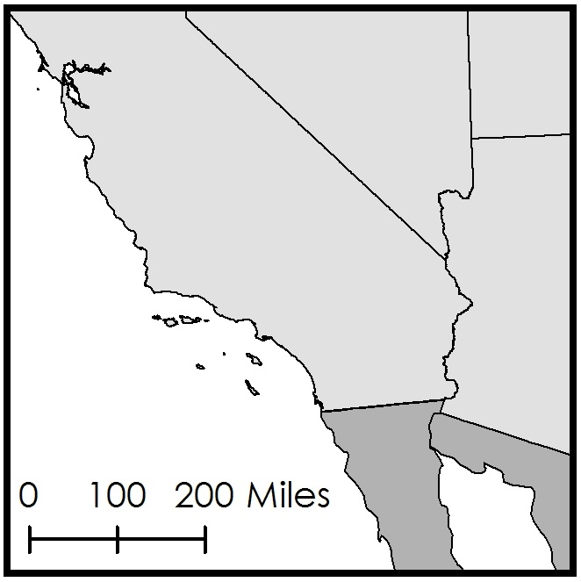
Study Area

III. Methodology
Data Acquisition:
Due to the longevity of the Landsat mission, and the 30 meter resolution of its imagery, which is superior to most other NASA satellites in orbit, we selected it as our primary data source. Using the USGS Earth Explorer portal, we downloaded level 1 imagery for, Landsat 7 Enhanced Thematic Mapper+ (ETM+), and Landsat 8 Operational Land Imager (OLI). Landsat 7 pre-scan line corrector error and the most recent Landsat 8 imagery were acquired to show the changes before and after the Bolsa Chica restoration efforts, with emphasis on a change detection analysis when the wetlands were reintroduced to tidal influences in 2006. Images from dry months, mainly September and October, were used in order to minimize the effects of standing water and puddles from recent rainfall on water extent maps. In those months it is easier to distinguish wetlands vegetation from uplands vegetation, since the uplands grasses are typically dormant in the early fall.
Another source of imagery for this project was the Airborne Visible/Infrared Imaging Spectrometer (AVIRIS), a hyper-spectral instrument on board NASA’s ER-2 aircraft. Images including the Bolsa Chica wetlands are available from several passes the ER-2 made over Southern California in 2014 and 2015. These datasets were accessed and downloaded from the AVIRIS Flight Locator Tool on the Jet Propulsion Laboratory website (NASA 2016).
To augment Landsat and AVIRIS datasets, high resolution imagery from other government sources was acquired. These include 2005 and 2014 true-color images from the United States Department of Agricultures’s National Agricultural Imagery Program (NAIP), and 2003 false color Digital Orthographic Quadrangles (DOQ) and true color High Resolution Orthoimagery (HRO) from the United States Geological Survey. We also downloaded Coastal Change Analysis Program (C-CAP) from the National Oceanic and Atmospheric Administration (NOAA), which shows how land cover along the coastline has changed between 1996 and 2010. C-CAP uses Landsat imagery in order to create their land cover and land cover change classifications.
Data Processing:
All Landsat images were processed in ArcMap 10.3. The processing steps included compositing the bands (figure 2) and sharpening Landsat 7 and 8 images using the panchromatic band to provide better resolution images (figure 3). Colored Infrared Imagery (CIR) was also created, which provides a false color image that includes the infrared (IR) band that allows for easy recognition of vegetation (figure 4).
AVIRIS images were already atmospherically corrected and converted to reflectance values when we obtained them. Using ENVI 5.1, we subsetted the imagery to the immediate area around our study site, and selected the bands within the visible spectrum.
The NAIP, DOQ, and HRO images were all in geoTIFF format and did not require processing. In ArcMap, we converted the C-CAP change image from raster to vector format, then combined all areas that didn’t change from one land cover class to another between 1996 and 2010 into one polygon.
Data Analysis:
Using QGIS Desktop 2.12.3, we then calculated the Normalized Difference Vegetation Index (NDVI) and Normalized Difference Water Index (NDWI) on the Landsat images.
The NDVI (equation 1) allows determination of the amount of vegetation present in an image. This calculation works because the chlorophyll in plants absorbs red light, while the structure of the plant’s leaves reflects light in the near infrared part of the spectrum (Pettorelli et al. 2005). NDVI values range from -1 to 1. Values below zero indicate no vegetation, while positive values indicate the presence of vegetation. As the density of the vegetation increases, so does the NDVI value.
$$NDVI=\frac{\left(Red-NIR\right)}{\left(Red+NIR\right)}$$

Equation 1. Normalized Difference Vegetation Index
The NDWI (equation 2) is similar to NDVI, except that it measures the presence of water rather than vegetation in images. Like NDVI, the values range from -1 to 1. Values in the positive range represent areas where open water is present, while negative values represent non-water features like bare soil and terrestrial vegetation (McFeeters 2013).
$$NDWI=\frac{(Green-NIR)}{(Green+NIR)}$$

Equation 2. Normalized Difference Water Index
After the NDWI and NVDI were calculated for both the 2002 and 2015 Landsat images, we produced index change maps by subtracting the 2002 values from the 2015 values.
The subsetted AVIRIS images were classified using ENVI. A supervised Spectral Angle Mapper Classification (SAM) was done to create six land cover classes. The resulting raster image was brought into ArcMap, and converted into a polygon layer to create a map (figure 5). The NOAA C-CAP change data was also turned into a map in ArcMap (figure 6).
Using the Landsat pan-sharpened images with NAIP, DOQ, and HRO images for reference, we manually drew polygons in ArcMap to create land cover maps of the site in 2002 and 2015. The polygon boundaries were placed where there was a transition from one land cover type to another. The six categories used were tidal waters, wetlands vegetation, uplands vegetation, mud and sand, manmade features, and non-tidal wetlands. We calculated the area covered by each of the land cover types in each year, and performed some basic statistical calculations on the resulting data in Microsoft Excel.

IV. Results & Discussion
Analysis of Results
The NDWI maps we produced (figure 2), show the extent of water at the study site before and after the restoration process began. The blue color in the images shows areas covered in water, while the orange color shows the areas that are lacking water. In the 2002 image on the left, there is not very much water in the wetlands. In the 2015 image on the right, not only can we see the newly formed full tidal basin, but also an increased presence of water in other parts of the site. Since aquatic regions allow for improved biota within wetland environments, this increase in water on the site would be expected to restore the presence of ecosystem engineers such as eel-grass and the mud flats, which provide feeding areas for avifauna.
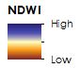
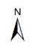
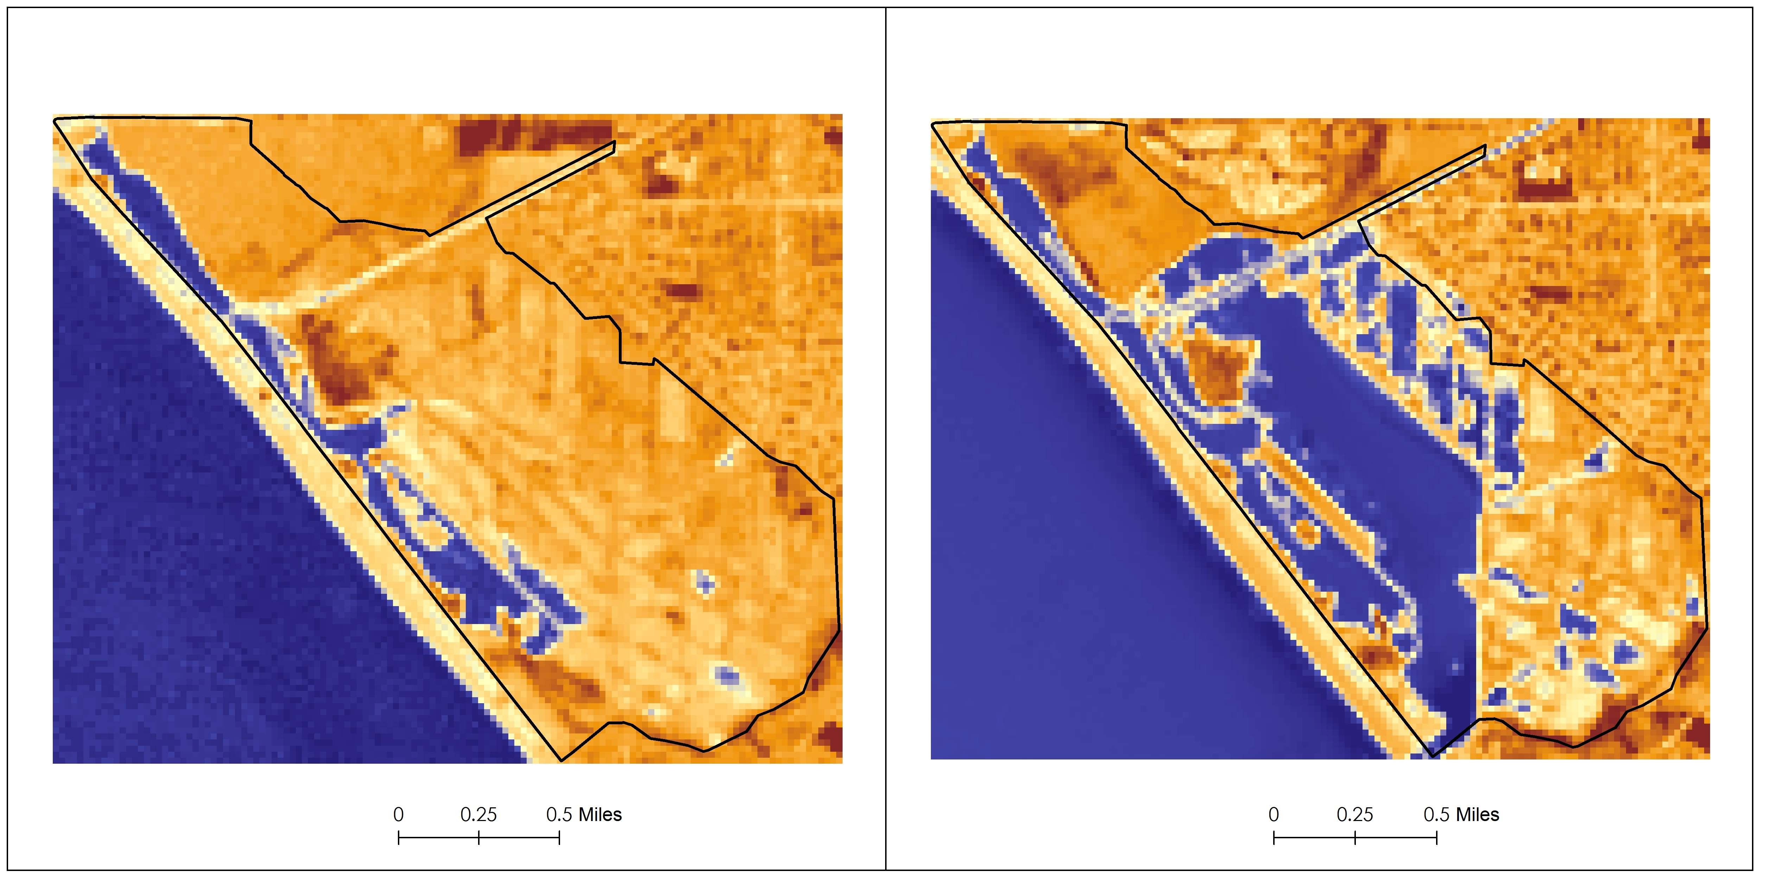Figure 6: Normalized Difference Water Index
The NDVI maps we produced (figure 7) show the extent of vegetation at the site in 2002 and 2015. The green color in the images indicates the presence of vegetation while the mauve color indicates a lack of vegetation. In the 2002 map on the left there much of the site is the in-between yellow color that indicates low density vegetation. That is in contrast to the 2015 map on the right, where most areas are either definitively green or mauve.
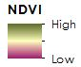
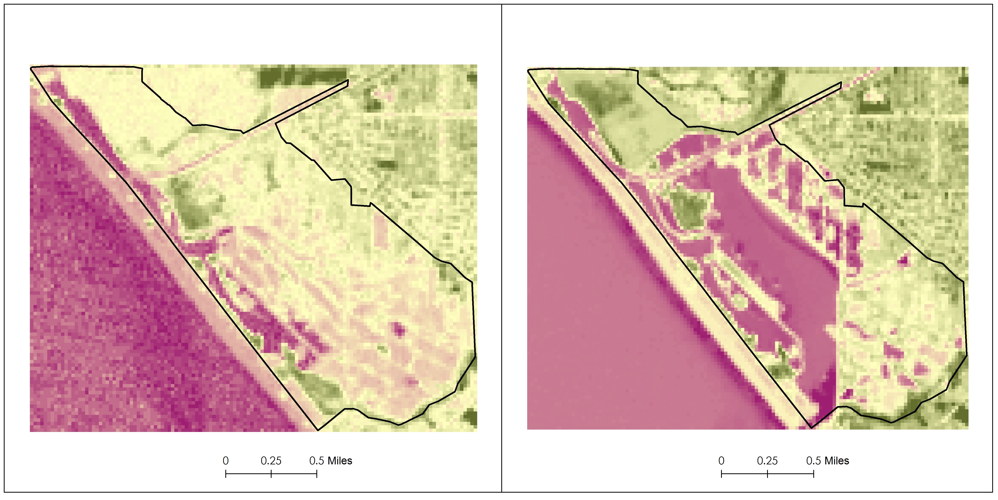
Figure 7: Normalized Difference Vegetation Index
The index change maps (figure 8). Quantify the changes we saw from 2002 to 2015 in NDWI and NDVI. On the left, we see the change in NDWI between 2002 and 2015. The green areas are where there is more water present in 2015, and the red areas are where there was more water present in 2002. Not surprisingly, the full tidal basin is green on the map, and a few other areas immediately to the north and northeast of it. The NDVI change map on the right shows areas with more vegetation in 2015 in green, and areas where there was more vegetation in 2002 in red. Interestingly, this map looks like it is an inverse of the NDWI change map. That means that in areas of the site where there isn’t more water in 2015, there is more vegetation. That increase in both water and vegetation is an indication of the success of the restoration process, since both are necessary for the health of a wetlands ecosystem.
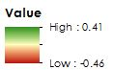
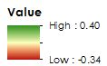
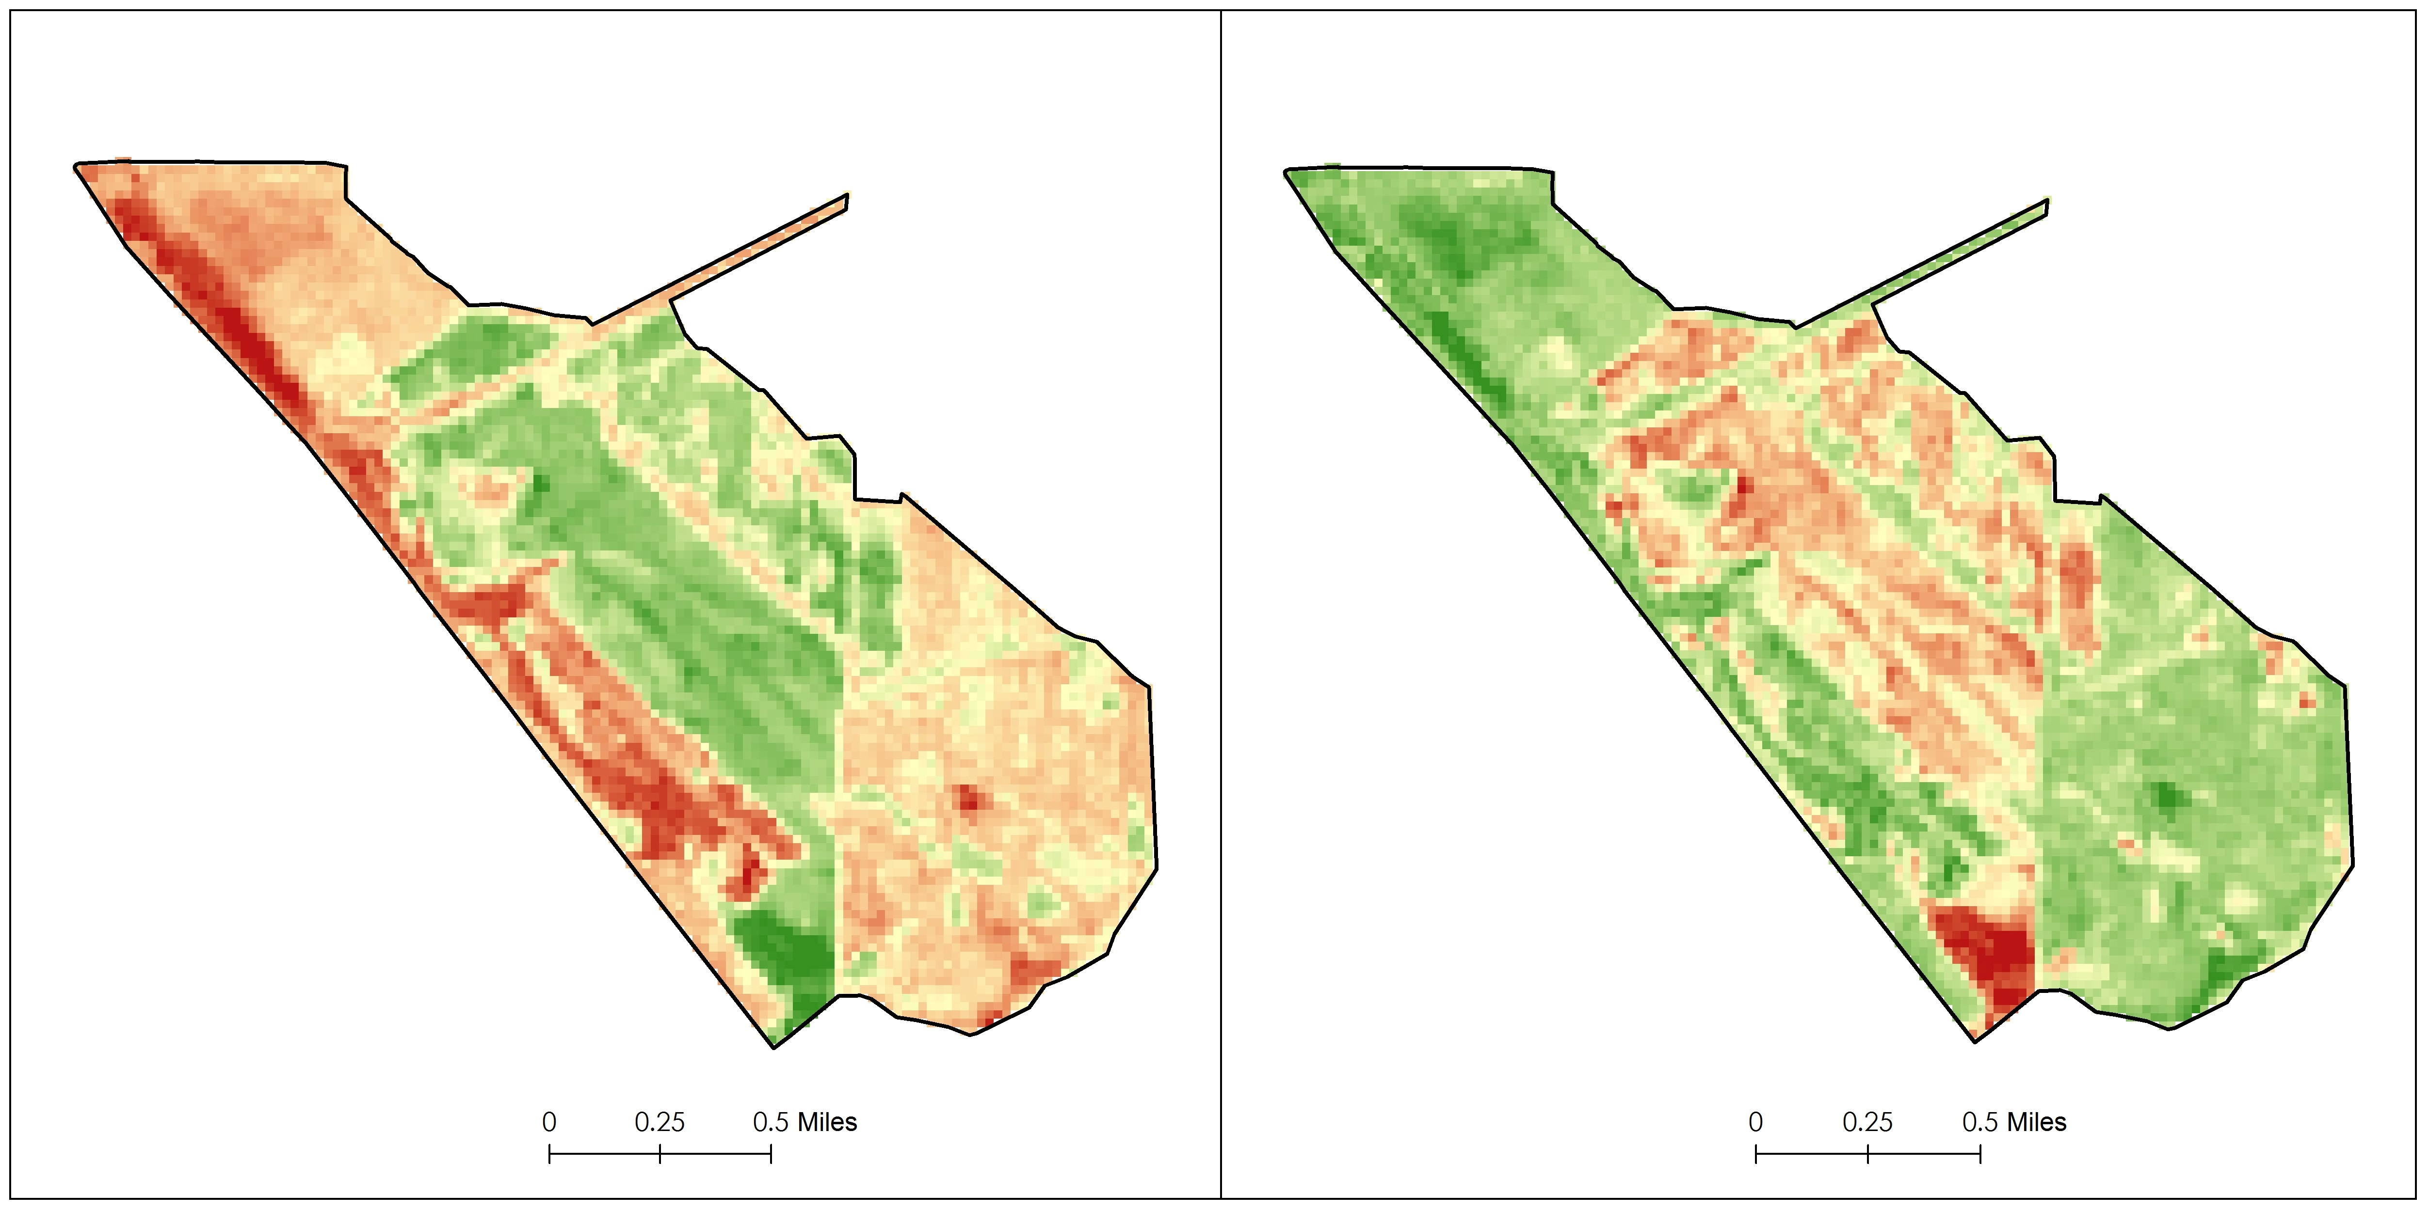
Figure 8: NDVI and NDWI Change Over Time
The land cover maps (figure 9) reveal the same trend. The full tidal basin is present in the 2015 map on the right, and absent from the 2002 map on the left. Areas adjacent to the full tidal basin show more wetlands vegetation or sand and mud in 2015, where they were non-tidal wetlands, uplands vegetation, or manmade features in 2002. The greater portion of the reserve covered by tidal waters, wetlands vegetation, sand, and mud, provides more habitat for species that only thrive in wetlands ecosystems.
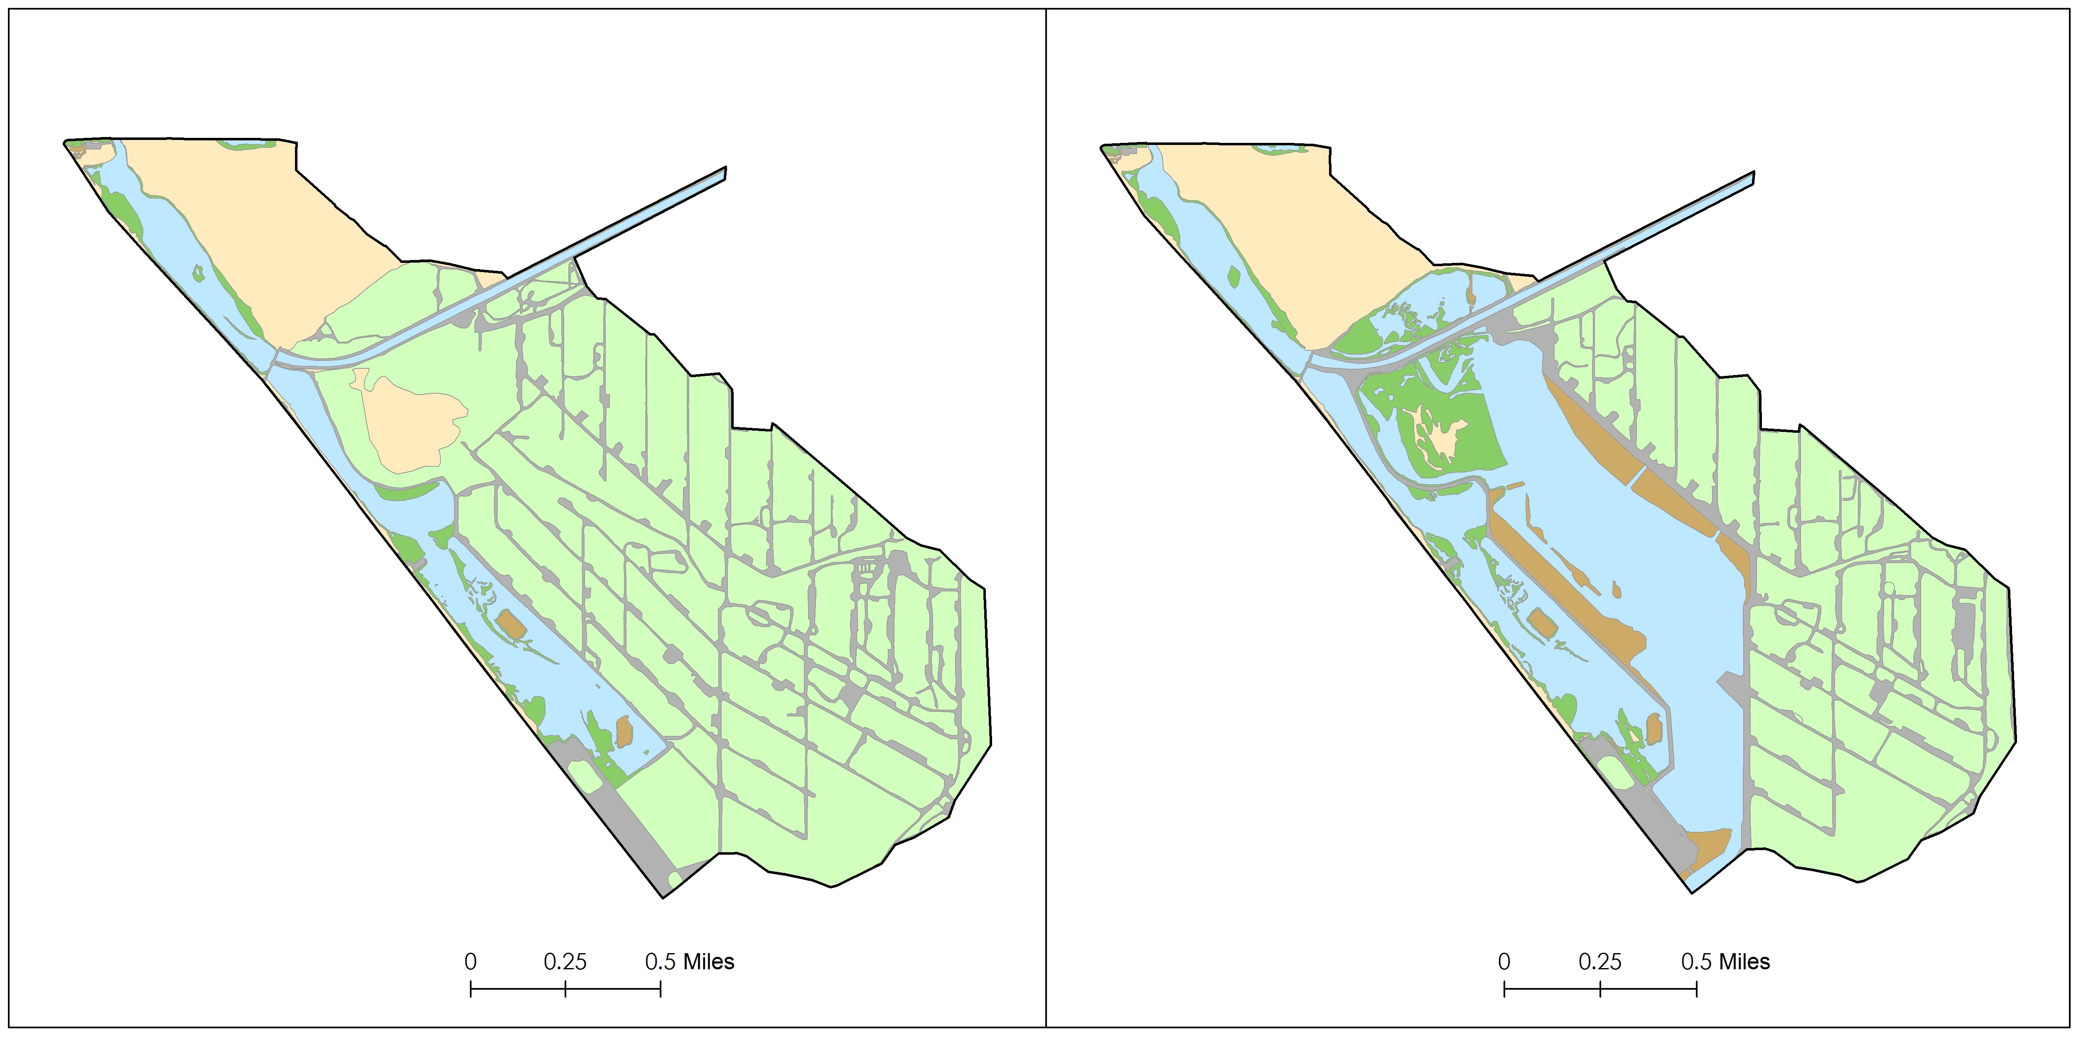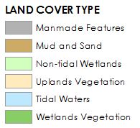
Figure 9: Land Cover Maps
The statistics chart (table 1) displays the area covered by each land cover category in 2002 and 2015 in square meters and as a percentage of the site’s total. It also shows the change in square meters between 2002 and 2015, plus the percentage change. Notably, tidal waters increased by 146.3%, wetlands vegetation by 163.6% and mud and sand by 1401.8% over the course of the study period, while manmade features declined by 6.6%, uplands vegetation by 3.3%, and non-tidal wetlands by 43%. These statistics lend quantitative support to the qualitative observations we have made by visually inspecting the maps.
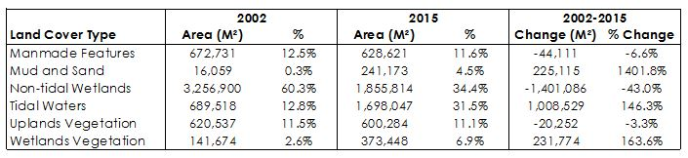
Table 1: Land Cover Statistics
Errors and Uncertainty
While the analysis done for this project using Landsat and ancillary imagery provides a nice overview of the progress of the restoration efforts at the Bolsa Chica Ecological Reserve, this study would benefit from a greater understanding of the influence of tide variance on the site, particularly in the full tidal basin.
In addition, the lack of higher resolution multi-spectral imagery proved limiting. Originally, we had hoped that our classification of the AVIRIS data would yield a more detailed land cover map, that didn’t prove to be the case. We were able to produce a classification (figure 5), but it wasn’t able to distinguish different plant species from each other, and ultimately was inferior to the land cover maps we produced manually.
Future Work
In order to more firmly establish the success of completed restoration efforts, the mapping of submerged eel grass and other aquatic vegetation would allow for the improvement of Bolsa Chica’s CRAM score. In-situ use of radiometers to detect the spectral signature of individual species such as cord-grass in combination with high resolution hyper-spectral imagery could allow for the creation of a species-specific site-map, enabling the user to identify areas most suited for endangered species habitat.

V. Conclusions
The remote sensing images obtained through NASA Earth Observations clearly illustrate that the restoration efforts conducted within the Bolsa Chica Ecological Reserve from 2002 – 2015 have been successful. Nine years after the re-establishment of the tidal inflow, there exists denser vegetation, fewer man-made features, and greatly expanded aquatic resources, including the full-tidal basin, which provides higher-quality habitat. These factors serve as important metrics for wetland health. The results of this project demonstrate the effectiveness of using remote-sensing as a tool to monitor and quantify restoration ecology efforts. The increased density of vegetation and greater water extent, as determined by the analysis, lend a quantitative approach to measure the success of the restoration efforts at the Bolsa Chica Ecological Reserve
The future success of the wetlands relies on the advocacy and public outreach campaigns of environmental-interest groups, such as the Amigos de Bolsa Chica, whose actions have historically protected and improved the wetlands. The long-term impacts of this project will be determined by the project-partners ability to utilize and integrate the data and deliverables provided to them. These deliverables are intended to enhance the under-users citizen science program while further strengthening their efforts to improve support within the local community. With the restoration still in progress, they also established a baseline to which to compare the future state of the site.

VI. Acknowledgments
- Cedric Fichot, NASA Jet Propulsion Laboratory
- Ben Holt, NASA Jet Propulsion Laboratory
- Joana Tavares-Reager, Jerry Donohue, and Vic Leipzig of Amigos de Bolsa Chica
- Bruce Chapman and David Thompson of NASA Jet Propulsion Laboratory
- Brittany Zajic, Emily Beck, Erika Higa, Rebecca Trinh, and Gwen Miller of NASA DEVELOP

Any opinions, findings, and conclusions or recommendations expressed in this material are those of the author(s) and do not necessarily reflect the views of the National Aeronautics and Space Administration.
This material is based upon work supported by NASA through contract NNL11AA00B and cooperative agreement NNX14AB60A.

VII. References
Bryant, Peter J. Biodiversity and Conservation. School of Biological Sciences University California Irvine, 2003.
Butchart, S. "Ecosystems and Human Well-being Wetlands and Water Synthesis." Millennium Ecosystem Assessment. World Resources Institute, 2005.
Dahl, T.E. Wetlands Losses in the United Sates 1780’s To 1980’s. U.S. Department of the Interior, Fish and Wildlife Service, (1990) 13pp.
Goodwin, Peter. Mehta, Ashish J. Zedler, Joy B. "Tidal Wetland Restoration." Journal of Coastal Research Special Issue No. 31. TIDAL DYNAMICS. Volume II: Extreme Tidal Peaks & Coastal Flooding.27 (2001): 1-6.
Heck, K. L., Jr., K. W. Able, C. T. Roman, and M. P. Fahay. "Composition, Abundance, Biomass, and Production of Macrofauna in a New England Estuary: Comparisons Among Eelgrass Meadows and Other Nursery Habitats." Estuaries 18.2 (1995): 379-1995.
Larson, Eric J. "California's Living Marine Resources: A Status Report." California Department of Fish and Game (2001): 483-86.
Lee, S.Y, C.W Fong, and R.S.S Wu. "The Effects of Seagrass (Zostera Japonica) Canopy Structure on Associated Fauna: A Study Using Artificial Seagrass Units and Sampling of Natural Beds." Journal of Experimental Marine Biology and Ecology 259.1 (2001): 23-50.
Mann, K. H. Ecology of Coastal Waters: A Systems Approach. Berkeley: U of California, 1982.
McFeeter, Stuart K. “Using the Normalized Difference Water Index (NDWI) within a Geographic Information System to Detect Swimming Pools for Mosquito Abatement: A Practical Approach.” Remote Sensing 5.7 (2013): 3544-561.
Mitsch, William J., Blanca Bernal, Amanda M. Nahlik, Ülo Mander, Li Zhang, Christopher J. Anderson, Sven E. Jørgensen, and Hans Brix. "Wetlands, Carbon, and Climate Change." Landscape Ecology 28.4 (2012): 583-97.
NASA “Airborne Visible Infrared Imaging Spectrometer.” AVIRIS. NASA. 2016
Noss, Reed F., Edward T. LaRoe, III, and Michael J. Scott. "Endangered Ecosystems of the United States: A Preliminary Assessment of Loss and Degradation." Department of Fish and Wildlife (1995): 1-95.
Pettorelli, Nathalie, Jon Olav Vik, Atle Mysterud, Jean-Michel Gaillard, Compton J. Tucker, Nils Chr. Stenseth. “Using the satellite-derived NDVI to assess ecological responses to environmental change.” Trends in Ecology & Evolution 20.9 (2005): 503-10.
Rosales-Casian, J.A. “Inshore Soft-bottom Fishes of Two Coastal Lagoons on the Northern Pacific Coast of Baja California.” California Cooperative Oceanic Fish Investment 38 (1997): 180-92.
Valle, Charles F., John W. O’Brien, and Kris B. Wiese. “Differential Habitat Use by California Halibut, Paralichthys californicus, Barred Sand Bass, Paralabrax nebulifer, and Other Juvenile Fishes in Alamitos Bay, California.” Fishery Bulletin 97.3 (1999) 646-60. California Department of Fish and Wildlife.
Zedler, Joy B. “Ecological Issues in Wetland Mitigation: An Introduction to the Forum”. Ecological Applications 6.1 (1996): 33–37.

VIII. Content Innovation
Glossary Viewer

Avifauna: The birds that exist within a specific habitat, region, or geological period.
Bands: The division of specific regions or wavelengths of light along the electromagnetic spectrum. Band color combinations are dependent upon the type of sensor and analysis being used.
Biodiversity Hotspot: A specific region that is home to significant numbers of different types of plant and animal life which is currently threatened by human activity. To qualify as a biodiversity hotspot the area must: contain at least 1500 species of plants found only in that region and have lost 70% or more of its primary vegetation. The southern California region falls under the “California Floristic Province.”
Biomass: The total amount or mass of living matter within an area.
Biota: The plant and animal life that exists within a specific habitat, region, or geological period.
Carbon Sequestration: The long-term storage of carbon that slows, mitigates, and helps prevent climatic changes by reducing the amount of CO₂ and other carbon-based greenhouse gases in the atmosphere.
Ecosystem Services: Natural functions of the environment which provide the following benefits: the production of food and water, the control of climate and disease, nutrient cycles and crop pollination, spiritual and recreational benefits.
GIS: Geographic Information Science or Systems (GIS) is the science of storing, manipulating, analyzing, and managing spatial or geographical data in vector or raster format.
Hyper-Spectral Imagery: Term used to describe the imagery derived from subdividing the electromagnetic spectrum into very narrow bandwidths. These narrow bandwidths may be combined with or subtracted from each other in various ways to form images useful in precise terrain or target analysis. Also called HSI.
Infrared: A wavelength or region along the electromagnetic spectrum that is longer than visible red light.
In-Situ: Latin for “in position,” describes measurements or data taken from the field.
Multi-Spectral Imagery: Imagery utilizing information from the electromagnetic spectrum, it is created by instruments sensitive to specific bands along the electromagnetic spectrum.
Nutrient Cycling: The movement and exchange of organic and inorganic matter that is then used in the production of new living matter.
Pacific Flyway: The major north-south migratory route for birds in America. It extends from Alaska to Patagonia South America.
Raster: A matrix of pixels organized into a grid, each pixel has a value representing information such as elevation or temperature. Raster images are obtained from aerial photographs, satellite images, etc.
Remote Sensing: The art, science, and technology of obtaining information about physical objects and the environment using non-contact sensor systems.
Subset: Creating a smaller map from a larger one in order to focus on a more specific geographic region of interest.
Vector: Data that is represented by points, lines, and polygons that are associated geometrically to represent geographic information.

Featured Multimedia for this Article (VPS Video)

Inline Supplementary Material (figures, tables, computer code)

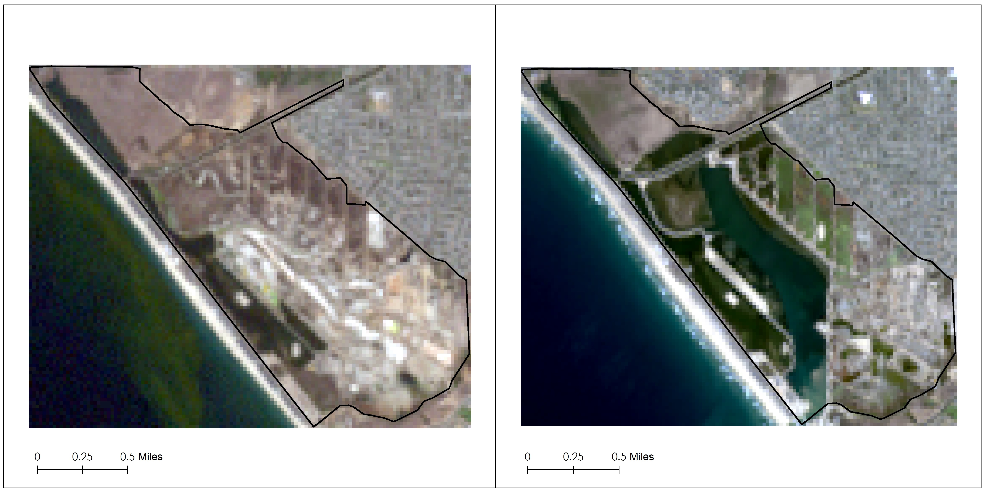
Figure 2: Landsat Imagery with Composited Bands
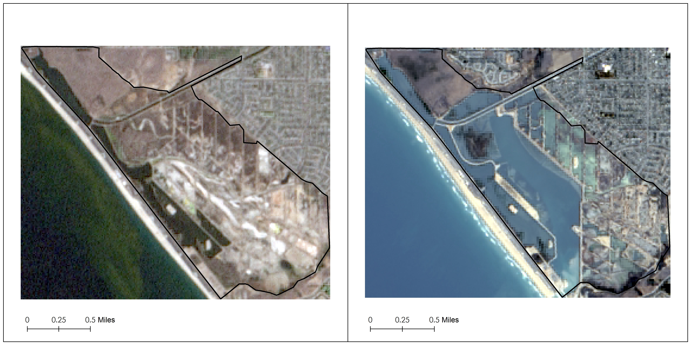
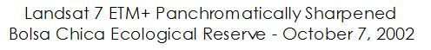
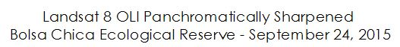
Figure 3: Panchromatically Sharpened True Color Landsat Imagery
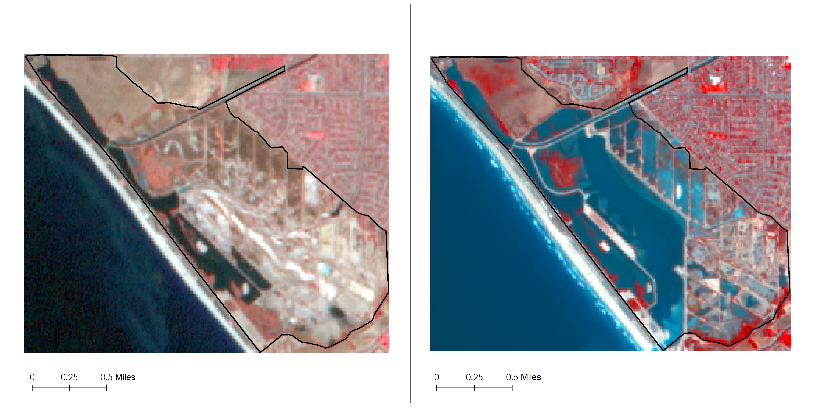
Figure 4: Panchromatically Sharpened Landsat Color Infrared Imagery (CIR)
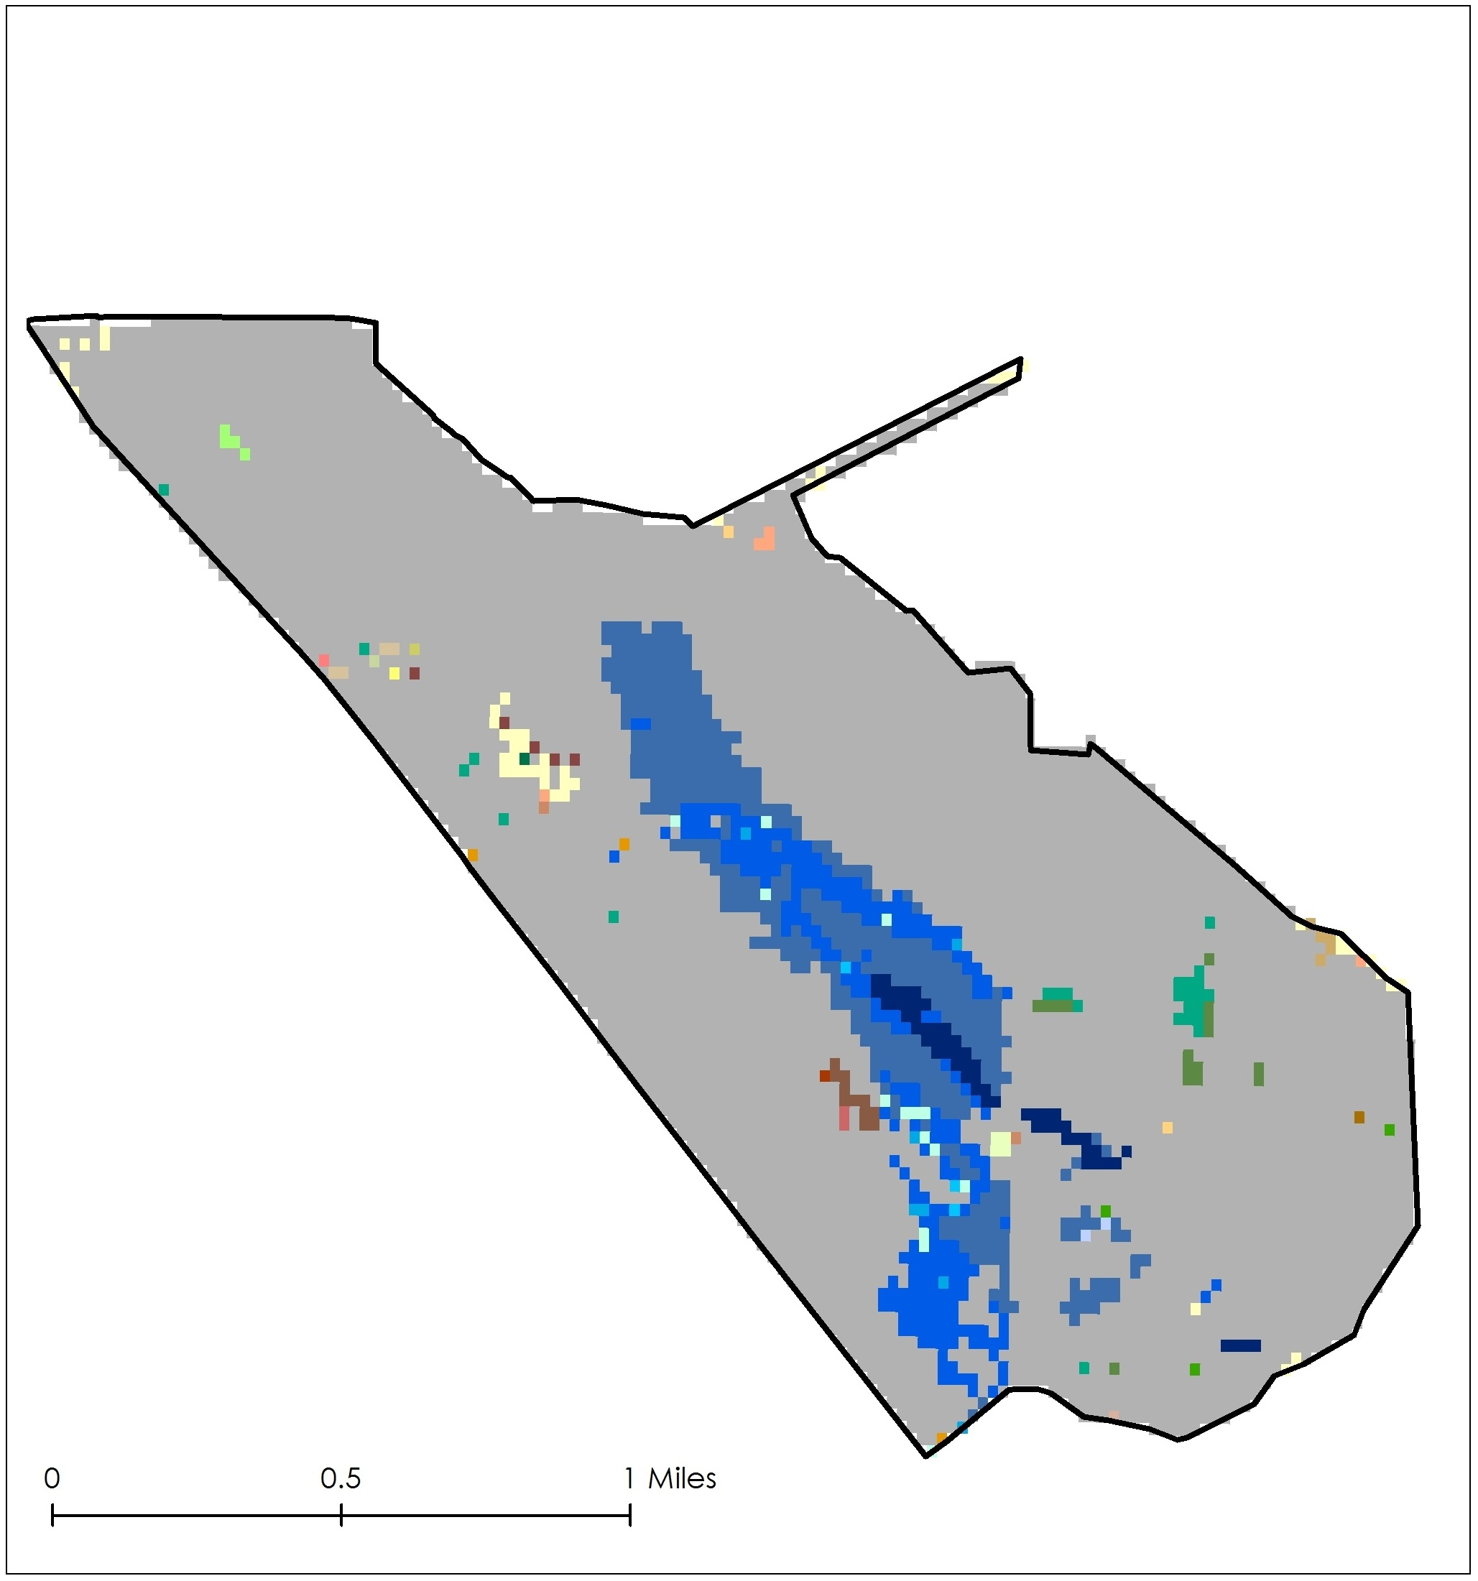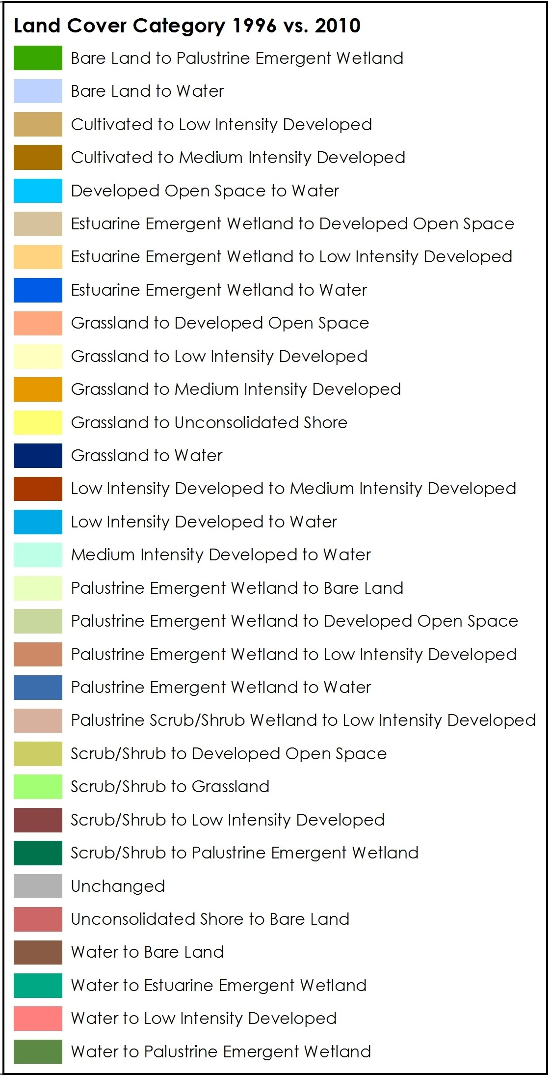
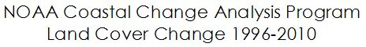
Figure 5: Panchromatically Sharpened Landsat Color Infrared Imagery (CIR)
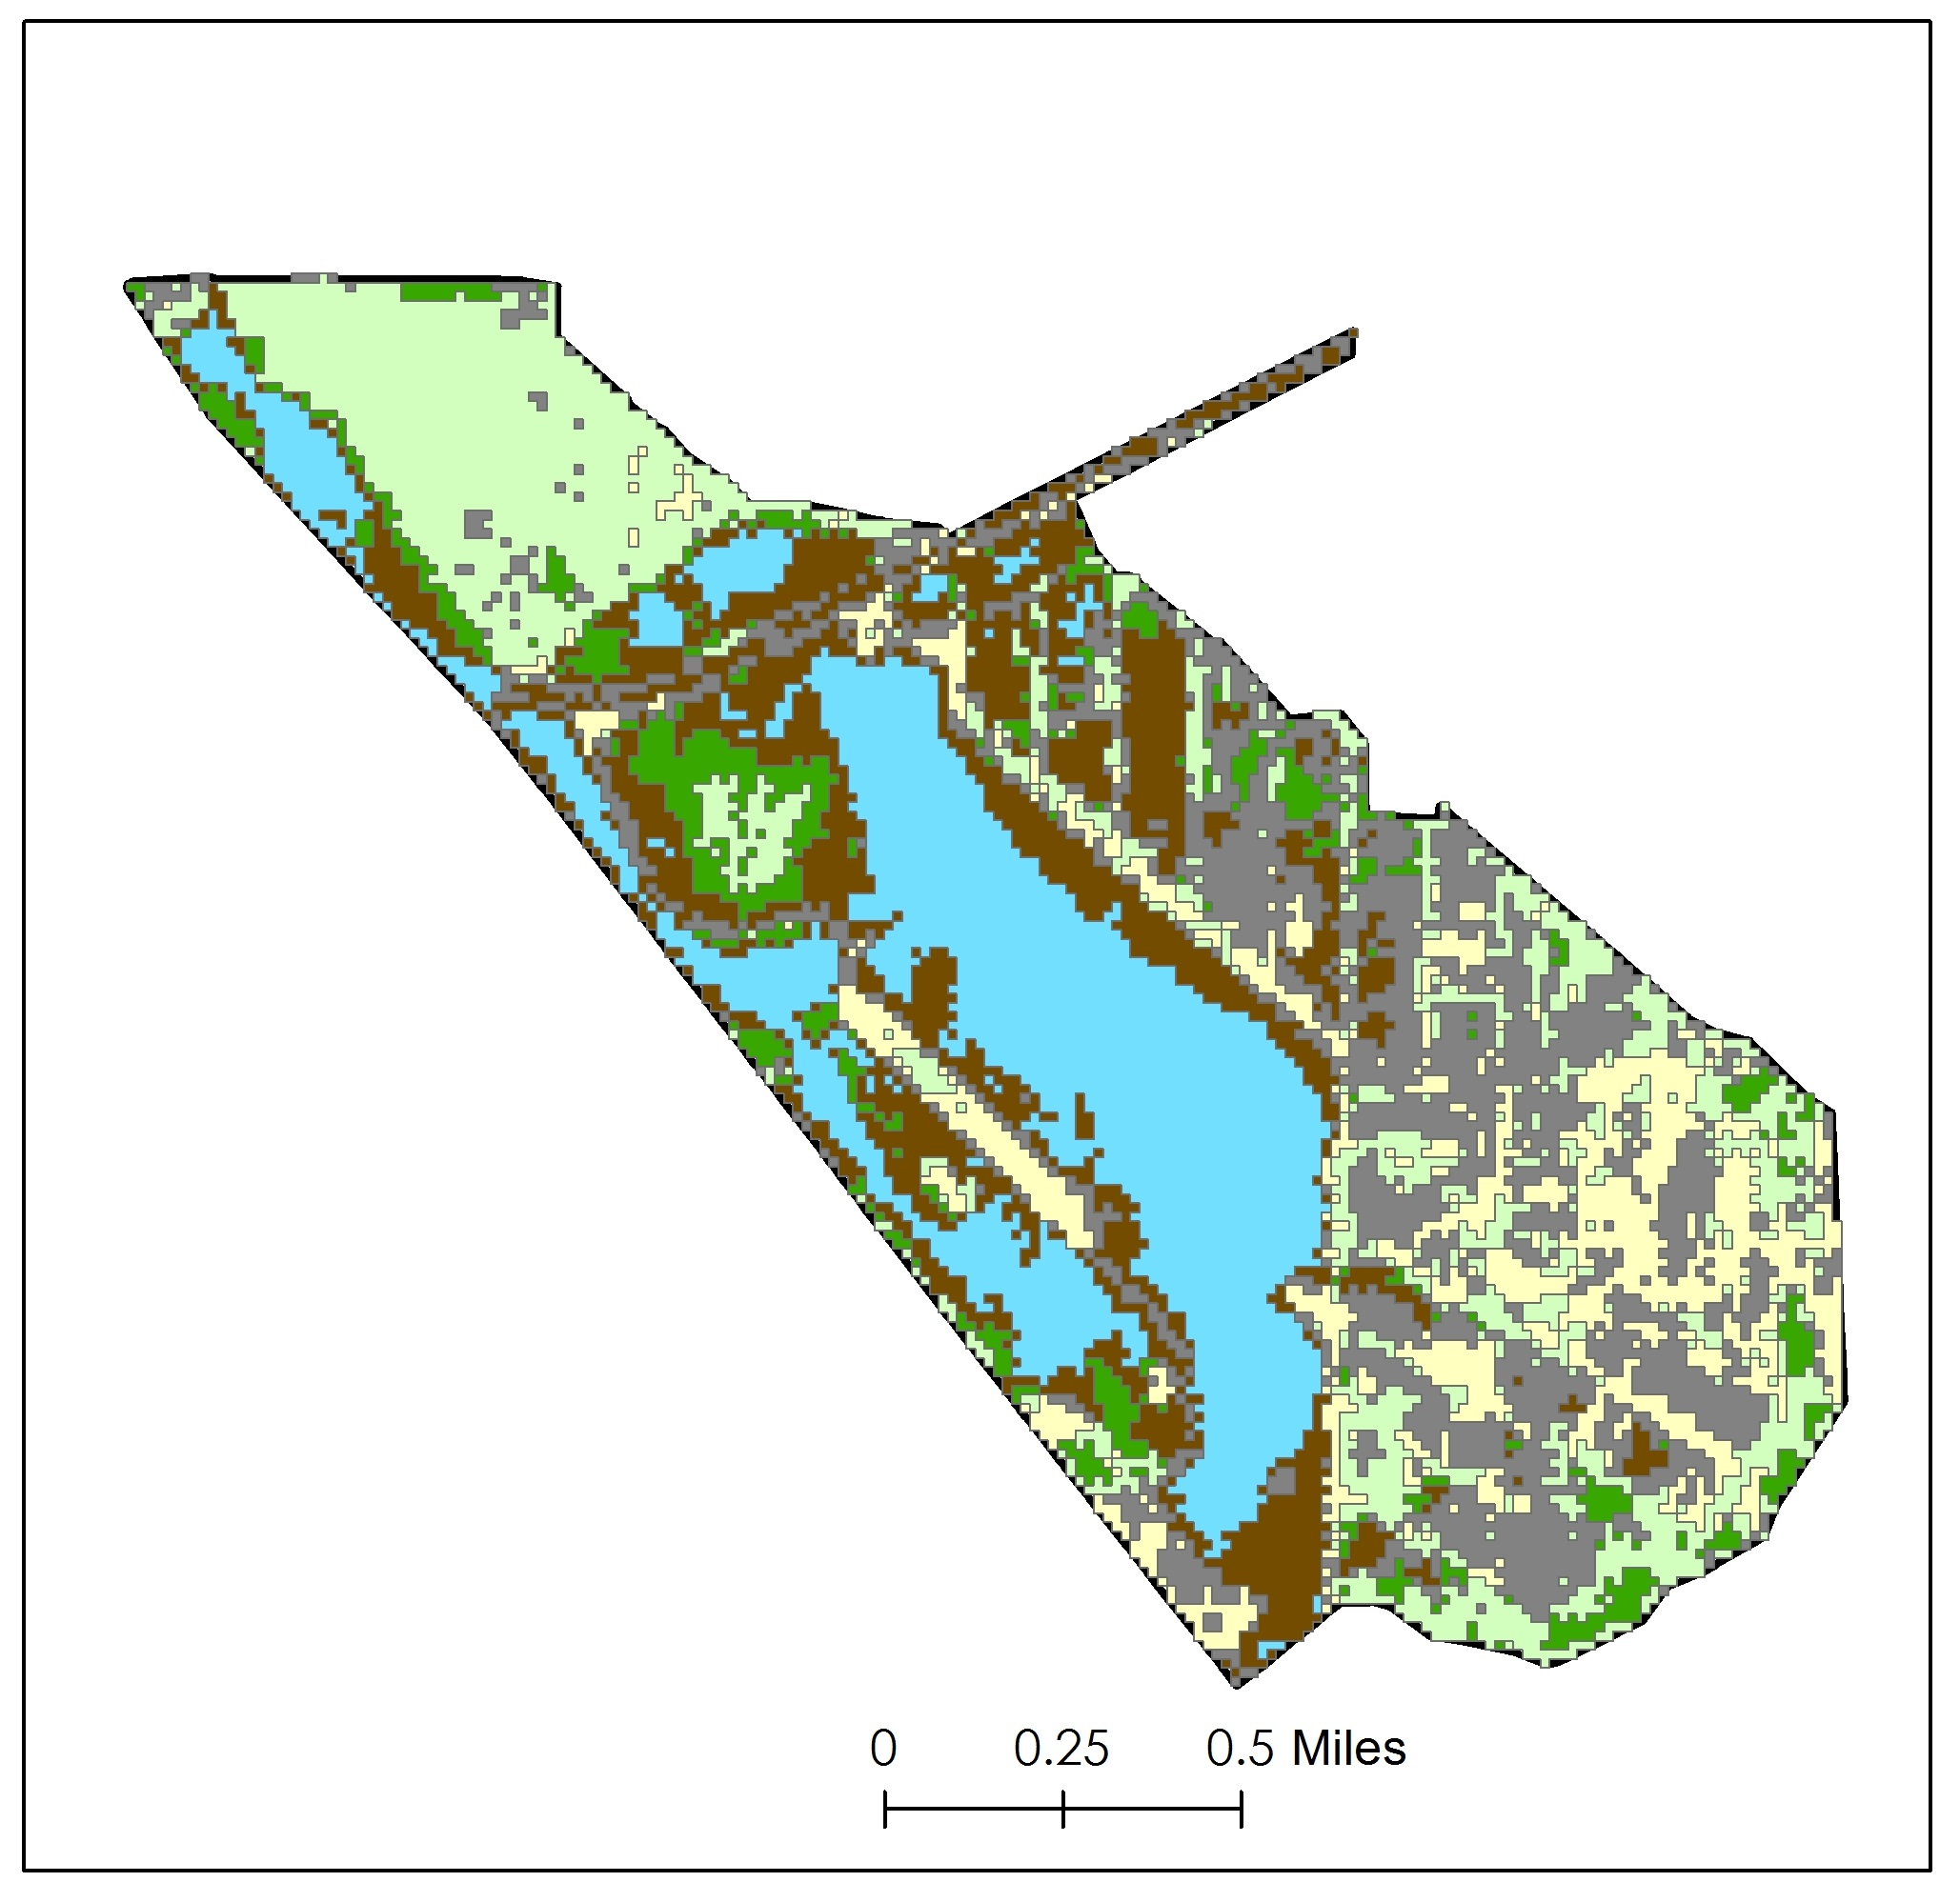
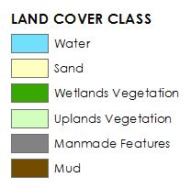
Figure 6: AVIRIS Land Cover Classification

