**NASA DEVELOP National Program**

****NASA Langley Research Center

**Summer 2015**

**Short Title: CALIPSO Cross-Cutting II**

**Subtitle:** Interfacing CALISPO Data through a Graphical User Interface

**VPS Title:** Catching the Black Smoke: Visualizing Aerosols with CALIPSO

**Project Team & Partners**

**Project Team:**

Grant Mercer (Project Lead), grant.a.mercer@nasa.gov

Nathan Qian

**Advisors & Mentors:**

Jeffry Ely (NASA DEVELOP National Program)

Dr. Kenton Ross (NASA DEVELOP National Program)

**Past or Other Contributors:**

Jordan Vaa

Courtney Duquette

Ashna Aggarwal

**Partner Organizations**

CALIPSO Science Team, End-User, POC: Dr. Charles Trepte and Dr. Amber Soja

**Project Details**

**Applied Sciences National Applications Addressed:**

Cross-Cutting

**Study Area:** Global

**Study Period:** May 2006 - Current

**Earth Observations & Parameters**

CALIPSO, CALIOP – Vertical Profile of Aerosols

**Software Utilized**

Python 2.7, sqlite3, CALIPSO L1 and L2 data products

**Project Overview**

**80-100 Word Objectives Overview**

**The CALIPSO satellite's goal is to provide new insight into the role that clouds and atmospheric aerosols play in regulating Earth weather, climate, and air quality. VOCAL is a visualization that offers an easy to use GUI interface that allows users to visualize CALIPSO data. Users can then use a number of tools to select areas of the plot by drawing 'shapes' around those areas, and label shapes with attributes and notes. Shapes can be exported to a backend database which can serve as a centralized point for researchers to share data and help track and identify aerosols in the atmosphere**

The CALIPSO satellite provides a wealth of information on the Earth’s atmosphere that allows researchers to examine aerosols, such as dust, smoke, or pollution, in the sky from all over the world. However, the current program used to read CALIPSO data is written in a proprietary language that is not easily adaptable and lacks database sharing. This project intends to address these issues by developing a new tool that is open source and allows researchers to save and share their CALIPSO findings.

**Abstract**

The CALIPSO satellite (Cloud-Aerosol Lidar and Infrared Pathfinder Satellite Observation) is a NASA Earth observation that analyzes aerosol particles suspended in the Earth’s atmosphere. Researchers use visualized CALIPSO data to track the global distribution, dispersion and source of aerosols. However, the current visualization tool for visualizing CALIPSO data does not support needed features for tracking aerosols such as highlighting areas of data and sharing highlighted sections, making tracking specific airborne objects difficult for researchers. Adding these necessary features to the current CALIPSO visualization tool is difficult, as the tool is written in a proprietary and localized language ; making adjustments and adding features would require a specialized development team. This summer our team is focused on the development of VOCAL, a successor to the current outdated visualization tool for CALIPSO data. We will be building off of a previous teams’ work, the spring 2015 team, to implement a number of new features and offer new tools for scientists to more easily identify the sources of aerosols and their impact on the Earth.

**Community Concerns**

* The current CALIPSO visualization tool is not easily configurable or adaptable
* The CALIPSO science team lacks a method for storing and sharing specific features of CALIPSO imagery

**Current Management Practices & Policies**

The tool currently used to visualize CALIPSO data is written in IDL, a proprietary language which lacks many features and hinders open source updates. Currently, the tool lacks any means to share results between researchers electronically. Any kind of collaboration between Earth scientists needs to be done in person.

**Decision Support Tools & Benefits**

|  |  |  |
| --- | --- | --- |
| **End-Product** | **Earth Observations Used** | **Benefit & Impact** |
| New CALIPSO Data Visualization Tool | CALIPSO | Our end users will have an open source, low maintenance program that can intuitively display and manipulate CALIPSO data. |

**Project Imagery**

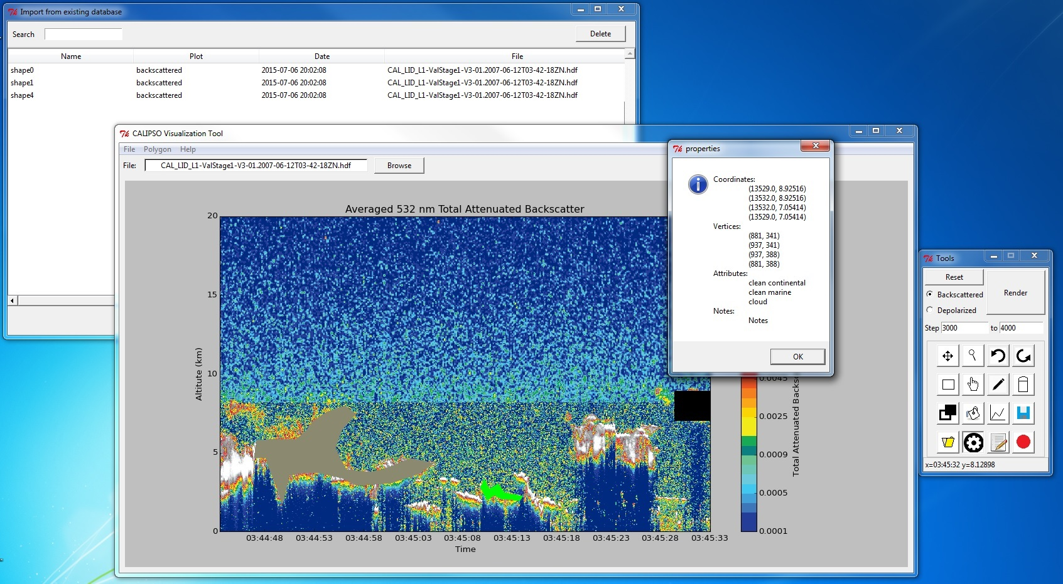

**Caption:** A shot of the Visualization Tool and some features included in the software

**Image:** VisualizationToolImage.jpeg