Santa Monica Mountains Ecological Forecasting III
Analyzing Recent Wildfire Impacts to Assist the Resource Conservation District of the Santa Monica Mountains in Identifying Tree Species to Replant


Technical Report
Final Draft – August 8th, 2019

Melissa Ferriter (Project Lead)
Laura Jessup
Roger Ly
Joshua Spector

Dr. Natasha Stavros, NASA Jet Propulsion Laboratory, California Institute of Technology (Science Advisor)
Dr. Latha Baskaran, NASA Jet Propulsion Laboratory, California Institute of Technology (Science Advisor)

Previous Contributors:
Natalie Queally
Kelsey Foster
Emil Chang
Ariana Nickmeyer
Nick Rousseau

1. Abstract
The Woolsey Fire began on November 8, 2018, and lasted for almost two weeks, during which it burned almost 100,000 acres of valuable landscape and habitat, including a vast area of woodland. The persistence of key woodland species provides aesthetic, monetary, and ecological value to the landscape through carbon sequestration, air temperature moderation, and erosion mitigation, among other ecosystem services. This study investigated the impact of the Woolsey Fire on native woodland species distributions and identified areas suitable for restoration within the Santa Monica Mountains National Recreation Area. The team partnered with the Resource Conservation District of the Santa Monica Mountains; National Park Service, Santa Monica Mountains National Recreation Area; California Department of Parks and Recreation, Los Angeles County Division; County of Los Angeles Fire Department, Prevention Services Bureau, Forestry Division; County of Los Angeles Department of Regional Planning; and the University of Montana. The Earth observations used include data from Landsat 8 Operational Land Imager, NASA ER-2 Jet Airborne Visible InfraRed Imaging Spectrometer, Shuttle Radar Topography Mission, and RapidEye. The team produced maps of burn severity from the Woolsey Fire, its impact on plant species distributions, and habitat suitability projections for 2060 and 2099 to assist partners in prioritizing areas for restoration. A plant community classification was successfully created using Multiple Endmember Spectral Mixture Analysis (MESMA). Overall accuracy was assessed at 90.54% by comparing the classification to validation pixels derived from ground truth information provided by our partners.

Keywords
remote sensing, MESMA, fire, climate scenarios, habitat suitability, Maxent

2. Introduction
  - Background Information
The Santa Monica Mountains (SMM) are a small mountain range (61,000 ha) northwest of Los Angeles, CA. Despite their size, the SMM hold great ecological and cultural significance (Tiszler & Rundel, 2007). The Mediterranean climate combined with topographical diversity and a variable fire regime create a dynamic landscape that supports rich floral and faunal diversity, including rare habitats like coastal sage scrub, chaparral, and salt marsh (Radtke, Arndt, & Wakimoto, 1982; Tiszler & Rundel, 2007). In particular, native oak and riparian woodlands are a limited and valuable part of the landscape that provide habitat, connectivity, and fundamental ecosystem services. Although native tree species are adapted to the periodic droughts and fires characteristic of the area, prolonged drought and increasing fire frequency compounded with the effects of fragmentation, urbanization, and invasive species are causing extensive dieback and decreased recruitment (Beltrán et al., 2014; Clark et al., 2016; Grunzweig et al., 2008; Mclaughlin & Zavaleta, 2012; Park, Hooper, Flegal, & Jenerette, 2018; Riano et al., 2002; Swenson & Franklin, 2000; Westerling, Hidalgo, Cayan, & Swetnam, 2006). As the climate fluctuates and exacerbates these environmental stressors, it is necessary for land managers to maintain biodiversity and resilience and restore native species in areas that will remain suitable even under the worst-case climate scenarios (Millar, Stephenson, & Stephens, 2007).

Traditionally, restoration efforts have focused on replanting trees in their contemporary distributions without regard to how future climate will shift suitable habitat and where microrefugia could occur. Microrefugia, which offer protection against our rapidly changing climate, are microclimates that support very small populations of species in areas that are beyond the climatic limits of their main distributions (Mclaughlin & Zavaleta, 2012). Species distribution models (SDMs) are an effective way of incorporating future climate conditions into restoration management to account for these shifts in species’ ranges and distributions (Riordan, Montalvo, & Beyers, 2018). Extensive dieback of native species in the SMM attributed to the recent severe droughts in California suggests that the vegetation will be vulnerable to a hotter and drier future climate, confirming the need for identification and protection of suitable habitat and microrefugia (Mclaughlin et al., 2017). Although in situ monitoring provides high-quality data, remote sensing provides a means of rapid mapping of species occurrence and environmental characteristics that can be used in SDMs (Buermann et al., 2008). A technique called multiple endmember spectral mixture analysis (MESMA) characterizes vegetation in hyperspectral imagery as a unique set of pure spectra that can be used to derive occurrence data by species (Roberts et al., 1998). Previous efforts to predict future habitat suitability in the SMMs have used field data to model single vegetation types with variable success (James, 2014). Additionally, studies assessing SDM inputs have demonstrated the benefits of using a combination of field data and remote sensing data to capture both regional and continental scale processes that affect species distribution (Buermann et al., 2008; Mclaughlin & Zalveta, 2012).

This study focused on the Santa Monica Mountains National Recreation Area (SMMNRA), a 62,360-hectare region that lies within Ventura and Los Angeles Counties. Paralleling the Pacific coast, the SMMNRA is characterized by rugged terrain interspersed with urban areas and woodlands. The study period of the project was June 2017 to June 2019, with model forecasts extending to 2099. Although precipitation falls largely between October and March, most imagery outside the summer months is obscured by clouds and fog due to the coastal location (Radtke et al., 1982). This study builds upon previous DEVELOP work that mapped vegetation mortality, climate variables, fire severity, and topographical influence in order to understand dieback patterns largely attributed to the 2011 to 2017 drought.

  - Project Partners & Objectives
The NASA DEVELOP Santa Monica Mountains Ecological Forecasting III team partnered with the Resource Conservation District of the Santa Monica Mountains (RCDSMM); National Park Service, Santa Monica Mountains National Recreation Area; California Department of Parks and Recreation, Los Angeles County Division; County of Los Angeles Fire Department, Prevention Services Bureau, Forestry Division; County of Los Angeles Department of Regional Planning; and the University of Montana. Our primary partner, the RCDSMM, has a mission to promote land stewardship and resource conservation through ecological research, conservation planning, habitat restoration, and environmental education. Currently, the RCDSMM is collecting data about the impacts that drought, pest infestation, and fire are having on Oak Woodlands using survey plots and citizen science programs. While these methods allow for an in-depth understanding of oak conditions from the ground, the survey plots cover a relatively small area of the Santa Monica Mountains. The development of a large scale overview and projection of future suitable habitat of oak woodland conditions can aid restoration ecologists in mapping areas burned in the Woolsey Fire (11/08/2019 to 11/21/2018) (Appendix A Figure A1), locating remaining woodland populations, and prioritizing areas for replanting efforts. The objectives of this project were to: (1) determine where and what species were still alive after the recent fires and drought, (2) map existing topographical and environmental conditions, and (3) map areas where native trees have survived both fire and drought to identify where conditions might be suitable to support native woodlands in the next 100 years.

3. Methodology
3.1 Data Acquisition
The Airborne Visible/Infrared Imaging Spectrometer (AVIRIS) is an optical sensor flown on NASA’s ER-2 Jet at an elevation of approximately 20 km. AVIRIS has a spectral bandwidth of 10 nm, and each pixel produced by the instrument covers about a 20-meter diameter, yielding a ground swath 11 km wide. The team downloaded AVIRIS Level-2 Atmospheric Surface Reflectance imagery from the AVIRIS data portal for June 25, 2018. We selected this date because it was the most recent image available prior to the Woolsey Fire which occurred in November 2018. Specifically, we acquired rows 08, 10, 11, and 12 from AVIRIS flight f180625t01, which encompassed our study area.

The team downloaded Landsat 8 Operational Land Imager (OLI) Analysis Ready 30-meter resolution data to determine the burn severity of the Woolsey Fire. To create the Relativized Burn Ratio (RBR) burn severity map, we downloaded Landsat 8 OLI multispectral imagery via the United States Geological Survey (USGS) Earth Explorer portal for dates prior to and after the Woolsey Fire. Imagery acquired pre-fire was collected on 11/03/2018 and paired with the post-fire imagery collected on 01/22/2019. The team used Band 5 Near Infrared (NIR) and Band 7 Short Wave Infrared 2 (SWIR) which contain wavelengths of .845 - .885µm and 2.100 - 2.300µm respectively.

We used two sets of RapidEye Ortho Tile 5-meter imagery acquired from Planet Team (2019) to identify surviving vegetation following the Woolsey Fire. The initial set contained 13 Ortho Tiles ranging from January 22 - January 25, 2019. We used this initial set of imagery to create the Normalized Difference Red Edge Index (NDRE) to locate remaining vegetation post-fire. The second set of RapidEye imagery consisted of 9 Ortho Tiles taken on June 30, 2019, and only depicted 95% of our study area. After combining both sets of imagery, we used the five-band, multispectral imagery to create a land cover classification that showed current vegetation health conditions. Additionally, field investigation was conducted on July 3rd by our project partners, coincident with our second set RapidEye acquisition date. We used the results of this investigation to refine and ground truth our map of vegetation health conditions.

We acquired climate data for species distribution models from the NASA Earth Exchange (NEX) Downscaled Climate Projections (NEX-DCP30) dataset (Thrasher et al., 2013). The NEX-DCP30 comprises downscaled outputs of 33 general circulation models for the conterminous United States as part of the Coupled Model Intercomparison Project Phase 5 (CMIP5) (Taylor, Stouffer, & Meehl, 2012). NEX-DCP30 outputs were generated for the representative concentration pathways (RCP) scenarios developed by the Intergovernmental Panel on Climate Change (IPCC) for the Fifth Assessment Report (IPCC, 2014; Meinshausen et al., 2011). We used monthly averages of precipitation flux (kg m-2 y-1) maximum near-surface air temperature (K), and minimum near-surface air temperature (K) for historical, RCP 4.5, and RCP 8.5 scenarios.

Our partners at the National Park Service (NPS) provided us with a detailed vegetation classification of the Santa Monica Mountains National Recreation Area and surrounding areas. The classification was created by the NPS in conjunction with the Biological Resources Division (BRD), the U.S. Geological Survey (USGS),
Aerial Information Services (AIS), Environmental Systems Research Institute (ESRI), NatureServe, and the California Department of Fish and Game. The classification constituted of repeated rounds of ecological reconnaissance, aerial photography, and image interpretation, coupled with extensive ground-truth verification over many years.

To incorporate topography into our species distribution model, the team downloaded a 30-meter resolution digital elevation model (DEM) from the Shuttle Radar Topography Mission (SRTM) using USGS EarthExplorer. SRTM data was acquired globally over an 11 day period in February of 2000. The mission created a DEM of much of the world, spanning from 60° N to 56° S. The DEM from SRTM was processed to create topographic data for the study.

3.2 Data Processing
3.2.1 AVIRIS
The team pre-processed and mosaicked the AVIRIS images to the study area using Harris Corporation ENVI (Exelis Visual Information Solutions, 2019). Pre-processing included rotating the images to the correct angle specified in the metadata, which ENVI automatically reads in the rotate tool. We changed values representing missing data to be uniform throughout each image, as the downloaded AVIRIS data had multiple values for areas with no data.

VIPER Tools, an ENVI package created by the VIPER Lab at the University of California, Santa Barbara, was used to classify land cover for the study area prior to the Woolsey Fire event. VIPER Tools simplifies the process of multiple endmember spectral mixing analysis (MESMA), a method of using pure representations of a spectral class, called endmembers, to classify an image. MESMA has been used to successfully map vegetation species with high accuracy (Roberts et al., 1998). MESMA can be used as a classifier with a two-endmember model. In this method, the classification algorithm is based upon picking two endmember models that fit each pixel spectrum with the lowest RMSE. For this term, the team used the spectral library created by the fall 2017 Santa Monica Mountains Ecological Forecasting II team to classify 2018 AVIRIS imagery into 7 classes. The vegetation classes are: annual grass, chaparral (Adenostoma fasciculatum, Ceanothus megacarpus, Ceanothus spinosus, Cercocarpus betuloides, Malosma laurina, Quercus berberidifolia), coastal sage scrub (Artemisia spp., Eriogonum cinereum, Eriognum fasciculatum, Cercocarpus fasciculatum, Salvia spp.,), Oak Woodland (Quercus agrifolia), and riparian (Alnus rhombifolia, Juglans californica, Platnaus racemosa, Salix spp.). We also included substrate (including urban areas) and water classes to prevent misclassification, as our image contained large areas of these classes. This term used the same constraints as the previous term; we ran MESMA with 2-endmember models, fractional constraints limited from values 0 to 1, and RMSE and residuals maxima raised to 0.15. We chose these constraints due to computational limitations and in order to fully classify every pixel within the image. Outputs consisted of a non-shade fraction and shade-fraction for each class. The shade-normalization tool in VIPER tools was used to create a classification showing class dominance within each pixel for the entire Santa Monica Mountains recreation area.

3.2.2 Landsat 8 OLI
All Landsat 8 OLI imagery was processed using QGIS Raster Calculator Tool (QGIS Development Team, 2019). To determine the Relativized Burn Ratio (RBR), multiple preliminary indices needed to be calculated. The initial index used within RBR was the Normalized Burn Ratio (NBR) (Equation 1), a common index used for burn analysis. The NBR was then implemented within a more advanced burn severity index, the difference Normalized Burn Ratio (dNBR) (Equation 2). This index takes the pre- and post-fire NBR and calculates the difference between them, indicating the burn severity of the fire. Finally, the RBR was produced using the dNBR and the pre-fire NBR (Equation 3). The dNBR is relativized using the pre-fire NBR, which gives a more accurate result of burn severity (Parks, Dillon, & Miller, 2014).

$NBR = \frac{NIR - SWIR}{NIR + SWIR}$ (1)

$dNBR = \left(NBR prefire - NBR postfire\right) * 100$ (2)

$RBR = \frac{dNBR}{NBR prefire + 1.001}$ (3)

$NDRE = \frac{NIR - RE}{NIR + RE}$ (4)
3.2.3 Rapid Eye
To create a single raster that included the entirety of the study area, we mosaicked the imagery together. Next, using the raster calculator tool, we calculated the Normalized Difference Red Edge (NDRE) index as defined in Equation 4. RapidEye Imagery from 06/30/2019 was also classified to highlight vegetation health. A MESMA two-endmember model classification algorithm was chosen as a classifier because of its ability to account for brightness of pixel spectra (Roberts et al, 2019) This feature was of interest due to the topographic variations in the Santa Monica Mountains that result in a large amount of shaded areas. Endmembers were selected to represent 5 classes: thriving vegetation, healthy vegetation, vegetative presence, non-photosynthetic areas, and water. Initially, 200 endmembers were selected to represent these classes. Non-photosynthetic areas were also broken up into separate classes (burned area, dirt/substrate, and urban) because of the difference in spectra which would cause the model to not run due to high RMSE. Using VIPER Tools, endmembers were pruned based on endmember average RMSE (EAR) and the resulting spectral library consisted of 28 endmembers. Spectra of these endmembers are depicted in Figure J1 in Appendix J. Non-photosynthetic classes (burnt, dirt, and urban) were combined into one class prior to spectral unmixing. No constraints on the two-endmember model were in place due to the high RMSE caused by the non-photosynthetic class spectra variability. A dominant class pixel classification was output in identical style to the AVIRIS MESMA classification. The classification was passed through a 3x3 pixel majority/minority analysis in ENVI to reduce speckles.

3.2.4 Climate Data
Monthly values of precipitation rate, minimum near-surface air temperature, and maximum near-surface air temperature from NEX-DCP30 (30-arcsecond grain size) were averaged over four time periods to reflect the life stages of trees: 1950-1979; 1980-2005; 2020-2060; and 2061-2099 (Appendix B Figure B1). The targeted time periods are necessary to reflect the different climatic conditions which are optimal for seedling vs. mature trees. The time period 1950-1979, covers the end of a recruitment pulse of many tree species in the SMM (R. Dagit, personal communication, July 8, 2019) through their seedling and sapling life stages. We assumed that the same cohort matured during the 1980-2005 time period. The current distribution of this cohort is assumed to be reflected in the NPS vegetation polygons used to determine species presence. The 2020-2060 time period reflects recruitment and the seedling stage for the cohort to be planted by the RCDSMM and other partners as part of their effort to restore the Santa Monica Mountains; models run for this time period will be referred to as seedling models. The 2061-2099 time period will be the period when the restoration cohort will mature; models run for this time period will be referred to as mature models. The purpose of using targeted time periods was to project the future distributions of seedlings when they are seedlings and mature trees when they are mature trees. By projecting the distributions separately and combining them in ArcMap, we generated a map of the most suitable habitat throughout the life of the trees (ESRI 2019). All climate data file manipulation was done using R package ‘ncdf4’ (Pierce, 2019; R Core Team, 2019).

3.2.5 Topographical Data
Slope and aspect rasters were derived from the SRTM 30-meter DEM using the 3D Analyst toolbox, Raster toolset with the Slope and Aspect tools in ArcMap. A flow accumulation raster was generated using the Raster Analysis toolbox, Hydrology toolset. The Fill tool was used to remove all small imperfections in the DEM. The Flow Direction tool identified the path of flow by finding each individual downslope neighbor and used the D8 flow method to find the steepest of these neighbors. Lastly, the Flow Accumulation tool was used to create the final raster of flow into each individual cell, providing us with the full hydrologic network to base our model on.

3.2.6 Guild Occurrence Records
We generated occurrence records from vegetation polygons provided by the NPS by placing one presence point in the center of each polygon. When appropriate, species of interest were grouped into guilds based on temperature and precipitation requirements, water source, and topography. The guilds we used for our analysis were a subset of the USGS & NPS (2007) report on vegetation types in the SMMs. We used Oak Woodland (Coast Live Oak Woodland and Valley Oak Woodland combined), Riparian Woodland (Willow Woodland, Red Willow Woodland, Arroyo Willow Woodland, White Alder Woodland, and California Sycamore Woodland combined), California Bay Woodland, and California Walnut Woodland. Descriptions of vegetation types can be found in USGS & NPS (2007). Occurrence records were not spatially rarefied, as is common practice in species distribution models, because we assumed our records to be an unbiased sampling of the study area that covers the full range of environmental conditions.

3.3 Data Analysis
3.3.1 Maxent
The guilds we identified were Oak Woodland, Riparian Woodland, California Bay Woodland and California Walnut Woodland. Guild distributions were projected for 2020-2060 and 2061-2099 based on climate variables of precipitation rate, minimum near-surface air temperature, and maximum near-surface air temperature from the NEX-DCP30 dataset (Thrasher et al., 2013) and topographical variables of slope, aspect, and flow accumulation using Maxent software (Phillips, Anderson, & Schapire, 2006). Climate and topographical variables were used to build separate species distribution models due to differing spatial resolutions among the two datasets as follows. We changed the default settings in Maxent by selecting linear, quadratic, and “hinge only” features (Raes & ter Steege, 2007). We divided and sub-sampled our occurrence data using 60% for training and 40% for testing for each of 10 replicate runs and set the regularization multiplier to 2.5 to reduce overfitting (James, 2014). We did not include a biased background file to Maxent because we assumed our records to be an unbiased sampling of the study area that covers the full range of environmental conditions.

3.3.2 Combined Suitability Models
Vegetation in the study area is sensitive to climate and topography, and these variables interact to create microclimate refugia for different vegetation types. The 30-meter spatial resolution of topographical variables was small enough to capture differences relevant to vegetation; however, we were unable to find a fine-scale climate dataset that covered the time periods of interest and was capable of identifying microclimates on a relevant scale. Rather than upscale the topographical variables to match the resolution of the climate variables, we created SDMs separately for climate and topographical variables. Additionally, separate species distribution models were built based on climate variables for seedling and mature life stages. This was done to account for the different climate conditions that are most suitable in each life stage (Collins & Carson, 2004; McLaughlin & Zavaleta, 2012). We assumed that topographical requirements would not vary by life stage and would not change drastically over the study period. We combined the occurrence probability raster based on topography with the occurrence probability rasters for each of the two life stages per guild using Raster Calculator (ArcMap tool) by taking an AUC-weighted average. The combined climate-topography rasters for seedling and mature life stages were then averaged to identify suitability throughout the lifespan of trees regenerating after the Woolsey Fire.

3.3.3 Distributional Shifts
To predict distributional changes between current and forecasted occurrence probability under RCP 4.5 as well between forecasted RCP 4.5 and 8.5 occurrence probability, we utilized the SDMtoolbox 2.4 in ArcMap 10.6 (Brown, Bennett, & French, 2017; Environmental Systems Research Institute (ESRI), 2019). First, we used the “Quick Reclassify to Binary” tool to convert each continuous raster to a binary raster. We then executed the “Raster to ASCII” tool and specified an “.asc” output to satisfy the requirements of the tools that calculate distribution changes. After obtaining the ASCII files, we defined the projection as WGS 1984 using the “Define Projection” tool and utilized the “Centroid Changes (Lines)’ and “Distribution Changes Between Binary SDMs” tools to obtain metrics of change. The outputs of these tools were a vector file showing the magnitude and direction of change and a raster and .csv file depicting range contraction and expansion. This process yielded results that allowed us to quantify how, where, and what amount of range shifted between current to forecasted occurrence probabilities and between forecasted RCP 4.5 to 8.5 occurrence probabilities

4. Results & Discussion

4.1 Existing Conditions
4.1.2 Burn Severity
We used RBR to determine the burn severity and extent of the Woolsey Fire. Studies assessing burn severity indices have shown that RBR provides both a higher classification accuracy and correspondence to field-based burn severity measurements than common alternatives such as dNBR and RdNBR, especially in arid areas of the Western U.S., such as the continually drying SMM (Parks, Dillon, & Miller, 2014). Additionally, RBR is shown to determine high-severity burn effects across a wide range of pre-fire vegetation cover, making it an ideal index for the requirements of our study area, specifically with the high severity of the Woolsey Fire and level of floristic biodiversity characteristic of the area. Figure 4 displays the composited RBR image with urban, agriculture, and water polygons excluded. The dark red areas of the map were most heavily affected by the Woolsey Fire and when overlaid with the Woolsey Fire polygon provided by our partners at the RCDSMM, the areas with high levels of RBR visually align with the fire burn area, further validating the accuracy and use of RBR as a proper metric for burn severity in this context. This kind of burn severity mapping is critical for land managers who need to identify highly impacted areas post-fire to prioritize replanting and restoration efforts.
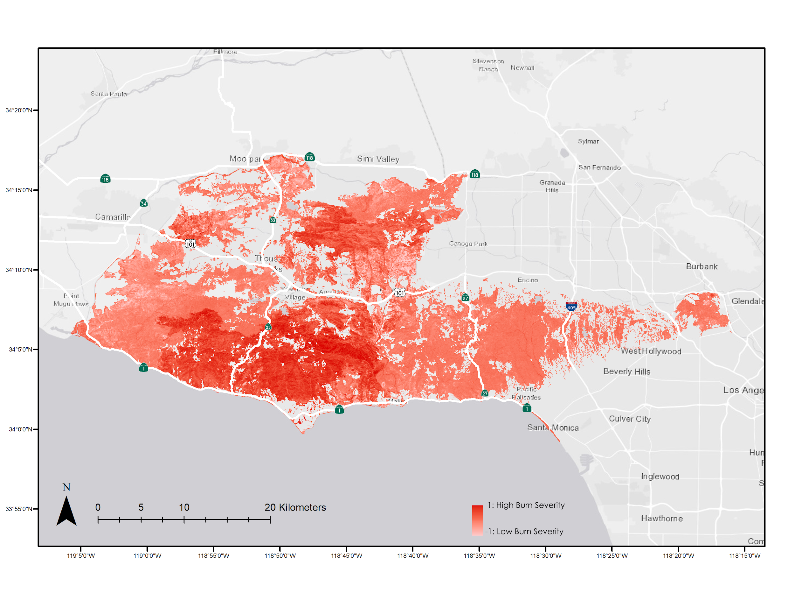
Figure 4. A composited RBR image over the SMM displaying burn severity from the Woolsey Fire (from Landsat 8 OLI, 2018 to 2019). Darker red indicates areas with higher burn severity.
4.1.3 Vegetation Health
A spectral based vegetation health classification was created for imagery acquired 6/30/2019 (Appendix L Figure L1). A confusion matrix was created comparing in-situ observations acquired 7/3/2019 (Appendix K Figure K2). A comparison of green vegetation and non-photosynthetic areas were made due to the absence of vegetation health observations, as in-situ data only specified green vegetation or dead vegetation. Thriving vegetation, healthy vegetation, and vegetative presences classes were combined to form green vegetation, while water was combined with the existing non-photosynthetic area class to create the final non-photosynthetic area class, resulting in a binary classification. Field vegetation aliveness observations were turned into point features, then into a binary raster to be used as ground control observations in a confusion matrix; a total of 41 pixels were compared. An overall agreement of 94.63% was found between the in-situ observations, and the classification produced. High agreement is expected due to the large spectral difference between green vegetation and non-photosynthetic areas and due to the coincidence of observation data and satellite imagery. Lack of ground observations for observations could be also attributed to high accuracy, since the majority of the study area is omitted from comparison.

We also mapped NDRE in the SMM to determine the vegetation condition within the study area following the Woolsey Fire. NDRE has been shown to provide the highest vegetation classification accuracy of any commonly used vegetation index such as the Normalized Difference Vegetation Index (NDVI) or Green Normalized Difference Vegetation Index (GNDVI) due to its use of the red-edge band included in RapidEye imagery, which is sensitive to the chlorophyll content found in healthy vegetation (Ustuner, Sanli, Abdikan, Esetlili, & Kurucu, 2014). Figure 5 displays NDRE of the study area with urban, agriculture, and water polygons excluded. The light green areas of the map contained the least healthy vegetation due to burning from the Woolsey Fire. Mapping NDRE at a 5-meter spatial resolution allows land managers to better assess vegetation health conditions, specifically where vegetation survived following the Woolsey Fire. The NDRE was used to create the current vegetation conditions map by clipping the extent of the alive vegetation extent to the MESMA AVIRIS vegetation classification. The cutoff value for alive versus dead vegetation based off of NDRE was identified using a combination of the ground-truthed data provided by the RCDSMM, the RapidEye MESMA vegetation classification, and indications of vegetation health thresholds identified through post-fire vegetation analysis (Key & Benson, 2006). This revealed the current vegetation conditions for the SMM as of June 2019.
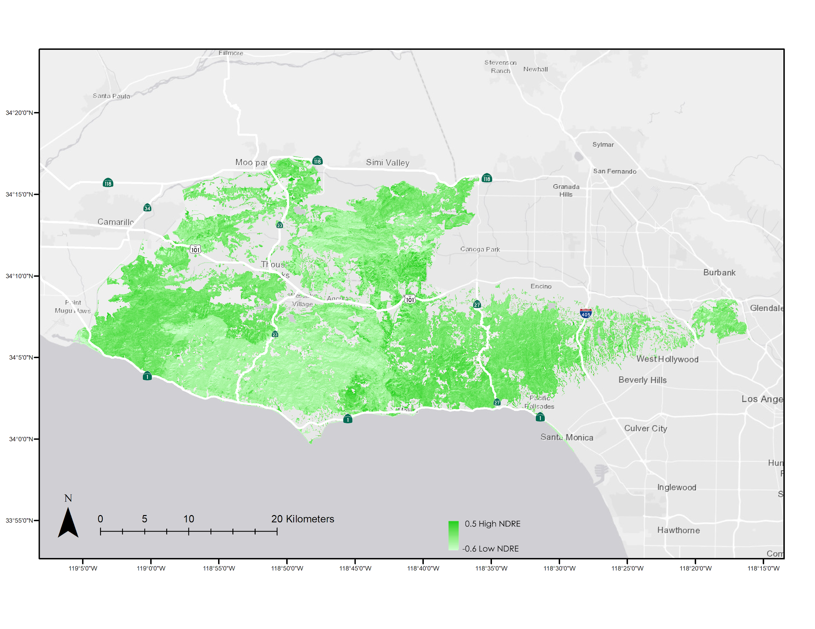
Figure 5. This is a composited NDRE Index image over the Santa Monica Mountains displaying vegetation health following the Woolsey Fire (from RapidEye, 2019). Lighter colors represent non-photosynthetic vegetation and darker green colors indicate thriving vegetation.
4.1.4 Vegetation Community Classification
We created a spectral based vegetation community classification using MESMA for the Santa Monica Mountains Recreation Area (Appendix I Figure I1). A confusion matrix were created to assess accuracy (Appendix K Figure K1). The classification was compared to NPS polygon data from 2007. NPS polygon data was randomly selected throughout the study area for each class and rasterized. An average of ~200 pixels from each class were created out of the polygon data to be used for accuracy assessment. An overall agreement of 90.54% was found in the comparison between the sampled NPS polygon data and AVIRIS classification. Water, urban areas, and annual grasses resulted in an accuracy of 100% which was expected as these classes had very distinct spectra compared to the other vegetation classes. Oak woodlands and riparian classes had lower agreement percentages, with the classification showing primarily chaparral where the NPS data shown Oak and riparian areas. This disagreement could be attributed to the increase in chaparral and coastal sage scrub and decrease in riparian woodlands due to recent drought. Since the NPS polygon data was created in 2007, it would not show the land cover change after the drought, and omit the decrease in riparian woodland land cover.

4.2 Species Distribution Models
4.2.1 Model Performance
We used AUC to quantify predictive power of climate and topography SDMs. AUC varied among guilds; however, AUC scores among life stages and climate scenarios within a guild did not exhibit any clear patterns. For the climate SDMs, predictive power was highest for California Bay Woodland (AUC = 0.811–0.823), followed by Riparian Woodland (AUC = 0.679–0.699), California Walnut Woodland (AUC = 0.652–0.673), and Oak Woodland (AUC = 0.592–0.598). Appendix C Table C1 includes AUC plus or minus standard deviation for all climate SDMs. Topography SDMs had higher AUC in guilds when compared to climate SDMs. For the topography SDMs, AUC was greatest in California Bay Woodland (0.852 ±0.014), followed by California Walnut Woodland (0.777 ±0.006), Riparian Woodland (0.732 ±0.015), and Oak Woodland (0.675 ±0.003) (Appendix D Table D1).

Our results suggest that slope, aspect, and flow accumulation may be better predictors of California Walnut Woodland, California Bay Woodland, Oak Woodland, and Riparian Woodland distributions than precipitation rate, minimum temperature, and maximum temperature. Although, the possible influence of grain size of the topographical (30-meter) and climate (~250m) variables should not be ignored. Khosravi et al. (2016) found that AUC had a significant negative correlation with grain size when testing model performance of environmental variables that were downscaled to seven different resolutions between three kilometers and 250 meters. Similar declines in AUC with increasing grain size were reported by Seo et al. (2008), Gottschalk et al. (2011), and Song et al. (2013). Conversely, Guisan et al. (2007) found that AUC did not necessarily decline significantly at differing grain sizes across modeling techniques, geographic regions, and species. Because nearly all studies examining the effect of grain size on model performance were using the same set of variables at different scales, it is impossible to determine whether the decrease in AUC that we observed between topographical and climate SDMs is an artefact of the larger spatial scale of the climate variables or whether it is ecologically meaningful.

Increasing grain size results in fewer habitat types being found on the landscape because rare habitat types are lost (Turner et al., 1989). The large grain for climatic variables used in our study may have caused microclimates to disappear. Microclimate refugia are becoming increasingly important as the regional climate becomes warmer and drier (McLaughlin et al., 2017). Loss of microclimates on the map due to a coarse resolution may have caused the poor model performance we observed in climate SDMs.

4.2.2 Variable Importance
We used permutation importance to determine the most important variable in projecting species distributions for climate and topography SDMs. Precipitation rate was the most important variable in climate SDMs for all species and climate scenarios. Appendix E Table E1 contains the permutation importance of precipitation rate for RCP 4.5 and RCP 8.5 scenarios averaged across lifestage. Permutation importance or precipitation rate ranged from 83.3% to 89.05% for California Walnut Woodland, Riparian Woodland, and California Bay Woodland; however, precipitation rate had a permutation importance of 48.3% for Oak Woodland. Within guilds, the permutation importance of precipitation rate was slightly larger in the RCP 8.5 scenario for California Bay Woodland, Oak Woodland, and Riparian Woodland. California Walnut Woodland, however, decreased from 83.3% to 53.05% between RCP 4.5 and RCP 8.5.

The most important variable in topography SDMs differed among guilds. Slope was most important for California Walnut Woodland and California Bay Woodland, aspect was most important for Oak Woodlands, and flow accumulation was most important for Riparian Woodland. Permutation importance for the most important variable by guild are shown in Appendix F Table F1. The importance of slope for California Walnut Woodland and California Bay Woodland is evident when comparing their projected distribution maps with maps of slope. Both species appeared to prefer steep slopes. We are unsure if this is accurate or an artefact of sampling bias in the occurrence data. It is intuitive that flow accumulation is the most important variable for Riparian Woodland as these plants generally grow in valleys, canyons, and other low-lying areas where run-off tends to collect. Our finding that Oak Woodland distribution is most affected by aspect is supported by the literature. Brooks and Merenlender (2001) found that natural regeneration of several oak species was greater on north-facing slopes than south-facing slopes.

4.2.3 Guild Distributions
We projected guild distributions using climate and topographical variables as inputs to Maxent. The probabilities of occurrence in the study area are shown in Figure 6. We found that Oak Woodlands had a moderate probability of occurrence throughout most of the landscape, with a slight preference for north-facing slopes. Natural regeneration of oaks was found to be greater on north-facing slopes in a study investigating species distributions and regeneration in a cleared Oak Woodland in Mendocino County, CA. The cool, moist climates found on north-facing slopes in the Santa Monica Mountains are the most likely habitat to support natural regeneration of Oak Woodlands in the future. Because of this, it may be important to focus restoration efforts on marginal areas where oaks are predicted to occur, but where they may not regenerate naturally.

California Walnut Woodland was projected to have a high probability of occurrence in most areas except the northeast corner of the study area. Steep slopes generally lead to the highest occurrence probabilities. The distribution of California Bay Woodland was similar to California Walnut Woodland, but was restricted to steep slopes in the southern and western portion of the study area. Occurrence probability was low in the northwest for both California Walnut Woodland and California Bay Woodland likely due to the extensive development in that area. Riparian Woodland has a high probability of occurrence in the southern part of the study area, specifically in valleys or canyons. The cooler climate near the coast and the high accumulation of precipitation in valleys and canyons contribute to the clustered distribution of Riparian vegetation.
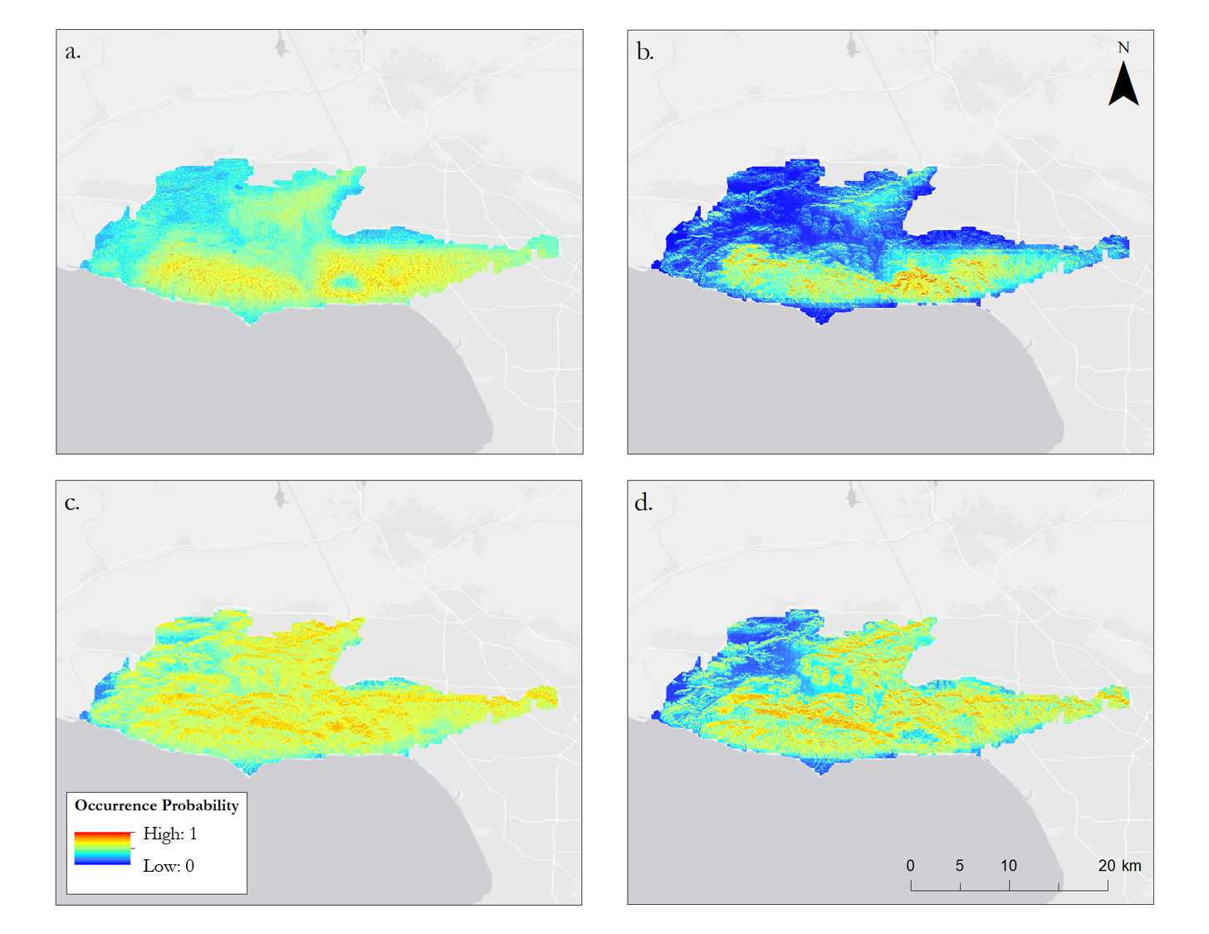
Figure 6. A map depicting projected probability of occurrence of a.) Riparian Woodland, b.) California Bay Woodland, c.) Oak Woodland, and d.) California Walnut Woodland in the SMM given RCP 4.5. Areas with low probability of occurrence are dark blue, and areas of high probability of occurrence are red. The maps are averages of occurrence probabilities of topography and climate SDMs, weighted by model AUC. The seedling and mature life stages in each guild were also averaged with equal weight given to each life stage.

4.2.4 Distributional Shifts
To quantify how the changing climate affected the probability of occurrence for each vegetation guild we calculated area of expansion, contraction, no change, and no occupancy. These metrics of change between the current and forecasted time periods under RCP 4.5 are shown in Appendix G Table G1. All vegetation guilds exhibited a higher degree of expansion than contraction, though Oak Woodland, Riparian Woodland, and California Walnut Woodland shifted approximately northwest while California Bay Woodland shifted southeast. The average amount of expansion was 79.54 km² and the average amount of contraction was 56.14 km², with Riparian Woodland exhibiting the most expansion and California Walnut Woodland exhibiting the most contraction.

The same metrics were calculated between the forecasted RCP 4.5 and RCP 8.5 scenarios and are shown in Appendix H Table H1. As expected, the amount of contraction and expansion between RCP 4.5 and 8.5 is lower than that of the current and forecasted time periods. The average amount of expansion was 7.00 km² and the average amount of contraction was 5.44 km², with Riparian Woodland exhibiting the most expansion and California Walnut Woodland exhibiting the most contraction.

4.3 Future Work
Continuing work on this project would allow us to better predict suitable replanting habitat, as well as creating a more accurate assessment of the current conditions in the SMM. Further work could comprise of adding more climate variables to the SDM. The incorporation of additional climate variables such as the maximum temperature of the warmest month, evapotranspiration, solar insolation, and water capacity; among others, would increase the confidence of the SDM in predicting suitable habitat for these tree species for the remainder of the century. These climate variables would increase the confidence of the SDM due to their ecological impacts on these species's ability to recruit, mature, and thrive. As well, to increase the confidence in the SDM the use of climate data with a finer spatial resolution that accounts for microclimate refugia would allow for a more accurate prediction of these variable areas. Additionally, the use of the most recent AVIRIS data from the June 2019 acquisition would allow us to more accurately classify vegetation health and species post Woolsey Fire. This data is not yet available and thus, we are using the June 2018 data for our study.

5. Conclusions
As the climate in Southern California continues to become hotter and drier, species will respond by shifting their distribution or evolving to persist under the new conditions. However, many species, particularly those with limited dispersal and longer generation times, will rely on climatic microrefugia for protection and stability (Mclaughlin et al., 2017). Although the resolution of our analysis was too coarse to accurately assess where climatic microrefugia could occur under future climate scenarios, we were able to assess broad trends in species occurrence probability for Riparian Woodland, Oak Woodland, California Bay Woodland, and California Walnut Woodland species.
Through a species distribution modeling approach in Maxent we found that precipitation had the highest permutation importance across all vegetation guilds for RCP 4.5 and 8.5 scenarios. Although our selection of climatic input variables was limited, this finding suggests that water availability is a more important distribution determinant than minimum and maximum temperature in this ecosystem. However, while precipitation rate still had the highest permutation importance for California Walnut Woodland in the RCP 8.5 scenario, it was only marginally more important than maximum temperature. This increase in the importance of maximum temperature in determining California Walnut Woodland distribution suggests that under the hotter, drier RCP 8.5 scenario, rising temperatures will be a limiting factor for California Walnut Woodland survival in the future.
Our analysis of distributional change of occurrence probability showed that all vegetation guilds expanded rather than contracted, when comparing current to future probabilities. Similarly, the distribution change between the forecasted RCP 4.5 and 8.5 scenarios showed greater expansion than contraction, but only marginally. This expansion across both distributions and into potentially novel climatic conditions, may indicate that these particular vegetation guilds are adapting to the changing climate. However, the effects of Maxent parameter selection on model performance should not be ignored when considering these results. When dealing with a small number of presence points, such as in our study, a combination of parameters should be evaluated to avoid creating a non-optimal model (Morales, Fernández, & Baca-González, 2017; Warren & Seiffert, 2011). We selected our parameters based on recommendations of related literature, but it would be judicious to further investigate how they affect model performance.
Successful conservation and managed relocation of key species by land managers in the Santa Monica Mountains relies on the identification of areas that will remain suitable under future climate conditions. Although most species in the area are influenced by myriad environmental factors, our inclusion of only climate and topography in the SDM still offers insight into these persisting suitable areas. The fine spatial scale of the topographic variables allowed us to identify topographic refugia which shape microclimate refugia. Furthermore, by separating and then recombining models for both the seedling and mature life stages of each vegetation guild, our resultant maps of species occurrence probabilities include climatic conditions that are suitable for both life stages. Nevertheless, we suggest the inclusion of more environmental variables into the SDM for a more robust model.

6. Acknowledgments
- Science advisors Natasha Stavros and Latha Baskaran
- Project partners Rosi Dagit, Marti Witter, Danielle LeFer, Joseph Algiers, Jay Lopez, Joseph Decruyenaere, and Zachary Holden
- Additional collaborators Dr. Megan Jennings, Kim Corella, Carly Simon, Tanessa Hartwig, and the TAC Committee
- Past team members Kelsey Foster, Natalie Queally, Emil Chang, Ariana Nickmeyer, Nick Rousseau
- Center Lead Erika Higa and Assistant Center Lead Erica O’Connor
- Mentor Benjamin Holt

Any opinions, findings, and conclusions or recommendations expressed in this material are those of the author(s) and do not necessarily reflect the views of the National Aeronautics and Space Administration.

This material is based upon work supported by NASA through contract NNL16AA05C.

7. Glossary
AVIRIS (Airborne Visible / Infrared Imaging Spectrometer) – An airborne optical hyperspectral sensor.
dNBR (difference Normalized Burn Ratio) – An element of the RBR equation which identifies change in burn severity.
Earth observations – Satellites and sensors that collect information about the Earth’s physical, chemical, and biological systems over space and time.
ENVI (Environment for Visualizing Images) – Image Analysis Software used to extract data.
IPCC (Intergovernmental Panel on Climate Change) – Governing body that oversees the creation of climate Assessment Reports.
Maxent – A maximum entropy modeling software used for projecting species distributions.
MESMA (Multiple Endmember Spectral Mixture Analysis) – A spectral mixing technique. Used as a classifier in this analysis
NBR (Normalized Burn Ratio) – An element of the RBR equation which identifies burn severity.
NDRE (Normalized Difference Red Edge) – A quantified index of vegetation health.
NIR (Near Infrared) – The electromagnetic radiation range with wavelengths larger than visible light used to calculate NDRE.
RBR (Relativized Burn Ratio) – A quantified ratio of burn severity.
RCDSMM (Resource Conservation District of the Santa Monica Mountains) – The primary partner organization of the project.
RCP (Representative Concentration Pathway) – A trajectory of greenhouse gas concentrations used by the IPCC in the fifth Assessment Report (AR5).
Red Edge – The electromagnetic radiation range with wavelengths smaller than NIR used to calculate NDRE.
RSME – Root mean square error, the standard deviation of residuals
SDM (Species Distribution Modeling) – A broad term encompassing various methods of predicting species distributions based on environmental variables using computer algorithms.
SMM (Santa Monica Mountains) – The area of interest for this project. A small mountain range north of Los Angeles, CA.
SMMNRA (Santa Monica Mountains National Recreation Area) – A protected area designated by the federal government encompassing the Santa Monica Mountains.
SRTM (Shuttle Radar Topography Mission) – A mission flown February 2000 that acquired global digital elevation model data.
SWIR (Short Wave Infrared) – The electromagnetic radiation range with wavelengths larger than NIR used to calculate RBR.

8. References
Airborne Visible Infrared Imaging Spectrometer Data Facility, Jet Propulsion Laboratory. (2017). Airborne
Visible-Infrared Imaging Spectrometer (AVIRIS) Archived Data and Standard Data Products from
JPL’s AVIRIS Data Facility [Data file]. July 2, 2019. Retrieved from https://aviris.jpl.nasa.gov

Beltrán, B. J., Franklin, J., Syphard, A. D., Regan, H. M., Flint, L. E., & Flint, A. L. (2014). Effects of climate change and urban development on the distribution and conservation of vegetation in a Mediterranean type ecosystem. International Journal of Geographical Information Science, 28(8), 1561-1589. https://doi.org/10.1080/13658816.2013.846472

Brooks, C. N., & Merenlender, A. M. (2001). Determining the pattern of oak woodland regeneration for a cleared watershed in northwest California: A necessary first step for restoration. Restoration Ecology, 9(1), 1-12. https://doi.org/10.1046/j.1526-100x.2001.009001001.x

Brown J. L., Bennett J. R., French C.M. (2017). SDMtoolbox 2.0: the next generation Python-based GIS toolkit for landscape genetic, biogeographic and species distribution model analyses. Peer J, 5:e4095; https://doi.org/10.7717/peerj.4095

Buermann, W., Sassan, S., Smith, T., Zutta, B., Mila, B., & Graham, C. (2008). Predicting species distributions across the Amazonian and Andean regions using remote sensing data. Journal of Biogeography, 35, 1160-1176. https://doi.org/10.1111/j.1365-2699.2007.01858.x

Clark, J. S., Iverson, L., Woodall, C. W., Allen, C. D., Bell, D. M., Bragg, D. C., & Zimmermann, N. E. (2016). The impacts of increasing drought on forest dynamics, structure, and biodiversity in the United States. Global Change Biology, 22(7), 2329-2352. https://doi.org/10.1111/gcb.13160

Collins, R. J., & Carson, W. P. (2004). The effects of environment and life stage on Quercus abundance in the eastern deciduous forest, USA: are sapling densities most responsive to environmental gradients?. Forest Ecology and Management, 201(2-3), 241-258. https://doi.org/10.1016/j.foreco.2004.06.023

Crabbé, A. H., Jakimow, B., Somers, B., Roberts, D. A., Halligan, K., Dennison, P., & Dudley, K. (2019). Viper Tools Software, Version 3.0 [Software]. Retrieved from https://bitbucket.org/kul-reseco/viper

Environmental Systems Research Institute (ESRI). (2019). ArcGIS Release 10.6. Redlands, CA.

Exelis Visual Information Solutions. (2019). Boulder, Colorado: Exelis Visual Information Solutions.

Gottschalk, T. K., Aue, B., Hotes, S., & Ekschmitt, K. (2011). Influence of grain size on species–habitat models. Ecological Modelling, 222(18), 3403-3412. https://doi.org/10.1016/j.ecolmodel.2011.07.008

Grunzweig, J., Carmel, Y., Riov, J., Sever, N., McCreary, D., & Flather, C. (2008). Growth, resource storage, and adaptation to drought in California and eastern Mediterranean oak seedlings. Canadian Journal of Forest Research, 38, 331-342. Retrieved from https://www.fs.usda.gov/treesearch/pubs/30720

Guisan, A., Graham, C. H., Elith, J., Huettmann, F., & NCEAS Species Distribution Modelling Group. (2007). Sensitivity of predictive species distribution models to change in grain size. Diversity and Distributions, 13(3), 332-340.

IPCC. (2014). Climate Change 2014: Synthesis Report. Contribution of Working Groups I, II and III to the Fifth Assessment Report of the Intergovernmental Panel on Climate Change, 151. Retrieved from http://www.ipcc.ch/report/ar5/syr/

James, J. (2014). Modeling suitable habitat under climate change for chaparral shrub communities (Master’s thesis). Arizona State University, Tempe, AZ. Retrieved from https://repository.asu.edu/attachments/134747/content/James_asu_0010N_13587.pdf

Key, C. H., & Benson, N. C. (2006). Landscape assessment (LA). In: Lutes, Duncan C.; Keane, Robert E.; Caratti, John F.; Key, Carl H.; Benson, Nathan C.; Sutherland, Steve; Gangi, Larry J. 2006. FIREMON: Fire effects monitoring and inventory system. Gen. Tech. Rep. RMRS-GTR-164-CD. Fort Collins, CO: US Department of Agriculture, Forest Service, Rocky Mountain Research Station. p. LA-1-55, 164.

Khosravi, R., Hemami, M. R., Malekian, M., Flint, A., & Flint, L. (2016). Maxent modeling for predicting potential distribution of goitered gazelle in central Iran: the effect of extent and grain size on performance of the model. Turkish Journal of Zoology, 40(4), 574-585. https://doi:10.3906/zoo-1505-38

Mclaughlin, B. C., Ackerly, D. D., Klos, Z. P., Natali, J., Dawson, T. E., Thompson, S. E. (2017). Hydrologic refugia, plants, and climate change. Global Change Biology, 23(8), 2941-2961.
https://doi.org/10.1111/gcb.13629

Mclaughlin, B. C., & Zavaleta, E. S. (2012). Predicting species responses to climate change: Demography and climate microrefugia in California valley oak (Quercus lobata). Global Change Biology, 18(7), 2301-2312. https://doi.org/10.1111/j.1365-2486.2011.02630.x

Meinshausen, M., Smith, S. J., Calvin, K., Daniel, J. S., Kainuma, M. L. T., Lamarque, J.-F., … & van Vuuren, D. P. P. (2011). The RCP greenhouse gas concentrations and their extensions from 1765 to 2300. Climatic Change, 109(1-2), 213. https://doi.org/10.1007/s10584-011-0156-z

Millar, C., Stephenson, N. L., & Stephens, S. L. (2007). Climate change and forests of the Future: Managing in the face of uncertainty. Ecological Applications, 17(8), 2145-2151. Retrieved from https://www.fs.usda.gov/treesearch/pubs/31774

Morales, N.S., Fernández, I.C., & Baca-González, V. (2017). MaxEnt’s parameter configuration and small samples: are we paying attention to recommendations? A systematic review. PeerJ, 5, 3093 https://doi.org/10.7717/peerj.3093

NASA JPL (2013). NASA Shuttle Radar Topography Mission Global 1 arc second [Data set]. NASA EOSDIS Land Processes DAAC. 09 July 2019. doi: 10.5067/MEaSUREs/SRTM/SRTMGL1.003

Park, I. W., Hooper, J., Flegal, J. M., & Jenerette, G. D. (2018). Impacts of climate, disturbance and topography on distribution of herbaceous cover in Southern California chaparral: Insights from a remote-sensing method. Diversity and Distributions, 24(4), 497-508. https://doi.org/10.1111/ddi.12693

Parks, S., Dillon, G., & Miller, C. (2014). A new metric for quantifying burn severity: The relativized burn ratio. Remote Sensing, 6(3), 1827–1844. https://doi.org/10.3390/rs6031827

Phillips, S. J., Anderson, R. P., & Schapire, R. E. (2006). Maximum entropy modeling of species geographic distributions. Ecological Modelling, 190(3-4), 231-259. https://doi.org/10.1016/j.ecolmodel.2005.03.026

Pierce, D. (2019). ncdf4: Interface to Unidata netCDF (Version 4 or Earlier) Format Data Files. R package version 1.16.1. Retrieved from https://CRAN.R-project.org/package=ncdf4

Planet Team (2019). Planet Application Program Interface: In Space for Life on Earth. San Francisco, CA. https://api.planet.com.

QGIS Development Team (2019). QGIS, Version 3.8 [Software]. Retrieved from http://qgis.osgeo.org

R Core Team (2019). R: A language and environment for statistical computing, version 3.6.1. [software]. Retrieved from https://www.R-project.org/

Radtke, K. W.-H., Arndt, A., & Wakimoto, R. (1982). Fire history of the Santa Monica Mountains 1 (General Technical Report No. PSW-58). Berkeley, CA: US Department of Agriculture. Retrieved from https://www.semanticscholar.org/paper/Fire-History-of-the-Santa-Monica-Mountains-1-Radtke-Arndt/0470870604d2096a179a900ad36a779c85c2a0fa

Raes, N., & ter Steege, H. (2007). A null‐model for significance testing of presence‐only species distribution models. Ecography, 30(5), 727-736.

Riano, D., Chuvieco, E., Ustin, S., Zomer, A., Dennison, P., Roberts, D., & Salas, J. (2002). Assessment of vegetation regeneration after fire through multitemporal analysis of AVIRIS images in the Santa Monica Mountains. Remote Sensing of Environment, 79(1), 60-71. https://doi.org/10.1016/S0034-4257(01)00239-5

Riordan, E., Montalvo, A., & Beyers, J. (2018). Using species distribution models with climate change scenarios to aid ecological restoration decisionmaking for southern California shrublands (No. PSW-RP-270). Albany, CA: US Department of Agriculture. Retrieved from https://www.fs.usda.gov/treesearch/pubs/56660

Roberts, D., E. Gardner, M., Church, R., Ustin, S., Scheer, G., & Green, R. O. (1998). Mapping chaparral in the Santa Monica Mountains using multiple endmember spectral mixture models. Remote Sensing of Environment, 267-279. https://doi.org/10.1016/S0034-4257(98)00037-6

Roberts, D. A., Halligan K., Dennison P., Dudley, K., Somers, B., & Crabbe, A. (2019) 2019 VIPER Tools User Manual, Version 2.1, 92pp

Seo, C., Thorne, J. H., Hannah, L., & Thuiller, W. (2008). Scale effects in species distribution models: implications for conservation planning under climate change. Biology letters, 5(1), 39-43. https://doi.org/10.1098/rsbl.2008.0476

Song, W., Kim, E., Lee, D., Lee, M., & Jeon, S. W. (2013). The sensitivity of species distribution modeling to scale differences. Ecological Modelling, 248, 113-118. https://doi.org/10.1016/j.ecolmodel.2012.09.012

Swenson, J. J., & Franklin, J. (2000). The effects of future urban development on habitat fragmentation in the Santa Monica Mountains. Landscape Ecology, 15(8), 713-730. https://doi.org/10.1023/A:1008153522122

Taylor, K. E., Stouffer, R. J., & Meehl, G. A. (2012). An overview of CMIP5 and the experiment design. Bulletin of the American Meteorological Society, 93, 485-498. https://doi.org/10.1175/BAMS-D-11-00094.1

Thrasher, B., Xiong, J., Wang, W., Melton, F., Michaelis, A., & Nemani, R. (2013). Downscaled climate projections suitable for resource management. Eos, Transactions American Geophysical Union, 94(37), 321-323. https://doi.org/10.1002/2013EO370002

Tiszler, J., & Rundel, P. (2007). Proceedings from the 32nd Annual Southern California Botanists Symposium: Flora and Ecology of the Santa Monica Mountains. Fullerton, CA. Retrieved from: https://www.nps.gov/samo/learn/management/upload/Vegetation-Response-to-Wildfire-and-Fire-History-in-the-Santa-Monica-Mountains-California.pdf

Turner, M. G., O'Neill, R. V., Gardner, R. H., & Milne, B. T. (1989). Effects of changing spatial scale on the analysis of landscape pattern. Landscape Ecology, 3(3-4), 153-162.

US Geological Survey (USGS) Earth Resources Observation and Science (EROS) Center. (2013). LANDSAT 8 OLI/TIRS Collection 1 Level 2. June 26, 2019. https://doi.org/10.5066/F78S4MZJ

US Geological Survey (USGS) and National Park Service (NPS). (2007). Santa Monica Mountains National Recreation Area Photo Interpretation Report. Retrieved from https://irma.nps.gov/DataStore/Reference/Profile/2177190

Ustuner, M., Sanli, F.B., Abdikan, S., Esetlili, M.T., & Kurucu, Y. (2014). Crop Type Classification Using Vegetation Indices of RapidEye Imagery. The International Archives of the Photogrammetry, Remote Sensing and Spatial Information Sciences, 40(7), 195.

Warren, D. L. and Seifert, S. N. (2011). Ecological niche modeling in Maxent: the importance of model complexity and the performance of model selection criteria. Ecological Applications, 21(2), 335-342. https://doi:10.1890/10-1171.1

Westerling, A. L., Hidalgo, H. G., Cayan, D. R., & Swetnam, T. W. (2006). Warming and earlier spring increase western U.S. forest wildfire activity. Science, 313(5789), 940-943. https://doi.org/10.1126/science.1128834

Appendix A

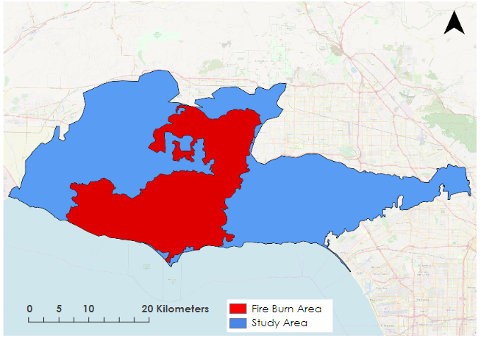
Figure A1. Map of study area depicted in blue and the Woolsey Fire burn area in red.

Appendix B

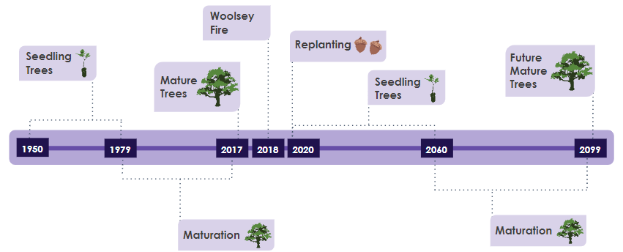
Figure B1. A timeline of important events in the study area. The time period 1950-1979, covers the end of a recruitment pulse of many tree species in the SMM (R. Dagit, personal communication, July 8, 2019) through their seedling and sapling life stages. We assumed that the same cohort matured during the 1980-2005 time period. The 2020-2060 time period reflects recruitment and the seedling stage for the cohort to be planted by the RCDSMM and other partners as part of their effort to restore the Santa Monica Mountains The 2061-2099 time period will be the period when the restoration cohort will mature.
Appendix C

Table C1
Climate SDM performance. Area under the [receiver operating characteristic] curve (AUC) is reported plus or minus standard deviation. Habitat suitability was assumed to change across life stages and climate scenarios; therefore, SDMs were generated for each guild, targeted life stage, and climate scenario combination.
Guild | Life Stage | Climate Scenario | AUC (±SD)
California Walnut Woodland | Seedling | RCP 4.5 | 0.673 | ±0.017
 |  | RCP 8.5 | 0.662 | ±0.018
 | Mature | RCP 4.5 | 0.664 | ±0.015
 |  | RCP 8.5 | 0.652 | ±0.014
Oak Woodland | Seedling | RCP 4.5 | 0.598 | ±0.010
 |  | RCP 8.5 | 0.592 | ±0.011
 | Mature | RCP 4.5 | 0.595 | ±0.008
 |  | RCP 8.5 | 0.596 | ±0.010
Riparian Woodland | Seedling | RCP 4.5 | 0.685 | ±0.020
 |  | RCP 8.5 | 0.699 | ±0.014
 | Mature | RCP 4.5 | 0.679 | ±0.017
 |  | RCP 8.5 | 0.686 | ±0.019
California Bay Woodland | Seedling | RCP 4.5 | 0.819 | ±0.011
 |  | RCP 8.5 | 0.823 | ±0.012
 | Mature | RCP 4.5 | 0.811 | ±0.013
 |  | RCP 8.5 | 0.817 | ±0.015

Appendix D

Table D1
Topography SDM performance. Area under the (receiver operating characteristic) curve (AUC) is reported plus or minus standard deviation. Topographical requirements of species was assumed to be constant across climate scenarios and life stages; therefore, one SDM was generated per guild.
Guild | AUC (±SD)
California Walnut Woodland | 0.777 | ±0.006
Oak Woodland | 0.675 | ±0.003
Riparian Woodland | 0.732 | ±0.015
California Bay Woodland | 0.852 | ±0.014

Appendix E

Table E1.
Permutation importance of precipitation rate in climate distribution models for RCP 4.5 and RCP 8.5 averaged across mature and seedling life stages.

 | RCP 4.5 | RCP 8.5
Juglans californica | 83.3% | 53.05%
Oak Woodland | 48.3% | 49.9%
Riparian Woodland | 84.3% | 91.95%
California Bay Woodland | 89.05% | 90.0%

Appendix F

Table F1.
Permutation importance of the most important variable identified in topography species distribution models by species.

 | Most Important Variable | Permutation Importance
California Walnut Woodland | Slope | 52.1%
Oak Woodland | Aspect | 70.0%
Riparian Woodland | Flow accumulation | 82.1%
California Bay Woodland | Slope | 59.4%

Appendix G
Table G1
Changes in guild range in current and forecasted species occurrence probability for each vegetation guild in km².

 | Expansion | Contraction | No Change | No Occupancy
California Walnut Woodland | 99.93 | 67.45 | 424.04 | 596.14
Oak Woodland | 83.08 | 61.62 | 741.21 | 301.66
Riparian Woodland | 101.01 | 65.63 | 348.80 | 672.12
California Bay Woodland | 34.15 | 29.87 | 148.08 | 978.70

Appendix H

Table H1
Changes in guild range in forecasted RCP 4.5 and forecasted RCP 8.5 species occurrence probability for each vegetation guild in km².

 | Expansion | Contraction | No Change | No Occupancy
California Walnut Woodland | .95 | 11.41 | 513.00 | 665.50
Oak Woodland | 3.50 | 6.86 | 818.49 | 362.022
Riparian Woodland | 20.91 | 1.76 | 449.01 | 719.18
California Bay Woodland | 2.61 | 1.74 | 180.34 | 1006.20

Appendix I

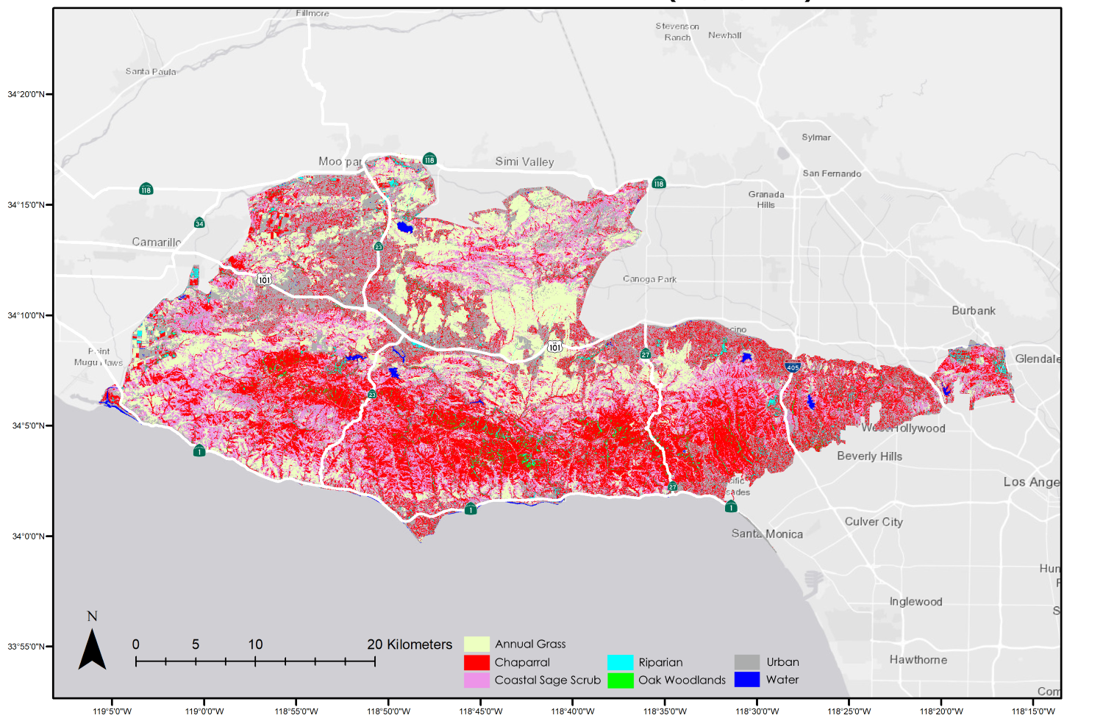Figure I1. AVIRIS MESMA Classification of imagery acquired 06/25/2018
Appendix J
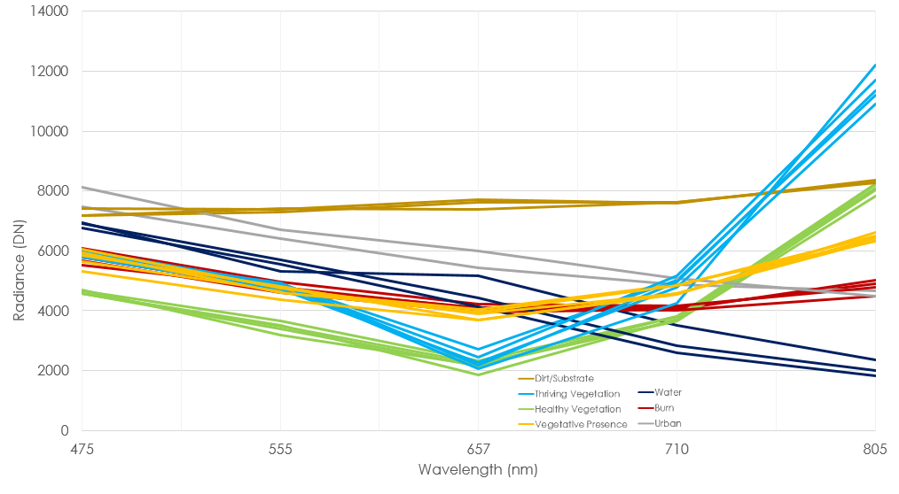
Figure J1. RapidEye imagery endmember spectra is depicted. Final spectral library used for classification included 28 endmember models. Water, burn, urban, and dirt were aggregated into one non-photosynthetic area class prior to spectral mixing.

Appendix K

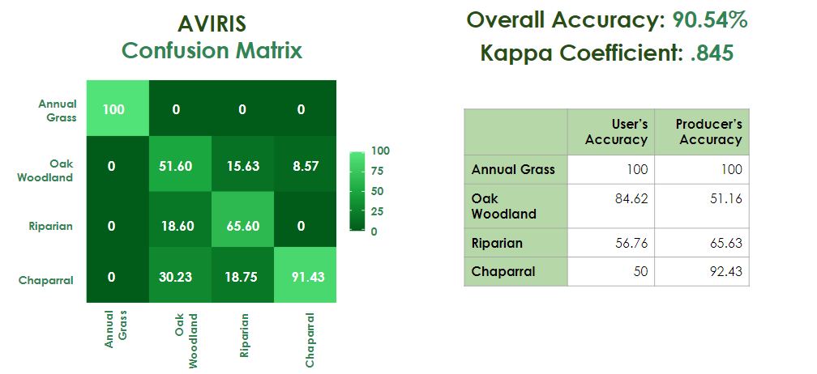
Figure K1. A confusion matrix and table of user’s and producer’s accuracy of the AVIRIS MESMA classification

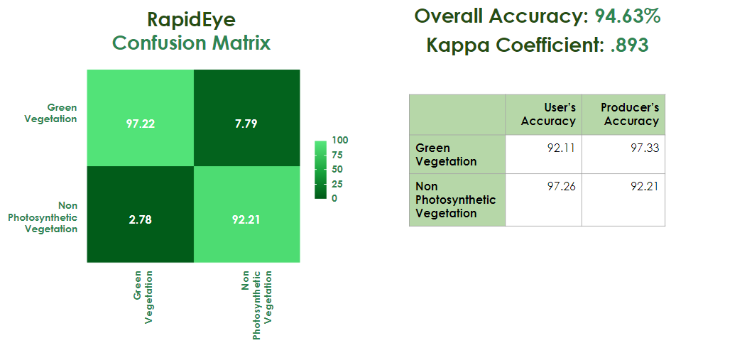
Figure K2. A confusion matrix and table of user’s and producer’s accuracy of the RapidEye MESMA classification
Appendix L

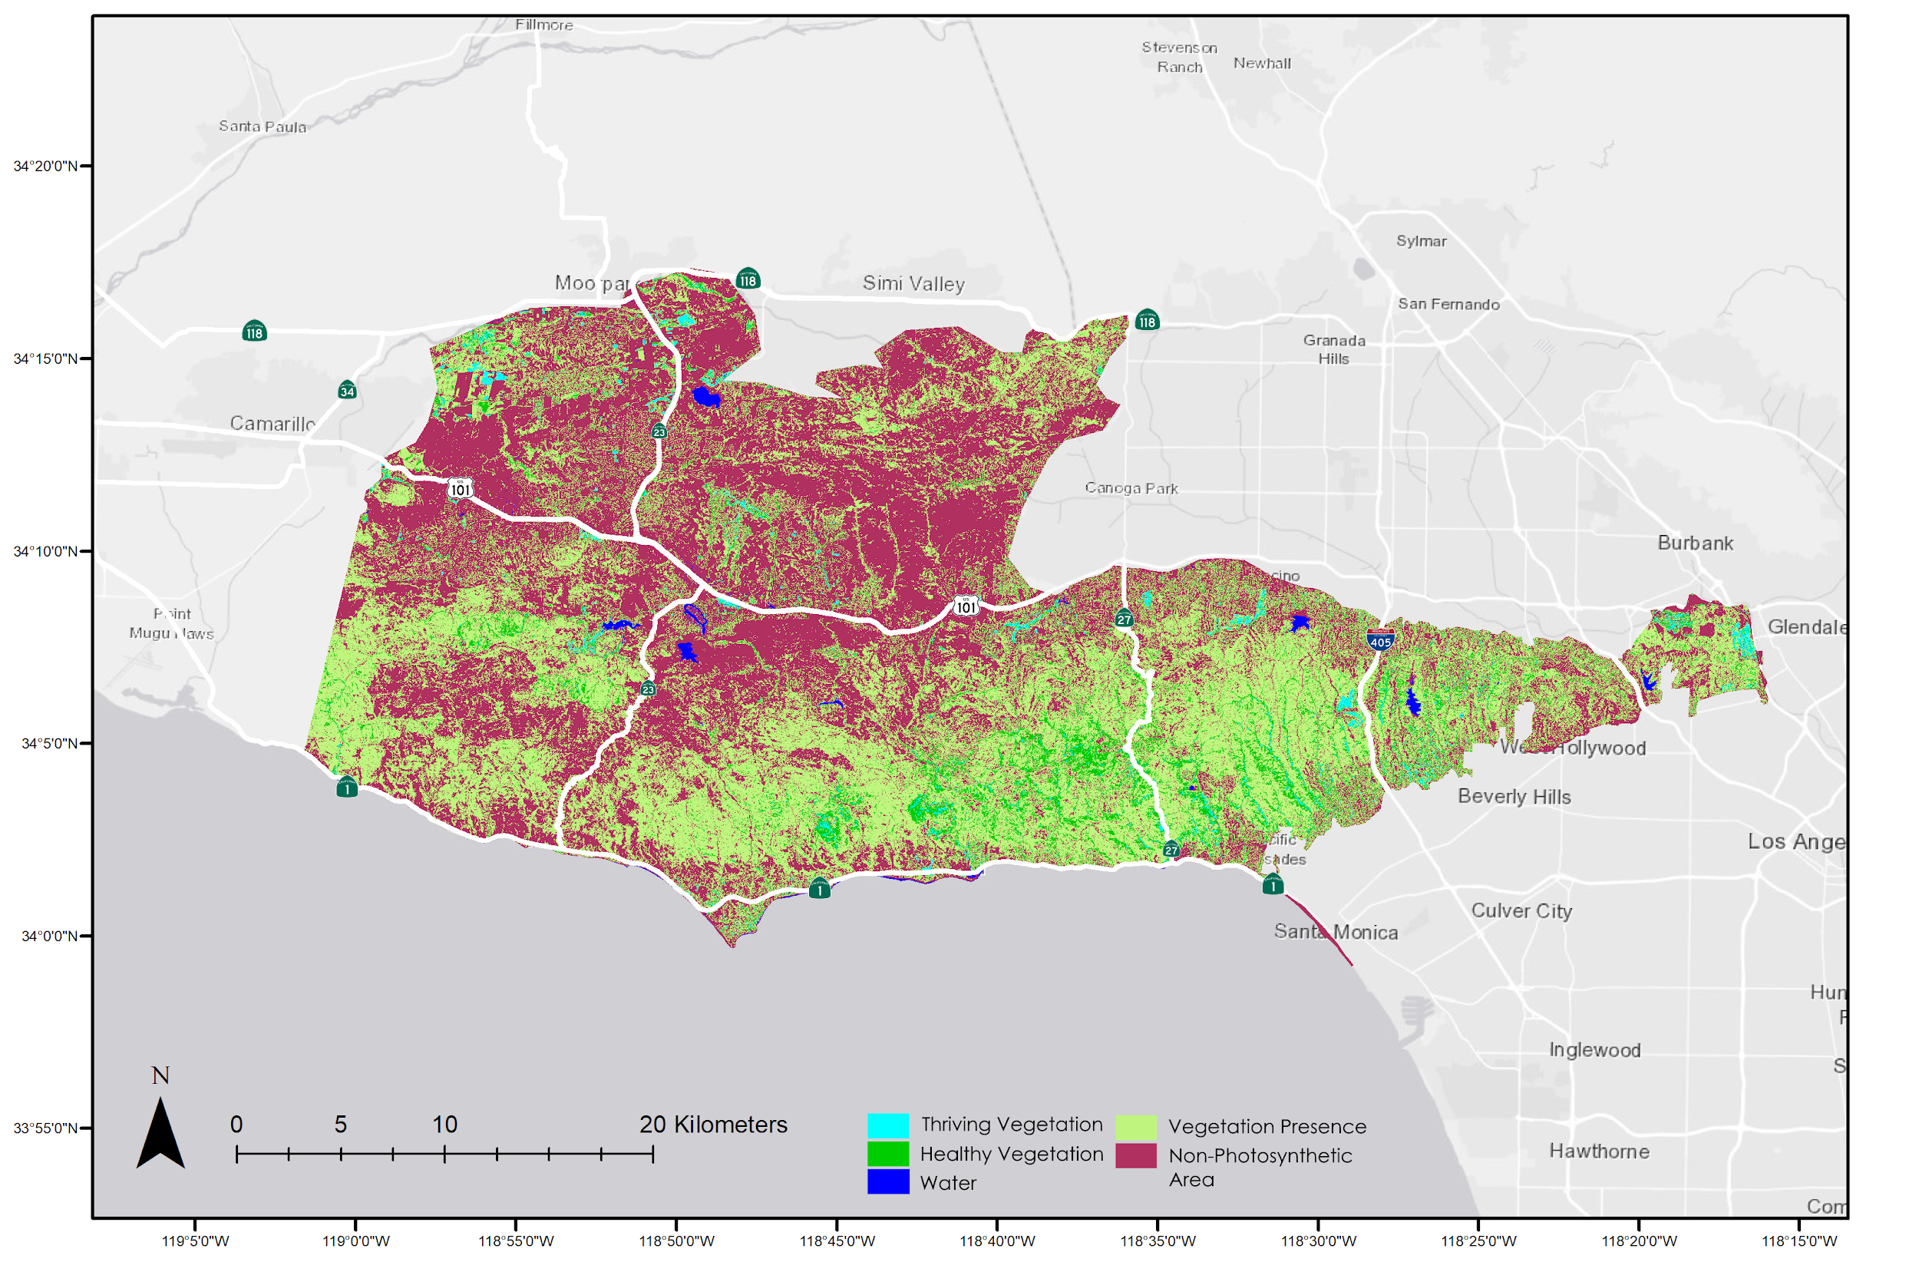
Figure L1. RapidEye MESMA classification on imagery acquired 06/30/2019

