NASA DEVELOP National Program
NASA Jet Propulsion Laboratory
Summer 2017

California Health and Air Quality
Identifying Methane Emissions Patterns from Dairy Farms Using Aircraft Remote Sensing Observations and Image Classification


Technical Report
Final Draft – August 10, 2017

Jacob Arndt (Project Lead)
Kelsey Foster
Erika Higa

Dr. Kristal Verhulst, NASA Jet Propulsion Laboratory, California Institute of Technology (Science Advisor)
Dr. Charles Miller, NASA Jet Propulsion Laboratory, California Institute of Technology (Science Advisor)

1. Abstract

Methane (CH₄) is a potent greenhouse gas (GHG) with a lifetime of less than 10 years and a global warming potential that is 25 times greater than carbon dioxide (CO₂) over a 100 year time period. Between the energy, industrial processes and product use, agriculture, and waste sectors, the majority of CH₄ emissions in the United States come from the agriculture sector. Within this sector, enteric fermentation by domestic livestock and manure management are the largest sources of emissions. California is the leading dairy producer in the United States and thus, enteric fermentation and manure management make substantial contributions to the state’s CH₄ budget. Furthermore, a number of studies suggest that EPA bottom-up methodologies are underestimating CH₄ emissions in many regions across California. Total number, location, size, and manure management infrastructure of dairy farms throughout the state is also uncertain. Given these uncertainties, in addition to dairy production’s large contribution to CH₄ emissions, its industrialization, and the need to more accurately account for and understand CH₄ emissions, we located and inventoried dairy farms across California’s Central Valley using RapidEye imagery and image classification techniques. We used the resulting classifications to create a spatial dataset of dairy farms and used it to help interpret AVIRIS-NG and HyTES CH₄ plume data collected over dairy farms. This will ultimately provide insight into an important source of CH₄ and help policy makers, dairy farmers, and management officials make more informed decisions on how best to mitigate CH₄ emissions within the state of California.

Keywords
Greenhouse gases, emissions, methane, AVIRIS-NG, HyTES, dairy farms, RapidEye, image classification

2. Introduction
  - Background Information
While methane (CH₄) only accounts for 10% of all U.S. greenhouse gas (GHG) emissions from human activities, CH₄ is more efficient at trapping radiation and has a global warming potential 25 times greater than carbon dioxide over a 100-year time period (EPA, 2017). In the U.S., 43 percent of CH₄ emissions originate from manure management practices from dairy farms (USDA, 2011). In California, the greatest dairy producer in the U.S., 54% of dairy CH₄ emissions were estimated to come from manure management practices (CARB, 2011). As livestock agriculture continues to become more industrialized, manure management practices are playing an increasingly large role in GHG emissions (Owen and Silver, 2015). Despite this, the variability in management systems make it difficult to measure and model emissions from dairy farms (Owen & Silver, 2015). To aid in GHG emission estimates from dairy farms, the Intergovernmental Panel on Climate Change (IPCC) created a Tier 2 model, but this model uses emission factors that are based on studies that were small-scale laboratory or pilot experiments and were not intended to be used for GHG inventory estimations (Owen & Silver, 2015; Jungbluth et al., 200;1 Chung et al., 2013). In addition, Miller et al. (2013) combined aircraft and tower measurements with an atmospheric transport model to calculate U.S. CH₄ emissions and found that emissions from livestock enteric fermentation and manure management were two times greater than EPA estimates. The discrepancies between different methods of calculating CH₄ emissions has created uncertainty surrounding dairy farm CH₄ emissions and a need for a more in depth understanding of dairy-specific manure management practices.

  - Project Partners & Objectives
Our project partner is the California Environmental Protection Agency, Air Resources Board (ARB). ARB’s mission is “To promote and protect public health, welfare and ecological resources through the effective and efficient reduction of air pollutants while recognizing and considering the effects on the economy of the state.” (https://www.arb.ca.gov/html/mission.htm). Over the past 11 years, the California State Legislature has passed important legislation regarding air quality and greenhouse gas monitoring in the state. This legislation has long guided the actions of our project partner and is the primary driver of our project. The passage of California’s Assembly Bill No. 1803 in 2006 (H&SC §39607.4) (A.B. 1803, 2006) requires that the ARB develop and maintain a greenhouse gas emissions inventory for the state. Assembly Bill No. 32 (AB 32), the California Global Warming Solutions Act of 2006 (A.B. 32, 2006), extended the ARB’s responsibility of monitoring and regulating sources of emissions of greenhouse gasses and addressing climate change for the state of California. Specifically, this bill requires that the state reduce its greenhouse gas emissions to 1990 levels by 2020. While AB 32 places equal emphasis on monitoring and regulating all greenhouse gasses, Assembly Bill No. 1496 (A.B. 1496, 2015) requires that the ARB make a focused effort in understanding and monitoring methane emissions. Passed in September 2016, Assembly Bill No. 197 (AB 197) (A.B. 197, 2016) requires the ARB to provide annual estimates of facility level emissions of greenhouse gases, criteria pollutants, and toxic air contaminants as well as break down these estimates to a local and sub-county level.

This project addresses the Health and Air Quality application area within the NASA Earth Science Applied Sciences Program. Our project contributes to this application area in a variety of ways. Earth observations are a critical source of air quality information for our project. The project supports our project partner’s legal commitment to monitoring and regulating air quality for the state of California and satisfies their research interest in dairy emission sources. Our collaboration with the ARB will help improve their greenhouse gas inventory. The project will build a better understanding of emissions and air quality in California and improve our project partner’s ability to use Earth observations.

The objectives of this project were to utilize ground-based, airborne, and satellite observations to better understand dairy emissions sources within the Tulare region of California from January 2014 to August 2017. Dairy features change frequently over time and these changes may correlate with changes in emissions rates. Therefore, our goal was to create a classifier that can identify dairy features from satellite imagery. To accomplish this goal, we identified which satellite data and classification methods would be suitable for our analysis and then applied them to imagery. Through our project, the ARB will be able to more fully understand dairy farms and how changing dairy features may be connected to changes in emissions. This will assist the ARB in their commitment to Assembly Bills No. 1803, 32, 1496, and 197, with a strong emphasis on AB 1496. This work will help build the ARB’s knowledge of emissions in the state of California and the various observational strategies that they can employ.

3. Methodology

3.1 Data Acquisition
3.1.1 Aqua AIRS
In order to quantify the amount of CH₄ being emitted from dairy farms we considered using Aqua Atmospheric Infrared Sounder (AIRS) to acquire the total column amount of CH₄ from the top of atmosphere to the surface. The AIRS2RET AIRSAqua L2 Standard Physical Retrieval (AIRS-only) V006 product contains the methane total column count which is a product of the Infrared stage of the combined Infrared and Microwave retrieval channels. Aqua AIRS data were acquired from NASA Earthdata Search (https://search.earthdata.nasa.gov/search). We downloaded six scenes that intersected with the AVIRIS-NG and HyTES flight dates so we could compare the spatial resolution and results from the airborne and satellite data. These dates were 5/1/15, 5/2/15, 9/14/16, 9/16/16, 10/12/16, and 10/26/16. AIRS has a spatial resolution of 50 km and a revisit time of 12 hours (Table A1 in Appendix).

3.1.2 HyTES and AVIRIS-NG
There is increasing need to synthesize the large collection of airborne collected methane data from the Hyperspectral Thermal Emission Spectrometer (HyTES) and the Airborne Visible InfraRed Imaging Spectrometer - Next Generation (AVIRIS-NG). Combining these data, mapping their location, and determining where they overlap helps us identify the observations that occur over dairies and our study region. Understanding the locations of previous flights also helps in determining where future flights need to be planned. Flight line information for AVIRIS-NG data were acquired from the AVIRIS-NG Data Products Portal. These data include all flights from September 2014 to January 2016. All flight line information from the fall 2016 and spring 2017 campaigns, and level 3 CH₄ products derived from AVIRIS-NG raw data, are currently not available to the public. Recent AVIRIS-NG flight line information and all level 3 AVIRIS-NG methane products used in this project were provided by Dr. Andrew Thorpe and were processed according to Thorpe et al. (2014).

Flight line information for HyTES and level 3 data products for all flights from July 2014 to January 2016 were downloaded from the HyTES ordering web page. While AVIRIS-NG already had flight line shapefiles available, HyTES did not. Without a visualization of HyTES flight lines it was difficult to understand where data has been collected and which areas overlapped with AVIRIS-NG data. To create the HyTES flight line shapefile, we wrote a Python script that creates a shapefile of the flight lines using the starting latitude/longitude and ending latitude/longitude for each flight line found in the metadata gathered from the HyTES ordering web page. Available level 3 products include CH₄, hydrogen sulfide (H₂S), and ammonia (NH₃). We only used the CH₄ and NH₃ data products from the HyTES data. The H₂S data products were avoided because they typically include unwanted noise. AVIRIS-NG and HyTES data for California are mostly located over known CH₄ emitting areas. These include areas such as the Los Angeles Basin, and San Francisco Bay area, Bakersfield, and the Central Valley. Figure 1 shows the available level 3 data for HyTES and AVIRIS-NG over the southern Central Valley. The flight lines show that HyTES and AVIRIS-NG data has been collected over our study area.

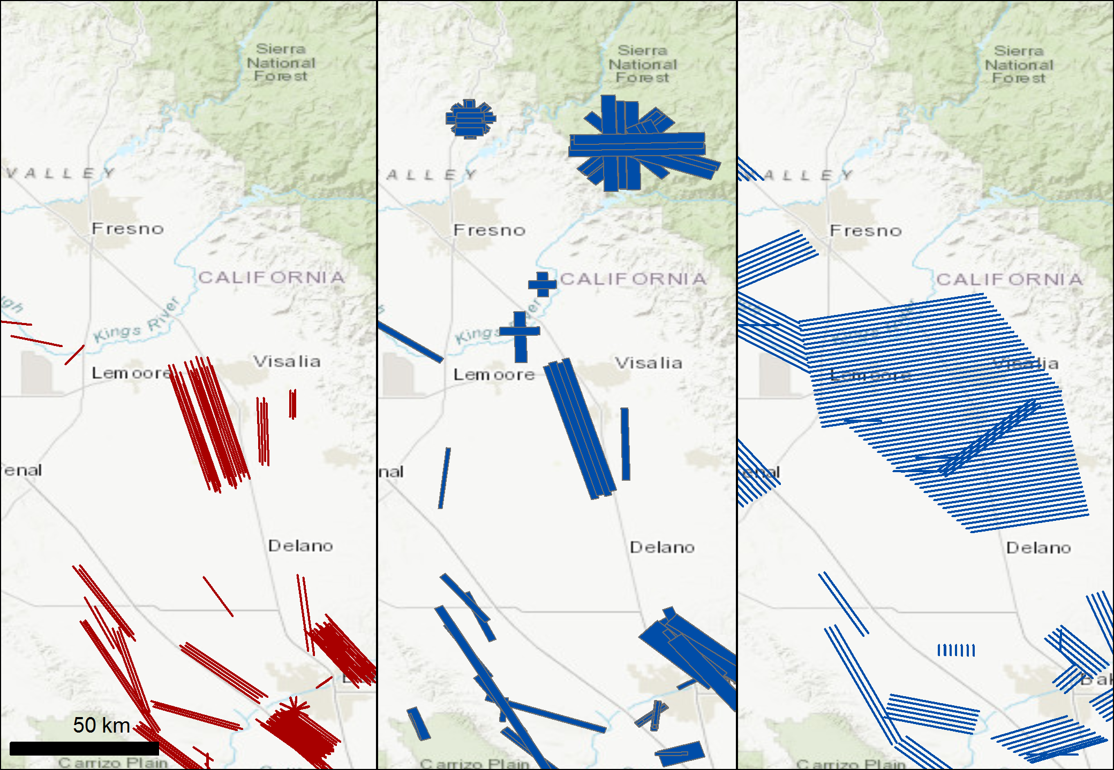
Figure 1. Level 3 airborne data available over the Central Valley. (Left) 2014-2016 HyTES data. (Center) Level 3 AVIRIS-NG 2014-2016 data. (Right) Fall 2016 AVIRIS-NG data.

3.1.3 RapidEye
We considered RapidEye, PlanetScope, Sentinel-2, and Landsat 8 as potential satellites to use for classification of dairy features in our study region (Table 1). Given that dairy features change frequently on timescales of hours to days, we did not use Sentinel-2 and Landsat 8. The 16-day revisit time for these satellites is not sufficient for understanding high frequency changes of dairy features. PlanetScope is a satellite constellation composed of multiple launches of groups of individual satellites. The complete constellation is made up of approximately 120 satellites and will have the ability to image the entire earth every day. PlanetScope has 3 m resolution, a one day revisit time, and four bands. RapidEye consists of a constellation of five satellites with a spatial resolution of 5 meters, a revisit time of 5 days, and 5 spectral bands including Blue, Green, Red, Red-Edge, and Near-Infrared. We chose to use RapidEye data over PlanetScope data for image classification and analysis of dairy features because it has an additional spectral band in the red-edge region of the electromagnetic spectrum. This additional spectral information, we thought, would be more helpful in identifying features in the image as opposed to the higher spatial resolution of PlanetScope data. RapidEye data was acquired through the Planet Explorer Beta (www.planet.com/products/explorer). We downloaded radiometrically-, sensor-, and geometrically-corrected RapidEye Analytic Ortho Tile products over the Tulare region. Ortho Tile products are delivered as 25 km by 25 km tiles. For dairy classification, we used a RapidEye tile collected by RapidEye 3 on June 13, 2015 (Figure 2).

Table 1
Specifications of satellites and sensors considered for dairy classification.
Satellite | Sensor | Spatial Resolution (m) | Revisit Time (days) | Time Period | Number of Bands
RapidEye | constellation | 5 | 5 | 2009 - Present | 5
PlanetScope | constellation | 3 | 1 | 2015 - Present | 4
Sentinel-2 | MSI | 20 | 16 | 2015 - Present | 16
Landsat 8 | OLI | 30 | 16 | 2013 - Present | 9

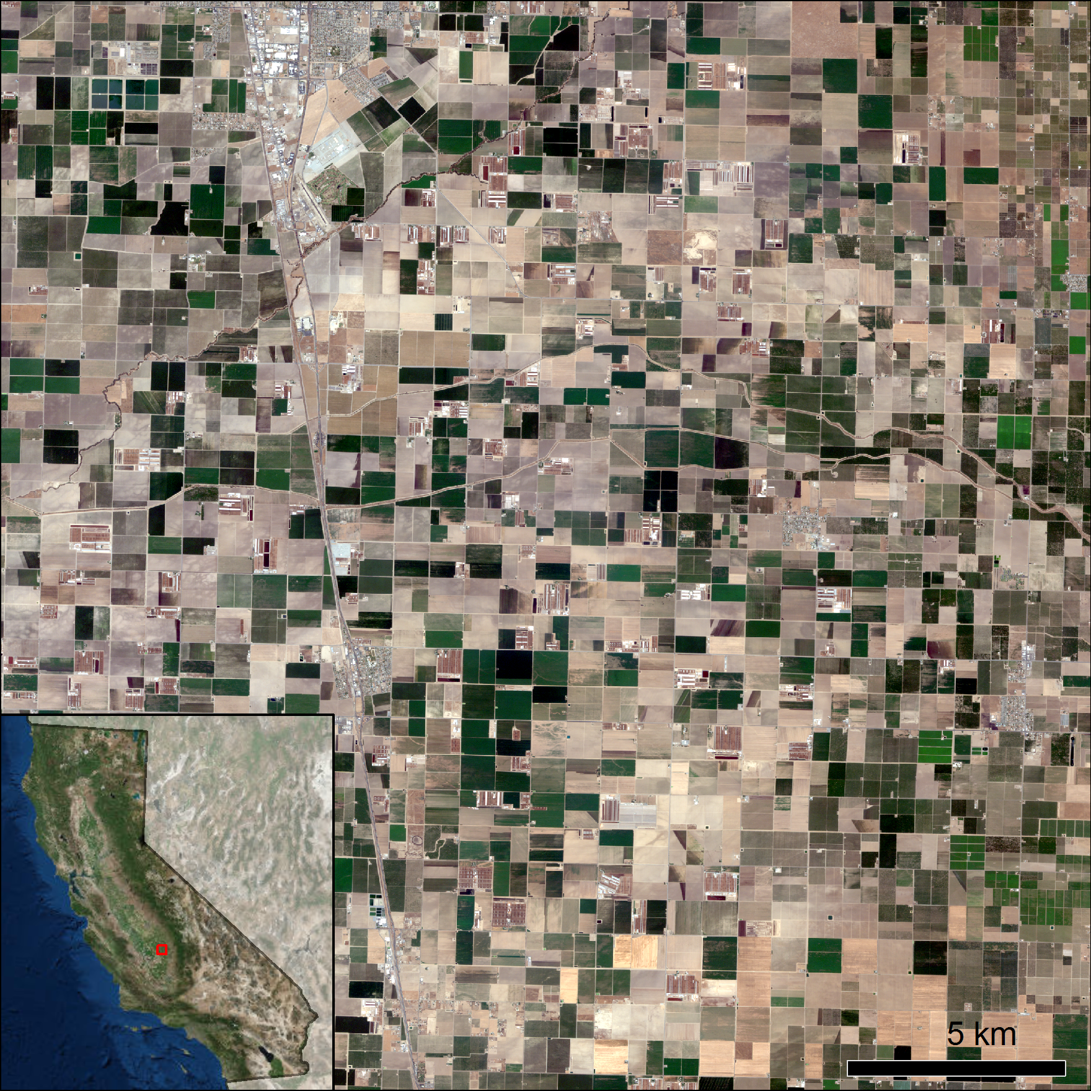
Figure 2. RapidEye Ortho Tile product used for classification. The tile is located directly south of Tulare, California. (Imagery © 2017 Planet Labs Inc.)

3.2 Data Processing
3.2.1 Aqua AIRS: CH4 Total Column Count
The Level 2 AIRS Standard Physical Retrieval products were converted to GeoTiff files from the original Hierarchical Data Format (HDF) files using QGIS. The CH4_total_column data was extracted from the HDF file and was clipped to the study area.

3.2.2 HyTES and AVIRIS-NG
All level 3 data products from AVIRIS-NG and HyTES require no additional processing. Level 3 HyTES data was georeferenced using the software Exelis ENVI (ENVI). Geographic lookup tables were built using each file’s associated metadata. The geographic lookup tables were then used to georeference the associated data to its specified coordinate system.

3.2.3 RapidEye
Rule based feature extraction is the process of segmenting an image and grouping similar clusters of pixels into classes that represent features. A class is defined by a set of rules that distinguish a feature based on attributes such as area or length. ENVI’s Rule Based Feature Extraction workflow was used to extract feedlots and dairy lagoons from RapidEye imagery. All five RapidEye bands in addition to normalized difference vegetation index (NDVI), hue, saturation and intensity bands were used to create rule sets for classification of dairy lagoons and feedlots. The RapidEye image was segmented into objects by grouping neighboring pixels with common values until the objects corresponded to real-world features (e.g. dairy lagoon). The image was then merged to combine neighboring segments that had similar spectral values. A set of rules that best defined the feedlot and dairy lagoon classes were created by determining attributes that effectively identify these features. ENVI has three categories of attributes: spatial, spectral, and texture. Attribute values were constrained to a subset of values that best identified the features of interest. The rule and class confidence preview images were used to check if objects within a class satisfied the conditions of the rule and the likelihood of the class meeting the requirements of the rule set. Based on the rule and class confidence images, the rule set was refined and classification results were exported (Figure 3).

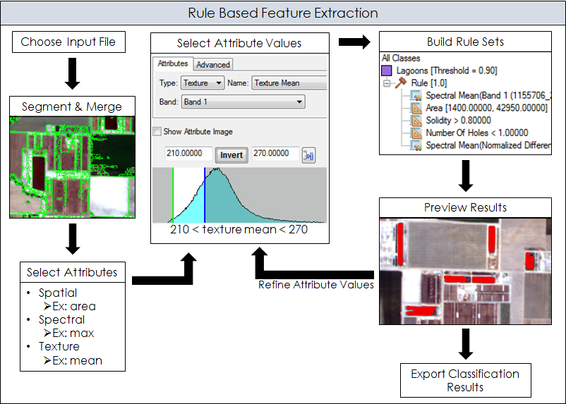
Figure 3. Flowchart of the methods used to classify dairy lagoons and feedlots using ENVI’s Rule Based Feature Extraction tool.

3.3 Data Analysis
The accuracy of the resulting classified image was assessed to determine the quality of the map created through identifying and measuring classification errors. Feedlots and lagoons make up a small percentage of the overall landscape and as such, it was important to ensure that these features were adequately represented in the sample of points chosen for accuracy assessment. Since simple random sampling tends to undersample rarely occurring categories, a stratified random sampling scheme, which ensures that an adequate number of samples in each class are selected, was used to generate sample points (Congalton, 1999). The stratified random sample of points was generated in ArcMap using the ‘Create Accuracy Assessment Points’ tool. The resulting points were manually classified as ‘lagoon’, ‘feedlot’, or ‘other’ by using NAIP imagery as a reference. These points were then used to create a confusion matrix using ArcMap’s ‘Compute Confusion Matrix’ tool. A confusion or error matrix is an array of numbers that allows for a class by class comparison between the reference data (stratified random sample of points referenced to NAIP imagery) and the classified image (Congalton, 1999).

4. Results & Discussion
4.1 Satellite vs Aircraft CH4 Data
The AIRS total CH₄ count data were found not to be useful for our study and did not meet our project partners’ needs because of its low spatial resolution. Unfortunately, due to AIRS 50 km spatial resolution it was not possible to identify point sources of CH₄ emissions as AIRS is better suited for giving regional estimates of CH₄ counts (Figure A1 in Appendix). Furthermore, AIRS along with other hyperspectral satellite sensors that have the ability to detect methane such as the Infrared Atmospheric Sounding Interferometer (IASI) (Aires et al., 2002), and the Tropospheric Emission Spectrometer (TES) (Beer, 2006) are insensitive to the near surface due to sensor saturation issues (Hulley et al., 2016). AIRS may be more helpful for conducting a time series analysis of regional, mid- or upper-atmosphere methane patterns. Our project partners at this time are more interested in combining classification maps of dairy features from satellite imagery with high resolution HyTES and AVIRIS-NG CH₄ plume data. The aircraft data is better suited for understanding facility level emissions.

4.2 Accuracy Assessment
The overall accuracy for classification of the Tulare RapidEye image was 75% (Figure 4 and Table 2). While the producer’s accuracies indicated that lagoons and feedlots had a high probability of being classified correctly, the user’s accuracies revealed that the percentage of lagoons and feedlots that were classified correctly was much lower. Although 98% of the reference lagoon data were correctly classified as “lagoons”, just 68% of the area determined to be “lagoons” from rule based feature extraction were actually lagoons. For feedlots, 86% of the reference feedlot data were correctly classified, but only 60% of the areas identified as “feedlots” from rule based feature extraction were actually feedlot areas. Both feedlots and lagoons were most often misclassified with the “other” class. This confusion is likely due to the heterogeneity of the landscape, limitations of the imagery used for classification, and the methods chosen for analysis. Since the landscape is highly variable this make it difficult to extract features based off of spectral features alone as many features may have similar spectral values. Since dairy features are a small subset of the landscape and similar to surrounding features, RapidEye data with 5 m resolution and 5 bands may not have been high enough spatial or spectral resolution to properly classify lagoons and feedlots. In addition, ENVI’s rule based feature extraction tool requires manual manipulation of attribute values so without prior knowledge of what attributes are most helpful in extracting features it is difficult to choose the best attributes and values.

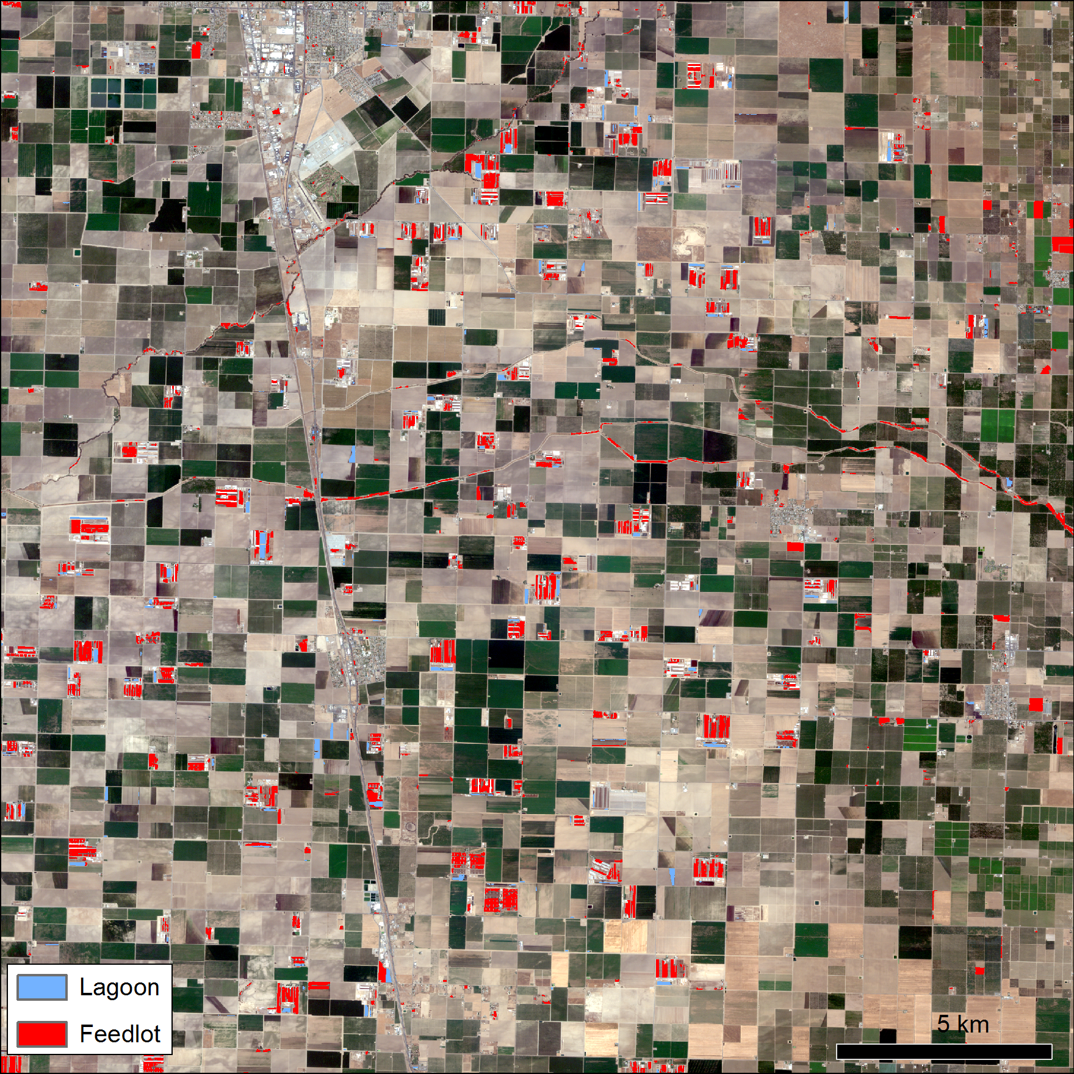
Figure 4 Classification results. (Imagery © 2017 Planet Labs Inc.)

Table 2
Accuracy assessment confusion matrix for Tulare RapidEye image
 | Reference Data
Classified Data | Feedlot | Lagoon | Other | Column Total | User’s Accuracy
Feedlot | 49 | 0 | 32 | 49/81 | 60%
Lagoon | 6 | 57 | 21 | 57/84 | 68%
Other | 2 | 1 | 82 | 82/85 | 96%
row total | 49/57 | 57/58 | 82/135 | 188/250
Producer’s Accuracy | 86% | 98% | 61%
Overall Accuracy = 75% | Kappa =0.63

4.3 Lagoon Change and CH4 Plume Analysis
Changes in dairy lagoons over time were analyzed by looking at a small subset of dairies in our study region. We observed that over the 9 day time period, lagoons were drained and filled multiple times (Figure A2). This observation highlights how quickly features on a dairy farm change and the importance of having data with high temporal frequency to study dairies. After seeing how frequently lagoons on dairy farms change, CH₄ and NH₃ plumes derived from HyTES were overlaid on dairy farms within our study region in order to determine what features on a dairy farm are responsible for GHG emissions. Methane plumes were shown to originate primarily from dairy lagoons, which is consistent with what other studies have found (Figure 6). Owen and Silver (2015) determined that dairy lagoons were one of the largest sources of CH₄ on dairy farms with 368 +/- 193 CH₄ hd-1 yr-1 emitted. The ability to determine point sources of CH₄ emissions from HyTES and AVIRIS-NG allows for an in depth understanding about what specific features on dairy farms are contributing most to CH₄ emissions. This information allows policy makers and management officials to properly regulate and monitor sources of GHG emissions.

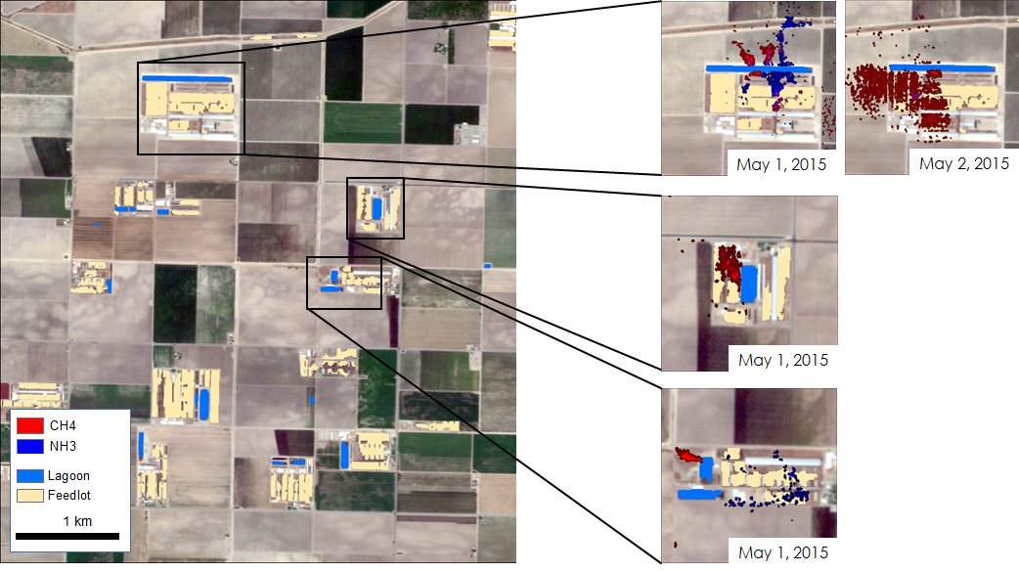
Figure 6. Demonstration of an overlay of HyTES plume data and the final dairy feature classification. (Imagery © 2017 Planet Labs Inc.)

4.2 Future Work
4.2.1 Future Satellites
While current satellite data were found not to have a high enough spatial resolution for use in our project, future satellite instruments may be useful in better understanding GHG emissions sources. The NASA Jet Propulsion Laboratory (JPL) is currently at the study stage for the Hyperspectral Infrared Imager (HyspIRI) mission aimed at studying the world’s ecosystems. HyspIRI will be capable of identifying different types of vegetation, determining if the vegetation is healthy, and assessing the gases released from wildfire and volcanoes, such as carbon and methane (JPL 2017). The HyspIRI mission includes two instruments on a satellite in low Earth orbit: imaging spectrometer measuring visible to shortwave infrared (IR) and multispectral imager measuring from 3 to 12 um and thermal infrared (Table A2 in Appendix). In addition to HyspIRI, the Environmental Mapping and Analysis Program (EnMAP) mission, a German hyperspectral satellite mission, aims to monitor Earth’s environment. EnMAP’s main objective is to study coupled environmental processes in order to assist in sustainable management of resources (EOC 2017). The EnMAP mission includes a pushbroom hyperspectral sensor with a broad spectral range from 420 nm to 1000 nm and from 900 nm to 2450 nm (Table A2). The HyspIRI and EnMAP missions will help give us new resources to better understand GHG emissions and their sources. These two missions are promising indications of how current satellite instrument technology is constantly improving so that we are better equipped to study Earth’s systems.

4.2.2 Image Classification
There are clear limitations in using ENVI’s rule based feature extraction for classifying dairy features. Our classification had an accuracy of only 75% for our study area and when the same rulesets were applied to other tiles outside the study area, accuracy fell dramatically. The ultimate goal is to produce a robust classifier that can identify dairy farms across the entire Central Valley. It is unrealistic to do this using ENVI’s rule based feature extraction due to the manual manipulation of attribute values and without the understanding of which attributes are most helpful in identification. Furthermore, spatial attributes of dairy farm features such as area, length, and compactness vary drastically between dairy farms. This issue is compounded when moving the classifier to a region different than the one it was trained on.

Understanding these limitations is important and future work should focus on implementing a convolutional neural network for classifying dairies and dairy features from satellite imagery. Convolutional neural networks are a category of neural networks that have been identified as being extremely accurate image classifiers. They are widely used in industry and science for tasks such as face recognition and identification of everyday objects. There are a variety of pre-trained convolutional neural networks available using the Python package Keras. These pre-trained models have been trained on large collections of images and thus only need to be altered and fine-tuned on training data relevant to our dairy classification problem. Using this method, it is not necessary to build a convolutional neural network from scratch.

5. Conclusions
Our results indicate that high spatial and temporal resolution satellite data can be used to identify dairy features and understand dairy farm management practices. Large dairy features such as feedlots, lagoons, and settling ponds can be classified using RapidEye satellite imagery. One meter or sub-meter resolution aerial imagery collected by NAIP or satellite imagery from WorldView-2, WorldView-3, QuickBird, and GeoEye-1 would help better distinguish and identify small dairy features such as silage piles, silage bags, digesters, and calf hutches. While these satellites would help in feature identification, they lack the high temporal resolution of RapidEye and thus would not be helpful in understanding management practices and how dairy features change over time. Further work could be done to understand dairy farms using Planet’s PlanetScope satellite constellation. PlanetScope has one less spectral band than RapidEye but has a revisit time of approximately one day making it an intriguing option for further research into management practices of dairy farms using satellite imagery.
With high frequency satellite imagery and accurate classifications of dairy features, it is possible to understand weekly, monthly, and seasonal changes occurring on dairy farms. The classifications become increasingly valuable when paired with AVIRIS-NG or HyTES CH₄ plume data collected at or very near the same time. By combining the two data products, we are able to make better inferences about the dairy activities that lead to emissions. At this time, satellite products do not have the high spatial resolution and sensitivity at the surface level necessary for identifying emission point sources. However, aircraft data from AVIRIS-NG and HyTES allows us to identify point sources at high resolution.
Rule based feature extraction using ENVI on one RapidEye image tile in the Tulare region yielded an accuracy of 75%. When applying the same ruleset to other image tiles in the Central Valley, accuracy was much lower indicating that more work needs to be done refining the ruleset for it to be applicable in other regions. A similar object based image analysis approach using the software eCognition may produce better results as there are more parameters and attributes available for classification. ENVI’s rule based feature extraction is limited in its functionality when compared to eCognition. Future work on classifying dairy features will focus on incorporating a machine learning approach using a convolutional neural network. This approach would be fully automated and could be incorporated into a tool that our project partners could easily use. An accurate dairy feature dataset derived from image classification techniques will help in future AVIRIS-NG and HyTES flight planning.

6. Acknowledgments

- Dr. Kristal Verhulst, NASA Jet Propulsion Laboratory & UCLA Joint Institute for Regional Earth System Science and Engineering
- Dr. Charles Miller, NASA Jet Propulsion Laboratory
- Dr. Francesca Hopkins, University of California Riverside
- Dr. Brian Bue, NASA Jet Propulsion Laboratory
- Talha Rafiq, NASA Jet Propulsion Laboratory & UCLA Joint Institute for Regional Earth System Science and Engineering
- Dr. Anny Huang, Manager of Greenhouse Gas Emission Inventory Analysis, California Air Resources Board
- Riley Duren, NASA Jet Propulsion Laboratory
- Nick Rousseau, JPL DEVELOP Center Lead
- Ben Holt, JPL DEVELOP Mentor

Any opinions, findings, and conclusions or recommendations expressed in this material are those of the author(s) and do not necessarily reflect the views of the National Aeronautics and Space Administration.

This material is based upon work supported by NASA through contract NNL16AA05C and cooperative agreement NNX14AB60A.

7. Glossary

AB – Assembly Bill
ARB – California Environmental Protection Agency, Air Resources Board
AIRS – Atmospheric Infrared Sounder
AVIRIS-NG – Airborne Visible Infrared Imaging Spectrometer Next Generation (AVIRIS-NG) is an airborne imaging spectrometer that provides imaging spectroscopy measurements ranging from 380 nm to 2510 nm in 5 nm samples
CH₄ – methane
CO₂ – carbon dioxide
Earth observations – satellites and sensors that collect information about the Earth’s physical, chemical, and biological systems over space and time
Emission – the production and discharge of gas
EnMAP – Environmental Mapping and Analysis Program
ENVI – Exelis ENvironment for Visualizing Images (ENVI) is a software application for geospatial imagery analysis
EPA – Environmental Protection Agency
GHG – greenhouse gas
H₂S – hydrogen sulfide
HDF – Hierarchical Data Format
HyspIRI – Hyperspectral Infrared Imager
HyTES – Hyperspectral Thermal Emission Spectrometer (HyTES) is an airborne imaging spectrometer that provides imaging spectroscopy measurements ranging from 750 nm to 1200 nm.
IASI – Infrared Atmospheric Sounding Interferometer
IPCC – the Intergovernmental Panel on Climate Change
JPL - Jet Propulsion Laboratory
NH₃ – ammonia
NDVI – Normalized Difference Vegetation Index is an indicator of whether an area of interest contains live vegetation or not
TES – Tropospheric Emission Spectrometer

8. References

AIRS Science Team/Joao Texeira (2013). AIRS Aqua L2 Standard Retrieval product using AIRS IR-only V6. NASA Goddard Earth Sciences Data and Information Services Center. DOI: 10.5067/AQUA/AIRS/DATA202. Accessed on 1 August 2017.

Aires, F., Chedin, A., Scott, N. A., & Rossow, W. B. A regularized neural net approach for retrieval of atmospheric and surface temperatures with the IASI instrument, Journal of Applied Meteorology, 41, 144–159, 2002.

Assembly Bill No. 1803 (2006). Ch. 77

Assembly Bill No. 32 (2006). Ch. 488, California Global Warming Solutions Act of 2006

Assembly Bill No. 1496 (2015). Ch. 604

Assembly Bill No. 197 (2016). Ch. 250

AVIRIS-NG team (2017). AVIRIS-NG Flight Locator kml file. AVIRIS-NG Data Portal 2014-2016, accessed 26 June 2017.

Beer, R. (2006) TES on the Aura mission: Scientific objectives, measurements, and analysis overview. IEEE Transactions on Geoscience and Remote Sensing, 44, 1102– 1105, 2006.

California Air Resources Board (2011) California Greenhouse Gas Emissions Inventory: 2000 - 2009. California Air Resources Board, Sacramento, CA.

California Air Resources Board (last modified 27 March 2012), ARB Mission and Goals, accessed on 26 June 2017, retrieved from https://www.arb.ca.gov/html/mission.htm.

Congalton, R.G. & Green, K. (1999). Assessing the accuracy of remotely sensed data: principles and applications. Lewis Publishers, Boca Raton, Fla.

Chung, M.L., Shilton, A.N., Guieysse, B., & Pratt, C. (2013). Questioning the accuracy of greenhouse gas accounting from agricultural waste: a case study. Journal of Environmental Quality, 42(3), 654 - 659.

Earth Observation Center (EOC) aof DLR. (2017). EnMAP Hyperspectral Imager Mission. Retrieved August 10, 2017, from http://www.enmap.org/?q=mission.

Hulley, G. C., Duren, R. M., Hopkins, F. M., Hook, S. J., Vance, N., Guillevic, P., … & Holmes, K. T. (2006) High spatial resolution imaging of methane and other trace gases with the airborne Hyperspectral Thermal Emission Spectrometer (HyTES), Atmospheric Measurement Techniques, 9, 2393-2408, https://doi.org/10.5194/amt-9-2393-2016.

HyTES team (2017). HyTES ordering web page, accessed 26 June 2017.

Jet Propulsion Laboratory (JPL), California Institute of Technology. (2017). HyspIRI Mission Study. Retrieved August 10, 2017, from https://hyspiri.jpl.nasa.gov/

Jungbluth, T., Hartung, E., & Brose, G. (2001). Greenhouse gas emissions from animal houses and manure stores. Nutrient Cycling in Agroecosystems, 60(1-3), 133 - 145.

Miller, S.M., Wofsy, S.C., Michalak, A.M., Kort, E. A., Andrews, A. E., Biraud, S.C., … & Miller, B. R. (2013). Anthropogenic emissions of methane in the United States. Proceedings of the National Academy of Sciences of the United States of America, 110(50), 20018 - 20022.

Owen, J.J., & Silver, W.L. (2015). Greenhouse gas emissions from dairy manure management: a review of field-based studies. Global Change Biology, 21(2), 550 - 565

Thorpe, A. K., Frankenberg, C., & Roberts, D. A. (2014). Retrieval techniques for airborne imaging of methane concentrations using high spatial and moderate spectral resolution: Application to AVIRIS. Atmospheric Measurement Techniques, 7(2), 491–506. https://doi.org/10.5194/amt-7-491-2014

USDA (2011) U.S. Agriculture and Forestry Greenhouse Gas Inventory: 1990 - 2008. Technical Bulletin No. 1930. Climate Change Program Office, Office of the Chief Economist, U.S. Department of Agriculture, Washington, DC.

U.S. Environmental Protection Agency. (2017, April 14). Overview of Greenhouse Gases: Methane Meissions Retrieved August 3, 2017, from https://www.epa.gov/ghgemissions/overview-greenhouse-gases#methane

9. Appendix A

Table A1
Specifications of satellites and sensors considered for methane column count.
Satellite | Sensor | Spatial Resolution (km) | Revisit Time (hours) | Time Period | Number of Bands
Aqua | AIRS | 50 | 12 | 2002 - Present | 2382

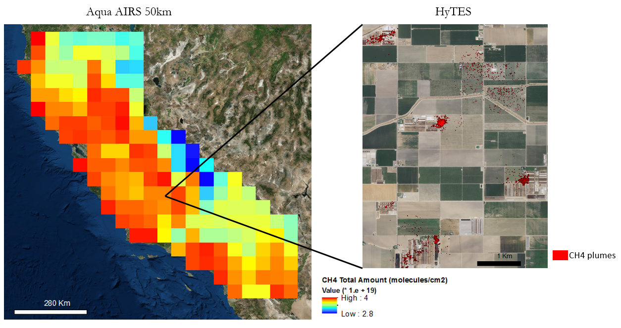
Figure A1. Comparison of AIRS CH4 column count and HyTES plume imagery.

Table A2
Future satellite instruments that are potentially useful for studying GHG emissions
Country and Organization | Sensor | Spatial Resolution (m) | Revisit Time (days) | Number of Bands | Progress
USA  JPL,NASA | HyspIRI | 60 | 5 (TIR)  19 (VSWIR) | > 200 | Currently at study stage
Germany GFZ/DLR | EnMAP | 30 | 27 | 218 | Currently at development and production phase

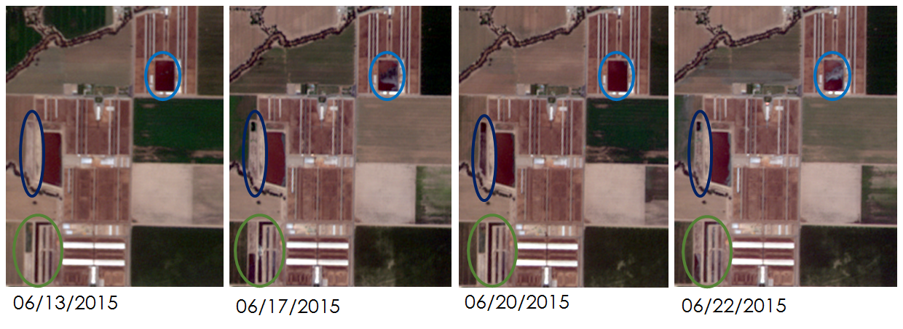
Figure A2. Dairy lagoons changing over time. (Imagery © 2017 Planet Labs Inc.)

