**NASA DEVELOP National Program**



NASA Goddard Space Flight Center

*Spring 2016*

Indonesia Agriculture

Identifying Current Areas of Palm Oil Production and Modeling a Risk Map for Future Expansion in Central Kalimantan, Indonesia

 **Technical Report**

Final Draft – March 30, 2016

Kyle T. Peterson (Project Lead)

Michael Riedman

Abigail Childs

Dr. Naikoa Aguilar-Amuchastegui, WWF (Science Advisor)

Aakash Ahamed, USRA/GSFC (Science Advisor)

# 1. Abstract

Indonesia is the world’s leading producer of palm oil. To keep pace with the continued worldwide expansion of palm oil demand, the government of Indonesia formulated an agricultural policy with the express purpose of doubling palm oil production by 2020. Unfortunately, palm oil plantation expansion has come at the cost of natural rainforest and biodiversity loss in the province of Central Kalimantan. Although the government imposed a moratorium on deforestation in 2011 and extended it to present, there has been insufficient enforcement and deforestation continues to be a pressing issue in the region. The purpose of this project was to work with the WWF to identify current palm oil plantations, including those on protected lands. A second component of the project was to delineate future palm oil plantation growth by creating a risk map of areas that are most vulnerable to palm expansion. The suitability analysis of palm oil plantations relied on Maxent to model palm oil plantation locations. This model used known plantation locations, continuous data from remote sensing systems including TRMM, GPM, Aqua/Terra along with ancillary data, to best predict other current and future locations of palm oil plantations. It is essential to map palm oil plantation locations and future palm oil plantation expansion to protect the biological and ecological diversity of rainforests and peatlands and to encourage palm oil expansion into regions that will not cause rainforest degradation.

**Keywords**

Agriculture, Indonesia, Maxent, Deforestation, Palm Oil

# 2. Introduction

***2.1 Background***

Palm oil is the primary agricultural export of Indonesia; Indonesia and Malaysia supply more than 90% of palm oil to the world market (Thomas et al., 2015). In the past decade, worldwide demand for palm oil has grown exponentially as palm oil has become an essential ingredient in most processed foods and household items such as make-up, soap, cookies, and toothpaste. In response to the growth of palm oil demand, the government of Indonesia formulated an agricultural policy in 2014 with the express goal of doubling palm oil production by 2020 (Thomas et al., 2015). A central pillar of this plan is to convert 20 million hectares (ha) of unused land into palm oil plantations. The most readily available land for palm oil plantations is uninhabited forest, particularly in remote areas such as Central Kalimantan, where governance of protected areas is not stringent and opportunities for large plantations and local livelihood improvements readily exist.

Coupled with the issue of natural forest loss are the negative environmental impacts of increased greenhouse gas (GHG) emissions. Within the past several years massive forest fires have wracked Indonesia, many fires stemming from the clearing of land for palm oil plantations. Forest fires coupled with deforestation, releases greenhouse gases, especially CO2, into the atmosphere (Fairhurst & McLaughlin, 2009). This negative externality is further heightened by the fact that most of the conserved rainforests in Central Kalimantan are located on top of peatlands that are natural CO2 sinks. Deforestation accounts for 94% of GHG emissions in Indonesia (Fairhurst & McLaughlin, 2009), making Indonesia one of the top GHG emitters in the world (Ramdani & Hino, 2013). Government and local policymakers have thus far been unable to effectively halt large and small scale deforestation and prevent rainforest and peatland loss.

In 2011, the government of Indonesia put a two-year moratorium on new concessions for land in natural forests and peatlands in an attempt to reduce deforestation and carbon emissions. This moratorium was extended for two years in 2013, and again in 2015. The moratorium does not address government licenses on natural forests and peatlands prior to 2011, nor does it apply to secondary forests, and does nothing to prevent against encroachment (Austin, Sheppard & Stolle, 2012). Moreover, the moratorium has not been strictly enforced by the government or local administrations, making it possible for developers to clear forests and peatlands without regulation.

Previous studies have analyzed the impact of deforestation and have modeled areas most likely for future deforestation. Some of these studies are outdated (Ramdhani & Taufik, 2006; Uryu et al., 2008) and do not accurately reflect current biophysical and management conditions. Other studies incorporate current modeling techniques such as Maximum Entropy Modeling (Maxent), but are not specific to Central Kalimantan (Aguilar-Amuchastegui et al., 2014), while others studies are specific to Kalimantan and Borneo, but have used land capability evaluation analysis (Bhermana et al., 2013) or land use change analysis (Wicke et al., 2011; Ramdani & Hino, 2013) to measure deforestation and do not model future land use change. The limitations with these analyses is that current palm oil plantations are difficult to locate with remote sensing systems. Therefore, a modeling approach based on Maxent is appropriate since it uses known locations to model suitability for future locations.

***2.2 Project Objectives***

The objectives of this project were to create a prediction map identifying current palm oil plantations in the Central Kalimantan region of Indonesia based on biophysical characteristics and a model of potential future palm oil plantation expansion based on existing plantations, forest loss, and management characteristics. Current palm plantations can be assessed using validated and non-validated plantation data coupled with environmental data for known locations to fit a model that allows extrapolation and identification of areas where other plantations may be located. By identifying current palm oil plantations and modeling a likelihood assessment of future plantations, World Wildlife Fund (WWF), Roundtable on Sustainable Palm Oil (RSPO), and other organizations can better identify areas to concentrate their deforestation efforts and better support decision makers when reviewing palm oil policy.

***2.3 Study Area and Period***

Central Kalimantan, located on the island of Borneo in the Republic of Indonesia, has seen the greatest increase in palm oil plantations within the last decade (Ramdani & Hino, 2013). Much of Central Kalimantan is natural rainforest and home to many diverse plant and animal species. Because international demand for palm oil has increased, developers have been clearing conserved rainforest at the expense of native flora and fauna to create new palm oil plantations. Often, these plantations are created without any national or local government oversight.

**Figure 2.1: Study Area Map for Central Kalimantan, Indonesia**

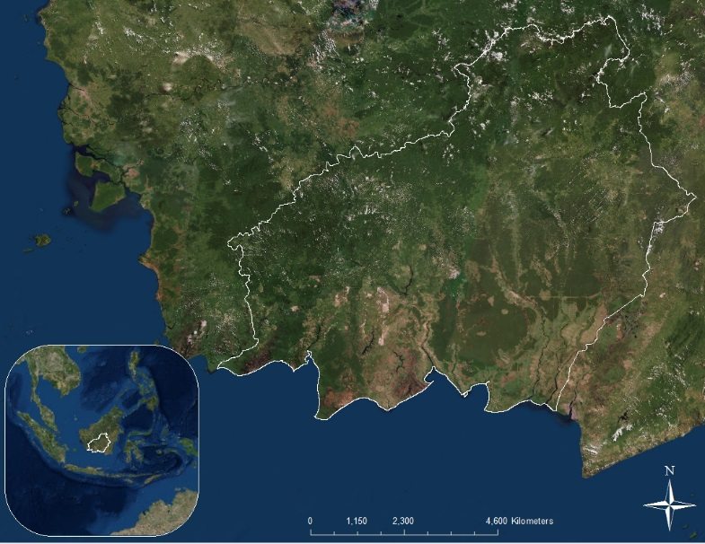

Central Kalimantan

The study utilized data of Central Kalimantan from January 2000 through January 2016.

***2.4 National Application Addressed***

The primary NASA National Application Area addressed by this project is agriculture. Mapping palm oil plantation presence and expansion in Central Kalimantan, Indonesia can positively impact efforts to increase the long-term sustainability of the palm oil supply chain and substantially reduce deforestation in the region. A map that models current and future palm oil plantations based on known locations and forest loss can better predict future palm oil plantation growth and lead to targeted interventions that address both deforestation and agricultural growth with a sustainable, coherent approach. A likelihood model can help policy makers and NGOs better determine the forests most at risk for agricultural expansion and deforestation.

***2.5 Project Partners***

The partner for this project is the Forests Division in WWF. Projects related to deforestation and forest conservation in Indonesia is a major focus area for WWF since forests provide species habitat protection. Current WWF deforestation programs in the area include a program to raise local governance of conserved areas by providing data and support to local governments.

The project of mapping known palm oil plantations and current forests that are likely of becoming palm plantations in the Central Kalimantan province can help target the work that WWF is doing on the ground, thereby increasing the impact of their work and effectively reducing the likelihood of deforestation. WWF currently relies on non-validated data of palm oil plantations, but this data only shows where suspected current locations are; it does not show possible future locations of plantations. WWF will benefit from the methodology of risk mapping by better targeting their interventions.

# 3. Methodology

***3.1 Data Acquisition***

Using the Maxent algorithm, data were divided into two categories: observed/known occurrences of palm oil plantations and forest loss used as training data and environmental data representing explanatory variables.

Maxent is a proven machine learning technique that is commonly used to identify species habitat within a specific geographic bound. This technique aids in assessing the relationship between palm oil plantations and their assumed explanatory variables while also producing a map of predicted palm oil plantation locations. Along with a visual representation of the results given by the map, Maxent also generates a Receiver Operating Characteristic (ROC) and Area Under the Curve (AUC) score. These outputs produce a value range between 0-1. If the resulting score is less than or equal to 0.5 the model being assessed is no greater than pure chance (Aguilar-Amuchastegui et al., 2014). Using the AUC score and standard deviation, the model and each individual variable was evaluated to gauge its overall accuracy and contribution to the model.

***3.1.1 Training Data***

The training data used in this study were derived from *in situ* data of verified palm oil plantation locations in Central Kalimantan provided by WWF and from forest loss estimations from 2000 - 2016. Using a random sample generator created by NOAA, in ArcGIS, a random sample of 704 and 234 points within the shapefile were created with a minimum distance of 500m between points. These points were extracted and used as the training data within the Maxent model.

***3.1.2 Environmental Data***

Environmental data was collected from a variety of NASA Earth Observations and ancillary data sources.

**Table 3.1.2: Environmental Data Collected and Processed**

|  |  |
| --- | --- |
| **Name** | **Source** |
| Conservation Areas | Global Forest Watch |
| Elevation | NASA - SRTM |
| Forest Cover Loss 2000-2014 | Hansen/UMD/Google/USGS/NASA |
| Indonesia – Water | DIVA GIS |
| Indonesia Administrative Areas | DIVA GIS |
| Indonesia and Malaysia Peatlands | Global Forest Watch |
| Indonesia Palm Oil Concessions | Global Forest Watch |
| Indonesia Primary Forest 2000-2012 | Global Forest Watch |
| Indonesia Roads | DIVA GIS |
| Palm Oil Mills | Global Forest Watch |
| Population | Worldpop.org.uk |
| Precipitation | NASA – GPM |
| Precipitation | NASA – TRMM |
| RSPO Mills | Global Forest Watch |
| Settlements | ArcGIS Online |
| Soil Types | Food and Agriculture Organization of the United Nations |
| Tree Plantations | Global Forest Watch |
| WWF Palm Oil Plantation Locations | WWF Indonesia |

***3.2 Data Processing***

To create the accessibility index, data was utilized from roads, palm oil mills, water bodies (used as transportation), and settlements. The accessibility index uses factors such as distance to networks to calculate the average speed and ease of movement across a given landscape (Eade et al., 2000). The first step was to calculate Euclidean distances for each individual layer. These Euclidean distance layers were then assigned a “fuzzy membership” value ranging from 0-1, zero being most accessible/shortest distance. After assigning the fuzzy membership values the layers were then combined using the fuzzy overlay tool in ArcGIS to create a single variable with continuous values ranging from 0-1.

A neighborhood analysis was completed to assign a mean value to cells within a 5km circular radius after calculating the population change between 2010 and 2015. This same process was used to calculate the future population change using the 2015 and 2020 data. 2010 – 2015 population change data was used as an input for the palm oil prediction model and 2015 – 2020 population change data was used as an input for the palm oil expansion likelihood model.

A condition of Maxent is that all input data must have the same cell size, extent, and resolution for Maxent to process and effectively model the environmental variables. Both vector and raster data were processed using a python program to make the resampling of input data more streamlined and automated. Vector data were converted into trinary raster variables; variables with a 1 to represent presence, 0 to represent absence, and -999 to represent background data. It was necessary to code for background data since background data should not be coded as 0. The program pulled files, converted vector files to rasters, reprojected files based on a specified projection, changed files to have a cell size of 1 ha, matched the extent, number of rows and columns to an input raster, clipped the rasters to the study area, and converted the outputs into ASCII files that could be entered into the Maxent program.

***3.3 Data Analysis***

Several iterations of the Maxent model were run to create the final output maps and charts. After carefully interpreting the initial model results in Microsoft Excel and ArcGIS, changes were made to include only non-redundant explanatory variables and more replications of the model were run to smooth the results. By using the results generated by these initial models variables that were able to be eliminated were EVI, surface temperature, soil degradation, and relative humidity from the model. These environmental variables were eliminated due to either redundancy or high correlation with other variables or low response curves.

Using the information gathered from initial models the variables accessibility, elevation, NDVI, palm oil concessions, peatlands, population trends (2010-2015), slope, and primary forests were determined to be the best biophysical predictors of palm oil plantations and utilized in our final model. Training data for this model were obtained using the NOAA random sample generator to create 704 unique points that were at least 500m apart.

A likelihood of expansion map that modeled potential future expansion of plantations throughout the Central Kalimantan region was created using a separate set of inputs to better identify the likelihood of palm oil plantation expansion. Using the Maxent modeling system, known palm oil plantation location data were combined with forest loss data, generating 234 random points with a minimum distance of 500m between each point, and used as the input training data. The environmental variable inputs were accessibility, Central Kalimantan regencies, conservation areas, peatlands, estimated population change from 2015 - 2020, and primary forest.

# 4. Results & Discussion

***4.1 Analysis of Results***

***4.1.1 Palm Oil Prediction Locations***

The first output of the Maxent model was a map to predict the presence of palm oil plantation locations in Central Kalimantan using biophysical environmental variables and known palm oil plantation location data as inputs. The results indicate that the model for predicting palm oil plantation locations in Central Kalimantan was strong. The mean area under the curve (AUC) score, with 10 replicate runs, was 0.835 with a standard deviation of 0.024, thus demonstrating that these findings are significant at the 95% confidence interval.

The average omission and prediction results [see Appendix A.1] indicate that the omission for the test data is very close to the predicted omission; this is as it should be. The closer the omission of test data to the predicted omission, the better the prediction model. The standard deviation of the omission is slightly above the predicted omission, indicating that there are environmental variable inputs that could probably make the model stronger.

The results of the average sensitivity vs. specificity [see Appendix A.2] indicate that the receiver operating characteristics (ROC) for the model are all above the 0.5 random prediction line, meaning that all of the resulting data of predicted palm oil plantation locations are significant. This implies that the Maxent model is able to effectively predict the presence of palm oil plantations in Central Kalimantan based on the environmental input variables and verified palm oil plantation locations.

**Table 4.1.1: Variable contribution and permutation importance**

|  |  |  |
| --- | --- | --- |
| **Variable** | **Percent Contribution** | **Permutation Importance** |
| Palm Concessions | 35.8% | 15.5% |
| Elevation | 27.3% | 51.0% |
| Accessibility | 10.6% | 3.9% |
| Primary Forest | 9.4% | 4.5% |
| Population Change | 9.0% | 14.3% |
| Peatlands | 4.2% | 5.1% |
| NDVI | 3.0% | 4.0% |
| Slope | 0.7% | 1.5% |

Palm oil plantation concessions was the main driver variable of the model. Elevation and accessibility were the other highest contributors to the model; elevation had the highest permutation importance that resulted from when each environmental variable was run on the presence of randomly permuted training data and background data.

The jackknife test of variable importance shows the environmental variables with the highest gain when used in isolation from the other environmental variables when used against the AUC. Elevation, palm oil concessions, and access were the variables that had the most useful information on their own [see Appendix A.3]. This confirms the importance of the variables in the percent contributions table. Peatlands has the lowest percent gain when compared individually against the AUC. The resulting output of the Maxent model created an image showing the percentile likelihood of predicted palm oil plantation locations.

The lower southwestern area of Central Kalimantan had the highest predicted area of palm oil plantation location presence; these are the areas that the model predicted had above a 50% chance of palm oil plantations presence based on environmental variables and the randomly selected training points [see Appendix A.4]. 11.7% of land had a 50-75% likelihood of containing palm oil plantation locations while 0.5% had a 75-100% likelihood of containing palm oil plantations.

A threshold of 60% was used as a cutoff for palm oil plantation prediction locations; it was assumed that all prediction locations Maxent identified with a score above 60% denoted a very likely occurrence of palm oil plantations. Data with a Maxent prediction above 60% were then compared with WWF in situ data to determine the validity of the model and to compare the Maxent model with verified palm oil plantation locations.

**Figure 4.1.1: Comparison of Maxent Results with WWF Data**

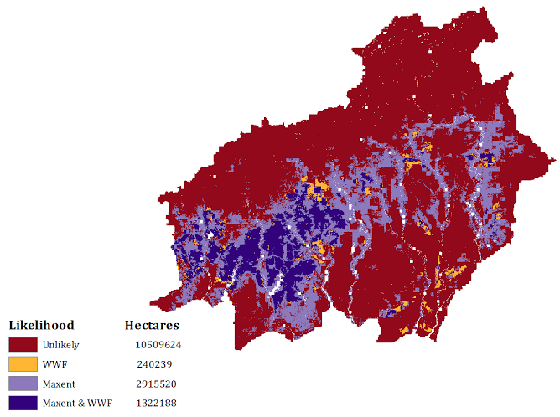

Compared to WWF in situ data, the Maxent model did well at predicting known palm oil plantation locations and was able to effectively extrapolate those results to find previously unknown palm oil plantation locations. The model failed to account for 1.6% of known locations, but estimated that there were 2,915,520 ha, or 19.54% of Central Kalimantan contain previously unknown locations where palm oil plantations are very likely to occur. Moreover, the Maxent and WWF data agreed on palm oil plantation locations and non-locations 78.94% of the time. The resulting map (Figure 4.1.4) indicates that most previously unknown palm oil plantation locations are close to existing palm oil plantations.

***4.1.2 Final Likelihood of Palm Plantation Expansion***

The second output of the Maxent model was a model to predict the likelihood for expansion of palm oil plantation locations in Central Kalimantan using policy and management environmental variables and known palm oil plantation location data combined with tree loss from 2000 - 2016 as input training data. The results of the Maxent model of likelihood palm oil expansion in Central Kalimantan were not as robust as the results for the predicted palm oil plantation locations. This is to be expected since the likelihood expansion model environmental variable inputs contain management attributes instead of biophysical attributes. The omission/commission analysis showed increased variance among the 10 runs of the model.

The omission/commission results indicate that the model has a low standard deviation for low fractional and cumulative threshold values, but the standard deviation increases as the fractional and cumulative threshold values grow [Appendix B.1]. The mean omission of the test data follows very close to the prediction omission rate; this is a good indicator of a quality of the model.

The AUC score for the likelihood of palm oil plantation expansion results was 0.713 for 10 replicate runs, with a standard deviation of 0.047. This output is significant at the 90% confidence interval; the model is still valid in that it is able to estimate above the random prediction value of 0.5 [see Appendix B.2].

**Table 4.2.1: Variable contribution and permutation importance**

|  |  |  |
| --- | --- | --- |
| **Variable** | **Percent Contribution** | **Permutation Importance** |
| Accessibility | 37.2% | 28.5% |
| Population Change | 25.0% | 38.2% |
| Provinces | 18.0% | 20.6% |
| Primary Forest | 14.2% | 2.4% |
| Peatlands | 4.9% | 7.7% |
| Conservation Areas | 0.9% | 0.5% |

Accessibility was the largest contributor to the likelihood expansion model, contributing 37.2% to the model. Estimated population change from 2015-2020 and Central Kalimantan provinces were also large contributors to the model, contributing 25% and 18%, respectively. Peatlands and conservation areas were the lowest contributing environmental variables to the model, indicating that future palm oil plantation expansion is not likely to occur in those areas. Population change had the highest permutation importance, followed by accessibility and provinces.

The jackknife curve for the AUC of likelihood expansion further clarifies the permutation and percent contribution impact of the environmental variables [see Appendix B.3]. Access, provinces in Central Kalimantan, population change from 2015-2020, and primary forests all had an individual AUC score of above 0.62, indicating that they are significant contributors to the likelihood of palm oil expansion model.

The resulting image of the Maxent expansion likelihood estimate [see Appendix B.4] showed substantial likelihood of palm oil expansion in the southwestern through northeastern parts of the province. The model estimated 24.81% of land had a probability over 0.5 of either already being palm oil plantation or was likely to be converted to plantations in the future.

A threshold of 40% was used to estimate future palm oil expansion locations in Central Kalimantan. 40% was used as the cut-off because there is considerably more variance in the possible outcome results of the likelihood model and to best capture the results of the model while taking into account known palm oil plantation locations and deforestation, 40% and above likelihood percentiles can best effectively illustrate possible plantation growth. All data above the 40% threshold were used in a comparison map to compare estimated likelihood of palm oil plantation growth to known palm oil plantation locations and deforestation from 2000 to 2016.

**Figure 4.2.4: Comparison of Maxent Results with WWF and Deforestation data**

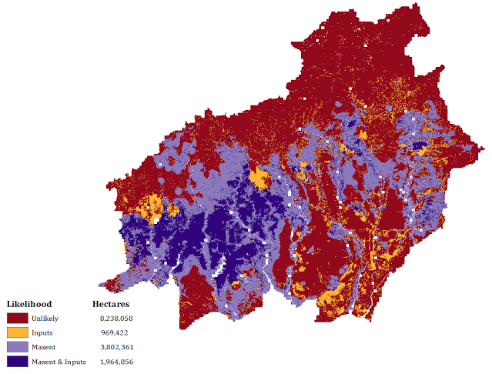

The overlap between the Maxent prediction and the combined WWF and deforestation inputs is less than in the palm oil prediction results. This could be a result of the increased number of possible points for the random point selection to choose from or the model overestimating likelihood plantations in other regions of the map, such as the western part of the province. There is less agreement about the likelihood of palm oil expansion between the input variables and the Maxent results. Again, Maxent was strong at predicting verified palm oil locations; 6.4% of verified forest loss and verified plantations were missed by the model. The model predicted that future palm oil expansion would cover 38.51% of the total area of Central Kalimantan.

An important aspect of this work was to determine the conservation areas and peatlands most at risk for deforestation. The expected palm oil plantation expansion results above 40% likelihood were overlaid with conservation areas and peatlands layers to find the areas where the model predicts that plantation expansion will encroach on preserved areas.

**Figure 4.2.5: Predicted Expansion in Conservation Areas and Peatlands**

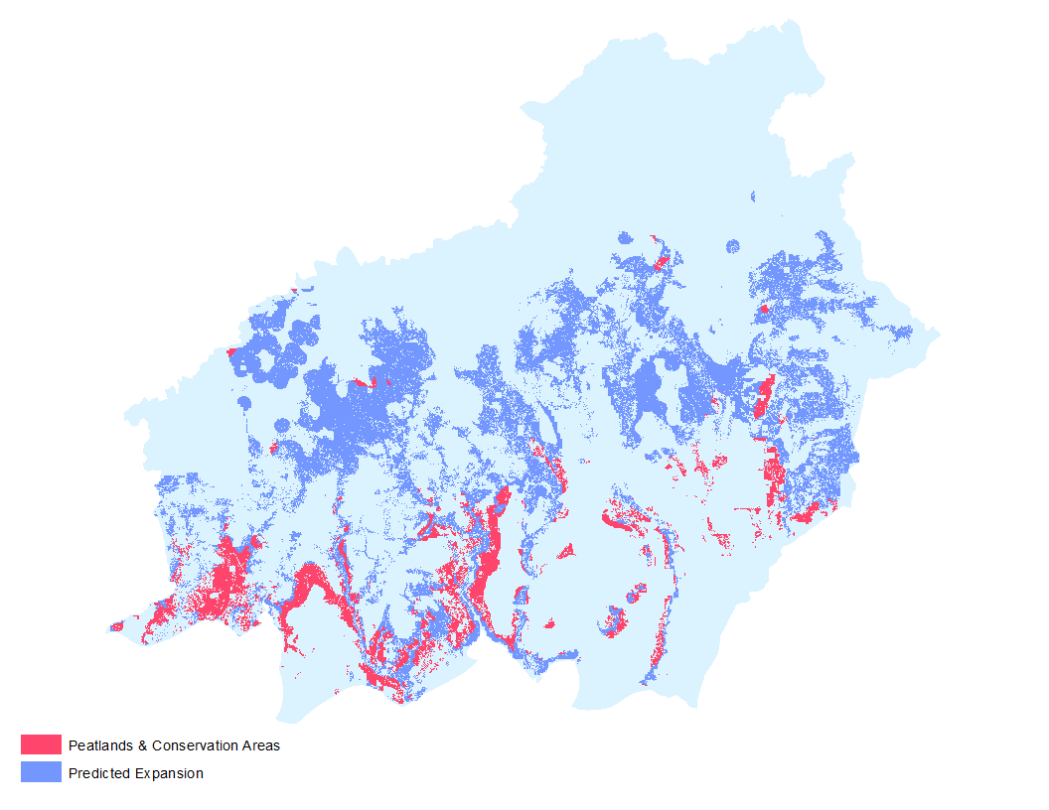

The areas highlighted in pink show the conservation areas and peatlands most at risk of destruction. These areas tend to be close to already existing plantations and are located primarily in the southwestern portion of the province. A 4.7% of the total land in Central Kalimantan is predicted to be conservation or peatlands at risk of becoming palm oil plantations in the future.

***4.2 Errors and Uncertainty***

As with all spatial modeling studies it is important to remember that it is an imperfect science. Potential errors may have been the result of omitting several datasets throughout the iterative Maxent process. A major difficulty of working in a study area as remote as Central Kalimantan is the lack of accurate and current data.

While conducting this study there were two main assumptions made. The first, was to use a 500m minimum distance between points when creating the training data. The purpose of this was to eliminate spatial autocorrelation. Due to time constraints we were not able to test for this potential error. The second major assumption made was the threshold used for both palm oil presence and expansion. The modeled locations of palm oil plantations were assigned a minimum threshold of 60%, meaning all values above this represented areas of palm oil agriculture. A lower threshold, of 40%, was used when analyzing the likelihood of expansion results.

***4.3 Future Work***

One of the major goals of this research is to expand the study area to all of Kalimantan and other areas within Indonesia. By altering several environmental variables that are unique to each region this process could be applied to other areas across the world that are experiencing similar growth in palm oil agriculture. This work could also benefit further by incorporating Land Use Land Cover, predicted forest loss and CO2 emissions, LIDAR, forest estates, and other future projection data in the model.

# 5. Conclusions

Palm oil plantations are likely to grow and expand in the future. Moreover, plantation growth is likely to occur in the areas that border existing plantations since the infrastructure and administrative leanings for growth already exists in those areas. Our model found that predicted palm oil plantations and the likelihood of expected palm oil plantation growth are most likely to occur in the already palm oil plantation dense southwestern region of the country. The three regencies at the highest risk of future conversion are (1) Sukamara (2) Kotawaringin Barat and (3) Kotawaringin Timur.

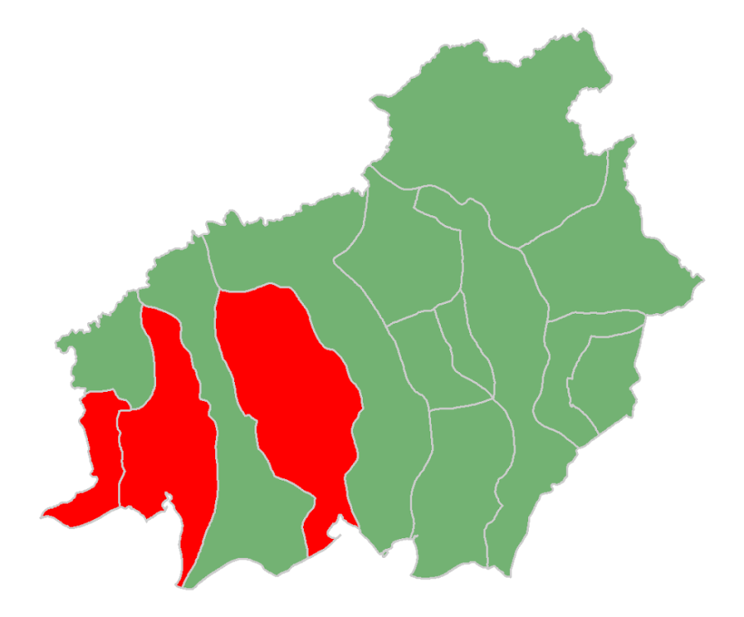

1.

3.

2.

Due to our findings it is suggested that preservation and policy efforts be focused in these regions.

Conservation areas and peatlands environmental variables did not significantly contribute to the likelihood expansion model, leading it to be interpreted that these regions, while still at risk for deforestation, are the not driving deforestation. Rather, population growth, coupled with accessibility and provincial administration are the likely drivers of deforestation for the creation of palm oil plantations in Central Kalimantan. Primary forests contribute to the model, indicating that they are the areas most likely to be converted into palm oil plantations in the near future.

# 6. Acknowledgments

We would like to thank Dr. Naikoa Aguilar-Amuchastegui, Mona Wang, and David McLaughlin at the WWF for their support and input, particularly with the design of the project and encouraging the use of Maxent to model palm plantations.

Additionally, we would like to thank Aakash Ahamed at NASA for proposing and piloting the project.

Lastly, we would like to thank Sean McCartney for all of his work as Center Lead at GSFC and for advising and assisting us throughout this process.

Any opinions, findings, and conclusions or recommendations expressed in this material are those of the author(s) and do not necessarily reflect the views of the National Aeronautics and Space Administration.

This material is based upon work supported by NASA through contract NNL11AA00B and cooperative agreement NNX14AB60A.

# 7. References

Aguilar-Amuchastegui, N., J.C. Riveros, and J.L. Forrest. 2014. Identifying areas of deforestation likelihood for REDD+ using a species modeling tool. *Carbon Balance Management* 9(10).

Austin, K., S. Sheppard, and F. Stolle. 2012. Indonesia’s moratorium on new forest concessions: key findings and next steps. WRI: Washington, DC.

Bhermana, A., B.H. Sunarminto, S.N.H. Utami, and T. Gunawan. 2013. The combination of land resource evaluation approach and GIS application to determine prime commodities for agricultural land use planning at developed area (a case study of Central Kalimantan province, Indonesia). *ARPN Journal of Agricultural and Biological Science*. 8(2): 771-784.

Eade, J.F.A., R. Knapp, G. LeClerc., A. Nelson, and M. Winograd. 2000. Accessibility Analyst: A Simple and Flexible GIS Tool for Deriving Accessibility Models. Centro Internacional de Agricultura Tropical (CIAT):Cali, Colombia*.*

Fairhurst T. and D. McLaughlin. 2009. Sustainable Palm Oil Development on Degraded Land in Kalimantan. WWF: Washington, DC.

Ramdani, F. and M. Hino. 2013. Land use changes and GHG emissions from tropical forest conversion by palm oil plantations in Riau province, Indonesia. *PLoS ONE* 8(7): e70323.

Ramdhani, Y. and R.K. Taufik. 2006. Land Suitability Analysis for Sustainable Oil-palm Plantations in Kalimantan using Fuzzy Weighted Linear Combination on Multi Criteria Spatial Decision Support System. *SarVision Indonesia*.

Thomas, M., J. Buchanan, D. McLaughlin, D. Grubba. 2015. Sustainable Sourcing Guide for Palm Oil Users. WWF: Washington, DC.

Uryu, Y., C. Mott, N. Foead, K. Yulianto, A. Budiman, F. Takakai, Nursamsu, Sunarto, E. Purastuti, N. Fadhli, C.M.B. Hutajulu, J. Jaenicke, R. Hatano, F. Siegert, and M. Stüwe. 2008. Deforestation, forest degradation, biodiversity loss, and CO2 emissions in Riau, Sumatra, Indonesia: One Indonesian province’s forest and peat soil carbon loss over a quarter century and its plans for the future. *WWF Indonesia Technical Report*. WWF: Washington, DC.

Wicke, B., R. Sikkema, V. Dornburg, and A. Faajj. 2011. Exploring land use changes and the role of palm oil production in Indonesia and Malaysia. *Land Use Policy* 28: 193-206.

# 8. Content Innovation

Inline Supplementary Material (see appendix for tables and charts)

Interactive Map Viewer

# 9. Appendices

***9.1 Appendix A: Palm Oil Prediction Results***

A.1: Average Omission and Predicted Area for Palm

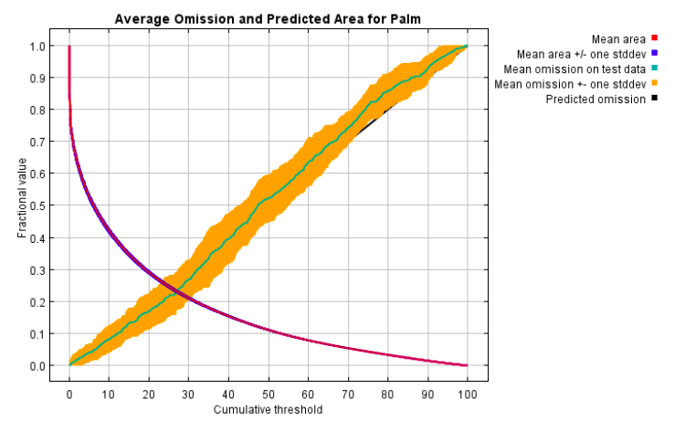

A.2: Average Sensitivity vs. 1: Specificity for Palm

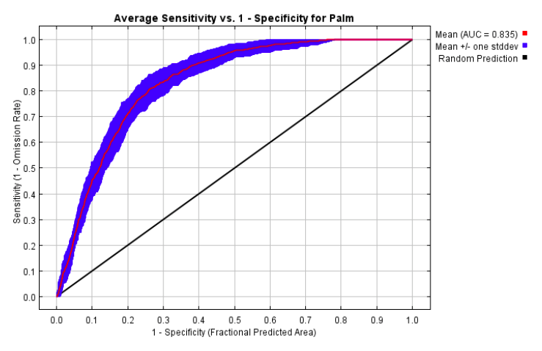

A.3: Jackknife of AUC for palm oil plantations

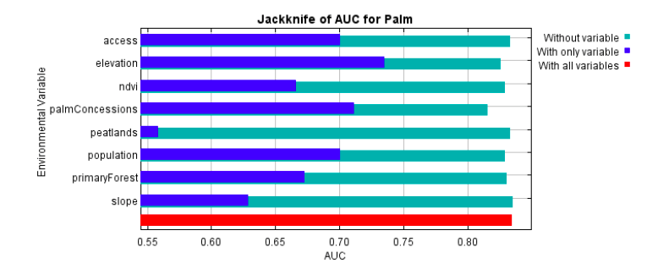

A.4: Maxent output of palm oil plantation locations likelihoods

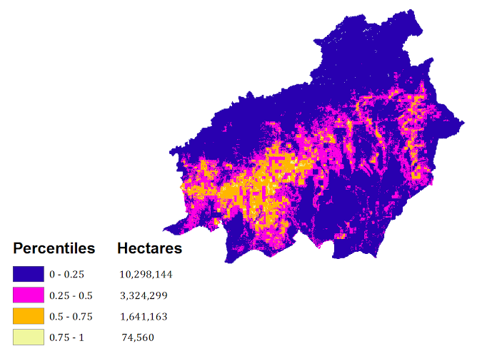

***9.2 Appendix B: Palm Oil Expansion Likelihood Results***

B.1: Average omission and predicted area for Likelihood expansion

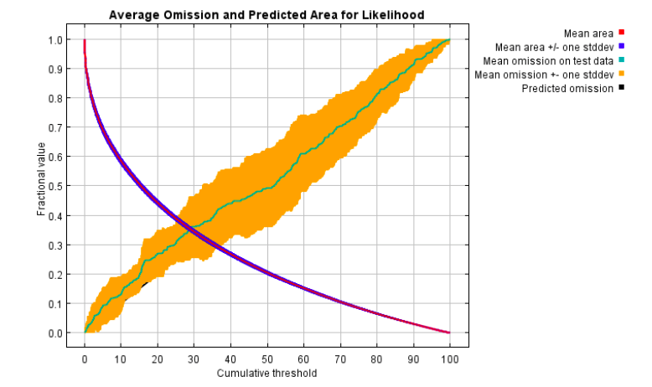

B.2: Average Sensitivity vs. 1: Specificity for Likelihood Expansion

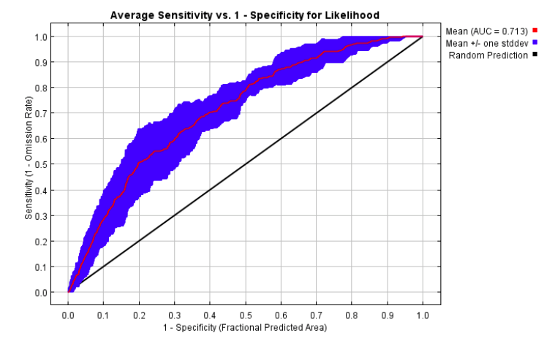

B.3: Jackknife of AUC for likelihood palm oil expansion

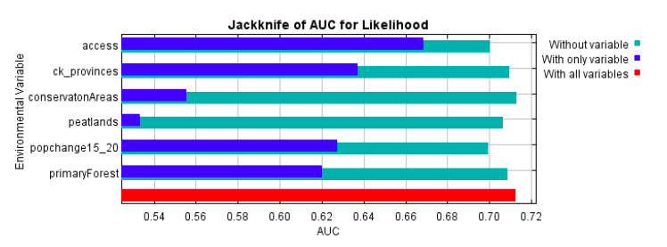

B.4: Percentile likelihood of palm oil plantation expansion

