Riley County Water Resources

*Comparing Runoff Curve Calculation Methods to Inform Local Resiliency Initiatives in Riley County, Kansas*

 **Technical Report**

Final Draft – August 6th, 2020

Trista Brophy

Ella Griffith

Elizabeth Nguyen

Adelaide Schmidt

***Advisor***

Dr. Kenton Ross, NASA Langley Research Center (Science Advisor)

# 1. Abstract

Riley County, Kansas, has observed increased levels of flooding, potentially due to changes in land use/land cover (LULC) and seasonal vegetation variation. This study contrasts two methods of generating runoff curve numbers (CN) from 2006-2020. (1) The traditional Soil Conservation Service CN calculation method uses a lookup table and tracked LULC to determine runoff changes. These tables allow for land cover-specific CN and account for various farming techniques but lack flexibility in calculations for various seasons or plant health. (2) A dynamic method employs normalized difference vegetation index (NDVI) compiled over the rainy season each year to calculate CN using seasonal vegetation. This method allows for a more precise analysis of runoff variability within and between rainy seasons because it can be updated with greater temporal detail and captures higher spatial resolutions by using NDVI as a proxy for LULC. This study further uses inputs from the United States Geological Survey (USGS) National Land Cover Database (NLCD), the United States Department of Agriculture (USDA) Cropland Data Layer, and Landsat imagery to create more precise LULC raster datasets including both urban cover and crop-specific land use and curve number maps of the area. Results can guide decision makers in the City of Manhattan, Riley County Department of Planning and Development, Riley County Conservation District, the Kansas Forest Service, and the Kansas Department of Health and Environment toward informed decisions on resiliency strategies to address future flooding.

Keywords: remote sensing, curve number, land cover change, land use change, NDVI, runoff, flooding, resiliency planning

# 2. Introduction

***2.1 Background Information***

In recent years, Riley County, Kansas experienced high levels of flooding potentially due to changes in land use, seasonal vegetation variation, and changes in impervious surface distribution. Due to repeated recent flooding of Wildcat Creek, including the headline-making Labor Day flood of 2018, officials across Riley County have confirmed extensive damage to businesses and homes in Manhattan, Kansas, and its rural surroundings. Local officials are concerned that land cover change in the Wildcat Creek watershed is leading to increased runoff and may be one of several factors in consequent flooding. Changes in land use and land cover can have significant impacts on surface runoff and flooding, especially as impervious land surfaces replace vegetation. Urbanization is not the only contributor to increased runoff, as changes in farming practices, abandonment of infrastructure, loss of native grasslands, and alterations to the grading and elevation of the land can also contribute to shifting hydrological patterns (Wang et al., 2014). In agricultural communities, land conversion, crop type, and tilling practices are the primary drivers of land cover change. In urban communities, land cover changes are more often related to the conversion of vegetated land into the built environment, which increases impervious surface cover. When considering the types of land use/land cover (LULC) changes that are most important to reducing flood risk, development intensity and the related ratio of impervious surface are the most important factors (Brody, et al, 2013).

Runoff curve numbers (CN) are the most common way to account for the rainfall runoff potential for each unique hydrologic soil-land cover complex. The U.S. Department of Agriculture’s Hydrology National Engineering Handbook maintains several CN tables that have been in place since 1954, with little changes other than supplemental tables for special regions (Natural Resources Conservation Service, 2004). While the CN is a trusted source that is widely adapted and used globally, it is a static method that does not account for variations in seasonal growth or die back, nor does it account for LULC changes that impact runoff conditions (Muche, et al, 2019). Remote sensing data from a variety of satellites are useful for estimating CN to account for these seasonal variations and LULC changes (Verma, et al, 2017). Gonzalez et al. (2015) used remotely-sensed greenness fraction measure to adjust for vegetation density changes and hold that the resulting adjustment is particularly useful for flood monitoring.

Our study aimed to replicate a portion of the phenology-adjusted dynamic CN method by Muche, et al. (2019), in a different environment. Our study deviates from a local reference condition at the Konza Prairie, located approximately five miles south of Manhattan, Kansas, to explore CN for a variety of LULC types across the county including several municipalities, preserves, and agricultural lands. The aforementioned study by Muche et al. (2019) focused on the Konza Prairie, an ecological preserve dominated by a variety of tallgrasses as well as riparian forest and streams. Due to preservation efforts and its designation as a research facility, the Konza Prairie is an excellent benchmark for comparison with the built environment to understand changes from the natural conditions across the rest of the county (Briggs et al, 2016). Here, we evaluated runoff risk utilizing both conventional CN calculations and the dynamic CN calculation using an NDVI coefficient equation from Muche et al. (2019). This study also differentiates from the Konza Prairie study due to the variation of LULC over Riley County including urban, agricultural, and forested lands.

***2.2 Study Area***

The primary study area was Riley County, Kansas, from January 2006 – May 2020 (Figure 1). Located in the northeast corner of Kansas and within the Southern Great Plains region, the county receives approximately 33 inches of rainfall annually (Kansas State University, 2020). Due to the county’s location along two major climate gradients, the northern and western portion of the county receives 30.97 to 33.84 inches of precipitation annually, and the southeast portion receives 33.8 to 37.2 inches of precipitation annually, with the majority of rainfall occurring between March and September. This rainfall pattern is mainly influenced by weather systems moving in from the Gulf of Mexico (Kansas State University, 2020). The Southern Great Plains region is expected to see an increase in the frequency and intensity of extreme precipitation by the end of the century, increasing soil moisture stress (Easterling et al., 2017). Riley County is dominated by agriculture, with cropland and grassland making up 87% of the total land area (Riley County Government, 2009). Fort Riley, which occupies approximately 82,000 acres in Riley County, is managed by the federal government and does not contribute to the tax base of Riley County, so it was not included in the calculation of land area type. This study also includes a secondary focus on the Wildcat Creek Watershed and three adjacent watersheds (Figure 2), in southeast Riley County. These watersheds are characterized by cropland and deciduous forest cover, with urban development concentrated in the southern portion of the watershed region

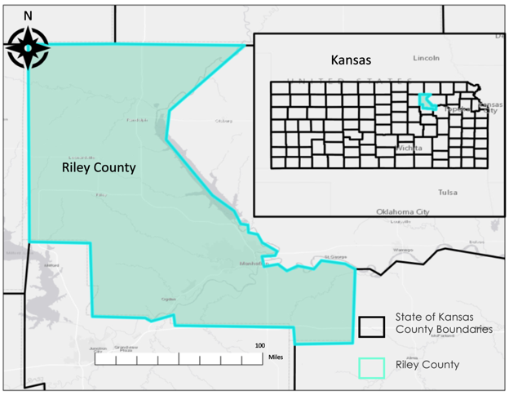

Figure 1. This map shows the study area, Riley County, Kansas. Boundaries are generalized.

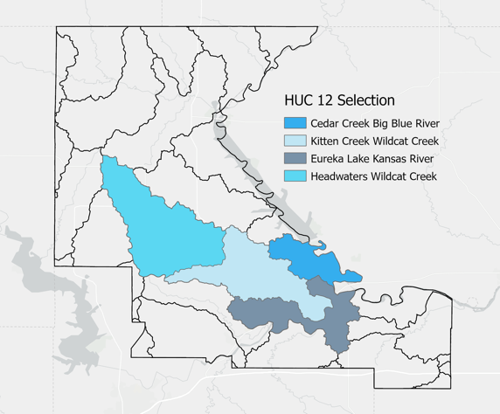

Figure 2. Hydrologic unit code 12 (HUC-12) watersheds in Riley County, Kansas.

***2.3 Project Partners***

This project included several partners working at different scales and with a variety of objectives. The City of Manhattan and Riley County work together to determine the best course of action to prevent future flooding in the Wildcat Creek Watershed, including upstream dam construction, downstream channel improvements and bridge replacements, targeted buyouts of homes and businesses, and non-structural measures such as improved flood prediction and emergency management tools. Kansas Forest Service provides technical assistance to landowners and natural resource agencies regarding watershed restoration and protection strategies. Kansas Department of Health and Environment (KDHE) develops statewide water quality standards, which includes identifying and prioritizing waterbodies and watersheds that may be impaired. Additionally, the Watershed Management Section of the KDHE provides expertise, assistance, and assessments of watershed restoration and protection strategies across the state to ensure groups are able to achieve water quality goals. The Riley County Conservation District works with Riley County landowners and residents to use natural resources responsibly by providing conservation planning, financial assistance, education, and representation in conservation policies and programs. Regardless of role, all of these local stakeholders are looking for more insight and tools to address increases in runoff and potential watershed degradation.

***2.4 Objectives***

The main objectives of this study were to compare CN calculation methods by creating synthetic LULC maps and an alternative dynamic CN data layer for the study area. The synthetic LULC maps demonstrate precise land cover change throughout the area, which can be used to visualize land use change over time to assess runoff correlation. The dynamic CN method used the Normalized Difference Vegetation Index (NDVI) to demonstrate seasonal changes in CN and to highlight the variability of runoff risk within the region. NDVI is a common proxy for measuring seasonal variation of vegetated land cover (Yin et al., 2012). This study utilized Landsat 5 and 8 missions to calculate NDVI derived from surface reflectance measurements.

Additionally, the project provided partners with a tutorial on how to create a dynamic CN data layer using a lookup table with NDVI measurements, as well as how to produce LULC maps using multiple sources. This allows partners or other users to update the maps in real-time as new data are made available. These tutorials may help inform the partners’ flood resiliency planning in the future.

# 3. Methods

***3.1 Data Acquisition***

The team utilized multiple sensors and ancillary datasets (Table 1) in order to calculate runoff CN. For the conventional method of CN calculation, the Cropland Data Layer (CDL) and the National Land Cover Database (NLCD) were used for LULC map synthesis. The CDL is released by the United States Department of Agriculture every year as a raster data layer including plant species type. The NLCD is released approximately every two to three years by the United States Geological Survey (USGS). Both datasets are created using Landsat imagery, *in situ* data, and other supplementary datasets. The gridded Soil Survey Geographical (gSSURGO) database is created by the USDA and is used for differentiating soil type. This database was used to determine the final CN from the LULC in the static CN tables (Appendix A). The dynamic CN calculations utilized Landsat 5 Thematic Mapper (TM), Landsat 7 Enhanced Thematic Mapper (ETM), and Landsat 8 Operational Land Imager (OLI) surface reflectance datasets to synthesize an NDVI aggregate layer from each rainy season between 2006-2020. These products are atmospherically corrected and available in Google Earth Engine.

Table 1

*Datasets Used to Calculate Conventional and Dynamic Curve Numbers*

|  |  |  |  |
| --- | --- | --- | --- |
| **Ancillary Dataset** | **Description & Use** | **Years Acquired** | **Source** |
| Cropland Data Layer (CDL) | Crop-specific land cover data layer used for agricultural land cover used in conventional CN analysis | 2006, 2008, 2011, 2013, 2016, 2019 | USDA |
| National Land Cover Database (NLCD) | Comprehensive, national land cover data product used for urban and non-agriculture land cover used in conventional CN analysis | 2006, 2008, 2011, 2013, 2016 | USGS |
| Gridded Soil Survey Geographic Database  (gSSURGO) | Data product differentiating soil types used in conventional CN analysis | 2020 | USDA-National Resources Conservation Service (NRCS) |
| LiDAR DEM Scans | High resolution scans used to differentiate farming techniques and slope | 2020 | Project Partners |
| **NASA Earth** **Observation Data** | | | |
| Landsat 5 TM | Surface Reflectance data utilized for NDVI in dynamic CN analysis | 2006-2012 | USGS via Google Earth Engine |
| Landsat 7 ETM+ | Surface Reflectance data utilized for NDVI in dynamic CN analysis | 2013 | USGS via Google Earth Engine |
| Landsat 8 OLI | Surface Reflectance data utilized for NDVI in dynamic CN analysis | 2013-2019 | USGS via Google Earth Engine |

***3.2 Data Processing***

The team used the tool “extract by features” in ArcGIS Pro to combine data from the NLCD and CDL. This tool allowed the team to extract all of the crop land use data from the CDL, including pasture/hay, grass/pasture, and other hay/non-alfalfa. For the NLCD layer, the team created two separate LULC layers. The first layer included all of the urban land use and open water. The second layer included all other NLCD land use categories. This ensured that there were no empty spaces when mosaicking the two datasets together. To ensure that none of the values would overlap between the NLCD layer and the CDL layer, the team multiplied the NLCD layer by 100, so that all the values would be in the thousands. The team then mosaiced the CDL cropland layer, the NLCD urban layer, and the NLCD layer with all other land use categories together. An attribute table was then built for the created raster.

To calculate CN using a conventional lookup table, the team used the newly created LULC data layer, a gSSURGO data layer, and a slope layer created from LiDAR scan provided by our partners (Figure 3). The hydrologic condition of the soil was exported from the gSSURGO dataset and then resampled. The slope layer was classified into three classes: a no data class, below 2% rise, and above 2% rise. The team combined the gSSURGO layer, the slope layer, and the LULC layer into a single raster layer with a dedicated attribute table. Each pixel combination was then assigned a CN based on the NRCS runoff CN lookup table (NRCS, 2004).

To calculate the phenology-based dynamic CN, the team used Google Earth Engine as a processing platform. The team imported the Riley County boundary shapefile, as well as the USGS Landsat 5 and Landsat 8 surface reflectance image collections. The data were filtered by date, from March to August of every year from 2006-2020, and a cloud mask function was applied to remove pixels contaminated by cloud reflectance over the study area. The two image collections from Landsat 5 and Landsat 8 were then merged to create a singular uniform data set with no temporal gaps. Next, the dataset was clipped to the Riley County boundary and the two Landsat scenes within the boundary were mosaiced to create a spatially uniform data set. The team then calculated NDVI, aggregating for each rainy season from March to September over each year to produce the average NDVI at the beginning and end of the rainy season and the maximum NDVI each year. Once the NDVI rasters were complete, the team exported the data to ArcGIS Pro (Figure 3). Within ArcGIS Pro, the team conducted raster math to calculate CN by inputting Equation 1 (Muche et al., 2019):

CNNDVI = -0.11 * NDVI + 100 (1)

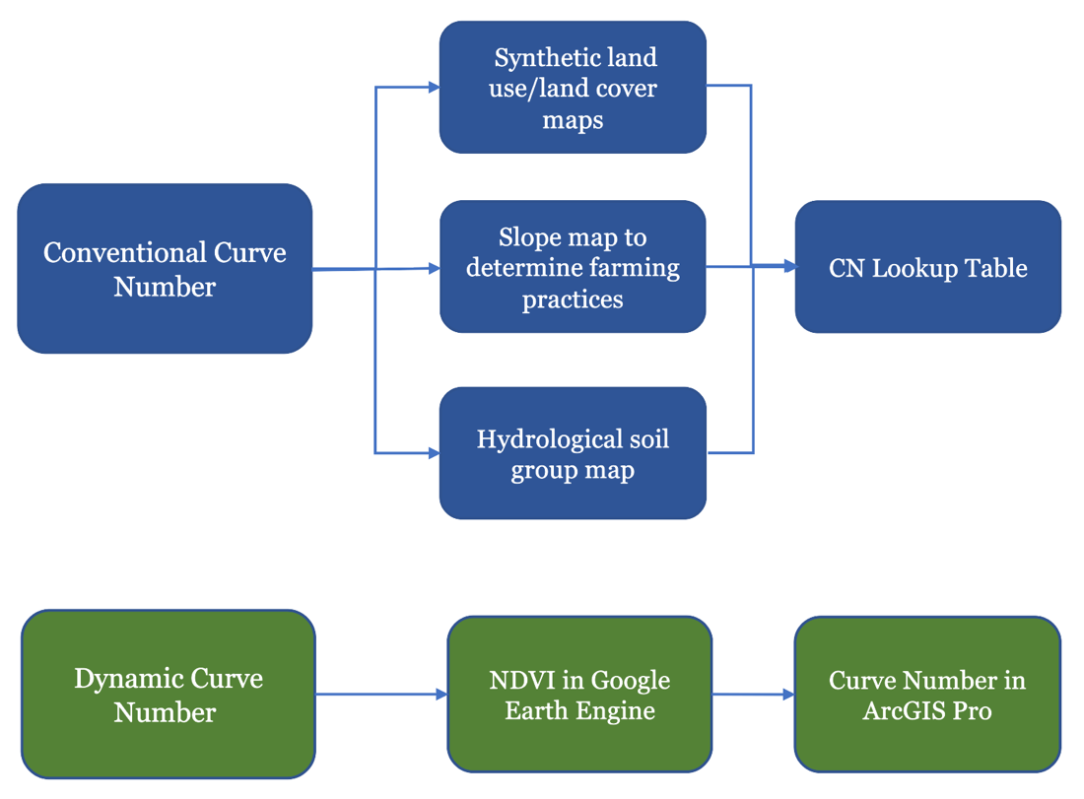

Figure 3. This figure demonstrates the methodology flow for the conventional and dynamic CN analysis

***3.3 Data Analysis***

The team conducted a temporal comparison of the conventional and dynamic CN at the county scale, as well as observed LULC change over time. For both the conventional and dynamic CN methods, the team conducted raster math and subtracted the 2006 CN maps from the 2019 CN maps to analyze the change in potential runoff over the study period. To analyze LULC change over time, the team used a similar method to subtract the 2006 LULC map from the 2019 LULC map to calculate overall percent changes in various LULC categories. The team also conducted zonal statistics at the HUC-12 watershed scale to identify watersheds that may be of particular importance to the project partners. This feasibility study did not conduct any validation of the analysis; however, the authors plan to further the study with validation using streamflow gauge data and through linear regression analysis.

# 4. Results

***4.1 Land Use and Land Cover***

The team created detailed LULC maps for the years 2006, 2008, 2011, 2013, 2016, and 2019 based on the availability of NLCD and the start of the CDL for Kansas in 2006. The map in Figure 4 shows the 2019 LULC maps created showing crop type, urban cover, forest cover, and other categories from the NLCD and CDL. Land use change was also evaluated from the synthetic LULC maps. Figure 5 shows the increase or decrease in land use by type from 2006 to 2019. Cropland cover increased by 13%, grass/pasture decreased by 11%, and urban development increased by 6%. According to this analysis, water and wetlands increased by 25% throughout the period. This is likely due to differences in the classification process received from the NLCD as wetland cover was further divided into more specific categories instead of physical changes in the land cover *in situ* for the county.

Figure 4. 2019 LULC map for Riley County using NLCD data and crop-specific cover.

*Figure 5: Change in main LULC types across Riley County from 2006 – 2019 based on area. Grass/pasture decreased by 11%, cropland increases by 13%, and urban/developed land increased by 6%.*

Figure 6: LULC changes across major categories in Riley County from 2006 - 2019.

Figure 7: Change in the most prevalent land cover, grass/pasture, from 2006-2019.

***4.2 Conventional Curve Number***

The team created CN change maps yearly, as well as a map demonstrating the overall change in the study area from 2006 to 2019 (Figure 8). For this 14-year period, 9,500 acres of land showed a decrease in CN, 10,600 acres showed an increase in CN, and 117,000 acres show no change in CN. It is important to note that the classification change in the NLCD from water to wetlands within the land use data caused the areas experiencing decreased runoff risk to appear inflated.

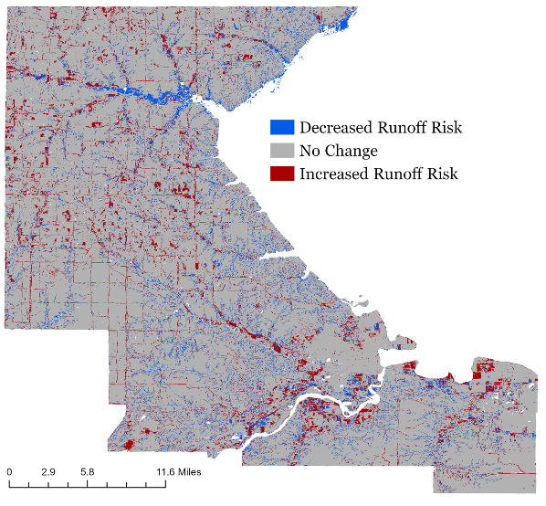

Figure 8: Conventional curve number runoff change from 2006 – 2019.

***4.3 Dynamic Curve Number***

Figure 9 highlights an overall increase in average CN from 2006 to 2019. However, some areas, shown in blue in the southeast portion of the county, demonstrate a decrease in CN. The study also calculated the maximum CN change for the early rainy season (March-May), shown in Figure 10, and the late rainy season (June-September), shown in Figure 11. Maximum potential CN was calculated in the early and late rainy season, as compared to average potential runoff annually, to highlight the greatest runoff risk and to compare extremes within the rainy season. Overall, the maximum CN decreased during both the early and late rainy seasons from 2006-2019. The early season displays a higher potential runoff risk overall, however, compared to the late season.

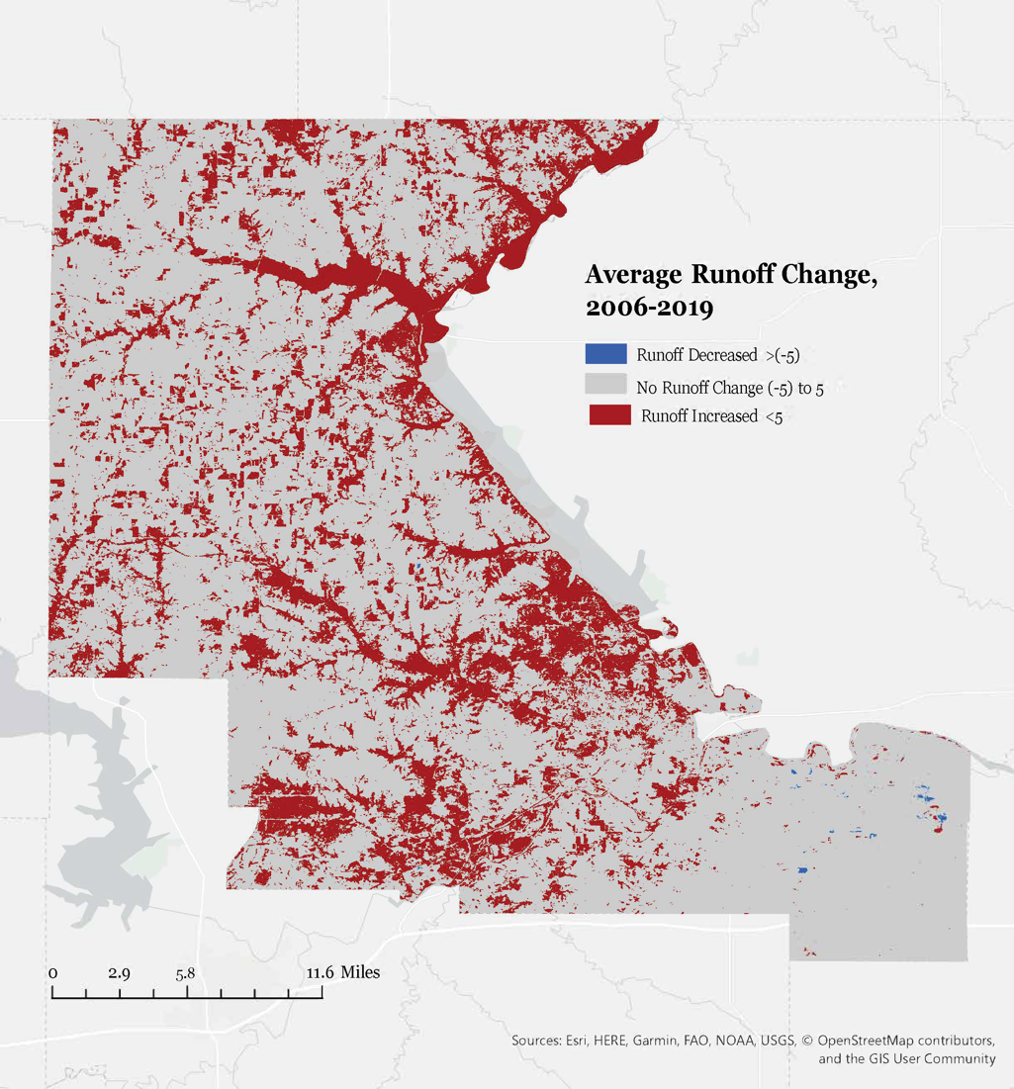

Figure 9. Dynamic method runoff curve number change from 2006 – 2019

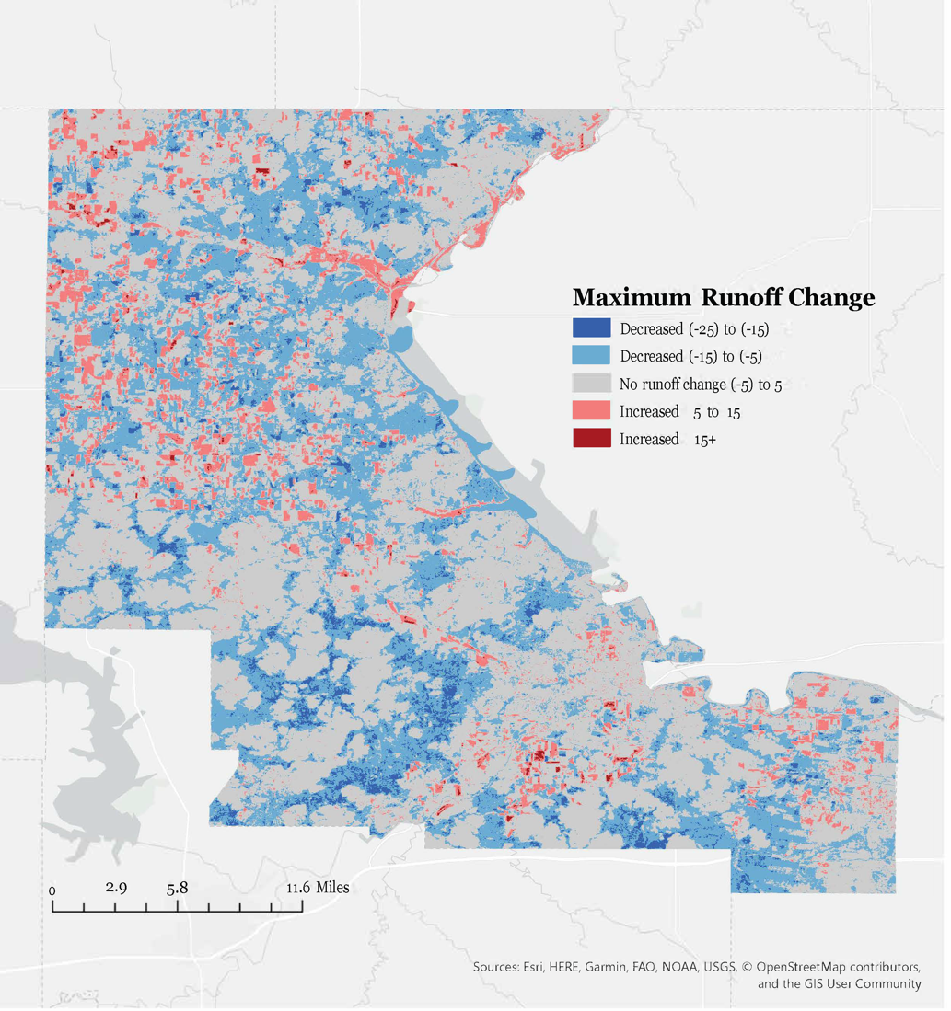

Figure 10. Dynamic method early season runoff curve number change from 2006 – 2019

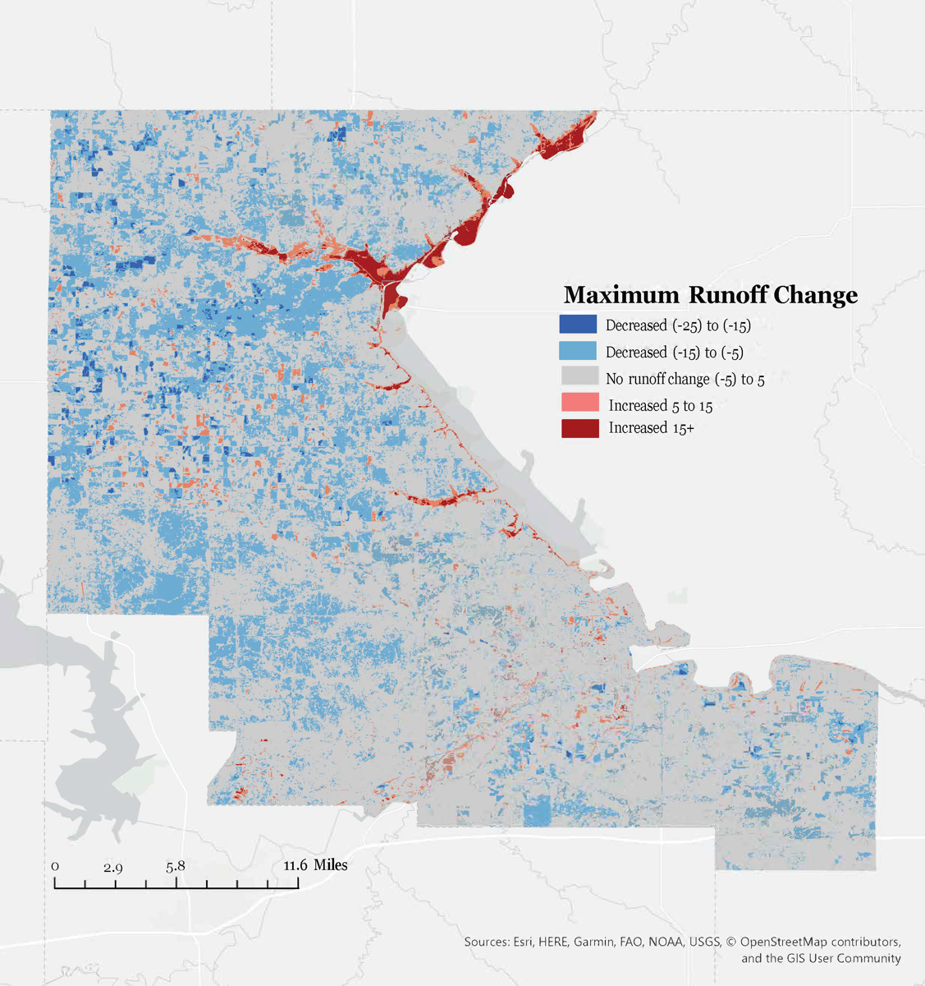

Figure 11. Dynamic method late season runoff curve number change from 2006 – 2019

Zonal statistics were calculated at the HUC-12 watershed level for four watersheds of interest for Riley County officials. These included Kitten Creek-Wildcat Creek, Eureka Lake-Kansas River, Cedar Creek-Big Blue River, and Headwaters-Wildcat Creek. Figure 12 displays mean annual conventional CN, mean annual dynamic CN, early rainy season mean dynamic CN, and late rainy season mean dynamic curve number for the four watersheds. These zonal statistics highlight the increased variability of the dynamic method. They also reveal higher CN across all watersheds during the early rainy season compared to the late rainy season. Some trends were consistent throughout the watersheds such including an overall increase in CN using both methods and yearly trends such as a decline in CN 2016. The team also conducted zonal statistics at the HUC-12 watershed scale to identify watersheds that may be of particular importance to the project partners (Figure 13).

Figure 12. Timeseries representing the average runoff curve numbers for the four HUC-12 watersheds of interest for the conventional method and dynamic method in full, early, and late rainy seasons.

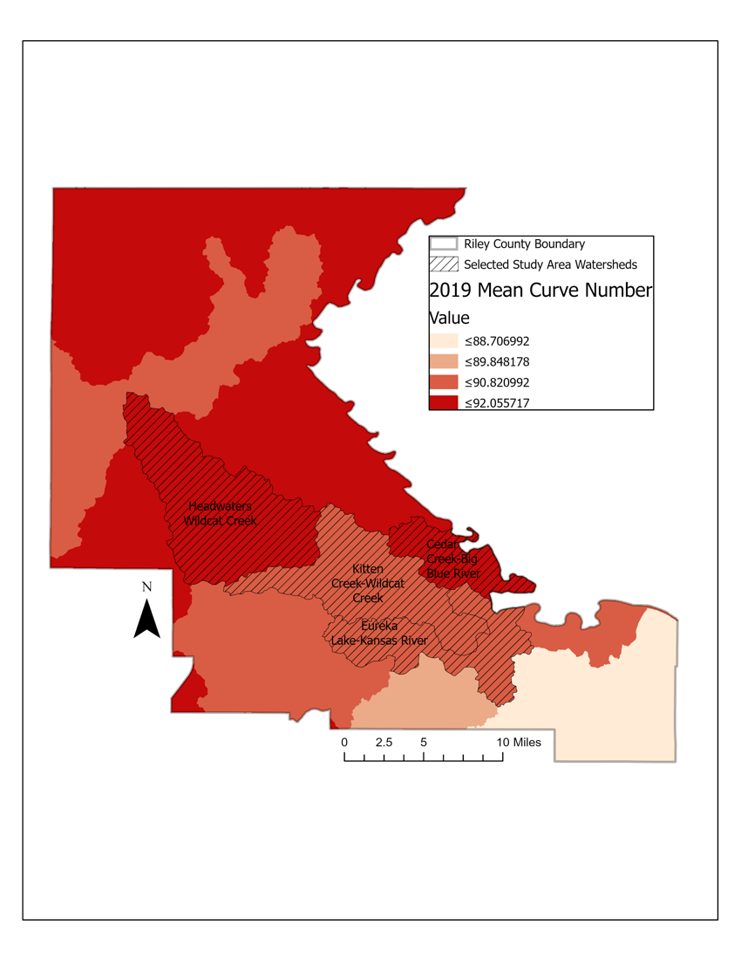

Figure 13: Mean curve numbers for the four HUC-12 watersheds of interest in 2019.

**5. Discussion & Conclusions**

***5.1 Land Use Land Cover***

Over the study period, Riley County had many land use and land cover changes. An especially important trend to note is the increase in urban land cover. Though not the largest land cover class in the county, urban land cover has the highest impervious surface percentage which correlates to more runoff and less infiltration. The 6% increase in urban land cover contributes to higher CN and a higher potential for flooding. Grass/pasture was the most prevalent land cover type, which was expected as the county is mostly prairie. This cover decreased by 11% or 25,294 acres throughout the study period. The decrease in this major ecosystem has the potential to disrupt local ecology and increase flood risk as the land cover changes. The increase in cropland (agricultural land not including ranch or pasture) reflects the expansion of agriculture throughout the region. The 13% increase in cropland could be contributing to increased flooding if the land was previously a natural ecosystem that provided more infiltration. Crop type could also impact flooding if more land is used for crops with less infiltration. Forest cover increased 25% over the study period from 2006 to 2019. As Riley County is not traditionally a forested ecosystem, this is likely due to invasive plant species such as the cedar trees reported by local partners.

***5.2 Conventional Curve Number vs Dynamic Curve Number Methodology***

When employing the conventional CN methodology using static lookup tables, the study found an increase in CN in 2.67% of the county from 2006-2019 and a decrease in 2.38%. This decrease is likely inflated due to the previously mentioned change in wetland classification for NLCD particularly in the northern portion of the state around waterways. The increase in CN based on static tables reflects the transition to land cover types with less infiltration causing a higher potential for floods. These changes are measured gradually as they are only recalculated on year-to-year data availability and are not typically variable. The increase in CN in Riley County over the 13-year study period demonstrates that LULC changes have an immediate impact on runoff and also on flooding risk. Across the county, the areas with increased CN and those downstream need to be targeted for flood prevention and monitoring due to this increase in flood risk.

According to the dynamic NDVI-based CN calculation, Riley County experienced an overall net increase in CN, and therefore runoff risk, in the county between 2006 and 2019. This mirrors the LULC change over the study period, with increases in impervious surface area representing the highest runoff potential. NDVI changes more frequently than the static elements incorporated into the conventional CN calculation method. As a result, runoff potential has greater variability and shows a larger margin of CN change when calculated using the dynamic method. This is advantageous for mapping incremental runoff change and subsequently highlighting areas for flood resiliency planning that might have the greatest runoff risk.

Another advantage of the dynamic method is that shows seasonal variation within rainy seasons, as well as between them. The comparison between the early and late rainy season year-to-year displayed a greater runoff risk in the early rainy season, particularly in the northern upland region of the county. These results further pinpoint the scope of flood resiliency planning. It is important to note, however, that a drought in any year would have affected the NDVI result and changed the maximum CN runoff risk. This is likely the case where there is a clear increase in runoff risk in the late rainy season surrounding the water channels in the northern portion of the county (Figure 11). This was surprising because NDVI over water should not change. However, if these areas were experiencing drought conditions, riparian vegetation could be negatively impacted, reducing the ability of a riparian buffer to infiltrate and mitigate runoff beyond the channel beds.

The study further analyzed CN runoff patterns in four HUC-12 watersheds upstream of the city of Manhattan. Throughout these watersheds, the early season consistently demonstrated higher runoff risks and average CN. The higher runoff risk in the early rainy season suggests that flood risk is higher during the months from March to May due to runoff. This may be attributed to new crop establishment in the early spring growing season and more mature crops in the later growing season changing phenological cycles. It could also be due to changes in extreme precipitation, something this study did not cover at this time. The HUC-12 comparison highlighted the increased potential for variability in the dynamic method as seen with increased fluctuations in CN reported.

While this study did not pursue validation of the conventional and dynamic methods, each method allowed us to compare and contrast areas of concern in the watersheds. This study highlighted the enhanced variability of the dynamic method compared to the conventional method. This variability should be considered a positive benefit of the dynamic method, as it allows for a wider range of accounting for phenological changes in the landcover that plays an integral role in runoff. The conventional method does not allow for seasonal analysis and can only be calculated on year-to-year changes, whereas the dynamic method can be updated much more frequently, in sync with Landsat’s repeating 16-day acquisition. Overall, the dynamic method allowed for more granular temporal analysis and allows researchers to track seasonal changes in relation to the flooding and growing season for the study area. The conventional method, however, requires inputs that help researchers better understand the specifics of the landscape. The dynamic method only tells us about change in NDVI; the conventional method sheds light on the LCLU changes that might be responsible for the NDVI change, impervious surface change, and landscape contour changes that potentially indicate tillage changes that alter the slope and runoff drainage in the watershed.

***5.3 Relevance for Partners***

This study expands upon the previous work of Muche, et al. (2019) by providing a detailed analysis of crop species and by employing dynamic CN calculations on a varied land cover region. Specifically, this study examined changes in LULC and runoff risk in order to inform future resiliency planning and strategies to mitigate and avoid future floods for our partners in the Riley County community. Flood resiliency planning can be more informed with seasonal runoff risk analysis. This study’s analyses and maps will help local stakeholders and decision makers in Riley County better utilize CN maps to pinpoint areas of highest risk and prioritize their planning efforts.

***5.4 Limitations and Future Work***

Runoff and flooding are complex processes with multiple contributing factors. The main focus of this study was to determine the impact of LULC change over time on runoff potential. However, a multitude of factors, including precipitation frequency and intensity, and natural disasters, also have the potential to impact runoff. The study area was at a county scale and covered multiple catchments and watersheds. The interactions of these factors at this broad scale make it difficult to identify specific LULC changes that may have the most impact on flooding (Viglione et al., 2016). The study area includes many agricultural lands where information on specific farming practices, such as tillage, is limited. Tillage practices impact runoff because the amount of organic matter on the soil’s surface can lead to changes in infiltration rates. A future study could incorporate tillage practices to provide a more detailed understanding of CN through the agricultural lands in the study area. Future work could also focus on modeling runoff with the Soil and Water Assessment Tool (SWAT+). This would allow researchers to quantify the environmental impacts of changes in land use, land management practices, and local climate on the watershed scale and to model the hydrologic impacts of future changes. Further research on precipitation would be valuable to understand how changes in rainfall frequency and intensity may be impacting runoff separately from land use and land cover changes. This study did not use any *in situ* data for ground truthing. Runoff or flood gauge data could be included in future studies, especially the data from localized flooding events. A further step would be to develop a new equation using streamflow data to calibrate the dynamic CN results. The municipal partners reported an observed decline in forest quality across the state. This study was not able to address these concerns, so a future study should identify hydrological parameters that may be affecting the forests. The recent extreme floods could play a role in the decline of forest quality, so future work could focus on mapping LULC change pre- and post-flood using the methodology outlined here.

# 6. Acknowledgments

The authors would like to thank NASA DEVELOP Fellow Sydney Neugebauer for her guidance and coordination of this project. We would also like to acknowledge the contributions made by Dr. Kenton Ross of NASA Langley Research Center, who served as a scientific advisor for this research.

Any opinions, findings, and conclusions or recommendations expressed in this material are those of the author(s) and do not necessarily reflect the views of the National Aeronautics and Space Administration.

This material is based upon work supported by NASA through contract NNL16AA05C.

# 9. References

Briggs, J. M., Blair, J. M, & Horne, E. A. (2016). Ecohydrological and climate change studies at the Konza Prairie Biological Station. *Transactions of the Kansas Academy of Science (1903-). Vol. 119, No.* 1, Ecohydrology Symposium Issue (Winter 2016), pp. 5-11. <https://www.jstor.org/stable/24887836>

Brody, S., Blessing, R., Sebastian., A., & Bedient, P. (2013). Examining the impact of land use/land cover characteristics on flood losses. *Journal of Environmental Planning and Management,* 57(8), 1252-1265. <https://doi.org/10.1080/09640568.2013.802228>

Easterling, D. R., J. R. Arnold, T. Knutson, K. E. Kunkel, A. N. LeGrande, L. R. Leung, R. S. Vose, D. E. Waliser, & M. F. Wehner. (2017). Precipitation Change in the United States. Climate Science Special Report: Fourth National Climate Assessment, Volume I. Wuebbles, D. J., D. W. Fahey, K. A. Hibbard, D. J. Dokken, B. C. Stewart, and T. K. Maycock, Eds., U.S. Global Change Research Program, Washington, DC, USA, 207–230. <https://doi.org/10.7930/J0H993CC>

Gonzalez, A., Temimi, M., & Khanbilvardi, R. (2015). Adjustment to the curve number (NRCS-CN) to account for the vegetation effect on hydrological processes. *Hydrological Sciences Journal*, 60(4), 591-605. <https://doi.org/10.1080/02626667.2014.898119>

Kansas State University. (2020, May). Kansas Climate Basics. Retrieved June 29, 2020, from <http://climate.k-state.edu/basics/>

Muche, M., Hutchinson, S. L., Hutchinson, J. M. S., & Johnston, J. M. (2019). Phenology-adjusted dynamic curve number for improved hydrologic modeling. *Journal of Environmental Management, 235*, 403-413. https://doi.org/10.1016/j.jenvman.2018.12.115

Natural Resources Conservation Service (Comp.). (2004). Chapter 9: Hydrologic Soil-Cover Complexes. In National Engineering Handbook (Vol. Part 630 Hydrology). United States Department of Agriculture.

Riley County Government (Ed.). (2009). Chapter 5: Agricultural Preservation and Rural Character. In Vision 2025: A Comprehensive Plan for Riley County, Kansas. Kansas: The Riley County Planning Board. doi: https://www.rileycountyks.gov/DocumentCenter/View/1539/K---V2025-Chapter-5-Ag-Preserv-and-Rural-Character

Soil Survey Staff. Gridded Soil Survey Geographic (gSSURGO) Database for *Kansas*. United States Department of Agriculture, Natural Resources Conservation Service. Available online at https://gdg.sc.egov.usda.gov/. June 30, 2020.

United States Department of Agriculture, National Agricultural Statistics Service Cropland Data Layer. (2006-2019). *Published crop-specific data layer*. [Data Set]. Retrieved on June 25, 2020, from <https://nassgeodata.gmu.edu/CropScape/>

US Geological Survey. (20XX). USGS Landsat 5 ETM Surface Reflectance Tier 1. US Geological Survey Earth Resources Observation and Science Center. Accessed through Google Earth Engine. <https://code.earthengine.google.com/?scriptPath=Examples:Datasets/LANDSAT_LT05_C01_T1_SR>

US Geological Survey. (2014). USGS Landsat 8 OLI/TIRS Surface Reflectance Tier 1. US Geological Survey Earth Resources Observation and Science Center. Accessed through Google Earth Engine. <https://code.earthengine.google.com/?scriptPath=Examples:Datasets/LANDSAT_LC08_C01_T1_SR>

Verma, S., Verma, R.K., Mishra, S.K, Singh, A., & Jayaraj, G.K. (2017). A revist of NRCS-CN inspired models coupled with RS and GIS for runoff estimation. *Hydrological Sciences Journal*, 62(12), 1891-1930. <https://doi.org/10.1080/02626667.2017.1334166>

Viglione, A., B. Merz, N. Viet Dung, J. Parajka, T. Nester, & G. Bloschl (2016). Attribution of regional flood changes based on scaling finger-prints. *Water Resourc*es *Research,* 52, 5322–5340. <https://doi.org/10.1002/2016WR019036>

Wang R, Kalin L, Kuang W, Tian H. (2014). Individual and combined effects of land use/cover and climate change on Wolf Bay watershed streamflow in southern Alabama. Hydrological Processes, *228*(22), 5530–46. <https://doi.org/10.1002/hyp.1005>

Yin, H., T. Udelhoven, R. Fensholt, D. Pfugmacher, and P. Hostert. (2012). How normalized difference vegetation index (NDVI) trends from Advanced very high resolution radiometer (AVHRR) and Systeme Probatoire d’Observation de la Terre VEGETATION (SPOT VGT) time series differ in agricultural Areas: A Inner Mongolian Case Study. *Remote Sensing, 4,* 3364-3389. <https://doi.org/10.3390/rs4113364>

# 10. Appendix

Traditional Curve Number Calculation

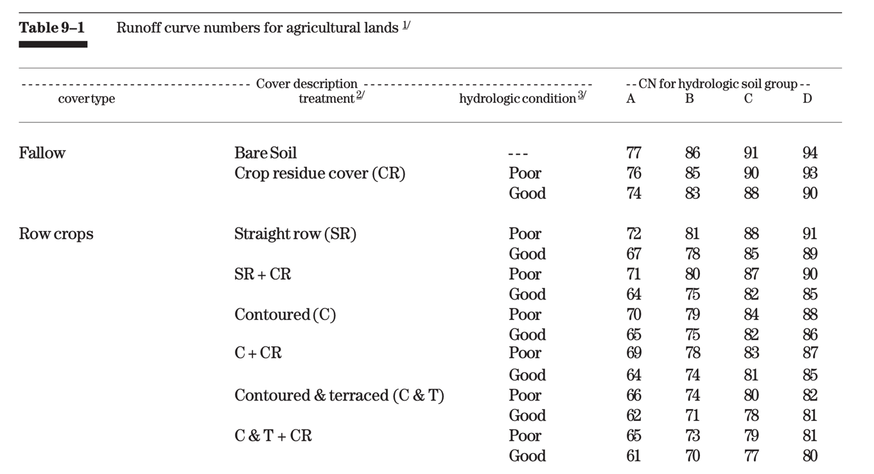

Figure A1: Curve Number Lookup Table for Agricultural Lands (NRCS, 2004)

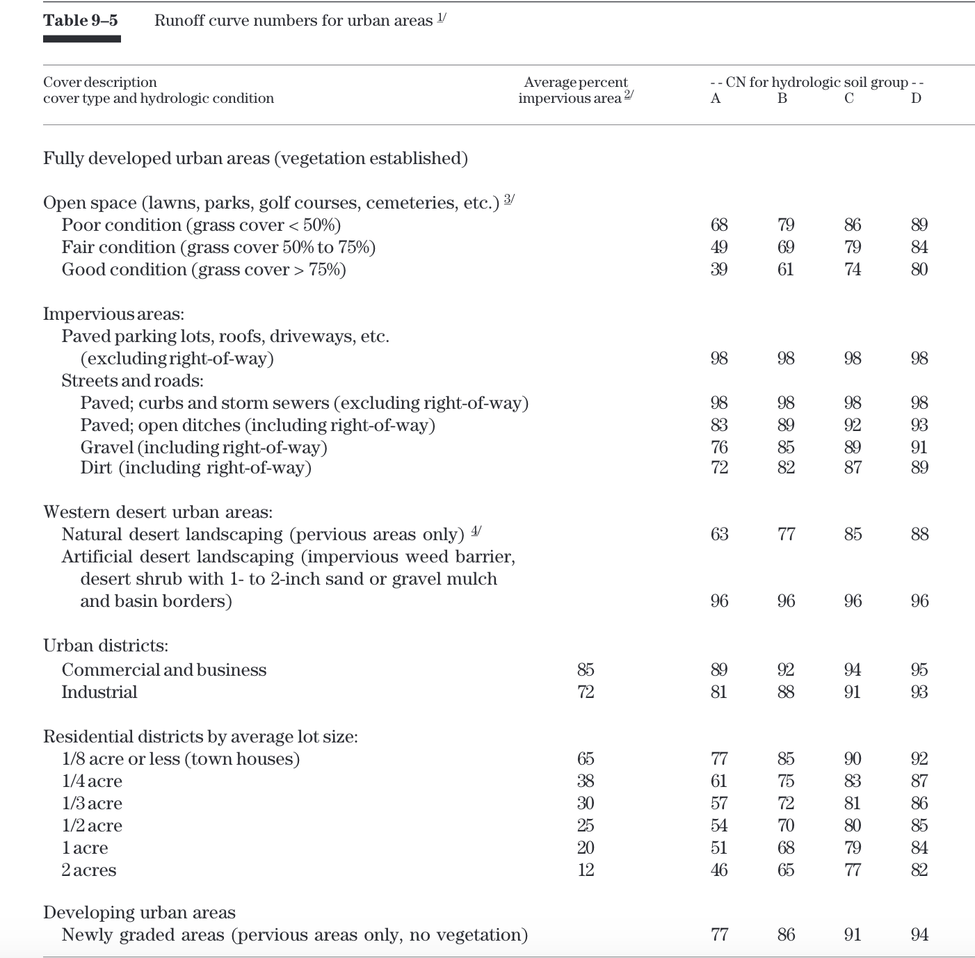

Figure A2: Curve Number Lookup Table for Urban Land Cover (NCRS, 2004)