NASA DEVELOP National Program
Virginia – Langley
Fall 2017

Shenandoah Health & Air Quality II
Monitoring Air Quality in Shenandoah National Park to Address National Park Service Initiatives Using Earth Observations


Technical Report
Final Draft – November 16, 2017

Emily S. Doerner (Project Lead)
Andrew Bonifas
James Ficklin
Nick Gulston
Roger Johnson
Sarah Phillips

Dr. Bruce Doddridge (NASA Langley Research Center)
Dr. Rich Ferrare (NASA Langley Research Center)
Dr. Kenton Ross (NASA Langley Research Center)

Previous Contributors:
Ellen Bubak
Amanda Clayton
Doug Gardiner
Nicholas Lenfant
Julie Terhune

1. Abstract
Air quality is considered one of Shenandoah National Park’s most fundamental resources. The park’s ecological health and visitor attendance are dependent on maintaining high air quality standards. This project utilized NASA’s aerosol optical depth (AOD), aerosol extinction profile, and tropospheric ozone residual (TOR) datasets to create a long-term analysis of air quality in the park from May 2007 through August 2017. This analysis was two-fold: to identify trends in visibility and ground-level ozone throughout the park. In situ station data from Big Meadows monitoring station and 30 Automated Surface Observing System (ASOS) stations located within a 200 km radius of Shenandoah National Park were used to validate NASA’s Earth observations. A tutorial on how to download, subset, and analyze AOD and TOR datasets was created to help park staff incorporate remote sensing data into their management practices related to air quality concerns. This project provided statistical and quantitative support for incorporating satellite data into Shenandoah National Park’s current air quality monitoring efforts and will aid in future decisions related to visitor education and ecological management.

Keywords
Ozone, visibility, TOR, AOD, MERRA-2, remote sensing, Shenandoah National Park

2. Introduction
  - Background Information
Each year over 1 million visitors flock to Shenandoah National Park. The 500 km² national park (Figure 1), is one of Virginia’s most popular tourist attractions – well-known for its scenic drives and astonishing views of the Blue Ridge Mountains. In 1977, under the Clean Air Act (CAA), Shenandoah National Park was classified as a Class I area in an attempt to prevent and reduce anthropogenic visibility impairment. The park is responsible for analyzing long-term visibility and air quality trends, identifying sources of pollutant and visibility impairment, and monitoring visibility and air quality conditions (National Park Service, 2015). The park has struggled to maintain high levels of air quality, leading to concerns over the health of wildlife and visitors. From 1997 to 2001, Shenandoah National Park did not meet its required air quality standards necessary for protecting plant and animal health and welfare (Sullivan, 2003). Since then, the park has been committed to improving its overall air quality.
In addition to using ground station measurements from the Interagency Monitoring of Protected Visual Environments (IMPROVE) program and Environmental Protection Agency’s Clean Air Status and Trends Network (CASTNET) to measure visibility impairment and ozone (O₃), Shenandoah National Park partnered with NASA DEVELOP to use NASA Earth observations to monitor air quality in the park. This study, expands on a previous DEVELOP project that used NASA Earth observations to observer ozone, nitrogen dioxide (NO₂), and sulfur dioxide (SO₂) in Shenandoah National Park. This project continued to monitor air quality with NASA Earth observations by calculating visibility and ground-level ozone in Shenandoah National Park and the surrounding area.
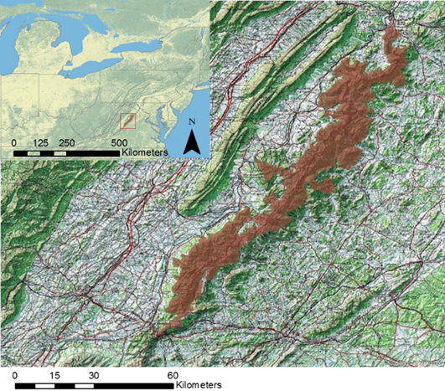
Figure 1. Shenandoah National Park and its airshed

Impaired visibility is aesthetically displeasing and has the potential to detract visitors from visiting the park (Kessner, 2013). Visibility is defined as the greatest horizontal distance at which it is possible to observe and identify a particular object with the naked eye (Bennett, 2012; Kessner, 2013). Visibility is directly dependent on the accumulation of aerosols – the visible components in the atmosphere, – in a given area (Retalis, 2010). In Shenandoah National Park, sulfate aerosols scatter the amount of visible light, under the Rayleigh scattering regime, leading to the blueness of the sky, or lack thereof (Sullivan, 2003). Past studies (Retalis, 2010; Kessner, 2013; Komeilian, 2014; He, 2016) have attempted to quantify surface visibility with remotely-sensed vertical atmospheric integrated extinction coefficient, or aerosol optical depth (AOD), and modeled aerosol vertical profiles based on the understanding that higher AOD values indicate lower visibility (Retalis, 2010; Kessner, 2013).
Visibility degradation in Shenandoah National Park can be caused by local sources, meteorological conditions, or by plumes and layered haze from remote areas carried to the park through Shenandoah’s airshed. Airsheds are geographic areas affected by the same air mass based on topography, meteorology, and climate (Civerolo, 2003; Sullivan, 2003; Komeilian, 2014). Likewise, ground-level ozone varies greatly with vegetation, season, climate, elevation, and latitude. Ground-level ozone also possesses significant health concerns for plants, animals, and humans. Exposure to high ozone levels irritates the respiratory system, can worsen asthma symptoms, and can cause permanent lung damage. Ground-level ozone can also stunt plant growth and damage plant foliage, leaving plants more vulnerable to other environmental stressors like drought, insects, and diseases (Sullivan, 2013). Understanding the extent and distribution of impaired visibility and ground-level ozone in Shenandoah National Park is necessary for the park to continue to protect its natural resources, deliver accurate air quality warnings to its visitors, and maintain its legal Class I area air quality standards.
It is difficult to quantify the spatial distribution of ozone and impaired visibility. Shenandoah National Park currently relies on a single ground monitoring station at Big Meadows to collect air quality data for the entire 500.8 km² park (National Park Service, 2015). With only one monitoring station, it is difficult to provide adequate visibility and ozone measurements across the large and diverse landscape that is Shenandoah National Park. Satellite data can supplement in situ data in areas of the park that lack sufficient spatial coverage to more accurately monitor these air quality indicators (Kessner, 2013). NASA Earth observations can be used to monitor surface visibility and ozone levels in the park and better characterize current air quality conditions, identify key sources of pollution, and document long-term trends.
Unlike previous studies, this project utilized Koschmieder’s Law (Equation 1) to calculate surface visibility using only vertical aerosol extinction profiles, or simply extinction profiles (Bennett, 2012), from NASA’s Modern-Era Retrospective analysis for Research and Applications, Version 2 (MERRA-2) model. Case studies of surface visibility were also calculated from AOD generated from MERRA-2 and MODIS (MODerate resolution Imaging Spectroradiometer) data, onboard the Aqua and Terra satellites. This additional analysis gave confidence to our study and provided our partners with multiple options to calculate surface visibility in the future. To quantify ground-level ozone in the park, we used tropospheric ozone residual (TOR) measurements derived from satellite data (Ziemke, 2006).
This two-part project examined visibility and ground-level ozone in Shenandoah National Park and its airshed. The first part utilized MERRA-2 and MODIS data to create maps showing surface visibility in 2015, which will help determine the feasibility of long-term visibility monitoring projects in the park. The second part used TOR datasets to create trend maps of tropospheric ozone levels from January 2007 to December 2016. This historic record help identify ozone trends and patterns in Shenandoah National Park as well as anomalous months and seasons. Incorporating satellite data into the national park’s air quality reporting efforts will improve their ability to accurately monitor air quality, and will create a foundation for further health and air quality studies.
  - Project Partners & Objectives
This project collaborated with Shenandoah National Park and the National Park Service’s Air Resources Division, Research and Monitoring Branch. The partners’ primary concerns were air quality, discernibility of scenic views, and the health of visitors and inhabitants of the park. As part of NASA’s Health and Air Quality application area, this project used NASA Earth observations to improve the understanding of visibility and ground-level ozone levels in Shenandoah National Park to aid in the improvement of air quality and environmental health. This project established effective ways to incorporate remotely-sensed data into the park’s interpretation and education program to inform visitors of health and air quality issues through the creation of trend maps and a visibility predictor method.

3. Methodology
In 1977, an amendment to the CAA established Class I Areas for wilderness areas greater than 5,000 acres, including Shenandoah National Park. Class I Areas are afforded special environmental protections, including from additional air pollution. To appropriately regulate air quality in Shenandoah National Park and other Class 1 Areas and to identify sources of air pollution in Class 1 Areas, it is critical to identify the airsheds that affect these areas. Because there are no clear boundaries in the atmosphere and air masses travel great distances, it is difficult to designate a single area as an airshed.

For the purpose of this project, we designated -88.0, 34.5 to -71.0, 34.5 as Shenandoah’s airshed. We arrived at this location based on a 2003 report on air quality in Shenandoah National Park (Sulluvan, 2003) and on talks with Shenandoah National Park’s Air & Water Program Manager. This area includes sources of both stationary and transport air pollution to the park. This airshed is large enough to revel where air pollution affecting Shenandoah National Park originates, and small enough to highlight pollution accumulating in the park from near-by industrial and metropolitan areas.

3.1 Data Acquisition
This project incorporated both in situ and remotely-sensed satellite data to create a more robust and accurate air quality study (Tables 1 & 2).

3.1.1 Visibility
Shenandoah National Park provided the team with daily in situ measurements of standard visual range (SVR) from January 2007 to December 2015, in km, from Big Meadows through the IMPROVE program. The program uses an algorithm to estimate light extinction based on fine and coarse particles in air samples.

For our study, we selected 30 automated surface observing system (ASOS) collection points located at airports within 200 km of the park that range in elevation from 92 m to over 1,100 m. The visibility data (in km) were downloaded from Iowa’s State University’s Iowa Environmental Mesonet (IEM) website as text files for each individual station. We then imported the individual text files into Microsoft Excel for analysis.

We acquired daily, Level-2 MODIS AOD data with a spatial resolution of 10 km by 10 km from the Level-1 and Atmosphere Archive and Distribution System (LAADS) Distributed Active Archive Center (DAAC). We used FileZilla to batch download all HDF5 files from January to December of 2015.

We obtained daily, global MERRA-2 AOD data from the Goddard Earth Sciences Distributed Active Archive Center (GES DAAC). This dataset has a spatial resolution of approximately 60 km by 50 km. We used the Firefox extension, DownThemAll, to batch download all netCDF files from January to December of 2015.

The standard MERRA-2 dataset, available from the GES DAAC, does not contain vertical aerosol extinction profiles, hereto referenced as extinction profiles. We obtained global MERRA-2 extinction profiles from Dr. Hongyu Liu (NASA Langley Research Center). He used the NASA Center for Climate Simulation (NCCS) computer to generate extinction profiles at 532 nanometers (nm) from MERRA-2 aerosol mixing ratios. The final MERRA-2 extinction profiles have a spatial resolution of approximately 60 km by 50 km. We used the Firefox extension, DownThemAll, to batch download all netCDF files from January to December of 2015.

Table 1. Visibility datasets used in this study
Data Product | Spatial Resolution | Temporal Resolution | Temporal Study Area
Big Meadows (IMPROVE) SVR | N/A | Every three days | January 2007 - December 2015
MODIS AOD, Level 2 | 10 km x 10 km | Daily | January - December 2015
MERRA-2 AOD  (M2I3NXGAS) | 60 km x 50 km | Daily | January - December 2015
MERRA-2 extinction profiles (M2T1NXAER) | 60 km x 50 km | Daily | January - December 2015
ASOS Visibility | N/A | Every 20 minutes | January - December 2015

3.1.2 Ozone
Shenandoah National Park provided hourly in situ measurements of ozone parts per billion (ppb) concentration from Big Meadows from January 2007 to December 2016 collected through CASTNET.

We downloaded monthly global averages of TOR, in Dobson Units (DU), from NASA Goddard’s Homepage for Tropospheric Ozone, Chemistry and Dynamics Branch, curated by Dr. J.R. Ziemke. The TOR measurements were derived from the Microwave Limb Sounder (MLS) and the Ozone Monitoring Instrument (OMI) sensors onboard the Aura satellite by subtracting MLS stratospheric column ozone (SCO) from OMI’s total column ozone (TCO). To extract the TOR from the website and convert it into a format readable with ArcGIS, monthly data from January 2007 to December 2016 were manually downloaded as individual text files.

We acquired non-gridded Level-2, global MERRA-2 surface and tropopause pressure data from the GES DAAC. This dataset has a spatial resolution of approximately 60 km by 50 km. We used the Firefox extension, DownThemAll, to batch download all netCDF files from January 2007 to December 2016.

Table 2. Ozone datasets used in this study
Data Product | Spatial Resolution | Temporal Resolution | Temporal Study Area
Big Meadows (CASTNET)  O_{3 in} ppb | N/A | Hourly | January 2007- December 2008
TOR in DU | 1° x 1.25° | Monthly | January 2007- December 2008
MERRA-2 surface and tropopause pressure in hPa (M2I1NXASM) | 60 km x 50 km | Daily | January 2007- December 2008

3.2 Data Processing
3.2.1 Visibility
In Microsoft Excel, we extracted all SVR values for 2015 from the Big Meadows IMPROVE dataset to compare with the satellite data. Also in Microsoft Excel, we extracted all 2pm values for all 30 ASOS stations from January to December of 2015. The extracted values for both datasets were compiled into a master data sheet.
MERRA-2 AOD was converted from netCDF files into rasters with a Python script and ArcPy. MERRA-2 raster data were projected into the geographic coordinate system WGS 1984 and subset to Shenandoah National Park’s airshed.
MODIS AOD was unpackaged, gridded, and converted from HDF5 files into geotiffs using the HDF-EOS to GeoTIFF (HEG) conversion tool. Using a Python script, all newly created rasters of MERRA-2 AOD were projected into the geographic coordinate system WGS 1984 and subset to Shenandoah National Park’s airshed.
MERRA-2 extinction profiles were unpackaged from their original 4D netCDF files into rasters in R using the GDAL and raster libraries for R. The newly created rasters were then projected into the geographic coordinate system WGS 1984 and subset to Shenandoah National Park’s airshed.
3.2.2 Ozone
In Microsoft Excel, we extracted all 1pm ozone values from the Big Meadows CASTNET dataset to compare with the satellite data. MERRA-2 surface and tropopause pressure data were converted from netCDF files to rasters with a Python script and ArcPy. MERRA-2 raster data were projected into the geographic coordinate system WGS 1984 and subset to Shenandoah National Park’s airshed.

We used the GDAL library in Python to write a script to batch convert TOR text files into GeoTiffs by extracting the data for each latitude and longitude in the text file and converting it into an array. Using the GDAL command ‘warp’ we converted the arrays into raster files. Each raster layer was projected into the geographic coordinate system, WGS 1984. We then subset each raster layer to Shenandoah National Park’s airshed. Lastly, each raster was converted into a point shapefile so that the Kriging method could be applied.

3.3 Data Analysis
3.3.1 Visibility
In order to give the park the best possible remotely-sensed visibility methodology, we selected a single day as a case study in which to compare our three visibility data sets against the IMPROVE SVR measurements from Big Meadows. We selected June 10, 2015 because the IMPROVE data estimated the SVR on that day in km. We wanted to test our methods on a poor visibility day because the park is more concerned with identifying impaired visibility as opposed to recording good visibility.

We calculated visibility using Koschmieder’s Law (see Equation 1), which relates the maximum visibility of an object to extinction coefficients (Bennett, 2012; Kessner, 2013).

${\text{C}}_{\text{T}}\text{ = }{\text{e}}^{\text{ –βV}}$ (1)

In this equation, C_{T} is the observer’s contrast threshold, V denotes visibility in meters, and β is the atmospheric extinction coefficient in m-1. Koschmieder’s Law accepts the minimum contrast identifiable by an observer in the daytime is 0.05 (Bennett, 2012). Assuming C_{T} = 0.05, this formula can be rearranged to make visibility the subject of Equation 2:

$\text{V=3/}{\text{b}}_{\text{ext}}$ (2)

Here V again demotes visibility and b_{ext} is the atmospheric aerosol extinction coefficient. AOD can be converted into an extinction coefficient using Equation 3 (Kessner, 2013):

${\text{b}}_{\text{ext}}\text{ = 0.46*AOD+1}$ (3)

In Python, MERRA-2 AOD was converted into visibility by first applying Equation 2 and then Equation 3 to all rasters.

Equation 2 was applied using ArcGIS’ raster calculator to convert MODIS AOD to extinction profiles. We then used Equation 3 to convert the extinction profiles into surface visibility in kilometers. Aqua and Terra MODIS images were stitched together to get full coverage of the study area.

In R, we used Equation 2, based off Koschmieder’s Law (see Equation 1) to calculate visibility based on MERRA-2 extinction profiles. The newly calculated visibility data in kilometers were then compared to the measurements taken by the ASOS monitoring stations and IMPROVE monitoring station to calculate the accuracy of the three different methods. Visibility was calculated for MERRA-2 AOD and MERRA-2 extinction profiles for January through December, 2015 (Appendix A & B).

3.3.2 Ozone
In order to compare TOR to ground station ozone measurements from CASTNET, we converted TOR from DU into parts per billion volume (ppbv) so that both measurements were in the same units. To calculate a pressure-average ozone volume mixing ration (VMR) we applied the surface and tropopause pressure results extracted from MERRA-2 to the TOR in DU to Equation 4 (Ziemke, 2006).

$\text{VMR = 1.27 * TOR/ (P}\text{Terrain}\text{ – P}\text{Tropopause}\text{)}$ (4)

The newly calculated mixing ratio was then compared to the measurements taken by the monitoring station to identify the accuracy of the monthly average TOR calculations. TOR was calculated for all months from 2007 to 2016 to observe the change in ozone during peak months and also the differences between years (Appendix C).

4. Results & Discussion
4.1 Analysis of Results
4.1.1 Visibility
Figure 2 displays the visibility in km derived from MODIS AOD, MERRA-2 AOD, and MERRA-2 extinction profiles. The visibility derived from each of these methods all display the same pattern, but the degree to which they estimate impaired visibility varies greatly. MODIS AOD provides finer resolution, but rarely covers the entire study area. We did not have enough cloud-free days to calculate a reliable correlation coefficient. The MERRA-2 extinction profile and the MERRA-2 AOD had the same R-value, when compared to ground station SVR data. The extinction profiles required a lot of post-processing to make it user-friendly and thus useful to our partners at Shenandoah National Park. MERRA-2 AOD was easy to calculate. However, both MERRA-2 datasets had poor spatial resolution.
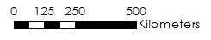

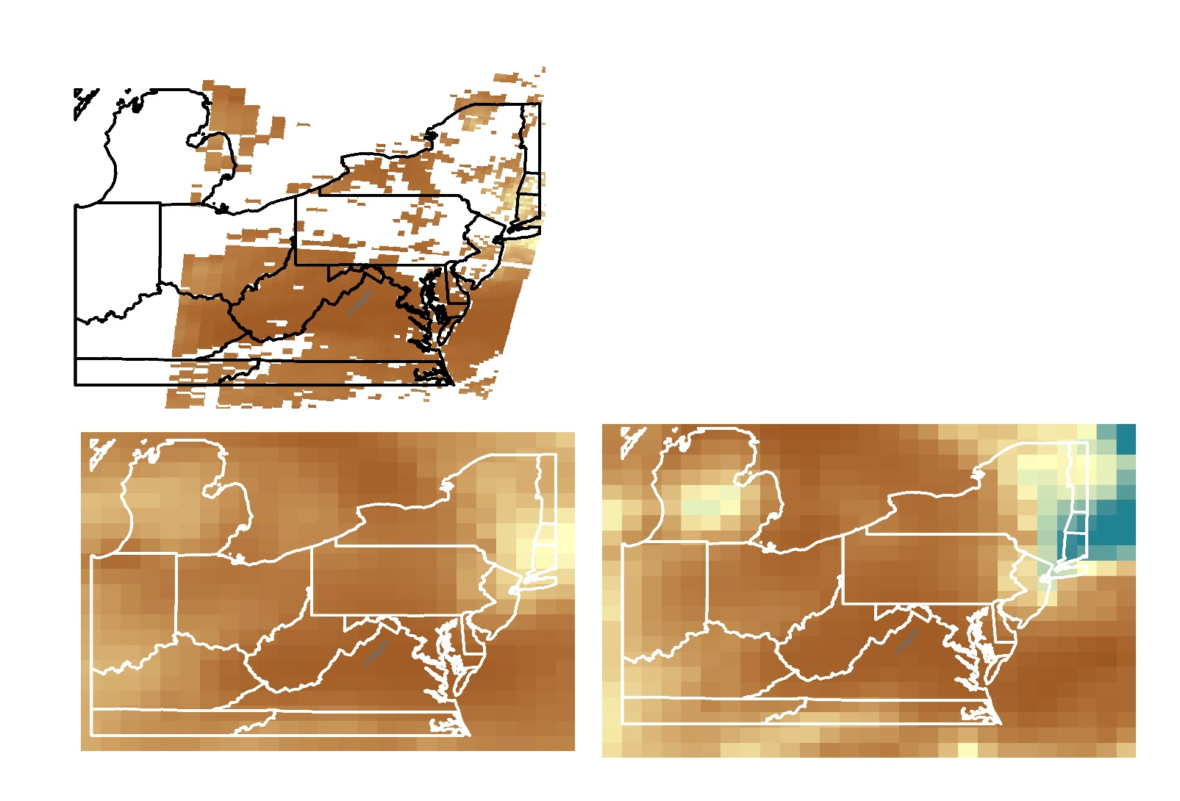
Good
Visibility
150 km
Poor
Visibility
0 km
MERRA-2 AOD
MERRA-2 Extinction Profiles
MODIS AOD
Figure 2. Visibility Method Comparison on June 10, 2015
To confirm our qualitative assessment of the different visibility methods, we calculated a correlation analysis between MERRA-2 AOD and IMPROVE measurements. Based on that correlation, we found that the models are fairly good at predicting visibility below 150 km, but above that they are not very accurate (see Figure 3). Our correlations for MERRA-2 may improve by adding more atmospheric parameters, like humidity, into our calculations (Randles, 2017). Park officials at Shenandoah National Park will likely find MERRA-2 AOD the most useful product for monitoring visibility in the park.

Figure 3. MERRA-2 AOD and Big Meadows IMPROVE correlation
4.1.2 Ozone
Neither our TOR nor the ground station ozone data revealed any significant annual variation. As expected, ozone in Shenandoah National Park exhibits a cyclical and seasonal trend (Figure 4). There is a gradual increase in ground-level ozone at Shenandoah National Park as the spring advances. This is likely a combination of seasonal ozone stratosphere-troposphere exchange (STE), which results in ozone-rich stratospheric/upper-tropospheric air mixing down to the mid- to lower troposphere and increased ozone photochemistry caused by warming temperatures and increased hydrocarbon emissions (Ziemke, 2006).
Figure 4. Comparison of TOR Average Monthly Ozone, CASTNET ozone, and Tropopause Pressure

Our remotely-sensed TOR and ground station ozone data had a correlation coefficient of 0.526 (Figure 5). This correlation is consistent with similar studies that used Earth observations to detect ground-level ozone (Ziemke, 2006; Fishman, 2010; Alston, 2011). One explanation for the discrepancy between the two data sets is that TOR is a tropospheric total-column measurement. TOR detects ozone in the upper free-troposphere that may not impact Big Meadows. This is seen most clearly in 2015 and 2016 (see Figure 4). In the spring and summer, when the planetary boundary layer is highest, our TOR results match up with the ground station data.

Figure 5. TOR and Big Meadows CASTNET Correlation

4.2 Future Work
Due to time constraints for this project, only a limited number of atmospheric parameters could be considered. Adding more atmospheric parameters such as humidity, temperate, and elevation, would result in data more robust analysis. Based on our TOR trend maps we can see that Shenandoah National Park is likely experiencing STE, resulting in greater amounts of ozone originating in the stratosphere moving into the troposphere. Future work could confirm this hypothesis by analyzing ground-level ozone parcels in the park for key stratospheric tracers such as potential vorticity (PV), relative humidity, and carbon monoxide. Extinction profiles that considered not only aerosols but also a combination of molecular scattering and absorption might offer more accurate measurements of visibility.
Shenandoah National Park would benefit from a visibility predictor tool. The same methodology we employed to calculate visibility from MERRA-2 extinction profiles could be applied to Goddard Earth Observing System Model, Version 5 (GOES-5) vertical aerosol extinction profiles. This would give the park a ten-day forecast of visibility for the entire park. Future projects, that continue to monitor air quality using NASA Earth observations, could use NASA’s Pandora Spectrometer Instrument as an additional verification tool. The Pandora Spectrometer Instrument is a small spectrometer used for measuring altitude profiles and trace amounts of NO₂, O₃, SO₂, water vapor in the lower atmosphere. In areas where the Pandora Spectrometer Instrument is active, its measurements could be used to verify satellite and model data in place of ASOS data. Studies wishing to expand on the use of AOD to calculate visibility should investigate the feasibility of using NASA’s Cloud-Aerosol Lidar and Infrared Pathfinder Satellite Observation (CALIPSO) AOD. CALIPSO has a finer spatial and vertical resolution, but was not appropriate for this study because it rarely had coverage for Shenandoah National Park. Future Earth observations, Sentinel-5P and TEMPO (Tropospheric Emissions: Monitoring Pollution) will provide finer spatial and temporal resolution to improve this research and Shenandoah National Park’s air quality monitoring.

5. Conclusions
This project can be useful for Shenandoah National Park to quantify impaired visibility and ground-level ozone trends in areas in which the park does not currently have ground monitoring stations and can supplement ground monitoring to obtain a more accurate measurement across large areas. This study's methodologies can be used to track long-term changes in visibility and ozone to determine whether they are changing over time. Measurements derived from Earth observations provide a better understanding of air pollution in Shenandoah National Park and its airshed. This information will be used to inform decisions for the park and protect the park’s natural resources and visitors.
Three different methods were used to test the feasibility of monitoring visibility in Shenandoah National Park using NASA Earth observations. Visibility calculated from MERRA-2 AOD proved to be the easiest to replicate, had excellent spatial coverage, and was reasonably accurate under 150 km. Visibility trend maps estimated from MERRA-2 AOD can be used to identify locations of impaired visibility in the Shenandoah airshed, and pinpoint the sources of pollution causing reduced visibility. The accuracy of visibility derived from all Earth observations would improve with finer spatial and temporal resolution as current NASA Earth observations are best used for monitoring and predicting visibility on global or continental scales.
The methodology used to calculate TOR provided a satisfactory estimation of the monthly trends in ground-level ozone for Shenandoah National Park. Trend maps of TOR revealed general seasonal patterns of ground-level ozone in the Shenandoah airshed. Differences between ground station measurements and TOR could be a result of random variability, aggregating data to averages, changing tropopause height, or STE. The accuracy of TOR derived from NASA Earth observations would improve by using sensors from two different satellites to calculate SCO and TCO. They would also be improved with finer spatial and temporal resolution as current NASA Earth observations are best used for monitoring and predicting visibility on global or continental scales.

6. Acknowledgments
A special thanks to our partners and science advisors:
- Jalyn Cummings of the National Park Service, Shenandoah National Park
- Dr. Barkley Sive of the National Park Service, Air Resources Division, Research & Monitoring Branch
- Dr. Bruce Doddridge, NASA Langley Research Center
- Dr. Rich Ferrare, NASA Langley Research Center
- Dr. Kenton Ross, NASA Langley Research Center

Any opinions, findings, and conclusions or recommendations expressed in this material are those of the author) and do not necessarily reflect the views of the National Aeronautics and Space Administration.

This material is based upon work supported by NASA through contract NNL16AA05C and cooperative agreement NNX14AB60A.

7. Glossary
Aqua – NASA satellite launched in 2002 as part of the Earth Observation System
Aerosol – Natural or artificial solid or liquid particles suspended in the atmosphere or another gas
AOD – Aerosol Optical Depth
ArcGIS – Program used for Geographic Information Systems, takes raw data points from observations and
applies data to maps for various types of analysis
ASOS – Automated Surface Observing System
CALIPSO - Cloud-Aerosol Lidar and Infrared Pathfinder Satellite Observation; a joint NASA and CNES
environmental satellite
CASTNET – Clean Air Status and Trends Network
Clean Air Act – The Clean Air Act is a government act first enacted in 1963 to promote public health by
limiting the release of airborne particles. The amendment of 1977 expanded the reach of the act to National Parks and included visibility measurements. The amendment of 1990 expanded the concerns to specific air pollutants such as ozone, nitrogen oxides, particulate matter, and sulfur oxides
DAAC – Distributed Active Archive Center
DownThemAll – an open source extension for Firefox which allows users to rapidly batch download files
DU – Dobson Unit; A unit of thickness, in units of 10µm, to determine the abundance of an atmospheric
parameter, typically used for ozone.
Earth Observations (EO) – Satellites and sensors that collect information about the Earth’s physical,
chemical, and biological systems over space and time
EPA – United States Environmental Protection Agency
GDAL – Geospatial Data Abstraction Library; An open source translator library for raster and vector geospatial data
GEOS-5 – Goddard Earth Observing System Model, Version 5\
GES – Goddard Earth Sciences
HDF5 files – Hierarchical Data Format version 5; a data format used by government and non-government
organizations for data that can be accessed
Hectopascal (hPa) – A measurement of barometric pressure
HEG Tool - HDF-EOS to GeoTIFF Conversion Tool; a tool developed to allow a user to reformat, re-
project and perform stitching/mosaicing and subsetting operations on HDF-EOS objects
IMPROVE – Interagency Monitoring of Protected Visual Environments
Koschmieder’s Law – Formula relating the extinction coefficient to maximum visibility; (CT = e ^{–βV})
Level 2 Data – Derived geophysical variables at the same resolution and location as Level 1 source data
LAADS – Level-1 and Atmosphere Archive and Distribution System
MERRA-2 – Modern-Era Retrospective analysis for Research and Applications, Version 2 (MERRA-2); incorporates aerosol data from MODIS onboard Aqua and Terra satellites and the upgraded version of GEOS-5
Microsoft Excel – A spreadsheet and statically package by Microsoft for Windows, macOS, Android, and iOS
MLS – Microwave Limb Sounder, onboard the Aura satellite
MODIS – MODerate resolution Imaging Spectroradiometer
NASA – National Aeronautics and Space Administration
National Park Service Organic Act – Enacted in 1916 for the formation of the National Park Service
NCCS – NASA Center for Climate Simulation; an integrated set of supercomputing, visualization, and data interaction technologies to enhance agency capabilities in weather and climate prediction
NetCDF Files – Network Common Data Form; a set of software libraries that support the creation, access, and sharing of array-oriented scientific data
OMI – Ozone Monitoring Instrument, sensor aboard the Aura satellite
Ozone (O₃) – Comprised of three oxygen atoms, caused by the breakdown of oxygen gas in the upper atmosphere and blocks harmful ultraviolet rays; at lower atmosphere, ozone breaks down protective tissues and membranes of organisms, making them vulnerable
PM – Particulate Matter; mixture of solid and liquid particles found in the atmosphere. Derived from natural
and anthropogenic sources
Parts per billion volume (ppbv) – the number of units of a contamination per 1000 million units of total
volume
PV – Potential vorticity, used to determines the threshold between stratosphere and troposphere
R – An open source software environment for statistical computing and graphics.
Remote Sensing – Gathering data of an object(s) without making direct contact
SCO – Stratospheric column ozone
Sentinel-5P – An Earth observation satellite developed by European Space Agency as part of the Copernicus Programme
STE – Stratosphere-Troposphere Exchange
SVR – Standard visual range, calculated by 3910/(aerosol_b_{ext}+10)
TCO – Total column ozone
TEMPO – Tropospheric Emissions: Monitoring Pollution; A NASA Earth observing mission and the first space-based instrument to monitor major air pollutants across the North American continent every daylight hour at high spatial resolution
TIFF files – Tagged Image File Format, also known as Tif files or GeoTiffs, a computer file format used for
storing graphics with values for each pixel generated; in this paper we use .Tif, .Tiff, and GeoTiff interchangeably
TOR – Tropospheric Ozone Residual
VIIRS – Visible Infrared Imaging Radiometer Suite
VMR – Volume Mixing Ratio
WGS 1984 – Standard coordinate system for the Earth, established in 1984, the system has its origin point at
the center of the earth

8. References
Alston, E. J., Sokolik, I. N., & Doddridge, B. G. (2011). Investigation into the use of satellite data in aiding characterization of particulate air quality in Atlanta, Georgia metropolitan area. Journal of the Air & Waste Management Association, 61(2), 211-225. doi:10.3155/1047-3289.61.2.211

Bennett, A. (2012). Introduction to atmospheric visibility estimation. Retrieved from http://www.biral.com/wp-content/uploads/2015/02/Introduction_to_visibility-v2-2.pdf

Bosilovich, M., Lucchesi, R., & Suarez, M. (2016). MERRA-2: File specification. Retrieved from https://ntrs.nasa.gov/search.jsp?R=20150019760

Civerolo, K. L., Mao, H., & Rao, S. T. (2003). The airshed for ozone and fine particulate pollution in the eastern United States. Pure and Applied Geophysics, 160(1), 81-105. doi:10.1007/s00024-003-8767-6

Fishman, J., Creilson, J. K., Parker, P. A., Ainsworth, E. A., Vining, G. G., Szarka, J., . . . Xu, X. (2010). An investigation of widespread ozone damage to the soybean crop in the upper Midwest determined from ground-based and satellite measurements. Atmospheric Environment, 44(18), 2248-2256

Global Modeling and Assimilation Office (GMAO). (2015). MERRA-2 inst3_2d_gas_Nx: 2d, 3-Hourly, Instantaneous, Single-Level, Assimilation, Aerosol Optical Depth Analysis V5.12.4, Greenbelt, MD, USA, Goddard Earth Sciences Data and Information Services Center (GES DISC), September 28, 2017 doi:10.5067/HNGA0EWW0R09

Global Modeling and Assimilation Office (GMAO). (2015), MERRA-2 tavg1_2d_aer_Nx: 2d,1-Hourly, Time-averaged, Single-Level, Assimilation, Aerosol Diagnostics V5.12.4, Greenbelt, MD, USA, Goddard Earth Sciences Data and Information Services Center (GES DISC), Accessed October 5, 201710.5067/KLICLTZ8EM9D

He, Q., Li, C., Geng, F., Zhou, G., Gao, W., Yu, W., . . . Du, M. (2016). A parameterization scheme of aerosol vertical distribution for surface-level visibility retrieval from satellite remote sensing. Remote Sensing of Environment, 181, 1-13.

Iowa Environmental Mesonet. (2017). Automated Surface Observing System Network: ASOS-AWOS-METAR Data 2007-2017. MD_ASOS Network, PA_ASOS Network, VA_ASOS Network, WV_ASOS Network. Retrieved from Iowa State University of Science and Technology

Kessner, A. L., Wang, J., Levy, R. C., & Colarco, P. R. (2013). Remote sensing of surface visibility from space: A look at the United States East Coast. Atmospheric Environment, 81(Supplement C), 136-147. doi:10.1016/j.atmosenv.2013.08.05

Komeilian, H., Ganjidoust, H., & Khodadadi, A. (July 2014). Parametric analysis for dust plumes modeling using MODIS data over Khuzestan Province, Iran. Journal of Middle East Applied Science and Technology (20), pp. 704-708.

National Park Service. (2015). Monitoring air quality in Shenandoah National Park. Retrieved from https://www.nps.gov/shen/learn/nature/mon_air.htm

National Park Service. (2017). Shenandoah: Park Statistics. Retrieved from https://www.nps.gov/shen/learn/management/statistics.htm

Randles, C., da Silva, A. M., Buchard, V., Colarco, P., Darmenov, A., Govindaraju, R., . . . Hair, J. (2017). The MERRA-2 aerosol reanalysis, 1980 onward. Part I: System description and data assimilation evaluation. Journal of Climate, 30(17), 6823-6850. doi:10.1175/JCLI-D-16-0609.1

Retalis, A., Hadjimitsis, D., Michaelides, S., Tymvios, F., Chrysoulakis, N., Clayton, C., & Themistocleous, K. (2010). Comparison of aerosol optical thickness with in situ visibility data over Cyprus. Natural Hazards and Earth System Sciences, 10(3), 421-428, https://doi.org/10.5194/nhess-10-421-2010.

Sullivan, T. J., Cosby, B. J., Laurence, J. A., Dennis, R. L., Savig, K., Webb, J. R., . . . Kern, J. S. (2003). Assessment of air quality and related values in Shenandoah National Park. (NPS/NERCHAL/NRTR-03/090). Philadelphia, PA: U.S. Department of the Interior, National Park Service, Natural Resource Stewardship and Science, Northeast Region. Retrieved from https://www.nature.nps.gov/air/Pubs/pdf/SHEN_Assess_Sullivan2003.pdf.

Sullivan, T. J., & E&S Environmental Chemistry, I. (2013). Shenandoah National Park: What's up with the air? In: National Park Service, U.S. Department of the Interior. Retrieved from http://www.esenvironmental.com/PDF/shenandoah.pdf

Ziemke, J. R., Chandra, S., Duncan, B. N., Froidevaux, L., Bhartia, P. K., Levelt, P. F., & Waters, J. W. (2006). Tropospheric ozone determined from Aura OMI and MLS: Evaluation of measurements and comparison with the Global Modeling Initiative's Chemical Transport Model. Journal of Geophysical Research: Atmospheres, 111(D19), 2156-2202. doi:10.1029/2006JD007089

9. Appendix
Appendix A
2015 Maps of Visibility from MERRA-2 AOD
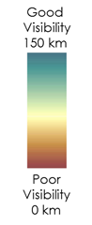
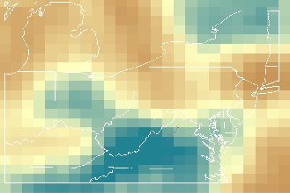
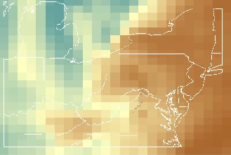
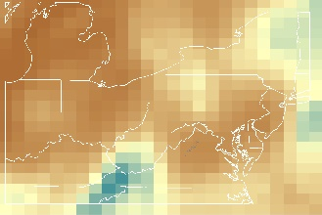
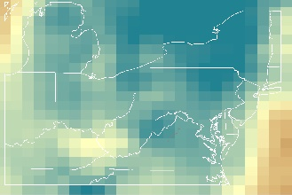
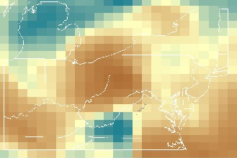
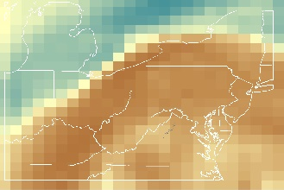
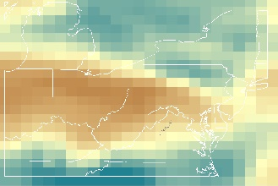
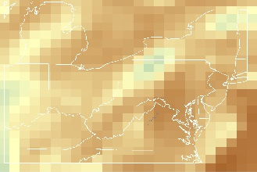
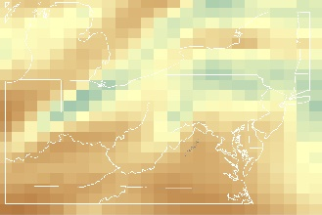
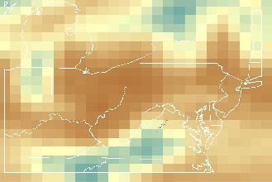
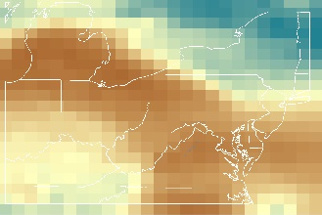
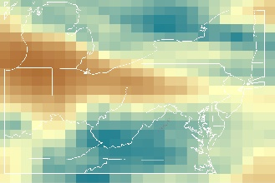
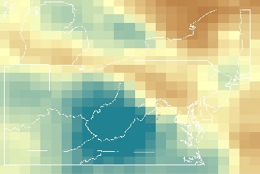
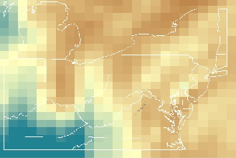
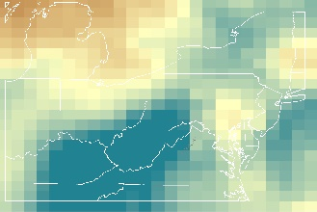
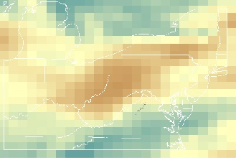
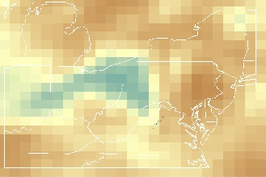
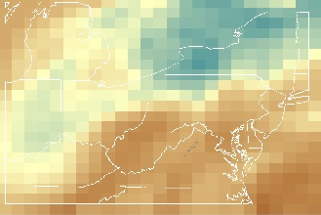
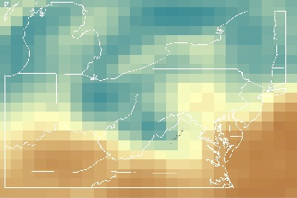
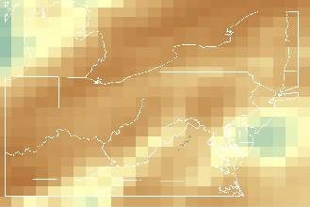
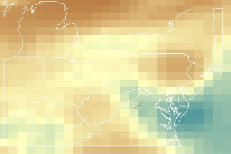
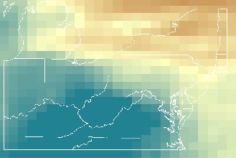
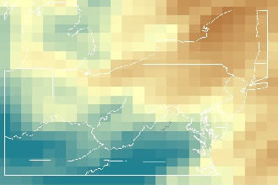
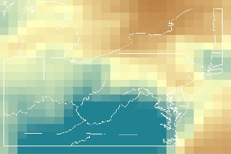
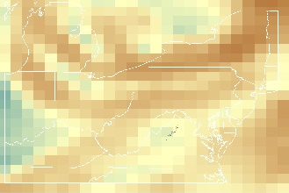
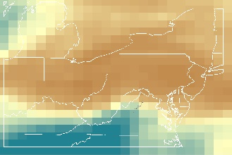
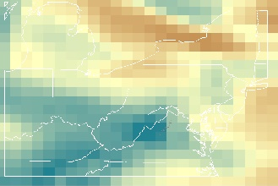
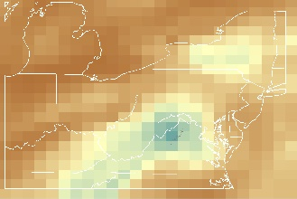
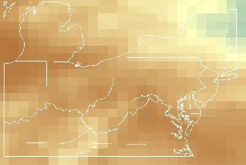
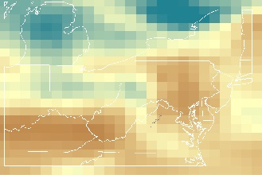
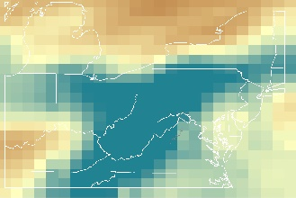
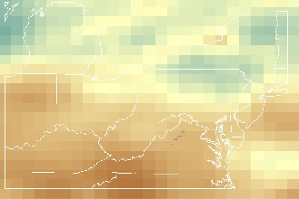
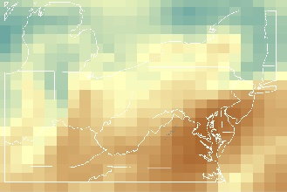
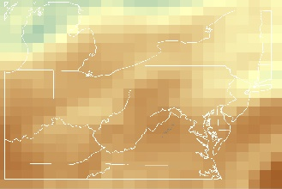
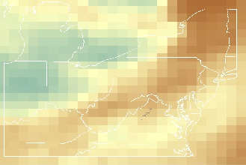
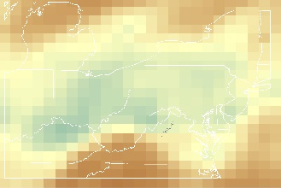
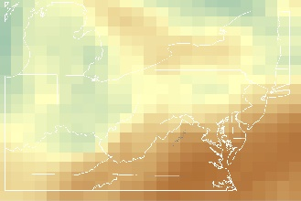
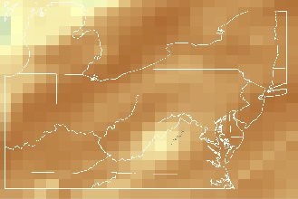
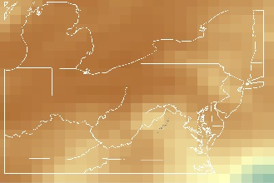
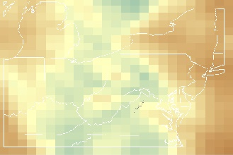
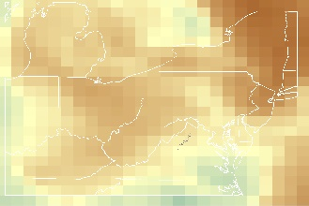
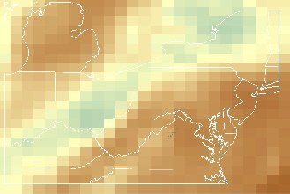
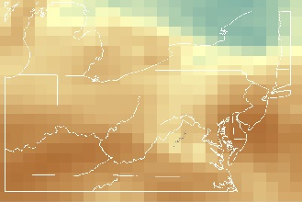
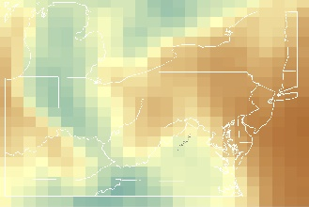
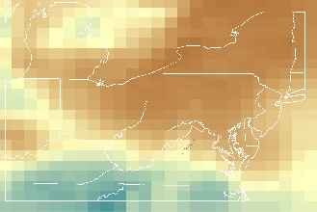
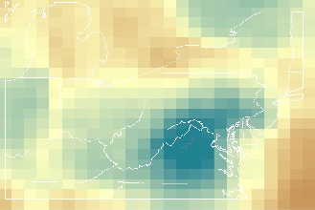
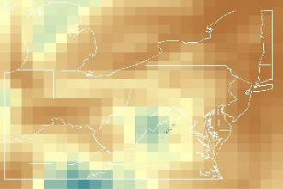
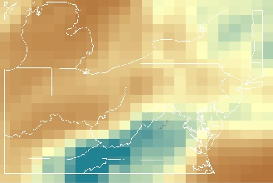
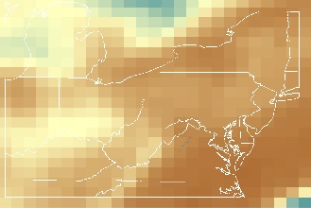
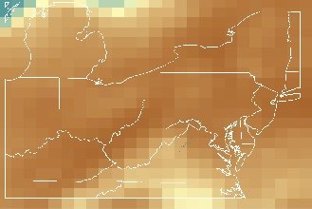
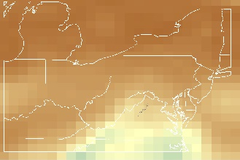
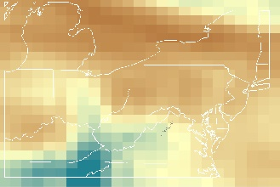
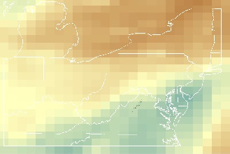
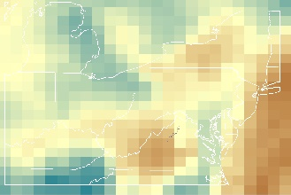
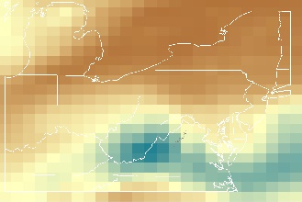
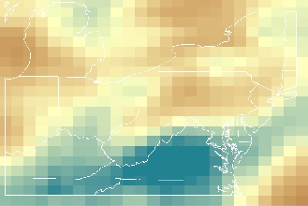
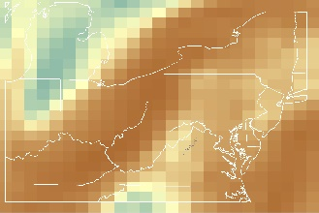
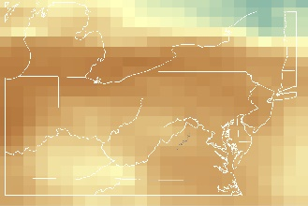
Figure A1. January 2015 Visibility from MERRA-2 AOD
1
2
6
7
3
4
5
8
9
10
11
12
13
14
15
16
17
18
19
20
21
22
23
24
25
26
27
28
29
30
31
Figure A2. February 2015 Visibility from MERRA-2 AOD
1
2
6
7
3
4
5
8
9
10
11
12
13
14
15
16
17
19
20
21
22
23
24
25
26
27
28
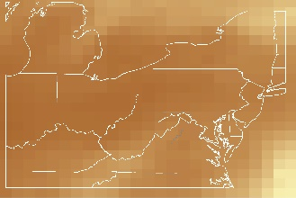
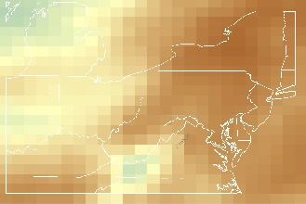
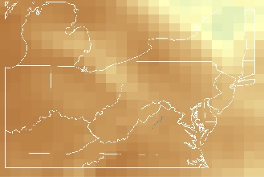
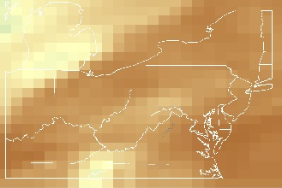
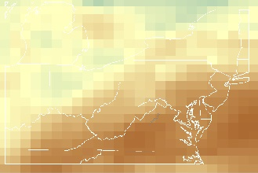
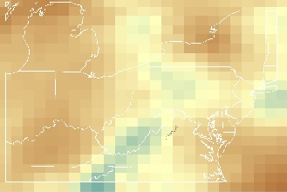
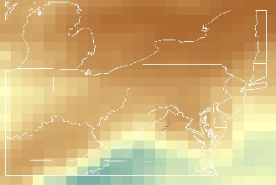
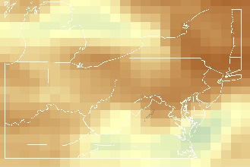
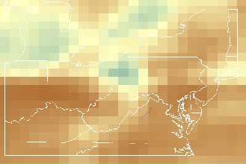
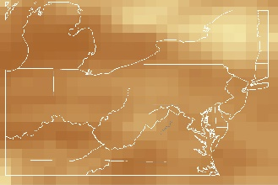
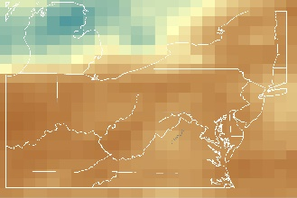
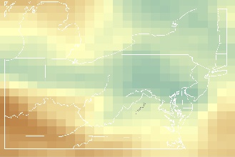
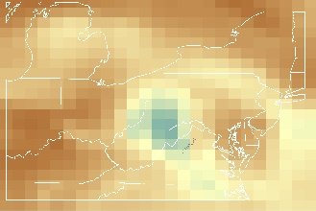
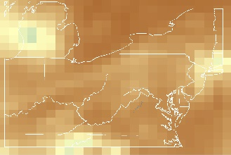
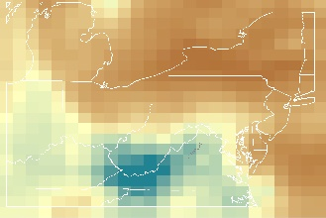
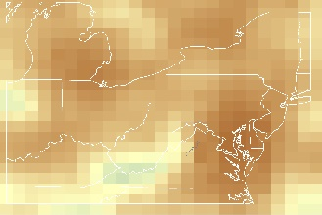
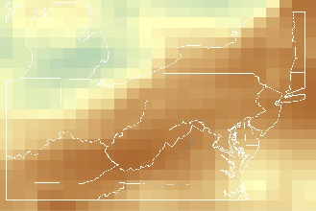
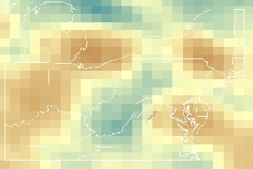
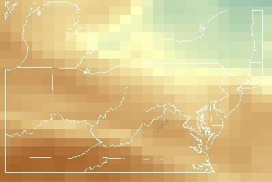
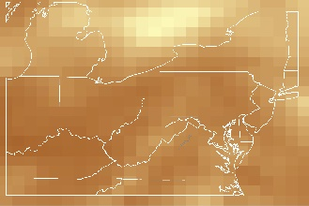
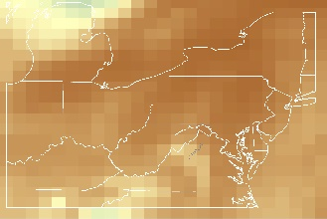
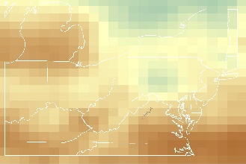
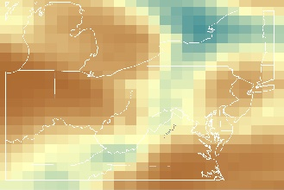
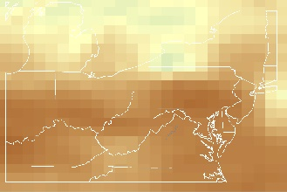
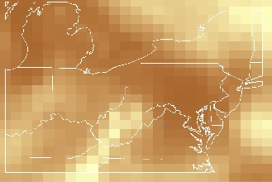
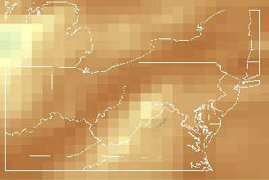
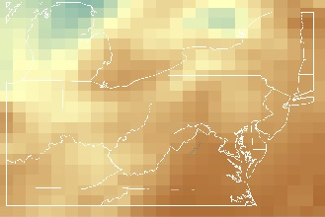
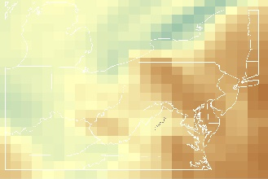
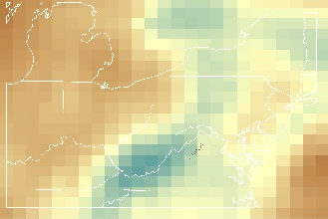
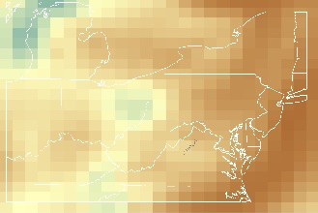
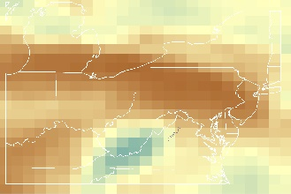
Figure A3. March 2015 Visibility from MERRA-2 AOD
31
30
29
28
27
26
25
24
23
22
21
20
19
18
17
16
15
14
13
12
11
10
9
8
5
4
3
7
6
2
1
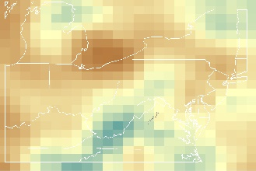
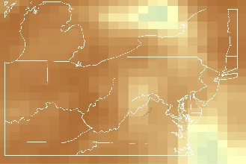
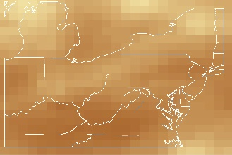
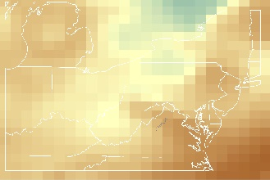
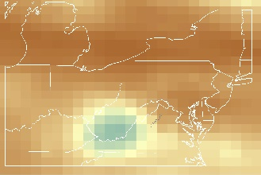
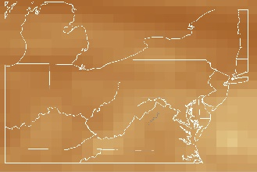
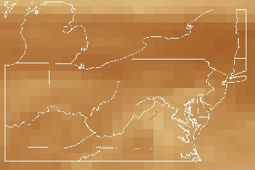
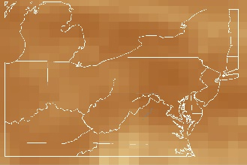
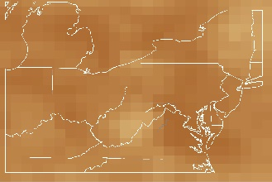
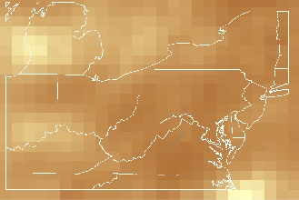
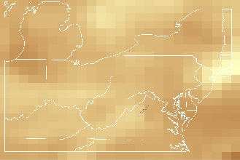
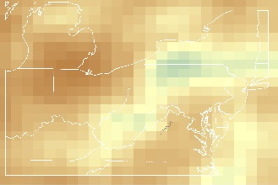
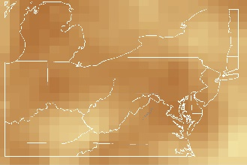
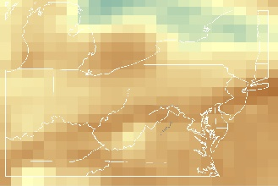
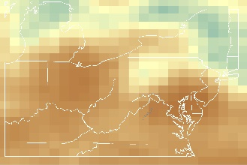
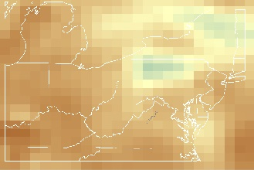
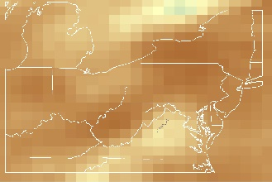
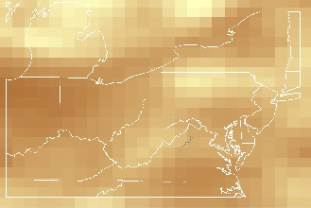
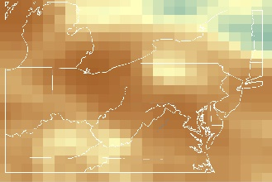
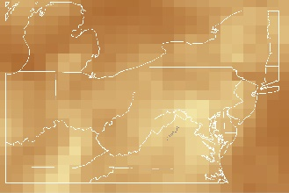
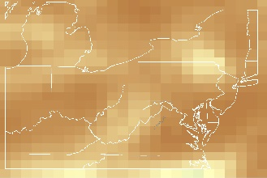
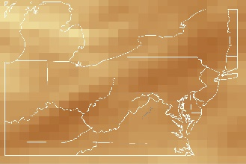
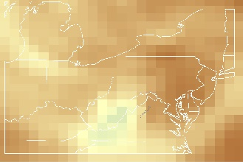
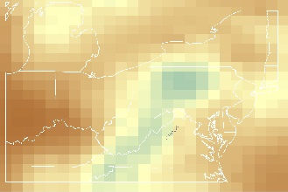
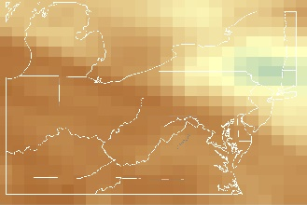
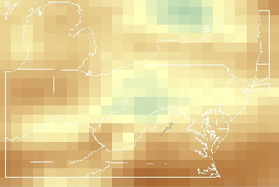
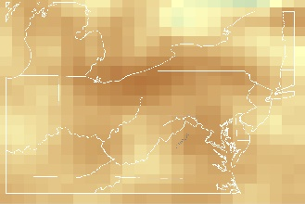
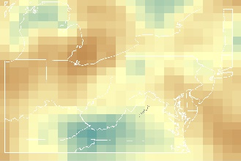
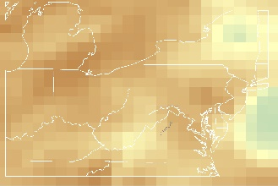
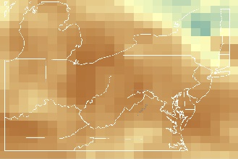
Figure A4. April 2015 Visibility from MERRA-2 AOD
30
29
28
27
26
25
24
23
22
21
20
19
18
17
16
15
14
13
12
11
10
9
8
5
4
3
7
6
2
1
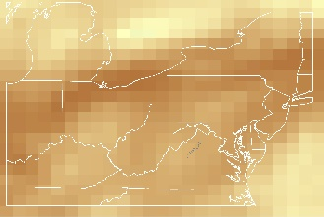
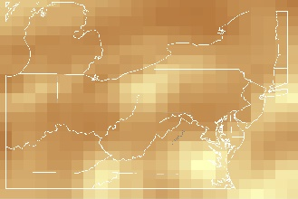
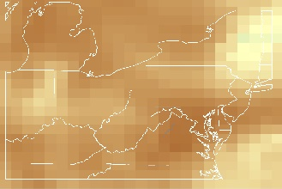
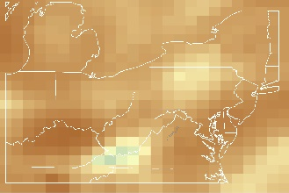
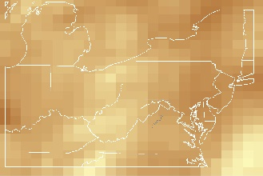
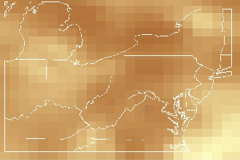
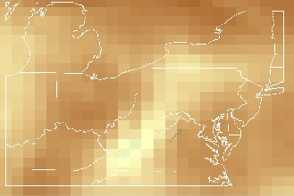
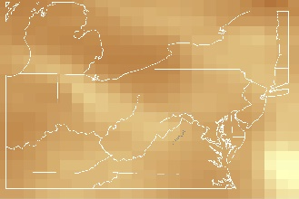
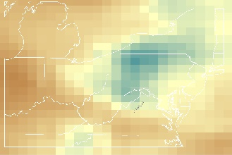
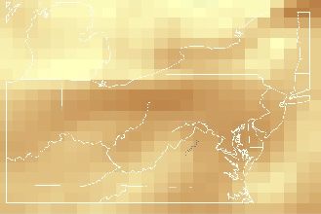
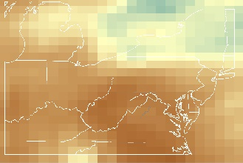
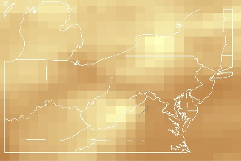
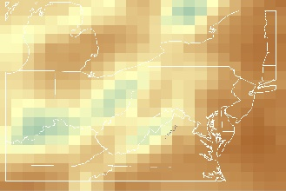
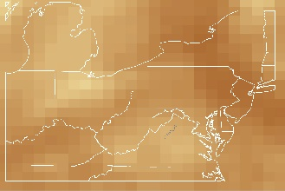
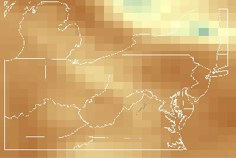
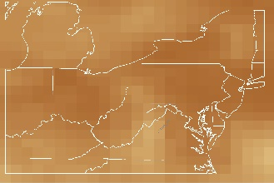
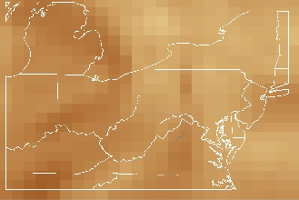
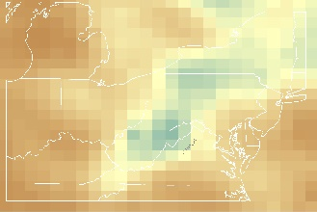
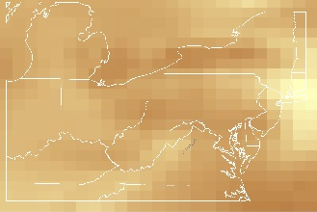
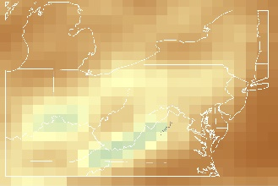
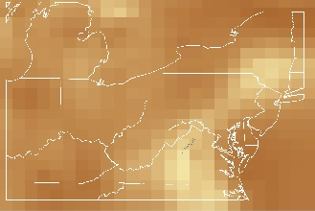
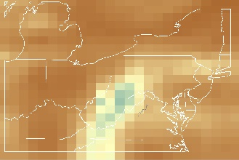
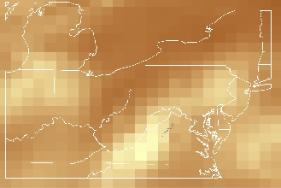
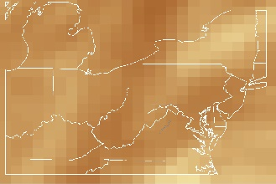
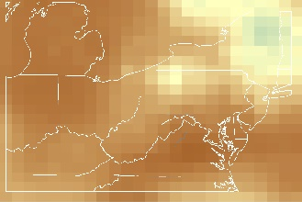
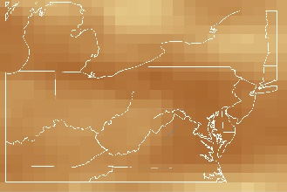
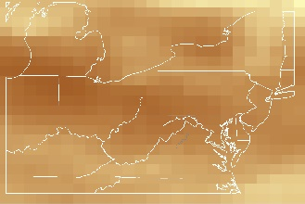
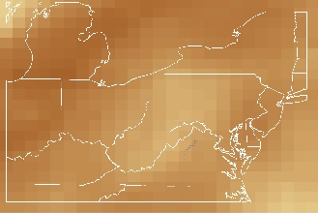
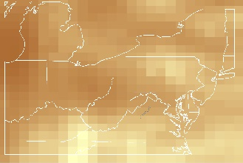
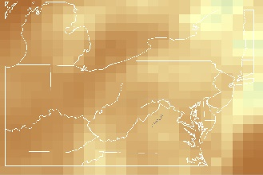
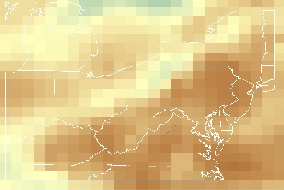
Figure A5. May 2015 Visibility from MERRA-2 AOD
1
2
6
7
3
4
5
8
9
10
11
12
13
14
15
16
17
18
19
20
21
22
23
24
25
26
27
28
29
30
31
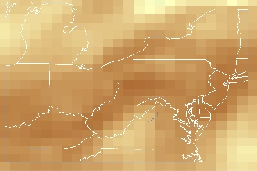
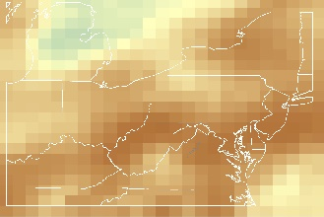
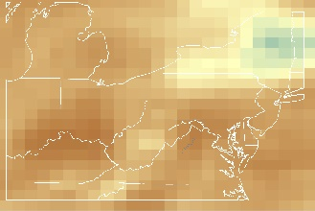
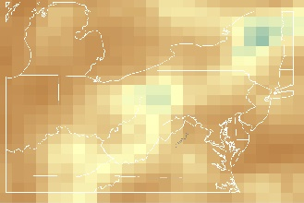
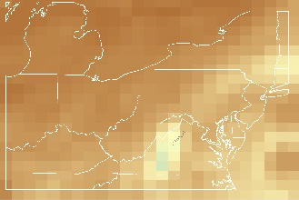
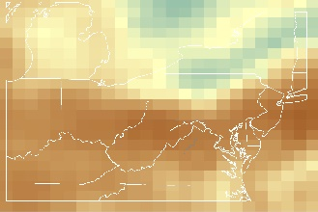
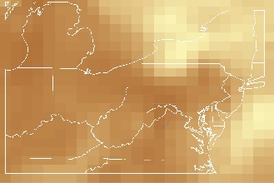
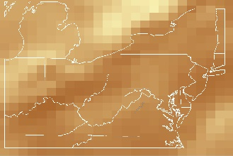
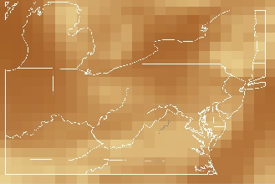
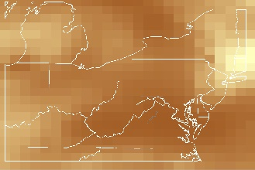
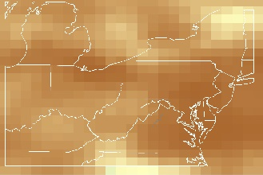
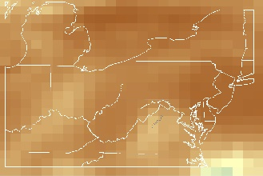
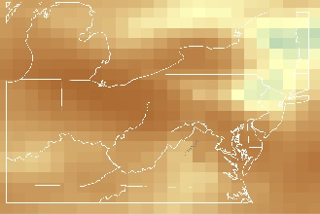
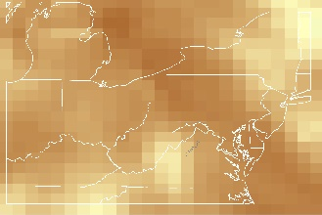
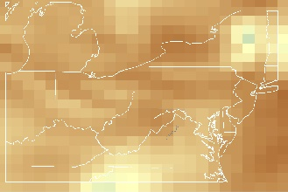
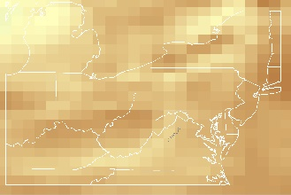
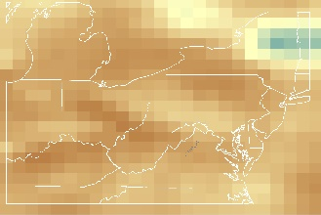
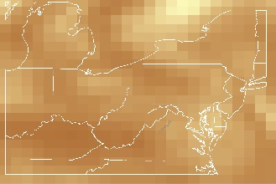
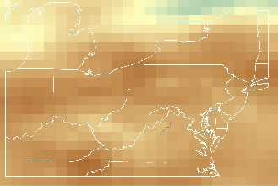
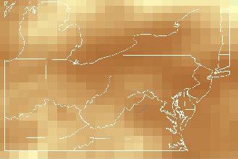
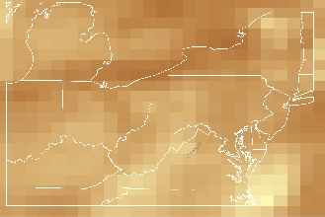
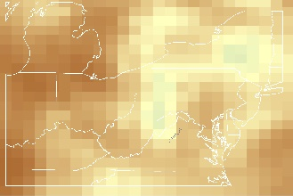
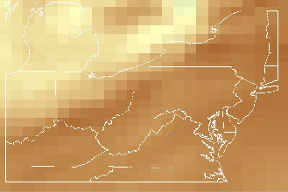
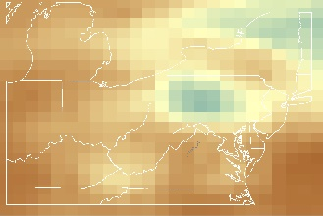
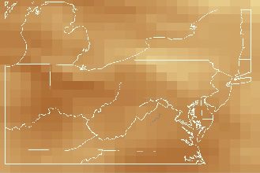
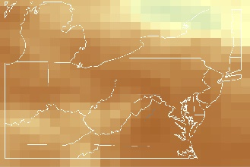
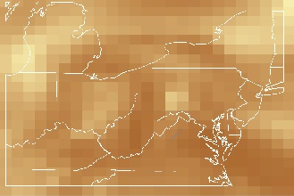
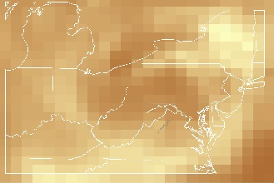
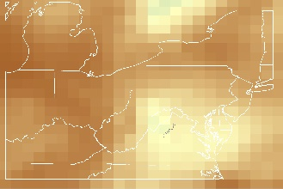
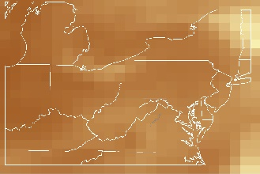
Figure A6. June 2015 Visibility from MERRA-2 AOD
30
29
28
27
26
25
24
23
22
21
20
19
18
17
16
15
14
13
12
11
10
9
8
5
4
3
7
6
2
1
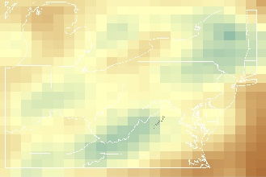
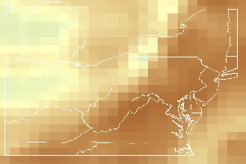
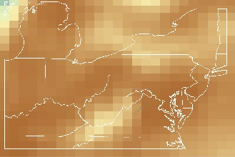
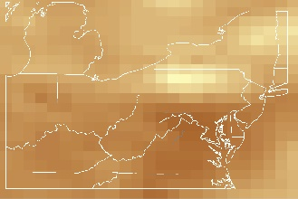
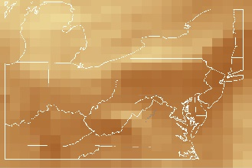
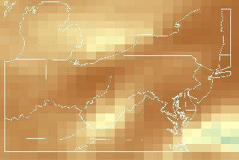
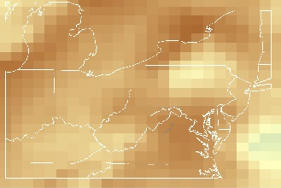
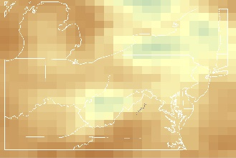
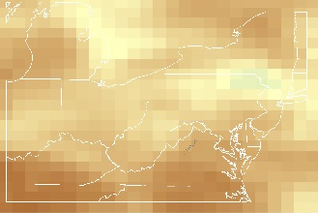
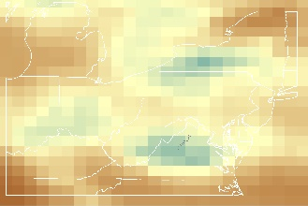
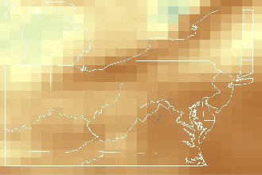
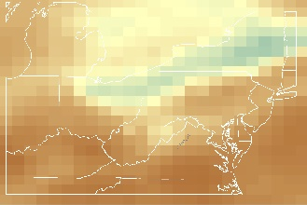
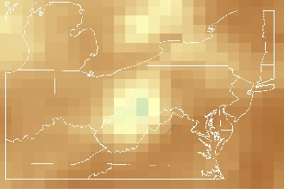
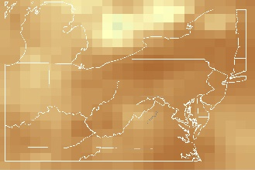
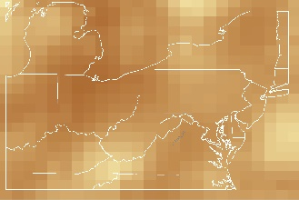
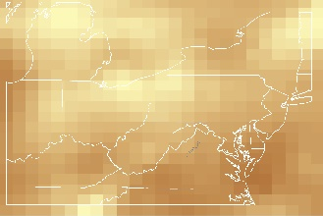
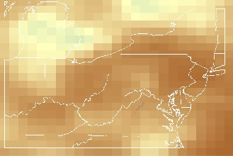
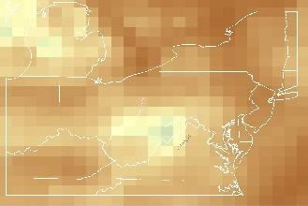
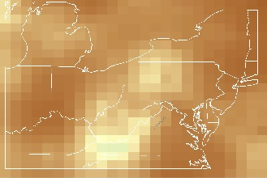
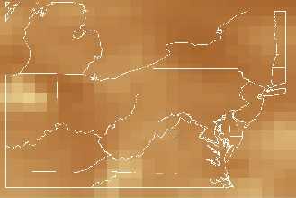
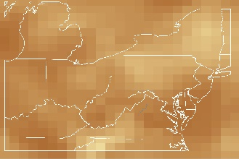
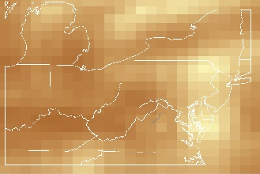
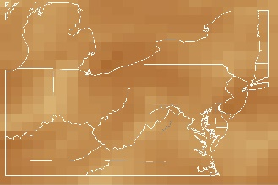
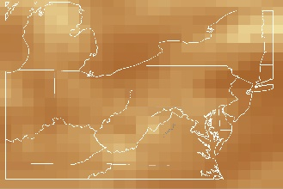
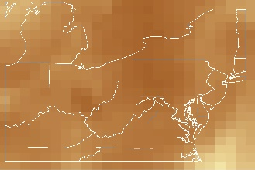
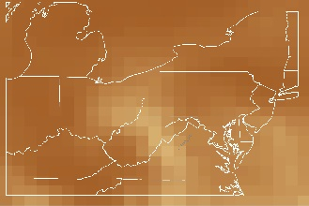
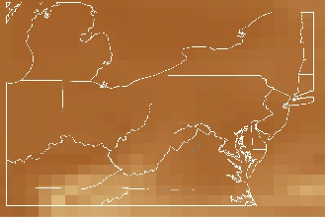
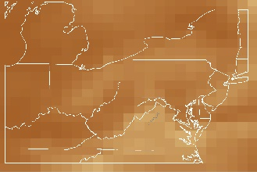
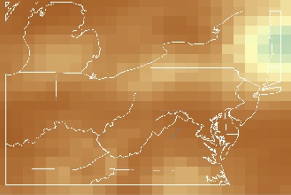
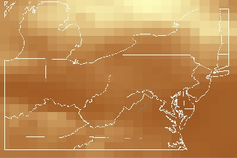
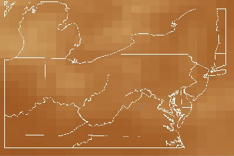
Figure A7. July 2015 Visibility from MERRA-2 AOD
1
2
6
7
3
4
5
8
9
10
11
12
13
14
15
16
17
18
19
20
21
22
23
24
25
26
27
28
29
30
31
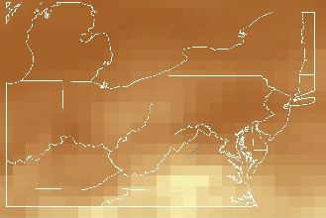
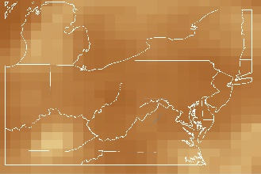
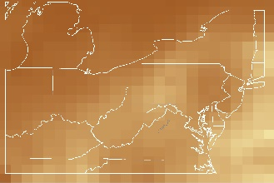
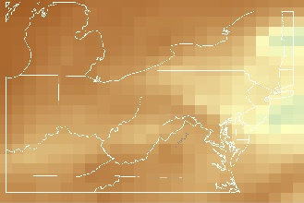
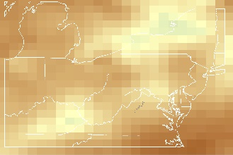
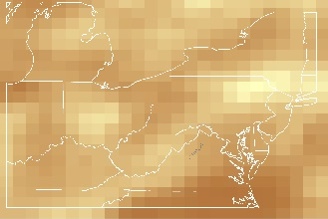
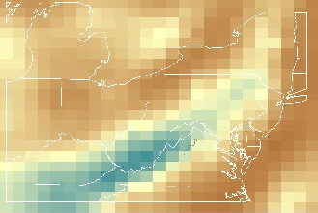
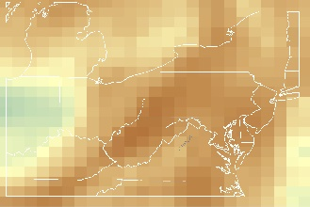
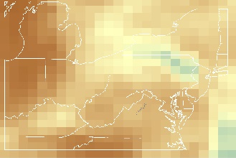
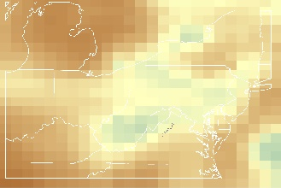
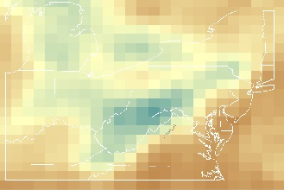
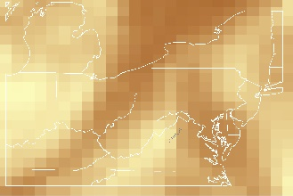
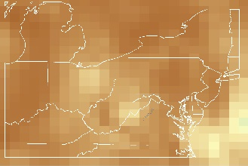
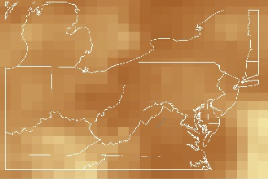
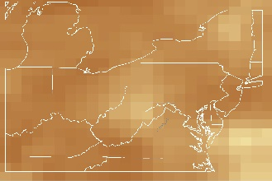
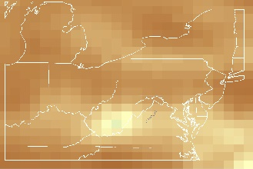
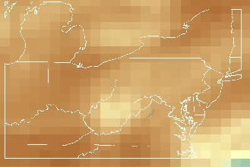
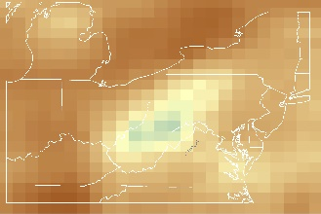
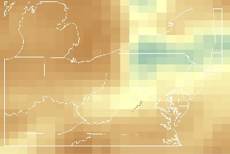
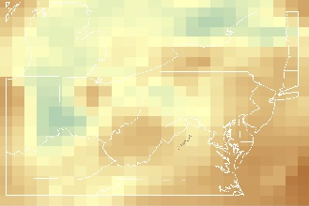
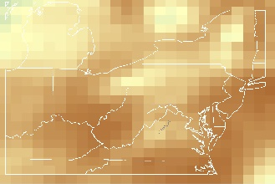
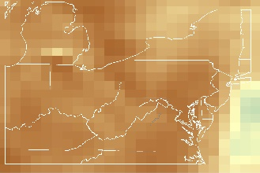
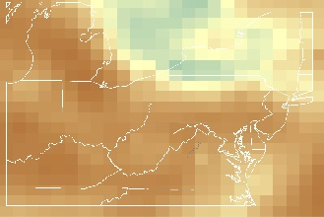
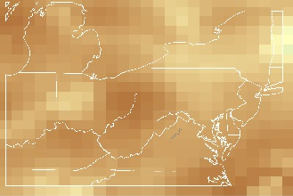
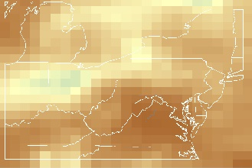
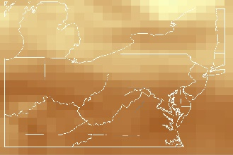
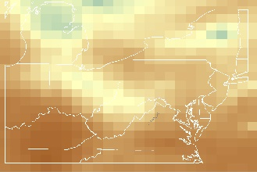
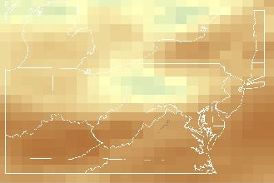
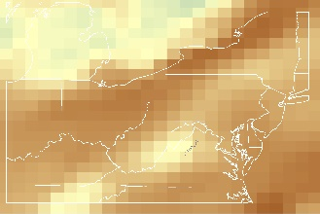
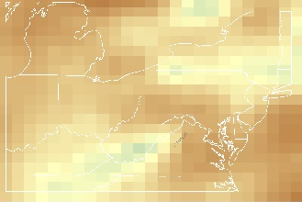
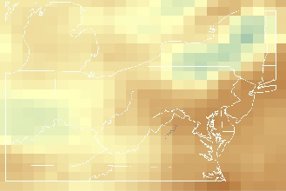
Figure A8. August 2015 Visibility from MERRA-2 AOD
1
2
6
7
3
4
5
8
9
10
11
12
13
14
15
16
17
18
19
20
21
22
23
24
25
26
27
28
29
30
31
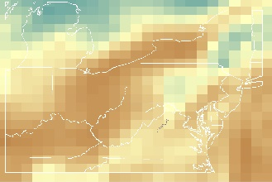
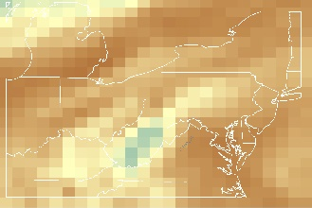
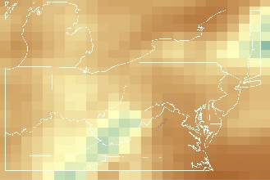
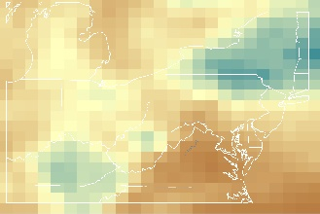
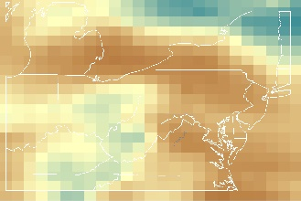
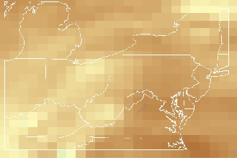
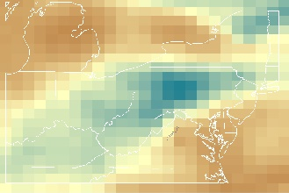
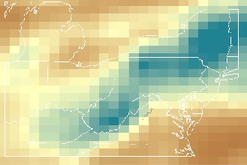
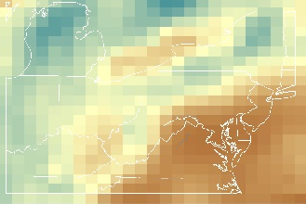
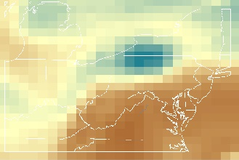
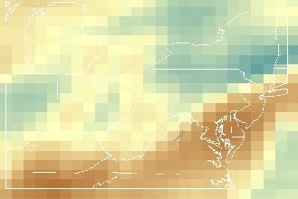
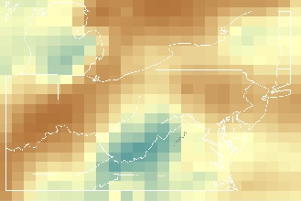
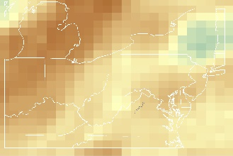
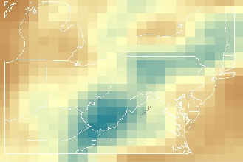
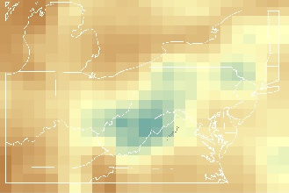
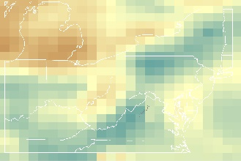
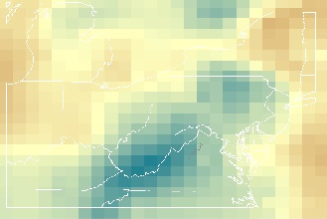
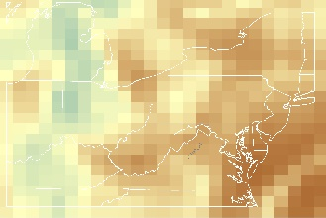
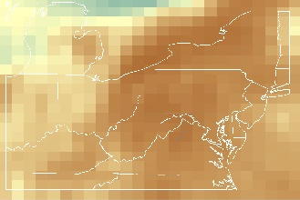
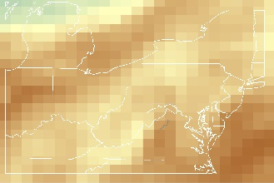
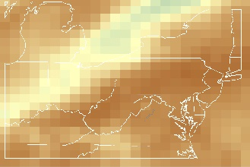
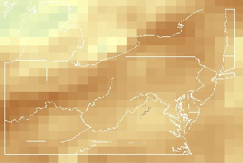
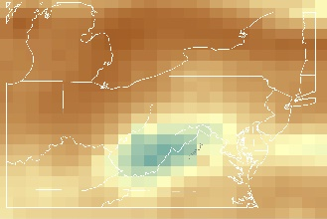
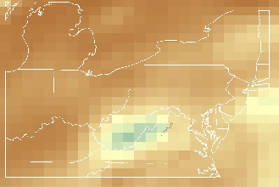
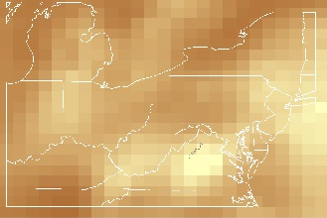
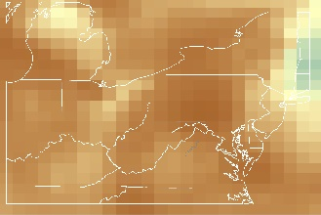
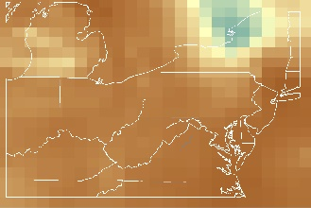
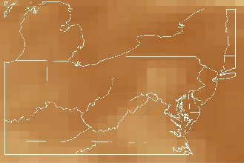
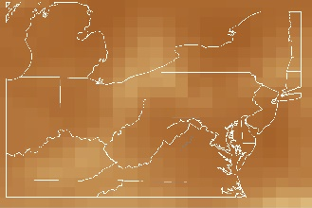
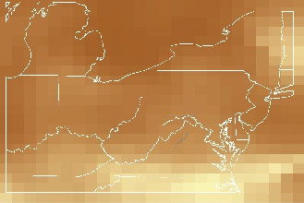
Figure A9. September 2015 Visibility from MERRA-2 AOD
1
2
6
7
3
4
5
8
9
10
11
12
13
14
15
16
17
18
19
20
21
22
23
24
25
26
27
28
29
30
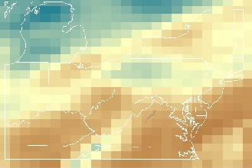
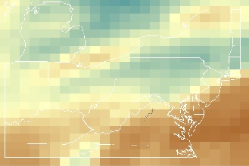
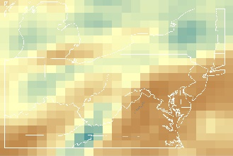
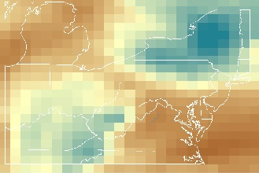
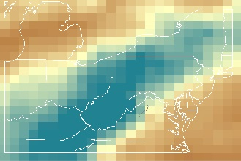
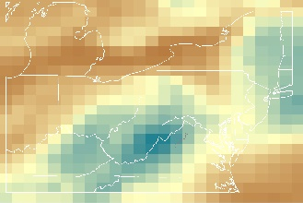
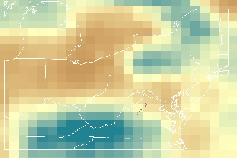
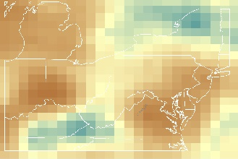
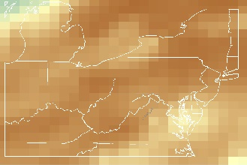
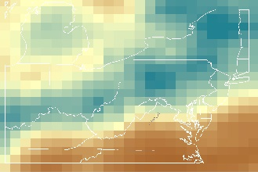
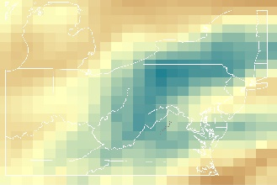
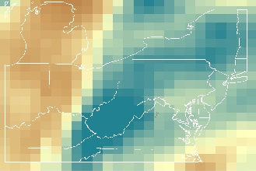
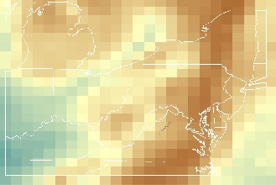
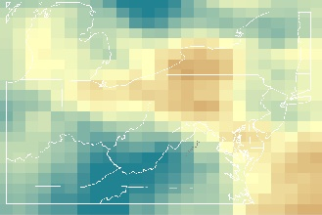
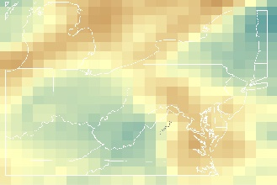
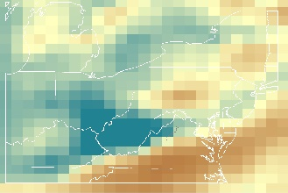
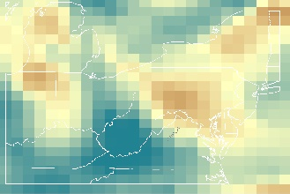
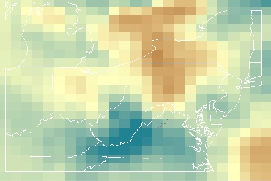
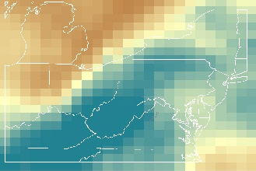
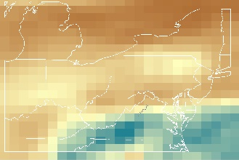
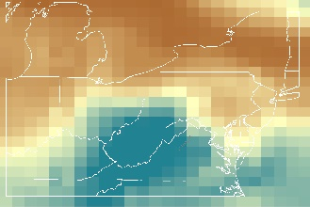
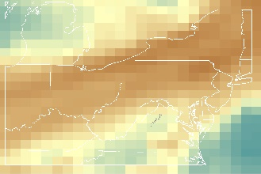
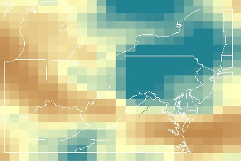
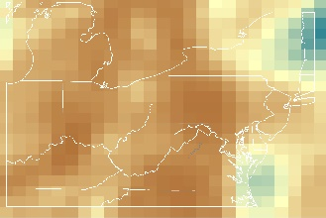
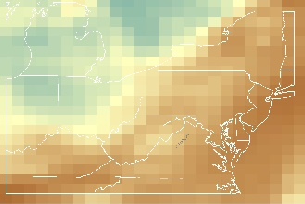
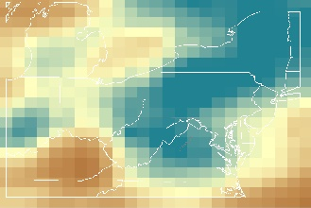
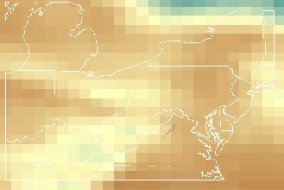
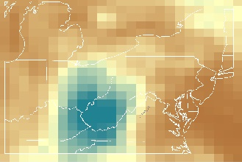
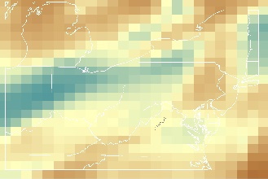
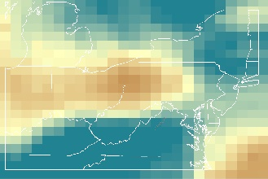
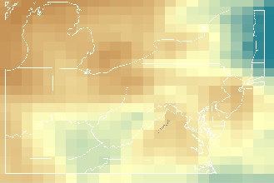
Figure A10. October 2015 Visibility from MERRA-2 AOD
31
30
29
28
27
26
25
24
23
22
21
20
19
18
17
16
15
14
13
12
11
10
9
8
5
4
3
7
6
2
1
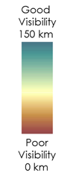
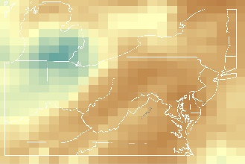
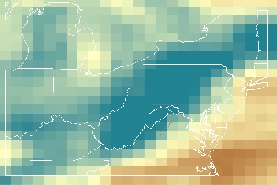
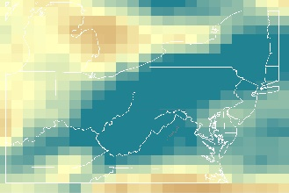
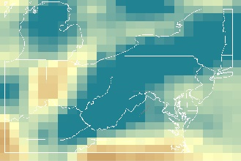
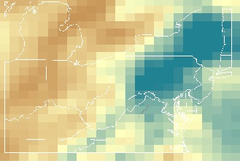
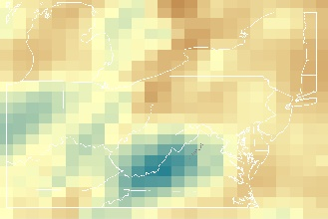
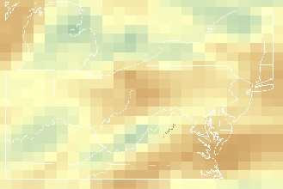
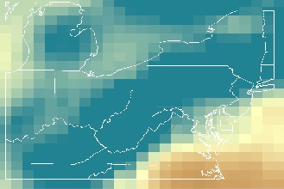
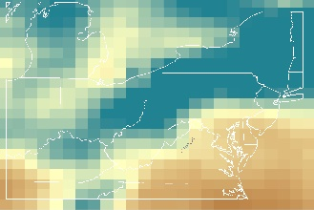
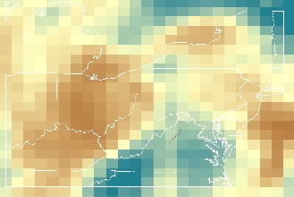
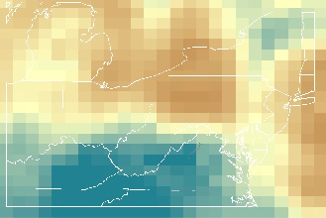
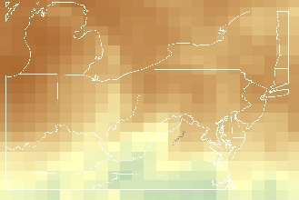
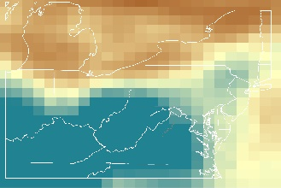
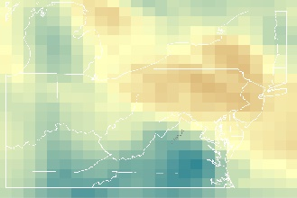
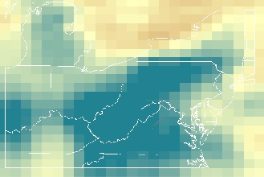
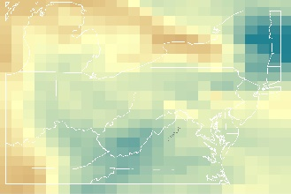
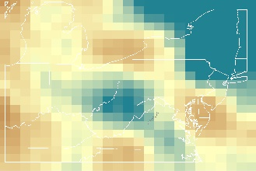
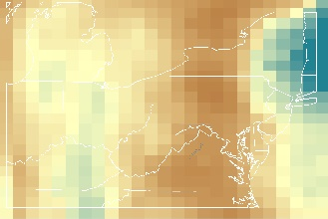
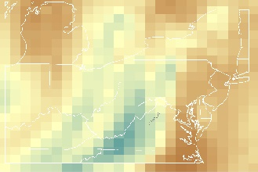
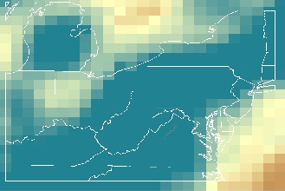
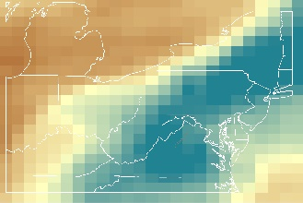
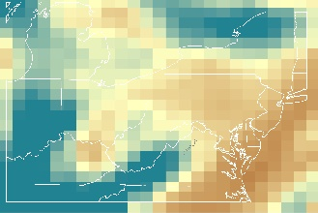
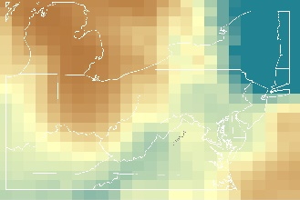
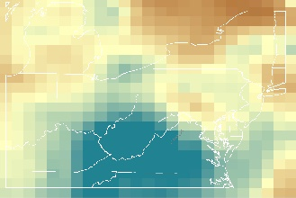
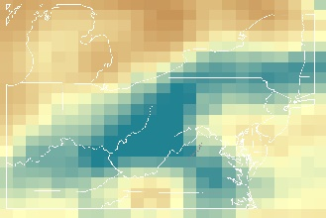
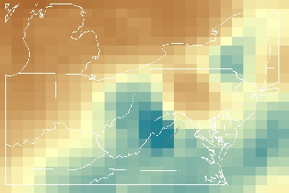
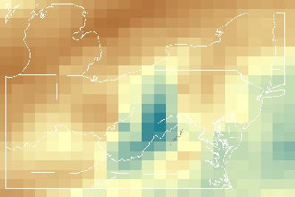
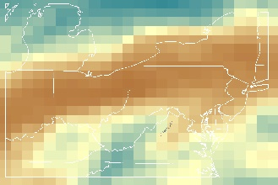
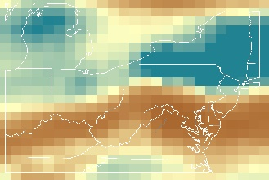
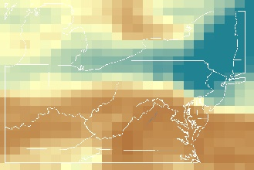
Figure A11. November 2015 Visibility from MERRA-2 AOD
30
29
28
27
26
25
24
23
22
21
20
19
18
17
16
15
14
13
12
11
10
9
8
5
4
3
7
6
2
1
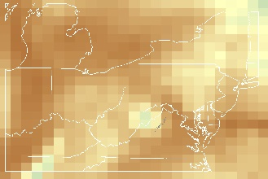
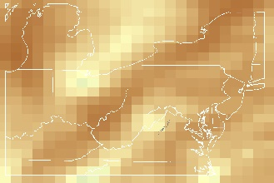
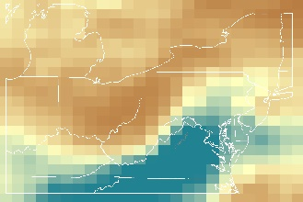
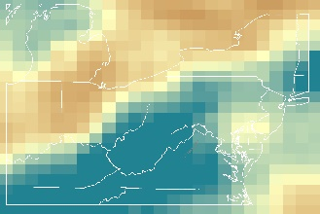
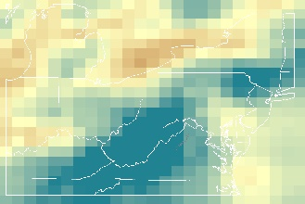
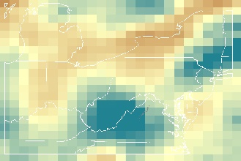
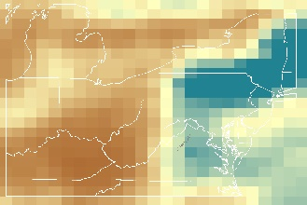
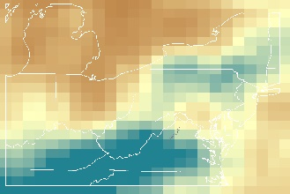
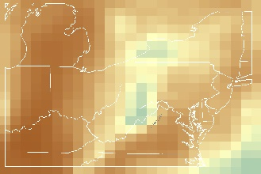
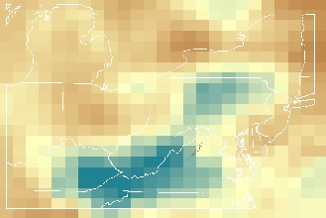
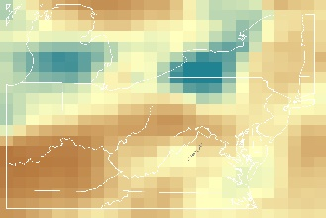
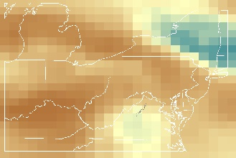
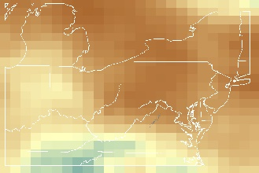
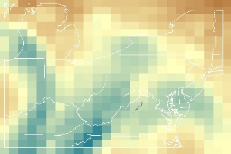
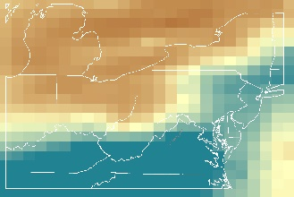
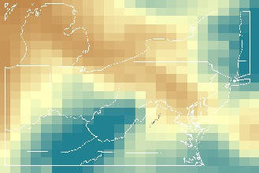
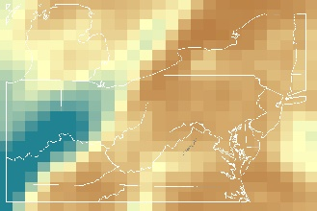
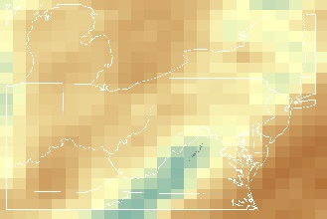
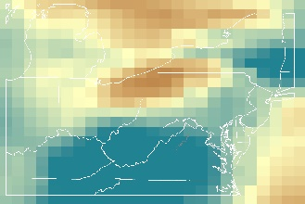
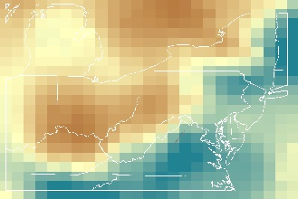
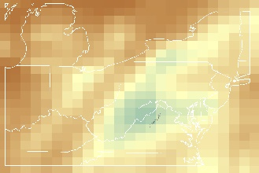
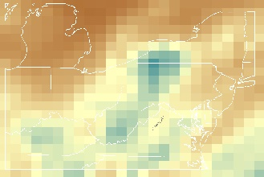
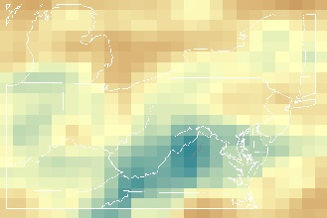
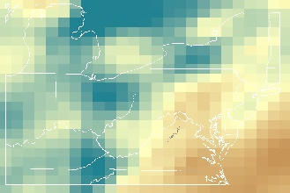
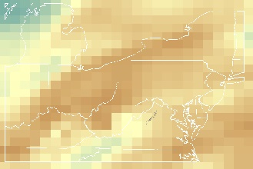
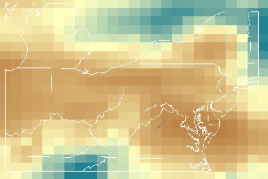
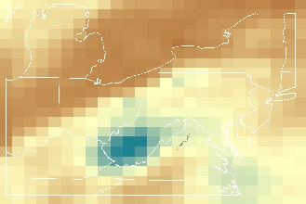
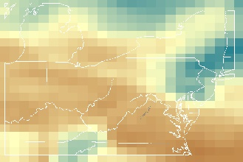
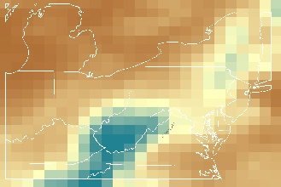
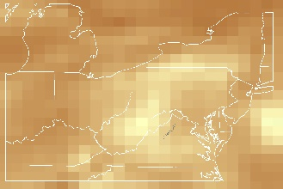
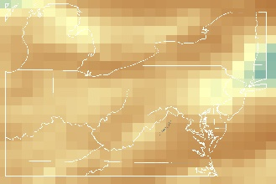
Appendix B
Figure A12. December 2015 Visibility from MERRA-2 AOD
31
30
29
28
27
26
25
24
23
22
21
20
19
18
17
16
15
14
13
12
11
10
9
8
5
4
3
7
6
2
1
2015 Maps of Visibility from MERRA-2 Extinction Profiles

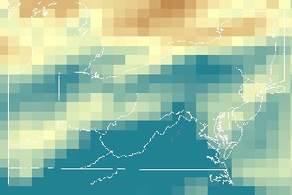
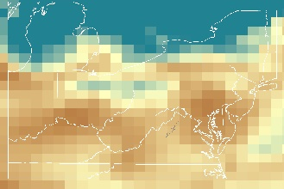
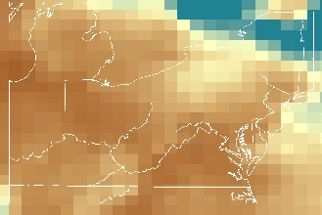
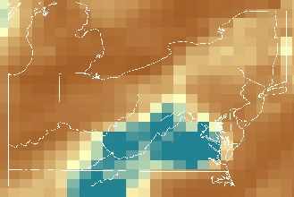
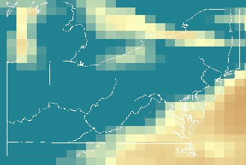
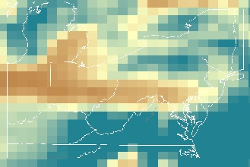
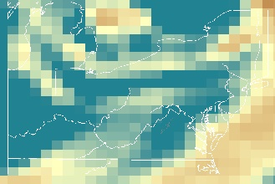
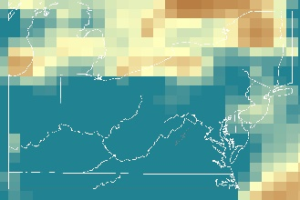
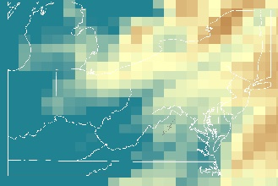
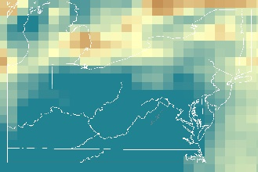
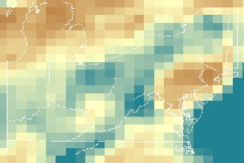
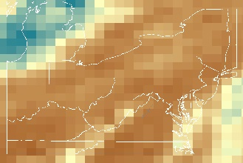
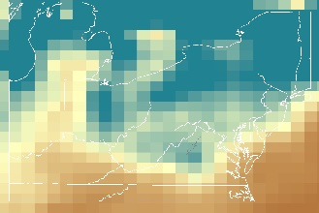
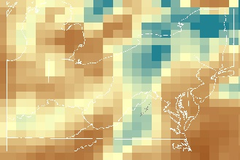
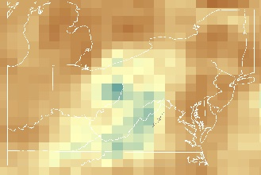
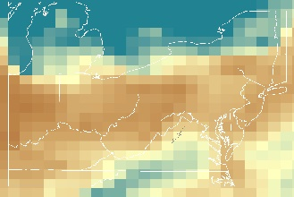
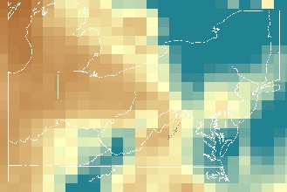
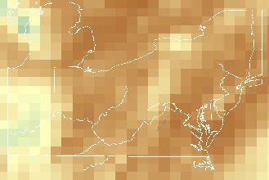
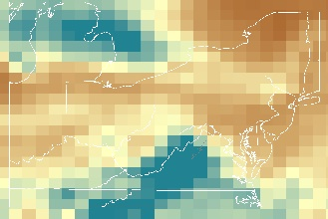
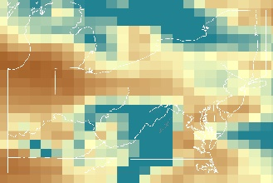
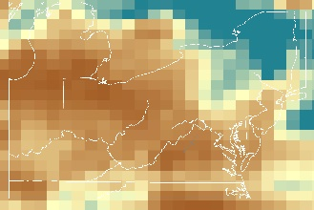
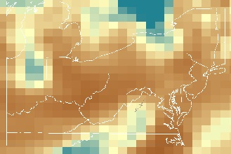
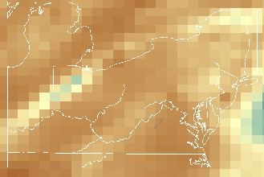
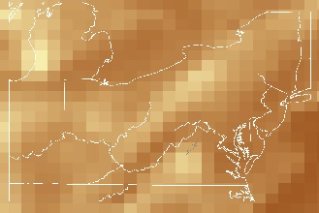
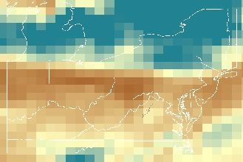
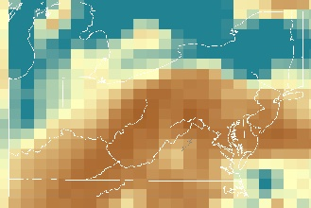
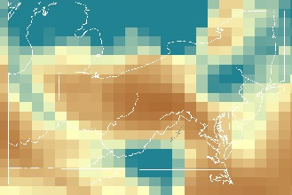
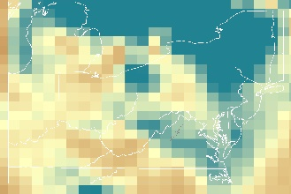
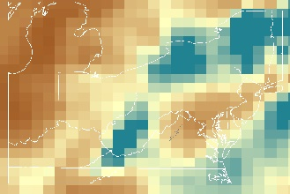
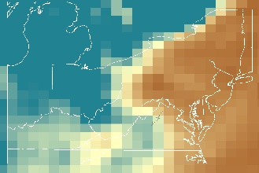
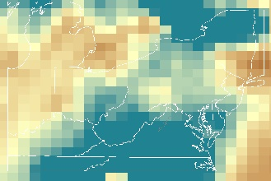
Figure B1. January 2015 Visibility from MERRA-2 Extinction Profiles
1
2
6
7
3
4
5
8
9
10
11
12
13
14
15
16
17
18
19
20
21
22
23
24
25
26
27
28
29
30
31
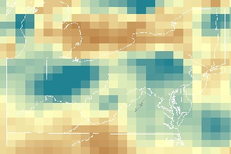
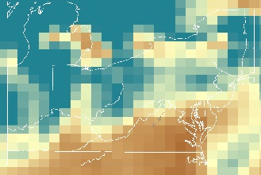
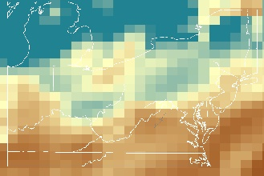
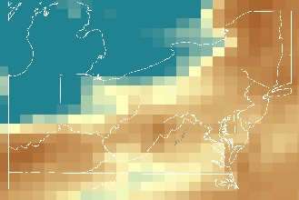
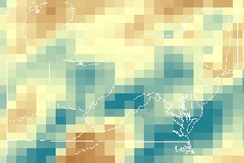
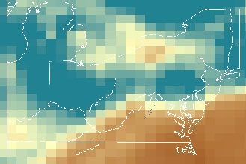
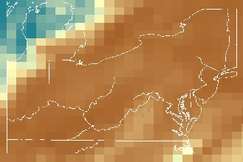
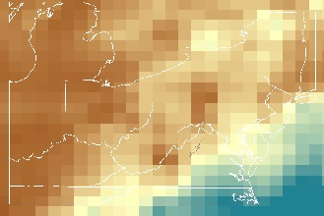
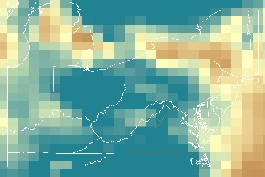
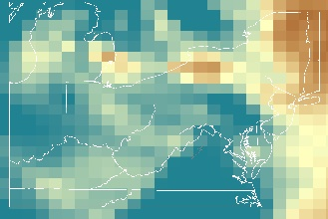
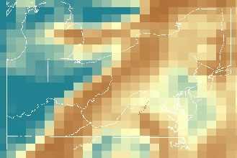
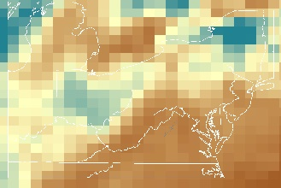
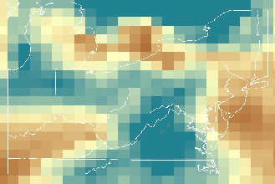
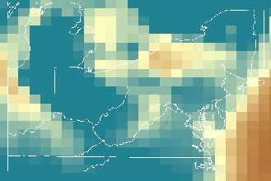
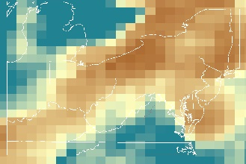
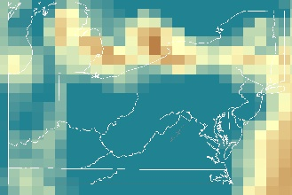
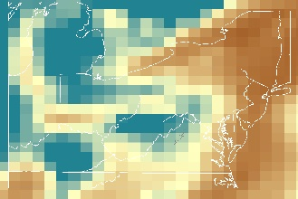
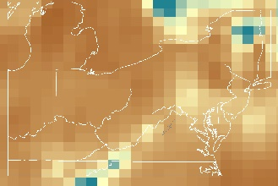
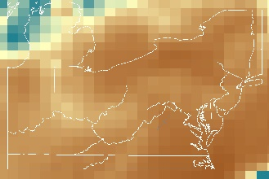
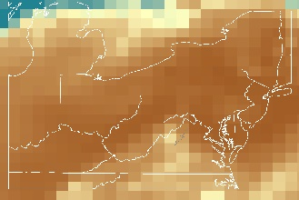
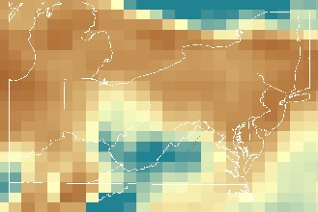
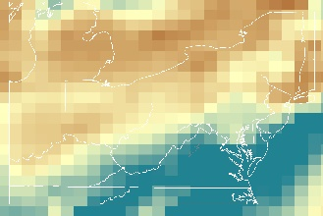
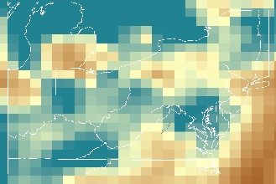
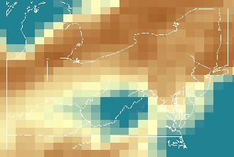
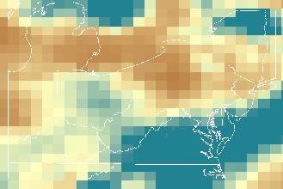
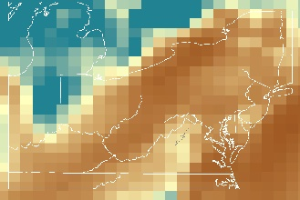
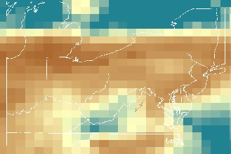
Figure B2. February 2015 Visibility from MERRA-2 Extinction Profiles
1
2
6
7
3
4
5
8
9
10
11
12
13
14
15
16
17
18
19
20
21
22
23
24
25
26
27
28
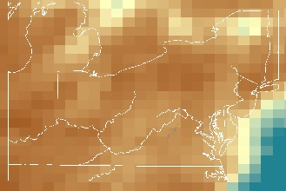
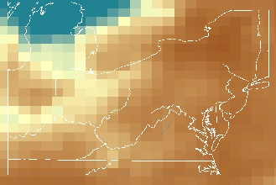
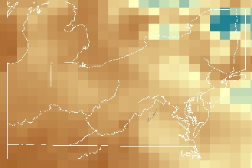
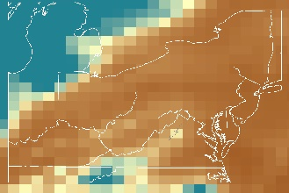
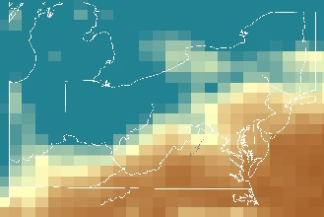
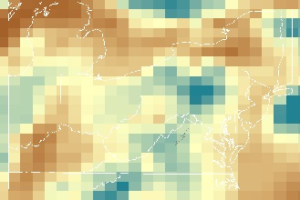
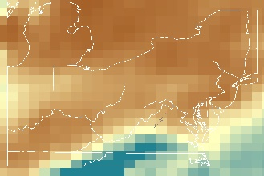
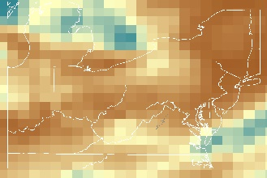
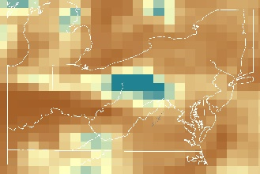
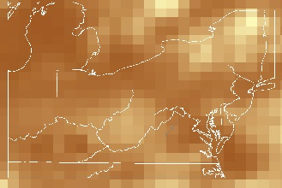
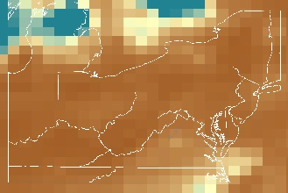
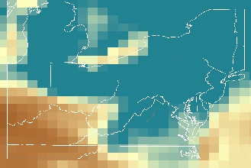
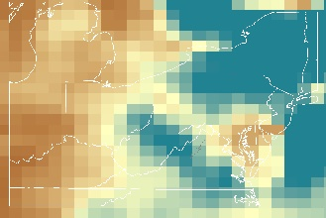
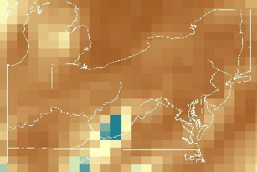
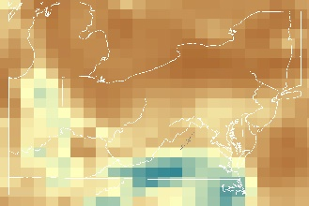
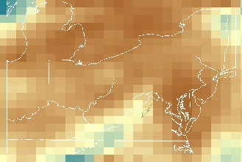
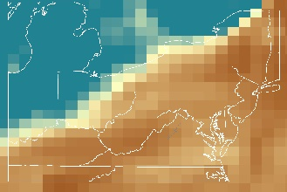
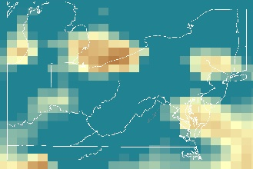
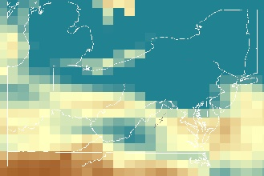
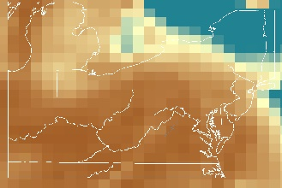
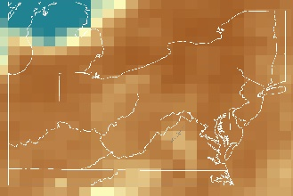
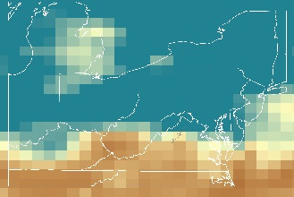
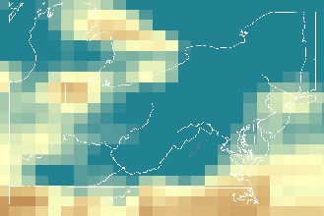
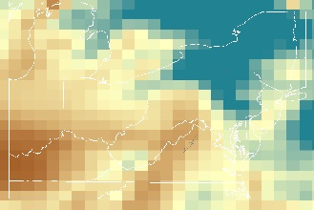
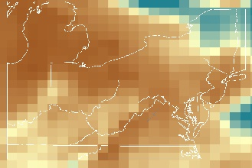
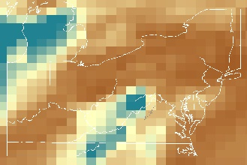
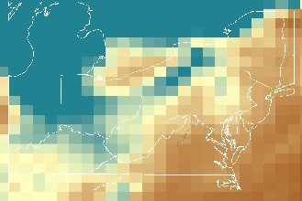
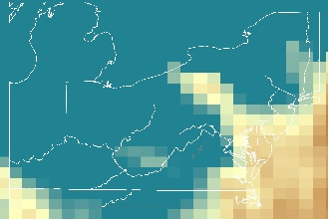
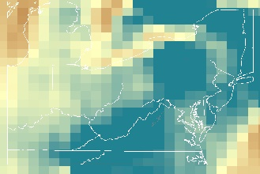
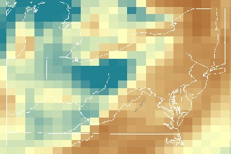
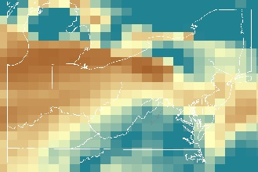
Figure B3. March 2015 Visibility from MERRA-2 Extinction Profiles
31
30
29
28
27
26
25
24
23
22
21
20
19
18
17
16
15
14
13
12
11
10
9
8
5
4
3
7
6
2
1
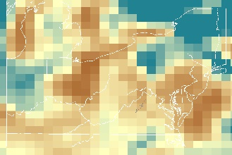
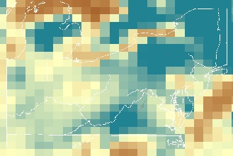
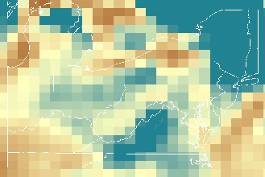
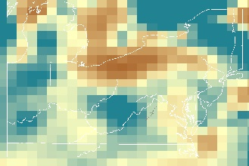
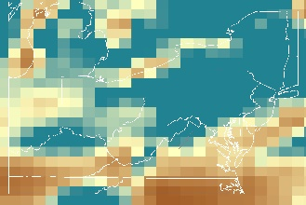
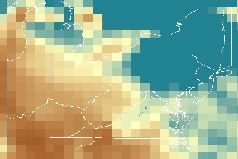
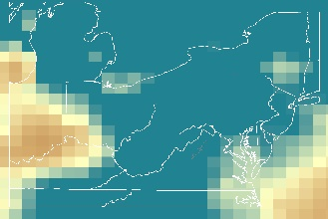
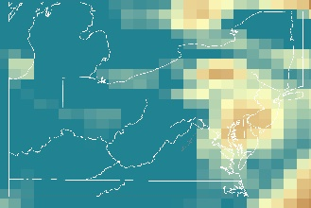
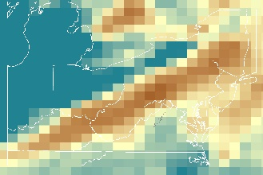
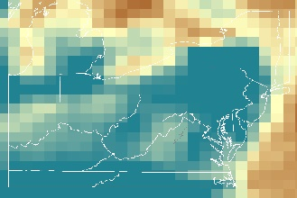
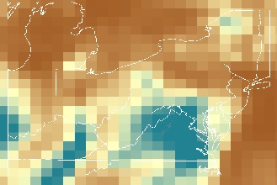
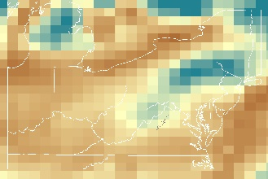
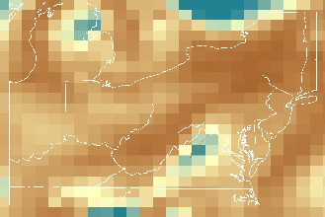
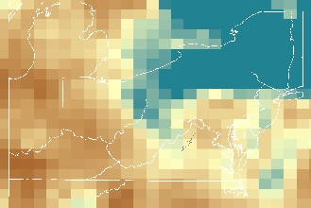
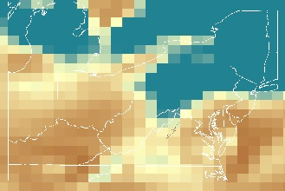
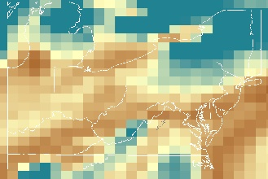
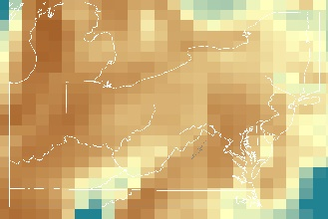
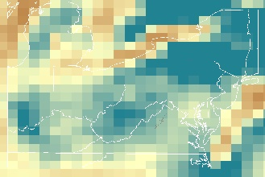
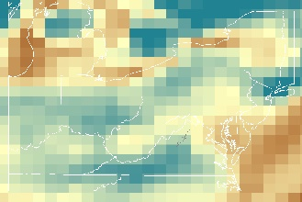
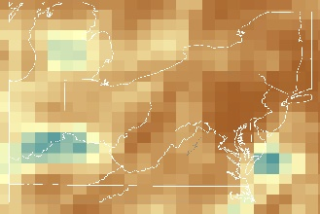
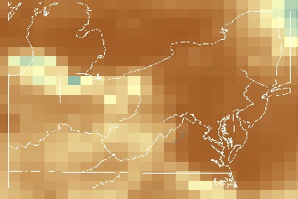
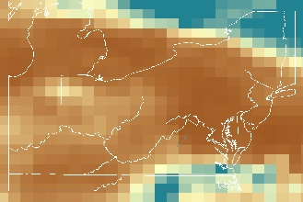
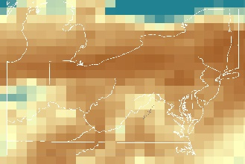
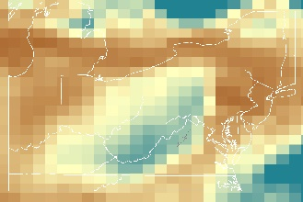
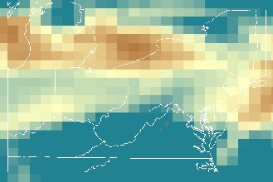
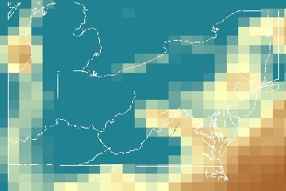
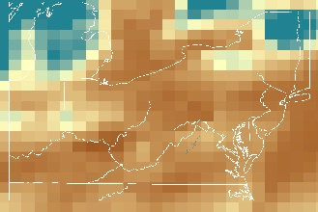
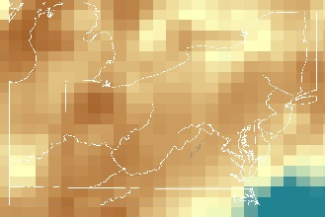
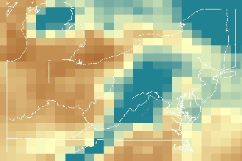
Figure B4. April 2015 Visibility from MERRA-2 Extinction Profiles
1
2
6
7
3
4
5
8
9
10
11
12
13
14
15
16
17
18
19
20
21
22
23
24
25
26
27
28
29
30
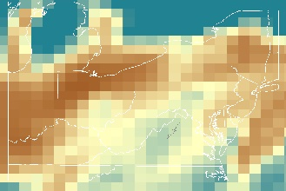
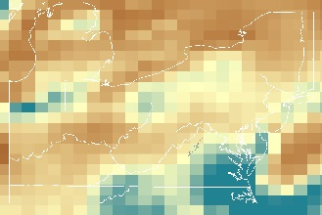
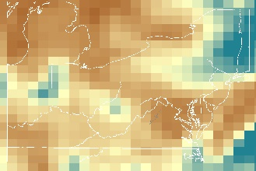
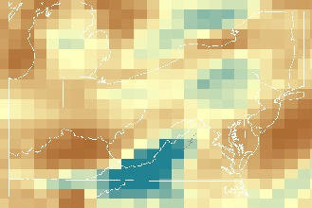
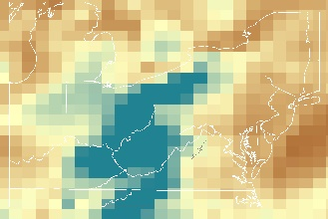
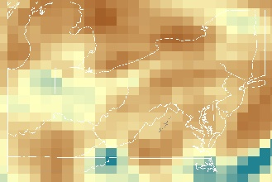
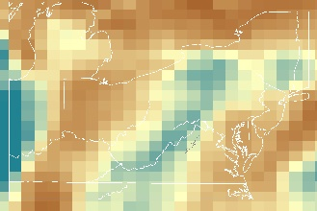
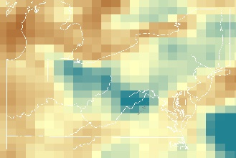
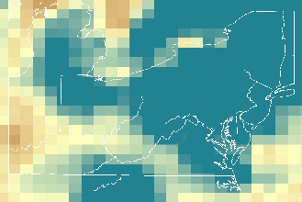
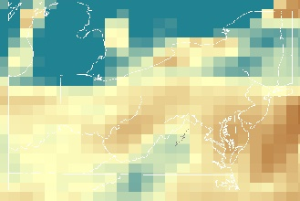
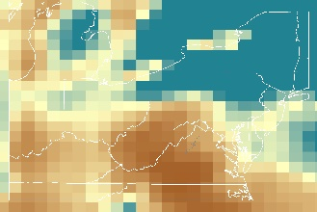
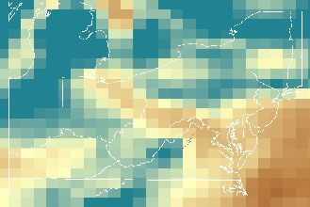
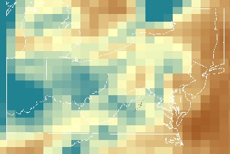
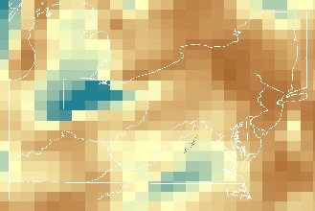
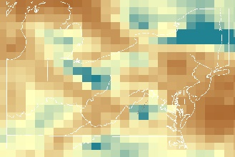
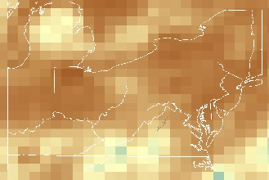
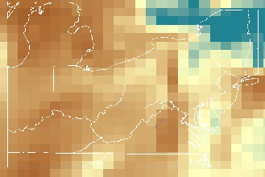
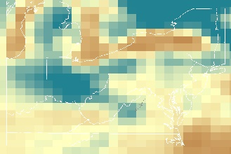
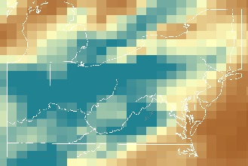
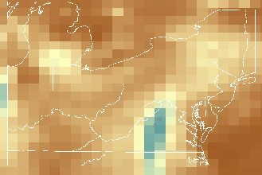
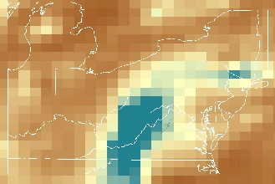
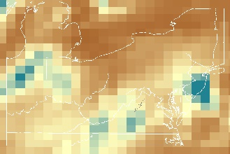
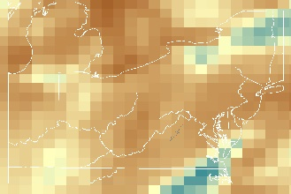
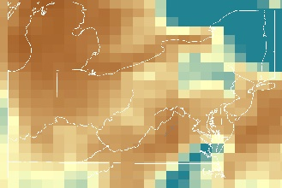
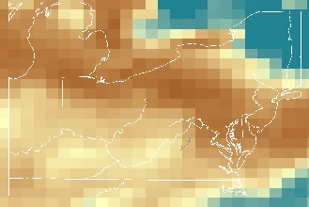
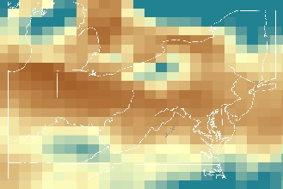
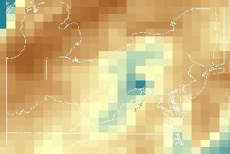
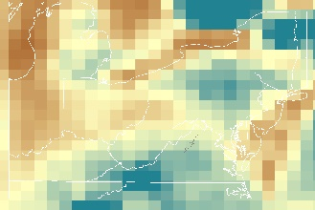
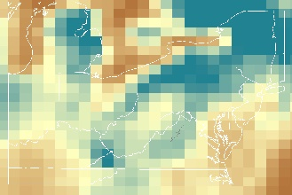
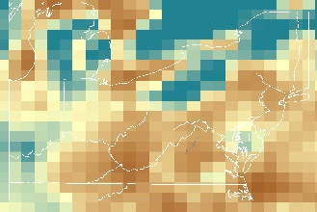
Figure B5. May 2015 Visibility from MERRA-2 Extinction Profiles
1
2
6
7
3
4
5
8
9
10
11
12
13
15
16
17
18
19
20
21
22
23
24
25
26
27
28
29
30
31
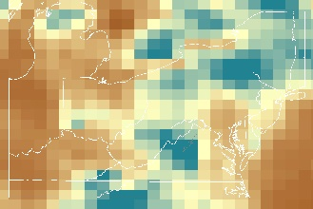
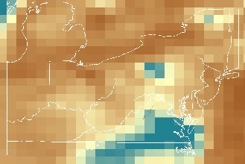
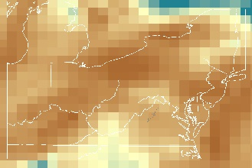
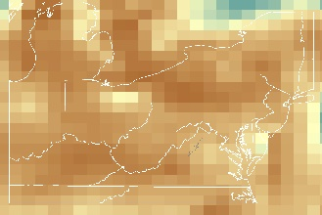
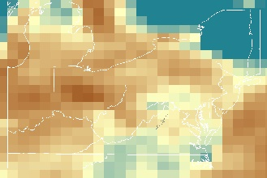
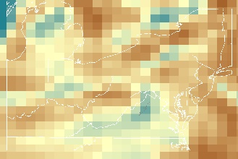
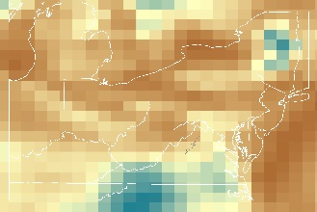
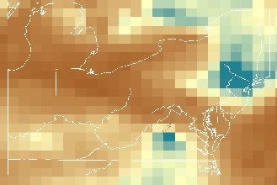
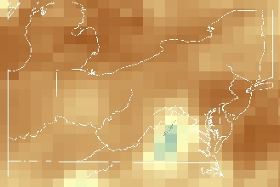
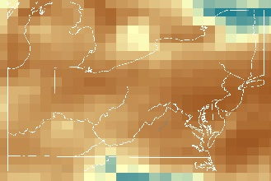
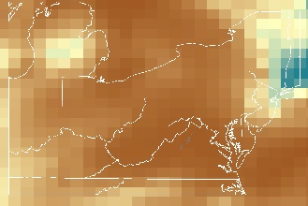
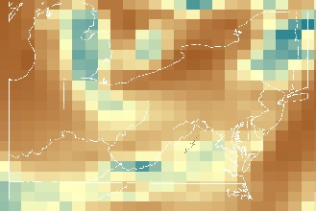
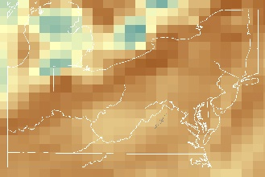
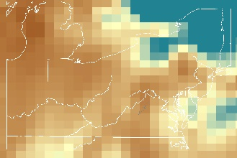
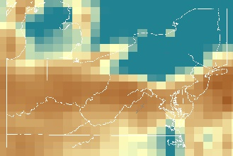
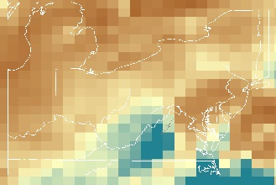
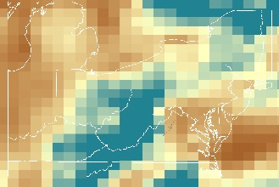
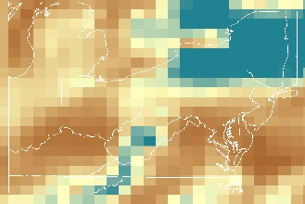
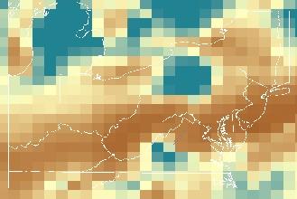
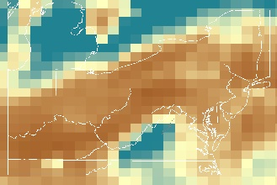
Figure B6. June 2015 Visibility from MERRA-2 Extinction Profiles
1
2
6
7
3
4
5
8
9
10
11
12
13
15
16
17
18
20
21
22
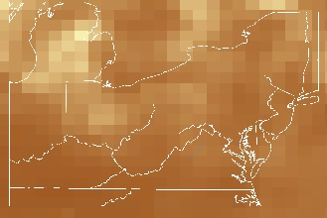
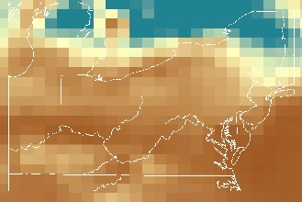
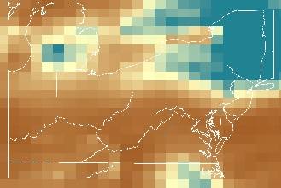
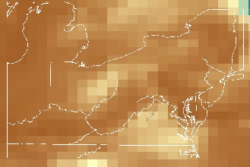
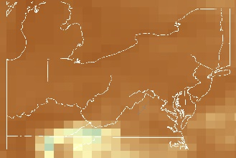
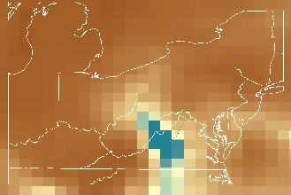
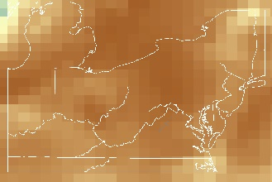
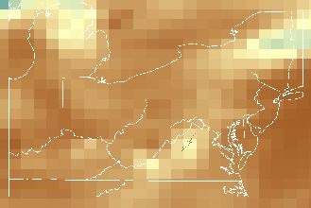
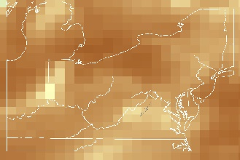
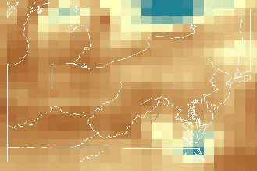
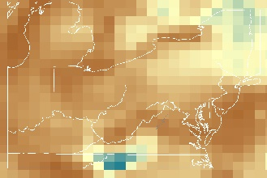
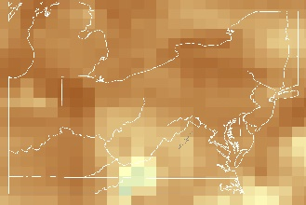
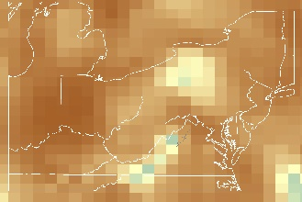
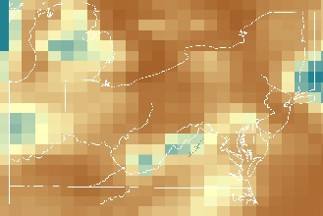
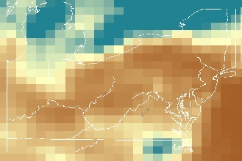
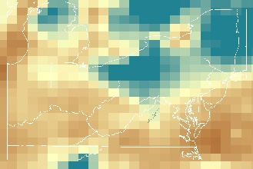
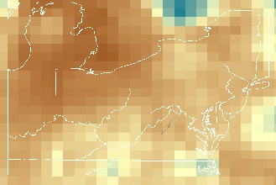
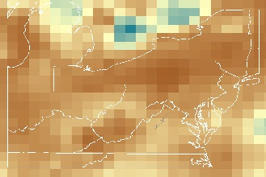
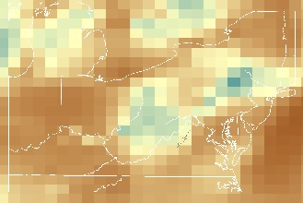
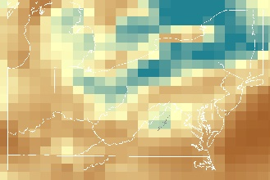
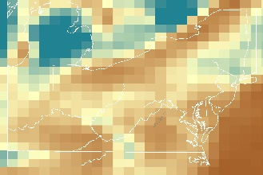
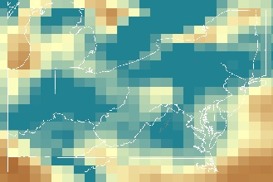
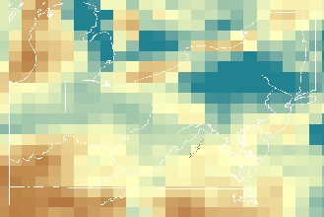
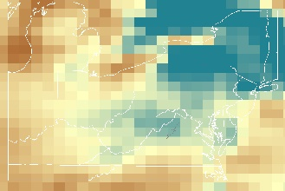
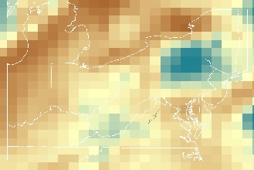
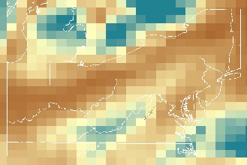
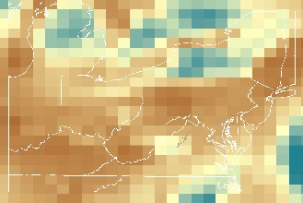
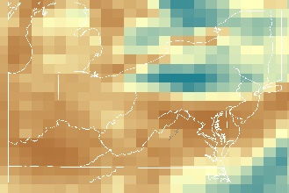
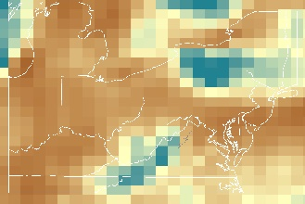
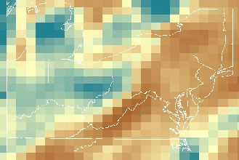
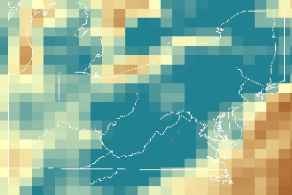
Figure B7. July 2015 Visibility from MERRA-2 Extinction Profiles
31
30
29
28
27
26
25
24
23
22
21
20
19
18
17
16
15
14
13
12
11
10
9
8
5
4
3
7
6
2
1
Figure B8. August 2015 Visibility from MERRA-2 Extinction Profiles
31
30
29
28
27
26
25
24
23
22
21
20
19
18
17
16
15
14
13
12
11
10
9
8
5
4
3
7
6
2
1
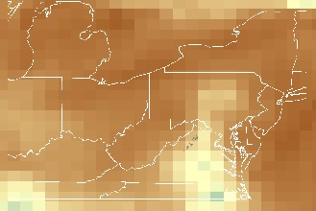
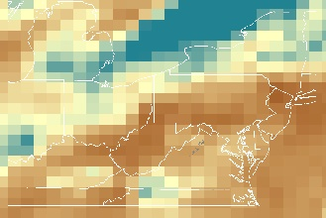
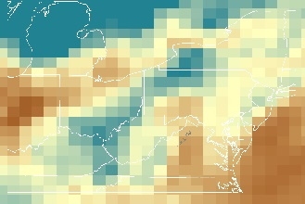
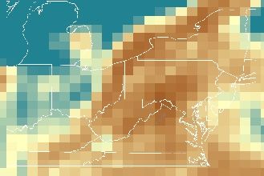
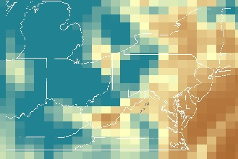
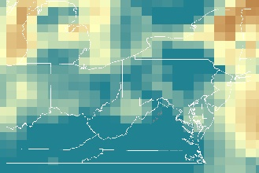
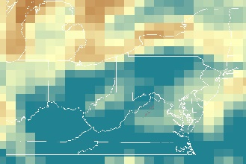
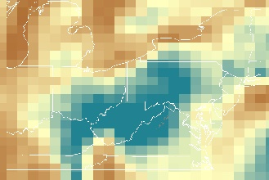
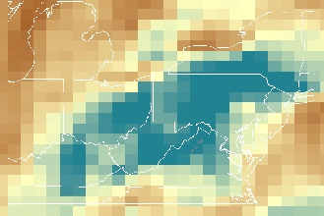
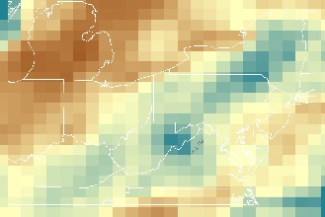
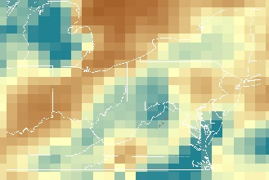
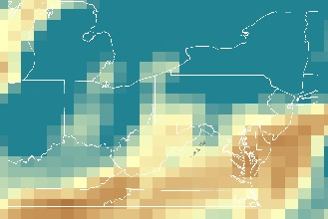
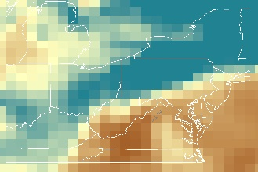
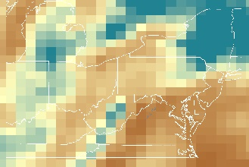
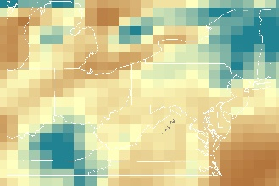
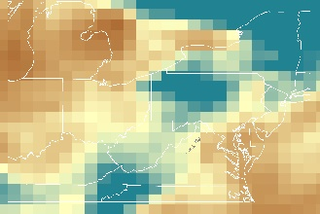
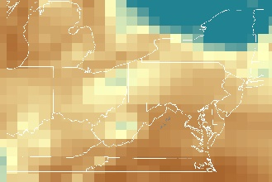
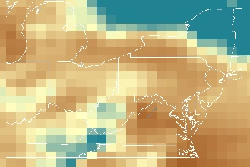
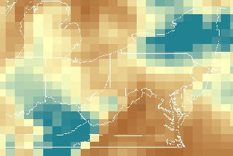
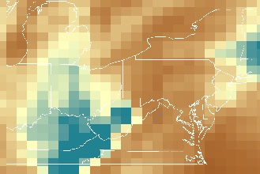
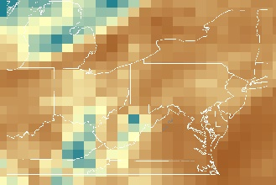
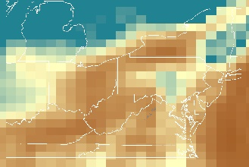
Figure B9. September 2015 Visibility from MERRA-2 Extinction Profiles
30
29
28
27
26
25
24
23
22
21
20
19
18
17
16
13
12
11
15
14
10
3
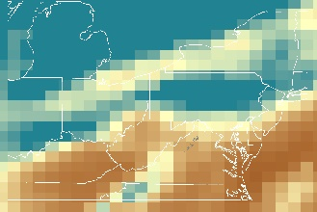
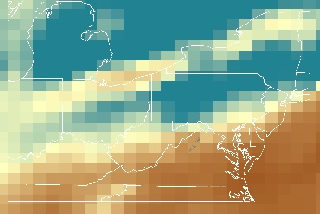
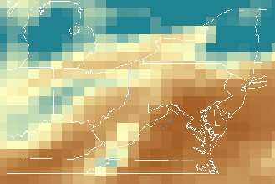
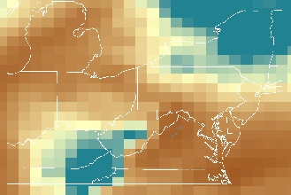
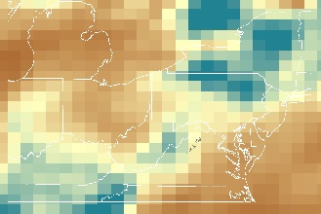
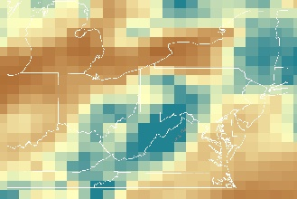
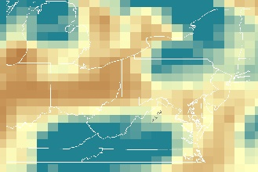
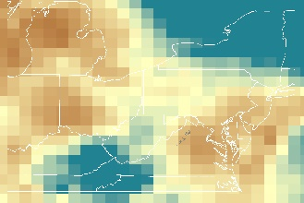
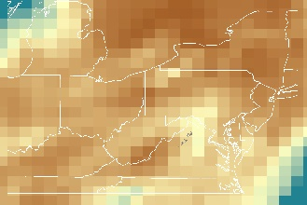
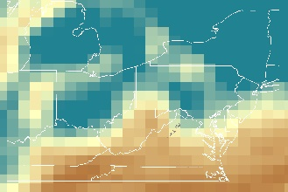
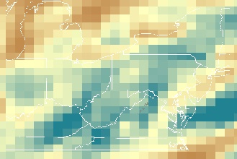
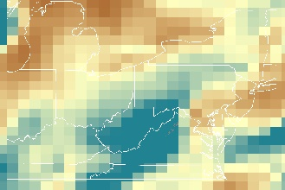
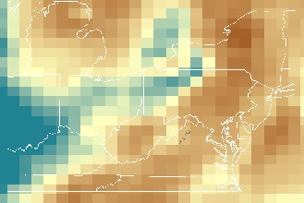
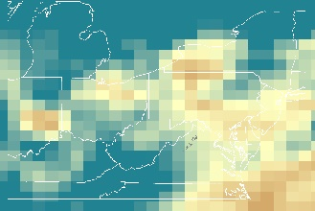
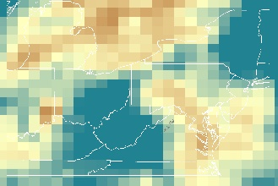
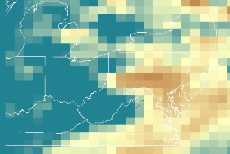
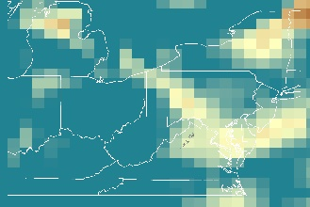
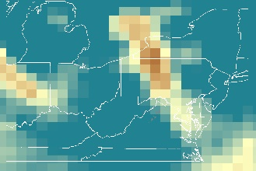
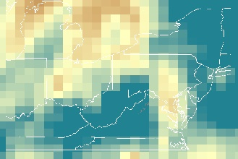
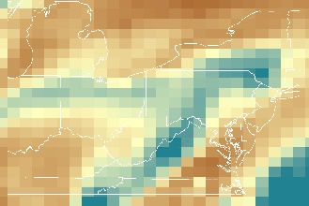
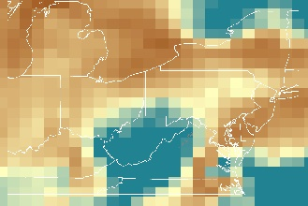
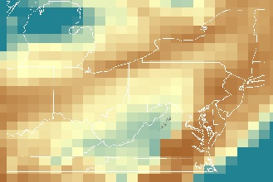
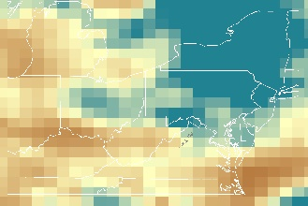
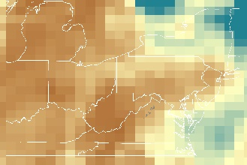
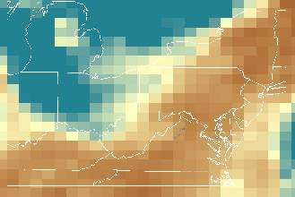
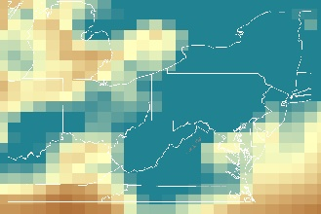
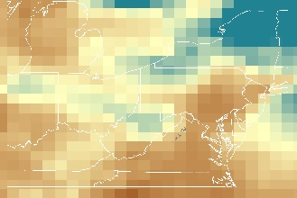
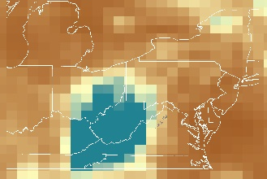
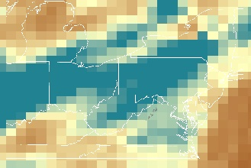
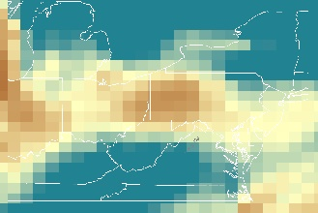
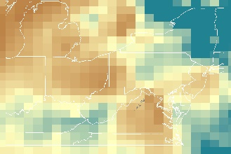
Figure B10. October 2015 Visibility from MERRA-2 Extinction Profiles
31
30
29
28
27
26
25
24
23
22
21
20
19
18
17
16
15
14
13
12
11
10
9
8
5
4
3
7
6
2
1
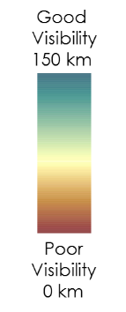
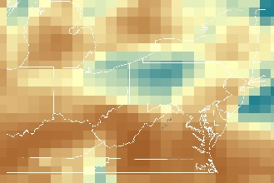
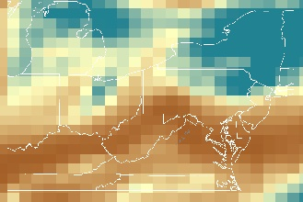
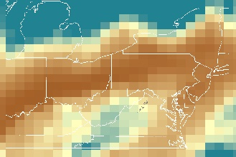
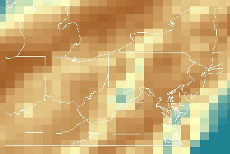
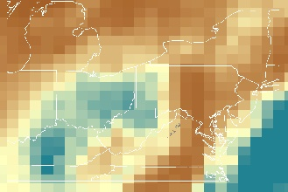
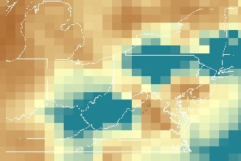
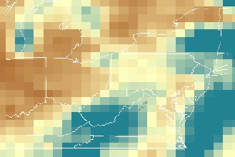
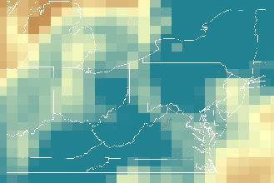
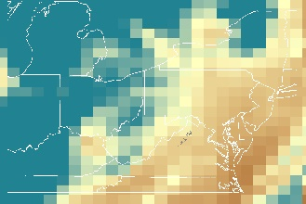
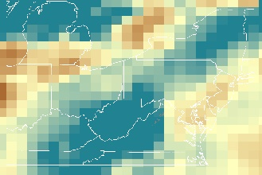
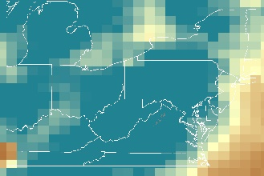
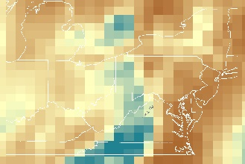
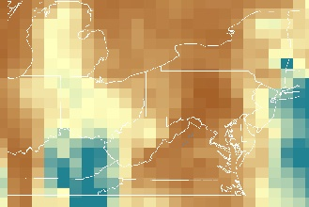
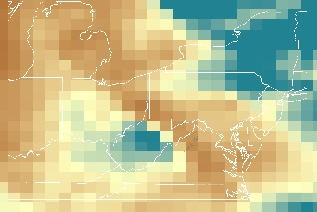
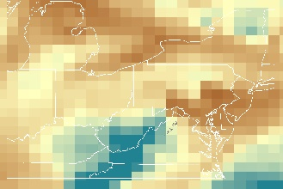
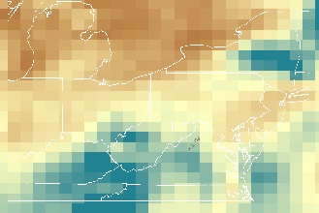
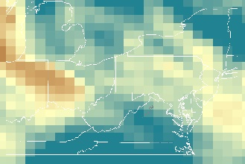
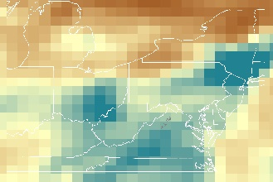
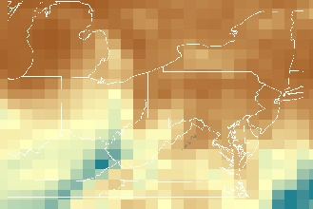
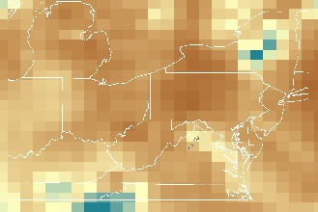
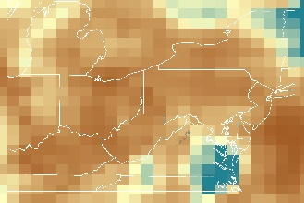
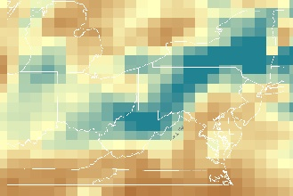
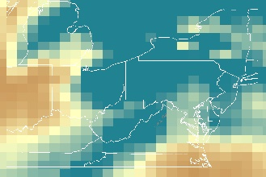
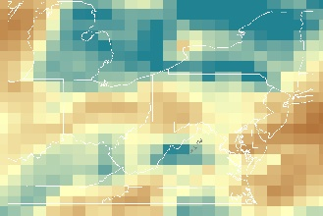
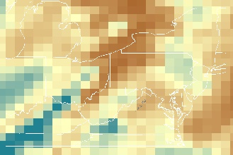
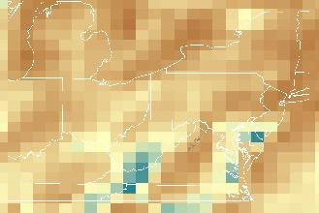
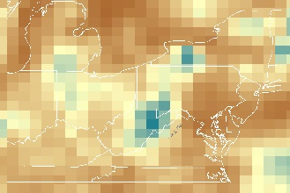
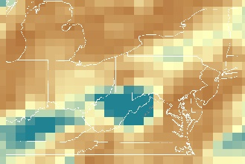
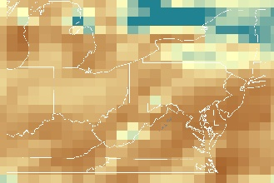
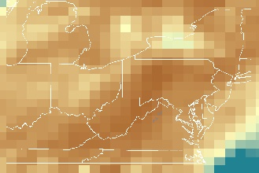
Figure B11. November 2015 Visibility from MERRA-2 Extinction Profiles
1
2
6
7
3
4
5
8
9
10
11
12
13
14
15
16
17
18
19
20
21
22
23
24
25
26
27
28
29
30
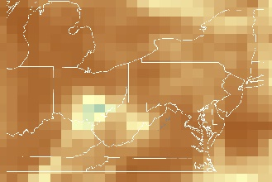
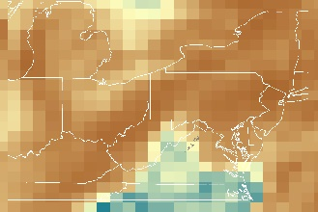
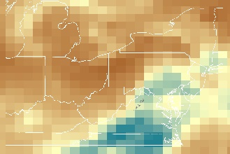
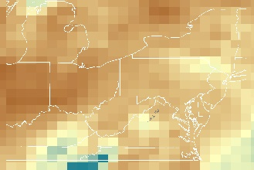
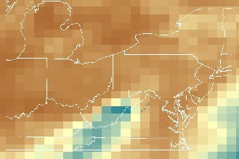
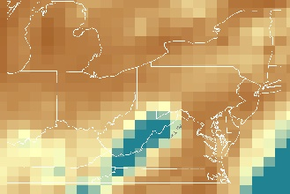
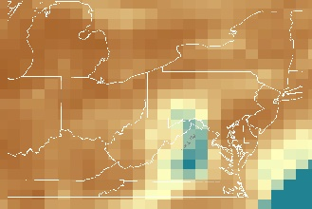
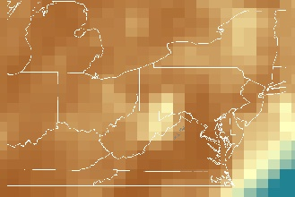
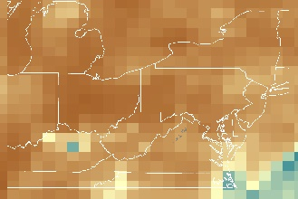
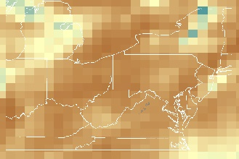
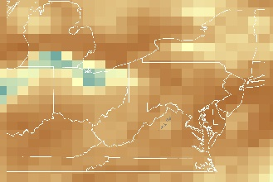
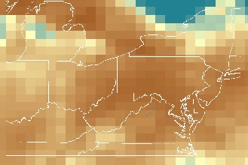
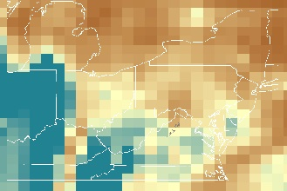
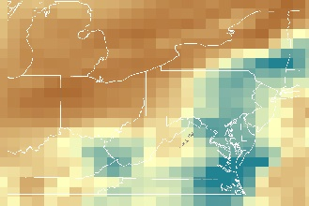
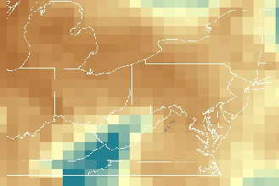
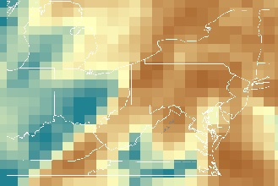
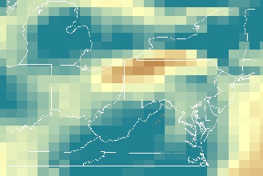
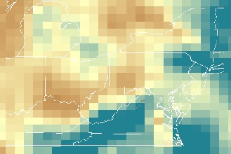
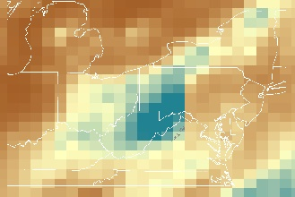
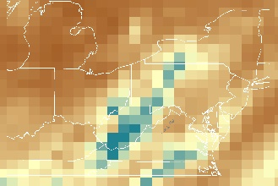
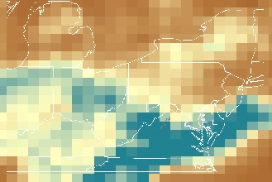
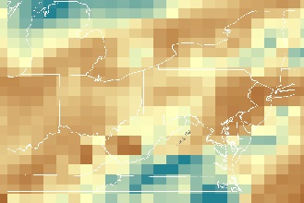
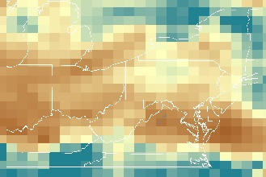
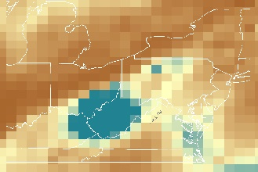
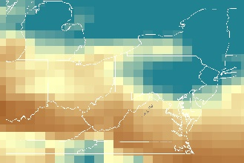
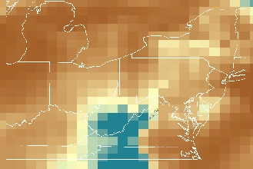
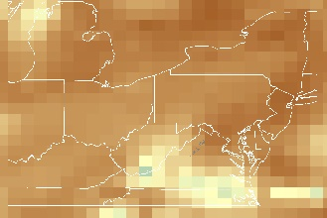
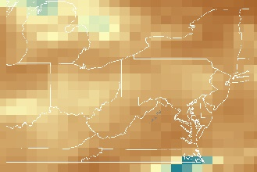
Figure B12. December 2015 Visibility from MERRA-2 Extinction Profiles
28
22
16
10
5
31
30
29
27
26
25
23
21
20
19
17
15
14
13
12
9
8
4
3
7
6
2
1
5
10
16
22
28
Appendix C
Tropospheric ozone residual trend maps from 2007 to 2016

Figure C1. 2007 TOR in ppbv
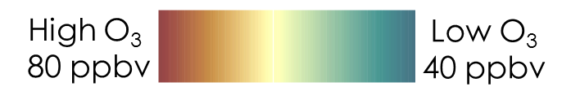
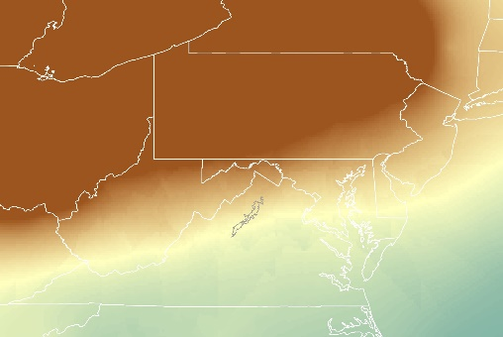
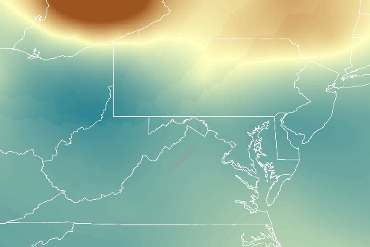
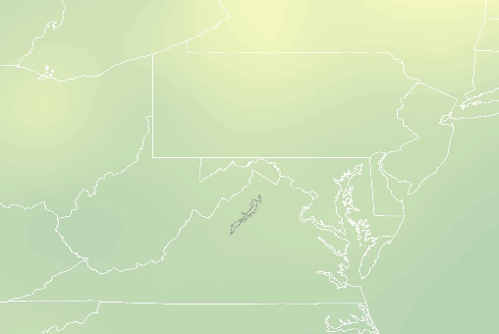
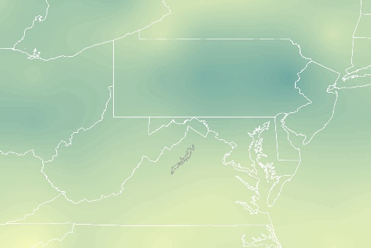
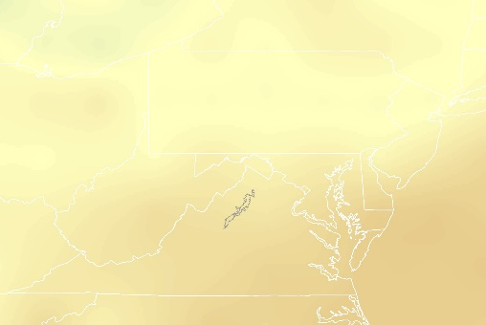
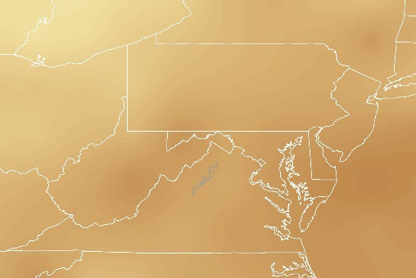
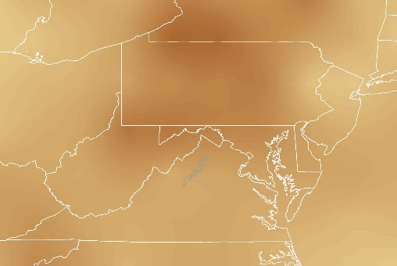
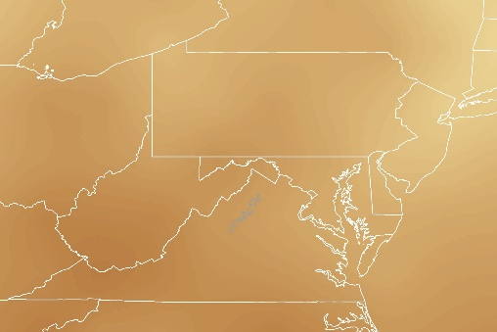
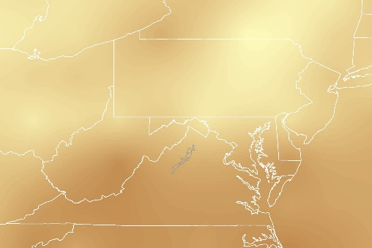
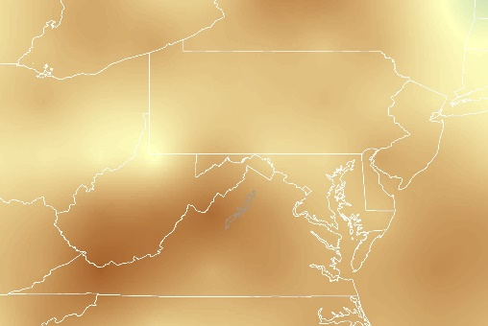
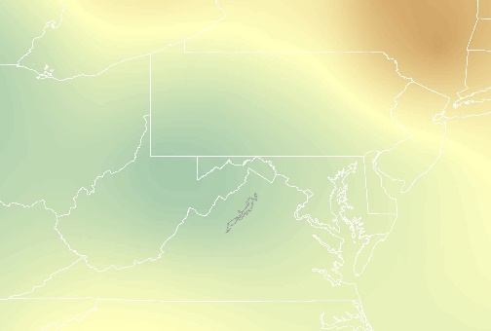
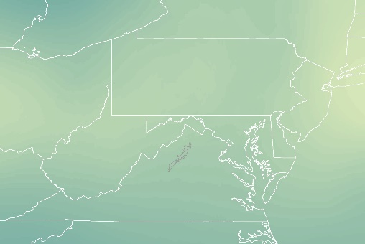
December
November
October
September
August
July
June
May
April
March
February
January
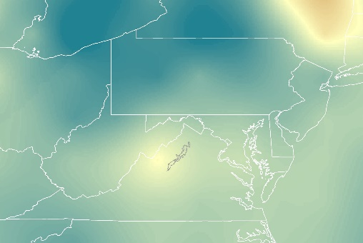
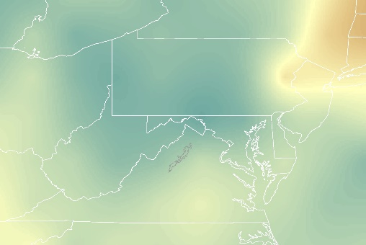
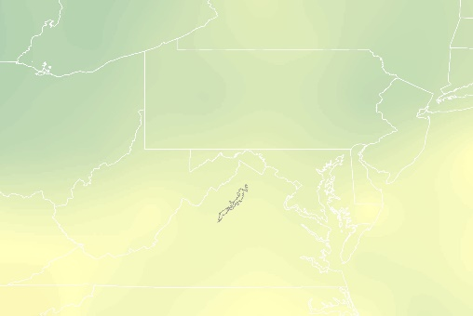
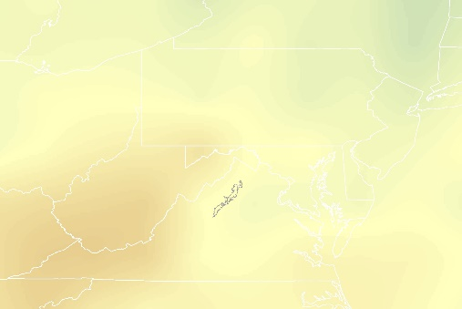
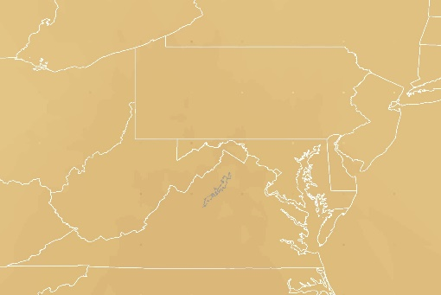
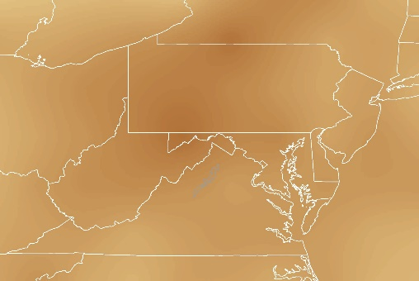
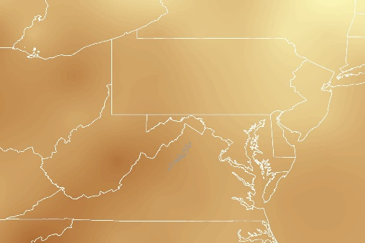
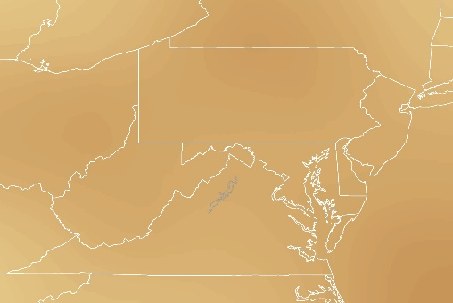
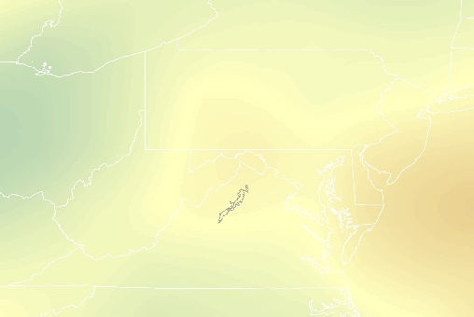
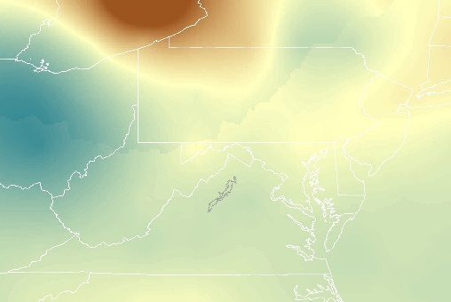
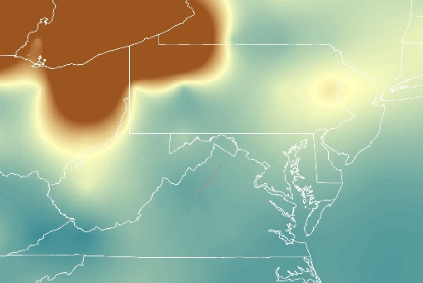
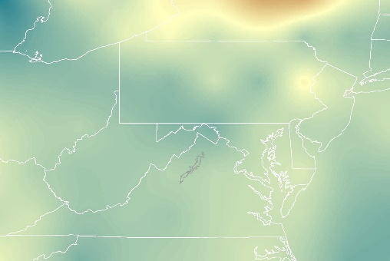
Figure C2. 2008 TOR in ppbv
January
February
March
April
May
June
July
August
September
October
November
December
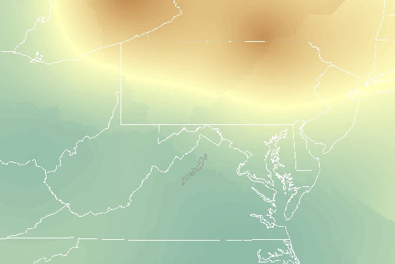
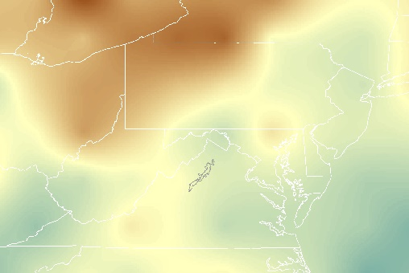
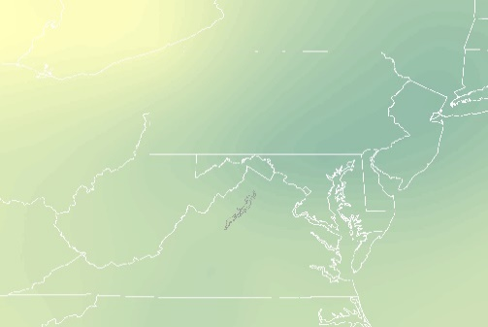
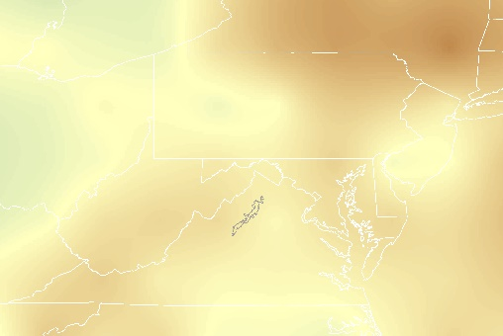
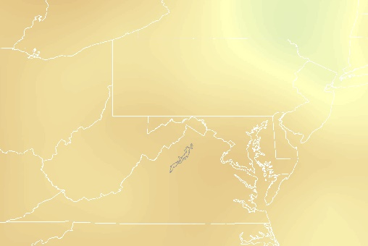
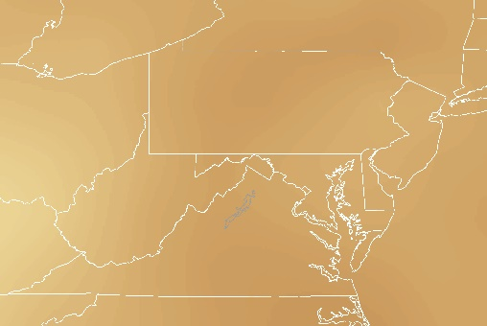
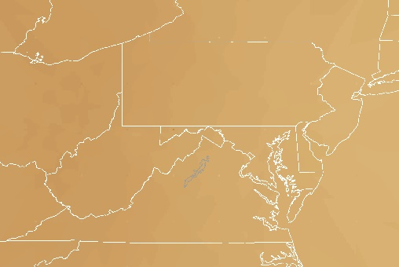
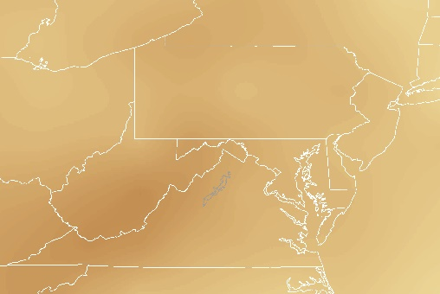
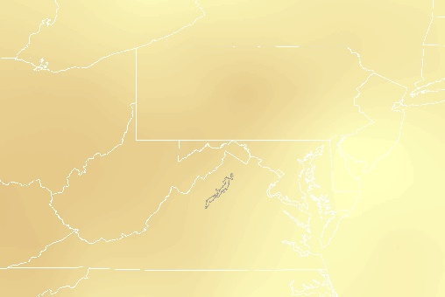
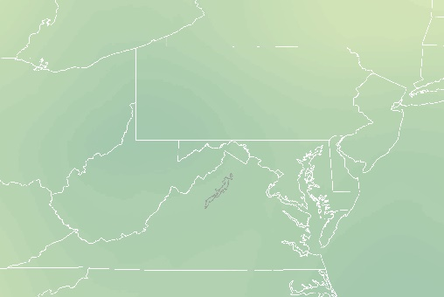
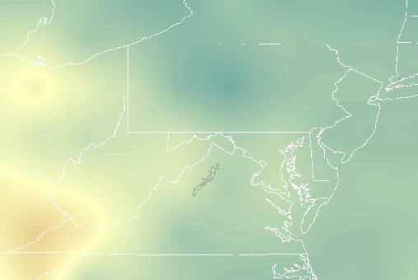
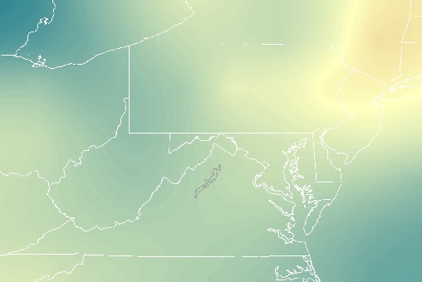
Figure C3. 2009 TOR in ppbv
January
February
March
April
May
June
July
August
September
October
November
December
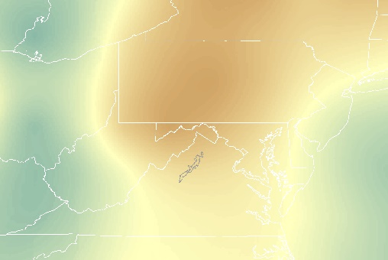
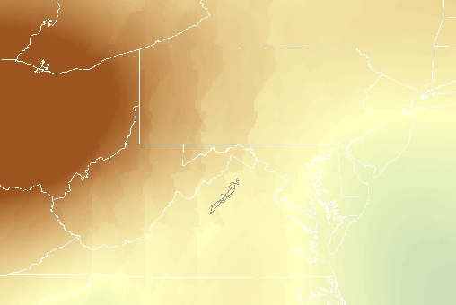
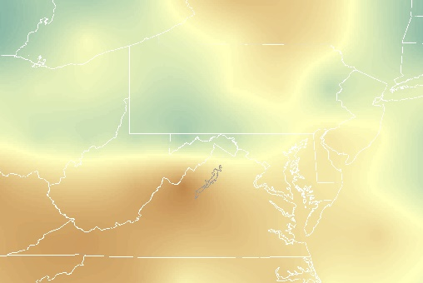
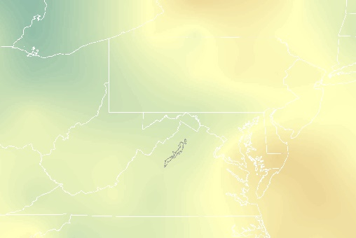
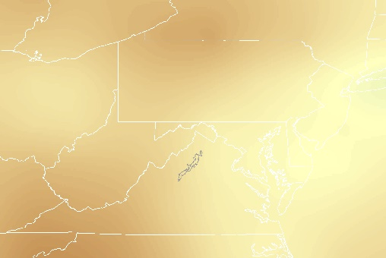
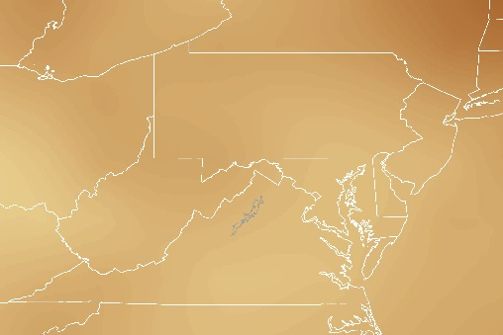
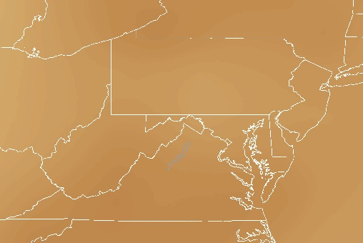
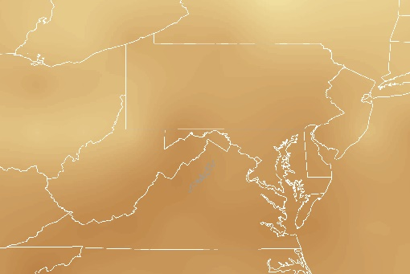
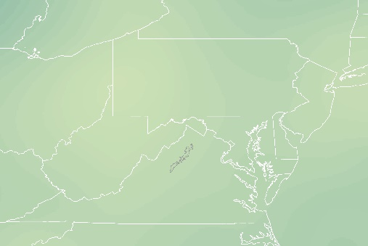
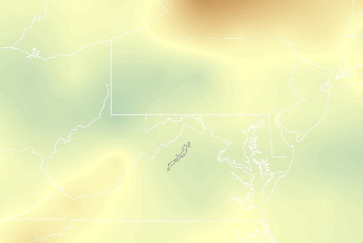
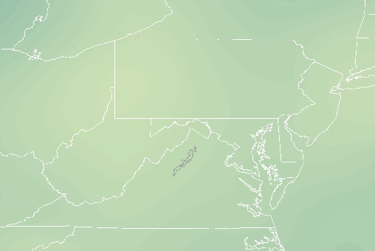
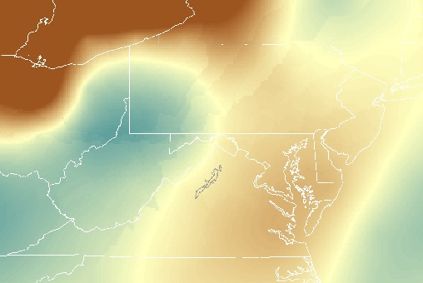
Figure C4. 2010 TOR in ppbv
December
November
October
September
August
July
June
May
April
March
February
January
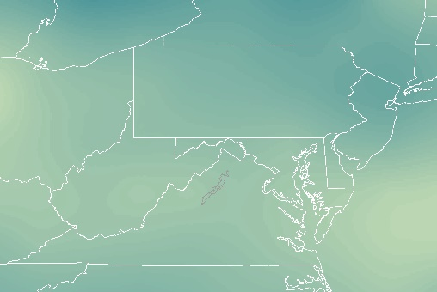
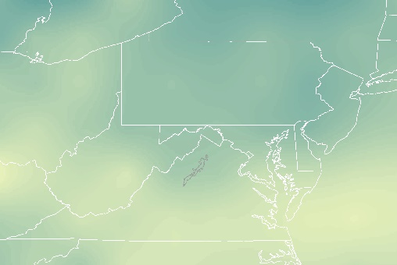
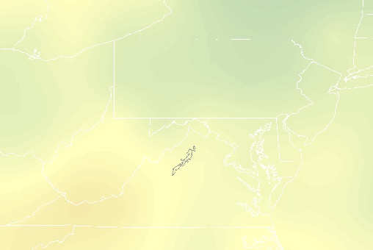
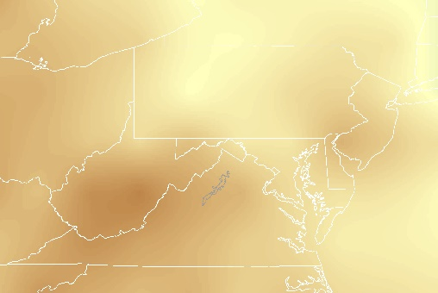
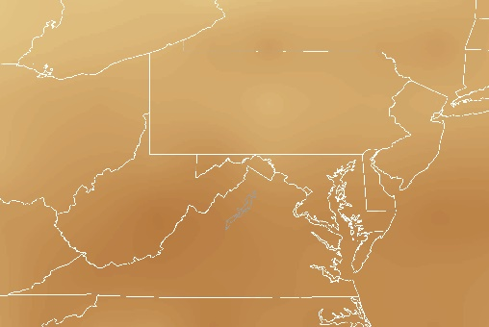
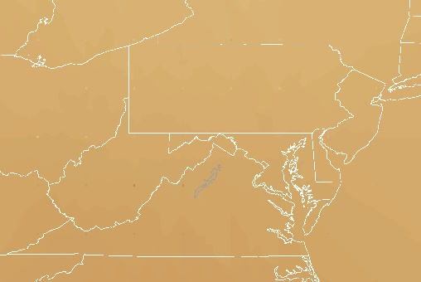
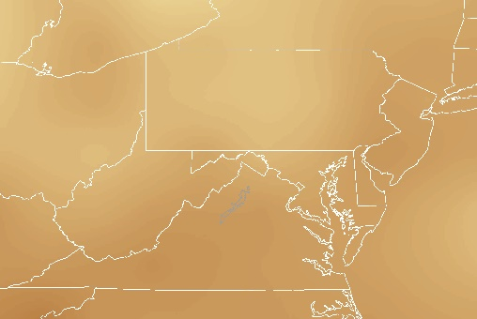
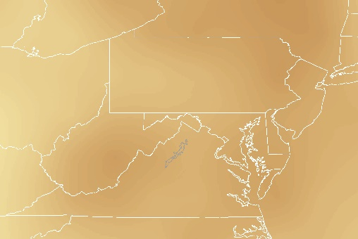
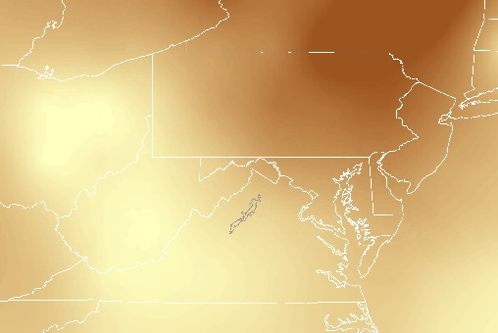
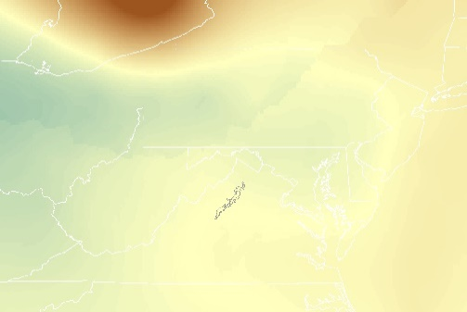
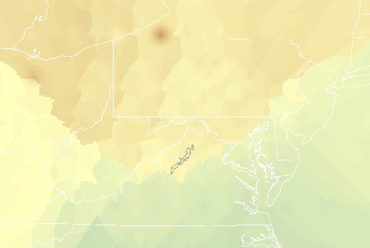
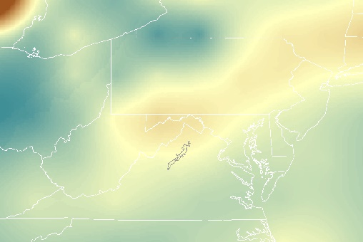
Figure C5. 2011 TOR in ppbv
December
November
October
September
August
July
June
May
April
March
February
January
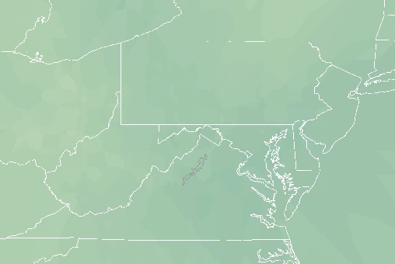
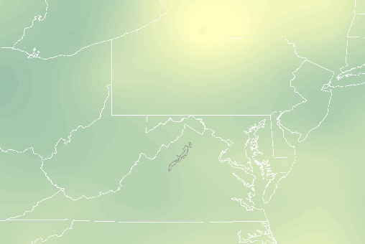
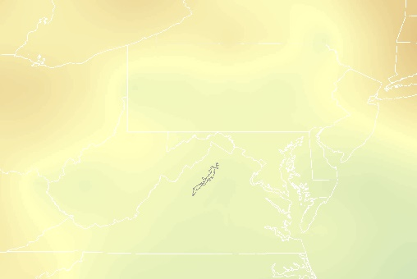
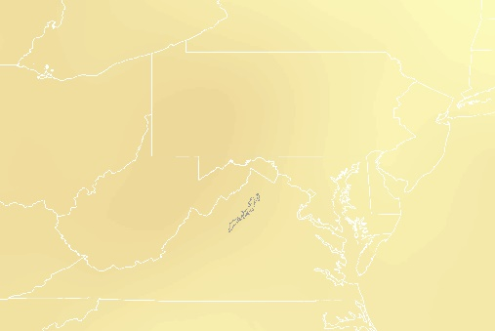
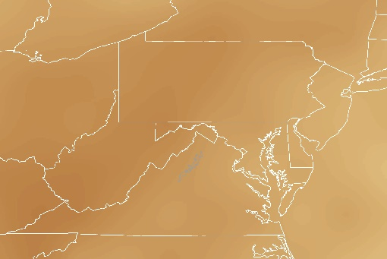
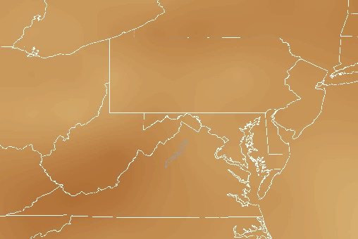
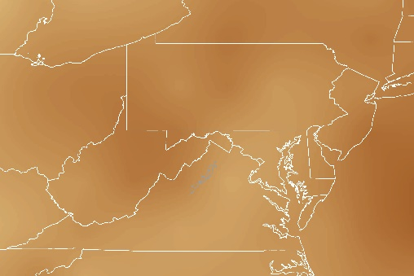
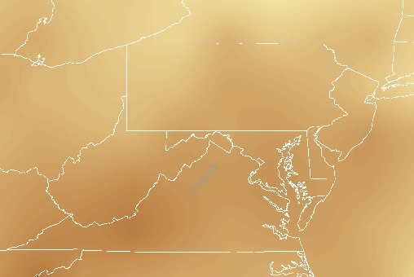
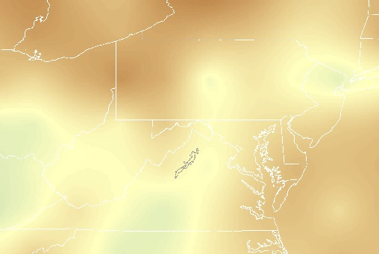
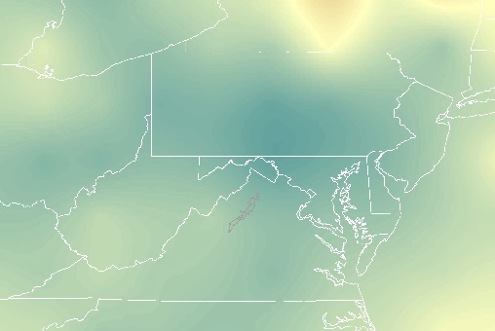
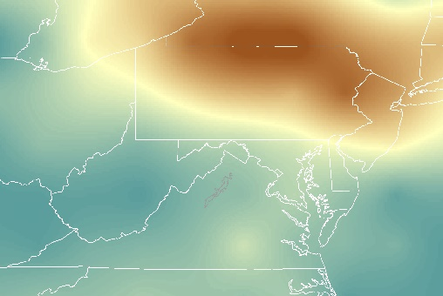
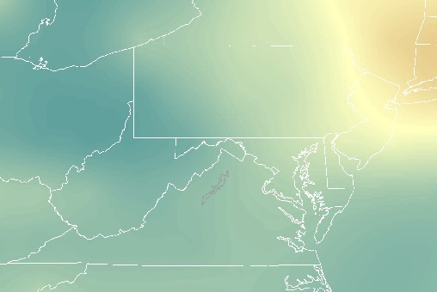
Figure C6. 2012 TOR in ppbv
January
February
March
April
May
June
July
August
September
October
November
December
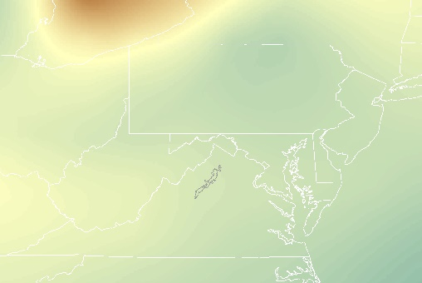
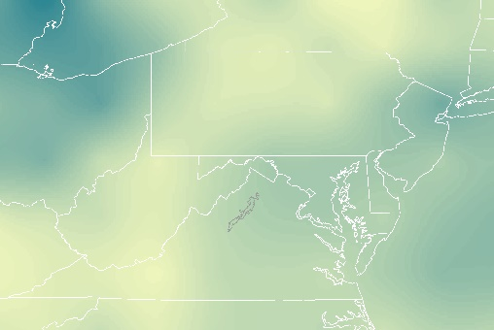
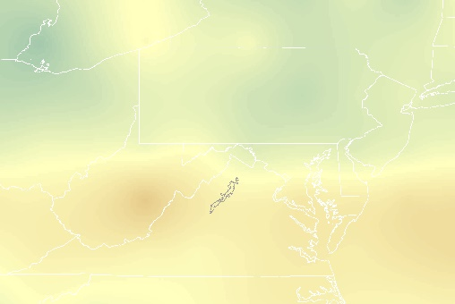
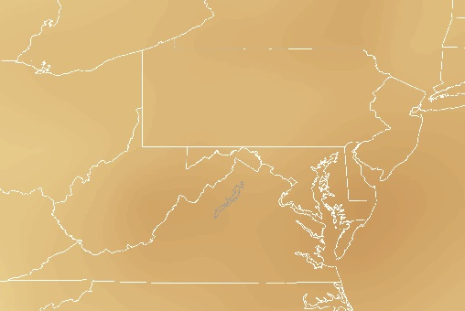
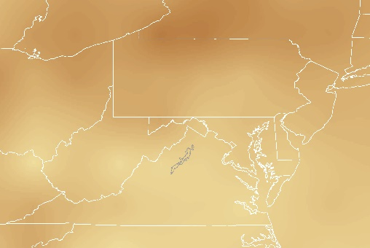
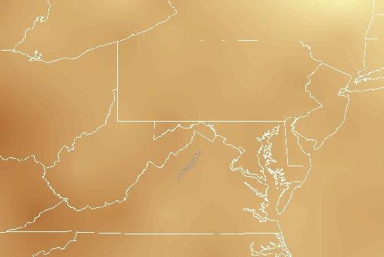
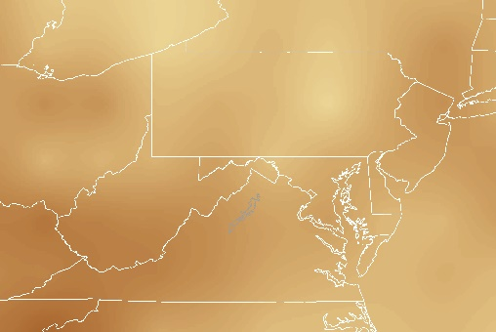
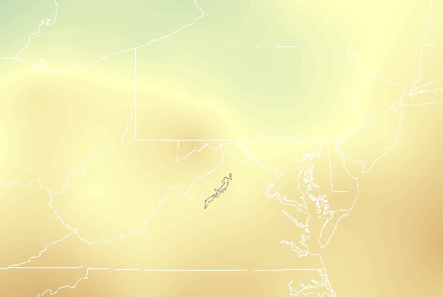
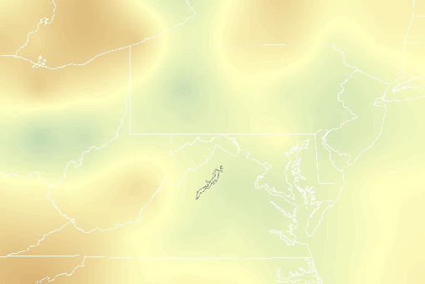
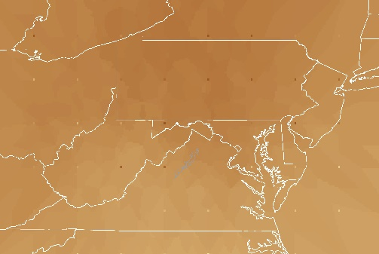
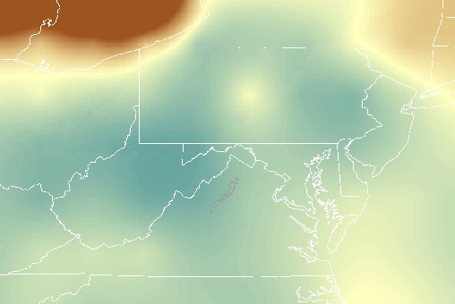
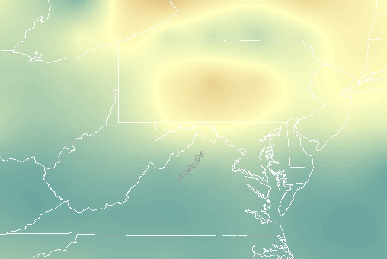
Figure C7. 2013 TOR in ppbv
December
November
October
September
August
July
June
May
April
March
February
January
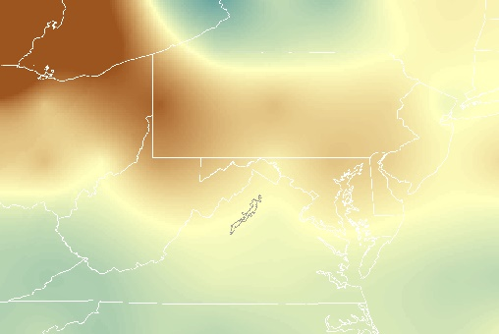
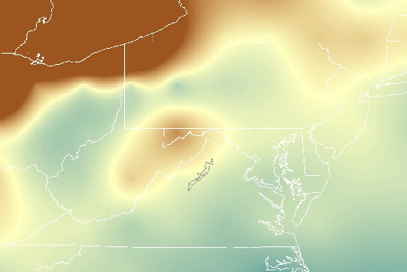
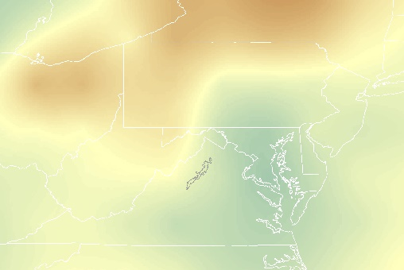
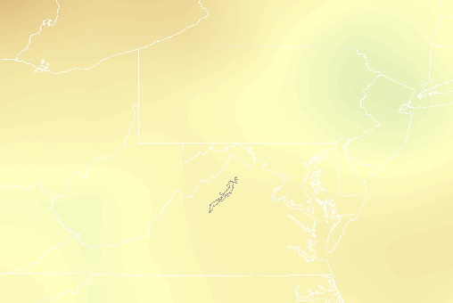
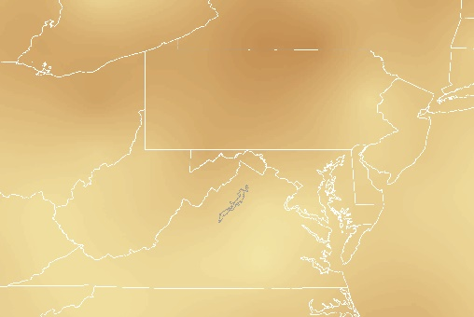
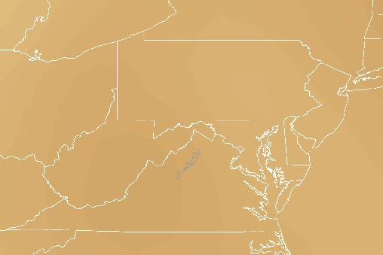
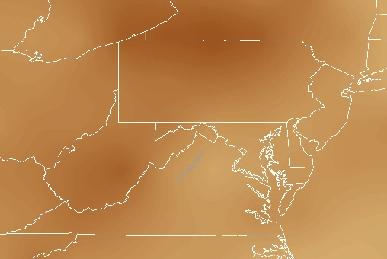
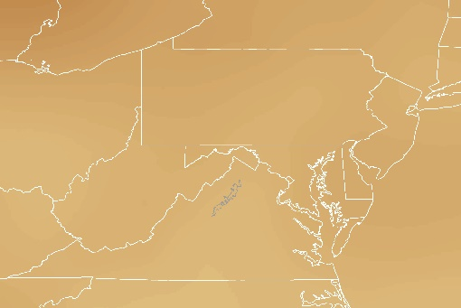
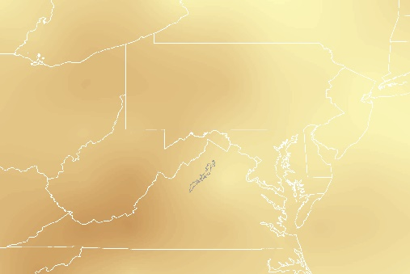
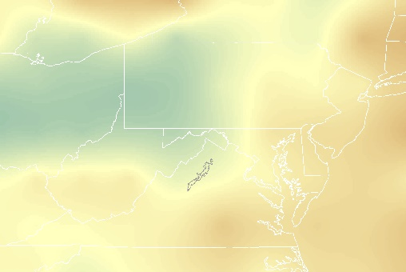
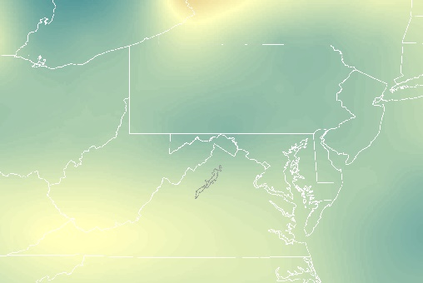
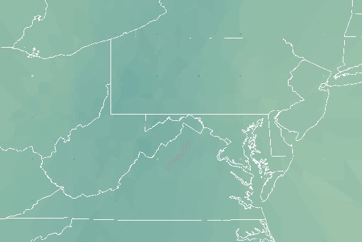
Figure C8. 2014 TOR in ppbv
December
November
October
September
August
July
June
May
April
March
February
January
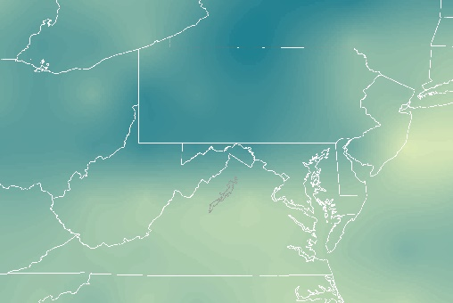
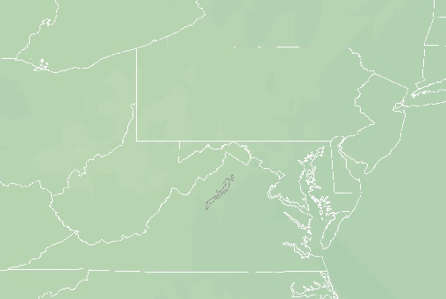
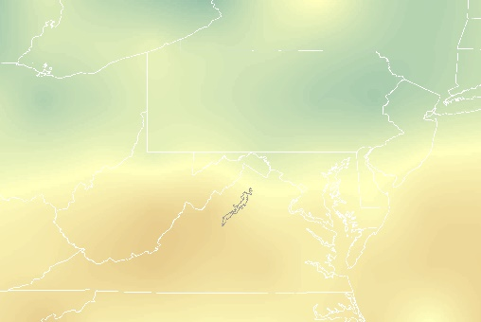
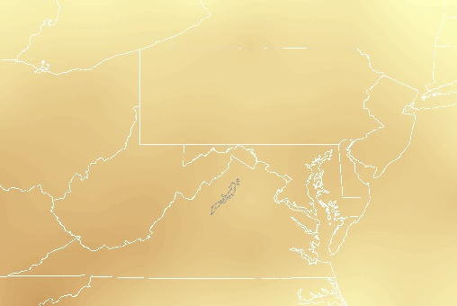
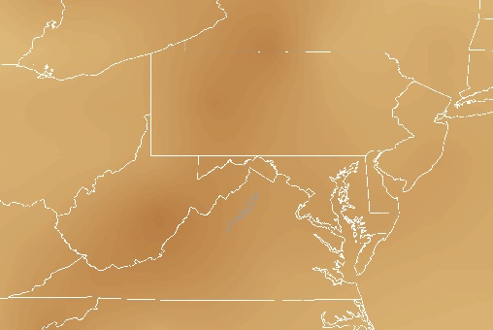
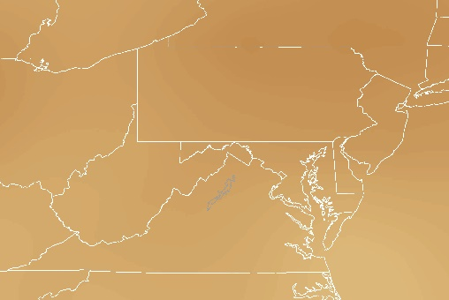
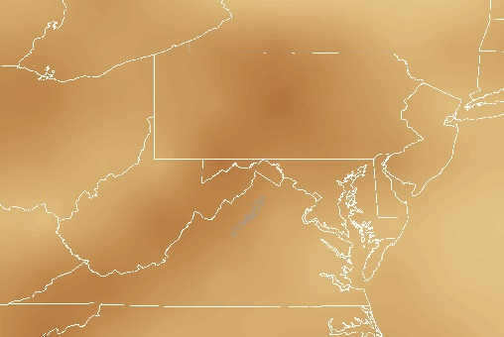
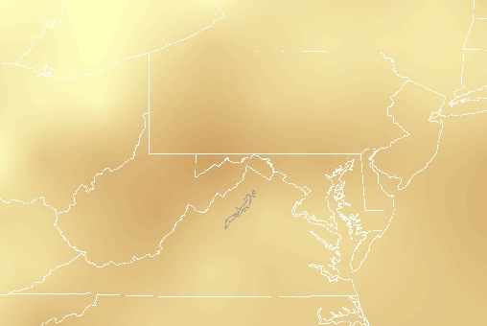
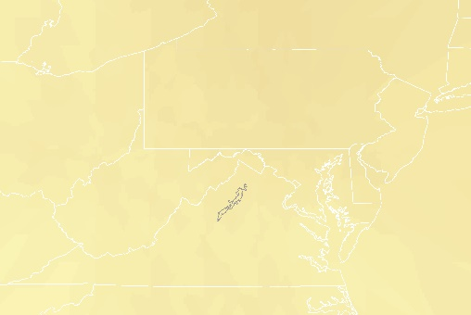
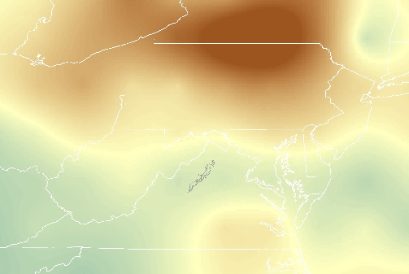
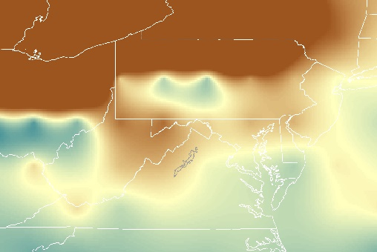
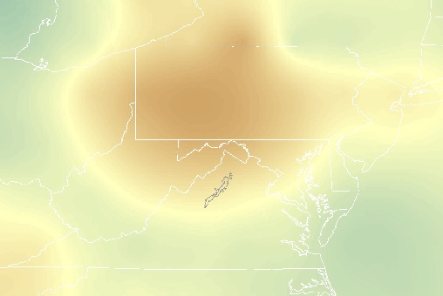
Figure C9. 2015 TOR in ppbv
December
November
October
September
August
July
June
May
April
March
February
January
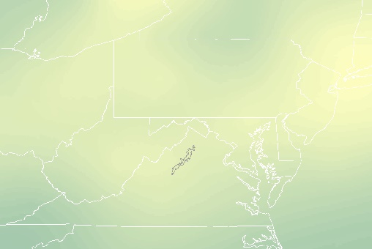
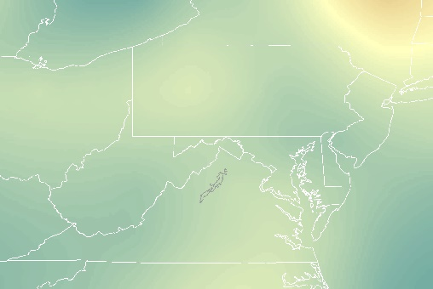
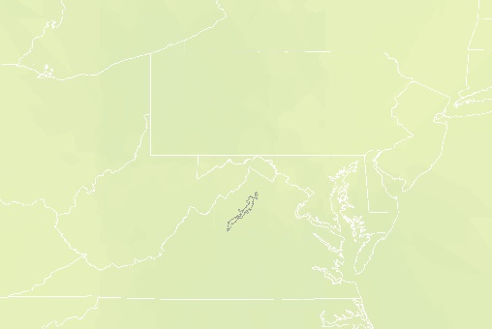
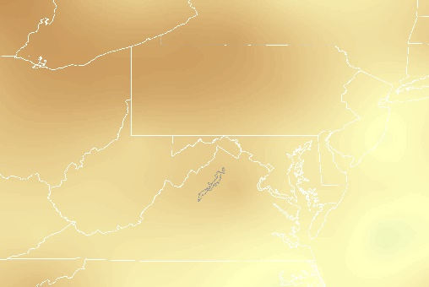
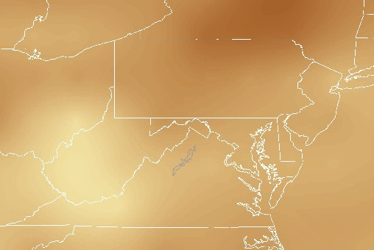
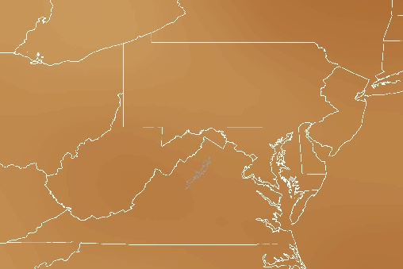
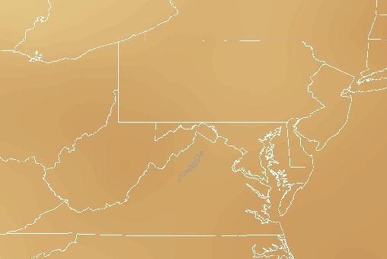
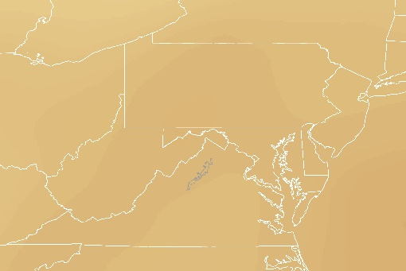
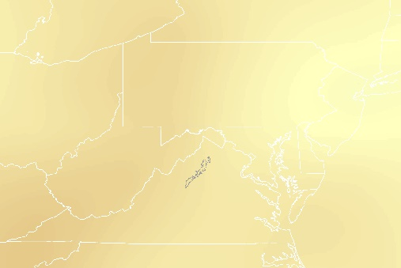
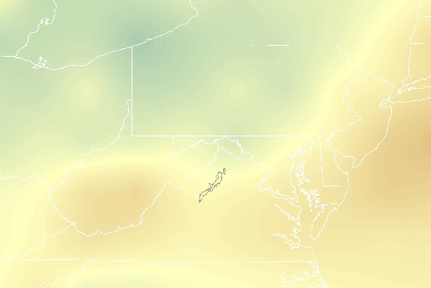
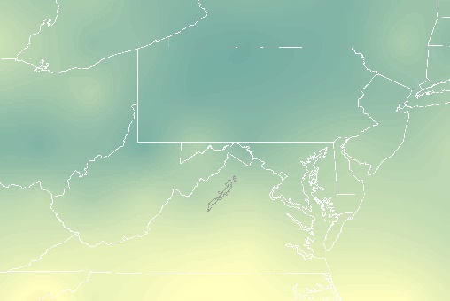
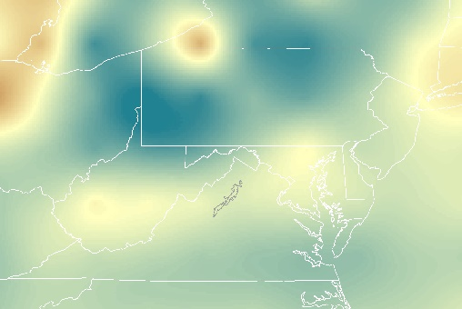
Figure C10. 2016 TOR in ppbv
December
November
October
September
August
July
June
May
April
March
February
January

