**NASA DEVELOP National Program**

****USGS at Colorado State University - Fort Collins, CO

**Summer 2015**

**Colorado Agriculture II**

**Subtitle:** Reconstructing Forest Harvest History in Northern Colorado and Southern Wyoming Using the Landsat Time Series

**VPS Title:** Down to Earth: Reconstructing Forest Disturbances with Landsat

**Project Team & Partners**

**Project Team:**

Brian Woodward (Project Lead), [brdwoodward@gmail.com](mailto:brdwoodward@gmail.com)

Stephanie Krail

Eric Rounds

Christina Welch

**Advisors & Mentors:**

Dr. Paul Evangelista (Natural Resources Ecology Lab, CSU)

Tony Vorster (Bioenergy Alliance Network of the Rockies)

**Past or Other Contributors:**

Ryan Anderson

Peter Gibbons

Andrea Harbin

Aaron Sidder

**Partner Organizations**

Ben Delatour Scout Ranch (BDSR), End-User, POC: Mr. Robert Sturtevant

Bioenergy Alliance Network of the Rockies (BANR), End-User, POC: Mr. Tony Vorster

Colorado State Forest Service, End-User, POC: Mr. John Twitchell

**Project Details**

**Applied Sciences National Applications Addressed:** Agriculture

**Study Area:** CO, WY

**Study Period:** August 1973 - September 2014

**Earth Observations & Parameters**

Landsat 1-3, MSS - Atmospherically corrected surface reflectance; Tasseled Cap Brightness, Greenness, and Wetness (Tcap 1,2, and 3); single-band cloudmask image

Landsat 4-5, TM - Atmospherically corrected surface reflectance; Tasseled Cap Brightness, Greenness, and Wetness (Tcap 1, 2, and 3); single-band cloudmask image

Landsat 7, ETM+ - Atmospherically corrected surface reflectance; Tasseled Cap Brightness, Greenness, and Wetness (Tcap 1, 2, and 3); single-band cloudmask image

Landsat 8, OLI - Atmospherically corrected surface reflectance; Tasseled Cap Brightness, Greenness, and Wetness (Tcap 1, 2, and 3); single-band cloudmask image

**Ancillary Datasets Utilized**

* USGS National Land Cover Database (NLCD) - Land cover
* Colorado State Forest Service- Colorado State Forest (CSF) - Management boundaries
* USDA-Medicine Bow-Routt National Forest map - Management boundaries
* USDA-Arapaho-Roosevelt National Forest - Management boundaries

**Models Utilized**

* Landsat-based Detection of Trends in Disturbance and Recovery (LandTrendr, v. 3.0)
* Oregon State University and USDA Forest Service Pacific Northwest Research Station Tools for Calibration and Validation of LandTrendr, v. 3.0 (TimeSync)

**Software Utilized**

Exelis ENVI/IDL - Preprocess Landsat data through atmospheric corrections and cloud masking

ArcGIS v.10.1 - Preprocess Landsat imagery, manage field data, process spatial information, and manage model layers for input into LandTrendr

**Project Overview**

**80-100 Word Objectives Overview**

This project utilized NASA Landsat 1-8 (MSS, TM, ETM+, and OLI) imagery as inputs to the LandTrendr model to map historical timber harvests. The primary objective was to bridge the gaps in knowledge of timber harvest, both temporally and spatially, by providing new data on the timing, duration, and intensity of timber harvests in Northern Colorado and Southern Wyoming from 1984-2014. By creating a more thorough and comprehensive geographical record of timber harvest history, the results of this project will better inform forest management and future harvesting, while simultaneously improving the understanding of the ecological impacts of forest harvests.

**Abstract**

Timber harvests are a crucial part of Northern Colorado and Southern Wyoming’s local economy. The future health of the forests and ecological diversity are contingent upon appropriately managing the present forest resources. However, incomplete records of past harvests expose disparities concerning the accurate location, timing, and extent of the forest harvests. This project was designed to provide natural resource managers with a reliable map of the forest harvest history in an effort to facilitate the most educated decision making process. At the request of the three project partners, Ben Delatour Scout Ranch (BDSR), Bioenergy Alliance Network of the Rockies (BANR), and Colorado State Forest Service (CSFS), the team spectrally linked 41 years of Landsat data to create a continuous map delineating forest harvest history, wildfires, and mountain pine beetle kill. By accessing the Landsat archives, this project utilized 1974-2014 imagery from Landsat 1-3 Multispectral Scanner (MSS); Landsat 4-5 Thematic Mapper (TM); Landsat 7 Enhanced Thematic Mapper Plus (ETM+); and Landsat 8 Operational Land Imager (OLI). These collected scenes were preprocessed using LandsatLinkr to acquire consistent images atmospherically corrected for surface reflectance, masked for cloud cover, and stacked in a Tasseled Cap (Tcap) composite. The generated inputs were run through the Landsat-based Detection of Trends in Disturbance and Recovery (LandTrendr) model to produce a visual representation of all magnitudes of disturbances within the designated area. By prioritizing timber harvest as a key disturbance, LandTrendr accurately delineated an annual forest harvest history in Northern Colorado and Southern Wyoming.

**Community Concerns**

* The primary community concern is the lack of a forest harvest history map for the forested areas of Northern Colorado and Southern Wyoming. Possessing an accurate representation of the past forest harvest history is imperative to planning sustainable and efficient future harvests.
* The forests are currently in a recovery phase due to droughts during 2001-2002, which triggered an unprecedented mountain pine beetle population outbreak. The excessive amount of dead wood exacerbates wildfires, flooding, and other ecological extremes in the western United States. The LandTrendr model has potential to delineate over 650,000 acres of native lodgepole and ponderosa pine trees that were destroyed by the mountain pine beetle in Northern Colorado alone.

**Current Management Practices & Policies**

The existing forest harvest maps and records that this project has improved upon were previously sporadic and incomplete. In order to provide a more accurate and comprehensive set of maps and records, the end-product of this project was a 43 year forest disturbance history, which ultimately provided data on extent of pine beetle mortality, as well as forest harvest in Northern Colorado and Southern Wyoming. The end product, a map delineating harvest history, was requested by all three project partners: Ben Delatour Scout Ranch (BDSR), the Bioenergy Alliance Network of the Rockies (BANR), and the Colorado State Forest Service (CSFS). BDSR is a Boy Scout ranch responsible for the implementation and oversight of sound management practices on its lands, including general maintenance, invasive species management, and forest harvests. Financial and personnel limitations restrict the organization’s ability to conduct field measurements or harvest mapping. Therefore, the newly developed and refined timber harvest history map will greatly assist the implementation of sound management decisions in the future. BANR, the second project partner, is an organization primarily interested in exploring the use of mountain pine beetle kill wood along with other sources of forest biomass as a sustainable source of bioenergy. As of present, BANR does not possess a reliable spatial depiction of pine tree mortality in northern Colorado or southern Wyoming. The end-product they have requested will assist the organization to delineate and quantify the location and extent of dead biomass within the study area. The third and final partner is the Colorado State Forest Service, an outreach agency of the Warner College of Natural Resources at Colorado State University whose mission is to achieve stewardship of Colorado’s forest environments. With the ultimate goal of implementing a sustainable model of forest management for both land managers and the public, the CSFS provides various educational and outreach opportunities meant to facilitate an inclusive process by which the public, students, and other invested parties can learn about and help facilitate the responsible and sustainable stewardship of Colorado’s forests. Currently, the CSFS does not have a reliable and comprehensive map of timber harvest history.

**Decision Support Tools & Benefits**

|  |  |  |
| --- | --- | --- |
| **End-Product** | **Earth Observations Used** | **Benefit & Impact** |
| Maps depicting location, extent, and year of timber harvests (as well as other disturbances)(GIS polygons, printed maps, Google Earth overlay) | Landsat 1-8 | These visual tools will assist partners in prioritizing locations for future timber harvests as well as developing a profitable yet ecologically sustainable plan for timber harvests. |
| A tutorial describing simplified pre-processing steps for LandTrendr | Landsat 1-8 | A step-by-step tutorial will help partners and future LandTrendr users to better navigate the model, allowing for the expedited use of the model. |

**Project Imagery**

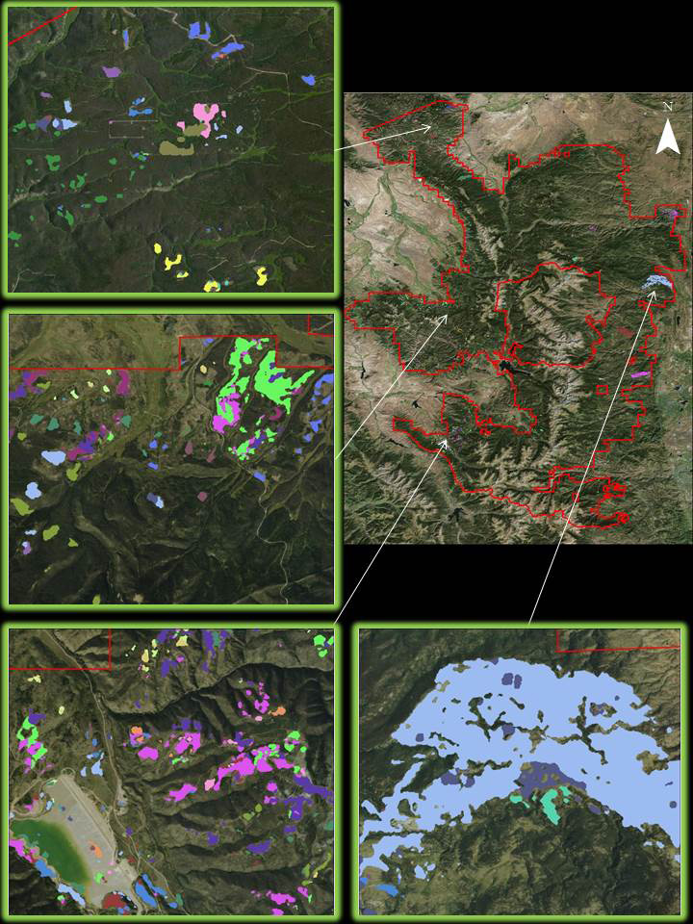

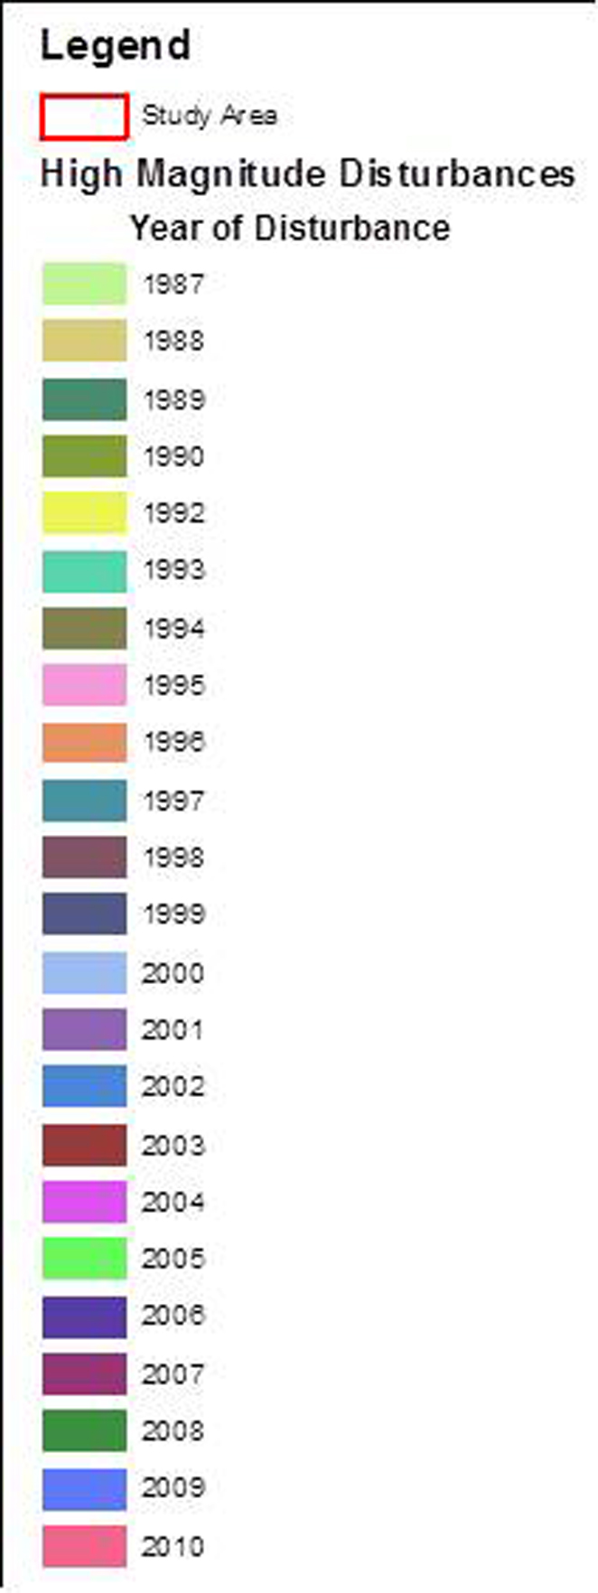

**Caption:** High Magnitude Disturbances in Forests Across Northern Colorado By Year

Image Credit: Results: Colorado Agriculture Team, Basemap: National Agricultural Imagery Program

**Image:** Colorado_Ag_FC_Final_Image_300.jpg