**NASA DEVELOP National Program**

****Langley Research Center

**Fall 2013**

**Great Plains Agriculture**

*Utilizing NASA Earth Observations to Monitor Drought Conditions for Enhancement of Rangeland Management*

**Team Lead:** Tiffani Orne (Liberty University), Tiffani.N.Orne@nasa.gov

**Team Members:**

Eric Dombrowsky (Christopher Newport University)

Emily Gotschalk (Christopher Newport University)

**Advisors & Mentors:**

Dr. Kenton Ross (NASA DEVELOP National Science Advisor)

**Past or Other Contributors:**

Lance Watkins

Jerrod Lessel

Alexandra Perillo

**Applied Sciences National Applications Addressed:**

Agriculture

**Study Area:** The United States Great Plains Region, including parts of Montana, Wyoming, Colorado, New Mexico, North Dakota, South Dakota, Nebraska, Kansas, Oklahoma, and Texas

**Study Period:** March through October, 2009-2013

**Community Concerns**

* Approximately 80% of the Great Plains region is used for agriculture and dryland farming
* Rangeland uses: livestock grazing, wildlife habitat, watershed protection, recreation, preservation of genetic diversity, ecotourism, wildlife viewing opportunities, fee hunting
* Severe droughts throughout the Midwest since 2011
* Oklahoma lost over $400 million in 2011 and 2012 from drought while the majority of counties in Colorado and Wyoming qualify for federal drought assistance
* Drought can also lead to nationwide increases in food prices for products such as beef, pork, poultry, and dairy

**80-100 Word Blurb**

Drought in the Great Plains region of the United States is a matter of constant concern for ranchers and land managers. Since 2011, the region has been severely impacted, resulting in much of this area qualifying for federal drought assistance. Organizations such as the United States Department of Agriculture (USDA) provide funding for drought assistance as well as up-to-date drought severity information to ranchers and land managers. This project provided partners at the USDA with a sustainable methodology for using NASA Earth observations to apply a local scale drought severity index throughout the Great Plains region.

**Abstract**

Drought in the Great Plains region of the United States is a matter of constant concern for ranchers and land managers in the region. All ranchers must respond to dry periods and approximately 80% of ranchers actively prepare for extreme conditions. Since 2011, the Great Plains region has been severely impacted by drought, including $400 million in losses in the state of Oklahoma. Further, most counties in Wyoming and Colorado currently qualify for federal drought assistance. Organizations such as the United States Department of Agriculture (USDA) currently use the Vegetation Drought Response Index (VegDRI) and the US Drought Monitor to track drought severity; however, both are too spatially coarse for individual rangeland managers to properly employ. This project utilized data collected by the Moderate Resolution Imaging Spectroradiometer (MODIS) aboard the Aqua and Terra satellites and by the National Oceanic and Atmospheric Administration (NOAA) Multi-sensor Precipitation Estimator (MPE). The purpose of the project was to apply the Drought Severity Index (DSI), created in a previous DEVELOP term, to the entire Great Plains region using NASA Earth observations. The methods and results generated by this project were provided to the USDA Agricultural Research Services Rangeland Resources Research Unit (ARS RRRU) for future use in regional drought monitoring.

**Partners/Collaborators**

United States Department of Agriculture Agricultural Research Services Rangeland Resources Research Unit (USDA ARS RRRU): Dr. Justin Derner

**Current Management Practices & Policies**

A 2012 Wyoming Rangeland Decision Making Survey found that while 100% of ranchers respond to drought, 80% actively prepare for drought and 40% report that drought will be more influential in their management plans and operations in the next decade. Dr. Justin Derner and his colleagues provide up-to-date range management research for land managers and ranchers to use in making management decisions. Currently, the USDA is using VegDRI and the US Drought Monitor to assess drought conditions. The USDA also provides approximately $30 million to assist farmers and ranchers impacted by severe drought.

**Benefit to End-User:**

* A sustainable methodology for monitoring drought severity throughout the Great Plains region
* Higher resolution drought severity data can be provided to ranchers and land managers, allowing decisions and preparations to be based on location specific information

**Decision Support Tools**

* Scaled Drought Severity Index, applied throughout the Great Plains region

**Earth Observations & Parameters**

Aqua and Terra, MODIS – Land surface temperature, surface reflectance

**Future Applicable NASA Missions**

SMAP – soil moisture

GPM – precipitation

**Models Utilized**

DEVELOP Drought Severity Index (Adapted from Rhee et al.)

**Ancillary Datasets Utilized**

NOAA Multi-sensor Precipitation Estimator (MPE) – Precipitation

**Software Utilized**

ERDAS IMAGINE – shapefile editing, converting file formats, data pre-processing

ArcGIS – raster calculation and analysis, map creation

**Imagery & Captions**

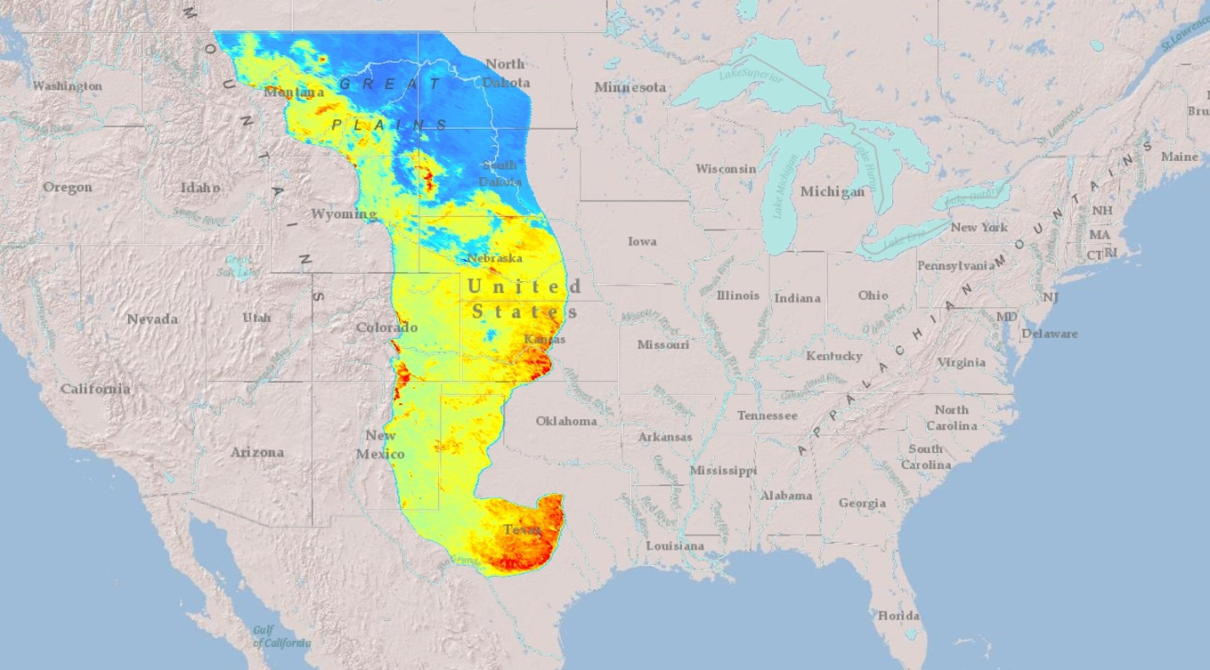

Image A. Normalized Difference Vegetation Index (NDVI) for the Great Plains, calculated based on a Terra MODIS surface reflectance 8-day composite for March 6-13, 2012. Red areas indicate higher NDVI values and therefore more healthy vegetation, while blue areas indicate lower NDVI values and less healthy vegetation. The image is overlaid on an ArcGIS basemap.