**NASA DEVELOP National Program**



University of Georgia

*Summer 2016*

Costa Rica Water Resources

Monitoring Drought and Water Balance in the Guanacaste Province to Enhance Decision Making and Response Planning in Costa Rica

 **Technical Report**

Final Draft – August 10, 2016

Rachel Durham (Project Co-Lead)  
María José Rivera-Araya (Project Co-Lead)  
Madison Davis

Luis Quesada  
Nelson Venegas

Diyang Cui

Dr. Marguerite Madden, Department of Geography, University of Georgia (Science Advisor)   
Dr. Sergio Bernardes, Department of Geography, University of Georgia (Science Advisor)   
Dr. Adam Milewski, Department of Geology, University of Georgia (Science Advisor)   
Dr. Angelica Gutierrez, NOAA (Science Advisor)

# 1. Abstract

The Arenal-Tempisque watershed in northwestern Costa Rica has experienced severe drought conditions during the last four years, complicating water management and agricultural production. Additional information for response planning and management is required to tackle the consequences of drought. In partnership with the Costa Rica Ministry of Environment and Energy (MINAE), Costa Rica National Service of Underground Water, Irrigation, and Drainage (SENARA), the University of Costa Rica (UCR) and the Costa Rican Embassy in Washington, D.C, the team used data from various Earth observing satellites – Landsat 8, Aqua and Terra Moderate Resolution Imaging Spectroradiometer (MODIS), Advanced Very High Resolution Radiometer (AVHRR), Global Precipitation Measurement (GPM), Tropical Rainfall Measuring Mission (TRMM) – and *in situ* stations to analyze and monitor the current state of meteorological and agricultural drought across the Arenal-Tempisque watershed using two indices. The Standardized Precipitation Index (SPI) was used to monitor meteorological drought and the Scaled Drought Condition Index (SDCI) was used to monitor agricultural drought. The team also created information for water balance assessment using the Soil Water Assessment Tool (SWAT) model by combining NASA earth observations, ancillary data sources, and in situ data. Upon receiving the hydrological data and tools, project partners at SENARA and MINAE will be able to replicate the project’s methods to continuously update their understanding of watershed conditions. These results will allow project partners to make a more efficient water management plan, benefitting the local inhabitants and stakeholders.

**Keywords**

Remote Sensing, MODIS, Landsat 8, SWAT, Time Series Analysis, Drought Monitoring

# 2. Introduction

* 1. ***Background Information***

Situated in the northwest corner of Costa Rica at the base of the Arenal Volcano, the Arenal reservoir is a vital hydrological component of the Guanacaste province and the country as a whole. Lake Arenal, a manmade reservoir, has a capacity of around 2 billion m3 of water (ICE, 2012). In addition to providing water to nearby agricultural operations, the dam in the Arenal reservoir produces a vast amount of hydrological power, providing 157 MW to meet roughly one quarter of the country’s energy needs (Diaz & Morehouse, 2003).

Costa Rica, known for its lush rainforest and biodiversity, boasts a national water resource availability of 23,000m3 per person (ICE, 2012). However, accessibility to these resources is not evenly dispersed throughout the country. The Guanacaste region of Costa Rica has experienced more than four consecutive years of drought, limiting water resources and highlighting the need for improved mitigation for water consumption from Lake Arenal. Drought has proven to affect crop production in Guanacaste, causing substantial yield reduction in maize crops every 7 out of 10 years (Lomas & Herrera, 1984). There are currently no geospatial analysis tools being utilized in the decision-making process.

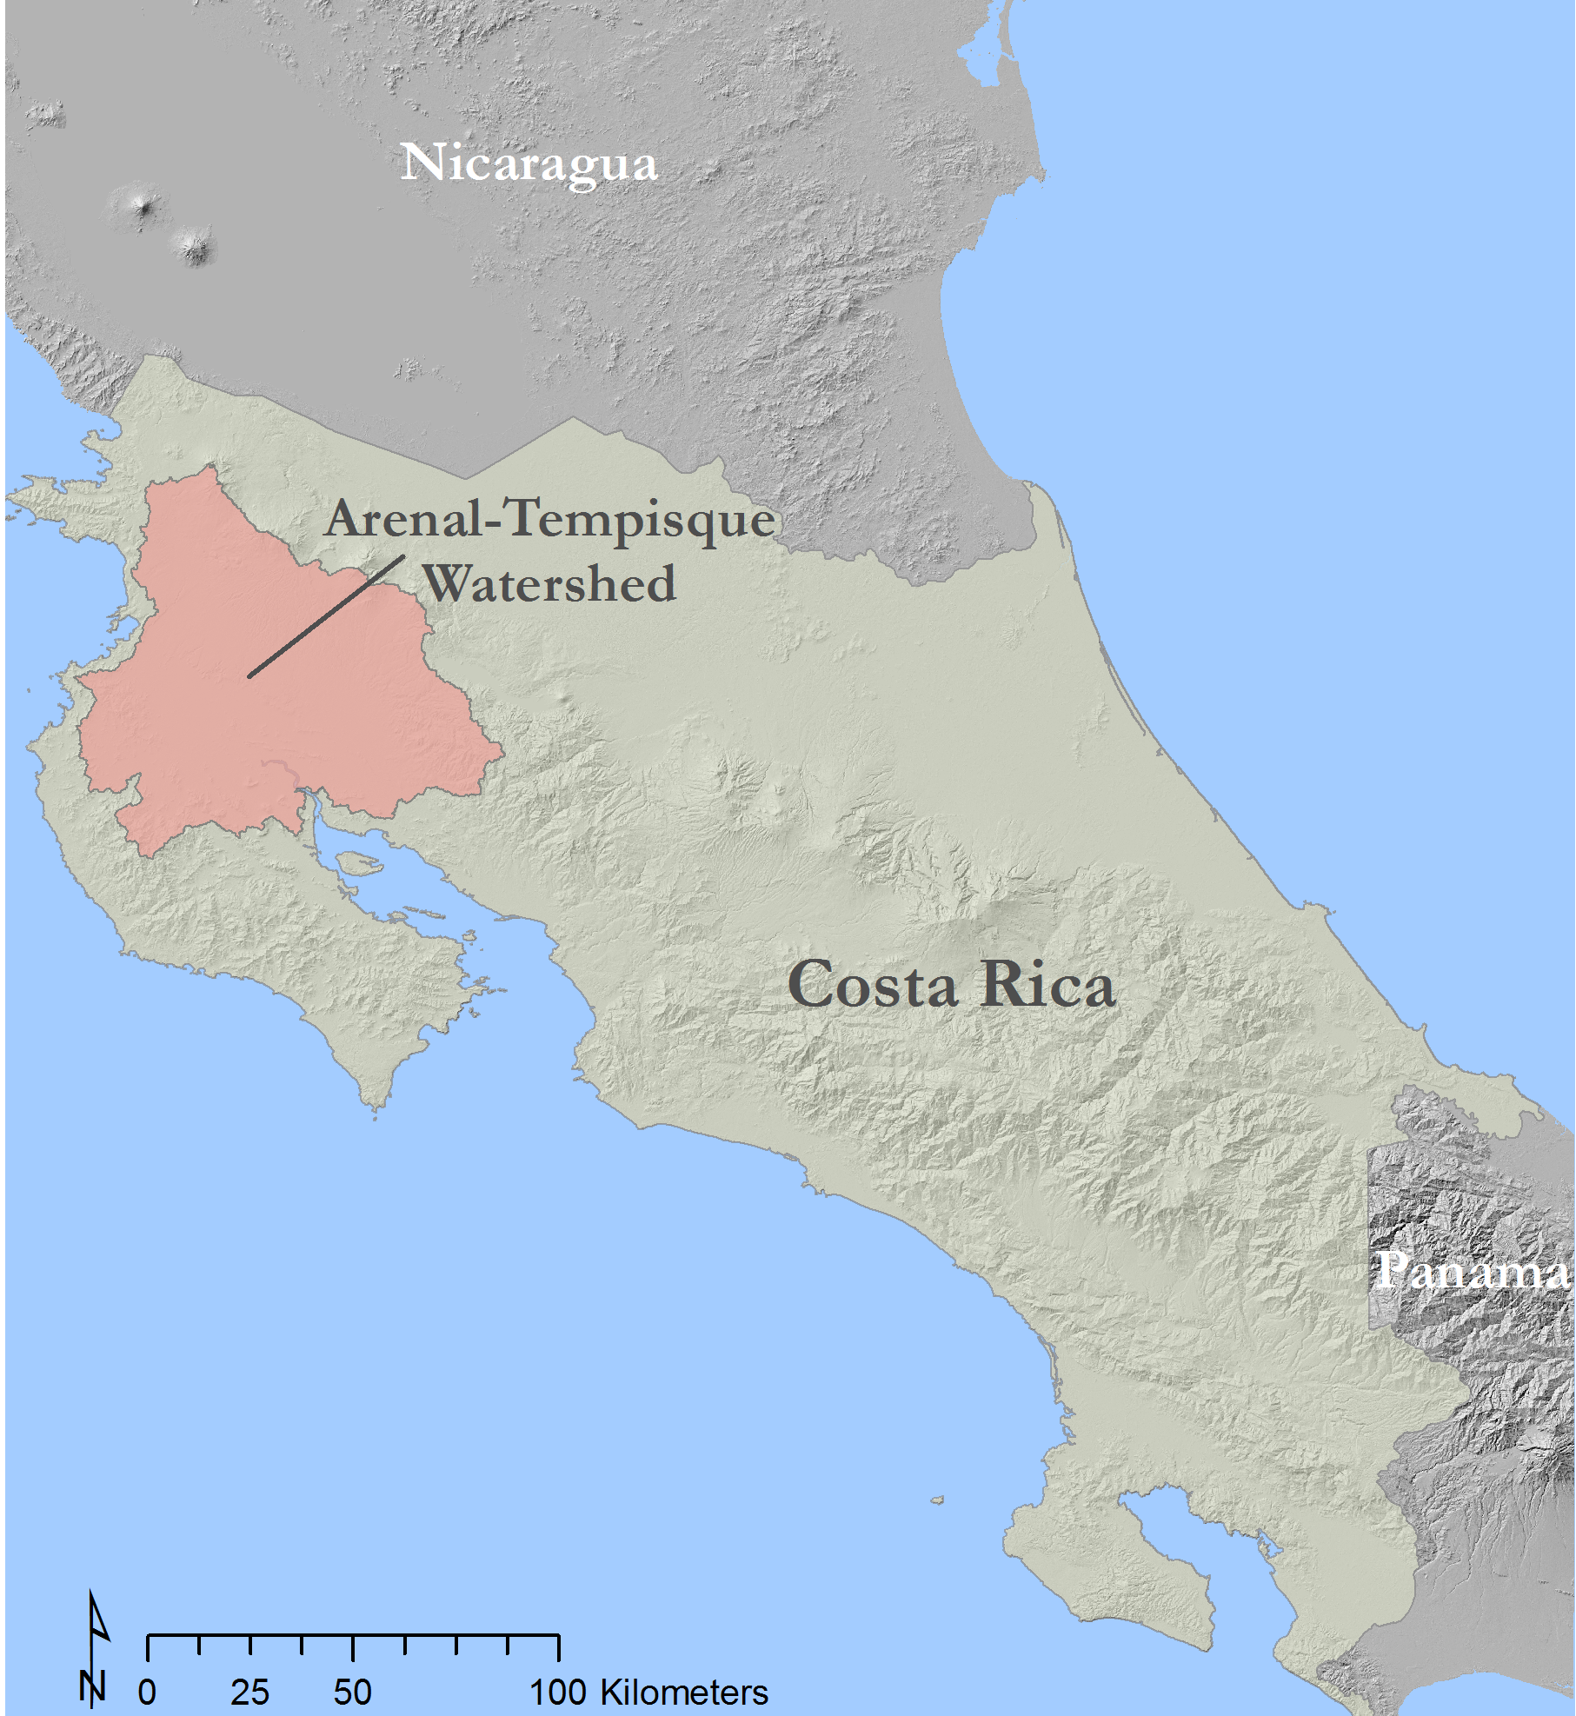  
Figure 1. Study area map for the Arenal-Tempisque watershed, located in Northwest Costa Rica.

In response to this concern, this project was developed to monitor drought conditions in the Arenal-Tempisque watershed and assist in decision-support services for local partners. The study area is located in the Guanacaste province in the northwest corner of Costa Rica (figure 1). The study period for this project was January 2000 to May 2016. This time frame was selected to show the effects of drought over time as well as to provide the most recent data for use in coordinating future water management.

* 1. ***Project Partners & Objectives***

National institutions in Costa Rica have been designing the Integral Program for Water Supply for Guanacaste – North Pacific (PIAAG), a plan to face the impacts of the severe drought in the Arenal-Tempisque watershed and mitigating the drought’s effects. This plan includes social assistance and protection of water supply, human and animal health. The Costa Rica Ministry of Environment and Energy (MINAE) and Costa Rica’s National Service of Underground Water, Irrigation, and Drainage (SENARA) are part of an inter-institutional commission in charge of creating a regional strategy that will help with the implementation of PIAAG. MINAE is managing a plan which aims to coordinate all institutions focused on the water sector (e.g., research, infrastructure, water management) towards monitoring and mitigating the impacts of the drought on the country’s natural resources and people. Both institutions are interested in incorporating new spatio-temporal data that support decision making and water management in the area. In an effort to increase efficiency in water usage, they have started to incorporate GIS into their data management and decision support tools.

This NASA DEVELOP project aimed to complement the PIAAG and the national institutions efforts to gain a better understanding of the development of drought through time. This was done by creating a time series showing the Standardized Precipitation Index (SPI) and the Scaled Drought Condition Index (SDCI), which measure meteorological and agricultural drought, respectively, from January 2000 to March 2016. A water balance assessment for the area was also generated using The Texas A&M University’s Soil and Water Assessment Tool (SWAT) Model. This project addressed NASA’s Water Resources National Application Area by contributing to the evaluation of water balance metrics in the Arenal-Tempisque watershed.

# 3. Methodology

***3.1 Data Acquisition***

Precipitation estimates from the Tropical Rainfall Measuring Mission— Precipitation Radar (TRMM-PR) were collected as a Level 3 Product (3B43 V7) in NetCDF format at 0.25° spatial resolution from the Goddard Earth Sciences Data and Information Services Center (GES DISC) Mirador Data downloads portal. The TRMM-PR data were collected for use in creating a meteorological drought index and time series to identify areas prone to drought resulting from insufficient rainfall. Precipitation estimates were collected in monthly temporal resolution from January 1, 2000 to March 31, 2016 in measurements of millimeters per hour (mm/hr).

The Global Precipitation Measurement – Integrated Multi-Satellite Retrievals for GPM (GPM-IMERG) was selected as the source of precipitation data for the near real-time monitoring tool, as this mission replaced TRMM to provide the next generation of global precipitation observations, which are available in near real-time. Daily precipitation data was fetched in NetCDF format at 0.1° spatial resolution from the Precipitation Processing System FTP data downloads server. The time period for this data is specified by the user of the monitoring tool, but is available beginning April 2015.

Other biophysical parameters, such as surface temperature and vegetation health, were needed in order to create an agricultural drought index and time series, as well as to be used as inputs in the drought monitoring tool. Land Surface Temperature (LST) and Normalized Difference Vegetation Index (NDVI) data from the Moderate Resolution Imaging Spectroradiometer (MODIS) onboard the Terra satellite were collected using the USGS Earth Explorer web download tool. Both were collected as Level 3 products (LST as MOD11C3 and NDVI as MOD13C2) at 0.05° spatial resolution in HDF format. These data were collected in monthly temporal resolution from January 1, 2000 to March 31, 2016. These parameters were also fetched for the near real-time monitoring tool at a time period specified by the user. NDVI values were also used for the land cover classification.

Additional data were collected to create the water balance assessment tool. Data from the Landsat 8 Operational Land Imager (OLI) were utilized to update the land cover data. Digital elevation models (DEM) were collected from the Shuttle Radar Topography Mission (SRTM) and used to run the SWAT model. This model requires the input of the soil’s physical characteristics and also meteorological data. Soil data were obtained from the Costa Rica Digital Atlas developed by the Institute of Technology of Costa Rica and the Soil Digital Map by the Center for Agronomic Research (CIA) at University of Costa Rica. Both datasets provided porosity, texture, organic matter content, and density of the soils in the Tempisque River’s watershed. In case some parameters were missing, the Harmonized World Soil Database (HWSD) was used to complete the local data. Streamflow data were obtained from SENARA. To compute and map the study area’s evapotranspiration, MODIS monthly evapotranspiration datasets from 2000 to 2012 were used. Finally, surface reflectance data were retrieved from Landsat 8.

Daily information on precipitation, temperature, radiation, relative humidity and wind were collected from stations located in the watershed. These stations belong to different Costa Rican public institutions such as Meteorological National Institute of Costa Rica. These meteorological data were required in order to reproduce all the processes related to the water cycle that occur in a watershed. Land use information was also included to understand the behavior of the superficial runoff (Berlanga et al., 2011).

***3.2 Data Processing***

It was determined that an appropriate spatial resolution for the study area was 0.1° or finer, which called for resampling TRMM-PR data from a spatial resolution of 0.25° to 0.1° by executing a python script. The script first converted the NetCDF files to TIFF format, then resampled the raster to 0.1° resolution using the Esri ArcGIS cubic method for area interpolation. The TIFF files were used to calculate the SDCI, and were also converted into ASCII format for analysis of the SPI using MATLAB.

For MODIS data to be used in the SDCI calculations and in the drought monitoring tool, LST and NDVI were extracted from HDF format into TIFF format. This was performed by executing a python script to extract the layers of interest for further analysis. The images were reprojected from a sinusoidal projection to WGS 1984 using the MODIS Reprojection Tool to match the projection of the precipitation data. Finally, the data extracted by a rectangular mask over the study area to reduce file size to the area of interest.

For the drought monitoring tool, precipitation data from GPM IMERG was converted from NetCDF format to TIFF format using a python script before further analysis.

The SWAT model requires the input of DEM, soil, land use and weather data. DEM did not need any preprocessing. The soil data required the reformatting of the HWSD and the soil digital map into a unified database. Given the lack of updated land cover classification, a supervised land cover classification was created for the area. Weather information (temperature and precipitation) from 6 meteorological stations were provided by the Meteorological National Institute of Costa Rica. It was re reformatted according to the SWAT requirements. Other statistical parameters such as maximum of precipitation in 0.5 hour, dew point, probability of precipitation, maximum and minimum of wind, temperature, solar radiation and relative humidity per month were calculated using the observed information provided by the Meteorological Institute.

***3.3 Data Analysis***  
*3.3.1 Standardized Precipitation Index*

The method for calculating the SPI was utilized to create a Time Series Analysis of meteorological drought in the study area. The SPI gives a normalized value to indicate the level of precipitation surplus or deficit in a certain location over a specified time period relative to its historical record (McKee, 1993). In this case, the specified time periods were monthly intervals and the historical record was January 2000 to March 2016 (a total of 195 months). The SPI value for each area is the Z-score of the cumulative probability of precipitation on a monthly time scale. The SPI values and their interpreted relation to drought conditions are listed below in Table 1.

|  |  |
| --- | --- |
| SPI Value | Interpretation |
| ≥ 2.0 | extreme wet condition |
| 1.5 to 1.99 | severe wet condition |
| 1.0 to 1.49 | moderate wet condition |
| 0.5 to 0.99 | mild wet condition |
| -0.49 to 0.49 | optimum rainfall |
| -0.5 to -0.99 | mild drought condition |
| -1.0 to -1.49 | moderate drought condition |
| -1.5 to -1.99 | severe drought condition |
| ≤ -2.0 | extreme drought condition |

Table 1. Interpretation of SPI values. Values ≤ -0.5 indicate drought conditions.

The computation of the SPI requires a series of statistical methods. First, the monthly precipitation data from the entire study period in a specified area (X) (i.e. a single pixel) were gathered and fitted into the Gamma function g((X)):

$$g(X)=\frac{1}{β^{α}\int_{0}^{∞}{y^{α-1}e^{-y}}dy}X^{α-1}e^{\frac{-y}{β}}$$

Where $α$ is a scale parameter and $β$ is a shape parameter. Estimating $α$ and $β$ was performed in MATLAB using the built-in Gamma fitting function and the process of Maximum Likelihood Estimation.

Then, the integral of the Gamma function determines the Cumulative Probability Function, which statistically converts precipitation into a probability. However, the Gamma function is bounded on the left at zero. Therefore, the probability that no precipitation occurs in a month in a certain area must be manually calculated from the ratio of months wherein no precipitation occurred *m* to the total number of monthly observations *n*, in other words:

$$g(0)=\frac{m}{n}$$

Thus, the Cumulative Probability Function H(x) is equal to:

$$H\left(X\right)=g(0)+(1-g(0))\int_{0}^{∞}{g\left(X\right)dX}$$

Finally, the SPI is calculated by taking the inverse normal of H(x) to get a distribution with a mean 0 and standard deviation 1.0, which is a Z-score.

*3.3.2 Scaled Drought Condition Index*

Scaled Drought Condition Index (SDCI) is a combination of three remote sensing components: a temperature component using Land Surface Temperature (LST), a vegetation component using Normalized Difference Vegetation Index (NDVI), and a precipitation component using precipitation radar data. It is used to assess drought conditions in both arid and humid regions (Rhee et al., 2010). To calculate SDCI, the variables were scaled from 0 to 1 in order to discriminate the weather component.

Each component was scaled as follows:

Scaled LST = $\frac{{LST}_{max}-LST}{{LST}_{max}-{LST}_{min}}$  
  
Scaled Precipitation = $\frac{X-X_{min}}{X_{max}-X_{min}}$  
  
Scaled NDVI = $\frac{NDVI-{NDVI}_{min}}{{NDVI}_{max}-{NDVI}_{min}}$

The three components were weighted based on regression analysis done by Rhee et al. (2010). The equation of SDCI is:

SDCI = *0.25(scaled LST) + 0.5(scaled precipitation) + 0.25(scaled NDVI)*

This produces scaled values from 0 to 1, where 0 indicates the driest condition and 1 indicates the wettest condition.

*3.3.3 SWAT Model*

The model was run from 2000 until 2014. The first 5 years were used for warm-up, leaving just 10 years to be simulated. The model showed the potential to reproduce some related hydrological processes. For example, when the model reproduced precipitation and superficial runoff for October and November, it corresponded with the expected increase in the amount of precipitation for these months. Although the model requires the input of streamflow data in order to be calibrated, these data were not available to be included at the time of the conclusion of this project.

# 4. Results & Discussion

***4.1 Analysis of Results***

*4.1.1 Drought Monitoring Indices*

The meteorological and agricultural drought indices were analyzed temporally and spatially. For the temporal analysis, time series plots were created for the SPI and SDCI indices at any of the weather stations in the study area. From the plot from the Pelon de la Bajura station, a station located in the central Arenal-Tempisque watershed, it is possible to recognize the drought conditions that have characterized the area throughout the past four years (figure 2). The time series plots are used to identify drought anomalies, for example, a recent drought anomaly in December 2015.

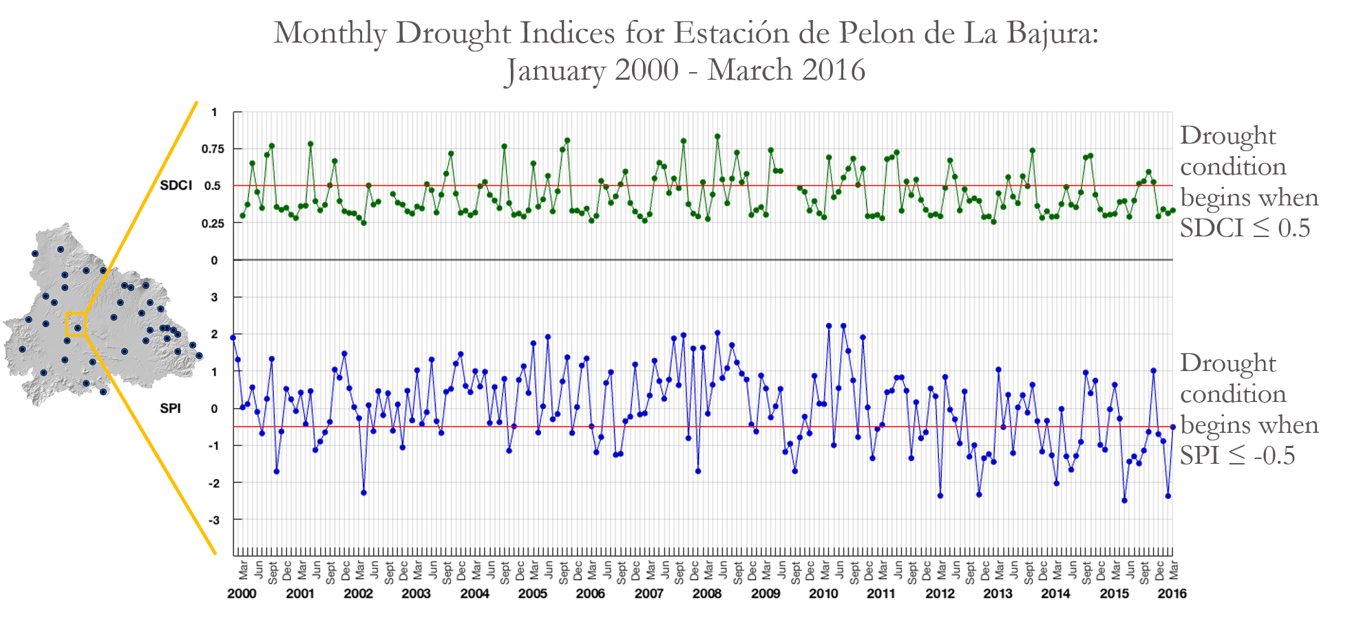

Figure 2. An example of the time series plot for the drought indices that can be created for any location in the study area. Drought conditions occur when values are observed on or below the red line in each graph.

A collection of maps was also created for the drought indices throughout the study period to observe the spatial distribution and severity of drought. Figure 3 shows the SPI and SDCI for the drought anomaly month identified by the time series plot in December 2015. The maps show more drastic drought conditions in the western and southern portion of the study area for that month. These maps were provided for each month in the study period.

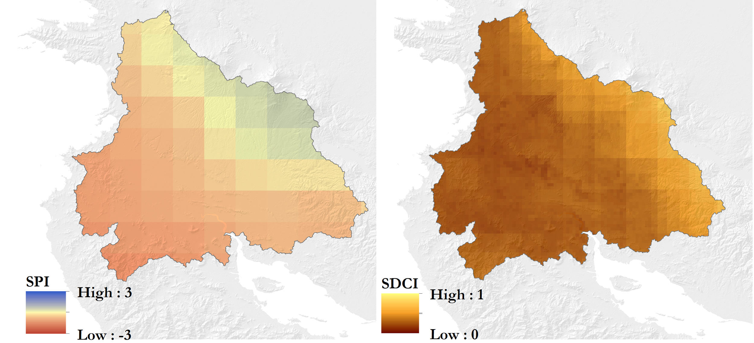

Figure 3. Maps of drought indices for drought anomaly month of December 2015. SPI and SDCI maps were generated for each month of the study period.

*4.1.2 ArcSWAT*

A supervised classification provided the most up to date land cover for the study area (figure 4). The SWAT model identified the presence of 34 sub-basins and 2182 hydrological response units. The ArcSWAT analysis provided a series of averaged outputs per year for the whole watershed and monthly results for each hydrological response unit and subbasin. The maps show the averaged, modeled superficial flow (figure 5) and evapotranspiration rates (figure 6) for the whole watershed for the year 2013. In conjunction with the analysis of other factors, both results have a great potential to understand the effect of land use, crop management and orography in the development of drought. Although they were not calibrated, the results suggest that drought had a higher impact in the west part of the watershed. This corresponds with both the drought analysis indices and the record of precipitation for the area, prompting further research in this direction.

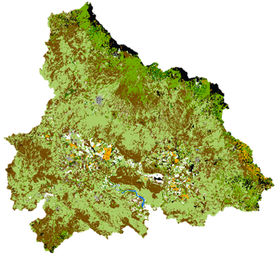

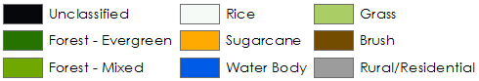

Figure 4. Land cover classification for the Arenal-Tempisque watershed

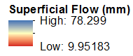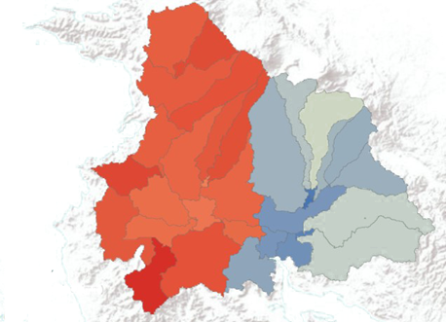

Figure 5. Modeled superficial flow for the Arenal-Tempisque watershed for the year 2013.

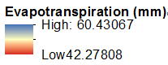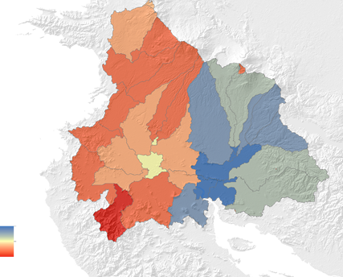

Figure 6. Modeled evapotranspiration rates for the Arenal-Tempisque watershed for the year 2013.

***4.2 Future Work***

Future work will include calibrating the ArcSWAT model using *in situ* streamflow data. The outputs from the calibrated ArcSWAT model will provide hydrologic data to support the creation of a water balance assessment toolset. Additional drought indices can be used to produce more detailed spatial and temporal analyses. The near real-time drought monitoring tool for SDCI will be completed, providing a tool for partners to evaluate the continuation of drought after the project has been completed. In addition, a more detailed spatio-temporal analysis of drought within the area will be created.

# 5. Conclusions

Monitoring the historical development of the drought achieved a better understanding of the development of drought through time. Datasets including monthly SDCI and SPI values for 6 weather stations in the Arenal-Tempisque watershed were created and will be provided to the partners. Land cover datasets were updated in detail, which will be used for ArcSWAT modeling in the future. This project also contributed to the valuation of water balance metrics in the Arenal-Tempisque watershed. The end-products for our partners included a foundational script for a near real-time monitoring tool, which will allow them to better assess drought. This tool will be completed by the next team in the upcoming term. Finally, a short manual describing the input, processing, and analysis of data to run the SWAT model will be provided to the partners, so they can replicate it in the future.

# 6. Acknowledgments

Dr. Marguerite Madden (Department of Geography, University of Georgia)

Dr. Sergio Bernardes (Department of Geography, University of Georgia)

Dr. Adam Milewski (Department of Geology, University of Georgia)

Dr. Angelica Gutierrez (NOAA)

Any opinions, findings, and conclusions or recommendations expressed in this material are those of the author(s) and do not necessarily reflect the views of the National Aeronautics and Space Administration.

This material is based upon work supported by NASA through contract NNL11AA00B and cooperative agreement NNX14AB60A.

# 7. References

Arnold, J., Moriasi, D.,Gassman, P., Abbaspour, K., White, M., Srinivassan, R., Santhi, S., Harmel, R., Van Griensven, D., Van Liew, M., Kannan, N., Jha, M. (2012). SWAT, Model Use, Calibration and Validation. *American Society of Agricultural and Biological Engineers*, *55*, 1491-1508.

Berlanga, C., Ruiz, A., Covarrubias, O., Hernández, R.. (2011). Patrones de escurrimiento en la Cuenca Lechuguilla–Ohuira–Navachiste, Sinaloa, asociados a cambios de uso del suelo: Una aproximación con el modelo del número de curva. *Boletín Sociedad Geológica Mexicana*, *63*, 39-52

Diaz, H. F., & Morehouse, B. J. (2003). *Climate and water : transboundary challenges in the Americas*. Dordrecht ; Boston: Kluwer Academic Publishers.

ICE (2012). Plan de expansión de la generación eléctrica. Período 2012-2024. Instituto Costarricense de Electricidad. San José, Costa Rica. 114 p.

Lomas, J., & Herrera, H. (1984). Weather and maize yield relationships in the tropical region of Guanacaste, Costa Rica. *Agricultural and Forest Meteorology, 31*(1), 33-45. doi:http://dx.doi.org/10.1016/0168- 1923(84)90004-2

McKee, T.B., Doesken, N.J., and Kleist, J. (1993). The relationship of drought frequency and duration to time scales. *8th Conference on Applied Climatology*.

Rhee, J., Im, J., and Carbone G. (2010). Monitoring agricultural drought for arid and humid regions using multi-sensor remote sensing data. *Remote Sensing of Environment, 114:2875-2887*.

# 8. Content Innovation

**Content Innovation #1**

Scaled Drought Condition Index 2000-2016, animation

Filename 2016Sum_UGA_CostaRicaWater_TechPaper_SPITimeSeries

Shared through Google Drive at:

<https://drive.google.com/open?id=0B02vlS4hdT5bT2N0VFhHb0xSRTA>

**Content Innovation #2**

Standardized Precipitation Index 2000-2016, animation

Filename 2016Sum_UGA_CostaRicaWater_TechPaper_SPITimeSeries

Shared through Google Drive at:

<https://drive.google.com/open?id=0B02vlS4hdT5bbGxaRW5KVl9YLU0>

**Content Innovation #3**

Virtual Poster Session, Video

Filename 2016Sum_UGA_CostaRicaWater_VPS_Final

Shared through Google Drive at: <https://drive.google.com/open?id=0B3x3S6Sa2ZdNcnRlLVhWMkhTemM>