**NASA DEVELOP National Program**

 NASA Langley Research Center & Wise County Clerk of Court's Office

**Summer 2016**

**Short Title: Appalachian Trail Health & Air Quality**

**Subtitle:** Monitoring Ozone and Atmospheric Pollutants in the Troposphere to Help Regulate Point Source Emissions and to Improve Ozone Advisory Messages by the National Park Service

**VPS Title:** The Ozone Effect: Life in the Troposphere

**Project Team & Partners**

**Project Team:**

Amy Wolfe (Project Lead), amy.c.wolfe@nasa.gov

Amber Showers

Emily Beyer

Eric White

Tyler Rhodes

**Advisors & Mentors:**

Dr. Kenton Ross (NASA Langley Research Center)

Dr. Travis Knepp (Science Systems and Applications Inc.)

**Partner Organizations:**

|  |  |  |  |
| --- | --- | --- | --- |
| **Organization** | **POC (Name, Position/Title)** | **Partner Type** | **Boundary Org?** |
| National Park Service, Shenandoah National Park | Jalyn Cummings, Air & Water Quality Program Manager | End-User | No |
| National Park Service, Harpers Ferry National Historical Park | Andrew Lee, Resource Management Specialist | End-User | No |
| National Park Service, Great Smoky Mountains National Park | Jim Renfro, Air Surface Specialist | End-user | No |
| National Park Service, Natural Resource Stewardship and Science Directorate, Air Resources Division | Barkley Sive, Program Manager for Gaseous Air Pollution Monitoring | End-User | No |
| National Park Service, Northeast Region | Holly Salazar, Air Resources Coordinator | End-User | No |
| National Park Service, Inventory & Monitoring Program, Northeast Temperate Network | Fred Dieffenbach, Environmental Monitoring Specialist | End-User | No |
| National Park Service, Appalachian National Scenic Trail | Jim Von Haden, Integrated Resources Program Manager | End-User | No |

**Project Details**

**Applied Sciences National Application Addressed:** Health & Air Quality

**Study Area:** Appalachian Trail - CT, GA, MA, MD, ME, NC, NH, NJ, PA, TN, VA, WV, NY, VT.

**Study Period:** May 2012 – September 2015

**Earth Observations & Parameters:**

Aura, Ozone Monitoring Instrument (OMI) - Total Column Ozone, Tropospheric Column NO2, Planetary Boundary Layer SO2

Aura, Microwave Limb Sounder (MLS) - Stratospheric Ozone

**Software Utilized:**

* ArcGIS - raster manipulation/analysis & map creation of Aura OMI and MLS datasets

**Project Overview**

**80-100 Word Objectives Overview:**

This project introduces the National Park Service to NASA’s Earth observations to enhance current research and monitoring practices of ozone as well as nitrogen and sulfur dioxides. Currently, monitoring stations are the main source of data collection for pollutants in the troposphere. The Ozone Monitoring Instrument (OMI) located on the Aura satellite can serve as an additional way to capture air quality information in the total-column troposphere. The Microwave Limb Sounder (MLS) provides a means to gather measurements in the ozone and the stratosphere. Combining these two instruments provides tropospheric ozone data in areas with few monitoring stations. This project established the effectiveness and usefulness of incorporating satellite sensor information with the National Park Service monitoring stations.

**Abstract:**

Ozone in the stratosphere serves as a boundary that absorbs harmful ultraviolet radiation from the sun. Ozone in the troposphere is hazardous to both human and plant health. Anthropogenic activities, such as fossil fuel combustion, are the main catalysts for high levels of tropospheric ozone, nitrogen oxides, and sulfur oxides. The warmer months, from May to September, typically display higher levels of tropospheric ozone located near urban areas with large populations. Tropospheric ozone forms from nitrogen oxides and volatile organic compounds (VOCs) reacting with sunlight, and fluctuates throughout the day displaying its peak concentration during mid-to-late afternoon. Lower concentrations occur during the early morning when the planetary boundary layer (PBL) is lowest and ozone molecules have not formed from the nitrogen oxide and VOCs reacting. NASA Earth observations can be used to monitor these atmospheric constituents. This project used Aura’s Ozone Monitoring Instrument (OMI) and Microwave Limb Sounder (MLS) to look at tropospheric ozone, nitrogen dioxide, and sulfur dioxide. The analysis and mapping of these atmospheric constituents provided data to compare to the National Park Service’s ground-level air quality stations. This project determined whether OMI and MLS are effective sensors for observing air pollutants in the troposphere and create visual aids of correlations and general trends.

**Keywords:**

Remote Sensing, OMI, MLS, Ozone, Nitrogen Dioxide, Sulfur Dioxide, Air Pollution

**Community Concerns:**

* Ground level - or tropospheric - ozone is a pollutant that poses significant health risks to plants and humans.
* Ground level ozone has been increasing as fossil fuel combustion has increased.
* Tropospheric ozone causes more damage to plant life than all other atmospheric pollutants combined.
* The effects of increasing tropospheric ozone heightens the vegetation’s susceptibility to drought, invasive species infestation, and wildfire.
* There are many key tree species along the Appalachian Trail that are especially susceptible to high levels of ozone: Black cherry, Aspen, White pine, Tulip poplar, Ponderosa pine, and Red alder.
* Increased ground-level ozone concentrations pose health risks for susceptible individuals such as children, older adults, and those with preexisting respiratory issues. The health risks include coughing, chest pain, worsened asthma, and permanent lung damage.
* An increase in sulfur and nitrogen in the air leads to the acidification of streams, which affects fish and aquatic insect populations.

**Current Management Practices & Policies**:

National parks greater than 6,000 acres and wilderness areas larger than 5,000 acres are protected under the Clean Air Act amendments of 1977 as Mandatory Class I lands. This Class I establishment requires the monitoring and regulation of air polluting emissions in these areas to prevent and remedy any existing visibility impairment caused by anthropogenic air pollution. In order to implement the visibility regulations, the Environmental Protection Agency (EPA) created the Interagency Monitoring of Protected Visual Environments (IMPROVE) that is essentially a long-term monitoring program to establish the current visibility conditions, track changes, and identify visibility impairment causations and sources. The National Park Service (NPS) has the responsibility of monitoring visibility and particulate concentrations in the air. The NPS Air Resources Division contains the Gaseous Pollutant Monitoring Program (GPMP) which measures the primary air pollutants and compares them to the standards set by the EPA. In 1987, the EPA and National Oceanic Atmospheric Administration (NOAA) agreed to create a national monitoring network, Clean Air Status and Trends Network (CASTNET), in order to provide data on dry deposition and other atmospheric pollutants such as sulfur dioxide, ammonium, and ground-level ozone. CASTNET determines trends in air pollutant emissions and helps assess the effectiveness of national control programs.

**Decision Support Tools & Benefits:**

|  |  |  |  |
| --- | --- | --- | --- |
| **End-Product** | **Earth Observations Used** | **Benefit & Impact** | **Software**  **Release** |
| Tropospheric Ozone, NO2, and SO2 Hotspot Maps of the Appalachian Trail and Associated National Parks | Aura, OMI  Aura, MLS | These maps will aid the partners in identifying areas of the parks where tropospheric ozone, NO2, and SO2 levels are highest | N/A |

**Project VPS/Booklet Imagery**

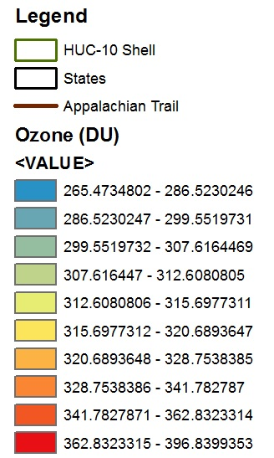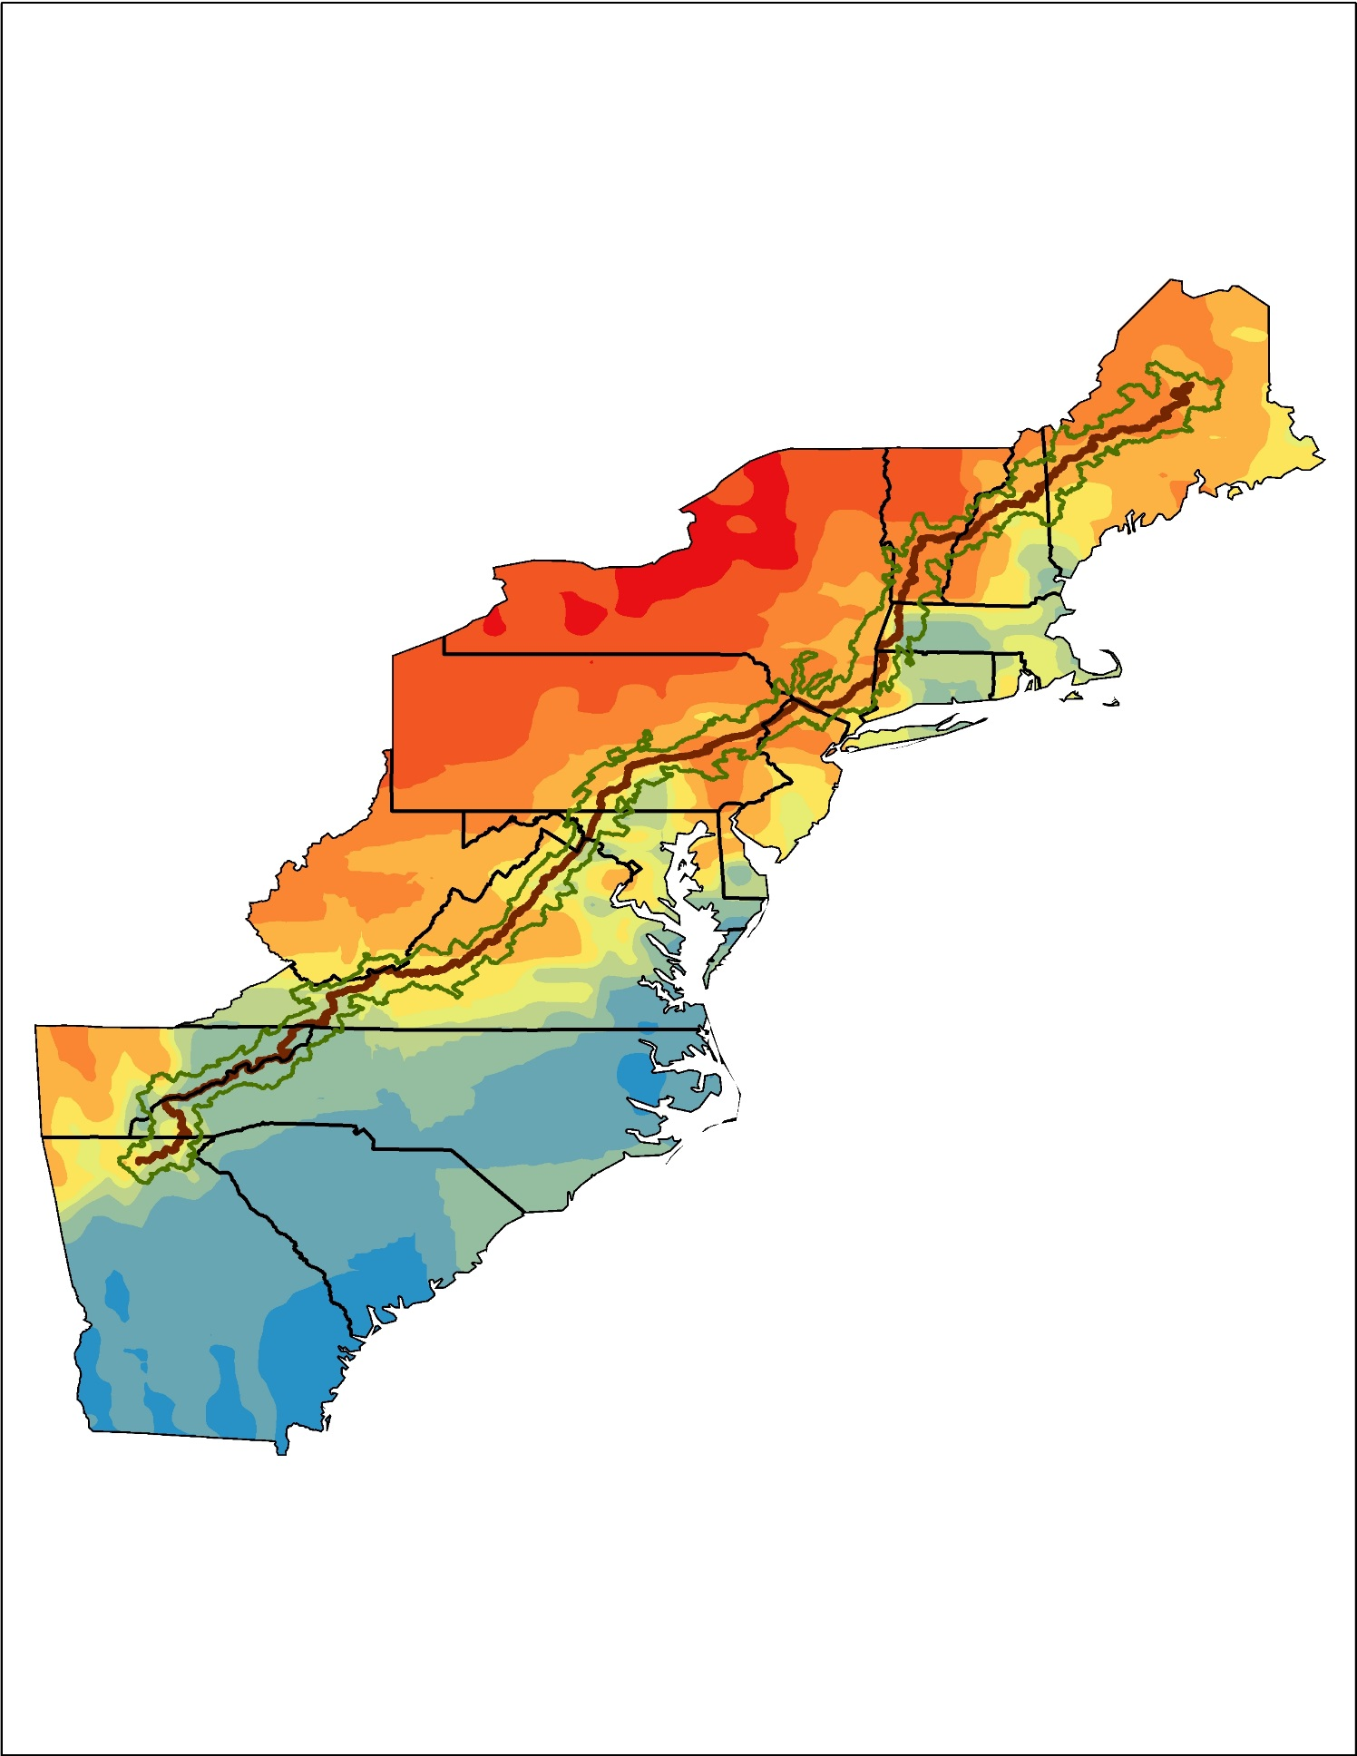

**Caption:** Data from the Aura satellite displays trends in tropospheric ozone levels to assist the National Park Service. Image Credit: Appalachian Trail Health & Air Quality Team.

**Image:** 2016Sum_LaRC_AppalachianTrailHealthAQ_VPSimage