**NASA DEVELOP National Program**

****Wise County Clerk of Court’s Office and Monterrey Tech, Saltillo

**Spring 2014**

**Oaxaca Water Resources**

*Using Earth Observing Systems to Characterize Drought Scenarios in Oaxaca, Mexico; to include adaptation actions in the Climate Change Program of the State*

**Team Lead:** Giovanni Colberg (University of North Dakota), gcolberg@wisedevelop.com

**Team Members:**

Yanina G Colberg (University of North Dakota)

Enrique Benavides (Tecnológico de Monterrey Saltillo Campus)

Laura Esqueda (Tecnológico de Monterrey Saltillo Campus)

**Advisors & Mentors:**

Dr. Kenton Ross (NASA Langley Research Center)

Dr. DeWayne Cecil (Global Science and Technology, INC.)

**Applied Sciences National Applications Addressed:**

Agriculture, Water Management

**Study Area:** Oaxaca, Mexico

**Study Period:** January 2005 – December 2013

**Community Concerns**

* Severe droughts have become a major cause of increased wild fires occurrence in Oaxaca. This creates a negative impact on the economy of the state.
* By April 2013, potable water was being rationed by 40% in Oaxaca due to droughts. These unfavorable conditions have detrimental effects on crops and cattle producing a deficit of millions of dollars in the farming industry.

**80-100 Word Blurb**

The state of Oaxaca is one of the three most biologically diverse states in Mexico. Within its state limits it has an array of different climates ranging from tropical climate, semi-humid up to dry desert like climate. Agriculture and cattle are the two largest economic markets of this state. This project aims to use NASA Earth Observation Systems (EOS) in combination with GIS and other analysis software to identify the areas that are most at risk from drought in this state. Additionally, we intend to use in-situ data to study the effects droughts have on crops and cattle and therefore their impact to the economy of Oaxaca.

**Abstract**

Droughts are a threat that has encompassed the entire world for many years. Scarcity of water does not only mean less access to drinking water which is crucial to human life, but also it brings consequences to crop yields and cattle. Oaxaca is one of three most biologically diverse states of the country of Mexico as well as one of the country’s top producers of grain, agave, peanuts, mango and sugar cane. Cattle is also a huge industry in this state using approximately 32% of state land. In 2013, 43% of Mexico was suffering from drought conditions. Oaxaca was rationing water by 40% causing mayor loss of crops and cattle costing the state and the economy millions of dollars. By partnering with local and federal agencies such as Centro Mario Molina (CMM), National Institute of Statistics and Geography (INEGI), and the National Water Commission (CONAGUA), this project will focus on producing a drought severity index report of the region by utilizing NASA Earth Observation Systems (EOS) from an array of satellites including Aqua and Terra MODIS, and TRMM Precipitation Radar. MODIS surface reflectance data were utilized to produce vegetation and water indices. MODIS Land Surface Temperature (LST) combined with TRMM rainfall data and Vegetation Indices were used in the Scaled Drought Condition Index (SDCI) model to derive drought severity index. Surface Reflectance data from MODIS was used to calculate Normalized Differential Drought Index (NDDI). Vegetation Health Index (VHI) was computed from scaled LST and scaled Vegetation Indices. The Standardized Precipitation Index (SPI) was used to compare the outputs of SDCI model, NDDI and VHI. The project also compared the differences in accuracy between TRMM rainfall data and Precipitation Estimation from Remotely Sensed Information using Artificial Neural Networks (PERSIANN). Socio economic data were used to estimate the percentage of most severely affected human and cattle population within the study area. The final results of the project will be incorporated in a climate change report that will be completed by the end of the year by the CMM.

**Partners/Collaborators**

Centro Mario Molina (POC: Nancy Hernández)

Centro Mario Molina (POC: Adolfo Lara)

National Water Commission (POC: Jose Guillermo Bárrios Gutierrez)

National Institute of Statistics and Geography (POC: Arturo López Juarez)

**Current Management Practices & Policies**

Early this year (January 2014), the board of directors of Mexico’s water commission (CONAGUA) met with southern Mexican state representatives to discuss adaptation strategies for climate change related events such as increased droughts and hurricane severity. While a final budget number is not yet decided, discussions focuses in looking at crops rotation are taking place. The idea behind these discussions is to utilize different crops that will not consume as much of the minerals of the top soil as that of the main crops used today. This will keep the soil nutrient rich and will cause it to suffer less soil erosion in case of a very dry season. Also, the government will be looking to provide cattle farmers with better tools to manage water consumption as well as control the cattle grazing.

**Benefit to End-User:**

* Ability to identify areas that are severely affected by drought in Oaxaca
* Plan more effective crop production efforts
* Cost effective analysis that can lead to enhanced drought mitigation policies
* Effective drought analysis that will provide essential data for the Mexican southern states climate change report.

**Decision Support Tools**

* Drought Severity Index showing high risk areas
  + Scaled Drought Condition Index (SDCI)
  + Normalized Differential Drought Index (NDDI)
  + Normalized Differential Vegetation Index (NDVI)
* Socio- Economic Risk Analysis
* Land Classification (Unsupervised)

**Earth Observations & Parameters**

Aqua/Terra (MODIS) – Surface reflectance, Land Surface Temperature (LST), Vegetation Indices (NDVI)

Landsat 5 TM

Landsat 8 – Operational Land Imager (OLI)

TRMM (Precipitation Radar, TRMM Microwave Imager) – Rainfall

**Future Applicable NASA Missions**

* Soil Moisture Active Passive (SMAP)
* Launch date - 2014

**Models Utilized**

Scaled Drought Condition Index Model (SDCI)

**Ancillary Datasets Utilized**

Center for Hydrometeorology and Remote Sensing (PERSIANN - Precipitation Estimation from Remotely Sensed Information using Artificial Neural Networks) – Rainfall data

Population dataset from INEGI

Palmer Index data from ground monitoring stations from CONAGUA

**Software Utilized**

ArcGIS – NDVI, NDWI Drought Indices

Python Scripting – Large scale data processing (rainfall, LST, Surface Reflectance and Vegetation Indices)

ENVI – Landsat level 1data processing

MRT – MODIS data projection and HDF-TIFF conversion

**Image**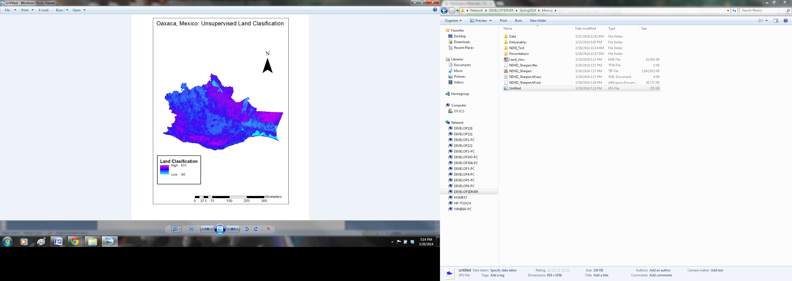

**Caption**

The image displays a 2014 unsupervised land classification of Oaxaca, Mexico derived from Landsat 8 satellite OLI sensor.