Tutorial

**Lake Victoria Landsat Surface Reflectance Product Download**

The following tutorial will explain how to download Landsat Surface Reflectance products.

1. Begin by accessing the USGS Global Visualization Viewer at <http://glovis.usgs.gov/>. downloading corresponding Landsat image dates from USGS using Path 170 and Row 60 (these files will need to be unzipped before they can be processed).

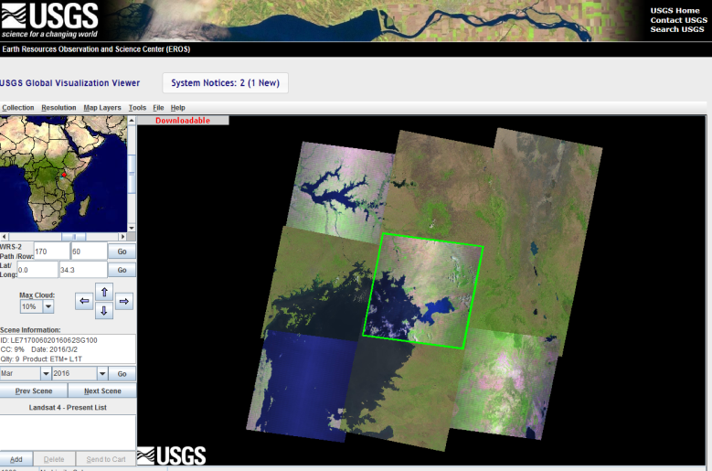

1. Use the search menu on the left to find Landsat image dates using Path 170 Row 60 for the Winam Gulf. Additional options include the Max Cloud dropdown menu with varying percentages of cloud cover to adjust image quality and area visibility.
2. Click the Add button at the bottom of the search menu, and then click the Send to Cart button to complete the checkout process. Registration is required to login and order products.

