**NASA DEVELOP National Program**

 NASA Jet Propulsion Laboratory

**Spring 2016**

**Short Title: Louisiana Ecological Forecasting II**

**Subtitle:** Using UAVSAR, AVIRIS, and AirSWOT to Model Coupled Water Flow and Sediment Transport for Delta Building within the Wax Lake Delta, Louisiana to Inform Coastal Restoration Efforts

**VPS Title:** Bringing Back the Bayou

**Project Team & Partners**

**Project Team:**

Erika Higa (Project Lead), Erika.Y.Higa@jpl.nasa.gov

Mark Barker

Emily Beck

**Advisors & Mentors:**

Dr. Cathleen Jones (NASA Jet Propulsion Laboratory)

Dr. Marc Simard (NASA Jet Propulsion Laboratory)

**Past or Other Contributors:**

Brittany Zajic

Raul Garcia

**Partner Organizations:**

US Naval Research Laboratory (End-User), POC: Richard Crout

Louisiana Universities Marine Consortium (Collaborator), POC: Alexander Kolker; Boundary Organization

**Project Details**

**Applied Sciences National Applications Addressed:** Ecological Forecasting

**Study Area:** Wax Lake Delta, LA

**Study Period:** April 2015 – May 2015

**Earth Observations & Parameters:**

UAVSAR, NASA Gulfstream III – Vegetation biomass

AirSWOT, NASA King Air B200 – Water height

AVIRIS-NG, NASA ER-2 – Vegetation type

Landsat 8, OLI – Land cover classification

**Ancillary Datasets Utilized:**

* DNR Strategic Online Natural Resources Information System (SONRIS) – Bathymetric data, Infrastructure (levees, etc)
* Coastal National Elevation Database (CoNED) Topobathymetric Digital Elevation Model (TBDEM) – Offshore bathymetry data
* Coastal Protection and Restoration Authority (CPRA) Coastal Information Management System (CIMS) – Accretion estimates
* Coastal Protection and Restoration Authority (CPRA) Coastwide Reference Monitoring System – Vegetation species, water levels
* USGS National Elevation Dataset (NED) – Bare earth elevation
* USGS National Water Information System – Water level gage data
* NOAA Water level gage data

**Models Utilized:**

* Deltares Delft3D

**Software Utilized:**

ERDAS IMAGINE – Land classification of UAVSAR

ArcGIS – Raster manipulation, model input preparation and map creation

QGIS – Radiometric correction of UAVSAR data

ENVI – Classification, image analysis, and enhancement of AVIRIS data

Delft3D – Modeling sediment transport within the Delta

**Project Overview**

**80-100 Word Objectives Overview:**

Our objective is to complete and calibrate a hydrological and sediment transport model of the Wax Lake Delta using the Delft3D modeling software suite, remotely-sensed data, and *in situ* data. The model will enable researchers to predict the future extent of the delta and better understand why the area is experiencing aggregation. The modeled results will provide crucial data to coastal scientists and managers in understanding the conditions necessary for land development in shallow deltas as well as offer insight into how to direct coastal restoration projects in areas of Louisiana where coastal marshes are eroding.

**Abstract:**

Erosion, land subsidence, and sea level rise along the Louisiana coast have led to 4900 km2 of land loss since the 1930's. It is estimated that Louisiana has the potential to lose an additional 4500 km2 over the next 50 years if no restoration action is taken. While most of the Louisiana coast is eroding, the Wax Lake Delta has continued to grow at a rate of approximately 5 km2 per year since the 1970's. Currently, labor intensive boat-based surveys are conducted to understand the delta building dynamics at Wax Lake. There have been a number of studies on the natural processes that contribute to this growth, but many of these studies lack tested models. We used remotely-sensed and *in situ* data, as well as Deltares Delft3D modeling software, to model water flow and sediment transport in the delta—calibrating the model using AirSWOT data. Model outputs will be used to inform coastal research by project partners at the United States Naval Research Laboratory in Mississippi and the Louisiana Universities Marine Consortium to assist the efforts of coastal managers in predicting coastline change and planning restoration projects to reduce land loss along Louisiana's coast.

**Community Concerns:**

* Land loss due to erosion, land subsidence, and sea level rise along the Louisiana coast has amounted to 4900 km2 since the 1930’s, threatening one of the most economically important port systems in the United States.
* The State of Louisiana’s Comprehensive Master Plan for a Sustainable Coast (2012) confirmed that Louisiana has the potential to lose up to an additional 4500 km2 over the next 50 years.

**Current Management Practices & Policies**:

Currently, restoration decisions are based on findings from ~400 projects identified by experts, citizens, and government studies. Restoration efforts can take the form of structural protection, bank stabilization, oyster barrier reefs, ridge restoration, shoreline protection, barrier island restoration, marsh creation, sediment diversion, and hydrological restoration. Nearly all of these projects rely on moving or trapping sediment, yet Louisiana has limited supplies of, or access to, usable sediment. Thus, it is imperative to understand the dynamics of delta building to maximize the use of the limited sediment available. These dynamics are currently studied using spot field measurements and labor-intensive, boat-based surveys.

**Decision Support Tools & Benefits:**

|  |  |  |
| --- | --- | --- |
| **End-Product** | **Earth Observations Used** | **Benefit & Impact** |
| Calibrated Water Flow and Sediment Transport Delft3D Delta model | AVIRIS, UAVSAR, AirSWOT | Coastal managers can use the modeled water flow and sediment transport to better understand and predict the growth of the Wax Lake Delta. End-users can use the modeled output to understand the land development processes and use this information in their efforts in wetland restoration along Louisiana’s coast. |
| Delta Vegetation Elevation Raster | UAVSAR | This end-product is a categorized vegetation elevation raster which is used as an input in the Delft3D Delta model. |
| Modeled Elevation Time Series | AVIRIS, UAVSAR, AirSWOT | A modeled elevation time series will illustrate where there is potential for land building. |

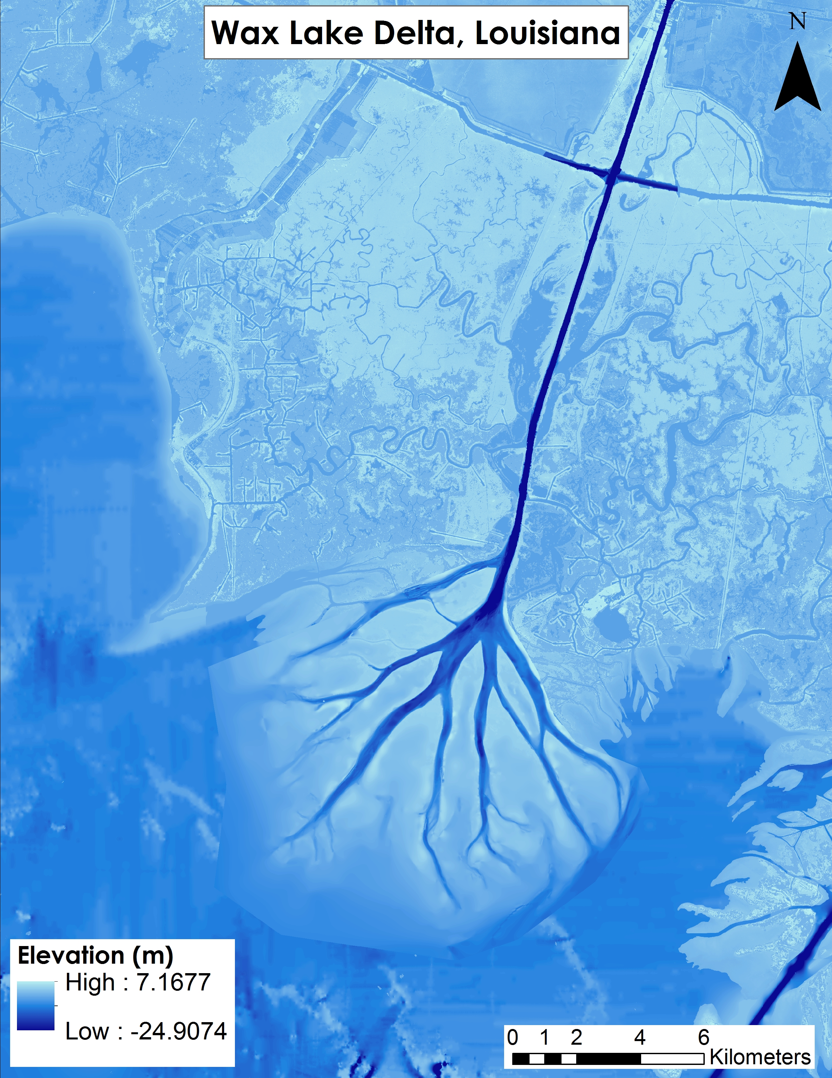**Project Imagery**

**Caption:** Bathymetry layer used in Delft3D that was created from a classified UAVSAR image merged with multiple topo-bathymetric datasets. Image Credit: Louisiana Ecological Forecasting II Team.

**Image:** 2016Spring_JPL_LouisianaEcoII_VPS_Image.jpg

**Software Release Requirements**

What category do the tools your project is creating fall within? Category I