**NASA DEVELOP National Program**



NASA Goddard Space Flight Center

*Fall 2015*

Montana Ecological Forecasting

Utilizing NASA Earth Observations to Forecast the Effects of Climate Change on Northern Goshawk Nesting Habitat

 **Technical Report**

Rough Draft – October 8, 2015

Erika Higa (Project Lead)

Sean McCartney

Amanda Clayton

Dr. Ross Nelson, NASA Goddard Space Flight Center (Science Advisor)

Dr. John Bolten, NASA Goddard Space Flight Center (Science Advisor)

# I. Abstract

[Placeholder - do not put anything here until the final draft submission. The abstract in the project summary is where the working draft of the abstract should “live”]

**Keywords**

Habitat Suitability, Northern Goshawk, Accipiter gentilis, Remote Sensing, Climate Change, Nesting, Ecological Forecasting, Montana

# II. Introduction

**Background Information**

The northern goshawk (*Accipiter gentilis*; hereafter goshawk) is the largest of the three forest raptors in the Accipiter family. The species occupies boreal and temperate forests in the United States and it breeds in mountainous or coniferous regions throughout Montana (Brewer, 2009). The goshawk has been a conservation concern in North America due to the potential impact of forest management practices on the habitat and the uncertainty in their population trends. As of 2009, the species is listed as “Sensitive” by Region 1 of the United States Department of Agriculture Forest Service (USDA Forest Service). While goshawks are designated as an Animal Species of Concern and hold a S3 state conservation rank in Montana, a G5 conservation rank (see Appendix A for definitions) indicates they are widespread throughout their global range (Montana Natural Heritage Program, 2009). The goshawk is also designated as a Management Indicator Species in the Lewis and Clark National Forest and is protected under the Migratory Bird and Treaty Act (Brewer, 2009). The goshawk has been a focus for conservationists and researchers due to the threat of habitat and climate change. Goshawks hunt in heavily forested areas and nest in mature forests where there is high canopy cover and an open understory (Miller et al., 2013). However, nest site locations are limited due to their preference in moderately sloped areas that are north to east facing (Squires and Reynolds, 1997). Goshawk nests are typically found in forests between 1500 - 2000 meters (5000 - 6600 feet) in elevation with an average of 350 millimeters (14 inches) of precipitation per year (Clough, 2000). It is believed that weather can affect egg and fledgling survival since cold wet springs and delayed snowmelt at higher elevations can delay the time goshawks lay their eggs (Squires and Kennedy, 2006). Past research has shown that goshawks are sensitive to drastic changes in weather—particularly on its effect on forest ecosystem dynamics. Climate change can over time affect the forest composition, cover, structure, and prey densities in the ecosystem and this can adversely affect the goshawk species since it is a top-tier predator. It is presumed that a change in weather, more than any other factor, in addition to habitat change, will affect the egg and nestling survival of the goshawk species (Keane et al., 2006). Additionally, the impact of climate change with warmer and drier weather can increase the mountain pine beetle (*Dendroctonus ponderosae*) outbreak with higher tree mortality and thus pose a risk to the goshawk population due to habitat change and loss (Brewer, 2009). Another threat to reducing the quality of nesting and foraging habitat of goshawks is timber management practices that involve removing nest trees, modifying nest stands, and removing portions of the canopy. Due to these specific habitat requirements, it is necessary to model areas that could be used by goshawks for breeding and nesting. This will allow forest managers and conservationists to maintain quality habitat to support future goshawk populations.

**Project Objectives and Partners**

The first objective of this project was to use data from NASA Earth Observing (EO) satellites, along with other ancillary data, as inputs for habitat suitability modeling to identify potential nesting habitat for the northern goshawk in the Lewis and Clark National Forest (LCNF). It is believed that climate change will affect nesting range and breeding phenology resulting in a delayed and shorter incubation period (Bechard et al., 2006). The second objective was to forecast the impacts on nesting habitat due to climate change and potential mountain pine beetle encroachment by the year 2050. The team examined different environmental variables that directly affect the goshawk nesting habitat, including: elevation, slope, aspect, precipitation, land cover, vegetation height, canopy cover, tree size and basal area.

The partners for this project are Dr. Nate Bickford of the University of Nebraska at Kearney and Oulu University Researchers, as well as Victor Murphy of the USDA Forest Service. These partners are interested in the project because they have not utilized remote sensing methods to analyze and forecast goshawk nesting sites. Nate Bickford and his team of researchers conduct time-consuming field observations of nest site locations and surrounding vegetation. Dr. Bickford and his colleagues at Oulu University in Finland will be able to apply the methods from this project to model habitat suitability for northern goshawks in other regions and project how climate change will affect the boreal forest habitat. Victor Murphy will use the results from this project to advise forest managers of timber management best practices to maintain vegetation structure in areas of critical goshawk nesting habitat.

**Study Area and Study Period**

The LCNF encompasses 7,300 km2 of land in central Montana. The forest is separated into two management areas: the Jefferson and Rocky Mountain Divisions. The Jefferson Division is further divided into five geographic areas (GAs): Castles, Crazies, Highwoods, Little Belts, and Snowies. Many of these geographic areas are discrete geologic units with unique landform and vegetation types, cultural histories, and recreation opportunities. The Rocky Mountain Division, to the west, consists of the Rocky Mountain Range GA which is located at the Rocky Mountain Front, and is characterized by a large designated wilderness area. The Forest's elevation ranges from 1370 to 2850 meters (4500 to 9362 feet). Primary forest types consist of lodgepole pine (*Pinus contorta*), Douglas fir (*Pseudotsuga menziesii*), ponderosa pine (*Pinus ponderosa*), and aspen (*Populus tremuloides*); all of which are common trees where goshawks nest. The USDA Forest Service oversees forest management practices within the study area including timber, fire, and recreational activities.

This study utilized 70 historical and active goshawk nest sites located in the Jefferson Division from 1985 to 2015. Because the nest site data were limited to the Jefferson Division, we excluded the Rocky Mountain Division of the LCNF from our study area.

Figure 1: Study area map of the Lewis and Clark National Forest, Jefferson Division. Study area is outlined in red.

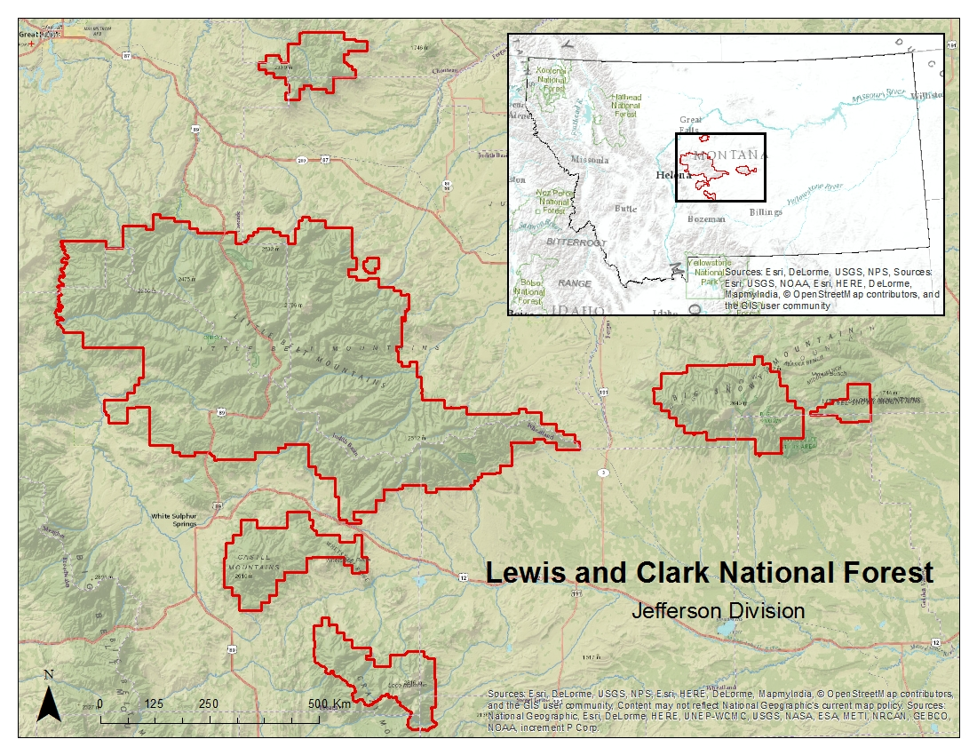

**National Application Addressed**

This project addressed the Ecological Forecasting Application Area within NASA’s Applied Sciences Program. This project utilized NASA EO to analyze land cover, precipitation, and to derive environmental variables provided by ancillary data sets to model potential areas of goshawk nesting sites. This study assisted our project partners to provide methods for habitat suitability analysis using remotely sensed data and to forecast how climate change will affect the goshawk habitat and nesting behavior by the year 2050. The information provided by this project will augment current decision-making practices regarding forest management in the LCNF.

# III. Methodology

**Habitat Suitability Modeling**

*Data Acquisition*

Seventy northern goshawk nesting sites from 1985 to the present were provided by project collaborator, Dr. Nate Bickford, of the University of Nebraska at Kearney. GPS coordinates, elevation, and the active years of each nest site location were recorded by Dr. Bickford and his staff. Specific nest site locations are shown in Figure 2 (see Appendix).

The USDA Forest Service maintains a large geospatial library containing data for Region 1 national forests. We utilized this library to obtain ancillary data on vegetation characteristics within the LCNF to derive a set of nesting habitat variables for the northern goshawk. Using USGS Earth Explorer, we acquired Shuttle Radar Topography Mission (SRTM) 1 arc-second data (30 m) which was used to derive terrain elevation, slope, and aspect. The USDA Forest Service Vegetation Map (VMap) and Forest Inventory and Analysis (FIA) programs survey, analyze, and produce geospatial data layers for various forest attributes. We used the VMap product to obtain vegetation metrics in vector format for tree canopy cover class and tree class size. Tree canopy cover is classified by percent canopy cover. Tree class size is determined by diameter at breast height (DBH). Basal area, in square meters per hectare, was downloaded from the FIA product at 250m resolution. An Existing Vegetation Height (EVH) layer was downloaded from the United States Geological Survey (USGS) LANDFIRE program. This layer provides an average height of the dominant vegetation at a 30m resolution.

Landsat 8 Operational Land Imager (OLI) data was acquired as three separate tiles for the dates of September 7, 2014, and August 2, 2015. All tiles were downloaded from the USGS Earth Resources Observation and Science Center (EROS). The tiles were used in creating a forest cover map of the study area for use as an environmental variable in habitat suitability modeling. Precipitation data was acquired from both Precipitation Measurement Missions (PPM), Tropical Rainfall Measuring Mission (TRMM) and Global Precipitation Measurement (GPM), for the months of February to June, 2010 - 2015. TRMM data was acquired as a level 3 product (3B43) at 0.25 degree spatial resolution and one month temporal resolution. GPM data was acquired as a level 3 product (3IMERGM) at 0.1 degree spatial resolution and one month temporal resolution. Both data sets were downloaded from the Science Team On-Line Request Module (STORM), a web-based data access interface hosted by NASA Goddard Space Flight Center (GSFC).

*Data Processing*

Data layers for each environmental variable were created to model suitable habitat for northern goshawk nesting sites. These variables included: elevation, slope, aspect, precipitation, land cover, vegetation height, canopy cover, tree size and basal area. ArcGIS 10.3 was used to prepare the environmental data for habitat suitability modeling. Eight individual SRTM elevation tiles spanning the study area was mosaicked and topographic layers for slope and aspect were derived from this 30m DEM using the Slope and Aspect tools in ArcMap. VMap data were converted to a 30m raster format to create separate layers for canopy cover class and tree class size. FIA Data for basal area was resampled from 250m to 30m spatial resolution to match the spatial resolution of the other environmental variables. TRMM and GPM data were resampled from 2.5 km spatial resolution, and 1 km spatial resolution respectively, to 30m spatial resolution. Precipitation averages for each month from 2010 - 2015 were then calculated as inputs into each model. For creating a land cover map of the study area, three tiles of Landsat 8 data were mosaicked together. Each data layer was subset to match the spatial extent of the LCNF, Jefferson Division, and projected to NAD 1983 UTM zone 12 N in raster format (see Figure 3 in Appendices).

*Data Analysis*

Once pre-processing of the Landsat OLI data was complete, further analysis was carried out to create a land cover classification for the LCNF; the results of which were two categories: forest and non-forest. Three separate hard classifications were undertaken using different methods in creating land cover maps for modeling. Maximum likelihood and Segmentation classifications were carried out using TerrSet software, and Monte Carlo Unmixing and subsequent hard classification was carried out using CLASlite software. Once all classifications were completed, 200 random samples were generated in a GIS and converted to a KML point file. These randomly generated points were then brought into Google Earth and verified as being either forest or non-forest. The resulting text file was used as ‘ground truth’ and brought back into a GIS and converted to a raster file where an accuracy assessment was performed with each hard classification. The object-based classification (Segmentation) resulted in the highest accuracy rate of 88% and was subsequently used in the running of habitat suitability models. Results from the accuracy assessment are found in figure 4 in the Appendices.

We utilized three presence-only modeling software to construct a habitat suitability model for northern goshawk nesting habitat. We ran the Maximum Entropy (Maxent) and Mahalanobis Typicality models through TerrSet’s Habitat and Biodiversity Modeler application. Maxent is a widely used program that estimates the probability distribution of a species using a maximum entropy approach, where the expected value of each environmental variable matches the empirical average (Phillips et al., 2010). Mahalanobis Typicality expresses the likelihood that a set of environmental variables at a specific location is typical to the known location of the species, or that the species distribution is normal with respect to environmental gradients (Hernandez et al., 2008). The stand-alone program, BioMapper 4.0, was used for the third model. BioMapper is based off of Ecological Niche Factor Analysis (ENFA) which computes the environmental factors that most explain the ecological distribution of the species (Hirzel et al., 2002).

The following 8 environmental variables were input into each model: elevation (m), slope (percent), aspect (degrees), land cover (forest/non-forest), vegetation height (m), tree canopy cover class (percent cover), tree size class (DBH), and basal area (m2/hectare). The outputs of each individual model were combined to create a single, composite model with different levels of predictive power.

**Ecological Forecasting**

*Data Acquisition*

Data was downloaded in vector file format from the USDA Forest Service Aerial Insect and Disease Detection Survey (ADS) to obtain information on mountain pine beetle infestation throughout the LCNF from 2001 - 2014. Data came georeferenced in a North American Datum 1983 (NAD83) and projected as Albers Conical Equal Area. This data identifies areas of tree mortality, the number of dead trees per acre, and provides additional information on host tree species and forest type.

Data was also acquired for climate projections from three global climate models (GCMs) for three representative concentration pathways (RCPs). Each RCP describes possible global climate scenarios based on greenhouse gas concentration trajectories adopted by the Intergovernmental Panel on Climate Change (IPCC) for its fifth Assessment Report (IPCC, 2014). The three possible climate scenarios reflect possible changes in greenhouse gas (GHG) emissions measured in CO2 equivalents. RCP 2.6 assumes the global GHG emissions will peak between 2010-2020, with emissions declining thereafter; GCP 4.5 assumes emissions will peak around 2040 and then decline; and GCP 8.5 assumes emissions will continue to rise throughout the rest of the 21st century. These data sets were downloaded from the WorldClim - Global Climate Data website (http://www.worldclim.org/cmip5_30s) after being averaged to the year 2050 and downscaled to 30 seconds resolution from the original 2-3 degree spatial resolution. The three environmental variables downloaded for ecological forecasting were minimum temperature, maximum temperature, and precipitation.

*Data Processing*

Pre-processing was performed on all forecast environmental variables by resampling them to a 30m spatial resolution, georeferencing them to NAD UTM zone 12N, and subsetting them to the study area. Vector files for mountain pine beetle infestations acquired from the USDA ADS were converted from vector file format to raster file format and georeferenced to NAD UTM zone 12 N in a 30m spatial resolution. Resampling of all data sets was needed as each data set came in varying extents, spatial resolution, and file format, preventing further analysis.

*Data Analysis*

Based on the results of each habitat suitability model for goshawk nesting sites, a consensus map was created showing a gradation of probabilities for nesting sites in the study area. If all three models showed a pixel suitable for a nesting site, this pixel was classified as ‘high’; if two of the models showed a pixel suitable for a nesting site, this pixel was classified as ‘medium’; if only one of the models showed a pixel suitable for a nesting site, this pixel was classified as ‘low’; and if none of the models showed a suitable pixel, this was classified as ‘none’. Based on these results we calculated beetle blight in 2050 based on the climate forecasts provided by WorldClim, and overlay these results with the results of our habitat suitability model. As beetle blight adversely affects the integrity of forest health and therefore goshawk nesting habitat, we forecast what areas of the LCNF will be viable for nesting based on the current conditions and future scenarios. The maps generated show which areas are most appropriate for conserving goshawk nesting habitat decades into the future.

# IV. Results & Discussion

Insert images, graphs, maps, charts, etc. here. Choose the most important results to highlight here. No word cap, but two to six pages is a good range.

Things to discuss:

* Analysis of Results: What can you tell from your graphs, images, etc? What does this mean for your project?
* Errors & Uncertainty: What factors could you not account for, what things didn’t work out like you expected they would, etc.
* Future Work: If this project was to be selected for another term, what would be the focus? What other areas would be of interest?

[In Progress]

# V. Conclusions

Final conclusions. Word count: 200-600 (~a page).

[In Progress]

# VI. Acknowledgments

[In Progress]

* Dr. Ross Nelson (NASA GSFC Science Advisor)
* Dr. John Bolten (NASA GSFC Science Advisor)
* Dr. Nate Bickford (Project Partner)

Any opinions, findings, and conclusions or recommendations expressed in this material are those of the author(s) and do not necessarily reflect the views of the National Aeronautics and Space Administration.

This material is based upon work supported by NASA through contract NNL11AA00B and cooperative agreement NNX14AB60A.

# VII. References

Bechard, M. J., Fairhurst, G. D., & Kaltenecker, G. S. (2006). Occupancy, productivity, turnover, and dispersal of northern goshawks in portions of the northeastern Great Basin. Studies in Avian Biology, 31, 100-108.

Blackard, Jock A. (2009). IW-FIA predicted forest attribute maps - 2005. [Vector digital data]. Fort Collins, CO: USDA Forest Service, Rocky Mountain Research Station. Available from http://dx.doi.org/10.2737/RDS-2009-0010.

Brewer, L. T., Bush, R., Canfield, J. E., & Dohmen, A. R. (2009). Northern goshawk Northern Region overview: key findings and project considerations. USDA Forest Service. Missoula, MT.

Clough, L. T. (2000). Nesting habitat selection and productivity of northern goshawks in west-central Montana (Doctoral dissertation). University of Montana, Missoula.

Eastman, J.R., (2014) TerrSet Geospatial Monitoring and Modeling System [Software]. Worcester, MA: Clark University.

Hernandez, P. A., Franke, I., Herzog, S. K., Pacheco, V., Paniagua, L., Quintana, H. L., ... & Young, B. E. (2008). Predicting species distributions in poorly-studied landscapes. Biodiversity and Conservation, 17 (6), 1353-1366.

Hijmans, R.J., S.E. Cameron, J.L. Parra, P.G. Jones & Jarvis, A. (2005). Very high resolution interpolated climate surfaces for global land areas. International Journal of Climatology, 25, 1965-1978.

Hirzel, A. H., Hausser, J., Chessel, D., & Perrin, N. (2002). Ecological-niche factor analysis: How to compute habitat- suitability maps without absence data? Ecology, 83 (7), 2027-2036.

Hirzel, A. H., Hausser, J., & Perrin, N. (2004). Biomapper 4.0. [Software]. Lab. of Conservation Biology, Department of Ecology and Evolution, University of Lausanne. Available from http://www.unil.ch/biomapper.

IPCC. (2014) Climate Change 2014: Synthesis Report. Contribution of Working Groups I, II and III to the Fifth Assessment Report of the Intergovernmental Panel on Climate Change [Core Writing Team, R.K. Pachauri and L.A. Meyer (eds.)]. IPCC, Geneva, Switzerland, 151 pp.

Keane, J. J., Morrison, M. L., & Fry, D. M. (2006). Prey and weather factors associated with temporal variation in northern goshawk reproduction in the Sierra Nevada, California. Studies in Avian Biology, 31, 85-99.

Miller, R., Carlisle, J., Bechard, M., & Santini, D. (2013). Predicting nesting habitat of Northern Goshawks in mixed aspen-lodgepole pine forests in a high-elevation shrub-steppe dominated landscape. Open Journal of Ecology, 3 (2), 109-115.

Montana Natural Heritage Program and Montana Fish Wildlife and Parks. (2009). Montana animal species of concern. Helena, MT: Montana Natural Heritage Program and Montana Department of Fish Wildlife and Parks. 17 pp. Retrieved from http://mtnhp.org/Reports.asp?key=0

Phillips, S., Dudik, M. & Schapire, R. (2010). Maxent Software, ver. 3.3.3e [Software]. Available from https://www.cs.princeton.edu/~schapire/maxent/.

Squires, J. R., & Kennedy, P. L. (2006). Northern Goshawk ecology: an assessment of current knowledge and information needs for conservation and management. Studies in Avian Biology, 31, 8-62.

Squires, J. R., & Reynolds, R. T. (1997). Northern Goshawk (Accipiter gentilis). The Birds of North America Online (A. Poole, Ed.). [Database]. Ithaca: Cornell Laboratory of Ornithology; Available from f database http://bna.birds.cornell.edu.

United States Department of Agriculture Forest Service. (2011). VMap base-level database (Version 11). [Vector digital data]. Missoula, MT: Northern Region, Engineering, Geospatial Group. Available from http://www.fs.fed.us/r1/gis/VMapWebPage.htm.

United States Department of Agriculture Forest Service. (n.d). Aerial insect and disease survey (2001-2014). [Vector digital data]. Missoula, MT: Region 1, Forest Health Protection. Unpublished material. Available from http://www.fs.usda.gov/detail/r4/forest-grasslandhealth/?cid=stelprdb5366459.

United States Geological Survey. (2012). LANDFIRE existing vegetation height. [Raster digital data]. Sioux Falls, SD: Wildland Fire Science, Earth Resources Observation and Science Center. Available from http://landfire.cr.usgs.gov/viewer/.

United States Geological Survey. (2014). SRTM 1 arc-second global. [Raster digital data]. Sioux Falls, SD: Earth Resources Observation and Science Center. Available from http://earthexplorer.usgs.gov/.

WorldClim. (n.d). CMIP5 30-seconds. [Raster digital data]. Available from http://www.worldclim.org/cmip5_30s.

# VIII. Content Innovation

In preparation for DEVELOP’s coming microjournal, please select three content innovation features to support your paper. For each item, please list the name of the feature, and include the tool itself if possible (eg. glossary terms and definitions). If the tool does not work in Microsoft Word (eg. Interactive MATLAB Figure Viewer), please list the file name and upload the related file to the DEVELOP Exchange. If you choose to use Inline Supplementary Material, please also include where the material should appear in the text.

**Some options include:**

AudioSlides

Database Linking Tool

Data Profile

Executable Papers

Featured Author Videos

Featured Multimedia for this Article (video and podcast options)

Glossary Viewer

Inline Supplementary Material (figures, tables, computer code)

Interactive Map Viewer

Interactive MATLAB Figure Viewer

Interactive Plot Viewer

Nomenclature Viewer

*[In Progress] The features we plan on using for content innovation are in red.

# IV. Appendices

**Appendix A**

**Heritage Program Ranks**

The international network of Natural Heritage Programs employs a standardized ranking system to denote global and state status. Species are assigned numeric ranks ranging from 1 (highest risk) to 5 (least concern). Rank definitions are given below.

**Global Rank Definitions**

|  |  |
| --- | --- |
| G1 | At high risk to extinction because of limited and/or rapidly declining numbers and range and/or habitat. |
| G2 | At risk because of very limited or potentially declining numbers and/or range and habitat |
| G3 | Vulnerable because of rarity or restricted range, even though it may be abundant in some other areas |
| G4 | Secure, though it may be rare in parts of its range and suspected to be declining. |
| G5 | Common, widespread, and abundant, though it may be rare in parts of its range. |

**State Rank Definitions**

|  |  |
| --- | --- |
| S1 | At high risk to extinction because of extremely limited numbers and extent of habitat in the state. |
| S2 | At risk because of very limited numbers and extent of habitat in the state. |
| S3 | Potentially at risk because of limited numbers and extent, though it may be abundant in some areas. |
| S4 | Uncommon but not rare. Not vulnerable in most of its range, but could be of long-term concern. |
| S5 | Common, widespread, and abundant. Not vulnerable in most of its range. |

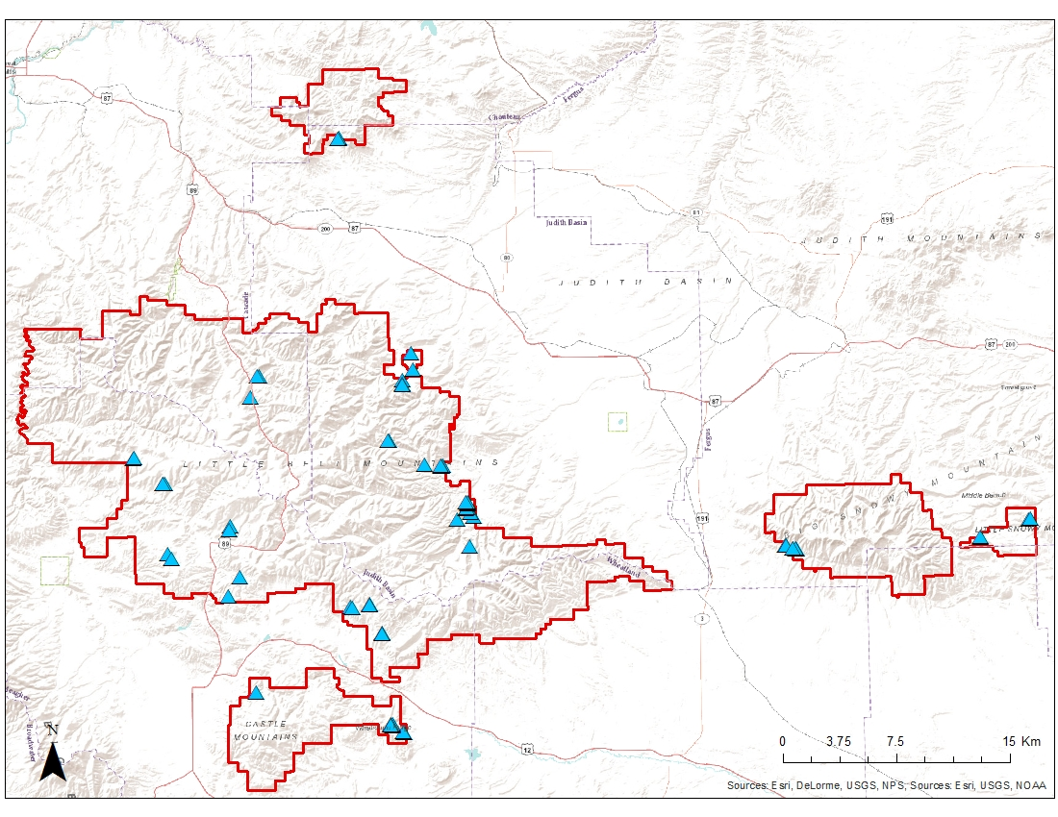

Figure 2. Northern goshawk nesting locations in the Lewis and Clark National Forest, Jefferson Division.

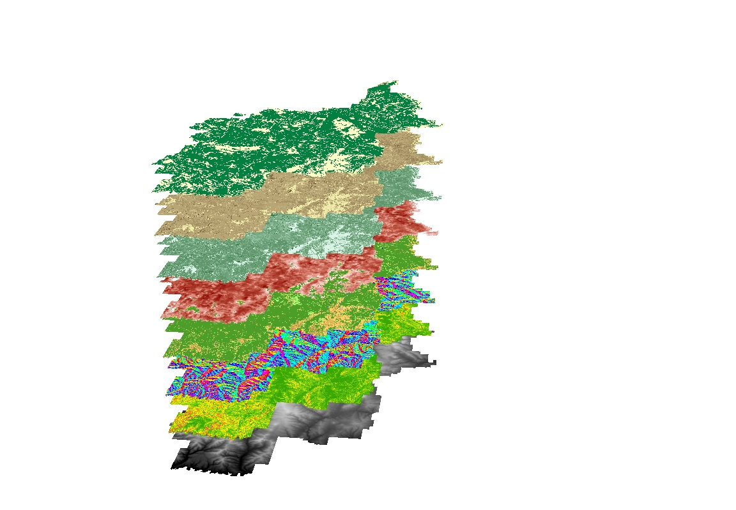

**Habitat Suitability Modeling**

*Environmental Variables Used*

Forest/Non-forest Land Cover

Tree Class Size

Tree Canopy Cover

Basal Area

Vegetation Height

Aspect

Slope

Elevation

Figure 3. Environmental variable layers used in the habitat suitability modeling.

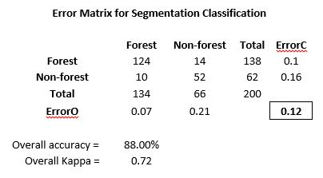

Figure 4. Error matrix created from object-based land cover classification in the LCNF.