**NASA DEVELOP National Program**



The University of Georgia

*Summer 2017*

Eastern India Ecological Forecasting III

A Multi-Sensor Approach to Enhance the Prediction of Mangrove Biophysical Characteristics in Chilika Lagoon and Bhitarkanika Wildlife Sanctuary, Odisha, India

 **Technical Report**

Final Draft – August 10, 2017

Abhishek Kumar (Project Lead)

Isabel Miranda

Maria Luisa Escobar Pardo

Taufiq Rashid

Shanti Shrestha

Deepak Mishra, University of Georgia, Department of Geography (Science Advisor)

Previous Contributors:

María José Rivera Araya

Roger Bledsoe

Christopher Cameron

Subash Dahal

Caren Remillard

Jessica Staley

Austin Stone

Patricia Stupp

# 1. Abstract

Across the globe, mangroves play a major role in coastal ecosystem processes mitigating erosion and serving as barriers against storm surges. India holds approximately 5% of the world’s mangroves, over half of which are along its east coast. Situated in the state of Odisha, Chilika Lagoon and Bhitarkanika Wildlife Sanctuary sustain mangrove sites of local importance in need of effective management. This study demonstrated the use of Terra, Landsat, and Sentinel-1 satellite data for spatio-temporal monitoring of mangrove health for both sites. Several indices including Normalized Difference Vegetation Index and Enhanced Vegetation Index, were examined to develop biophysical prediction tools and derive a 17-year time-series (2000 to 2016) of leaf chlorophyll (CHL), Leaf Area Index (LAI), and Gross Primary Productivity (GPP). Parallel to this assessment, a long-term (2000 to 2016) analysis of meteorological factors such as precipitation and temperature was completed to determine an association between these parameters. The correlation between meteorological parameters and mangrove biophysical characteristics enabled forecasting of mangrove health and productivity. A historical analysis of land cover maps was produced using Landsat 5 and 8 data to determine decadal changes in mangrove area estimates between 1995 and 2017. This analysis was used to predict land use-land cover change or fragmentation of Bhitarkanika mangroves. Based on IPCC data availability, the soft prediction map for 2050 showed the probability of mangrove risk to disturbance in the eastern part of Bhitarkanika. This study revealed the advantages of using a multi-sensor approach to monitor mangrove health and inform monitoring protocols.

**Keywords**

MODIS, Landsat, Bhitarkanika, chlorophyll, mangrove degradation, leaf-area index, Sentinel

# 2. Introduction

* 1. ***Background Information***

Mangrove forests are one of the most productive and biologically complex ecosystems on Earth. These forests play important roles in their local ecosystem through the environmental, biological, economical, and medical services they provide to local communities.  For example, mangrove forests provide a buffer against erosion and storm damage, serve as primary habitats and nurseries for many animal species, support fisheries, and sequester large amount of carbon compared to other forests (Das &Vincent, 2009; Rodriguez, Feller & Cavanaugh, 2016). Unlike many other types of vegetation, mangroves can weather extreme environmental conditions including high salinity, high temperature, extreme tides, high sedimentation, and anaerobic soils (Giri et al., 2010). This is mainly attributed to their complex root system, which not only allows them to live in such harsh environmental settings, but also helps protect coastlines from storm surges and erosion (Kauffman & Donato, 2012).

Mangroves are especially important for countries, such as India, which frequently face tropical cyclones that ravage coastal areas (Das & Vincent, 2009). India has approximately 4,461 km2 of associated mangrove habitats, 57% of which is located along the east coast of the country (Pattanaik, Reddy, Murthy, & Swain, 2008). Bhitarkanika Wildlife Sanctuary and Chilika Lagoon, located in the state of Odisha, are two notable east coast wetland sites recognized by the 1971 international treaty known as the Ramsar Convention on Wetlands, which promotes the sustainable use of wetlands and their associated resources (The Ramsar Convention Secretariat, 1996). Chilika Lagoon, the world’s second largest brackish water lagoon, holds three small, distinct mangrove patches near its opening to the Bay of Bengal (Peetabas & Panda, 2015). Bhitarkanika Wildlife Sanctuary, the second largest mangrove ecosystem in India (Chauhan & Ramanthan, 2008), lies ~100 km northeast of Chilika Lagoon on a delta formed by the Brahmani and Baitarani rivers and has several large, dense patches of mangroves (Fig. 1). With a total of 71 different mangrove and associated plant species, Chilika Lagoon and Bhitarkanika Wildlife Sanctuary are biodiversity hotspots supporting several populations of crocodiles, lizards, resident and migratory birds, and several rare and endangered mammals (Behera & Nayak, 2013). Residents from at least 36 nearby villages also receive valuable resources and services from these mangroves, including food, raw materials, and medicinal and ornamental products (Hussain & Badola, 2010). Despite their ecological, social, and economic importance, mangroves in this region have been over-exploited or converted to agricultural land (Reddy & Murthy, 2007). Therefore, there is a need to analyze and monitor changes in these mangrove ecosystems to assist in effective resource management.

Remote sensing is a critical tool to efficiently monitor mangrove forests over time as satellite imagery allows for the examination and frequent monitoring of mangrove habitat over a large area. Recent developments in remote sensing technology allow for an increased range of image datasets at varying spatial, temporal, and spectral resolutions (Kamal, Phinn & Johansen, 2015). Findings from recent studies indicate the potential for using freely available, moderate resolution satellite data to produce a long-term phenology and identify hotspots for early stages of mangrove degradation (Ibharim, Mustapha, Lihan & Mazlan 2015; Ishtiaque, Soe & Wang, 2016; Pastor-Guzman, Atkinson, Dash & Rioja-Nieto, 2015). Studies have shown the applicability of utilizing multispectral satellite imagery to monitor biophysical health indicators of mangroves. A recent study published by Ishtiaque et al. (2016) used Moderate Resolution Imaging Spectrometer (MODIS) products to analyze degradation in the Sundarbans forest of Bangladesh and India using five ecological characteristics including the Percent Tree Cover (PTC), Enhanced Vegetation Index (EVI), Net Primary Productivity (NPP), Leaf Area Index (LAI), and Evapotranspiration (ET) to assess mangrove health.  Another recent study by Ibharim et al. (2015) used Landsat and RapidEye data to evaluate changes in land use/land cover and produced change detection maps of mangrove forests to determine threats toward these ecosystems.

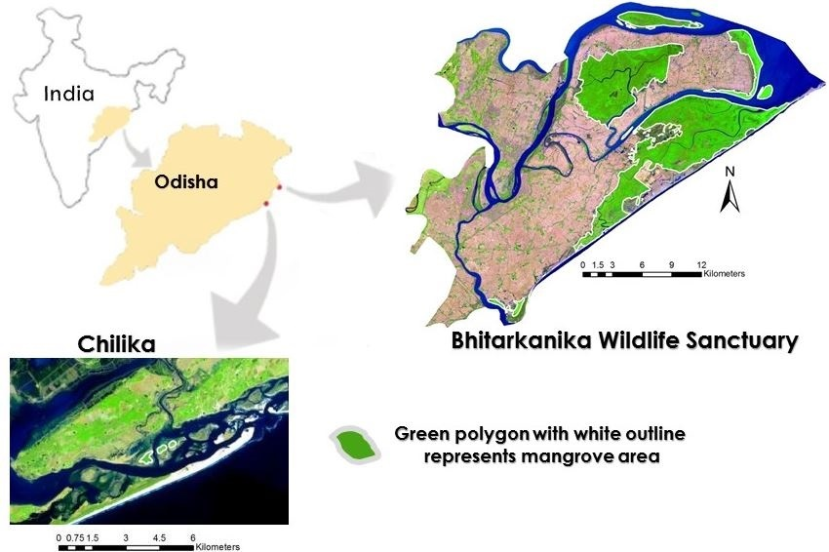

*Figure 1.* Study area map showing Bhitarkanika Wildlife Sanctuary and Chilika Lagoon. Mangrove patches are highlighted in green color with a white outline. Landsat 8-OLI imagery (2017) was used to create the color composite map with band combination (R: Band 6; G: Band 5; and B: Band 4).

While space and ground-based observations are used to monitor natural resources and ecosystems, they only consider current conditions. Forecasting potential areas of land-cover change and future biophysical conditions of ecosystems provides decision makers with insights into the future status of ecosystems (Clark et al., 2001; Nemani et al., 2007). Additionally, it allows decision makers to take precautionary steps towards mitigating the effects of and preparing for future conditions (Nemani et al., 2007). Within the past decade climate forecasting capabilities of coupled ocean-atmosphere global circulation models (GCMs) have improved allowing for future climate trends to be applied on the ecosystem to forecast biophysical and land-cover conditions (Nemani et al., 2007; Zebiak, 2003). Therefore, in this study we integrated data from multiple satellite sensors with projected climate variables to achieve forecasting of mangrove biophysical characteristics and future land cover change. To the best of our knowledge, this study is the first of its kind for forecasting Gross Primary Productivity (GPP) for Odisha mangrove forest.

***2.2 Project Partners & Objectives***

This project addresses the Ecological Forecasting application area, which promotes the use of Earth observations to analyze and forecast changes in the ecosystems to assist in effective resource management.

The primary end user for this project is the Chilika Development Authority (CDA), a government agency in

Odisha, India. The CDA was created under the Forest and Environment Department with an objective for conservation and management of these valuable ecosystems. The previous two terms of this project utilized satellite data to develop a phenological pattern for mangrove biophyisical characteristics corresponding to the different seasons. The objective of this project was to refine and implement a mangrove biophysical characteristics prediction tool for Bhitarkanika Wildlife Sanctuary and Chilika Lagoon by using a suite of satellite data including surface reflectance products and MODIS standard LAI and GPP products. In addition, biophysical parameters were correlated with meteorological parameters to achieve forecasting of GPP, LAI, and Chlorophyll (CHL) up to 2050. The secondary objective of this study was to forecast land cover change (up to 2050) using TerrSet’s Land Change Modeler. The results will increase understanding of long-term changes in mangrove cover and allow project partners to identify hotspots for early stages of mangrove degradation. Additionally, project partners received long-term spatio-temporal estimations of mangrove physiological status which will help to improve management and restoration efforts by the CDA.

# 3. Methodology

The overall process and data involved in different stages of this study are shown in Fig. 2. The major components during the process included downloading satellite products, data extraction, refining previous term biophysical models (LAI and GPP) based on long-term MODIS data (2000-2016) and subsequently implementing the models for long-term seasonal and inter-annual analysis of biophysical characteristics (CHL, LAI, and GPP). In addition, multivariate correlation analysis between meteorological factors and mangrove GPP was carried out and best correlation result was utilized for forecasting average CHL, LAI, and GPP based on projected precipitation and temperature data for 2050. Apart from mangrove biophysical characteristics projection, land use/land cover classification was carried out for 22 years (1995-2017) using Landsat 5 TM and Landsat 8 OLI data. Further, classification result was used for change detection in land use/land cover in TerrSet Land Change Modeler (LCM). At the end, Multilayered Perceptron (MLP) Neural Network (NN) based forecasting (up to 2050) was carried out in LCM to identify mangrove areas that might be under potential threat in future. More details about each component presented in the methodology work flow (Fig. 2) are described in the following sections.

***3.1 Data Acquisition***

Satellite data from multiple sensors were acquired from April 1995 to May 2017 (Table 1). Cloud-free Landsat 5 Thematic Mapper (TM) and Landsat 8 Operational Land Imager (OLI), surface reflectance (r) products were downloaded from the United States Geological Survey (USGS) EarthExplorer website for both the Bhitarkanika and Chilika sites. Terra MODIS 250 m Level-2G r daily products (MOD09GQ), corresponding to the closest available dates to the Landsat 8 OLI data, were downloaded from NASA’s Level 1 and Atmosphere Archive and Distribution System (LAADS) website. MODIS data with the closest corresponding dates to the OLI data were chosen for cross-calibration purpose. In addition to daily r products, 8-day average r (MOD09A1), LAI (MOD15A2H) and GPP (MOD17A2H)) products were downloaded from the LAADS website as well for long-term (2000-2016) seasonal and annual trend analysis. Sentinel-1 products were downloaded from the European Space Agency (ESA) Scientific Data Hub website.

*Table 1*

Data Acquisition Chart. Cloud-free and nearly cloud-free satellite images were collected from April 1995 to May 2017.

|  |  |  |  |  |  |
| --- | --- | --- | --- | --- | --- |
| **Satellite** | **Sensor** | **Product** | **Temporal Resolution** | **Spatial Resolution (m)** | **Source** |
| Landsat 5 | Thematic Mapper  (TM) | Surface Reflectance (r) | 16-day | 30 | USGS Earth Explorer |
| Landsat 8 | Operational Land Imager (OLI) | Surface Reflectance (r) | 16-day | 30 | USGS Earth Explorer |
| Terra | Moderate Resolution Imaging Spectroradiometer (MODIS) | Level-2G Surface Reflectance (MOD09GQ) | 1-day | 250 | NASA's Level 1 and Atmosphere Archive and Distribution System (LAADS) |
| Level-2G Surface Reflectance (MOD09A1) | 8-day | 500 |
| Leaf Area Index (LAI) (MOD15A2H) | 8-day | 500 |
| Gross Prmary Productivity (GPP) (MOD17A2H) | 8-day | 500 |
| Sentinel-1 | Synthetic Aperture Radar (SAR) | High Resolution Ground  Range Detected (GRD)  Level-1 (IW mode) | 12-day | 10 | ESA Scientific Data Hub |

Additionally, we incorporated area averaged physical-meteorological time series (January 2000-December

2016) data from the NASA’s Giovanni web-based application tool corresponding to Bhitarkanika. These data included monthly averaged precipitation from Tropical Rainfall Measuring Mission (TRMM) products monthly averaged surface runoff, and surface temperature (Table 2). The CO2 product (AIRX3C2M v005, AIRS3C2M v005) was available from September 2002 and also downloaded from NASA’s Giovanni website. All data were first visualized using the NASA Giovanni tool and corresponding ASCII files were downloaded for each parameter for further analysis in Microsoft Excel. The projected (2050) precipitation and temperature data were acquired from the WorldClim website.

*Table 2*

Physical-meteorological variables used in this study.

|  |  |  |
| --- | --- | --- |
| Physical-Meteorological Variables | Product Name | Source |
| Precipitation | TRMM_3B43_v7 | NASA Giovanni |
| Surface Runoff | GLDAS_NOAH025_Mv2.1 | NASA Giovanni |
| Surface Temperature | GLDAS_NOAH025_Mv2.1 | NASA Giovanni |
| CO2 | AIRX3C2M v005, AIRS3C2M v005 | NASA Giovanni |
| Projected Temperature (2050) | GISS-E2-R (RCP 4.5) | WorldClim |
| Projected Precipitation (2050) | GISS-E2-R (RCP 4.5) | WorldClim |

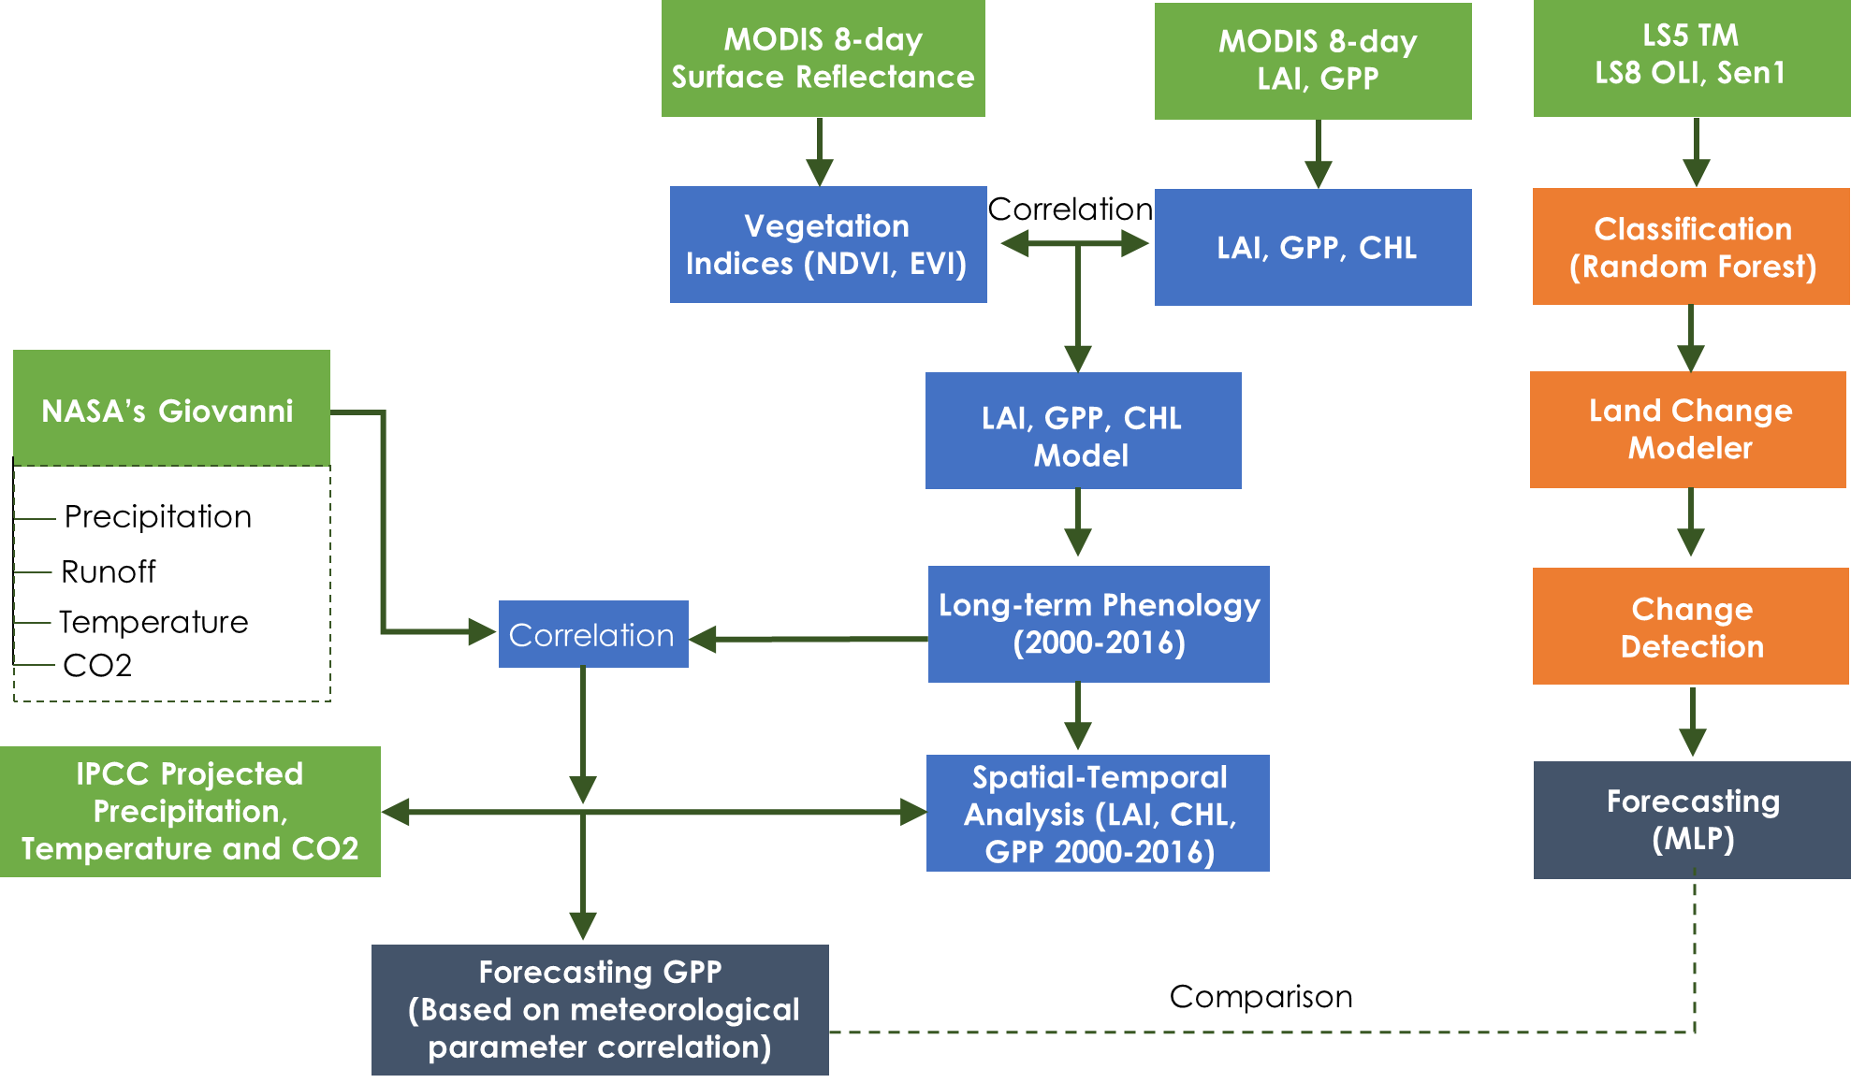

*Figure 2.* Overall methodology and various remote sensing datasets utilized in forecasting mangrove biophysical parameters and future risk assessment.

***3.2 Data Processing***

Data processing was accomplished in parallel components to achieve the objectives of this study. These components included: (1) refining biophysical models (LAI and GPP) developed during this project’s previous term and implementing these models to conduct long-term spatio-temporal analysis, (2) simple and multiple regression analysis between long term (2001-2016) CHL, LAI, GPP and meteorological parameters (3) forecasting CHL, LAI, and GPP based on their relationship with meteorological parameters (4) improving accuracy of previous term land use-land cover classification and forecasting threatened area.

To refine the previous term LAI and GPP model, long-term (2000-2016) r, LAI, and GPP data from MODIS 8-day products were extracted. A fish-net with spatial resolution of 500 m by 500 m was created across Bhitarkanika Wildlife Sanctuary (Fig. 3a) for extracting long-term data. However, long-term analysis of the Chilika site was not possible since it was more recently established. Data extraction for mangrove pixels was performed using batch processing methods in Sentinel Application Platform (SNAP) and Esri ArcGIS (Fig. 3b). Both non-mangrove and mixed pixels were excluded following this data extraction process. The long-term r data from mangrove pixels were exported to Microsoft Excel and previous term LAI, GPP models (Eq. 1-2) were implemented to estimate these biophysical characteristics. Further, estimated long-term LAI and GPP data using previous term models were compared with MODIS derived LAI and GPP long-term data from MOD15A2H and MOD17A2H products for accuracy assessment. To improve the LAI and GPP models, the 17 years (2000-2016) of MODIS derived data (r, LAI, and GPP) was randomly separated into two groups for calibration (12 years) and validation datasets (5 years). However, unchanged previous term CHL model (Eq. 3) was used to derive long-term CHL data as there is no CHL product available from MODIS for terrestrial sites.

$\text{LAI=17.155*EVI-2.574}$ (1) $\text{GPP=0.0983*EVI+0.016}$ (2)

$\text{CHL=127*NDVI-46.61}$ (3)

Where; NDVI = [Rrs (NIR) - Rrs(Red)]/[Rrs (NIR) + Rrs(Red)]

EVI =2.5*[Rrs(NIR)- Rrs(Red)]/ [(1+Rrs(NIR)+2.4*Rrs(Red)]



*Figure 3.* (a) Selected point locations for extraction of the pure Mangrove pixels. (b) The SNAP and ArcGIS tool used for projecting, clipping and extracting pixel values of the satellite imagery.

NASA’s Giovanni derived physical and meteorological data were processed in Microsoft Excel and R (R Develop Core Team, 2015) for regression analysis with long-term LAI, CHL, and GPP. WorldClim data (in GeoTiff format) was imported in Sentinel Application Platform (SNAP) software for extracting forecasted precipitation and temperature data.

To accomplish land use/land cover classification, training site polygons were created for seven land cover classes: dense mangrove, open mangrove, water agriculture; mudflat, sand; and plantation. A false- color composite was created to distinguish land cover classes using bands 4, 5, and 3 from Landsat 5 and bands 5, 6 and 4 from Landsat 8. We used the classification created by Pattanaik et al. (2008) as reference for our 2004 classification. The 1995 and 2017 classifications were cross-referenced with a false-color composite and Google Earth Imagery. GEE Explorer was used to create a supervised classification on Landsat 5 TM, Landsat 8 OLI, and Sentinel-1 Satellite data and the random forests algorithm was used to classify the imagery. Random Forests is a machine learning technique that is being increasingly used for image classification of percentage tree cover and forest biomass (Horning, 2010). The random forests algorithm is good for dealing with outliers in training data. It calculates classification error using one third of the training data (out-of-the-bag samples) while the remaining two thirds of the data is used to build the Random Forests Model (Horning, 2010). Random forests provide fast and higher accuracy compared to other well-known classifiers for remotely sensed data (Gislason, Benediktsson & Sveinsson, 2006). Land-cover maps were then created on TerrSet and LCM was run to identify vulnerability of each pixel to transition to a different land cover class in 2050 (Eastman, 2015).

***3.3 Data Analysis***

MODIS 8-day products derived LAI, GPP, and CHL data were analyzed monthly and annually in Microsoft Excel and R. LAI, GPP, and CHL data were averaged monthly for each year (2000-2016) for seasonal and inter-annual analysis. Mangrove pixels were grouped into sub-clusters based on their spatial location within study area for analyzing spatial and temporal variability in LAI, GPP, and CHL. Physical-meteorological long-term data (2000-2016) were also averaged monthly for correlating with biophysical parameters. Data from monsoon season (June, July, August, September) were not included in correlation analysis between biophysical parameters (LAI, GPP, and CHL) and physical-meteorological variables because of lack of cloud free-quality data for these months. The season classification is provided in Appendix A. Apart from direct correlation between mangrove biophysical characteristics and physical-meteorological parameters, a time-lag analysis was also carried out during single and multivariate correlation analysis.

Output land cover maps were validated visually with stratified sample points using Google Earth satellite imagery at the closest timestamp. In addition, published literature was referenced to maximize the accuracy of the land cover classification (Reddy & Murthy, 2007; Pattanaik et al., 2008). An accuracy assessment was calculated in TerrSet Geospatial Monitoring and Modeling Software to create an error matrix indicating the producer and user accuracy. Additionally, the random forests algorithm produces an accuracy assessment using out-of-bag samples which was used to compare with the error matrix accuracy assessment.

The land cover classification was analyzed in TerrSet to calculate the total area in square kilometers for each land cover class. The Land Change Modeler suite (LCM) in TerrSet was run to quantify land cover category change in the study area from 1995 to 2004 and from 2004 to 2017. The LCM output consists of land cover gains, losses, and persistence of each time period as well as graphs of the contributors to change experienced by each land cover category. Several studies have used the LCM to map land cover change and predict future Land-cover transitions based on user-specific drivers of change (Weber, Keddell, & Kemal, 2014; Rodriguez Eraso, Armenteras-Pascual, & Alumbreros, 2013).

To predict future land cover transitions, the transition potential and change allocation tab in the LCM were used. Land cover transitions that had less than 1,500 pixels of transition to another land cover class were excluded from the transition potential modeling. Therefore, only three transitions were used to run the transition submodel: dense mangrove to open mangrove, open mangrove to agriculture, dense mangrove to agriculture. Each transition has its own submodel with a set of driver variables that will influence transitions of dense and open mangrove classes to another land cover class. These driver variables consist of temperature, precipitation, distance from roads, distance from channels and distance from disturbance (open mangrove to agriculture).

To predict future changes in land cover it is necessary to empirically model each of the transitions; this was done using the Multilayered Perceptron (MLP) Neural Network. The MLP was chosen because it can handle multiple transitions at once and because the driving forces for these transitions are the same. The MLP Neural Network selects random samples of pixels that went through each transition users are modeling and pixels that could have gone through each transition but did not (Eastman, 2015). Half of the sample pixels are used to train the model and the other half will be used to test how well the model is doing at predicting change. The MLP creates a multivariate function that can predict the potential for a pixel to transition based on the values of the driver variables for that pixel (Eastman, 2015). The model produces an accuracy of how well the driver variables can predict change. The MLP produces a transition potential image that describes the probability that a transition will occur in the landscape and is used to predict future land cover change. The change demand modeling panel is used to predict future transition of land cover change for the year 2050. A soft prediction map which indicates a scale of vulnerability was used to show the risk of mangroves in the future. A soft prediction model is a “comprehensive assessment of change potential and also yields to a map of vulnerability to change that habitat and biodiversity assessments prefer” (Eastman, 2015; Rodriguez Eraso et al., 2013).

# 4. Results & Discussion

***4.1 Re-parameterizing LAI and GPP Models***

The time series for LAI and GPP derived from previous term models showed overestimation when compared to MODIS standard LAI and GPP (Figs. 4a-b). This is primarily because data from only 20 locations (Appendix B) were used in previous model calibration which produced biasness towards higher value. However, in this study we incorporated 17 years of data from all mangrove pixels (except mixed pixels and boundary pixels) for LAI and GPP model calibration and validation. Calibration and validation results showed improvement in the model with reduced NRMSE of 8.56% for LAI model and 12.73% for GPP model, compared to previous term NRMSE which was 19.54% for LAI and 18.64% for GPP (Appendix C). Therefore, models from previous terms were updated with new coefficients shown in Eq. 4 and 5 respectively. The time series of GPP and LAI from tuned model clearly resolved the overestimation issue in prediction which was encountered before (Figs. 4a-d).

$\text{LAI }\text{new}\text{=11.80*EVI-1.041}$ (4)

$\text{GPP}\text{ new}\text{=0.096*EVI+0.0003}$ (5)

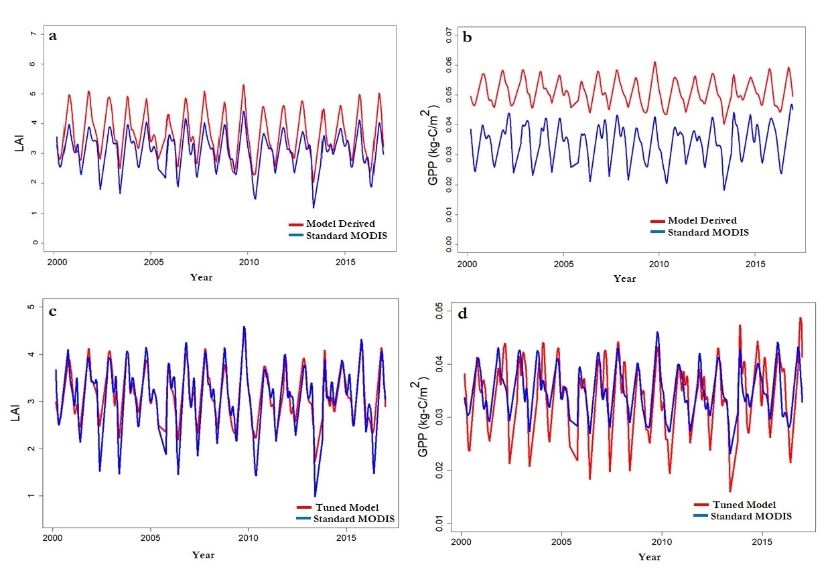*Figure 4.* Comparison between MODIS standard LAI, GPP and previous term model derived LAI, GPP (a-b). Comparison between tuned model derived LAI, GPP and MODIS standard LAI, GPP (c-d).

***4.2 Long-term Spatio-temporal Analysis of Biophysical Parameters***

The long-term (2000-2016) spatio-temporal analysis of GPP, LAI, and CHL revealed a phenological pattern such as peaked during Fall (September-October) and reached lowest during Summer (April-May). The cluster-wise analysis of mangrove pixels based on their spatial location suggested that isolated clusters (C1 & C2) have relatively lower values of GPP, LAI, and CHL (Figs. 5a-d; Appendix D). Also, Cluster 7 (C7) showed lower mean value for all parameters-GPP (mean: 32 g-C/m2), LAI (mean: 2.82), and CHL (mean: 36.71 µg/cm2). These clusters are dominated by open mangroves. In contrast, cluster 4 (C4) which is dominated by dense mangrove, showed highest values for all biophysical parameters (mean GPP: 38.2 g-C/m2; mean LAI: 3.56; mean CHL: 44.49 g-C/m2).

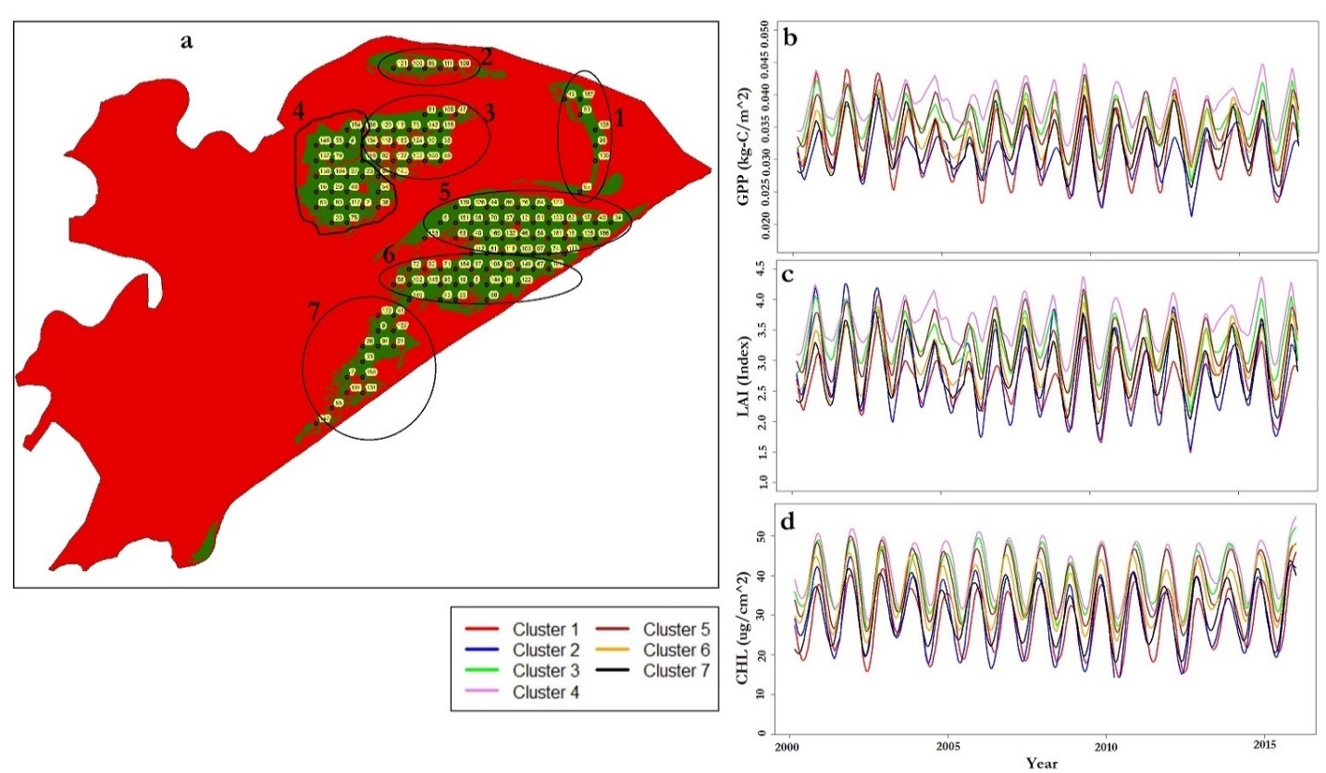*Figure 5.* Long-term (2000-2016) spatio-temporal variability of LAI, CHL, and GPP in Bhitarkanika Wildlife Sanctuary. Study area was sub-divided into seven clusters as per spatial location of mangrove pixels.

Further, relationships between various combinations of physical-meteorological parameters (precipitation, temperature, runoff, CO2) and mangrove biophysical parameters were investigated. In addition, 1-month lag time in precipitation and runoff was also analyzed to observe their impact on LAI, CHL, and GPP. The results revealed negative relationship for temperature and CO2 with biophysical parameters. However, precipitation and runoff with 1-month time lag showed positive relationship with GPP, LAI, and CHL (Appendix E). Months were also included as categorical variable in establishing relationship along with physical-meteorological parameters to capture seasonality effect. The best combination of variables derived from multiple-regression analysis were finally used in forecasting GPP, CHL, and LAI (Appendix E).

***4.3 Forecasting Biophysical parameters (GPP, LAI, CHL)***

Visual comparative analysis between current (2016) and forecasted (2050) mean annual GPP, LAI and CHL maps revealed that there was reduction in the values for all three parameters (Figs. 6a-f). The mean annual GPP forecasted for 2050 was 7.7% less compared to the mean annual GPP for 2016. The reduction in LAI for year 2050 was 20.83 % compared to mean annual LAI of year 2016. Similarly, the mean annual chlorophyll for year 2050 was forecasted to be 32.9% less compared to the mean annual chlorophyll of year 2016. Analyzing the change in climate between current and projected (2050), it was found that the mean annual temperature for year 2016 was 26.6°C, which was projected to increase by 5.03°C in 2050 reaching up to 31.63°C. Similarly, mean annual precipitation for year 2050 was projected to be 150.88 mm, which was 29.88 mm higher compared to the 2016 case.

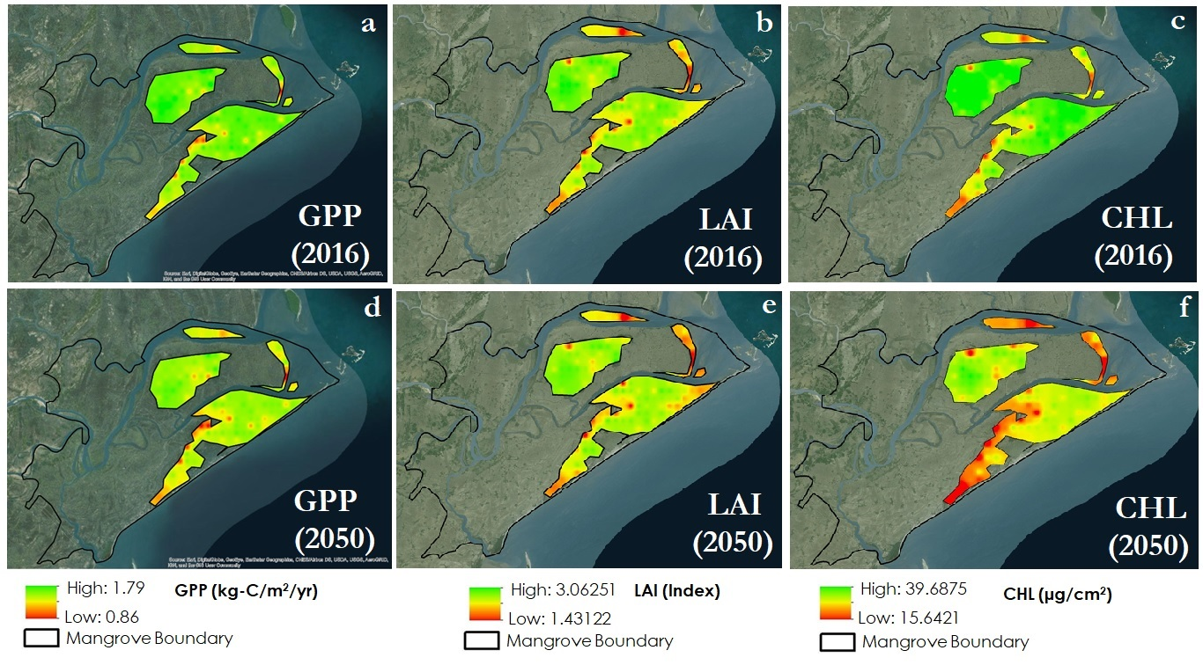*Figure 6.* Comparison between current (2016) and forecasted (2050) mean annual biophysical parameters (GPP, LAI, CHL). MODIS derived GPP, LAI, and CHL data from 2016 were used as a reference for creating current GPP, LAI and CHL maps (a, b, c). The forecasted maps (d, e, and f) were created using 17-years relationship between biophysical parameters, meteorological parameters, and associated seasonality.

The reduction in CHL between two years was higher compared to the other two parameters. This could potentially be explained based on the coefficients of the meteorological parameters we obtained while fitting regression models predicting GPP, LAI and CHL (Appendix E). Multiple-regression for GPP revealed that it is negatively associated to temperature but positively related to precipitation (Appendix E). In LAI prediction model also, temperature showed negative relation with LAI and positive relationship with precipitation. But in case of CHL prediction model, temperature and precipitation are both negatively related to CHL (Appendix E). Since temperature and precipitation both are projected to increase in future, the reduction in CHL was higher compared to reduction in other parameters. The influence of temperature was relatively higher compared to that of precipitation. Analyzing the spatial variation, the southernmost areas, the isolated areas and some pixels in the boundary have relatively lower values of the biophysical parameters. This could potentially be due to fragmentation of mangroves and conversion of dense to open mangroves. Hence, we have analyzed these potential sources of variation in GPP, LAI and CHL based on other factors in following sections.

***4.4 Land Cover Classification and Change Detection***

The land-cover maps were made using Google Earth Engine Explorer with a random forest algorithm. These classification results have an overall accuracy of 84% for 1995, 82% for 2004 and 86% for 2017 (Appendix F). Google Earth imagery was used as a reference for accuracy assessment of different land cover types (Appendix G). An accuracy assessment was calculated in TerrSet to create an Error Matrix indicating the overall accuracy (Appendix H, I, J).

Visually, we can observe fragmentation of dense mangrove and increase in agriculture and open mangrove land cover (Appendix F). Emphasizing the dense mangrove land cover class, we used the Land Change Modeler in TerrSet to map areas of gain, loss and persistence in Bhitarkanika.  The total amount of loss of dense mangrove was 9.28 square km from 1995 to 2004 and the total amount of loss from 2004 to 2017 was 21.44 square km, indicating more loss occurred between 2004 and 2017 than between 1995 and 2004 (Fig. 7). Zooming into a particular part of our study area, we observed that in 1995 areas of open mangrove (red) were replaced by dense mangrove in 2004. In 2017, we found that locations of dense mangrove were again lost to open mangrove (Fig. 7). In addition, 70% of the total dense mangrove that was lost from 2004 and 2017 changed to open mangrove. There was also a 24.4% gain in dense mangrove from 1995 to 2004 due to increased protection within the study area (Reddy, Pattanaik and Murthy, 2008).

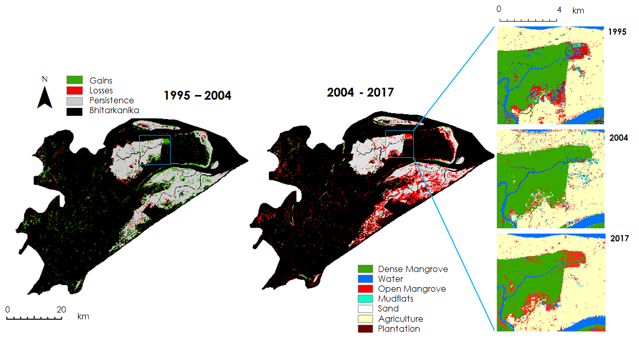

*Figure 7*. Dense mangrove change from 1995 to 2004 and 2004 to 2017.

Furthermore, we used MLP for future risk assessment in mangrove cover for Bhitarkanika. The MLP produced a soft prediction map that indicated a scale of mangrove risk to disturbance in 2050. Red to orange locations indicated medium to high vulnerability and locations of yellow to blue indicated lower vulnerability (Fig. 8).   
  
In the northern part of Bhitarkanika, lower mangrove risk locations were demarcated in blue while the edges of the mangrove extent indicated higher mangrove risk to disturbance in red (Fig. 8). The southern part of the study area indicated medium to high mangrove risk to disturbance (in yellow and red) was located below the Rajnagar-Pattamundai Road and was fragmented along the river (Fig. 8).   
  
Another model that the Markov Chain analysis outputs was the hard prediction, which was a “best guess” of the many plausible scenarios that land cover could have in the future. Therefore, the chances that the hard prediction would match future conditions are slim and should be interpreted with caution. The soft prediction model provided a better indication for risks to habitat and biodiversity. The hard, soft and 2017 classification map are compared in Appendix K. Locations with high mangrove risk in the soft prediction map coincide with locations of agriculture and open mangrove in the 2050 hard prediction. The hard prediction map compared to the 2017 classification map showed a greater increase in agriculture from open mangrove. In addition, the soft prediction map located areas of high mangrove risk that coincided with open mangrove areas in the 2017 classification map.

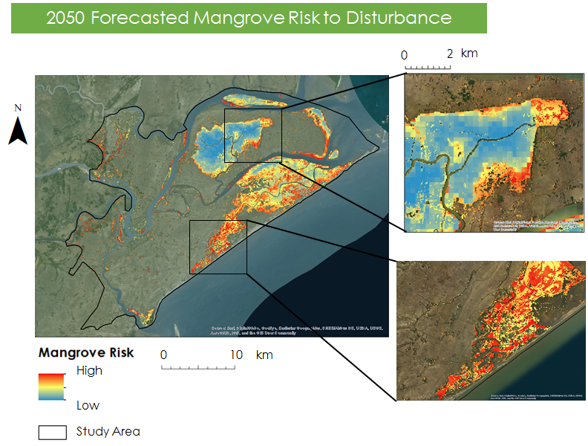

*Figure 8.* The soft prediction map for 2050 mangrove extent indicated the scale of risk of mangroves to disturbance. Red indicates high mangrove risk and blue indicates low mangrove risk.

***4.5 Limitations and Sources of Uncertainties***

Conducting a supervised classification with the random forests algorithm posed some uncertainty to assign all pixels to the proper class due to mixed land cover present within a pixel. Open mangrove was sometimes mixed with agriculture or plantation. However, the random forest algorithm performed well when compared to other classifiers such as single CART classifiers and can also detect outliers which increased our confidence in the land cover classification (Gislason, Benediktsson and Sveinsson, 2006).  The lack of high resolution imagery and lack of in-situ data availablity in our study area posed limitations when conducting validation.  Therefore, ground truth imagery used to validate 1995 and 2004 land cover classification was limited to the Google Earth imagery available for certain years. Furthermore, the driver variables used in the MLP model do not explain all the reasons for dense mangrove to transition to open mangrove or open mangrove to transition to agriculture. Therefore further research on variables that would influence transitions in land cover is necessary to improve the model.

# 5. Conclusions

Despite conservation efforts, the current extent of dense mangrove in Bhitarkanika Wildlife Sanctuary is projected to decrease up to 10% by the year 2050. A comparison between the classification for 1995, 2004, 2017 and the projected classification for 2050 indicated that dense mangrove extent decreased while open mangrove and agriculture extents increased.

By 2050, patches of mangrove along the south-west and northern coast of Bhitarkanika Wildlife Sanctuary are projected to decrease. With the reduction in the forest cover, the reduction in biophysical parameters was revealed. The degradation of biophysical characteristics, which are also the indicators of mangrove health and vitality, indicates that the mangrove ecosystem of Bhitarkanika wildlife sanctuary and Chilika lagoon may not be able to meet the environmental, economic, and social needs in future. Therefore, park managers should focus on further monitoring open mangroves within the study area as well as the outer edges of dense mangrove patches. It is recommended that management efforts focus more on the restoration programs and policy efforts be made to halt immediate conversion of mangroves to other land forms. The results of this study show the effectiveness of multi-sensor approach for monitoring mangrove biophysical parameters and LULC change analysis that can be replicated for other study areas as well.

# 6. Acknowledgments

We would like to thank our science advisors, Dr. Deepak Mishra and Dr. Marguerite Madden at UGA. We would also like to acknowledge our partners at the Government of Odisha’s CDA, especially Dr. Gurdeep

Rastogi for his involvement with the project and international communication during the term. Additionally, our team would like to thank UGA Center Lead Caren Remillard and Assistant Center Lead Christopher Cameron for their support.

Any opinions, findings, and conclusions or recommendations expressed in this material are those of the author(s) and do not necessarily reflect the views of the National Aeronautics and Space Administration.

This material is based upon work supported by NASA through contract NNL16AA05C and cooperative agreement NNX14AB60A.

# 7. Glossary

**Advanced Spaceborne Thermal Emission and Reflection Radiometer (ASTER) –** an imaging instrument onboard Terra; ASTER data is used to create detailed maps of land surface temperature, reflectance, and elevation

**Biophysical Parameters –** a numerical or other measurable factor derived from in-situ data that can be used to assess changes in wildlife habitat, watersheds, permafrost and vegetation in support of cumulative impact monitoring and ecosystem assessment; examples include leaf area index, leaf chlorophyll, and gross primary productivity

**Chlorophyll (CHL) –** a green pigment that absorbs sunlight and uses its energy to synthesize carbohydrates from CO and water

**Earth observations** – satellites and sensors that collect information about the Earth’s physical, chemical, and biological systems over space and time

**Google Earth Engine (GEE)** – includes a catalog of satellite imagery and geospatial datasets with analysis capabilities to detect changes, map trends and quantify changes on the Earth’s surface

**Gross Primary Productivity (GPP)** – the rate at which ecosystem’s producers store and capture provided amount of energy as biomass in a given time duration

**Multilayered Perceptron (MLP) Neural Network** – Used to empirically model each of the transitions of land cover to be used to predict future change in land cover. The MLP selects random samples of pixels that went through each transition you are modeling and pixels that could have gone through each transition but did not.  Half of the sample pixels are used to train the model and the other half will be used to test how well the model is doing at predicting change. The MLP is creating a multivariate function that can predict the potential for a pixel to transition based on the values of the driver variables for that pixel

**Landsat 8 –** launched on February 11, 2013, the Landsat 8 satellite images the entire Earth every 16 days in an 8-day offset from Landsat 7 and acquires moderate resolution, multispectral images of the globe

**Leaf Area Index (LAI)** – the total one‐sided area of leaf tissue per unit ground surface area. It is defined as the one-sided green leaf area per unit ground surface area (LAI = leaf area / ground area, m2 / m2) in broadleaf canopies

**Mangroves –** tropical trees or shrubs that grow in coastal saline or brackish water

**Moderate Resolution Imaging Spectroradiometer (MODIS) –** moderate-resolution imaging spectroradiometer is ideal for tracking large scale changes with its high temporal resolution and 36 discrete spectral bands

**Multi Spectral Instrument (MSI)** **–** onboard the Sentinel-2 satellite, it collects wide swath (290 km) high-resolution (10 m) images with 13 spectral bands

**Multilayered Perceptron (MLP) Neural Network** – The MLP is used to empirically model each of the transitions of land cover to be used to predict future change in land cover. The MLP selects random samples of pixels that went through each transition you are modeling and pixels that could have gone through each transition but did not. Half of the sample pixels are used to train the model and the other half will be used to test how well the model is doing at predicting change. The MLP is creating a multivariate function that can predict the potential for a pixel to transition based on the values of the driver variables for that pixel.

**Normalized Difference Vegetation Index (NDVI) –** an index of plant “greenness” or photosynthetic activity, and is one of the most commonly used vegetation indices

**Operational Land Imager (OLI) –** one of two instruments onboard Landsat 8, the OLI collects image data for nine visible shortwave bands

**Random Forests** - a machine learning technique that is increasing being used for image classification such as percentage in tree cover and forest biomass; Random Forests constructs a number of decision trees from training data and determines which land cover class should be assigned to pixel; the technique produces an accuracy assessment for the model using one third of the training data and is useful for omitting outliers

**Sentinel-2–** launched on June 23, 2015 by the European Space Agency, the Sentinel-2 satellite’s mission is mainly to provide information for agricultural and forestry practices; expands on the French Spot and US Landsat missions

**Surface Reflectance(r) –** ratio of the amount light not absorbed by a surface to the amount of light striking the surface

**Terra** **–** launched December 18, 1999, the Terra satellite acquires data in 36 groups of wavelengths and promotes understanding of energy balance and climate regimes across the Earth

**TerrSet Software** - TerrSet is software for monitoring and modeling the earth system for sustainable development. The software incorporates the IDRISI GIS analysis and image processing tools. The software features tools such as the Land Change Modeler, Habitat and Biodiversity Modeler and Earth Trends Modeler.

# 8. References

Azam, N. N. A. (2011). The Importance of Mangrove Forests Management. *International Islamic University Malaysia*.

Behera, D. P. & Nayak, L. (2013). Floral Diversity of Bhitarkanika, East Coast of India and its potential uses. *Journal of Chemical, Biological and Physical Sciences*, *3*, 1863-1874.

Bhar, S., Chakraborty, D., Ram, S. S., Das, D., Chakraborty, A., Sudarshan, M., & Santra, S. C. (2013). Spatial variation of chlorophyll integrity in a mangrove plant (*Excoecaria agallocha*) of Indian Sundarban, with special reference to leaf element and water salinity. *Journal of Environmental Science, Toxicology, and Food Technology, 3(5)*, 24-31.

Chauhan, R. & Ramanathan, A. L. (2008). Evaluation of water quality of Bhitarkanika mangrove system, Orissa, east coast India. *Indian Journal of Marine Sciences, 37*, 153-158.

Clark, J. S., Carpenter, S. R., Barber, M., Collins, S., Dobson, A., Foley, J. A., & Pizer, W. (16).

Others (2001). Ecological forecasts: an emerging imperative. *Science*, *293*(657), 60.

Das, S., & Vincent, J. R. (2009). Mangroves protected villages and reduced death toll during Indian super cyclone. Proceedings of the National Academy of Sciences, 106(18), 7357-7360.

Department of Forest and Environment, Government of Odisha. (2008). State of Environment: Biodiversity Hotspot – Bhitarkanika.

Eastman, J. Ronald. "TerrSet manual." *Accessed in TerrSet version* 18 (2015): 1-390.

Flores-de-Santiago, F., Kovacs, J., & Flores-Verdugo, F. (2012). Seasonal changes in leaf chlorophyll a content and morphology in a sub-tropical mangrove forest of the Mexican Pacific. *Marine Ecology Progress Series, 444,* 57–68. doi: 10.3354/meps09474

Flores-de-Santiago, F., Kovacs, J. M., & Flores-Verdugo, F. (2013). The influence of seasonality in estimating mangrove leaf chlorophyll-a content from hyperspectral data. *Wetlands Ecology and Management, 21(3),* 193–207. doi: 10.1007/s11273-013-9290-x

Giri, C., Ochieng, E., Tieszen, L. L., Zhu, Z., Singh, A., Loveland, T., Masek, J., Duke, N. (2010). Status and distribution of mangrove forests of the world using earth observation satellite data. *Global Ecology and Biogeography, 20*, 154-159. doi: 10.1111/j.1466-8238.2010.00584.x

Gislason, P. O., Benediktsson, J. A., & Sveinsson, J. R. (2006). Random forests for land cover classification. *Pattern Recognition Letters*, *27*(4), 294-300.

Horning, N. (2010). Random Forests: An algorithm for image classification and generation of continuous fields data sets. *New York*.

Hussain, S. A. & Badola, R. (2010). Valuing mangrove benefits: contribution of mangrove forests to local livelihoods in Bhitarkanika Conservation Area, East Coast of India. *Wetlands Ecology and Management, 18,* 321-331. doi: 10.1007/s11273-009-9173-3

Ibharim, N.A., Mustapha, M.A., Lihan, T., & Mazlan, A.G. (2015). Mapping mangrove changes in the Matang Mangrove Forest using multi temporal satellite imageries. *Ocean & Coastal Management, 114*, 64-76.

Ishtiaque, A., Soe, W.M., & Wang, C. (2016). Examining the ecosystem health and sustainability of the world's largest mangrove forest using multi-temporal MODIS products. *Science of the Total Environment,* *56*, 1241-1254.

Kamal M, Phinn S, Johansen K (2015). Object-based approach for multi-scale mangrove composition mapping using multi-resolution image datasets. *Remote Sensing, 7*(4), 4753-4783.

Kauffman, J. B. & Donato, D. C. (2012). Protocols for the measurement, monitoring and reporting of structure, biomass and carbon stocks in mangrove forests. No. CIFOR Working Paper no. 86. Center for International Forestry Research (CIFOR), Bogor, Indonesia.

Lacerda, L. D. (Ed.). (2002).  *Mangrove Ecosystems*. Berlin, Heidelberg: Springer Berlin Heidelberg. Retrieved from http://link.springer.com/10.1007/978-3-662-04713-2

Mitra, A. and Banerjee, K. (2010). Pigments of *Heritiera fomes* seedlings under different salinity conditions: Perspective sea level rise. *Mesopotamian Journal of Marine Science, 25(1)*, 1-10.

Mitsch, W. J., & Gosselink, J. G. (2015). *Wetlands* *(Fifth edition).* Hoboken, NJ: John Wiley and Sons, Inc.

Nemani, R., Votava, P., Michaelis, A., White, M., Melton, F., Coughlan, J., & Jolly, M. (2007). Terrestrial Observation and Prediction System (TOPS): Developing ecological nowcasts and forecasts by integrating surface, satellite and climate data with simulation models. *Research and Economic Applications of Remote Sensing Data Products, edited by U. Aswathanarayana and R. Balaii. London: Taylor and Francis*.

Parida, A., Das, A. B., and Das, P. (2002). NaCl stress cause changes in photosynthetic pigments, proteins, and other metabolic components in the leaves of a true mangrove, *Bruguiera parviflora*, in hydroponic cultures. *Journal of Plant Biology 45(1)*, 28-36.

Pastor-Guzman, J., Atkinson, P. M., Dash, J. Rioja-Nieto, R. (2015). Spatiotemporal Variation in Mangrove Chlorophyll Concentration Using Landsat 8. *Remote Sensing*, *7*, 14530-14558; doi:10.3390/rs71114530

Pattanaik, C., Reddy, C. S., Murthy, M. S. R., & Swain, D. (2008). Assessment and monitoring the coastal

wetland ecology using RS and GIS with reference to Bhitarkanika mangroves of Orissa, India. In *Monitoring and Modelling Lakes and Coastal Environments* (pp. 226-236). Springer Netherlands.

Peetabas, N. & Panda, R. P. (2015). Conservation and Management of Bioresources of Chilika Lake, Odisha, India. *International Journal of Scientific and Research Publications, 5*.

R Development Core Team (2015). R: A Language and Environment for Statistical Computing. R Foundation for Statistical Computing, Vienna.

Ramsar Convention Secretariat (1996) Ramsar convention on wetlands. <http://ramsar.org/>. Accessed June 18,2017.

Reddy, S. C & Murthy, M. (2007). Assessment and monitoring of mangroves of Bhitarkanika Wildlife Sanctuary, Orissa, India using remote sensing & GIS. *Current Science*, *92*, 1409-1415.

Rodríguez Eraso, N., Armenteras-Pascual, D., & Alumbreros, J. R. (2013). Land use and land cover change in the Colombian Andes: dynamics and future scenarios. *Journal of Land Use Science*, *8*(2), 154-174.

Rodriguez, W., Feller, I. C., & Cavanaugh, K. C. (2016). Spatio-temporal changes of a mangrove–saltmarsh ecotone in the northeastern coast of Florida, USA. *Global Ecology and Conservation*, *7*, 245-261.

Townshend, J.R.G. (2017). MOD44B MODIS/Terra Vegetation Continuous Fields Yearly L3 Global 250m SIN Grid V006. NASA EOSDIS Land Processes DAAC.

https://doi.org/10.5067/MODIS/MOD44B.006

U.S. Geological Survey (2014). Provisional Landsat 8 OLI Surface Reflectance. U.S.Geological Survey Earth Resources Observation and Science Center.

https://doi.org/10.5066/F78S4MZJ

U.S. Geological Survey (2012). Provisional Landsat 5 TM Surface Reflectance

U.S. Geological Survey Earth Resources Observation and Science Center. https://doi.org/10.5066/F7KD1VZ9

Vermote, E. & Wolfe, R. (2015). MOD09GQ MODIS/Terra Surface Reflectance Daily L2G Global 250m SIN Grid V006. NASA EOSDIS Land Processes DAAC.

https://doi.org/10.5067/MODIS/MOD09GQ.006

Vermote, E. (2015). MOD09Q1 MODIS/Terra Surface Reflectance 8-Day L3 Global 250m SIN Grid V006.

NASA EOSDIS Land Processes DAAC. https://doi.org/10.5067/MODIS/MOD09Q1.006

Weber, S. J., Keddell, L., & Kemal, M. (2014). Myanmar Ecological Forecasting: Utilizing NASA Earth Observations to Monitor, Map, and Analyze Mangrove Forests in Myanmar for Enhanced Conservation.

Zebiak, S. E. (2003). Research potential for improvements in climate prediction. *Bulletin of the American Meteorological Society*, *84*(12), 1692-1696.

# 9. Appendices

**Appendix A**. Seasons for study area and corresponding months.

|  |  |
| --- | --- |
| **Season** | **Months** |
| Fall (post-monsoon/wet) | October and November |
| Winter | December and January |
| Spring | February and March |
| Summer (pre-monsoon/dry) | April and May |
| Monsoon | June, July, August, and September |

**Appendix B.** Spatial locations of MODIS pixels used in previous term LAI and GPP model calibration and validation



**Appendix C**. LAI model calibration and validation (a-b). GPP model calibration and validation (c-d). 12 years of MODIS data used for calibration and 5 years of data were used for validation.

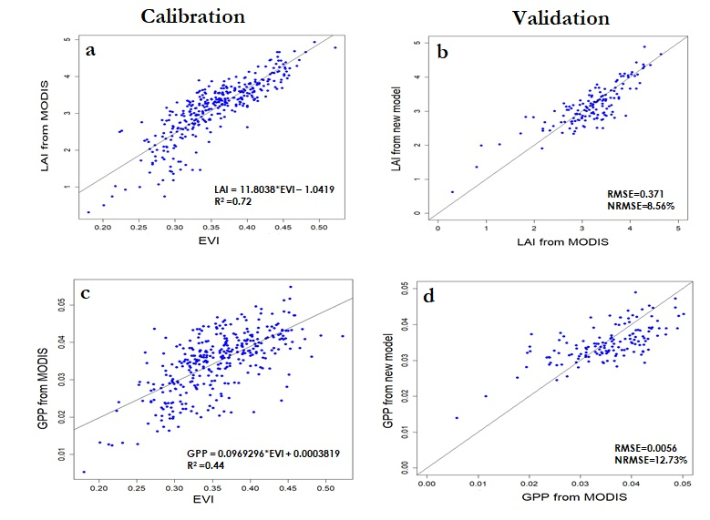

**Appendix D**. Cluster-wise variability in MODIS derived GPP, LAI, and CHL from 17 years (2000-2016) of data analyzed for Bhitarkanika Wildlife Sanctuary.

|  |  |  |  |  |  |  |  |
| --- | --- | --- | --- | --- | --- | --- | --- |
| Parameters  Statistics | Different Clusters within Bhitarkanika Wildlife Sanctuary | | | | | | |
| **GPP (gC/m2)** | **C1** | **C2** | **C3** | **C4** | **C5** | **C6** | **C7** |
| Min | 4.80 | 3.20 | 8.60 | 9.40 | 9.80 | 12.20 | 5.20 |
| Max | 51.90 | 45.30 | 52.40 | 54.50 | 51.90 | 50.00 | 49.10 |
| Mean | 32.00 | 31.30 | 35.70 | 38.20 | 35.70 | 33.60 | 32.00 |
| SD | 7.40 | 6.10 | 5.80 | 6.20 | 5.90 | 5.40 | 5.70 |
| **LAI (index)** | | | | | | | |
| Min | 0.23 | 0.25 | 0.36 | 0.06 | 0.11 | 0.40 | 0.88 |
| Max | 5.23 | 4.42 | 5.29 | 5.55 | 5.24 | 5.01 | 4.90 |
| Mean | 2.82 | 2.74 | 3.28 | 3.56 | 3.26 | 3.00 | 2.82 |
| SD | 0.89 | 0.71 | 0.68 | 0.75 | 0.72 | 0.66 | 0.68 |
| **CHL (µg/cm2)** | | | | | | | |
| Min | 8.99 | 4.39 | 9.86 | 13.53 | 15.93 | 18.42 | 14.88 |
| Max | 55.94 | 55.97 | 58.11 | 59.88 | 59.17 | 55.30 | 53.32 |
| Mean | 34.49 | 32.56 | 42.92 | 44.49 | 41.96 | 38.40 | 36.71 |
| SD | 7.98 | 11.81 | 8.99 | 9.56 | 9.33 | 8.88 | 9.09 |

**Appendix E.**Percentage of variability explained by different combination of physical-meteorological variables with mangrove biophysical parameters (GPP, LAI, CHL). Coefficient of determination (R2) are presented in table for each possible combination which were found significant (p<0.05). The relationship used in forecasting is marked in bold.

|  |  |  |  |  |  |  |
| --- | --- | --- | --- | --- | --- | --- |
| Meteorological & Physical Variables | GPP | Correlation Coefficients (GPP) | LAI | Correlatio  Coefficients  (LAI) | CHL | Correlation Coefficients  (CHL) |
| Temperature | 0.35 | - (negative) | 0.35 | - (negative) | 0.59 | - (negative) |
| Temperature (1-month lag) | N/A | N/A | N/A | N/A | 0.19 | - (negative) |
| Runoff (1-month lag) | 0.24 | +(positive) | 0.24 | +(positive) | 0.19 | +(positive) |
| Precipitation (1-month lag) | 0.25 | +(positive) | 0.25 | +(positive) | 0.18 | +(positive) |
| Temperature & Precipitation (1-month lag) | 0.54 | - (Temp),  + (Prec.) | **0.54** | **- (Temp),**  **+ (Prec.)** | 0.71 | - (Temp),  + (Prec.) |
| Temperature, Precipitation, Months | **0.73** | **- (Temp),**  **+ (Prec.)** | N/A | N/A | **0.85** | **- (Temp),**  **- (Prec.)** |
| Temperature, Runoff, Months | N/A | N/A | 0.73 | - (Temp),  - (Runoff) | N/A | N/A |
| CO2 | 0.04 | -(negative) | 0.04 | -(negative) | N/A | N/A |
| CO2, Precipitation (1-month lag) | 0.28 | -(CO2),  +(Prec.) | N/A | N/A | N/A | N/A |
| Precipitation, Months | 0.69 | -(Prec.) | N/A | N/A | N/A | N/A |
| Precipitation, Months, CO2 | N/A | N/A | 0.69 |  | N/A | N/A |
| Temperature, Precipitation, CO2, Months | 0.72 | -(Temp),  -(Prec.),  -(CO2) | N/A | N/A | N/A | N/A |

**Appendix F.** Land cover classification using Landsat 5-TM (1995, 2004), Landsat 8-OLI (2017), and Sentinel 1 (C-SAR) Radar data (2017). Radar data derived classification showed highest accuracy compared to other results.

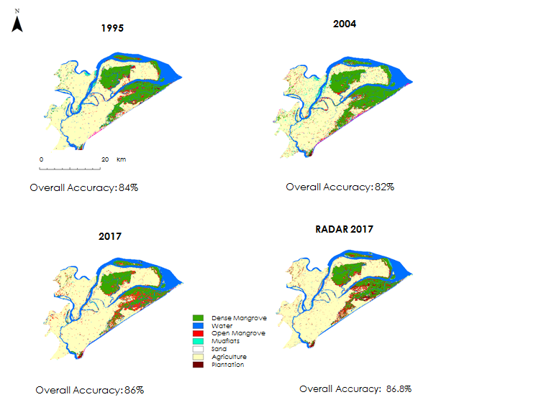

**Appendix G.** Google earth derived different land cover types for accuracy assessment.

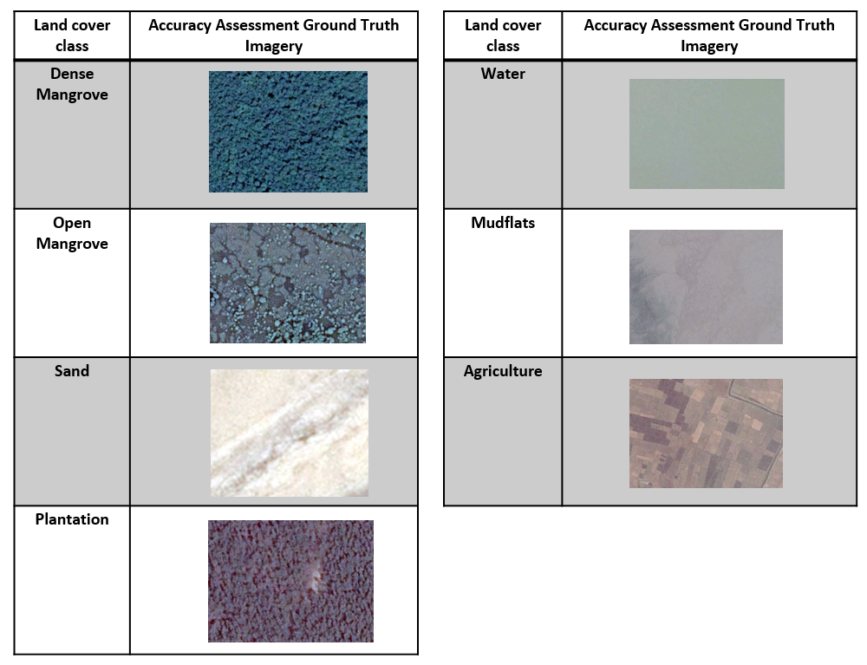

**Appendix H.** Accuracy assessment for 1995 Landsat 5-TM classified map.

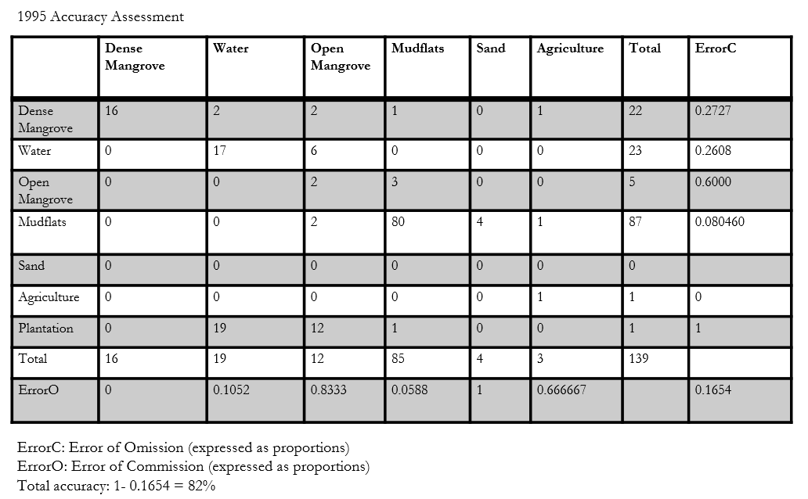

**Appendix I.** Accuracy assessment for 2004 Landsat 5-TM classified map.

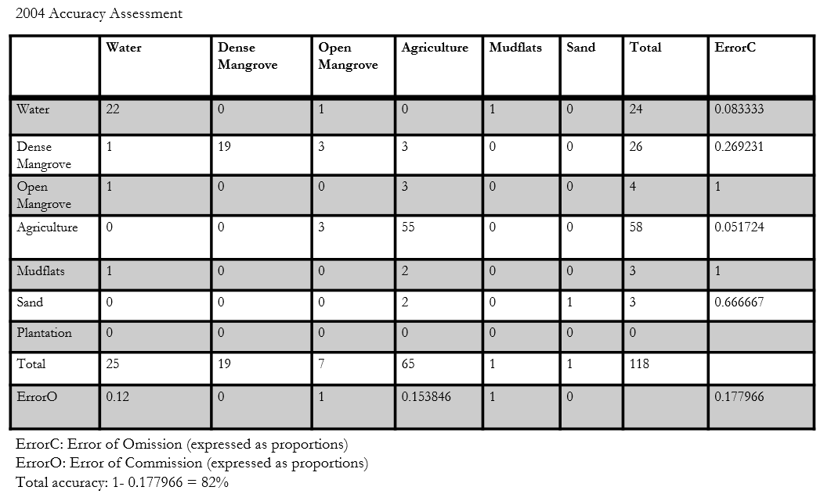

**Appendix J**. Accuracy assessment for 2017 Landsat 8-OLI classified map.

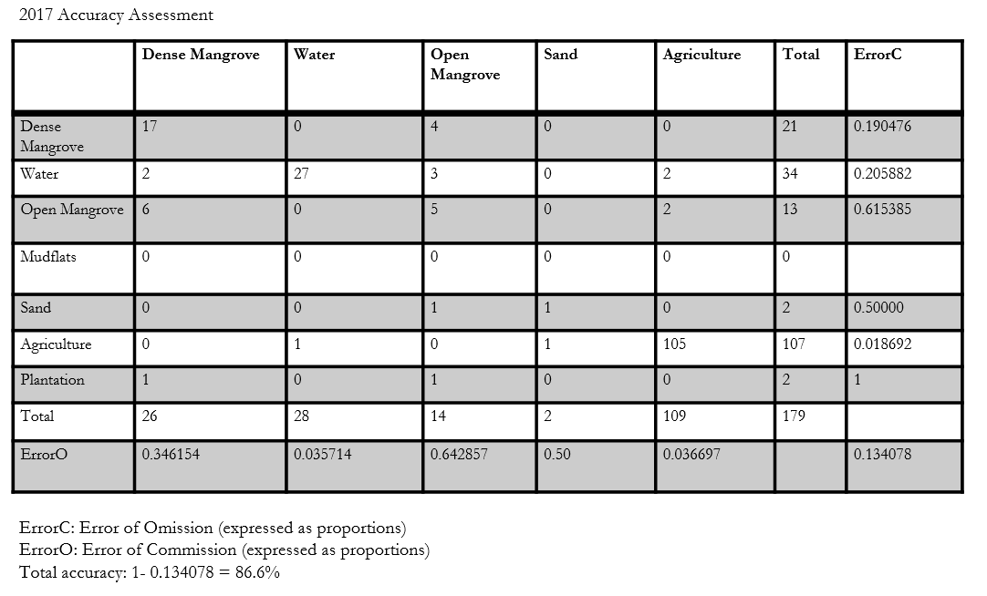

**Appendix K.** Comparison between hard prediction, soft prediction, and 2017 classified map.

