Belize & Honduras Water Resources II

Developing a Google Earth Engine Dashboard for Assessing Coastal Water Quality in the Belize and Honduras Barrier Reefs to Identify Adequate Waste Control and Inform Coastal Resource Monitoring and Management

**Technical Report**

November 21, 2019

Hayley Pippin (Project Lead)

Arbyn Olarte

Roxana Pilot

Vanessa Valenti

Dr. Christine Lee, NASA Jet Propulsion Laboratory, California Institute of Technology (Science Advisor)

Dr. Juan Torres-Perez, Bay Area Environmental Research Institute, NASA Ames Research Center (Science Advisor)

Dr. Emil Cherrington, University of Alabama in Huntsville, NASA SERVIR (Science Advisor)

Dr. Deepak Mishra, University of Georgia (Science Advisor)

Benjamin Page, University of Minnesota, Water Resources Center (Science Advisor)

Previous Contributors:

Charlie Devine

Alana Higgins

Alice Lin

Sophia Skoglund

# 1. Abstract

The Mesoamerican reef is a biodiverse ecosystem that stretches more than 600 miles along four Central American coasts and is the longest barrier reef in the western hemisphere. The national economies of Belize and Honduras heavily depend on the commercial, recreational, and subsistence fishing services the reef supplies. While the reef has benefitted from sustainable collaborative management practices, ecosystem stress resulting from the destruction of coastal habitats and overfishing threatens its diverse communities and ecological functions. The Belize & Honduras Water Resources II team at NASA Jet Propulsion Laboratory partnered with the Secretaría de Recursos Naturales y Ambiente (Honduras), the Comisión Centroamericana de Ambiente y Desarrollo, the Coastal Zone Management Authority and Institute (Belize), and the Wildlife Conservation Society to continue developing the Optical Reef and Coastal Area Assessment (ORCAA) tool in Google Earth Engine to monitor and evaluate water quality changes and advise coastal management decisions. The tool incorporates Earth observations from Landsat 8 Operational Land Imager (OLI), Sentinel-2 Multispectral Instrument (MSI), and Aqua and Terra Moderate Resolution Imaging Spectroradiometer (MODIS). ORCAA outputs maps and time series graphs of turbidity, sea surface temperature, chlorophyll-a, and colored dissolved organic matter concentrations from 2013 onward, which our partners will use to identify reef degradation, pass coastal resource regulations, and establish protected zones along the reef. These maps will better enable our partners to address declining water quality conditions through policy initiatives and maintain the environmental and economic health of the region.

**Keywords**

turbidity, CDOM, chlorophyll-a, Landsat 8 OLI, Sentinel-2 MSI, MODIS, remote sensing, Google Earth Engine

# 2. Introduction

* 1. ***Background Information***

The Mesoamerican Reef is the second largest barrier reef system in the world (*Figure 1*)*.* It hosts a wide range of ecosystems including coral reefs, seagrass beds, and mangrove forests, which serve as habitats for a diverse collection of wildlife (McField et al., 2008). This biodiversity is fragile; the reef protects six endangered and five critically endangered marine species (McField, Kramer, Gomez, & McPherson, 2007). On land, the reef provides support to coastal communities through its economic and cultural value. Millions of tourists visit the Belize and Honduras Barrier Reef Systems every year, spending an average of $999 per individual each visit. This revenue stream accounts for over one quarter of both the Belizean and Honduran economies and must be preserved to sustain both countries’ economic health (Chollett et al., 2017; International Sustainability Unit, United Nations Environment Programme, & International Coral Reef Initiative, 2018; World Resources Institute, 2008).

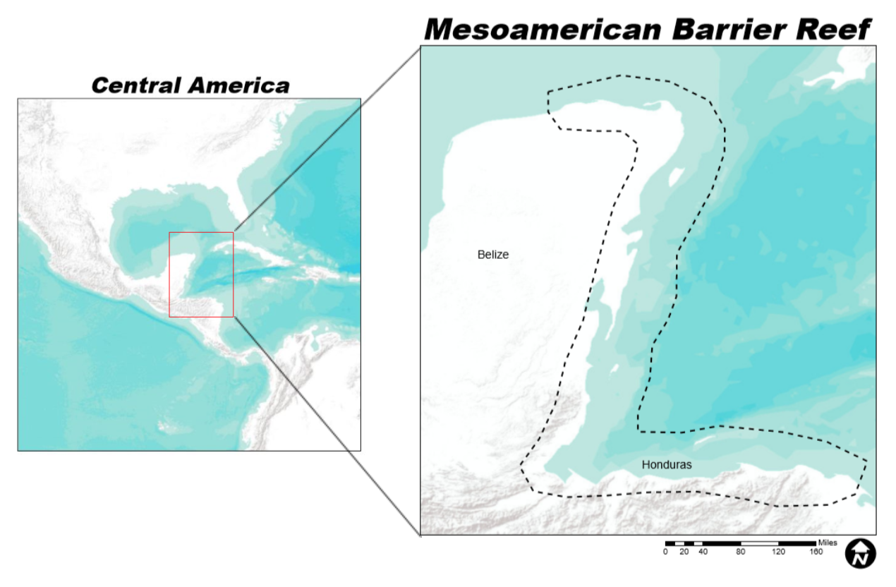

*Figure 1.* The study area focuses on the Belize and Honduras Barrier Reefs that help make up the larger Mesoamerican Barrier Reef System (Basemap: ESRI “Terrain” Layer Package, ArcMap).

Natural and human disturbances, however, threaten this critical and complex environment. While the governments of Belize, Honduras, Guatemala, and Mexico signed the Tulum Declaration in 1997 with the objective of implementing sustainable practices to conserve the reef, their efforts have not staved off its serious decline (Chollett et al., 2017). The landfall of Hurricane Mitch in 1998 caused an increased deposit of land-based pollution and runoff into coastal waters, extending from the Honduras coastline to the reefs of Belize and Mexico (Sheng et al., 2007). ‘No-take zones,’ regions that prohibit fishing and other human activities, are too small relative to coral bleaching events and the broad scale of anthropogenic disturbance. Agencies must carry out more extensive monitoring and protective management to preserve the coral reefs (Bellwood, Hughes, Folke, & Nyström, 2004).

*In situ* monitoring of reef systems proves to be costly and time consuming. Alternatively, remote sensing allows researchers to assess water quality and reef health efficiently and comprehensively. Previous studies have effectively evaluated coastal water quality by detecting chlorophyll-a and colored dissolved organic matter (CDOM) concentrations from Sentinel-2 imagery using two-band ratio models (Gholizadeh, Melesse, & Reddi, 2016; Chen et al., 2017; Toming et al., 2016). Although satellite data shows promise for assessing reef health, imagery for shallow areas along the coast must undergo complex processing to correct for changes in bottom surface cover, water depth, and attenuation (Mishra, Narumalani, Rundquist, Lawson, & Perk, 2007). Cross-satellite analysis could improve the detection accuracy of water quality parameters (Page, Kumar, & Mishra, 2018).

A prior study conducted by the Summer 2019 NASA DEVELOP team created a Google Earth Engine (GEE) dashboard that examined some of these water quality parameters in the Belize Barrier Reef from January 2013 to May 2019. They compared the results with those from ACOLITE, a robust atmospheric correction model for aquatic applications (Vanhellemont, 2019). Data from Landsat 8 Operational Land Imager (OLI), Sentinel-2 Multispectral Instrument (MSI), and Aqua and Terra Moderate Resolution Imaging Spectroradiometer (MODIS) were processed in GEE and cross-referenced with ACOLITE values. The team found high agreement between GEE turbidity outputs and ACOLITE turbidity outputs, but low agreement between GEE and ACOLITE chlorophyll-a and Normalized Difference Chlorophyll Index (NDCI) estimates.

The team this term expanded the scope of the project by incorporating coastal Honduran rivers and the Honduras Barrier Reef System into the tool and lengthening the study period to November 2019. We used Sentinel-2 MSI Level-1C imagery atmospherically corrected with the Modified Atmospheric correction for Inland waters (MAIN) algorithm to derive more accurate chlorophyll-a and NDCI values (Page, Olmanson, & Mishra, 2019). Finally, we included CDOM as a water quality parameter in the tool and improved the tool’s Graphical User Interface (GUI) to facilitate its use for the partners.

* 1. ***Project Partners & Objectives***

Coastal Zone Management Authority & Institute (CZMAI) is a quasi-governmental organization responsible for conducting research in the coastal areas of Belize. It focuses primarily on collaborative management to effectively deal with rapid economic growth in Belize through ecologically-sustainable development. The Secretaría de Recursos Naturales y Ambiente (MiAmbiente Honduras) allied with the Comisión Centroamericana de Ambiente y Desarrollo (CCAD) to promote regional cooperation between the government, non-governmental organizations, private sector industry, and the community to ensure the sustainable use of natural resources for improving the quality of life in Honduras. The partners will utilize the Optical Reef and Coastal Area Assessment (ORCAA) tool in GEE to monitor, track, and evaluate coastal degradation with the purpose of balancing both economic and developmental needs with conservation efforts. The use of remotely sensed data will enable the partners to observe water quality conditions, such as turbidity, chlorophyll-a, and CDOM, and address environmental challenges through collaborative decision-making processes.

# 3. Methodology

***3.1 Data Acquisition***

We accessed optical imagery from the GEE data catalog for Landsat 8 OLI Level 2 Surface Reflectance (SR) Tier 1, Sentinel-2 MSI Level 1C Top Of Atmosphere (TOA) Reflectance, and Aqua and Terra MODIS Level 3 Standard Mapped Image products from January 2013 to November 2019 (*Table 1*). We removed the Sentinel-2 MSI Level 2A SR (S2_SR) data that was previously used to produce turbidity, NDCI, and chlorophyll-a values due to its poor performance generating NDCI and chlorophyll-a. Instead, we derived turbidity, NDCI, chlorophyll-a, and CDOM levels from atmospherically-corrected Sentinel-2 MSI Level 1C TOA data. Turbidity was also estimated using Landsat 8 OLI SR Tier 1 data.

Additionally, we included precipitation datasets from the National Oceanic and Atmospheric Administration (NOAA) Precipitation Estimation from Remotely Sensed Information Using Artificial Neural Networks-Climate Data Record (PERSIANN-CDR) in the ORCAA tool. The team clipped the GEE imagery to the coastal areas of Belize and Honduras to capture the Mesoamerican Barrier Reef study area. We installed new boundary visualizations in the tool using shapefiles of Honduras Marine Protected Areas (MPAs), economic exclusive zones, and a number of Honduran rivers and lagoons per the request of our end users (*Table 2*). The shapefiles were acquired via public geodatabases.

Table 1

*Remote sensing data acquired in GEE used for ORCAA parameter inputs*

|  |  |  |  |
| --- | --- | --- | --- |
| **Sensor** | **Processing Level** | **Data Provider** | **GEE ImageCollection ID** |
| Landsat 8 OLI | Level 2 SR Tier 1 | United States Geological Survey (USGS) Earth Explorer | LANDSAT/LC08/C01/T1_SR |
| Sentinel-2 MSI | Level 1C TOA Reflectance | European Space Agency (ESA Open Access Hub) | COPERNICUS/S2 |
| Aqua MODIS | Level 3 Standard Mapped Image | NASA Ocean Biology Processing Group (OBPG) | NASA/OCEANDATA/MODIS-Aqua/L3SMI |
| Terra MODIS | Level 3 Standard Mapped Image | NASA OBPG | NASA/OCEANDATA/MODIS-Terra/L3SMI |
| NOAA PERSIANN-CDR | Level 4 | NOAA | NOAA/PERSIANN-CDR |

Table 2

*Ancillary datasets incorporated into ORCAA for visualization and reef health analysis*

|  |  |  |
| --- | --- | --- |
| **Data Type** | **Specifications** | **Source** |
| Honduras MPAs | Shapefile | World Database on Protected Areas, protectedplanet.net |
| Exclusive Economic Zones | Shapefile | VLIMAR Gazetteer and the VLIZ Maritime Boundaries Geodatabase |
| Honduras Rivers and Lagoons | Shapefile | University of North Carolina, Chapel Hill, Department of Geological Sciences, gaia.geosci.unc.edu/rivers |

***3.2 Data Processing***

The products in our study were processed and corrected in GEE. Our team chose not to conduct atmospheric corrections within ORCAA for Landsat 8 and MODIS imagery due to the availability of pre-corrected surface reflectance products in GEE for these datasets. In the previous term of this project, the team found that the pre-corrected S2_SR products cannot feasibly be used to derive water quality metrics for NDCI and chlorophyll-a due to the large variance between their results and ACOLITE-generated results. The team attributed this variance to the lack of a coastal-calibrated atmospheric correction algorithm applied to the S2_SR data in GEE.

Accordingly, our team included an atmospheric correction algorithm for Sentinel-2 MSI Level 1C data in our GEE tool, as opposed to utilizing GEE S2_SR data. We incorporated the MAIN script developed in GEE to atmospherically correct Sentinel-2 MSI Level-1C data into the ORCAA tool. This script has the advantage of being specifically geared towards coastal ocean color rather than terrestrial analysis. Our tool also applies a land mask using the shortwave infrared (SWIR) band based on a threshold value set by ACOLITE to isolate ocean water pixels. We utilized a shapefile to mask mainland areas in order to remove inland water bodies. Lastly, we used a variation of the built-in GEE simpleCloudScore algorithm to mask out clouds and cloud shadows.

*3.2.1 Turbidity*

Our turbidity function was initially developed by Sol Kim, Rafael Grillo Avila, and Xiaowei Wang at University of California, Berkeley under the guidance of Dr. Christine Lee at the Jet Propulsion Laboratory. Using the algorithm developed by Nechad, Ruddick, & Neukermans (2009), they created turbidity raster layers. Nechad’s algorithm uses reflectance in the red and near-infrared (NIR) range of the electromagnetic spectrum and measures optical properties in comparison to the suspension of Formazin, a uniformly-sized, insoluble, light scattering polymer that serves as the calibration standard for turbidity quantification (Rice, 1976). Therefore, turbidity is measured here in Formazin Nephelometric Units (FNUs) (*Equation 1*).

$\text{Turbidity (FNU) = }\frac{{\text{A}}_{\text{T}}\text{*}{\text{ρ}}_{\text{W}}}{\text{1-}{\text{ρ}}_{\text{W}}\text{/C}}$ (1)

${\text{A}}_{\text{T}}$ and *C* are wavelength-dependent calibration coefficients, while ${\text{ρ}}_{\text{W}}$ is the water leaving reflectance at a given wavelength. *C* is calibrated using standard Inherent Optical Property data, i.e. the scattering and absorbing properties of a medium, while nonlinear least-square regression analysis is used to find ${\text{A}}_{\text{T}}$ (Nechad et al., 2009). We applied this function to Landsat 8 OLI and Sentinel-2 MSI imagery in our GEE tool to derive turbidity values in the coastal reef areas.

*3.2.2. Chlorophyll-a*

To measure chlorophyll-a, our tool derived NDCI from Sentinel-2 MSI imagery according to the Mishra and Mishra equation (2012) (*Equation 2*). The advantage of the NDCI metric is that it allows for chlorophyll-a concentrations in more remote and isolated areas to be calculated without *in situ* data. Landsat 8 OLI imagery was not utilized to extract NDCI values because of the lack of a band centered around 708 nm. Here, Rrs(708) represents the remote sensing reflectance at 708 nm and Rrs(665) represents the remote sensing reflectance at 665 nm. Normalizing their difference helps remove uncertainties in the reflectance estimation.

$\text{NDCI =} \frac{{\text{R}}_{\text{rs}}\text{(708) -} {\text{R}}_{\text{rs}}\text{(665)}}{{\text{R}}_{\text{rs}}\text{(708) +} {\text{R}}_{\text{rs}}\text{(665)}}$ (2)

Chlorophyll-a concentration was then derived from NDCI using Mishra and Mishra (2012) (*Equation 3*):

$\text{[Chlorophyll-a] = }{\text{a}}_{\text{o}}\text{+(}{\text{a}}_{\text{1}}\text{*NDCI)+(}{\text{a}}_{\text{2}}\text{*NDC}{\text{I}}^{\text{2}}\text{)}$ (3)

where ${\text{a}}_{\text{o}}$, ${\text{a}}_{\text{1}}$, and ${\text{a}}_{\text{2}}$ are calibrated model coefficients with values 14.036, 86.115, and 194.325, respectively. These coefficients are determined based on the solar angle, geographic location, and the nonlinear pattern of observed chlorophyll-a data and NDCI values (Mishra & Mishra, 2012). We incorporated the NDCI and chlorophyll-a functions into our GEE tool and applied them to Sentinel-2 MSI Level 1C imagery to generate chlorophyll-a concentrations in the study area.

*3.2.3 CDOM*

We utilized Sentinel-2 MSI Level-1C data in order to derive CDOM values. Our GEE tool uses MAIN to atmospherically correct the Level-1C data, as opposed to utilizing the readily available pre-corrected Level 2 data found in GEE. While it would require less calibration and validation steps to utilize the Level 2 data in GEE, our team found that it was not feasible to use Level 2 imagery for deriving water quality parameters when we examined the quantity of available S2_SR products and the range of values that these products derived. This discrepancy likely results from differing atmospheric correction algorithms that are geared towards terrestrial rather than ocean color correction. Our GEE tool atmospherically corrected the Level-1C data for ocean color analysis, and then calculated CDOM according to Equation 4 developed by Chen et al. (2017).

${\text{a}}_{\text{CDOM}}\text{(440) = 22.283}{\text{e}}^{\text{-1.724X}}\text{, X} \text{=} \frac{{\text{R}}_{\text{rs}}\text{(B3)}}{{\text{R}}_{\text{rs}}\text{(B5)}}$ (4)

The function is such that $\text{y} \text{=} \text{a}{\text{e}}^{\text{bx}}$, where Xrepresents the remote sensing reflectance of the band ratio. We chose to use the band ratio model from Chen et al. (2017) for its applicability to coastal waters and the tendency for band ratio models to remove certain negative impacts of atmospheric correction errors. Additionally, including wavelengths greater than 600 nm in the model, such as the B5 band, significantly improves CDOM retrieval accuracy, especially for complex waters like the coast. The B5 band mitigates the effects of particulate matter and derives CDOM with higher accuracy in complex waters (Chen et al., 2017). Our GEE tool applies this function to Sentinel-2 MSI Level-1C imagery corrected by MAIN to derive CDOM levels in the coastal waters of Belize and Honduras.

*3.2.4 Sea Surface Temperature and Precipitation*

In addition to deriving turbidity, chlorophyll-a, and CDOM, our tool also outputs sea surface temperature (SST) and precipitation metrics. The tool merges GEE processed Aqua and Terra MODIS datasets to produce SST values for a given scene. Our tool also utilizes the NOAA PERSIANN-CDR precipitation dataset in GEE to obtain precipitation values over the Belize and Honduras coast to compare against coastal water quality metrics.

***3.3 Data Analysis***

*3.3.1 Land Feature Comparison*

We carried out a land feature comparison to identify the differences in water quality trends between two distinct landforms: an urban river mouth and a coastal island. Because Belize and Honduras house approximately 65 protected areas, we selected four case study areas to conduct our analysis on. The team chose one of each land type from the marine protected areas in each country to analyze for changes in turbidity, chlorophyll-a, and CDOM (*Figure 2*). In Belize, we selected a river mouth that spills into Chetumal Bay near the city of Chetumal, a municipality in northern Belize. For the island, we picked Lighthouse Reef. This area is known to be one of the healthiest and well-preserved reef systems in the Belize Barrier Reef (Robinson, 2000). In Honduras, we chose Punta Izopo as the urban river mouth because of the rapid agricultural expansion the area has faced in the last ten years. Finally, the team selected the UNESCO World Heritage Site Cayos Cochinos as the island feature for comparison in Honduras.

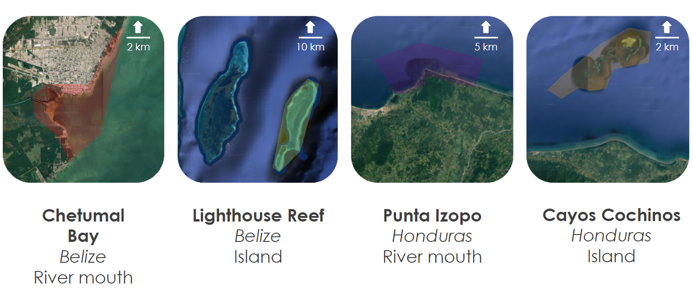

*Figure 2.* The land feature case study areas selected for water quality comparison in Belize and Honduras.

*3.3.2 Time Series Analysis*

To aid in the applicability of our tool for coastal management, we incorporated a time series analysis function for users to easily generate graphs and charts of water quality metrics over time. The user inputs a date range for analysis, selects an area for inspection, and can choose to output a line graph for turbidity, chlorophyll-a concentration, CDOM, SST, or precipitation. These charts can be calculated as daily or monthly averages, and every water pixel within the selected region of interest is utilized to calculate the averages. End users in Belize and Honduras can use this function and its products to observe patterns of water quality over time and make informed decisions about coastal management and conservation. The team utilized this function in our land feature comparison in both Belize and Honduras to examine the differing parameter trends over time for each set of contrasting landforms.

*3.3.3 Statistical Analysis*

The team created boxplots from the values generated in the time series charts to gauge the contrasting distributions of values between the islands and river mouths for each of the parameters. The data from the time series charts were converted into a CSV file in GEE and loaded into R, a software environment for statistical computing and graphics (R Project for Statistical Computing, n.d.). These plots both provided insight into the difference in water quality between the two land types and illustrated the quality of the data used in the analysis by determining and displaying outlying data points.

# 4. Results & Discussion

***4.1 Analysis of Results***

*4.1.1 Time Series Analysis*

For each of our parameters, we generated time series charts for both countries that displayed the derived water quality parameter levels of the two contrasting landforms from December 2017 through November 2019. While we did not find a significant difference between the levels surrounding the island reefs and the levels at the river mouth for any of the parameters in either country, we did find that the data picked up on a strong pattern of seasonal variability. We added light blue demarcations to the charts to signify the range of the typical wet season in Belize and Honduras. The team then examined the trends in water quality across the wet and dry seasons in each country for all of the parameters. Our temporal analysis indicated that the seasonal change from dry to wet universally increases turbidity and CDOM in coastal waters in both Belize and Honduras. This trend likely emerges from runoff, sediment, and other matter that increased rainfall carries into coastal waters during the wet season. Although data is more sparse in 2017 and 2018 than 2019, it is sufficient to indicate an annual pattern that coastal management can prepare for to minimize the increase in turbidity and CDOM that occurs during these months.

Figure A1 displays increases in turbidity levels leading up to and peaking during the wet season of May through November. Those levels decrease toward the end of the wet season and the start of the dry season, where both locations reach a minimum level around the months of January and February. The time series chart for CDOM suggests a similar effect, whereby each case study location in Belize and Honduras indicates rising CDOM levels leading up to and peaking in the months of the rainy season. CDOM decreases rapidly at the start of December in each location, with the lowest levels of CDOM found in January and February (*Figure A2*). The universal increase in CDOM in the wet season and repetition of this pattern for all three years demonstrates that yearly seasonal change gives rise to increases and decreases in water quality. Chlorophyll-a breaks this trend in Figure A3, exhibiting an inverse pattern to the one shown by turbidity and CDOM. Chlorophyll-a values appear to increase in the dry months and decrease in the wet months, highlighting that seasonality does indeed affect chlorophyll-a levels in coastal waters, but perhaps to the opposite effect of the other two parameters.

*4.1.2 Imagery Analysis*

The team wanted to inspect this notable seasonal difference visually, so we generated images in ORCAA at each case study location during both the dry season and wet season to show how seasonality affects water quality spatially throughout Belize and Honduras. Imagery from January 12th, 2019 and May 12th, 2019 was compared to highlight the effect of the wet season on water quality, as those two dates displayed the minimum and maximum parameter values, respectively, for each location. January 10th, 2018 and March 1st, 2018 were chosen for Chetumal Bay due to cloud cover and image availability in this area. Our turbidity and CDOM imagery showed plumes emanating from the river mouths and demonstrated the general seasonal increase observed in the time series charts, spatially visualizing the effect of wet seasonality on water quality in Belize and Honduras (*Figure B1, Figure B2*).

Our chlorophyll-a imagery, however, does not display as stark a difference. In Figure B3, there are no discernable or clear differences between the image sets of the dry and wet seasons at almost any of the locations. The team had to mask out a disproportionately high number of outlying pixel values in the chlorophyll-a dataset; consequently, the images may look indistinguishable due to the reduced amount of data available for comparison. The January 12th, 2019 image of Lighthouse Reef exhibits elevated levels of chlorophyll-a compared to the May 12th, 2019 image, an unlikely observation in such a pristine reef. ORCAA may have confused seagrass populations for the chlorophyll pigment, since high chlorophyll-a levels typically denote large algal populations that mark unhealthy reefs.

*4.1.3 Statistical Analysis*

We conducted statistical analysis by producing boxplots for each wet and dry season date. Each boxplot visualizes the distribution of pixel values in each location for turbidity, CDOM, and chlorophyll-a. Every pixel within each location is represented to produce a complete distribution of water quality levels for both a wet season and dry season date.

Figure C1clearly displays the effect of seasonality on turbidity in Belize and Honduras, with the majority of the pixel values in the dry season falling below the range of values in the wet season at each location. These contrasting distributions statistically support our assertion that the wet season brings higher levels of turbidity to coastal waters. Figure C2continues to underline this pattern with CDOM, showing a significant hike in CDOM levels in the wet season boxplots compared to the much lower dry seasonal distributions. Chetumal Bay, Lighthouse Reef, and Cayos Cochinos all show remarkable increases in CDOM during the wet season, while Punta Izopo shows a less severe distinction between the two periods. While the average between the two Punta Izopo boxplots does not radically change, the interquartile range for the May 12th box plot shrinks dramatically, indicating a concentration of elevated CDOM values during the wet season. The chlorophyll-a box plots illustrate the trend observed in the imagery; each area maintains relatively consistent distributions and averages between the seasons (*Figure C3*). The quality of the limited available data produces an inconclusive effect of seasonality on chlorophyll-a.

***4.2 Optical Reef and Coastal Area Assessment Tool***

The Optical Reef and Coastal Area Assessment tool (ORCAA) was first developed by the previous team for the analysis of turbidity and chlorophyll-a on the Belize coastline. This term, we added the CDOM parameter and expanded the tool to include the Honduras coastline. Furthermore, we increased the accessibility of the tool by allowing users to switch the interface language between English and Spanish. The team also let users choose which parameter layers they wished to display on the map by including a checkbox selection panel and added a feature for users to export the imagery they generated to their Google Drive for further analysis.

ORCAA was created in JavaScript to run on the GEE platform. By using a GUI, the tool allows users to easily generate time series charts and export imagery of turbidity levels, chlorophyll-a and CDOM concentrations, and sea surface temperature to their Google Drive. The user inputs a particular date range into the GUI and selects a study area for analysis by choosing any of the MPAs in Belize or Honduras, uploading their own asset, or drawing a geometry on the map. ORCAA then creates a filtered, masked, and corrected image collection for each of the water quality parameters customized to the user’s temporal and spatial inputs. The tool can conduct analysis from 2013 to the current date, though the parameters derived from Sentinel-2 data will only display values from 2017 onward. As more imagery becomes available in GEE, it will automatically become available in ORCAA as well.

***4.3 Sources of Error***

None of the values generated with the ORCAA tool were validated with *in situ* data. Thus, while we can make conclusions about the relative patterns observed in the parameter trends, we cannot make the same conclusions about the absolute values of these parameter levels. Furthermore, this lack of ground truth data prevented us from calibrating our water quality algorithms for our specific study area. The previous team found that the derived chlorophyll-a concentrations were heavily uncertain, and we were unable to improve the accuracy of these results by calibrating the chlorophyll-a coefficients for Belize and Honduras without *in situ* data. Our CDOM algorithm was designed for northern lakeshore waters rather than the shallow, tropical coasts of the Mesoamerican Barrier Reef. Without *in situ* data, the suitability of the coefficients determined by the Chen et.al. (2007) study that we used for this particular region is unknown.

Additionally, cloud-masking and atmospheric correction of remote sensing data remains a source of error, as different algorithms and study areas produce different results and outputs. Currently, there are no advanced cloud-masking algorithms available for Sentinel-2 data in GEE. The MAIN algorithm uses a Normalized Difference Water Index threshold that discerns between water and cloud pixels, but this fails to mask every cloud and cloud shadow, thereby reducing data quality. In terms of atmospheric correction, the MAIN algorithm is calibrated for inland and coastal waters, but it is not tailored specifically for Belize and Honduras coastal environments. Reflection from the sea floor, benthic reflectance, can also distort satellite-derived water quality parameters. Because ORCAA does not include an algorithm to correct for benthic reflectance, some of our generated values may be skewed by this factor.

***4.4 Future Work***

This project requires *in situ* data to ground truth the accuracy of coastal water quality assessments; fieldwork to collect chlorophyll-a and CDOM is the best method to validate results. Data collection is underway in Belize. However, the results were not ready by the conclusion of the DEVELOP term. The data should be used to calibrate the coefficients of the Mishra algorithm to generate more accurate estimations of chlorophyll-a concentrations and enable the other parameters to be validated against non-ACOLITE data.

Moreover, incorporating a cloud-masking algorithm for Sentinel-2 and a benthic reflectance correction algorithm would improve the imagery and the accuracy of parameter values generated by ORCAA. The developer of the Landsat 8 cloud-masking algorithm we incorporated into the tool also has a Sentinel-2 cloud-masking algorithm that could be explored. Further, active research is being conducted to correct for sea floor reflectance in shallow waters to improve the accuracy of satellite data and metrics. Including an algorithm generated using this research that corrects for benthic reflectance in the ORCAA tool would improve its outputs.

Our partners expressed interest in developing a *Sargassum* parameter for the tool. *Sargassum* is a genus of macroalgae commonly found in shallow waters and coral reefs. These types of macroalgae blooms are an increasing threat to coral reef health (McField, et.al., 2019). The ability to track the spread of macroalgae in the Belize and Honduras Barrier Reefs would be an invaluable tool for lawmakers and coastal land managers in their evaluation of current marine protection policies.

# 5. Conclusions

The Belize Water Resources Team II successfully completed the Optical Reef and Coastal Area Assessment (ORCAA) tool, a GEE application that generates maps and time series charts of turbidity, chlorophyll-a, CDOM, SST, and precipitation. Using remote sensing methods, the team identified seasonal trends in water quality parameters that showcase the need for an extensive reef health monitoring system. While variations between wet and dry seasons are common for turbidity, chlorophyll-a, and CDOM, the amount of variation is atypical. The relative level of increase most likely results from anthropogenic disturbances to the surrounding environment. The outputs of our tool showcase massive plumes along the northern Honduras coastline which are exclusively occurring near palm oil plantations in national forests. The huge concentrations of CDOM exiting the mouths of rivers, in particular, indicate the presence of clear cutting and deforestation related to palm oil. In the past ten years, palm oil production in Honduras doubled. Three major protected forests are undergoing illegal forestation. The ORCAA tool has the ability to alert land use managers and lawmakers to these problematic trends without the burden of observing them from the ground. *In situ* datasets, however, are required to calibrate the Mishra algorithm coefficients to produce more accurate estimations of chlorophyll-a concentrations and validate other parameters against non-ACOLITE data.

ORCAA will be an effective asset for both our Belize and Honduras partners. The spatiotemporal coverage of satellites enables broadscale monitoring of coastal waters across time. Because the tool is hosted on the GEE cloud computing platform, it allows for efficient and effective processing of large amounts of data. Furthermore, ORCAA provides contemporaneous analysis, since it automatically includes the most recently available Earth observations in GEE in its analysis dataset. Since users may upload their own assets, our tool may be shared to aid in the monitoring of Central and South American coastal waters or in other coral reefs across the globe.

These ORCAA features will allow our Belize and Honduran partners to effectively pinpoint regions at risk of water quality degradation which will result in better-informed decisions concerning environmental policies and regulations. Handing off the tool, its tutorial, and the other deliverables to our partners serves to build their capacity in remote sensing. Globally, advances in cloud computing and increased availability of remote sensing data will allow for more effective environmental management in the future.

# 6. Acknowledgments

The Belize & Honduras Water Resources II team would like to thank our partners from MiAmbiente Honduras, CZMAI, WCS, and CCAD for their feedback and involvement in the development of the ORCAA tool. Thank you to our Science Advisors who provided us with guidance and support: Dr. Christine Lee of NASA Jet Propulsion Laboratory, Dr. Juan Torres-Perez of NASA Ames Research Center, Dr. Emil Cherrington of NASA SERVIR, Dr. Deepak Mishra of the University of Georgia, and Benjamin Page from the University of Minnesota, Twin Cities. Thanks also to Sean McCartney of NASA Goddard Space Flight Center, our NASA DEVELOP Fellow Cecil Byles, and our node advisor Benjamin Holt of NASA Jet Propulsion Laboratory for their project coordination efforts and general assistance throughout the term.

This material contains Moderate-resolution Imaging Spectroradiometer (MODIS) chlorophyll-a and sea surface temperature data, processed by the NASA Goddard Space Flight Center, Ocean Ecology Laboratory, Ocean Biology Processing Group.

This material contains modified Copernicus Sentinel data (2016-2019), processed by ESA.

Any opinions, findings, and conclusions or recommendations expressed in this material are those of the author(s) and do not necessarily reflect the views of the National Aeronautics and Space Administration.

This material is based upon work supported by NASA through contract NNL16AA05C.

# 

# 7. Glossary

**CCAD** – Comisión Centroamericana de Ambiente y Desarrollo

**CDOM** – Colored Dissolved Organic Matter, a measure of the amount of dissolved carbon-based compounds in water

**Chlorophyll-a** – Photosynthetic pigment found in chloroplasts of plants, algae, and plankton

**CZMAI** – Coastal Zone Management Authority and Institute

**Earth observations** – Satellites and sensors that collect information about the Earth’s physical, chemical, and biological systems over space and time

**Ecosystem functions** – Ecological processes that benefit humans

**GEE** – Google Earth Engine

**GUI** – Graphical User Interface

**MAIN** – Modified Atmospheric correction for INland waters

**MiAmbiente Honduras** – Secretaría de Recursos Naturales y Ambiente

**MODIS** – MODerate resolution Imaging Spectroradiometer

**MPA** – Marine Protected Area

**MSI** – Multispectral Instrument

**NDCI** – Normalized Difference Chlorophyll Index

**OLI** – Operation Land Imager

**ORCAA** – Optical Reef and Coastal Area Assessment

**SST** – Sea Surface Temperature

**Turbidity** – A measure of water clarity in which high turbidity corresponds to a large presence of suspended matter

**WCS** – Wildlife Conservation Society

# 8. References

Bellwood, D.R., Hughes, T.P., Folke, C., & Nyström, M. (2004). Confronting the coral reef crisis. *Nature, 429,* 827-833. Retrieved from https://www.nature.com/articles/nature02691

Chen, J., Chu, W., Tian, Y.Q., Yu, Q., Zheng, Y., & Huang, L. (2017). Remote estimation of colored dissolved organic matter and chlorophyll-a in Lake Huron using Sentinel-2 measurements. *Journal of Applied Remote Sensing, 11*(3). doi:10.1117/1.JRS.11.036007

Chollett, I., Garavelli, L., Holstein, D., Cherubin, L., Fulton, S., & Box, S. (2017). A case for redefining the boundaries of the Mesoamerican Reef ecoregion. *Coral Reefs*. doi:10.1007/s00338-017-1595-4

Copernicus Sentinel-2 MSI Level 1C Data. [2013-2019]. Retrieved from Google Earth Engine, processed by ESA.

Gholizadeh, M.H., Melesse, A.M., & Reddi, L. (2016). A comprehensive review on water quality parameters estimation using remote sensing techniques. *Sensors, 16*(8)*,* 1298. doi:10.3390/s16081298

Hoffmann, T.C. (2002). Coral reef health and effects of socio-economic factors in Fiji and Cook Islands. *Marine Pollution Bulletin, 44,* 1281-1293. Retrieved from https://www.blueearthconsultants.com/pdf/MPBTCH-pubs2.pdf

International Sustainability Unit, United Nations Environment Programme, & International Coral Reef Initiative. (2018). *The coral reef economy: The business case for investment in the protection, preservation, and enhancement of coral reef health.* Retrieved from https://wedocs.unep.org/bitstream/handle/20.500.11822/26694/Coral_Reef_Economy.pdf?sequence=1&isAllowed=y

McField, M., Bood, N., Fonesca, A., Arrivillaga, A., Rinos, A.F., & Viruel, R.M.L. (2008). Status of the Mesoamerican Reef after the 2005 coral bleaching event. In *The status of Carribbean coral reefs after bleaching and hurricanes in 2005* (5)*.* Retrieved from https://www.coris.noaa.gov/activities/caribbean_rpt/SCRBH2005_05.pdf

McField, M., Kramer, P., Alvarez-Filip, L., Drysdale, I., Flores, M.R., Petersen, A.G., & Soto, M. (2019). 2018

Mesoamerican reef report card. *Healthy Reefs Initiative.* doi:10.13140/RG.2.2.19679.36005.

McField, M., Kramer, P., Gorrez, M., & McPherson, M. (2007). *Healthy reefs for healthy people: A guide to indicators of reef health and social well-being in the Mesoamerican reef region.* Retrieved from https://www.researchgate.net/publication/228627962_Healthy_Reefs_for_Healthy_People_A_Guide_to_Indicators_of_Reef_Health_and_Social_Well-being_in_the_Mesoamerican_Reef_Region

Mishra, S., & Mishra, D. R. (2012). Normalized difference chlorophyll index: A novel model for remote estimation of chlorophyll-a concentration in turbid productive waters. *Remote Sensing of Environment*, *117*, 394-406.<https://doi.org/10.1016/j.rse.2011.10.016>

Mishra, D.R., Narumalani, S., Rundquist, D., Lawson, M., & Perk, R. (2007). Enhancing the detection and classification of coral reef and associated benthic habitats: A hyperspectral remote sensing approach. *Journal of Geophysical Research, 112,* C08014. doi:10.1029/2006JC003892

NASA Goddard Space Flight Center, Ocean Ecology Laboratory, Ocean Biology Processing Group. (2018). Moderate-resolution Imaging Spectroradiometer (MODIS) Aqua Chlorophyll Data [Dataset]. NASA OB.DAAC, Greenbelt, MD, USA. https://doi.org/10.5067/AQUA/MODIS/L3M/CHL/2018

NASA Goddard Space Flight Center, Ocean Ecology Laboratory, Ocean Biology Processing Group. (2014). Moderate-resolution Imaging Spectroradiometer (MODIS) Aqua SST Data [Dataset]. NASA OB.DAAC, Greenbelt, MD, USA. https://doi.org/10.5067/AQUA/MODIS/L3M/SST/2014

NASA Goddard Space Flight Center, Ocean Ecology Laboratory, Ocean Biology Processing Group. (2018). Moderate-resolution Imaging Spectroradiometer (MODIS) Terra Chlorophyll Data [Dataset]. NASA OB.DAAC, Greenbelt, MD, USA. https://doi.org/10.5067/TERRA/MODIS/L3M/CHL/2018

NASA Goddard Space Flight Center, Ocean Ecology Laboratory, Ocean Biology Processing Group. (2014). Moderate-resolution Imaging Spectroradiometer (MODIS) Terra SST Data [Dataset]. NASA OB.DAAC, Greenbelt, MD, USA. https://doi.org/10.5067/TERRA/MODIS/L3M/SST/2014

Nechad, B., Ruddick, K. G., & Neukermans, G. (2009). Calibration and validation of a generic multisensor algorithm for mapping of turbidity in coastal waters. In C. R. Bostater Jr., S. P. Mertikas, X. Neyt, & M. Velez-Reyes (Eds.), *SPIE Remote Sensing of the Ocean, Sea Ice, and Large Water Regions 2009* (Proceedings Volume 7473, 74730H). https://doi.org/10.1117/12.830700

Page, B., Kumar, A., & Mishra, D.R. (2018). A novel cross-satellite based assessment of the spatio-temporal development of a cyanobacterial harmful algal bloom. *International Journal of Applied Earth Observation and Geoinformation, 66,* 69-81. https://doi.org/10.1016/j.jag.2017.11.003

Page, B.P., Olmanson, L.G., & Mishra, D.R. (2019). A harmonized image processing workflow using Sentinel-2/MSI and Landsat-8/OLI for mapping water clarity in optically variable lake systems. *Remote Sensing of Environment, 231,* 111284. https://doi.org/10.1016/j.rse.2019.111284

R Project for Statistical Computing (n.d.). What is R?. Retrieved November 20, 2019 from https://www.r-project.org/about.html

Rice, E.W. (1976). The preparation of formazin standards for nephelometry. *Analytica Chimica Acta, 87*(1), 251-253. https://doi.org/10.1016/S0003-2670(01)83146-9

Robinson, J.S. (2000). Lighthouse reef atoll: Conservation and protection project [PDF file]. Retrieved from https://pdf.usaid.gov/pdf_docs/Pnack154.pdf

Sheng, J., Wang, L., Andréfouët, S., Hu, C., Hatcher, B., Muller-Karger, F., … Yang, B. (2007). Upper ocean response of the Mesoamerican Barrier Reef System to Hurricane Mitch and coastal freshwater inputs: A study using Sea-viewing Wide Field-of-view Sensor (SeaWiFS) ocean color data and a nested-grid ocean circulation model. *Journal of Geophysical Research, 112*, C07016. doi:10.1029/2006JC003900

Sorooshian, S., Hsu, K., Braithwaite, D. K., Ashouri, H., & NOAA CDR Program. (2014). NOAA Climate Data Record (CDR) of Precipitation Estimation from Remotely Sensed Information using Artificial Neural Networks (PERSIANN-CDR), Version 1 Revision 1 [Dataset]. NOAA National Centers for Environmental Information. https://doi.org/10.7289/V51V5BWQ

Toming, K., Kutser, T., Laas, A., Sepp, M., Paavel, B., & Nõges, T. (2016). First experiences in mapping lake water quality parameters with Sentinel-2 MSI imagery. *Remote Sensing, 8*(8), 640. https://doi.org/10.3390/rs8080640

US Geological Survey Earth Resources Observation and Science Center. (2014). Landsat 8 OLI/TIRS Level-2 Data Products - Surface Reflectance [Dataset]. https://doi.org/10.5066/F78S4MZJ

Vanhellemont, Q. (2019). Adaptation of the dark spectrum fitting atmospheric correction for aquatic applications of the Landsat and Sentinel-2 archives. *Remote Sensing of Environment, 225,* 175-192. https://doi.org/10.1016/j.rse.2019.03.010

World Resources Institute. (2008). *Belize’s coastal capital: The economic contribution of Belize’s coral reefs and mangroves.* Retrieved from https://pdf.wri.org/coastal_capital_belize_brochure.pdf

# 9. Appendices

**Appendix A.**

Figure A1

*Turbidity values in Belize and Honduras river mouths and islands, derived from Sentinel-2 Level 1-C MAIN corrected data.*

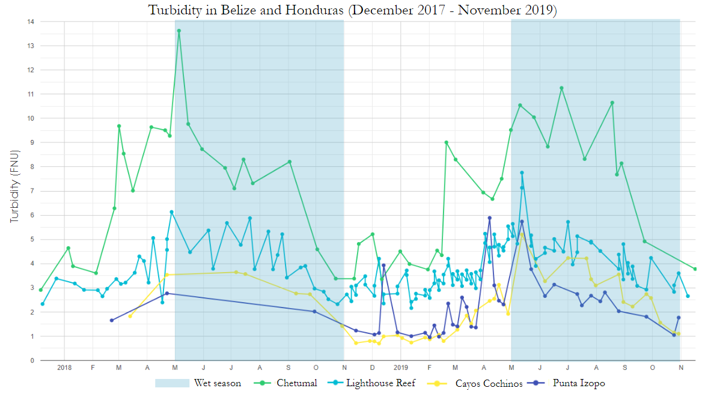

Figure A2

*CDOM values in Belize and Honduras river mouths and islands, derived from Sentinel-2 Level 1-C MAIN corrected data.*

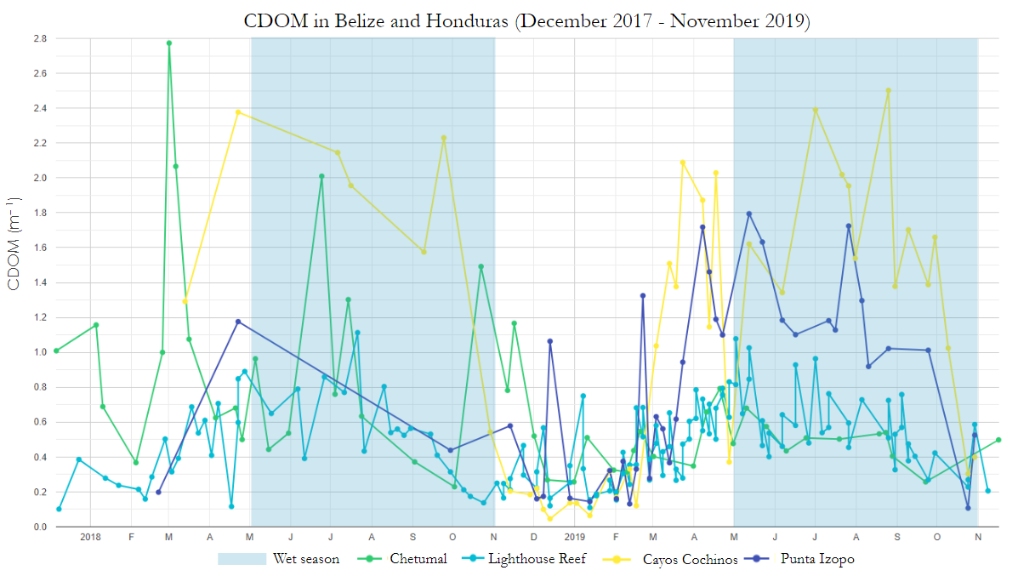

Figure A3

*Chlorophyll-a concentration in Belize and Honduras river mouths and islands derived from Sentinel-2 Level 1-C MAIN corrected data.*

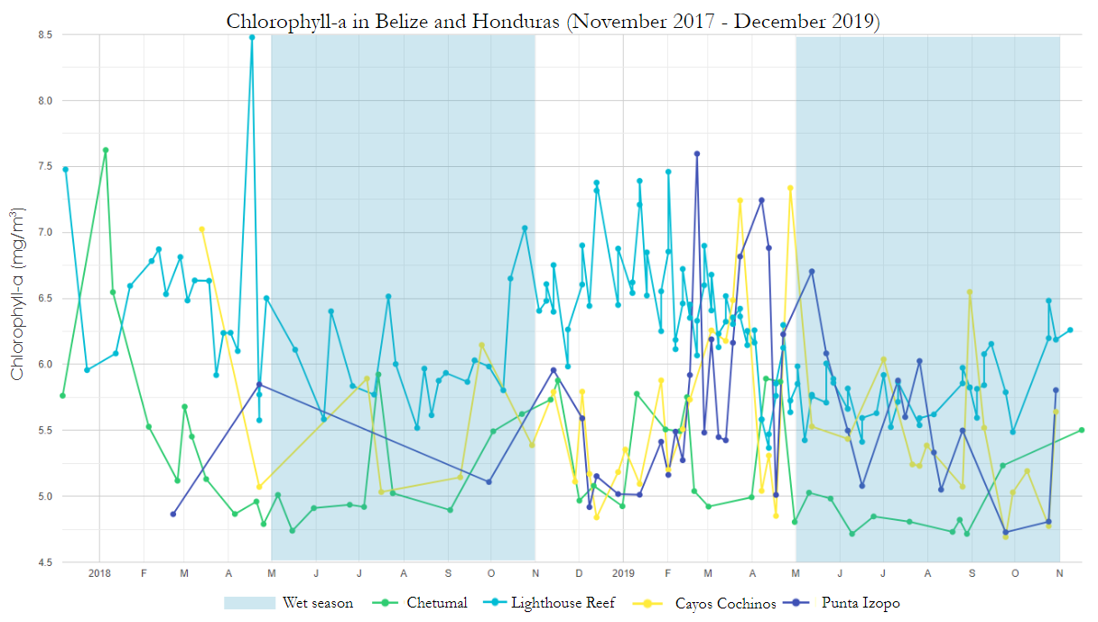

**Appendix B.**

Figure B1

*ORCAA generated imagery of turbidity in Belize and Honduras river mouths and islands during the dry and wet season.*

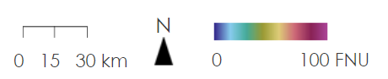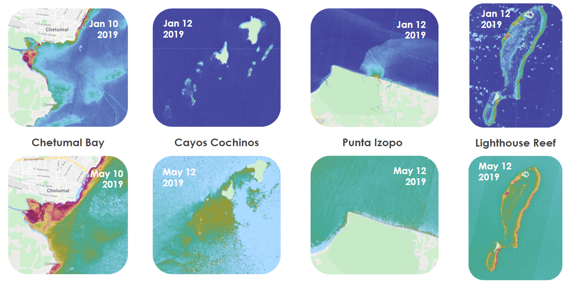

Figure B2

*Imagery generated in ORCAA of CDOM in Belize and Honduras river mouths and islands during the dry and wet season.*

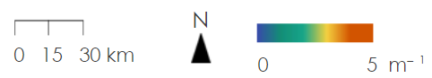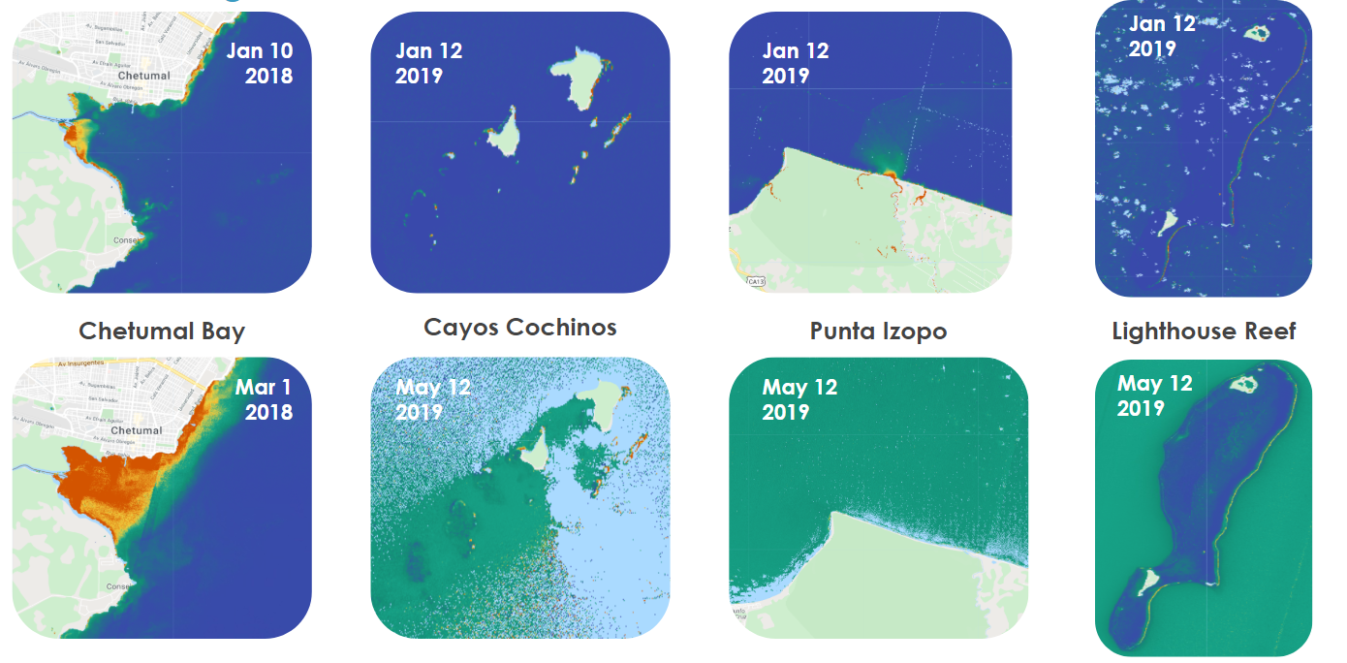

Figure B3

*ORCAA imagery of Belize and Honduras river mouths and islands chlorophyll-a concentrations.*

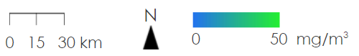

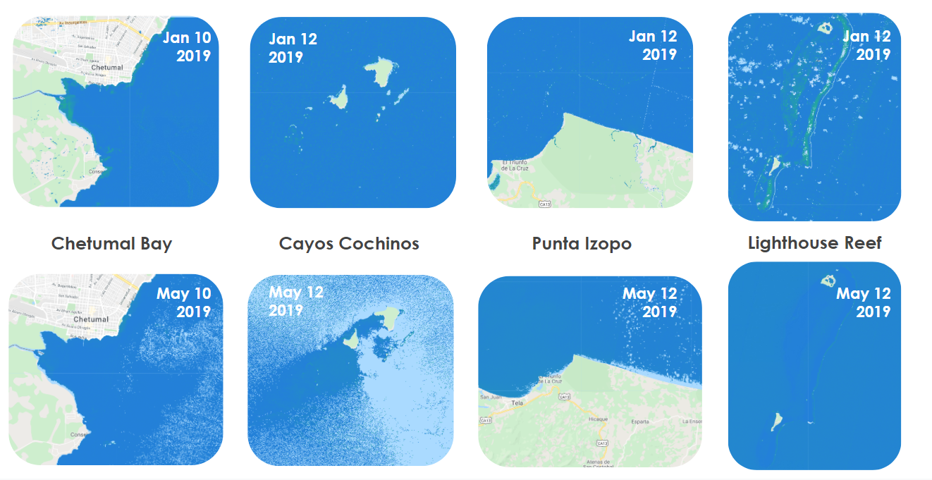

**Appendix C.**

Figure C1

*Boxplot representation of pixel values in Belize and Honduras river mouths and islands for Sentinel-2 Level 1-C derived turbidity before and after the wet season.*

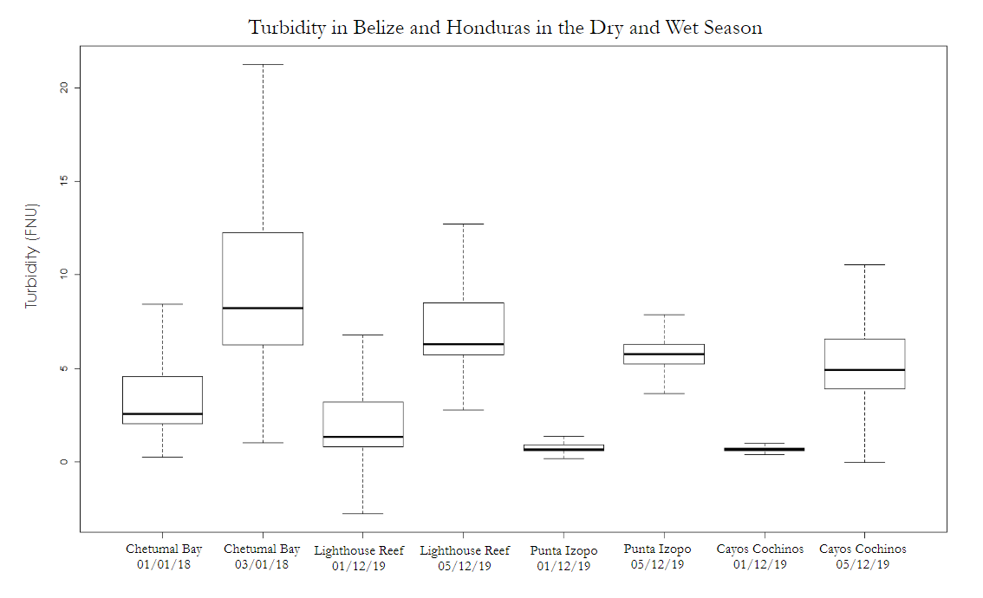

Figure C2

*Distribution of CDOM pixel values for Belize and Honduras case study location’s derived from Sentinel-2 Level 1-C data.*

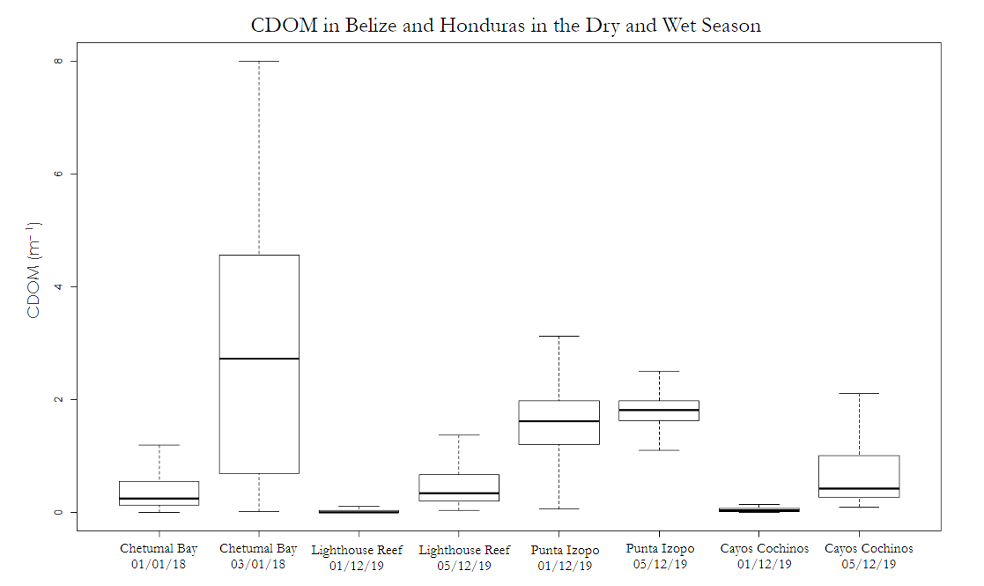

Figure C3

*Boxplot visualization of chlorophyll-a concentration pixel values in Belize and Honduras river mouths and islands.*

