**NASA DEVELOP National Program**



Langley Research Center

*Summer 2014*

Great Plains Agriculture

Utilizing NASA Earth Observations to Monitor Drought Conditions for Enhancement of Rangeland Management

 **Technical Report**

Final Draft – August 7, 2014

Joseph Novak, Old Dominion University (Project Lead)

Ashley Garner, Old Dominion University

Shani Kent Hall, Old Dominion University

John Lingenfelser, Virginia Polytechnic Institute and State University

Megan Laurine, United States Air Force

Dr. Kenton Ross (NASA DEVELOP National Science Advisor)

**I. Abstract**

Drought in the Great Plains region of the United States is a matter of constant concern for ranchers and land managers in the region. Every rancher must respond to drought conditions and approximately 80% of them actively prepare for drought. Since 2011, the Great Plains region has been severely impacted by drought, including $400 million in losses in the state of Oklahoma (“Great Plains,” Fall Term 2013). Drought conditions may make rangelands more susceptible to diseases, insect pests, weed invasions, and overgrazing (Hunt *et al*). The United States Department of Agriculture (USDA) and other organizations use sources, such as the Vegetation Drought Response Index (VegDRI) and the US Drought Monitor, to track drought severity.  However, both of these sources have limitations since they measure drought on a large spatial scale. The Drought Severity Index created in previous terms of DEVELOP utilized data collected by the Moderate Resolution Imaging Spectroradiometer (MODIS) sensor aboard the Aqua and Terra satellites and NOAA Multisensor Precipitation Estimator (MPE). The purpose of our project was to validate the Drought Severity Index (DSI) developed in a previous DEVELOP term against  VegDRI, Palmer Drought Severity Index (PDSI) and *in situ* data collected from several meteorological locations across the Great Plains region along with providing a sustainable methodology for calculating the DSI. The methods and results produced by this project were presented to the USDA Agricultural Research Service Rangeland Resources Research Unit (ARS RRRU) for future use throughout the region. The benefit of this project is a drought index that can be produced at a low cost while maintaining high spatial resolution.

**Keywords**

Great Plains, Drought, Remote Sensing, VegDRI, Drought Severity Index, Palmer Drought Severity Index, MODIS

**II. Introduction**

**Background Information**

The USDA Great Plains region is covered in grasslands expanding from the Rocky Mountains to the Missouri River and from the Rio Grande to Canada. It is an area greater than 1800 miles from north to south and more than 500 miles east to west (Wishart, 2011). It includes the states of Montana, North Dakota, South Dakota, Wyoming, Colorado, New Mexico, Texas, Nebraska, Oklahoma, and Kansas. The demand for water resources for human consumption and agriculture has greatly increased due to the growth in population throughout the Great Plains over the past few years (Basara, 2013). Due to this heightened demand on water resources, drought has become a more persistent problem in the Great Plains.

The Great Plains is a major source of agricultural production nationally and globally. Approximately 70% of the Great Plains is used for agriculture and dry-land farming, with half of the agriculture being rangelands and pastures (EPA, 2013). Rangelands provide many other ecosystem services including wildlife habitat, watershed protection, recreation, and preservation of genetic diversity (University of Nebraska-Lincoln, 2011). Rangelands also promote ecotourism, wildlife viewing opportunities, and provide profit from hunting fees which all provide income for ranchers (University of Nebraska-Lincoln, 2011).  Agriculture, specifically, is most severely impacted by drought because soil moisture is not capable of meeting the demands farmers and ranchers need. As drought continues, the effects on agriculture and rangelands worsen and water resources become limited (Basara, 2013). Approximately 80% of ranchers preemptively prepare for drought conditions because drought causes rangelands to be more susceptible to diseases, insect pests, weed invasions, overgrazing (EPA, 2013).

Drought is a constant concern for ranchers and rangeland managers in the Great Plains. Drought consists of a lower than normal amount of precipitation over a long period of time that does not meet the needs for human consumption and the environment (Renza, 2010). It is also characterized by persistence, intensity, and spatial extent (Renza, 2010). The Great Plains has been severely impacted by drought since 2011, with major losses in crops and livestock. Between 2011 and 2012, drought led to over $240m in crop loss, $157m in livestock loss, $27m in wildlife property loss, and $2m in municipalities loss in Oklahoma alone (“Oklahoma Water Resources Center”). Many people rely on the agricultural products from the Great Plains; therefore, drought not only affects those who live in the Great Plains, but other regions around the world (Basara, 2013).

Drought has negatively impacted the food production and economy of the Great Plains. Nearly fifty percent of beef cattle in the United States are raised in the Great Plains (Wishart, 2011). The average American consumes around 276 pounds of meat per year, reinforcing how much people rely on agricultural production (Haney, 2012). Due to severe drought conditions, ranchers have had to reduce their herd sizes, causing the price of beef to increase.

Currently, the USDA provides up-to-date range management research for land managers and ranchers to utilize in drought management decisions. The USDA also assists the counties that experience extreme drought with the funding necessary to mitigate loss. The USDA monitors rangeland health using the US Drought Monitor drought indicator and also has access to VegDRI, PDSI and the DSI. The USDA’s Natural Resources Conservation Service unit offers programs to farmers and ranchers to help provide them financial assistance and prepare them for drought conditions. These programs help with conservation practices that address certain environmental concerns such as improving soil, water, animal and other related resources on agricultural lands (Natural Resources Conservation Service).

**Project Objectives**

This project was built on the work completed by two previous DEVELOP teams in the summer and fall of 2013. The summer 2013 team derived the DSI, based on the work of Rhee *et al* in 2010, which is calculated by combining land surface temperature, precipitation and a vegetation index. They applied it to several counties in Wyoming and Colorado as a pilot study area. The fall 2013 team expanded the area to include most of the Great Plains to see if the methodology would work on a larger area.

This term, the team continued with the USDA Great Plains region with the intent of validating the DSI.  The validation was completed by running a correlation between the DSI with other drought indices currently in use, such as VegDRI and PDSI. A correlation was also run between all 3 indices and *in situ* soil moisture data collected from several USDA meteorological locations throughout the Great Plains region.  A sustainable methodology for calculating the DSI for future applications was also provided to the USDA.

**Study Area**

The study area for this project includes the entire USDA Great Plains Region in the United States, to include the states of Montana, North Dakota, South Dakota, Wyoming, Colorado, New Mexico, Texas, Nebraska, Oklahoma, and Kansas.

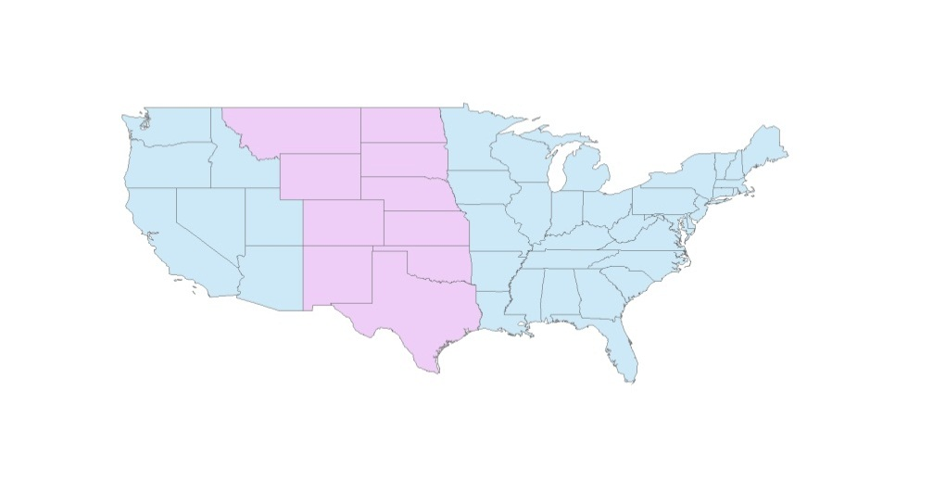

Figure 1. A map of the Great Plains region of the United States

**Study Period**

The data for the calculation of the Land Surface Temperature (Aqua, MODIS) and the surface reflectance data to calculate the Normalized Difference Vegetation Index (Terra, MODIS) were both collected from five specific days throughout the spring and summer months of 2011, 2012 and 2013. The days chosen for study, April 1st, May 15th, June 15th, August 1st and September 15th, were selected by the Project Partner, Dr. Justin Derner because of their importance to ranchers in the Great Plains area. For instance, April 1st is a key date for decision making regionally, May 15th is the start of the grazing season, June 15th marks the start of the warm season grasses, and August 1st is the usual date of peak crop standing. September 15th was added as a study date to give representation of the growth of the cool-season grasses in the early fall. It is important to note that both Land Surface Temperature (LST) and surface reflectance data are 8 day averages so the actual days chosen don’t necessarily fall on the previously discussed days but are as close as we could get. The dates used were March 30th, May 17th, June 18th, July 28th and September 14th. The daily precipitation data from the Multi-Sensor Precipitation Estimator (MPE) were collected from October of 2010 through December of 2013.

**National Application Addressed**

This project addressed the NASA Applied Science’s national application area of agriculture due to the heavy use of rangelands for livestock production. The Agriculture Program promotes innovation in public and private sector organizations to apply NASA satellite data, model products, and scientific findings in agricultural management and policy activities (“Application & Capacity Building”). The program specifically promotes activities associated with the production and availability of food products. This project relates directly to food production and availability because severe drought hinders food production, and negatively impacts food price and availability throughout the nation and in other parts of the world.

**Project Partners**

The partner for this project was research leader and rangeland scientist, Dr. Justin Derner from the United States Department of Agriculture (USDA) Agriculture Research Service (ARS) Rangeland Resources Research Unit (RRRU). The USDA currently utilizes multiple indices to monitor drought to help land managers, ranchers and farmers prepare for the potential effects of an extreme drought season. The DSI provides a higher spatial resolution than PDSI that can be used for rangeland management, which could reduce the amount of money being spent by the USDA for drought relief.

**III. Methodology**

The methods for producing the scaled Normalized Difference Vegetation Index (NDVI), the scaled LST and the scaled precipitation data layers have been described in greater detail in the previous tech papers from the summer 2013 term and the fall 2013 term. For more information regarding this part of the methodology, please refer to the previous tech papers.

**NASA Earth Observation System Data**

The LST consists of Aqua satellite data from the MODIS sensor. The MYD11A2 product is Level 3 data. Of the available bands, only Band 1 was extracted which has a spatial resolution of 1000 m.

The NDVI uses data collected by the MODIS sensor onboard the Terra satellite. The MOD09A1 data was also Level 3 data. Both Bands 1 (visible red light) & 2 (near infrared) were extracted and both have spatial resolutions of 500 m. Temporal resolution of the DSI is limited because both the MOD09A1 and MYD11A2 data sets are best estimates based on averages over a period of 8 days to help eliminate data gaps due to cloud cover.

**Data Acquisition**

Both land surface temperature and surface reflectance data were downloaded from USGS’s Earth Explorer website. In addition to the multiple NASA Earth Observations that were utilized during the process of creating the DSI, several other data sets were used throughout the project. MPE data from NOAA was collected from October of 2010 to September of 2013.The high-resolution MPE data provides an excellent source of information on the primary driver of drought, precipitation, on a 4-km grid (McRoberts, 2012). PDSI data was downloaded from NOAA’s west wide drought tracker site for the selected study period. The data is available on a monthly basis. The VegDRI data was retrieved from the earthexplorer.usgs.gov for the study period and has a temporal resolution of 7 days. The soil moisture data was collected from the Soil Climate Analysis Network (SCAN) and consists of hourly soil moisture readings at different depths. For our validation we averaged the hourly readings and focused on the 4 inch depth readings. The DSI model was compared to these 2 indices and *in situ* data.

**Data Processing**

A python script created in the Summer 2013 term for the Great Plains Agriculture project, was used in the processing of the precipitation data files. The precipitation data was interpolated to encompass our entire study area and then summed in 180 day intervals for each day in the study period. The LST and NDVI data from the MODIS sensors were uploaded and mosaicked in ArcGIS. The data was then projected to GCS North American 1983 and clipped to the USDA Great Plains region in Arcmap. The LST was scaled in a script by first extractingBand 1 and then using Equation 1 (see Appendix). The NDVI was also calculated in a script using Equation 2 (see Appendix). NIR in this equation stands for the near infrared reflectance Band 2, and red stands for the visible red light Band 1. The equation for the DSI was taken from the Rhee et. al 2010 paper, “Monitoring agricultural drought for arid and humid regions using multi-sensor remote sensing data”. The DSI model was produced by the combination of the LST, NDVI, and the MPE precipitation data. The process was completed using a Python script calculating Equation 3 (see Appendix).

The VegDRI and PDSI data was clipped to the USDA Great Plains region in Arcmap to prepare it for the comparison with the DSI. Coordinates were collected for selected SCAN sites throughout the Great Plains region and converted to decimal degrees. The soil moisture data was imported into an Excel file and converted to a shapefile in Arcmap. The SCAN shapefile was then converted to a raster in Python and compared to the DSI. GDAL was used to resize and resample each image to make sure that the DSI pixels aligned perfectly with the VegDRI, SCAN and PDSI pixels for the correlations.

**Data Analysis**

Once the DSI was calculated and all of the images were adjusted, a comparison was made against VegDRI, PDSI, and SCAN data. A script written in R allowed the comparison to be made using Spearman’s Rank Correlation. The Spearman’s Rank Correlation was chosen since each index had a different scale allowing for a better comparison of their indication of relative dryness and wetness, rather than simply evaluating their linear correlation of increasing or decreasing values. Each index’s raster was converted into a matrix of points for the five days in the study period. The index matrices were then compared using the correlation function with the output being a single correlation for each of the days. The results of these correlations can be seen in tables 1-5 (see Appendix).

**IV. Results & Discussion**

**Analysis of Results**

With the Spearman’s Rank Correlation we were able to understand how close the DSI model was to the other drought indices and how close each index was to the *in situ* SCAN data. The aforementioned correlations can be seen in figures 2 and 3 respectively (see next page). The DSI is most highly correlated to the PDSI. This correlation is a result of the PDSI and the DSI having similar input variables of precipitation and land surface temperature. The input variables of VegDRI include the traditional drought indicators combined with additional satellite-based metrics. VegDRI accounts for precipitation by using a combination of standardized precipitation index (SPI) values and PDSI computations (McRoberts, 2012). The additional input variables skewed the results making the correlation with DSI weaker than the correlation PDSI had with DSI. The comparison of the three drought indices with the *in situ* SCAN data was done to compare the indices with data that wasn’t retrieved from a satellite. In Graph 2, it is evident that DSI had the highest correlation with the *in situ* SCAN data. This implies that the DSI is a better indicator of soil moisture at 4” of soil depth for the Great Plains than either of the other indices used in this comparison.

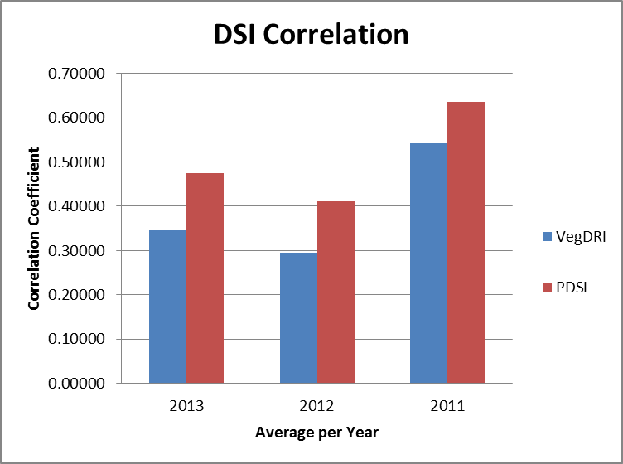

Figure 2. Graph showing the average yearly correlation coefficients between the DSI and other drought indices

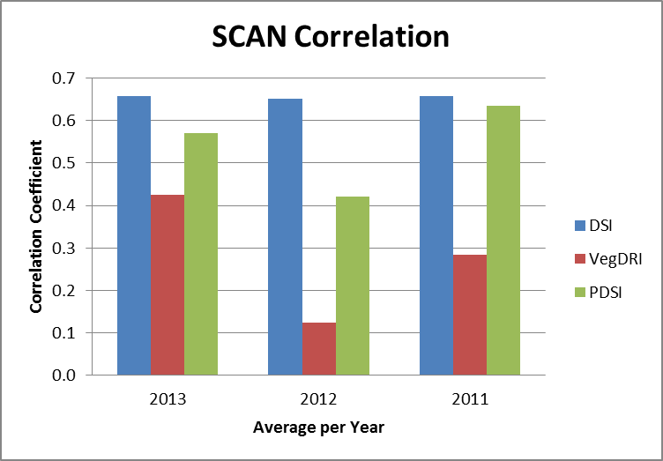

Figure 3. Graph showing the average yearly correlation coefficients between the in situ SCAN soil moisture data and the drought indices

**Errors & Uncertainty**:

In order to run the correlation in R, we had to resize our DSI image to perfectly match the other indices. To do this, the cell size and positioning of each cell were changed. Cubic resampling was performed to get values which, slightly alters the original values of the data. Each of the index rasters had to be clipped to the points in the SCAN shapefile. In one case VegDRI didn’t have data at the SCAN site, causing an error in the correlation. The LST data were an 8-day average temperature. This dataset was used in order to avoid cloud cover; however, there are still days missing data due to continuous cloud cover over the 8-day period. DSI values were not able to be calculated in areas with missing data.

**Future Work**

Future work could attempt to change the coefficients of the DSI equation to make it more comparable to the *in situ* data. Additional sources of *in situ* data could be added to the analysis. For example, *In situ* plant data would give a very accurate reading on plant health under the current weather conditions and would be an ideal standard to further validate the DSI to see how accurately it shows rangeland health statuses.

**V. Conclusions**

The results of the drought index comparison show that the DSI has a relatively low correlation with the VegDRI and a moderately higher correlation with the PDSI, once again due to similar input variables of precipitation and land surface temperature. The results of the SCAN data correlation show that the DSI has a stronger correlation with the *in situ* soil moisture than the other indices.

Along with providing a successfully validated DSI model to our end-users we also provided a sustainable methodology. Maps and images accurately represent the effect drought has had on the Great Plains region. With the help of a high resolution drought severity index model that has been validated, farmers and ranchers will now be able to appropriately prepare for extreme drought conditions in the future. Preparedness will help mitigate the effects that drought has on agriculture and can potentially reduce the amount of federal aid given to those affected by severe drought. The methodology and scripts provided to the end users will help them effectively monitor drought conditions.

**VI. Acknowledgments**

Dr. Kenton Ross (NASA DEVELOP National Science Advisor)

Dr. Justin Derner (USDA ARS RRRU)

Lance Watkins (Mississippi State University)

Jerrod Lessel (California State University, Fresno)

Alexandra Perillo (University of North Carolina, Wilmington)

Tiffani Orne (Liberty University)

Eric Dombrowsky (Christopher Newport University)

Emily Gotschalk (Christopher Newport University)

Nathan Owen (Mississippi State University)

Christopher Ferraro (Clark University)

Matthew Koslovsky (UT Health Science Center)

**VII. References**

"Application & Capacity Building: Application Areas." *NASA*. NASA, n.d. Web. 23 July 2014. <http://www.nasa.gov/applied-sciences/agriculture.html#.U8_NlPldU1I>.

J. Basara, J. Maybourn, C. Peirano, J. Tate, P. Brown, J. Hoey and B. Smith, "Drought and Associated Impacts in the Great Plains of the United States—A Review," *International Journal of Geosciences*, Vol. 4 No. 6B, 2013, pp. 72-81.

Environmental Protection Agency (EPA). ( 2013, June 21). Great Plains Impacts and Adaptations.   <http://www.epa.gov/climatechange/impacts-adaptation/greatplains.html#ref1>

Haney, Shaun. "How Much Meat Do We Eat?." Real Agriculture. Real Agriculture, 8 May 2012. Web. 22 July 2014. <http://www.realagriculture.com/2012/05/how-much-meat-do-we-eat/>.

Hunt, Jr., E. Raymond, James H. Everitt, Jerry C. Ritchie, M. Susan Moran, D. Terrance Booth, Gerald L. Anderson, Patrick E. Clark, and Mark S. Seyfried. "Applications and Research Using Remote Sensing for Rangeland Management." *Photogrammetric Engineering & Remote Sensing*: 675-693. Print.

"Natural Resources Conservation Service." Financial Assistance. United States Department of Agriculture, n.d. Web. 22 July 2014. <http://www.nrcs.usda.gov/wps/portal/nrcs/main/national/programs/financial/>.

McRoberts, D. Brent, and John Nielsen-Gammon. "The Use of a High-Resolution Standardized Precipitation Index for drought Monitoring and Assessment." *Journal of Applied Meteorology and Climatology* 51: 68-83. Print.

"Oklahoma Water Resources Center*." Drought losses in OK top $400 million for 2012* —. N.p., n.d. Web. 23 June 2014. <http://water.okstate.edu/news-events/news/acs/drought-losses-in-ok-top-400-million-for-2012/>.

Renza, Diego, Estibaliz Martinez, Agueda Arquero, and Javier Sanchez. "Drought Estimation Maps by Means of Multidate Landsat Fused Images." Remote Sensing for Science, Education, and Natural and Cultural Heritage: 2010, 775-782. Print.

University of Nebraska-Lincoln. (2011). Encyclopedia of the Great Plains: Range Management.                                                           <http://plainshumanities.unl.edu/encyclopedia/doc/egp.ag.055>

USDA Emergency Preparedness and Response. (2013, June 26). Disaster and Drought Assistance: Help for You. <http://www.usda.gov/wps/portal/usda/usdahome?navid=DISASTER_ASSISTANCE>

Wishart, David J.. "Encyclopedia of the Great Plains." *Encyclopedia of the Great Plains |*. University of Nebraska-Lincoln, 1 Jan. 2011. Web. 16 June 2014. <http://plainshumanities.unl.edu/encyclopedia/>

**VIII. Appendices**

Equation 1:    Scaled LST = (LSTmax – LST) / (LSTmax – LSTmin)

Equation 2: NDVI = (NIR - Red) / (NIR + Red)

Equation 3: DSI = (1/4) scaled LST + (1/2) scaled MPE + (1/4) scaled NDVI

|  |  |  |  |
| --- | --- | --- | --- |
| Table 1: DSI-VegDRI Correlation | | | |
| Date | **2013** | **2012** | **2011** |
| 1-Apr | 0.22233 | 0.30878 | 0.30957 |
| 15-May | 0.19555 | 0.23297 | 0.46641 |
| 15-Jun | 0.51525 | 0.32594 | 0.63913 |
| 1-Aug | 0.40609 | 0.23542 | 0.63384 |
| 15-Sep | 0.38644 | 0.37648 | 0.67429 |
| Average | 0.34513 | 0.29592 | 0.54465 |

|  |  |  |  |
| --- | --- | --- | --- |
| Table 2: DSI-PDSI Correlation | | | |
| Date | **2013** | **2012** | **2011** |
| 1-Apr | 0.28048 | 0.33203 | 0.62310 |
| 15-May | 0.35234 | 0.36049 | 0.58441 |
| 15-Jun | 0.64383 | 0.53007 | 0.66770 |
| 1-Aug | 0.61755 | 0.43999 | 0.64185 |
| 15-Sep | 0.48248 | 0.39313 | 0.65781 |
| Average | 0.47534 | 0.41114 | 0.63497 |

|  |  |  |  |
| --- | --- | --- | --- |
| Table 3: DSI-SCAN Correlation | | | |
| Date | **2013** | **2012** | **2011** |
| 1-Apr | 0.76398 | 0.83286 | 0.86222 |
| 15-May | 0.88123 | 0.58628 | 0.79474 |
| 15-Jun | 0.86917 | 0.85545 | 0.67928 |
| 1-Aug | 0.50376 | 0.65330 | 0.44551 |
| 15-Sep | 0.27218 | 0.33371 | 0.50720 |
| Average | 0.65806 | 0.65232 | 0.65779 |

|  |  |  |  |
| --- | --- | --- | --- |
| Table 4: VegDRI-SCAN Correlation | | | |
| Date | **2013** | **2012** | **2011** |
| 1-Apr | NA | -0.14286 | -0.40000 |
| 15-May | 0.42965 | 0.35341 | 0.58720 |
| 15-Jun | 0.79610 | 0.42547 | 0.57960 |
| 1-Aug | 0.20228 | 0.05818 | 0.30895 |
| 15-Sep | 0.27228 | -0.07008 | 0.34784 |
| Average | 0.42508 | 0.12482 | 0.28472 |

|  |  |  |  |
| --- | --- | --- | --- |
| Table 5: PDSI-SCAN Correlation | | | |
| Date | **2013** | **2012** | **2011** |
| 1-Apr | 0.52840 | 0.52004 | 0.71474 |
| 15-May | 0.55780 | 0.30781 | 0.72220 |
| 15-Jun | 0.81073 | 0.47472 | 0.75757 |
| 1-Aug | 0.40856 | 0.55862 | 0.55266 |
| 15-Sep | 0.54868 | 0.24063 | 0.43052 |
| Average | 0.57083 | 0.42036 | 0.63554 |