**NASA DEVELOP National Program**

The University of Georgia and NASA Marshall Space Flight Center

**Summer 2013**

**Southeast Health and Air Quality**

*Infusing NASA satellite data to model air-quality for Southeast United States:*

*A wildfire, aerosol transport, and respiratory health case study*

**Team Leads:** Binita KC (The University of Georgia), [leebinita@gmail.com](mailto:leebinita@gmail.com) & Swatantra Kethireddy (Jackson State University), swatantra.r.kethireddy@students.jsums.edu

**Team Members:**

Eric Dobbs (University of Alabama in Huntsville)

Jennifer Bell (The University of Georgia)

**Advisors & Mentors:**

Dr. Jeffrey C. Luvall (Global Hydrology and Climate Center, MSFC)

Dr. Marshall Shepherd (Department of Geography, UGA)

Dr. Thomas L. Mote (Department of Geography, UGA)

Dr. Sundar A. Christopher (Department of Atmospheric Science, UAH)

Dr. Mohammad Al-Hamdan (Research Scientist, USRA)

Steve Padgett-Vasquez (UGA)

**Past or Other Contributors:**

Mark T. Dransfield, MD (Medical Director, University of Alabama at Birmingham Lung Health Center)

Michael Rogers (Operations Analyst, Georgia Department of Public Health)

**Applied Sciences National Applications Addressed:** Health & Air Quality

**Study Area:** Pollution modeling: Southeast, USA and Health study: Jefferson County, AL and all counties in Georgia

**Study Period:** May 14, 2007 - June 3, 2007 (Time series comparison: May 14 - June 3, 2006 and 2008)

**Community Concerns**

The Okefenokee fires, which occurred between April and July of 2007, caused biases in ambient air quality measurements in Birmingham, AL which ultimately led to the reclassification of the period between May 14 and June 3, 2007 as an “exceptional event”. This sudden spike of fine particulate matter (PM2.5) levels adversely impacted the population especially those with upper respiratory health disorders. The Southeastern U.S. utilizes prescribed fires as a land management tool to burn an average of four to six million acres per year which further contributes to air pollutants. Regions not meeting National Ambient Air Quality Standards (NAAQS) are classified as non-attainment areas and are subject to stringent rules governing pollution activities. The more stringent the new standards for fine particulate matter are, the more likely that counties will be pushed into non-attainment status. Non-attainment status would severely limit the use of prescribed fire in a region further adversely impacting the economic development in many areas in the Southeast and Gulf Coast regions. NASA satellite products are valuable in estimating and analyzing the amount of aerosol transport into an area which could be helpful in developing a set of rules that may be utilized in decision making processes by public health departments.

**80-100 Word Blurb**

The main objective of this study is to determine the level of fine particulate matter (PM2.5) transported into Jefferson County, AL during the Okefenokee fires (April to July of 2007). NASA satellite products are advantageous to a greater degree when integrated and analyzed in combination with ground based observations and other ancillary data. Utilizing multiple sets of data provides a holistic and integrated approach to understand an environmental phenomenon. The flux of fine aerosols into Jefferson County, AL was assessed in relation to the respiratory health of the population which could assist in decision making processes.

**Abstract**

Air pollutants from the burning of wild land vegetation have adverse impacts on air quality, visibility, and public health. Fine particulate matter from smoke has been shown to cause respiratory and pulmonary ailments in susceptible populations. The Okefenokee Swamp fires were the largest fire complex in Florida and Georgia history. The fires began in Georgia in April 2007 and merged with another large fire to the south which then began to move over the state line into Florida; a total of approximately 600,000 acres of land had burned by the time the fires were contained in July 2007. The low oxygen environment found in swamps such as the Okefenokee caused an incomplete combustion of vegetation leading to large quantities of particulates released into the troposphere. The burn scars from the Okefenokee fires were identified using Landsat 5 Level 1 product utilizing the 7, 4, 2 band combinations.

With the use of NASA datasets such as MODIS Aerosol Optical Depth (AOD), the UGA/MSFC DEVELOP team analyzed the regional transport of PM2.5 into Jefferson County, AL between May 14 and June 3, 2007. Level 2 MODIS AOD data sets were used to derive PM2.5 levels which in turn were validated with ground-based observations. Because the spatial presence of the Environmental Protection Agency’s (EPA) PM2.5 monitoring stations is sparse, pollution maps produced using spatial interpolation techniques may not alone represent the holistic picture of the studied phenomenon. For this reason, MODIS AOD products were used to derive the estimated PM2.5 levels at the surface for all of the areas that did not contain PM2.5 monitors. True color composites created from MODIS Level 1B Radiance data and archive synoptic meteorological charts were used to qualitatively assess the transport of smoke aerosols. NOAA’s Hybrid Single Particle Lagrangian Integrated Trajectory Model (HYSPLIT model) was used to analyze the forward trajectories in the Southeast. Flux analysis using NOAA Geostationary Operational Environmental Satellite (GOES) GASP product was used to determine the amount of aerosol transported into Jefferson County, AL compared to local source generation. Finally, statistical analysis was performed using t-test to assess the respiratory health of populations before and after the fires using emergency room visits in Birmingham, AL and all Georgia counties.

**Partners/Collaborators**

Jefferson County Department of Health (POC: Matt Lacke)

U.S. Forest Service (POC: Dr. Scott Goodrick)

**Current Management Practices & Policies**

To analyze PM2.5 levels, the Jefferson County Department of Health utilizes eight monitoring ground stations in the Birmingham area. Currently, the department does not have a reliable method of assessing the origins and quantities of PM2.5 reaching Birmingham from other areas in the region. This is an issue that will become very important over the next few years as new air qualityregulations are enacted; for example, in 2006, the daily standard PM2.5 averaged over 24-hour periods was reduced from 65 μg/m3 to 35 μg/m3. Tracking of air pollutants and their sources using satellite monitoring may be cost-effective and may benefit the public health departments in decision making processes.

**Benefit to End-User:**

Using MODIS AOD to estimate PM2.5 could provide more accurate and reliable levels of pollutant over Jefferson County, AL. Our project and data support can help Jefferson County Department of Health (JCDH), Alabama Department of Public Health (ADPH), and Alabama Department of Environmental Management (ADEM) to formulate rules and set practices. These organizations can come to a coordinated approach to discuss implications and future plan of actions during wildfires. This data can be used in epidemiological, in vitro controlled exposure-response, and geospatial health modeling studies to understand what levels and duration of exposure is harmful to the public health. These experimental results can be further used by federal and state governments to administer air-quality and population health. The flux analysis of aerosols in the Southeast U.S. provides a comparison between locally versus regionally generated PM2.5 in Jefferson County, AL. The EPA has a great use for the flux methodology in determining whether or not certain days should be considered “exceptional events” in terms of the county meeting NAAQS.

**Decision Support Tools**

* NASA EOS satellite AOD data to assess columnar loading of aerosols for particular regions.
* PM2.5 pollution maps of Southeast U.S.
* Maps comparing upper respiratory related ER visits and PM2.5 levels
* Aerosol flux map

**Earth Observations & Parameters**

Aqua and Terra, MODIS - Aerosol Optical Depth

Landsat 5 TM - Burn Scars

GOES GASP - Flux Analysis

**Future Applicable NASA Missions**

PACE - Pre-Aerosol, Clouds, and Ocean Ecosystem

**Models Utilized**

Flux model- Optical Flow Technique

AOD - PM2.5 Linear Regression Analysis

Geostatistical Modeling for PM2.5 - Kriging and Inverse Distance Weighting (IDW)

HYSPLIT model - Aerosol Forward Trajectory

**Ancillary Datasets Utilized**

EPA Air Data - PM2.5 dataset

UAB Hospital - Inpatient chronic obstructive pulmonary disease (COPD)

- Outpatient asthma ER visit dataset

USGS - Federal Wild land Fire Occurrence Data

**Software Utilized**

IDL - Extract Level 2 AOD values around Jefferson County, AL and create images

Python - Image differencing for Flux analysis

ERDAS IMAGINE 10 - Landsat band stacking

ArcGIS 10.1 - PM2.5 surface pollution interpolation and burn scar maps

**Imagery & Captions**

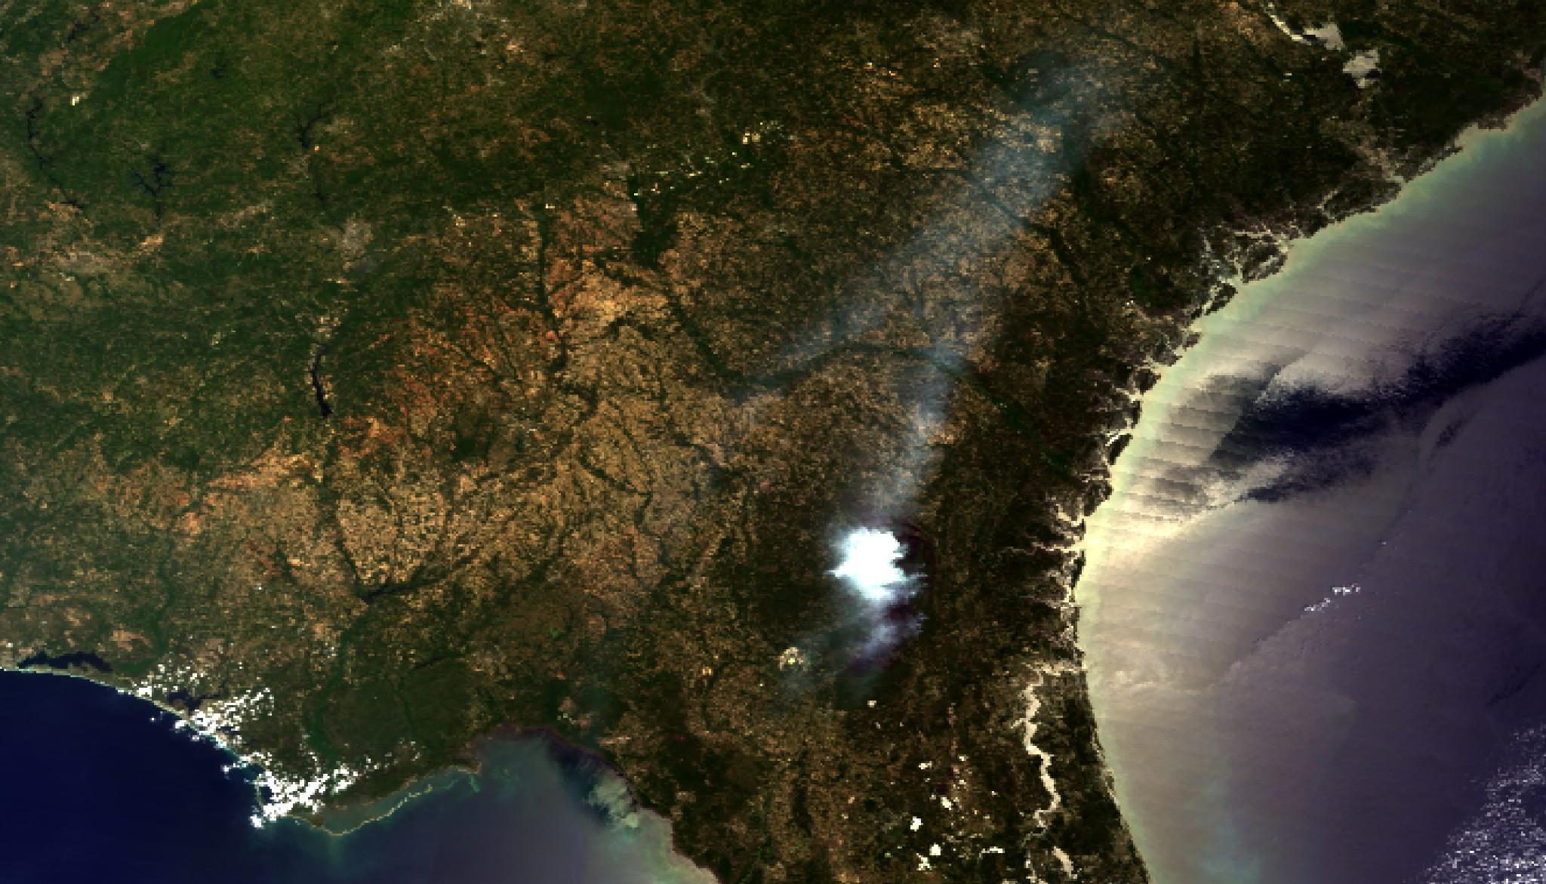

Figure 1a: True-color composite from MODIS aboard the NASA Terra satellite on May 20, 2007. A large plume of smoke can be seen over the fire’s location; smoke from the fire can also be seen rising into the upper levels and being transported by upper-level flow.

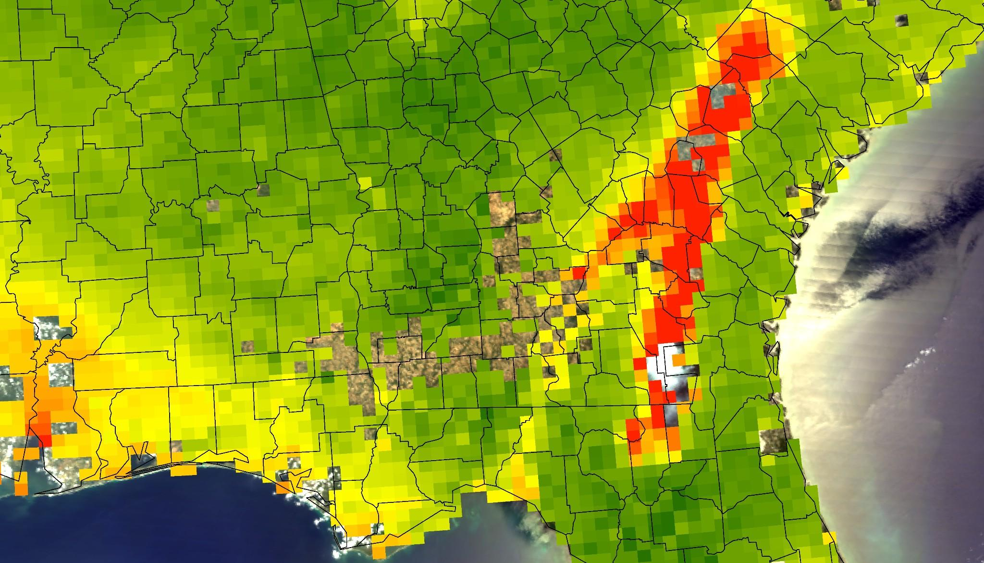

Figure 1b: This image contains Terra MODIS Level 2 AOD data from May 20, 2007 overlaid on top of the MODIS true-color composite image from the NASA Terra satellite in Figure 1a. High AOD values can be seen in areas where the smoke is being lifted high into the atmosphere.

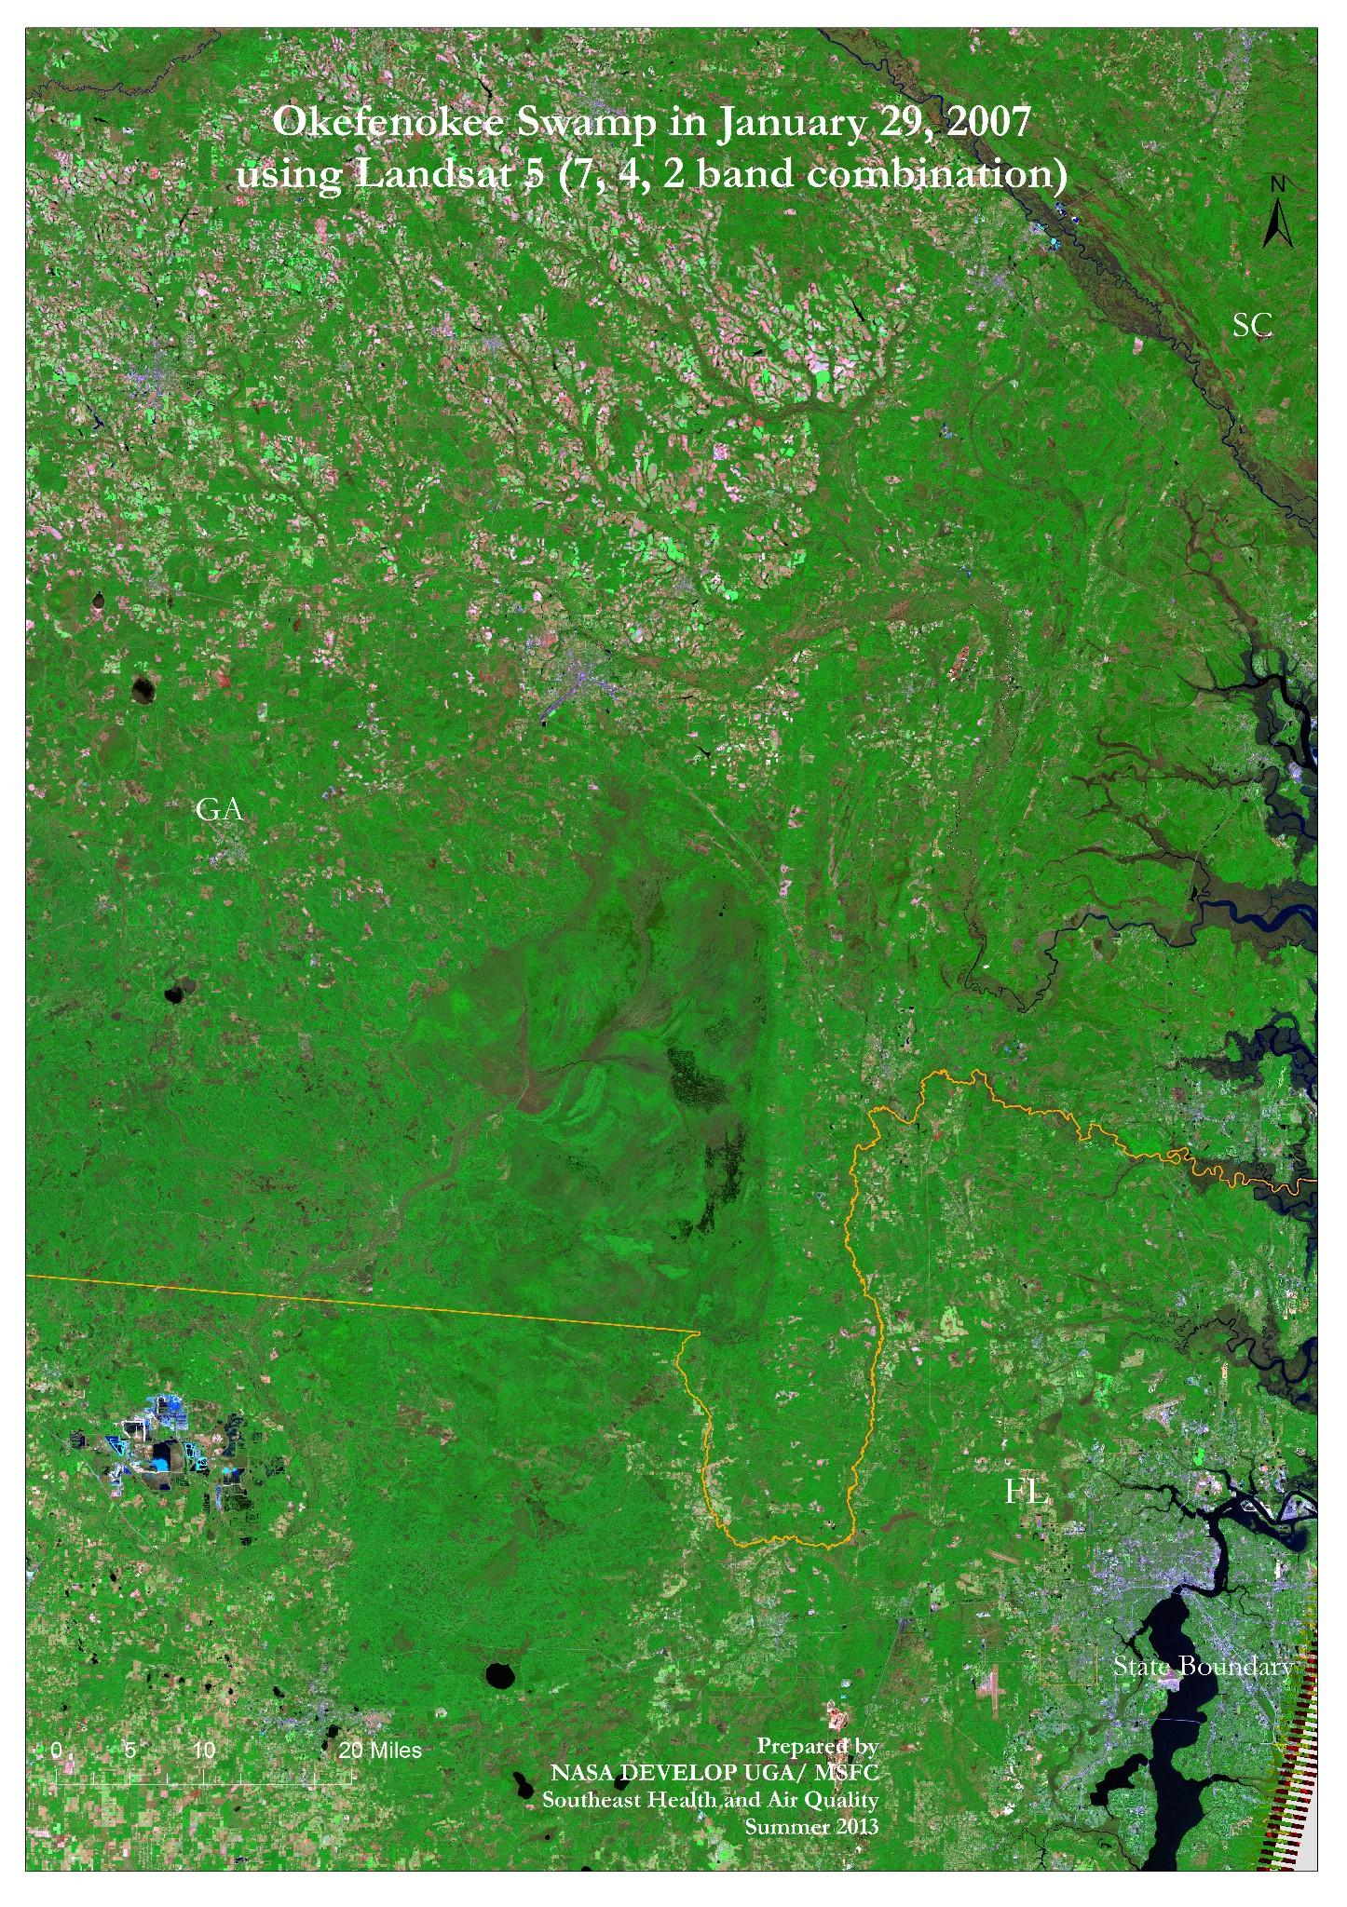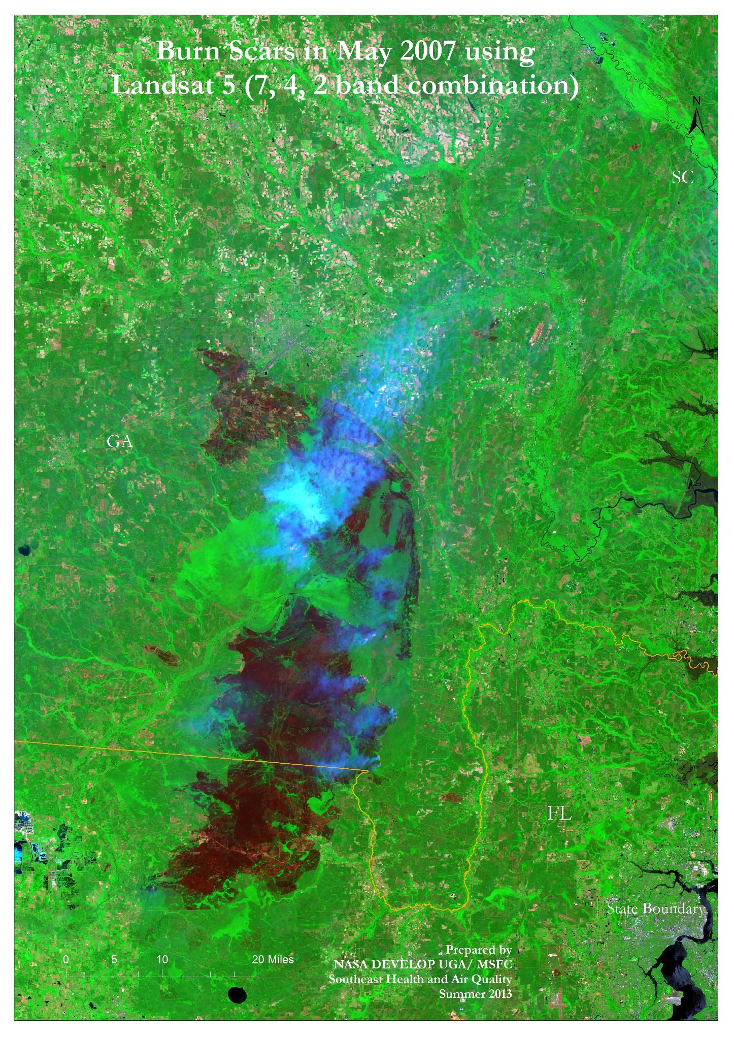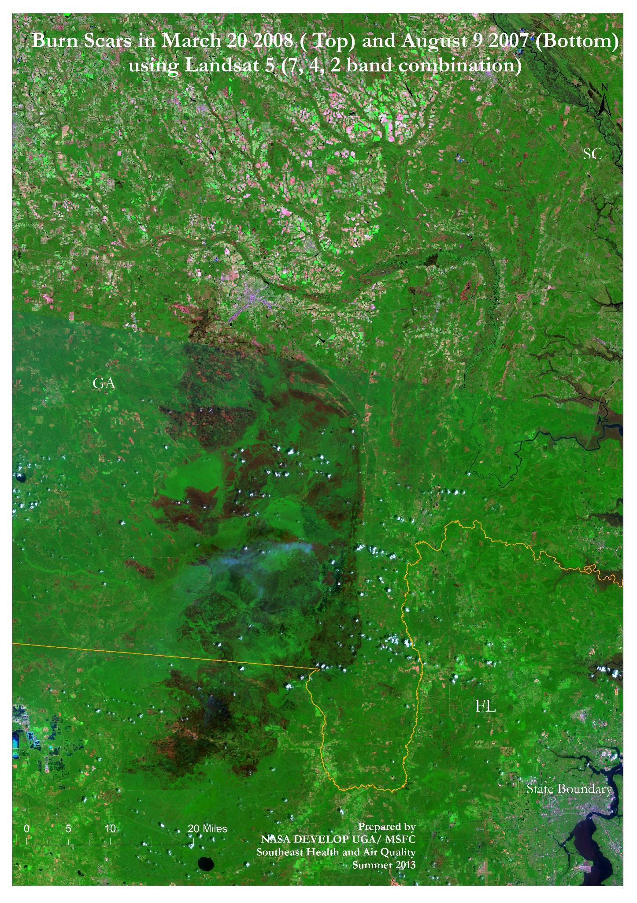

2a 2b 2c

Figure 2: Okefenokee Swamp

2a: Before the fire occurrence in January 29, 2007

2b: During the fire in May 21, 2007

2c: After the fire in August 09, 2007 (Bottom scene) and March 20, 2008 (Top scene).