**NASA DEVELOP National Program**



University of Georgia

*Spring 2016*

Perú Climate II

Monitoring and Forecasting Shifting Climate and Land Change Impacts in Perú’s Parque de la Papa for Enhanced Agricultural Management

 **Technical Report**

Rough Draft – Feb 18, 2016

Caren Remillard (Project Lead)

Brandon Hays

Benjamin Page

Adam Salway

Sam Weber

Xuan Zhang

Dr. Kenton Ross, NASA DEVELOP National Program (Science Advisor)

Dr. Marguerite Madden, University of Georgia Center for Geospatial Research (Science Advisor)

Previous Contributors:

Rebekke Muench

Kayla McDonald

Ryan Murphy

Michael Sclater

Richard Rose

Dajon Begin

# I. Abstract

[Placeholder - do not put anything here until the final draft submission. The abstract in the project summary is where the working draft of the abstract should “live”]

**Keywords**

Remote Sensing, Landsat, Landscape Change, Time Series, Crop Suitability, Climate

# II. Introduction

**Background**

Shifting precipitation patterns and increases in average global temperatures due to climate change are likely to impact agricultural systems around the world. Tropical montane regions such as the Andean Highlands will be especially affected (Jamieson et al., 2002). Vuille et al. (2000) demonstrated a distinct warming trend throughout the Andes from 1979 onwards, as much as 0.32-0.34 °C per decade, and it is predicted that these warming trends will continue into the future (Thibeault et al., 2010).These changes in temperature and precipitation have altered growing patterns (Daccache et al., 2011) and increased the presence of insect damage (David Ellis, CIP, personal communication, September 22, 2015). Subsequently, research has shown that from 1982 to 2012, potato cultivation in the Andes ascended 150 m higher in elevation (Shaw & Kristjanson, 2013). These changes threaten the continued use of traditional farming practices and indigenous crop varieties.

Potatoes are a relatively hardy crop, but they are increasingly being affected by changes in climate. In Perú, where potatoes originated and were first cultivated by humans, they are now becoming increasingly difficult to grow. As average temperatures increase, suitable habitat for pests and diseases also increases, which is forcing farmers into higher elevations. However, the only suitable cropland remaining is wedged between the warm, pest-ridden lower elevations, and the barren, frost-prone higher elevations and as a result, it is becoming increasingly difficult to find land warm enough to grow potatoes but cool enough to not harbor devastating pest and disease populations.

Generally, locations suitable for potato cultivation are determined by biotic and abiotic factors as well as economic and social conditions. With respect to climate, potato production must occur during a time period that is both “heat free” and “frost free,” (Haverkort et al. 2013). Risk of frost increases below 3°C, and tuber production decreases at mean temperatures above 22°C (Hijmans et al, 2000). In addition to regulating plant growth, temperature also affects insect growth and development (Jamieson et al., 2002). Warming temperatures may also increase vulnerability of plants to insect damage, especially if water availability is reduced (Jamieson et al., 2002).

Potato weevils are one of the most prevalent pests for potatoes cultivated in the high Andean mountains (Cisneros, 1999). An increase in Andean weevil populations can be attributed to the rise in temperatures over time in Perú (Parsa, 2010). These pests cause irreparable damage to crops as well as surrounding fields. Weevil eggs are laid at the base of potato plants (Parsa et al., 2012), in the upper twenty centimeters of the soil profile (Rios, 2010) for a period of twelve to fourteen weeks (Cisneros, 1999). Larvae bore through tubers for eleven to seventeen weeks, then abandon these tubers and pupate in surrounding soil (Cisneros, 1999). The emergence of overwintering adult weevils lasts eight to fourteen weeks and coincides with the onset of rain (Cisneros, 1999). Infestations are then exacerbated by the travel of weevils to nearby potato fields (Parsa et al., 2012).

Potato planting within Parque de la Papa occurs from October to November, depending upon rainfall. The two species primarily grown within Parque de la Papa are bitter potato, *Solanum juzepczukii,* and the ‘Irish’ potato, *Solanum tuberosum*. There are more than 4,000 varieties of potato around the world; most are found in the Andes. Globally, potatoes are the third most important food crop in terms of human consumption (CIP). Conservation of this genetic and cultural diversity will depend on a clear understanding of the effects a changing climate has on crop suitability.

Remote sensing and Geographic Information Systems (GIS) have emerged as new tools to assess agricultural suitability (Rahman, 2008) and monitor the distribution of crops over large areas (Panigrahy & Chakraborty, 1998). The goal of this project was to use NASA Earth observations to document recent changes in cropland distribution and altitude, temperature, and precipitation. These results will inform a potato suitability model designed to identify areas with the most potential for future agricultural use.

**Study Area**

This project was conducted in the Parque de la Papa (Figure 1), located in the Cusco region of Southeastern Perú. The Parque de la Papa is an Indigenous Biocultural Heritage Area collectively owned by six local communities belonging to the Quechua people. It is located roughly 25 km away from Cusco, the nearest city, and is 8,661 ha in size ranging from 3,200-5,000 m above sea level. The indigenous communities consist of some 7,000 people who pursue traditional lifestyles and agricultural cultivation as practiced in the region for centuries (Argumedo, 2008).

The park is managed by the local communities with input from two NGO’s: the International Center for Potatoes (CIP) and Association for Nature and Sustainable Development (ANDES). The primary objective is to preserve the cultural and agricultural traditions of the indigenous people living within the park. This includes following centuries old farming practices and propagating some 300 varieties of potato that have been cultivated in this region for hundreds of years (Argumedo).

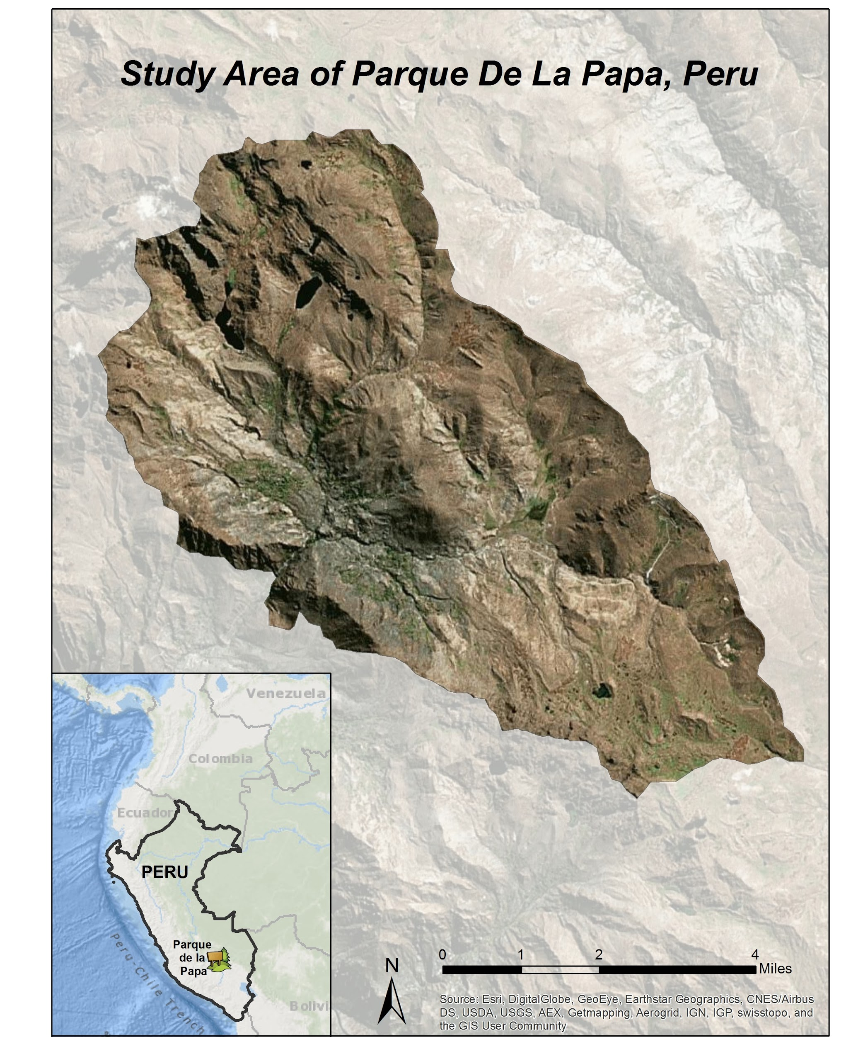

Figure 1: Study Area: the Parque de la Papa, Perú

**Study Period**

Landsat imagery from the month of May between 1985 and 2015 were collected and analyzed. This span represents the earliest publically available remotely sensed data up to the present.

**Objectives**

Our objectives were to quantify changes in growing conditions and climatic patterns within the park and to create a predictive model to assess areas for optimal potato cultivation.

**National Application Areas**

Our work incorporated precipitation, temperature, topography, and habitat requirements for both potatoes and their pests in order to create a forecasting model for an important agricultural product. As such, this project falls under multiple categories in NASA Applied Sciences Applications, including: climate, agriculture, and ecological forecasting.

**Project Partners**

We collaborated with ANDES and CIP. These NGO’s work with the indigenous communities within the Parque de la Papa and help them to translate field data and scientific research into management plans that they can implement. Currently there is only anecdotal evidence of shifting crop suitability. Confirming changing planting and climate patterns will allow park management to conduct outreach activities and better convey the difficulties associated with changing climates. A crop suitability model for potatoes will enable these organizations to direct farmers’ planting efforts to the optimal growing areas and improve their production of an important subsistence crop under changing climatic conditions.

# III. Methodology

**Data Acquisition**

*Satellite Data*

Level 1 GeoTIFF imagery for Landsat 5 Thematic Mapper (TM), 7 Enhanced Thematic Mapper+ (ETM+), and 8 Operational Land Imager (OLI) were downloaded from the United States Geological Survey (USGS) GloVis server for path 4, row 69. All imagery was collected for the month of May, just before the harvest and, therefore,a time of maximum reflective vegetation. If more than 10% of the study area was covered with clouds, the image was excluded.

An Advanced Spaceborne Thermal Emission and Reflection Radiometer (ASTER) Global Digital Elevation Model (DEM) was downloaded from the USGS EarthExplorer server with coordinates -13.5, -71.5. This dataset was processed in 2011 and is globally available at 1 arc-second resolution.

*Meteorological Data*

Weather data, including precipitation and temperature, were collected from the National Climatic Data Center’s (NCDC) Global Summary of the Day (GSOD) interface. The weather station used was located at the Teniente Alejandro Velasco Astete International Airport in Cusco, located at 3310 m above sea level and 25 km away from the park. Temperature, light intensity, relative humidity and dew point data were also provided by the CIP partners from HOBO data logging units placed at different locations throughout the park. These units, from which hourly weather data were extracted, are placed at higher elevations than the airport. The HOBO data falls within distinct time ranges from 2012-2013, 2013-2014 and 2014-2015.

**Data Processing**

*Satellite Image Processing*

Prior to image analysis and classification, noise influenced by the atmosphere was removed. Landsat Level 1 GeoTIFF products were first converted from their 16-bit digital number (*DN*) format (8-bit for LS4, 5) to top of atmosphere *(TOA)* reflectance from the radiometric calibration coefficients provided in the .MTL metadata file and then normalized for the earth-sun distance:



# where *ML* and *AL* are the multiplicative and additive factors for band *i,* respectively, *d* is the earth-sun distance, and *ESUN* is the downwelling extraterrestrial solar irradiance. Rayleigh scattering can attribute to almost 50% of the total signal reached by the sensor in the coastal and blue bands with an exponential decrease across the rest of the spectrum. Therefore, its contribution *(ρr)* was determined and removed from the *TOA* reflectance (Gordon et al. 1988):



where *r* is the Rayleigh optical thickness (Hansen and Travis, 1974), *Pr* is the Rayleigh scattering phase function (Doerffer, 1992), and *θo* and *θv* are the Sun and satellite zenith angles. Aerosol type was determined by utilizing the short-wave infrared (SWIR) band to find the maximum pixel value in a clear water body. Water has a large absorption window in the SWIR band so any reflectance signal received is due to the multiple scattering aerosol effects in the atmosphere. This aerosol contribution *(ρa)* value (or two values when using Landsat 8’s two SWIR bands) is then extrapolated across the visible and near-infrared (VNIR) bands and then subtracted from the Rayleigh corrected reflectance images:



where *λ* is the band center wavelength and *ε* is the aerosol type, determined as the negative of the slope of the straight line between the two SWIR channels used or was set to a value of one when only one SWIR channel was used. Finally, the images were divided by the two-way diffuse transmittance to retrieve final surface reflectance *ρs* product:



*Surface Brightness Temperature*

The Landsat series (4, 5, 7 and 8) are equipped with thermal infrared sensors (TIRS) that allow calculations to estimate surface temperatures. TIRS band data can be converted from spectral radiance to brightness temperature using the thermal constants provided in the metadata file:



where *T* is the at-satellite brightness temperature in Kelvin and *Lλ* is the *TOA* radiance. Temperatures were converted to Celsius for a better understanding during project partner interaction.

*DEM*

The ASTER images were reprojected to UTM Zone 18N to match the Landsat projection, and clipped to the study area’s shapefile. ASTER pixels represent a 30.8 m2 area compared to Landsat’s 30 m2 spatial resolution. Therefore, the Landsat images were resampled to match ASTER quality when deriving relationships between elevation, slope, temperature, and spectral features.

*Classification*

Initially, a series of ground-truthed points collected in 2016 by field technicians were used to train a classification scheme. This classification scheme was applied to the most recently available Landsat imagery. A second set of points predicted by the model were sent back to the field technicians for validation and were subsequently used for further model training.

*Meteorological Data*

The weather station data collected from the NCDC Interface contained relatively few null values, which were omitted. The remaining data were processed into monthly averages to illustrate the temporal trend. Additionally, the HOBO hourly temperature data was transformed into daily temperature in order to compare and further validate the weather station data.

Validation of the HOBO temperature data from within the park were performed using a standard environmental lapse rate to compare it to the data from the weather station in Cusco. A moist-adiabatic lapse rate of 6°C/km was determined to be most appropriate for a mountainous region such as the Parque de la Papa. In the equation below, *THadj* is the adjusted temperature from the HOBO unit in degrees Celsius, *Elev H* is the elevation above mean sea level for the specified HOBO unit in meters, *Elev* *S* is the elevation above mean sea level for the weather station in meters, and *TH* is the recorded temperature from the HOBO unit in degrees Celsius.



**Data Analysis**

*Surface Brightness Temperature*

Patterns of surface temperature within the study area were explored from 1985-2016. Relationships are being investigated between surface temperature, elevation, and precipitation to fine-tune a potential suitability map for optimal potato farming.

*Meteorological Data*

The precipitation data were used to analyze historical trends in rainfall. The temperature data from the HOBOs were used to interpolate air temperature across the park in order to further validate surface brightness temperature derived from Landsat imagery.

# IV. Results & Discussion

The following figure shows how the precipitation changed from 2006-2015 (Figure 2). A trend of increasing 5-year averages of precipitation from the past (light blue) to recent years (dark blue) is shown in figure 3.

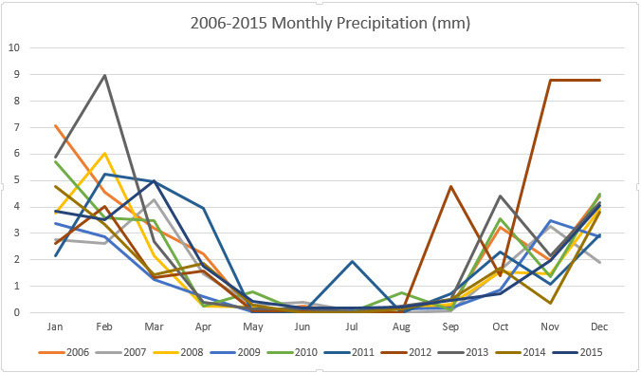

Figure 2: Monthly precipitation data from Teniente Alejandro Velasco Astete International Airport

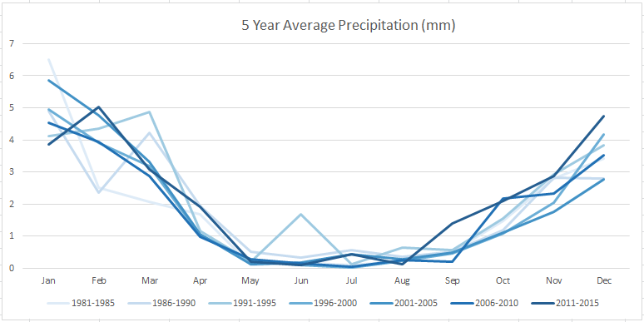

Figure 3: Five year average precipitation data

The HOBO hourly data were processed into daily values in order to compare and further validate the weather station data.

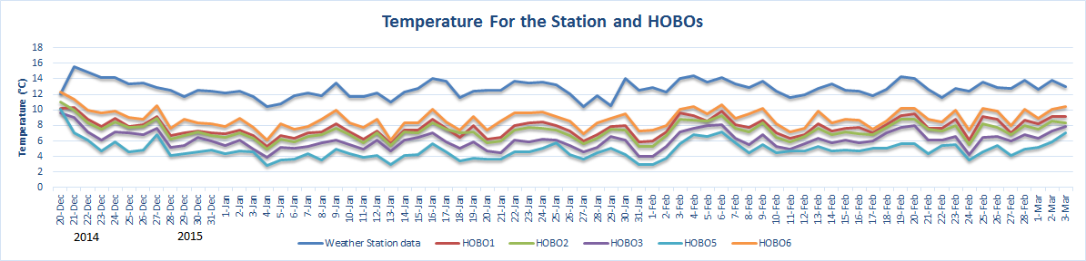

Figure 4: Comparison of daily temperatures within and outside of Parque de la Papa

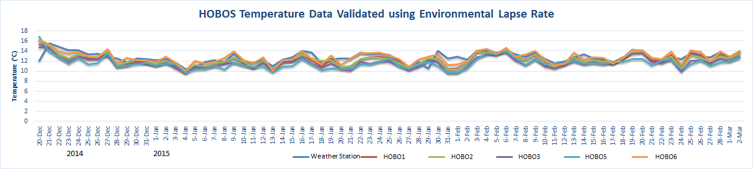

Figure 5: Validation of airport data using standard environmental lapse rate on HOBO data

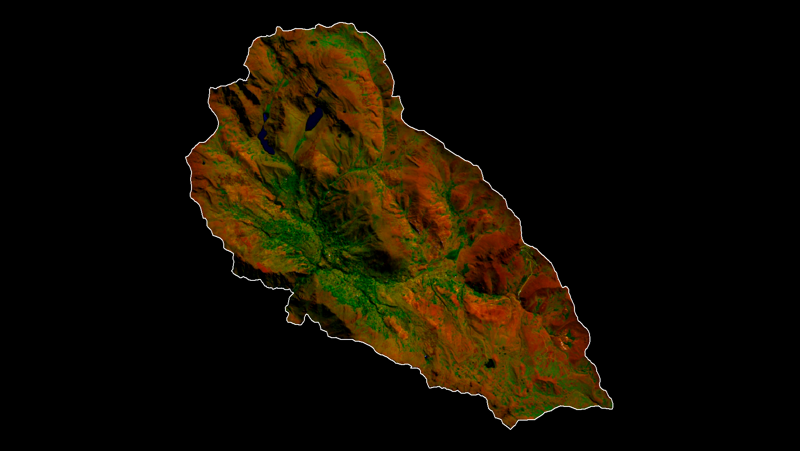

Figure 6. Landsat 6-5-2 false color composite of Parque de la Papa

# V. Conclusions

*Soup without Potatoes is like Life without Love*

# VI. Acknowledgments

We would like to thank our science advisors, Drs. Marguerite Madden and Kenton Ross, for their help crafting and executing this project.

Additional thanks go to the International Potato Center (CIP) for their input and help, including Genesis Abreu, Alejandro Argumedo, Noelle Barkley, David Ellis, and Rene Gomez.

We would also like to acknowledge the contributions of the Perú Climate I team: Rebekke Muench, Kayla McDonald, Michael Sclater, Richard Rose, Dajon Begin.

Any opinions, findings, and conclusions or recommendations expressed in this material are those of the author(s) and do not necessarily reflect the views of the National Aeronautics and Space Administration.

This material is based upon work supported by NASA through contract NNL11AA00B and cooperative agreement NNX14AB60A.

# VII. References

Argumedo, A. (2008). The Potato Park, Peru: Conserving agrobiodiversity in an Andean

indigenous biocultural heritage area. *Protected Landscapes and Agrobiodiversity Values. Volume 1 in the series, Protected Landscapes and Seascapes, IUCN & GTZ*, 45.

Cisneros, F. (1999). Controlling the Andean potato weevil through integrated pest

management. *Horizon International Solutions Site*. Retrieved from http://www.solutions-site.org/node/90/

Haverkort, A. J., De Ruijter, F. J., van Evert, F. K., Conijn, J. G., & Rutgers, B. (2013).

Worldwide sustainability hotspots in potato cultivation. 1. Identification and mapping. *Potato research*, 56(4), 343-353.

Hijmans, R. J., Forbes, G. A., & Walker, T. S. (2000). Estimating the global severity of

potato late blight with GIS‐linked disease forecast models. *Plant Pathology*, 49(6), 697-705.

Jamieson, M. A., Trowbridge, A. M., Raffa, K. F., & Lindroth, R. L. (2012). Consequences

of climate warming and altered precipitation patterns for plant-insect and multitrophic interactions. *Plant physiology*, *160*(4), 1719-1727.

NOAA/National Weather Service. Storm Prediction Center. Environmental Temperature

Lapse Rates. http://www.spc.noaa.gov/

Panigrahy, S., and M. Chakraborty. "An integrated approach for potato crop

intensification using temporal remote sensing data." *ISPRS journal of photogrammetry and remote sensing* 53.1 (1998): 54-60.

Parsa, S. (2010). Native herbivore becomes key pest after dismantlement of a traditional

farming system. *American Entomologist*, 56(4), 242.

Parsa, S., Ccanto, R., Olivera, E., Scurrah., Alcazar, J., & Rosenheim, J. A. (2012).

Explaining Andean potato weevils in relation to local and landscape features: a facilitate ecoinformatics approach. *PLoS One,* 7(5).

Rios, Alfred Arturo. (2010). *Land Use, Spatial Ecology and Control of the Andean Potato*

*Weevil in the Central Andes of Peru* (Doctoral Dissertation). Retrieved from

ProQuest Dissertations Publishing. (3447056)

Shaw A, Kristjanson P. 2013. Catalysing learning for development and climate change:

an exploration of social learning and social differentiation in CGIAR. CCAFS Working Paper No. 43. Copenhagen, Denmark: *CGIAR Research Program on Climate Change, Agriculture and Food Security (CCAFS)*.

Thibeault J.M., Seth A., Garcia M. (2010). Changing climate in the Bolivian Altiplano:

CMIP3 projections for temperature and precipitation extremes. *J Geophys Res* Vol. 115

Vuille M, Bradley R (2000) Mean annual temperature trends and their vertical structure

in the tropical Andes. *Geophysical Research Letters* 27(23): 3885–3888.

# VIII. Content Innovation

Inline Supplementary Material (figures, tables, computer code)

Interactive MATLAB Figure Viewer

# IV. Appendices