Downloading LANDFIRE Data

1. Go to <http://www.landfire.gov/>

2. Click on “Get Data” in the brown data bar.

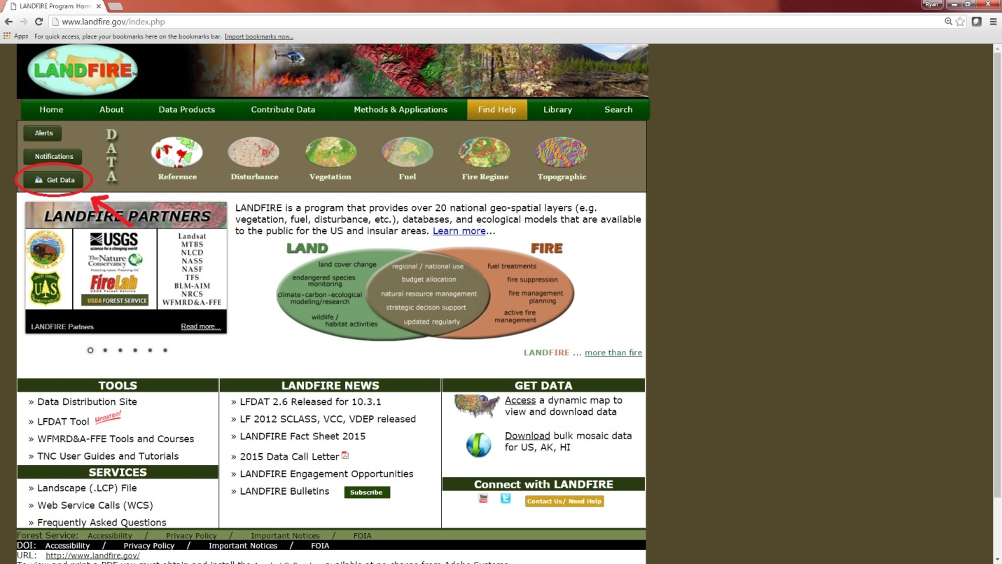

3. A new tab will open with a map of the United States. Click on any of the Insular Areas that are within Alabama.

4. A map showing part of the state will come up. In the top left corner of the screen there will be a menu bar. Mouse over the Earth and then click “Download Data”.

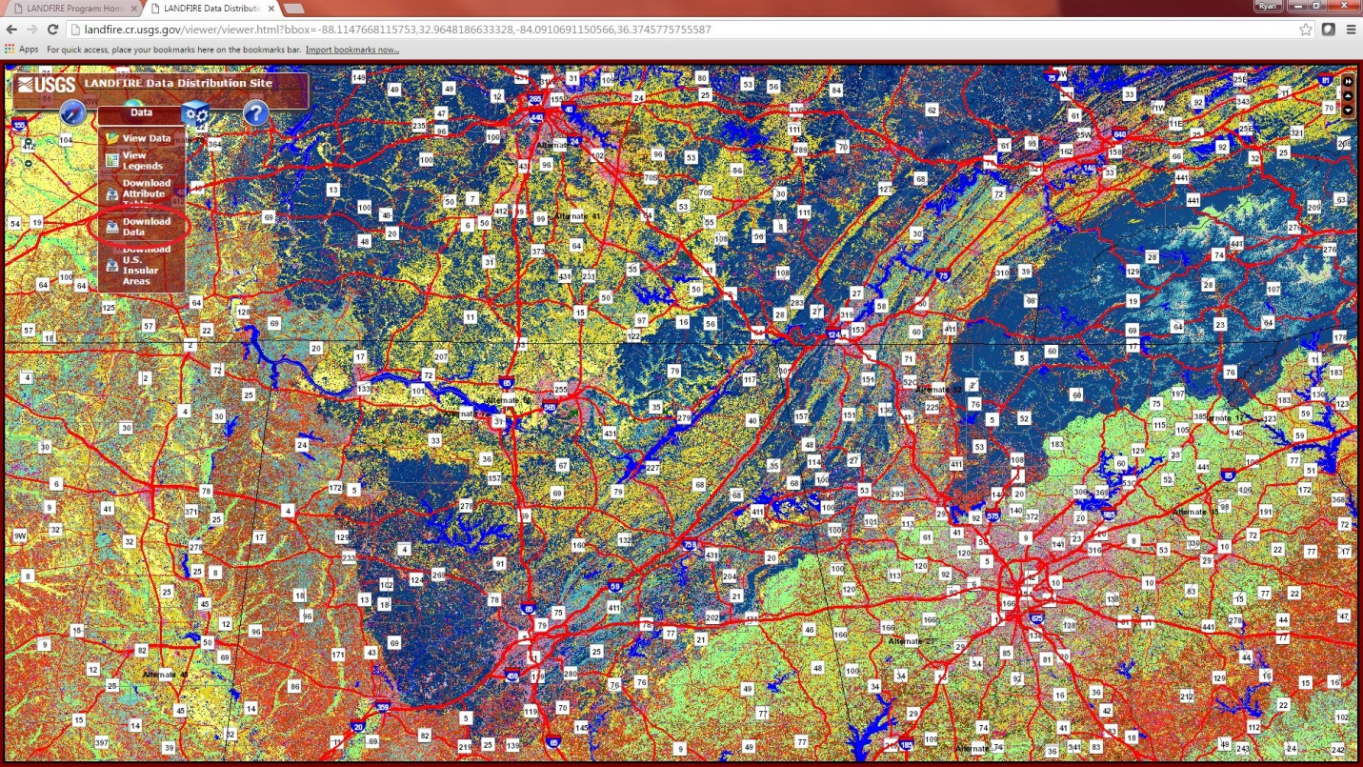

5. A menu will pop up in the top right corner of the screen. Select “LF2010 (LF_120)”, “Vegetation”, “us_120 Existing Vegetation Type”.

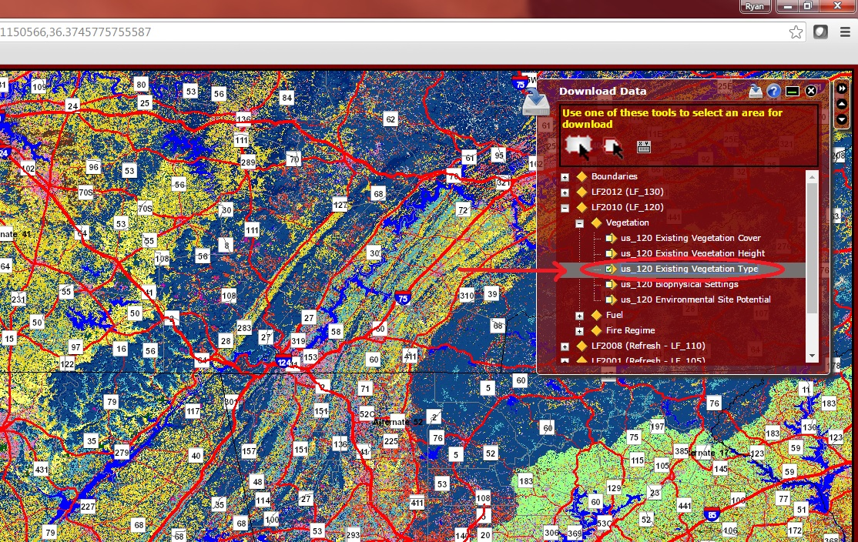

6. Next, select the “Define Download Area By Template Selection” icon (circled below) and then select “Atlas State Boundaries” from the drop down menu.

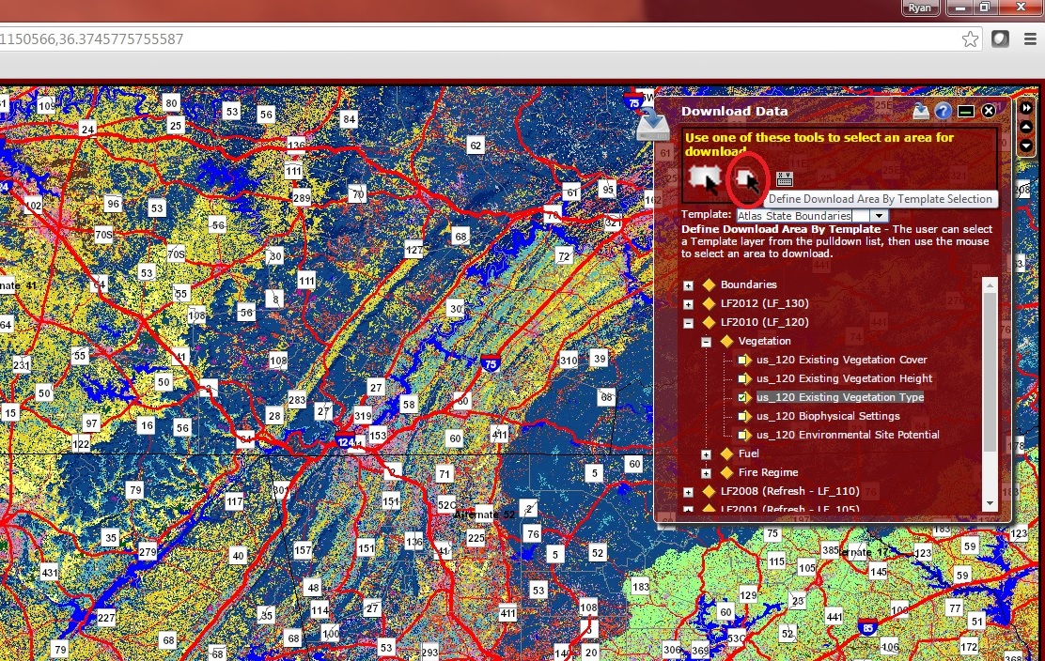

7. Now click anywhere within the state of Alabama on the map. A new window will open with information about the download. (If the window does not open, make sure you do not have a pop-up blocker enabled.) Above the download box should read “National Atlas State Boundaries: ID 79 AL”; if not, you have selected the wrong state.

8. Click the download button. A new window will open will open telling you the order status. The order will take a few minutes to prepare for download.

9. Once the download is ready, the window will read “The data extraction has completed” and the download will start automatically.

10. Once the download is finished, unzip the folder.

11. Replace the old LANDFIRE folder on your computer, if one exists, with the new folder.