**NASA DEVELOP National Program**



NASA Langley Research Center

**Spring 2016**

**Short Title: Southern Rockies Ecological Forecasting II**

**Subtitle:** Tracking Mule Deer for Wildlife Corridors between Seasonal Habitats in the Southern Rockies

**VPS Title:** Oh Deer! Where are the Mule Deer Going?

**Project Team & Partners**

**Project Team:**

Tyler M. Rhodes (Project Lead), Tyler.M.Rhodes@NASA.gov

Mike Sclater

Amanda Flake

Allison Chappell

Maggie Jenkins

Cody Walker

**Advisors & Mentors:**

Dr. Kenton Ross (NASA DEVELOP National Science Advisor)

**Past or Other Contributors:**

Ross Reahard (Project Lead)

Teresa Fenn

Jeri Wisman

**Partner Organizations:**

Southern Rockies LCC (End-User), POC: John Rice

Western Association of Fish and Wildlife Agencies (WAFWA) Mule Deer Working Group (End-User) POC: Jim Heffelfinger

**Project Details**

**Applied Sciences National Application Addressed:** Ecological Forecasting

**Study Area:** Southern Rocky Mountains (ID, WY, UT, CO, AZ, NM)

**Study Period:** 01/2011 – 12/2015

**Earth Observations & Parameters:**

Aqua, MODIS – Spectral vegetation indices and phenology products

Terra, MODIS – Global elevation datasets, spectral vegetation indices, phenology products

Landsat 5 and 8, TM and OLI – Spectral vegetation, land cover classifications

**Ancillary Datasets Utilized:**

* USGS National Land Cover Dataset (NLCD) - land cover
* NASA ForWarn system - Vegetation phenology
* NASA Digital Elevation Model (DEM) - digital elevation model

**Software Utilized:**

ERDAS IMAGINE - land classification of Landsat imagery

ArcGIS - raster manipulation/analysis, image enhancement & map creation

**Project Overview**

**80-100 Word Objectives Overview:**

Mule deer (*Odocoileus hemionus*) are considered a keystone species and a symbol of the West and for that reason, their disappearance would be detrimental to the Southern Rockies. Mule deer are a migratory species and decreases in their population have been partially attributed to fragmentation of their habitats throughout the region. Wyoming alone has seen a 36% decrease in mule deer population from 1991-2012. The goal of this project was to create final mapping products to examine mule deer migration and help identify ideal conservation areas.

**Abstract:**

Mule deer are economically and ecologically important to the Southern Rockies, however, their populations are currently on the decline. Mule deer are migratory animals that are capable of traveling a few hundred miles from their summer to winter habitats and therefore require safe, uninterrupted passageways that will allow them to continue migrating without navigating over anthropogenic obstructions such as roads, oil well pads, and fences. Such disturbances have interrupted their migration paths and contributed to mule deer population decline. NASA DEVELOP provided spatial analysis in the form of maps to aid in the conservation of mule deer and their habitats in support of Southern Rockies Landscape Conservation Cooperative (SRLCC) and the Western Association of Fish and Wildlife Agencies (WAFWA) Mule Deer Working Group. The project encompassed the SRLCC boundary, comprised of land in Idaho, Wyoming, Utah, Colorado, Arizona and New Mexico, from 2011 to 2014. Aqua and Terra Moderate Resolution Imaging Spectroradiometer (MODIS) data were primarily used to evaluate vegetation phenology and Normalized Difference Vegetation Index (NDVI) to assess migratory patterns. Terra ASTER data were utilized to create a Digital Elevation Model (DEM) and slope map to aid in determining suitable habitats, additionally, ground temperature and precipitation layers provided by Prism were included. Landsat 5 TM and 8 OLI data were applied to determine current and historical land use, land cover, patch size, and winter to summer connectivity corridors. These factors were incorporated into a species distribution model and mule deer range maps.

**Community Concerns:**

* Mule deer numbers are declining in the Southern Rocky Mountains. As they are economically and ecologically important to the Southern Rockies due to the revenue from hunting licenses and species diversity, this is cause for alarm.

**Current Management Practices & Policies**:

Currently, land managers are attempting to track where mule deer migrate in order to conserve land and create corridors. These land managers are limited in their research because they are unable to identify the extent to which human involvement has played a role in the mule deer’s migratory patterns. John Rice has established a need for a landscape-scale solution that will allow for the development of a predictive habitat for the restoration and conservation of these mule deer habitats.

**Decision Support Tools & Benefits:**

|  |  |  |
| --- | --- | --- |
| **End-Product** | **Earth Observations Used** | **Benefit & Impact** |
| Mule Deer Range Maps | Landsat 5 TM & 8 OLI  Terra ASTER (DEM)  Aqua/Terra MODIS | An accurate Mule Deer Range Map of current and historical migration patterns will aid our partners in establishing conservation areas and connectivity corridors for mule deer |

**Project Imagery**

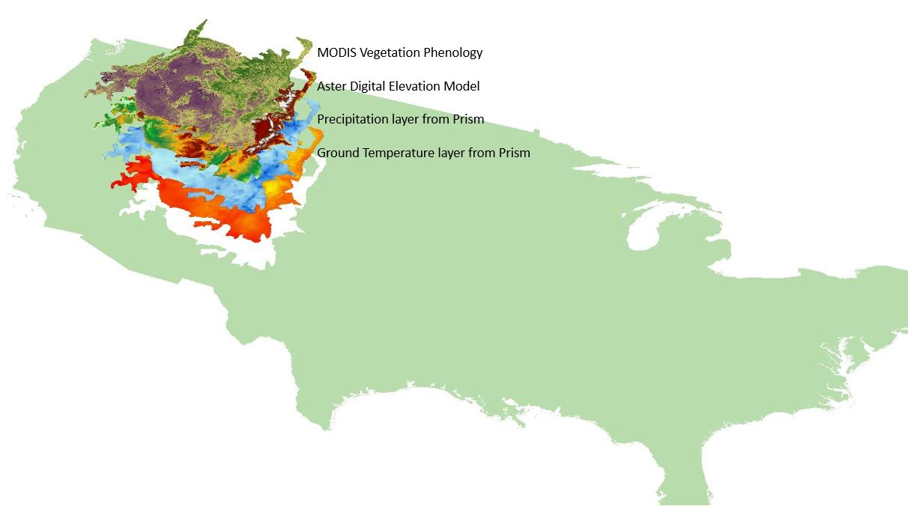

**Caption:** Layers shown above from the top down are MODIS Vegetation Phenology, a DEM from Aster, precipitation and surface temperature from Prism. Image Credit: SREFII Team.

**Software Release Requirements**

What category do the tools your project is creating fall within? N/A