**NASA DEVELOP National Program**



NASA Langley Research Center

*Spring 2016*

Arizona Health & Air Quality II

Enhancing Extreme Heat Intervention and Preparedness Activities in Maricopa County, Arizona with NASA Earth Observations

**Technical Report** 

Final Draft – Mar 31, 2016

Daniel Finnel (Project Lead)

Teresa Fenn

Richard Muench

Ashley Brodie

Dr. Kenton Ross, NASA Develop National Program (Science Advisor)

Dr. Dave Hondula, Arizona State University (Science Advisor)

Lance Watkins, Arizona State University (Science Advisor)

Previous Contributors:

Amy Stuyvesant

Geordi Alm

Rocky Garcia

Emma Baghel

April Rascon

Bernardo Gracia

# I. Abstract

Extreme heat causes and exacerbates a number of health problems, leading to hospitalization and death in some cases. The problem of severe heat is notably felt in Maricopa County, Arizona, where the socially disadvantaged and physically vulnerable are especially susceptible to the effects of extreme heat. Within the Maricopa County limits is the city of Phoenix, a dense urban area surrounded by 300 – 2,000 meter ridge lines above the valley floor. The volume of impervious surfaces, lack of shade and vegetation, and the high ridge lines surrounding the city exacerbate the heat stress by a phenomenon known as the urban heat island effect (UHI). After the sun sets, heat retained by impervious building materials is released at a decreased rate compared to natural vegetation and soil coverage. Ambient air temperatures in urban areas tend to be higher than the surrounding rural areas. Several organizations, including the Arizona Department of Health Services and the Phoenix Heat Relief Network, are working to create more effectively placed cooling centers and heat warning systems to aid those with the highest risk of exposure. This project created a Python and R tool using Aqua Moderate Resolution Imaging Spectroradiometer (MODIS) land surface temperature parameters to generate heat maps that reference demographics data on extreme heat days.

**Keywords**

Public Health, Urban Heat Island, MODIS, Land Surface Temperature, Census Tracts

# II. Introduction

For over a decade, academics and decision-makers have recognized the dangers that extreme heat pose to human health. As a result, many researchers have explored its effects as well as possible mitigation strategies (McMichael et al., 2008; Harlan et al., 2013). The desert ecoregions in the southwest U.S., including southern California, Arizona, New Mexico, southwest Texas, Nevada, and Utah, are susceptible to extreme heat events. The city of Phoenix and its surrounding metropolitan areas within Maricopa County, Arizona are greatly affected by high heat (Grossman et al., 2010). The effects of which are particularly felt in urban areas where the Urban Heat Island effect (UHI) is putting citizens at increasing risk of heat related illness and death (Grossman et al., 2010). UHI is caused by the prevalence of impervious surfaces within the city, such as concrete and asphalt, trapping heat from incoming solar radiation. In a typical UHI, heat trapped by impervious surfaces during the day will be released into the lower atmosphere at night; as opposed to heat trapped in rural areas, which radiates into space. Thus, the effects of the UHI are relatively greater at night than during the day (Hardegree, 2006).

While populations in arid climates can be more acclimated to elevated temperatures, demographics that are typically disadvantaged or isolated, such as the elderly, the poor, the homeless, and non-native English speakers, are all more vulnerable to heat related illness and death (MCDPH, 2014). In addition to causing heat stroke, elevated temperatures can lead to cramps, exhaustion, heat syncope, and can exacerbate pre-existing respiratory and circulatory conditions (Scott et al., 2004). Temperatures above 104°F (40°C) fall into NOAA’s Heat Index “danger” zone and serve as an appropriate threshold for severe heat stress. (Harlan et al., 2003, Harlan et al., 2014). The majority of heat related service calls are made during the monsoon season in the later summer months of July and August, when elevated temperatures and high humidity are most prevalent (Golden et al., 2008). According to the Maricopa County Department of Public Health (MCDPH) 2013 annual report, there were 1,050 confirmed heat related deaths between the years 2006 to 2013.

This project arose as a result of discussions between the DEVELOP National Program and researchers at Arizona State University and the MCDPH. In this study, the UHI effect in Maricopa County was analyzed using Aqua MODIS Land Surface Temperature (LST) data acquired during the summer months of April through October from 2006 to 2015. Because the UHI effect so adversely affects the health of the population, this project falls under the NASA Applied Science Program’s Health & Air Quality Application Area. The project maintained its partnership with the Arizona Department of Health Services (ADHS), the Phoenix Heat Relief Network, the National Weather Service (NWS), Phoenix Forecast Office, and the Center for Policy Informatics (CPI) at ASU. Currently, the partners issue heat warning products to the service region based on meteorological observations at Phoenix Sky Harbor airport and forecaster opinion on the conditions that are dangerous for human health, and the warning zone typically spans multiple counties across Arizona. The MCDPH maintains several heat relief centers; however, these centers are situated according to available resources and without regard to the spatial variability of heat. The project objectives allowed for the creation of an automated tool named LaSTMoV (Land Surface Temperature MODIS Visualization), which was written in python and R to create heat maps of Maricopa County. The partners will be able to use this tool to understand spatial and temporal patterns of extreme heat events, which will better inform their heat mitigation strategies.

# III. Methodology

**Data Acquisition**

Manual collection of Aqua MODIS MYD11A1 version 005 data were available through the NASA EarthData Search Client. A case study was conducted in conjunction with the Atmospheric Science Data Center (ASDC) to include OPeNDAP data collection. Connection to the data portal was made available through PyDAP code which allowed users of the python tool to acquire near real-time imagery for processing.

The threshold for increased heat related illness determined by the national weather service is 104°F (40°C); therefore, only MODIS data for days at or above this threshold were analyzed. In order to identify days over 104°F (40°C), the air temperature readings from Phoenix Sky Harbor International Airport (PHX) were acquired through the University of Utah’s Mesowest API. Shape files of Maricopa County census tracts were obtained from the Maricopa County Health Department.

The study period was chosen to be the summer months (April to October) from 2006 to 2015. It was necessary to use the same data for proof of concept and to establish a baseline for continued analysis during demonstrations of the tool. However, term 1 only acquired data for the months of May to September. The current term expanded on this period in order to ensure that data for all days over 104°F (40°C) were acquired (Table 1).

**Table 1:** The number of study days (days over 104°F (40°C)) by month and year.

|  |  |  |  |  |  |  |  |  |  |  |  |
| --- | --- | --- | --- | --- | --- | --- | --- | --- | --- | --- | --- |
|  | 2006 | 2007 | 2008 | 2009 | 2010 | 2011 | 2012 | 2013 | 2014 | 2015 | **Total** |
| April | 0 | 0 | 0 | 0 | 0 | 0 | 0 | 0 | 0 | 0 | 0 |
| May | 3 | 1 | 3 | 4 | 0 | 0 | 5 | 0 | 4 | 2 | 22 |
| June | 27 | 20 | 20 | 10 | 16 | 16 | 20 | 27 | 26 | 21 | 203 |
| July | 23 | 21 | 21 | 28 | 21 | 23 | 19 | 20 | 26 | 21 | 223 |
| August | 12 | 23 | 20 | 22 | 18 | 28 | 18 | 19 | 15 | 28 | 203 |
| September | 2 | 11 | 4 | 8 | 15 | 13 | 5 | 8 | 6 | 4 | 76 |
| October | 0 | 0 | 0 | 0 | 0 | 0 | 0 | 0 | 0 | 1 | 1 |
| **Total** | 67 | 76 | 68 | 72 | 70 | 80 | 67 | 74 | 77 | 77 | **728** |

**Data Processing**

In order to process the data and create heat severity maps, a python script was compiled from a combination of scripts written by the past and current term. The compiled script formed the first part of LaSTMoV. The first step of data processing was to convert the MODIS HDF files to tiff files, which was done using tools from the DEVELOP National Program python library (dnppy). Next, LaSTMoV automatically downloaded data from Mesowest API, used the data to identify days over 104°F (40°C), which it then compiled into a list of study days, and deleted the MODIS data for days that did not correspond to the study days. Once the data for the correct study days had been accumulated, LaSTMoV proceeds to clip the tiffs to the area of Maricopa County and convert the LST from digital number to degrees Fahrenheit. This conversion was initially accomplished using ArcGIS model builder, and the model was exported into python and reformatted to fit into LaSTMoV. The second Analysis of the data were accomplished using an R script for LaSTMoV.

**Data Analysis**

Once the data were processed using the python portion of LaSTMoV, the R portion of LaSTMoV used zonal statistics to compute the average LST value by census tract. By making a folder connection to any of the years in the collected historical data at the beginning of the script the user creates a location for files to be read and written into. For ease of use the census file is copied to the new directory. The user only has to change the file path of the variables “TempDIR” (where .tiff MODIS layers are stored) and “Current.folder” (where the Census files are currently stored). The census shape file is then loaded into the script and a new projection is applied. The raster list is read for the specified folder that creates a file sample to be run through an iteration. However, before the iteration can be run a new table called Newatt must be created with two columns and the same number of rows in the raster list. “Newatt” is essentially a storage container for the percentage of cloud cover over the census tracts. Then the iteration begins, calling on one raster at a time for every raster in the length of the raster list. Each raster that was image (.tiff file) is converted to a true raster using the function raster. A true raster layer contains cell (pixel) values in RAM memory. The rasters are then projected against the Coordinate Reference System (CRS) of the census shape file. Using the extract command and the function mean we were able to apply the daily mean LST values to the census shape file. The command “last.col” was then used to append values to the end of the census files. This command was also useful in replacing NaN values, representative of cloud cover, with -9999 values that can be read in ArcMap. To generate a table of the percent of clouds that covered the census tracts we needed to define how many NaN values on each day and night there were. This is represented by the formula below where ΣNaN is the sum of all -9999 values for the given day and 916 is the number of rows in the census file.

1. Percent Clouds = {(ΣNaN)/916}*100

Columns were created to fill in the blanks in the Newatt table. The for loop was then closed and using write.dbf and write.csv tables of mean temperature for day and night Aqua MODIS LST and percent cloud cover table was created and deposited into the “TempDIR” initially set by the user. Upon clicking on the folder the user will notice that the .dbf file was the most recent file updated. The user can then open ArcMap, connect to the folder of the specified year and produce a visual of an LST heat map in seconds.

**Semivariograms**

To understand the spatial cohesion of LST across Maricopa Co. semivariograms were generated. A semivariogram function quantifies the assumption that similarity occurs when points are closer together (i.e. the strength of the statistical correlation as a function of distance). The semivariogram function is defined below where *var* is the variance.

**(2)** γ(si,sj) = ½ var(Z(si) - Z(sj))

A semivariogram has three major components nugget, range, and sill. The range is the distance between the nugget (either zero or on the y-axis) and the sill, the point where the curve begins to flatten out (Figure 2). All points that fall within the range are more similar to each other than those that fall outside of the range.

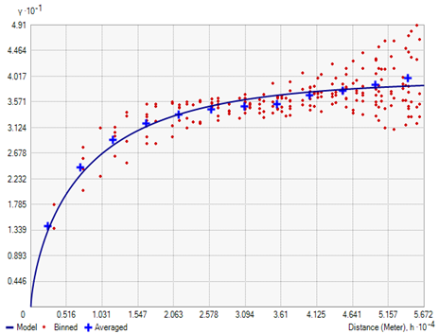The generation of semivariograms took place in ArcMap. Tiff images had to be converted to points, using the raster to points tool, to be read appropriately. The point layers were then fed into the preexisting geostatistics tool for kriging in ArcMap. It was necessary to select the data field: Grid_Code, which now represents LST, to obtain the appropriate results. The parameters were set to ordinary with no transformation type or order of trend removal selected. Semivariograms were generated at random for days and associated nights once per month that had little to no cloud cover (0-15%).

Sill

Range

Nugget

**Figure 2:** Example of a Semivariogram for August 3, 2015 during the daytime. X-axis is distance in Meters and Y-axis is variance.

# IV. Results & Discussion

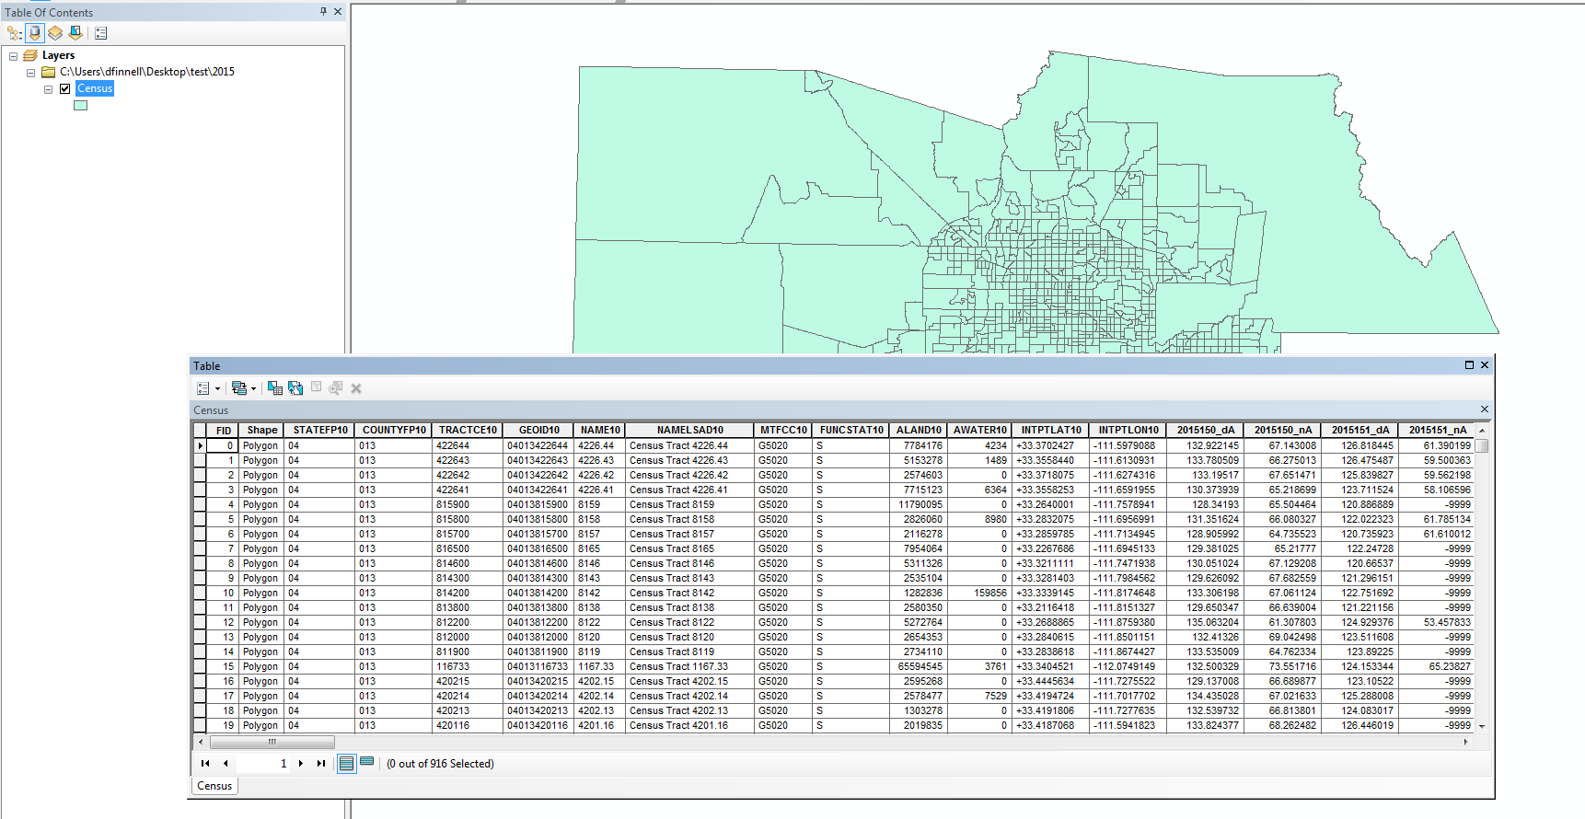LaSTMoV allows the user to specify a study period by year and then by month/day. In this manner, the user is able to compare a single month across multiple years, compare multiple months within a year, or both. A user of LaSTMOV can use the data to look at the days that comprise a heat wave to understand which census tracts retain the most heat during the event. Figure 3 below displays a sample of the appended data from that was added to the census shape file while using the R portion of last move. Table 2 depicts a 10 day range of cloud cover percentage from 2015.

**Figure 3:** An example of the outputs the R portion of LaSTMOV produces. The days append to the dbf file after the INTPTLON10 column.

**Table 2:** A ten day sample of the percent cloud csv that is generated at the end of the R portion of LaSTMOV

|  |  |  |
| --- | --- | --- |
| Column1 | X1 | X2 |
| 1 | 2015150_daytime | 0 |
| 2 | 2015150_nighttime | 0 |
| 3 | 2015151_daytime | 0 |
| 4 | 2015151_nighttime | 47.70742 |
| 5 | 2015152_daytime | 0 |
| 6 | 2015152_nighttime | 0 |
| 7 | 2015153_daytime | 0 |
| 8 | 2015153_nighttime | 10.58952 |
| 9 | 2015159_daytime | 53.71179 |
| 10 | 2015159_nighttime | 0.327511 |

The semivariograms that were generated showed higher spatial consistency during the night time observations of LST. Nightly observations tend to show more similarity because the lack of sunlight does not influence the retention of heat by surfaces. Generally the large rural areas of Maricopa County influenced how temperatures remained similar to each. Figures 4-11 below depict multiple years of semivariograms, 2006-2009, all taken from early August. The range of all the day time figures is noticeably less than the range observed during the night.

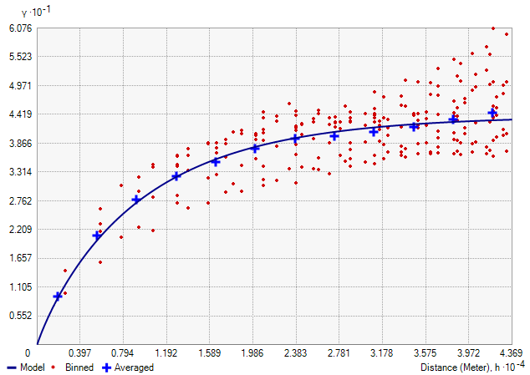

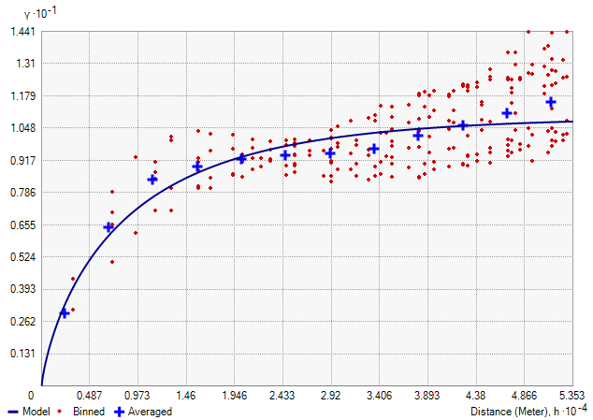

**Figures 4&5:** Semivariograms from early August 2006. Top left: Day time and bottom right is night time. These figures were made larger for comparison to figures 7-12.

Daytime 2007-2009 Nighttime 2007-2009

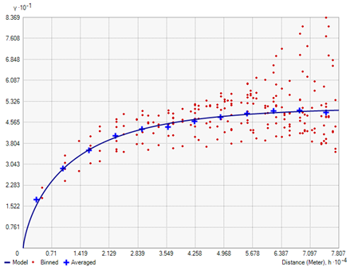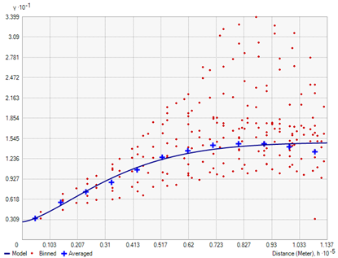

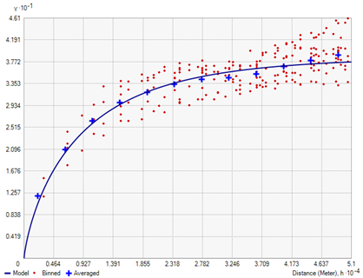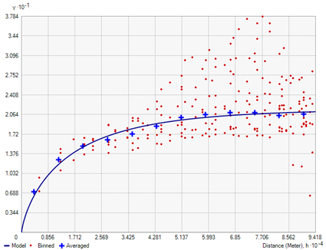

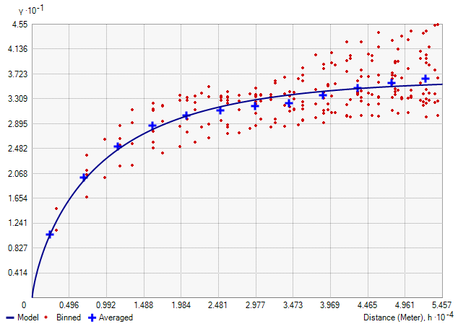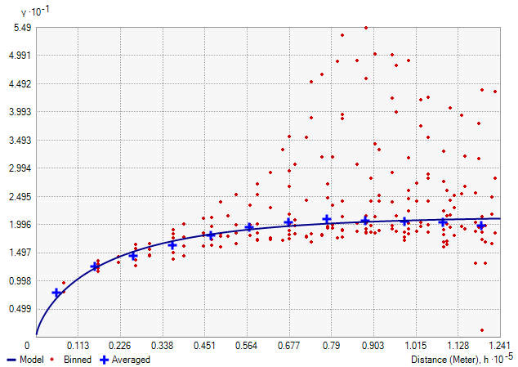

**Figures 6-11:** Semivariograms from early August 2007-2009. All figures were taken from days with little to no cloud cover (0 - 6.1%).

**Errors and Uncertainty**

LaSTMoV measures LST by census tract. LST is generally much higher than air temperature, so the output from LaSTMoV cannot be compared directly to weather station readings. It will only be useful in locating the hottest regions of the county, as well as trends in the data.

Even though Maricopa County is located in an arid region, there are cloudy days that have to be accounted for. LaSTMoV automatically generates a table for each day displaying the percent cloud cover by census tract; unfortunately, there is no mask to filter out clouds in the tiff images. The lack of a mask means that statistics are computed regardless of cloud cover, and the user must manually cross-reference each census tract with the cloud cover table to determine if the output is accurate.

Creating maps in near real-time proved impossible for the time being due to issues acquiring the MODIS imagery from OPeNDAP. The LPDAAC had two separate sites containing MODIS files. The main site using the OPeNDAP address generated NcML files but only to August 25 2013 at the time of writing this paper. A different site was found to have the most recent files but did not allow for the selection of a single band of MODIS data as the OPeNDAP site did.

**Future Work**

OPeNDAP is currently in the process of beta-testing. When the interface has been finalized, it will be possible to use OPeNDAP to generate near real-time heat vulnerability maps. The first term of Arizona Health & Air Quality performed several statistical analyses, which we were unable to incorporate into our script due to time constraints. Additionally, we were unable to incorporate the locations of the heat relief centers maintained throughout Maricopa County by the MCDPH or the CASPER survey data on air conditioning use in different communities. Future work may also involve creating a cloud mask for the MODIS imagery.

# V. Conclusions

Initially, the primary goal of this project was to automate the processes that were developed in the first term. We were able to complete a fair portion of the automation process with LaSTMOV. One item that our final product lacked was the analysis of the CASPER survey data which generated AC use statistics. As mentioned earlier, connection to the OPeNDAP server for near real-time data was not viable for this term of the project. This difficulty arose due to the lack of near real-time data on OPeNDAP; however, it is possible that near real-time data could be incorporated into LaSTMoV in the future as OPeNDAP continues to develop.

With the LaSTMoV software innovations the user is now able to easily organize and run batch analysis of large sets of compiled MODIS LST files starting from the HDF file form. The user has the freedom to explore the data appended to the Census.dbf file in ArcMap or Excel. The user also has the ability to see which days were affected by clouds with the output of a percent clouds csv file. Since any future statistical analysis will be hindered by cloud cover, the percent clouds csv allows the user to examine the feasibility of including a given day for statistical analyses.

Semivariograms produced for the city of Phoenix, AZ and the surrounding metropolitan areas may show more statistical significance in discovering LST spatial consistency or inconsistency when looking at urban heat islands. There will be more influence on what factors the built environment places on heat retention as opposed to the surrounding geographic relief. Areas with more infrastructure closer the city center will retain higher values for heat than the fringe and urban sprawl that surrounds the city. Thus, depicting a much smaller range in relation to the size of the area studied.

# VI. Acknowledgments

* Kate Goodin (Maricopa County Department of Public Health)
* Dave Hondula (Arizona State University)
* Dr. Kenton Ross (NASA DEVELOP National Program)
* Lance Watkins (Arizona State University)

Any opinions, findings, and conclusions or recommendations expressed in this material are those of the author(s) and do not necessarily reflect the views of the National Aeronautics and Space Administration.

This material is based upon work supported by NASA through contract NNL11AA00B and cooperative agreement NNX14AB60A.

# VII. References

Golden, J.S., Hartz, D.H., Brazel, A, et al. 2008,.“A biometeorology study of climate and heat-related morbidity in Phoenix from 2001 to 2006.” International Journal of Biometeorology, v. 52, p. 471-480, doi: 10.1007/s00484-007-0142-3.

Grossman-Clarke, S., Zehnder, J.A., Loridan, T, et al. 2010. “Contribution of Land Use Changes to Near-Surface Air Temperatures during Recent Summer Extreme Heat Events in the Phoenix Metropolitan Area.” American Meteorological Society 49 (August): 1649-1664.

Hardegree, Lynn C. 2006. “Spatial Characteristics of the Remotely-Sensed Surface Urban Heat Island in Baton Rouge, LA: 1988-2003.” PhD diss., Louisiana State University.

Harlan, S.L., Brazel, A.J., Prashad, L., et al., 2006, “Neighborhood microclimates and vulnerability to heat stress.” Social Science & Medicine: v. 63, p. 2847-2863.

Harlan, S. L., Declet-Barreto, J. H., Stefanov, W. L., & Petitti, D. B. 2012. “Neighborhood effects on heat deaths: social and environmental predictors of vulnerability in Maricopa County, Arizona.” Environmental health perspectives, v. 121, no. 2, p. 197 - 204.

Maricopa County Department of Public Health: Division of Disease Control: Office of

Epidemiology (MCDPH). 2014. “Heat-Associated Deaths in Maricopa County, AZ.” Final Report for 2013. Accessed February 2016. http://www.maricopa.gov/publichealth/Services/EPI/pdf/heat/2013annualreport.pdf

McMichael AJ, Wilkinson P, Kovats RD, Pattenden S, Hajat S, Armstrong B, et al. 2008. “International study of temperature, heat and urban mortality: the ‘ISOTHURM’ project.“ Int J Epidemiol 37:1121–1131.

Scott, Sheridan C., Kalkstein, Laurence S. 2004. “Progress in Heat Watch-Warning System Technology.” *American Meteorological Society* 85, no. 12 (June): 1931-1941. Accessed February 11, 2016. http://dx.doi.org/10.1175/BAMS-85-12-1931

ESRI. "Modeling a Semivariogram." *Geostatistical Analysis*. Web. 01 Mar. 2016.

# VIII. Content Innovation

Glossary Viewer

Inline Material

VPS