**NASA DEVELOP National Program**

****USGS at Colorado State University

**Fall 2016**

**Short Title: Ethiopia Disasters**

**Subtitle:** Utilizing NASA Earth Observations to Assess Agricultural Drought Severity in Ethiopia and Provide a Tool for Monitoring Drought at the Regional Level

**VPS Title:** Drought, no Doubt: Assessing Agricultural Drought Severity in Ethiopia

**Project Team & Partners**

**Project Team:**

Amandeep Vashisht (Project Lead), amandeep.vashisht@colostate.edu

Sarah Carroll

Rebecca Girma

Bethlehem Astelle

Cara Steger

**Other Contributors:**

Brian Woodward

**Advisors & Mentors:**

Dr. Paul Evangelista (Colorado State University, Natural Resources Ecology Lab)

Amanda West (Colorado State University, Natural Resources Ecology Lab)

**Partner Organizations:**

|  |  |  |  |
| --- | --- | --- | --- |
| **Organization** | **POC (Name, Position/Title)** | **Partner Type** | **Boundary Org?** |
| US Department of State Office of Space and Advanced Technology (OES/SAT) and Humanitarian Information Unit (HUI) | Dr. Melinda Laituri, Director of Secondary Cities Project | End-User | Yes |
| Mekelle University, Institute of Geo-Information and Earth Observation Sciences (I-GEOS) | Dr. Daniel Teka, Director | End-User | No |
| USGS, North Central Climate Science Center | Dr. Gabriel Senay, Research Physical Scientist | Collaborator | No |

**Project Details**

**Applied Sciences National Applications Addressed:** Disasters

**Study Area:** Amhara and Oromia, Ethiopia

**Study Period:** January 2006 – August 2016

**Earth Observations & Parameters:**

Terra and Aqua, Moderate Resolution Imaging Spectroradiometer (MODIS) – Vegetation Index and Land Surface Temperature

Tropical Rainfall Measuring Mission (TRMM) – Rainfall

Global Precipitation Measurement (GPM) Integrated Multi-satellite Retrievals for GPM (IMERG) –Rainfall

Soil Moisture Active Passive (SMAP) – Land Surface Soil Moisture

Shuttle Radar Topography Mission (SRTM) – Elevation

**Ancillary Datasets Utilized:**

* Climate Hazards Group CHIRPS – Precipitation
* Central Statistical Agency of Ethiopia Annual Agricultural Sample Survey data – Crop yield and administrative boundaries
* USGS Famine Early Warning Systems Network (FEWS NET) – Evapotranspiration anomaly and Rainfall estimates
* NASA SERVIR Landcover Scheme- Ethiopia land cover classification

**Software Utilized:**

* Exelis ENVI – Classification of Landsat imagery and raster analysis
* ESRI ArcGIS – Raster manipulation/analysis, map creation
* R – Raster compositing, index calculation, statistical comparisons
* Google Earth Engine – Raster compositing and downloading

**Project Overview**

**80-100 Word Objectives Overview**

El Niño weather patterns in 2015 and early 2016 have caused severe agricultural drought and food insecurity in many parts of Ethiopia, and humanitarian relief efforts are often influenced by administrative boundaries rather than conditions on the ground. Utilizing Earth observations, this project developed a drought index to analyze drought duration, extent and severity on a regional scale from 2006 to 2016. The team mapped hotspots of severe drought to provide a decision support tool for aid allocation and drought mitigation efforts. Finally, tutorials were created to build capacity in partner organizations to monitor drought in the future.

**Abstract:**

Ethiopia has been affected by several droughts over the last few decades, with the latest 2015 drought being the worst in half a century. Agriculture, being the predominant sector of the country’s economy, is rain-fed and is therefore most susceptible to droughts. Developing a remotely sensed tool can help in reliable detection of drought. This project implemented a scaled drought index utilizing NASA’s Aqua and Terra Moderate Resolution Imaging Spectroradiometer (MODIS), Tropical Rainfall Measuring Mission (TRMM) and Global Precipitation Measurement (GPM) Integrated Multi-satellite Retrievals for GPM (IMERG) data to assess agricultural drought and its spatio-temporal characteristics at a regional scale over the last 10 years. The index maps and decision support tools were provided to the project partners to supply timely information for humanitarian aid, and to build their capacity to monitor droughts in the future.

**Keywords:**

Drought Index, agriculture, remote sensing, precipitation, Land Surface Temperature, NDVI, SDCI

**Community Concerns:**

* In 2015, extreme El Niño weather patterns resulted in the worst drought in Ethiopia in half a century. The drought is still ongoing and over 10 million people are in need of emergency food assistance due to widespread crop failures, primarily throughout the central and northern part of the country.
* La Niña in the latter part of 2016 could further result in extreme weather and suppress rainfall in different parts of the country.
* Information on duration, location, and severity of drought is necessary to direct response efforts and humanitarian aid.

**Current Management Practices & Policies**:

In Ethiopia, locations impacted by drought are often determined by administrative boundaries, which may not necessarily represent actual environmental conditions. Even though I-GEOS is establishing an Earth Observation Center (EOC) that will be focused on the application of remotely sensed data, they currently have limited institutional and technical resources to monitor the ongoing drought to be able to mitigate its impacts. This organization has utilized some NASA Earth observations in the past, but never for drought assessment.

**Decision Support Tools & Benefits:**

|  |  |  |  |
| --- | --- | --- | --- |
| **End-Product** | **Earth Observations Used** | **Benefit & Impact** | **Software**  **Release** |
| Aggregated Evapotranspiration Anomaly Map for the Region | Aqua and Terra MODIS | Aggregated Monthly ET anomalies analyzed will help in selecting locations of severe drought. | I |
| Agricultural Drought Index Maps | Aqua and Terra MODIS, TRMM, GPM IMERG, SMAP | Time-series of drought index maps will provide information on drought extent, intensity, duration and severity. SMAP was used to validate the map results. | I |
| Tutorial | Aqua and Terra MODIS, SMAP, TRMM, GPM IMERG | The tutorial will teach our partners how to select drought-impacted study area, and to follow our methodology to analyze drought severity in other areas. | I |

**Project VPS/Booklet Imagery**

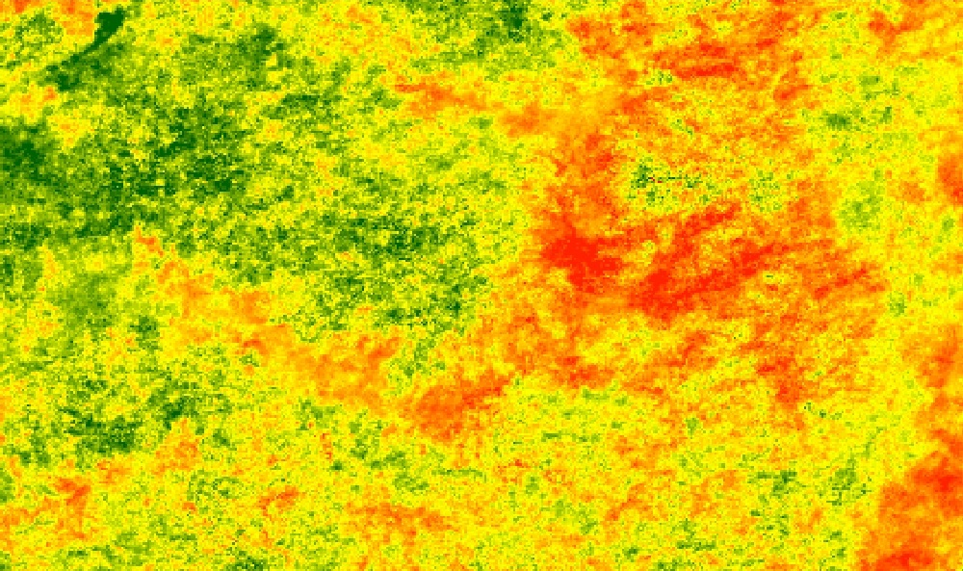

**Caption**: MODIS and TRMM data were integrated to form a seasonal drought index to analyze drought extent, duration and severity. Image Credit: Ethiopia Disasters team.

**Image**: 2016Fall_FC_EthiopiaDisasters_VPSImage.jpg