Bhutan Water Resources III

Analyzing Forest Disturbances and Climate Data in Bhutan to Create a Tool for assisting the Himalayan Environment Rhythm Observation and Evaluation Systems (HEROES) Project

 **Technical Report**

Final – August 12th, 2021

Tashi Choden (Project Lead)

Kinley Dorji

Yeshey Seldon

Sherab Dolma

***Advisors:***

Timothy Mayer (NASA SERVIR Science Coordination Office)

Caily Schwartz (NASA SERVIR Science Coordination Office)

Sean McCartney (NASA Goddard Space Flight Center)

Joseph Spruce (Consultant to Science Systems & Applications, Inc., Diamondhead, MS)

Dr. Kenton Ross (NASA Langley Research Center)

Dr. Jeffrey Luvall (NASA Marshall Space Flight Center)

Dr. Robert Griffin (The University of Alabama Huntsville)

***Previous Contributors:***

Deki Namgyal

Tenzin Wangmo  
Sonam Dorji

Tashi Kaneko

# 1. Abstract

Forest disturbances from bark beetle outbreaks are a major concern in Bhutan, known to cause extensive tree mortality to pine and spruce forests. The NASA DEVELOP team partnered with the Ugyen Wangchuck Institute of Conservation and Environmental Research (UWICER), the Bhutan Foundation, and the Karuna Foundation to assess forest changes for the districts of Bumthang and Haa from 2000 to 2018. The project used preprocessed meteorological data from the Climate Hazards Center Infrared Precipitation with Station (CHIRPS) and Famine Early Warning System Network Land Data Assimilation System (FLDAS), along with Landsat 5 Thematic Mapper (TM), Landsat 7 Enhanced Thematic Mapper plus (ETM+), and Landsat 8 Operational Land Imager (OLI) to assess apparent forest disturbance occurrences and observed climate trends. Shuttle Radar Topography Mission (SRTM) was used to resolve variations in elevation and slope for mountainous regions. Using the Google Earth Engine LandTrendr (LT) code algorithm, along with Landsat and STRM data, the team developed an app called Forest Disturbances Detection Toolbox (FDDT) to assess forest changes in Bhutan. The app includes climate variables for the focus districts, along with LT variables, which allows the end users to further examine the cause of disturbances. The team compared geocoordinates for known disturbances with LT disturbance detection products. Although additional work is needed in the future to validate the project end products from the FDDT, the tool will be provided to the project partners to aid forest management efforts in Bhutan.

**Key Terms**

forest disturbance, climate variability, vegetation phenology, Landsat data, remote sensing, LandTrendr, Google Earth Engine

# 2. Introduction

***2.1 Background Information***

Bhutan is well-renowned for its efforts to remain as the only carbon-negative country in its fight against climate change. Being geographically located in the Himalayas, however, renders the nation vulnerable because of higher warming trends (compared to global average) and extreme changes in altitude over short distances (Shreshta & Erikson, 2009). The majority of the residents reported having experienced rising temperatures and observed changes in rainfall and snowfall patterns. Land degradation as a result of natural or anthropogenic creations poses a serious threat to temperate forest areas (Chhogyel, 2020). Between 1992 and 2008, five incidences of pine dieback were observed along the Paachu-Wangchu Valley, which were related to dry growing conditions (e.g., higher temperature and lower rainfall). There were outbreaks of bark beetle in spruce forests, increased incidence of mistletoe infestation, and moisture-stress–related problems in blue pine forests (UNDP, 2016). A decrease in area of 6.2% for blue pine forest was observed from 2005 to 2017 due to change in land cover, bark beetle infestation, forest fire, construction, and other causes (Wangchuk, 2017). Moreover, threats from bark beetle infestations contribute to forest disturbances resulting in tree mortality, increased felling, and migration of lower elevation tree species towards higher altitudes (Ramachandran & Roy, 2018).

The project discussed herein is the final term of a three-term project. The first term of the project assessed trends in climate variables such as precipitation, temperature, and phenology for three focus districts: Gasa, Thimphu, and Chhukha. These regions were chosen due to their variation in topography and climate. Phenological trends in term one was analyzed within Bhutan from 2000 to 2017 using NASA’s Moderate Resolution Imaging Spectroradiometer (MODIS) phenology products and meteorological trends were analyzed from 1996 to 2017 using ancillary datasets such as Climate Hazards Center InfraRed Precipitation with Stations (CHIRPS) and Famine Early Warning System Network Land Data Assimilation System (FLDAS). A comparative analysis was performed to see if there was a correlation between the satellite and ground data from meteorological stations in the three focus districts. The second term employed preprocessed phenology-derived satellite products from the Advanced Very High-Resolution Radiometer (AVHRR) and MODIS to assess trends in vegetation phenology, and trends in climate looking at precipitation from CHIRPS and temperature from FLDAS for the entire country over a 40-year period (1981-2020). Utilizing data on meteorological trends, the current term project was conducted to assess forest disturbances in the focus districts of Bumthang and Haa which have known bark beetle infestations. The LandTrendr (LT) algorithm implemented in Google Earth Engine (GEE) was used along with Landsat data to assess forest changes, the duration of disturbance, and the rate of recovery for 1984-2020.

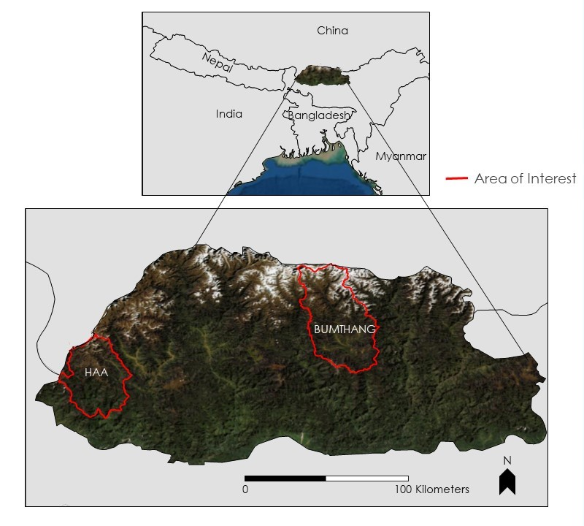

*Figure 1*. Study area map, Landsat true color image of Bhutan with outlined areas of interest.

***2.2 Project Partners & Objectives***

This project was conducted in collaboration with the Ugyen Wangchuck Institute for Conservation and Environmental Research (UWICER), the Karuna Foundation, and the Bhutan Foundation. These organizations are cooperatively working on the Himalayan Environmental Rhythm Observation and Evaluation System (HEROES) project, a school and community-based citizen science initiative to monitor climate change and its impact on the Himalayan Mountain ecosystem. Projects within UWICER examine climate change impacts on ecosystems through satellite imagery and modeling. UWICER bases its project support decisions on the goals outlined in the 12th Five Year Plan for Bhutan and strives to foster better stewardship of Bhutan’s natural resources–land, water, air, and wildlife. The Karuna Foundation contributes to the pressing issues of climate mitigation and adaptation in the vulnerable Himalayan region including Bhutan. It will also help to promote the NASA-Bhutan STEM engagement through its initiative of funding the HEROES project. The Bhutan Foundation works and supports efforts to build Bhutanese capacity and serve the Bhutanese people in sharing the principles of Gross National Happiness. Since the Bhutan Foundation works extensively with Civil Society Organizations (CSOs) and government ministries, they can disseminate project results to many branches of government as well as CSOs operating in the country. Overall, this project will expand educational outreach and help raise awareness for climate change mitigation.

The main objective of this project was to identify and assess areas with forest damage from bark beetle infestations, tree mortality, and forest recovery in the areas of interest. The team incorporated pre-processed climate and phenology data to create a reliable GEE-based forest assessment tool called the Forest Disturbances Detection Tool (FDDT) to monitor forest change within Bhutan. The primary benefit of the project for the end user includes access to the FDDT for compiling project-relevant maps to view, assess, and monitor changes in climate, vegetation, and forest health conditions across multi-year periods. The tool can contribute to the HEROES project by providing timely, consistent, actionable data to monitor changes to climate and adapt to its impact on the ecosystem. Furthermore, we produced a tutorial briefly describing the GEE tool to allow the partners to use it more effectively.

# 3. Methodology

***3.1 Data Acquisition***

Precipitation data from CHIRPS and temperature data from FLDAS were made available from the previous terms’ results. This term, Landsat 5 Thematic Mapper (TM), Landsat 7 Enhanced Thematic Mapper Plus (ETM+), and Landsat 8 Operational Land Imager (OLI) were used along with ground data from our partner, UWICER. Landsat imagery was accessed in GEE using the LT algorithm for the period of 2000 to 2018 (Figure 2). Shuttle Radar Topography Mission (SRTM) data was collected in GEE.

​

*Figure 2*. Methodology flow chart.

***3.2 Data Processing***

The team created an application called Forest Disturbance Detection Toolbox (FDDT) using the LT algorithm in GEE discussed by Kennedy et al. (2018). End users that access the application can see LT results of the variables (magnitude, duration, rate, prevalence, and year of detection) in a histogram which can help in trend analysis, correlation, and assist in creating maps. The ground data included 15 geo-coordinates of the locations of known disturbance, 5 in Haa and 10 in Bumthang. SRTM was used to help resolve variations in elevation and slope for mountainous regions. To better understand the forest disturbances in the focus districts, the team used the LT tool to analyze trends and identify potential forest mortality/disturbance in known bark beetle outbreak areas. Roughly based on the LT output, Figure 3 shows a schematic temporal profile of a vegetation index time series for disturbed vegetation. The black line represents the segments, and the red dots represent the vertices between segments (i.e., observation point in time). Given such segments and vertices, the temporal duration can be calculated for each segment and spectral magnitude can be calculated for each vertex. Given cloud-free data across the time series, such LT attributes enable users to summarize and query when changes in a vegetation index occurs and how frequently they occur (Kennedy et al., 2018). The schematic profile in Figure 3 shows an example where the initial prevalent value is followed by a downward spike associated with a disturbance and ending with a comeback/recovery from the start year to the end year.

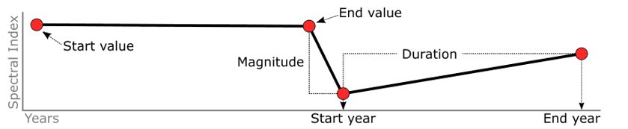

*Figure 3.* Diagram of segment attributes. Image provided by collaborators at NASA SERVIR.

To analyze the forest cover stability and change within the focus districts, we evaluated the five LT variables including magnitude, duration, rate, prevalence, and year of detection (see section 4.1 for further discussions). These LT variables in our project employed the Normalized Difference Vegetation Index (NDVI) as the spectral index. In order to obtain the best possible results, a different set of values for the LT algorithm parameters were tested. The highly sensitive model run was based on guidance from the Kennedy et al. (2018) paper. The LT input parameter settings used for the analysis of our project as shown below in Table 1. For the ground data, the given geo-coordinates were imported as a shapefile in ArcMap overlayed on top of the LT magnitude result to assess LT parameter products for areas with potential forest disturbance (Table 2).

*Table 1.*

*Parameters to filter vegetation changes*

|  |  |  |  |
| --- | --- | --- | --- |
| Parameter | Filter | Filter | Filter |
| delta: | loss | - | - |
| sort: | greatest | - | - |
| year: | checked: true | Start: startYear | End: endYear |
| mag: (Magnitude) | checked: true | value: 150 | operator: > |
| dur: (Duration) | checked: true | value: 19 | operator: < |
| preval: (Prevalence) | checked: true | value: 150 | operator: > |
| mmu | checked: true | value: 3 | - |

*Table 2.*

*Collection parameters representing a summary of background information about the project. Beginning year and ending year refer to the data collection time frame of the LandTrendr variables.*

|  |  |
| --- | --- |
| **Parameter** | **Value** |
| Beginning year | 2000 |
| Ending year | 2018 |
| Start day | Oct 31st |
| End day | May 31st |
| Area of interest | Haa & Bumthang |
| MaskThese | Cloud, shadow, snow, water |

***3.3 Data Analysis***

Through analysis of the LT algorithm and the code from previous terms, the team incorporated the areas of interest, Bumthang and Haa districts, into GEE as the defined study area to subsequently run the FDDT app. Once the latter runs, it displays a description box with some tips and tricks for using the tool, as well as the features that our team worked on. The way this tool works is that users do not have to work with any of the code, they only define the parameters on the interface and hit run. The panel to the left displays a dropdown menu for the NDVI LT variables for each area of interest and the legend section is located at the bottom left corner and the panel to the right shows the date slider along with the graph section beneath the slider (Figure 4).

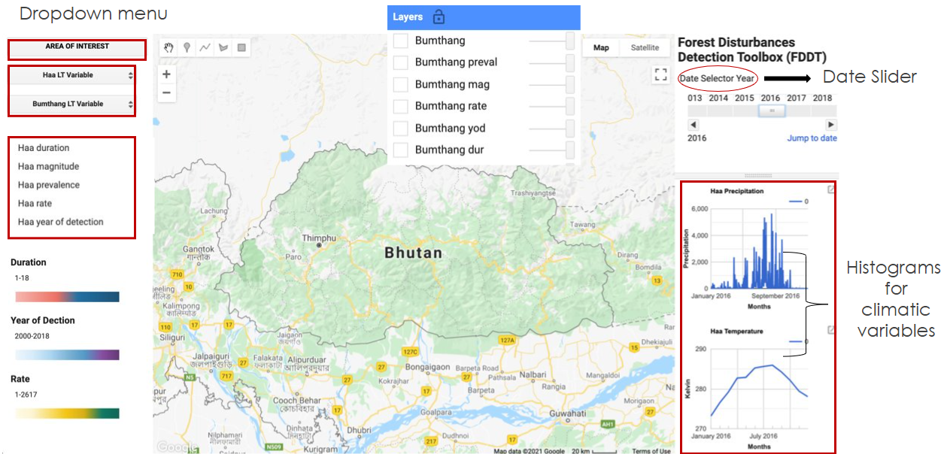

*Figure 4.* A screenshot of the FDDT App with its respective features.

Description of each FDDT feature:

* The *Date Selector Slider,* to the top right corner, allows the user to select a date or a year of interest to display the results for the variables. The years on the slider range from 2000-2018. Selecting a year from the slider generates a graph for each climatic variable for that particular year underneath the slider in the graph section.
* The *Graph Section,* to the bottom right, provides a visual representation of the climatic variables which includes temperature and precipitation of each district for which, as mentioned earlier, the data was collected utilizing the previous terms’ codes.
* The *Dropdown Menu* displays the options to select an LT variable for area of interest.
* The *Legend Section* displays the legend for the five LT variables.

After selecting an LT variable from the dropdown menu, the best-fit graph for the selected variable will be displayed in the bottom left panel in the chart display section. The graph displays the spectral values and the vertices indicating whether there are any disturbances for the selected region. The team used the geo-coordinates for known disturbances provided by UWICER and mapped those points to see if there were any disturbances observed spatially for the focus districts. The geo-coordinates assisted the team in understanding which areas had the most disturbances over the years.

# 4. Results & Discussion

***4.1 Analysis of Results***

***4.1.1 Magnitude***

After analyzing the ground data provided by the partners, the team was able to draw conclusions for each of the LT variables. The magnitude is defined as the spectral delta of a change event resulting in a lowered vegetation index value. With the magnitude product, spatially we looked at how big the spike (i.e., change) was for a given location and a given disturbance may have occurred across multiple, adjacent pixels. The yellow represents lower magnitude, orange represents medium-high magnitude, red represents high magnitude, and white represents no data. In Figure5for Bumthang, the orange pixels suggest that there was a relatively low magnitude event happening and that there was a sharp, abrupt decline in the vegetation index from the pre-disturbed versus immediate post disturbed vertex/date. Fifteen locations of ground data were displayed on the maps using a black circle; 5 being in Haa and 10 in Bumthang. The partners have determined these locations as places that have experienced forest disturbances related to bark beetle outbreaks. The in-situ data were then compared with the data observed from the LT analysis for the magnitude of land disturbance ranging from 1 to 378 (unitless). The circles denoting ground data fall on the colored pixels instead of the no data values, which suggests relationships can be drawn between the in-situ data and magnitude of land disturbance. While the disturbance magnitude is lower than the most extreme observed values, this seems reasonable for small patches of disturbed forest intermixed with adjacent green forested canopy cover. The more extreme magnitudes are typically associated with stand replacement disturbances such as clear-cuts and wildfires. Once bark beetle disturbances become more extensive and less intermixed with green, healthy vegetation, then the magnitude (i.e., decline in the observed vegetation index) would become more pronounced.

*Figure 5.* Magnitude of decline (unitless) in the observed vegetation index for most disturbed versus pre-disturbed state with geo-coordinates for known locations of disturbance overlain. The color scale demonstrates a range from light green (with a minimum unit of 1, depicting little change in NDVI over the entire study period 2000 through 2018), to yellow, to orange, to red (with a maximum unit of 378, depicting a larger change in NDVI value during one or more change events in the study period).

***4.1.2 Duration***

Duration is the number of years a forest damage change event took to transition from a disturbed to a recovered state in which the forest is no longer disturbed. LT was run for 18 years across the time series of Landsat data acquired for the project (2000 to 2018). Figure 6shows the duration of disturbance for the focus districts. For our project, not many of the disturbances were observed to have lasted for a long duration since the graph is slightly left skewed. Most of the duration values observed by the modeled output ranged from 6 to 8 years for the areas of interest. As clearly observed in the graph, longer durations were estimated for Haa as compared to Bumthang. In general, longer duration disturbances tend to be due to the more severe disturbance events. Forest stand replacement disturbances take longer for forest recovery to occur, compared to the ephemeral lower severity disturbances that only moderately damage the trees.

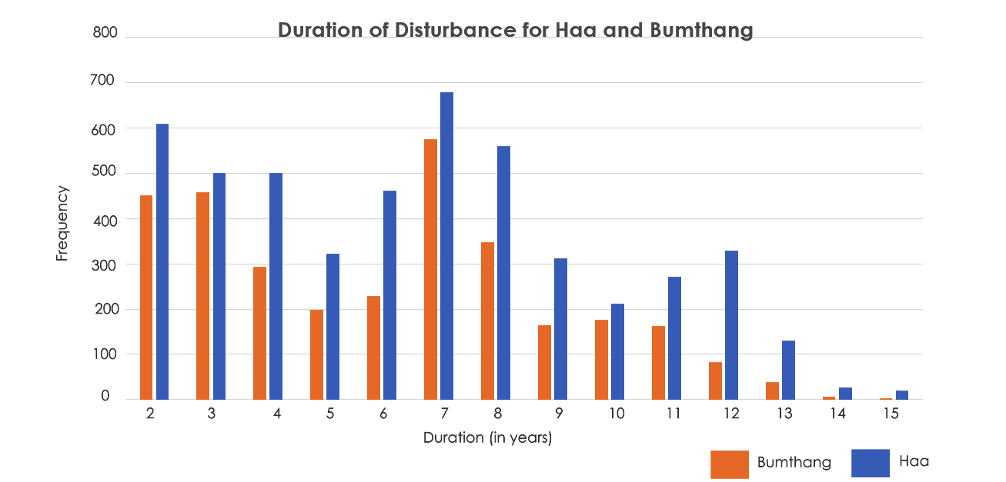

*Figure 6.* Duration of disturbances for focus districts.

***4.1.3 Rate***

The rate of a change event is defined as the magnitude divided by the duration. In Figure 7, as the color ramp changes from blue to beige to red, it represents an increase in rate across the two districts. The two districts have experienced a medium-to-high rate of change in certain areas, suggesting higher likelihood of forest disturbance.

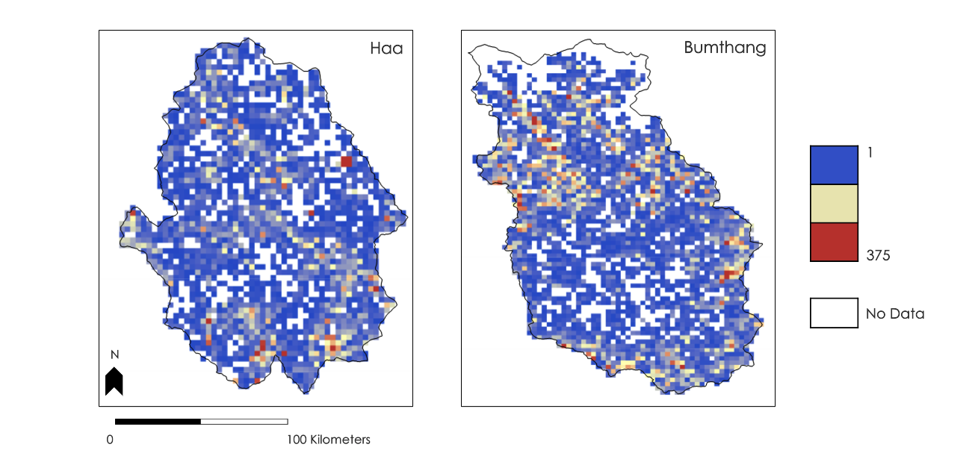*Figure 7*: Rates (Change in NDVI per year, or ratio of magnitude over duration). As the color scale changes from blue to beige to red-orange, the spectral values for rate increase i.e., 1-375. The color scale demonstrates a range from blue (with a minimum unit of 1, depicting lower rate of change and therefore lower likelihood of disturbance over the period 2000 through 2018), beige, to red-orange (with a maximum unit of 375, depicting a higher rate of change and therefore higher likelihood of forest disturbance over the study period).

***4.1.4 Prevalence***

The prevalence is the pre-change spectral value before any major changes had occurred. In Figure 8, most of the observed prevalence values are low (teal), meaning these areas did not experience much change (i.e. the magnitude would also be small). Therefore, it is more likely they were less affected by disturbance. This could be due to lack of vegetation or steep topography preventing disturbance in some areas. The brown pixels represent a higher risk of disturbance, while teal pixels indicate a lower risk of disturbance.

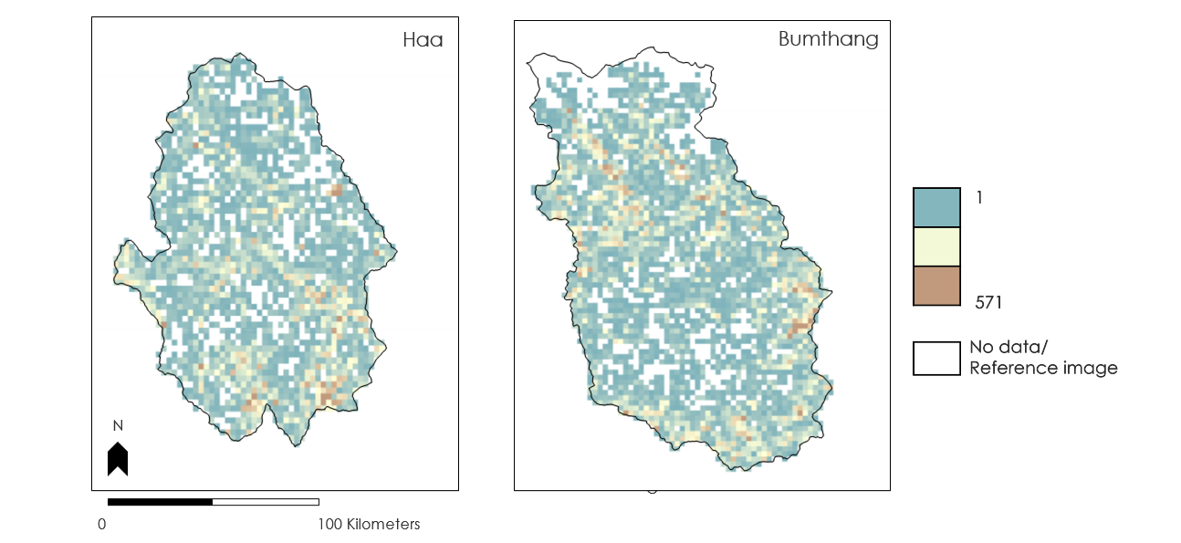

*Figure 8.* Prevalence (unitless) is given as the spectral vegetation index value before any major changes occurred. The color scale demonstrates a range from teal (with a minimum unit of 1, representing lower risk of disturbance), to beige, to brown (with a maximum unit of 571, representing potentials for higher risk for disturbances).

***4.1.5 Year of Detection***

The year of disturbance detection was computed with LT. The result shows that the disturbances were mainly in 2000 and 2001. In Figure 9, we can see that in 2000 and 2001, most of the forest disturbance areas were detected in Haa and decreased drastically. From 2002 to 2008, the disturbance detection was highly reduced, but a gradual increase in disturbances were detected again from 2010 to 2018.

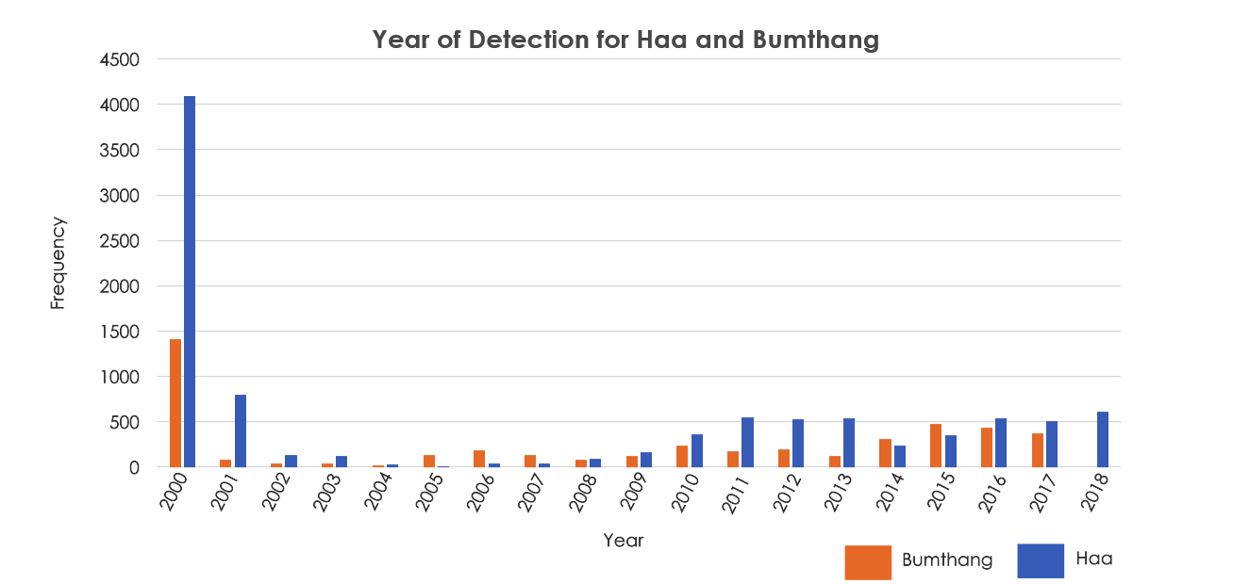

*Figure 9:* Year of detection from 2000 to 2018. Frequency is defined as the number of pixels.

***4.2 Limitations***

It is difficult to pinpoint if forest disturbance is specifically due to a single factor (i.e., determination of causal agent) since there may be multiple possible singular or co-occurring forest damage inducing factors involved such as climate variability, bark beetle outbreaks, and droughts. Trees experiencing droughts or dry conditions may lose the ability to fight bark beetle attacks, resulting in their deaths or predisposing trees to increased damage from dwarf mistletoe. The worst vegetative decline in many cases might have been from other drivers, such as clear-cutting harvest in some spots, or fire, or something that caused a complete loss even of tree stems. Stand replacement disturbances cause decreases in the indices even more than the decline that happens from bark beetles killing small patches of trees. Also, the availability of cloud-free Landsat data is needed to find recent disturbances, though cloud-free data is not always available for when the bark beetles are actively damaging trees (e.g., during the more biologically active part of the growing season). Winter Landsat data may be good for detecting recent bark beetle damage but may be less useful for aiding early detection of new damage from bark beetles.

Forest recovery was observed in multiple locations where previous disturbances had occurred. It is challenging to detect and trace back disturbance due to late mortality symptoms and most of the affected areas being remote and inaccessible via roads. The topography is also a contributing factor affecting the detection of forest damage in the higher elevation forests of Bhutan. Topographic shadows can obscure the ability to see forest damage on Landsat imagery, though the parts of the data that are shadow free can be useful for identifying areas with forest damage. Due to time constraints, a limited amount of validation of the FDDT and disturbance mapping products from the tool was done. Limiting the assessment of forests to coniferous forests would help end users know which areas to consider for field surveys, since the bark beetles of concern only attack coniferous tree species. Masking out the broad-leaved forests and showing only the LT results for the coniferous forests would help in assessing the context of apparent disturbances on the FDDT/LT data products. It would also probably help to extend the time series to be more current (e.g., to 2021), given that there was good quality Landsat data collected in the early months of 2021 and that the supplied bark beetle survey points pertain to current or relatively recent tree mortality events.

***4.3 Future Work***

The project was only able to conduct a preliminary validation of the application at hand, including the computation of the products and the application of the products from the FDDT. Further testing and validation of the tool and its output products is needed to achieve optimal usage of the application. More work could be done with higher spatial resolution data like Sentinel-2 data at 10-meter spatial resolution and PlanetScope data at approximately 3-meter spatial resolution. The Sentinel-2 data also has spectral bands that might help for the early detection of forest damage. Also, there are efforts to use Landsat and Sentinel-2 data together in order to get more timely cloud-free imagery for times of the year when bark beetles are actively causing damage. Another Landsat mission (Landsat 9) is scheduled to be deployed soon, which would help to increase the availability of cloud-free data. Also, there are high temporal resolution multispectral satellite data that can be useful for regional monitoring of forest disturbances, such as Sentinel-3, VIIRS (Visible Infrared Imaging Radiometer Suite), and MODIS. The project results will be of use in future research by project partners (potentially including other projects being done by NASA SERVIR in support of Bhutan) in identifying early detection of tree dieback, measuring the extent of forest damage, and regularly monitoring to see if there’s bark beetle outbreak over the years. Any future related projects could also look at additional areas with coniferous forest disturbances in western and central Bhutan. Some of these other districts have been known to have occasional bark beetle issues as well.

# 5. Conclusions

The Bhutan Water Resources III team used Landsat time series data in conjunction with GEE and LT algorithm to develop a tool to assess trends in forest disturbances. The team developed the FDDT app to identify forest changes in Bhutan for the focus districts of Bumthang and Haa from 2000 to 2018. The app was used to compute mapping products for the selected LT forest disturbance variables and enabled zoomed in views on the LT output maps to display disturbances within the focus districts. The geo-coordinates for known locations of disturbances were provided by the end users and were useful for comparing to LT maps for disturbance detection and assessment.

The FDDT products showed negative magnitude of change for many of the bark beetle survey points, though the magnitude was less than that of the more severe apparent forest disturbances, such as those due to harvesting and wildfire. The magnitude of observed detected disturbances tended to be relatively low compared to the most severe disturbances and there was a sharp decline at the point of being disturbed. The modeled output captured a higher duration for Haa in comparison to Bumthang. Most of the duration values observed by the modeled output ranged from 6 to 8 years for the areas of interest. The year 2000 observed some big spikes suggesting major disturbances, though more work is needed to confirm if this finding is real or else due to Landsat data quality issue. Both districts have experienced a medium-high rate which has more probability of forest disturbance.

It is important to note that LT primarily detects disturbance and does not determine which factor is specifically driving these disturbances. Also, LT depends on cloud-free inputs of Landsat data. Unmasked clouds and snow could reduce the performance of the LT modelled output products. Additional work is needed to validate the final products. The project’s FDDT will be provided to project partners in aiding forest management efforts in Bhutan. The use of Earth observations will help end users and decision makers to assess trends within the country and make informed decisions for the local communities.

# 6. Acknowledgments

The team would like to acknowledge the following individuals for their influence in our work: Timothy Mayer (NASA SERVIR Science Coordination Office), Caily Schwartz (NASA SERVIR Science Coordination Office), Sean McCartney (Science Systems & Applications, Inc., NASA Goddard Space Flight Center), Joseph Spruce (Consultant to Science Systems & Applications, Inc., Diamondhead, MS), Dr. Kenton Ross (NASA Langley Research Center), Dr. Jeffry Luvall (NASA Marshall Space Flight Center), Dr. Robert Griffin (The University of Alabama Huntsville), and A. R. Williams (NASA DEVELOP Fellow).

# 7. Glossary

**AVHRR** – Advanced Very High-Resolution Radiometer

**CHIRPS** – Climate Hazards Group InfraRed Precipitation with Station data

**FDDT** – Forest Distrubances Detection Toolbox

**FLDAS** – Famine Early Warning Systems Network (FEWS NET) Land Data Assimilation System

**GEE** – Google Earth Engine

**HEROES** – Himalayan Environmental Rhythm Observation and Evaluation System

**LT** – LandTrendr

**MODIS** – Moderate Resolution Imaging Spectroradiometer

**NDVI** –Normalized Difference Vegetation Index

**UWICER** – Ugyen Wangchuck Institute for Conservation and Environmental Research

# 8. References

Chhogyel, N., Kumar, L., & Bajgai, Y. (2020). Consequences of climate change impacts and incidences of extreme weather events in relation to crop production in Bhutan. *Sustainability, 12*(10), 4319. https://doi.org/10.3390/su12104319.

Climate Hazards Group InfraRed Precipitation with Station Data (CHIRPS): https://www.chc.uscb.edu/data/chirps

Famine Early Warning Systems Network (FEWS NET) Land Data Assimilation System (FLDAS): https://ldas.gsfc.nasa.gov/fldas

Kennedy, R. E., Yang, Z., Gorelick, N., Braaten, J., Cavalcante, L., Cohen, W. B., & Healey, S. (2018). Implementation of the LandTrendr algorithm on Google Earth Engine. *Remote Sensing, 10*(5), 691. https://doi.org/10.3390/rs10050691

Ramachandran, R. M., & Roy, P. S. (2018). *Vegetation response to climate change in Himalayan hill ranges: a remote sensing perspective.* Plant Diversity in the Himalaya Hotspot Region.

Shreshta, A. B., & Erikson, M. (2009). *Climate change in the Himalayas*. http://www.nbc.gov.bt/wp-content/uploads/2011/05/Draft-national-paper-on-biodiversity-persistence-and-climate-change.pdf

Wangchuk, S. (2017). *The management of blue pine (pinus wallichiana) in the temperate conifer forests of Bhutan.* https://www.researchgate.net/publication/321265773_THE_MANAGEMENT_OF_BLUE_PINE_PINUS_WALLICHIANA_IN_THE_TEMPERATE_CONIFER_FORESTS_OF_BHUTAN_A_Report_Submitted_to_Asst_Prof_Damrong_Pipatwattanakul_Ph_D_as_part_of_the_learning_experience_and_in_fulfilme

UNDP (United Nations Development Programme). 2016. *Enhancing Sustainability and Climate Resilience of Forest and Agriculture Landscape and Community Livelihoods in Bhutan*. New York: UNDP. https://www.bt.undp.org/content/bhutan/en/home/projects/napa-iii.html