**NASA DEVELOP National Program**

****NASA Goddard Space Flight Center

**Spring 2016**

**Short Title: Great Lakes Ecological Forecasting**

**Subtitle:** Utilizing Earth Observations to Monitor and Forecast the Spread of *Phragmites australis* in the Great Lakes Basin

**VPS Title:** Bogged Down in Phragmites: Assessing Risk in the Great Lakes Basin

**Project Team & Partners**

**Project Team:**

Carl Issac Kinton (Project Lead), carl.i.kinton@nasa.gov

Peter Jacobs

Sean McCartney

**Advisors & Mentors:**

Dr. Laura Bourgeau-Chavez (Michigan Tech Research Institute)

Dr. Kurt Kowalski (USGS Great Lakes Science Center)

**Partner Organizations:**

Great Lakes and St. Lawrence Cities Initiative (Collaborator), POC: Laura Bretheim, Simon Belisle; Boundary Organization

Michigan Tech Research Institute (Collaborator), POC: Laura Bourgeau-Chavez

**Project Details**

**Applied Sciences National Application Addressed:** Ecological Forecasting

**Study Area:** Great Lakes Basin: United States (MN, WI, MI, IL, IN, OH, PA, NY) and Canada (Ontario, Quebec)

**Study Period:** June 1985 – June 2020

**Earth Observations & Parameters:**

SRTM, IFSAR - Digital Elevation Model

TRMM, TMI - Precipitation

GPM, GMI - Precipitation

**Ancillary Datasets Utilized:**

* Natural Resources Canada, Earth Sciences Sector - land cover
* NOAA Coastal Change Analysis Program (C-CAP) - land cover
* Michigan Tech Research Institute (MTRI) - field sites
* Global Biodiversity Information Facility (GBIF) - field sites
* Esri North America Detailed Streets - streets
* Agriculture and Agri-food Canada, The National Soil Database (NSDB) - soil classifications
* USDA Natural Resource Conservation Service (NRCS) State Soil Geographic (STATSGO)

Soils- soil classifications

* Modern-Era Retrospective Analysis for Research and Applications (MERRA 2) - climatic temperature

**Models Utilized:**

* TerrSet Geospatial Monitoring and Modeling System Land Change Modeler
* TerrSet Geospatial Monitoring and Modeling System Habitat and Biodiversity Modeler
* Maximum Entropy for Habitat Suitability Modeling (MaxEnt)

**Software Utilized:**

ArcGIS - raster manipulation/analysis, image enhancement & map creation

CDO – netCDF manipulation/analysis

Panoply – netCDF map creation & animation

QGIS - raster manipulation/analysis, image enhancement & map creation

TerrSet - raster manipulation/analysis, forecast modeling of land change

MaxEnt - habitat suitability analysis and modeling

**Project Overview**

**80-100 Word Objectives Overview:**

This project explored the capability of using Earth observations and environmental modeling to monitor and forecast the extent of *Phragmites australis* in the Great Lakes Basin. Using a combination of environmental variables, land cover relevant for Phragmites extent was modeled from 1985 to 2010. Additionally, the team examined which driver variables were most correlated with Phragmites presence. Finally, the extent of Phragmites in the Great Lakes Basin was forecast to the year 2020 using modeled land cover changes and environmental drivers.

**Abstract:**

*Phragmites australis* is an invasive species that threatens wetland habitats in the Great Lakes and St. Lawrence River basin. Governments in both Canada and the United States recognize that Phragmites detection is a first line of defense in limiting the spread of this species. Left untreated, *Phragmites australis* outcompetes native regional wetland species, resulting in monotypic stands of invasive Phragmites. As a result, habitat for native fish and wildlife becomes unsuitable, fire risk grows, and elevation of the landscape increases due to an expansion of below-ground biomass, depriving wetlands of nutrients needed by native flora and fauna. Project goals included identifying relevant drivers of the extent of Phragmites and forecasting near-term Phragmites extent throughout the Great Lakes Basin. Research from this project will help the Great Lakes and St. Lawrence Cities Initiative in its goal to distribute Phragmites information to local policymakers in both the US and Canada. Earth observations (EO) utilized included Shuttle Radar Topography Mission (SRTM), Tropical Rainfall Measuring Mission (TRMM), and Global Precipitation Measurement (GPM). Ancillary datasets known to correlate with Phragmites were also used as model variables. Land use/land cover (LULC) maps were created using TerrSet Land Change Modeler. MaxEnt habitat suitability modeling used environmental variables and LULC classifications to forecast Phragmites habitat suitability extent through the year 2020. Forecasting results will help local governments enact policies to plan for and mitigate the spread of *Phragmites australis*. Challenges and limitations included finding an alternative to mapping Phragmites using radar data, and acquiring current LULC maps of the study area.

**Community Concerns:**

* *Phragmites australis* is an aggressive invasive freshwater or brackish-tidal wetland perennial grass.
* Phragmites easily outcompetes native plant species due to its ability to reproduce through seeds or underground rhizome clones.
* Phragmites can grow up to 15 ft. tall with up to 60 stems per sq. ft., displacing native marsh vegetation.
* Dense monotypic stands of Phragmites create unsuitable habitat for native fish or wildlife, increase fire risk, and increase elevation of the landscape.
* Once Phragmites is established in an area, it is difficult to eradicate.

**Current Management Practices & Policies**:

The Great Lakes and St. Lawrence Cities Initiative (GLSLCI) does not currently involve species modeling in their management decisions for the Great Lakes Basin, nor do they have a strong understanding of the current extent of *Phragmites australis* for the region. The GLSLCI also neglects to consider how the extent of Phragmites will change in the future. Current policies are carried out through an intergovernmental collaboration across cities, municipalities, states, and provinces. The Great Lakes Phragmites Collaborative was established to facilitate communication among stakeholders across the region and serve as a resource center for information on Phragmites biology, management, and research. Current inventories of Phragmites extent involve funding field crews to collect field data of known areas of invasion. Current management practices to eradicate *Phragmites australis* involve the use of herbicides, mowing, prescribed burning, flooding, tarping, and grazing.

**Decision Support Tools & Benefits:**

|  |  |  |
| --- | --- | --- |
| **End-Product** | **Earth Observations Used** | **Benefit & Impact** |
| Current Habitat Suitability Risk Map for *Phragmites australis* | SRTM IFSAR; TRMM TMI;  GPM GMI | Current risk map will provide the probabilistic extent of *Phragmites australis* throughout the Great Lakes Basin. This will allow city governments to plan and mitigate the impact of this invasive species within their jurisdiction. |
| Forecast Habitat Suitability Risk Map for *Phragmites australis* | SRTM IFSAR; TRMM TMI;  GPM GMI | Forecast maps for the year 2020 will help local and regional governments throughout the Great Lakes identify where *Phragmites australis* is likely to spread. This will allow city and regional governments to direct capital and resources in preventing the invasive species from establishing itself in these areas. |

**Project Imagery**

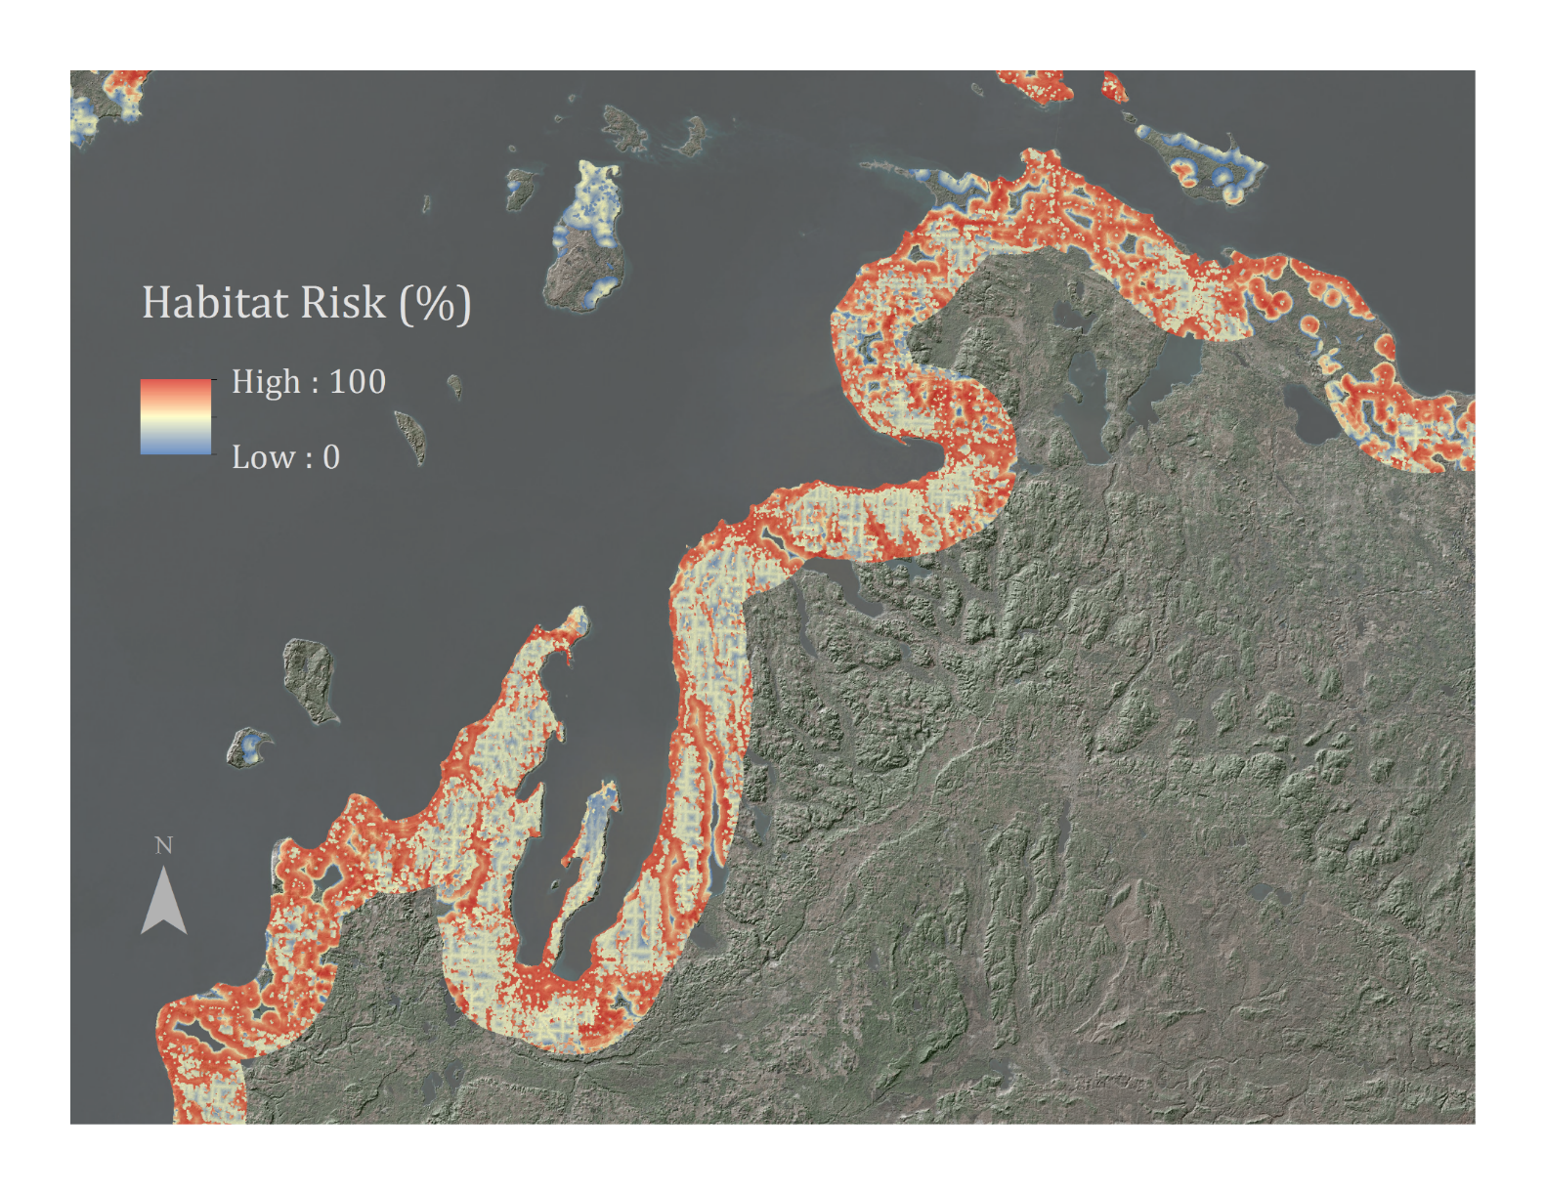

**Caption:** Utilizing Earth observations and habitat models to generate a suitability risk map for *Phragmites australis* in the coastal Great Lakes and St. Lawrence River Basin. Image Credit: Great Lakes Ecological Forecasting Team.

**Image:** 2016Spring_GSFC_GreatLakesEco_VPSImage_FD

**Software Release Requirements**

What category do the tools your project is creating fall within? Category I