**NASA DEVELOP National Program**



Wise County Clerk of Court’s Office

**Summer 2015**

**Short Title: Peru Disasters II**

**Subtitle:** *Utilizing NASA Earth Observations to Develop the Tools for Flood Risk Mitigation for the Ochape Sub-Basin in the La Libertad Region of Peru*

**VPS Title:** Don’t be Stressed, Test it with CREST!

**Project Team & Partners**

**Project Team:**

William Wilson (Project Lead), will.h.wilson@gmail.com

Grant Bloomer

Allison Daniel

Anthony Donzella

Josh Hammes

**Advisors & Mentors:**

Dr. Kenton Ross (NASA DEVELOP)

Dr. DeWayne Cecil (Global Science and Technology Inc.)

**Past or Other Contributors:**

Scott Arnette Sarah Medley

Jordan Bates Steve Padgett-Vasquez

Kieran Blakemore Azeb Shewago

Manzi Roger Dusabimana Catherine Steentofte

Abigail Holbrook Rohini Swaminathan

**Partner Organizations**

Water for People, End-User, POC: Mark Duey (Head of Program Quality) & Francisco Soto

Director of Peru Instituto Nacional de Defensa Civil del Peru (INDECI), POC:

**Project Details**

**Applied Sciences National Applications Addressed:**

Disasters

**Study Area:** Ochape sub-basin, Cascas District, Gran Chimu Province, La Libertad Region, Peru

**Study Period:** 2007 – 2014 (3 major floods identified during 2008, 2013 and 2014)

**Earth Observations & Parameters**

Landsat 8, OLI/TIRS - Evapotranspiration, Land Cover

SRTM - “”HydroSHEDS” DEM

TRMM - Near Real Time Tropical Rainfall Measuring Mission, Multi-satellite Precipitation

MODIS - Global Evapotranspiration Project (MOD16)

**Ancillary Datasets Utilized**

* SENAMHI– Weather station data

**Models Utilized**

* CREST - NASA/Oklahoma University Coupled Routing and Excess Storage Flood Model

**Software Utilized**

* ArcGIS - Raster Manipulation/Analysis, flood inundation map creation
* Python - Processing of bulk data
* CREST v2.1 – Hydrological modeling and simulation of spatial and temporal surface variations
* MATLAB – Numerical computation and data analysis

**Project Overview**

**80-100 Word Objectives Overview**

Peru’s diverse physical landscape leaves large segments of the population exposed to natural disasters. Heavy flooding, landslides, and mudslides in the rural highlands contribute largely to these figures. Reliable flood risk management plans are inadequate in this area. Water for People, a non-profit organization dedicated to providing clean water in developing countries, is currently working with the Peruvian government to develop a water budget and assist in flood- risk mitigation in the Cascas and Asuncion Districts. For this project, the NASA DEVELOP team in Wise, Virginia utilized NASA Earth Observation Systems to improve upon the resources necessary for a complete water budget and to provide a preliminary flood risk analysis.

**Abstract**

In recent years, natural disasters have devastated the rural regions of Peru. Large flooding events in 2008, 2013, and 2014 ravaged the central highlands districts, including the Cascas district of the Gran Chimu province about 110 km inland from the coastal city of Trujillo. The primary study area is the Ochape sub-basin near the City of Cascas, the capital of the Gran Chimu Province. In partnership with Water for People and the Instituto Nacional de Defensa Civil Del Peru (INDECI), this project aims to create resources and tools necessary for flood risk assessment projects in the Cascas District of Peru. NASA Earth observations were used in this project to provide input datasets for the Coupled Routing and Excess Storage (CREST) Distributed Hydrological Model which was jointly developed by the University of Oklahoma and NASA SERVIR. . These include Digital Elevation Models (DEM) and related data from the HydroSHEDS portfolio of NASA’s Shuttle Radar Topography Mission (SRTM) and rainfall data collected by Tropical Rainfall Measuring Mission (TRMM) and Landsat 8 imagery.. All final maps, models, datasets, and tutorials developed in this project will enable Water for People and the Peruvian government to better prepare for flooding based on historical examples.

**Community Concerns**

* Water for People, a non-profit organization, is currently working with the Peruvian government to establish better water resource management systems, while also assisting the Peruvian government in flood risk mitigation.
* Flooding greatly affects the agricultural sector, the largest source of income for Peru, contributing 13% of the Gross Domestic Product (GDP) and employing 10,000,000 Peruvians.
* Statistics compiled by the National Emergency Operations Center (COEN) show that between October 2014 and February 2015, natural disaster episodes claimed 6,344 lives and displaced another 77,534 individuals.

**Current Management Practices & Policies**

The National System for Management of Disasters (SINAGERD) tasks itself with crafting risk management policies that will help prevent and control future natural disasters. It operates in coordination with the National Centre for Strategic Planning (CEPLAN), Instituto Nacional de Defensa Civil del Peru (INDECI), and entities in the private sector. National regulations are disseminated to local Civil Defense committees, who adopt and tailor these guidelines to their respective administrative realms. Currently, Water For People is partnering with these local governments to develop water resources management plans. However, because of the lack of *in-situ* data, Water For People wishes to incorporate remotely sensed data from NASA Earth observations to help augment currently available *in-situ* data. In addition to underdeveloped water resource management plans, current flood disaster management plans are incomplete and there are not enough proactive plans to prevent widespread disaster. This project would assist local policy makers to develop stronger and research-backed efforts to manage floods.

**Decision Support Tools & Benefits**

|  |  |  |
| --- | --- | --- |
| **End-Product** | **Earth Observations Used** | **Benefit & Impact** |
| Flood Extent / Inundation Maps | TRMM  SRTM  Landsat 8 | Flood inundation maps will help show the expected extent of flooding and can be used to improve flood risk preparation, communication, response, and mitigation |
| Flood Modeling Method Graphs showing correlations b/w precip and streamflow etc. |  | Improved flood modeling without in situ data requirements. Flood forecasting at higher spatial and temporal resolutions |

**Project Imagery**

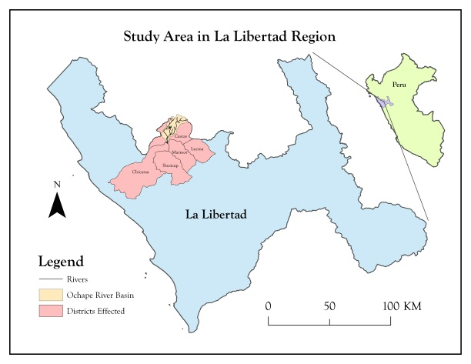

**Caption:** [Study area in the La Libertad Region.] Image Credit: [Josh Hammes, Peru Diasasters II Team]

**Image:** josh_studyarea.jpeg