Central Valley Water Resources II

Groundwater Sustainability Management Support using GRACE and InSAR Datasets

 **Technical Report**

Final Draft – November 18th, 2020

Kathleen Lange (Project Lead)

James Kitchens

Vanessa Valenti

Elizabeth Perez

***Advisors:***

Zhen Liu, Ph.D., NASA Jet Propulsion Laboratory, California Institute of Technology (Science Advisor)

Kyra Kim, Ph.D., NASA Jet Propulsion Laboratory, California Institute of Technology (Science Advisor)

John T. Reager, Ph.D., NASA Jet Propulsion Laboratory, California Institute of Technology (Science Advisor)

***Previous Contributors:***

Forrest Corcoran

Marissa Dudek

Patrick Saylor

# 1. Abstract

California’s Central Valley is one of the most productive agriculture regions in the United States, producing a fourth of the nation’s food supply. The water demand in this region is heavily dependent on groundwater resources, resulting in over pumping of aquifers at unsustainable rates during recent periods of severe drought. Over the past century, Central Valley aquifers have experienced a significant decline in groundwater levels, resulting in land subsidence and irreversible loss in groundwater storage. In 2014, the state enacted the Sustainable Groundwater Management Act, requiring high and medium priority sub-basins to suspend overdraft and achieve sustainable levels of pumping and recharge by 2042. The California Department of Water Resources (DWR) oversees subbasin groundwater management; however, monitoring remains challenging due to sparse and inconsistent *in situ* data. To assist the DWR, this project developed a user-friendly executable application and an interactive visualization tool to quantify groundwater storage and land subsidence trends using remotely sensed and *in situ* data. The team utilized NASA’s Gravity Recovery and Climate Experiment (GRACE), GRACE Follow-On (GRACE-FO), Sentinel-1 C-band Synthetic Aperture Radar (C-SAR) interferograms, and Advanced Land Observing Satellite 2 (ALOS-2) Phased Array L-band Synthetic Aperture Radar 2 (PALSAR-2) interferograms in conjunction with well and GPS measurements to analyze groundwater and subsidence trends. GRACE and welldata returns produced a strong Pearson correlation of .84, while Sentinel-1 and GPS data returns produced a Pearson correlation of .41 over the entire Central Valley. These findings suggest remotely sensed GRACE and interferometric SAR data can be used in the absence of *in situ* data.

**Key Terms**

wells, GPS, land subsidence, SGMA, aquifer, subbasin

# 2. Introduction

***2.1 Background Information***

The Central Valley of California is one of the most productive agricultural regions in the world, supplying a fourth of the United States’ food, and 40% of the nation’s fruits and nuts, while only representing less than 1% of U.S. farmland. Estimated at a value of $17 billion per year, the region grows more than 250 different crops (“California’s Central Valley”, 2020). However, this fertile region is characterized by arid to semiarid conditions and is inherently water deficient. Agriculture in the Central Valley relies on extensive state and federal water systems supplied by both surface water and groundwater. Surface water, primarily snowmelt from the Sierra Nevada Mountains, is diverted to agricultural fields, however, substantial variability in surface water year to year has led to a dependence on groundwater for agriculture irrigation. This has led to the Central Valley aquifers being the second-most-pumped aquifer in the US, providing 20% of the nation’s demand for groundwater and 65% of the state’s groundwater demand (Faunt et al., 2015).

The Central Valley is one of the most notable depressions in the world covering close to 20,000 square miles bound by the Cascade Range to the north, the Tehachapi Mountains to the south, the Sierra Nevada Mountains to the east, and the San Francisco Bay to the west (“California’s Central Valley”, 2020) (*Figure 1*). Beneath the surface, various aquifers provide the vast amount of groundwater used by entities such as agriculture. The aquifer within the San Joaquin Valley consists of coarse and fine material that creates confined, unconfined, and semi-confined layers (Liu et al., 2019). In certain areas, fine grained materials consisting of clay and silt account for around 50 percent of the valley sediment (Faunt et al, 2009). In other areas where an abundance of coarse-grained sediments exist, subsidence is a major issue (“California’s Central Valley Hydrological Model: Texture Model”, 2020).

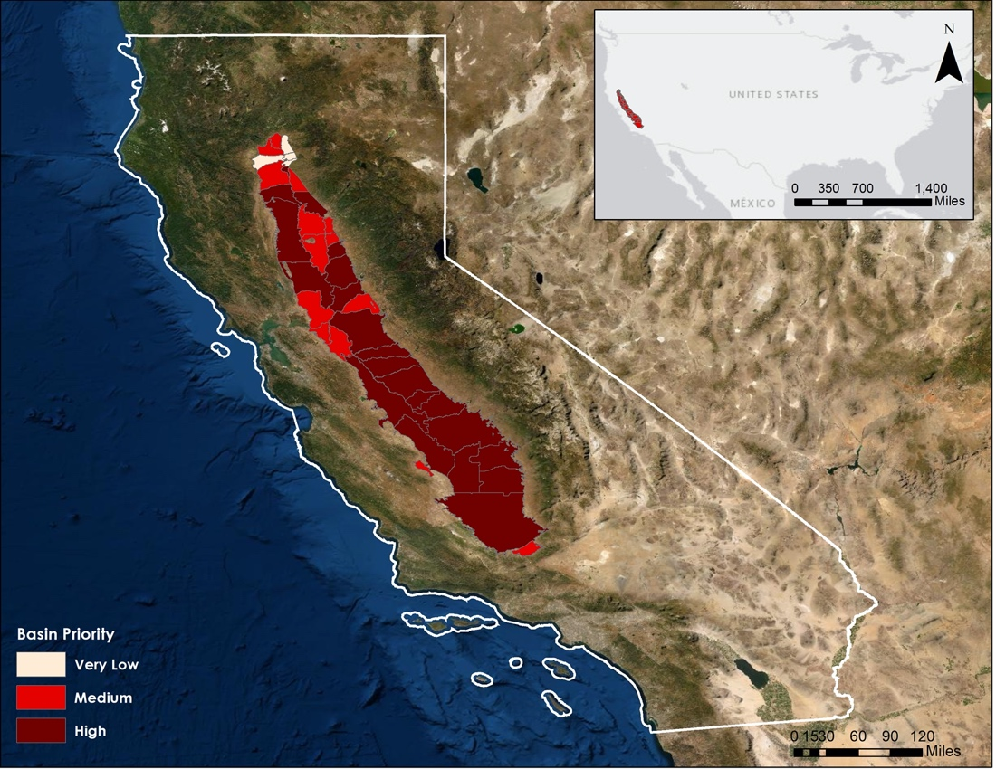

*Figure 1.* Map of the Central Valley within California and the United States. DWR subbasins groundwater priority levels are reflected by the change in red. Higher priority subbasins are darker red which is seen on the southern end of the San Joaquin Valley.

Intensive drought periods in California over the past decade have led to over-pumping of aquifers at levels exceeding the rate of recharge. Consequently, Central Valley aquifers have experienced a significant decline in groundwater levels, resulting in permanent groundwater storage loss and land subsidence (Liu et al., 2019). To address this issue, the Sustainable Groundwater Management Act (SGMA), enacted in 2014, hopes to achieve sustainable levels of groundwater pumping and recharge in high and medium priority basins by 2040 (“SGMA Groundwater Management”). The California Department of Water Resources has been working with local subbasin Groundwater Sustainability Agencies (GSAs) to provide *in situ* well data for groundwater analysis; however, well data is often sparse or non-existent in areas within the Central Valley. For this reason, remotely sensed data, such as NASA’s Gravity Recovery and Climate Experiment (GRACE), have become an attractive approach for monitoring groundwater levels in the absence of *in situ* data.

Previous studies, such as Liu et al. (2019), have analyzed groundwater budgets using interferometric synthetic-aperture radar (InSAR) and NASA’s Gravity Recovery and Climate Experiment (GRACE) datasets. They observed a good temporal correlation between GRACE and long-term subsidence records indicating satellite geodesy is useful for tracking groundwater change (Liu et al., 2019). However, the low-resolution estimates of groundwater storage highlight the need for higher spatial resolutions, such as downscaled GRACE data, for management purposes (Ojha et al., 2018).

The Spring 2020 NASA DEVELOP Central Valley Water Resources project mapped groundwater storage change and land subsidence in the Delta Mendota subbasin using GRACE, InSAR, well, and GPS datasets. The project found GRACE and InSAR to be dependable sources for mapping of groundwater storage and land subsidence in the absence of *in situ* data. This project focused on building off the previous term’s methodology to expand the study region, incorporate Advanced Land Observing Satellite 2 (ALOS-2) Phased Array L-Band Synthetic Aperture Radar (PALSAR-2), and develop a user-friendly front end and back end tool for data visualization and streamlined workflow. The study period is January 2003-August 2020 to analyze drought periods and incorporate the maximum amount of reliable *in situ* data.

***2.2 Project Partners & Objectives***

Partners for this project, shown in Table 1, include the California Department of Water Resources (CA- DWR) and California State University, Los Angeles (CSULA). In order to assist partner decision making in groundwater management practices, the objectives of this project were to use NASA Earth observations to quantify groundwater storage change and surface subsidence. The team developed an interactive web application for digestible interpretation of results, and created an executable tool to control the backend of data processing. This provides a graphical interface to the workflow and streamlines the process of updating datasets into the future. Partners can use the final products of this project to inform local decision makers with concerns about groundwater storage and land subsidence in the Central Valley and will be able to build capacity using GRACE and InSAR in future analyses.

Table 1

*Partner Organizations and Partner Roles*

|  |  |  |  |
| --- | --- | --- | --- |
| **Organization** | **Point of Contact** | **Partner Type** | **Boundary Organization?** |
| California Department of Water Resource | Bill Brewster, Senior Engineering Geologist, North Central Region Office Section Lead;  Mike McKenzie, Senior Engineering Geologist, South Central Region Office Section Lead;  Jack Tung, Water Resources Specialist Research Scientist, Southern Region Office | End User | Yes |
| California State University, Los Angeles | Dr. Charles Hays, Professor | Collaborator | No |

# 3. Methodology

***3.1 Data Acquisition***

The team acquired the satellite and *in situ* datasets used in this project through a variety of platforms (Table 2). The team obtained downscaled NASA’s GRACE and GRACE Follow On (GRACE-FO) from the NASA EarthData Portal. These data, originally collected by GRACE and GRACE-FO, were downscaled to 0.25 x 0.25 degree using the GLDAS Catchment Land Surface Model L4 and is available under the NASA Global Land Data Assimilation System Version 2 (GLDAS-2.2) (Li et al., 2020). Interferograms derived from Sentinel-1 C-SAR and ALOS-2 PALSAR were obtained from Dr. Zhen Liu at NASA’s Jet Propulsion Laboratory (JPL) via NASA Large File Transfer.

The team downloaded *in situ* well measurements from a combination of USGS and DWR datasets to obtain continuous, monthly, and periodic well data measurements. These datasets were acquired from the California Statewide Groundwater Elevation Monitoring Program (CASGEM) Open Data Portal (California Department of Water Resources, 2020). *In situ* GPS station measurements were downloaded from the University of Nevada Reno’s (UNR) Nevada Geodetic Laboratory (NGL) database in the North American (NA) easting, northing, and vertical (ENV) format (Blewitt et al., 2018). A shapefile defining Central Valley subbasins, Bulletin 118 Groundwater Basins-2018, was obtained through the SGMA Open Data Portal. In order to acquire the most recently updated data, the team created Python script web scrapers for GRACE, GRACE-FO, GPS, and well data. These web scrapers allow our partners to easily incorporate updated datasets in the future.

Table 2

*Data used in this project*

|  |  |  |  |
| --- | --- | --- | --- |
| **Sensor or Data Type** | **Data Product** | **Data Availability** | **Acquisition Method** |
| GRACE | GLDAS Catchment Land Surface Model L4 daily 0.25 x 0.25 degree GRACE-DA1 V2.2 | 2003-Present | EarthData Portal |
| GRACE-FO | GLDAS Catchment Land Surface Model L4 daily 0.25 x 0.25 degree GRACE-DA1 V2.2 | 2003-Present | EarthData Portal |
| Sentinel-1 C-SAR | Interferograms | 2015-Present | Dr. Zhen Liu via NASA Large File Transfer |
| ALOS-2 PALSAR-2 | Interferograms | 2015-2019 | Dr. Zhen Liu via NASA Large File Transfer |
| DWR continuous groundwater wells | Groundwater Well Measurement Time Series | 2000-Present | California DWR Open Data Portal |
| DWR periodic groundwater wells | Groundwater Well Measurement Time Series | 2000-Present | California DWR Open Data Portal |
| USGS groundwater wells | Groundwater Well Measurement Time Series | 2000-Present | USGS Water Resources National Water Information System |
| UNR GPS Stations | GPS Station Measurement Time Series, NA ENV files | 2000-Present | UNR Geodetic Laboratory |

***3.2 Data Processing***

*3.2.1 In situ well and GPS Data*

A single master well dataset created by the team combined in situ well measurements from various public datasets. This was done by first individually filtering measurements based on quality assurance and quality control (QA/QC) flags provided alongside the respective datasets. As each dataset had a separate station naming convention, prior to combining, each station was given a unique identification number. For the rest of this paper, stations will be referred to by this number rather than the identification found in the individual datasets to avoid confusion arising from nomenclature differences. Once the master well dataset was made, we used a scorecard method to select the most representative station from every square kilometer grid cell across the Central Valley. Representative wells were selected based on QA/QC codes, number of observations, number of months in the study period with observations, and mean observations per month. More information about this method can be found in the previous term’s technical paper from Spring 2020. Lastly, as there may be varied responsiveness to changing conditions across all of the wells, the team opted to use normalized measurements rather than absolute measurements originally found within the dataset. Normalized measurements were calculated by subtracting the mean value of the well over its measurement period from the observed measurement and dividing by the standard deviation over its measurement period. This converted the data to a common unitless measurement (*z*-score) to depict the standard deviation of each value above or below the mean. By doing this, the team was able to more easily aggregate wells of different constructions and depths.

*In situ* GPS station measurements quantified changes in ground surface elevation as a result of land surface subsidence. The team used ENV readings from 125 GPS stations located in the study area. As was done with the well measurements, all GPS measurements were normalized according to the mean and standard deviation of each station. In the time series analysis, GPS stations were presented separately within a subbasin, rather than aggregating them in time and space, as to avoid issues where GPS stations measurements do not overlap in time through the study period.

*3.2.2 GRACE and InSAR*

GRACE data were acquired from the EarthData Portal in the form of NetCDF files. As the GRACE missions generate a number of different measurements, we isolated the groundwater surface arrays, denoted as “GWS_tavg,” from these files, and saved these arrays as individual TIFs. Each TIF included modeled groundwater surface measurements for the entire world on a given day. As we are solely interested in the Central Valley region for this project, we clipped the GRACE data to our study region and normalized values over the time period of measurement. By clipping prior to normalizing, we saved significant computational time over the previous term’s methods. As InSAR files from both Sentinel-1 and ALOS-2 satellites were already provided as TIFs, we did not need to go through the same conversion steps as for GRACE. The extent of InSAR coverage within our dataset is almost contained to the Central Valley, so it was not necessary to clip these TIFs. Both datasets were normalized over the time period of measurement.

*3.2.3 In situ GPS and InSAR*

In order to compare GPS data with InSAR data, GPS data were converted from vertical displacement to line of sight. This conversion assumes the difference angle to be 37 degrees to match the incidence angle of the InSAR datasets. Line of sight was used in order to account for horizontal movement in areas of significant land subsidence, as vertical displacement presumes horizontal movement as negligible (Liu et al., 2019). The GPS station locations were referenced by their associated latitude and longitude coordinates, then filtered to only include stations within the study area and grouped based on subbasin.

*3.2.4 Aggregating Datasets*

The team developed data processing scripts in Python to aggregate datasets both spatially and temporally. Users may input a shapefile containing regions of interest, in this case subbasins within California’s Central Valley, and the program grounds the datasets into their respective region based on location. Monthly averages of each dataset are then calculated to generate time series. We visualized these time series through both static and interactive plotting methods to elucidate overall trends of the different datasets within subbasins.

*3.2.5 Executable tool and Visualization tool*

In order to allow for easy replication of this project’s data acquisition, processing, and analysis, the team created an executable tool with a user-friendly graphical interface (GUI) and an interactive locally hosted web-based visualization tool. The executable tool compiles the backend Python scripts that run the web scrapers, data cleaning and normalization processes, and statistical analysis into a downloadable application with a GUI (Figure *2*). Users can then easily click through the backend processes without having to interact with the code directly. The executable tool's final output files feed into the visualization tool for users to update with more recently acquired data.

The web-based visualization tool, also known as the Visualization of In-situ and Remotely Sensed Observations (VIRGO) tool, is a locally-hosted interactive application that allows users to visualize trends at the sub basin level. Users can specify time periods, data type, and subbasin selection to customize their visualization output. The executable tool and web-based visualization tool allow decision makers with varying levels of remote sensing and coding experience to map and visualize groundwater and land subsidence trends into the future.

*Figure 2.* (Top) Executable tool graphical user interface. (Bottom) Locally hosted visualization tool.

***3.3 Data Analysis***

In order to quantify datasets’ relation to each other and evaluate their ability to measure groundwater storage change and land subsidence, the team performed zonal analyses at both the subbasin and Central Valley scale. As previously mentioned in this paper, all datasets were normalized and placed on a *z*-score which made the various data sources comparable across time and allowed for cross-platform comparisons at the subbasin and regional level. The average monthly normalized measurements for GRACE, Sentinel-1, GPS, and well datasets were calculated for each subbasin and the entire Central Valley then plotted on a common axis, creating a time series analysis. The team performed static and rolling Pearson correlations across datasets to analyze overall and seasonal correlation trends between datasets.

Utilizing GRACE groundwater thickness data, the team created groundwater storage maps for the Central Valley, ranging from February 2003 to August 2020. The GRACE data contains one image for every day of the year, which was grouped and averaged by month for each pixel in the data to create monthly maps. The team then created groundwater storage difference maps, whereby one year’s groundwater storage map is subtracted from another to show groundwater difference between those two years. The team selected pre-drought, extreme drought, and post-drought years to highlight the impact and recovery of drought on groundwater in the Central Valley.

# 4. Results & Discussion

***4.1 Analysis of Results***

*4.1.1 Time Series Analysis*

The time series analyses created for the entire Central Valley and individual subbasins depict the monthly average value spatially and temporally for each dataset. Seasonal and decadal trends are visualized in the Central Valley inFigure 3. From the Central Valley time series analysis, a downward trend is observed in GPS and Sentinel-1 from 2015-2020, beginning halfway through the 2012-2017 drought. From 2017-2020 both GPS and Sentinel-1 measurements remained below the mean after the drought had ended. This behavior indicates a potential inelastic response, where a region permanently loses groundwater storage capacity and the land surface elevation does not fully recover. Although the Sentinel-1 and GPS data follow a similar overall trend in the time period the datasets overlap, they diverge seasonally. This may be attributed to our aggregation method, as GPS stations across the Central Valley have different seasonal trends due to underlying geological and hydrological characteristics at the station locations. Aggregating the station measurements shows an overall representation of their trends but omits their individual seasonal variation.

The GRACE and well data show consistent seasonal patterns and decadal patterns. A relatively steady variation is observed from 2001-2012. In 2012, both the well and GRACE measurements show a drop in *z*-score, indicating the start of the drought. The GRACE and well *z*-score remain below the mean until 2017, when the values appear to rebound from the drought period. Though some rebound is observed, the values do not reach the same level as the pre-drought period. This behavior indicates a permanent loss in groundwater storage, which could be due to soil consolidation that physically changes the aquifer’s structure.

In the drought years of 2012-2017, an immediate single response is shown in the GRACE and well data indicating the start of the drought. In comparison, the GPS and Sentinel *z*-score begin to decline about halfway through the drought in 2015. This relationship suggests there is a lag period where land subsidence does not occur until after groundwater levels have remained low for a period of time. In the Central Valley time series analysis graph, the lag period appears to be about two years; however, this time period likely varies by region due to differing geology and hydrology in the Central Valley. Overall, similar trends are observed in the subbasin scale time series analysis. Time series analysis graphs for Modesto, Madera, Turlock, Chowchilla, and Merced subbasins can be found in Appendix A.

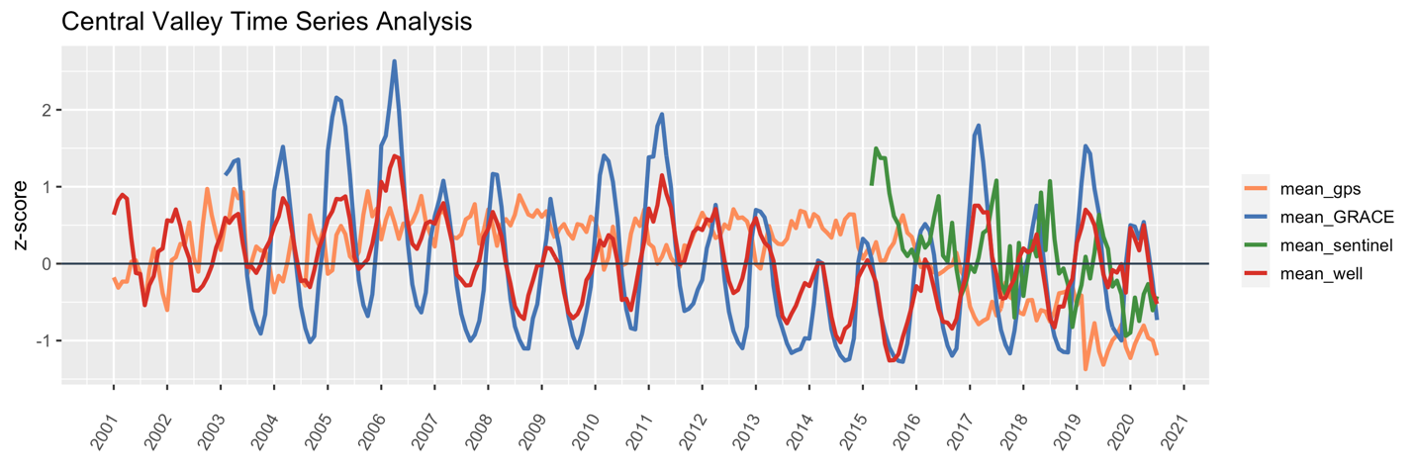*Figure 3.* 2001-2020 Central Valley time series analysis with GPS measurements in orange, GRACE in blue, Sentinel-1 in green, and wells in red.

*4.1.2 Pearson Correlations*

In order to understand the relationships between datasets, the term performed static Pearson correlations and rolling Pearson correlations in the Central Valley and partner-specified subbasins. The static Pearson correlations for the Central Valley and the partner-specified subbasins are shown in Appendix A. The greatest correlation was observed in the Central Valley GRACE and well data with a Pearson correlation of 0.86 indicting a strong correlation. Additionally, Sentinel-1 and GPS produced a moderate Pearson correlation of 0.41 in the Central Valley. As a reminder, the extent of the Sentinel-1 track does not cover the entire Central Valley, which may account for some of this discrepancy. The Pearson correlations of all datasets were generally lower at the subbasin scale; however, some showed the much higher levels of correlations between GRACE and well data and GPS and Sentinel-1 data (Appendix A).

Rolling Pearson correlations were performed in order to understand when datasets diverged seasonally. In Figure4, well and GRACE three month rolling correlation in the Central Valley from 2011-2014 shows consistently low correlations in September and October. This pattern was also observed in subsequent years, shown in Appendix D. The team hypothesized the low correlation may be attributed to an influx of well measurements during these months, as September and October marks the start of the DWR water year when the majority of manually collected well measurements are obtained. Alternatively, as GRACE measures total groundwater thickness and wells measure groundwater depth to surface at a given location, GRACE measurements may be better able to detect the aquifers lowest levels on a subbasin or regional scale. Low correlation is also observed between well and GRACE data at the subbasin scale in the months of April and May, as shown in the Modesto three month rolling correlation in Figure5. This may also be attributed to an influx of well measurements as many well measurements are taken at the start of the spring season.

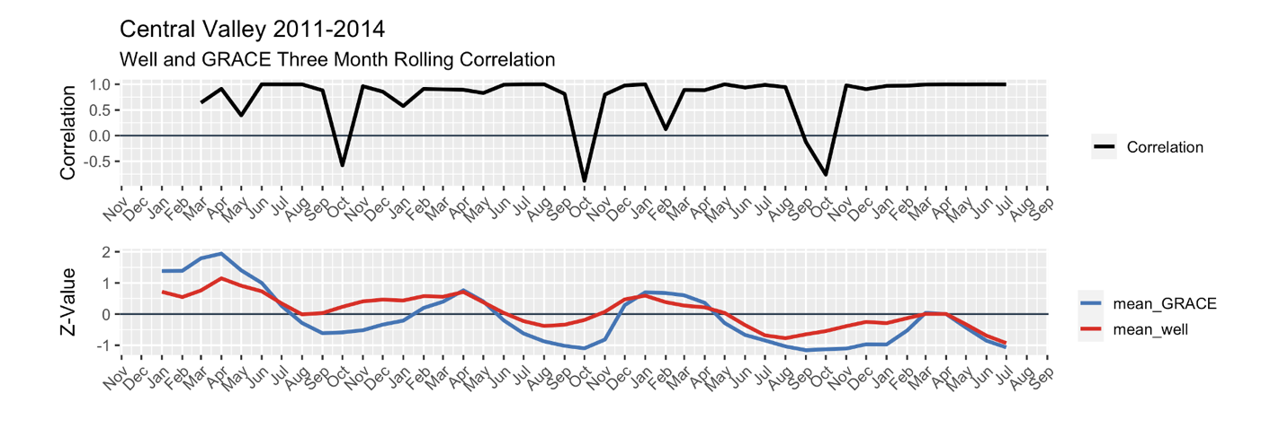

*Figure 4.* Well and GRACE three month rolling correlation in the Central Valley from 2011 to 2014 (Top). Well and GRACE z score measurements in the Central Valley from 2011 to 2014 with GRACE shown in blue and well shown in red (Bottom)

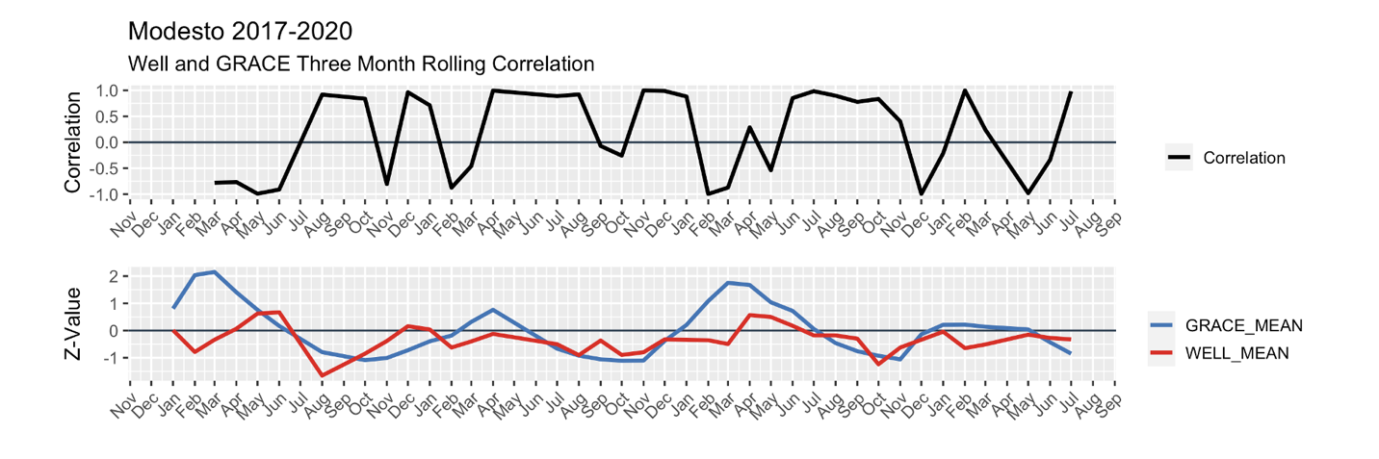

*Figure 5.* Well and GRACE three month rolling correlation in the Modesto subbasin from 2017 to 2020 (Top). Well and GRACE z score measurements in the Modesto subbasin from 2017 to 2020 with GRACE shown in blue and well shown in red (Bottom)

In comparison, the GPS and Sentinel-1 three month rolling correlation in the Central Valley from 2017 to 2020 does not show any consistent seasonal correlation (Figure 6). This again could be attributed to our GPS aggregation method where seasonality in the data is lost. However, both the static Pearson correlations and rolling correlations of the GPS and Sentinel-1 data show less similarities than that of the GRACE and well data on both a regional and subbasin scale.

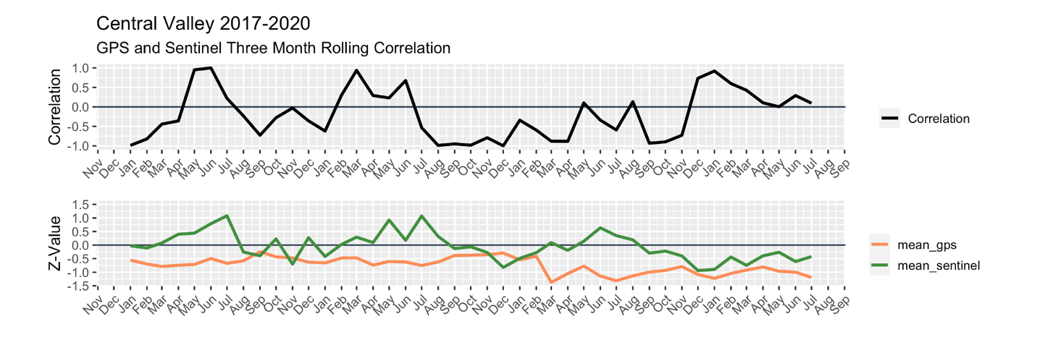

*Figure 6.* GPS and Sentinel-1 three month rolling correlation in the Central Valley from 2017 to 2020 (Top) GPS and Sentinel-1 z-score measurements in the Central Valley from 2017 to 2020 with GPS shown in orange and Sentinel-1 shown in green (Bottom)

*4.1.3 Groundwater Storage & Change Maps*

The groundwater storage maps for the years 2004, 2014, and 2019 are included in Figures 7 and 8. These maps represent groundwater thickness as measured by GRACE and covers the entire Central Valley. Although maps were constructed for each year from 2003-2020, the three years included here represent important water years in assessing the impact of drought. The 2004 map is representative of a pre-drought year, while the 2014 map is highlighted as one of the driest years ever recorded in California and serves as our comparison year to evaluate effects of intensive drought. The 2019 groundwater map is included as our most recent complete year (as available 2020 GRACE data extends only until August), which highlights how Central Valley groundwater storage has recovered since intensive drought. All of the maps show a clear divide between the north and south portions of the Valley, with the north exhibiting higher amounts of groundwater than the south.

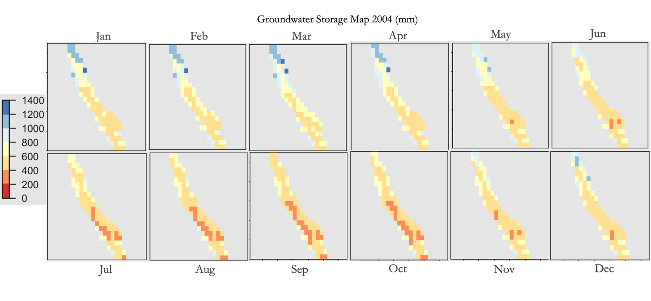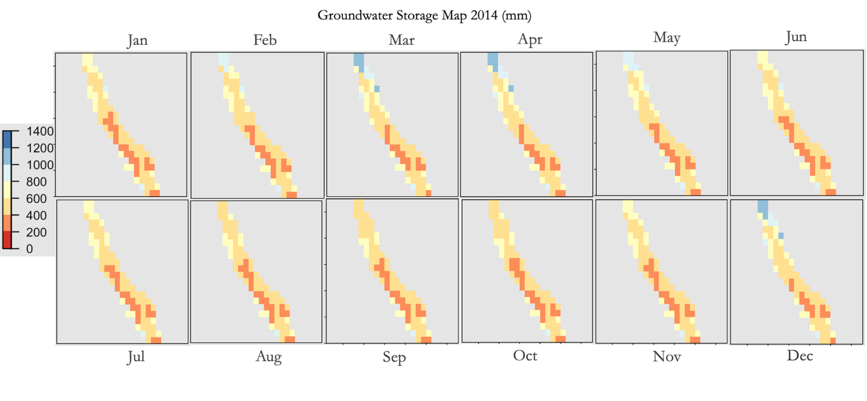

*Figure 7a.* Groundwater storage (mm) in the Central Valley in 2004 January-December. (Top)

*Figure 7b.* Groundwater storage (mm) in the Central Valley in 2014 January-December. (Bottom)

To evaluate pre-drought conditions, we first focus on the 2004 groundwater map, Figure 7a. From January to June, the far north of the Valley contained between 1,000 and 1,400 mm of groundwater, while the central and southern portions contained between 400 and 800 mm of groundwater. Into the drier months of July to December, the entire Valley experienced a decrease in groundwater which illustrates seasonal variation in groundwater. The northern area declined to 400-800 mm, and the southern and central area declined to 200-600 mm of groundwater, before showing some increase in December, coinciding with the onset of the wet season.

However, the 2014 groundwater storage map, Figure 7b, in conjunction with the 2004-2014 groundwater storage change map, Figure C1, shows sharp declines in groundwater for most parts of the Valley with the onset of intensive drought. The 2014 groundwater storage map (Fig. 7b) highlights how the south west area of the Central Valley is especially hard hit by the drought – the entire year in this region exhibits only 200-400 mm of groundwater, with no hint of seasonal variation or increase in the wet months as observed in 2004. The majority of the northern area of the Valley also illustrates the impact of drought, as groundwater declines to 600-800 mm of groundwater with some far north areas in the 1,000-1,200 mm range. The storage change

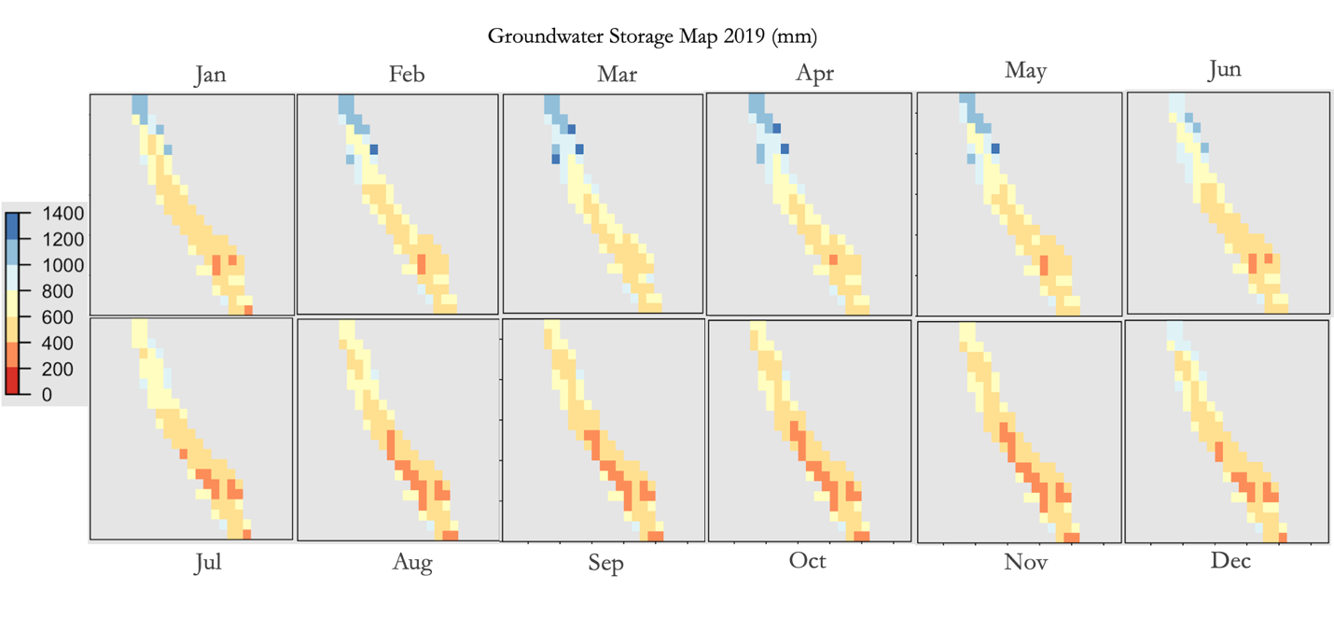*Figure 8.* Groundwater storage (mm) in the Central Valley in 2019 January-December.

map comparing 2014 to 2004, Figure C1, emphasize this drought driven decline in January-May, with the northern Valley exhibiting extremely large differences, showing a loss of 300, 400, and even 500 mm of groundwater deficit. Almost the entire Central Valley shows a decline of around 100 mm in groundwater from June-December, highlighting the impact of the drought on groundwater in comparison to a pre-drought year.

To further assess how the Central Valley has recovered since intensive drought, the team produced a 2019 groundwater storage map (Figure 8) and a 2014-2019 storage difference map (Figure C2). In 2019, the storage map shows a noticeable recovery of groundwater in comparison to 2014, similar to that of 2004 levels. The northern portion of the Central Valley contains around 800-1,200 mm of groundwater, with some select spots of 1,400 mm in January-June. The south western area, which was hard-hit in 2014, has recovered considerably in 2019, showing mostly 400-800 mm of groundwater in the wet season months of January-June, which previously stayed 200-400 mm even during drought. This is confirmed in the 2014-2019 difference map (Figure C2), which indicates increases of 200 to 500 mm increase in groundwater in the northern region January-June, and about 100 mm increase in the south western area, illustrating how the Central Valley has recovered from intensive drought in 2014. In July to December, the majority of the Central Valley also shows gains in groundwater of 100 to 200 mm, although there is some slight deficit in small areas in November and December. Although there has been recovery since intensive drought, the 2019 groundwater storage map (Figure 8) shows that the south western area of the Valley still reaches lows of about 200-400 mm in the summer and fall months, but overall considerable recovery from drought is confirmed.

***4.2 Future Work***

Currently, InSAR coverage was limited to the southern region of the Central Valley. Future data analysis may be expanded by including an increased coverage of InSAR across the Central Valley in order to obtain land subsidence results across the whole region. By completing this analysis, there will be a better understanding of land subsidence over a heterogenous geological area within the study area. Additionally, for this term, we did not consider the geological and hydrological features of the study area. The team understands that the valley has various differing geological features, such as soil types, as well as the hydrological cycle, which may vary from subbasin to subbasin. Geology and the hydrological cycle should be studied to see how the classification of the soil as well as precipitation and evapotranspiration affects groundwater storage and land subsidence. Finally, as the western region of the United States continues to go through drought conditions, the same effects of loss of groundwater storage and land subsidence can be seen. The VIRGO tool may be edited to allow use of this tool in other states. By editing the tool to the desired area, organizations and state agencies may be able to recreate the work done by the team to manage groundwater more efficiently.

# 

# 5. Conclusions

Remotely sensed GRACE and InSAR are capable of detecting groundwater storage change and subsidence in the absence of *in situ* data. Remotely sensed data can be used by decision makers, such as the California Department of Water Resources, to aid in understanding of groundwater status and management of water resources. We were able to identify periods of drought in both well and GRACE datasets; these datasets show a high level of correlation across the Central Valley as a whole that, in many cases, is maintained also at the subbasin scale. Further analysis needs to be conducted to determine the cause of low correlation between the datasets during the months of April-May and September-October. From our GRACE groundwater storage maps, we observed the greatest amount of groundwater storage loss in the south western portion of the Central Valley. As higher resolution GRACE products are created and released publicly, we will be able to observe changes within the region at an even finer scale and potentially allow researchers at the California Department of Water Resources to measure groundwater conditions in regions without the need for construction of *in situ* well stations. Additionally, InSAR measurements from Sentinel-1 and GPS station measurements will provide insight to elastic and inelastic response to drought in the Central Valley. Inelastic changes may represent permanent groundwater storage potential loss; therefore, identifying areas of inelastic subsidence are crucial for groundwater management and future sustainability plans. Though we were unable to find clear correlations between the InSAR and GPS measurements used for this study, these relationships have been found in previous publications and may require more time to elucidate within our study.

Altogether, this information can help our partners monitor both groundwater levels and land subsidence response in times of drought. By bringing these datasets together, we have built a centralized resource for further data analysis. Many of the tools throughout this research have been generalized for use in regions outside of the Central Valley. Pairing remotely sensed and in situ helps to fill in the gaps and weaknesses within each individually; this will increase as data with higher spatial and temporal resolution become more common. NASA Earth observations provide a powerful source of information on scales unachievable by *in situ* measurements. The tools and dataset comparisons developed during this term will provide decision makers with groundwater management techniques for studying subbasin level trends in the Central Valley in the context of SGMA sustainability plans.

# 6. Acknowledgments

We thank everyone at the California - Jet Propulsion Laboratory DEVELOP node for their support and guidance during this term and for providing the Earth observation data required for this project.

John T. Reager (NASA Jet Propulsion Laboratory, California Institute of Technology)

Zhen Liu (NASA Jet Propulsion Laboratory, California Institute of Technology)

Kyra Kim (NASA Jet Propulsion Laboratory, California Institute of Technology)

Ben Holt (NASA Jet Propulsion Laboratory, California Institute of Technology)

Erica Carcelen (NASA DEVELOP National Program, Lead/Fellow)

A special thanks to our project partners who provided us with areas of interest, remotely sensed data, and their expertise throughout this project.

Bill Brewster (California Department of Water Resources, North Central Region Office Section Lead)

Mike McKenzie (California Department of Water Resources, South Central Region Office Section Lead)

Jack Tung (California Department of Water Resources, Southern Region Office Specialist Research Scientist)

Dr. Charles Hays (California State University, Los Angeles)

Finally, we would like to thank the previous contributors who were the Central Valley Water Resources I team who started this project.

Forrest Corcoran (California – JPL Central Valley Water Resources I)

Marissa Dudek (California – JPL Central Valley Water Resources I)

Patrick Saylor (California – JPL Central Valley Water Resources I)

This material contains modified Copernicus Sentinel data (2015-2020), processed by ESA.

Any opinions, findings, and conclusions or recommendations expressed in this material are those of the author(s) and do not necessarily reflect the views of the National Aeronautics and Space Administration.

This material is based upon work supported by NASA through contract NNL16AA05C.

# 

# 7. Glossary

**Aquifer** - A body of permeable rock which can contain or transmit groundwater

**Earth observations** – Satellites and sensors that collect information about the Earth’s physical, chemical, and biological systems over space and time

**DWR** - Department of Water Resources

**GRACE -** Gravity Recovery and Climate Experiment

**GRACE-FO** – Gravity Recovery and Climate Experiment Follow-On

**GSA** - Groundwater Sustainability Agency

**InSAR -** Interferometric synthetic aperture radar

**SGMA** - Sustainable Groundwater Management Act

**Subsidence** - The gradual caving in or sinking of the land

# 8. References

Blewitt, G., Hammond, W.C., & Kreemer, C. (2018), Harnessing the GPS data explosion for interdisciplinary science, *Eos*, *99*, <https://doi.org/10.1029/2018EO104623>

California Department of Water Resources, Continuous Groundwater Level Measurements. Accessed [Nov 19 2020]. https://data.cnra.ca.gov/dataset/continuous-groundwater-level-measurements

California Department of Water Resources, Periodic Groundwater Level Measurements. Accessed [Nov 19 2020]. https://data.cnra.ca.gov/dataset/periodic-groundwater-level-measurements

California Department of Water Resources (2020). *Periodic Groundwater Level Measurements* [Data set]. California Department of Water Resources. Accessed [Nov 19 2020]. https://data.cnra.ca.gov/dataset/periodic-groundwater-level-measurements

California Department of Water Resources. (n.d.). *SGMA Groundwater Management.* Retrieved October 14, 2020 from <https://water.ca.gov/Programs/Groundwater-Management/SGMA-Groundwater-Management>.

Faunt, Claudia, ed. (2009). *Groundwater Availability of the Central Valley Aquifer, California*: U.S. Geological Survey Professional Paper 1766, 225. Retrieved from <https://pubs.usgs.gov/pp/1766/>

Faunt, Claudia., Sneed, M., Traum, J., & Brandt, J. (2015). Water availability and land subsidence in the

Central Valley, California, USA. *Hydrogeology Journal, 24*(3), 675–684. <https://doi.org/10.1007/s10040-015-1339-x>

Li, B., M. Rodell, S. Kumar, H. Beaudoing, A. Getirana, B. F. Zaitchik, et al. (2019) Global GRACE data assimilation for groundwater and drought monitoring: Advances and challenges. *Water Resources Research, 55*(9), 7564-7586. <https://doi.org/10.1029/2018WR024618>

Li, B., H. Beaudoing, and M. Rodell, NASA/GSFC/HSL (2020), GLDAS Catchment Land Surface Model L4 daily 0.25 x 0.25 degree GRACE-DA1 V2.2, Greenbelt, Maryland, USA, Goddard Earth Sciences Data and Information Services Center (GES DISC), <https://doi.org/10.5067/TXBMLX370XX8>

Liu, Z., Liu, P.-W., Massoud, E., Farr, T. G., Lundgren, P., & Famiglietti, J. S. (2019). Monitoring groundwater change in California’s Central Valley using Sentinel-1 and GRACE observations. *Geosciences, 9*(10), 436. <https://doi.org/10.3390/geosciences9100436.x>

Ojha, C., Shirzaei, M., Werth, S., Argus, D. F., & Farr, T. G. (2018). Sustained groundwater loss in California's Central Valley exacerbated by intense drought periods. *Water Resources Research*, *54*(7), 4449– 4460. <https://doi.org/10.1029/2017WR022250>

United States Geological Survey (n.d.). *California’s Central Valley.* Retrieved October 14, 2020 from <https://ca.water.usgs.gov/projects/central-valley/about-central-valley.html>

United States Geological Survey. (n.d.). *California’s Central Valley: Central Valley Hydrological Model: Texture Model*. Retrieved October 14, 2020 from <https://ca.water.usgs.gov/projects/central-valley/cvhm-texture-model.html>

United States Geological Survey. (n.d.). *USGS Grounndwater Data for the Nation.* Retrieved November 19, 2020 from https://waterdata.usgs.gov/nwis/gw

# 9. Appendices

**Appendix A.**

Table A1

Pearson Correlation table between mean monthly values for the Central Valley.

|  |  |  |  |  |
| --- | --- | --- | --- | --- |
| **Central Valley** | Well mean | GPS mean | GRACE mean | Sentinel-1 mean |
| Well mean | 1 | .00 | .86 | -.27 |
| GPS mean | .00 | 1 | -.09 | .41 |
| GRACE mean | .86 | -.09 | 1 | -.09 |
| Sentinel-1 mean | -.27 | .41 | -.09 | 1 |

Table A2

Pearson Correlation table between mean monthly values for the Modesto subbasin.

|  |  |  |  |  |
| --- | --- | --- | --- | --- |
| **Modesto Subbasin** | Well mean | GPS mean | GRACE mean | Sentinel-1 mean |
| Well mean | 1 | -.04 | .27 | .23 |
| GPS mean | -.04 | 1 | -.42 | .11 |
| GRACE mean | .27 | -.42 | 1 | -.09 |
| Sentinel-1 mean | .24 | .11 | -.09 | 1 |

Table A3

Pearson Correlation table between mean monthly values for the Merced subbasin.

|  |  |  |  |  |
| --- | --- | --- | --- | --- |
| **Merced Subbasin** | Well mean | GPS mean | GRACE mean | Sentinel-1 mean |
| Well mean | 1 | .19 | .41 | -.09 |
| GPS mean | .19 | 1 | -.01 | .60 |
| GRACE mean | .41 | -.01 | 1 | -.09 |
| Sentinel-1 mean | -.09 | .60 | -.09 | 1 |

Table A4

Pearson Correlation table between mean monthly values for the Turlock subbasin.

|  |  |  |  |  |
| --- | --- | --- | --- | --- |
| **Turlock Subbasin** | Well mean | GPS mean | GRACE mean | Sentinel-1 mean |
| Well mean | 1 | .16 | .55 | -.25 |
| GPS mean | .16 | 1 | -.17 | .33 |
| GRACE mean | .55 | -.17 | 1 | -.08 |
| Sentinel-1 mean | -.25 | .33 | -.08 | 1 |

Table A5

Pearson Correlation table between mean monthly values for the Chowchilla subbasin.

|  |  |  |  |  |
| --- | --- | --- | --- | --- |
| **Chowchilla Subbasin** | Well mean | GPS mean | GRACE mean | Sentinel-1 mean |
| Well mean | 1 | -.09 | .48 | -.60 |
| GPS mean | -.09 | 1 | .11 | .98 |
| GRACE mean | .48 | .11 | 1 | -.18 |
| Sentinel-1 mean | -.60 | .98 | -.18 | 1 |

Table A6

Pearson Correlation table between mean monthly values for the Madera subbasin.

|  |  |  |  |  |
| --- | --- | --- | --- | --- |
| **Madera Subbasin** | Well mean | GPS mean | GRACE mean | Sentinel-1 mean |
| Well mean | 1 | .00 | .43 | -.21 |
| GPS mean | .00 | 1 | .27 | .78 |
| GRACE mean | .43 | .27 | 1 | -.13 |
| Sentinel-1 mean | -21 | .78 | -.13 | 1 |

**Appendix B.**

*Figure B1.* 2001-2020 Madera subbasin time series analysis with GPS measurements in orange, GRACE in blue, Sentinel-1 in green, and wells in red.

*Figure B2.* 2001-2020 Merced subbasin time series analysis with GPS measurements in orange, GRACE in blue, Sentinel-1 in green, and wells in red.

*Figure B3.* 2001-2020 Turlock subbasin time series analysis with GPS measurements in orange, GRACE in blue, Sentinel-1 in green, and wells in red.

*Figure B4.* 2001-2020 Chowchilla subbasin time series analysis with GPS measurements in orange, GRACE in blue, Sentinel-1 in green, and wells in red.

*Figure B5.* 2001-2020 Modesto subbasin time series analysis with GPS measurements in orange, GRACE in blue, Sentinel-1 in green, and wells in red.

**Appendix C.**

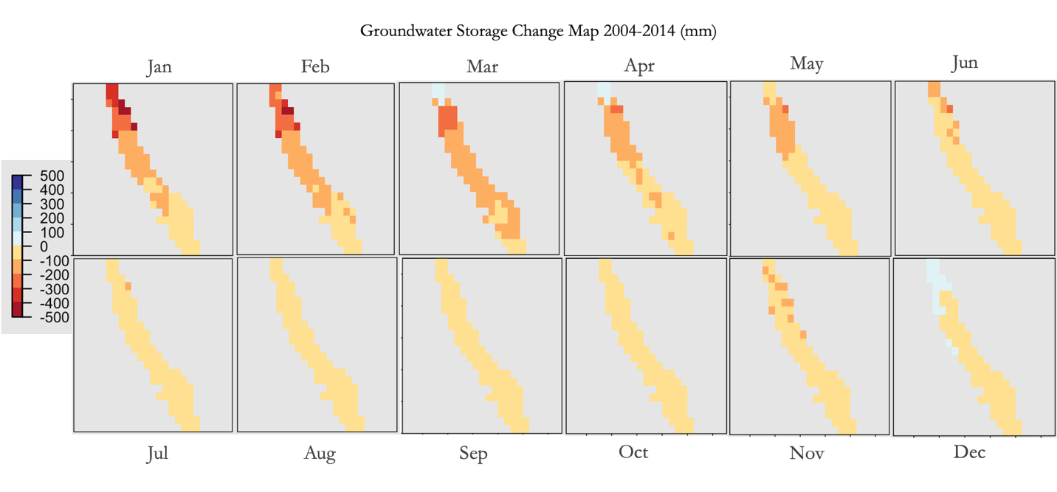*Figure C1.* Groundwater change map showing difference (mm) in groundwater in 2014 compared to 2004 in the Central Valley.

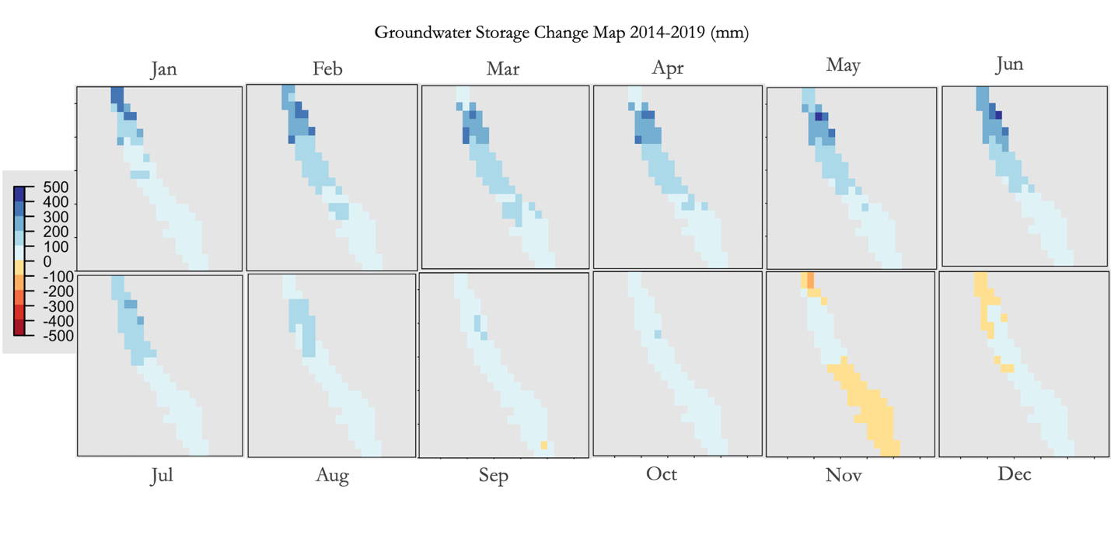

*Figure C2.* Groundwater change map showing difference (mm) in groundwater in 2019 compared to 2014 in the Central Valley.

**Appendix D.**

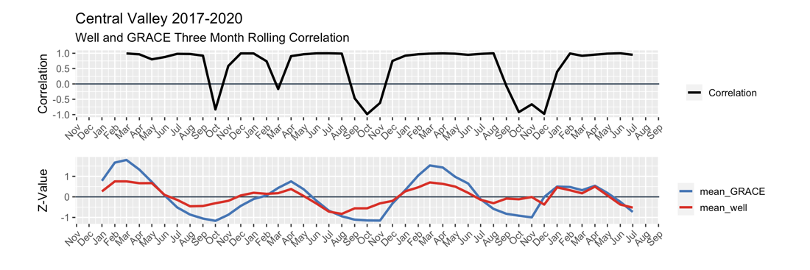

*Figure D1.* Well and GRACE three month rolling correlation in the Central Valley from 2017 to 2020 (Top). Well and GRACE z score measurements in the Central Valley from 2017 to 2020 with GRACE shown in blue and well shown in red (Bottom)

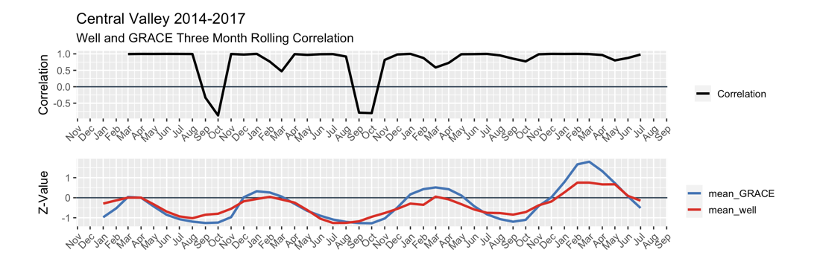

*Figure D2.* Well and GRACE three month rolling correlation in the Central Valley from 2014 to 2017 (Top). Well and GRACE z score measurements in the Central Valley from 2017 to 2020 with GRACE shown in blue and well shown in red (Bottom)