Louisville Urban Development

Utilizing NASA Earth Observation to Assess the Overall Greenness and Land Surface Temperature of Cities in Relation to Public Health Outcomes

 **Technical Report**

Final Draft – November 21st, 2019

Naji Rizig (Project Lead)

Hannah Besso

Camille Canivet

Julie Sorfleet

Dr. David Hondula, Arizona State University (Science Advisor)

Dr. Kenton Ross, NASA Langley Research Center (Science Advisor)

# 1. Abstract

Greenness and land surface temperature (LST) have been extensively correlated to urban public health. Chronic diseases such as diabetes, asthma, and cardiovascular illnesses have been linked to regions of high LST and areas lacking urban green spaces. One of our partners, the University of Louisville Envirome Institute, champions the importance of urban green spaces. Their research has pioneered efforts in increasing the area and accessibility of urban parks and greenspaces as a way to improve public health and combat environmental inequality. Louisville, Kentucky, is currently working to plant and manage urban trees. Our team used NASA Landsat 8 Operational Land Imager (OLI) and Thermal Infrared Sensor (TIRS) imagery to calculate the Normalized Difference Vegetation Index (NDVI) in Louisville at the census tract level and automated the process for use in other cities. The New York University School of Medicine’s City Health Dashboard displays public health metrics across 500 US cities and will use our methods to complete the NDVI analysis for all of these locations plus an additional 293 cities they are adding to their dashboard in the near future. Our NDVI and LST calculations will allow cites across the US to make informed decisions about reducing environmental inequality by focusing on areas with low NDVI and high LST.

**Keywords**

remote sensing, normalized difference vegetation index, greenness, land surface temperature

# 2. Introduction

* 1. ***Background Information***

The city of Louisville, KY (*Figure 1*) is losing tree cover and experiencing increased Urban Heat Island (UHI) effects. From 2004 to 2012, the city experienced a 7% decrease in tree cover and an average increase of 9% in impervious surfaces. Tree cover is predicted to continue decreasing in the future due to pests and urbanization if no preventative measures are taken (Davey Resource Group, 2015). Research has shown a link between increased urban green spaces and health benefits, such as enhanced mental, respiratory, cardio-vascular, and general health (Donovan et al., 2013; Kondo, Fluehr, McKeon, & Branas, 2018; Lovasi, Quinn, Neckerman, Perzanowski, & Rundle, 2008; Twohig-Bennett & Jones, 2018). Moreover, research has shown that increased vegetation helps reduce the UHI effect by decreasing land surface temperatures (LST) through shading and evapotranspiration (Jenerette et al., 2016), thus mitigating heat-related health issues. Multiple local initiatives have been designed to address the issues caused by the urban heat island effect in the study area, such as Sustain Louisville and the Green Heart Louisville Project. Sustain Louisville was established by city officials to promote city-wide sustainable development. The Green Heart Louisville Project focuses on examining the relationship between urban greenness and community health.

The City Health Dashboard (CHD) provides easily accessible public health metrics for 793 US cities at the city and census tract level. Common users of the CHD website include city planners and the general public. The CHD is interested in including greenness and LST metrics, which have to be easily reproducible for each city listed on the website. Remote sensing has proven effective in analyzing large-scale trends in urban vegetation (Beck, Lobitz, & Wood, 2000) and LST (Johnson, Wilson, & Luber, 2009). One particularly useful remote sensing tool to examine urban greenness patterns is the Normalized Difference Vegetation Index (NDVI), which indicates a proxy for the health and density of vegetation by measuring the normalized difference between near infrared and red visible light. NDVI can alternatively be referred to as a measure of “greenness.” The 2019 Fall NASA DEVELOP Arizona team calculated mean NDVI and LST for the years 2013 through 2019 using NASA Landsat 8 satellite imagery and carried out these methods for all 793 cities on the CHD website. These metrics will help cities develop the most effective strategies for planting urban vegetation and for improving urban public health.

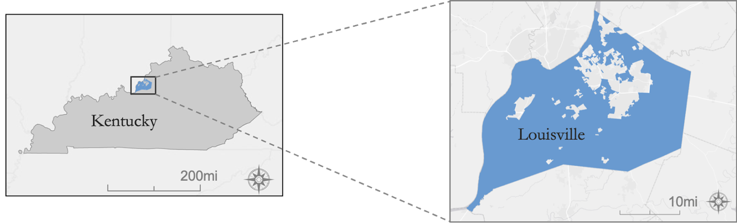

*Figure 1.* Louisville is located in northern Kentucky and has a population of over 770,000 people.

* 1. ***Project Partners & Objectives***

The partners for this project were New York University School of Medicine’s City Health Dashboard and the University of Louisville’s Envirome Institute. The CHD website provides freely accessible and frequently updated data for 793 cities (*Figure 2*) across the United States, to support health-related decision-making at the city level. The website currently provides various city health as well as socio-economic metrics but does not include any greenness or LST data.

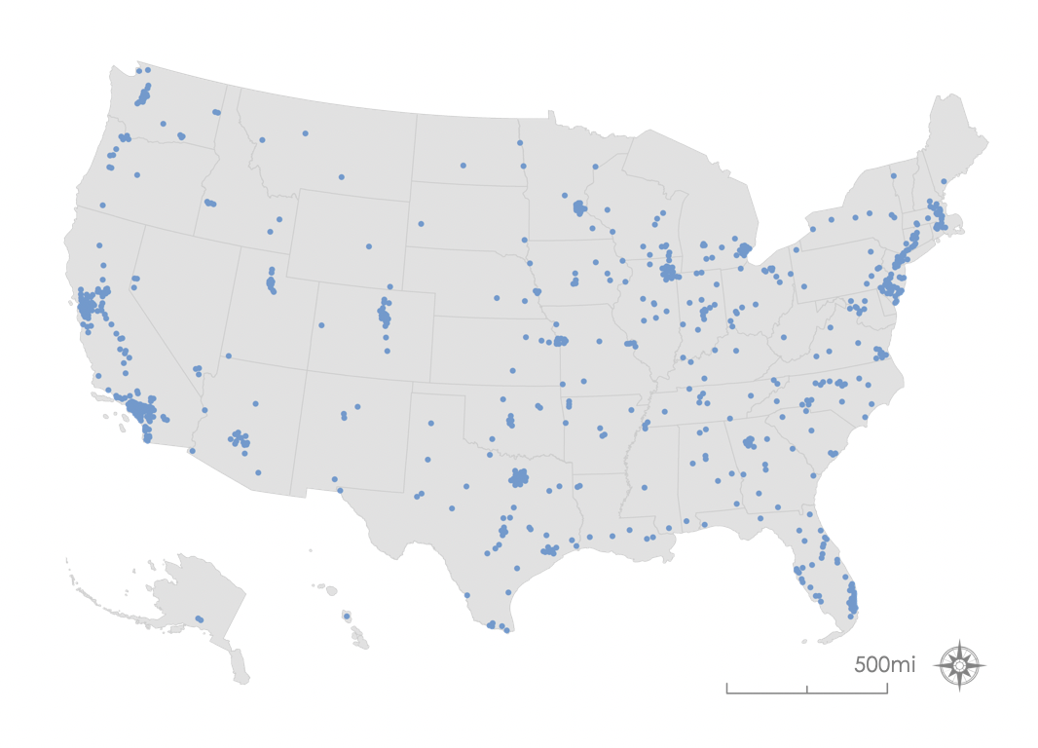

*Figure 2.* Map of the793 cities on the CHD website.

The University of Louisville’s Envirome Institute focuses on how environmental factors impact chronic disease and human health. Therefore, greenness is an area of particular interest for the University of Louisville’s Envirome Institute, as studying urban vegetation trends in relation to community health can allow for a better understanding of the role greenness plays when pertaining to chronic diseases and cardiovascular issues.

This project will benefit the CHD team by providing an easily replicable method for calculating NDVI and LST for every city on the website in future years. These metrics will highlight areas that would benefit from revegetation and heat mitigation strategies, thus supporting enhanced decision-making and urban planning at the city level. These data may also help investigate potential health inequities between neighborhoods, by providing data for cities to compare to demographics and socio-economic factors.

# 3. Methodology

The team developed a Google Earth Engine (GEE) script to automate calculations of NDVI and LST within census tracts to identify areas where greening efforts and heat mitigation strategies are most needed. The method used Landsat 8 surface reflectance satellite imagery from the Operational Land Imager (OLI) to create a median NDVI temporally composited image of the study area. To calculate LST, the team used Landsat 8 Thermal Infrared Sensor (TIRS) brightness temperature data, modeled emissivity based on the NDVI calculations, and then used the modeled emissivity to convert brightness temperature to LST. The team then created a median LST temporally composited image of the study area. Finally, the team averaged NDVI and LST per census tract. The scripts produce spreadsheets for each metric, by city and census tract separately, for inclusion in the CHD database.

***3.1 Data Acquisition***

The Earth observations and other ancillary data acquired for this project are denoted in Table 1 and Table 2 below. Data were retrieved in multiple file formats dependent on the retrieval location. The “Source” column of Table 2 contains links to both the Hansen Global Forest Change and Louisville Childen in Poverty Data.

Table 1

*NASA Earth Observation satellite data used in this project.*

|  |  |  |  |
| --- | --- | --- | --- |
| **Platform** | **Sensor and Level** | **Image Years** | **Google Earth Engine Image Collection IDs** |
| NASA Landsat 8 | Thermal Infrared Sensors (TIRS) and Operational Land Imager (OLI) Surface Reflectance Tier 1 | 2013 to 2019 | LANDSAT/LC08/C01/T1_SR |

Table 2

*Ancillary Data acquired used in this project.*

|  |  |  |  |
| --- | --- | --- | --- |
| **Data Description** | **Data Format** | **Dates** | **Source** |
| Hansen Global Forest Change | Land cover dataset | 2000 to 2018 | [Hansen/UMD/Google/USGS/NASA](http://earthenginepartners.appspot.com/science-2013-global-forest) |
| 793 Cities Polygons | Shapefile | 2019 | City Health Dashboard - Personal Communication |
| Census Tracts | Shapefile | 2019 | City Health Dashboard - Personal Communication |
| Louisville Children in Poverty Data | CSV file | 2019 | [City Health Dashboard Data Access](https://www.cityhealthdashboard.com/data-access) |

***3.2 Data Processing***

The team loaded in the Landsat 8 Tier 1 Surface Reflectance image collection and uploaded the Louisville census tract shapefile as an asset in GEE. The data were filtered to be limited to summer months (June to August) for three-year periods. For example, calculations for the year 2015 included satellite images for June through August of 2013, 2014, and 2015. The three-year period was used to increase the sample size of satellite images for each calculation, which would allow us to produce more accurate results. Data were also filtered by region of interest, which was Louisville for the initial study and all 793 CHD cities for the final study. To remove cloudy portions of satellite images, the team created a cloud mask using the pixel_qa band, that reassigns any cloud cover or cloud shadow pixel as a “clear” pixel so that they have no data. To exclude water bodies from the analysis, the team created a water mask using the Hansen Global Forest Change dataset, using the same pixel reassignment technique as for the cloud mask.

***3.3 Data Analysis***

The team applied an NDVI function (Equation 1) to the filtered and masked image collections for years 2013 to 2019 and created annual median pixel composite images. The team then clipped the composite image to the study area and found the average NDVI per census tract. CSV files of average NDVI by census tract were exported for every city in the proper format for use on the CHD website. This process was repeated separately for citywide average NDVI calculations since the boundaries of the cities do not directly correspond to the areas covered by the census tracts. Maps were created for data visualization of these results in ArcMap 10.6.1, ArcGIS Pro 2.4, and QGIS 3.0.2-Girona.

$\text{NDVI=}\frac{\text{NIR}\left(\text{band 5}\right)\text{-Red(band 4)}}{\text{NIR}\left(\text{band 5}\right)\text{+Red(band 4)}}$ (1)

To calculate LST, the team corrected Landsat 8 brightness temperature using modeled emissivity. The emissivity was modeled using NDVI values according to Shen, H., Huang, L., Zhang, L., Wu, P., & Zeng, C. (2016) (Table 3).

*Table 3*

|  |  |  |
| --- | --- | --- |
| **NDVI** | **Emissivity** | **Surface Type** |
| -1 – 0 | 0.9925 | Various, non-vegetation |
| 0 – 0.15 | 0.923 | Urban Impervious Surfaces/Bare Ground |
| 0.16 – 0.727 | 1.0094 + 0.047*ln(NDVI) | Various, including Vegetation |
| >0.727 | 0.986 | Dense Vegetation |

The team calculated LST from brightness temperature and emissivity using Equation 2 obtained from Shen et al. (2016).

${\text{T}}_{\text{S}}\text{=}\frac{\text{BT}}{\text{\{1+[}\left(\frac{\text{λBT}}{\text{ϱ}}\right)\text{ln}{\text{ε}}_{\text{λ}}^{\text{'}}\text{E\}}}$ (2)

In order to test the viability of our modeled emissivity, we compared the LST values obtained using our NDVI-based emissivity model to LST calculated using other methods for the city of Phoenix, Arizona. We compared values found with our method to LST based on the USGS Provisional Land Surface Temperature data, the Forth Remote Sensing Lab Aster-based method, and the Forth Remote Sensing Lab NDVI-based calculations for the same geographic area. Our values for LST (denoted in black) match closely with the Forth Remote Sensing Lab NDVI based LST calculations (denoted in red) (*Figure 3*). Our values for LST also have moderate overlap with the other two methods.

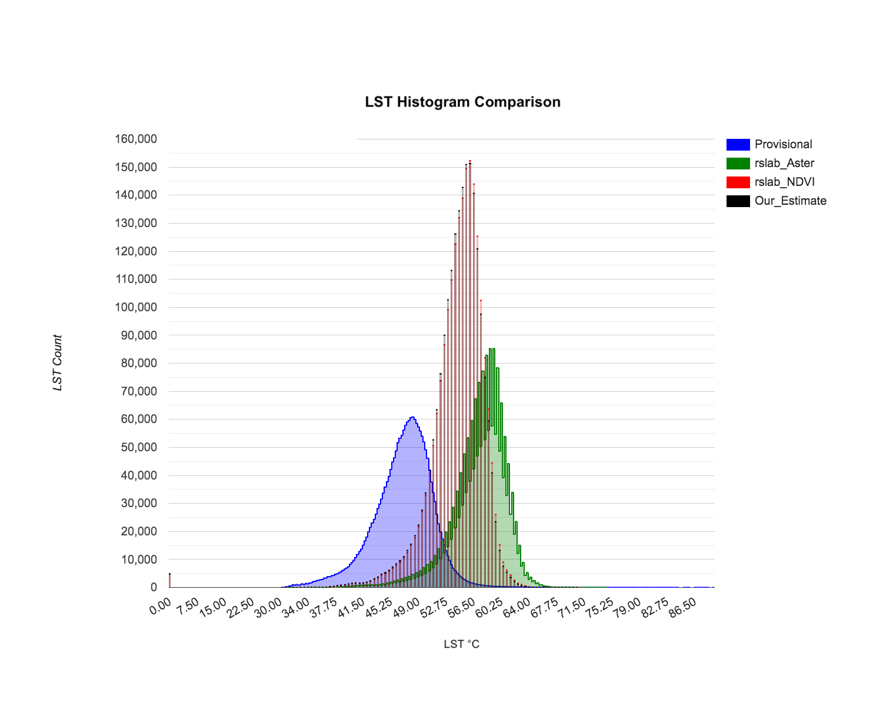

*Figure 3.* Comparison of LST calculated from different methods of modeling or measuring emissivity. Blue corresponds to the USGS Provisional Land Surface Temperature data, green to the Forth Remote Sensing Lab Aster-based LST calculations, red to the Forth Remote Sensing Lab NDVI based LST calculations, and black to our teams NDVI based LST calculations. The black curve representing our LST calculations closely match the Forth Remote Sensing Lab NDVI-based calculations (L. Watkins, personal communication, October 28, 2019).

The team calculated the Pearson Correlation Coefficient between NDVI and LST for the cities of Louisville, KY, Seattle, WA, and Phoenix, AZ using R. These cities were chosen for data analysis to ensure that our methods were viable for locations with notably different climates. Furthermore, we compared the results of the average NDVI and LST for census tracts in Louisville to the percentage of children in poverty by census tract data downloaded from the CHD website. The CHD appears to use this metric as an indicator of income. This was done to identify whether there was a correlation between the location of less affluent communities and the level of greenness and urban heat in those areas.

# 4. Results & Discussion

***4.1 Analysis of Results***

2019 NDVI for Louisville’s census tracts displayed values between 0.3 and 0.89 (*Figure 4*). Thus, all census tracts in Louisville had vegetation coverage that can be considered to be on average moderately to highly green and vegetated. Phoenix had NDVI values that ranged from 0.03 to 0.4. Compared to Louisville, Phoenix had fewer green spaces and more bare ground or built surfaces. Seattle had NDVI values that ranged from 0.134 to 0.654. These values correspond to a range between bare ground and areas with a high possibility of dense green vegetation.

Phoenix had the highest absolute and largest range in LST values for 2019. The values ranged from 108 °F to 133 °F. The LST values for Seattle ranged from 77° F to 100° F. Louisville had results similar to Seattle, with LST ranging from 74° F to 97° F.

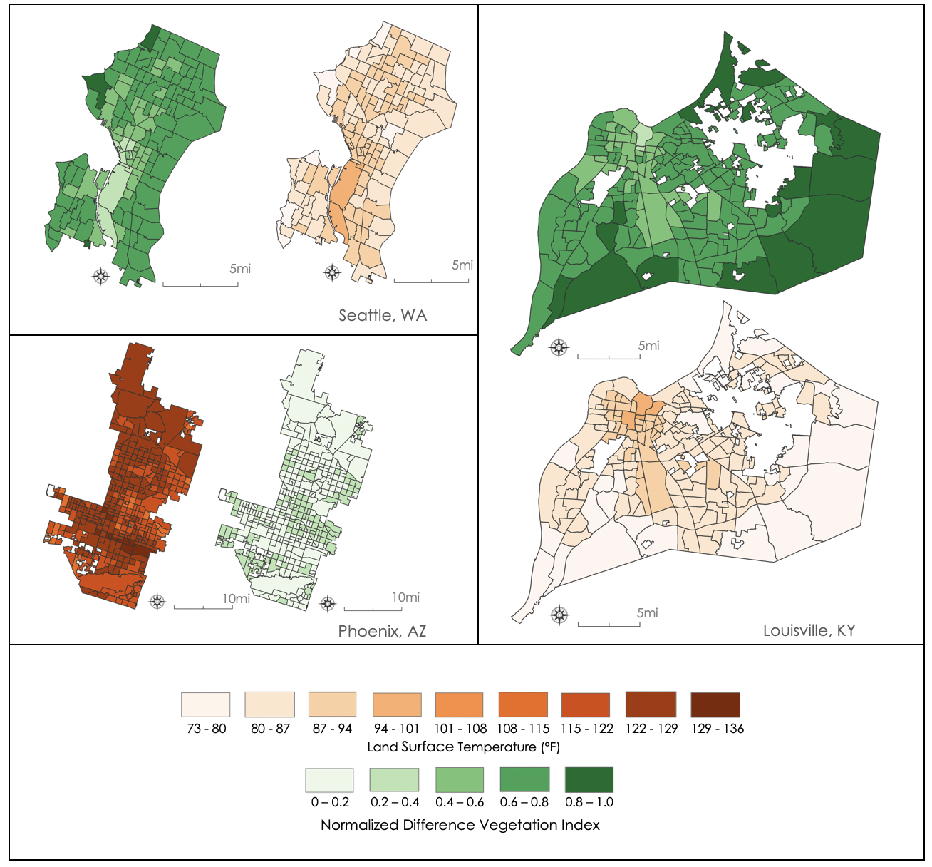

*Figure 4.* 2019 NDVI and LST for Seattle (top-left), Phoenix (bottom-left), and Louisville (right). Darker green colors correspond with higher NDVI values, and darker red colors correspond with higher LST values. Notice that census tracts with lower NDVI tend to correspond to census tracts with higher LST.

The Pearson Correlation Coefficients between NDVI and LST for the 2019 census tract data for Louisville (*Figure 5*), Phoenix (*Figure 6*), and Seattle (*Figure 7*) were all statistically significant. There is a strong negative linear relationship between LST and NDVI for all three cities, as their Pearson Correlation Coefficients were all -0.93 and above.

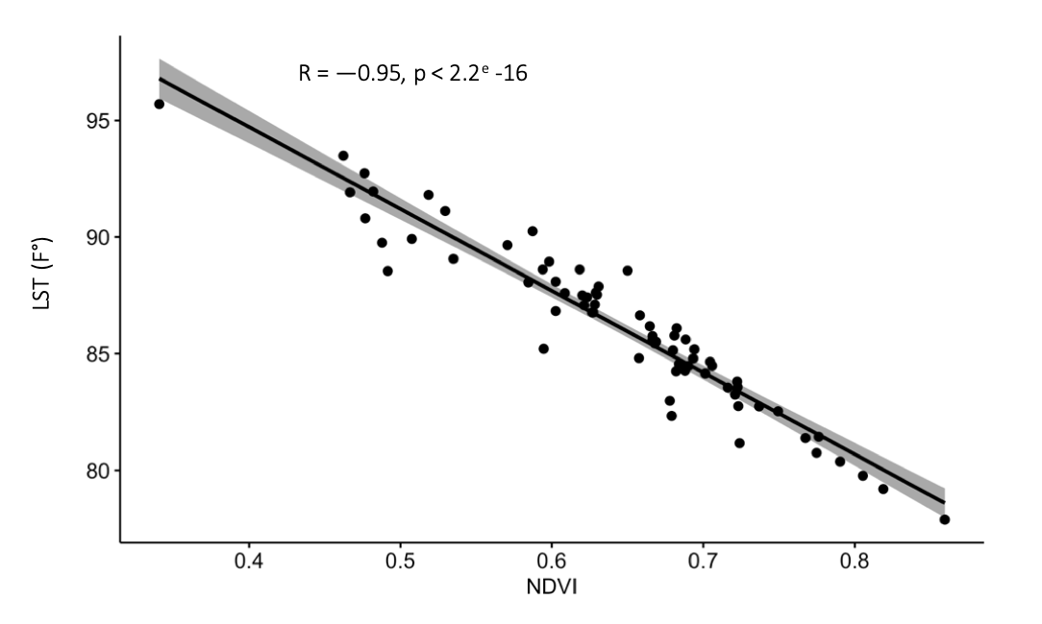

*Figure 5.* 2019 LST and NDVIlinear correlation plot for Louisville

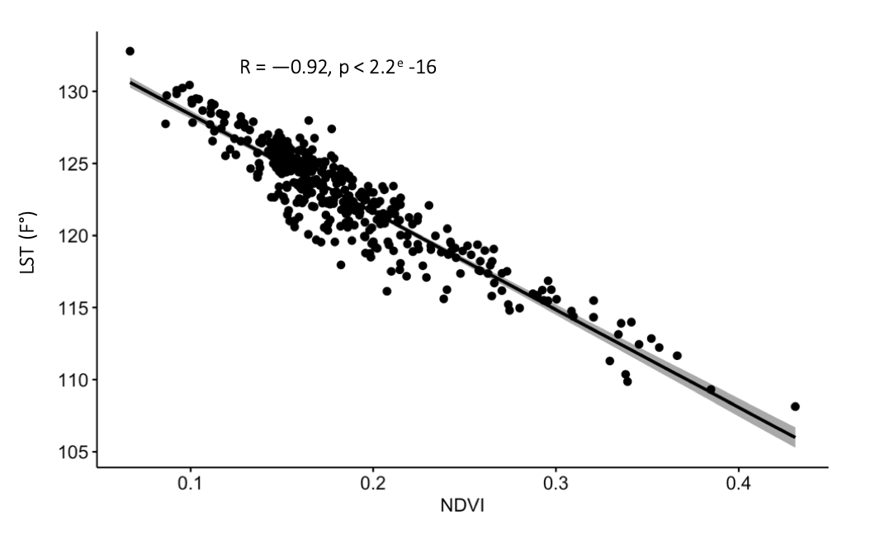

*Figure 6.* 2019 LST and NDVIlinear correlation plot for Phoenix

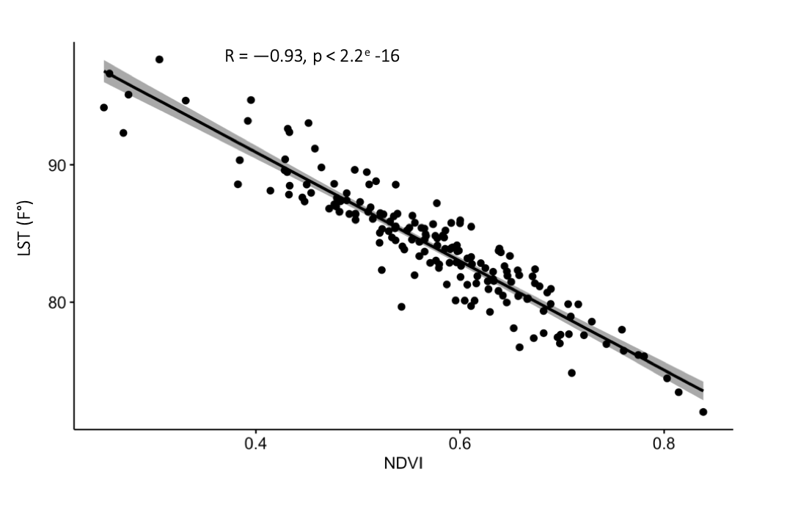

*Figure 7.* 2019 LST and NDVIlinear correlation plot for Seattle

Looking at changes in citywide averages of NDVI and LST over time can be used as a general indicator of the successfulness of greening and heat mitigation initiatives. Although Louisville enacted programs to increase the number of green spaces in their city between 2015 and 2019, the efforts did not increase the overall NDVI of the city or combat the increase in LST for the city during that time. In 2015, Louisville had an overall average NDVI of 0.673 and in 2019 the NDVI had negligibly increased to 0.675. The average LST value for the city increased by about 4 degrees Fahrenheit from 80.6 to 84.7.

Finally, the relationship between the percentage of children in poverty and NDVI for Louisville in 2019 was moderately negative (R = - 0.55) and statistically significant (p = 7.02e-16). The relationship between the percentage of children in poverty and LST for Louisville in 2019 was moderately positive (R = 0.48) and statistically significant (p = 4.941e-12) (*Figure 8*). This suggests that there are fewer green spaces and more urban heat effects in census tracts with lower income. Therefore, city planners hoping to address certain health inequities, such as rates of asthma and heart disease, may want to consider focusing on increasing green spaces in less affluent areas.

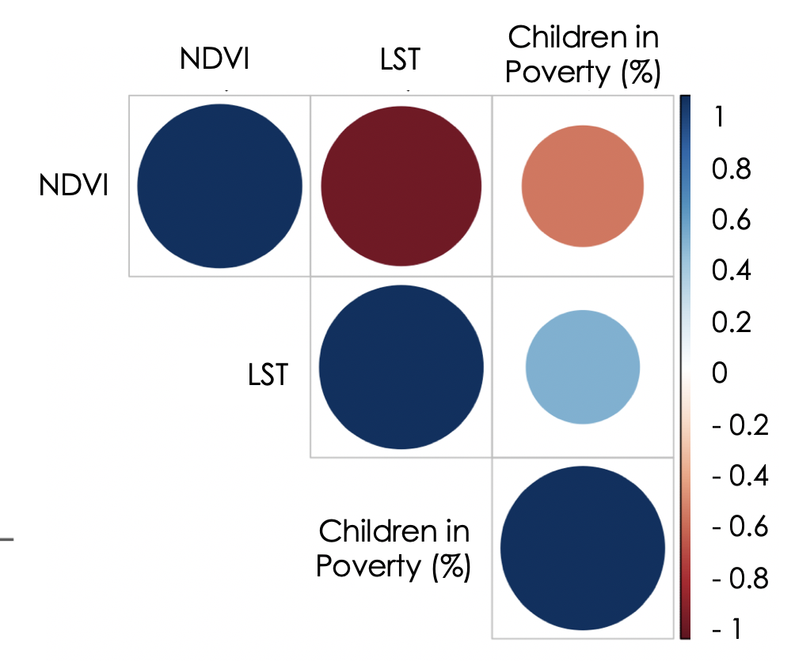

*Figure 8.* Correlation chart between NDVI, LST, and percentages of children in poverty. The numbers on the right indicate the R-value by color. The size of the circles also corresponds to the correlation value. NDVI and LST values are significantly correlated to children in poverty. The relationship between NDVI and children in poverty has an R-value of -0.55, while the relationship between LST and children and poverty has an R-value of 0.48

***4.2 Future Work***

Our work will be repeated by our partners, who will use our code tutorial to compute NDVI and LST for future years of data. When NASA launches its Landsat 9 satellite in 2020, our code could be updated by calculating LST using data from the new thermal sensor. Further work could also be done with additional statistics to establish whether or not NDVI and LST are correlated to other demographic factors, such as ethnicity.

# 

# 5. Conclusions

Our team created new greenness and land surface temperature metrics replicable for future years that will be incorporated into the CHD website. Our method has been applied to each of the 793 cities and, therefore, works for various climatic regions. For instance, we were able to produce results for both Phoenix, AZ, and Seattle, WA, which both have very distinct weather patterns, vegetation types, and overall climates.

Despite Louisville’s efforts to expand urban green spaces, the city-wide average NDVI remained relatively constant from 2013 to 2019, while LST increased by 4 degrees Fahrenheit. This may suggest that urban revegetation measures have not been sufficient enough in Louisville to counteract LST increases from ongoing urban development and changes in land cover. Factors like these that can lead to higher LST should also be considered and further studied.

Our results will help cities previously lacking this type of data in planning and monitoring progress toward urban greenness and heat mitigation goals. These findings could also be useful for further investigating the causes of health inequity at the census-tract level in Louisville and in cities across the nation. Providing policymakers and the public with data showing a correlation between green spaces and LST within cities will support public health-related environmental decisions and better target urban planning, as these metrics will highlight areas where revegetation efforts and heat mitigation initiatives should be focused.

# 6. Acknowledgments

The Louisville Urban Development team would like to thank the mentors and partners who dedicated their time and assistance to this project. Without them, this project would not have been possible.

We appreciate the cooperation and help from our project partners at the City Health Dashboard and the Louisville Envirome Institute:

# Ben Spoer, Manager, Data and Analytics for the City Health Dashboard

# Miriam Gofin, Senior Data Analyst for the City Health Dashboard

# Taylor Lampe, Data Analyst for the City Health Dashboard

# Peggy Hsieh, Research Analyst for the City Health Dashboard

# Leena Abbas, Associate Research Analyst for the City Health Dashboard

# Ted Smith, Research Center Lead at the Louisville Envirome Institute, University of Louisville

# Ray Yeager, Research Scientist at the University of Louisville

Mentors/Science Advisors:

# Dr. David Hondula, Science Advisor at Arizona State University

# Dr. Kenton Ross, NASA DEVELOP National Science Advisor

# Crystal Wespestad, AZ – Tempe NASA DEVELOP Fellow

# Lance Watkins, Former DEVELOPer, Arizona State University

Any opinions, findings, and conclusions or recommendations expressed in this material are those of the author(s) and do not necessarily reflect the views of the National Aeronautics and Space Administration.

This material is based upon work supported by NASA through contract NNL16AA05C.

# 7. Glossary

**Brightness temperature** – The brightness temperature is a measurement of the radiation traveling upward from the atmosphere to the satellite. This value is then expressed in units of the temperature of an equivalent black body.

**CHD** – City Health Dashboard. An online dashboard launched in 2017 to provide city leaders with an array of regularly refreshed data to support health-related decision-making.

**Emissivity** – A measurement of an object’s ability to emit infrared energy. This emitted energy indicates the temperature of the object.

**Greenness** – A measure of the health and abundance of green vegetation in an area. This term is used interchangeably with NDVI as more of a layman’s definition.

**Impervious surfaces** – Any constructed surface that prevents water runoff. Impervious surfaces re-emit heat and cause land surface temperatures to increase. These surfaces are more common in urban areas.

**LST** – Land Surface Temperature. A measurement of how hot a surface on Earth would feel to the touch. From a satellite’s perspective, the surface is the first object that it sees when looking from the atmosphere down to the ground.

**NDVI** – Normalized Difference Vegetation Index. It is used to assess the presence and health of vegetation with values ranging from -1 to +1. A low value for NDVI represents a lack of vegetation whereas a high value for NDVI indicates healthier and denser vegetation.

**Urban heat island effect**  – This phenomenon occurs when land surface temperatures within urban areas are hotter than the surrounding rural areas due to more impervious surfaces and less green spaces.

# 8. References

Beck, L. R., Lobitz, B. M., & Wood, B. L. (2000). Remote sensing and human health: New sensors and new opportunities. *Emerging infectious diseases*, *6*(3), 217-227. doi: [10.3201/eid0603.000301](https://dx.doi.org/10.3201%2Feid0603.000301)

Davey Research Group. (2015). Louisville urban tree canopy assessment. Retrieved September 26, 2019, from <https://louisvilleky.gov/sites/default/files/community_forestry/community_foresty_files/louisvilleutcreport-24march2015_draft.pdf>

Donovan, G. H., Butry, D. T., Michael, Y. L., Prestemon, J. P., Liebhold, A. M., Gatziolis, D., & Mao, M. Y. (2013). The relationship between trees and human health: Evidence from the spread of the emerald ash borer. *American Journal of Preventive Medicine*, *44*(2), 139-145. doi: [10.1016/j.amepre.2012.09.066](https://doi.org/10.1016/j.amepre.2012.09.066)

Jenerette, G. D., Harlan, S. L., Buyantuev, A., Stefanov, W. L., Declet-Barreto, J., Ruddell, B. L., …Li, X. (2016). Micro-scale urban surface temperatures are related to land-cover features and residential heat related health impacts in Phoenix, AZ USA. *Landscape Ecology*, *31*(4), 745-760. doi: [10.1007/s10980-015-0284-3](https://doi.org/10.1007/s10980-015-0284-3)

Johnson, D. P., Wilson, J. S., & Luber, G. C. (2009). Socioeconomic indicators of heat-related health risk supplemented with remotely sensed data. *International Journal of Health Geographics*, *8*, 57. doi: [10.1186/1476-072X-8-57](https://doi.org/10.1186/1476-072X-8-57)

Kondo, M. C., Fluehr, J. M., McKeon, T., & Branas, C. C. (2018). Urban green space and its impact on human health. *International Journal of Environmental Research and Public Health*, *15*(3), 445. doi: [10.3390/ijerph15030445](http://doi.org/10.3390/ijerph15030445)

Lovasi, G. S., Quinn, J. W., Neckerman, K. M., Perzanowski, M. S., & Rundle, A. (2008). Children living in areas with more street trees have lower prevalence of asthma*. Journal of Epidemiology & Community Health*, *62*(7), 647-649. doi: [10.1136/jech.2007.071894](http://doi.org/10.1136/jech.2007.071894)

Shen, H., Huang, L., Zhang, L., Wu, P., & Zeng, C. (2016). Long-term and fine-scale satellite monitoring of the urban heat island effect by the fusion of multi-temporal and multi-sensor remote sensed data: A 26-year case study of the city of Wuhan in China. *Remote Sensing of Environment*, *172*, 109-125. doi: [10.1016/j.rse.2015.11.005](http://doi.org/10.1016/j.rse.2015.11.005)

Twohig-Bennett, C., & Jones, A. (2018). The health benefits of the great outdoors: A systematic review and meta-analysis of greenspace exposure and health outcomes. *Environmental Research*, *166*, 628-637. doi: [10.1016/j.envres.2018.06.030](http://doi.org/10.1016/j.envres.2018.06.030)

U.S. Geological Survey Earth Resources Observation and Science Center. (2014). Landsat OLI and TIRS Level-1 Surface Reflectance. US Geological Survey. doi: [/10.5066/F71835S6](https://doi.org/10.5066/F71835S6)