**NASA DEVELOP National Program**



University of Georgia

*Spring 2017*

Southern Appalachia Disasters

Using NASA Earth Observation to Monitor Vulnerability, Wildfire Damage, and Recovery in the Appalachian Forest

 **Technical Report**

Final Draft – March 30th, 2017

Amanda Aragón (Project Lead)

Natalia Bhattacharjee

Christopher Cameron

Matthew Hevert

Stephen Jordan

Caren Remillard

Joshua Willis

Dr. Marguerite Madden, University of Georgia, Center for Geospatial Research (Science Advisor)

Dr. Sergio Bernardes, University of Georgia, Center for Geospatial Research (Science Advisor)

# 1. Abstract

Wildfires in the southeastern US are relatively less-understood compared to other portions of the nation. In October and November of 2016, over 60 individual wildfires across seven states in the Southern Appalachian region damaged hundreds of buildings, caused numerous power outages, and resulted in several fatalities. The devastating effects of these wildfires led to the evacuation of cities such as Gatlinburg and Pigeon Forge, TN and highlight the need to improve understanding of fire-susceptibility and risk in the southeastern US. Agencies like the US Forest Service require a thorough understanding of wildfire vulnerability, damage, and recovery to effectively help local communities respond to and prepare for these unfortunate events. The University of Georgia NASA DEVELOP team partnered with US Forest Service’s Southern Research Station to assess vegetation dynamics before and after the 2016 major wildfire events in portions of GA, NC, and TN. This was accomplished by utilizing Landsat 8 OLI, Terra ASTER, and Terra MODIS data to evaluate land cover changes and air quality from October to December 2016 to assess the severity of these fires. In addition to physical environmental parameters associated with the fire, this project incorporated demographic data to examine the relationship between fire risk and fuel build-up associated with under-managed lands, such as heirs’ properties. The results of this project provided researchers at the US Forest Service with an increased understanding of how property ownership and community management practices can affect the risks for future wildfires.

**Keywords**

Remote sensing, MODIS, Landsat 8, wildfire susceptibility, heirs’ property, NDVI, CWPP, Firewise communities

# 2. Introduction

* 1. ***Background Information***

Driven by human and natural forces such as changes in climate, human population growth, and vegetation change, the threat of wildfires has increased and is anticipated to intensify in the future (Pechony & Shindell, 2010). A better understanding of wildfire risks, particularly in the Southeastern United States, is needed as some climate models predict that droughts will become more common in Appalachia in the future leading to more wildfires (Boddy, 2016). During late 2016, nearly 60 individual wildfires burned in seven states surrounding the southern Appalachian Mountains (Georgia, Tennessee, North Carolina, South Carolina, Kentucky, West Virginia, Virginia) and damaged hundreds of buildings, caused multiple power outages, and led to the evacuation of several populated areas. Over 15,000 acres within the Great Smoky Mountains National Park, a designated UNESCO World Heritage Site (and one of the world’s most biologically diverse and intact forests), and the adjacent tourist areas of Gatlinburg and Pigeon Forge, are estimated to have burned over a two-day period, from November 28th to November 29th, 2016. Some environmental factors that contributed to the fire intensity and propagation in these areas include the presence of 90 mile per hour winds, low humidity, drought conditions, and the abundance of high fuel loads.

While both wildfire and prescribed fire have been integral to the function of ecosystems across the southern U.S., fire can pose risks to local civilian communities in regards to medical, economic, financial, and other burdens (Gan et al. 2015). Although there have been intensive studies on the fire ecology of the region and the physical wildfire risk factors, much less attention has been devoted to simultaneously identifying socio-economic drivers related to the spread of wildfires. A portion of this project in subsequent DEVELOP terms will focus on “heirs’ properties”, defined as any real property with multiple owners whose names are not explicitly noted on property deeds. It is believed that the unclear ownership and mismanagement of these lands has contributed to increased fuel loads, making these parcels and adjacent parcels more susceptible to fires. Furthermore, some communities have Community Wildfire Protection Plans (CWPPs) and/or are designated as Firewise Communities (Figure 2). The presence and/or lack of these fire mitigation efforts may be another social indicator of wildfire risk in a region and will be analyzed in the future.

The ultimate goal for this term’s project includes a wildfire risk model that is based on both physical and biological risk factors. The study area for this project concentrates on three states that were heavily affected by the fall 2016 fire events including parts of Georgia, Tennessee, and North Carolina (Figure 1). Forest resource agencies and local communities require a more thorough understanding of areas that are at an increased risk for wildfire and will be able to use our model to better allocate attention and resources to high risk communities.



VA

KY

NC

GA

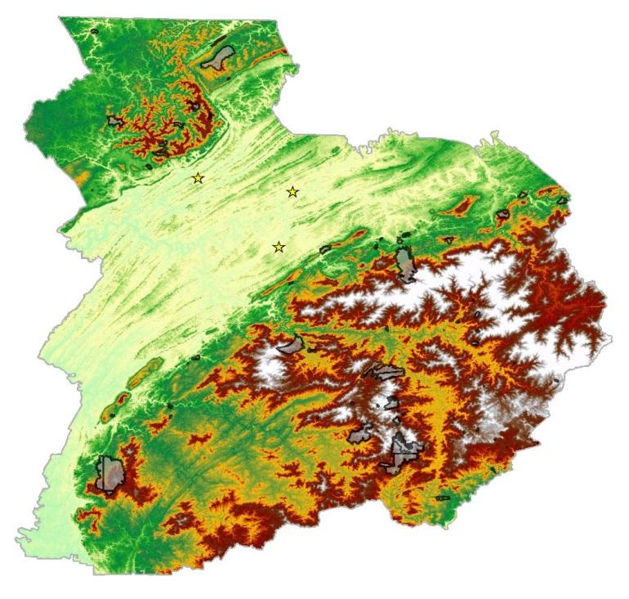

TN

**Knoxville**

**Oak Ridge**

SC

**Maryville**







**Figure 1.** Southern Appalachian project area including parts of GA, TN, and NC.

* 1. ***Project Partners & Objectives***

This project falls under the Disasters application area of NASA’s Applied Science Program. The Disasters area supports projects that work to enhance management practices and disaster reduction across several disaster types, including wildfires. Earth observations via remote sensing data are readily available and particularly useful in analyzing large areas that have already suffered from natural disasters or may be subject to them in the future. This Southern Appalachia Disasters project utilizes remote sensing data to evaluate a southern sub-region heavily impacted by wildfires in the fall of 2016. The main objectives of this project were to use NASA satellite imagery, 1) to explore the physical and biological factors that may lead to increased wildfire susceptibility within the Southern Appalachian study region, and 2) to create a wildfire risk model that can be used by our partners to narrow mitigation efforts and better allocate resources toward specific communities and regions that are most at risk.

Our project partner, The US Forest Service, is currently developing methods to properly treat areas of concern in southern Appalachia through three primary goals: restoration, regeneration, and fuel reduction (Waldrop, 2016). Recently, the Forest Service has performed thinning treatments and prescribed burns to areas in the southeastern US where there have been multi-year droughts. Studies conducted by the US Forest Service Southern Research Station have focused on excessive fuel loading, management policies related to human alteration of local ecosystems, and both the use and effectiveness of prescribed burns. These studies are long-term and require additional field observations to determine forest sustainability (Prestemon et al, 2016). This project’s wildfire risk model will include fuel loading as a key input and may be used to help determine the areas that could benefit the most from prescribed burns and treatment strategies.



**TN**

**GA**

**NC**

Cleveland

Knoxville

Maryville

Morristown

Kingsport

Anderson

Dalton

Oak Ridge

Asheville

**Legend**

Firewise US Events

CWPPs

2016 Fire Perimeters

Cities

Project Outline







Image result for N arrow ESRI

**Figure 2.** CWPP and Firewise Communities locations: Southern Appalachian GA, TN, NC.

# 3. Methodology

***3.1 Data Acquisition***

Prior to data acquisition, the DEVELOP team conducted a thorough literary review of past research conducted on the topic of wildfire modeling as well as a review of previous DEVELOP projects that focused on disaster modeling. Furthermore, our team interviewed fire ecology experts from the US Forest Service Rocky Mountain Research Station in order to develop a more comprehensive understanding of wildfire risk and functionality. Based on our findings, we identified nine biological and physical risk factors to incorporate into our GIS wildfire risk model. Future work will focus on incorporating social wildfire risk indicators and vulnerability metrics into the model to build a comprehensive wildfire vulnerability index (Figure 3).

Several biological risk indicators were used in the GIS wildfire risk model for the Southern Appalachian study area. ForWarn, a MODIS based data collection retrieved from the US Forest Service, provided data of recent decline of both deciduous and evergreen vegetation. Both were used as model parameters with the thought that areas of recent decline would entail an abundance of dead, woody vegetation that could burn intensely if ignited. Similarly, NDVI values were used as an indicator of potential fuel presence with higher values representing dense vegetation and fuel abundance and lower values representing barren areas that are at a low risk for fire ignition and propagation. NDVI use in large-scale wildfire modeling has been widely used (Helman et al, 2015; Cao et al, 2013; Escuin et al, 2008). NDMI analysis provided the team with a notion of vegetation moisture prior to the fall 2016 fire events. Intuitively, areas with NDMI values indicative of low moisture content were deemed to be at a higher risk for wildfire. Lastly, land cover types were assigned risk values according to their likelihood to burn intensely. Canopy presence and impervious surface density were incorporated into the model as well.

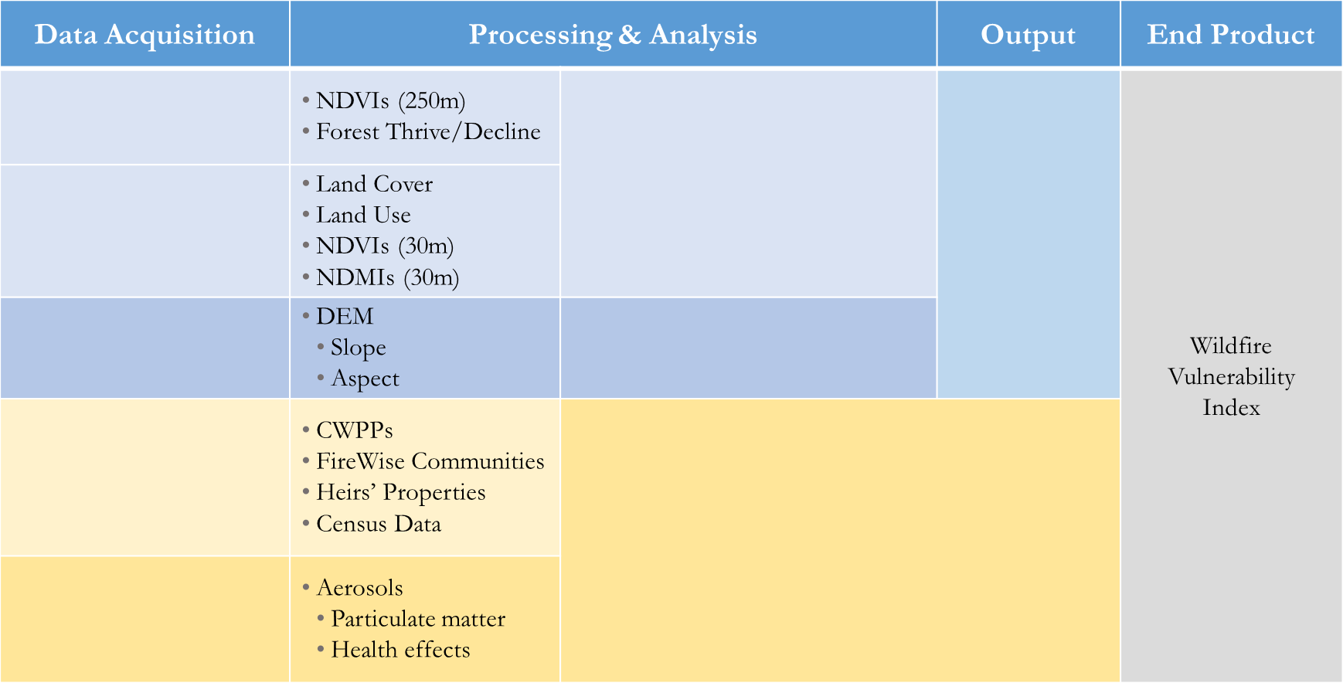

Terra MODIS

Biological Risk Factors

Physical Risk Factors

Fire Risk Model

Landsat 8 OLI

Wildfire

Vulnerability

Index

Terra ASTER

Socio-

Demographic

Social Impacts and Risk Factors

Terra MODIS

Air Quality

**Figure 3.** Summary of overall methodology

As for physical risk factors, wildfire studies and literature indicate that the topography of a region can contribute to wildfire risk (Pyne et al., 1996; Rothermal, 1983). Our approach to account for topography in our physical risk index relied heavily on prior methodology outlined by Ercanoglu et al (2016) for modeling wildfire susceptibility. Terra ASTER DEM data accounted for the topographic variables of slope and aspect in our Southern Appalachia study region. Areas with steep slopes were assigned higher risk values as fire tends to spread quickly towards higher elevations. In regards to aspect, areas facing south or southwest were given higher risk values since they are known to receive more sunlight and consequently have a higher probability of ignition. Similarly, areas facing towards the north were assigned lower risk values as they receive less light. (Appendix A)

The Terra and Landsat 8 satellites provided the majority of the data used in creating a wildfire risk model. Landsat 8 Operational Land Imager (OLI) images were obtained from the United States Geological Survey (USGS) EarthExplorer website. Four pre-fire scenes, Landsat 8 OLI/TIRS C1 Level-1 products, corresponding to path and rows: LC80190362016244LGN00, LC80190352016244LGN00, LC80180362016285LGN00, and LC80180352016285LGN00 were downloaded and provided coverage of the entire study area. Normalized difference vegetation indices (NDVI) and normalized difference moisture indices (NDMI) were each calculated from the Landsat 8 OLI images. A digital elevation map (DEM) created from Advanced Spaceborne Thermal Emission and Reflection Radiometer (ASTER) instrument aboard the Terra satellite provided our team with terrain relief data used in our fire risk analysis. The AST14DEM: ASTER Digital Elevation Model V003 was also retrieved from EarthExplorer. The Moderate Resolution Imaging Spectroradiometer (MODIS), also aboard the Terra satellite, supplied valuable phenological data of our study region including the decline of evergreen and deciduous vegetation. This ForWarn data was preprocessed and received directly from the US Forest Service Eastern Forest Environmental Threat Assessment Center.

The remaining inputs into our model came from the 2011 National Land Cover Database (NLCD) obtained from the Multi-Resolution Land Characteristics Consortium (MRLC) website. Specifically, land cover type, canopy cover, and impervious surface data were used in our analysis. All ancillary data provided was fitted to the project study region (Appendix B).

Lastly, the US Forest Service Rocky Mountain Research Station provided polygon shapefiles representative of the regions that were actually burned during the fall 2016 fire events. They also provided point shapefiles of the known CWPP locations in our study region up to the year 2011. Firewise Community locations within our study region were downloaded from ArcGIS Online and were current as of summer 2016.

***3.2 Data Processing***

A variety of data processing steps were taken to form the nine raster images which served as inputs into the GIS model. Landsat 8 OLI Surface Reflectance bands were processed in ESRI’s ArcMap software including compilation, mosaicking, clipping, and NDVI processing. Bands 1-7 were compiled in the Image Analysis subset of the program which allowed the bands to be recognized as a single layer for easier management and analysis. Band compilations were mosaicked using the “Mosaic to New Raster” ArcToolbox function and then clipped to our designated study area. Landsat 8 OLI bands 4 and 5, corresponding to red and near infrared respectively, were used to calculate NDVI values for each 30 meter pixel to provide estimates of vegetation greenness and fuel content (Equation 1). NDVI values were calculated using the Image Analysis “NDVI” calculator. A nearly identical method was used to calculate NDMI values for our study area. The only difference was that bands 5 and 6 were designated in the Image Analysis options tab (Equation 2). NDMI values provided us with an estimate of the amount of moisture present for each 30 meter pixel just prior to the fire events.

$NDVI=\frac{NIR-VIS}{NIR-VIS}$ (1)

$NDMI=\frac{NIR-SWIR1}{NIR+SWR1}$ (2)

The ASTER DEMs were also mosaicked and clipped to produce one continuous elevation data layer that covered the entire study area. The DEM was further processed using the ArcToolbox 3D Analyst functions “Aspect” and “Slope” to provide us with aspect and steepness values respectively.

Several additional datasets were acquired and formatted appropriately for input to ArcMap. These included ForWarn phenological data and land cover datasets. Appendix A provides a summary of all the data processing undergone for the fire risk model.

Once the nine raster images for each of our model parameters were generated, they needed to be reclassified to a common scheme. Since our project partner, the US Forest Service, was interested in a model that assigned categorical rankings to areas based on low, medium, or high fire risk, we reclassified each of the rasters to values of 1, 2, and 3 representing low, medium, and high risk respectively. The reclassification of the raster data into three separate groups was based on literature, expert opinion, and the natural jenks classification scheme in ArcMap software. The last data processing step involved using the “Raster Calculator” tool in ArcToolbox to weigh each of the nine rasters and combine them into a single raster image representing the cumulative wildfire risk for our study area (Appendix C).

***3.3 Data Analysis***

After assigning weights to the 9 model inputs, running the raster calculator tool, and analyzing the initial output raster, the model seemed to perform well and categorized risk areas as expected. In order to validate the model which was based on temporal data leading up to and immediately prior to the 2016 fire events, polygon boundaries of the actual fires were overlaid onto the initial wildfire risk raster (Figure 4). When analyzing only the assigned wildfire risk categories within the burned land areas, the model classified 50.7% of the pixels (or land) as high risk, 47.6% as medium risk, and 1.7% as low risk. In terms of a few major individual fire events within our study region, the model predicted the Chimney Top fire and the Rock Mountain fire with land risk assignments of H-66.6%, M-29.9%, L-3.5% and H-64.5%, M-35.5%, and L-0% respectively. After adjusting the weighted values of the model slightly (Appendix D), a final model for this DEVELOP term’s project was achieved (Figure 5). For all of the burned land areas within the study area, it assigned 61.7% as high risk, 36.9% as medium risk, and 1.4% as low risk. It also performed better for several of the individual fire events including the Chimney Top and Rock Mountain fires (Figures 7 and 8).

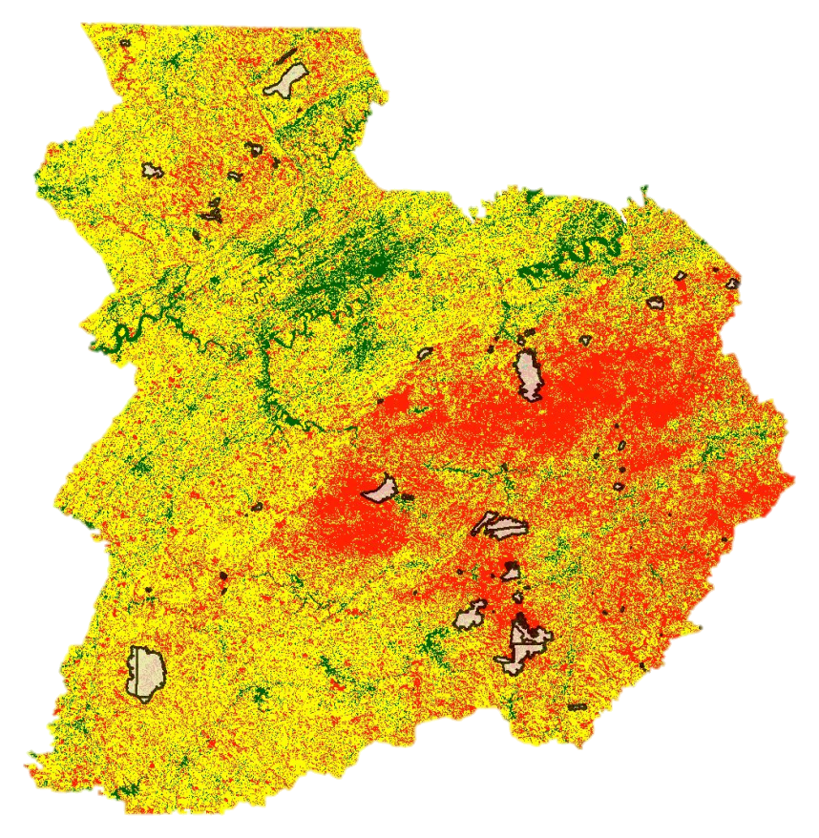

Chimney Top Fire

High

Medium

Low

2016 Fire Perimeters

N

Rock Mountain Fire

Rough Ridge Fire

**Figure 4.** First iteration of wildfire risk model with boundaries of the actual fire events

**Figure 5.** Final model categorization of entire study area

**Figure 6.** Final model categorization of actual burned area

**Figure 7.** Final model categorization of Rough Ridge Fire

**Figure 8.** Final model categorization of Chimney Top Fire

**Figure 9*.*** Final model categorization of Rock Mountain Fire

# 4. Results & Discussion

***4.1 Analysis of Results***

While both the initial and second models performed well, the latter model more accurately predicted the 2016 Southern Appalachian fire events in our tri-state study area. The final model classified 34.7% of the entire study area as high risk, yet it categorized 61.7% of the land within areas that actually burned as high risk thus demonstrating its predictive capabilities. As depicted in Figures 7 and 8, the model also performed very well in predicting the Chimney Top and Rock Mountain fires at H-72.2% and H-76.9%. While the model did not perform as well with the Rough Ridge fire in North Georgia, the vast majority of the area immediately affected by that fire was classified as high and medium risk at H-35.6% and M-64.2%.

There are a few shortcomings of our model that should be noted. First, our model does not account for wind, which undoubtedly plays an important role in the spreading of wildfires. While we chose the 9 physical and biological inputs to our model as well as their associated weights based on literature review and expert opinion, there are likely some other important risk factors that would enhance the model considerably. While some of the inputs to our model remain relatively constant through time (such as slope, aspect, land cover type, etc.) other inputs such as NDVI and NDMI can change significantly from year to year and may affect the accuracy and usefulness of our wildfire risk model in the future.

The final wildfire risk model does appear to accurately classify our study region into areas of high, medium, and low wildfire risk. The model can be used by the US Forest Service to focus their prevention planning and allocate their resources to areas most at risk for fire events in the near future. Over half of all fire event locations can be characterized by high risk areas. Approximately one percent of the fire perimeters were characterized by low risk areas. Due to the physical and social impacts of the wildfire events, these estimates reflect sound justifications for the level of impact occurred. Our DEVELOP team was able to compare the 2016 wildfire extents with model outputs to generate summary statistics. This allowed the team to gain a better understanding of where these fire events occurred within the context of the model results and what environmental factors represented the perimeter of these events. More than half of the Rock Mountain event was characterized by high risk and nearly thirty six percent possessing medium wildfire risk. Low risk rates were characterized by less than one percent.

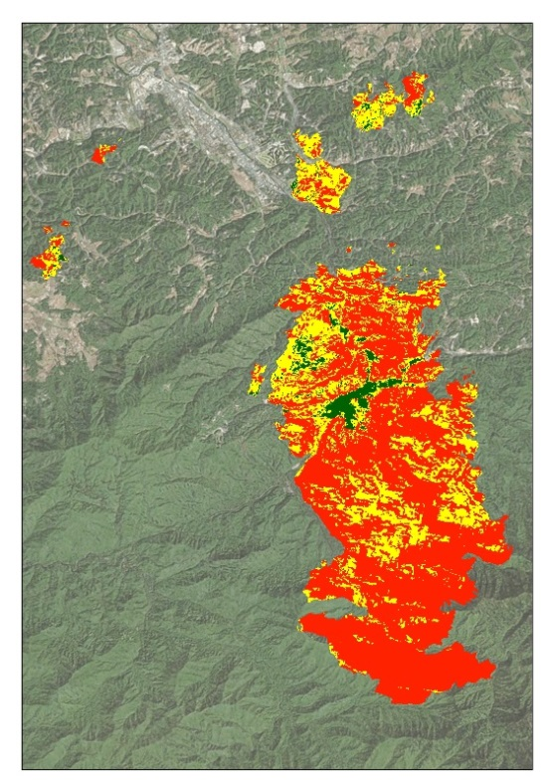

N

Sevierville

Gatlinburg

High



Medium

Low



**Figure 10.** Chimney Top Fire

For a better grasp at individual fire risk designations, the Chimney Top Fire (Figure 10) highlights the location of Gatlinburg’s city boundaries and its surrounding landscape vulnerability levels. The physical characteristics of differing impervious surface cover appear to contribute to the likelihood of wildfire spread.

***4.2 Future Work***

Further analysis could be done to better calibrate our final model. A wider variety of inputs into the wildfire risk model could be experimented with and multivariate logistic regression could be used to ultimately determine which of the inputs are most important to the model. While the current framework of our model seems to be effective, future work could be done to transform it from a static model to a dynamic model using a platform such as Google Earth Engine. This could provide nearly real-time updates to the model to better represent changes within the study area, particularly in regards to NDVI and NDMI values. Since the major focus of this term was based on physical and biological impacts on the indicated landscape, social wildfire risk indicators and impacts will be examined in the summer 2017 term. Data from this term’s analysis of physical impacts will provide a great deal of reference and information for future analysis of both social risk indicators and social impacts of the communities residing in immediate areas.

# 5. Conclusions

The 2016 wildfire events in the southeastern US deeply impacted the region leading to evacuations, economic hardships, and even the loss of life. These events highlighted the need for better preparation and increased mitigation measures moving forward. The DEVELOP team successfully examined the biological and physical wildfire risk factors pertinent to the Southern Appalachian study region. They created a fire risk model that will aid partners at the US Forest Service Southern Research Station in planning for future fires in the region. Validation of the wildfire risk model with 2016 US fire perimeter polygons within this region suggests that the nine parameters and weights used in the model provide a reasonable framework. This allowed the team to classify land areas as high, medium or low fire risk regions with a 30 meter resolution. Additional work will involve model calibration as well as integrating the findings of this project with further analyses of satellite data to account for air particulates, along with socio-demographic factors, CWPPs, and heirs’ properties land designations to create a comprehensive vulnerability index. The US Forest Service, as well as many other entities on the federal, state, and community levels, can use this end-product to assist with making science-based decisions about resource management, prescribed burns, and other forms of wildfire mitigation for the Southern Appalachians.

# 6. Acknowledgments

The team would like to thank our science advisors Dr. Marguerite Madden and Dr. Sergio Bernardes at UGA.  The team would also like to acknowledge our partners at The Forest Service Southern Research Station, Cassandra Johnson Gaither, Steve Norman, and Bill Christi, for their involvement with the project and communication during the term. Additionally, our team would like to thank UGA Center Lead Caren Remillard for her support.

Any opinions, findings, and conclusions or recommendations expressed in this material are those of the author(s) and do not necessarily reflect the views of the National Aeronautics and Space Administration.

This material is based upon work supported by NASA through contract NNL16AA05C and cooperative agreement NNX14AB60A.

# 7. Glossary

**MODIS** **–** Moderate Resolution Imaging Spectroradiometer

**ASTER –** Advanced Spaceborne Thermal Emission and Reflection Radiometer

**NDVI –** Normalized Difference of Vegetation Index

**NDMI –** Normalized Difference of Moisture Index

**SR –** Surface Reflectance, remote sensed data from primarily satellite based technology that provides surface information such as thermal, infrared, vegetation health, and similar type information.

**EOS –** Earth Observing System

**OLI** **–** Operational Land Imager

**TIRS** **–** Thermal Infrared Sensor

**DEM** **–** Digital Elevation Model

**CWPP** **–** Community Wildfire Protection Plan

**GEE –** Google Earth Engine

# 8. References

Boddy, J. (2016). As record Appalachian wildfires fizzle out, scientists look to learn from the destruction. Science. doi:10.1126/science.aal0537

Cao, X., Cui, X., Yue, M., Chen, J., Tanikawa, H., & Ye, Y. (2013). Evaluation of wildfire propagation susceptibility in grasslands using burned areas and multivariate logistic regression. *International Journal of Remote Sensing*, 34(19), 6679-6700. doi:10.1080/01431161.2013.805280

Escuin, S., Navarro, R., and Fernandez, P. (2008). Fire severity assessment by using NBR (Normalized Burn Ratio) and NDVI (Normalized Difference Vegetation Index) derived from LANDSAT TM/ETM images. *International Journal of Remote Sensing*, *29*(4), 1053-1073.

Ercanoglu, M., Weber, K., Langille, J., and Neves, R. (2006). Modeling wildland fire susceptibility using fuzzy systems. *GIScience & Remote Sensing,* *43*(3), 268–82. doi:10.2747/1548-1603.43.3.268.

Gan, J., Jarrett, A., & Gaither, C. J. (2015). Landowner response to wildfire risk: Adaptation, mitigation or doing nothing. *Journal of Environmental Management*, 159, 186-191. doi:10.1016/j.jenvman.2015.06.014

Helman, D., Lensky, I., Tessler, N., & Osem, Y. (2015). A Phenology-Based Method for Monitoring Woody and Herbaceous Vegetation in Mediterranean Forests from NDVI Time Series. Remote Sensing, 7(9), 12314-12335. doi:10.3390/rs70912314

Johnson Gaither, C., Goodrick, S., Murphy, B., & Poudyal, N. (2015). An Exploratory Spatial Analysis of Social Vulnerability and Smoke Plume Dispersion in the U.S. South. Forests, 6(5), 1397-1421. doi:10.3390/f6051397

Johnson Gaither, C., Poudyal, N. C., Goodrick, S., Bowker, J., Malone, S., & Gan, J. (2011). Wildland fire risk and social vulnerability in the Southeastern United States: An exploratory spatial data analysis approach. *Forest Policy and Economics*, 13(1), 24-36. doi:10.1016/j.forpol.2010.07.009, Retrieved February 15, 2017, from https://www.colorado.edu

Pechony, O., & Shindell, D. T. (2010). Driving forces of global wildfires over the past millennium and the forthcoming century. Proceedings of the National Academy of Sciences, 107(45), 19167-19170. doi:10.1073/pnas.1003669107

Prestemon, J. P., Shankar, U., Xiu, A., Talgo, K., Yang, D., Dixon, E., . . . Abt, K. L. (2016 June 2). Projecting wildfire area burned in the south-eastern United States, 2011–60. *International Journal of Wildland Fire*, 25(7), 715. doi:10.1071/wf15124, Retrieved from https://www.srs.fs.usda.gov

Pyne, S.J., Andrews, P.L., and Laven, R.D. (1996). Introduction to wildland fire (2nd ed). New York, NY: John Wiley & Sons.

Rothermel, R.C. (1983). How to predict the spread and intensity of forest and range fires.” *USDA Forest*

*Service General Technical Report INT-143*. Ogden, UT: Intermountain Forest and Range Experiment Station.

Waldrop, T.A., Hagan, D., & Simon, D.M. (2016, May) *Repeated application of fuel reduction techniques in the southern Appalachian mountains, USA. Implications for achieving management goals.* Retrieved from <https://www.srs.fs.udsa.gov>

ForWarn (2017) /MODIS/ Oak Ridge National Laboratory / MOD13Q1 MODIS/Terra Vegetation Indices 16-Day L3 Global 250m SIN Grid V006. NASA EOSDIS Land Processes DAAC

NASA LP DAAC., accessed 17 February 2017. doi.org/10.5067/MODIS/MOD13Q1.006

US Geological Survey (2014)/Provisional Landsat 8 surface reflectance 16 day global 30m. US Geological Survey Observation and Science Center/EarthExplorer.usgs.gov/ US Geological Survey, accessed 8 February 2017/doi.org/10.5066/F78S4MZJ

NASA LP DAAC. (2001). ASTER DEM Product GDEM. NASA LP DAAC., accessed 8 February 2017doi.org/10.5067/ASTER/AST14DEM.003

# 9. Appendices

**Appendix A.**  Fire Risk Model Matrix

|  |  |  |  |  |
| --- | --- | --- | --- | --- |
| **Parameter** | **Score** | **Possible Reclassification Scheme (0-1000)** | **Weight%**  **(Priority)** | **Purpose** |
| Moisture (NDMI) | 0-200 high, 200-400 med, 400-800 low |  | low | Moisture content.  Score based on Keetch-Byram Drought Index |
| Vegetation Greenness (NDVI) | Low, med, high | Neg values = 0  0.2-0.5 = medium  0.6-0.9 = high  0.1-0.2 = low | high | Ecological conditions |
| Vegetation Type MODIS (Thrive/Decline) | Deciduous vs. evergreen |  | high |  |
| Land Cover Type 2011 (NLCD) | Plants that are high, med, low fuel load produced, and n/a |  | high | National land cover type 2011. |
| Impervious Surface (NLCD) | 2 classes, impervious or non-impervious  Urban disturbance | 0, 1000 | high | Areas with non-impervious surface are more likely to be at risk for forest fires. |
| Canopy Cover  (NLCD) | Below %, Above %, none, 0-1 |  | med | % of canopy cover of tree density measurements. |
| Terra ASTER  Slope/Aspect | High >45%, med 15-45%, low <15% | Suppression Difficulty (Slope)   |  |  | | --- | --- | | 0-10 deg = 100  10-20 deg = 200  20-30 deg =850  30+ deg = 1000  Spread (Slope)  0-10 deg = 41  10-20 deg = 137  20-30 deg = 256  30-40 deg = 489  40+ deg =1000 | Aspect  N = 100  NE = 150  E = 300  Flat = 500  SE = 800  S = 1000  SW = 1000  W = 700  NW = 200 |   (Ercanoglu, 2006) | higher | DEM from Terra ASTER |

**Appendix B.** Ancillary Data

|  |  |
| --- | --- |
| **Dataset** | **Source** |
| Land Cover 2011 | National Land Cover Dataset |
| Tree Canopy | National Land Cover Dataset |
| Impervious Surfaces | National Land Cover Dataset |
| 2016 Fire Perimeters | US Forest Service |
| Community Wildfire Protection Plan (CWPP) Locations | DOI/USDA |
| Firewise Communities Locations | National Fire Protection Association |

**Appendix C.** Summary of Data Processing Steps for Each Dataset

|  |  |  |
| --- | --- | --- |
| **Dataset** | **Processing** | **Data Format** |
| Landsat 8 OLI | ·    Reprojected to UTM 17N  ·    Formed composites from bands 1-7  ·    Mosaicked scenes  ·    Clipped to study area  ·    Calculated NDVI  ·    Calculated NDMI  ·    Reclassified Rasters | Landsat 8 NDVI and NDMI raster datasets for study area |
| ForWarn Phenological Data - Evergreen and Deciduous Decline | ·    Reprojected to UTM 17N  ·    Merged GA, TN, NC datasets  ·    Clipped to study area  ·    Resampled from 250m to 30m resolution  ·    Reclassified Rasters | MODIS raster dataset for study area |
| NLCD 2001 and 2011 | ·    Reprojected to UTM 17N  ·    Clipped to study area  ·    Added ID field classes  ·    Reclassified Rasters | Land cover raster dataset for study area |
| ASTER DEM | ·    Reprojected to UTM 17N  ·    Mosaicked scenes  ·    Clipped to study area  ·    ArcToolbox 3D Analyst “Aspect” and “Slope” tools  ·    Reclassified Rasters | DEM dataset for study area |

**Appendix D.** 2016 Pre-Fire Model Weights

|  |  |  |
| --- | --- | --- |
| **Rank** | **Pre-Fire Model 1** | **Weights** |
| 1 | Slope | 0.182 |
| 2 | NDVI | 0.182 |
| 3 | Evergreen Decline | 0.182 |
| 4 | Impervious Surface | 0.091 |
| 5 | Deciduous Decline | 0.091 |
| 6 | NLCD | 0.091 |
| 7 | NDMI | 0.091 |
| 8 | Canopy | 0.0455 |
| 9 | Aspect | 0.0445 |
|  |  | 1 |