NASA DEVELOP National Program
NASA Langley Research Center
Spring 2017

Glacier National Park Climate II
A Threshold-Based Decision Tree Approach to Mapping Landscape Disturbance in Glacier National Park


Technical Report
Final Draft – March 31, 2017

Charlotte Mays (Project Lead)
Antonio Alvarado
Ryan Avery
Jemiris Gonzalez-de Jesus
Suzannah Richards

Dr. Kenton Ross, NASA Langley Research Center (Science Advisor)

Previous Contributors:
Jordan Lubbers
Dr. Sunita Yadav-Pauletti
Zachary Wardle
Joe Harris

1. Abstract
Insects and pathogens cause extensive damage to pine forests in the northwestern United States. Bark beetles in particular cause mortality in pine stands that can impact the timber industry and national parks. Previously, studies have used spectral indices derived from Landsat time series to identify insect disturbance. The team mapped landscape disturbance in Glacier National Park and Waterton Lakes National Park in Alberta, Canada from 1999-2016 using a time series of Normalized Difference Moisture Index (NDMI) and red-green index (RGI) computed from cloud-free Landsat composites. Aerial Detection Survey (ADS) polygons were used to fine tune thresholds, targeting the classification of moderate disturbance toward insect disturbance. Insects and pathogens were the primary focus of this classification scheme, however, due to the level of ambiguity in the ADS data and because NDMI is sensitive to various disturbance types, the study opted to map all moderate disturbance. To determine the thresholds for these categories, the team analyzed spatial subsets of our spectral indices within ADS polygons, fire data from the National Park Service, and polygons representing healthy forest as digitized from high resolution NAIP imagery. RGI was then incorporated to further target the red stage of bark beetle attack in the moderate disturbance category. Maps of persistent disturbance over a time series of five inter-annual periods were created from the resulting maps of interannual disturbance. The study programmatically generated all maps and histograms with Python for efficiency and modularity, so that the methodology may be applied to map future outbreaks.
Keywords
Remote sensing, Landsat, landscape disturbance, bark beetle, time series, image classification

2. Introduction
  - Background Information
Parasitic insects have caused unprecedented damage to pine forests of the Crown of the Continent ecosystem since 1999 (Goodwin et al., 2008). This has resulted in significant economic costs for the forestry industry and has compromised the ecological and aesthetic value provided by national parks in the area (Meddens et al., 2013). Two species of insects, the mountain pine beetle and the western spruce budworm, are biotic drivers of tree mortality and defoliation in western North America, affecting larger areas of pine stands each year than wildfire (Meigs et al., 2011; Meigs et al., 2015). Park managers at Glacier National Park are concerned with how insect disturbances may alter the pre-fire conditions and exacerbate fire severity or extent. However, there is ongoing debate as to whether the severe outbreaks of mountain pine beetle, are associated with wildfire parameters (Hicke, 2012). Nevertheless, bark beetle and spruce budworm can alter forest structure and stand health and pose a safety risk from falling trees (Meddens, 2013). The magnitude of recent outbreaks has been due in large part to climatic conditions, such as shorter winters, which favor the insects and lead to populations of epidemic proportions (DeNitto, 2001). Within GNP, park managers have noted that the time period of 1999-2016 has been characterized by climatic extremes and thus more insect outbreak (Potter, 2016). In order to mitigate the effects of these disturbance agents, it is important to map the range and severity of damage over time in order to understand present disturbance and to forecast future risk.

Glacier National Park (GNP), located within the larger Crown of the Continent ecosystem, encompasses one million acres of diverse northern Rocky Mountain wilderness in northwestern Montana (Figure 1). GNP is one of America’s largest and most pristine wilderness (Waldt, 2004). However in recent years, GNP has been subject to insect outbreak that could mar the iconic pine forests that park visitors value at GNP and pose a safety hazard. To improve the park service’s monitoring and management of insect disturbance, the team sought to map and quantify insect and pathogen disturbance in Glacier National Park from 1999 to 2016.

The utility of moderate resolution, multispectral imagery to examine insect disturbance has been widely documented (Shakun et al., 2003; Meddens et al., 2013). Because insect disturbance causes changes in canopy spectral signatures, remote sensing has become an important tool to measure this change (Hicke, 2013). In previous studies, researchers have used 30m Landsat 5 Thematic Mapper (TM) and Landsat 7 Enhanced Thematic Mapper Plus (ETM+) to distinguish deviations in spectral signatures and capture different disturbances (Goodwin et al., 2008). In many studies, the Normalized Difference Moisture Index (NDMI) has been used because of the correlation between moisture decrease and prolonged insect infestation (Goodwin et al., 2008; Vogelmann et al., 2009). Moisture indices are particularly valuable in mapping bark beetle disturbance because after a bark beetle attack, declines in moisture content are more pronounced than changes in visible reflectance (Wulder et al., 2006). Other studies have incorporated the red-green index (RGI) to capture the transition of insect-infested trees from the green stage to the red stage, with success (Dennison et al., 2010). When bark beetles attack trees, green reflectance tends to decrease and red reflectance tends to increase, producing a spectral signature that is potentially identifiable with moderate resolution sensors like Landsat (Meddens et al., 2013). This project evaluated both NDMI and RGI indices to estimate the presence of moderate level defoliation and mortality due to insects.
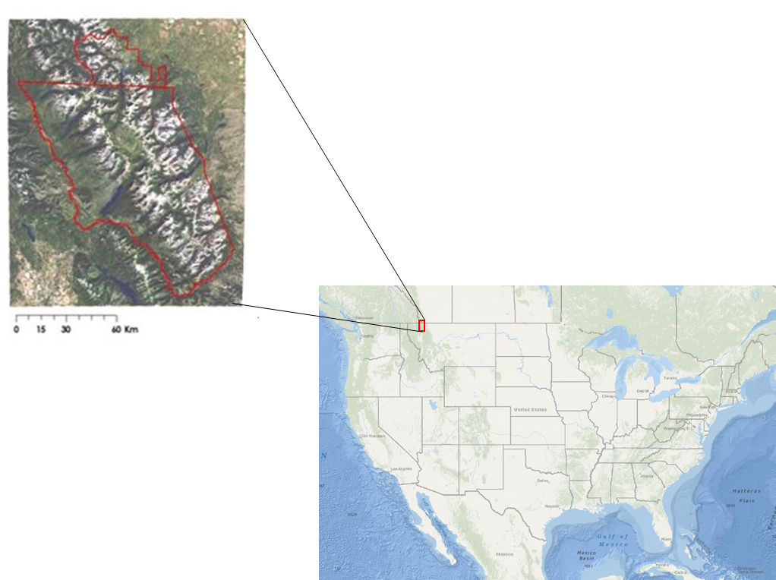

Figure 1: Inset map of Waterton-Glacier International Peace Park. U.S. Map courtesy of geology.com

  - Project Partners & Objectives
The team partnered with Richard Menicke, Geographer for the National Park Service (NPS) at Glacier National Park, Dr. Christopher Potter, Senior Research Scientist for the National Aeronautics and Space Administration (NASA) Biospheric Branch at NASA Ames Research Center, and Dr. Jeffrey Hicke, Associate Professor at the University of Idaho. Richard Menicke is interested in quantifying and mapping landscape disturbance in GNP. He would like to evaluate how NASA Earth observations can offer a more consistent and synoptic view of landscape disturbance in the park. Dr. Christopher Potter is interested in the methodological development to quantify and map bark beetle disturbances. Dr. Jeffrey Hicke’s interests and experiences are in the realm of patterns, controlling factors, and effects of forest disturbance due to insect outbreak. This project will potentially help inform his research going forward.

This project falls under the Climate Application Area of NASA’s Applied Sciences Program and will help scientists, park staff, and land managers better understand the impacts of a changing climate on forest ecosystems. The objectives of this study were to (1) classify insect disturbance within Glacier National Park using decision tree based thresholds, (2) develop an automated methodology using remote sensing techniques that benefit future research, and (3) create a tutorial that allows high school students near GNP to interact with similar disturbance datasets.

3. Methodology
3.1 Data Acquisition
Richard Menicke provided the team with a variety of website links to geospatial data, as well as the Fire Atlas for the Crown of the Continent Ecosystem, delineating the extent and burn severity of forest fires occurring within the park (Parks, et al., 2015). The team downloaded a time series of Aerial Detection Surveys (ADS) polygons, a vegetation land cover classification map layer, and a park boundary map layer. The Aerial Detection Surveys map insect activity using representative polygons to reflect forest and terrain disturbances. These surveys have been collected annually for decades, providing insight into insect behavior and species interaction with the vast forested landscapes characteristic of the western U.S. (Meigs et al., 2015). The vegetation land coverage map was developed by the USGS-NPS Vegetation Mapping Program by interpreting aerial imagery from 1997-1999 and referencing wide-ranging field surveys.

The bulk of the multispectral imagery collected by the team was downloaded, by request, from the United States Geological Survey Earth Science Processing Architecture (USGS ESPA). Landsat surface reflectance data for the time period of 1999-2016 were downloaded, including satellite images from Landsat 5 Thematic Mapper (TM), Landsat 7 Enhanced Thematic Mapper Plus (ETM+), and Landsat 8 Operational Land Manager (OLI). The team also ordered Normalized Difference Vegetation Index (NDVI) and NDMI indices computed for each image in our time series of surface reflectance data using the Earth Resources Observation and Science (EROS) Science Processing Architecture (ESPA) interface. Since GNP experiences high snow and cloud cover in most of the park from October through May, only data for the months of June through September were downloaded to reduce inaccuracies in surface spectral signatures.

The team referenced total precipitation and snow water equivalent (SWE) data averaged annually for four weather stations (Many Glacier, Flat Top Mountain, Pike Creek, and Emery) in the vicinity of GNP using the National Resources Conservation Service (NRCS) Snow Telemetry data set. The team also downloaded 2014 NASA SRTM (Shuttle Radar Topography Mission) digital elevation model data from USGS EarthExplorer. The data come in 1-arc second (approx. 30m) tiles which the team mosaicked together in order to get complete coverage of the study area.

3.2 Data Processing
The decision tree for categorizing disturbances within Glacier National Park was broken down into five interconnecting components. Each component helped shape the methodology of the decision tree, and the overall development of automation. These components included (1) processing of NDMI index, (2) processing of ADS polygons, (3) digitization of healthy forest polygons from National Agriculture Imagery Program (NAIP) 1 meter imagery and NDVI computed from Landsat, (4) selection of fire polygons from the Fire Atlas for the Crown of the Continent Ecosystem, and (5) processing of the RGI index.

Each Landsat scene was clipped to the minimum bounding box of a 4 kilometer buffered park boundary, to include areas of interest in and directly outside Glacier National Park’s administrative boundaries for analysis. Appendix 1.1 details a true-color raw Landsat 5 image from 2005 with the 4km study boundary area layered on top for comparison of scale. From there, clouds, water, and snow were masked from Landsat scenes using each scene’s cfmask layer. Using a target date of July 21st, the resulting “No Data” pixels were filled-in with the temporally closest Landsat scenes available within that year’s month range. Since NDMI is sensitive to changes in moisture that can be affected by seasonality, it was important to keep these composited Landsat scenes as close to the target date as possible. The target date was selected because it occurs when there is minimal snow and cloud cover in Glacier National Park and is when the trees are the most phenologically active, according to our partner at the National Park Service. An example of a composited, masked, and clipped image can be seen below in Figure 2.

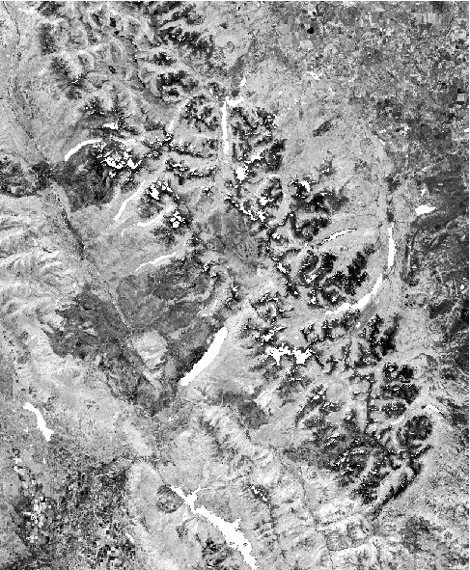
The Normalized Difference Moisture Index was selected due to its relative sensitivity in detecting insect and pathogen disturbance compared to other indices (Goodwin et al., 2008). The yearly composited NDMI images were then used for computation of subsequent analyses. The index is calculated with the following equation, where, SWIR = surface reflectance shortwave-infrared band (1550nm – 1750nm) and NIR (770nm – 900nm) = surface reflectance near infrared band.

$NDMI=\frac{NIR-SWIR}{NIR+SWIR}$ (1)

Landsat 5 and 7 utilized bands 5 and 4 for SWIR and NIR respectively, with Landsat 8 utilizing bands 6 and 5. The specific satellite sensor used for each year can be found in Table 1 in the Appendix, showing the inter-annual periods that were selected based on data availability, as well as data attributes. Attributes such as “detected fire occurrence” and “percentage of clouds” were accounted for and masked out within the images. NDMI values range from -1 to 1. The team used a scale factor of 10,000 to convert the data to integer format, so values for pixels in NDMI images range from -10,000 to 10,000 and values for pixels in inter-annual ∆NDMI images range from -20,000 to 20,000. The change in moisture was calculated by finding the difference between the inter-annual periods of analysis (Table 1 in Appendix).
Figure 2: Example of a composited and cloud-masked NDMI raster clipped to the 4km study boundary (from Landsat 5 TM, 2005)

Processing of the ADS data began with inspection of the attributes associated with each polygon. The data include attributes that denote damage causal agents, dead trees per acre, and host species. See Table 2 in the Appendix for a list of ADS attributes. The team decided to subset the ADS polygons to the bark beetle and dead trees per acre (DTPA) categories because it was hypothesized that the progression of desiccation and eventual mortality from this species would coincide with inter-annual changes in NDMI. In past studies, DTPA has been used as a way to locate bark beetle activity. The team chose to only include the top 15% of DTPA because a higher concentration of dead trees tends to produce a stronger spectral signal of bark beetle attack (Hicke, 2012).

The team digitized polygons of healthy tree canopies in Google Earth Engine API (GEE) using true-color NAIP imagery and NDVI derived from Landsat for individual years. The team excluded all areas identified as disturbed or defoliated by the ADS surveys and restricted our digitizing of healthy forest to pine species within the NPS vegetation classification map of 1997 (USGS, 2007). The team then digitized these healthy forest areas by visual examination for both high NDVI values from Landsat and canopy health from NAIP. Areas were only digitized if they were identified as being healthy at both ends of the inter-annual period.

From the Fire Atlas provided by Richard Menicke (National Park Service) that spanned from 1967 to present, the team selected only years that were in our study period and those that occurred after our target date Landsat scenes. For example, in 2015 three fires occurred: July 21, August 9, and August 14. Because the Landsat scenes mosaicked in 2015 were all captured before August 9, the team only selected the two August fires, and did not include the one from July. Examples of bark beetle, healthy forest, and fire polygons on top of Google Earth Digital Globe imagery can be found in Appendix 1.2.

Additionally, the team calculated the red-green index (RGI) using Landsat red and green bands. The red-green index was utilized to detect insect-caused tree mortality through the use of single-date Landsat imagery; RGI is indicative of red-stage tree mortality (Meddens et al., 2013) and is calculated differently than NDMI, only taking the ratio of red reflectance to green reflectance of vegetation. The index is calculated with the following equation, where Red Band = 630nm – 690nm and Green Band = 520nm – 600nm:

$RGI=\frac{Red Band}{Green Band}$ (2)

Referring back to Table 1 in the Appendix, Landsat 5 and 7 utilized bands 3 and 2 for red and green reflection respectively, with Landsat 8 utilizing bands 4 and 3. RGI was calculated with bands from which clouds, water, and snow had already been masked. Similar to the NDMI process, the RGI images were also composited so that “No Data” gaps were filled in. The flowchart of all four processes can be found in Figure 3 below. The team used the arcpy Python package to automate our methodology wherever possible.
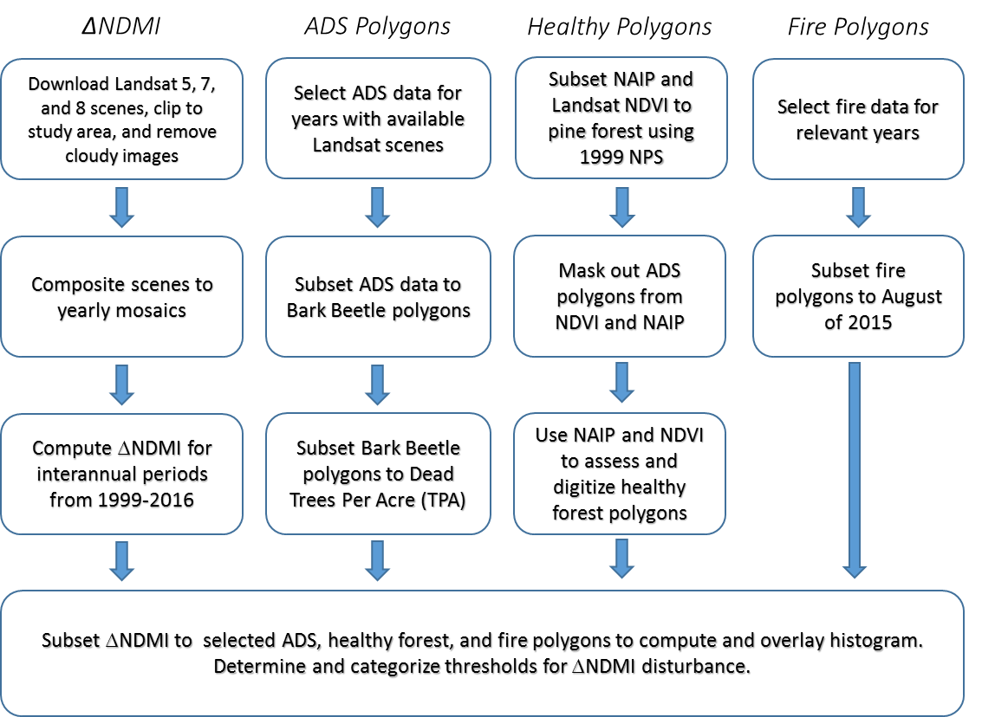

Figure 3: Decision tree methodology for categorizing disturbances within Glacier National Park

3.3 Data Analysis
The clipped, masked, and mosaicked ∆NDMI rasters were then clipped to match all three sets of polygons separately: Bark beetle, healthy vegetation, and fire. Using an R script, the team created histograms for each ∆NDMI subset. The inter-annual period 2013-2014 was chosen because it was a non-drought year for which the team had digitized healthy vegetation polygons. However, because no fires occurred in that time period, 2015 fire polygons were used. The resulting histograms (Figure 4) were displayed in the same plane so that their overlaps could be compared and assessed. The team used these histograms to establish thresholds for five distinct categories. These thresholds can be found in Figure 5.

Once thresholds were established, the team reclassified the ∆NDMI rasters to make classification maps. The team then made persistence of moderate disturbance maps by extracting the moderate disturbance category from the classification maps and grouping them into five inter-annual periods (Table 3, Appendix). Because there are no cloud-free Landsat scenes available for 2008 and 2012, the team had to use an inter-annual period of 2007-2009 and from 2011-2013. From these maps elevation over 6,500 ft. was masked out using the SRTM because most pine species preferred by the bark beetle tend to grow at lower elevations (Logan and Powell, 2001). The towns of Whitefish and Columbia Falls in Montana and Aetna and Cardston in Canada were also masked out because they detracted from the main focus of our study.
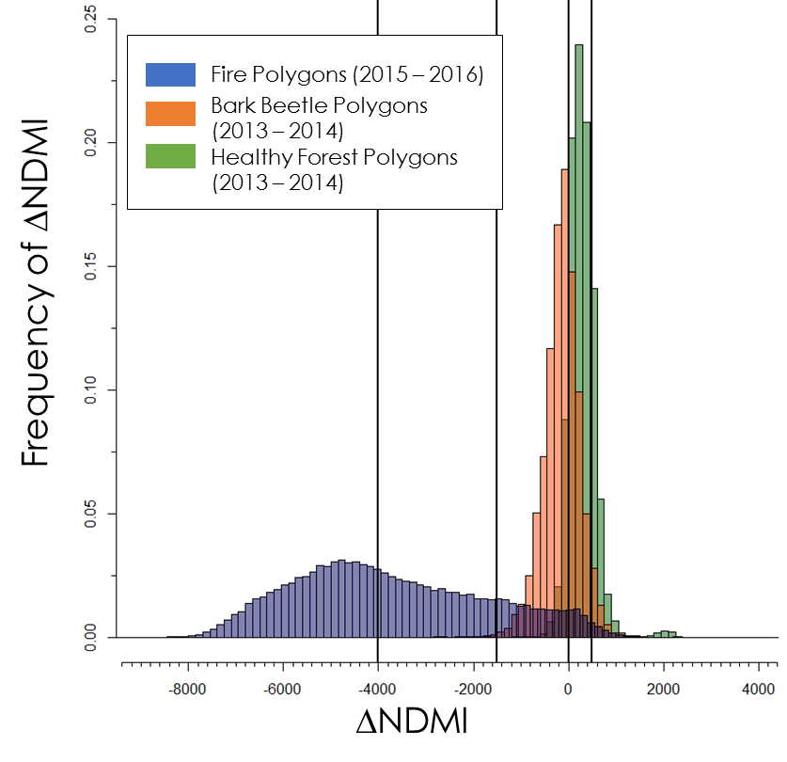

Figure 4. Histogram comparison of ∆NDMI Subset to Bark Beetle, Healthy Forest, and Fire Polygons
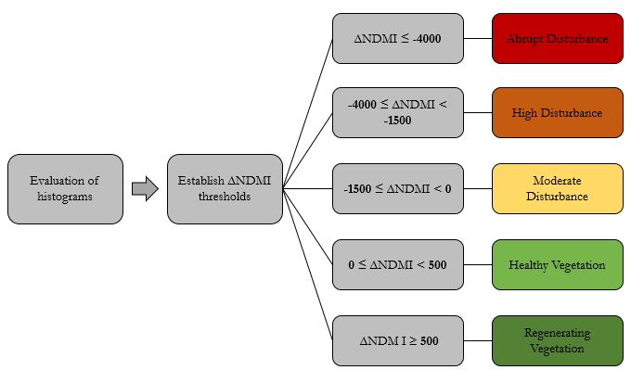

Figure 5. Flow chart showing chosen thresholds

The team then clipped RGI to the ADS subsets used in previous processing (bark beetle and the top 15% of dead trees per acre) at different lag years. Table 4 in the Appendix shows the ADS lag years selected for each RGI year. The team also clipped RGI to the moderate disturbance category that had been established during the classification of ∆NDMI process. Because NDMI had been classified using inter-annual periods, and RGI in single year, for clipping the team matched each RGI year to the second year of the inter-annual period in order to keep our analysis consistent. Using the histogram script again, the team created RGI histograms of each RGI year with lag years of -1, 0, +1, and +2. The team then chose a threshold separating two categories: “Potential Red Attack” and “Other Disturbance”.

3.4 Evaluation
Post-classification, the percent of each disturbance category within the ADS, healthy forest, and fire polygons was calculated. The moderate disturbance pixels that fell within the ADS polygons were considered correctly classified, healthy forest pixels that fell within healthy forest polygons were considered correctly classified, and abrupt disturbance pixels that fell within fire polygons were considered correctly classified. The team also examined correlations between precipitation and the amount of moderate disturbance per inter-annual period. To accomplish this, the team averaged Snow Telemetry precipitation data over the four ground monitoring stations present in Glacier National Park for each water year that coincided with each inter-annual period. The team then computed the number of moderate disturbance pixels for each inter-annual period and determined the correlation between these two variables.

4. Results & Discussion
4.1 Analysis of Results
The classification maps (Figures 6 and 7) show that the amount of moderate disturbance varies from year to year. 2005-2006 has a lot of moderate disturbance, whereas 2015-2016 has much more healthy vegetation than moderate disturbance. Upon visual inspection of the entire time series (Appendix 1.3), the team can see that when a fire occurs in red in one inter-annual period, the next inter-annual period shows regeneration in dark green in the same area where the fire took place.

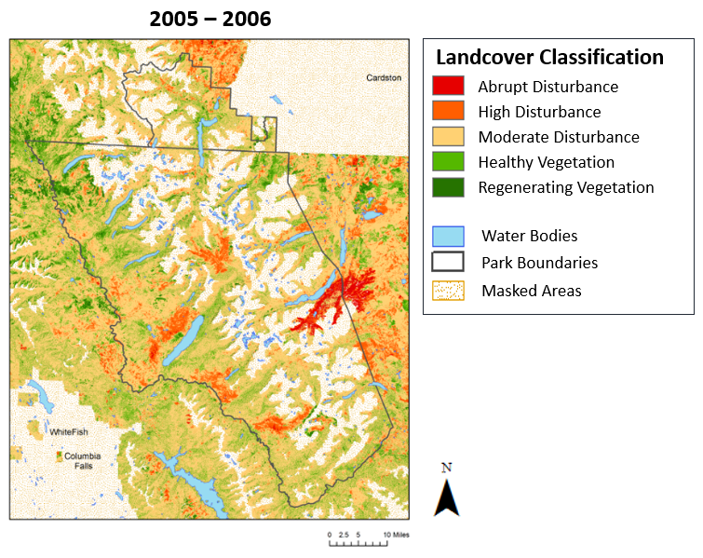
Results of the accuracy assessment (Table 5 in Appendix) indicate that the producer’s accuracy was high. These results, however should not be taken to mean that everything in our moderate disturbance category was bark beetle disturbance. Many of the pixels in this category are mapping phenomena other than bark beetle, thus while the producer’s accuracy is high, if the team were to test consumer’s accuracy, it would most likely be low. Table 5 in the Appendix reveals that in every inter-annual period, at least 40% of the pixels in the moderate disturbance category were correctly classified. The period with the highest percentage of correctly classified pixels as moderate disturbance is 2014-2015 with 83.3%. The period with the lowest percentage is 2006-2007 with 42.06%. The percentage of moderate disturbance pixels misclassified as healthy vegetation ranged from 14.73% in the period 2014-2015 to 39.83% in the period 2006-2007. The percentage of pixels misclassified as regenerating vegetation ranged from 0.79% to 23.5%. Pixels misclassified as high disturbance ranged from 0.35% to 5.8% and those misclassified as abrupt disturbance from 0%-0.06%. The inter-annual period on which our classification was based (2013-2014) (Appendix 1.4) did not have the highest accuracy, signaling that our classification method was effective for more periods than only 2013-2014.
Figure 6. Disturbance Classification Map (2005 – 2006)

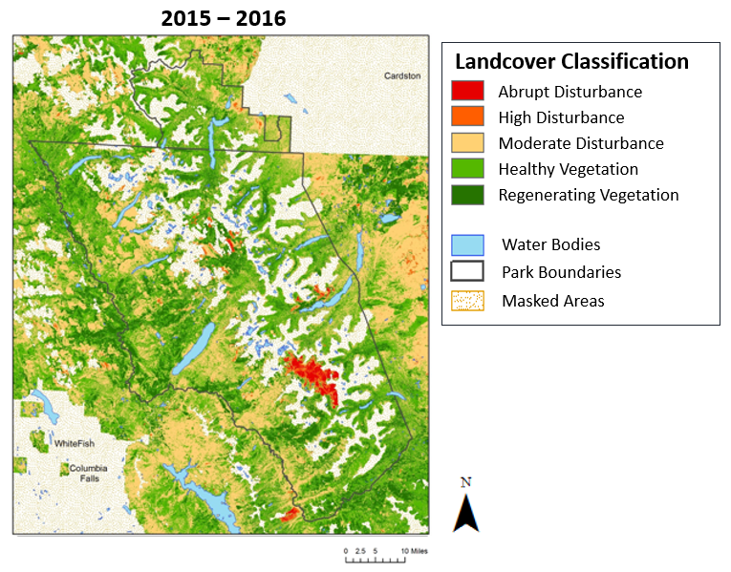
There were only three inter-annual periods of healthy vegetation for which to assess accuracy because there were only three years of sufficient, quality NAIP data. These results (Appendix 1.5) show that in 2013-2014, 70% of healthy vegetation pixels were correctly classified. 15% of pixels were misclassified as regenerating vegetation and 10% were misclassified as moderate disturbance. The team only examined fire polygons for the period 2015-2016 (Appendix 1.6). In this inter-annual period, 50% of pixels were correctly classified as abrupt disturbance, 35% were classified as high disturbance, and 12% as moderate disturbance.
Figure 7. Disturbance Classification Map (2005 – 2006)

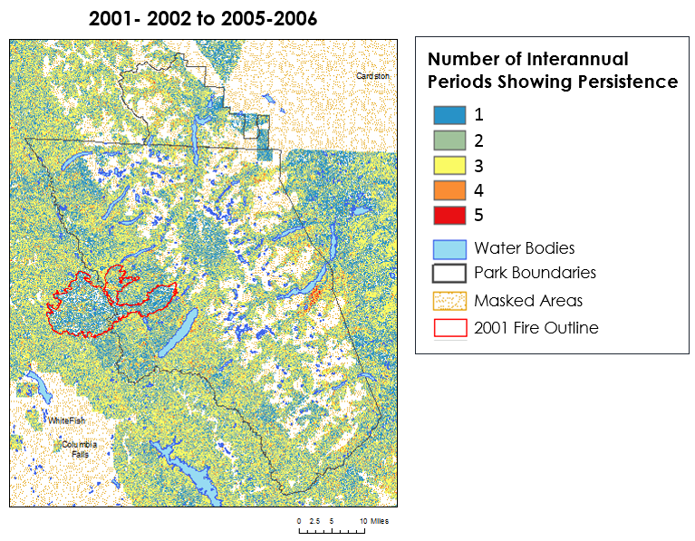
With visual assessment of the moderate disturbance persistence maps (Figures 8), the team saw that moderate disturbance persisted from 1-5 inter-annual periods, although the bulk of that persistence was from 1-3 periods. In looking at the Moose fire that took place in 2001(Figure 9), the team observed that moderate disturbance persisted up to 4 periods in and around the fire area. The team also observed that the Aerial Detection Survey recorded an abundance of bark beetle polygons inside the fire perimeter 3-5 years after the fire.

Figure 8. Persistence of Moderate Disturbance from 2001-2002 to 2005-2006

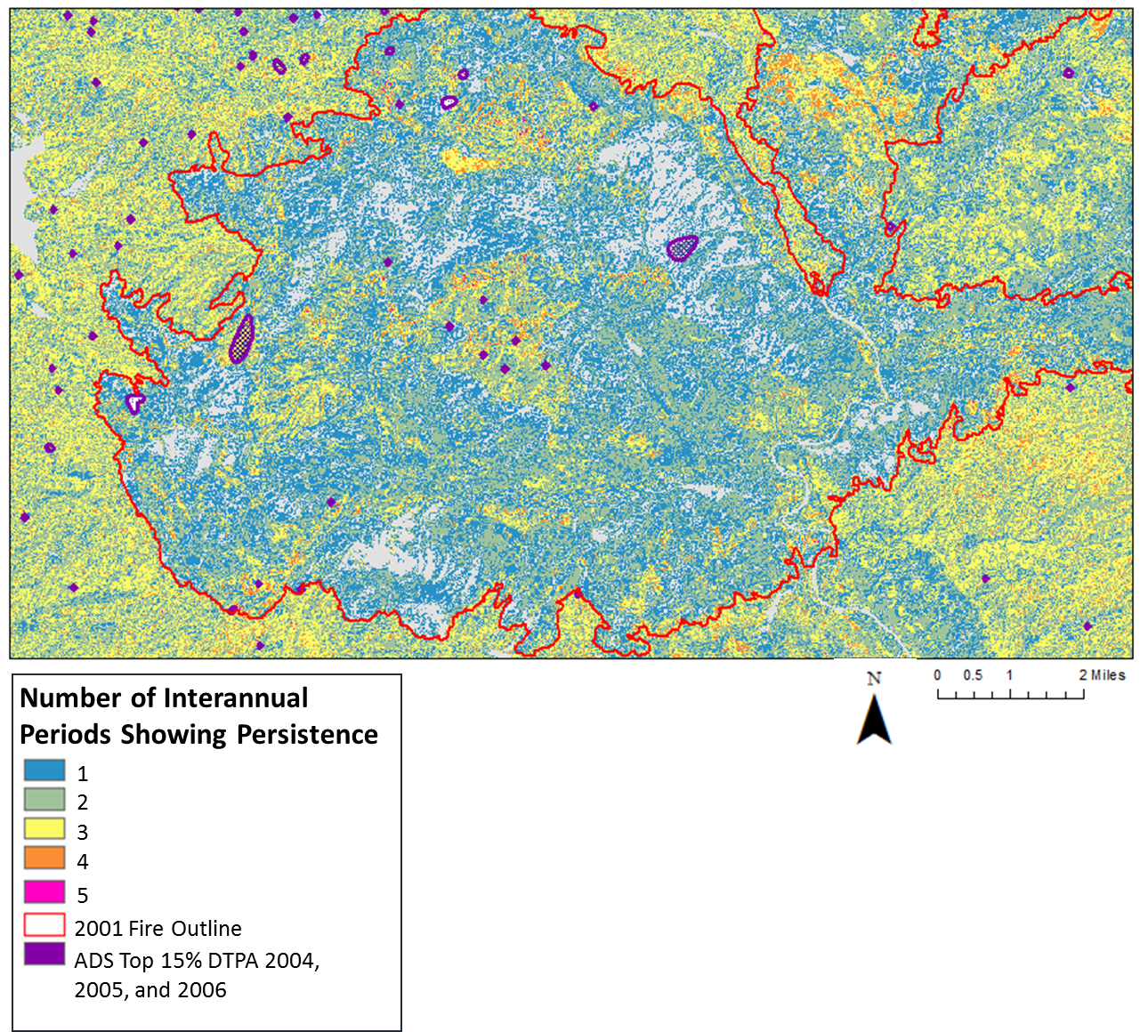
Figure 9. Close up of persistence of moderate disturbance from 2001-2002 to 2005-2006 with overlaid ADS polygons and 2001 fire outline

In looking at a correlation of precipitation and moderate disturbance (Appendix 1.7) the team had hypothesized that less precipitation would mean less stress which would cause a drop in NDMI. However the team found that there was a very small correlation of 0.08 which leads us to infer that annual precipitation does not have an effect on the amount of moderate disturbance in this study.

For the RGI analysis, the hypothesis was that in looking at the histograms the team would be able to see a pattern of increasing red with a lag of one or two years owing to the way in which ADS polygons are drawn. However, the team did not see any pattern relating to lag years (Appendix 1.8). There was a slight bi-modality in the histograms for most years, where at the value of 0.9 there seemed to be a slight increase of redness. Therefore, the team masked out all values of RGI below 0.9 (Appendix 1.9). In looking at ADS polygons of lags -1, 0, +1, and +2 overlaid on top of RGI for the corresponding year, most polygons did not match up with RGI greater than or equal to 0.9. For this reason, the team did not incorporate RGI into the classification scheme.

One reason for why RGI did not give significant results was that the team did not have ground truth data for red attack. The team was relying on the Aerial Detection Surveys, which were not necessarily looking for red-attack when pinpointing bark beetle. If the team had reliable high resolution imagery, red-attack polygons may have been digitalized and used for validation.

4.2 Sources of Error
NDMI, being highly sensitive to changes in moisture, is also highly sensitive to precipitation variations from year to year. Therefore, years following “drought years” show a much more pervasive presence of disturbances within the study area. Due to these findings, the team suggests the methodology be used with caution in years following drought years, and if possible, be restricted to being used following years with average or above average precipitation. This will eliminate areas being falsely identified as insect infected, when in reality they are distressed from drought conditions.

Some of the misclassification errors could be due to the thresholds used in our classification scheme which were somewhat arbitrarily drawn. There was overlap among fire, bark beetle, and healthy vegetation polygons in looking at their histograms and so classes cannot be considered pure. The moderate spatial resolution of Landsat also may have led to mixed pixels when classifying patchy disturbance such as bark beetle and spruce budworm. In addition, Landsat’s coarse spectral resolution restricted us to classifying broad disturbance categories, as opposed to identifying specific disturbances. The team was also limited by temporal resolution because in 2008 and 2012 there were no cloud-free Landsat images available. For other years there were very few cloud-free images around the target date, thus the team might not have as accurate a picture as the team would like.

Another source of error could be how the ADS polygons are collected. The same areas are not sampled every year due to fire conditions or lack of resources and so only some years give an overall picture of the park. In other years, the sample could be biased towards areas that are not affected by fire (DeNitto, 2002). For those years affected by fire, there were few or no surveys taken in the park, and so the team had to use samples that were just outside the park boundary. The digitization of healthy forest polygons could also be a source of human error. Healthy forests were digitized with high resolution imagery and were not verified with ground truth data. Thus, polygons that appear healthy may in fact be stressed. In looking at the histogram for healthy vegetation (Figure 4), based on how the team drew our thresholds, some pixels in the healthy polygons show decreases in NDMI that were classified as disturbance.

4.3 Future Work
Expanding upon the work already done in this term, future avenues are as follows: analyze disturbance persistence maps to try and look at why certain areas are disturbed more frequently than others (e.g. forest type, soil type, elevation, etc.), continue to work with National Park Service or academic groups to better develop ground truth data sets that will allow for better accuracy assessment of our thresholds and overall more accurate disturbance maps, explore the correlation between Mountain Pine Beetle and fire (intensity and frequency).

Although the team was successfully able to automate the methodology, our future work should include making a more concise, user-friendly script. The script automates the pre-processing for NDMI and mapping of landscape disturbance within Glacier National Park. However, future work includes optimizing the current script to provide a more accessible package that does not require the user to open up the script and manually make changes to the code. The script is also formatted to specifically work with Landsat’s spectral reflectance products. The code is also dependent on a strict folder and file structure ranging from the naming convention of downloaded satellite scenes, all the way to what the workspace and destination path of each step is designated.

The team has developed a tutorial that will teach part of this methodology to future high school students. The tutorial will give these students an introduction to Landsat NASA Earth observations and to ArcGIS through working directly with the imagery. Through their work they will learn about their surrounding environment and gain skills that can help them in career development.

5. Conclusions
Threshold-based classification schemes can provide an effective way of identifying and mapping landscape disturbances. NDMI is useful in this process, but because of its sensitivity to moisture changes due to drought, it is best used after years of average or above average precipitation. Our findings in regards to bark beetle attack and fire could contribute to the ongoing debate of whether one influences the other. The team also found that although NDMI is sensitive to moisture changes, it is more sensitive to increases or decreases of water right before it is sensed, and not moisture over the entire year. Without ground truth data for red attack, RGI should not be used to identify bark beetle disturbance. Furthermore, by improving ground truth accuracy of insect detection, accuracy of NDMI thresholds for detecting insect and other types of disturbance via remote sensing will increase and be better able to predict the way insect disturbance spreads across the landscape over time.

6. Acknowledgments
The team would like to thank the following people for their contributions throughout the duration of this project. Without them, this work would not have been possible.
- Dr. Kenton Ross, Science Advisor, NASA Langley Research Center
- Dr. Christopher Potter, Senior Research Scientists, NASA Ames Research Center – Dr. Potter’s past research using NASA Earth observations to map and quantify temporal vegetation change caused by fire and his direct counsel have helped with various aspects of this project with the previous term.
- Richard Menicke, Geographer, National Park Service - As Chief Geographer at GNP, Mr. Menicke assisted the team by providing background information related to the park, such as specific ecological and disaster events in the park’s history and other areas of the park that are of particular interest
- Dr. Jeffrey Hicke, Associate Professor, University of Idaho - Dr. Hicke has also been a valuable asset to the team through his ability to provide detailed information regarding remote sensing and modeling.
- The students and teachers of Whitefish and Columbia Falls High Schools

Any opinions, findings, and conclusions or recommendations expressed in this material are those of the author(s) and do not necessarily reflect the views of the National Aeronautics and Space Administration.

This material is based upon work supported by NASA through contract NNL16AA05C and cooperative agreement NNX14AB60A.

7. Glossary
Aerial Detection Surveys (ADS) - Provided by the U.S. Forest Service, Aerial Detection Surveys are a remote sensing technique used to detect forest changing events often attributed to insects and disease. These surveys are conducted using a small aircraft on which an observer visually gauges the extent of forest degradation. The observer will manually record his or her observations through sketches onto a map.
CFmask layer – A Landsat Collection 1 Level-1 product that uses a decision tree algorithm to label pixels in a scene as cloud, cloud confidence, cloud shadow, and snow/ice pixels. A CFmask layer is available for every Landsat scene and can be used to mask out unwanted pixels such as clouds, snow, ice, etc.) that could interfere with calculations.
Columbia, Missouri, Saskatchewan Rivers – Glacier National Park water can be considered the headwaters of rivers throughout the entire United States, including the three major rivers listed. The Columbia is one of the largest rivers in the Pacific Northwest and enters the Pacific Ocean. The Missouri River is the longest river in American and feeds into Mississippi River. The Saskatchewan is one of Canada’s major rivers and empties several hundred miles away into Lake Winnipeg.
Crown of the Continent Ecosystem - This encompasses Glacier National Park, Great Bear Wilderness, Bob Marshall Wilderness, and Scapegoat Wilderness. The term “Crown of the Continent” was coined by George Bird Grinnell, an early American explorer who heavily advocated for the protection and establishment of what is now GNP. (https://www.nps.gov/glac/learn/historyculture/index.htm)
“Far away in northwestern Montana, hidden from view by clustering mountain peaks, lies and unmapped corner- The Crown of the Continent.” –George Bird Grinnell (1901)
Desiccation – The process of extreme drying
Landsat 5 Thematic Mapper (TM) - This satellite carries several sensors including the Thematic Mapper (TM) which uses seven spectral bands while scanning the Earth with a spatial resolution of 30 meters. Landsat 5 was launched by NASA in March of 1984. The Thematic Mapper sensor halted its imaging in January of 2013.
Landsat 7 Enhanced Thematic Mapper (ETM+) - Landsat 7 satellite carrying the Enhanced Thematic Mapper (ETM+) sensor was launched by NASA in April of 1999. The sensor has eight spectral bands, a spatial resolution of 30 meters, and is still in use today. (http://landsat.gsfc.nasa.gov/the-enhanced-thematic-mapper-plus/)
Landsat 8 Operational Land Manager (OLI) - Landsat 8 satellite carrying the Operational Land Manager (OLI) was launched by NASA in February 2013 and its still in operation today. The OLI has nine spectral bands and its spatial resolution in 30 meters. (http://landsat.gsfc.nasa.gov/operational-land-imager-oli/)
Red attack phase – The stage following a bark beetle attack in which pine needles turn red
Spectral signature – The variation of reflectance or emittance of a material with respect to wavelengths in the Electromagnetic spectrum
Shuttle Radar Topography Mission (SRTM) – NASA SRTM is an international project that provides digital elevation models for over 80% of the globe and is distributed free of charge. These products are available at resolutions of 1-arc second and 3-arc second. (http://www.crownscience.org/topics/history/ glaciernationalpark)
Snow Water Equivalent (SWE) – SWE is a measure of the amount of water contained within a snowpack. It can be accessed from the National Resources Conservation Service (NRCS) Snow Telemetry data set. (https://www.wcc.nrcs.usda.gov/snow/)

8. References
Dennison, Philip E., Andrea R. Brunelle, and Vachel A. Carter. “Assessing Canopy Mortality during a Mountain Pine Beetle Outbreak Using GeoEye-1 High Spatial Resolution Satellite Data.” Remote Sensing of Environment 114, no. 11 (November 2010): 2431–35. doi:10.1016/j.rse.2010.05.018.

DeNitto, Greg. Montana Insect and Disease Conditions and Program Highlights 2001. (2002). USDA Forest Service.

Goodwin, Nicholas R., Nicholas C. Coops, Michael A. Wulder, Steve Gillanders, Todd A. Schroeder, and Trisalyn Nelson. “Estimation of Insect Infestation Dynamics Using a Temporal Sequence of Landsat Data.” Remote Sensing of Environment 112, no. 9 (September 15, 2008): 3680–89. doi:10.1016/j.rse.2008.05.005.

Hicke, Jeffrey A., Morris C. Johnson, Jane L. Hayes, and Haiganoush K. Preisler. “Effects of Bark Beetle-Caused Tree Mortality on Wildfire.” Forest Ecology and Management 271 (May 2012): 81–90. doi:10.1016/j.foreco.2012.02.005.

Logan, Jesse A., and James A. Powell. “Ghost Forests, Global Warming, and the Mountain Pine Beetle (Coleoptera: Scolytidae).” American Entomologist 47, no. 3 (July 1, 2001): 160–73. doi:10.1093/ae/47.3.160.

Meddens, Arjan J. H., Jeffrey A. Hicke, Lee A. Vierling, and Andrew T. Hudak. “Evaluating Methods to Detect Bark Beetle-Caused Tree Mortality Using Single-Date and Multi-Date Landsat Imagery.” Remote Sensing of Environment 132 (May 15, 2013): 49–58. doi:10.1016/j.rse.2013.01.002.

Meigs, Garrett W., Robert E. Kennedy, and Warren B. Cohen. “A Landsat Time Series Approach to Characterize Bark Beetle and Defoliator Impacts on Tree Mortality and Surface Fuels in Conifer Forests.” Remote Sensing of Environment 115, no. 12 (December 15, 2011): 3707–18. doi:10.1016/j.rse.2011.09.009.

Meigs, Garrett W., Robert E. Kennedy, Andrew N. Gray, and Matthew J. Gregory. “Spatiotemporal Dynamics of Recent Mountain Pine Beetle and Western Spruce Budworm Outbreaks across the Pacific Northwest Region, USA.” Forest Ecology and Management 339 (March 2015): 71–86. doi:10.1016/j.foreco.2014.11.030.

Potter, Christopher, “Vegetation Cover Change in Glacier National Park Detected Using 25 Years of Landsat Satellite Image Analysis.” Journal of Biodiversity Management & Forestry 05, no. 01 (2016). doi:10.4172/2327-4417.1000152.

Parks, Sean A.; Holsinger, Lisa M.; Miller, Carol; Nelson, Cara R. (2015). Fire atlas for the Crown of the Continent Ecosystem (Glacier National Park, Great Bear Wilderness, Bob Marshall Wilderness, and Scapegoat Wilderness). Fort Collins, CO: Forest Service Research Data Archive. accessed 2 October 2016. https://doi.org/10.2737/RDS-2015-0022

Shakun, Robert S., Michael A. Wulder, and Steven E. Franklin. “Sensitivity of the Thematic Mapper Enhanced Wetness Difference Index to Detect Mountain Pine Beetle Red-Attack Damage.” Remote Sensing of Environment 86, no. 4 (August 30, 2003): 433–43. doi:10.1016/S0034-4257(03)00112-3.

Vogelmann, James E., Brian Tolk, and Zhiliang Zhu. “Monitoring Forest Changes in the Southwestern United States Using Multitemporal Landsat Data.” Remote Sensing of Environment 113, no. 8 (August 2009): 1739–48. doi:10.1016/j.rse.2009.04.014.

Wulder, M. A., J. C. White, B. Bentz, M. F. Alvarez, and N. C. Coops. “Estimating the Probability of Mountain Pine Beetle Red-Attack Damage.” Remote Sensing of Environment 101, no. 2 (March 30, 2006): 150–66. doi:10.1016/j.rse.2005.12.010.

Waldt, Ralph. “Crown of the continent: The last great wilderness of the Rocky Mountains.” (2004) Riverbend Publishing.

U.S. Geological Survey Earth Resources Observation and Science Center. (2012). Provisional Landsat TM Surface Reflectance [Data set]. U.S. Geological Survey. https://doi.org/10.5066/F7KD1VZ9

U.S. Geological Survey Earth Resources Observation and Science Center. (2012). Provisional Landsat ETM+ Surface Reflectance. U.S. Geological Survey. https://doi.org/10.5066/F7Q52MNK

U.S. Geological Survey Earth Resources Observation and Science Center. (2014). Provisional Landsat OLI Surface Reflectance. U.S. Geological Survey. https://doi.org/10.5066/F78S4MZJ

U.S. Geological Survey Upper Midwest Environmental Sciences Center. (2007). Spatial Vegetation Data for Glacier National Park Vegetation Mapping Project. U.S. Geological Survey-National Park Service Vegetation Mapping Program, accessed 01 February 2017.

9. Tables in Appendix
Table 1. Table shows the inter-annual periods used in this study. Data gaps include the years of 2008 and 2012, therefore, inter-annual periods from 2007-2008, 2008-2009, 2011-2012, and 2012-2013 were not examined.

Inter-annual Period | Sensor used to create cloud free composites
1999-2000 | Landsat 5; Landsat 7
2000-2001 | Landsat 5; Landsat 7
2001-2002 | Landsat 5; Landsat 7
2002-2003 | Landsat 5; Landsat 7
2003-2004 | Landsat 5
2004-2005 | Landsat 5
2005-2006 | Landsat 5
2006-2007 | Landsat 5
2009-2010 | Landsat 5
2010-2011 | Landsat 5
2013-2014 | Landsat 8
2014-2015 | Landsat 8
2015-2016 | Landsat 8

Table 2. ADS attributes and description
*Denotes attributes used in analysis

ADS Attribute Field | Description
Damage type code (DMG_TPYE) | Type of damage observed
Damage casual agents (DCA)* | Species that cause disturbance
Host tree species (HOST) | Tree species impacted by disturbance
Forest type (FOR_TYPE) | Type of forest
Defoliation severity code (SEVERITY) | Tells if there is less than, equal to or more than 50% defoliation
Defoliation pattern code (PATTERN) | Tells if damage is contiguous, patchy, or scattered
Dead trees per acre (TPA)* | Number of dead trees/ acres in field
Number of dead trees (NO_TREES) | Measure of tree mortality

Table 3. Inter-annual periods used to create persistence maps
*Indicates ranges with gaps due to missing inter-annual periods from Landsat for 2008 and 2012

Persistence Year Range | Inter-annual Periods Aggregated for Persistence
2000-2005 | 2000-2001, 2001-2002, 2002-2003, 2003-2004, 2004-2005
2005-2011* | 2005-2006, 2006-2007, 2007-2009, 2009-2010, 2010-2011
2010-2016* | 2010-2011, 2011-2013, 2013-2014, 2014-2015, 2015-2016

Table 4. RGI year with corresponding lagged ADS years. *The team did not obtain ADS data for the year 1999; consequently, there was no lag -1 for RGI 2000

RGI Year | Lag | ADS Year
2000 | 0 | 2000
 | +1 | 2001
 | +2 | 2002
2004 | -1 | 2003
 | 0 | 2004
 | +1 | 2005
 | +2 | 2006
2014 | -1 | 2013
 | 0 | 2014
 | +1 | 2015
 | +2 | 2016

Table 5. Percent classified for each category within bark beetle polygons.

Interannual Period | Bark Beetle Polygon Disturbance Category | Abrupt | High | Moderate | Healthy  Veg. | Regenerating Veg.
2000_2001 | Percent Classified | 0.00 | 5.80 | 69.91 | 17.54 | 6.75
2001_2002 |  | 0.00 | 0.79 | 45.24 | 31.95 | 22.02
2002_2003 |  | 0.00 | 2.52 | 46.07 | 31.79 | 19.62
2003_2004 |  | 0.01 | 2.49 | 55.90 | 26.85 | 14.74
2004_2005 |  | 0.06 | 1.50 | 45.95 | 28.99 | 23.50
2005_2006 |  | 0.00 | 1.36 | 76.67 | 19.28 | 2.69
2006_2007 |  | 0.00 | 0.13 | 42.06 | 39.83 | 17.98
2009_2010 |  | 0.00 | 0.73 | 71.31 | 22.06 | 5.89
2010_2011 |  | 0.00 | 1.27 | 51.76 | 22.93 | 24.05
2013_2014 |  | 0.00 | 0.35 | 64.86 | 30.85 | 3.93
2014_2015 |  | 0.00 | 1.18 | 83.30 | 14.73 | 0.79
2015_2016 |  | 0.02 | 0.43 | 52.92 | 39.62 | 7.02

10. Appendices
Appendix 1: Relevant Figures
Appendix 1.1: True Color raw Landsat Scene from August 11th, 2005 with the added 4km study boundary.

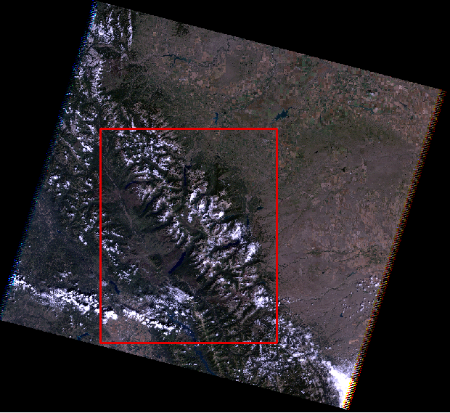

Appendix 1.2. Bark beetle, healthy vegetation, and fire polygons on top of Google Earth Digital Globe Imagery

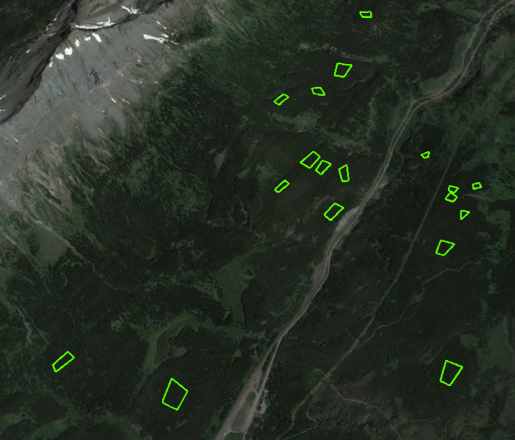
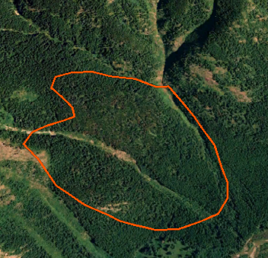
2007 Bark beetle polygon on top of 2006 Digital Globe Imagery

2013 Healthy Forest on top of 2013 Digital Globe Imagery

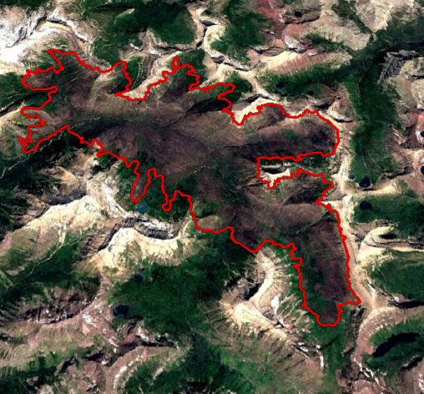

2015 Fire Polygon on top of 2015 Digital Globe Imagery

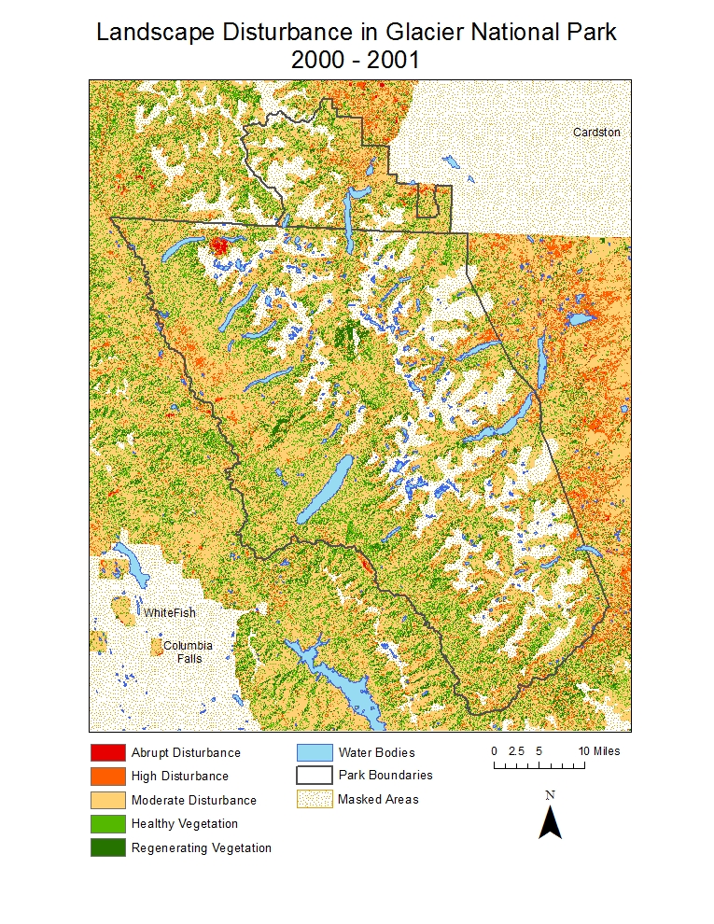

Appendix 1.3. Disturbance Classification Maps for all years

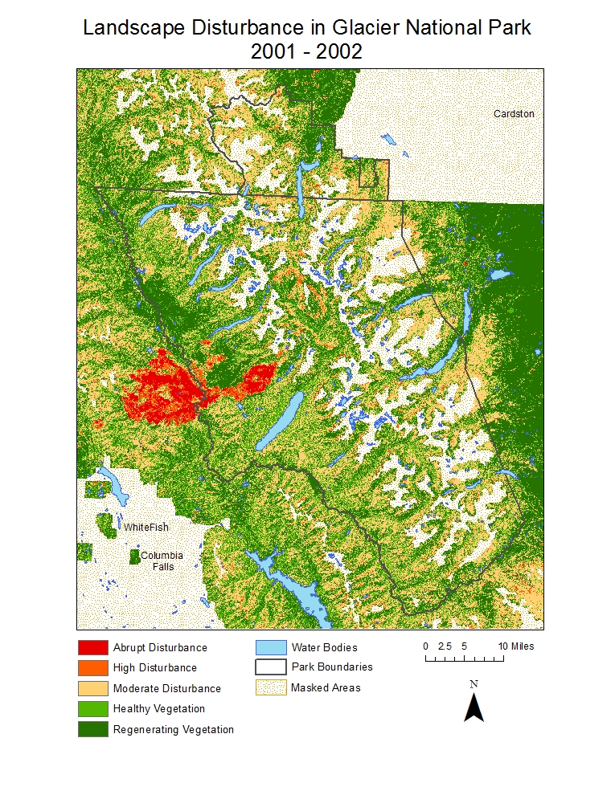

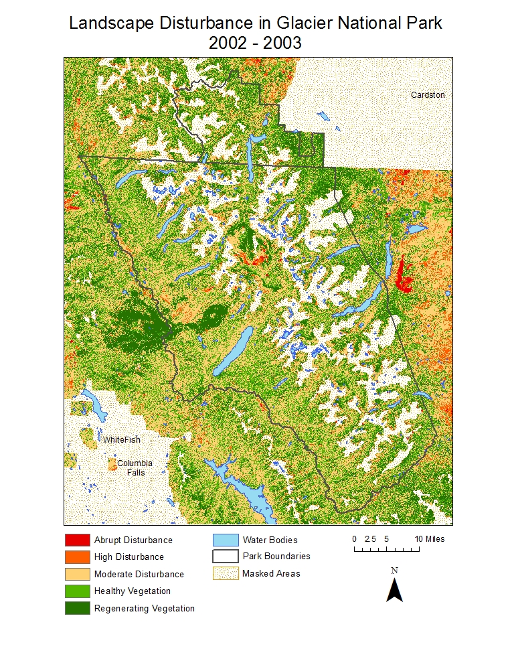
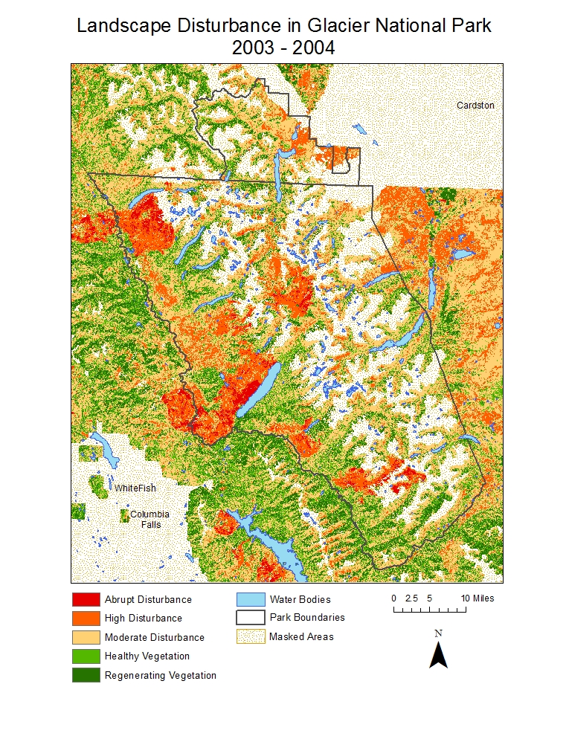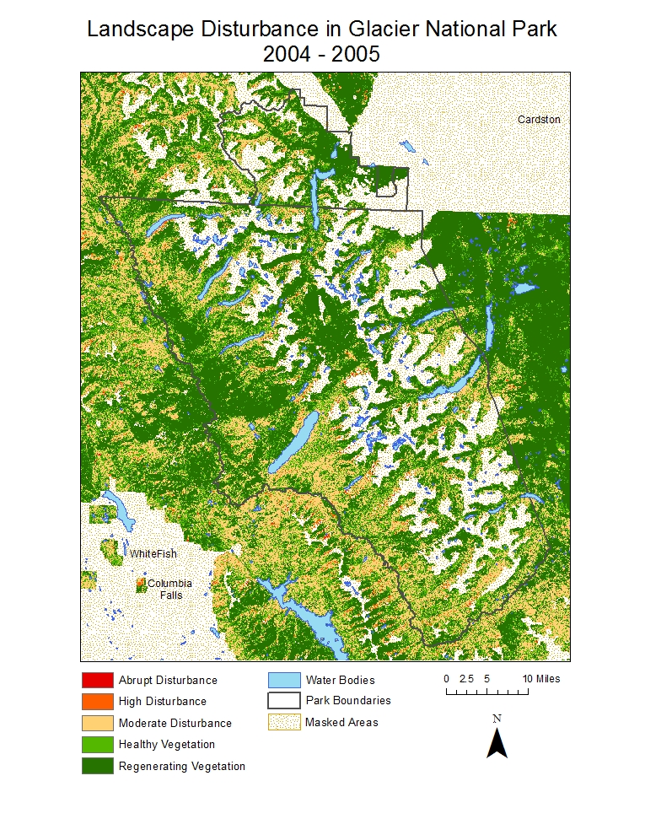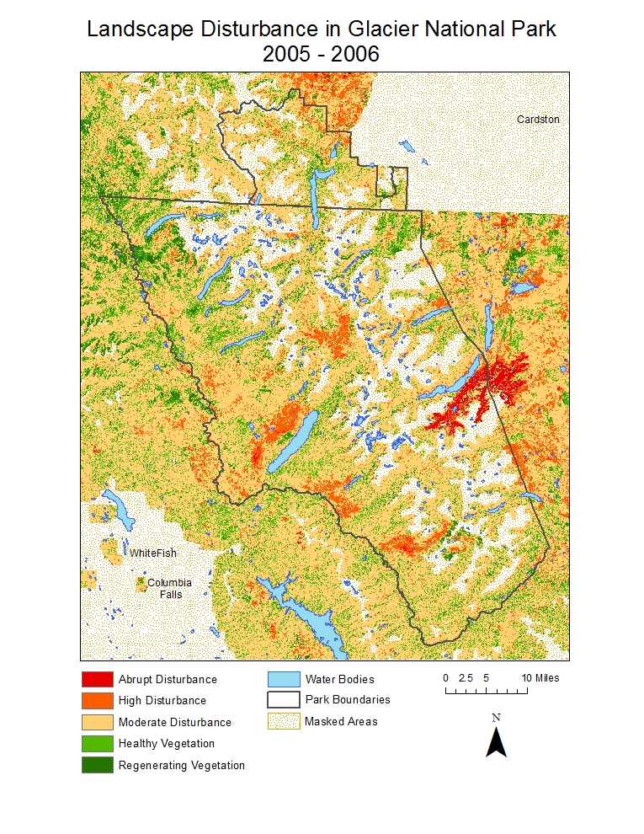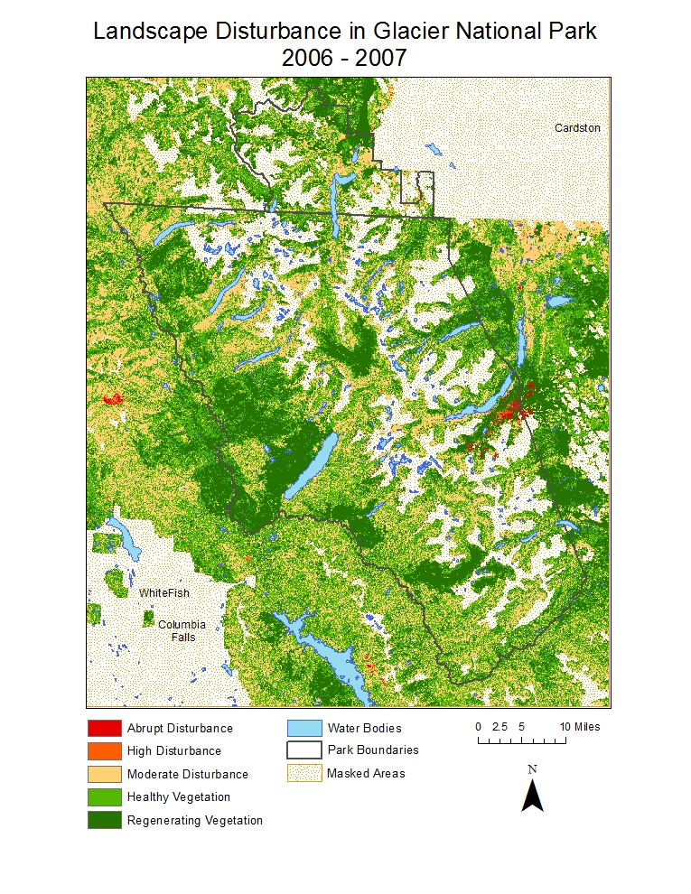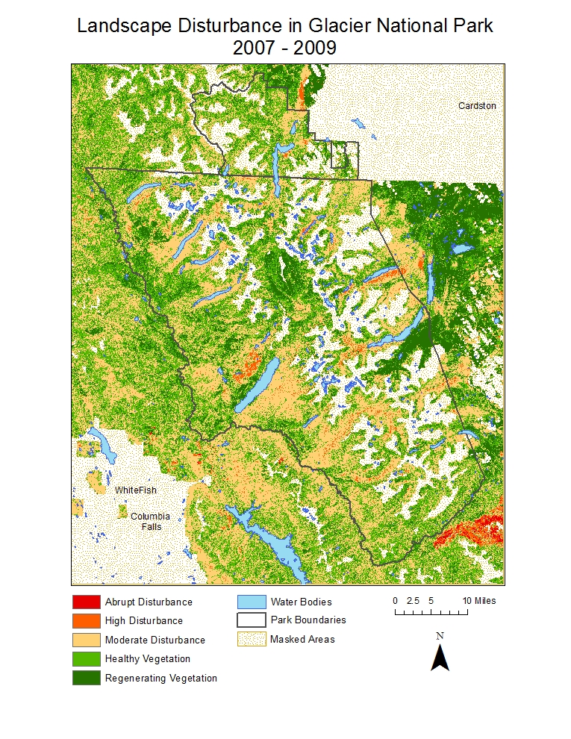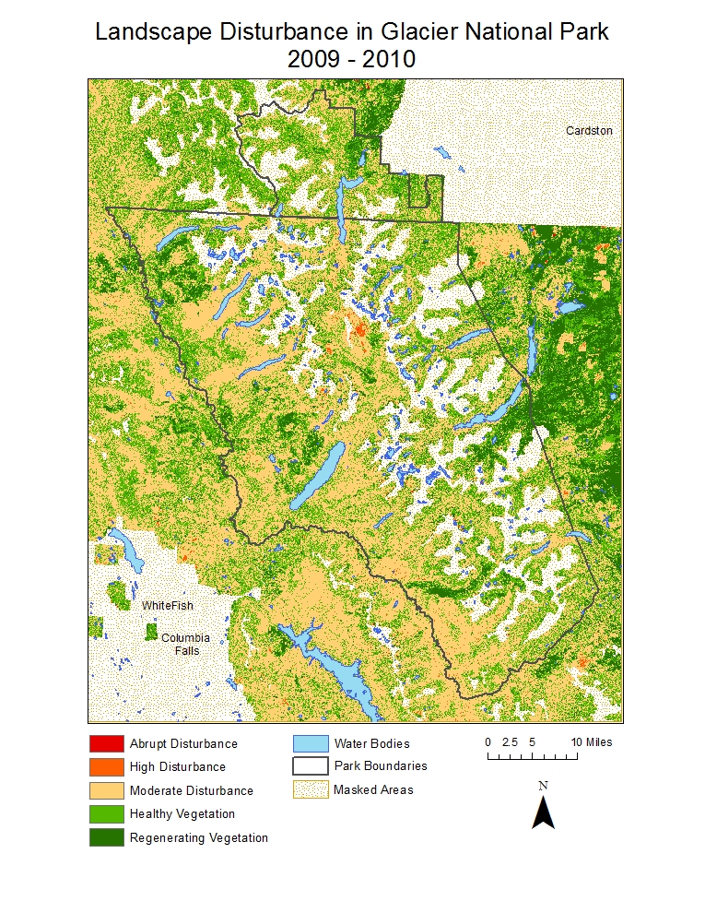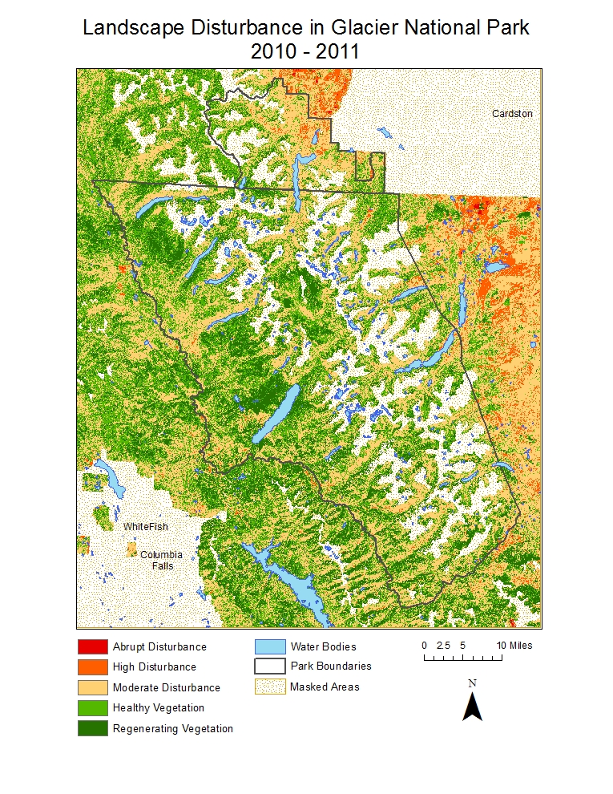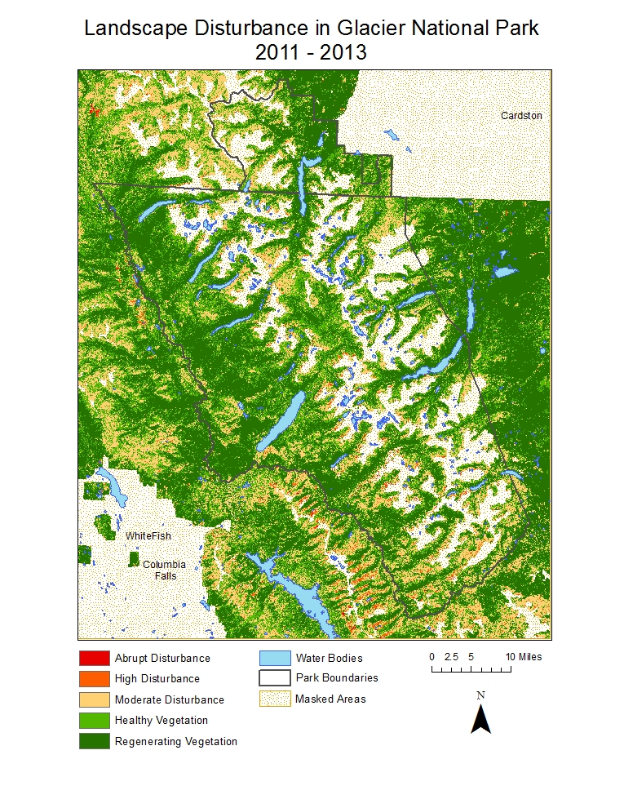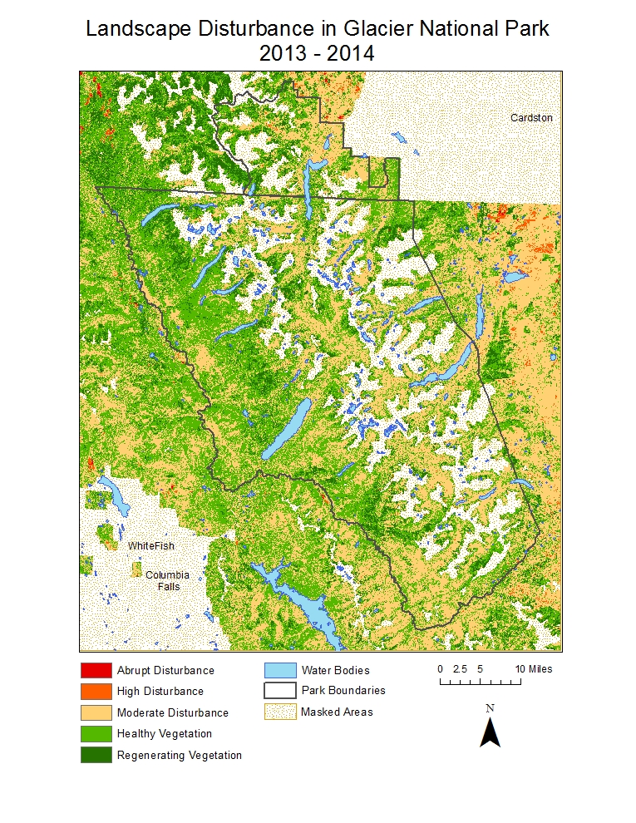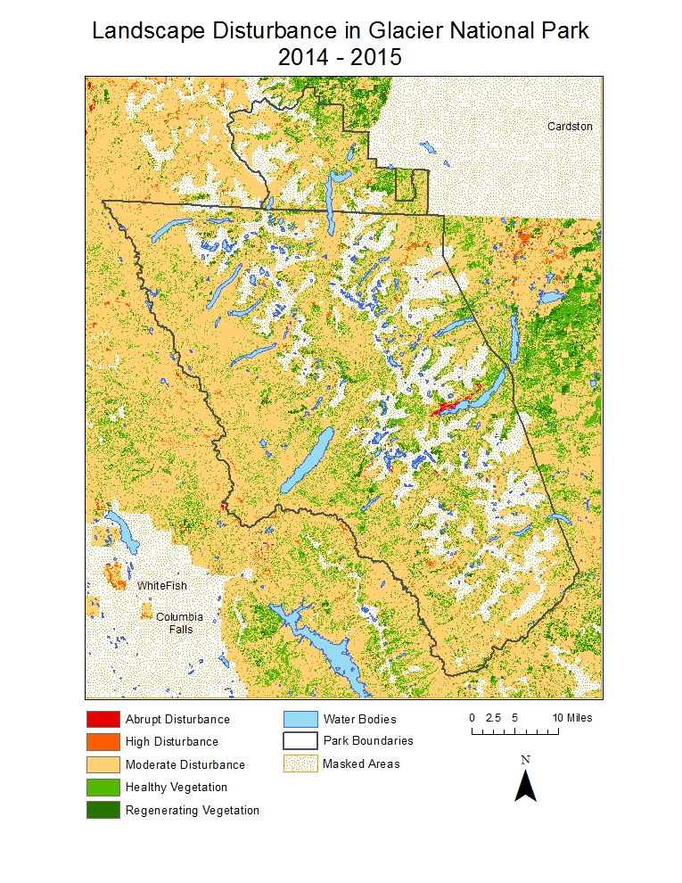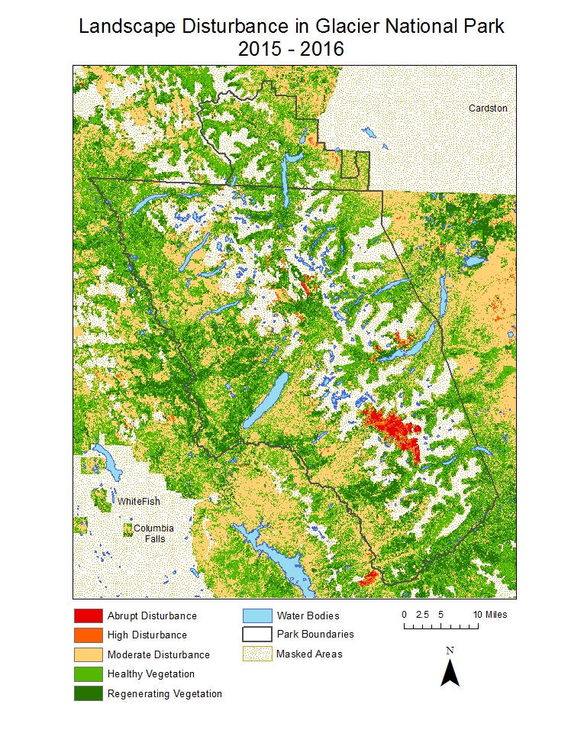

Appendix 1.4. Disturbance Classification within Bark Beetle Polygons (2013-2014)

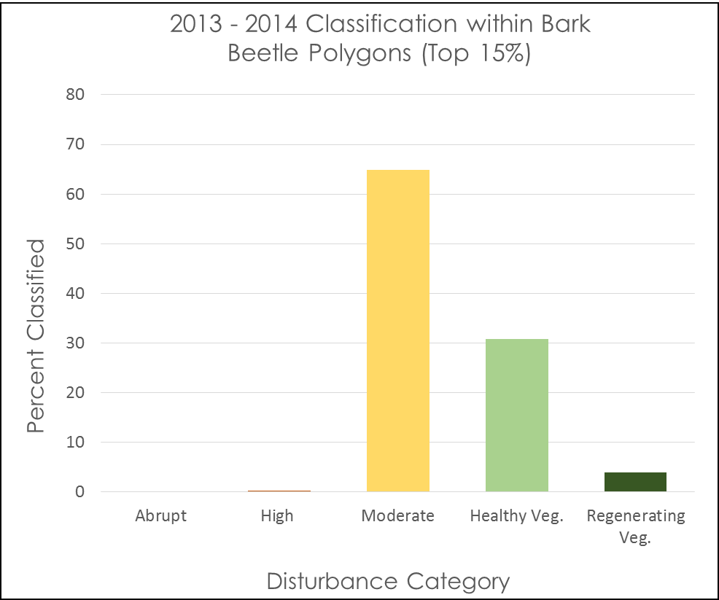
Figure 8.

Appendix 1.5. Disturbance Classification within Healthy Vegetation Polygons (2013-2014)

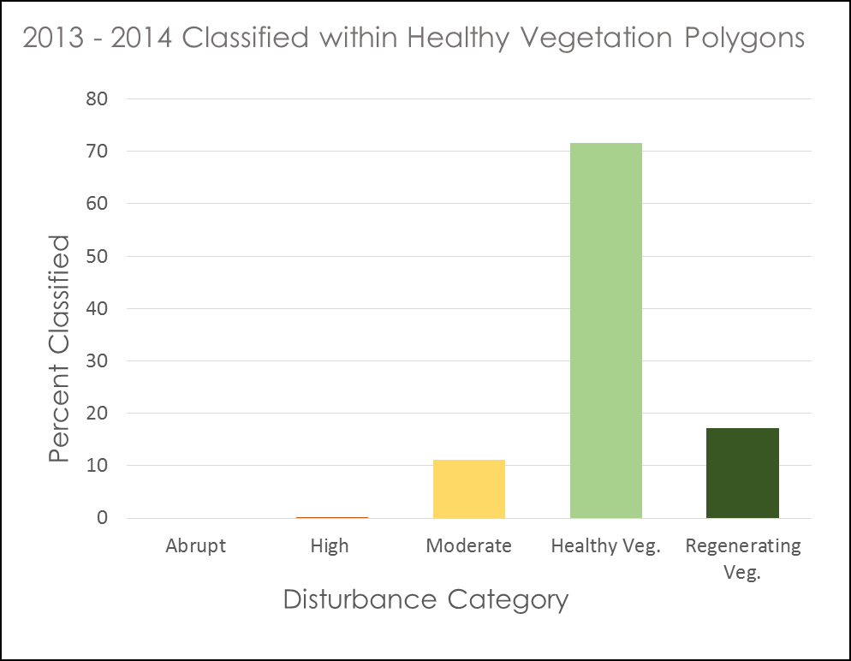

Appendix 1.6. Disturbance Classification within Fire Polygons (2015-2016)

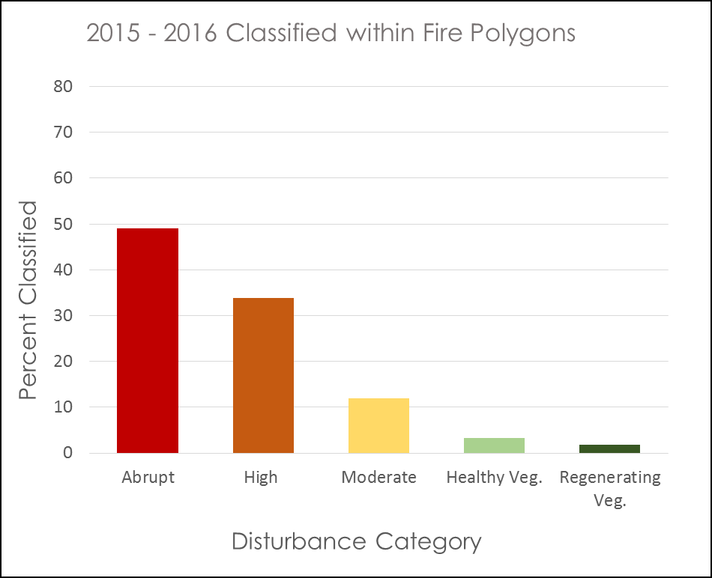

Appendix 1.7. Correlation between average precipitation accumulation of 4 sites (in) and the number of moderate disturbance pixels per inter-annual period

Appendix 1.8. Histogram of 2001 RGI subset to 2001 ADS and moderate disturbance (Lag 0)

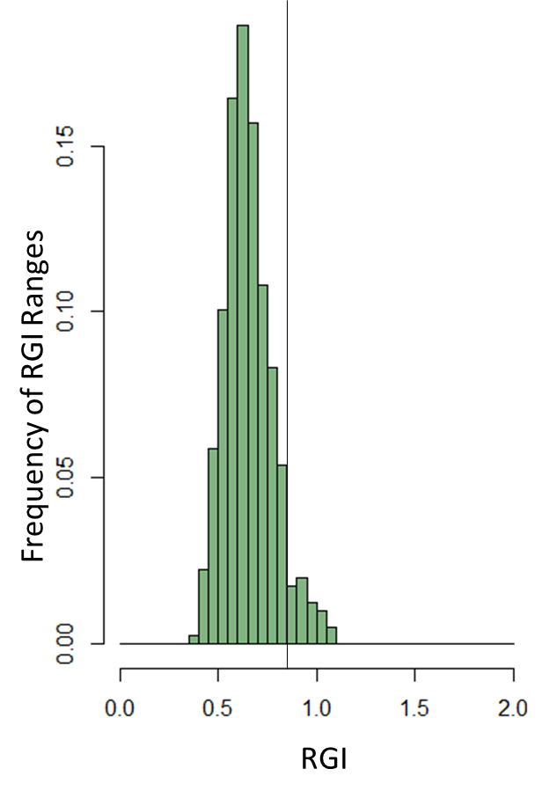

Appendix 1.9. Result of sub-setting RGI to moderate disturbance, reclassifying to RGI ≥ 0.9, and adding 2016 ADS polygons

