How to Install dnppy (pronounced dun-pie)

1. Open the dnppy-master.zip. If your computer does not automatically unzip, you’ll have to do it manually.

2. Once unzipped, open the dnppy-master folder.

3. Right click easy_install.py.

4. Click edit with IDLE. An IDLE window will open with the script to install dnppy.

6. Hit F5 to run the script. A new window will open and the script will run. **IMPORTANT: DO NOT CLOSE THE WINDOW OR PRESS ANY KEYS UNTIL THE INSTALLATION IS COMPLETE!**

7. Once the installation is finished, a message will be displayed stating dnppy was successfully installed. It will look similar to this:

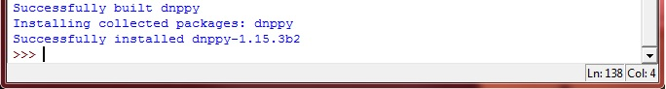

8. dnppy is now installed and ready for use.