**NASA DEVELOP National Program**



NASA Jet Propulsion Laboratory

*Spring 2016*

Louisiana Ecological Forecasting II

Using UAVSAR, AVIRIS, and AirSWOT to Model Coupled Water Flow and Sediment Transport for Delta Building within the Wax Lake Delta, Louisiana to Inform Coastal Restoration Efforts

 **Technical Report**

Rough Draft – Feb 18, 2016

Erika Higa (Project Lead)

Mark Barker

Emily Beck

Dr. Cathleen Jones, NASA Jet Propulsion Laboratory (Science Advisor)

Dr. Marc Simard, NASA Jet Propulsion Laboratory (Science Advisor)

Previous Contributors:

Brittany Zajic

Raul Garcia

# I. Abstract

[Placeholder - do not put anything here until the final draft submission. The abstract in the project summary is where the working draft of the abstract should “live”]

**Keywords**

Modeling, Remote Sensing, Sediment Transport, Delta Formation, Coastal Restoration, Delft3D, Wax Lake Delta

# II. Introduction

Erosion, land subsidence, and sea level rise along the Louisiana coast have led to the loss of 4900 km2 of land since the 1930’s, threatening one of the most economically important port systems in the United States as well as the tapestry of unique cultures that contribute to the region’s rich history (Olea & Coleman, 2014). According to the State of Louisiana’s Comprehensive Master Plan for a Sustainable Coast (2012), Louisiana has the potential to lose up to an additional 4500 km2 over the next 50 years unless immediate action is taken. Although most of the coast is suffering land loss, the Wax Lake Delta has created over 50 km2 of new deltaic surface since the early 1970’s, building at a rate of approximately 0.8 km2 per year (Kleiss 2009). Much work has been done to understand what natural processes contribute to this growth, but these studies are limited by a lack of tested models and key observations. Measurements that do exist are largely boat-based and inherently spatially and temporally limited.

The primary objective of this study was to use remotely sensed data, *in situ* data, and hydrological modeling software to model water flow and sediment transport within the Wax Lake Delta in order to examine delta formation and obtain a better understanding of why the area is experiencing aggregation. The results will support current research in the region, provide data to coastal scientists and managers, and offer insight into potential ways to direct coastal restoration projects in areas of Louisiana where coastal marshes are eroding, often at rapid rates. The study area for this project is the Wax Lake Delta in Louisiana (see Figure 1), and the study period is from May 2009 to May 2015. The NASA Earth observations used in this project were the Uninhabited Aerial Vehicle Synthetic Aperture Radar (UAVSAR), Air Surface Water and Ocean Topography (AirSWOT), and Airborne Visible-Infrared Imaging Spectrometer – Next Generation (AVIRIS-NG). UAVSAR, mounted beneath the Gulfstream-III, measures Earth surface change (Chapman 2015) and has the capability to see below vegetation, examine water level and examine properties of both thick vegetation cover and the ground below it (Dr. Jones, C., personal communication, November 2015) using an L-band radar antenna with a wavelength of about one foot (Chapman 2015). AirSWOT is a multi-purpose Ka-band radar, mounted on King Air B200, which can be used to obtain centimeter-level topographic maps of water surfaces and flood plains (Srinivasan 2015). AVIRIS-NG, an optical sensor with 432 bands, has been developed to provide continued access to high signal-to-noise ratio imaging spectroscopy measurements in the solar reflected spectral range from a DHC-6 Twin Otter platform (Lundeen 2015).

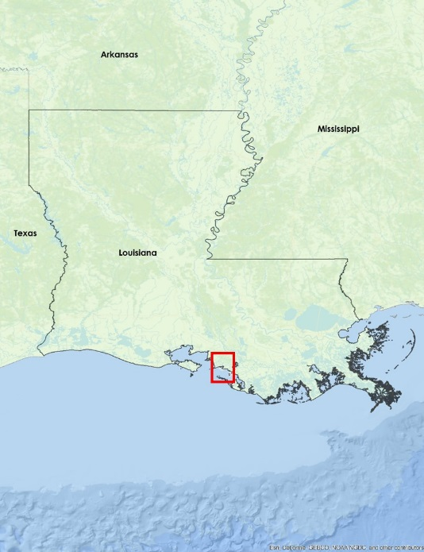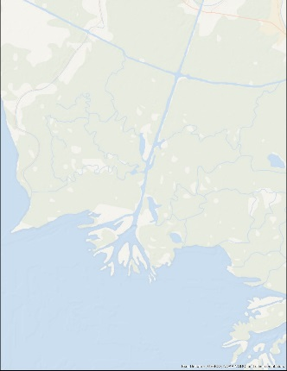

Figure 1: Wax Lake Delta, LA

This project addresses the Ecological Forecasting National Application Area by combining UAVSAR, AirSWOT, and AVIRIS-NG sensor data with *in situ* data in hydrological modeling software to forecast coastal aggregation in the Wax Lake Delta. Results of this project will inform restoration efforts to promote better management strategies.

End products of the study will include a Wax Lake Delta vegetation elevation raster and a hydrological model of the Delta, depicting sediment transport, water flow, and an elevation time series. These end products will help to inform the decision making process of our project partners. Those partners include Richard Crout, an oceanographer from the Naval Research Laboratory at NASA Stennis Space Center in Mississippi, and Dr. Alexander Kolker from the Louisiana Universities Marine Consortium. Mr. Crout is investigating buoyancy plume modulation of coastal processes in the area impacted by the Mississippi and Atchafalaya River discharge. His project utilizes an ocean circulation model, which uses *in situ* water level and discharge rates from the Atchafalaya Bay and Wax Lake outlet region. The end products from our project will provide greater accuracy and also complement this model. Dr. Kolker is an academic liaison to Louisiana’s Comprehensive Master Plan for a Sustainable Coast that is being developed for 2017. Our resulting products will provide Dr. Kolker with a broad-scale picture of the accretion process to inform the development of an improved sediment distribution algorithm that will help coastal management in understanding how to direct land restoration efforts along the Louisiana coast.

# III. Methodology

Still in Progress

**Vegetation Elevation Classification of UAVSAR Data**

We used UAVSAR data to classify the vegetation in the Wax Lake Delta into elevation values. There were multiple UAVSAR images collected along the Louisiana coastline in May 2015 and a calibrated and mosaicked UAVSAR image was acquired from our project science advisor, Dr. Marc Simard. The acquired UAVSAR image was also already converted to decibels (dB) for ease of interpretation and analysis.

To create an elevation raster, we classified the UAVSAR data based on vegetation type. With Dr. Simard’s suggestion, we created four Regions of Interest (ROI) to delineate areas of water, submerged vegetation, low vegetation (grass), and high vegetation (tree). We, then, applied an Interactive Supervised Classification onto the UAVSAR image using the ROIs in ArcMap to classify the different types of vegetation (see Figure 2). Under Dr. Simard’s suggestion, the vegetation classes were later reclassified to elevation values in which the submerged vegetation were classified as -1 meter, low vegetation as 40 centimeter, and high vegetation as 0 meter. We replaced the water regions with depth values from the channel bathymetry which was interpolated using transect points from the US Army Corps of Engineers 1999 Atchafalaya River Hydrographic Survey.

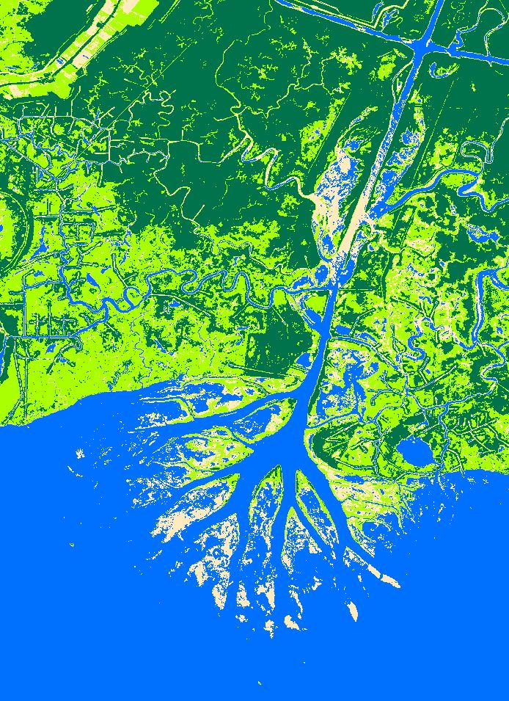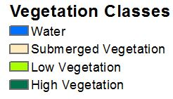

Figure 2. Classified UAVSAR data of the Wax Lake Delta.

This should be the focus of the paper - concise, yet explanatory, and highlight the NASA Earth observations utilized and its/their capabilities. Include a paragraph or more for each of the following items. No word cap, but be thoughtful and keep it in the two to six page range.

Content to include:

* Data Acquisition: What data did you get, what level products are they, for what dates did you get images, where did you get the images from, etc.
* Data Processing: What did you do to the data? Were there conversions needed to be able to analyze it? Did you have to mosaic images? Did you have to normalize anything to fit other datasets? Did you run an NDVI, change detection, etc?
* Data Analysis: How did you analyze the data? What methods did you use?

# IV. Results & Discussion

Still in Progress

Insert images, graphs, maps, charts, etc. here. Choose the most important results to highlight here. No word cap, but two to six pages is a good range.

Things to discuss:

* Analysis of Results: What can you tell from your graphs, images, etc? What does this mean for your project?
* Errors & Uncertainty: What factors could you not account for, what things didn’t work out like you expected they would, etc.
* Future Work: If this project was to be selected for another term, what would be the focus? What other areas would be of interest?

# V. Conclusions

Still in Progress

Final conclusions. Word count: 200-600 (~a page).

# VI. Acknowledgments

Still in Progress

Insert here. Keep to a concise paragraph or bullets of names. End with the following sentence.

Any opinions, findings, and conclusions or recommendations expressed in this material are those of the author(s) and do not necessarily reflect the views of the National Aeronautics and Space Administration.

This material is based upon work supported by NASA through contract NNL11AA00B and cooperative agreement NNX14AB60A.

# VII. References

Chapman, B. (2015, October 1). *UAVSAR Uninhabited Aerial Vehicle Synthetic Aperture*

*Radar*.Retrieved from <http://uavsar.jpl.nasa.gov/>

Dr. Jones, C. (2015, November 3). Personal Interview.

Kleiss, B. 2009. The Utilization of the Mississippi River in the Restoration of Coastal Louisiana. US Army Corps of Engineers Mississippi Valley Division. Retrieved from <http://www.conference.ifas.ufl.edu/NCER2009/PPTPDF_pres/4-Thursday/3-Avalon%20Room/PM/0220%20B%20Kleiss.pdf>

Louisiana (2012). Coastal Protection and Restoration Authority. Louisiana ’s Comprehensive Master Plan for a Sustainable Coast.

Lundeen, S. (2015, July 1). *Airborne Visible/Infrared Imaging Spectrometer AVIRIS Next*

*Generation*. Retrieved from <http://avirisng.jpl.nasa.gov/>

Olea, R. a., & Coleman, J. L. (2014). A Synoptic Examination of Causes of Land Loss in Southern Louisiana as Related to the Exploitation of Subsurface Geologic Resources. *Journal of Coastal Research*, *297*(5), 1025–1044. http://doi.org/10.2112/JCOASTRES-D-13-00046.1

Srinivasan, M. (2015, October 1). *Surface Water and Ocean Topography*.Retrieved from

<http://swot.jpl.nasa.gov/airswot>

# VIII. Content Innovation

In preparation for DEVELOP’s coming microjournal, please select two content innovation features to support your paper. For each item, please list the name of the feature, and include the tool itself if possible (eg. glossary terms and definitions). If the tool does not work in Microsoft Word (eg. Interactive MATLAB Figure Viewer), please list the file name and upload the related file to the microjournal folder on the DEVELOP Exchange. If you choose to use Inline Supplementary Material, please also include where the material should appear in the text.

**Some options include:**

Tentative contents highlighted in yellow

AudioSlides

Database Linking Tool

Data Profile

Executable Papers

Featured Author Videos

Featured Multimedia for this Article (video and podcast options)

Glossary Viewer

Inline Supplementary Material (figures, tables, computer code)

Interactive Map Viewer

Interactive MATLAB Figure Viewer

Interactive Plot Viewer

Nomenclature Viewer

# IV. Appendices

Insert here