NASA DEVELOP National Program
NASA Langley Research Center
Summer 2015

North Carolina Ecological Forecasting
Evaluating the Application of NASA Earth Observations to Monitor Wetland Health in the Albemarle-Pamlico Watershed


Technical Report
Final Draft – August 5, 2015

Zand Bakhtiari, (Project Lead)
Stephen Zimmerman
Kayla Patel
Brad Gregory

Dr. Kenton Ross, NASA DEVELOP National Program (Science Advisor)
Michael Bender, NASA DEVELOP National Program (Technical Lead)

I. Abstract
As a result of their sensitivity to sea level rise, wetlands are one of the most vulnerable ecosystems to climate change. In addition, wetland extents have diminished over time due to population increases and associated land change patterns. This project, partnered with the Albemarle-Pamlico National Estuary Partnership (APNEP), sought to monitor wetland health within the Albemarle-Pamlico watershed from 2000 to 2015 using NASA’s Landsat 5 Thematic mapper(TM), Landsat 7 Enhanced Thematic Mapper Plus (ETM+), and Landsat 8 Operational Land Imager (OLI). Four images (representing spring, summer, fall, and winter) were collected for each year from 2000 to 2015. Multiple images were used for each year to account for seasonal variation in vegetation health and tidal changes. After pre-processing the images, indices that measure water extent and wetland health were calculated for each image. A Green Normalized Difference Vegetation Index was used to delineate shoreline. A wetland health index that ratios the near infrared and short wave infrared bands, and a Normalized Difference Pigment Index were used to assess wetland health. From these indices, wetland extent and relative health were measured more rapidly than contemporary classification methods. A tutorial was provided to APNEP to support the organization in implementing policies toward wetland monitoring, protection, and restoration.

Keywords
Wetlands, Outer Banks, Albemarle Sound, Pamlico Sound, Land cover, Land cover change, Ecological Forecasting

II. Introduction

Background: Coastal regions, such as the Albemarle-Pamlico estuary system, are heavily dependent on extensive healthy wetlands to provide a transitional buffer between terrestrial and aquatic ecosystems (Dame et al. 2000). These regions provide various ecosystem services that are commonly misunderstood. Wetlands are responsible for sediment trapping, shoreline erosion control by stabilizing loose soil with a dense root mat, filtering toxic heavy metals, and retaining overloaded nutrients from urban or agriculture runoff (Howarth et al. 1996, Lytle et al. 1998, Stevenson et al. 1985, Verhoeven et al. 2006). Vegetation in these ecosystems effectively remove toxic heavy metals such as Chromium (Cr) Cr(IV) from contaminated wastewater and can reduce the metal into a stable non-toxic form Cr(III) by a reduction mechanism (Lytle et al. 1998). Modern agriculture relies heavily on fertilizers to ensure a proper yield; however, this overloads nutrients like nitrogen (N) and phosphorus (P) into watersheds. Wetland vegetation species are effective natural buffers to N and P overloading because of their nutrient retention properties in primary production (Verhoeven et al., 2006). Wetlands also offer predation refuge for juvenile fish species, which supports local fishing industry by ensuring steady and healthy fish populations (Jude and Pappas, 1992). These ecosystems have very high primary production and effectively sequester carbon by fixing carbon dioxide (CO₂) in the form of plant biomass, and also the anaerobic conditions slow down decomposition allowing for long term burial of carbon (Whiting and Chanton 2001, Gross et al. 1990). Coastlines frequently subjected to hurricanes and heavy storms such as the eastern United States benefit greatly from wetlands’ ability to mitigate damage and flood conditions (Gedan et al. 2011). Ecotourism also benefits from extensive wetland ecosystems by offering economic opportunities in recreational water activities such as fishing, kayaking and canoeing tours.

Project Objectives: This project looked at wetland health and extent in the Albemarle-Pamlico estuary over time. Using a dense time stacking of Landsat Imagery, wetland extent was mapped throughout the Albemarle-Pamlico watershed between the years 2000 and 2015. NASA’s Landsat 5, 7, and 8 were used to collect imagery. Two indices were used, one that measured change in water extent over the years and one that measured the relative health of the wetlands themselves. This two pronged approach sought to capture both natural and anthropogenic effects on the Albemarle-Pamlico estuary system.

Study Area:

The Albemarle-Pamlico watershed encompasses a large geographic area, approximately 30,000 square miles. This includes 25 counties in northeastern North Carolina and 10 counties in Southeastern, Virginia. The watershed is made of six major river basins and two major sounds. This project’s study area focused on the Albemarle-Pamlico estuary system, the second largest estuary system in the United States.
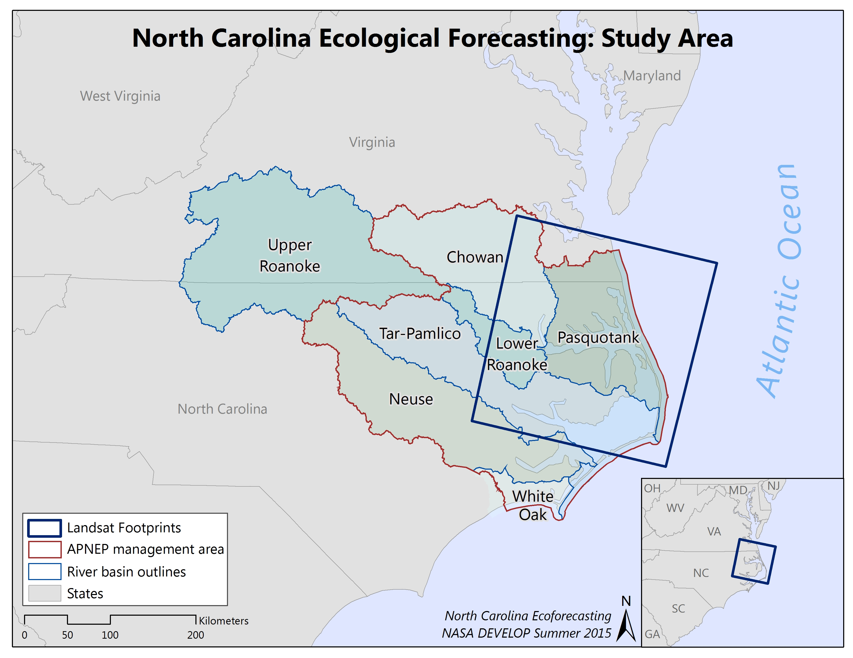
Map 1: Albemarle-Pamlico Watershed
Study Period: The time period for this study took place over 15 years, from 2000 to 2015.

National Application: This project contributed to NASA Ecological Forecasting by focusing on mapping wetland extent and creating a method to determine wetland health using remote sensing applications.

Project Partners: A partnership with Albemarle-Pamlico National Estuary Partnership (APNEP) has been growing since the spring 2015 term. Jim Hawhee proposed this project with the intention of applying the methodology to all land cover types in the Albemarle-Pamlico region. The methodologies can also be applied to all National Estuary Programs (28 total) across the United States, who would like to more rapidly and accurately evaluate wetland extent trends within watersheds. APNEP staff is well positioned to disseminate the results of this project to other programs and consult with them regarding the utility of the effort for environmental management purposes.

III. Methodology
This analysis used Landsat 5 Thematic Mapper (TM), Landsat 7 Enhanced Thematic Mapper Plus (ETM+), and Landsat 8 Operational Land Imager (OLI) scenes (path 14, row 35) to examine changes in wetland health and shoreline extent from 2000-2015 (Table 1). In an effort to account for phenology changes associated with seasonality, a summer, fall, winter and spring image for each year was collected from USGS Earth Explorer (Table 2). Imagery with their acquisition dates and sensors are shown in table 3. Image pre-processing included extracting necessary image bands and calculating top-of-atmosphere reflectance for each scene.

Table 1: NASA Earth Observation Satellites used in analysis.
NASA EOS Used | Year
Landsat 5 TM & Landsat 7 ETM+ | 2000 - 2013
Landsat 8 OLI | 2013 - 2015

Table 2: Downloaded Landsat data with acquisition date and sensor provided. Landsat 5(LT5), Landsat 7 (LE7), and Landsat 8 (LC8).
Year | Winter | Spring | Summer | Fall
2000 | 1/21/2000 [LT5] | 5/4/2000 [LE7] | 8/16/2000 [LT5] | 10/19/2000 [LT5]
2001 | 2/8/2001 [LT5] | 4/29/2001 [LT5] | 7/10/2001 [LE7] | 10/30/2001 [LE7]
2002 | 1/26/2002 [LT5] | 4/24/2002 [LE7] | 7/29/2002 [LE7] | 11/2/2002 [LE7]
2003 | 12/28/2002 [LT5] | 4/3/2003 [LT5] | 8/25/2003 [LT5] | 11/13/2003 [LT5]
2004 | 1/16/2004 [LT5] | 4/5/2004 [LT5] | 7/10/2004 [LT5] | 11/15/2004 [LT5]
2005 | 2/19/2005 [LT5] | 5/10/2005 [LT5] | 8/22/2005 [LE7] | 11/26/2005 [LE7]
2006 | 2/14/2006 [LE7] | 4/11/2006 [LT5] | 8/1/2006 [LT5] | 10/4/2006 [LT5]
2007 | 1/24/2007 [LT5] | 4/30/2007 [LT5] | 7/19/2007 [LE7] | 10/15/2007 [LE7]
2008 | 2/28/2008 [LT5] | 4/16/2008 [LT5] | 7/21/2008 [LT5] | 11/10/2008 [LT5]
2009 | 3/18/2009 [LT5] | 5/21/2009 [LT5] | 8/9/2009 [LT5] | 11/5/2009 [LE7]
2010 | 2/17/2010 [LT5] | 5/8/2010 [LT5] | 7/11/2010 [LT5] | 10/31/2010 [LT5]
2011 | 1/3/2011 [LT5] | 4/25/2011 [LT5] | 7/14/2011 [LT5] | 10/18/2011 [LT5]
2012 | 1/30/2012 [LE7] | 4/3/2012 [LE7] | 7/24/2012 [LE7] | 11/29/2012 [LE7]
2013 | 3/5/2013 [LE7] | 4/14/2013 [LC8] | 7/19/2013 [LC8] | 11/8/2013 [LC8]
2014 | 2/28/2014 [LC8] | 5/19/2014 [LC8] | 7/6/2014 [LC8] | 10/26/2014 [LC8]
2015 | 2/15/2015 [LC8] | 5/22/2015 [LC8] | N/A | N/A

The change analysis was two-fold, with an examination of coastline change and of overall wetland health throughout the time period. Data processing involved calculating three band indices, the Green Normalized Difference Vegetation Index (Green NDVI), a wetland discrimination index (WDI), and Normalized Difference Pigment Index (NDPI) to assess changes in wetland characteristics over time. Green NDVI (equation 1) leverages the green and Near Infra-red (NIR) bands to highlight and measure surface water extent (McFeeters 2013). A threshold of 0 was applied to the index with values > 0 classified as water and values <= 0 classified as non-water (McFeeters 2013).

$$Green NDVI= \frac{\left(Green-NIR\right)}{\left(Green+NIR\right)}$$

Equation 1: Green Normalized Difference Vegetation Index

The WDI is known for separating water from urban and wetland (Ozesmi and Bauer 2002). The ratio uses the NIR band and Shortwave Infra-red (SWIR) bands to highlight wetlands, allowing them to be easily visually identified. The NIR band highlights vegetation and shorelines, and is often considered the most important band in wetland determination (Ozesmi and Bauer 2002). The SWIR band discriminates soil moisture content and vegetation helping to determine areas of frequently wet and inundated soils. Leveraging these bands highlights wetland health and extent, and when the index is calculated for each scene, these characteristics can be viewed across a time series.
$$WDI= \frac{(NIR*SWIR)}{(NIR+SWIR)}$$

Equation 2: Wetland Discrimination Index
The NDPI highlights the Carotenoid to Chlorophyll a ratio within leaves giving an indicator of the vegetation’s physiological health. Carotenoid persists longer in dying leaves; therefore the NDPI value generally increases in senescing or unhealthy leaves. Assessing this index for each season of each year between 2000 and 2015 gives an understanding of the ways in which wetland health within the study area has changed over time.

$$NDPI= \frac{(Red-Blue)}{(Red+Blue)}$$

Equation 3: Normalized Differences Pigment Index

To account for seasonal and tidal water level differences, the binary land and water images, derived from the Green NDVI, were added together, and the resulting raster shows how frequently a pixel was considered water or land throughout the year, giving an understanding of shoreline extent for the time step. This method allows coastline changes along the Albemarle-Pamlico watershed throughout the time series to be examined without the influence of seasons or tides, and illustrates how coastal wetland locations have moved and shifted throughout the time period. The WDI and the NDPI were calculated for each image and complied into a short animation that allows the users to view the two indices in conjunction and visually assess wetland health over time.

IV. Results & Discussion
According to NOAA C-CAP Land cover data, wetland extent in our study area decreased by 30 mi² from 2001 to 2010 (2,916.7 mi² and 2875.5 mi² respectively). Every 4 to 6 years C-CAP land cover data is released making continuous and rapid monitoring of wetlands difficult. Choosing 3 study areas highlights changes in wetland health between 2000 and 2015 for every year in between more rapidly. These study areas encompass both private and public lands. Along with our three study areas, ancillary data was produced and are included in the appendix.
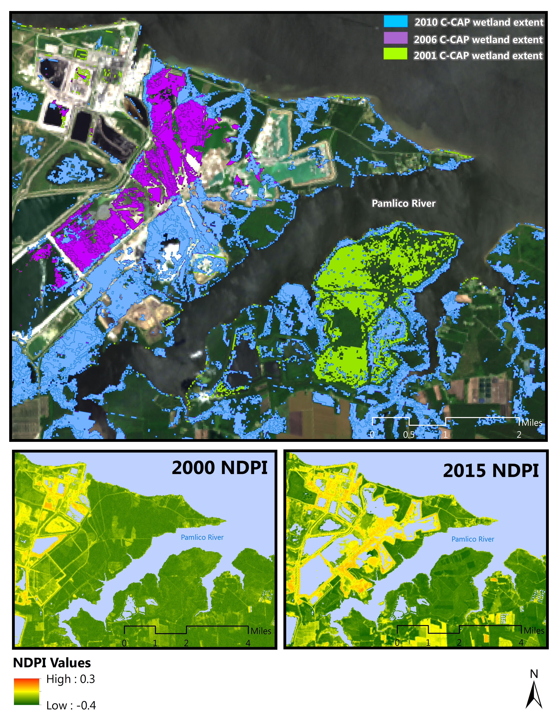
The first case study is located in the Southwestern part of our Landsat scene along the Pamlico River (Fig. 1). From 2000 to 2010, this area exhibits a visible amount of wetland loss. Green pixels represent wetlands that were present in 2001 and lost by 2006. Purple pixels represent wetlands present in 2006 that were lost by 2010. Wetlands that have persisted from 2001 to 2010 are represented by blue pixels. This is reflected in our NDPI analysis, where low green values indicate healthy wetlands and high yellow/red values indicate unhealthy wetlands (Appendix A). The NDPI is being utilized to determine the health of vegetation. However, the NDPI recognized expansion of a local phosphate mine, showcasing the capacity of this index to also reveal anthropogenic influences on wetlands.
Figure 1. Case study site 1 located along the Pamlico River is an example of anthropogenic wetland destruction, visible by NOAA C-CAP data and calculated NDPI image. A phosphate mine expanded into previously wetland land cover.
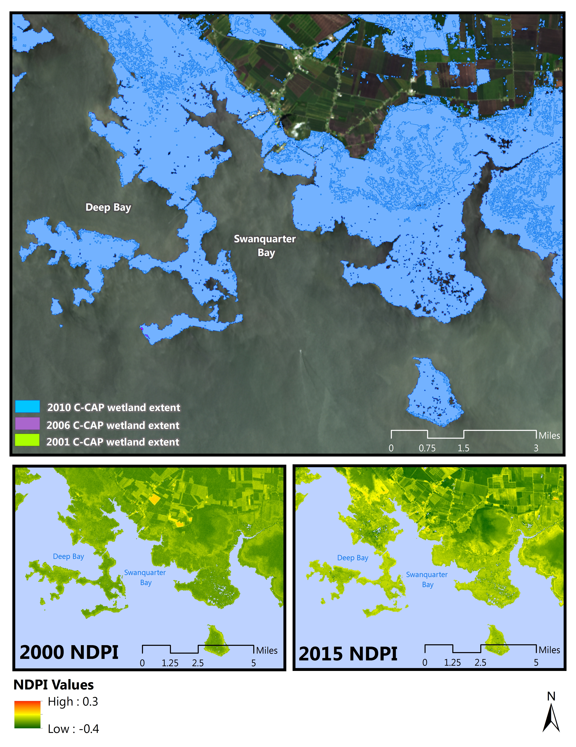
Figure 2. Case study site 2 located along the Pamlico River, downriver of the phosphate mine (Figure 1), is an example of an unknown source of wetland stress where NOAA C-CAP does not show any change in extent but calculated NDPI image reveals degraded wetland health.

The second case study located slightly downriver of the Pamlico River was chosen to showcase an area exhibiting little to no change in wetland extent (Fig. 2). While there was no visible change in wetland extent according to C-CAP land cover data, a noticeable decrease in the wetland health between 2000 and 2015 was seen from the NDPI calculated image (Appendix B). While the first case study was an apparent destruction of wetlands for urban development, factors contributing to the decrease in wetland health for the second case study cannot be determined from visual inspection. Future studies can investigate potential factors causing the decrease in wetland health, stress caused by non-point pollution from sources such as agricultural derived from fertilizer/pesticide runoff, other sources of pollution/urban development runoff from higher in the watershed, and stress caused by sea level rise.

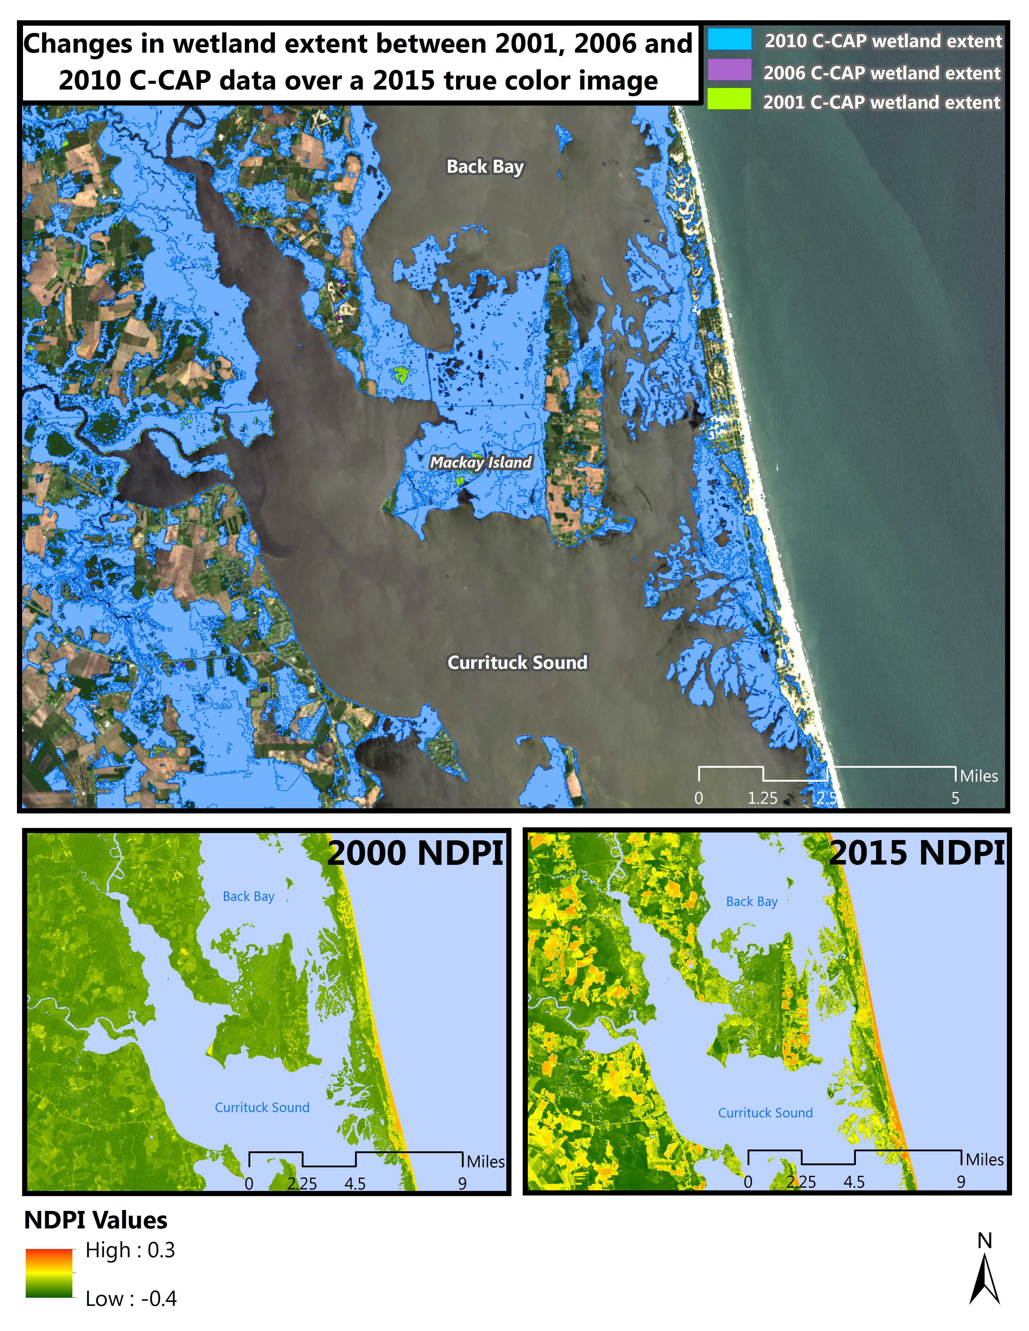
The third and final case study located at the Virginia/North Carolina border between Back Bay and the Currituck Sound contains two major wildlife refuges, MacKay Island National Wildlife Refuge and Currituck National Wildlife Refuge (Fig. 3). These regions are protected by the National Wildlife Refuge System under the National Wildlife Refuge System Administration Act of 1966 and the Wilderness Act of 1964. With this in mind the assumption is that the health of these wetland refuges would remain relatively constant between 2000 and 2015. However, similar results from case study 2 are seen. Wetland health derived from the NDPI calculated Landsat scene exhibits a noticeable decrease, while C-CAP land cover data remains constant (expected since it is a National Wildlife Refuge). Similar to case study 2, future work can investigate potential factors impacting the health of these wetlands.
Figure 3. Case study site 3 located at the Virginia/North Carolina border between Back Bay and the Currituck Sound is another example of an unknown source of wetland stress where NOAA C-CAP data shows minimal to no change in extent but calculated NDPI image reveals degraded wetland health. This image however, contains two National Wildlife Refuge’s protected under federal law.

Having a monitoring tool that provides a visualization of wetland health is important for initial recognition of degradation. While this methodology is a good tool for visualizing wetland health, more can be done to accurately quantify changes in wetlands. Calculating the changes in band ratio values over time can increase confidence in results pulled from an initial visual inspection. Ground truth data can be utilized in tandem with the band ratios to provide accuracy and confidence to the images.

V. Conclusions
The need to monitor and protect wetlands is high as they provide many ecosystem services and are increasingly threatened due to continued population growth and urbanization. The wetlands within the Albemarle-Pamlico watershed provide important environmental and economic benefits that are vital to the surrounding communities. The wetlands help prevent shoreline erosion, protect against flooding from storm and hurricane surges, and filter runoff water overloaded with nutrients before it mixes with water in the larger sounds (Howarth et al. 1996). In addition, these areas are the economic backbone for many residents in the area who engage in fishing and recreational water activities. Protecting wetland areas is extremely important in ensuring the health and vitality of the surrounding communities.

The purpose of this study was to monitor changes in wetland health between every year from 2000 to 2015. Band ratio indices were used to gain an understanding of relative wetland health for each season of the year throughout the study period. The NDPI index was used to assess overall vegetation health throughout the study area, the WDI index was used to discriminate wetlands from other land covers throughout the scene, and the GNDVI was used to derive the shoreline for each image and create a water mask. The water mask for each image was the applied to the corresponding NDPI and WDI images to determine the coastline extent throughout seasons and years as well as highlight wetlands throughout the image. Baseline land cover classification data (C-CAP) provided by NOAA every 4 to 5 years was utilized to determine regions of notable wetland loss. A simple calculation performed in ArcGIS applied to the C-CAP dataset within the entire Landsat scene reveals approximately 30 mi² of wetland loss between the years 2001 to 2010 (2015 C-CAP has not been released), indicating that wetland extent has remained relatively constant over a nine year time period.

Further investigation using the NDPI shows that while the extent of wetland land cover has remained relatively consistent, the health of some of these wetlands has decreased over time, seen in the three case studies. The first case study showcases the only noticeable loss of wetland land cover within the Landsat scene, in a localized area caused by an apparent anthropogenic factor (Figure 1). The second and third sites show areas in which wetland extent has remained the same but are exhibiting a downward trend in wetland health. Figures 2 and 3 show differences in wetland health from 2000 to 2015 and maps of each year in between for each study site can be found in Appendix A. These maps show a general downward trend in NDPI values as time progresses indicating overall increases in stressed vegetation of wetland areas. Overall, the research indicates more extensive decreases in wetland and plant health over the study area while exhibiting less extensive decreases in overall wetland extent. In general, it appears wetland areas are well delineated and protected but are being stressed throughout the study area. Future work will look into environmental or anthropogenic factors that could be contributing to the stress of these wetland areas and assess ways in which wetlands can be better protected.

VI. Acknowledgments
Dr. Kenton Ross – National Science Advisor, NASA DEVELOP National Program
Emily Adams – Center Lead LaRC, NASA DEVELOP National Program
Dan Wozniak – Assistant Center Lead LaRC, NASA DEVELOP National Program
Jeff Ely – Geoinformatics Fellow, NASA DEVELOP National Program

This material is based upon work supported by NASA through contract NNL11AA00B and cooperative agreement NNX14AB60A.

VII. References

Dame, R., M. Alber, D. Allen, M. Mallin, C. Montague, A. Lewitus, A. Chalmers, R. Gardner, C. Gilman, B. Kjerfve, J. Pinckney, and N. Smith. 2000. Estuaries of the South Atlantic Coast of North America: Their Geographical Signatures.Estuaries, 23: 793-819.
Gedan K.B., M.L. Kirwan, E. Wolanski, E.B. Barbier, and B.R. Silliman. 2011. The present and future of coastal wetland vegetation in protecting shorelines: answering recent challenges to the paradigm. Climate Change, 106: 7-29.
Gross M.F., V. Klemas, and M.A. Hardisky. 1990. Long-term remote monitoring of salt marsh biomass. Remote Sensing of the Biosphere, 1300: 59-70.
Jude D.J. and J. Pappas. 1992. Fish utilization of Great Lakes coastal wetlands. Journal of Great Lakes Research, 18: 651-672.
Lytle C.M., F.W. Lytle, N. Yang, J.H. Qian, D. Hansen, A. Zayed, and N. Terry. 1998. Reduction of Cr(VI) to Cr(III) by Wetland Plants: Potential for In Situ Heavy Metal Detoxification. Environmental Science and Technology, 32: 3087-3093.
Stevenson J.C., M.S. Kearney, and E.C. Pendleton. 1985. Sedimentation and erosion in a Chesapeake Bay brackish marsh system. Marine Geology, 67: 213-235.
Verhoeven J.T.A., B. Arheimer, C. Yin, and M.M. Hefting. 2006. Regional and global concerns over wetlands and water quality. TRENDS in Ecology and Evolution, 21: 96-103.
Whiting G.J. and J.P. Chanton. 2001. Greenhouse carbon balance of wetlands: methane emission versus carbon sequestration. Tellus, 53B: 521-528.

VIII. Content Innovation
North Carolina Ecological Forecasting VPS
Tittle: Monitoring Wetland Health in the Albemarle Pamlico Watershed
Link: http://earthzine.org/2005/07/27/2-5/

North Carolina Ecological Forecasting Project Code
Tittle: Code
Link: DNPPY

IV. Appendices

Table 1: NASA Earth Observation Satellites used in analysis.
NASA EOS Used | Year
Landsat 5 TM & Landsat 7 ETM+ | 2000 - 2013
Landsat 8 OLI | 2013 - 2015

Table 2: Downloaded Landsat data with acquisition date and sensor provided. Landsat 5(LT5), Landsat 7 (LE7), and Landsat 8 (LC8).
Year | Winter | Spring | Summer | Fall
2000 | 1/21/2000 [LT5] | 5/4/2000 [LE7] | 8/16/2000 [LT5] | 10/19/2000 [LT5]
2001 | 2/8/2001 [LT5] | 4/29/2001 [LT5] | 7/10/2001 [LE7] | 10/30/2001 [LE7]
2002 | 1/26/2002 [LT5] | 4/24/2002 [LE7] | 7/29/2002 [LE7] | 11/2/2002 [LE7]
2003 | 12/28/2002 [LT5] | 4/3/2003 [LT5] | 8/25/2003 [LT5] | 11/13/2003 [LT5]
2004 | 1/16/2004 [LT5] | 4/5/2004 [LT5] | 7/10/2004 [LT5] | 11/15/2004 [LT5]
2005 | 2/19/2005 [LT5] | 5/10/2005 [LT5] | 8/22/2005 [LE7] | 11/26/2005 [LE7]
2006 | 2/14/2006 [LE7] | 4/11/2006 [LT5] | 8/1/2006 [LT5] | 10/4/2006 [LT5]
2007 | 1/24/2007 [LT5] | 4/30/2007 [LT5] | 7/19/2007 [LE7] | 10/15/2007 [LE7]
2008 | 2/28/2008 [LT5] | 4/16/2008 [LT5] | 7/21/2008 [LT5] | 11/10/2008 [LT5]
2009 | 3/18/2009 [LT5] | 5/21/2009 [LT5] | 8/9/2009 [LT5] | 11/5/2009 [LE7]
2010 | 2/17/2010 [LT5] | 5/8/2010 [LT5] | 7/11/2010 [LT5] | 10/31/2010 [LT5]
2011 | 1/3/2011 [LT5] | 4/25/2011 [LT5] | 7/14/2011 [LT5] | 10/18/2011 [LT5]
2012 | 1/30/2012 [LE7] | 4/3/2012 [LE7] | 7/24/2012 [LE7] | 11/29/2012 [LE7]
2013 | 3/5/2013 [LE7] | 4/14/2013 [LC8] | 7/19/2013 [LC8] | 11/8/2013 [LC8]
2014 | 2/28/2014 [LC8] | 5/19/2014 [LC8] | 7/6/2014 [LC8] | 10/26/2014 [LC8]
2015 | 2/15/2015 [LC8] | 5/22/2015 [LC8] | N/A | N/A

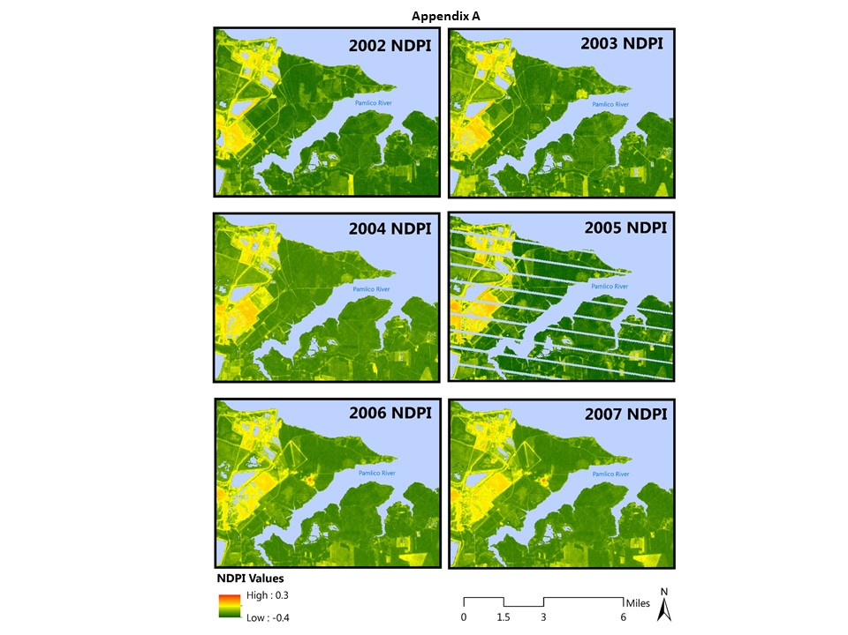
Study Area 1

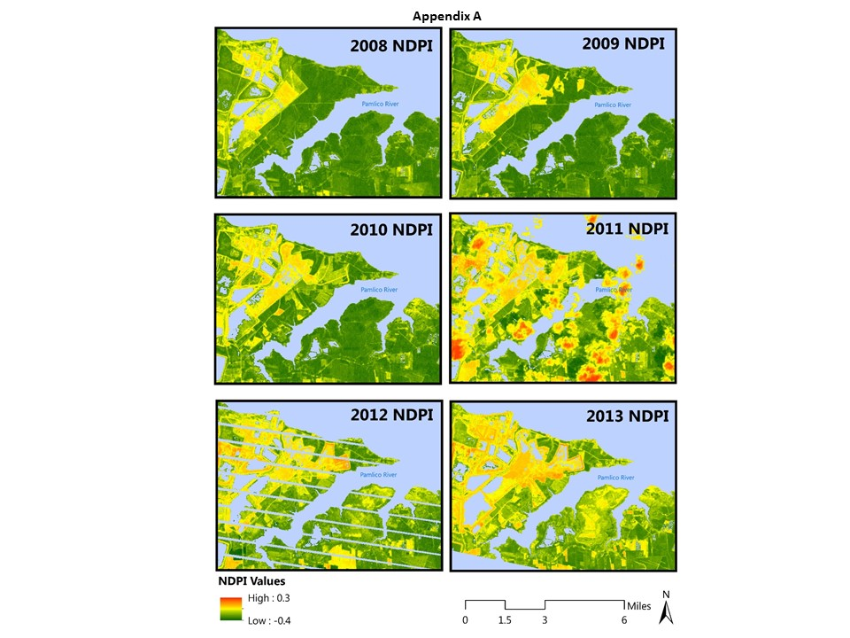
Study Area 1
Study Area 1

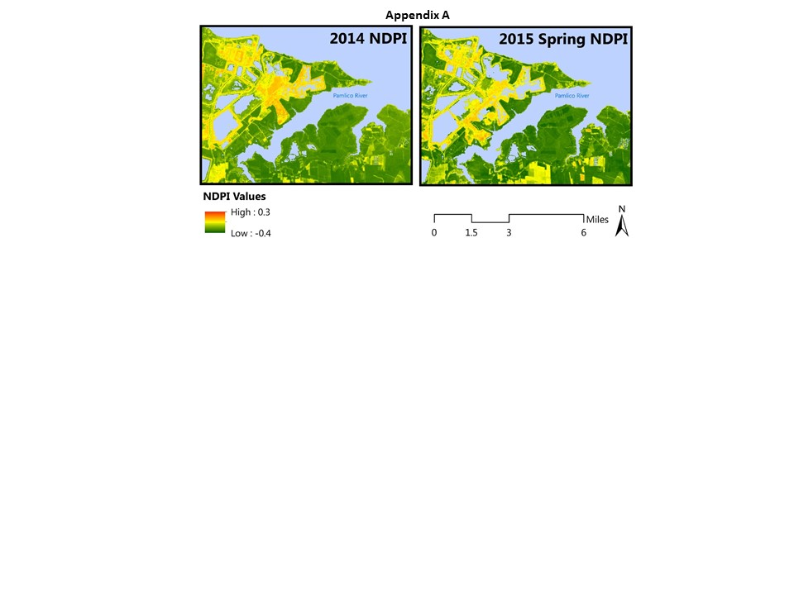
Study Area 1

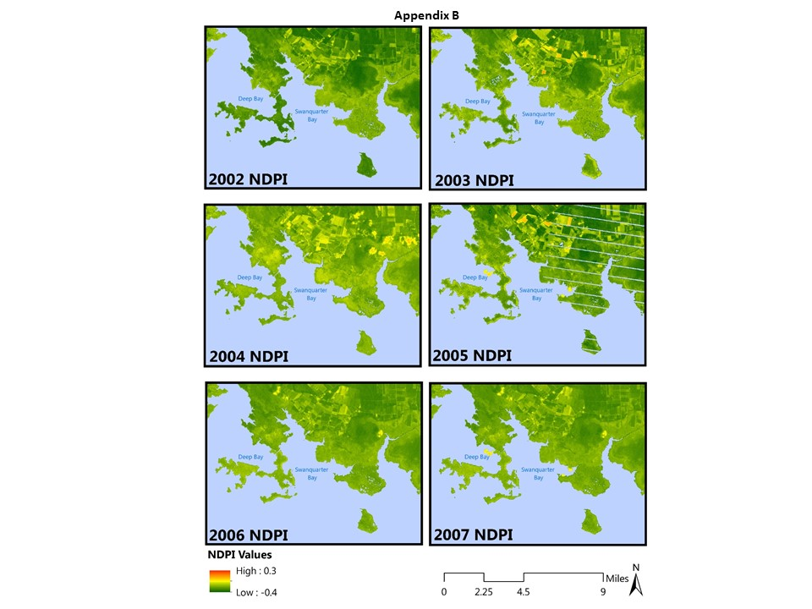
Study Area 2
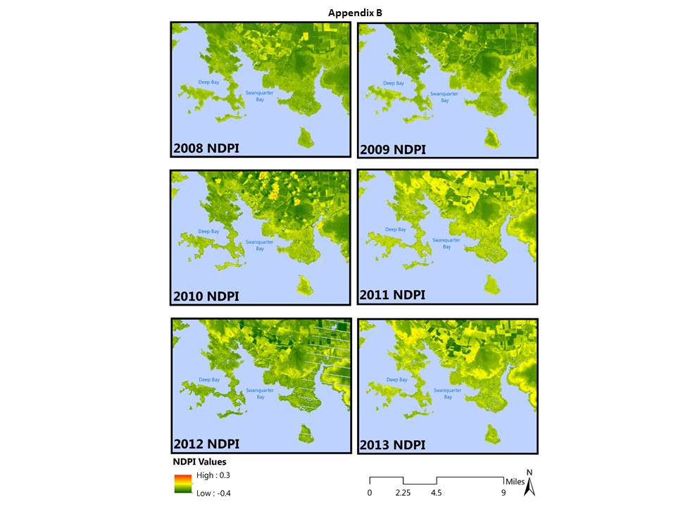
Study Area 2
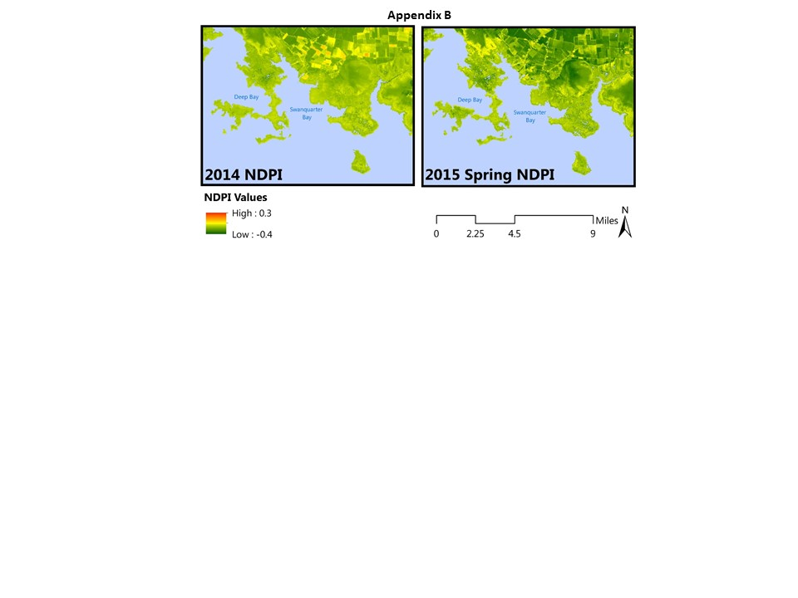
Study Area 2
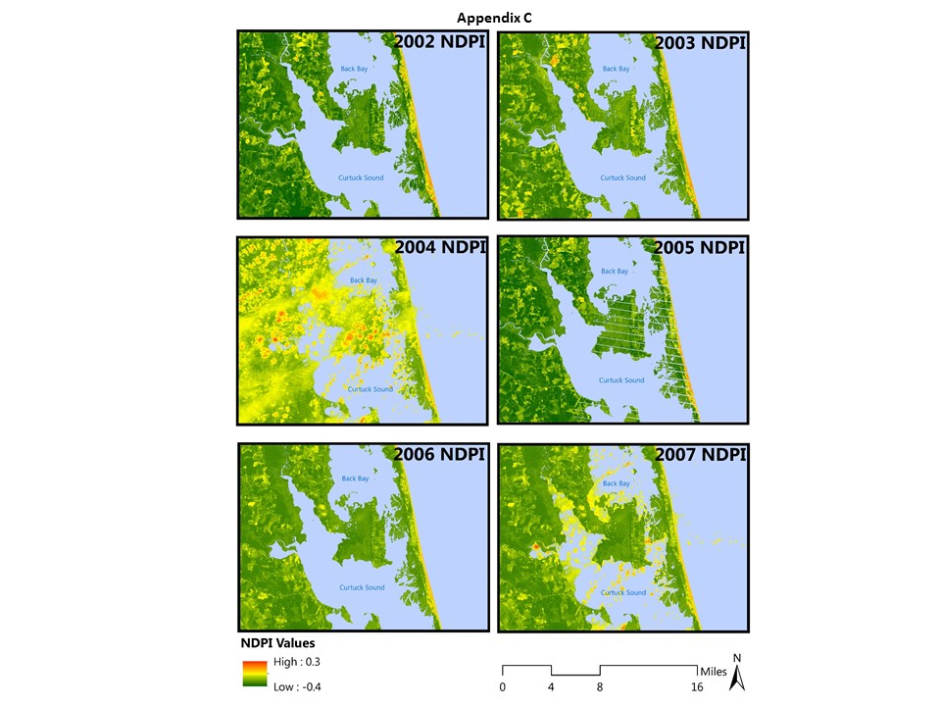

Study Area 3
Study Area
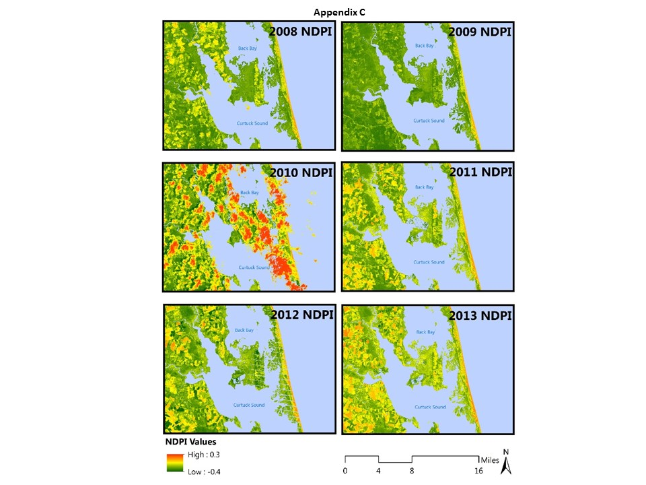
Study Area 3
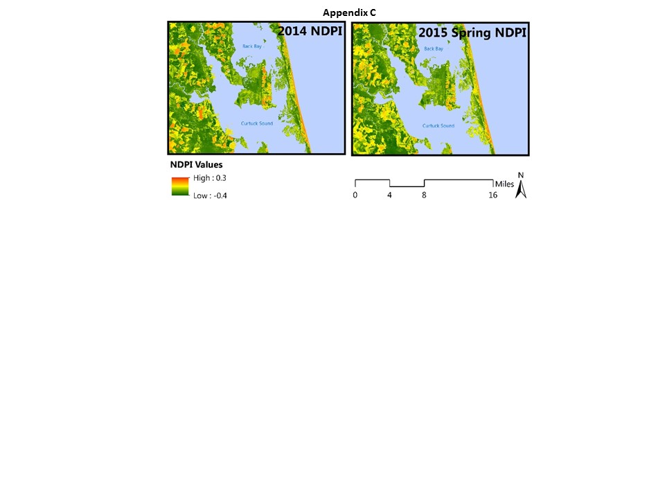
Study Area 3

