NASA DEVELOP National Program
International Research Institute for Climate and Society (IRI)
Spring 2015

Malawi Disasters
Comparing Techniques of Inundation Detection for the January 2015 Malawi Floods using NASA Earth Observations


Technical Report
Rough Draft - Feb 19, 2015

Andrew Kruczkiewicz (Project Lead)
Helen Cen

Dr. Pietro Ceccato, Lead Environmental Monitoring Program, IRI (Science Advisor)

Previous Contributors:
Jerrod Lessel
Alex Sweeney

I. Abstract
Malawi is prone to floods especially during its rainy season from October to April. In January 2015, Malawi experienced a series of flooding which resulted in 200 deaths, 153 missing, and over 175,000 people displaced. The series of floods consisted of flash floods and riverine floods. Due to differences in temporal and spatial limitations of various flood detecting methodologies, some are more likely to be sensitive to certain types of flooding. As such, the possibility exists that floods maps may introduce a bias into flood monitoring and assessment, especially in flooding events that consist of 2 or more types of events. A comparative analysis using shelter locations to explore the spatial coverage of the January 2015 Malawi floods was conducted using Dartmouth Flood Observatory (DFO) flood map, NASA Goddard Space Flight Center Moderate Resolution Imaging Spectroradiometer Near Real-Time Global Flood Mapping Project (NRT-GFM), TerraSAR-X (German Aerospace Center) inundation map, RADARSAT (Canadian Space Agency) inundation map, RADARSAT-2 (Canadian Space Agency) inundation map, the University of Maryland Global Flood Monitoring System Flood Detection (GFMS-FD) product and GFMS Inundation 1KM (GFMS-I) product. It is expected that the results of this study will increase the ability to monitor flood events and help distinguish between types of floods, which may possibly lead to better definition of the spatial and temporal limits of flood impacts. This project will benefit humanitarian organizations involved with disaster relief efforts in Malawi; potentially increasing the accuracy in flood map production and allocation of resources after a flood event.

Keywords
Malawi Floods, Flood Maps, Inundation, Remote Sensing, Validation, Disaster Management

II. Introduction
Remote regions in Africa often exhibit a paucity of in situ climatic and environmental data. Some data sparse regions, such as Malawi, also tend to experience seasonal flood events that can occasionally escalate into a national disaster, dramatically impacting livelihoods. Without reliable time series of climatic and environmental data on suitable temporal and spatial scales, it is difficult to complete a robust analysis of flood impacts. Malawi is a flood prone nation, especially south of Lake Malawi in the lower Shire River Basin, the southernmost extent of east Africa’s rift valley. Since early January 2015, heavy rainfall and subsequent runoff have caused massive flooding in Malawi, affecting 15 out of 28 districts, causing over 200 deaths, leading to 153 missing people, and displacing 174,000 people as of 27 January, 2015 (Department of Disaster Management Affairs and United Nations Office of the Resident Coordinator, 2015). Days after the height of the January floods, food, water and shelter were still in urgent need. Many displacement sites were overcrowded and raised concerns for rape, diarrhea and malaria (Nkawihe, 2015).

To increase spatial and temporal resolution of climatic and environmental data, interpolation of data between stations can be used, but should be done with caution. In attempting to interpolate between stations, data may become compromised because of complex topography, increased temporal sensitivity during extreme events and large distances between stations.

Remote sensing can be used to extend datasets of climatic and environmental variables. NASA Earth Observations play an important role in increasing the spatial and temporal resolution of variables that are relevant to flood disaster analysis - including rainfall, inundation and soil moisture.

Humanitarian organizations in Malawi rely heavily on satellite-based mapping to evaluate the impact of floods and make decisions for resource allocation after a disaster. Two such organizations and project partners, The Malawi Red Cross and The Red Cross Red Crescent Climate Centre, use various techniques to analyze the January 2015 flood in Malawi.

Data from Moderate Resolution Imaging Spectroradiometer (MODIS) onboard Aqua and Terra along with data from the Tropical Rainfall Measuring Mission (TRMM) enable project partners working in these regions to better evaluate the impact extent and develop response programs. This project aimed to first identify a set of current flood detection products. The following products will be used: Dartmouth Flood Observatory (DFO) flood map, NASA Goddard Space Flight Center MODIS Near Real-Time Global Flood Mapping Project 3 Day Composite Flood Water product (NRT-GFM), TerraSAR-X flood map, RADARSAT flood map, RADARSAT-2 flood map, the University of Maryland Global Flood Monitoring System Flood Detection (GFMS-FD) product and GFMS Inundation 1KM (GFMS-I) product. Second, we validated each product by comparing the spatial extent of inundation signal to displacement site locations provided by UK Aid and Malawi Red Cross. It should be noted that because of to the lack of ground truth data for community impact due to floods, shelter locations were used as proxies. We assumed that shelters are an acceptable proxy for the scope of this project as project partners confirmed that shelters are typically located in close spatial proximity to inundated communities (usually within 10km). Lastly, we discussed the similarities/differences between each product and explored drivers of the variations, evaluating whether different types of flooding (e.g. flash floods, riverine floods) skewed the detection skills. Each aim was carried out with the overarching goal to produce a set of next steps to assess accuracy in spatial agreement of the NASA Earth observations. Such increase in detection skills will enable our project partners, as well as other disaster responders, to better monitor spatial extent of floods and improve response programs by tailoring response type based on flood type.

This project falls under the NASA Applied Sciences national application area of Disasters. It will contribute to current disaster management practices to better evaluate the spatial impact and enhance the efficiency of resource allocation.

Project partners of this project are Erin Coughlan, the Senior Climate Specialist of the Red Cross Red Crescent Climate Center (RCRCC), and Hastings Kandaya, Director of Programmes and Development at Red Cross Malawi (RCM). Both RCRCC and RCM rely heavily on these flood maps for disaster response. Validating these flood detection products would enable them to be more aware of potential affected locations being overlooked due to the limited flood types these satellite products can detect.

III. Methodology
The project first compiled data from the seven satellite based products that produced flood maps during January 2015 in Malawi: DFO, NRT-GFM, TerraSAR-X, RADARSAT, RADARSAT-2, GFMS-FD, and GFMS-I. Second, the products were grouped into three categories based on characteristics of the primary flood-detecting sensor. Group 1 consisted of products using the Synthetic Aperture Radar sensor: TerraSAR-X, RADARSAT and RADARSAT-2. Group 2 included products using MODIS: DFO and NRT-GFM. Group 3 comprised of products produced by University of Maryland’s Global Flood Monitoring System using TRMM/Global Precipitation Monitoring (GPM) precipitation data coupled with a hydrologic model: GFMS-FD and GFMS-I. Third, community impact data was processed as a shapefile layer using shelter sites location data provided from UK Aid and the Malawi Red Cross. This layer would represent the ‘ground truth’ of where the floods occurred as a list of impacted communities with verified names and latitude and longitude coordinates has not yet been compiled.

The community impact layer will be used for comparative analysis of each flood detection product to assess skill of the products’ flood signal. Lastly, each flood detection product were then layered above the shelter sites data using OpenStreet Map in QGIS for post-processing.

As products are produced on various temporal intervals, care was taken to capture a products rendering of the maximum flood extent, or roughly January 10-21.

The TerraSAR-X, RADARSAT and RADARSAT-2 shapefiles were downloaded separately from the Malawi Spatial Data Portal (MASDAP), representing spatial extent of flood signal from January 10, 13 and 21, 2015 respectively. The DFO data was obtained as a geotiff raster file from the Dartmouth Flood Observatory website and was in turn was processed as a shapefile in QGIS DFO updated maximum flood extent on a continuous basis since the onset of heavy rains in early January 2015, hence the data is assumed to represent spatial extent of flooding from January 1, 2015 to the data acquisition data of 3 February, 2015. The NRT-GFM data were retrieved from NASA Goddard’s Office of Applied Science’s NRT Global Flood Mapping site and were available on a daily scale for the month of January 2015. Both the GFMS-FD and GFMS-I images were downloaded from University of Maryland’s Global Flood Monitoring System website.

The GFMS generates maps in three hour intervals, but as the goal of the project is to compare spatial coverage and accuracy between products, we choose to process maps produced on the January 13, 2015 (total of eight maps per GFMS product). This data corresponds to the period of maximum inundation, which we assumed each product covered. This data also coincides with the date in which the President of Malawi declared a State of Emergency for Central and Southern Malawi, home to a total of 11 million residents (The Government of Malawi, 2015).

To isolate the maximum flood extent and georeference each product, different techniques were used. For TerraSAR-X shapefile, RADARSAT shapefile, RADARSAT-2 shapefile, DFO geotiff image and NRT-GFM shapefiles included maximum flood extent data and were received in a georeferenced format; therefore, no further data processing was needed using QGIS. For NRT-GFM data, each day of January 2015 were overlaid in chronological order to compile a maximum flood extent map. GFMS-FD and GFMS-I images were downloaded as .gif format. Due to additional map scale and exogenous white space, we cropped out the map portion of all the images and reprocessed each as a raster in.png format. Next, each of the GFMS-FD raster data files were georeferenced in QGIS, and subsequently polygonized (raster to vector) to isolate flood signal from the background noise. Afterwards, all eight GFMS-FD polygonized layers were stacked on top of each other in chronological order to generate a single maximum flood extent map. Similarly, the eight GFMS-I images in raster format were georeferenced in QGIS and stacked in chronological order to generate a single map of maximum flood extent. The maps of displacement sites were developed for various regions, hence they were each added as a raster into QGIS and processed into a single shapefile.

Next, a qualitative visual comparison was conducted to assess spatial agreement between flood products and against the community impact data. It was apparent that spatial distribution of flood signal varied between two distinct clusters, splitting the community impact region into two zones (North and South) implicating Chikwawa as an approximate inflection point. Being such, a black horizontal line was drawn through Chikwawa to further isolate the two clusters and allow for a more comprehensive qualitative analysis.

North of the line are areas prone to flash floods, and below the line areas are susceptible to riverine floods (The Government of Malawi, 2015; Davies, 2015; Mponda, 2015; Face of Malawi, 2015; NTA Newstime Africa, 2015; Chang'anamuno, 2015; Sanje & Rowling, 2015). After post processing of the satellite images, each product was qualitatively analyzed and spatial agreement was compared within the group.

IV. Results & Discussion
From the qualitative analysis, there was a distinction between products that produced a maximum inundation signal north and south of a latitudinal line approximately through Chikwawa.

Group 1 satellite products (Figures 1-3) only detected a flood signal in the southern cluster. It should be noted that RADARSAT-2 coverage was limited to southern tip of Malawi (Figure 3). Group 2 products (Figures 4-5) had flood signals in the Northern and Southern clusters. When consider the spatial relationship between product flood signal in both Northern and Southern clusters and the community impact data, DFO performed the best. NRT-GFM did not perform well with detected flood signal near shelter sites in the Northern cluster. Group 3 products (Figures 6-7) had flood signal in both Northern and Southern clusters, but it should be noted that the products are produced in various spatial resolution, with GFMS-FD at 30 km and GFMS-I with 1km resolution. GFMS-FD failed at distinguishing between areas that were flooded versus non-flooded as it exhibited a flood signal across most of the study region. Alternatively, GFMS-I inundation signals were located near shelter sites by visual comparison.
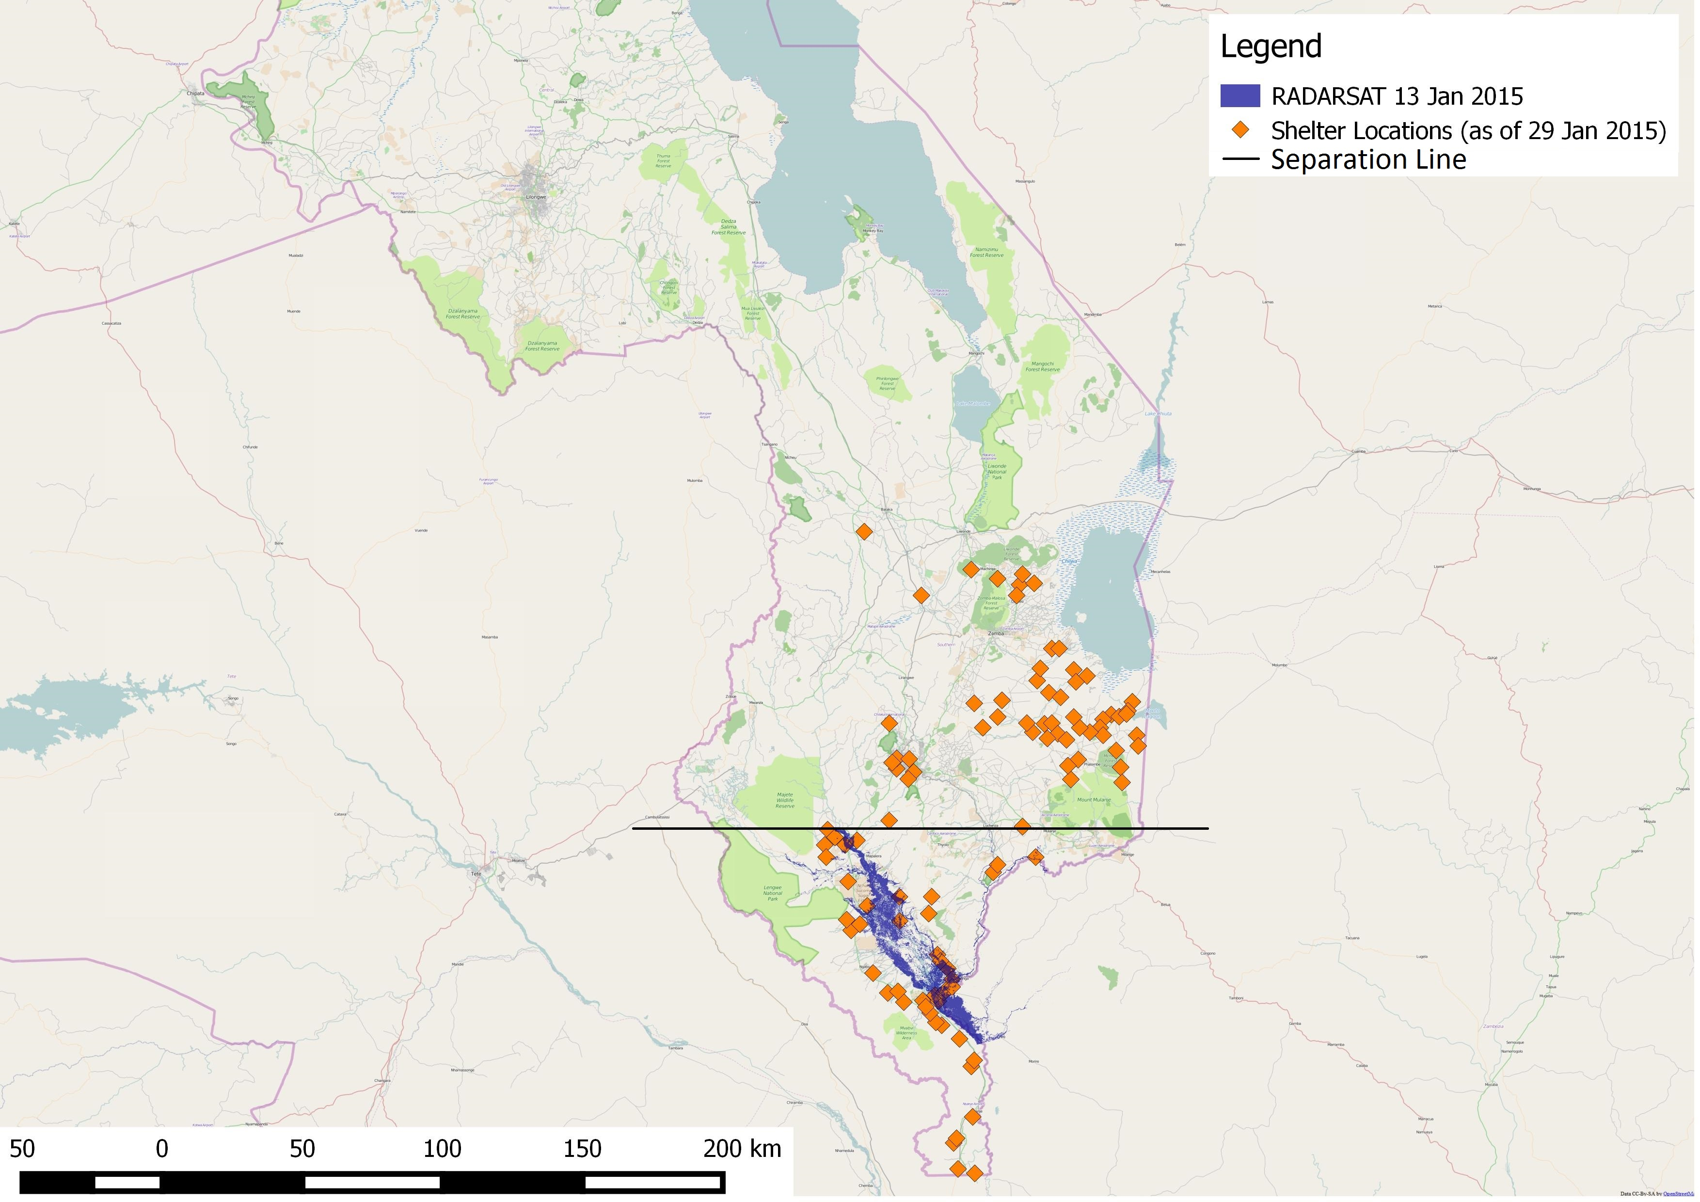
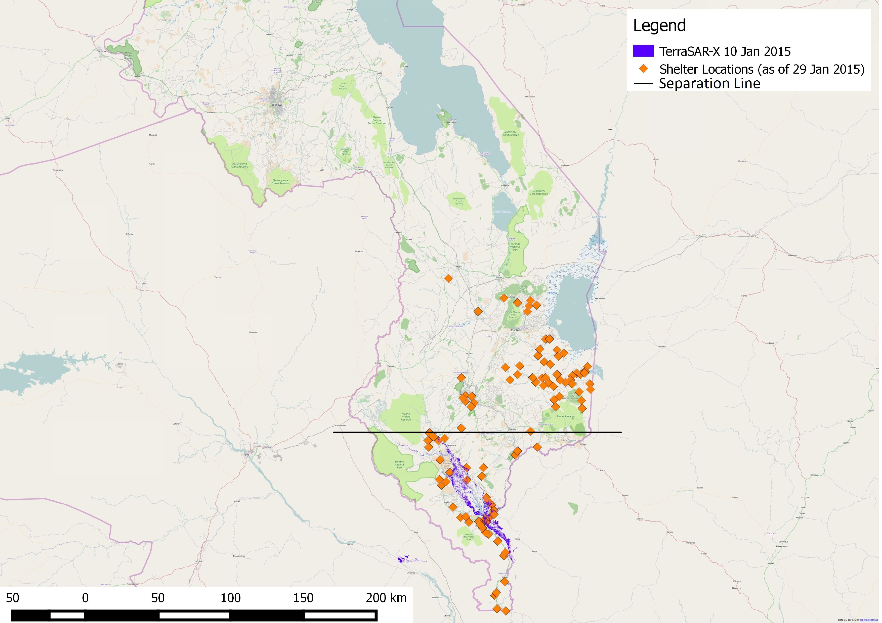
Figure 2. RADARSAT flood detection product on January 13, 2015 represented with the color dark purple. Shelter sites are indicated with the color orange. The black line was drawn to assist spatial analysis.
Figure 1. TerraSAR-X flood detection product on January 10, 2015 represented in the color purple. Shelter sites are indicated with the color orange. The black line was drawn to assist spatial analysis.
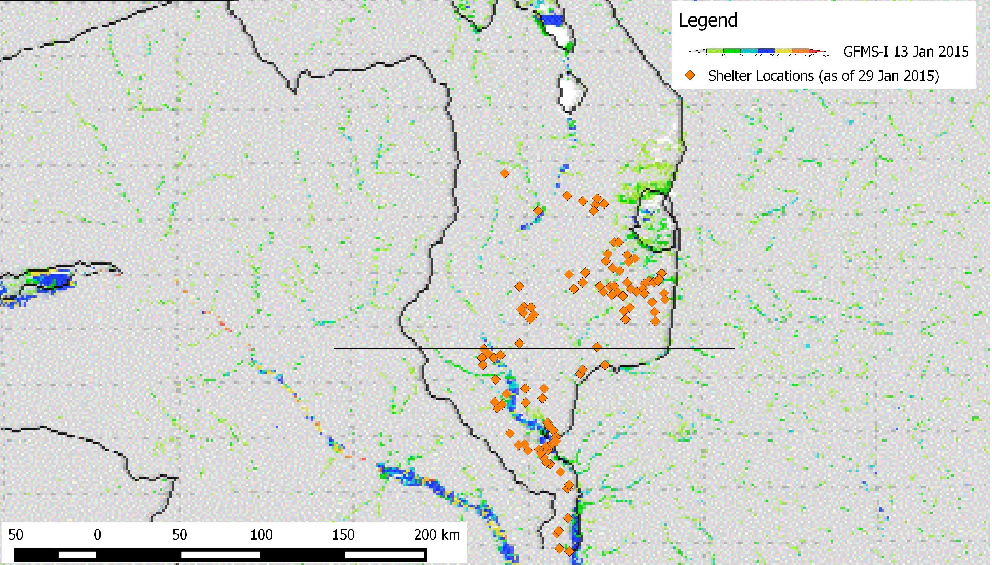
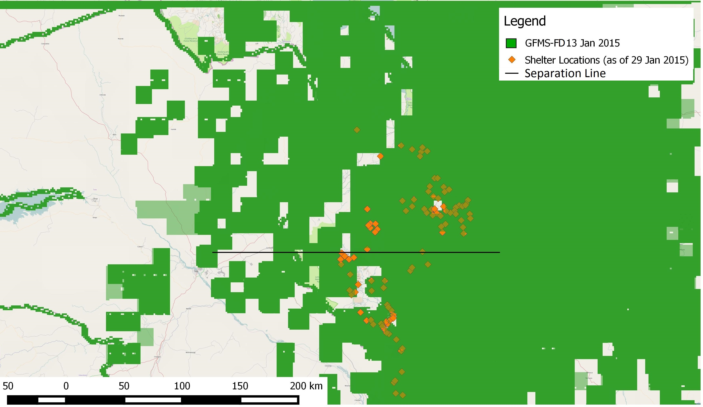
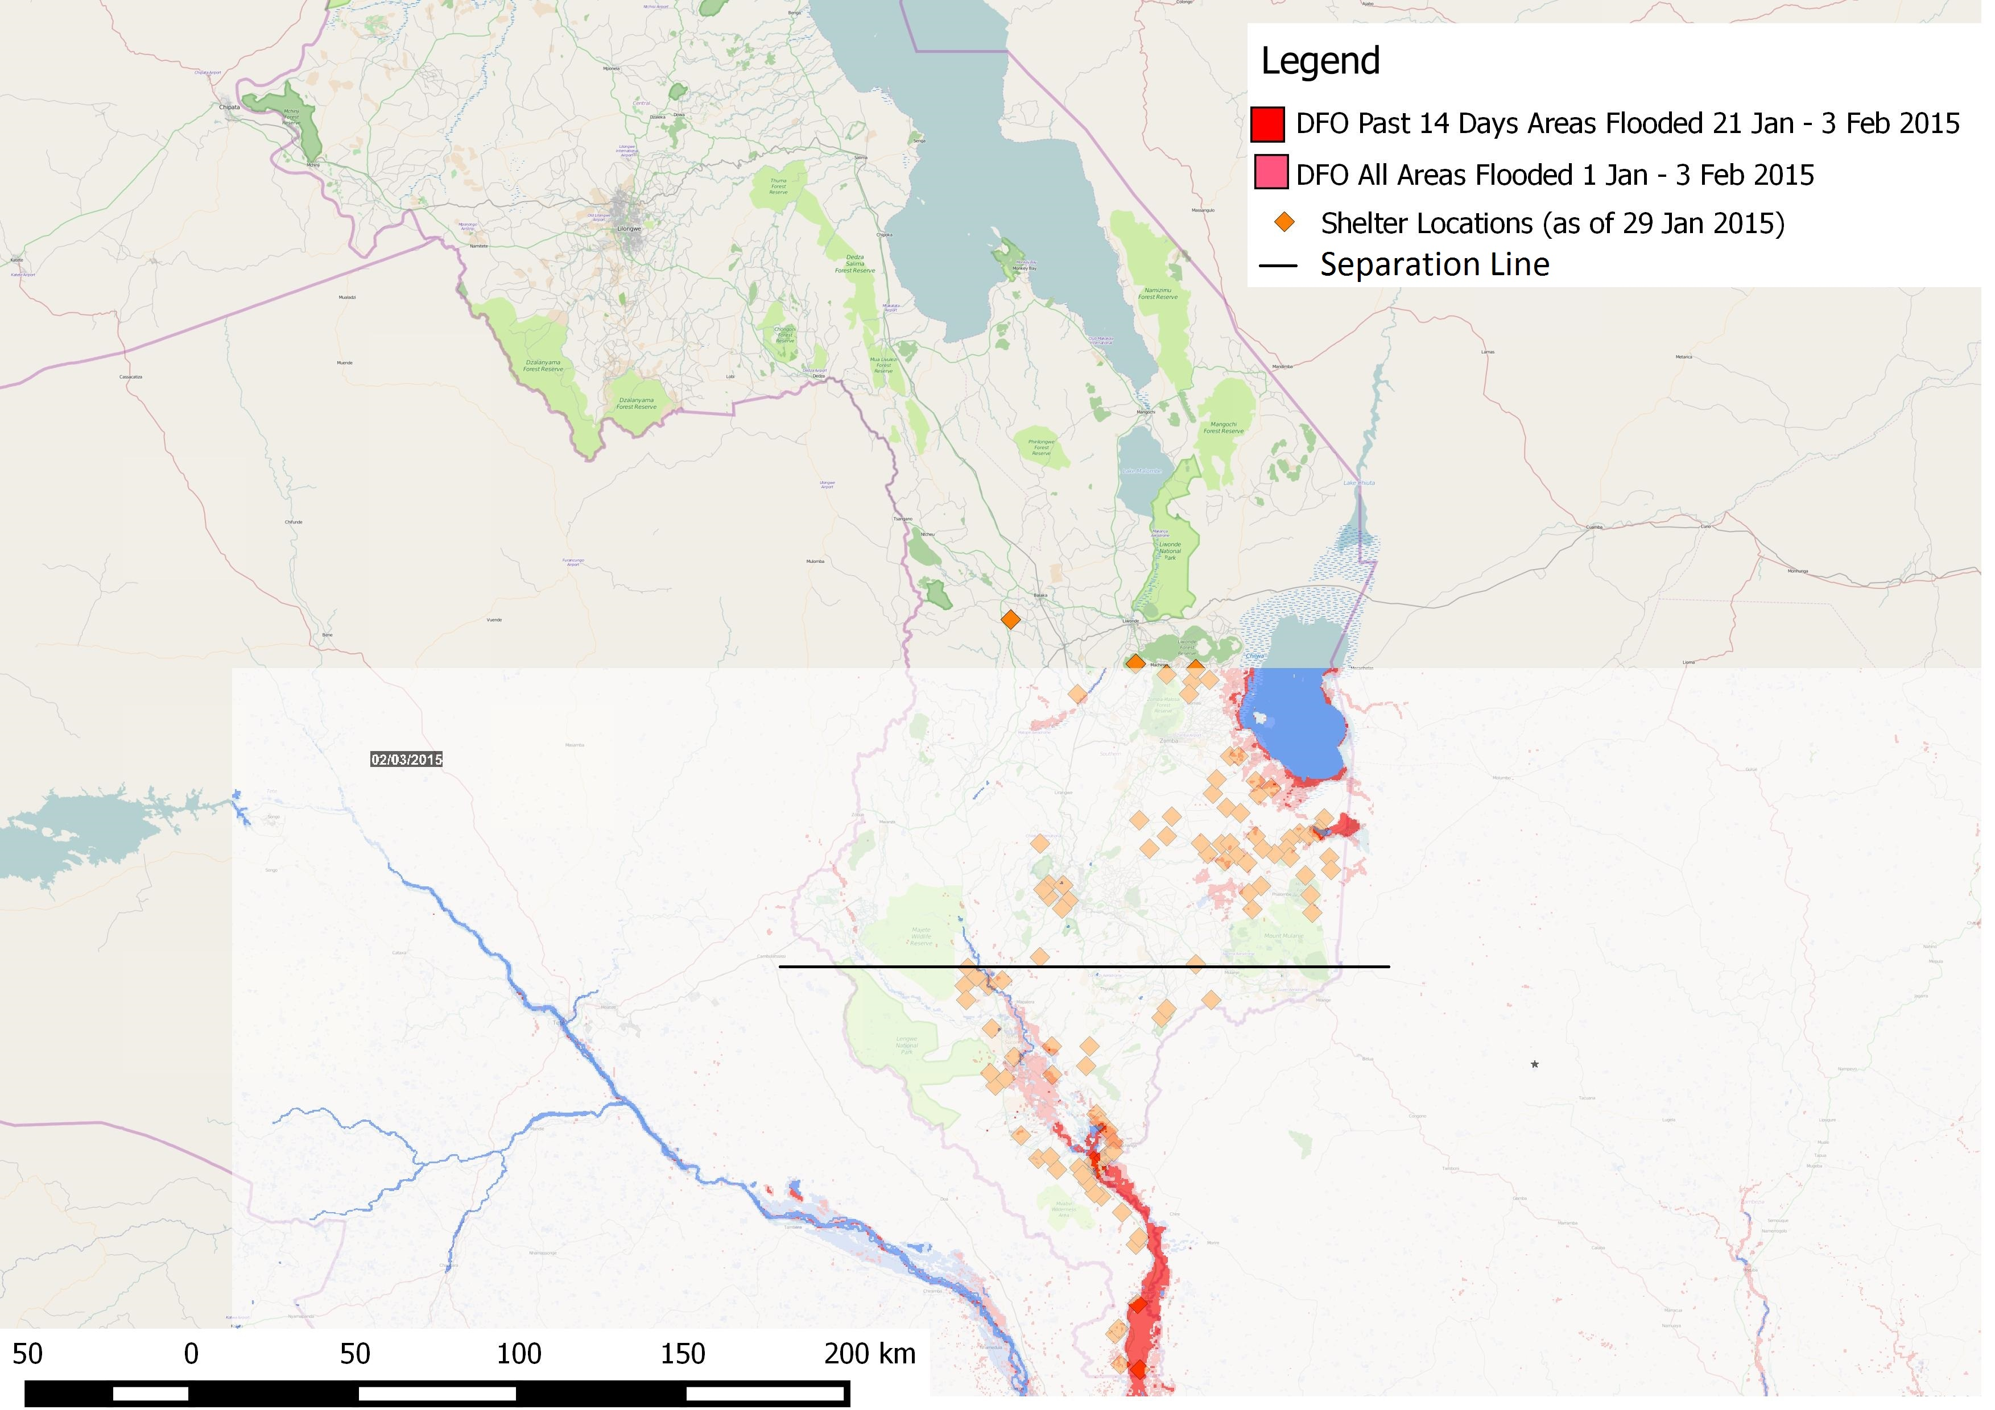
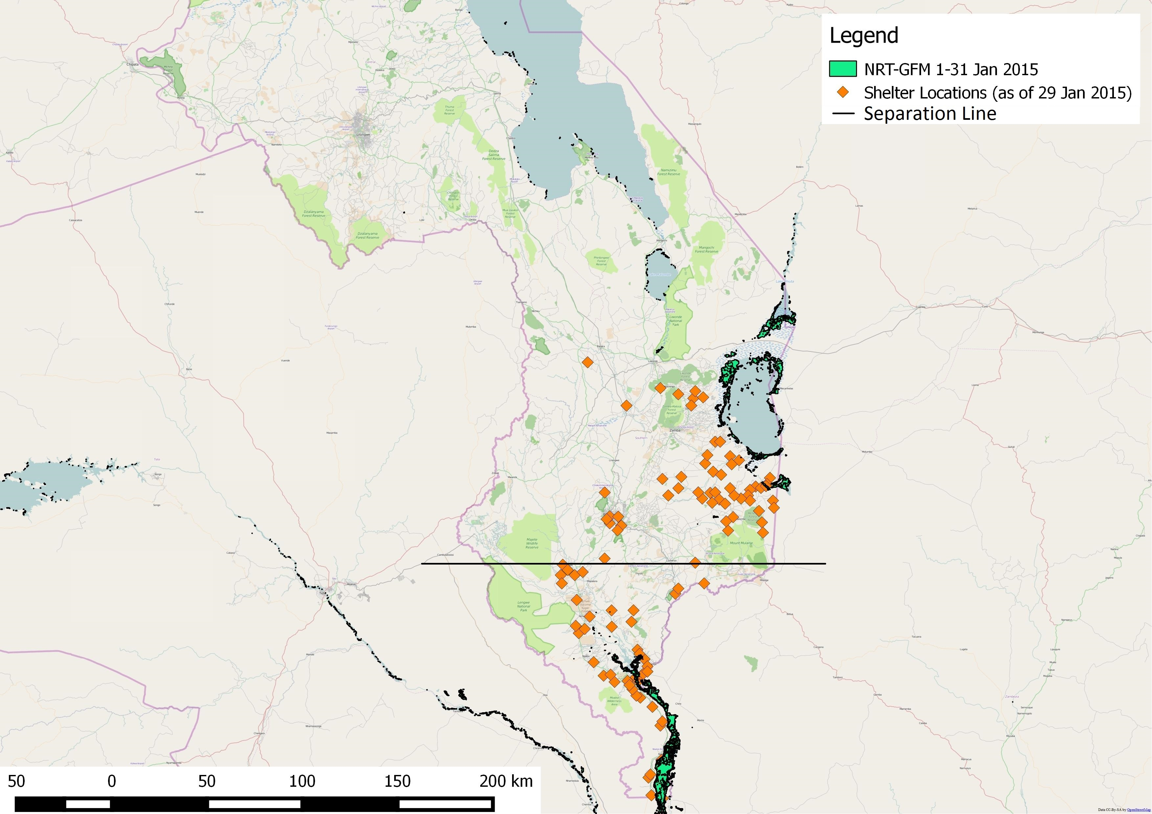
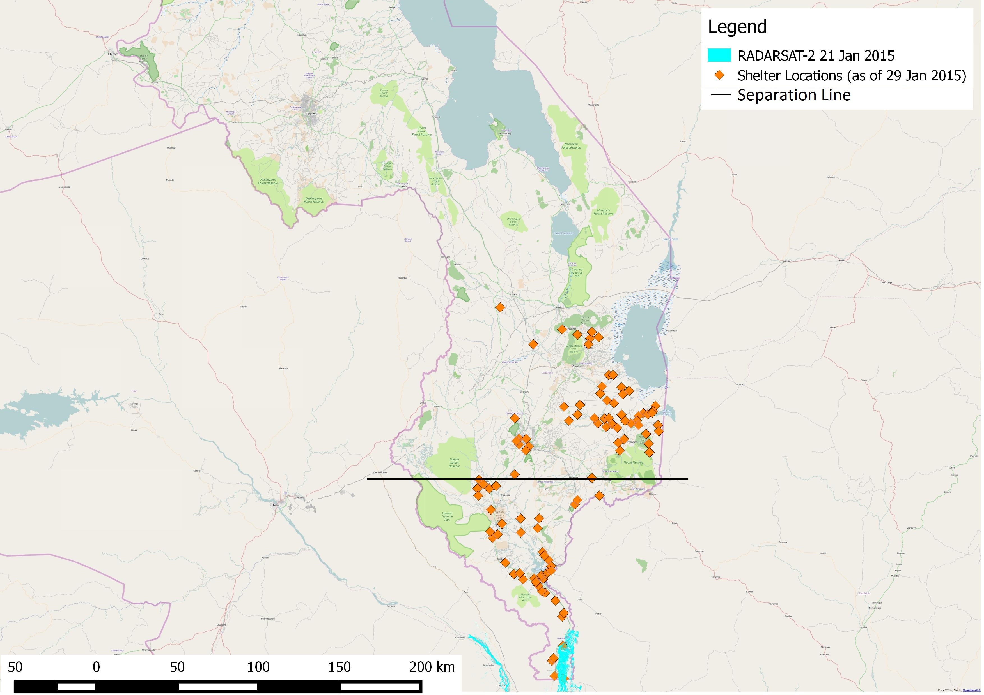
Figure 7. Eight GFMS-I flood detection maps overlaid together in chronological order for maximum flood extent on January 13, 2015, represented in rainbow color spectrum. Shelter sites are indicated with the color orange. The black line was drawn to assist spatial analysis.
Figure 6. Eight GFMS-FD flood detection maps overlaid together in chronological order for maximum flood extent on January 13, 2015, represented in green color. Shelter sites are indicated with the color orange. The black line was drawn to assist spatial analysis.
Figure 5. NRT-GFM maximum flood extent map for January 2015, represented in bright green color. Shelter sites are indicated with the color orange. The black line was drawn to assist spatial analysis.
Figure 4. DFO maximum flood extent map from January1- February 3, 2015, with current flood indicated in the color red and all areas flooded in light red. Shelter sites are indicated with the color orange. The black line was drawn to assist spatial analysis.
Figure 1. RADARSAT-2 flood detection product on January 21, 2015 represented in the color purple. Shelter sites are indicated with the color orange. The black line was drawn to assist spatial analysis.
Additionally, shelter site locations provided for this project were approximated, the exact coordinates and size of these displacement sites were not available at the time this analysis was conducted. Such estimation resulted in approximately five shelter sites being falsely located on reference water bodies. However, the displacement site locations provided an overview on where flooding has occurred. This not only brought attention to sites where no flood signals were detected by the satellite products, but also allowed spatial coverage and accuracy comparison between the seven inundation detection products. Further, it created grounds for future product validation of the flood types being undetected by satellite sensors and a quantitative analysis of accuracy rate when flooded village data becomes available.

V. Conclusions
With the assumption that shelter locations were selected near flooded areas, TerraSAR-X and RADARSAT in Group 1, DFO and NRT-GFM in Group 2 along with GFMS-I in Group 3 can better detect riverine floods at high resolution. As for flood mapping in flash flood prone regions, DFO and GFMS-I showed flooding near shelter locations; yet, ground truth data was needed for verification and inundation signal triggered by reference water bodies were needed to be differentiated from flooding signals in GFMS-I. This is the set of flood detection products identified through this analysis that can better depict flood events in Malawi. It would enable stakeholders to better monitor spatial extent of floods, improve efficiency of disaster programs, raise awareness on potential affected locations being overlooked, and promote accurate documentation of flood disasters.

VI. Acknowledgments
Thank you to Dr. Pietro Ceccato for his guidance and counsel on this project. Thank you to Erin Coughlan, Hastings Kandaya and Keiko Seito for their help on this project.

This material is based upon work supported by NASA through contract NNL11AA00B and cooperative agreement NNX14AB60A.

VII. References

Chang'anamuno, M. (2015, Janaury 31). Malawi Flood Response Trip #2: Phalombe District. Retrieved from African Bible Colleges: http://www.africanbiblecolleges.net/malawi-floods-trip2/
Dartmouth Flood Observatory. (2015, February 3). Current Conditions and Maximum Flood Extent, 2015 Flooding in Malawi and Southern Mozambique. Retrieved from Dartmouth Flood Observatory: http://floodobservatory.colorado.edu/Version3/2015Malawi4219.html
Davies, R. (2015, February 6). Malawi Floods and Deforestation. Retrieved from Flood List: http://floodlist.com/africa/deforestation-floods-malawi
Department of Disaster Management Affairs and United Nations Office of the Resident Coordinator. (2015). Malawi Floods Situation Report No. 4. http://www.humanitarianresponse.info/.
Department of Disaster Management Affairs; United Nations Office of the Resident Coordinator. (2015). Malawi: Floods Situation Report No. 4 (as of 27 January 2015). Relief Web.
Face of Malawi. (2015, January 9). Flash-floods hit Zomba . Retrieved from Face of Malawi: http://www.faceofmalawi.com/2015/01/flash-floods-hit-zomba/
Humannitarian Partners; OCHA. (2015). Malawi: 2015 Floods Humanitarian Situation (as of 23 January 2015). UNOCHA.
MapAction. (2015). Malawi: Flood Event - Overview of UNDC assessements of Nsanje District, as of 26th of January 2015. MapAction.
MapAction. (2015). Malawi: Flood Event - Results of UNDAC assesement of East Bank, Nsanje District, 19 Jan 2015. MapAction.
MapAction. (2015). Malawi: Flood Event - Results of UNDAC asssessment of Phalombe District, 17th to the 25 th of January. MapAct.
MapAction. (2015). Malawi: Flood Event 3W - Chikwawa District (as of 26 Jan 2015). MapAction.
MapAction. (2015). Malawi: Flood Event Displacement Camps - Chikwawa District (as of 22 Jan 2015). MapAction.
Mponda, F. (2015, January 17). Volunteers join grim search for Malawi flood victims. Retrieved from Yahoo News: http://news.yahoo.com/volunteers-join-grim-search-malawi-flood-victims-110028835.html
National Aeronautics and Space Administration. (2015, February 4). NRT Global Flood Mapping. Retrieved from National Aeronautics and Space Administration: http://oas.gsfc.nasa.gov/floodmap/getTile.php?location=030E010S&day=13&year=2015&product=3
National Oceanic and Atmospheric Administration. (2015). Climate Prediction Center's Africa Hazards Outlook January 29 - February 4, 2015. Relief Web.
Nkawihe, M. (2015). Rape, diarrhoea and malaria scare Malawi flooded hit areas: MSF deploys 70 heath [sic] workers. Nyasa Times.
NTA Newstime Africa. (2015, January 9). 6 Feared Dead in Malawi Flash Floods. Retrieved from NTA Newstime Africa: http://www.newstimeafrica.com/archives/37304
Saito, K. (2015, January 21). Jan2015-flood_Radarsat_by_DLR. Retrieved from MASDAP: http://www.masdap.mw/layers/geonode:flood_radarsat_bydlr
Saito, K. (2015, January 21). Jan2015 flood Radarsat2 by UNOSAT. Retrieved from MASDAP: http://www.masdap.mw/layers/geonode:rs2_20150121_flood#more
Saito, K. (2015, January 21). Jan2015-flood_TerraSARX_by_DLR. Retrieved from MASDAP: http://www.masdap.mw/layers/geonode:flood_terrasarx_bydlr
Sanje, K., & Rowling, M. (2015, January 29). Malawi Floods Expose Need to Step up Disaster Prevention. Retrieved from All Africa: http://allafrica.com/stories/201501291555.html
The Government of Malawi. (2015, January 22). Preliminary Response Plan: Malawi Floods 2015.
UN Office for the Coordination of Humanitarian Affairs. (2015). 2015 Floods Displacement Site Locations as of 19 February 2015. Relief Web.
University of Maryland. (2015, February 4). Global Flood Monitoring System (GFMS). Retrieved from http://flood.umd.edu/
UNOSAT. (2015). Estimated rainfall accumulation from 07 to 14 January 2015 in Southern Malawi. Relief Web.

VIII. Appendices
Un-processed by QGIS images used to generate GFMS-FD and GFMS-I one-day maximum flood extent map of January 13, 2015. Images were produced at the hours of 00:00, 03:00, 06:00, 09:00, 12:00, 15:00, 18:00, and 21:00 every day.

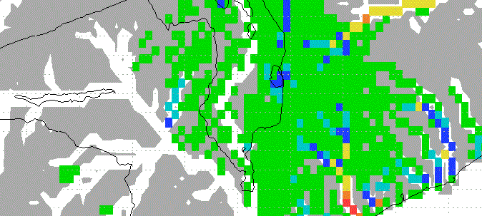
Appendix A. Cropped images from GFMS-FD on January 13, 2015.
At 00:00 January 13, 2015
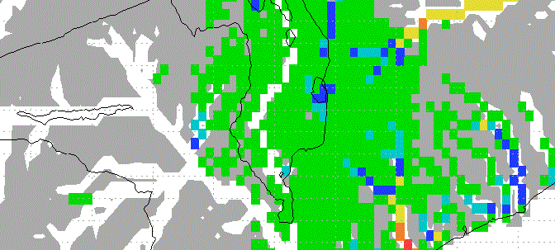
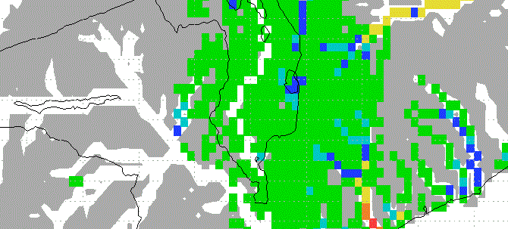
At 03:00 January 13, 2015
At 06:00 January 13, 2015
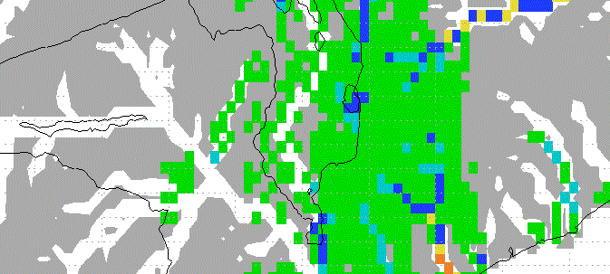
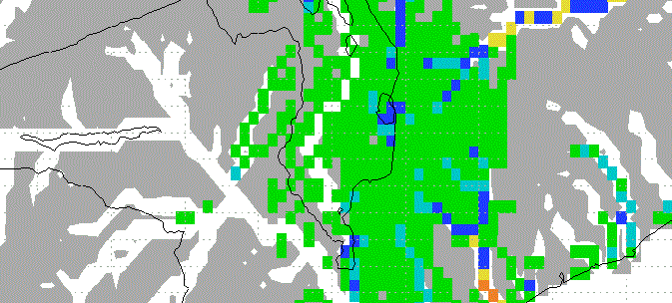
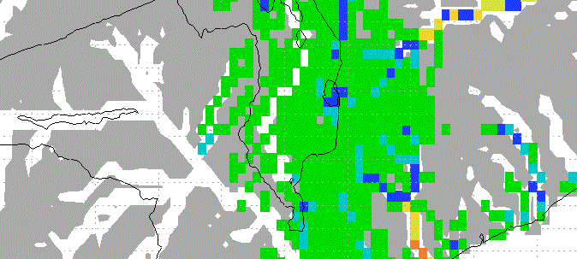
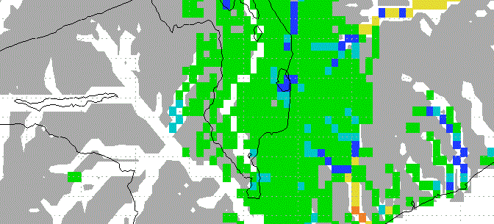
At 18:00 January 13, 2015
At 15:00 January 13, 2015
At 12:00 January 13, 2015
At 09:00 January 13, 2015
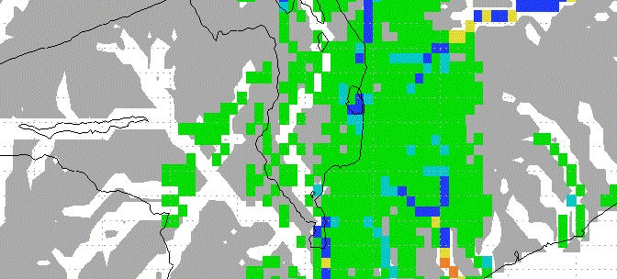
At 21:00 January 13, 2015

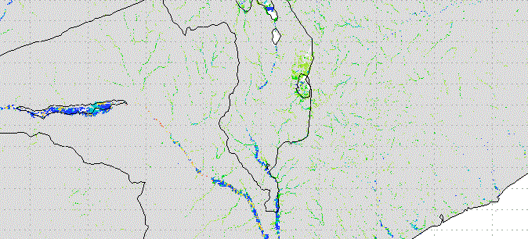
Appendix B. Cropped images from GFMS-I on January 13, 2015.
At 00:00 January 13, 2015
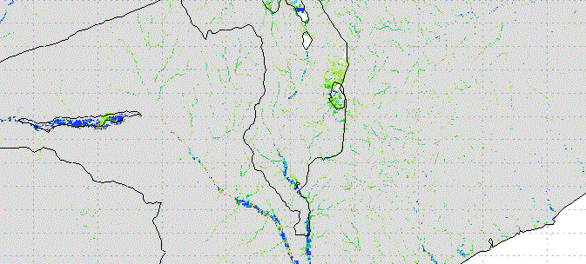
At 03:00 January 13, 2015
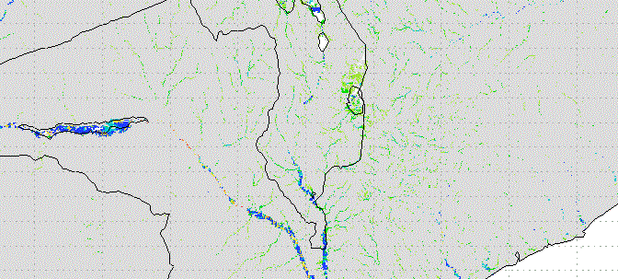
At 06:00 January 13, 2015
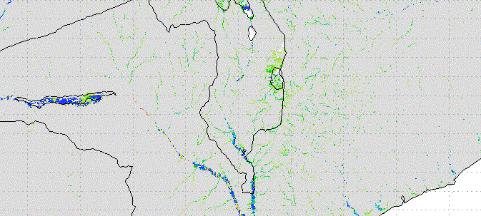
At 09:00 January 13, 2015
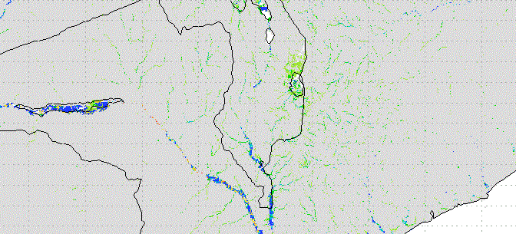
At 12:00 January 13, 2015
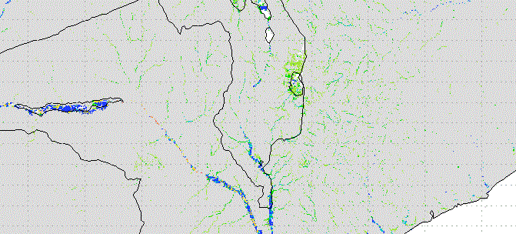
At 15:00 January 13, 2015
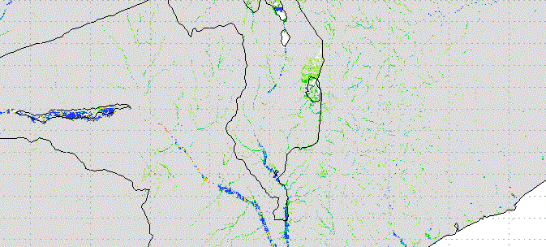
At 18:00 January 13, 2015
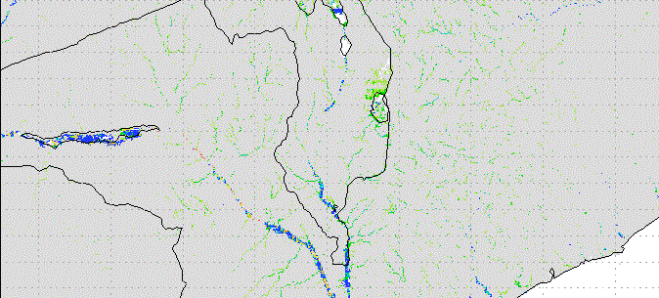
At 21:00 January 13, 2015

