Ohio Energy

Restructuring the Energy Balance in Ohio by Quantifying Energy Loss and Solar Potential Using NASA Earth Observations and LiDAR

 **Technical Report**

Final Draft – August 8th, 2019

Hannah Besso (Project Lead)

Yiyi He

Crystal Wespestad

Sihang Chen

Dr. David Hondula, Arizona State University (Science Advisor)

Dr. Nickolas Rajkovich, University of Buffalo (Science Advisor)

# 1. Abstract

The City of Cleveland and Cuyahoga County in Ohio are joining local governments around the globe in committing to 100% renewable energy goals by encouraging the use of solar technologies. Our team developed a method for estimating rooftop solar power potential using NASA Prediction of Worldwide Energy Resources (POWER) data to assist the City of Cleveland and Cuyahoga County with their renewable energy goals. POWER provides an estimate of incoming solar irradiance on a tilted surface by accounting for the light scattering and filtering effects of clouds and aerosols. Our methods improve on existing solar potential estimation tools through the inclusion of POWER data adjusted for roof slope and a high-resolution (1 ft) digital surface model derived from LiDAR data which allowed for detailed shadow, slope, and aspect modeling. To avoid overestimation, we calculated solar potential for individual roof segments and removed those unsuitable for solar panel installation. We then applied our methods to a 5.38 square mile test area within the county, and we found a total rooftop solar potential of over 100,000 MWh/yr. Of all the buildings with solar power potential, 19% could supply 85% of the total potential energy. These methods have the capacity to be applied to the entire county and to other regions seeking to efficiently utilize solar energy.

**Keywords**

remote sensing, POWER, LiDAR, photovoltaic, solar irradiance

# 2. Introduction

* 1. ***Background Information***

Cleveland was once considered one of the most polluted American cities, and as of 2018, Ohio still generated 47% and 34% of its energy from coal and natural gas, respectively (Ohio Public Utilities Commission, 2018 ). The departments of sustainability for Cleveland and Cuyahoga County are now putting significant efforts toward switching to 100% renewable energy. Renewable energy, especially rooftop solar, has the potential to make the city more sustainable because it localizes energy generation and decreases fossil fuel emissions (Mansouri Kouhestani et al., 2018). Conversion to renewables will help decrease the county’s contribution to global climate variations, which have already resulted in increased temperatures and precipitation in Cuyahoga County (Cuyahoga County Planning Commission, 2019).

The utilization of solar panels is economically beneficial as well. The cost of solar power systems has decreased in recent years while their efficiency has increased, and the installation of solar panels boosts the local economy and cuts down on fossil fuel importation costs. Additionally, the sun is an inexhaustible source of free energy for Earth that theoretically could fulfill the energy needs of the global population if harvesting and storage technologies are readily available (Kabir, Kumar, Kumar, Adelodun, & Kim, 2018).

The departments of sustainability for Cleveland and Cuyahoga County need a detailed solar insolation map of the county in order to make informed decisions about solar panel placement. Past analyses of the solar potential in Cuyahoga County have been limited to small-scale experimentation with online tools such as the PVWatts Calculator and Google Sunroof. These tools do not use surface topography data, and thus do not include important factors such as roof slope, orientation, and shading from surrounding structures. They also do not use solar insolation data that accounts for solar panel tilt angles. Previous work has shown that LiDAR data are effective for modeling rooftop slope, aspect, shading, and sun angle (Boz, Calvert, & Brownson, 2015; Lukač et al., 2013; Mansouri Kouhestani et al., 2018). Well-vetted solar irradiance satellite data specific to a variety of solar panel tilt angles is available through NASA POWER. This dataset incorporates meteorological and atmospheric data across a 22 year timespan to create a climatological average (Stackhouse et al., 2018). We focused our efforts on developing a methodology that utilizes the available high-resolution digital surface model (DSM) from LiDAR and the atmospherically corrected solar irradiance data from NASA POWER. We then applied this methodology to a small test area within the county for which it will eventually be run (Figure 1).

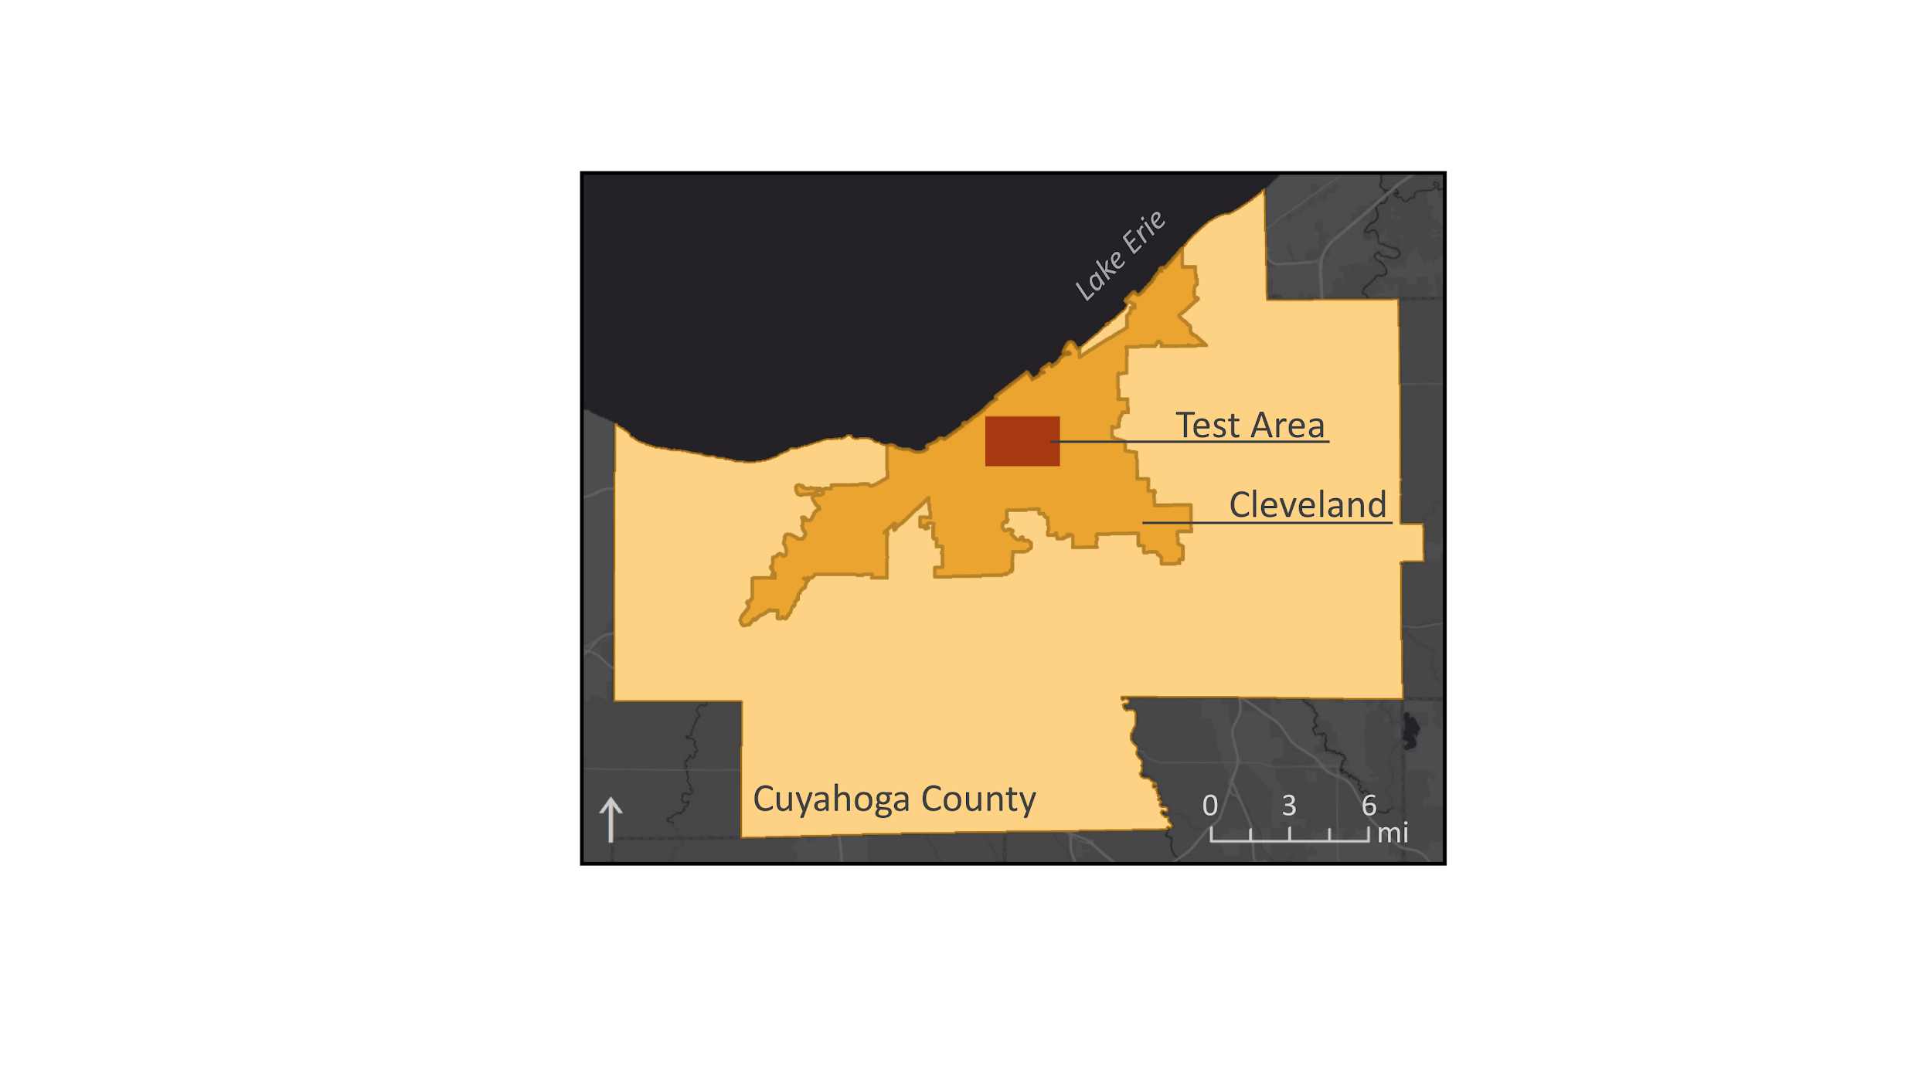

*Figure 1.* The test area is an approximately five-square mile region within the City of Cleveland and Cuyahoga County, which are located in northern Ohio along the shore of Lake Erie.

* 1. ***Project Partners & Objectives***

The Ohio Energy team partnered with officials from the Department of Sustainability and Office of Sustainability of Cuyahoga County and the City of Cleveland to support efforts to increase solar energy production. The county and city have set the goal of 100% renewable energy by 2050 and 2035, respectively (Cuyahoga County Planning Commission, 2019). Cuyahoga County has developed a Climate Change Action Plan that sets renewable energy targets, means for tracking progress toward these targets, and strategies for climate adaptation. The county and city are seeking a method for identifying individual rooftops across the county with relatively high solar potential so they can target solar energy outreach efforts to specific landowners. Therefore, the objectives of this project were to (1) create a method for assessing rooftop solar energy potential within the county, (2) generate a semi-automated tool to identify roof segments that are viable for solar panel installation, and (3) combine analysis results with land use and socioeconomic data to identify priority locations for equitable green energy distribution initiatives. This project will help the county and city to conduct targeted outreach to property owners with the most to gain and will provide energy output estimates to help landowners make informed installation decisions.

# 3. Methodology

The team developed a semi-automated tool that can be used by the project partners to identify potential rooftops and brown spaces for solar panel installation. The tool calculates the average annual solar energy that could be generated at a given location with consideration of cloud cover and shading effects from surrounding buildings, trees, and hills. The NASA POWER solar irradiance dataset was used in this study to account for atmospheric interactions, solar geometry, and tilt-specific panel irradiance. The output values from this dataset were then combined with the modeled results from the Esri Area Solar Radiation tool to calculate the amount of energy that could be generated for each location within the test area.

***3.1 Data Acquisition***

The Solar Irradiance for Equator Facing Tilted Surfaces dataset is made up of preprocessed Earth observation data that were obtained from the NASA Langley Research Center (LaRC) POWER Project funded through the NASA Earth Science Division/Applied Science Program. The resolution of this solar irradiance data is a 0.5-degree global grid. Meteorological parameters, such as cloud cover depth and duration, come from the NASA Global Modeling and Assimilation Office Modern Era Retro-analysis for Research and Applications, Version 2 (GMAO MERRA-2) assimilation model. Solar parameters on an equator-facing tilted surface values are from the NASA Global Energy and Water Exchanges Surface Radiation Budget (GEWEX/SRB) release 3.0 archive, averaged over 22 years (1983 to 2005) from GMS 1-5, GOE 5-12, INS-1, MET 2-9, MTS-1, and NOA 7-18 satellites (Stackhouse et al., 2018). Earth observations and other ancillary data were acquired as shown in Tables 1 and 2.

Table 1

*NASA Earth observation data and data products used in this project*

|  |  |  |  |
| --- | --- | --- | --- |
| **Dataset** | **Parameters** | **Use** | **Data Acquisition** |
| Digital Elevation Model (DEM) | Elevation | Analyze the effect of large-scale topography on annual solar duration | [Shuttle Radar Topography Mission (SRTM)](https://www2.jpl.nasa.gov/srtm/) |
| Solar Irradiance for Equator Facing Tilted Surfaces | Solar radiation, accounting for clouds and aerosols | Tilt-specific solar irradiance data that accounts for atmospheric and meteorological conditions | [NASA Prediction Of Worldwide Energy Resources (POWER)](https://power.larc.nasa.gov/data-access-viewer/) |

Table 2

*Ancillary Data used in this project*

|  |  |  |  |
| --- | --- | --- | --- |
| **Specifications** | **Data Type** | **Use** | **Source** |
| Digital Surface Model (DSM) | Raster  (1 ft resolution) | Analyze rooftops for solar duration, including aspect, slope, and shadow effects | University of Vermont Spatial Analysis Laboratory/Cuyahoga County GIS Department (Personal Communication) |
| Building footprints | Vector | Identify individual buildings with solar potential for outreach purposes | Cuyahoga County GIS Department (Personal Communication) |
| Land use classes | Vector | Identify building ownership and land use type | [Cuyahoga County](https://data-cuyahoga.opendata.arcgis.com/datasets/77962fab2da24970928feda14109ddda_0?page=10) Open Data |
| TIGER/Line Shapefiles | Vector | Inspect socioeconomic data and identify low-income areas that overlap with high solar power potential zones | Cuyahoga County GIS Department (Personal Communication) |

***3.2 Data Processing***

The Cuyahoga County DSM had been preprocessed to make it spike-free and was created in a projection best suited for the study site (State Plane Ohio North) at a 1-ft resolution. The NASA POWER dataset was also preprocessed. Top of atmosphere satellite data was combined with atmospheric and meteorological data from a 22 year timespan to create a climatologically averaged dataset for specific surface tilt angles. We worked with our partners to select a five-square mile test site that included a variety of land use types and buildings of interest to both the city and the county. All methods were performed on this test site. A detailed tutorial of our methods is provided as a supplementary document.

Our first step was to tile the inputs to decrease computation time. After this, there were three major steps in finding the solar energy potential for each building: generating a solar irradiance raster of the test area, selecting viable roof segments for solar panel installation, and aggregating the above results together with individual building footprints to gain solar energy potential per building.

First, we used the Esri Area Solar Radiation tool on the test area DSM to calculate the number of hours per year of direct incoming solar radiation per 1 square foot pixel. We then converted the NASA POWER Solar Irradiance for Equator Facing Tilted Surfaces data to kWhr/(ft2∙hr). Finally, we multiplied the hours of direct incoming solar radiation by the tilt-specific irradiance per hour to obtain an annual irradiance raster.

Next, we identified suitable roof areas for solar panel installation. Using Esri slope and aspect tools, we aggregated DSM raster cells with similar geometries to create roof segment polygons. We then removed roof areas that did not comply with local solar panel installation practices. This included removing north facing roof segments, areas with slope greater than 60 degrees (Mansouri Kouhestani et al., 2018), and a 3 foot buffer around roof edges (International Code Council, 2017).

Finally, we calculated the solar potential of each building in the test area by aggregating the irradiance raster to roof segments and then summing each segment to its corresponding building footprints. We found the total solar potential by summing the potential of all buildings within the test area.

***3.3 Data Analysis***

By tiling the DSM before modeling solar duration, we assumed that there were no shading effects from large-scale topography. To validate this assumption, we used a 30 foot resolution Digital Elevation Model (DEM) and the Esri Area Solar Radiation tool to model solar duration on an approximately 4,800 square mile area surrounding the county.

# 4. Results & Discussion

There was a total of 111,321,337 kWhr/yr potential energy within the test area. The mean potential per roof segment was 10.7 MWh/yr (Figure 2).

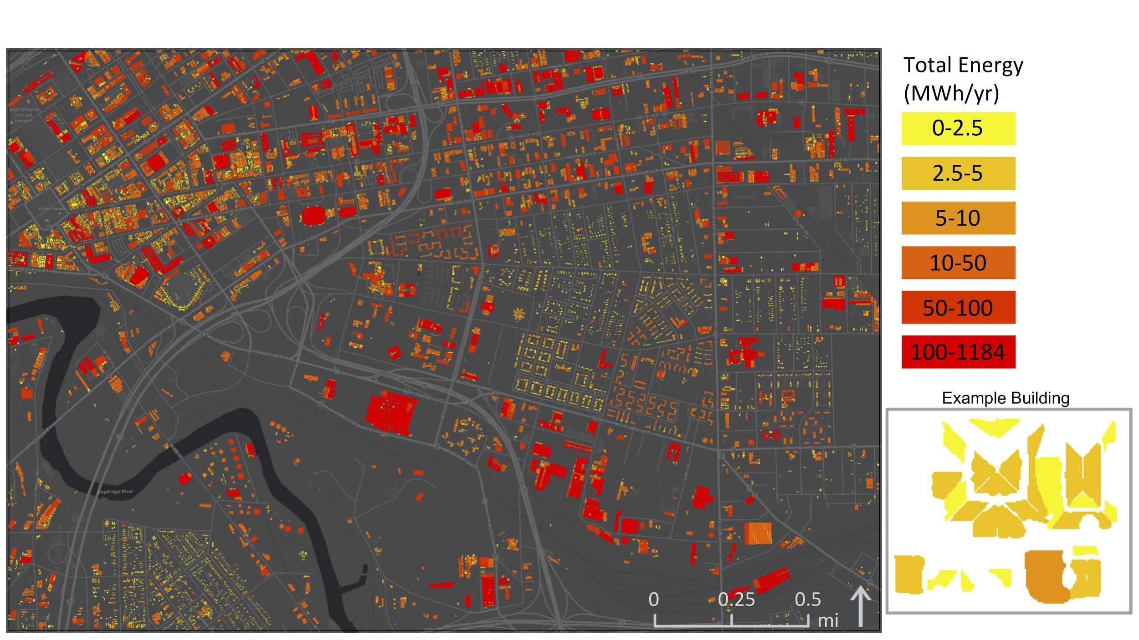

*Figure 2.* Roof segment polygons deemed viable for solar panel installation, colored according to their annual solar energy generation potential in megawatt hours. Polygons that were northwest to northeast facing, steeper than 60 degrees tilt, or had smaller than 100-ft sq surface area were eliminated, and not included in this results figure. An example of the produced roof segment polygons on one building, colored according to their respective total annual solar energy potential, is shown at the bottom right of the figure.

The maximum efficiency (defined as total potential energy divided by roof segment area) of roof segments in the test area was 16 kWhr/(ft2∙yr). The mean efficiency was 6.22 kWhr/(ft2∙yr) (Figure 3). 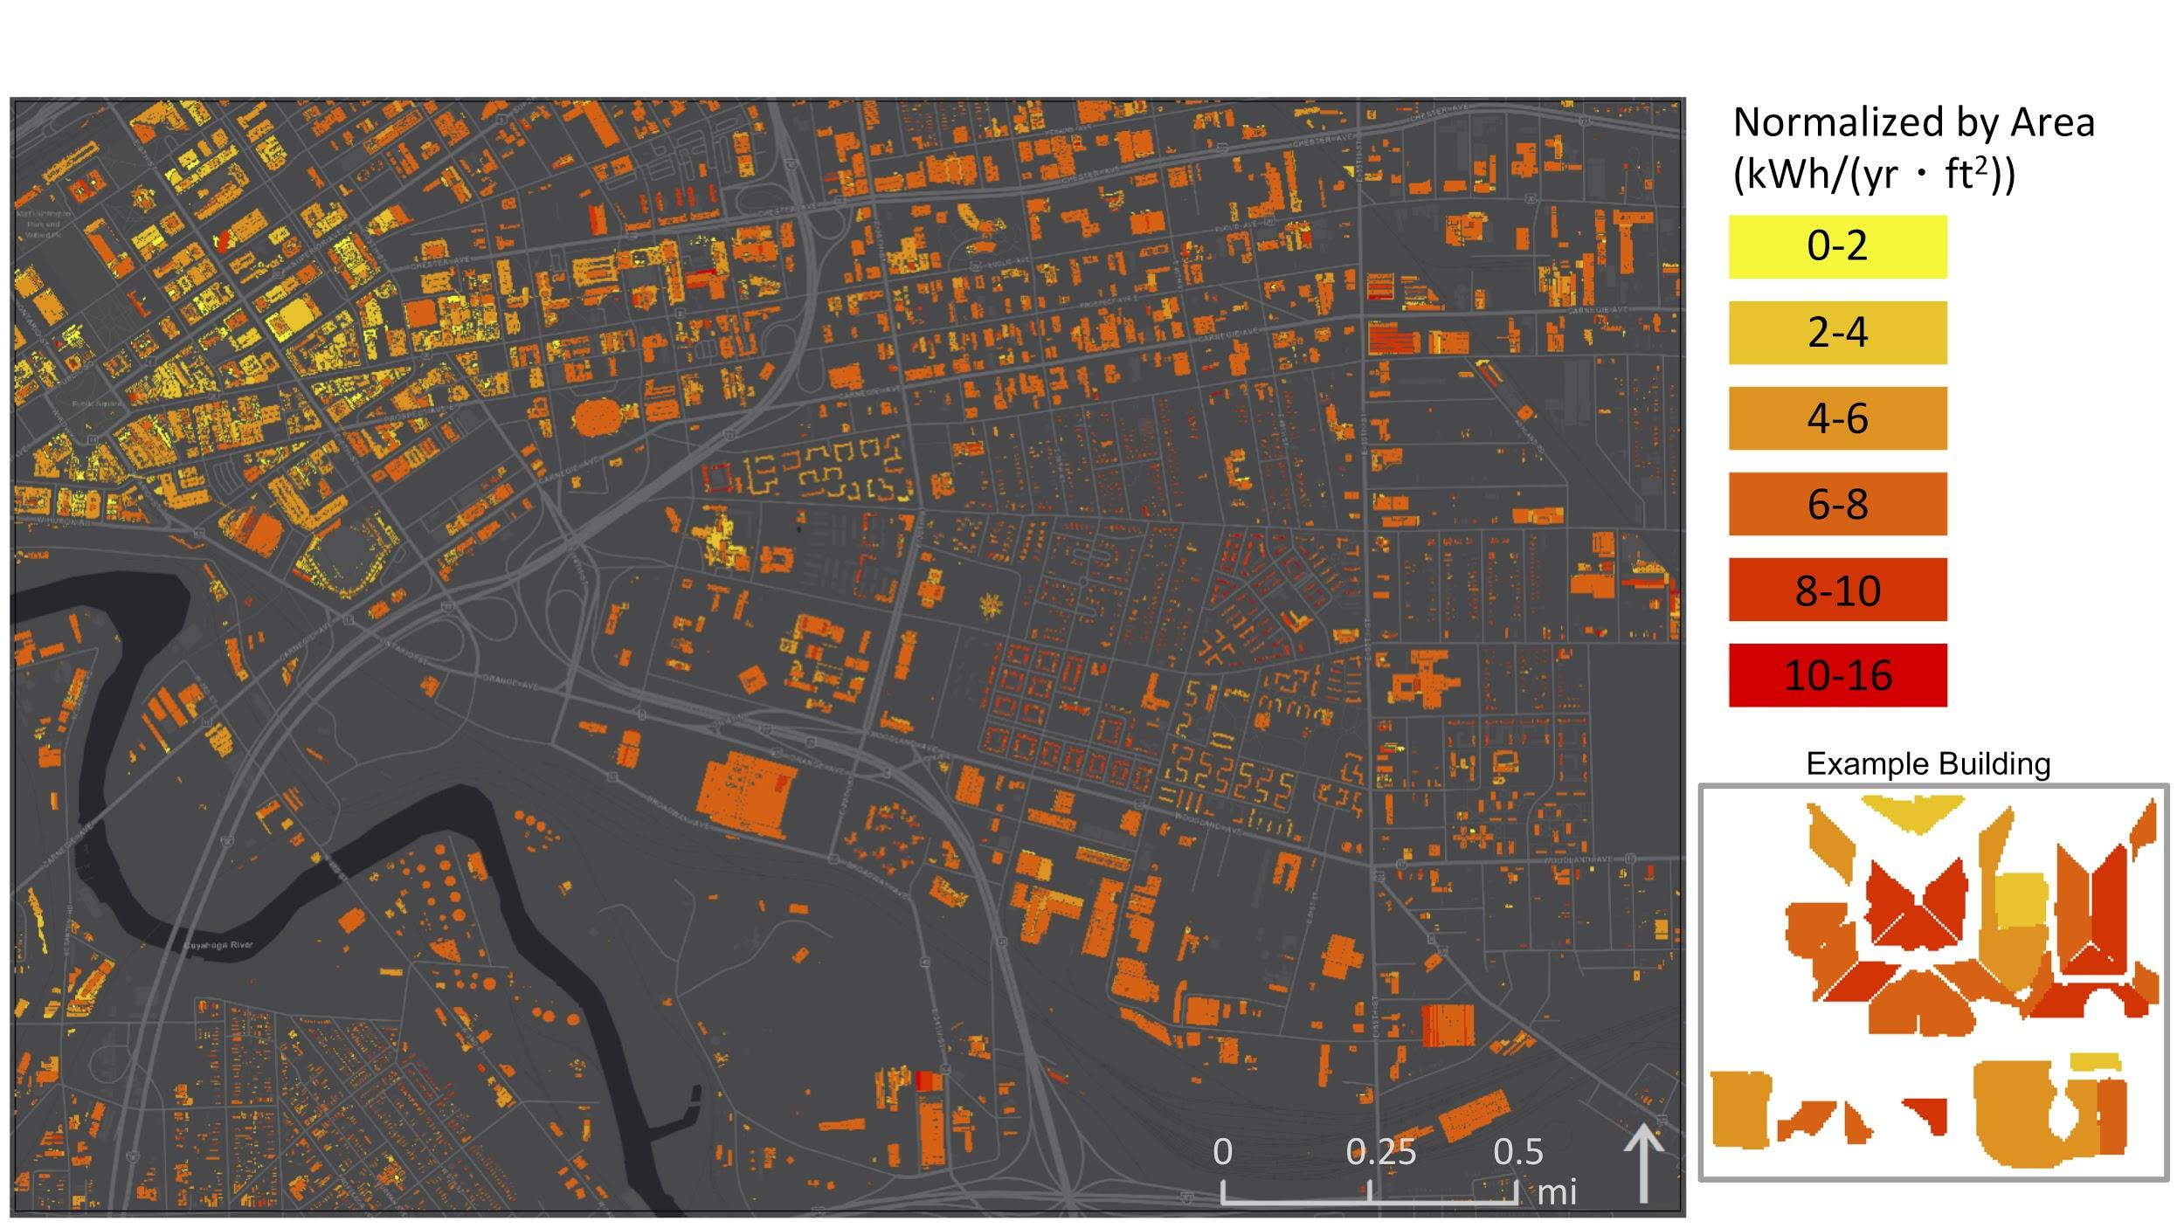

*Figure 3*. Roof segment polygons deemed viable for solar panel installation, colored according to their energy generation potential divided by their surface area. This is a proxy for their potential efficiency of solar energy production in kilowatt hours per year per square foot. The same example building as shown in Figure 2 is shown again with the production efficiency color scale.

The maximum solar energy potential by building was 3,463 MWhr/yr. The mean was 37.5 MWhr/yr (Figure 4a). The maximum efficiency (defined as total potential energy divided by roof segment area) per building was 10.77 kWhr/(ft2∙yr) and the mean was 7 kWhr/(ft2∙yr) (Figure 4b).

(a)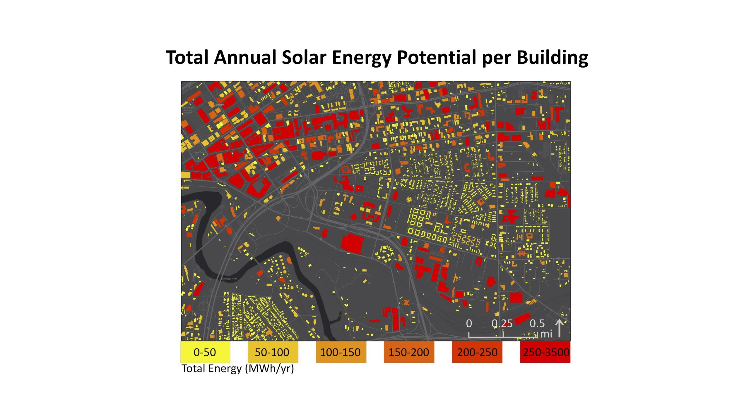(b)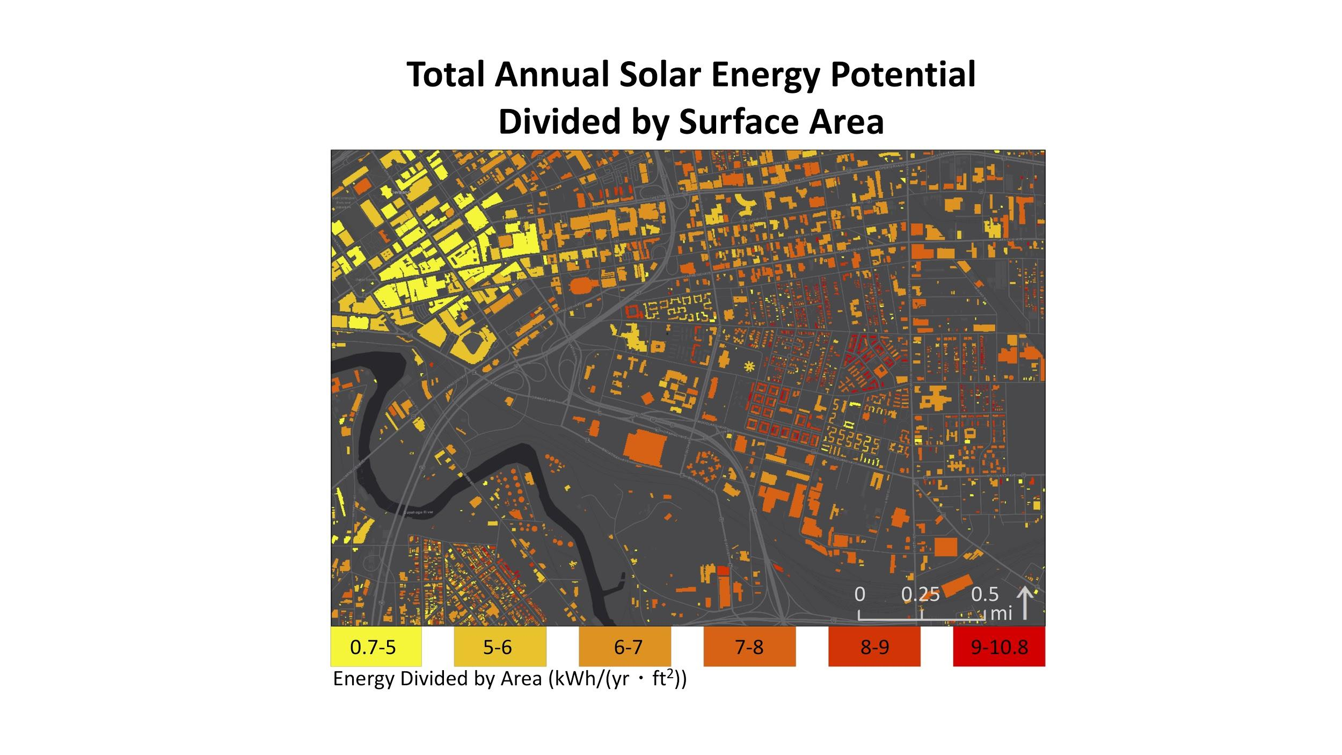

*Figure 4.* (a) Annual solar energy generation potential per building in MWhr/yr, calculated by summing the total energy potential of each roof segment polygon to the corresponding building. (b) Potential energy generation efficiency for each building’s viable roof area in kWhr/(ft2∙yr), calculated as the sum of the annual solar energy potential for all roof segment polygons within the building footprint divided by the sum of the combined surface areas.

The large-scale analysis of the effect of topography on sunlight exposure, using Shuttle Radar Topography Mission (SRTM) data, showed that the region surrounding the county is relatively flat and existing hills generally only cast localized shadows (Figure 5). We performed this test to confirm clipping the DSM to grid cells with 1000-ft buffers for use in the Esri Area Solar Radiation tool was a viable method for making our methods feasible on machines with low computation power. Large-scale topography appeared to have only localized effects on the number of sunlight hours received at a given location.

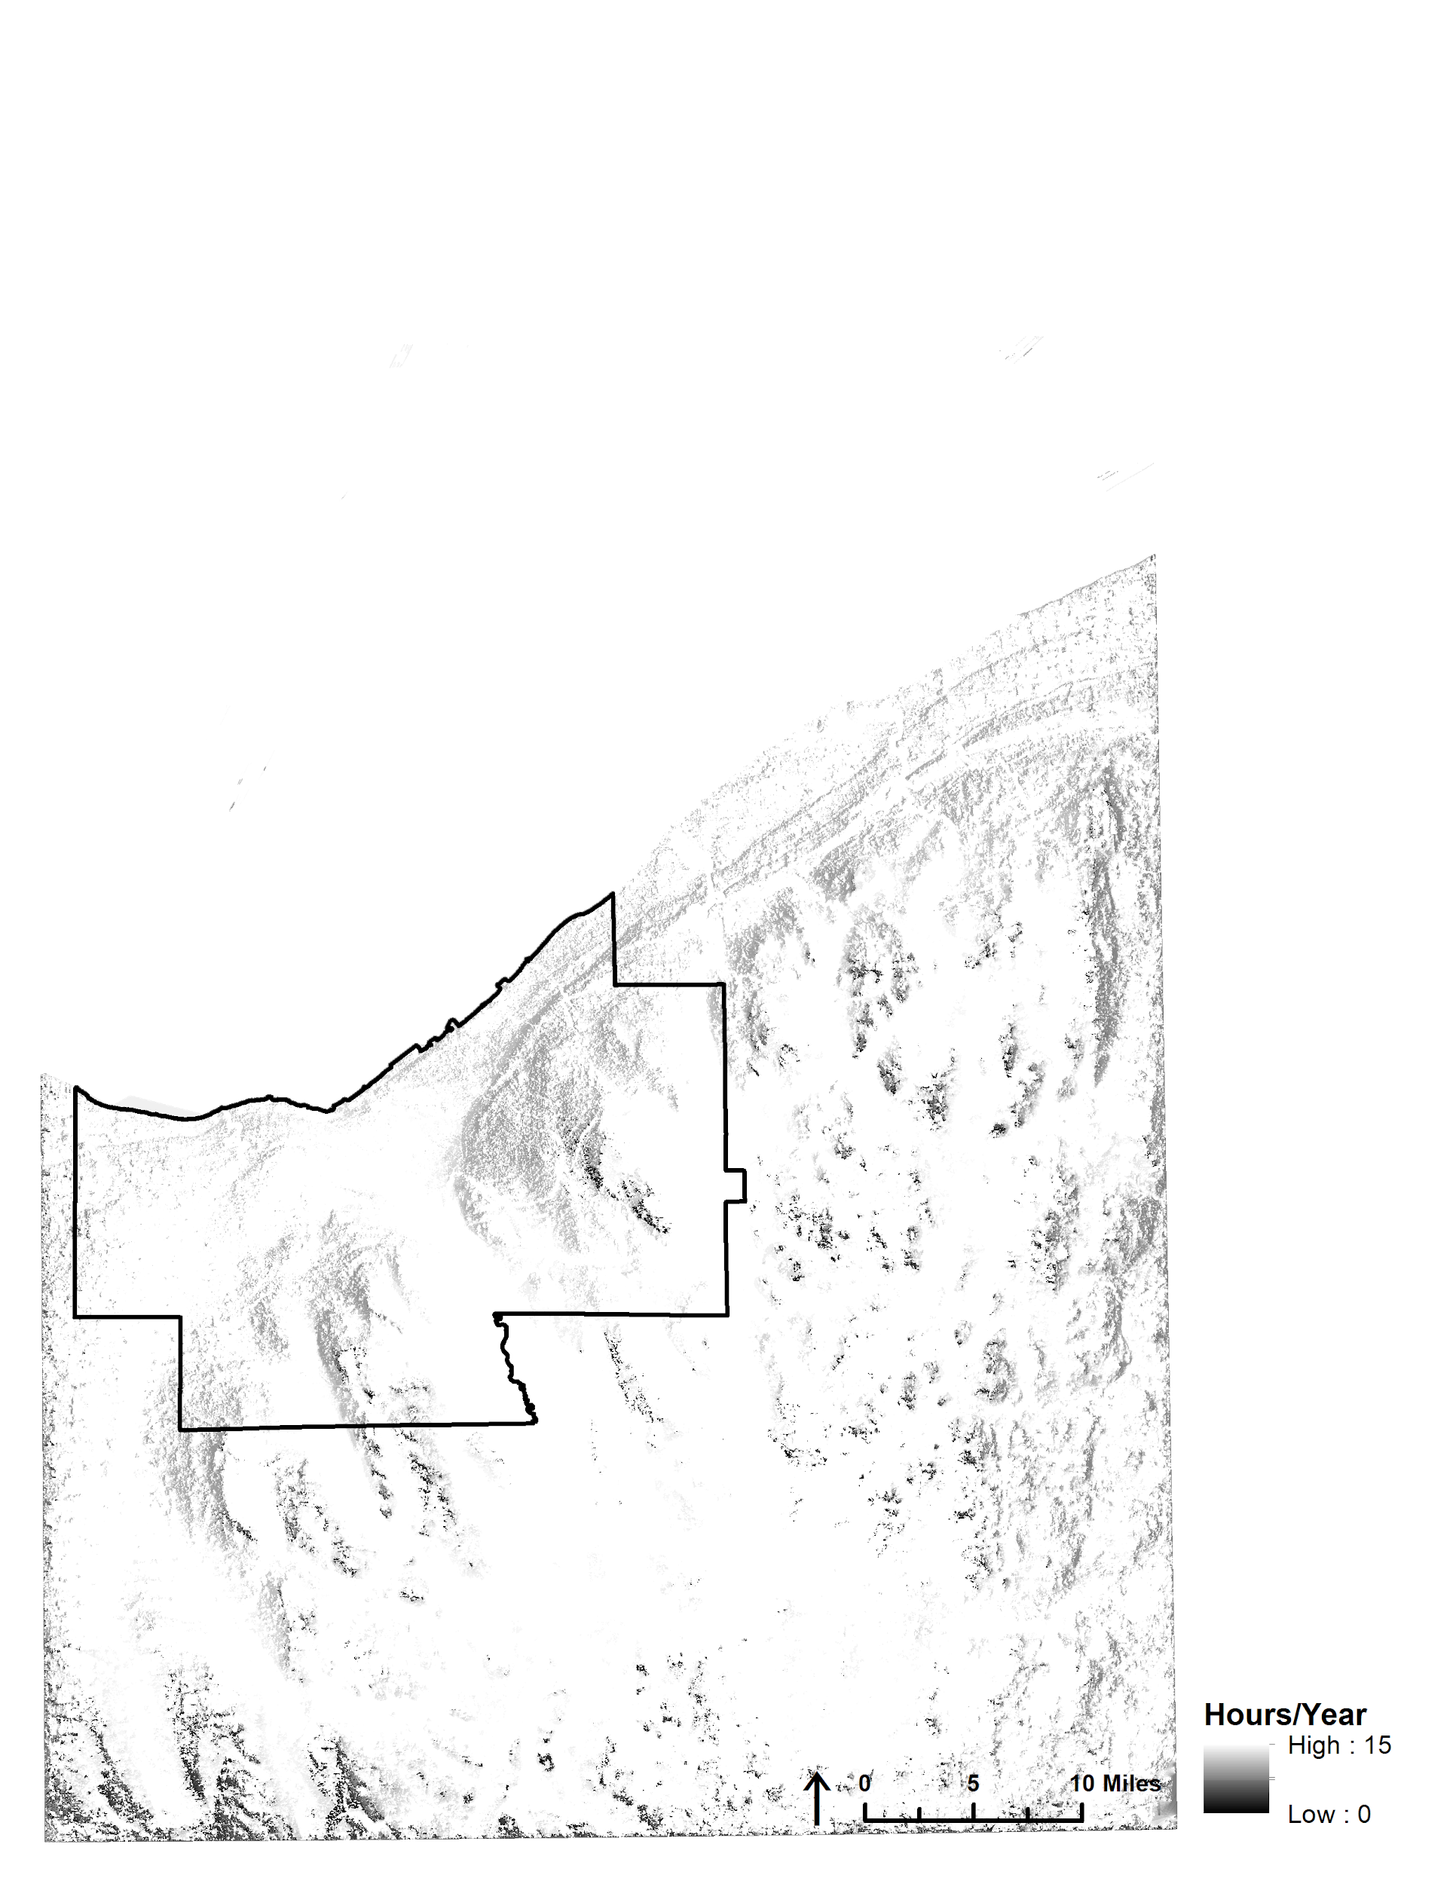

*Figure 5*. Annual hours of sunlight exposure for areas in and around Cuyahoga County, OH. This analysis was generated using 30-m resolution SRTM data.

***4.1 Analysis of Results***

The roof segment polygon maps (Figures 2 and 3) are necessary to determine exactly which roof segments on a given building would produce the most solar energy, and be the most efficient for energy generation. The total potential energy by building (Figure 4) is useful for communicating study results to project partners and building owners. The majority of the highest producing buildings are the large and flat commercial building rooftops downtown. However, when divided by surface area, the residential roofs with a slope closer to the optimal solar panel tilt of 34 degrees (NASA POWER, 2019) are more efficient energy producers than the larger flat roofs. This is also due in part to the fact that solar arrays on flat roofs can only be installed on about 72% of the total viable area, since increased panel spacing is required to prevent the tilted panels from shadowing each other.

We recognize that installing solar panels on all 2,945 viable buildings in the test area may not be feasible. Therefore, we conducted a cumulative sum assessment to identify buildings with the highest solar potential. We summed the total solar potential of all buildings in the test area in order of decreasing solar potential. Then we used the elbow method to calculate the “elbow point,” which is an estimation of the number of buildings after which additional panel installation produces diminishing returns. A full description of the process for generating this analysis is provided in the methods tutorial supplementary document. The “elbow point” on our curve occurs at 560 buildings, which together have a cumulative sum of 94,363 Mwh/yr. This means that 19% of the total selected buildings could produce 85% of the 111,321,337 kWh/year total potential energy. We chose to select buildings for further analysis based on total potential energy rather than energy production efficiency since this would allow our partners to focus their outreach efforts on a few landowners with a high potential for solar energy production.

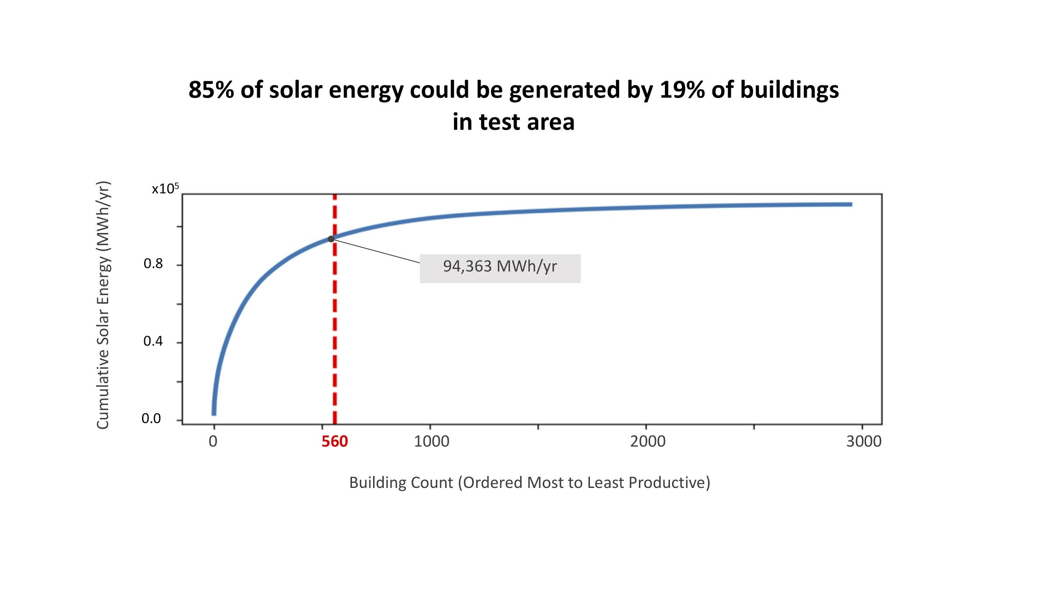

*Figure 6*. Cumulative sum of the total annual solar energy generation potential for each building, summed in order from highest to lowest potential producers. The “elbow point” indicates the point of diminishing returns.

a)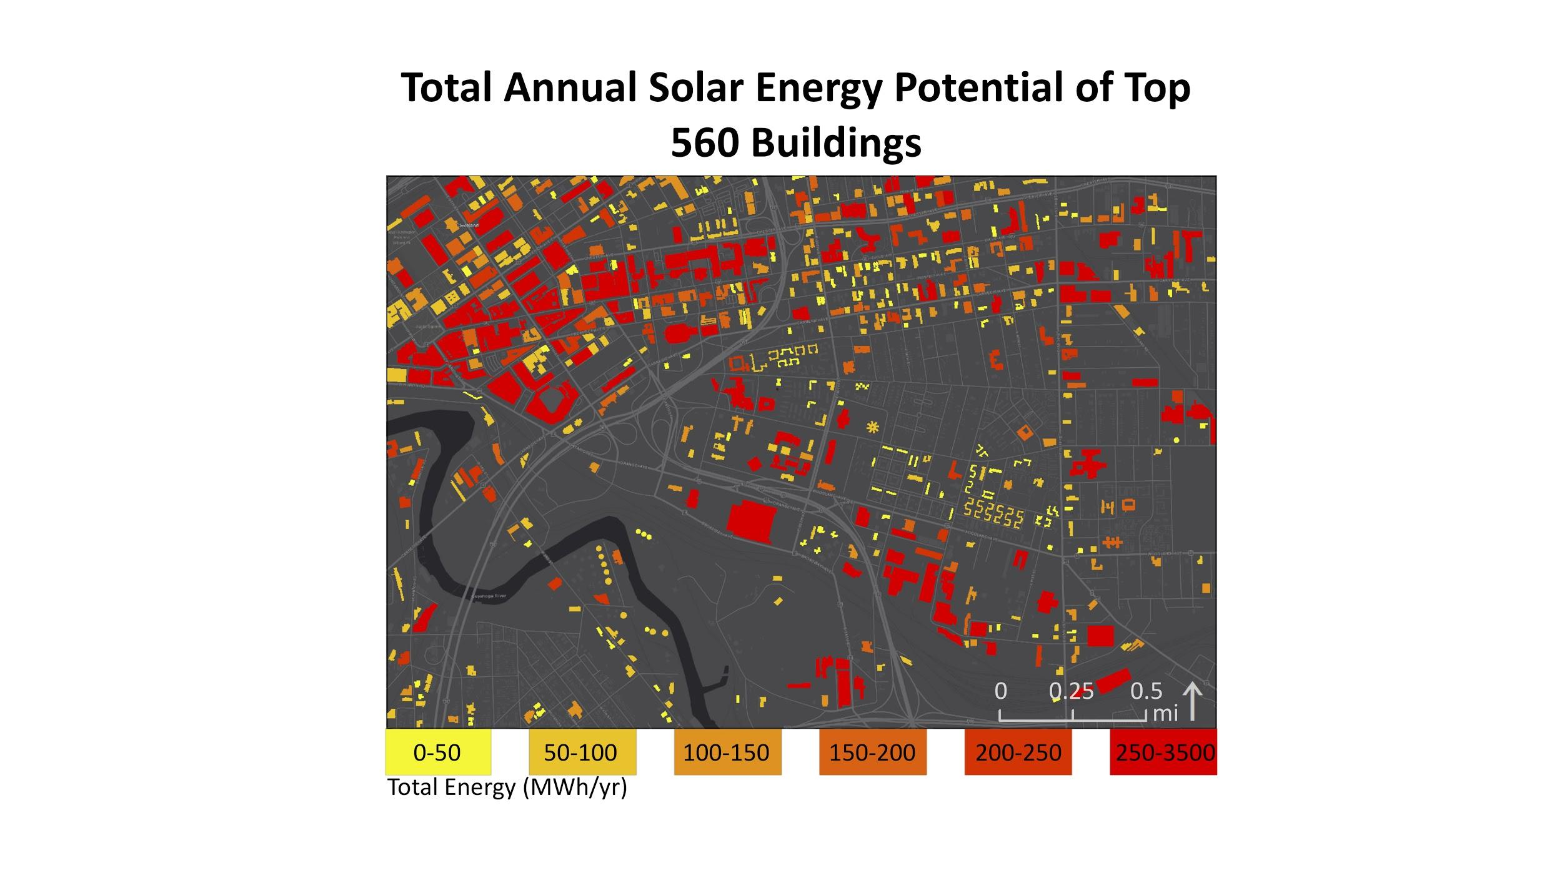(b)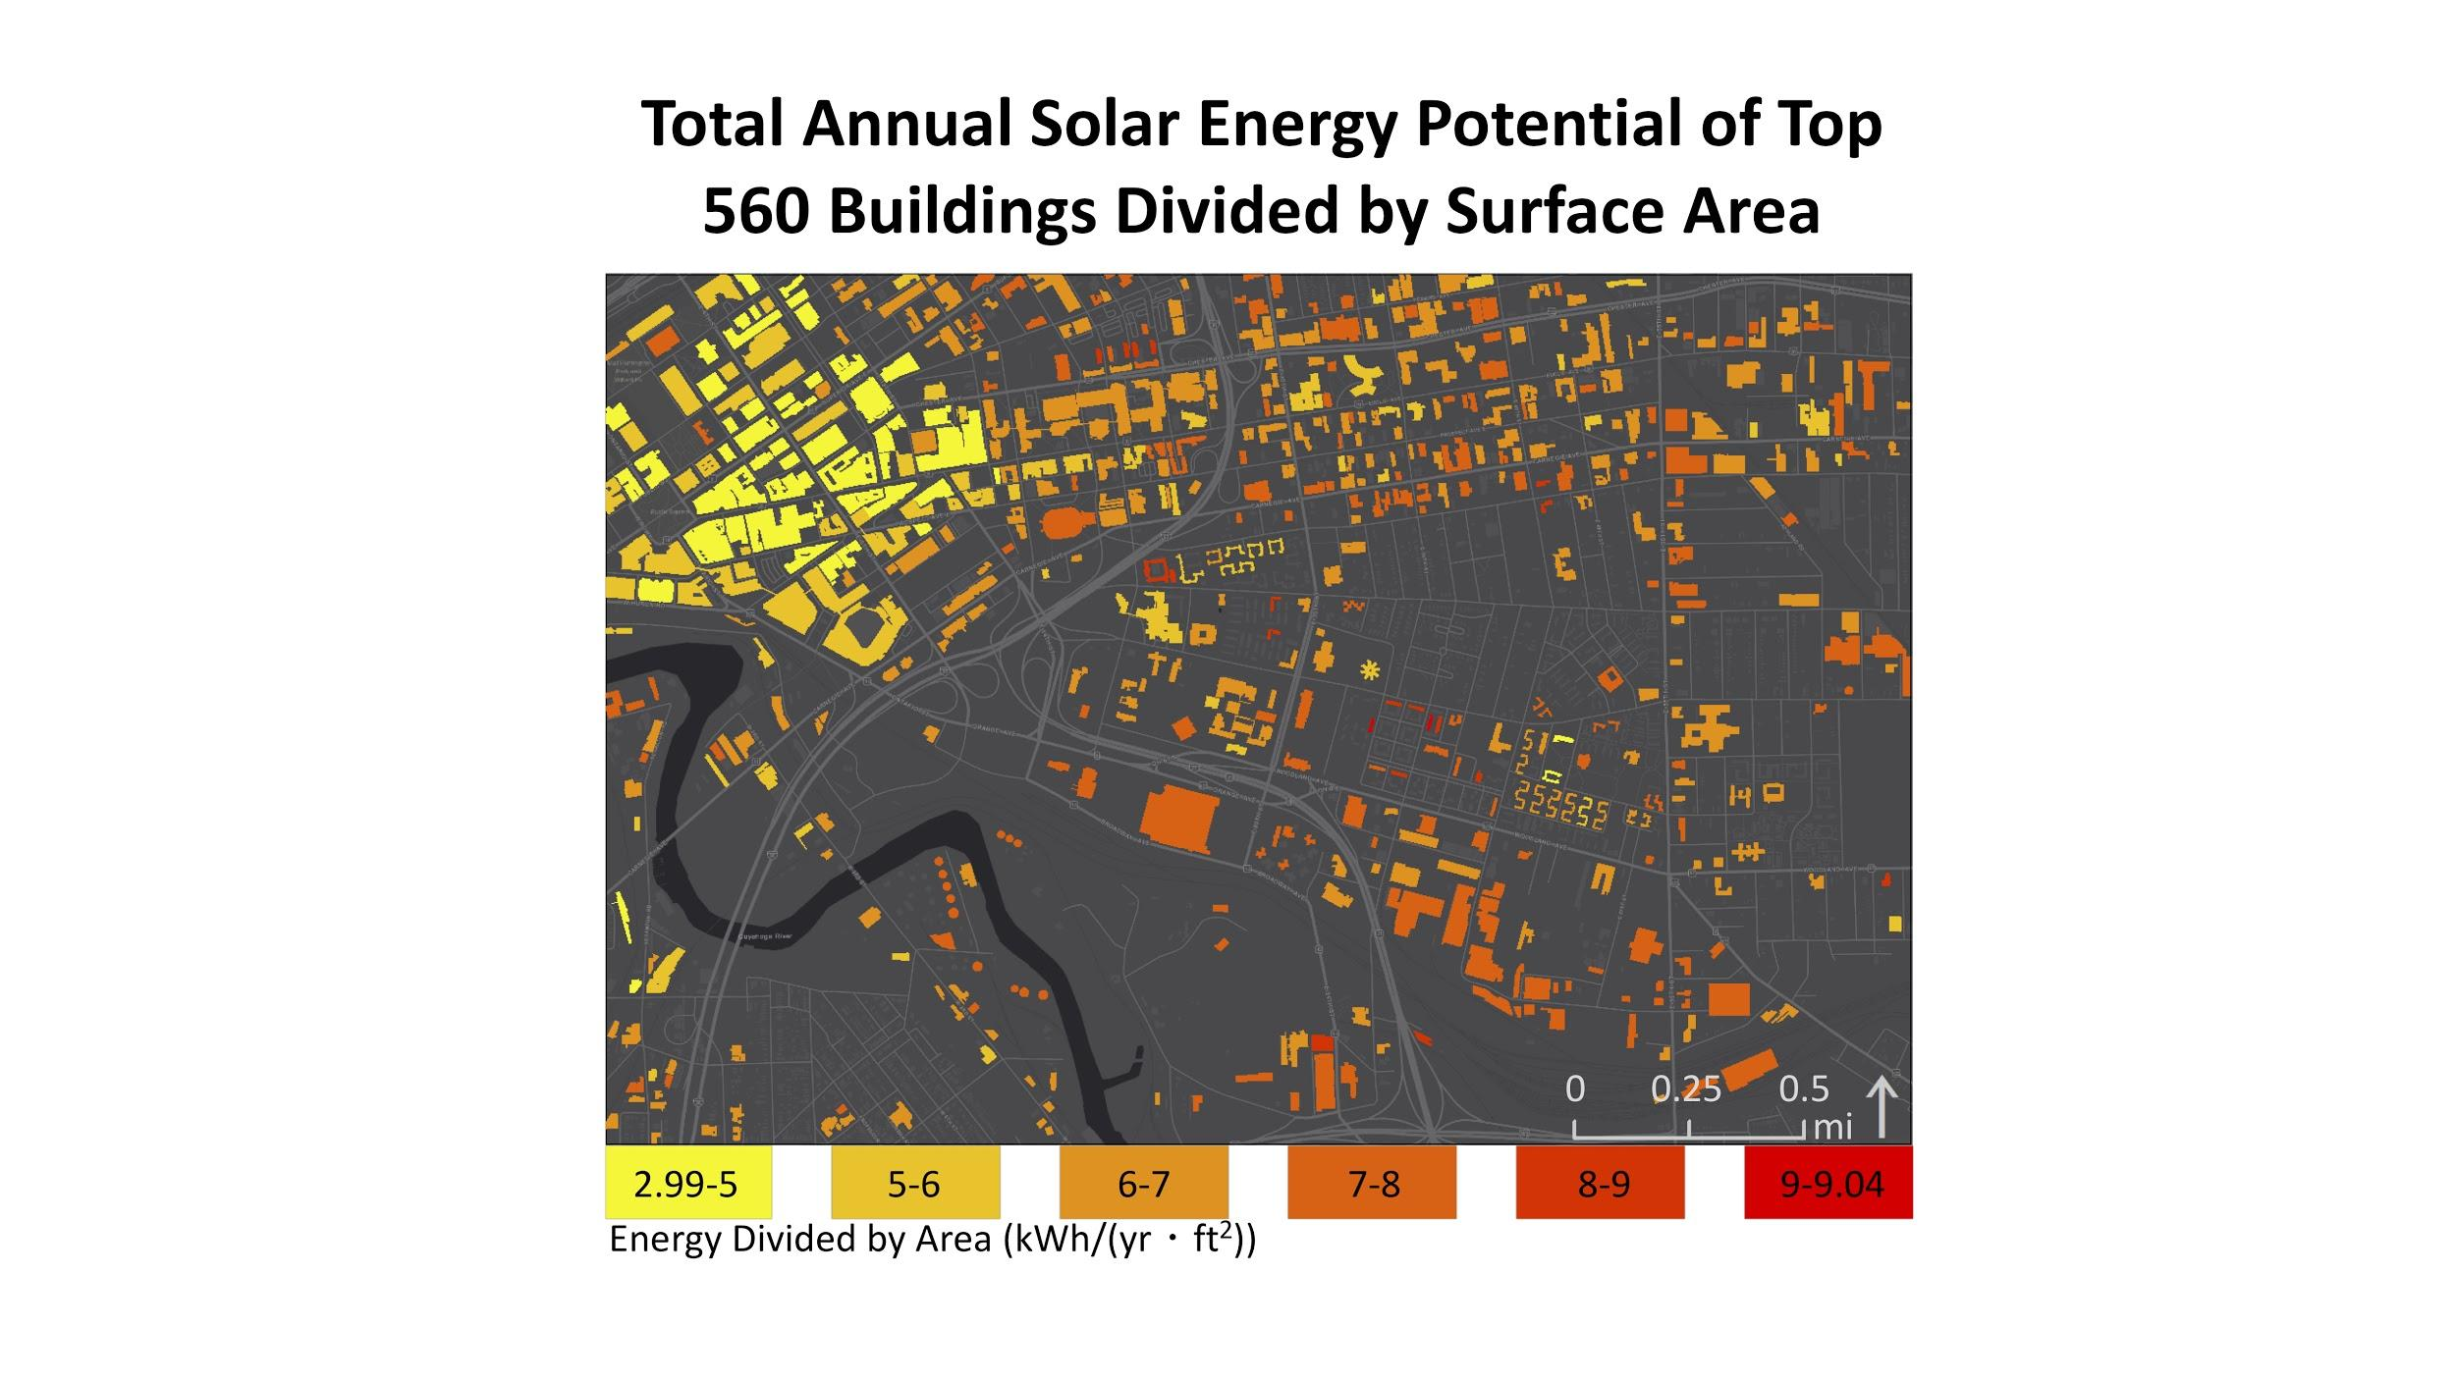

*Figure 7*. (a) Annual solar energy generation potential per building in MWh/yr for the top-producing 560 buildings. (b) Potential energy generation efficiency for each building’s viable roof area in kWhr/(ft2∙yr) for the top-producing 560 buildings, calculated as the total annual solar energy potential divided by the total viable roof surface area.

The highest solar potential was within the industrial (35%), commercial (25%), and institutional (19%) land use types, which we determined was mainly due to building size (Figure 8).

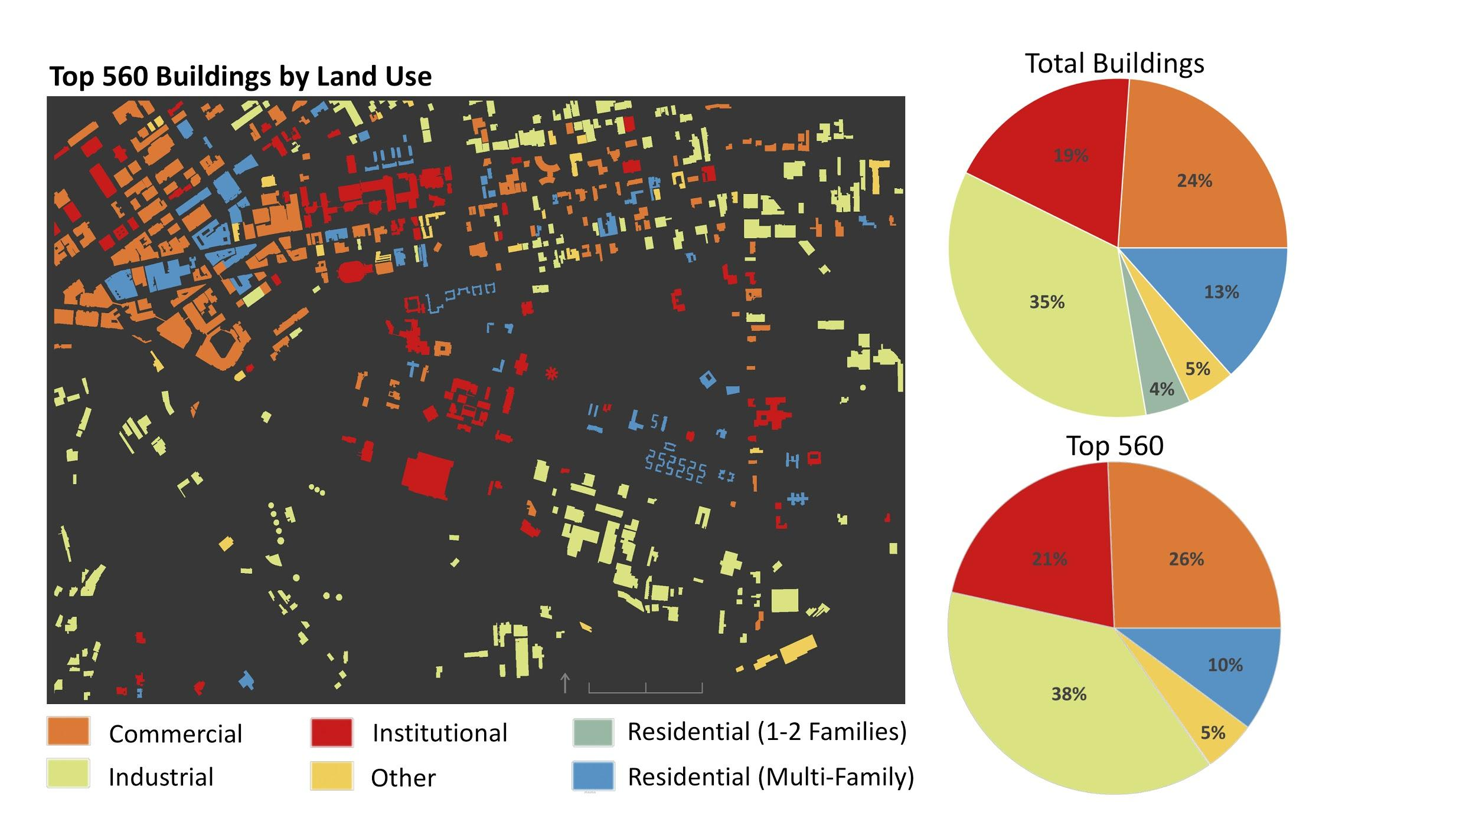

*Figure 8*. The top-producing 560 buildings organized by land use class (left); pie chart of the total potential energy of all viable buildings organized by land use class (top right); pie chart of the total potential energy of the top-producing 560 buildings organized by land use class (bottom right).

A large portion of the study area contained over 17.5% of people under the poverty line (Figure 9). These will be areas of interest for our partners in planning future renewable energy equity initiatives.

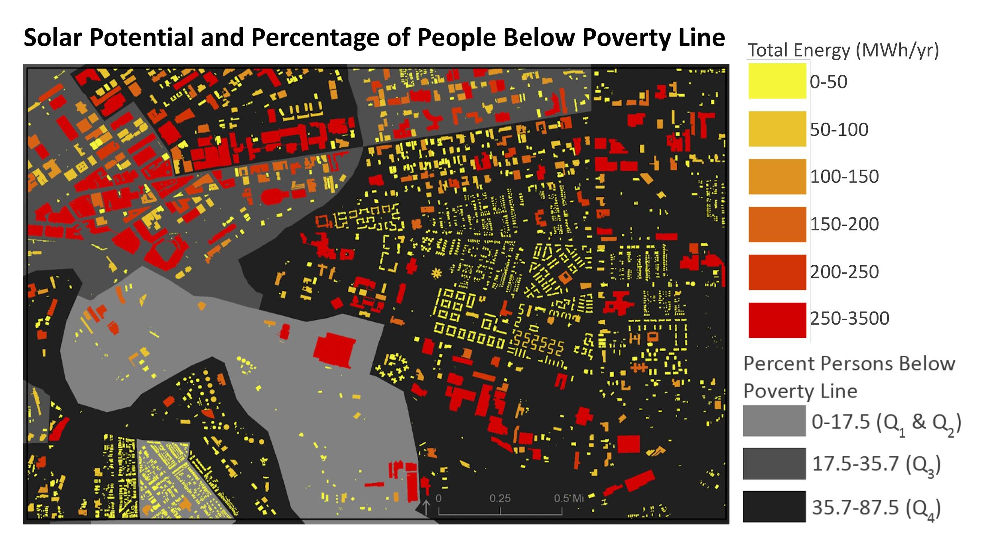

*Figure 9*. Total solar potential of all viable buildings (MWh/yr) and the percentage of people under the poverty line. Parcels were categorized based on quartiles, with the third and fourth quartiles deemed to be of interest for equity initiative outreach by Cuyahoga County.

We were not able to validate our results using local solar panel output data, so as an alternative test of our model, we compared our results to the output of the Esri Area Solar Radiation tool (Figure 10). This tool used similar methods for calculating solar potential, but we included additional factors that describe solar insolation and panel tilt. The majority of our pixel values were lower than the Esri output, in part due to the inclusion of more descriptive NASA POWER solar irradiance data.

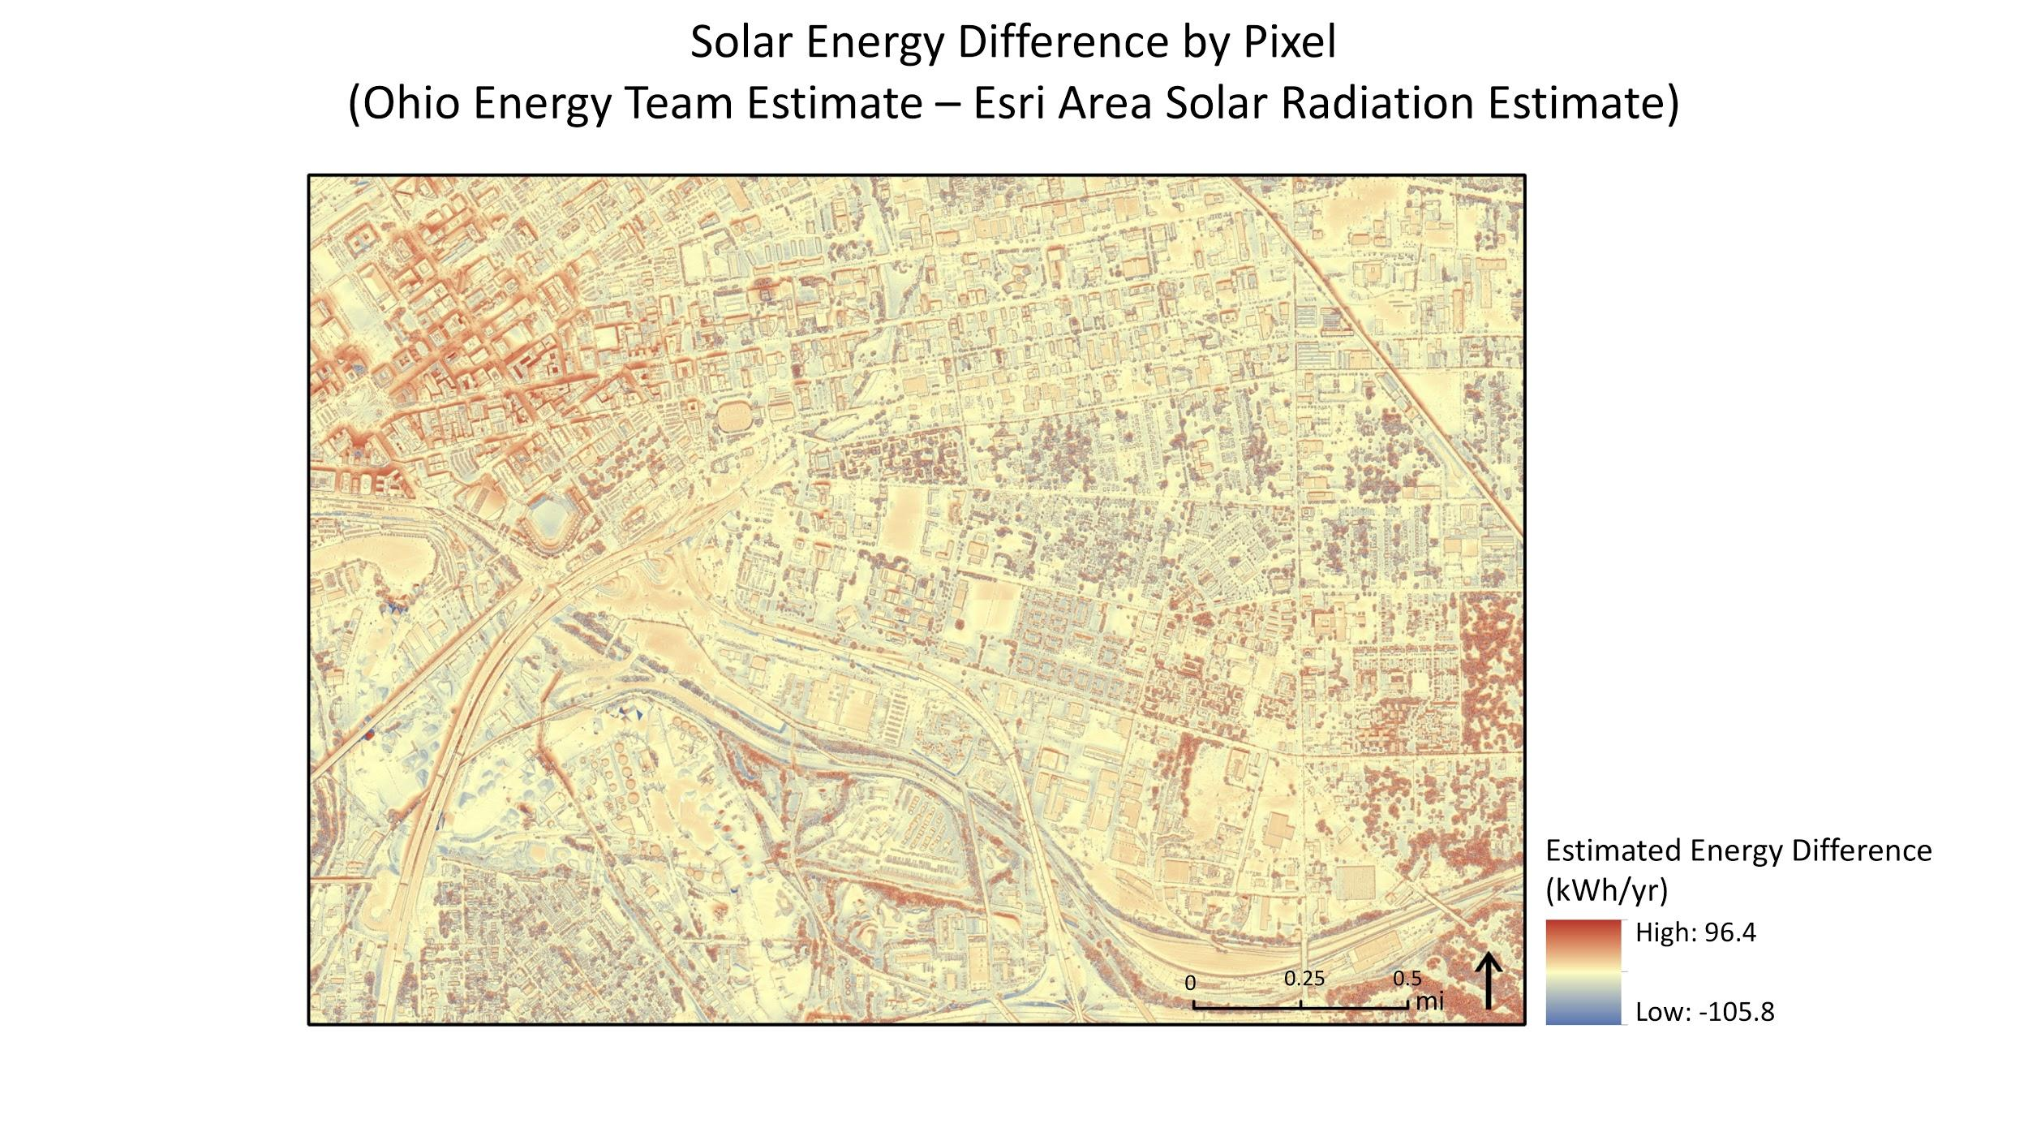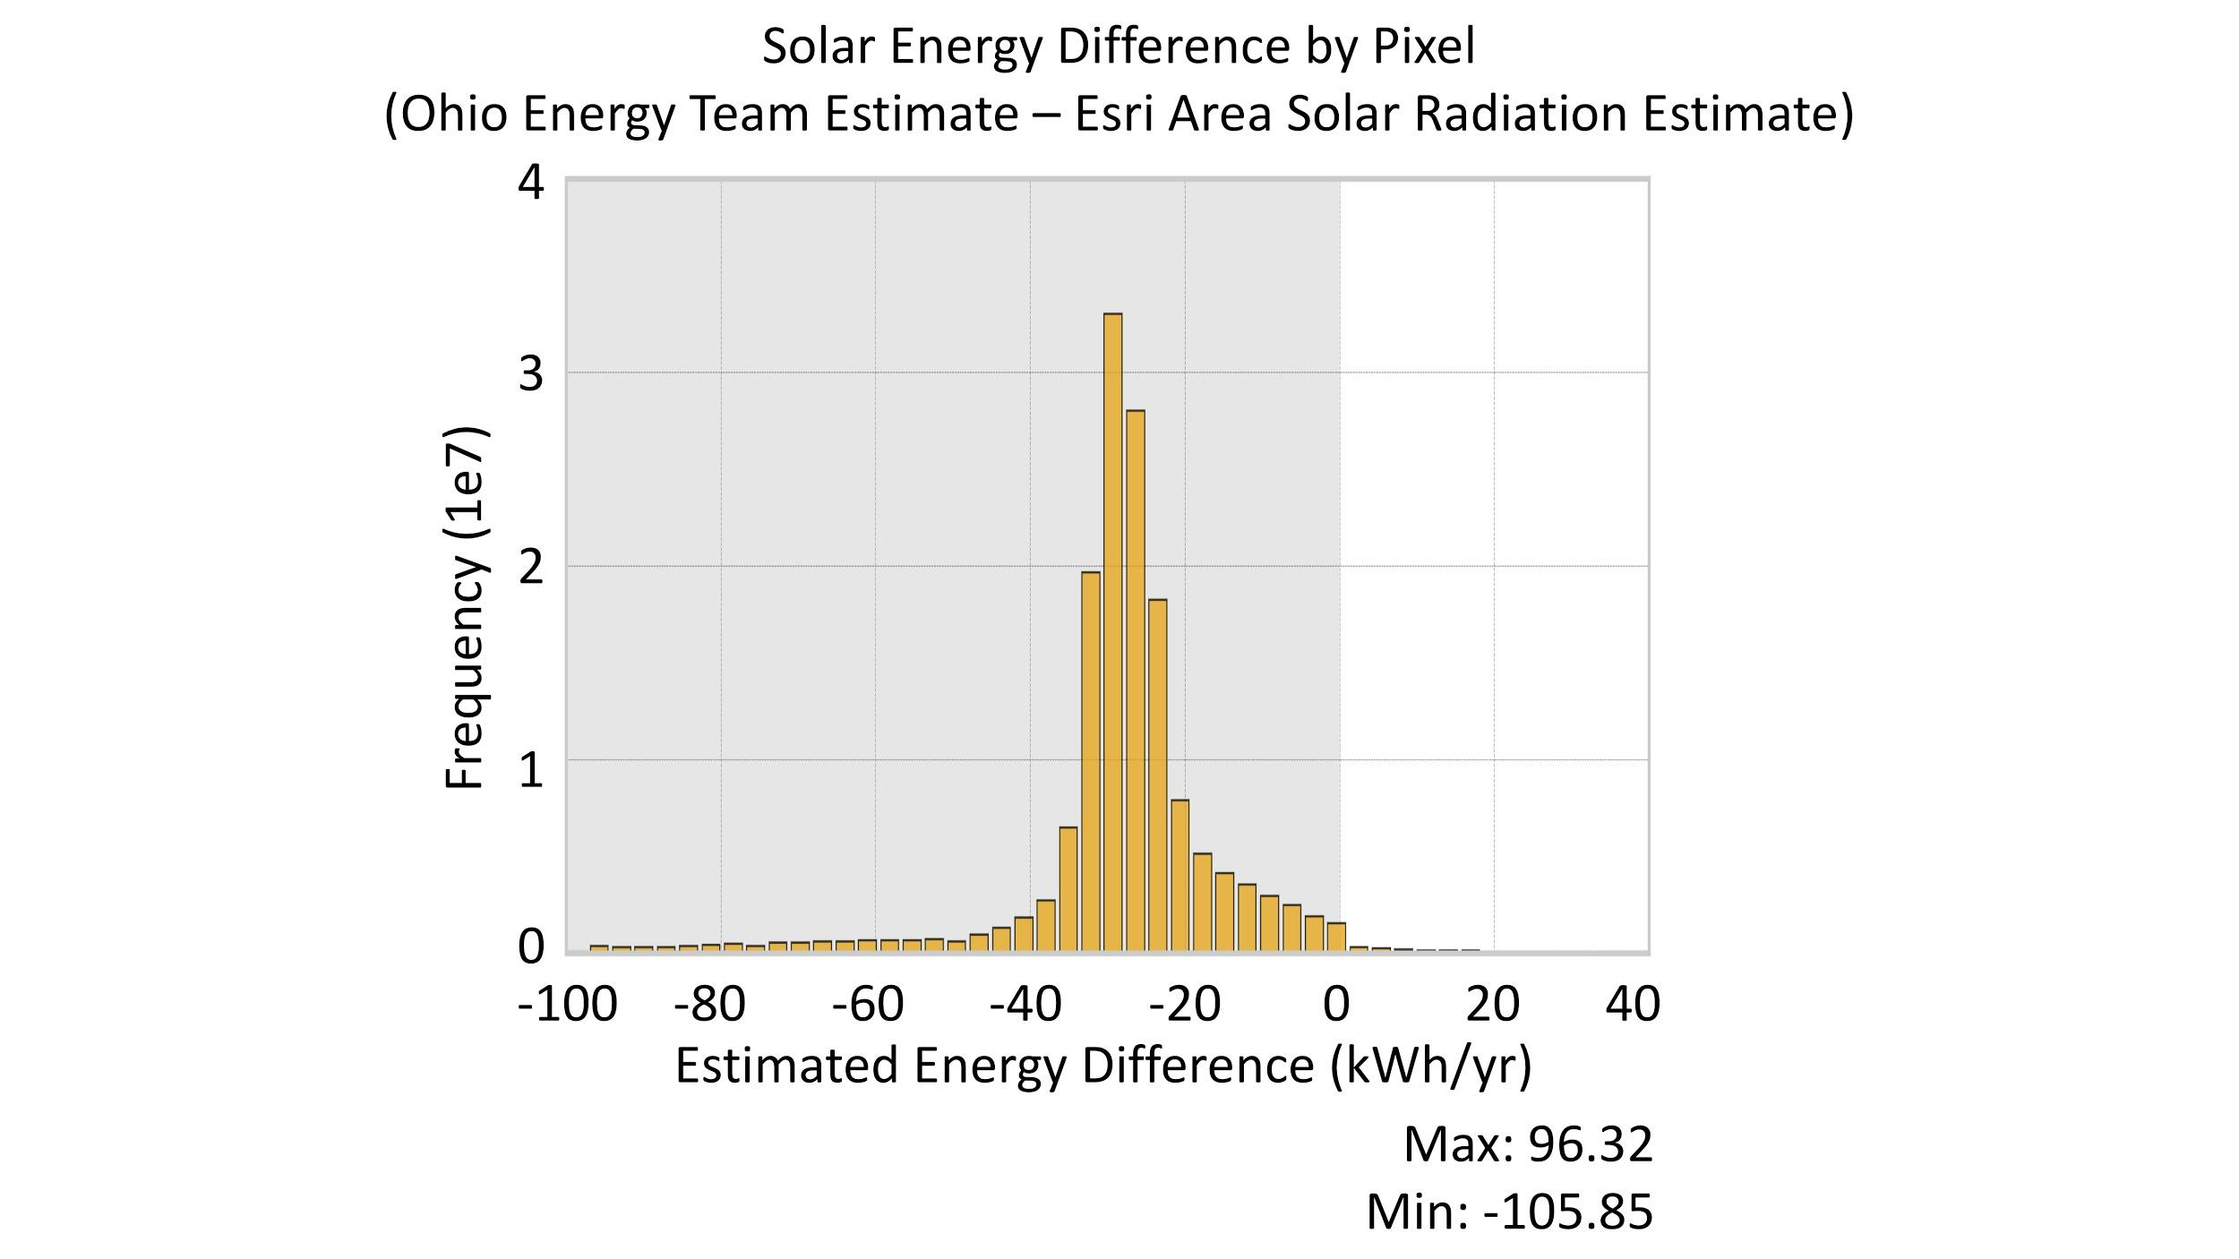

*Figure 10*. Solar energy difference by pixel between our solar energy estimates and those output by the Esri Area Solar Radiation tool. This map (left) is a difference raster of the Esri result subtracted from ours. The frequency histogram (right) shows the distribution of this data.

Since our model provided a large scale analysis, it included sources of uncertainty. First, there were occasional misalignment issues between the building footprint polygons the DSM. A few buildings are present in the building footprint layer that are not included in the DSM, likely due to recent construction. Also, there are temporary objects included within the DSM, such as cars on the roofs of parking structures, that impact our results for viable roof segment selection.

The solar irradiance data included some uncertainties as well. The currently available NASA POWER data assumes that all solar panels are equator-facing, instead of accounting for different orientations. Also, the irradiance data we used in our model was averaged from 1983-2005. It is well vetted, but it may not include recent climatological shifts like changes in typical cloud cover.

***4.2 Future Work***

An accuracy assessment of the model should be performed by our partners with help from local solar power companies. This would compare model results to annual energy output from current solar arrays in the test area. After validation, future efforts related to this study will include a full analysis of the county’s solar potential, carried out by the local sustainability GIS expert.

The partners will analyze the full scale results using a cumulative sum assessment to focus their outreach efforts to the land owners with the most capacity to contribute toward the 100% renewable energy goals for the city and county. The potential energy production for individual buildings could also be compared to current annual energy consumption. In addition, this methodology could be updated to include new NASA POWER data products that are currently being developed, including some that account for the effects of aspect and that utilize current NASA Earth observation data. This will aid in reducing the current model uncertainties.

# 5. Conclusions

Partners from Cuyahoga County and the City of Cleveland will be able to use this method to better target landowners with the highest solar power potential on their properties. This analysis will serve as scientific support for the validity of utilizing solar energy as a renewable energy alternative in the area. Overall, the test area had an estimated technical potential of 111,321,337 kWh/yr if solar panels were installed on all viable rooftop areas. A majority of the potential energy within the test area could be generated by buildings within industrial, commercial, and institutional land use classes. The differences in distribution between total rooftop potential and rooftop area efficiency may be due to a more optimal tilt for solar panels on sloped residential roofs as opposed to a less optimal tilt for panels on larger flat rooftops common to the commercial buildings in the area.

If solar panels were installed on the top-producing 560 buildings within our test area, enough energy would be produced to power 9000 typical houses for a year (“How much electricity,” n.d.). Targeting the owners of these 560 buildings would produce 85% of the total potential solar energy. Additionally, the method we developed during this project will soon be applied to the entirety of the county and will aid in developing an efficient and effective plan for solar energy outreach in Cuyahoga County.

This method has an advantage over online solar calculation tools because it utilizes irradiance data for tilted surfaces from NASA POWER instead of data that assumes all surfaces are flat. Our method also automatically determines the specific sections of a building’s roof that are viable for solar panel installation according to local installation regulations, and measures the total potential energy generation and production efficiency for each roof segment. This avoids overestimations due to the inclusion of all roof areas, which are common in other online solar energy estimation tools. We also included typical installation limitations and solar panel efficiency parameters in our calculations that are overlooked by other alternative tools.

This analysis will provide the county and city with a reliable method for selecting outreach targets, and will be an additional tool to landowners, helping them make informed decisions about the economic viability of investing in solar power technology on their property. Our methodology could also be easily applied to other communities interested in estimating their solar energy potential. For now, the results of this study should act as a significant stepping stone for Cuyahoga County and the City of Cleveland toward their 100% renewable energy goals.

# 6. Acknowledgments

We appreciate the contributions from our partners at Cuyahoga County, Department of Sustainability:

* Mike Foley: Department of Sustainability Director
* Dan Meaney: Cuyahoga County Planning Commission Manager

We would also like to thank our partners from the City of Cleveland, Office of Sustainability:

* Anand Natarajan: Mayor’s Office of Sustainability Energy Manager
* Elizabeth Lehman: Mayor’s Office of Sustainability Energy Analyst

Special thanks to our NASA DEVELOP leadership:

* Dr. Nicholas B. Rajkovich: Science Advisor, University of Buffalo
* Dr. Dave Hondula: Science Advisor, Arizona State University
* Erika Higa: Center Lead
* Megan Seeley: Geoinformatics Fellow, Assistant Center Lead

The following people were extremely helpful in explaining their team’s NASA Prediction of Worldwide Energy Resources solar dataset that was utilized in this research:

* Dr. Paul Stackhouse, Jr.: Senior Research Scientist and Principal Investigator
* Bradley Macpherson: Geospatial and Technology Developer
* Brian Tisdale: Booz-Allen and Hamilton, Inc.

Also, thank you to the solar panel experts from Ohio for their insights on installation practices that allowed us to improve our model:

* Al Frasz: Dovetail Solar and Wind President and YellowLite Commercial Business Manager
* Robert Martens: Better Together Solar President/CEO

These data were obtained from the NASA Langley Research Center (LaRC) POWER Project funded through the NASA Earth Science/Applied Science Program.

Any opinions, findings, and conclusions or recommendations expressed in this material are those of the author(s) and do not necessarily reflect the views of the National Aeronautics and Space Administration.

This material is based upon work supported by NASA through contract NNL16AA05C.

# 7. Glossary

**DSM** – Digital surface model, depicting elevation of LiDAR first returns so it includes building and ground surfaces

**Earth observations** – Satellites and sensors that collect information about the Earth’s physical, chemical, and biological systems over space and time

**Insolation** – The amount of solar radiation received on a given surface in a given time period

**LiDAR** – Light Detection and Ranging, generates a 3-D representation of a surface with laser return time point clouds

**Solar irradiation** – The amount of light energy hitting a given surface area over a set period of time

**Solar radiation** – Radiant energy emitted by the sun from a nuclear fusion reaction that creates electromagnetic energy

# 8. References

Boz, M. B., Calvert, K., & Brownson, J. R. S. (2015). An automated model for rooftop PV systems assessment in ArcGIS using LIDAR. *AIMS Energy 2015, 3*(3), 401-420. <https://doi.org/10.3934/energy.2015.3.401>

Cuyahoga County Planning Commission. (2019). *Cuyahoga County Climate Change Action Plan.* Retrieved June 25, 2019, from <https://www.countyplanning.us/projects/climate-action-plan/>

How much electricity does an American home use? - FAQ - U.S. Energy Information Administration (EIA). (n.d.). Retrieved August 6, 2019, from <https://www.eia.gov/tools/faqs/faq.php?id=97&t=3>

International Code Council. (2017). 2018 International Fire Code. Retrieved August 6, 2019, from

https://codes.iccsafe.org/content/IFC2018

Kabir, E., Kumar, P., Kumar, S., Adelodun, A. A., & Kim, K.-H. (2018). Solar energy: Potential and future

prospects. *Renewable and Sustainable Energy Reviews*, *82*(1), 894-900.

<https://doi.org/10.1016/j.rser.2017.09.094>

Lukač, N., Žlaus, D., Seme, S., Žalik, B., & Štumberger, G. (2013). Rating of roofs’ surfaces regarding their

solar potential and suitability for PV systems, based on LiDAR data. *Applied Energy*, *102*, 803-812.

<https://doi.org/10.1016/j.apenergy.2012.08.042>

Mansouri Kouhestani, F., Byrne, J., Johnson, D., Spencer, L., Hazendonk, P., & Brown, B. (2018). Evaluating solar energy technical and economic potential on rooftops in an urban setting: the city of Lethbridge, Canada. *International Journal of Energy and Environmental Engineering*, *10*(1), 13-32. <https://doi.org/10.1007/s40095-018-0289-1>

NASA Jet Propulsion Laboratory. (2013). *NASA Shuttle Radar Topography Mission Global 1 arc second* [Data set].

NASA EOSDIS Land Processes DAAC. Retrieved June 17, 2019 from https://doi.org/10.5067/MEaSUREs/SRTM/SRTMGL1.003

NASA Langley Research Center. (2018). NASA Langley Research Center (LaRC) POWER Project

funded through the NASA Earth Science/Applied Science Program [Data set]. Retrieved June 17,

2019 from https://power.larc.nasa.gov/data-access-viewer/

Ohio Public Utilities Commission. (2018). How does Ohio generate electricity? Retrieved June 25, 2019 from <https://www.puco.ohio.gov/be-informed/consumer-topics/how-does-ohio-generate-electricity/>

Stackhouse, P. W., Taiping, Z., Westberg, D., Barnett, A. J., Bristow, T., Macpherson, B., & Hoell, J. M. (2018). *POWER Release 8.0.1 (with GIS applications) Methodology.* Retrieved June 27, 2019 from https://power.larc.nasa.gov/documents/POWER_Data_v9_methodology.pdf