**NASA DEVELOP National Program**



California – JPL

*Fall 2017*

Santa Monica Mountains Ecological Forecasting II

Utilizing NASA Earth Observations to Determine Drought Dieback and Insect-related Damage in the Santa Monica Mountains, California

 **Technical Report**

Final Draft – November 17, 2017

Kelsey Foster (Project Lead)

Natalie Queally

Ariana Nickmeyer

Nick Rousseau

Dr. Natasha Stavros, NASA Jet Propulsion Laboratory, California Institute of Technology (Science Advisor)

Previous Contributors:

Emil Chang

# 1. Abstract

The Santa Monica Mountains (SMM) lie between the city of Los Angeles and the San Fernando Valley, California, enduring as a steadfast haven for native vegetation, wildlife, and recreational activities. Both public and private conservation agencies have secured protection for much of the mountain range; however, the severe California drought from 2011-2017 had a major impact on vegetation, including 11,000 acres of oak woodlands. The fall Santa Monica Mountains Ecological Forecasting II project explored how and why vegetation has changed from 2013-2017, a continuation study from the spring term that further investigated the effect of climate, harmful beetles, and varying topography on dieback. The heavy rains of the 2016-2017 winter allowed our team to investigate initial response to post-drought conditions. The team used ER-2 Airborne Visible Infrared Imaging Spectrometer (AVIRIS) imagery, climate data, digital elevation models, and *in situ* beetle and oak data to analyze the extent of vegetation loss over the course of the drought, including which areas will be most vulnerable to drought in the future. The results from these analyses will help the Resource Conservation District of the Santa Monica Mountains determine how to focus efforts towards regaining oak woodland vigor.

**Keywords**

Remote sensing, AVIRIS, oak woodland, drought, Santa Monica Mountains, SRTM

# 2. Introduction

* 1. ***Background Information***

Along a south-facing stretch of the California coast lie the Santa Monica Mountains, home to a beautiful and unique Mediterranean ecosystem featuring the indigenous coast live oak, *Quercus agrifolia*. Accessible and inviting, the mountains allow residents in Los Angeles and the other surrounding urban areas to experience and benefit from the ecosystem services of this habitat, which enhance both physical and mental wellbeing. The area is ecologically complex, hosts hundreds of vertebrate species, and contains many of the important California plant assemblages that contribute to the state’s designation as a global biodiversity hotspot (Tiszler & Rundel, 2007; Myers, Mittermeier, Mittermeier, da Fonseca, & Kent, 1999). Oak woodlands in particular have been recognized as providing considerable benefits to their home environment, including carbon sequestration, slope stability, flood control, temperature moderation, and aesthetic value. In 1982, Los Angeles County was among the first in the state to take action towards protecting the oaks, with the Oak Tree Ordinance that declared oak trees as “significant and valuable historical, aesthetic, and ecological resources” (Dagit, Carlberg, Cuba & Scott, 2014). In 2001, recognition of the importance of these trees and their increasing vulnerability to human removal resulted in the Oak Woodlands Conservation Act, which identified oak woodlands as a significant resource throughout the state.

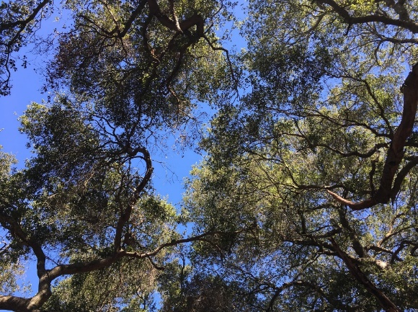

*Figure 1.* Oak canopy at Trippet Ranch in Topanga State Park in the SMM (September 2017). If the oaks were healthy, the sky would not be visible through their canopy. Image credit: Ariana Nickmeyer.

Oaks are hardy trees that are adapted for surviving years of decreased rainfall and periodic drought stress, but the recent drought from 2011-2017 was unusual in its severity and duration, and took a heavy toll on the oak woodlands. Years of low rainfall and extended drought are not uncommon in the Santa Monica Mountains, but the increased severity of precipitation fluctuations due to an increasingly variable climate have taken a toll on the vegetation (Tiszler & Rundel, 2007). In addition to inflicting physical stress on the trees, the drought may have left the trees more susceptible to damage from harmful beetles, such as the invasive Polyphagous Shot Hole Borer (*Euwallacea sp.*) and the native Western oak bark beetle (*Pseudopityopthorus pubipennis*) (Eskalen et al., 2013; Staggs, 2014). Drought dieback in the Santa Monica Mountains National Recreation Area (SMMNRA) has thus been widespread and unrelenting, heightening concern about the future of the oak woodlands and calling different perspectives into action to decide the best approach for preserving them.

This project builds upon the work of the spring 2017 team, which used ER-2 Airborne Visible Infrared Imaging Spectrometer (AVIRIS) data to map plant mortality in an effort to understand dieback patterns. The project’s study region encompasses the Santa Monica Mountains and the Simi Hills, which lie in the northern part of the study area boundary and contain oak woodlands (Figure 2). The time period of the study is from 2013-2017, which covers only a part of the drought due to data availability. This term will allow the team to continue the previous analysis with the addition of data from 2017, which saw heavy winter rains and ended the drought. Over this time interval, climatic variables such as temperature and precipitation were obtained for every month of the year, while aerial imagery of the vegetation itself was obtained for only May or June of each year.

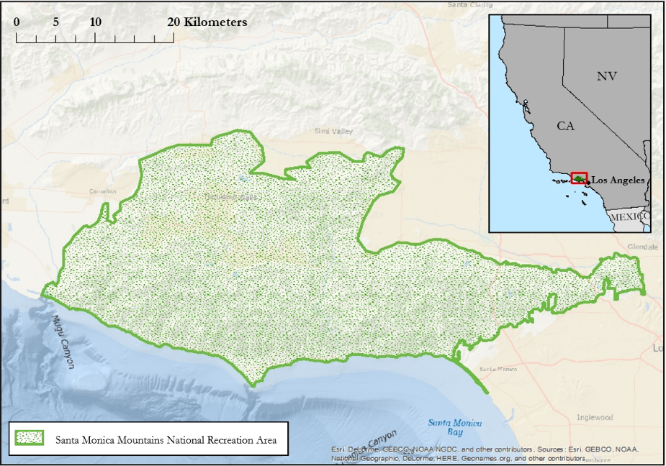

*Figure 2.* Project study area, encompassing the Santa Monica Mountains and Simi Hills.

***Project Partners & Objectives***

This project’s partners were the Resource Conservation District of the Santa Monica Mountains (RCDSMM); the National Parks Service, Santa Monica Mountains National Recreation Area; California Department of Parks and Recreation, Los Angeles District; California Department of Forestry and Fire Protection (CAL FIRE); County of Los Angeles Fire Department, Prevention Services Bureau, Forestry Division; and the University of California, UC Cooperative Extension.

Our primary partner, the RCDSMM, is dedicated to environmental stewardship and conservation. Through research, habitat restoration and conservation planning, the RCDSMM works to preserve native habitats and prevent the spread of invasive species. Currently, the RCDSMM is collecting data about the impact that drought and pest infestation are having on oak woodlands using survey plots and citizen science programs. While these methods allow for an in-depth understanding of oak conditions from the ground, the survey plots cover a relatively small area of the Santa Monica Mountains. The development of a large scale overview of oak woodland conditions will aid land managers in identifying high-risk areas of infestation, tree mortality, or increased wildfire risk. This will ultimately assist land managers in prioritizing areas of concern to focus scarce resources for monitoring oak health, and allow for better outreach and targeted education.

The objectives of this project were to determine how much green vegetation has been lost in the SMMNRA over the span of the drought, to analyze the role of physical constraints and harmful beetles on dieback, and to determine areas that are especially likely to suffer from future drought. This final objective is intrinsically linked to the results of the first two, and places the project within the NASA national application area of ecological forecasting, as the future state of the oak woodlands is investigated.

# 3. Methodology

***3.1 Data Acquisition***

In order to study land cover, the team downloaded AVIRIS level 2 surface reflectance data products from the AVIRIS data portal. The team downloaded all flight lines that covered the study area in May of 2013, a time that was chosen to maintain consistency with work done during the first term of this project. Surface reflectance data was necessary in order to perform species mapping using spectral reflectance. To relate species to plant mortality, AVIRIS-derived relative fraction of alive cover (RFAL) data were obtained from the spring 2017 Santa Monica Mountains Ecological Forecasting I team. The team also downloaded National Agriculture Imagery Program (NAIP) orthoimagery in order to visually confirm land cover types

The team decided on a set of climate variables to download based on data options, advice and interest from project partners, and inspiration from a similar study of drought-induced die-off in pine trees (Clifford et al, 2013). Ultimately, the team downloaded daily values of precipitation, minimum temperature, maximum temperature, and minimum vapor pressure deficit (VPD) from the Parameter-elevation Regression on Independent Slopes Model (PRISM) climate group’s data portal. These data were acquired for 2012-2017 to accommodate the study period and the early start of the water year.

To account for topography, the team downloaded a digital elevation model (DEM) from the Shuttle Radar Topography Mission (SRTM) using USGS EarthExplorer.

The team acquired high resolution LiDAR data of the SMM from the Los Angeles Region Imagery Consortium (LAIAC), Internal Services Department. These data consist of 1,211 LAS datasets in their native format acquired in January 2016. Each LAS file contains binned cells of 1 m X 1 m resolution point cloud. The dataset excludes a western portion of the SMM in Ventura County, yet includes all of the SMMNRA. The products created from LiDAR to derive a suitable fire danger map include a digital elevation model (DEM), digital surface model (DSM), canopy height model (CHM) and canopy density. Our aim was to investigate the use of LiDAR in this project, and to determine if fire danger maps could be derived.

Finally, the team received several datasets from project partners that helped with species mapping and testing thresholds of plant mortality. The RCDSMM provided the team with oak health plot data and harmful beetle trap data. The National Park Service (NPS) shared a detailed vegetation map, fire history polygons, and a delineation of the study area and distinct ecological zones within the area.

***3.2 Data Processing***

Slope and aspect maps were derived from the DEM using the straightforward slope and aspect tools in ArcMap. In order to understand broader aspect trends that were difficult to see at 30m resolution on a landscape scale, a triangular irregular network (TIN) was created. The TIN shows surface morphology, and captures features like ridgelines and streams. The team used the TIN, which was in vector data format, to create separate files for each aspect.

*PRISM preprocessing*

To generate annual rasters for the climate variables, the team completed several stages of preprocessing on PRISM data. For all variables, each raster was clipped to the study area extent and projected to UTM zone 11N - WGS 84 to match the projection of AVIRIS data. To generate annual precipitation rasters, the daily precipitation rasters were organized by water year, which runs from October 1st of one year to September 30th of the following year (U.S. Geological Survey, 2016). To calculate annual cumulative precipitation, the rasters were added together for each water year to find the cumulative precipitation value for each pixel. To calculate the number of days of precipitation, a threshold for the precipitation amount that would count as a precipitation day was set at 0.1 inch or greater, based on NOAA data (National Oceanic and Atmospheric Administration, 2017). Each daily precipitation raster was reclassified so that every pixel with precipitation ≥ 0.1 inch became 1 and all else became 0. The reclassified daily precipitation rasters were added together, resulting in one raster per water year containing the number of precipitation days per pixel. To generate annual temperature rasters, the daily minimum and daily maximum temperature data were organized by year. To calculate annual minimum temperature, the daily minimum temperature rasters were added together and averaged. To calculate days of extreme heat, defined as 95°F or above (Lin, 2016), the daily maximum temperature rasters were reclassified in a similar way to the precipitation days. Pixels ≥ 95°F were assigned a value of 1 and all other pixels were given a value of 0. These rasters were added together, which created a map of extreme heats days by pixel. Finally, to generate annual VPD, the daily minimum VPD rasters were organized by year, added together, and averaged.

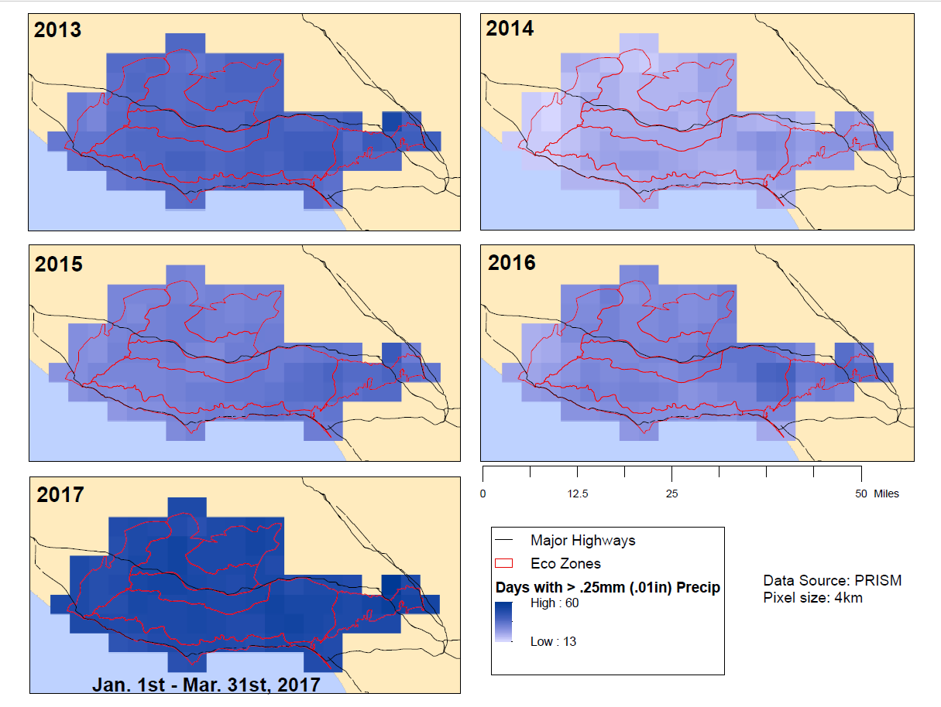

*Figure 3.* Sum of the number of precipitation days occurring in each PRISM pixel over the course of one water year (Oct 1st – Sep 30th).

*Species Mapping*

The team used the AVIRIS data and Viper Tools, an ENVI package created by the Viper Lab at University of California, Santa Barbara (Roberts, Alonzo, Wetherley, Dudley, & Dennison, 2007), to create a species map of the study area. Viper tools streamlines the process of Multiple Endmember Spectral Mixing Analysis (MESMA), a method of spectral unmixing that uses endmembers, or pure representations of a spectral class, to classify an image. MESMA has been used successfully to map vegetation species with high accuracy (Roberts et al., 1998). The first step was creating a spectral library, which would serve as training data for the classification of the AVIRIS image.

To create a spectral library, the team consulted with project partners to determine which vegetation classes to target. The team ultimately chose to target the following species: annual grass, *Ceanothus megacarpus*, *Ceanothus spinosus*, chaparral--common species (*Adenostoma fasciculatum, Cercocarpus betuloides, Quercus berberidifolia*), coastal sage scrub--drought deciduous (*Artemisia spp., Eriogonum fasciculatum, Salvia spp.*), coastal sage scrub--summer active (*Eriogonum cinereum*), *Malosma laurina*, Coast live oak woodland (*Quercus agrifolia*), and Riparian (*Alnus rhombifolia, Juglans californica, Platanus racemosa, Salix spp.)*. The team added classes for substrate and water to prevent other classes from being erroneously classified in these areas. The team used the highly detailed vegetation map provided by the project partners and the very high spatial resolution (1m) NAIP orthoimagery to define a minimum of 10 polygons per class that contained pure representations of each class. We then overlaid the AVIRIS imagery and created points for each AVIRIS pixel that fell completely within a polygon. Using Viper Tools, these points were imported into ENVI. The spectrum at each point was extracted from the AVIRIS imagery and compiled in a spectral library. The full spectral library consisted of 2,698 spectra.

To increase computational efficiency and choose the best endmembers for each class, the team used endmember average root mean square error (EAR). EAR uses MESMA to calculate average error of a spectra being modeled by other members of its class. The lowest EAR spectra are the best representatives of the class (Dennison & Roberts, 2003). After calculating EAR for each spectra, the 20 lowest EAR in each class were chosen for the spectral library. From within this library, certain spectra were manually deleted based on previous familiarity with what spectral outliers for the class may look like. After manual deletion, stratified random sampling was used to assign half of the spectra from each class to the final library for training data, and the other half as validation data. The validation data consisted of the original points from which the spectra were derived.

Using the final spectral library, the team used MESMA to classify the four flight lines that covered the study area. MESMA models the image based on the given library and an additional “shade” endmember, which represents 0% reflectance, and outputs a fractional value of cover of a given class. There are several adjustable preferences and constraints, including the number of desired endmembers for the model, and fractional, RMSE, and residual constraints. The team ran MESMA with 2-endmember models only, which means each pixel was modeled with one of our defined classes and shade, to maintain computational efficiency. Fractional constraints were limited from 0 to 1, and RMSE and residuals maxima were raised to 0.15 to ensure a large portion of the image would be classified. In future work, lower RMSE and residuals constraints should be tested.

*Figure 4*. This graph shows the final spectral library used to classify the AVIRIS images by species, where ceameg is *Ceanothus megacarpus*, ceaspi is *Ceanothus spinosus*, c_ss_dd is coastal sage scrub—drought deciduous, c_ss_s is coastal sage scrub—summer active, and mallau is *Malosma laurina*.

*Dieback Threshold*

To determine the RFAL value under which vegetation would be considered dead, the team compared its partner’s field data with its own RFAL data. RFAL is a metric that was calculated by the spring 2017 Santa Monica Mountains Ecological Forecasting I project that determines the relative amount of alive vegetation in each AVIRIS pixel. Our partners provided center coordinates for 2016 oak tree field plots and the field plot size (25m by 25m). This information was used to create a shapefile of all the field plot locations using the buffer and minimum bounding geometry tools in ArcMap. Upon visual inspection of the 2016 RFAL imagery overlaid with the 2016 field plots and 2016 NAIP imagery, it was determined that the RFAL imagery was not properly registered (Figure A). Due to the misalignment, 2016 AVIRIS imagery, which was used to calculate RFAL, was co-registered to NAIP imagery using the image registration workflow in ENVI. The image registration workflow geometrically aligns two images by using tie points, so that pixels in each image correspond to the same objects (Jin, n.d.). NAIP imagery was used as the reference image and was resampled in ArcMap to 10m so that the spatial resolution of NAIP was similar to AVIRIS, which has 15.6m spatial resolution. This resampling was done because ENVI’s automatic tie point generation performs better when both images have similar spatial resolution (Jin, n.d.). The results of image registration were previewed to ensure that objects in both images aligned, and were then exported with an output pixel size equal to AVIRIS imagery. Using the methods from the Santa Monica Mountains Ecological Forecasting I project, MESMA was run on the co-registered 2016 AVIRIS imagery to classify the images into substrate, non-photosynthetic vegetation, and green vegetation and to calculate RFAL (1).

$\text{RFAL =}\frac{\text{green vegetation}}{\text{green vegetation + nonphotosynthetic vegetation}}$ (1)

***3.3 Data Analysis***

*Species Map Accuracy*

To assess the accuracy of the species map, each validation point was viewed to see if it coincided with the correct classification. The team created a confusion matrix to view overall, producer’s, and user’s accuracies, as well as Cohen’s kappa coefficient. Overall accuracy is computed by dividing the total number of agreements by the total number of reference points. While overall accuracy describes the average accuracy of the classification, it leaves out the details of the individual classes and does not acknowledge that error is not distributed evenly amongst them. Producer’s and user’s accuracies provide information on the performance of the classification according to each land cover type. A high producer’s accuracy, which is computed by dividing the number of class agreements by the total number of reference points in that class, shows that the reference points are consistently classified as the correct cover type. A high user’s accuracy, which is computed by dividing the number of class agreements by the total number of classified pixels for that land cover type, means that the classification corresponds well to the actual cover on the ground. The final statistic, Cohen’s kappa coefficient, quantifies how much better the classification is than if it were left to random chance. Kappa is computed as follows:

$\text{K =}\frac{\text{observed accuracy - chance agreement}}{\text{1 - chance agreement}}$ (2)

By incorporating the probabilities of random agreements, kappa adds insight to the accuracy assessment that is not provided by the other accuracy indicators. Kappa can be expressed as the percent by which the classification performed better than if left to chance.

*Dieback Threshold*

The team was provided with oak tree field plot locations containing the condition of each plot in 2016 by the RCD. The condition of each field plot represents the percentage of dead leaves, as determined from a visual estimate of canopy cover. A field plot condition of 1 represents 0% brown or missing leaves and a field plot condition of 4 represents 75% brown or missing leaves. In order to understand the condition metric, we created a field fraction alive metric that was plotted against the field condition (Equation 3). The extract by mask tool in ArcMap was then used to extract the 2016 RFAL pixel values whose center fell within the perimeter of a field plot. The RFAL pixel values were then averaged to find the mean RFAL value for each field plot. The RFAL values were plotted against field condition, and a trendline with the highest R2 value was fitted to the plot. The equation of the trendline was used to calculate the RFAL value that corresponded with a field plot condition of3.2 or 55% dead, which the RCD identifies as declining tree health.

$\text{field fraction alive =}\left(\frac{\text{\# alive trees}}{\text{\# trees}}\right)\left(\text{adjusted canopy \%}\right)+ \left(\text{\% live understory}\right)\text{(adjusted live understory)}$ (3)

*Climate Variable Regressions*

The RFAL value that corresponded with a field plot condition of 3.2 was used as the dieback threshold. The con tool in ArcMap was used to subset RFAL rasters into an alive vegetation raster (RFAL values > dieback threshold) and a dead vegetation raster (RFAL values <= dieback threshold). The extract by mask tool in ArcMap was used to extract dead and alive pixels for each vegetation type and the reclassify tool was used to reclassify the dead and alive pixels to a value of 1. This process was repeated for each vegetation type in each year. Once each vegetation class was split into dead and alive rasters for each year and reclassified, an R script was run to extract the data necessary to run regressions. The R script counted the number of dead and alive 15.6m pixels of a vegetation type that fell within a 4km PRISM pixel. The count of dead and alive pixels was used to calculate the percent vegetation type alive for a single PRISM pixel (Equation 4).

$\text{\% vegetation type alive =}\frac{\text{\# alive pixels}}{\text{\# dead pixels + \# alive pixels}}$ (4)

The PRISM pixel value, which corresponds to a climate variable value (e.g. minimum temperature), was extracted and written to a table for every pixel within the PRISM climate variable raster. The percent vegetation type alive within a 4 km PRISM pixel was also written to a table. This was repeated for every vegetation type and PRISM climate variable raster for each year. The percent vegetation type alive was plotted against a climate variable and fitted with a trendline that had the highest R2 value (Figure 8).

*Topographic Effects*

The team prepared elevation, slope, and aspect rasters in order to assess topographic effect on vegetation dieback. However, due to time constraints the team was only able to assess the role of aspect on dieback for oak woodland, *Ceanothus megacarpus*, and chaparral-common. Oak woodland and *C. megacarpus* were chosen due to expressed interest from the project partners. Chaparral-common was also chosen because it had significantly higher classification accuracies than *C. megacarpus* and represents similar species*.* To find how aspect affected these species, the team used the dead and alive species rasters created for the climate variable regressions, along with the separate aspect files created from the TIN. Using the aspect files, the team extracted the number of dead pixels per aspect class per species class, then the number of alive pixels. The team was able to assess how aspect affected the fraction of dead vegetation per species class with the following for the years 2013-2016:

$\text{fraction dead pixels =}\frac{\text{\# dead pixels}}{\text{\# dead pixels + \# alive pixels}}$ (5)

*LiDAR*

The team derived a DEM and a DSM using the LAS dataset to raster tool which processes all the data points in a raster surface. The interpolation requires that ground points are classified for a DEM and return points for DSM. Through raster calculator, the team calculated a canopy height model (CHM) by subtracting the bare Earth surface DEM with first return surface DSM (6). Due to the file size of each LAS dataset, the team chose a single dataset within Trippet Ranch (Figure 5).

$\text{CHM = DSM - DEM}$ (6)

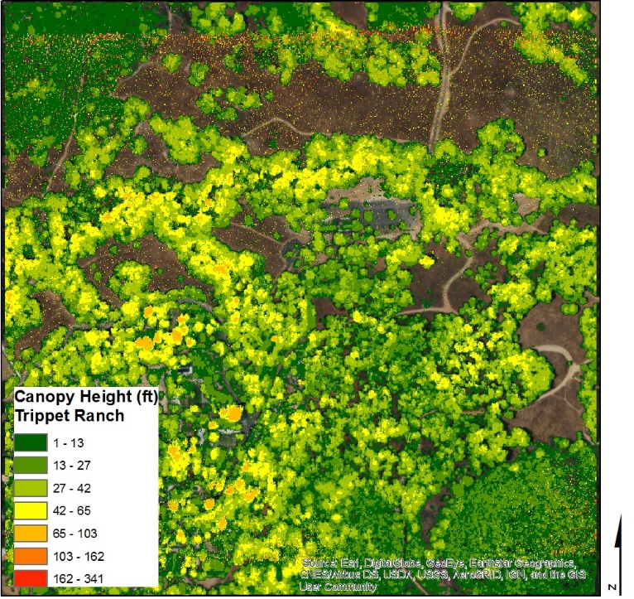

*Figure 5.* Canopy Height Model (CHM) depicting Forest height in Trippet Ranch.

Canopy density was computed using the LAS point statistics as raster geoprocessing tool. Estimating forest canopy density was based on dividing the LAS datasets of the SMM into many smaller, equally-sized units through rasterization. The raster cell was then compared to the aboveground points with the total number of points. This method provides a point-count using the cell size (1m) to convert the study area into small equal-sized units during rasterization. Together, the number of aboveground points can be compared with the total number of points in each raster cell to generate vegetation density.

In order to derive relative fraction dead vegetation cover for the entire study area, the team subtracted RFAL from one. Fire danger was then computer by multiplying canopy density by relative fraction dead (1 – RFAL) (Equation 7).

$\text{Fire Danger = Canopy Density * (1 - RFAL)}$ (7)

# 4. Results & Discussion

*Figure 8.* This shows the negative relationship between the field fraction alive and the field condition. As the field fraction alive declines, the field plot condition worsen. The R2 is 0.1286 and the linear trend line equation is y = -0.04x + 0.4963.

*Figure 9.* This shows the positive relationship between RFAL and field plot percentage alive. The R2 is 0.0251 and the linear trend line equation is y = 0.0016x + 0.4711. Our partner’s told us that 45% field plot percentage alive is where oaks show signs of declining health and this corresponds with a RFAL value of 0.5431.

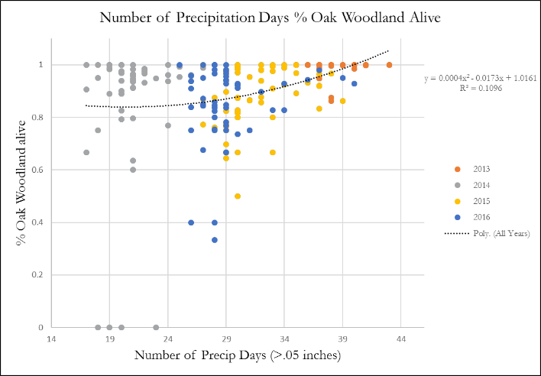 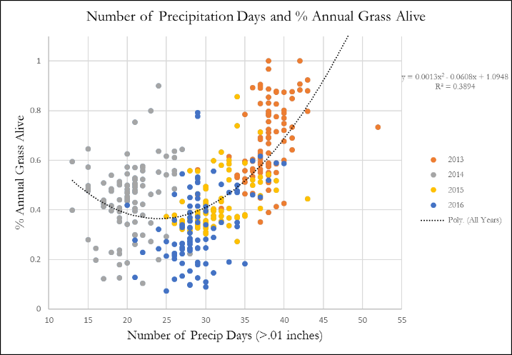

*Figure 10.* Percent oak woodland and annual grassland alive plotted against the PRISM variable of number of precipitation days per water year.

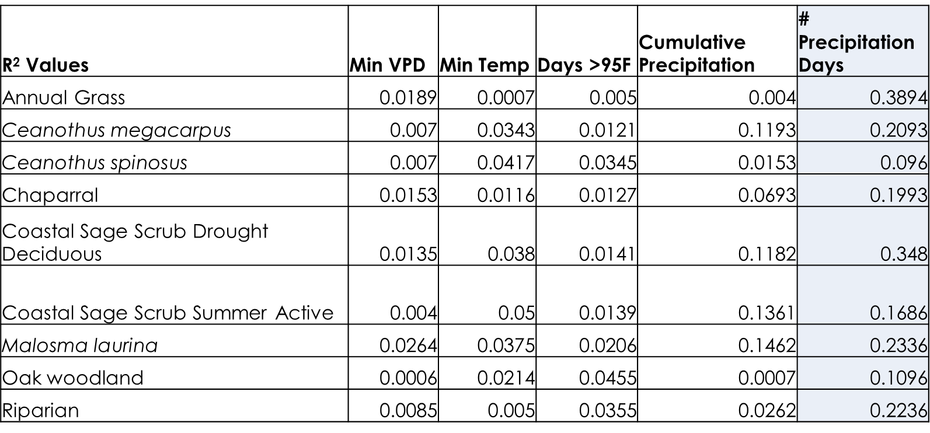

*Table 1.* The nine vegetation classes and give PRISM climate variables plotted with their R2 values.

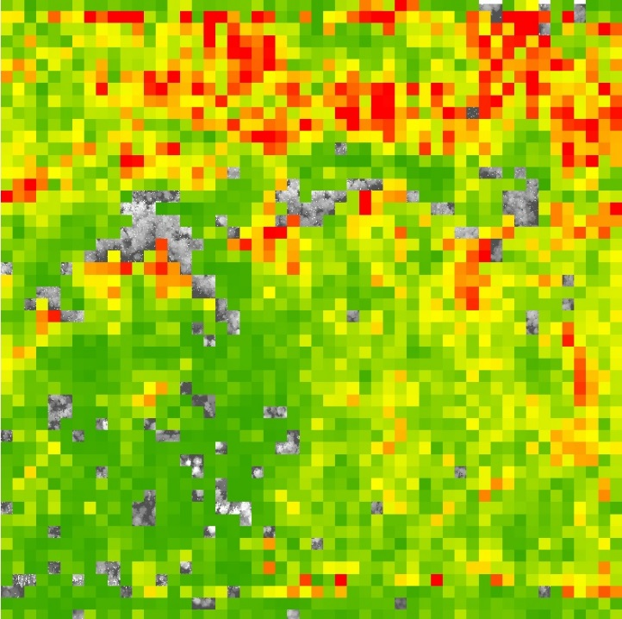

*Figure 11.* Fire Danger probability map at Trippet Ranch derived from multiplying canopy density with Relative Fraction Dead (1-RFAL). Pixels tend to line up with areas of lower vegetation grasses

***4.1 Analysis of Results***

*Species Map*

The species map had generally high accuracy, with an overall accuracy of 81.01%, and average producer’s and user’s accuracies of 78.3% and 82.42%, respectively. The team considered everything above 75% as high accuracy, and everything below as low accuracy. The high producer’s accuracies were seen for annual grass (90%), *Ceanothus spinosus* (100%), chaparral-common (100%), oak woodland (100%), riparian (88.89%), substrate (85.71%), and water (80%). High user’s accuracies were observed for annual grass (90%), *C. megacarpus* (100%), *C. spinosus* (100%), chaparral-common (85.71%), coastal sage scrub-drought deciduous (80%), oak woodland (90.91%), riparian (100%), and water (100%). Classes that had high accuracies in both include annual grass, *C. spinosus*, chaparral-common, oak woodland, riparian, and water. Low producer’s accuracies were seen for *C. megacarpus* (40%), coastal sage scrub-drought deciduous (66.67%), coastal sage scrub-summer active (60%), and *Malosma laurina* (50%). Low user’s accuracies were seen in coastal sage scrub-summer active (50%), *M. laurina* (50%), and substrate (60%). Classes that had low accuracies in both include coastal sage-summer active and *M. laurina*.

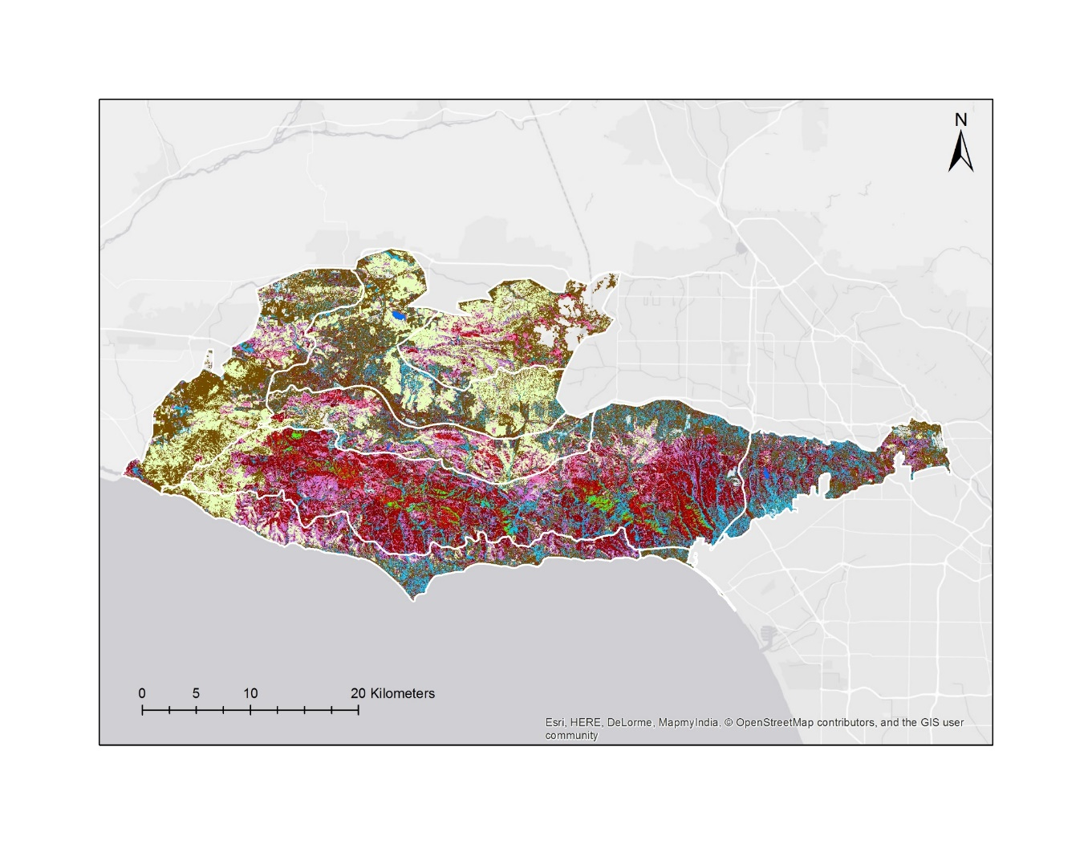

*Figure 12.* This image shows the species classification over the Santa Monica Mountains using Multiple Endmember Spectral Mixture Analysis (MESMA) on AVIRIS imagery.

Annual grass

*C. megacarpus*

*C. spinosus*

Chaparral - common

Coastal sage –

summer active

*M. laurina*

Oak woodland

Riparian

Substrate

Water

Coastal sage –

drought deciduous

Due to time constraints, the team was not able to run these classifications again after revising or eliminating the classes with the poorest performance (coastal sage scrub-summer active and *M. laurina*). Having noticed considerable confusion between chaparral classes and coastal sage scrub classes, the team experimentally merged *C. megacarpus*, *C. spinosus*, chaparral-common, and *M. laurina* into ‘chaparral’ and coastal sage scrub-drought deciduous and coastal sage scrub-summer into ‘coastal sage scrub.’ Merging these classes and reorganizing the confusion matrix improved overall accuracy to 88.61%, as well as average producer’s and user’s accuracies (88.19% and 88.96%, respectively). The kappa statistic also improved to 0.865. The only low accuracy result was user’s accuracy for substrate (60%). The underlying cause for why several categories were classified incorrectly as substrate is unclear, although it may be caused by pixels having mixed fractional cover of substrate if too much bare ground is exposed.

*Dieback Threshold*

The RFAL threshold value was found to be 0.5431, with an R2 value of 0.0251 (Figure 8). The low R2 value can be attributed to the low sample size of plots (n=22) and to the difference in data collection times. The AVIRIS imagery was taken in June, while the field plot data was recorded from September to October. Our partners note that oak trees are dying within months, meaning that the field condition recorded could be much worse than the RFAL alive values obtained. In addition, when the team created the plot to better understand the condition metric, the field condition observed tended to be an overestimate of the field fraction alive (Figure 9). The team expected to see a field condition of 3.2 correspond with a 0.5 field fraction alive, but found that a field condition of 3.2 corresponded with a 0.36 field fraction alive. This may also serve as an explanation as to why the R2 value for RFAL threshold was low.

*Climate Variable Regressions*

While most of the R2 values for the nine vegetation classes plotted against the given PRISM climate variables were low, the number of precipitation days had the highest R2 values among all climate variables (Table 1). This suggests that the health of the vegetation species has a stronger relationship with the number of precipitation days than min VPD, min temperature, and cumulative precipitation days. Even though vegetation species had a stronger relationship with the number of precipitation days, the type of response each species had varied greatly. Annual grassland had a sharp increase in % annual grassland alive when the number of precipitation days increased, but oaks had a much slower increase in % oak woodland alive (Figure 10). Even with increased precipitation days, oaks woodlands may still be dying because die-off patterns are a result of a combination of variables including increased temperature and increased atmospheric demands (Clifford, Royer, Cobb, Breshears, & Ford, 2013). It is possible that there are confounding variables that the team did not account for which should have been included in the regression analysis.

*Topographic Effects*

Oak woodlands have the highest fraction of dead pixels in the southern, southwestern, and western aspects. The lowest fraction of dead pixels is in the northern and northeastern aspects (Figure 13). This suggests that the oaks are experiencing the greatest dieback on the south to west gradient. *C. megacarpus* has the highest fraction of dead pixels in the southeastern, western, and southwestern aspects. The lowest fraction is in the northern and northeastern. These are also the highest and lowest fractions for chaparral-common, although the highs and lows are more discernable in chaparral-common. Judging by the range amongst the different aspect dead fractions, the oak woodlands are more severely affected by aspect.

Figure 13. This graph shows the fraction of dead pixels across 2013-2016 for oak woodlands, *C. megacarpus*, and chaparral—common.

*LiDAR – Fire Danger Zone*

Multiplying canopy density with relative fraction dead (1-RFAL) resulted in areas of higher fire danger that tend to correlate with shrubs and grasses when compared with canopy height < 1ft and the values of RFAL. Areas that are depicted to be much lower in fire danger tend to be more present with higher canopy, yet, it is not clear whether the fire danger model portrays accuracy when comparing with the RFAL threshold value described above. The fire danger maps could, however, offer probable areas in which RCDSMM could use to aid in their work for fuel clearing in relation to camp sites or other areas of human activity.

***4.2 Future Work***

There are many possible avenues for continuing work on this project. One interesting approach would be to modify the time intervals in which to view climatic variables such as precipitation. Looking at cumulative and number of days of precipitation annually is a reasonable human metric, but oak trees and other vegetation types operate on their own timescales. Relationships or trends may be missed as a result of the lag time between a climatic occurrence and vegetation response because the study’s temporal field of vision is not aligned. There is also room for a more in-depth analysis of harmful beetle impact on the oaks, as this project did not get to explore their impact on the trees very closely due to time constraints. The RCD has noticed that not only invasive but native beetles are beginning to attack and kill more trees, making it an important perspective to investigate. Exploring the applications of LiDAR and AVIRIS towards another concern, fire danger, is another possibility, as this project mainly focused on the tree side of things and not on their impact on fuel levels and fire danger to surrounding areas.

## 5. Conclusions

Through the combination of using NASA Earth observations and field data, this team could better understand the repercussions of the most recent drought in California on multiple scales. The number of precipitation days had the strongest relationship with percent oak woodland alive, highlighting the importance of precipitation days throughout the year. Overall, the severe drought has weakened oak trees and made them more susceptible to the impacts of physical stress as well as attacks from harmful beetles, ultimately resulting in greater oak woodland dieback.

# 6. Acknowledgments

* Dr. Natasha Stavros (NASA Jet Propulsion Laboratory, California Institute of Technology)
* Erika Higa (NASA DEVELOP, NASA Jet Propulsion Laboratory)
* Rosi Dagit (RCD Santa Monica Mountains)

Any opinions, findings, and conclusions or recommendations expressed in this material are those of the author(s) and do not necessarily reflect the views of the National Aeronautics and Space Administration.

This material is based upon work supported by NASA through contract NNL16AA05C and cooperative agreement NNX14AB60A.

# 7. Glossary

**AVIRIS** – Airborne Visible/Infrared Imaging Spectrometer

**CAL FIRE -** California Department of Forestry and Fire Protection

**DEM** – Digital elevation model

**EAR -** Endmember average root mean square error

**endmember** - Pure representation of a spectral class

**LiDAR** - Light Detection and Ranging

**MESMA** - Multiple Endmember Spectral Mixture Analysis

**NAIP -** National Agriculture Imagery Program

**NPS -** National Park Service

**PRISM** – Parameter-elevation Regressions on Independent Slopes Model

**RCDSMM** –Resource Conservation District of the Santa Monica Mountains

**RFAL** - Relative fraction of alive vegetation

**SMMNRA** – Santa Monica Mountains National Recreation Area

**SRTM** – Shuttle Radar Topography Mission

**TIN -** Triangular irregular network

**VPD** - Vapor pressure deficit

# 8. References

Airborne Visible Infrared Imaging Spectometer Data Facility, Jet Propulsion Laboratory (2017). Airborne Visible-Infrared Imaging Spectrometer (AVIRIS) Archived Data and Standard Data Products from JPL's AVIRIS Data Facility [Data file]. Retrieved from <https://aviris.jpl.nasa.gov>

Clifford, M. J., Royer, P.D., Cobb, N.S., Breshears, D.D., & Ford, P.L. (2013). Precipitation thresholds and

drought-induced tree die-off: insights from patterns of *Pinus edulis* mortality along an environmental

stress gradient. *New Phytologist*, *200*, 413-421. doi: 10.1111/nph.12362

Dagit, R., Carlberg, C., Cuba, C., & Scott, T. (2015)*.* Economic incentives for oak woodland preservation and

conservation*.* Proceedings of the seventh California oak symposium: managing oak woodlands in a

dynamic world. Visalia, CA, November 3-6, 2014. Berkeley, CA: U.S. Department of Agriculture.

Dennison, P.E., & Roberts, D.A. (2003). Endmember selection for multiple endmember spectral mixture

analysis using endmember average RMSE. *Remote Sensing of Environment*, *87*, 123-135.

doi:10.1016/S0034-4257(03)00135-4

Eskalen, A., Stouthamer, R., Lynch, S.C., Rugman-Jones, P.F., Twizeyimana, M., Gonzalez, A., & Thibault, T. (2013). Host range of Fusariam dieback and its ambrosia beete (Coleoptera: Scolytinae) vector in Southern California. *The American Phytopathological Society*, *97*(7), 938-951. doi:10.1094/PDIS-11-12-1026-RE

Jin, Xiaoying. (n.d.) *ENVI Automated Registration Solutions*. Retrieved from: <https://www.harrisgeospatial.com/portals/0/pdfs/ENVI_Image_Registration_Whitepaper.pdf>

Lin, R. (2016, June 21). L.A. will keep getting hotter, scientists say--a lot hotter. *Los Angeles Times*. Retrieved

from <http://beta.latimes.com/local/california>

Myers, N., Mittermeier, R.A., Mittermeier, C. G., da Fonseca, G. A. B., & Kent, J. (2000). Biodiversity

hotspots for conservation priorities. *Nature* 403, 853-858. doi: 10.1038/35002501

National Oceanic and Atmospheric Administration. (2017, June 27). *Advanced hydrological prediction service*.

Retrieved from: <http://water.weather.gov/precip/>

Roberts, D.A., Alonzo, M., Wetherley, E., Dudley, K., & Dennison, P. (2007). Multiscale analysis of urban

areas using mixing models. In D.A. Quattrochi, E. Wentz, N.S. Lam & C.W. Emerson (Eds.), *Scale in*

*Remote Sensing and GIScience Applications* (pp. 247-282). Boca Raton: CRC press.

Roberts, D.A., Gardner, M., Church, R., Ustin, S., Scheer, G., & Green, R.O. (1998). Mapping chaparral in

the Santa Monica Mountains using multiple endmember spectral mixture models. *Remote Sensing of*

*Environment*, *65*(3), 267-279.

Staggs, B.E. (2014, May 12). Once mere pests, beetles now carry fungus.... *The Orange County Register*.

Retrieved from <http://www.ocregister.com>

Tiszler, J., & Rundel, P. W. (2007). Santa Monica Mountains: Biogeography and cultural history. Flora and

ecology of the Santa Monica Mountains: Proceedings of the 32nd annual Southern California

Botanists symposium. Fullerton, CA, October 28, 2006. Fullerton, CA: southern California Botanists.

U.S. Geological Survey. (2016, February 10). *Explanations for the National Water Conditions*. Retrieved from:

https://water.usgs.gov/nwc/explain_data.html

# 9. Appendices

**Appendix A: RFAL registration issue**

Figure A1: RFAL is not co-registered to NAIP imagery.

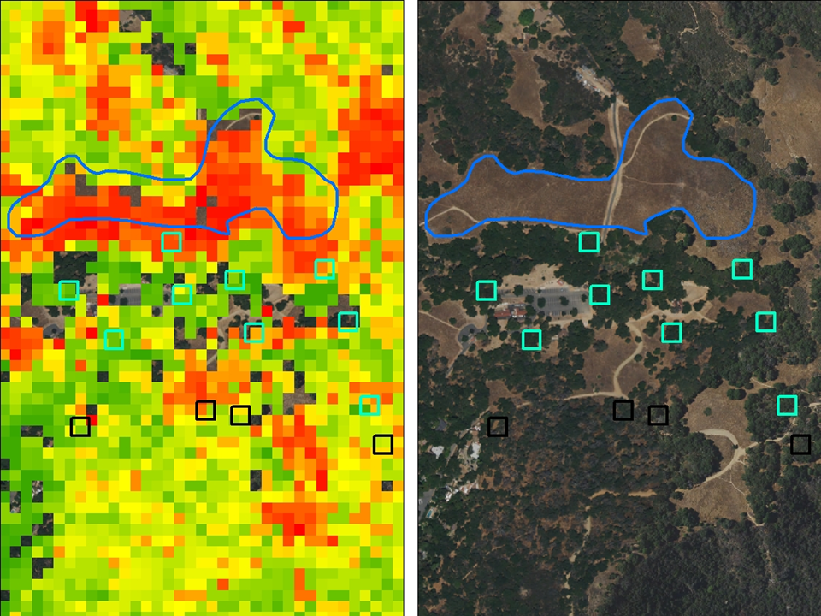

**Legend**

Annual Grass

2016 alive field plots

2016 dead field plots

**2016 RFAL**

High : 1

Low : 3.98989e-007

**2016 NAIP Imagery**

**RGB**

Red: Band_1

Green: Band_2

Blue: Band_3

**Appendix B: Aspect and species mortality by year**

Figure B1: Oak woodland

Figure B2: *Ceanothus megacarpus*

Figure B3: Chaparral—common

**Appendix C: Species map confusion matrices**

Table C1: Confusion matrix with all classes

|  |  |  |  |  |  |  |  |  |  |  |  |  |  |  |
| --- | --- | --- | --- | --- | --- | --- | --- | --- | --- | --- | --- | --- | --- | --- |
|  |  | **Reference source** | | | | | | | | | | |  |  |
|  |  | Ann. grass | *C. mega-carpus* | *C. spinosus* | Chap.-com. | Coastal sage - dr. dec. | Coastal sage - sum. act. | *M. laurina* | Oak wood. | Ripar. | Substr. | Water | Total | **user's accuracy** |
| **Classified map** | Annual grass | 9 | 0 | 0 | 0 | 1 | 0 | 0 | 0 | 0 | 0 | 0 | 10 | 90% |
| *C. mega-carpus* | 0 | 2 | 0 | 0 | 0 | 0 | 0 | 0 | 0 | 0 | 0 | 2 | 100% |
| *C. spinosus* | 0 | 0 | 5 | 0 | 0 | 0 | 0 | 0 | 0 | 0 | 0 | 5 | 100% |
| Chap. - common | 0 | 0 | 0 | 6 | 0 | 0 | 1 | 0 | 0 | 0 | 0 | 7 | 85.7% |
| Coastal sage - dr. dec. | 0 | 0 | 0 | 0 | 4 | 1 | 0 | 0 | 0 | 0 | 0 | 5 | 80% |
| Coastal sage - sum. act. | 0 | 0 | 0 | 0 | 1 | 3 | 2 | 0 | 0 | 0 | 0 | 6 | 50% |
| *Malosma laurina* | 0 | 3 | 0 |  |  |  | 3 | 0 | 0 | 0 | 0 | 6 | 50% |
| Oak wood. | 0 | 0 | 0 | 0 | 0 | 0 | 0 | 10 | 1 | 0 | 0 | 11 | 90.9% |
| Riparian | 0 | 0 | 0 | 0 | 0 | 0 | 0 | 0 | 8 | 0 | 0 | 8 | 100% |
| Substrate | 1 | 0 | 0 | 0 | 0 | 1 | 0 | 0 | 0 | 6 | 2 | 10 | 60% |
| Water | 0 | 0 | 0 | 0 | 0 | 0 | 0 | 0 | 0 | 0 | 8 | 8 | 100% |
| Un-classified | 0 | 0 | 0 | 0 | 0 | 0 | 0 | 0 | 0 | 1 |  | 1 |  |
|  | Total | 10 | 5 | 5 | 6 | 6 | 5 | 6 | 10 | 9 | 7 | 10 | 79 | Average = 82.42% |
|  | **producer's accuracy** | 90% | 40% | 100% | 100% | 66.7% | 60% | 50% | 100% | 88.9% | 85.7% | 80% | Avg = 78.30% | Overall = 81.01% |
|  | agreement | 9 | 2 | 5 | 6 | 4 | 3 | 3 | 10 | 8 | 6 | 8 | 64 |  |
|  | by chance | 1.266 | 0.127 | 0.316 | 0.532 | 0.380 | 0.380 | 0.456 | 1.392 | 0.911 | 0.886 | 1.013 | 7.658 |  |
|  | **kappa** |  |  |  |  |  |  |  |  |  |  |  | 0.790 |  |

Table C2: Confusion matrix with merged chaparral and coastal sage scrub

|  |  |  |  |  |  |  |  |  |  |  |
| --- | --- | --- | --- | --- | --- | --- | --- | --- | --- | --- |
|  |  | **Reference source** | | | | | | |  |  |
|  |  | Annual grass | Chaparral | Coastal sage scrub | Oak woodland | Riparian | Substrate | Water | Total | **user's accuracy** |
| **Classified map** | Annual grass | 9 |  | 1 |  |  |  |  | 10 | 90% |
| Chaparral |  | 20 |  |  |  |  |  | 20 | 100% |
| Coastal sage scrub |  | 2 | 9 |  |  |  |  | 11 | ### |
| Oak woodland |  |  |  | 10 | 1 |  |  | 11 | ### |
| Riparian |  |  |  |  | 8 |  |  | 8 | 100% |
| Substrate | 1 |  | 1 |  |  | 6 | 2 | 10 | 60% |
| Water |  |  |  |  |  |  | 8 | 8 | 100% |
| Unclassified |  |  |  |  |  | 1 |  | 1 |  |
|  | Total | 10 | 22 | 11 | 10 | 9 | 7 | 10 | 79 | Avg = 88.96% |
|  | **producer's accuracy** | 90% | 90.9% | 81.8% | 100% | 88.9% | 85.7% | 80% | Avg = 88.19% | Overall = 88.61% |
|  | agreement | 9 | 20 | 9 | 10 | 8 | 6 | 8 | 70 |  |
|  | by chance | 1.266 | 5.570 | 1.532 | 1.392 | 0.911 | 0.886 | 1.013 | ### |  |