**NASA DEVELOP National Program**



NASA Jet Propulsion Laboratory

*Spring 2016*

Los Angeles Oceans II

Validating Satellite Observations of Wastewater Plumes and their Biological Impacts in Santa Monica Bay, California

 **Technical Report**

Final Draft – March 31, 2016

Rebecca Trinh (Project Lead)

Lindsay Almaleh

Benjamin Holt, Oceans-Ice Group, NASA Jet Propulsion Laboratory (Science Advisor)

Michelle Gierach, Oceans-Ice Group, NASA Jet Propulsion Laboratory (Science Advisor)

Previous Contributors:

Mark Barker

Christine Rains

Jack Pan

# I. Abstract

The Hyperion Water Reclamation Plant is one of the largest wastewater treatment plants in the western United States. Treated sewage is generally released at depths of approximately 60 m through 8.05 km outfall pipes into a deep marine canyon in the Santa Monica Bay. In times of repair and maintenance, services on the main outfall pipe are temporarily suspended and require the plant to divert treated sewage to a shorter 1.6 km pipe that extends into shallow coastal zones. These shallow zones make it possible for the buoyant freshwater plumes to reach the surface, potentially contaminating the local environment. A six-week diversion event occurred at HWRP from September 21 to November 2, 2015. This project plans to integrate previously obtained NASA satellite images and ancillary data collected by other scientists. By combining remotely sensed observations with GPS-equipped drogue surface drifters and *in situ* readings of temperature, salinity, atmospheric aerosols, and chlorophyll-a florescence, an accurate assessment of the full impact and extent at which these effluent plumes affected the Los Angeles Basin is possible. The outcome of this study can aid in developing proper methods to avoid harmful outcomes during similar diversion events in the future.

**Keywords**

Wastewater, sea surface temperature, chlorophyll-a, ocean color, algal blooms, Landsat-8, ASTER, MODIS

# II. Introduction

The coastal waters of Southern California are of great ecological and economic importance; the waters are home to many marine species and serve as a valuable resource to humans in terms of sport and commercial fishing, recreation, and tourism (Washburn et al. 1992). As a result, coastal pollution management of offshore effluent is necessary to maintain water quality, which relies heavily on the dispersal and dilution by ocean currents to reduce local concentrations (Uchiyam et al. 2014).

Located in Playa del Rey, California, the Hyperion Water Reclamation Plant (HWRP) of The City of Los Angeles-Department of Public Works, Bureau of Sanitation, is one of the largest wastewater plants on the west coast of the United States (Washburn et al. 1992) (Figure 1). It serves two-thirds of Los Angeles County, approximately 4 million people, releasing an average of 362 million gallons per day (MGD) into coastal waters (Reifel et al. 2013). Wastewater from the HWRP undergoes two levels of treatment, removing about 85% of suspended solids before being discharged. However, the effluent, treated municipal wastewater, that is discharged into the ocean still contains oils, bacteria, particulates, metals, chlorine, nutrients, and other compounds that may have ecological implications and pose a risk to human health (Raco-Rands and Steinberger 2001). Effluent from the HWRP is primarily discharged from a 3.7 m diameter outfall pipe that terminates 5 miles (8.05 km) offshore and at a depth of 57 m, near the head of the Santa Monica Marine Canyon. Discharging effluent at depth along the continental slope allows for rapid flushing and mixing with ambient seawater which dilutes the buoyant wastewater plumes before they reach the water’s surface or coastline (Washburn et al. 1992). HWRP also has a secondary backup outfall pipe that terminates 1 mile (1.61 km) from shore at a depth of about 15 m (Reifel et al. 2013). During emergencies or scheduled maintenance, effluent is diverted from their primary 5-mile deep ocean pipe to the shallow 1-mile pipe. An inspection of the 5-mile pipe uncovered structural damage to the interior of the pipe. To perform the necessary maintenance on the 5-mile pipe, HWRP planned a 6-week outfall diversion from September 21 to November 2, 2015.

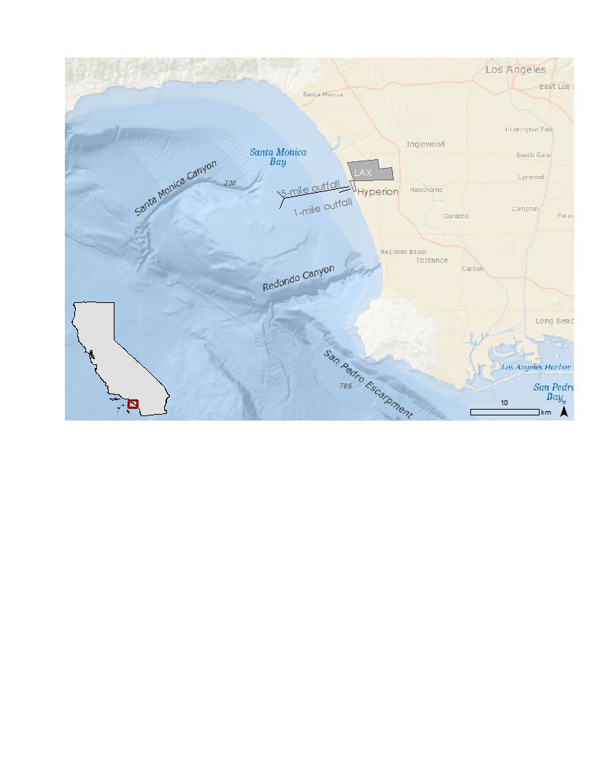

Figure 1: Project study area, Santa Monica Bay, Los Angeles, California.

Public concern grew during this diversion event, after a large storm event on September 15, 2015 caused an unexpected amount of wastewater, medical waste, and other materials of sewage origin (MOSA) to wash ashore on the beaches adjacent to the HWRP (Rocha 2015). The beaches remained closed for several days, and the public became increasingly concerned about the water’s pollution due to media coverage of the story. This study, along with our partners’ studies, offers transparency on the environmental impacts of such diversion events to the public, the scientific community, and municipalities planning similar diversions.

Wastewater plumes are characteristically rich in suspended organic particles, giving them a unique spectral response. The Moderate Resolution Imaging Spectroradiometer (MODIS) on NASA’s Aqua satellite, the Visible Infrared Imaging Radiometer Suite (VIIRS) on Suomi National Polar-orbiting Partnership (NPP), and the Operational Land Imager (OLI) on NASA’s Landsat-8 can detect these signatures in ocean-color images. MODIS, VIIRs, and OLI are also able to detect the level of chlorophyll-a (chl-a) in phytoplankton, which may bloom in response to the high nutrient load of the effluent. Effluent will have a cold sea surface temperature (SST) signature as compared to the ambient water as the buoyant effluent plume entrains and brings colder bottom ocean water to the surface as it rises. This thermal signature can be detected by the Thermal Infrared Sensor (TIRS) on Landsat-8, and the thermal infrared band of the Advanced Spaceborne Thermal Emission and Reflection (ASTER) instrument on Terra. Images from these satellites were processed by DEVELOP (Trinh et al. 2015) during the previous term of this project at the NASA Jet Propulsion Laboratory (JPL).

There was a massive effort taken to combine research results from various institutions during and after the diversion event. The scientists from HWRP, City of Los Angeles, and University of California Santa Barbra (UCSB) used a CTD (conductivity-temperature-depth) instrument to measure salinity, temperature, and chlorophyll-a fluorescence onboard a boat. HWRP’s microbiology scientists gathered daily shoreline and offshore readings of fecal indicator bacteria (FIB), E.coli, fecal coliform, and enterococcus. UCSB deployed Lagrangian drifters, which tracked the plume as it moved through the localized surface currents. The University of Southern California (USC) performed phytoplankton water chemistry laboratory experiments to determine the density of phytoplankton and if harmful algal species were present due to the diversion. Measurements were taken at critical sampling stations within, around, and outside of the effluent plume to provide an accurate cross section of the plume signature, both temporally and spatially. Many of the instruments were used during satellite overpasses to give a direct comparison to the measurements obtained by the satellite sensors. The results of *in situ* measurements can be used to further verify our remote sensing data. Validating remote sensed data may help future efforts of tracking effluent plumes during these diversion events and decrease the cost of field data collection if the satellite observations can accurately identify the wastewater plume and environmental changes due to it.

The objectives of this study were to: (1) Coordinate with the Hyperion Water Reclamation Plant’s research team in obtaining *in situ* data collected in the Santa Monica Bay, (2) validate NASA Earth observations using i*n situ* data taken during the diversion event, (3) determine whether the expelled effluent has negatively impacted the local ecosystem or washed ashore to potentially contaminate beaches, and (4) publish results in a journal and Hyperion’s technical report.

# III. Methodology

We utilized four NASA satellites to obtain our satellite imagery (Table 1). The primary signatures that we were interested in validating were SST and chl-a. Landsat-8 OLI, Aqua MODIS and Suomi-NPP VIIRS were used to evaluate chl-a concentration. The thermal infrared bands on Terra, ASTER and Landsat-8, TIRS were used to evaluate SST.

Table 1: Satellites and sensors used to cover the 6-week effluent diversion.

|  |  |  |  |  |  |
| --- | --- | --- | --- | --- | --- |
| **Satellite** | **Sensor** | **Band** | **Resolution** | **Acquisition** | **Detection** |
| Terra | ASTER | Thermal Infrared | 90 m | 16 days | Sea surface temperature |
| Aqua | MODIS | Optical | 250 m | Daily | Chlorophyll-a,  Particulate reflectance |
| Landsat 8 | OLI, TIRS | Optical, Thermal Infrared | 30 m | 16 days | Sea surface temperature,  Chlorophyll-a,  Particulate reflectance,  Turbidity |
| Suomi-NPP | VIIRS | Optical | 375m | Daily | Chlorophyll-a,  Particulate reflectance |

***Biological Observation through Ocean Color: MODIS – Aqua, VIIRS – Suomi-NPP, and TIRS – Landsat-8***

Both MODIS-Aqua and VIIRS-Suomi Level-1 (L1) data were obtained through NASA’s OceanColor database. Ocean color data were processed with SeaDAS, a python-based image analysis package. L1A data were processed to a resolution of 250 m. Atmospheric corrections were automatically applied during the processing. A fixed spatial subset was applied to each image in order to focus on the regions of interest (ROIs). On cloudy or stormy days, data from MODIS could not be processed because the sensor cannot obtain ocean color data through cloud cover.

Each MODIS and VIIRS file was sent through two separate processing algorithms to create two distinct L2 products. One algorithm produced a file with normalized water-leaving radiance, and generalized chlorophyll-a concentration bands. The chl-a concentration calculated by this algorithm tended to pick up signals from sediment and detritus, in addition to chlorophyll-a from phytoplankton. To help separate the effects of each of these contributors, files were processed using a second algorithm. Using the two different files, it was possible to compare the total chl-a signature with calculated concentrations of the signature’s components.

Landsat-8 OLI bands were processed in Acolite, a stand-alone IDL-based program for marine applications of Landsat-8. Short Wave Infrared (SWIR) atmospheric corrections, using bands 6 and 7 of OLI, were applied to the Landsat data (Vanhellemont and Ruddick 2015). Algorithms were applied for Rayleigh reflectance, chl-a, total suspended matter (TSM), and turbidity. The chlorophyll algorithm used takes the blue-green ratio of the image, using bands 483-561. TSM was calculated from an algorithm based on a previous paper (Nechad et al. 2010) using the 560 nm wavelength. Turbidity measurements were made using a previously established method by Dogliotti et al. 2015.

***Sea Surface Temperature: ASTER – Terra, and TIRS – Landsat-8***

ASTER-derived SST measurements were retrieved from the Land Processes Distributed Active Archive Center (LPDAAC) operated by NASA and USGS. ASTER records data in 14 bands, including five thermal infrared (TIR) bands, which were used for deriving SST data. An algorithm similar to the In-Scene Atmospheric Compensation (ISAC) (Johnson and Young 1998) was applied to the TIR bands for thermal atmospheric correction; this process estimated and removed the atmospheric contributions to the thermal infrared radiance data. The thermal infrared radiation is also a function of the SST and emissivity, thus the emissivity was separated to derive the SST. An emissivity normalization technique was applied to the data after the thermal atmospheric correction to create temperature output (Kealy et al. 1993; Hook et al. 1992). Lastly, the temperature data was converted from units of Kelvin to units of Celsius.

Landsat-8 has high-resolution thermal imaging capabilities in bands 10 and 11. We applied a method similar to the one used for ASTER SST processing to the scenes in ENVI, a geospatial imagery processing and analysis software program. An equation was used to convert pixel values to top of the atmospheric (TOA) spectral radiance:

Lλ = MLQcal + AL

Where, Lλ is the TOA spectral radiance measured in Watts/( m2 * srad * μm), ML is the band-specific multiplicative rescaling factor from the metadata, AL is the band-specific additive rescaling factor from the metadata, and Qcal is the quantized and calibrated standard product pixel values (DN).

TOA spectral radiance was then converted to brightness temperature, hence the temperature at the ocean surface. We used the equation below to derive the temperature in Kelvin.

$$T=\frac{K_{2}}{\ln\left(\frac{K_{1}}{L_{λ}}\right)+1}$$

Where T is the satellite brightness temperature (K), Lλ is the TOA spectral radiance (Watts/( m2 * srad * μm)), and K1 and K2 are the band-specific thermal conversion constants.

***Remote Sensing - In Situ Data Comparison***

In conjunction with satellite remote sensing monitoring obtained during the previous term of DEVELOP, our team has compiled *in situ* data results to ground truth the satellite data and provide a more comprehensive overview on the biological impact by the effluent plume within the coastal environment. Both satellite and *­in situ* data were gathered prior to, during, and after the effluent diversion, beginning August 26, 2015 and ending November 30, 2015, to provide baseline condition data and a clear picture of the coastal waters without impacts from surfacing effluent.

We obtained auxiliary datasets from Hyperion and its collaborating institutions and processed their raw data to a usable format to insert into MATLAB. These *in situ* datasets included measurements from: two CTD’s with a flourometer, GPS equipped Lagrangian drifters, phytoplankton laboratory chemistry, and the Microtops (Table 2).

Table 2: *In situ* data used to validate satellite observations

|  |  |  |
| --- | --- | --- |
| **Data Provider** | **Sensor** | **Detection** |
| Hyperion Water Reclamation Plant | CTD with fluorometer | Salinity  Temperature  Chlorophyll-a |
| University of California Santa Barbra | CTD with fluorometer | Salinity  Temperature  Chlorophyll-a |
| University of California, Santa Barbara | Drifters | Surface current movement |
| University of Southern California | Phytoplankton chemistry | Species and surface density of phytoplankton chl-a |
| NASA/JPL | Microtops | Aerosol Optical Thickness (AOT) |

To make the previously processed satellite data from fall 2015 more accurate, atmospheric corrections which correspond specifically to the Santa Monica Bay study area were incorporated using SeaDAS.

MODIS L2, Landat-8 OLI, and VIIRs raw data were reprocessed using an aerosol optical thickness value (Tau-A, τ) obtained from *in situ* results measured on specific days from NASA JPL’s Microtops instrument. When satellites emit electromagnetic radiation waves down to the earth, some of the radiation is scattered or absorbed by microscopic aerosol particles in the atmosphere. These aerosols prevent the transmission of light waves, thus distorting the true color of the earth. τ is defined as the extinction coefficient over a vertical unit of atmosphere, and is dimensionless (NASA 2012). This newly processed image allows for a true ocean-color image, removing interference from aerosol particulates that lie between the satellite and ocean.

The Microtops was aimed at the sun to collect atmospheric values, and the most consistent measurement was chosen for each field day. The data was extrapolated, using MATLAB, at various wavelengths based on the optical wavelengths of each sensor. For example, MODIS required extrapolated τ values of 412, 433, 469, 488, 531, 551, 555, and 645 nm (Figure 2). The extrapolated values were then inserted into SeaDAS (version 7.3.1) multi-scattering with fixed aerosol optical thickness algorithm to produce an atmospherically corrected image unique to Santa Monica Bay on a specific day. Seven days of Microtops readings were taken throughout our study period, allowing for adequate atmospherically corrected images.

ASTER L2 08 surface kinetic temperature products were ordered for the four days overpasses occurred during our study period, with one scene from pre-diversion, one during the diversion, and two post diversion (Table 3). Surface radiance is isolated from atmospheric components of the five different thermal infrared bands using the Moderate Resolution Atmospheric Radiance and Transmittance Model (MODTRAN). A local atmospheric profile obtained from the National Centers for Environmental Prediction was used for a more accurate atmospheric correction. The data is interpolated from 1-degree grid nodes and in six-hour time intervals to the time and location of the scene over Santa Monica Bay (Berk et al. 1999; Thome et al. 1998). A Temperature/Emissivity Separation (TES) algorithm is then applied to the five bands to produce the surface kinetic temperature product. The algorithm hybridizes three existing algorithms, estimating normalized emissivity and calculating emissivity band ratios. TES uses an iterative process to remove sky irradiance reflectance (Gillespie et al. 1998). The data is then converted to Celsius temperature values. The location-specific atmospheric correction and more accurate TES algorithm yields more reliable surface temperature values.

Satellite maps and corresponding *in situ* data (Table 3) were imported into MATLAB using a basic mapping toolbox code called M-Map (Pawlowicz 2014). To obtain surface chl-a values, USC measured discrete water samples using a fluorometer with the non-acidification method. Duplicate samples were collected for chl-*a* analysis by gentle filtration of 5-100 mL of water onto glass fiber filters (Whatman GF/F), with the filtration volume dependent on the biomass present in the sample. Filters were extracted in 100% acetone at -20 °C in the dark for 24 hours. Filter extracts were analyzed on a Trilogy Turner Designs fluorometer (Turner Designs, Sunnyvale, CA). CTD chl-a, temperature, and salinity data from UCSB and HWRP were combined. The top five meters of data were averaged for each sample station for each day, to yield similar depth integration to what the satellites were detecting. Adjusted CTD chl-a values were obtained by performing a power regression between the surface chl-a values obtained at each sample station to CTD depth chl-a data from UCSB and HWP. The power regression equation was then applied to the CTD chlorophyll-a data. These data were then plotted in MATLAB (Appendix 1 and 2). Drifter data obtained from UCSB were plotted in MATLAB to identify a correlation between where the satellite data was showing the wastewater plume and associated phytoplankton blooms and the prevailing surface currents measured by the drifters (Appendix 3).

Table 3: Comprehensive list of satellite and *in situ* data overlap.

|  |  |  |  |  |  |  |  |  |
| --- | --- | --- | --- | --- | --- | --- | --- | --- |
| **DATE** | **Landsat-8** | **ASTER** | **MODIS** | **VIIRS** | **Micro-tops** | **CTD** | **Phyto** | **Drifter** |
| 16-Sep |  | X | X |  | X | X | X | X |
| 20-Sep |  |  | X |  |  | X |  | X |
| 22-Sep |  |  | X |  |  | X |  | X |
| 24-Sep | X |  | X |  | X | X |  | X |
| 28-Sep |  |  | X |  |  | X |  | X |
| 30-Sep |  |  |  | X | X | X | X |  |
| 1-Oct |  | X | X |  |  | X |  | X |
| 3-Oct |  |  | X |  |  | X |  | X |
| 6-Oct |  |  | X |  |  | X |  | X |
| 7-Oct |  |  |  |  |  | X | X |  |
| 8-Oct |  |  | X |  |  | X |  |  |
| 9-Oct |  |  |  |  |  | X |  | X |
| 10-Oct | X |  | X | X |  |  |  |  |
| 12-Oct |  |  | X |  |  | X |  | X |
| 14-Oct |  |  |  | X |  |  | X |  |
| 17-Oct |  |  | X | X |  |  | X |  |
| 21-Oct |  |  | X |  | X | X | X |  |
| 22-Oct |  |  | X |  |  | X |  | X |
| 26-Oct | X |  | X |  | X | X |  | X |
| 28-Oct |  |  |  |  |  |  | X |  |
| 30-Oct |  |  | X |  |  | X |  | X |
| 2-Nov |  |  |  |  |  | X |  | X |
| 3-Nov |  | X |  |  |  |  |  |  |
| 5-Nov |  |  | X | X | X | X | X |  |
| 11-Nov | X |  | X | X | X | X | X |  |
| 17-Nov |  |  | X |  |  | X |  |  |
| 18-Nov |  |  | X |  |  | X |  |  |
| 19-Nov |  | X |  | X |  | X |  |  |

# IV. Results & Discussion

**Atmospheric corrections**

*In situ* readings of AOT can be collected and used to atmospherically correct satellite images using values specific to a location and day. Atmospherically corrected MODIS images had more subtitle looking algal blooms, and the coastline chl-a concentration was smoothed to a more true-to-life gradient (Figure 3). When the algorithm was applied to the VIIRs images, the pixilation and monochromatic signature were reduced, and extreme values at the coastline were eliminated (Figure 4). Atmospherically correcting Landsat-8 chl-a images lead to less graininess and revealed eddies that could not be seen prior to the image-specific atmospheric aerosol corrections measured from the Microtops (Figure 5). When ASTER was atmospherically corrected and smoothed, scan lines were reduced, and extreme temperatures were eliminated, while still leaving the cold water temperature signature from the 1-mile outfall intact (Figure 6).

Our ability to atmospherically correct satellite images was limited to seven days of Microtops data. Since every day has a different AOT signature, data could not be extrapolated for other days. Landsat-8 and ASTER have an acquisition time of 16 days. The NASA JPL team coordinated weekly field days onboard the sampling boats operated by HWRP. Sampling days using the Microtops instrument, as well as CTD and surface chl-a measurements, were coordinated with known satellite overpasses. But due to the limitation of ship-time, it was not possible to be in field for every satellite overpass, due to storms, mechanical problems, and human error. Overall, the AOT values that were obtained allow for a more accurate depiction of conditions by filtering out the distortions caused by aerosols in remote sensed images.

Figure 3: Image of a southward phytoplankton bloom extended below the Palos Verdes Peninsula, captured during the diversion by Aqua, MODIS. (A) Default atmospheric correction algorithm. (B) Atmospherically corrected image using AOT values extrapolated from the Microtops instrument.

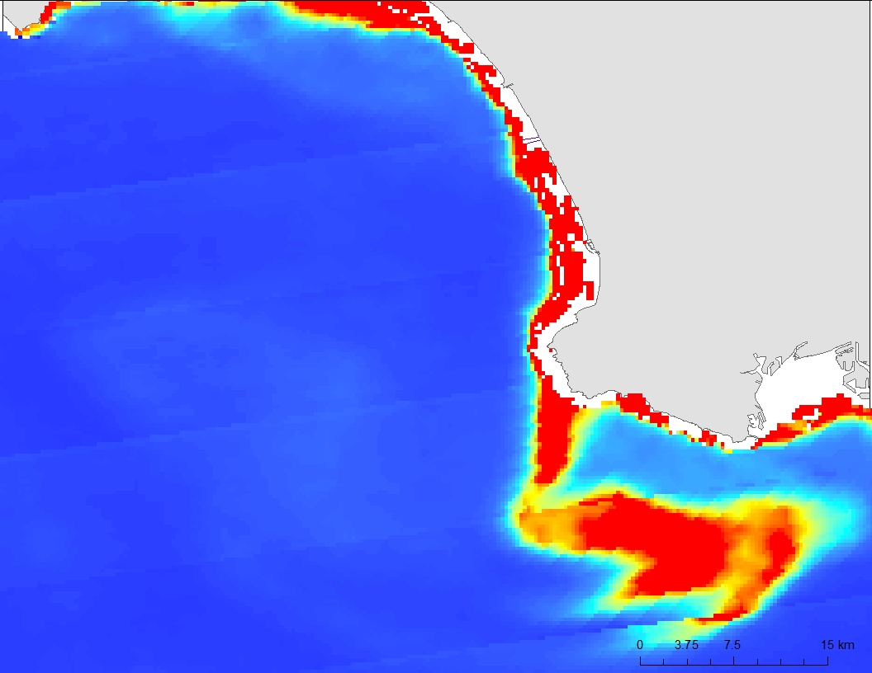

(A)



Aqua MODIS

Oct. 26, 2015

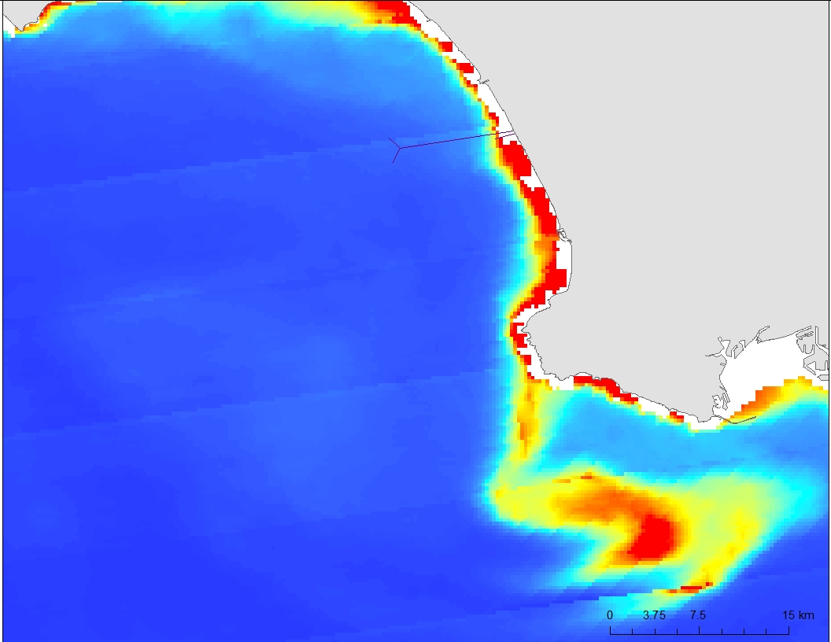

(B)

**Chlorophyll-a Validation**

Algal blooms and coastal phytoplankton signatures observed in remote sensed images were validated by *in situ* chlorophyll-a data from the CTD flourometer and phytoplankton water chemistry from discrete surface samples. The main pigmentation in phytoplankton (algae) is chlorophyll-a, and an anomalous presence of chl-a higher than 10 mg/m3 is considered an algal bloom. The increased nutrient load being released from the effluent into shallow waters were predicted to stimulate algal blooms within Santa Monica Bay. USC’s surface phytoplankton density samples along the coastline revealed very high concentrations on Oct. 17, 2015, during the diversion. This validates our high readings of chl-a in the same coastal area seen in the MODIS chl-a image of the same day (Figure 7). However, the data from USC reveals that the chl-a density is much higher than what satellite images reveal. This is perhaps due to the sample location, very near shore, and the low resolution of the satellite images. Additionally, this particular date did not have field aerosol measurements, so only underwent standard atmospheric correction techniques internal to the SeaDas program.

Chlorophyll-a data acquired from Aqua MODIS, VIIRS, and Landsat-8 was compared with *in situ* CTD flourometer data in order to determine the correlation between field measured chl-a data and satellite chl-a data. On Oct. 22, 2015, the chl-a samples measured by the CTD along the coastline have higher concentrations than offshore, which match with our satellite data. There is a distinctly lower concentration of chl-a at the terminus of the outfall, which is due to the freshwater effluent displacing the seawater, which is rich in phytoplankton. The average chl-a CTD values (Figure 8A) and the adjusted average chl-a CTD values (Figure 8B), using the power regression equation, are different, with the adjusted averaged chl-a values being more in line with the satellite image. In general, the chl-a CTD values validate the trend of chl-a along the coast, at the 1-mile outfall, and offshore.

Several large algal blooms were observed on our satellite images during the diversion study period. These algal blooms were validated using *in situ* CTD data. The elevated levels of chl-a within the plume were also recorded using the CTD. For example, on October 26, 2015, a large algal bloom was observed wrapping around the Palos Verdes Peninsula, and CTD data was able to validate the presence of it (Figures 9).

Figure 9: A southward phytoplankton bloom extended below the Palos Verdes Peninsula, during the diversion event on October 26, 2015 and overlain with *in situ* CTD data, (A) Aqua, MODIS. (B) Landsat-8, OLI.

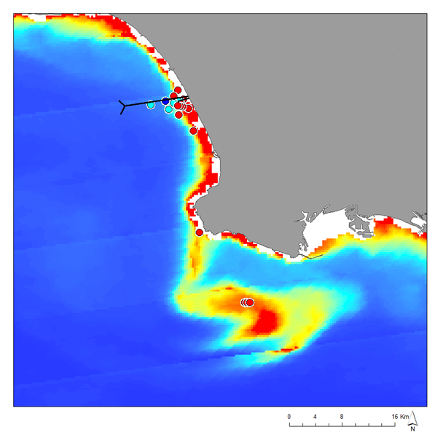

CTD



Aqua MODIS

Oct. 26, 2015

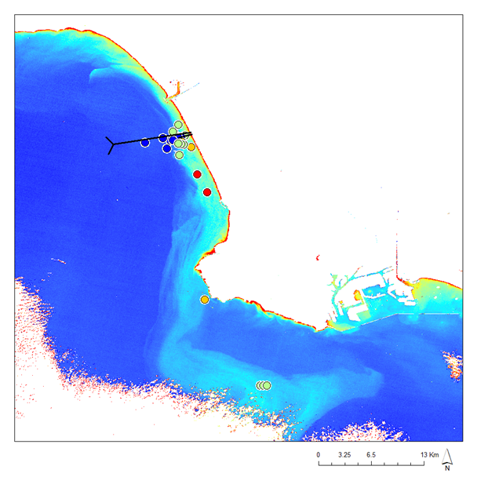

CTD

Landsat-8

Oct. 26, 2015

(A)

(B)

**Surface Drifters**

UCSB’s surface drifters were released near the mouth of the 1-mile outfall and were allowed to drift with prevailing currents for extended amounts of time. The drifters traveled both north and southward from the plume depending on the prevailing surface currents at the time, mainly influenced by tidal patterns. There was a general trend of small northward currents, and longer southward currents. The surface drifters corroborate strongly with the snapshot image capturing the phytoplankton plume heading south from the 1-mile pipe in the Landsat-8 chl-a image (Figure 10).

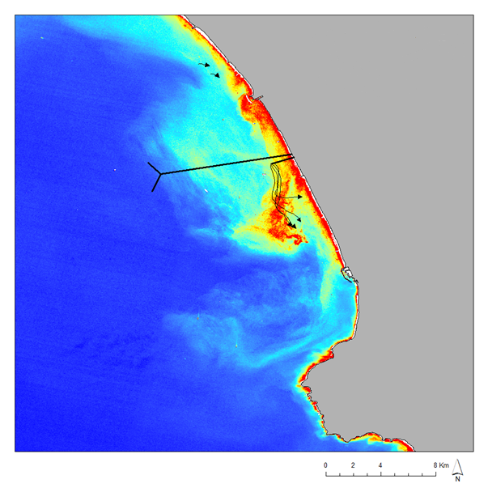

Drifter Direction

Landsat-8

Oct. 10, 2015

Figure 10: Surface drifters were released near the mouth of the 1-mile outfall. Landsat-8 image shows high amounts of chlorophyll heading south from the outfall. The drifter tracks are overlain over the satellite image to reveal a strong correlation between algal blooms and surface currents.

**Sea Surface Temperature Validation**

The satellite imagery from Landast-8, TIRS and Terra, ASTER reveals a cold SST signature at the terminus of the 1-mile outfall pipe, which is localized and dissipates less than 1km from the pipe. The entrainment and surfacing of cold freshwater effluent can be seen in the satellite SST data. The CTD measured both temperature and salinity at sample stations throughout the bay. These readings were overlain on the remote sensed SST images to provide validation. The CTD captured a noticeably colder signature at the terminus of the pipe as compared to the surrounding waters. It also captured a significantly lower salinity signature at the terminus, showing that freshwater effluent is reaching the surface and quickly mixing with the surrounding saltwater (Figure 11 A & B, respectively).

# V. Conclusions

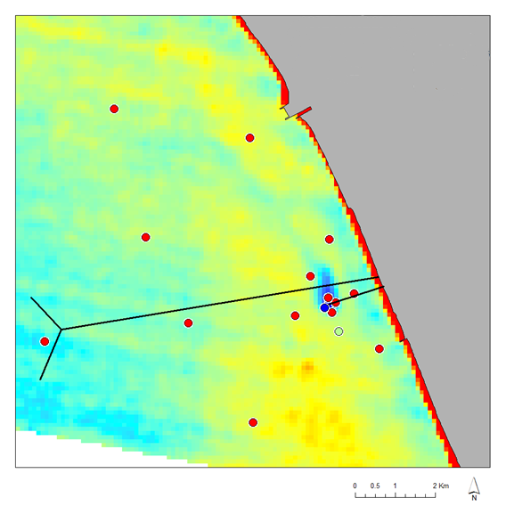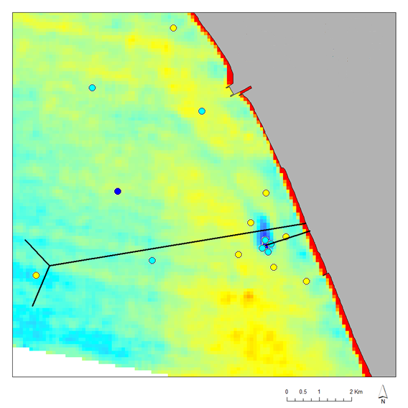

Figure 11: An ASTER image depicts a cold SST signature at the mouth of the 1-mile pipe, evidence of the surfacing effluent. (A) CTD temperature data is overlain on the SST image validating the same SST signature as ASTER. (B) Further validating this signature is salinity measurements taken from the CTD. There is a lower salinity concentration at the outfall, in keeping with the freshwater effluent signature.



Terra, ASTER

Oct. 2, 2015

CTD



CTD

(B)

(A)

By using multiple sensors and satellites, as well as *in situ* field measurements, we were able to provide a comprehensive overview of what was happening in Santa Monica Bay in relation to HWRP’s 2015 diversion event. Aerosol Optical Thickness values obtained in the field, and extrapolated for each satellite instrument, improved the quality and accuracy of the remote sensed images by filtering out atmospheric aerosol interference. The presence of algal blooms throughout the diversion was revealed using chlorophyll-a algorithms with Landsat-8 OLI, MODIS, and VIIRS. These satellite images were validated with *in situ* CTD flourometer data and surface water phytoplankton chemistry data. A power regression model using chlorophyll-a data from the *in situ* surface phytoplankton chemistry and two CTD chl-a datasets revealed variation in the density of phytoplankton, but the overall algal bloom patterns corroborated what we were seeing in the satellite data. The direction in which the effluent plume was traveling and stimulating algal blooms was validated through surface drifter records. The presence of a localized cold SST signature at the terminus of the 1-mile outfall pipe, as seen in images from ASTER and Landsat-8 TIRS, was validated by CTD data measuring temperature. Salinity measurements from the *in situ* CTD additionally verify how much of the freshwater effluent made it to the surface at the mouth of the 1-mile outfall pipe and how it mixed with ambient surface ocean water. In the future, these methods can be used in combination with field measurements to provide a broad view of the effects associated with wastewater diversion events. This study has shown the validity of using satellite remote sensing in monitoring coastal changes during such diversion events. Ultimately, the total findings of this project will be summarized and submitted to be published in a peer reviewed journal in summer 2016.

# VI. Acknowledgments

We would like to thank our science advisors—Ben Holt and Michelle Gierach—for data retrieval and assisting in data analysis.

We would like to acknowledge our project partners: Curtis Cash, Ashley Booth, and Mas Dojiri at the Hyperion Water Reclamation Plant. We would also like to thank Cedric Fichot, USC Scientist Jayme Smith, and UCSB Scientist Carter Ohlmann, for the use of their auxiliary data, along with the NASA DEVELOP Program, all of whom have made this project possible.

Any opinions, findings, and conclusions or recommendations expressed in this material are those of the author(s) and do not necessarily reflect the views of the National Aeronautics and Space Administration.

This material is based upon work supported by NASA through contract NNL11AA00B and cooperative agreement NNX14AB60A.

# VII. References

Washburn, L., B.H. Jones, A. Bratkovich, T.D. Dickey, and M. Chen. 1992. Mixing, dispersion, and resuspension in vicinity of ocean wastewater plume. Journal of Hydraulic Engineering 118, 38-58.

Uchiyama, Y., E.Y. Idica, J.C. McWilliams, and K.D. Stolzenbach. 2014. Wastewater effluent dispersal in Southern California Bays. Continental Shelf Research, 76, 36-52.

Raco-Rands, V.E. and A. Steinberger. 2001. Characteristics of effluents from large municipal wastewater treatment facilities in 1997. Southern California Coastal Water Research, 28-44.

Reifel, K.M., A.A. Corcoran, C. Cash, R. Shipe, and B.H. Jones. 2013. Effects of a surfacing effluent plume on coastal phytoplankton community. Continental Shelf Research, 60, 38-50.

Rocha, V. Dockweiler. State Beach closed after medical waste washes ashore. Los Angeles Times, September 24, 2015

Trinh, R., L. Almaleh, and M. Barker. 2015. Using remotely sensed observations to detect wastewater plumes and assess their impat on public water quality in Los Angeles County, California. NASA DEVELOP.

Vanhellemont, Q. and K. Ruddick. 2015. Advantages of high quality SWIR bands for ocean colour processing: examples from Landsat-8. Remote Sens. Environ*.* 161, 89–106.

Nechad, B., K.G. Ruddick, and Y. Park. 2010. Calibration and validation of a generic multisensory algorithm for mapping of total suspended matter in turbid waters. Remote Sensing of Environment 114, 854-866.

Dogliotti, A.I., K.G. Ruddick, B. Nechad, D. Doxaran, E. Knaeps. 2015. A single algorithm to retrieve turbidity from remotely-sensed data in all coastal and estuarine waters. Remote Sensing of Environment 156, 157-168.

Johnson, B.R. and S.J. Young. 1998. In-scene atmospheric compensation: application to SEBASS data collected at the ARM Site, Aerospace Report ATR-99 8407.

Kealy, P.S. and S.J. Hook. 1993. Separating temperature and emissivity in thermal infrared multispectral scanner data: Implications for recovering land surface temperatures. IEEE Transactions on Geoscience and Remote Sensing, 31(6), 1155-1164.

Hook, S.J., A. R. Gabell, A. A. Green, and P. S. Kealy. 1992. A comparison of techniques for extracting emissivity information from thermal infrared data for geologic studies. Remote Sensing of Environment, 42, 123-135.

NASA. Giovanni Online Users Manual: 19. 2012. Aerosol Optical Thickness Measurement and Model Comparison.

Berk, A., G.P. Anderson, L.S. Bernstein, P.K. Acharya, H. Dothe, M.W. Matthew, S.M. AdlerGolden, J.H. Chetwynd Jr., S.C. Richtsmeier, B. Pukall, C.L. Allred, L.S. Jeong, M.L. Hoke. 1999. MODTRAN4 radiative transfer modeling for atmospheric correction. SPIE Proceedings: Optical Spectroscopic Techniques and Instrumentation for Atmospheric and Space Research 3, 3756.

Thome, K., F. Palluconi, T. Takashima, K. Masuda. 1998. Atmospheric correction of ASTER. IEEE Transactions on Geoscience and Remote Sensing 36 (4), 1199–1211.

Gillespie, A., S. Rokugawa, T. Matsunaga, J.S. Cothern, S. Hook, A.B. Kahle. 1998. A temperature and emissivity separation algorithm for advanced spaceborne thermal emission and reflection radiometer (ASTER) images. IEEE Transactions on Geoscience and Remote Sensing 36, 1113–1126.

Pawlowicz, R., E. Firing, D. Bryrne, M. Mann, J. Pringle, and J.E. Nilsen. 2014. M-Map: A Mapping Package for Matlab. University of British Columbia.

# VIII. Content Innovation

Featured Author Videos - VPS

Inline Supplementary Material (MATLAB computer code found in **appendix**)

Inline Supplementary Material (figures, highlighted yellow in text and found in **appendix**)

# IX. Appendices

**In-line Supplemental MATLAB Code:**

Appendix 1: Surface Chl-a Code:

%step 1: prep csv file. Remove white space. Make sure all values in the

%csv file are "numbers". If not convert them to "numbers". I removed all

%depths after 5 m so that I could make a matrix within matlab. Matlab

%likes symmetry.

%step 2: in matlab, go to the top menubar and click "Import Data". Make

%sure the headers says all columns are "Numbers". If not change to

%"Numbers". Make sure "Column vectors" is selected. Then click "Import

%Selection".

addpath '/Users/rtrinh/Documents/MATLAB/m_map'

% Chla_depth(:,1) = Chla(1:10:100); %change Chla with any of the other variables

% Chla_depth(:,2) = Chla(2:10:100);

% Chla_depth(:,3) = Chla(3:10:100);

% Chla_depth(:,4) = Chla(4:10:100);

% Chla_depth(:,5) = Chla(5:10:100);

Surf_Chla = Chla;

% avg=reshape(mean(reshape(Chla,7,[])),[],24)

new_lon = Lon(1:10)+360; %change to 0 to 360 vs. 180 to -180 coordinate system. 0-360 is what is needed for m_map to work

new_lat = Lat(1:10);

%new_time = Time(1:10:100);

%1-mile pipe

x5 = [-118.433056;-118.448056];

x5 = x5+360;

y5 = [33.922778;33.918611];

%5-mile pipe

x6 = [-118.434444;-118.520556];

x6 = x6+360;

y6 = [33.925;33.911944];

x7 = [-118.520556; -118.528889];

x7 = x7+360;

y7 = [33.911944; 33.919167];

x8 = [-118.520556; -118.526111];

x8 = x8 +360;

y8 = [33.911944; 33.900556];

scrsz = get(0,'ScreenSize');

figure('Position',[1 scrsz(4)/2 scrsz(3)/2 scrsz(4)/2]);

m_proj('equi', 'lat', [33.8 34.05],'lon', [241.4 241.7]); %feel free to change the lat/lons

m_scatter(new_lon,new_lat,100,Surf_Chla(:),'filled'); %change 50 to make the circle size larger or smaller

caxis([0 3]); %can set this as a constant as is done here or you can comment this out and let it choose it's max and min

%Color bar, axis labels

cc=colorbar('vert');

xlabel('\fontsize{16}Longitude');

xh=get(gca,'xlabel');

set(xh, 'Units', 'Normalized');

pos=get(xh,'Position');

offset = 4.5;

set(xh,'Position', pos.* [1, offset, 1]);

ylabel('\fontsize{16}Latitude');

set(get(cc,'xlabel'),'string','\fontsize{16} mg/m^-^3');

set(gca,'fontsize',16);

title(strcat('Nov-11-2015 Surface Chla'));

hold on;

m_gshhs('ic','patch',[.7 .7 .7],'edgecolor','k'); %lc low res, ic intermediate, fc full, hc high res

m_coast('patch',[.7 .7 .7],'edgecolor','k');

m_grid('box','fancy','tickdir','out');

%plot outfall pipes

m_plot(x5,y5,'k','LineWidth',1.25);

hold on;

m_plot(x6,y6,'k','LineWidth',1.25);

hold on;

m_plot(x7,y7,'k','LineWidth',1.25);

hold on;

m_plot(x8,y8,'k','LineWidth',1.25);

hold on;

file = strcat('Nov-11-2015_Surface_Chla_2');

print(file,'-djpeg'); %jpeg file

%print(file,'-depsc2'); %encapsulated postscript - great for article publications

Appendix 2: CTD Chl-a Code

%step 1: prep csv file. Remove white space. Make sure all values in the

%csv file are "numbers". If not convert them to "numbers". I removed all

%depths after 10 m so that I could make a matrix within matlab. Matlab

%likes symmetry.

%step 2: in matlab, go to the top menubar and click "Import Data". Make

%sure the headers says all columns are "Numbers". If not change to

%"Numbers". Make sure "Column vectors" is selected. Then click "Import

%Selection".

addpath '/Users/rtrinh/Documents/MATLAB/m_map'

Chla_depth(:,1) = Chla(1:5:55); %change Chla with any of the other variables

Chla_depth(:,2) = Chla(2:5:55);

Chla_depth(:,3) = Chla(3:5:55);

Chla_depth(:,4) = Chla(4:5:55);

Chla_depth(:,5) = Chla(5:5:55);

Temp_depth(:,1) = Temperature(1:5:55);

Temp_depth(:,2) = Temperature(2:5:55);

Temp_depth(:,3) = Temperature(3:5:55);

Temp_depth(:,4) = Temperature(4:5:55);

Temp_depth(:,5) = Temperature(5:5:55);

Sal_depth(:,1) = Salinity(1:5:55);

Sal_depth(:,2) = Salinity(2:5:55);

Sal_depth(:,3) = Salinity(3:5:55);

Sal_depth(:,4) = Salinity(4:5:55);

Sal_depth(:,5) = Salinity(5:5:55);

a=unique(Station);

k=size(a);

w=k(1);

% avg=reshape(mean(reshape(Chla,7,[])),[],24)

new_lon = Lon(1:5:55)+360; %change to 0 to 360 vs. 180 to -180 coordinate system. 0-360 is what is needed for m_map to work

new_lat = Lat(1:5:55);

%1-mile pipe

x5 = [-118.433056;-118.448056];

x5 = x5+360;

y5 = [33.922778;33.918611];

%5-mile pipe

x6 = [-118.434444;-118.520556];

x6 = x6+360;

y6 = [33.925;33.911944];

x7 = [-118.520556; -118.528889];

x7 = x7+360;

y7 = [33.911944; 33.919167];

x8 = [-118.520556; -118.526111];

x8 = x8 +360;

y8 = [33.911944; 33.900556];

%% Chlorophyll

sz = size(Chla_depth);

scrsz = get(0,'ScreenSize');

figure('Position',[1 scrsz(4)/2 scrsz(3)/2 scrsz(4)/2]);

m_proj('equi', 'lat', [33.7 34.05],'lon', [241.4 241.7]); %feel free to change the lat/lons

for i = 1:sz(2) %this will cycle through all of the depths from 1m to 5m and create images

m_scatter(new_lon,new_lat,50,Chla_depth(:,i),'filled'); %change 50 to make the circle size larger or smaller

caxis([0 3]); %can set this as a constant as is done here or you can comment this out and let it choose it's max and min

cc=colorbar('vert');

xlabel('\fontsize{16}Longitude');

xh=get(gca,'xlabel');

set(xh, 'Units', 'Normalized');

pos=get(xh,'Position');

offset = 4.5;

set(xh,'Position', pos.* [1, offset, 1]);

ylabel('\fontsize{16}Latitude');

set(get(cc,'xlabel'),'string','\fontsize{16} mg/m^-^3');

set(gca,'fontsize',16);

title(strcat('Oct-8-2015 CTD Chla, ',num2str(i),'m'));

hold on;

m_gshhs('ic','patch',[.7 .7 .7],'edgecolor','k'); %lc low res, ic intermediate, fc full, hc high res

m_coast('patch',[.7 .7 .7],'edgecolor','k');

m_grid('box','fancy','tickdir','out');

m_plot(x5,y5,'k','LineWidth',1.25);

hold on;

m_plot(x6,y6,'k','LineWidth',1.25);

hold on;

m_plot(x7,y7,'k','LineWidth',1.25);

hold on;

m_plot(x8,y8,'k','LineWidth',1.25);

hold on;

file = strcat('Oct-8-2015_CTD_Chla_',num2str(i),'m');

print(file,'-djpeg'); %jpeg file

%print(file,'-depsc2'); %encapsulated postscript - great for article publications

clf

end

%% Chlorophyll 2

sz = size(Chla_depth);

scrsz = get(0,'ScreenSize');

figure('Position',[1 scrsz(4)/2 scrsz(3)/2 scrsz(4)/2]);

m_proj('equi', 'lat', [33.7 34.05],'lon', [241.4 241.7]); %feel free to change the lat/lons

for i = 1:sz(2) %this will cycle through all of the depths from 1m to 5m and create images

m_scatter(new_lon,new_lat,50,Chla_depth(:,i),'filled'); %change 50 to make the circle size larger or smaller

caxis([0 10]); %can set this as a constant as is done here or you can comment this out and let it choose it's max and min

cc=colorbar('vert');

xlabel('\fontsize{16}Longitude');

xh=get(gca,'xlabel');

set(xh, 'Units', 'Normalized');

pos=get(xh,'Position');

offset = 4.5;

set(xh,'Position', pos.* [1, offset, 1]);

ylabel('\fontsize{16}Latitude');

set(get(cc,'xlabel'),'string','\fontsize{16} mg/m^-^3');

set(gca,'fontsize',16);

title(strcat('Oct-8-2015 CTD Chla, ',num2str(i),'m'));

hold on;

m_gshhs('ic','patch',[.7 .7 .7],'edgecolor','k'); %lc low res, ic intermediate, fc full, hc high res

m_coast('patch',[.7 .7 .7],'edgecolor','k');

m_grid('box','fancy','tickdir','out');

m_plot(x5,y5,'k','LineWidth',1.25);

hold on;

m_plot(x6,y6,'k','LineWidth',1.25);

hold on;

m_plot(x7,y7,'k','LineWidth',1.25);

hold on;

m_plot(x8,y8,'k','LineWidth',1.25);

hold on;

file = strcat('Oct-8-2015_CTD_Chla_',num2str(i),'m_2');

print(file,'-djpeg'); %jpeg file

%print(file,'-depsc2'); %encapsulated postscript - great for article publications

clf

end

%% Temperature

sz2 = size(Temp_depth);

scrsz = get(0,'ScreenSize');

figure('Position',[1 scrsz(4)/2 scrsz(3)/2 scrsz(4)/2]);

m_proj('equi', 'lat', [33.7 34.05],'lon', [241.4 241.7]); %feel free to change the lat/lons

for i = 1:sz2(2) %this will cycle through all of the depths from 1m to 5m and create images

m_scatter(new_lon,new_lat,50,Temp_depth(:,i),'filled'); %change 50 to make the circle size larger or smaller

caxis([21 23]);

cc=colorbar('vert');

xlabel('\fontsize{16}Longitude');

xh=get(gca,'xlabel');

set(xh, 'Units', 'Normalized');

pos=get(xh,'Position');

offset = 4.5;

set(xh,'Position', pos.* [1, offset, 1]);

ylabel('\fontsize{16}Latitude');

set(get(cc,'xlabel'),'string','\fontsize{16} C');

set(gca,'fontsize',16);

title(strcat('Oct-8-2015 CTD Temperature, ',num2str(i),'m'));

hold on;

m_gshhs('ic','patch',[.7 .7 .7],'edgecolor','k'); %lc low res, ic intermediate, fc full, hc high res

m_coast('patch',[.7 .7 .7],'edgecolor','k');

m_grid('box','fancy','tickdir','out');

m_plot(x5,y5,'k','LineWidth',1.25);

hold on;

m_plot(x6,y6,'k','LineWidth',1.25);

hold on;

m_plot(x7,y7,'k','LineWidth',1.25);

hold on;

m_plot(x8,y8,'k','LineWidth',1.25);

hold on;

file = strcat('Oct-8-2015_CTD_Temp_',num2str(i),'m');

print(file,'-djpeg'); %jpeg file

%print(file,'-depsc2'); %encapsulated postscript - great for article publications

clf

end

%% Salinity

sz3 = size(Sal_depth);

scrsz = get(0,'ScreenSize');

figure('Position',[1 scrsz(4)/2 scrsz(3)/2 scrsz(4)/2]);

m_proj('equi', 'lat', [33.7 34.05],'lon', [241.4 241.7]); %feel free to change the lat/lons

for i = 1:sz3(2) %this will cycle through all of the depths from 1m to 5m and create images

m_scatter(new_lon,new_lat,50,Sal_depth(:,i),'filled'); %change 50 to make the circle size larger or smaller

caxis([32 34]);

cc=colorbar('vert');

xlabel('\fontsize{16}Longitude');

xh=get(gca,'xlabel');

set(xh, 'Units', 'Normalized');

pos=get(xh,'Position');

offset = 4.5;

set(xh,'Position', pos.* [1, offset, 1]);

ylabel('\fontsize{16}Latitude');

set(get(cc,'xlabel'),'string','\fontsize{16} psu');

set(gca,'fontsize',16);

title(strcat('Oct-8-2015 CTD Salinity, ',num2str(i),'m'));

hold on;

m_gshhs('ic','patch',[.7 .7 .7],'edgecolor','k'); %lc low res, ic intermediate, fc full, hc high res

m_coast('patch',[.7 .7 .7],'edgecolor','k');

m_grid('box','fancy','tickdir','out');

m_plot(x5,y5,'k','LineWidth',1.25);

hold on;

m_plot(x6,y6,'k','LineWidth',1.25);

hold on;

m_plot(x7,y7,'k','LineWidth',1.25);

hold on;

m_plot(x8,y8,'k','LineWidth',1.25);

hold on;

file = strcat('Oct-8-2015_CTD_Sal',num2str(i),'m');

print(file,'-djpeg'); %jpeg file

%print(file,'-depsc2'); %encapsulated postscript - great for article publications

clf

end

%% Average Chlorophyll of top 5 meters

avg_chla=reshape(mean(reshape(Chla,5,[])),[],w);%5 depths @ #of stations

figure('Position',[1 scrsz(4)/2 scrsz(3)/2 scrsz(4)/2]);

m_proj('equi', 'lat', [33.7 34.05],'lon', [241.4 241.7]); %feel free to change the lat/lons

m_scatter(new_lon,new_lat,50,avg_chla,'filled'); %change 50 to make the circle size larger or smaller

caxis([0 3]); %can set this as a constant as is done here or you can comment this out and let it choose it's max and min

cc=colorbar('vert');

xlabel('\fontsize{16}Longitude');

xh=get(gca,'xlabel');

set(xh, 'Units', 'Normalized');

pos=get(xh,'Position');

offset = 4.5;

set(xh,'Position', pos.* [1, offset, 1]);

ylabel('\fontsize{16}Latitude');

set(get(cc,'xlabel'),'string','\fontsize{16} mg/m^-^3');

set(gca,'fontsize',16);

title(strcat('Oct-8-2015 CTD Average Chla'));

hold on;

m_gshhs('ic','patch',[.7 .7 .7],'edgecolor','k'); %lc low res, ic intermediate, fc full, hc high res

m_coast('patch',[.7 .7 .7],'edgecolor','k');

m_grid('box','fancy','tickdir','out');

m_plot(x5,y5,'k','LineWidth',1.25);

hold on;

m_plot(x6,y6,'k','LineWidth',1.25);

hold on;

m_plot(x7,y7,'k','LineWidth',1.25);

hold on;

m_plot(x8,y8,'k','LineWidth',1.25);

hold on;

file = strcat('Oct-8-2015_CTD_Avg_Chla');

print(file,'-djpeg'); %jpeg file

%print(file,'-depsc2'); %encapsulated postscript - great for article publications

%% Average Chlorophyll of top 5 meters 2

avg_chla=reshape(mean(reshape(Chla,5,[])),[],w);%5 depths @ #of stations

figure('Position',[1 scrsz(4)/2 scrsz(3)/2 scrsz(4)/2]);

m_proj('equi', 'lat', [33.7 34.05],'lon', [241.4 241.7]); %feel free to change the lat/lons

m_scatter(new_lon,new_lat,50,avg_chla,'filled'); %change 50 to make the circle size larger or smaller

caxis([0 10]); %can set this as a constant as is done here or you can comment this out and let it choose it's max and min

cc=colorbar('vert');

xlabel('\fontsize{16}Longitude');

xh=get(gca,'xlabel');

set(xh, 'Units', 'Normalized');

pos=get(xh,'Position');

offset = 4.5;

set(xh,'Position', pos.* [1, offset, 1]);

ylabel('\fontsize{16}Latitude');

set(get(cc,'xlabel'),'string','\fontsize{16} mg/m^-^3');

set(gca,'fontsize',16);

title(strcat('Oct-8-2015 CTD Average Chla'));

hold on;

m_gshhs('ic','patch',[.7 .7 .7],'edgecolor','k'); %lc low res, ic intermediate, fc full, hc high res

m_coast('patch',[.7 .7 .7],'edgecolor','k');

m_grid('box','fancy','tickdir','out');

m_plot(x5,y5,'k','LineWidth',1.25);

hold on;

m_plot(x6,y6,'k','LineWidth',1.25);

hold on;

m_plot(x7,y7,'k','LineWidth',1.25);

hold on;

m_plot(x8,y8,'k','LineWidth',1.25);

hold on;

file = strcat('Oct-8-2015_CTD_Avg_Chla_2');

print(file,'-djpeg'); %jpeg file

%print(file,'-depsc2'); %encapsulated postscript - great for article publications

%% Average Regression Chlorophyll of top 5 meters

avg_chla=reshape(mean(reshape(Chla,5,[])),[],w);%5 depths @ #of stations

reg_chla=(1.4612)*(avg_chla.^(1.0494));% regression equation

figure('Position',[1 scrsz(4)/2 scrsz(3)/2 scrsz(4)/2]);

m_proj('equi', 'lat', [33.7 34.05],'lon', [241.4 241.7]); %feel free to change the lat/lons

m_scatter(new_lon,new_lat,50,reg_chla,'filled'); %change 50 to make the circle size larger or smaller

caxis([0 3]); %can set this as a constant as is done here or you can comment this out and let it choose it's max and min

cc=colorbar('vert');

xlabel('\fontsize{16}Longitude');

xh=get(gca,'xlabel');

set(xh, 'Units', 'Normalized');

pos=get(xh,'Position');

offset = 4.5;

set(xh,'Position', pos.* [1, offset, 1]);

ylabel('\fontsize{16}Latitude');

set(get(cc,'xlabel'),'string','\fontsize{16} mg/m^-^3');

set(gca,'fontsize',16);

title(strcat('Oct-8-2015 CTD Average Chla'));

hold on;

m_gshhs('ic','patch',[.7 .7 .7],'edgecolor','k'); %lc low res, ic intermediate, fc full, hc high res

m_coast('patch',[.7 .7 .7],'edgecolor','k');

m_grid('box','fancy','tickdir','out');

m_plot(x5,y5,'k','LineWidth',1.25);

hold on;

m_plot(x6,y6,'k','LineWidth',1.25);

hold on;

m_plot(x7,y7,'k','LineWidth',1.25);

hold on;

m_plot(x8,y8,'k','LineWidth',1.25);

hold on;

file = strcat('Oct-8-2015_CTD_Avg_Chla_Reg');

print(file,'-djpeg'); %jpeg file

%print(file,'-depsc2'); %encapsulated postscript - great for article publications

%% Average Regression Chlorophyll of top 5 meters2

avg_chla=reshape(mean(reshape(Chla,5,[])),[],w);%5 depths @ #of stations

%reg_chla=(1.9918*avg_chla)-1.3174;%linear regression equation

figure('Position',[1 scrsz(4)/2 scrsz(3)/2 scrsz(4)/2]);

m_proj('equi', 'lat', [33.7 34.05],'lon', [241.4 241.7]); %feel free to change the lat/lons

m_scatter(new_lon,new_lat,50,reg_chla,'filled'); %change 50 to make the circle size larger or smaller

caxis([0 10]); %can set this as a constant as is done here or you can comment this out and let it choose it's max and min

cc=colorbar('vert');

xlabel('\fontsize{16}Longitude');

xh=get(gca,'xlabel');

set(xh, 'Units', 'Normalized');

pos=get(xh,'Position');

offset = 4.5;

set(xh,'Position', pos.* [1, offset, 1]);

ylabel('\fontsize{16}Latitude');

set(get(cc,'xlabel'),'string','\fontsize{16} mg/m^-^3');

set(gca,'fontsize',16);

title(strcat('Oct-8-2015 CTD Average Chla'));

hold on;

m_gshhs('ic','patch',[.7 .7 .7],'edgecolor','k'); %lc low res, ic intermediate, fc full, hc high res

m_coast('patch',[.7 .7 .7],'edgecolor','k');

m_grid('box','fancy','tickdir','out');

m_plot(x5,y5,'k','LineWidth',1.25);

hold on;

m_plot(x6,y6,'k','LineWidth',1.25);

hold on;

m_plot(x7,y7,'k','LineWidth',1.25);

hold on;

m_plot(x8,y8,'k','LineWidth',1.25);

hold on;

file = strcat('Oct-8-2015_CTD_Avg_Chla_Reg_2');

print(file,'-djpeg'); %jpeg file

%print(file,'-depsc2'); %encapsulated postscript - great for article publications

%% Average Temperature of top 5 meters

avg_temp=reshape(mean(reshape(Temperature,5,[])),[],w); %5 depths @ #of Stations

figure('Position',[1 scrsz(4)/2 scrsz(3)/2 scrsz(4)/2]);

m_proj('equi', 'lat', [33.7 34.05],'lon', [241.4 241.7]); %feel free to change the lat/lons

m_scatter(new_lon,new_lat,50,avg_temp,'filled'); %change 50 to make the circle size larger or smaller

caxis([21 23]); %can set this as a constant as is done here or you can comment this out and let it choose it's max and min

cc=colorbar('vert');

xlabel('\fontsize{16}Longitude');

xh=get(gca,'xlabel');

set(xh, 'Units', 'Normalized');

pos=get(xh,'Position');

offset = 4.5;

set(xh,'Position', pos.* [1, offset, 1]);

ylabel('\fontsize{16}Latitude');

set(get(cc,'xlabel'),'string','\fontsize{16} C');

set(gca,'fontsize',16);

title(strcat('Oct-8-2015 CTD Average Temperature'));

hold on;

m_gshhs('ic','patch',[.7 .7 .7],'edgecolor','k'); %lc low res, ic intermediate, fc full, hc high res

m_coast('patch',[.7 .7 .7],'edgecolor','k');

m_grid('box','fancy','tickdir','out');

m_plot(x5,y5,'k','LineWidth',1.25);

hold on;

m_plot(x6,y6,'k','LineWidth',1.25);

hold on;

m_plot(x7,y7,'k','LineWidth',1.25);

hold on;

m_plot(x8,y8,'k','LineWidth',1.25);

hold on;

file = strcat('Oct-8-2015_CTD_Avg_Temp');

print(file,'-djpeg'); %jpeg file

%print(file,'-depsc2'); %encapsulated postscript - great for article publications

%% Average Salinity of top 5 meters

avg_salinity=reshape(mean(reshape(Salinity,5,[])),[],w); %5 depths @ #of Stations

figure('Position',[1 scrsz(4)/2 scrsz(3)/2 scrsz(4)/2]);

m_proj('equi', 'lat', [33.7 34.05],'lon', [241.4 241.7]); %feel free to change the lat/lons

m_scatter(new_lon,new_lat,50,avg_salinity,'filled'); %change 50 to make the circle size larger or smaller

caxis([32 33.7]); %can set this as a constant as is done here or you can comment this out and let it choose it's max and min

cc=colorbar('vert');

xlabel('\fontsize{16}Longitude');

xh=get(gca,'xlabel');

set(xh, 'Units', 'Normalized');

pos=get(xh,'Position');

offset = 4.5;

set(xh,'Position', pos.* [1, offset, 1]);

ylabel('\fontsize{16}Latitude');

set(get(cc,'xlabel'),'string','\fontsize{16} psu');

set(gca,'fontsize',16);

title(strcat('Oct-8-2015 CTD Average Salinity'));

hold on;

m_gshhs('ic','patch',[.7 .7 .7],'edgecolor','k'); %lc low res, ic intermediate, fc full, hc high res

m_coast('patch',[.7 .7 .7],'edgecolor','k');

m_grid('box','fancy','tickdir','out');

m_plot(x5,y5,'k','LineWidth',1.25);

hold on;

m_plot(x6,y6,'k','LineWidth',1.25);

hold on;

m_plot(x7,y7,'k','LineWidth',1.25);

hold on;

m_plot(x8,y8,'k','LineWidth',1.25);

hold on;

file = strcat('Oct-8-2015_CTD_Avg_Sal');

print(file,'-djpeg'); %jpeg file

%print(file,'-depsc2'); %encapsulated postscript - great for article publications

%%

t=size(avg_chla);

r=t(2);

q=t(1);

ctd_lat=new_lat;

ctd_lon=new_lon-360;

reg_chla2=reshape(reg_chla, [r,q]);

avg_chla2=reshape(avg_chla, [r,q]);

avg_temp2=reshape(avg_temp, [r,q]);

avg_salinity2=reshape(avg_salinity, [r,q]);

dlmwrite('Oct-8-CTD_avg.txt',[ctd_lat ctd_lon reg_chla2 avg_chla2 avg_temp2 avg_salinity2],'delimiter','\t','precision',6)

%%

% scrsz = get(0,'ScreenSize');

% figure('Position',[1 scrsz(4)/2 scrsz(3)/2 scrsz(4)]);

% depth = [-7,-6,-5,-4,-3,-2,-1];

% plot(flipud(Chla_depth(:,1)),depth,'k','LineWidth',1.25);

% hold on; plot(flipud(Chla_depth(:,2)),depth,'r','LineWidth',1.25);

% hold on; plot(flipud(Chla_depth(:,3)),depth,'b','LineWidth',1.25);

% hold on; plot(flipud(Chla_depth(:,4)),depth,'g','LineWidth',1.25);

% hold on; plot(flipud(Chla_depth(:,5)),depth,'c','LineWidth',1.25);

% hold on; plot(flipud(Chla_depth(:,6)),depth,'k--','LineWidth',1.25);

% hold on; plot(flipud(Chla_depth(:,7)),depth,'r--','LineWidth',1.25);

% hold on; plot(flipud(Chla_depth(:,8)),depth,'b--','LineWidth',1.25);

% hold on; plot(flipud(Chla_depth(:,9)),depth,'g--','LineWidth',1.25);

% hold on; plot(flipud(Chla_depth(:,10)),depth,'c--','LineWidth',1.25);

% axis([15.3 17.5 -10 -1])

% xlabel('\fontsize{14}Chla (psu)');

% ylabel('\fontsize{14}Depth (m)');

% set(gca,'fontsize',16);

% title('28-Oct-8006')

% hleg = legend('D6B','D8B','D6C','D6.5C','D7C','D7.5C','D8C','D9C','D8D','D9D'); %STATION #

% htitle = get(hleg, 'Title');

% set(htitle, 'String', 'Station #')

% print -djpeg Oct-88-06_CTD_Chla_Profiles

% %print -depsc2 Oct-88-06_CTD_Chla_Profiles

%

Appendix 3: Drifter Code

DegLongitude = DegLongitude+360; %change from -180 to 180 to 0 360 coordinates for m_map plotting

%1-mile pipe

x5 = [-118.433056;-118.448056];

x5 = x5+360;

y5 = [33.922778;33.918611];

%5-mile pipe

x6 = [-118.434444;-118.520556];

x6 = x6+360;

y6 = [33.925;33.911944];

x7 = [-118.520556; -118.528889];

x7 = x7+360;

y7 = [33.911944; 33.919167];

x8 = [-118.520556; -118.526111];

x8 = x8 +360;

y8 = [33.911944; 33.900556];

Drifters=unique(Buoy);

a=size(Drifters);

i=find(Buoy == Drifters(1));

newlong1=DegLongitude(i);

newlat1=DegLatitude(i);

b=find(Buoy == Drifters(2));

newlong2=DegLongitude(b);

newlat2=DegLatitude(b);

c=find(Buoy == Drifters(3));

newlong3=DegLongitude(c);

newlat3=DegLatitude(c);

d=find(Buoy == Drifters(4));

newlong4=DegLongitude(d);

newlat4=DegLatitude(d);

e=find(Buoy == Drifters(5));

newlong5=DegLongitude(e);

newlat5=DegLatitude(e);

f=find(Buoy == Drifters(6));

newlong6=DegLongitude(f);

newlat6=DegLatitude(f);

h=find(Buoy == Drifters(7));

newlong7=DegLongitude(h);

newlat7=DegLatitude(h);

j=find(Buoy == Drifters(8));

newlong8=DegLongitude(j);

newlat8=DegLatitude(j);

k=find(Buoy == Drifters(9));

newlong9=DegLongitude(k);

newlat9=DegLatitude(k);

l=find(Buoy == Drifters(10));

newlong10=DegLongitude(l);

newlat10=DegLatitude(l);

m=find(Buoy == Drifters(11));

newlong11=DegLongitude(m);

newlat11=DegLatitude(m);

n=find(Buoy == Drifters(12));

newlong12=DegLongitude(n);

newlat12=DegLatitude(n);

%%%%%%%%%%%%%%%%%%%%%%%%%%%%%%%%%%%%%%%%%%%%%%%%%%%%%%%%%%%%%%

%plot Drifter Lat/Lon

scrsz = get(0,'ScreenSize');

figure('Position',[1 scrsz(4)/2 scrsz(3)/2 scrsz(4)/2]);

m_proj('equi', 'lat', [33.88 34],'lon', [241.44 241.62]);

% m_plot(newlong,newlat,'k','LineWidth',1.5);hold on;

% m_plot(DegLongitude(2), DegLatitude(2), 'rx', 'MarkerSize', 8);hold on;

% m_plot(DegLongitude(43), DegLatitude(43), 'bo', 'MarkerFaceColor','k','MarkerSize',3);hold on;

m_plot(newlong1,newlat1,'k','LineWidth',1.5);hold on;

m_plot(newlong1(1), newlat1(1), 'rx', 'MarkerSize', 8);hold on;

m_plot(newlong1(24), newlat1(24), 'bo', 'MarkerFaceColor','k','MarkerSize',3);hold on;

m_plot(newlong2,newlat2,'k','LineWidth',1.5);hold on;

m_plot(newlong3,newlat3,'k','LineWidth',1.5);hold on;

m_plot(newlong4,newlat4,'k','LineWidth',1.5);hold on;

m_plot(newlong5,newlat5,'k','LineWidth',1.5);hold on;

m_plot(newlong6,newlat6,'k','LineWidth',1.5);hold on;

m_plot(newlong7,newlat7,'k','LineWidth',1.5);hold on;

m_plot(newlong8,newlat8,'k','LineWidth',1.5);hold on;

m_plot(newlong9,newlat9,'k','LineWidth',1.5);hold on;

m_plot(newlong10,newlat10,'k','LineWidth',1.5);hold on;

m_plot(newlong11,newlat11,'k','LineWidth',1.5);hold on;

m_plot(newlong12,newlat12,'k','LineWidth',1.5);hold on;

% m_plot(newlong,newlat,'k','LineWidth',1.5);hold on;

% m_plot(newlong,newlat,'k','LineWidth',1.5);hold on;

% m_plot(newlong,newlat,'k','LineWidth',1.5);hold on;

% m_plot(newlong,newlat,'k','LineWidth',1.5);hold on;

xlabel('\fontsize{16}Longitude');

xh=get(gca,'xlabel');

set(xh, 'Units', 'Normalized');

pos=get(xh,'Position');

offset = 4.5;

ylabel('\fontsize{16}Latitude');

set(gca,'fontsize',16);

title(strcat('Sep-24-2015 Drifters'));

hold on;

m_gshhs('ic','patch',[.7 .7 .7],'edgecolor','k'); %lc low res, ic intermediate, fc full, hc high res

m_coast('patch',[.7 .7 .7],'edgecolor','k');

m_grid('box','fancy','tickdir','out');

m_plot(x5,y5,'k','LineWidth',1.25);

hold on;

m_plot(x6,y6,'k','LineWidth',1.25);

hold on;

m_plot(x7,y7,'k','LineWidth',1.25);

hold on;

m_plot(x8,y8,'k','LineWidth',1.25);

hold on;

file = strcat('Sep-24-2015_Drifters');

print(file,'-djpeg'); %jpeg file

dlmwrite('testdrifter.txt',[newlong1; newlat1],'delimiter','\t','precision',2)

**In-line Supplemental Figures:**

Figure 2: Interpolated Aerosol Optical Thickness (AOT) values for Aqua MODIS, obtained from the Microtops instrument and imputed in an algorithm to atmospherically correct the satellite image.

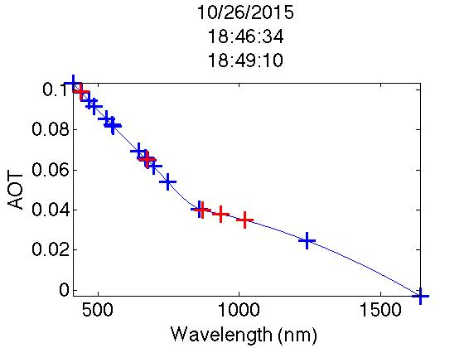

10/26/15

18:46:34 -18:49:10

Wavelength (nm)

AOT (Tau)

Figure 5: Remote sensed image of chlorophyll- a captured during the diversion by Landsat-8, OLI. (A) Default atmospheric correction algorithm. (B) Atmospherically corrected image using AOT values extrapolated from the Microtops instrument (Wavelengths 433, 482, 561, 655, 865, 1610, and 2201 nm.)

Figure 4: Remote sensed image of chlorophyll-a captured during the diversion by Suomi-NPP, VIIRS. (A) Default atmospheric correction algorithm. (B) Atmospherically corrected image using AOT values extrapolated from the Microtops instrument (Optical wavelengths 410, 443, 486, 551, 671, 745, and 862 nm.)

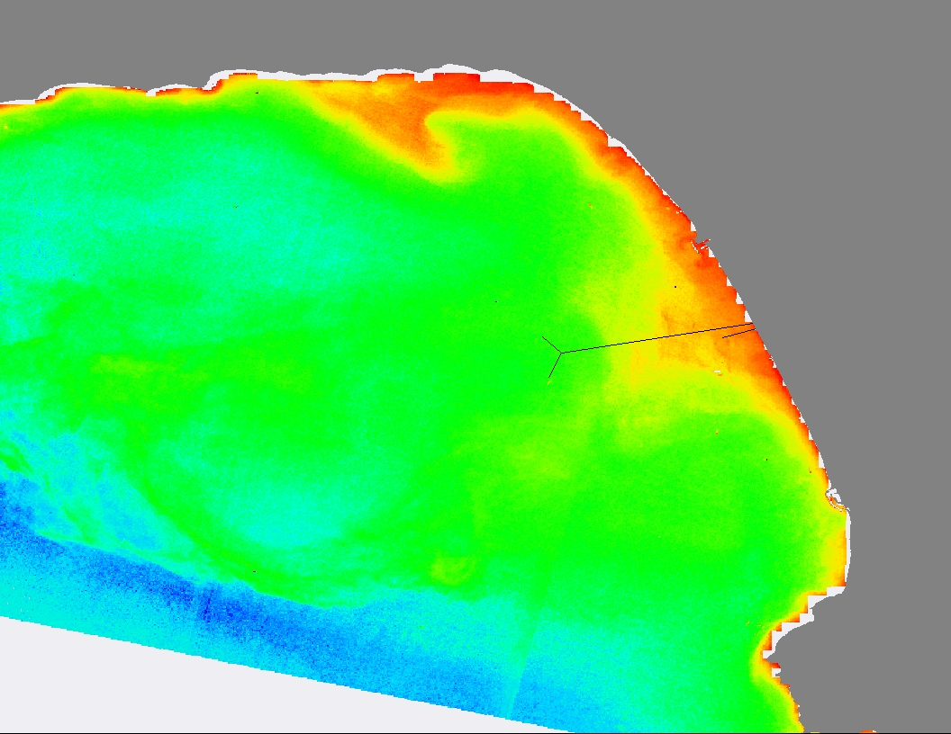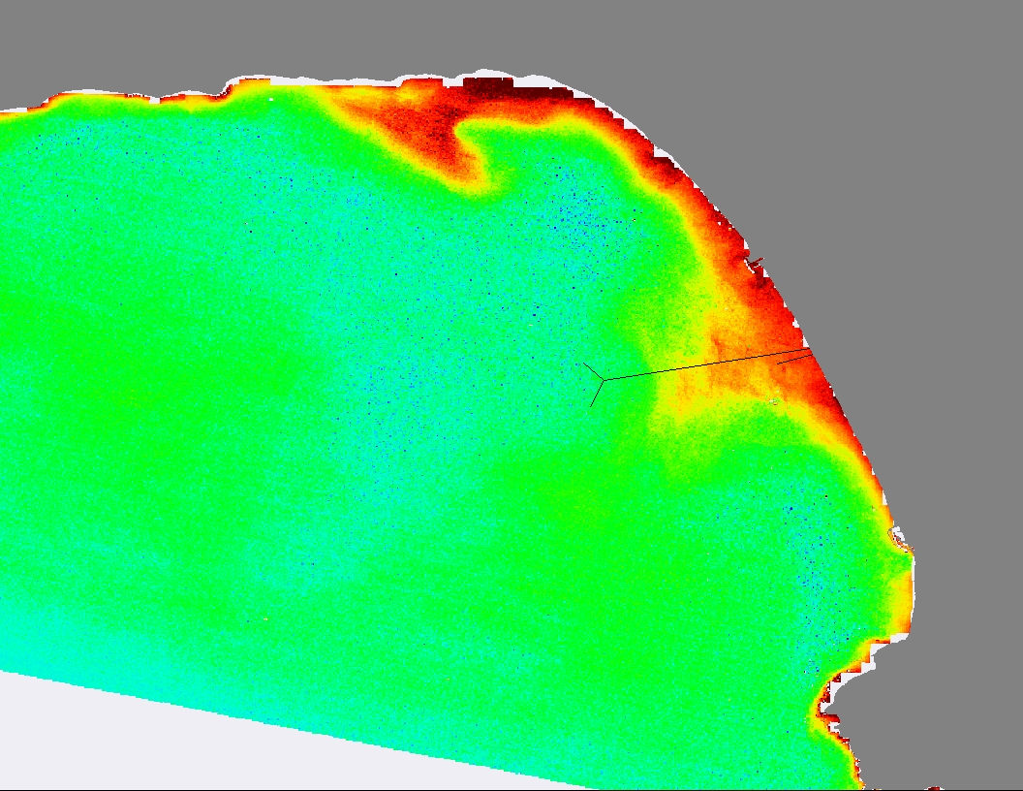

(B)

(A)

Landsat-8

Sept. 24, 2015

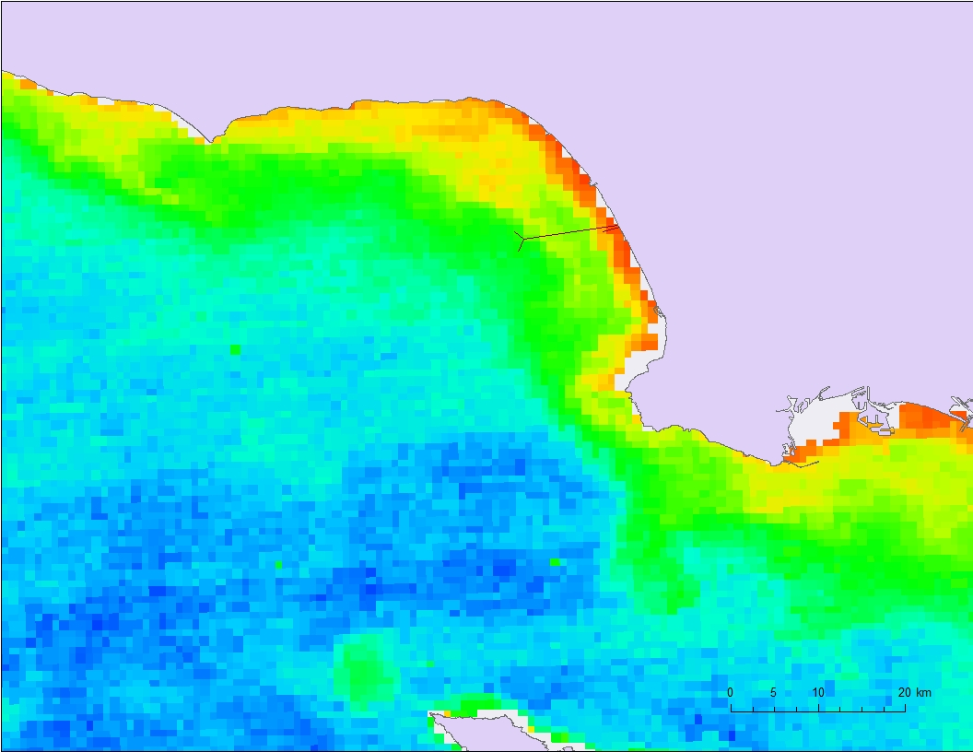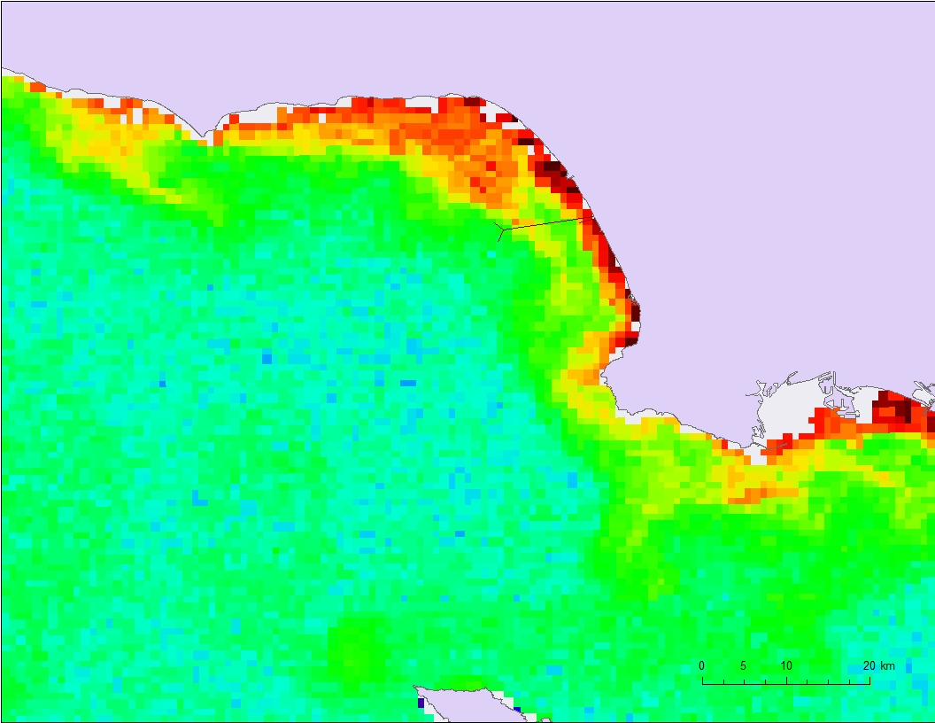

(A)

(B)

Suomi-NPP VIIRS

November 11, 2015

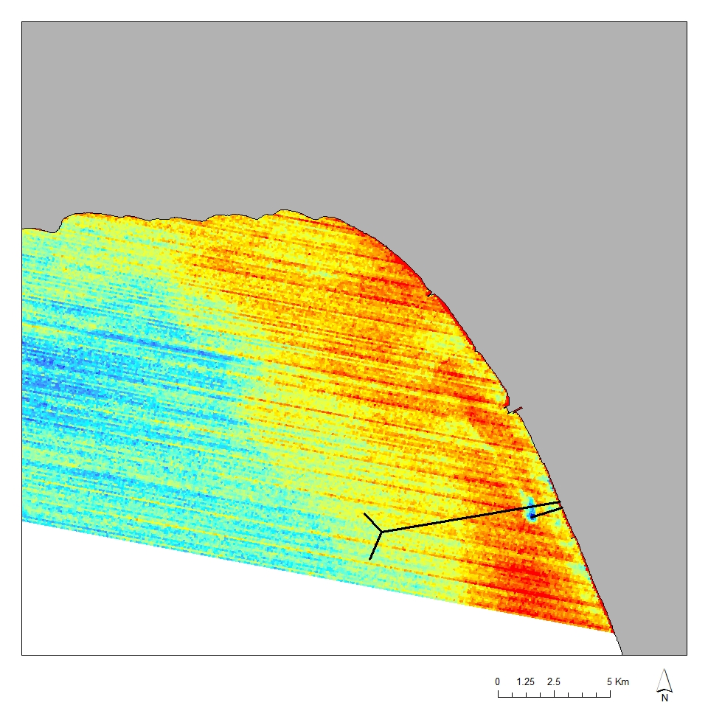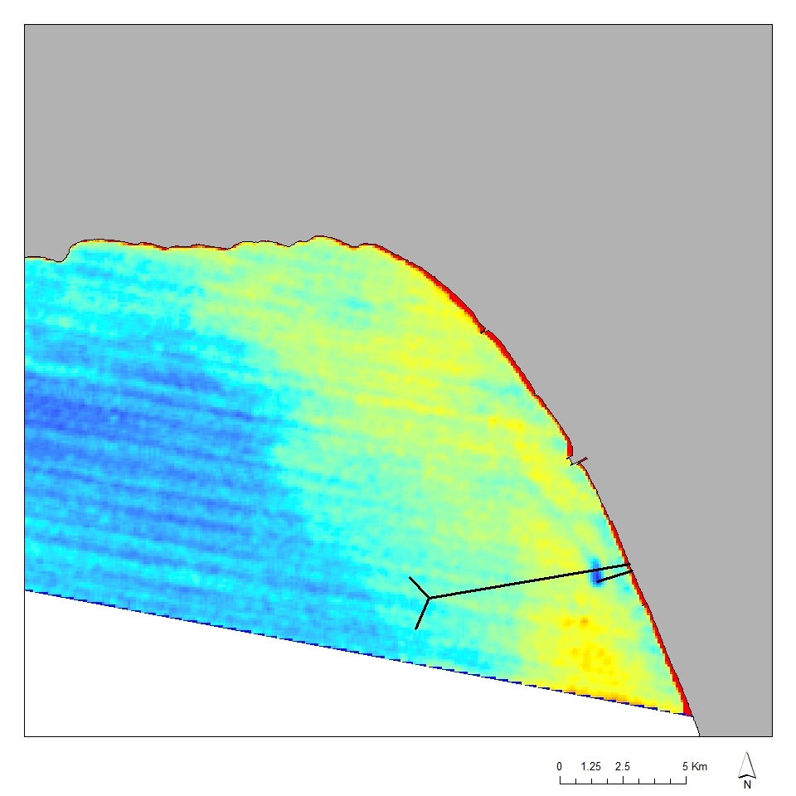

(B)

(A)

Terra, ASTER

Oct. 2, 2015

Figure 6: Remote sensed image of SST captured during the diversion by Terra, Aster’s thermal bands. (A) Default atmospheric correction algorithm. (B) Atmospherically corrected image.

Figure 7: Surface chlorophyll-a data obtained by USC, plotted on top of the chlorophyll MODIS image. The measured values are higher than those detected by MODIS, but the general trend holds true.

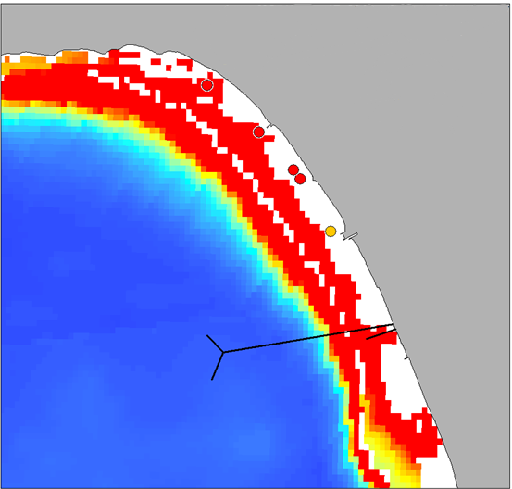

Aqua, MODIS

Oct. 17, 2015

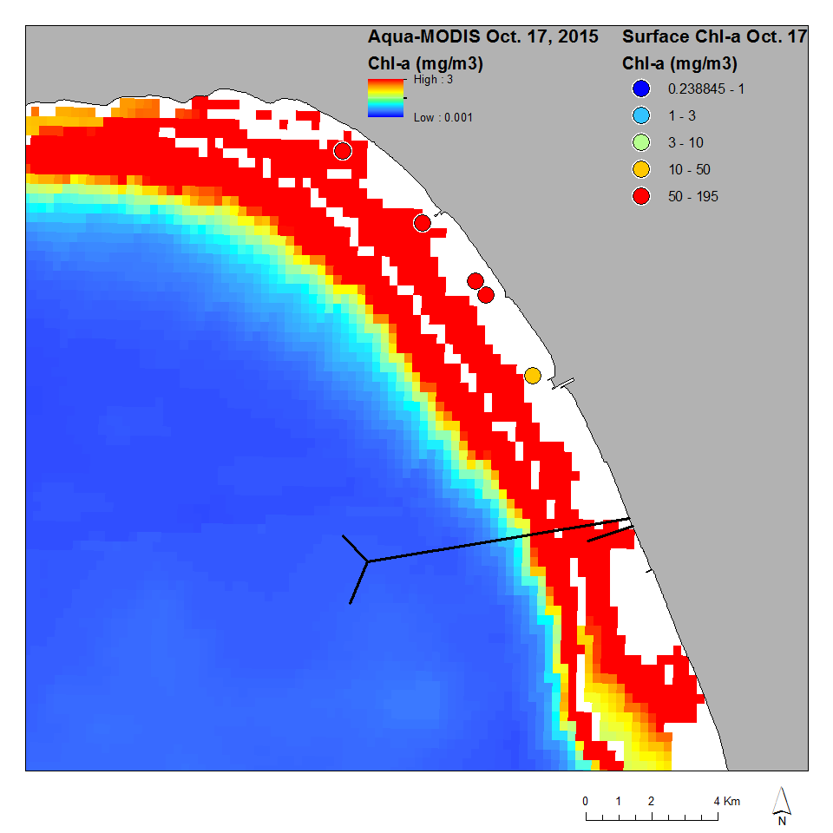

Figure 8: Chlorophyll-a data acquired from Aqua MODIS, (A) with *in situ* CTD flourometer data plotted on top. (B) CTD data is adjusted using the phytoplankton chemistry chlorophyll values using a linear regression model.

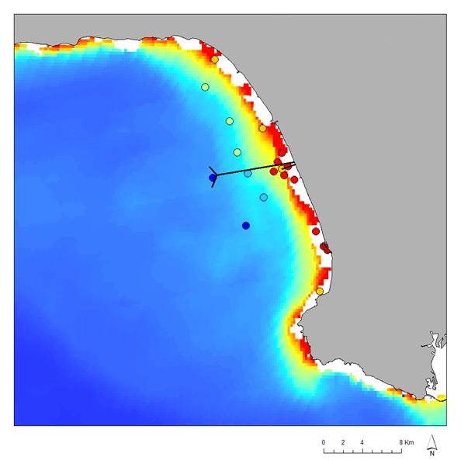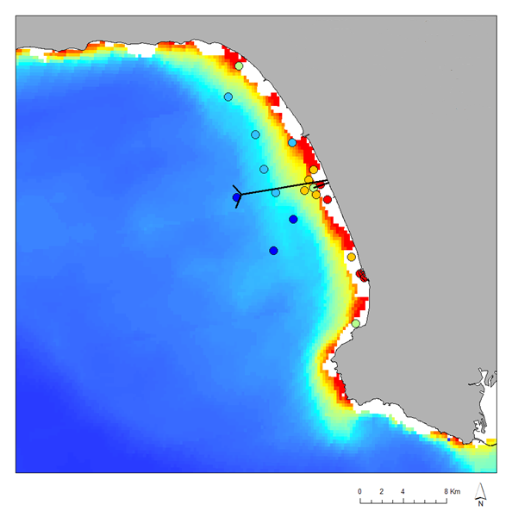

Aqua, MODIS

Oct. 22, 2015

(A)

(B)

**Adjusted**



CTD

Terra, ASTER

Oct. 2, 2015

**BEFORE**

Landsat-8

Sept. 24, 2015