**NASA DEVELOP National Program**

 NASA Goddard Space Flight Center

**Fall 2015**

**Short Title: Montana Ecological Forecasting**

**Subtitle:** Utilizing NASA Earth Observations to Forecast the Effects of Climate Change on Northern Goshawk Nesting Habitat

**VPS Title:** Forecasting Northern Goshawk Nesting Sites, One Model at a Time

**Project Team & Partners**

**Project Team:**

Erika Higa (Project Lead), erika.y.higa@nasa.gov

Sean McCartney

Amanda Clayton

**Advisors & Mentors:**

Dr. Ross Nelson (NASA GSFC)

Dr. John Bolten (NASA GSFC)

**Partner Organizations:**

USDA Forest Service (End-User), POC: Victor Murphy

Oulu University Researchers (End-User & Boundary Organization), POC: Nate Bickford

University of Nebraska at Kearney (Collaborator & Boundary Organization), POC: Nate Bickford

**Project Details**

**Applied Sciences National Applications Addressed:** Ecological Forecasting

**Study Area:** Lewis and Clark National Forest, MT

**Study Period:** February 1985 – June 2015

**Earth Observations & Parameters:**

Landsat 8, OLI – Land Cover Classification

SRTM – Digital Elevation Model

TRMM, TMI – Precipitation Measurements

GPM, DPR/GMI – Precipitation Measurements

**Ancillary Datasets Utilized:**

* USDA Forest Service, Region 1 Aerial Insect and Disease Detection Survey (ADS) - Mountain Pine Beetle Infestation Data
* USDA Forest Service, 2012 National Insect and Disease Risk Maps/Data - Mountain Pine Beetle Infestation Projections 2013 - 2027
* USDA Forest Service, Region 1 Existing Vegetation Map Products (VMap) - Vegetation Data
* USDA Forest Service, IW-FIA Predicted Forest Attribute Maps - Vegetation Data
* USDA Forest Service, Timber Harvests - Timber Harvest Data
* Landscape Fire and Resource Management Planning Tools Program (LANDFIRE), Existing Vegetation Height - Vegetation Data
* Landscape Fire and Resource Management Planning Tools Program (LANDFIRE), Mean Fire Return Interval - Fire Regime Data
* Nate Bickford, Northern goshawk nest habitat locations - Nest Data
* Laura Conway, USDA Forest Service, Northern goshawk nest habitat locations - Nest Data

**Models Utilized:**

* Goddard Institute for Space Studies ModelE/Russell Model (GISS-E2-R)
* AT&T Research, Maximum Entropy for Habitat Suitability Modeling (Maxent)
* Clark Labs, Mahalanobis Typicality for Habitat Suitability Modeling
* Alexandre Hirzel, BioMapper for Habitat Suitability Modeling (BioMapper)

**Software Utilized:**

ArcGIS – Raster manipulation/analysis, image enhancement

BioMapper – Habitat suitability analysis and modeling

Maxent – Habitat suitability analysis and modeling

TerrSet – Landcover classification, raster manipulation/analysis, habitat suitability analysis and modeling

**Project Overview**

**80-100 Word Objectives Overview:**

This project explored the capability of using NASA Earth observations to forecast the effects of climate change on the nesting habitat of the northern goshawk (*Accipiter gentilis*) in the Lewis and Clark National Forest, Montana. The team examined different environmental variables that directly influence northern goshawk nesting habitat and determined areas that are most suitable for nesting using multiple habitat suitability modeling software. Additionally, future climate trends were analyzed to forecast and understand the effects of potential mountain pine beetle encroachment on goshawk habitat by the year 2050.

**Abstract:**

The northern goshawk (*Accipiter gentilis*) is currently identified as both a Sensitive Species and a

Management Indicator Species in the Lewis and Clark National Forest (LCNF) land and resource management plans. Goshawks are important top-tier predators in the LCNF and changes in the forest habitat greatly affect their survival and population. We examined the potential of using NASA Earth observations to locate and model suitable nesting habitat for the goshawk. Currently, Nate Bickford and the US Forest Service (USFS) do not use remote sensing to identify or forecast goshawk nesting habitat, and the tools they use are limited to topographic maps and *in situ* data. We identified various environmental variables measured by Landsat 8 Operational Land Imager (OLI), Shuttle Radar Topography Mission (SRTM), TRMM Precipitation Radar (PR), and GPM Dual-frequency Precipitation Radar/Global Microwave Imager (DPR/GMI). These derived variables, along with ancillary vegetation data, were input into several habitat suitability models, using BioMapper, Maxent, and Mahalanobis Typicality, and a consensus map was made to identify areas of suitable habitat for nesting goshawks. Timber management, fire frequency, and mountain pine beetle risk were used as ancillary data to determine the likelihood of available nesting habitat for the future under different climate change scenarios. The Goddard Institute for Space Studies ModelE/Russell Model was used in forecasting different climate change scenarios. The results from this project will augment current decision making practices in forest management in the LCNF and assist in understanding how climate change will affect the goshawk nesting habitat in the future.

**Community Concerns:**

* Northern goshawks are a top-tier predator and serve as a bioindicator of ecosystem health. As climate change causes a change in forest habitat and insect blight, this negatively affects goshawk nesting sites.
* Mountain pine beetle outbreak infects trees where goshawks commonly nest, and hotter and drier summers and milder winters spur this infestation.
* Cold wet springs can delay the timing when goshawks lay their eggs and this can be fatal to the survivorship of fledglings when they hatch at later months than usual.

**Current Management Practices & Policies**:

Under Montana’s State Wildlife Action Plan (SWAP), the northern goshawk, and its associated habitat, are identified as a species and community type of “Greatest Conservation Need”. The goshawk is also listed as a sensitive species in all National Forests and on all Bureau of Land Management lands and is designated as a Montana Species of Concern. Current monitoring protocols within the Lewis and Clark National Forest are unable to accurately estimate goshawk population size and trend. Because of a lack of baseline population data, there is not a species-specific management plan. General vegetation management practices within the forest, including increased timber harvest, can negatively impact available nesting habitat. The end-users for this project, Nate Bickford and the US Forest Service, currently do not utilize remote sensing methods to analyze and forecast goshawks nesting sites. Instead, they conduct time-consuming field observations of nest site locations and surrounding vegetation characteristics.

**Decision Support Tools & Benefits:**

|  |  |  |
| --- | --- | --- |
| **End-Product** | **Earth Observations Used** | **Benefit & Impact** |
| Habitat suitability model | Landsat 8 OLI; GPM DPR/GMI; Terra/Aqua MODIS | Three separate habitat suitability models will provide new methodologies for end-users to locate new nesting areas in order to better monitor goshawk distributions in the LCNF. |
| Habitat suitability maps | Landsat 8 OLI; Terra/Aqua MODIS | These maps will help conservation researchers to find potentially new nesting sites in order for them to better monitor goshawk distributions in the LCNF. The identified suitable habitats in these maps will also help forest managers decide on best forest management practices. |

**Project Imagery**

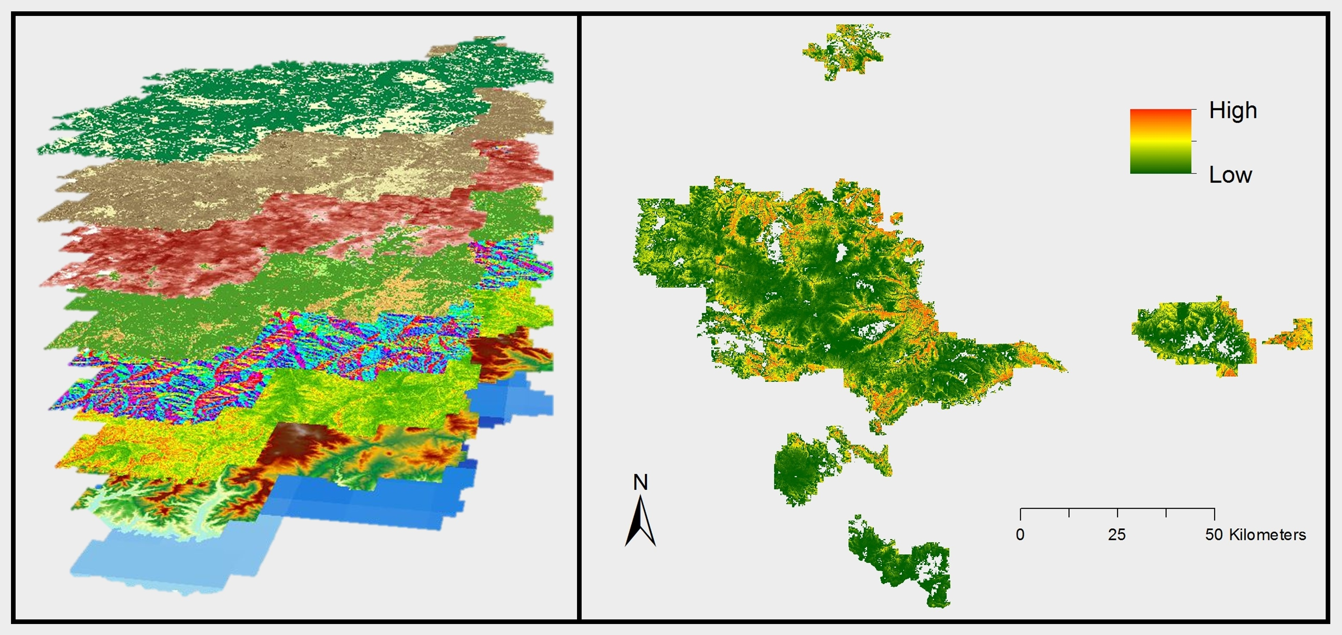

**Caption:** Environmental layers used in the habitat suitability models (left). Consensus habitat suitability map for the northern goshawk in the Lewis and Clark National Forest (right). Image Credit: Montana Ecological Forecasting Team.

**Image:** 2015Fall_GSFC_MTEcoForecasting_VPS_Image.jpg

**Software Release Requirements**

What category do the tools your project is creating fall within? Category I