Apostle Islands Water Resources

Mapping Sediment Plumes and Algal Blooms using Earth Observations at the Apostle Islands National Lakeshore

 **Technical Report**

Final Draft – November 21st, 2019

Sarah Wingard (Project Lead)

Lea Davidson

Erin Johnson

Brandy Nisbet-Wilcox

Kristen Dennis

Dr. Paul Evangelista, Colorado State University, Natural Resource Ecology Laboratory (Science Advisor)

Dr. Catherine Jarnevich, United States Geological Survey, Fort Collins Science Center (Science Advisor)

Tony Vorster, Colorado State University, Natural Resource Ecology Laboratory (Science Advisor)

Nicholas Young, Colorado State University, Natural Resource Ecology Laboratory (Science Advisor)

Peder Engelstad, Colorado State University, Natural Resource Ecology Laboratory (Science Advisor)

# 1. Abstract

Perceived increases in the occurrence of sediment plumes and algal blooms following storm events have raised concerns about water quality within western Lake Superior. Increases in algal productivity and suspended sediment concentration may have negative impacts on wildlife, human health, and recreation. Altering phenomena are of critical concern for the Water Resources Division of the National Park Service (NPS). Researchers at the NPS and the University of Minnesota Duluth, Large Lakes Observatory (UMD LLO) first identified algal blooms in western Lake Superior in 2012. They currently only incorporate Moderate Resolution Imaging Spectroradiometer (MODIS) Earth observations in a limited capacity, but to this point have not been utilizing MODIS in conjunction with *in situ* data. The Apostle Islands Water Resources team partnered with the NPS and UMD LLO to develop a methodology utilizing Aqua MODIS, Terra MODIS, and Sentinel-3 Ocean and Land Colour Instrument (OLCI) observations to better understand the dynamics of sediment plumes and algal blooms within western Lake Superior during summer months (June to August) from 2011 to 2019. Results indicated success in incorporation of remote sensing technology for the detection of sediment plumes and the potential for the remote detection of algal blooms with expanded field data collection. The use of Earth observations will aid project partners in implementing effective mitigation strategies and improving public communication surrounding issues of water quality within the Apostle Islands National Lakeshore.

**Keywords**

chlorophyll-a, turbidity, transmissivity, Aqua/Terra MODIS, Sentinel-3 OLCI EFR, western Lake Superior, water quality, remote sensing

# 2. Introduction

* 1. ***Background Information***

Perceived increases in the frequency and severity of sediment plumes and algal blooms have raised concern for recreation, water quality, and the overall health of aquatic ecosystems within western Lake Superior and the Apostle Islands National Lakeshore. Recent changes in local precipitation patterns are perceived to augment these phenomena, though this relationship is not yet fully understood. From qualitative observations, sediment plumes appear to precede algal blooms by several weeks, implying to researchers at the National Park Service (NPS) and University of Minnesota Duluth, Large Lakes Observatory (UMD LLO) that a relationship exists between these phenomena within western Lake Superior. The threats these events pose to ecological functioning warrant deeper exploration of the dynamics of this lake system.

Sediment plumes are comprised of suspended organic and inorganic material and nutrients, which at a high enough concentration decrease transmissivity and light penetration within the water column (Minor, Forsman, & Guildford, 2014). Heavy rain events may exacerbate coastal erosion and plume events driven by sediment runoff into the St. Louis and Nemadji River tributaries (Cooney, McKinney, Sterner, Small, & Minor, 2018). The suspended sediment of plumes decreases solar penetration in the water column as suspended particles absorb and scatter light. Reduced light penetration lowers the amount of sunlight available for benthic photosynthesizers (Donohue & Molinos, 2009). In addition, sediment plumes carry excess nutrients such as nitrogen and phosphorus from agricultural and urban lands bordering rivers within the Great Lakes system. (Michalak et al., 2013). Excess nutrients and suppressed photosynthetic activity within the water column create an ideal environment for algal populations to rapidly increase, potentially resulting in blooms with cascading effects on the aquatic ecosystem (Schindler, Carpenter, Chapra, Hecky, & Orihel, 2016). Qualitative observations have seen an increase in frequency of these events since *in situ* monitoring began in 2014 by the NPS and UMD LLO (Lafrancois, 2018).

Within the Great Lakes system, previous studies have observed algal blooms blanketing the water’s surface, decreasing photosynthetic ability of other organisms and disproportionately using oxygen (Ho & Michalak, 2015; Watson et al., 2016). In severe blooms, algae can create dead zones in which available oxygen decreases to levels where other organisms can no longer survive. Certain phylum of algae, specifically cyanobacteria, produce toxins that are harmful to both humans and wildlife (Ho & Michalak, 2015). Blooms within western Lake Superior have been observed to last one to two weeks, sometimes spanning the entire shoreline from Twin Ports of Duluth to the Apostle Islands Lakeshore (90 km). These blooms have also been observed to extend approximately 0.5 kilometers from shore. Such algae pose safety concerns for public drinking water resources, recreation, and native aquatic species. Water quality monitoring is therefore a critical concern within western Lake Superior.

Past research has utilized space-borne sensors to detect the presence of both sediment plumes and algal blooms within lake systems. Chlorophyll-a, the main pigment present in green algae species, serves as a good indicator of potential algal bloom events. Trescott et al. (2013) employed chlorophyll-a indices with Landsat 7 TM satellite imagery to detect and map algal bloom presence over Lake Champlain in Vermont, and band ratio indices have been used to detect and classify algal blooms over Lake Erie with Landsat 8 OLI imagery (Ogashawara, Li, & Moreno-Madriñán, 2016). Additionally, sediment plumes can be detected remotely, as sediment within the water column can cause an increase in spectral response in surface waters in the visible portion of the electromagnetic spectrum. Kaba et. al. (2014) found great success in quantifying sediment plumes by incorporating band math to detect total suspended sediment within large lake systems in Ethiopia. The use of remote sensing in water quality monitoring efforts can provide critical information about these phenomena such as their extent, duration, and changes over time. Remotely sensed satellite data can permit long term temporal studies of such events and aid public policy makers and land managers in effective adaptation and mitigation strategies.

***2.2 Objectives***

The goal of this project was to assess the feasibility of monitoring sediment plume and algal bloom presence, extent, and duration using remote sensing. First, the suitability of different satellites was evaluated to determine which were the most appropriate for this study. The secondary objective was to determine the most effective indices for remote detection of sediment plumes and algal blooms using transmissivity and chlorophyll-a proxies for water quality. Lastly, a model was generated to map sediment plumes in the western arm of Lake Superior. The incorporation of remote sensing in water quality monitoring may provide key information on where these events are most likely to occur in Lake Superior, their frequency, and how their severity has changed throughout time.

***2.3 Study Area & Project Partners***

Lake Superior is the largest freshwater lake in the world by surface area, encompassing 31,700 square miles and reaching depths of 406 meters. Lake Superior is also the largest, deepest, and coldest of the five Great Lakes (University of Missouri Kansas City, 2019).  Located in the Laurentia bioregion, glacial till and red clays comprise Superior’s lake floor, a color resulting from high levels of iron oxides (Andrews, Houtman, Lontz, Christensen, & Wilson, 1979). Coastal cliffs within western Lake Superior are composed primarily of clay and some exposed bedrock, a lithology which likely plays a central role in regional erosion (Johnson & Johnston, 1995).  The Apostle Islands National Lakeshore (*Figure* *1*) spans 69,372 acres of shoreline and includes 22 islands along the northern tip of Wisconsin in the western arm of Lake Superior (National Park Service, 2015).

The natural and historic objects, wildlife, and scenery of the Apostle Islands National Lakeshore exist within a federally protected area and are conserved under the National Park Service Organic Act of 1916. Partners on this project include researchers at the NPS and UMD LLO who collaborate to conduct scientific research aimed at protecting ecosystem health and recreational areas within the Great Lakes. Due to their proximity to Lake Superior and their professional mission, UMD LLO is heavily involved in the study of natural phenomena within the Great Lakes system, and by extension, threats to the Apostle Islands National Lakeshore.

Researchers from the NPS and UMD LLO began monitoring plume and bloom phenomena in 2014. Researchers have collected *in situ* data of chlorophyll-a concentrations and total organic/inorganic carbon with the research vessel, the Blue Heron. Partners have explored Moderate Resolution Imaging Spectroradiometer (MODIS) Earth observations in a limited capacity, but have not utilized MODIS in conjunction with *in situ* data.

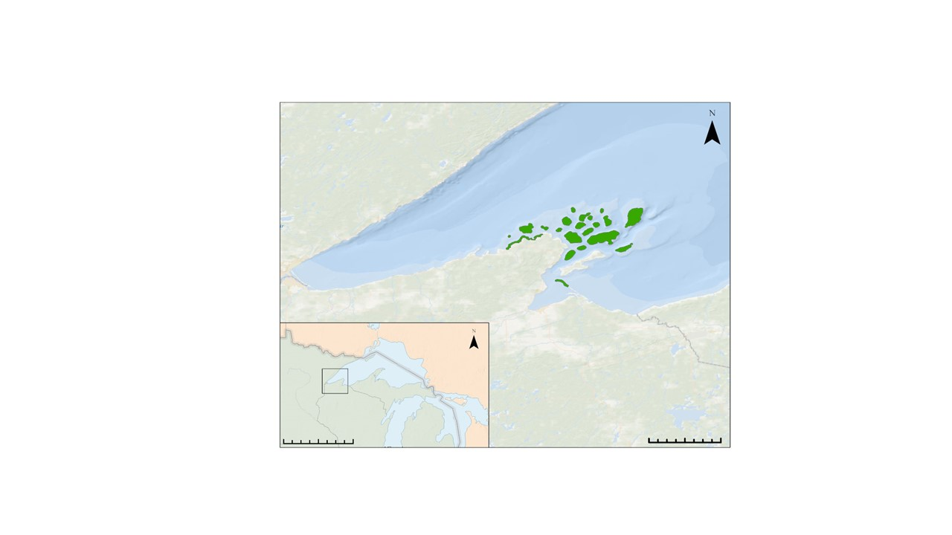

Apostle Islands National Lakeshore

# 

Minnesota

Apostle Islands National Lakeshore

Wisconsin

Michigan

600

300

0

40

20

0

*Figure 1*. Study area including western arm of Lake Superior and the Apostle Islands National Lakeshore, sharing coastline with the states of Minnesota, Wisconsin, and Michigan. Map created using ArcGIS Pro.

# 3. Methodology

* 1. ***Algal Blooms***

*3.1.1 Remote Sensing Data*

Initial satellite imagery exploration included Aqua/Terra MODIS, Landsat 8, Sentinel-2 MSI, and Sentinel-3 Ocean and Land Cover Instrument (OLCI) Earth Observation Full Resolution (EFR). Project partners provided dates of suspected algal blooms that were used as a reference when searching for satellite imagery in Google Earth Engine (GEE) (*Table A1*). Available imagery from all proposed sensors was explored within 1-4 weeks of these dates, with all suitable, cloud free satellite imagery compiled into a document for partner referral. The Aqua/Terra MODIS sensors produced the most available imagery, with a revisit time of 1-2 days, but were determined to be inappropriate for studying algal blooms because the 500 meter to 1 kilometer spatial resolution would prevent reasonable observations of this nearshore phenomena. Both Landsat 8 OLI and Sentinel-2 MSI had finer spatial resolution, but imagery did not cover the full study area and had infrequent flyover around observed bloom dates. Sentinel-3 OLCI EFR imagery was ultimately chosen for its moderate spatial resolution of 300 meters, allowing for nearshore detection, and temporal resolution of two days.

*3.1.2 In Situ Data*

Dr. Liz Minor from UMD LLO provided passive and active *in-situ* chlorophyll-a measurements. Passive measurements were obtained from the under-belly of the Blue Heron during cruises. Though chlorophyll-a measurements were collected every six seconds, data was collected off-shore and was not within known bloom events. The active chlorophyll-a measurements were intentional samplings collected at repeated locations. However, the dataset provided did not include samples from bloom events. Both the active and passive *in situ* data contained very low chlorophyll-a values ranging from 1.8-6.8 μg/L, indicative of non-bloom conditions. The absence of near-shore collection points coupled with extremely low chlorophyll-a measurements made it infeasible to correlate partner field data with satellite imagery.

*3.1.3 Case Study*

# Partners at the NPS observed and described a large algal bloom that spanned 90 kilometers from Cornucopia Beach to the Apostle Islands on August 9, 2018. Partners indicated that the bloom likely started several days before August 9, 2018 (on or around August 5, 2018) and was observed lingering until approximately August 14, 2018. Relatively cloud-free Sentinel-3 OLCI EFR satellite imagery was available in GEE before, during, and after the bloom event. Sentinel-3 OLCI EFR images were therefore utilized in GEE to investigate algal bloom presence and absence via remote sensing techniques.

Indices were first compiled from literature focused on chlorophyll-a detection within similar large-lake systems (*Table 1*). Four indices were then applied to Sentinel-3 OLCI EFR images before, during, and after the bloom event to visually evaluate changes near the shoreline. When viewing an output index in GEE, the default stretch does not accurately display data; flawed visualization parameters can lead to misinterpretation of output data. Index visualization parameters within GEE were thus standardized across the before, during, and after images to avoid the generation of misleading imagery. A green to blue color ramp was applied to output indices. Green pixels represented areas with high chlorophyll-a values, and blue pixels represented areas with low chlorophyll-a values, with intermediately colored pixels representing areas with intermediate chlorophyll-a values. For the purpose of this study, green pixels near the shoreline were interpreted as potential algal blooms, although given Sentinel-3 OLCI EFR’s coarse spatial resolution, mixed pixels and edge effects may introduce some uncertainty. Next, a slideshow was created with images ordered by date to allow for direct comparison of areas with green pixels. The four band ratio indices were qualitatively compared across dates to detect differences in chlorophyll-a presence and to identify the index which best reflects project partners’ description of the bloom extent and location.

An image differencing technique was then applied to strengthen our qualitative assessment of algal bloom presence and absence. Image differencing is a simple change detection technique in which images of two different dates are subtracted to generate an output that shows changes in land use/land cover. A Sentinel-3 OLCI EFR satellite image obtained before the algal bloom on July 7, 2018 was subtracted from an image acquired near the algal bloom date on July 31, 2018. The output image displayed blue and pink areas hugging the coastline. This revealed areas of potential change, or areas interpreted as an algal bloom forming and receding.

Table 1

*Algal bloom indices applied in GEE*

|  |  |  |
| --- | --- | --- |
| **Sensor** | **Index** | **Algorithm** |
| Sentinel-3 OLCI EFR | Toming1 | B8/ B11 |
| Toming2 | B8/ B12 |
| Toming3 | B9/ B11 |
| Toming4 | B9/ B12 |

***3.2 Sediment Plumes***

*3.2.1 Remote Sensing Data*

Investigation of remote sensing data for sediment plumes included the NASA Earth Observing satellite sensors Aqua MODIS, Terra MODIS, and Landsat 8 Operational Land Imager (OLI) in GEE. Temporal resolution and spatial resolution were the two main attributes used to determine which satellite sensors were utilized in subsequent analysis, further influenced by weather and availability of cloud free imagery on dates of interest. Aqua MODIS and Terra MODIS were ultimately selected for their fine temporal resolution of daily pass overs, appropriate spatial resolution of 500 meters, and highest number of cloud free images. Exploration of satellite imagery in dates surrounding notable precipitation events with high river flows were carried out within GEE, with imagery from dates one day prior and two weeks following precipitation events (*Table A2*). Suitable imagery was compiled into image collections for project partner perusal. It is important to note that smaller, more localized sediment plumes are often present within western Lake Superior. This study, however, is concerned with understanding larger, potentially climatically driven plume events.

*3.2.2 In situ Data*

Dr. Liz Minor at the UMD LLO provided *in situ* transmissivity data from the study area, collected passively during cruises with the Blue Heron research vessel. Transmissivity is a measure of the amount of light (at 254 nm) able to pass through a water sample, provided to us as a percentage. Dr. Minor defined plume presence as values less than 75%, and plume absence as values greater than 75%. Project partners supplied two dates with transmissivity field data corresponding to plume events: June 18, 2019 and July 2, 2019. These dates became the focus of our sediment plume analysis, comprised of transects of presence and absence, with 415 points on June 19th and 61 points on July 2nd, spaced at least 500 meters apart.

During data processing, it became apparent that the July 2, 2019 field data would likely be unusable. Corresponding satellite imagery from this date demonstrated a strange pattern with many black pixels in what seemed to be satellite error. This resulted in pixels with no values which prevented comparison to field data and analysis. This resulted in a shifted focus to the June 19, 2019 event exclusively.

*3.2.3 Case Study*

A significant sediment plume was noted by project partners on June 18, 2019 in the western arm of Lake Superior. Satellite imagery on this day proved cloudy and unusable, but the western arm of the lake was visible in imagery from June 19th, 20th, and 22nd. Satellite imagery was kept within four days of the initial plume observation for relevance, as phenomena can change rapidly.

Indices were initially compiled from available literature involving turbidity analysis within similar large bodies of water and suspended sediment studies (*Table 2*). Eighteen indices were ultimately compiled using both Aqua and Terra MODIS. Compiled plume indices were next input as functions into GEE, applied to Aqua/Terra MODIS imagery, and index values at transect points were exported as values into a CSV file. Before proceeding with statistical analysis, an initial visual inspection was performed to determine which indices appeared most effective in detection of nearshore sediment plumes.

In quantifying sediment plumes, Spearman’s correlation (*Equation 1*), a statistical measure of correlation between two ranked variables, was applied in comparison of index values and transmissivity values for plume presence and absence.

$$ρ=1-\frac{6\sum{d^{2}}}{n(n^{2}-1)}$$

Spearman’s correlation represents the rho value (measuring the strength of the relationship between two variables), d represents the difference in paired ranks, and n represents the number of cases. This statistical test produced a correlation coefficient between -1 and +1, with values closer to +1 indicating a strong positive monotonic relationship and values closer to -1 indicating a strong negative relationship. A value of zero indicates no correlation. Index values extracted from a satellite image of June 19, 2019 were correlated to *in situ* transmissivity values obtained on June 18, 2019. Top performing indices displayed high positive and negative correlation coefficients, indicating their success in identifying sediment plume presence and absence from satellite imagery within the study area. A Spearman’s correlation was further used in RStudio to evaluate the correlation between indices which reduced model redundancy.

(1)

A random forest classification algorithm was then used in RStudio to create a model from the top three performing indices. Random forest is an ensemble learning method for classification through the construction of a large number of decision trees. In the creation of our model, we had random forest take in a variety of predictors, specifically 18 different indices. Variable Selection Using Random Forest (VSURF) was then run, ordering our predictors by the degree of importance and impact to the model and reducing redundancy. From this, the top six indices were selected and used to train and run 500 decision trees in a continuous model. These top six indices were compared against one another in regards to their correlation to transmissivity data as well as one another. From this, our top three indices were selected, with minimal relationship to one another (low Spearman’s correlation) and strong relationship to the transmissivity data (high Spearman’s correlation). After identification of the top three performing indices, the random forest model was transferred to GEE and applied to the buffered study area shapefile for mapping. A fusion table was created in GEE incorporating the sampling locations and transmissivity values collected by the Blue Heron on June 18, 2019. The top three performing indices were run in GEE on Aqua/Terra MODIS imagery for June 19, 2019. Index outputs were then stacked and sampled to include the latitude, longitude, and transmissivity values of the fusion table to train the random forest model. The random forest model was used to generate a prediction map of transmissivity values across the western arm of Lake Superior. The prediction map was exported as an image and reclassified in ArcGIS Pro for a binary display of presence or absence of a plume. Predicted values greater than 75% were classified as absence and values less than or equal to 75% were considered presence.

Table 2

*Sediment plume indices utilized in GEE*

|  |  |  |
| --- | --- | --- |
| **Sensor** | **Index** | **Algorithm** |
| Terra MODIS | Kaba1 | 2371 * (B2) - 62.8 |
| Moreno1 | B1 |
| Wang1 | B1 + B2 |
| Wang2 | B2 + B5 |
| Wang3 | B2 + B6 |
| Wang4 | B2 - B1 |
| Wang5 | B2 - B5 |
| Wang6 | B2 - B6 |
| Wang7 | B2/ B1 |
| Wang8 | (B2 - B5) / (B1 - B5) |
| Wang9 | (B2 - B6) / (B1 - B6) |
| Aqua MODIS | Hamidi1 | TSS = 1.6355e (.7402 * B1) |
| Hamidi2 | Turbidity = 1.1627e^(.778 * B1) |
| Petus1 | TSM = 12450(B1)^2 + 666.1(B1) + .48 |
| Petus2 | Turbidity = 26110(B1)^2 + 604.5(B1) + .24 |
| Wang2_1 | -1.91 * 1140.25(B1) |
| Wang2_2 | SSC = e^((43.233*B2) + 1.369) |
| Wang2_3 | TSS = (13181 * B1 *2) - (1408.6 * B1) + 44.15 |

# 4. Results & Discussion

* 1. ***Algal Blooms***

*4.1.1 In situ Data*

The lack of i*n situ* data from algal bloom events within western Lake Superior limited quantitative analysis of these phenomena with remotely sensed imagery. Strictly qualitative conclusions were made for algal bloom events using chlorophyll-a detecting indices, Sentinel-3 OLCI EFR imagery, and image differencing.  Incorporation of *in situ* chlorophyll-a data would likely allow qualitative understandings to become quantitative correlations.

*4.1.2 Case Study*

In looking at the Toming 2 index output for the July 7, 2018 image prior to the bloom, few green pixels were observed along the shoreline. On August 11, 2018 during the bloom, the number and extent of green nearshore pixels increased significantly along the entire northern shoreline. Following the bloom date, the image from August 30, 2018 showed a recession and decrease in extent of green pixels along the shoreline. This lack of green pixels before the described bloom date, followed by an increase on the bloom date, and subsequent decrease after the bloom date matches well with partner descriptions of the event dynamics and location. This indicates that the most visually appealing index, Toming 2, may be detecting algal bloom activity along the coastline (*Figures 3.1, 3.2, & 3.3*).  It is important to note that Toming 2 was selected for visual analysis because its output displayed the brightest pixels, however all the simple band ratio indices explored displayed similar patterns.

Moreover, our differenced image reinforces that there are changing phenomena present along the coastline. The bright blue and pink pixels hugging the northern coastline are interpreted as changing algal bloom extents (*Figure 4*). Because image differencing is a strictly qualitative remote sensing technique, our interpretation needs to be taken with caution.

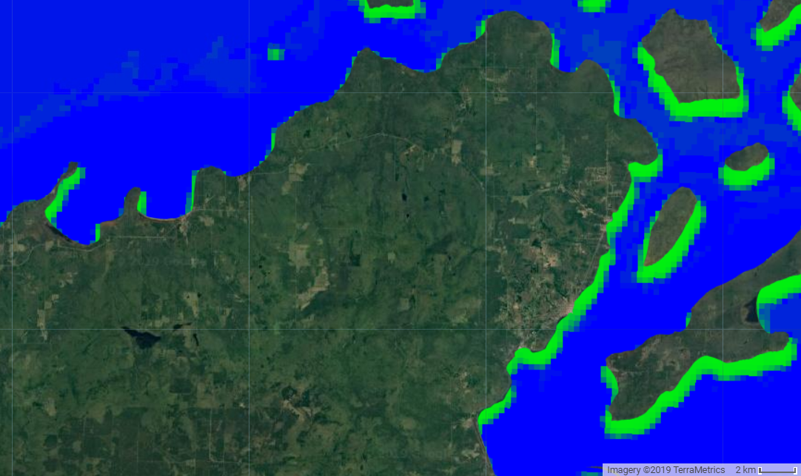

Low Chlorophyll-a Values

High Chlorophyll-a Values

*Figure 3.1* Index output of a Sentinel-3 OLCI EFR image in GEE featuring the Apostle Islands National Lakeshore before bloom July 7, 2018. Note very few green pixels nearshore from Cornucopia Beach to the Apostle Islands.

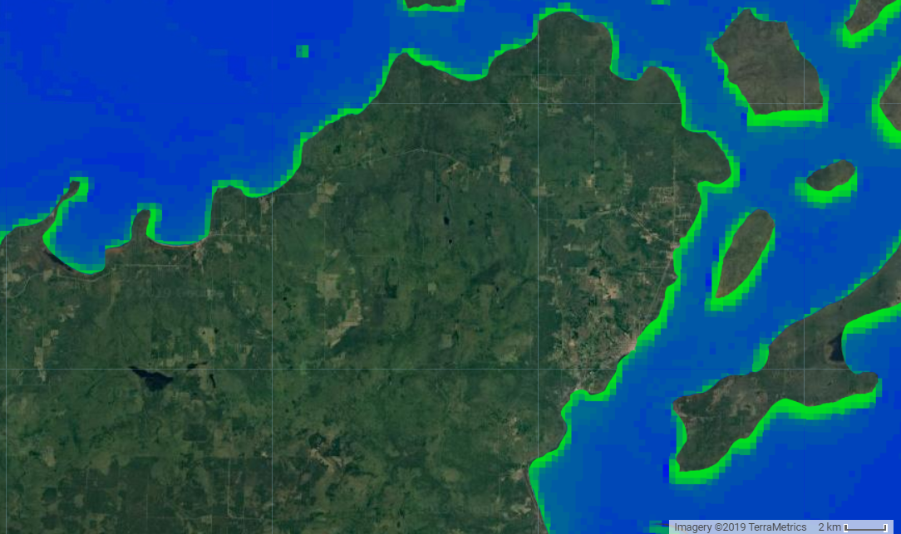

Low Chlorophyll-a Values

High Chlorophyll-a Values

*Figure 3.2* Index output of a Sentinel-3 OLCI EFR image in GEE featuring the Apostle Islands National Lakeshore during bloom August 11, 2018. Green pixels appear all along shoreline from Cornucopia Beach to Apostle Islands.

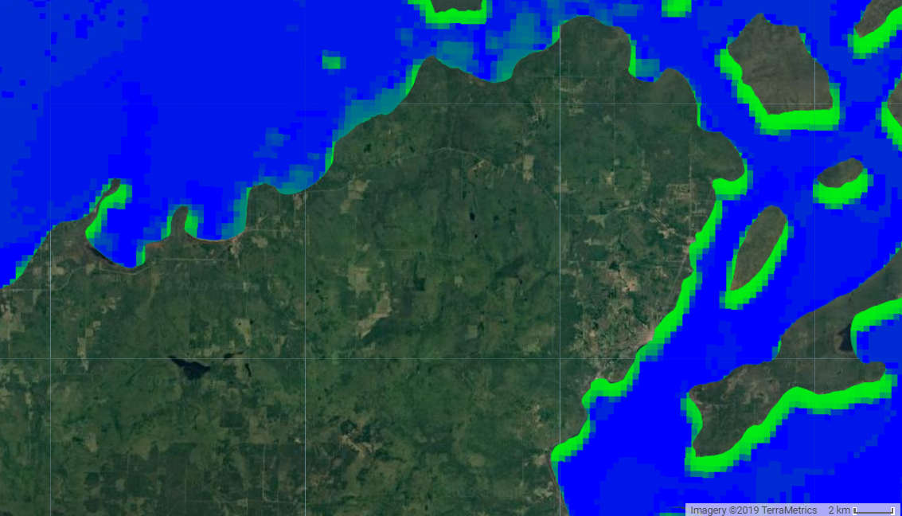

Low Chlorophyll-a Values

High Chlorophyll-a Values

*Figure 3.3* Index output of a Sentinel-3 OLCI EFR image in GEE featuring the Apostle Islands National Lakeshore after bloom August 31, 2018. Green pixels from Cornucopia Beach to Apostle Islands recede. Hazy grey/green pixels are unmasked clouds.

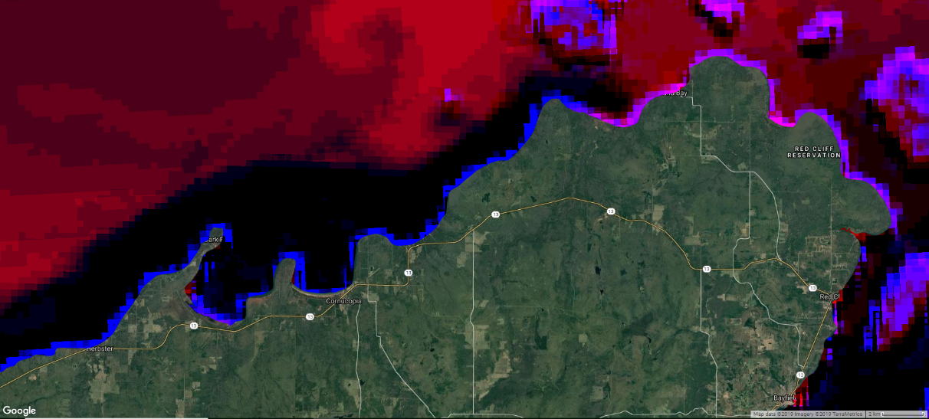

Potential Areas of Change

*Figure 4*. Image differencing output of a Sentinel-3 OLCI EFR image in GEE featuring the Apostle Islands National Lakeshore. Images differenced were from July 7, 2018 and August 31, 2018, displaying red and NIR bands. Image extent includes Cornucopia Beach and the Apostle Islands.

*4.1.3 Challenges and Future Work*

Tradeoffs were made between satellite spatial and temporal resolution due to the sensors available. Inadequate temporal resolution is problematic for observing the rapidly changing, ephemeral events of algal blooms. Coarse spatial resolution was further an issue as blooms tend to only extend approximately 500 meters from the shore. Sentinel-3 OLCI EFR imagery was ultimately chosen for its finer spatial resolution of 300 meters and temporal resolution of two days. Sentinel-3 OLCI EFR bands are further comparable to MERIS bands, with the potential for a similar workflow to be applied to historic MERIS imagery to track blooms pre-2012. In the necessary prioritization of spatial resolution for algal blooms, finer temporal resolution was sacrificed. With a revisit time of two days, Sentinel-3 OLCI EFR imagery is useful, but may fail to document algal blooms rapidly evolving on a time scale of hours to days.

Consistent field data collection of chlorophyll-a is necessary to quantitatively understand the success of indices in relation to *in situ* values, a relationship we were unable to assess. Qualitative observations were however possible with image comparisons with the Toming 2 index applied. Images were compiled and arranged from before, during, and after the bloom event on August 9, 2018. Though Toming 2 appeared to detect bloom presence with the greatest success, all of the indices applied appeared to delineate low chlorophyll-a and high chlorophyll-a areas in similar locations along the shoreline. These indices further picked up terrestrial vegetation, which could contribute to a mixed pixel effect near the shoreline, making it difficult to notice change directly around the Apostle Islands.

Success in differentiating between bloom and non-bloom regions demonstrates index potential in observing algal extent and change within the system. Viewing images before, during, and after a bloom event highlighted the sections of coastline gaining and losing green pixels. Green pixels were present at all image dates on several eastern facing sections of shoreline, which may not be indicative of an algal bloom. Green pixels along the eastern shoreline areas may instead represent terrestrial vegetation in sections of the study area where the buffered shapefile used for visual analysis overlapped with land. Variable water levels at different times of year could also contribute to this mixed pixel and edge effect, as the boundaries of the shoreline fluctuate seasonally.

Based on the consistency between index images and bloom locations described by partners at NPS, incorporation of satellite imagery in monitoring algal blooms shows promise in potential feasibility. Further research into pairing satellite imagery with consistently collected field data would allow partners and others conducting similar studies in large lake systems to better understand algal bloom dynamics over time. Partners may further benefit from the use of selected indices with MERIS imagery to look back to 2002, ten years before algal blooms in the lake became of concern, to determine historic extent and severity.

* 1. ***Sediment Plumes***

*4.2.1 In situ data*

*In situ* data from June 18, 2019 contained 311 points of plume presence and 104 points of plume absence. Though a diverse data set, we observed a gap between transmissivity value of 60% and 80%. This is believed to be a result of natural groupings of available data for the date in question, not a larger trend. Though the July 2, 2018 dataset was largely unusable, incorporation into a test model filled this gap in the data while producing a similarly strong R2 value. Though combined dates were not used to create the final model, it supported the hypothesis that the data gap was simply a relic of the June 18, 2019 dataset.

*4.2.2 Indices*

Wang 3, Wang 21, and Wang 6 indices had the greatest success in identification of plume presence and absence, with strong correlations between *in situ* observations and index values. Through a Spearman’s correlation, each index was identified as statistically distinct from other indices, as well as highly correlated to transmissivity data (*Figure A3*).

The creation of a random forest model confirmed findings for these three indices: observed vs. predicted transmissivity values for each pixel within the study area produced an R2 value of .827 and Root Mean Square Error of 6.9922 (*Figure 5*). Using VSURF, the Wang 3 index was identified as responsible for explaining the greatest degree of the model at 63.7%, followed by Wang 21 at 36.3%, and Wang 6 at 28.3%  in degree of model influence.

The prediction map created via application of the model to all pixels within the study area appeared to predict plume presence in a large portion of western Lake Superior (*Figure 6*). This may, however, be the result of a sensor error rather than an error in the model. The satellite imagery for June 19, 2019 may be affected by noise or scattering based on an unnatural pattern of dark pixels within the lake. Further investigation using field data and imagery from additional dates is warranted to test the robustness of the model.

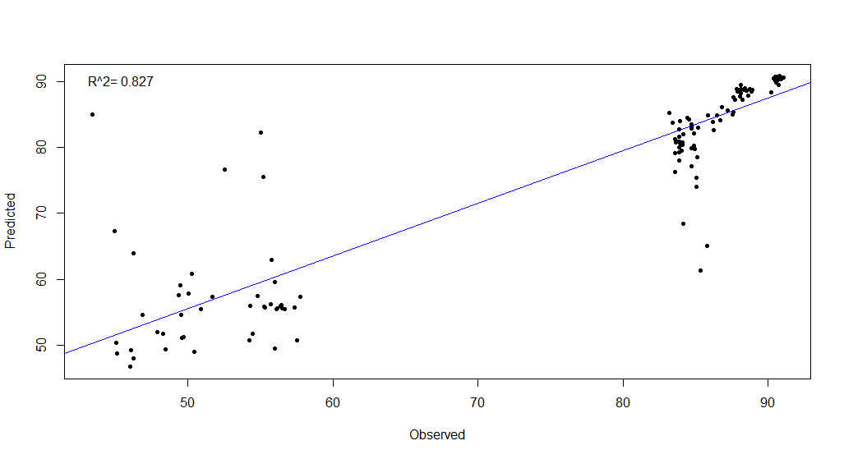

Predicted Transmissivity

Observed Transmissivity

*Figure 5.* Random forest model prediction of observed (x-axis) versus predicted (y-axis) transmissivity values for Wang 3, Wang21, and Wang 6. Model was built on June 18, 2018 field data and June 19, 2019 satellite imagery.



Values >75

Values <75

***­­***

*Figure 6*. Prediction map of random forest model applied to a Sentinel-3 OLCI EFR image featuring the Apostle Islands National Lakeshore for June 19, 2019. Image was generated in GEE and reclassified in ArcGIS Pro. Values above 75 represent plume absence (blue color), while values below 75 represent bloom presence (red color). Satellite noise may be affecting this image.

*4.2.3 Challenges and Future Work*

The high observed R2 value strengthened our confidence in the application of Wang 3, Wang 21, and Wang 6 indices in the creation of our model. Such results reveal the potential for application of this model to imagery which lacks *in situ* data for corroboration. The promise of this method has the potential to allow for model application across historic *in situ* data to determine previously unknown plume presence and areas commonly impacted. This may further provide information on plume maximum extent and historic change. Incorporation of additionally relevant data, such as tributary stream gauge data and precipitation data, may be useful in identification of historic plume dates.

As sediment plume events generally occur shortly following storm events, obtaining usable cloud free imagery proved difficult. Many of the satellite images identified during sensor exploration had cloud cover, which masked areas of interest and interfered with satellite data collection over the larger area. Increasing the number of dates with i*n situ* data would help to manage this challenge, as it would increase the likelihood of dates with overlapping cloud free satellite imagery and field data. Additional intentional field sampling to match known satellite flyovers would likely improve correlations, a methodology employed by Kaba et al. (2014). The additional incorporation of *in situ* data for multiple plume dates across several years would likely benefit the robustness of the model, helping to further strengthen confidence in identified relationships. Incorporating additional dates would likely diminish any existing gaps in the data, as well as improve diversity of sampling location and the model’s ability to differentiate within nearshore and open waters.

# 5. Conclusions

Future studies of sediment plume and algal bloom dynamics within western Lake Superior and the Apostle Islands National Lakeshore are needed for increased knowledge surrounding historic and present day extent, duration, and likely causation. The application of remote sensing in the study of sediment plume phenomena within western Lake Superior shows promise, while more information, specifically in the form of *in situ* data, is needed for algal bloom understandings. Ultimately, foundational work through this project paves the way for increased understanding of impacts to lake ecology, tourism, and water quality with future data collection and analysis.

# 6. Acknowledgments

A special thanks to everyone at the Fort Collins node for their support and guidance in the creation of this project.

Dr. Paul Evangelista (Colorado State University, Natural Resource Ecology Laboratory)

Dr. Catherine Jarnevich (United States Geological Survey – Fort Collins Science Center)

Tony Vorster (Colorado State University, Natural Resource Ecology Laboratory)

Nicholas Young (Colorado State University, Natural Resource Ecology Laboratory)

Peder Engelstad (Colorado State University, Natural Resource Ecology Laboratory)

Kristen Dennis (NASA DEVELOP, Fellow)

A special thanks to our Project Partners who provided us with field data and their expertise throughout this project.

Dr. Brenda Moraska Lafrancois (National Park Service, Water Resources Division)

Dr. Bob Sterner (University of Minnesota- Duluth, Large Lakes Observatory)

Dr. Elizabeth Minor (University of Minnesota- Duluth, Large Lakes Observatory)

Any opinions, findings, and conclusions or recommendations expressed in this material are those of the author(s) and do not necessarily reflect the views of the National Aeronautics and Space

Administration.

This material is based upon work supported by NASA through contract NNL16AA05C.

This material contains modified Copernicus Sentinel data (2018), processed by ESA.

# 7. Glossary

**Aqua/Terra MODIS-** Satellites operated by NASA, Moderate Resolution Imaging Spectroradiometer

**Chlorophyll-a** – Pigment used as a proxy for algal biomass

**Earth observations** – Satellites and sensors that collect information about the Earth’s physical, chemical, and biological systems over space and time

**GEE**- Google Earth Engine

**Landsat 8 OLI** - Satellite, operated by NASA and the USGS, Operational Land Imager on-board Landsat 8 for measuring Earth’s reflected radiance

**NPS** – National Park Service

**Sentinel-2 MSI**- Satellite operated by the European Space Agency, Multi-Spectral Instrument onboard Sentinel-2 for measuring Earth’s radiance

**Sentinel-3 OLCI EFR**- Satellite operated by the European Space Agency, Operational Land Colour Imager, Earth Observation Full Resolution

**Transmissivity-** A measure of the amount of light (at 254 nm) able to pass through a water sample as a percentage

**UMD LLO** – University of Minnesota Duluth, Large Lakes Observatory

**VSURF**- Variable Selection Using Random Forest

# 8. References

Andrews, S.C., Houtman, D.S., Lontz, W.J., Christensen, R.G., Wilson, C.D. (1979). Impact of Nonpoint Pollution Control on Western Lake Superior. *EPA*, January, 1-33.

Donohue, I. & Molinos, J.G. (2009). Impacts of increased sediment loads on the ecology of lakes. *Biological Reviews*, 84, 517-531.

doi:[10.1111/j.1469-185X.2009.00081.x](https://doi.org/10.1111/j.1469-185X.2009.00081.x)

Cooney, E.M., McKinney, P., Sterner, R., Small, G.E., Minor, E.C. (2018). Tale of Two Storms: Impact of Extreme Rain Events on the Biogeochemistry of Lake Superior. J*ournal of Geophysical Research: Biogeosciences*, 123.

doi:10.1029/2017JG004216

Copernicus Sentinel Data [2016-2018]. Retrieved from United States Geological Survey Earth Explorer [21 November 2019], processed by ESA

Ho, J.C., & Michalak, A.M. (2015). Challenges in tracking harmful algal blooms: A synthesis of evidence from Lake Erie. *Journal of Great Lakes Research,* 41(2), 17-325.

doi:[10.1016/j.jglr.2015.01.001](https://doi.org/10.1016/j.jglr.2015.01.001).

Johnson, B.L. & Johnston, C.A. (1995). Relationship of Lithology and Geomorphology to Erosion of the Western Lake Superior Coast. *Journal of Great Lakes Res.*, 1(1):, 3-16.

doi:10.1016/S0380-1330(95)71016-4

Kaba, E., Philpot, W., & Steenhuis, T. (2014). Evaluating suitability of MODIS-Terra images for reproducing historic sediment concentrations in water bodies: Lake Tana, Ethiopia. Int. J. Applied Earth Observation and Geoinformation, 26, 286-297.

Lafrancois, B.M. (2018). Plumes, Blooms, and Plastic Spoons: Emerging Coastal Resource Issues in Apostle Islands Area. Presentation at Science on Tap, Ashland, WI.

Michalak, A. M., Anderson, E. J., Beletsky, D., Boland, S., Bosch, N. S., Bridgeman, T. B., Zagorski, M. A. (2013). Record-setting algal bloom in Lake Erie caused by agricultural and meteorological trends consistent with expected future conditions. *Proceedings of the National Academy of Sciences of the United States of America*, *110*(16), 6448–6452.

doi:10.1073/pnas.1216006110

Minor, E.C., Forsman, B., Guildford, S.J. (2014). The effect of a flood pulse on the water column of western Lake Superior, USA. *Journal of Great Lakes Research*, 40, 455-462.

doi:10.1016/j.jglr.2014.03.01

NASA Goddard Space Flight Center, Ocean Ecology Laboratory, Ocean Biology Processing Group. Moderate-resolution Imaging Spectroradiometer (MODIS) Aqua MYDO9GA.006 Aqua Surface Reflectance daily Global 1km and 500m Data; NASA OB.DAAC, Greenbelt, MD, USA.

doi: data/10.5067/AQUA/MODIS/L2/OC/2018.

NASA Goddard Space Flight Center, Ocean Ecology Laboratory, Ocean Biology Processing Group. Moderate-resolution Imaging Spectroradiometer (MODIS) Terra MOD9GA.006 Terra surface reflectance daily Global 1km and 500 Data; NASA OB.DAAC, Greenbelt, MD, USA.

doi: data/10.5067/TERRA/MODIS/L2/OC/2018.

National Park Service. (2015). Apostle Islands. *Nature & Science*. Accessed 9 October 2019. <https://www.nps.gov/apis/learn/nature/index.htm>

Ogashawara, I., Li L., Moreno-Madriñán, M.J. (2016). Slope algorithm to map algal blooms in inland waters for Landsat 8/Operational Land Imager images. J. Appl. Rem. Sens. 11(1), 012005. doi:1[0.1117/1.JRS.11.012005](https://dx.doi.org/10.1117/1.JRS.11.012005)

Records of the U.S. Senate. (1916). *An Act to establish a National Park Service* (Report No. 662). Accessed 30 September 2019.<https://www.archives.gov/legislative/features/national-park-service/nps.html>

Schindler, D.W., Carpenter, S.R., Chapra, S.C., Hecky, R.E., Orihel, D.M. (2016). Reducing phosphorus to curb Lake eutrophication is a success. *Environ. Sci. Technol*, 50: 8923–8929.

doi:[10.1021/acs.est.6b02204](http://dx.doi.org/10.1021/acs.est.6b02204).

Trescott, A., Park, M. (2013). Remote sensing models using Landsat satellite data to monitor algal blooms in Lake Champlain. Water Science and Technology. Journal of the International Association on Water Pollution Research, 67(5), 1113-112.

doi: 10.2166/wst.2013.661

University of Missouri Kansas City. Lake Superior Facts. Accessed on 10 October 2019. <http://law2.umkc.edu/faculty/projects/ftrials/superior/superiorfacts.html>

U.S. Geological Survey Earth Resources Observation And Science Center. (2014). Landsat 8 OLI Level-2 Surface Reflectance (SR) Science Product [Data set]. U.S. Geological Survey.<https://doi.org/10.5066/f78s4mzj>

Watson, S. B., Miller, C., Arhonditsis, G., Boyer, G. L., Carmichael, W., Charlton, M. N., Wilhelm, S. W. (2016). The re-eutrophication of Lake Erie: Harmful algal blooms and hypoxia. Harmful Algae, 56, 44–66. doi:[10.1016/j.hal.2016.04.010](https://doi.org/https:/doi.org/10.1016/j.hal.2016.04.010)

# 9. Appendix

Table A1

*Suspected algal bloom events identified by project partners in western Lake Superior.*

|  |  |  |
| --- | --- | --- |
| **Key Event** | **Classification** | **Imagery Date Range** |
| June 10-19, 2012 | Suspected algal bloom | May 31 - June 29, 2012 |
| July 14-15, 2012 | July 1-14, 2012 |
| September 1, 2015 | August 26 - September 4, 2015 |
| July 12, 2016 | July 1-29, 2016 |
| August 31, 2016 | August 25 - September 2, 2016 |
| August 9, 2017 | August 1 - September 1, 2017 |
| August 5-15, 2018 | July 7 - August 30, 2018 |

Table A2

*Key events including high flow and rainfall events identified by project partners and investigated for sediment plumes within western Lake Superior.*

|  |  |  |
| --- | --- | --- |
| **Key Event** | **Classification** | **Imagery Date Range** |
| August 3, 2011 | High flow event | August 2, 2011 - August 17, 2011 |
| June 19-20, 2012 | Major rainfall event, plume followed | June 18, 2012 - July 4, 2012 |
| April 28, 2013 | High flow event | April 27, 2013 - May 12, 2013 |
| May 21, 2013 | High flow event | May 20, 2013 - June 4, 2013 |
| August 26-27, 2013 | Major rainfall event | August 25, 2013 - September 10, 2013 |
| May 1, 2014 | High flow event | April 30, 2014 - May 15, 2014 |
| July 12 - August 16, 2016 | Major rainfall event | July 11, 2016 - August 30, 2016 |
| June 16, 2018 | Major rainfall event | June 15, 2018 - June 30, 2018 |
| August 27, 2018 | Major rainfall event | August 26, 2018 - September 10, 2018 |
| June 18, 2019 | Field collection | June 17, 2019 - June 22, 2019 |

Hamidid1

Hamidid2

Kaba1

Moreno1

Petus1

Petus2

Wang1

Wang2

**Wang21**

Wang5

Wang4

Wang23

**Wang3**

Wang22

Transmissivity (%)

Wang9

Wang8

Wang7

**Wang6**

Transmissivity (%)

Wang9

Wang8

Wang7

**Wang6**

**Wang3**

Wang5

Wang23

Wang4

Wang22

**Wang21**

Wang2

Wang1

Petus2

Petus1

Moreno1

Kaba1

Hamidi1

Hamidi2

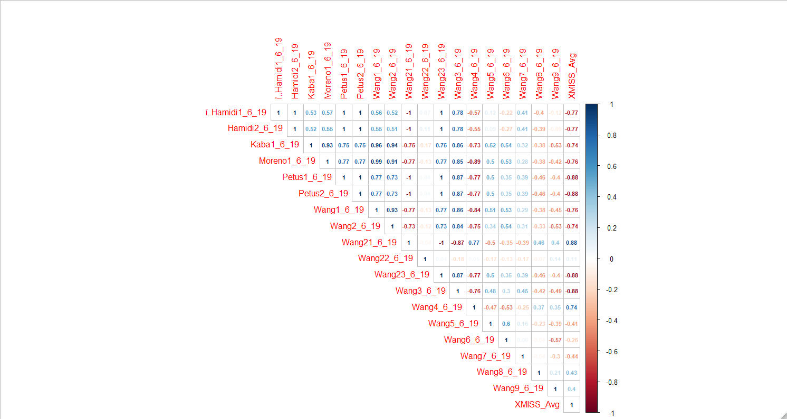

*Figure A3.* Correlation plot produced with Spearman’s correlation in RStudio. Figures displays all 18 indices derived from the literature and applied to sediment plume satellite imagery. The numbers and colors in this figure indicate the correlation between individual indices, as well as correlation of each index to transmissivity data. Bolded indices are those which were ultimately used to create the model.