Great Bear Lake Water Resources

A Long-Term Remote Sensing Analysis to Evaluate Changes

in Water Quality of Great Bear Lake

**Technical Report**

Final Draft – November 15th, 2018

Krishna Sharma (Project Co-Lead)

Juan Jaimes (Project Co-Lead)

Huan Mi

Mahrokh Moknatian

Zach Bengtsson

Dr. Cedric Fichot, Boston University (Science Advisor)

**1. Abstract**

The Sahtu Dene people of Délįnę have a strong traditional tie to Great Bear Lake (GBL), which they refer to as “The Water Heart.” The indigenous community is concerned with how changes in the lake may affect their livelihoods and fisheries. Arctic lakes like the GBL, the largest lake in Canada, are sensitive to increasing global temperatures. However, assessing the changing climate’s impacts on large water bodies is challenging and requires long-term time series analyses across large datasets. The scarcity of continuous monitoring has constrained the spatiotemporal evaluation of the GBL’s responses to climate variability in past years. Previous research of GBL primarily consists of ice phenology and fisheries studies. To complement previous studies in the region and support environmental monitoring done by project partners in the Délįnę Renewable Resources Council, Environment and Climate Change Canada, and Fisheries and Oceans Canada, the fall 2018 NASA DEVELOP Massachusetts team analyzed long-term remote sensing data to assess the water quality changes of GBL over the past 20 years. The data were acquired from Aqua and Terra Moderate Resolution Imaging Spectroradiometer (MODIS), Sea-Viewing Wide Field-of-View Sensor (SeaWiFS), Suomi NPP Visible Infrared Imaging Radiometer Suite (VIIRS), and the ARCLake Database to evaluate changes in lake surface water temperature (LSWT), Chlorophyll-a, and chromophoric dissolved organic matter (CDOM). We did not observe any significant trends. More work must be done to assess long term water quality trends in arctic lakes.

**Keywords**

Arctic lakes, MODIS, VIIRS, SeaWiFS, (A)ATSRs, chromophoric dissolved organic matter, Chlorophyll-a, lake surface water temperature

**2. Introduction**

* 1. ***Background Information***

Arctic lakes are susceptible to warming climates and global forces of change even when secluded from direct urban influence. In the past 100 years, arctic lake temperatures went from steadily cooling for millennia to drastically increasing (Kaufman et al., 2009). Rising lake temperatures can trigger changes in hydrology, biogeochemical processes (Ruehland, Paterson, Keller, Michelutti, & Smol, 2013), and lake size (Carrol & Loboda, 2017; Carroll, Townshend, DiMiceli, Loboda, & Sohlberg 2011). Additionally, the increased melting of nearby permafrost can augment carbon deposition in the water via runoff, causing a cascade effect of altered productivities and water quality. Ice cover can also become thinner (Mullan et al., 2017). These changes favor suspended algae growth, whose subsequent carbon dioxide production and attenuation of sunlight generate anaerobic environments in deeper layers, releasing the greenhouse gas methane. These effects threaten to disrupt the ecology of lakes and even diminish fish populations (Gerdeaux, 2011; McDonald, Hershey, & Miller, 1996). Therefore, people reliant on large northern water bodies and associated fisheries are concerned about changes in climate. However, ecological monitoring of arctic lakes can be difficult due to high monitoring costs and remote sampling sites.

Great Bear Lake (GBL), known by its indigenous community as “The Water Heart”, straddles the Arctic circle of Canada’s Northwest Territories (Figure 1). Its clear water and low productivity are due, in part, to sparse inhabitance and the undeveloped subarctic environment that surrounds it. Because it is likely the last pristine large arctic lake, UNESCO designated it as a World Biosphere Reserve in 2016 (UNESCO, 2016). The only active human settlement of GBL is Délįnę where around 550 individuals of the Sahtu Dene people reside. GBL provides Délįnę’s indigenous community with fisheries, drinking water, and access to caribou hunting posts. Furthermore, it represents a culturally sacred site: it is a symbol of interconnectedness and life in the Sahtu region. The lake also hosts record-breaking trout that have spawned several recreational fishing lodges along the shores (Muir, Leonard, & Krueger, 2013).

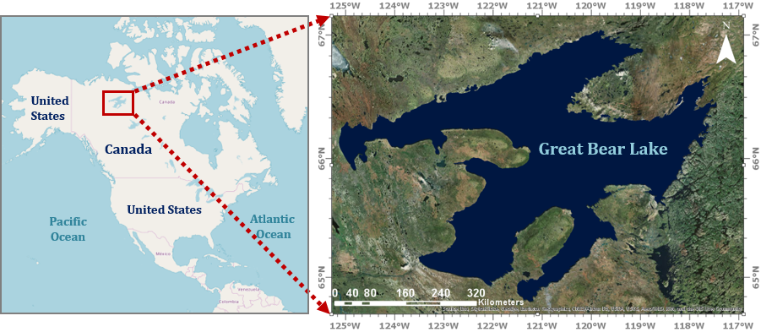

*Figure 1.* A map of Great Bear Lake, where Délįnę is marked with a black star.

Recent changes in ecological traits of GBL concern the Délįnę community. Over the last century, they have noticed increasing lake temperatures, changes in water color, variation in wind patterns, thinner ice, later ice onset and earlier ice melt, and more frequent pressure ridges in ice cover. Warming temperatures also threaten to convert GBL from a monomictic system, experiencing one turnover per year, to a dimictic system, which would drastically alter its ecological characteristics (Meyer, Masliev, & Sómlyódy, 1994). Their inclination is that global climate trends are disturbing the ecosystem (Nesbitt, 2011). Further environmental concerns include heavy metal contamination from 20th-century uranium mining (Gandhi, Potter, & Fayek, 2018).

Remote sensing provides a powerful tool to indicate the variability of water quality parameters such as chromophoric dissolved organic matter (CDOM), Chlorophyll-a, and temperature (Cao et al., 2018; Del Castillo & Miller, 2008; Joshi et al., 2017). Microbial populations, namely bacteria and phytoplankton, can be considered the foundation of the aquatic food web, supporting upper trophic levels from planktivores to fish. DOM sustains bacteria while sunlight sustains phytoplankton. CDOM is the fraction of DOM that interacts with the visible spectrum, usually absorbing blue and UV wavelengths and adding a yellow tint to the water. While photodegradation of CDOM can increase bacterial activity (Piccini, Conde, Pernthaler, & Sommaruga, 2010), it can also limit the availability of photosynthetically available radiation (PAR) for phytoplankton, lowering primary production (Blough & Del Vecchio, 2002). Chlorophyll-a presence, innate to phytoplankton, is an indicator of primary production (Bot & Colijn, 1996).

With a relatively high temporal resolution, remote sensing facilitates the monitoring of ice phenology and surface water temperature (Latifovic & Pouliot, 2007; Politi, Cutler, & Rowan, 2012). Such research has been occasionally conducted for GBL (Howell, Brown, Kang, & Duguay, 2009; Kang, Duguay, & Howell, 2012). However, there is a lack of research on the long-term trends of GBL water quality and lake surface water temperature (LSWT). Based on satellite data availability, we examined GBL water quality trends from 1998 to 2018.

***2.2 Project Partners & Objectives***

To address environmental preservation concerns of GBL, an ad hoc coalition involving representatives of Délįnę, the Northwest Territories Government, the Canadian Federal Government, and other stakeholders drafted the GBL Management Plan (2005). The Délįnę Got’įnę Government began operating in 2016 and has since served as the chief acting body of local policy (“Deline Got’ine Government”, 2018).

The Massachusetts – Boston node of NASA DEVELOP collaborated with the Délįnę Renewable Resources Council. We also worked in collaboration with Environment and Climate Change Canada and Fisheries and Oceans Canada to ascertain what scientific research had already been conducted in the region. Remote sensing using NASA Earth observations offers long-term water quality data, allowing decision-makers of Délįnę to complement traditional ecological knowledge of environmental change. It also can help managers discern if GBL is on a trajectory of greater ecological change. We assessed the feasibility of using currently available NASA Earth observation data products to estimate trends in LSWT, CDOM, and Chlorophyll-a in Great Bear Lake. We also created training and capacity building products for the end users to understand the potential of utilizing NASA Earth observations as a tool for natural resource management, thus aiding preservation efforts for GBL.

**3. Methodology**

***3.1 Overview***

We chose to examine LSWT, Chlorophyll-a, and CDOM as indicators of water quality. We used atmospherically corrected remote sensing products from Aqua and Terra Moderate Resolution Imaging Spectroradiometer (Aqua MODIS, Terra MODIS), SeaStar Sea-viewing Wide Field-of-view Sensor (SeaWiFS), and Suomi National Polar-orbiting Partnership Visible and Infrared Imaging Radiometer Suite (SNPP VIIRS) as the main satellite sensors to extract CDOM and Chlorophyll-a data and assess temporal changes in these parameters. We also used ARCLake products as an ancillary source of LSWT data. Then, we employed statistical analysis techniques to evaluate temporal changes in these parameters.

***3.2 Data Acquisition***   
To evaluate changes in water quality of GBL over the past two decades, we constructed a time series of the aforementioned water quality parameters. Using the NASA Ocean Color website (<https://oceancolor.gsfc.nasa.gov/>), Level-3 data were acquired from Aqua MODIS (2002 to 2018, spatial resolution of 4km), SeaWiFS (1997 to 2010, spatial resolution of 9km), Terra MODIS (2000 to 2018, spatial resolution of 4km), and SNPP VIIRS (2012 to 2018, spatial resolution of 4km). Data products included remote sensing reflectance (Rrs) and inherent optical properties (IOPs). We also acquired composited V3 (A)ATSRs products (0.05-degree spatial resolution, 1995-2012), which contain atmospherically corrected and reconstructed data, from the ARCLake database (<http://www.laketemp.net/>). This product contained spatially-resolved monthly time-series of lake surface water temperature from night-time ATSR2/AATSR reconstructions.

***3.2 Data Processing***  
Atmospheric satellite correction for high latitude areas is most reliable during summer months when sunlight’s angle of incidence is most conducive to reflectance detection. In our study area, ice is present on the lake surface from mid-fall to mid-summer (Howell et al., 2009). Therefore, we chose the month of August for water quality analysis to avoid ice cover and unreliable atmospheric correction.

The Level-3 products of Rrs contained negative values along the shoreline of GBL. Visual inspection showed a correlation between negative values and aerosol optical thickness (AOT) on the edges of the lake. This indicated atmospheric over-correction and compromised data. Algorithmic errors are common in the blue & green spectrum bands, which are utilized for the estimation of Chlorophyll-a and CDOM concentrations. The spatial distribution of AOT is presented in Figure 2.

|  |  |
| --- | --- |
| (a) | (b) |

*Figure 2.* (a)Aerosol optical thickness for Aqua MODIS (2002-2018). Higher aerosol concentrations are present near the coastline, implying compromised Rrs data. (b) Visualization of our study area. Light purple areas near the coastline had many negative Rrs values and were thus ignored. The center of GBL represents the most reliable area for Rrs data, so the white square is where we conducted all trend analysis.

Furthermore, we analyzed a lake as opposed to the large ocean environments that the satellites data products are better suited for. This brought forth problems such as adjacency effects, where land can reflect light and skew readings of nearby water. Water surfaces also generally have variations in sunlight glint and reflection as well as varying levels of organic matter that can be hard to correct for (Cao et al., 2018).

To avoid the effect of the edges on the analysis, a mask was defined to only consider the coverage of positive values of Rrs in the center of the lake. The extent of the mask we applied is 65.94N to 66.15N and 120.27W to 120.81W (white square in Figure2b). The mask was applied to CDOM and Chlorophyll-a in order to compute the average surface values and to assess their spatial distribution. The absorption coefficient of non-algal material plus CDOM (*adg*) at 443 nm in m-1 (adg_443_giop) was employed as the indicator of change in CDOM. For Chlorophyll-a, we analyzed the same product provided on the Ocean Color Website under the same name. The concentration of Chlorophyll-a was estimated based on the absorption coefficient of phytoplankton at 443 nm in m-1(aph_443_giop). For LSWT, no difference was observed in the preliminary results when applying the mask. Therefore, the whole surface was used to report the results.

***3.3 Data Analysis***  
After generating the time series of surface temperature, CDOM, and Chlorophyll-a for GBL, we analyzed their temporal variability. The purpose of this study was to investigate whether or not the target environmental parameters exhibited any average increases or decreases over time. Trend analysis can reveal if such changes are due to chance (trendless) or are statistically significant (trend). We used two statistical methods of parametric and non-parametric tests, including linear regression (Bates, Chandler, & Bowman, 2012) and the Mann-Kendall test (Hamed, 2008) for trend detection. To apply trend tests to the time series, these were first passed through serial correlation tests. The existence of serial correlation in the data series may result in false detection or ignorance of the trend values (Hamed & Rao, 1998; Yue, Pilon, Phinney, & Cavadias, 2002).  If serial correlation was present, it was removed before trend significance was subsequently quantified for the entire lake surface.

**4. Results & Discussion**

***4.1 Chlorophyll-a***

The absorption coefficient of phytoplankton at 443 nm in m-1(aph_443_giop), calculated using the Generalized Inherent Optical Property (GIOP) model, was derived from four NASA Earth observation satellites’ level 3 products as an indicator of Chlorophyll-a. The yearly time series of the aph_443_giop in August were calculated in the lake center using the same mask (Figure 3). The noticeable discrepancies among concurrent satellite Rrs values implied the existence of unaccounted for data errors. Trend analysis shows that Chlorophyll-a had a non-significant increasing trend over respective time periods for SeaWiFS and Aqua and Terra MODIS (Figures 3a through 3c). However, there is a non-significant decreasing trend for SNPP VIIRS, which only has data for the past 7 years (Figure 3d). To determine if the GIOP model was the source of data inconsistency between satellites, time series of absorption due to phytoplankton at 443 nm in m-1 from the Quasi-Analytical (QAA) Algorithm (aph_443_qaa) were also generated. The trends of aph_443_qaa were similarly inconsistent, and so no further trend analysis was pursued.

|  |  |
| --- | --- |
| (a) | (b) |
| (c) | (d) |

*Figure 3.* Temporal trend of Chlorophyll-a at the center of GBL for (a) SeaWiFS; (b) Aqua MODIS; (c) Terra MODIS; and (d) SNPP VIIRS. Points show the average value of Chlorophyll-a at the center of GBL while the dotted lines represent the trend fitted on the time series.

***4.2 CDOM***

The absorption coefficient of gelbstoff at 443 nm in m-1(aph_443_giop), calculated using the Generalized Inherent Optical Property (GIOP) model, was derived from four NASA Earth observation satellites’ level 3 products as an indicator of CDOM. The analysis showed a non-significant decreasing trend in CDOM for SeaWiFS and Terra MODIS (Figure 4a, 4c), but a non-significant increasing trend for Aqua MODIS and SNPP VIIRS (Figure 4b, 4d). To determine if satellite sensor discrepancies were due to the GIOP model, we ran parallel tests using the QAA (adg_443_qaa) and the Garver-Siegel-Maritorena algorithms (adg_443_gsm). Neither alternative algorithm resolved satellite inconsistency, therefore no further trend analysis was pursued.

|  |  |
| --- | --- |
| (a) | (b) |
| (c) | (d) |

*Figure 4.* Temporal trend of CDOM at the center of GBL for (a) SeaWiFS; (b) Aqua MODIS; (c) Terra MODIS; and (d) SNPP VIIRS. Points show the average value of CDOM at the center of GBL while dotted lines represent the trend fitted on the time series.

***4.3 Lake Surface Water Temperature (LSWT)***

The monthly time series of the LSWT (Figure 5a) generated from ARCLake data for 1995 to 2012 revealed strong seasonality and a positive 1-lag and 2-lag serial correlation. After removing serial correlation factors and seasonality from the time series, trend tests were performed. Both Mann-Kendall and linear regression trend tests exhibit no significant decreasing trend with probability values (p-values) of 0.07 and 0.51 with a confidence interval of 95%, respectively. The Kendall’s tau statistic and linear regression slope were -0.086 and -0.0005. Spatial trend analysis using the linear regression method did not detect any significant trends for the entire lake surface. Figure 5b depicts the linear regression trend slope derived for each pixel after removing seasonality and serial correlation.

In the same manner, the climatological time series of August was assessed to see if a trend could be detected. Figures 5c and 5d show the climatological time series of LSWTs and the spatial distribution of linear regression trend slopes for August. Despite the presence of decreasing trends in both the climatological time series and increasing and decreasing trends in spatial distribution, none of the detected trends were statistically significant given the significance level of 5%. The p-values associated with Kendall’s tau statistic and the slope of the linear regression test were computed to be 0.17 and 0.4, respectively. Note: LSWT data for GBL during different seasons can be found in Appendix D.

|  |  |
| --- | --- |
| (a) | (b) |
| (c) | (d) |

*Figure 5.* (a) Monthly time series of the LSWT averaged over the surface of Great Bear Lake; (b) Spatial linear regression slope for monthly time series; (c) Climatological time series of LSWT averaged over the surface of Great Bear Lake for August; (d) Spatial linear regression slope for August [Graphs: blue lines are time series derived for the entire surface of the lake and red lines are trend lines fitted on the time series; Maps: red and yellow show increasing trends and shades of blue show decreasing trends]

***4.4 Discussion***

All observed trends were not significant, which may be due to several limiting factors. High latitudes present inherent problems in remote sensing analysis: lower angles of incidence for sunlight can corrupt Rrs values, and current atmospheric correction algorithms are inappropriate for such conditions. GBL Remote sensing data could only be utilized during summer months when there was no polar darkness. Combined with the region’s frequent cloud cover, the dates of valid data acquisition were greatly limited. The lake also exhibits high interannual variability in water quality parameters, necessitating a large temporal study period to confidently extract any long-term trends. Satellite inconsistencies prohibited the stitching together of datasets into one coherent time series, which precluded confidence in trend analysis.

Trend analysis for CDOM and Chlorophyll-a was further compromised by the oligotrophy of GBL, where low primary production makes trend detection difficult. Thus, the only implication to draw from our analysis is that there has been no drastic change in average CDOM or Chlorophyll-a at the center of GBL from 1998 to 2018.

We observed a slightly decreasing trend in temperature that was not statistically significant over a 20-year time period. While a cooling average lake surface water temperature may conflict with expected results, the slope of the trend is relatively minute. Thus, the strongest implication to draw from this is that Great Bear Lake has not undergone any drastic change in average lake surface water temperature from 1995 to 2012. There may be a correlation between the decreasing lake surface water temperature trend and an increasing amount of discharge from Great Bear River over recent decades (for the discharge graph, see Appendix A). Changes in air temperature and precipitation or groundwater levels might also have a slight cooling effect on the lake. It should also be noted that changes in average air temperature do not necessarily correlate with changes in average water temperature. This may be due to the pristine nature of the lake and its remote location. Information regarding regional air temperature and precipitation can be found in Appendix B.

In situ validation would have alleviated many of these challenges and highlighted the most appropriate dataset to use. However, the provided in situ data varied considerably at spatial scales and temporal scales (Appendix C) and did not include the necessary ground surface reflectance data that would be collected via spectroradiometry. Moreover, the sample sites were almost exclusively near the coast and outside our area of analysis. We were, therefore, unable to compare *in situ* data with our remote sensing analyses.

***4.5 Future Work***

Future studies could better implicate the driving forces of water quality changes in Great Bear Lake. While we can infer which parameters are shifting, we have no basis to explain causality. Research on local air quality trends focused on carbon dioxide levels may be able to correlate these changes with global climate and atmosphere trends, widening the significance of the study to a global scale. Given the presence of mercury contamination in GBL, another plausible area of research would be Great Bear Lake’s biogeneration of monomethylmercury and the influence of DOM on mercury-oxidizing bacteria, both of which can also affect the ecology of the lake. Further research of CDOM with in situ measurements would complement all of the above research.

**5. Conclusions**

This study highlighted the many challenges of accurate remote sensing in GBL. High latitude, adjacency effects, lack of ideal in situ datasets, and inappropriate atmospheric correction algorithms impede confidence in the estimation of CDOM and Chlorophyll-a. While LSWT can be pursued through ancillary datasets, this data is temporally limited and thus not ideal for long-term trend analysis. Overall trends between satellites indicate there has been no drastic change in water quality parameters over the 20 year study period. This coincides with the relatively pristine state of GBL.

Further research is necessary to conclusively estimate trends of water quality change and must address these challenges with in situ spectroradiometry sampling, namely at the center of the lake, and incorporate appropriately adapted atmospheric correction algorithms. Future efforts to launch satellite sensors useful to water resources remote sensing should address the need for higher spectral sensitivity when analyzing water quality of oligotrophic lake ecosystems. In ecosystems like Great Bear Lake, relatively large changes in CDOM and Chlorophyll-a can occur at minute, difficult to detect scales when using satellite imagery. The availability of more hyperspectral data products at higher temporal resolution would bolster the ability to detect these small changes in water quality. Identifying trends in water quality of Great Bear Lake is further complicated by the difficulty of distinguishing atmospheric correction errors from true reflectance measurements.

Until more appropriate atmospheric correction algorithms and hyperspectral data are publicly available, future water quality remote sensing projects of Great Bear Lake will likely run into similar issues. This study highlights considerations that must be made by future projects interested in environmental monitoring of the lake via satellite imagery. The potential for the community of Délįnę to utilize Earth observations for the management of their vast natural resources should be further explored as improvements are made to water quality estimation techniques. The amelioration of these issues will allow easily accessible, cost-effective, and informative environmental monitoring to take place at one of the last remaining pristine arctic lakes.

**6. Acknowledgments**

We wish to thank the following individuals for their contributions to our project:

* The Community of Délįnę
* Ed Reeves, Délįnę Renewable Resources Council
* Dr. Marlene Evans, Environment and Climate Change Canada
* Dr. Kimberly Howland, Fisheries and Oceans Canada
* Mandy Bayha, UNESCO Tsá Tué World Biosphere Reserve
* Heather Clark, Fisheries and Oceans Canada
* Colin Gallagher, Fisheries and Oceans Canada

Any opinions, findings, and conclusions or recommendations expressed in this material are those of the author(s) and do not necessarily reflect the views of the National Aeronautics and Space Administration.

This material is based upon work supported by NASA through contract NNL16AA05C.

**7. Glossary**

**Aqua MODIS** - One of two satellites that house the MODIS sensor: MODerate resolution Imaging Spectroradiometer; Aqua launched in 2002

**AOT** - Aerosol optical thickness; measure of aerosolized particles that may interfere with Rrs values

**DOM** - Dissolved organic matter; biologically available compounds usually present from the decay of microorganisms; foundation of the aquatic food web

**CDOM** - Chromophoric dissolved organic matter; DOM that absorbs light, usually blue and UV wavelengths, allowing less light to reach photosynthetic organisms

**Chlorophyll-a** - A constituent of photosynthetic cells that absorbs light and converts it to sugar; Green in color and used as a visual indicator for algae

**Earth observations** - Satellites and sensors that collect information about the Earth’s physical, chemical, and biological systems over space and time

**IOP** - Inherent optical properties; the physical characteristics of a surface that the Rrs can convey

**PAR** - Photosynthetically available radiation; light that photosynthetic organisms are receptive to

**Rrs** - Remote sensing reflectance; amount of light reflected off a surface for a particular wavelength; indicates various water quality attributes

**SeaWiFS** - Sea-Viewing Wide Field-of-View Sensor onboard the SeaStar spacecraft; launched in 1997

**Terra MODIS** - “Sister” satellite to Aqua: MODerate resolution Imaging Spectroradiometer; launched in 2002

**VIIRS** - Visible Infrared Imaging Radiometer Suite sensor onboard the Suomi National Polar-Orbiting Partnership (Suomi NPP) spacecraft; launched in 2011

**8. References**

Bates, B. C., Chandler, R. E., & Bowman, A. W. (2012). Trend estimation and change point detection in individual climatic series using flexible regression methods. *Journal of Geophysical Research: Atmospheres 117*, 1–9. doi:10.1029/2011JD017077

Blough, N. V., & Del Vecchio, R. (2002). Chromophoric DOM in the coastal environment In D.A. Hansell & C.A. Carlson (Eds.), *Biogeochemistry of Marine Dissolved Organic Matter* (pp. 509–546). https://doi.org/10.1016/B978-012323841-2/50012-9

Bot, P. V. M., & Colijn, F. (1996). A method for estimating primary production from chlorophyll concentrations with results showing trends in the Irish Sea and the Dutch coastal zone. *ICES Journal of Marine Science*, *53*, 945–950.

Cao, F., Tzortziou, M., Hu, C., Mannino, A., Fichot, C. G., Del Vecchio, R., … Novak, M. (2018). Remote sensing retrievals of colored dissolved organic matter and dissolved organic carbon dynamics in North American estuaries and their margins. *Remote Sensing of Environment*, *205*, 151–165. https://doi.org/10.1016/j.rse.2017.11.014

Carroll, M. L., & Loboda, T. V. (2017). Multi-Decadal surface water dynamics in North American tundra. *Remote Sensing*, *9*(5), 497. https://doi.org/10.3390/rs9050497

Carroll, M. L., Townshend, J. R. G., DiMiceli, C. M., Loboda, T., & Sohlberg, R. A. (2011). Shrinking lakes of the Arctic: Spatial relationships and trajectory of change. *Geophysical Research Letters*, *38*, L20406. https://doi.org/10.1029/2011GL049427

Del Castillo, C. E., & Miller, R. L. (2008). On the use of ocean color remote sensing to measure the transport of dissolved organic carbon by the Mississippi River Plume. *Remote Sensing of Environment*, *112*(3), 836–844. https://doi.org/10.1016/j.rse.2007.06.015

Deline Got’ine Government webpage (2018). https://www.deline.ca/en/home/

Gandhi, S. S., Potter, E. G., & Fayek, M. (2018). New constraints on genesis of the polymetallic veins at Port Radium, Great Bear Lake, Northwest Canadian Shield. *Ore Geology Reviews*, *96*, 28–47. https://doi.org/10.1016/j.oregeorev.2018.04.002

Gerdeaux, D. (2011). Does global warming threaten the dynamics of Arctic charr in Lake Geneva? *Hydrobiologica*, *660*(1), 69–78. https://doi.org/10.1007/s10750-010-0412-7

Hamed, K. H. (2008). Trend detection in hydrologic data: The Mann-Kendall trend test under the scaling hypothesis. *Journal of Hydrology. 349*(3 – 4), 350–363. https://doi.org/10.1016/j.jhydrol.2007.11.009

Hamed, K. H., & Ramachandra Rao, A. (1998). A modified Mann-Kendall trend test for autocorrelated data. *Journal of Hydrology. 204*(1), 182–196, doi:10.1016/S0022-1694(97)00125-X

Howell, S. E. L., Brown, L. C., Kang, K. K., & Duguay, C. R. (2009). Variability in ice phenology on Great Bear Lake and Great Slave Lake, Northwest Territories, Canada, from SeaWinds/QuikSCAT: 2000-2006. *Remote Sensing of Environment*, *113*(4), 816–834. https://doi.org/10.1016/j.rse.2008.12.007

Joshi, I. D., D’Sa, E. J., Osburn, C. L., Bianchi, T. S., Ko, D. S., Oviedo-Vargas, D., … Ward, N. D. (2017). Assessing chromophoric dissolved organic matter (CDOM) distribution, stocks, and fluxes in Apalachicola Bay using combined field, VIIRS ocean color, and model observations. *Remote Sensing of Environment*, *119*, 359–372. https://doi.org/10.1016/j.rse.2017.01.039

Kang, K.-K., Duguay, C. R., & Howell, S. E. L. (2012). Estimating ice phenology on large northern lakes from AMSR-E: Algorithm development and application to Great Bear Lake and Great Slave Lake, Canada. *Cryosphere*, *6*(2), 235–254. https://doi.org/10.5194/tc-6-235-2012

Kaufman, D. S., Schneider, D. P., McKay, N. P., Ammann, C. M., Bradley, R.S., Briffa, K. R., … Vinther, B. M. (2009). Recent warming reverses long-term arctic cooling. *Science, 325*(5945), 1236–1239. doi:10.1126/science.1173983

Latifovic, R., & Pouliot, D. (2007). Analysis of climate change impacts on lake ice phenology in Canada using the historical satellite data record. *Remote Sensing of Environment*, *106*(4), 492–507. https://doi.org/10.1016/j.rse.2006.09.015

McDonald, M. E., Hershey, A. E., & Miller, M. C. (1996). Global warming impacts on lake trout in arctic lakes. *Limnology and Oceanography*, *41*(5), 1102–1108. https://doi.org/10.4319/lo.1996.41.5.1102

Meyer, G., Masliev, I., & Sómlyódy, L. (1994). *Impact of Climate Change on Global Sensitivity of Lake Stratification* (No. WP-94-028). Laxenburg, Austria. Retrieved from http://pure.iiasa.ac.at/id/eprint/4181/1/WP-94-028.pdf

Muir, A. M., Leonard, D. M., & Krueger, C. C. (2013). Past, present and future of fishery management on one of the world’s last remaining pristine great lakes: Great Bear Lake, Northwest Territories, Canada. *Reviews in Fish Biology and Fisheries*, *23*(3), 293–315. https://doi.org/10.1007/s11160-012-9295-1

Mullan, D., Swindles, G., Patterson, T., Galloway, J., Macumber, A., Falck, H., … Pisaric, M. (2017). Climate change and the long-term viability of the World’s busiest heavy haul ice road. *Theoretical and Applied Climatology*, *129*(3–4), 1089–1108. https://doi.org/10.1007/s00704-016-1830-x

NASA Goddard Space Flight Center, Ocean Ecology Laboratory, Ocean Biology Processing Group.

Moderate-resolution Imaging Spectroradiometer (MODIS) Aqua Chlorophyll-a Data; NASA OB.DAAC, Greenbelt, MD, USA. Accessed on 10/03/2018. doi:10.5067/AQUA/MODIS/L3M/CHL/2018

NASA Goddard Space Flight Center, Ocean Ecology Laboratory, Ocean Biology Processing Group.

Moderate-resolution Imaging Spectroradiometer (MODIS) Aqua Diffuse attenuation coefficient for downwelling irradiance at 490 nm (kd490) Data; NASA OB.DAAC, Greenbelt, MD, USA. Accessed on 10/03/2018. doi:10.5067/AQUA/MODIS/L3M/KD/2018

Nesbitt, L. (2011). Climate Change in Great Bear Lake. Canada: Deline Renewable Resources Council.

Piccini, C., Conde, D., Pernthaler, J., & Sommaruga, R. (2010). Alteration of chromophoric dissolved organic

matter by solar UV causes rapid changes in bacterial community composition. *Photochemistry & Photobiology, 8*(9), 1321–1328. https://doi.org/10.1039/b905040j

Politi, E., Cutler, M. E. J., & Rowan, J. S. (2012). Using the NOAA Advanced Very High Resolution

Radiometer to characterise temporal and spatial trends in water temperature of large European lakes. *Remote Sensing of Environment, 126*, 1–11. https://doi.org/10.1016/j.rse.2012.08.004

Ruehland, K. M., Paterson, A. M., Keller, W., Michelutti, N., & Smol, J. P. (2013). Global warming triggers the loss of a key Arctic refugium. *Proceedings of the Royal Society Biological Sciences, 280*(1772). https://doi.org/10.1098/rspb.2013.1887

UNESCO (2016). Tsá Túé Biosphere Reserve webpage. http://tsatue.ca/

Yue, S., Pilon, P., Phinney, B., & Cavadias, G. (2002). The influence of autocorrelation on the ability to detect trend in hydrological series. *Hydrological. Processes. 16*, 1807–1829. doi:10.1002/hyp.1095

**9. Appendices**

**Appendix A: Outflow Discharge from Great Bear River**

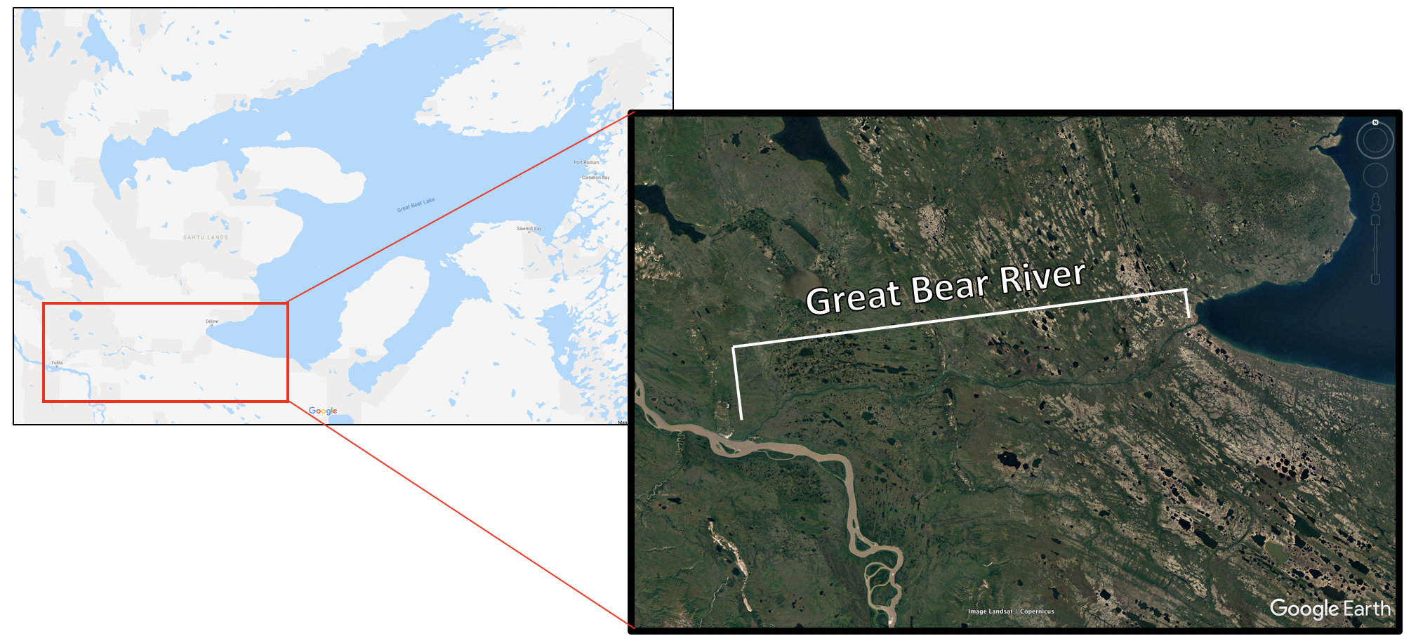

*Figure A1.* Location of Great Bear River, which outflows water of Great Bear Lake to the Mackenzie River. The head of the river is located near Délįnę. Images: Google Maps, Google Earth

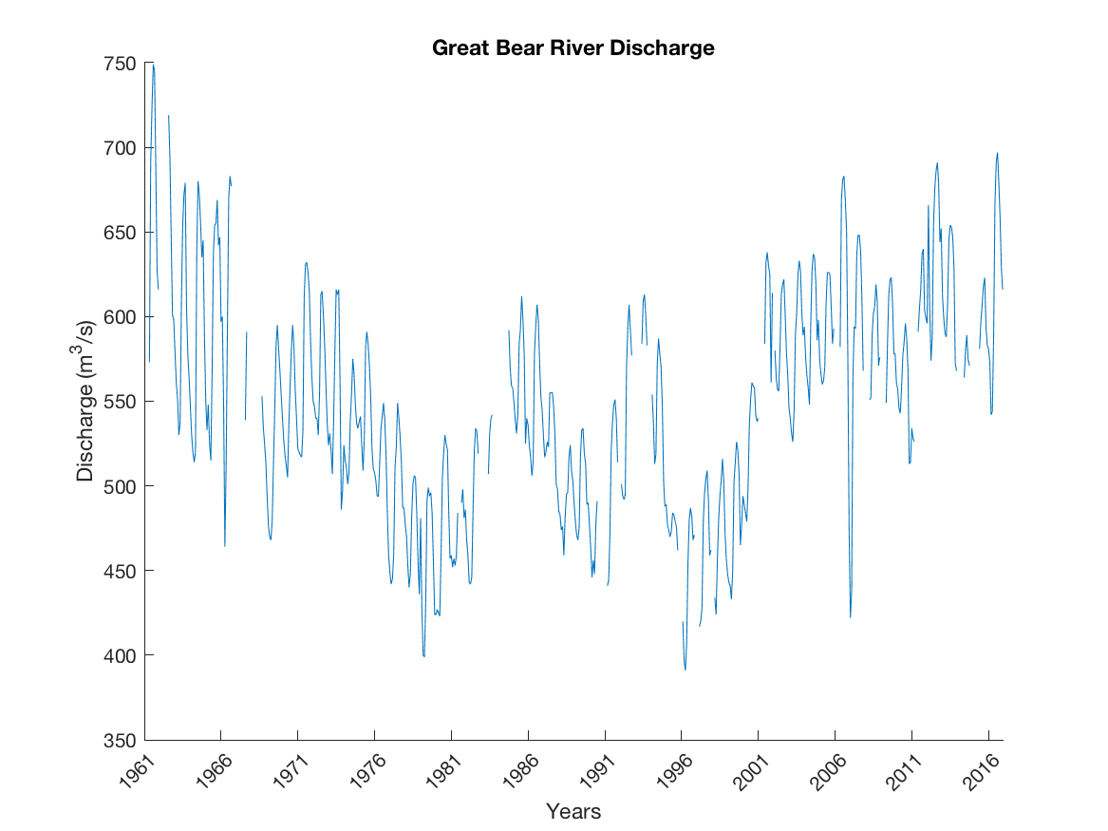

*Figure A2.* Average monthly discharge of water from Great Bear River. Although recent decades seem to indicate an upwards slope, there is no significant trend overall. Data derived from the Canadian federal climate database.

**Appendix B: Regional Climatological Analysis of Precipitation and Air Temperature**

Two regional stations near GBL and their associated meteorological data were obtained from the Canadian federal climate database (<http://climate.weather.gc.ca/prods_servs/cdn_climate_summary_e.html>). These stations are Délįnę A (ID: 6850) and Délįnę CS (ID: 27749) with coordinates 65.21N, 123.44W and 65.21N, 123.43W, respectively. Their elevations were 214.3m and 212.8m, respectively. We retrieved daily data and compiled it into monthly series (Figure B1, Figure B2).

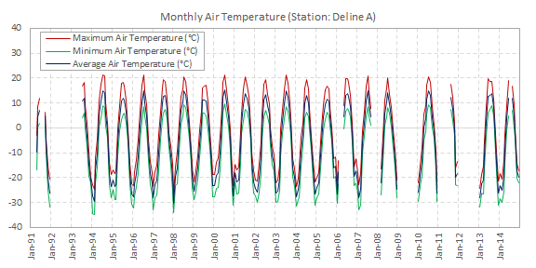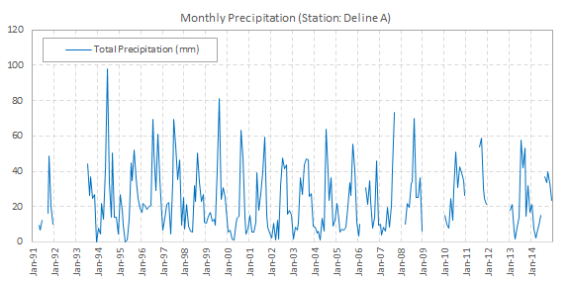

*Figure B1.* Délįnę A station temperature and precipitation time series. Daily data were compounded into monthly time series.

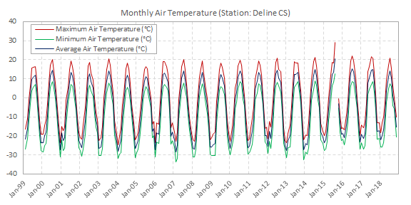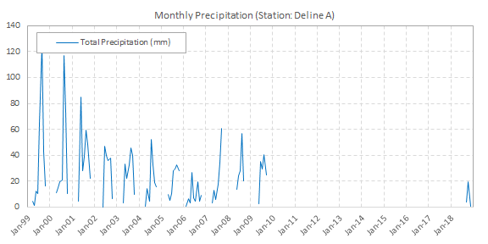

*Figure B2.* Délįnę CS station temperature and precipitation time series. Daily data were compounded into monthly time series.

The discontinuity in these graphs is due to missing values. Monthly time series were evaluated to see if they exhibited any increasing and decreasing trend using Mann Kendall and linear regression tests. All data sets showed serial correlations plus monthly, annual and multi-decadal periodicity. We, therefore, removed serial correlation before conducting trend tests. The results showed that the Deline A station temperature data does not possess any statistically significant trend. However, total precipitation had a decreasing trend from 1991 to 2014, with a confidence interval of 90 percent. The p-values of the Mann Kendall and linear regression tests were 0.054 and 0.063, respectively. For the Délįnę CS station, all temperature time series, including the maximum, minimum, and monthly average, exhibited an increasing trend with a confidence interval of 95%. We did not perform trend analysis on the precipitation time series at this station due to the large portion of missing values.

**Appendix C: *In situ* Chlorophyll-a and LSWT data of Great Bear Lake**

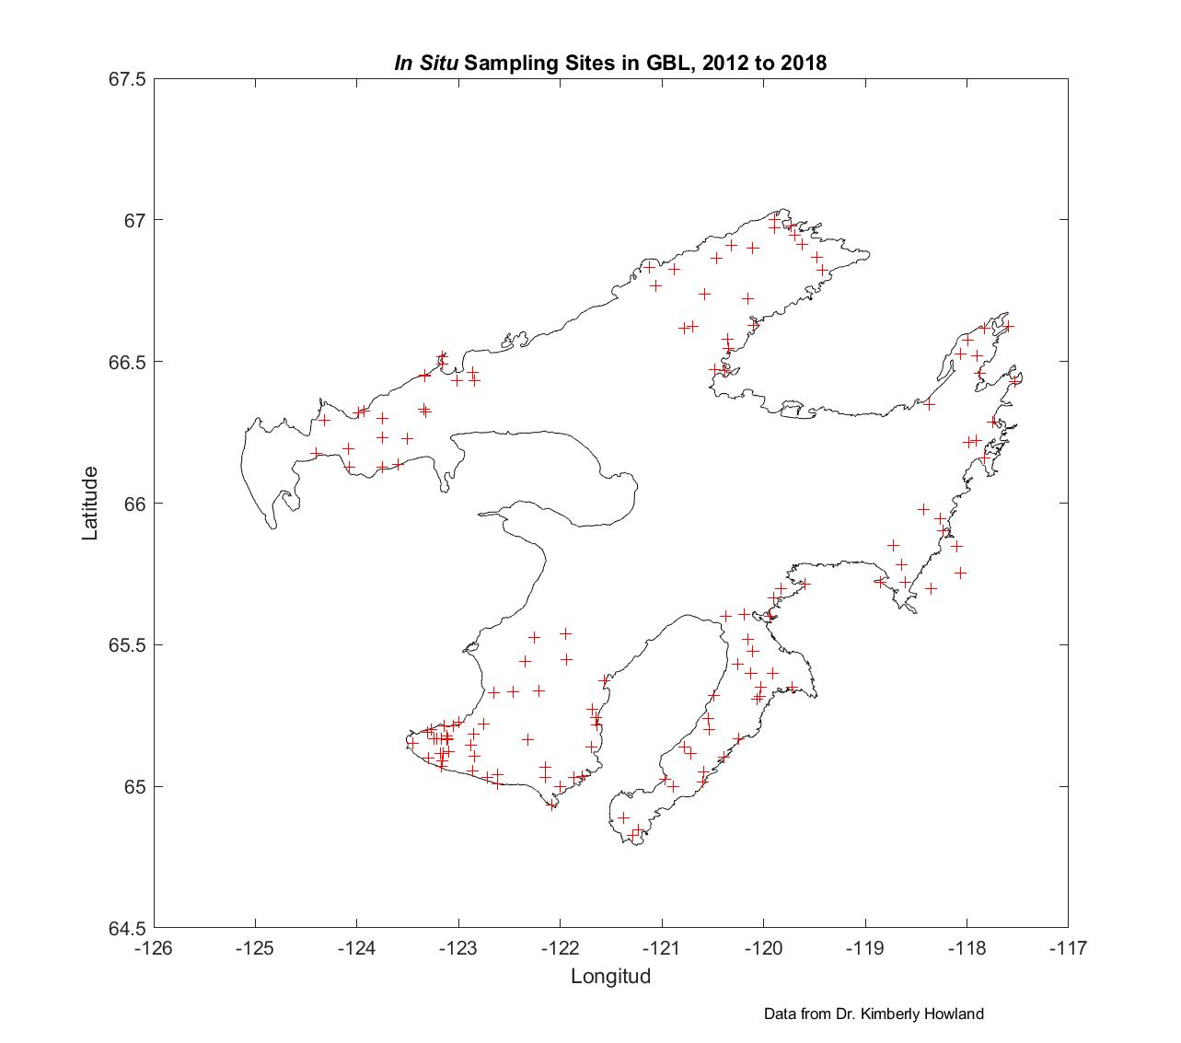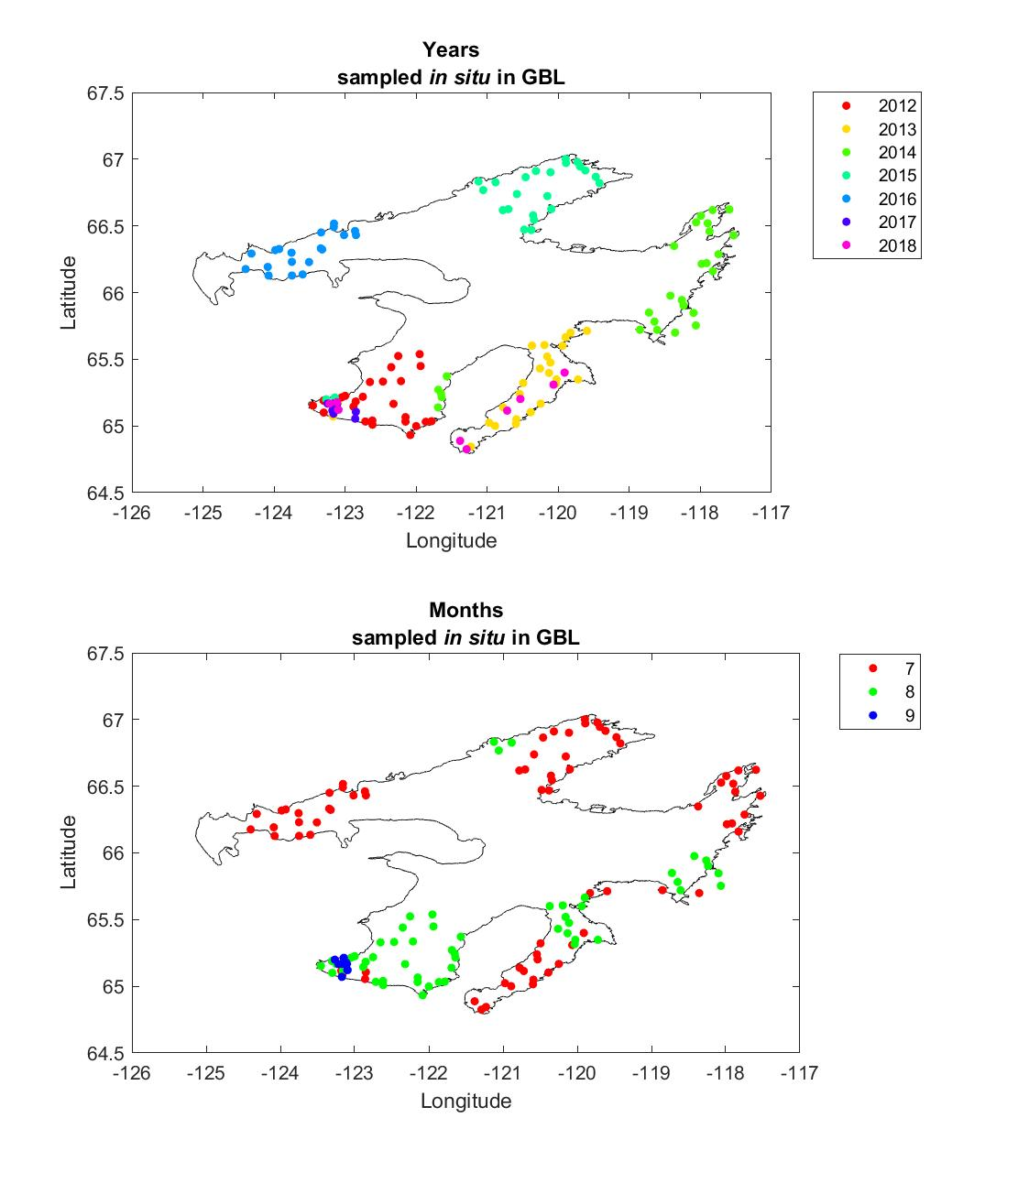

*Figure C1.* Great Bear Lake *in situ* sampling sites from 2012 to 2018, including locations (left), year of sampling (top right), and month of sampling (bottom right). Data provided by Dr. Kimberly Howland. Note the lack of sampling sites at the lake center.

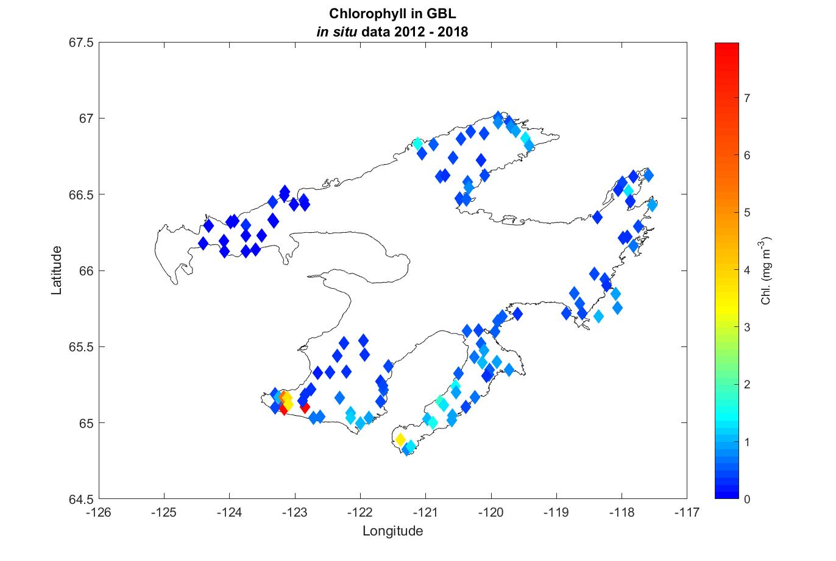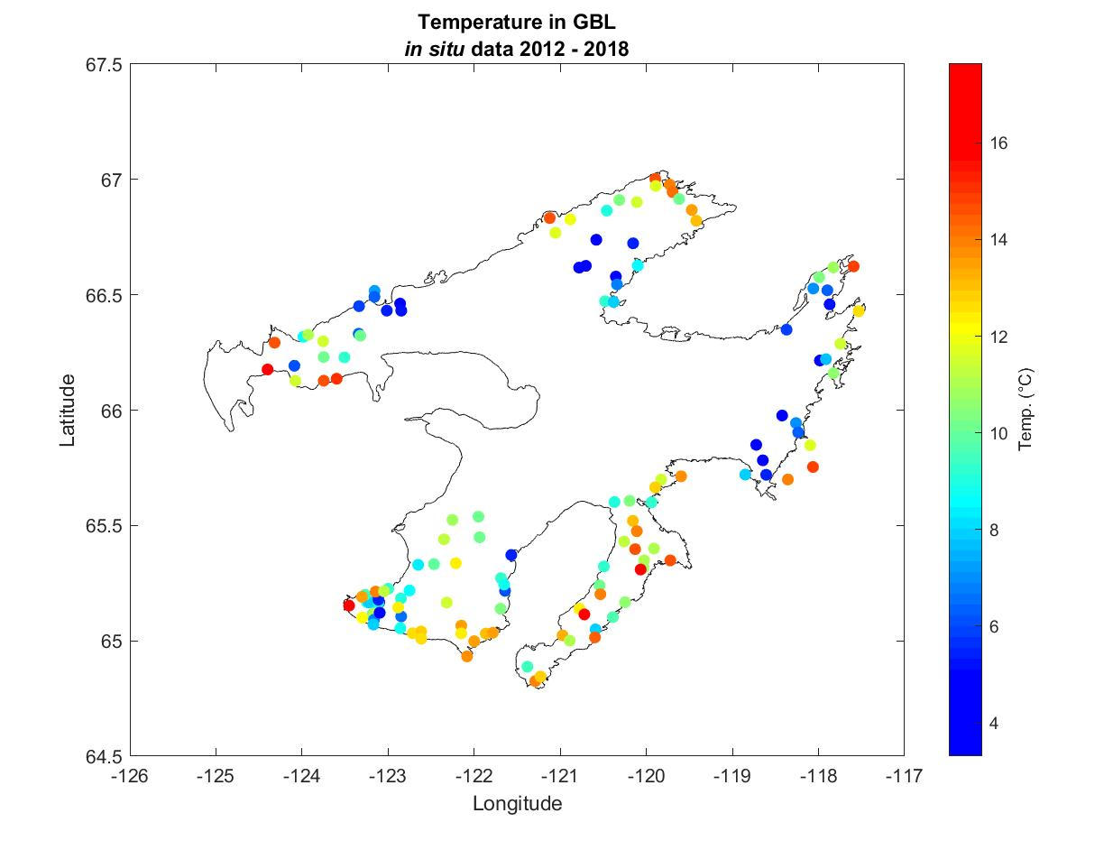

*Figure C2.* Great Bear Lake *in situ* Chlorophyll-a (left) and LSWT (right) samples from 2012 to 2018. Sample dates are visualized in Figure C1. Chlorophyll-a measurements were taken at an average of water column depth between 2m and 10m, while temperature was sampled near the lake surface.

**Appendix D: Seasonal Lake Surface Water Temperature (LSWT)**

Figure D1 shows the spatial distribution of the climatological seasonal average temperature for GBL.

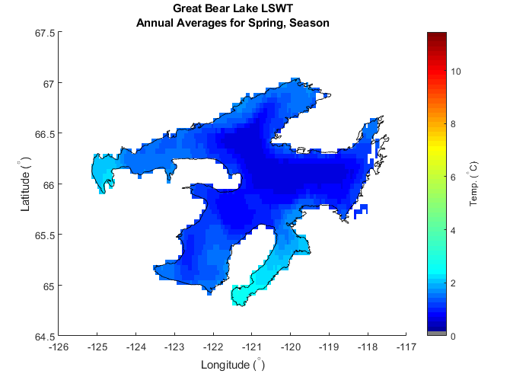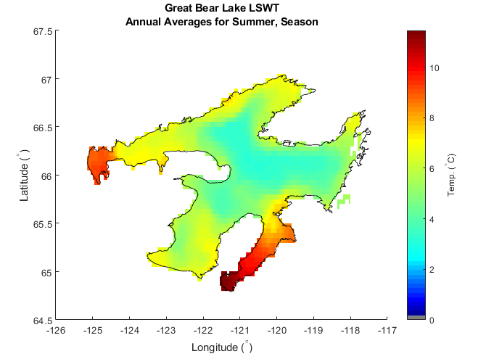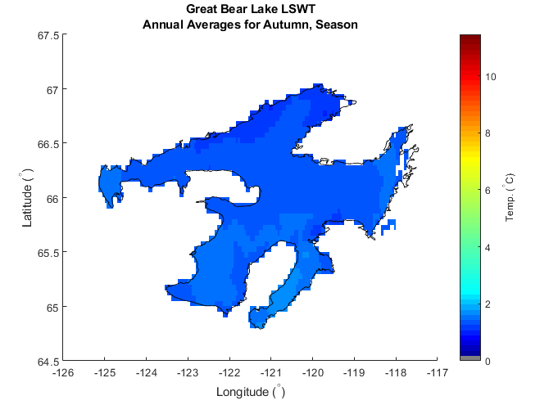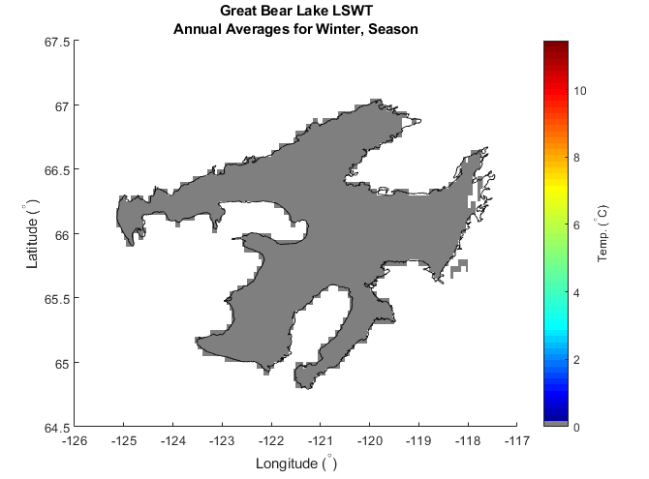

*Figure D1.* The climatological seasonal average temperature for GBL (grey color indicates ice cover). Data processed from the ARCLake database.