**NASA DEVELOP National Program**



NOAA National Centers for Environmental Information

*Spring 2017*

Missouri River Climate II

Utilizing NASA Earth Observations and NOAA Data Records to Produce Climate Indicators for Wildland Fire

 **Technical Report**

Final Draft – March 31, 2017

Kimberly Berry (Project Lead)

Alec Courtright

Kathy Dooley

Ben House

Michael Kruk, Earth Resources Technology, NOAA NCEI (Science Advisor)

Michael Brewer, NOAA NCEI (Science Advisor)

Previous Contributors:

Emily Sturdivant

Alec Courtright

Nancy Barnhardt

Samuel Swanson

# 1. Abstract

Grasslands are the most prominent land cover in the Missouri River Basin (MRB), and they are highly susceptible to wildland fires. Due to sparse data sources, fire managers in the MRB are unable to quickly discern spatial differences in the wildland fire potential. The region is in need of a robust, communicable, and easily distributable method of analyzing fire potential. This project combined fuel moisture content derived from NASA’s MODIS sensor aboard the Terra and Aqua satellites; wind speeds, temperature, and relative humidity from NOAA’s Real-Time Mesoscale Analysis (RTMA); and precipitation estimates from the Global Precipitation Measurement (GPM) mission to construct a wildland fire potential matrix of the MRB. These data were used to produce an updateable script for generating fire potential maps. This interface allows fire managers to quickly discern the potential for complex wildland fires throughout the MRB.

**Keywords**

Missouri River Basin, wildland fire, disasters, cured fuel, MODIS, GPM, Great Plains Region

# 2. Introduction

* 1. ***Background Information***

Wildland fire is a common natural phenomenon impacting ecosystems and societies around the world. Many landscapes, such as grasslands in the Great Plains Region of the U.S., have adapted to wildland fires (Samson, Knopf, and Ostlie, 2004). The fires burn away excess dead and decaying debris, creating room and letting in sunlight for new plants to grow (Ruokolaine and Salo, 2009). However, large fires can also lead to soil erosion and degradation, increased flooding potential, and CO2 emissions (Campbell et al., 1997, Shakesby et al., 1993). Fires also pose a threat to human life and economy, as they can quickly burn through agricultural land and developed areas.

In the Missouri River Basin (MRB), an estimated 838 fires have occured annually since 1998, burning a total of approximately 1,568,520 acres (Clabo, 2017). Therefore, it is important for fire managers to understand which weather and fuel conditions are most likely to result in large, dangerous conflagrations. Knowledge of fire potential allows fire response teams to position firefighting equipment and personnel in regions of high fire risk and carefully monitor changing conditions in vulnerable areas. Traditionally, fire managers and fuel models rely on fire indicators measured by weather stations and interpolate the data over a broader region. This may result in inaccurate readings in areas with sparse weather stations, and different interpolation methods yield inconsistent estimates. The use of remote sensing to gather weather data and fuel conditions is becoming more common to predict fire potential in areas with little *in situ* data (Chowdhury and Hassan, 2014). This project developed an online GIS model, Fire Risk Estimation (FIRE), which used remotely-sensed data to produce a user friendly near real-time map of fire potential for fire management teams in the MRB.

This is the second term of a two-term project. The first term of this project improved the understanding of water supply and water runoff in the MRB. The team combined remotely sensed and *in situ* data to examine the 30-year climate trends of and frozen soil, snow melt, and water discharge and their relationship with run-off. These projects are independent in terms of scientific research, but this term builds off partner connections formed during the first project to address a different environmental issue of concern.

* 1. ***Study Area and Period***

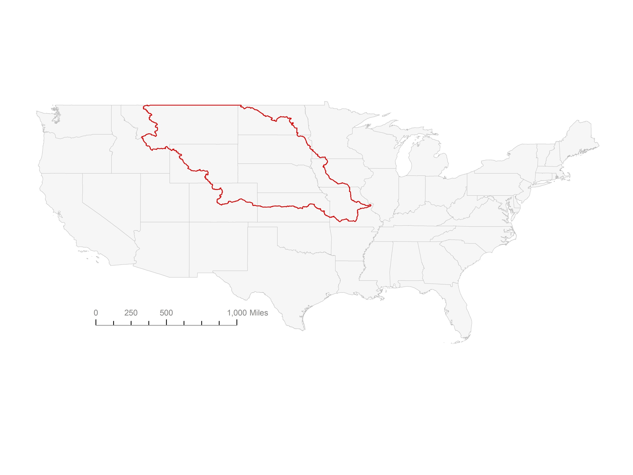

Figure 1. The MRB.

The analysis of wildland fire potential encompassed the entire MRB (Figure 1). According to the National Land Cover Dataset (NLCD), 40% of the MRB was covered by grassland and 25% by agricultural land. This project analyzed each month, but focused on April through October to capture the two peak fire seasons in the region, spring and fall. This analysis spanned from 2002 to March 2017 due to the availability of MODIS satellite data.

* 1. ***Project Partners & Objectives***

This project falls under the NASA Applied Sciences Applications Areas of Climate, Disasters, and Weather. The NASA DEVELOP National Program partnered with various fire management state officials in South Dakota to analyze fire potential. Darren Clabo, South Dakota State Fire Meteorologist, Doug Kluck, NOAA Regional Climate Services Director of the Central Region, and the Bureau of Indian Affairs Fire Management Office of the Great Plains Region are all involved with wildland fire management and monitoring. Currently, fire conditions are estimated by fire managers at regional offices across the state of South Dakota during peak fire seasons. Fire risk information is manually collected from several information sources and distributed by the partners. This project aimed to provide a robust and easily distributed wildland fire potential map.

# 3. Methodology

***3.1 Data Acquisition***

Google Earth Engine (GEE) provided GIS data layers and the interface to calculate and display wildland fire potential (Table 1). The quick processing time and automatic data updating, along with the ability to easily share the script and output map, made GEE an ideal platform to run the analysis and distribute the end product. Project partners provided the geometries for reservation locations, and USGS National Water Information System provided the MRB geometry.

|  |  |  |
| --- | --- | --- |
| Data Source | Data Product Name | Indicator |
| MODIS 8-Day Level 3 Surface Reflectance | Google Earth Engine  MODIS/MYD09GA | Snow Cover, Fuel Moisture |
| Global Precipitation Measurement (GPM) | Google Earth Engine  NASA/GPM_L3/IMERG | Precipitation |
| Real Time Mesoscale Analysis (RTMA) | Google Earth Engine  NOAA/NWS/RTMA | Temperature, Wind Speed, Dew Point |
| National Land Cover Database (NLCD) | Google Earth Engine  USGS/NLCD | Forests, Crops, Grasslands/Shrublands |
| Palmer Drought Severity Index (PDSI) | Google Earth Engine  IDAHO_EPSCOR/PDSI | Drought |
| Monthly Average Temperature | NOAA nClimGrid | Temperature Anomaly |

Table 1. Data products used and their sources and corresponding wildfire indicators.

MODIS 8-Day Level 3 Surface Reflectance data were chosen over Landsat Surface Reflectance products because it has a higher temporal resolution and it removes cloud cover to a high accuracy. MODIS has the shortest timespan available, from 2002 to present day, of data collected from the GEE data catalog. Historical fire data has not been updated since March of 2017; therefore, the fire risk validation ranges from 2002-2017. The Shortwave Infrared (SWIR) band 5, Near Infrared (NIR) band 2, and band 4 were used from the MODIS dataset in GEE.

Precipitation data were acquired from NASA’s Global Precipitation Measurement (GPM) mission. Drought conditions, measured with the Palmer Drought Severity Index (PDSI) were prepared by the University of Idaho and collected from GEE. The 2011 National Land Cover Database (NLCD) data were collected from the GEE data catalog created and provided by the U.S. Geological Survey (USGS). Temperature, dew point, and wind speeds were collected from the Real Time Mesoscale Analysis (RTMA) dataset were provided by NOAA and the National Weather Service.

***3.2 Data Processing***

Some indicators are available straight from the data source, GEE, while others must be derived. The FIRE matrix requires no processing to calculate PDSI drought. Temperature is converted from Celsius to Fahrenheit and wind speeds are converted from meters per second to miles per hour. The temperature anomaly takes NOAA nClimGrid 100-year average temperature and calculates daily averages through linear approximation. The current temperature is then subtracted from the corresponding daily average to get the temperature anomaly. Relative humidity is calculated from temperature and dew point through the August-Rush-Roche Approximation (Equation 1). Precipitation data is aggregated into the previous three day and seven day cumulative volumes. Normalized Difference Infrared Index (NDII) is used as a proxy for fuel moisture Yebra, et al., 2013) (Equation 2).

|  |  |
| --- | --- |
| $$RH=100 ×\frac{e^{ ^{\frac{17.625 × TD}{243.04 × TD}}}}{e^{ ^{\frac{17.625 × T}{243.04 × T}}}}$$ | (1) |

|  |  |
| --- | --- |
|  | (2) |

One partner, David Martin, Assistant Regional Fire Management Officer with the BIA in the Great Plains Region, provided thresholds for fire indicators (Table 2). These values were observed by fire managers within South Dakota during large and complex wildfire outbreaks. Thresholds were applied to each of the layers in GEE to generate a mask to remove areas below the threshold requirements.

|  |  |
| --- | --- |
| Variable | Threshold |
| Wind Speeds (mph) | Greater than 30 |
| Temperature (oF) | Greater than 40 |
| Temperature Anomaly | Greater than 10 |
| Relative Humidity (%) | Less than 30 |
| Precipitation (inches) | Greater than 1/10 |

Table 2. Thresholds for relative humidity, wind speed, temperature provided by the Partners.

Wind speed, temperature, and dew point were collected from RTMA in the GEE data catalog for the most recent 24 hours. Winds speeds were converted from meters per second to miles per hour and masked to only show areas that exceeded wind speeds of 30 mph. The temperature was converted from degrees Celsius to Fahrenheit. The temperature anomaly was calculated from NOAA nClimGrid 100-year average temperature. The monthly temperature normals were loaded into GEE as rasters because these were the only images not found in the GEE data catalog. The daily average temperature was calculated by linear approximation. Then the approximated historical temperature was subtracted from the daily RTMA temperature.

The precipitation matrix is split into two parts: wetting precipitation and soaking precipitation accumulation. Wetting precipitation is defined great than 1/10 inch of rainfall cumulatively over the past three days, while soaking precipitation is defined as one inch of rainfall cumulatively over the past seven days. When either of these conditions are met, fire potential decreases. The time periods for the two categories of precipitation were chosen based on average annual Pan eVaporation Rates (PVR) sourced from a NOAA NWS Report (Farnsworth, Thompson, & Peck, 1982). The lowest annual PVR within the study area was 40 inches per year or 0.109 inch per day. The lowest annual PVR was then used to estimate the wetting precipitation. It showed that precipitation less than 0.1 inch will completely evaporate within two days. Soaking precipitation events have longer lasting effects on vegetation and soil moisture. PVR showed that any precipitation less than one inch evaporates within seven days.

To estimate fuel moisture in the MRB, MODIS data and 2011 NLCD were loaded into GEE in a separate script. The team focused on three land cover types aggregated from the NCLD: grassland, woody vegetation (including shrubland and forests), and cropland. The MODIS data were divided into each category for fuel analysis. Cured fuels cannot be directly calculated from remotely-sensed data. A useful proxy for cured fuels is fuel moisture. The Normalized Difference Inferred Index (NDII) shows the moisture content of vegetation, displayed in Equation 2 (Yebra, et al., 2013).

The NDII layers were used in two parts of the fire potential matrix: NDII anomaly and NDII weekly change. NDII anomaly show how much wetter or dryer the vegetation is from its historical norm while the NDII weekly change would show how the fuel moisture changed from the previous week. NDII Anomaly was calculated by collecting the NDII measurement for each week from 2002-2011, with 46 images per year. Then the images were averaged by their date to find the average NDII value per pixel for each week. NDII 10-year weekly average images were stored in the GEE Asset folder to be pulled as a data layer in the final fire potential matrix. The NDII Anomaly is calculated by subtracting the most recent NDII MODIS image from the corresponding weekly average NDII image stored in the Assests folder. NDII weekly change was calculated by subtracting the previous NDII image from the most recent.

The presence of snow greatly reduces fire risk in the MRB. The Normalized Difference Snow Index (NDSI), shown in Equation 3, was generated from the MODIS sensor to include as a fire potential reducer in the matrix. A value greater than 0.4 was treated as in indicator for snow. The NDSI layer was thresholded to remove any areas less than 0.4 pixel value (Salomonson and Appel, 2004). The resulting layer was masked to a unit of 1 and given a negative weight in the fire potential matrix.

|  |  |
| --- | --- |
| $NDSI=$ $\frac{{VIS }_{4}- SWIR}{{VIS }_{4}+ SWIR}= \frac{Band 4 - Band 5}{Band 4 + Band 5}$ | (3) |

The final variable in the analysis was drought conditions. The PDSI from the University of Idaho was used to incorporate drought conditions due to data availability in GEE. In our matrix, any PDSI layer less than -1 indicated drought conditions. A mask was used to remove any areas greater then -1 and the remaining pixels were given the unit of one.

|  |  |
| --- | --- |
| Variable | Threshold |
| Drought (PDSI) | Less than -1 |
| Soaking Precipitation (inches/days) | Greater than 1/5 |
| Wetting Precipitation (inches/days) | Greater than 0.1/2 |
| NDSI | Greater than 0.4 |

Table 3. Thresholds for drought, precipitation, NDII, and NDSI.

***3.3 Data Analysis***

The weekly change in NDII data from 2002-2011 was divided and masked along the NLCD for cropland, grass/shrub lands, and forest. The images were then exported from GEE and converted to points. The points were then clipped to the NLCD sections again to remove points with masked values showing as zero. The data was pulled into R Statistical Program to find the standard deviation and mean for each land cover type (Table 4). Figure 2 shows the distribution of pixel values for forest pixels.

|  |  |  |
| --- | --- | --- |
| Land cover | Standard Deviation | Mean |
| Crops | 0.08784 | 0.003459213 |
| Grass | 0.098855107 | 0.00235527 |
| Forest | 0.07211071 | 0.0003643007 |

Table 4. The standard deviation and mean of NDII for each land cover type.

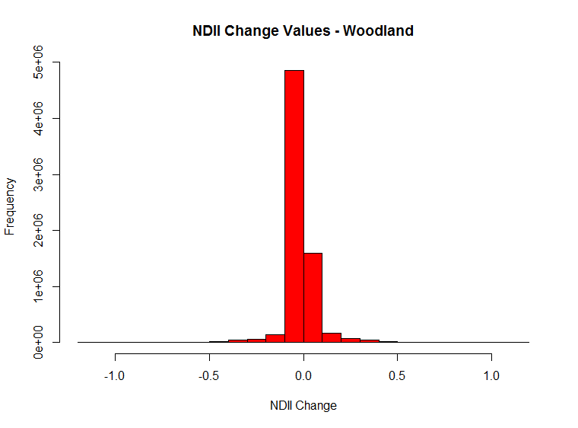

Figure 2. Histogram of fire frequency per month.

The layers of the matrix were analyzed and weighted by seasons: summer, fall, and winter/spring. The seasonal breaks were defined by historical fire data collected by one partner, Darren Clabo. Figure 3 shows the frequency of fires per month in South Dakota from 1989 to 2015. The summer season is the shortest as a transitional break from the two fire seasons, spring and fall, and spans May through June. The fall season is from August through October. The winter/spring begins in November and ends in April.

Figure 3. Histogram of Fire Frequency per month.

Once all of the thresholds had been applied to the data, the layers were masked to show regions that met the threshold requirements for fire potential. Areas that met the threshold were given a value of one; areas that were below the threshold were given a value of zero. The layers were then weighted differently depending on seasonal dependencies (Table 5).

Once the indicators were weighted, they were added together to create a single layer with values ranging from zero, no detected risk of fire, to six, indicating that all of the indicators met the threshold values for large complex fire potential.

|  |  |  |  |  |
| --- | --- | --- | --- | --- |
| Variable | Winter/Spring Weight | Summer Weight | | Fall Weight |
| NDII (Anomaly) | 0.15 | 0.15 | 0.15 | |
| NDII (Change) | 0.05 | 0.05 | 0.05 | |
| Drought (PDSI) | 0.1 | 0.05 | 0 | |
| Precipitation Events | 0.1 | 0.12 | 0.15 | |
| Wind Speeds (mph) | 0.08 | 0.1 | 0.1 | |
| Temperature (oF) | 0.15 | NA | NA | |
| Temperature Anomaly | 0.15 | 0.15 | 0.15 | |
| Relative Humidity (%) | 0.12 | 0.14 | | 0.15 |

Table 5. Weights of variables in seasons

To validate the weights, the team compared the fire potential maps to the fire danger maps produced by the NWS in South Dakota (Figure 4). Weights were tweaked to better fit the peak spring fire season according to visual comparisons (Figure 5). Partners within the BIA and South Dakota School of Mines and Technology will collect daily fire potential images, derived from the GEE tool and measure the performance compared to the NWS fire danger maps over the spring and summer fire seasons following the spring 2017 project term.

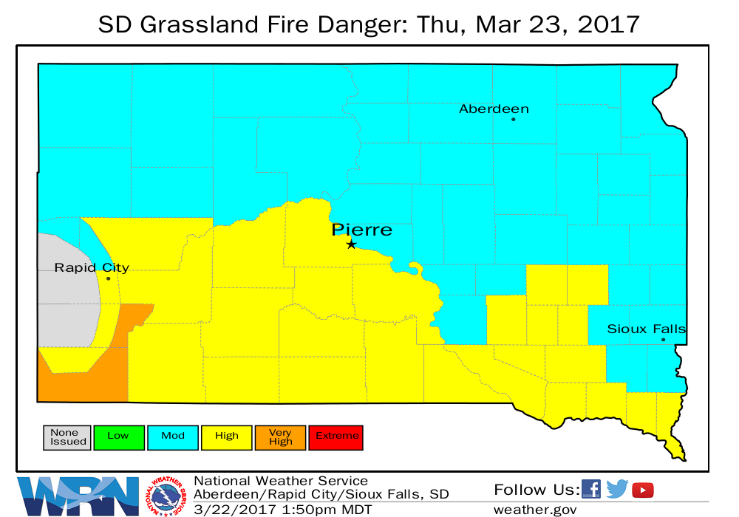

Figure 4. SD Grassland Fire Danger Index March 23, 2017

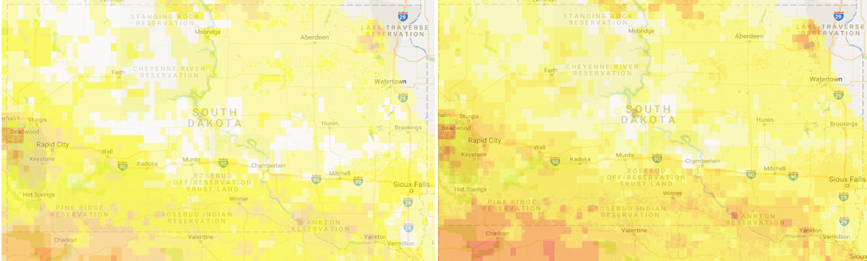

Figure 5. Demonstration of weighting the matrix based on observation from SD Grassland Fire Danger Index. The Figure on the right is before weights were added and the figure on the left is after the weights were adjusted.

Once the indicators were weighted, they were added together to create a single layer with values ranging from zero, no detected risk of fire, to six, indicating that all of the indicators met the threshold values for large complex fire potential.

# 4. Results & Discussion

***4.1 Analysis of Results***

This project successfully produced an interactive tool for fire risk assessment in the Missouri River Basin. This tool improves on the current methods used by fire managers in the study area. Currently, fire managers manually combine climate and weather information and drought conditions from a variety of sources on a daily basis. GEE provided the ideal server to bring all of their data into a single website where individual indicator data layers can be accessed, as well as a comprehensive single layer of fire risk. GEE also allows partners to view the code used to produce the map. Using the FIRE tutorial provided with the tool, end users will be able to easily refine the indicator weights and thresholds as they compare the outputs of this tool to observed fire risk over the coming fire seasons. Darren Clabo, South Dakota State Fire Meteorologist, plans to take daily fire potential maps from our matrix and compare them to the South Dakota Fire Danger maps from the NWS (Figure 3) to test how the team’s tool performs over the spring and summer fire seasons. This tool also has the potential to be expanded to other regions of the country. The fire indicators are currently calibrated to the Missouri River Basin study area, but other fire managers could use the same interface to change the indicators and weights to meet their regional needs.

***4.2 Future Work***

The fire potential matrix will be used by the BIA, South Dakota State fire meteorologists, and fire managers to analyze fire risk in the MRB. Each partner will have the capability to use the fire potential matrix as a base and enhance the matrix for their interests. As new datasets become available, the matrix can be updated, refined, and reweighted.

Further contributions to this product could include utilizing the GEE API to create an interactive map interface to display the interactive map without showing the JavaScript code. That map would be more easily shareable with fire manager in the field while making use of the near real-time capability of the GEE script.

# 5. Conclusions

Fire management teams in our study area will use the interactive fire potential map to assess where wildfires have the greatest potential to ignite and spread. With this information, they will be able to move their emergency fire equipment to places with the highest levels of threat. This map is not meant to replace existing tools or monitoring systems used by fire departments, nor does it claim to be more accurate. However, the incorporation of high resolution satellite data offers a more complete assessment of weather and especially fuel conditions in places removed from weather stations or other *in situ* data. Additionally, in contrast to complex fuel models with multiple inputs and parameters, the user-friendly interface allows people to easily view where the fire danger exists and understand which indicators are contributing to that risk in near real time. This map will be released publicly, and therefore its information can be easily spread and communicated between response teams.

# 6. Acknowledgments

The Missouri River Climate II Team would like to thank the following people for their guidance and contributions, without whom none of this would be possible:

**Science Advisors and Collaborators**

Michael Kruk, Michael Brewer, Darren Clabo, Doug Kluck, David Martin, Nancy McCraw, Andrew Backe, Steve Ansari, Kelly Meehan, Sol Kim, Dr. L. DeWayne Cecil, Dennis Todey, and Kevin Grode

**Previous team members**

Nancy Barnhardt, Alec Courtright, Emily Sturdivant, and Samuel Swanson

Any opinions, findings, and conclusions or recommendations expressed in this material are those of the author(s) and do not necessarily reflect the views of the National Aeronautics and Space Administration.

This material is based upon work supported by NASA through contract NNL16AA05C and cooperative agreement NNX14AB60A.

# 7. Glossary

**BIA** – Bureau of Indian Affairs: federal agency that provides services to American Indians and Alaska Natives

**Cured Fuels –** vegetation that has begun to die and dry out, often times due to seasonal or annual cycles

**GEE –** Google Earth Engine: cloud-based geospatial processing platform

**MODIS** – MODerate resolution Imaging Spectroradiometer

**MRB** – Missouri River Basin: a collection of watersheds in which precipitation, run-off, and other flows of water drains into the Missouri River. The MRB spreads across ten different states as well as Canada in the center of the United States.

**NDII** – Normalized Difference Infrared Index: serves as a satellite derived proxy for vegetation moisture

**NDSI** – Normalized Difference Snow Index: a satellite derived measurement of snow cover

**PDSI** – Palmer Drought Severity Index: measurement of dryness based on recent precipitation and temperature and often used as a proxy for drought conditions

**NOAA RTMA** – The National Oceanographic and Atmospheric Association’s Real Time Mesoscale Analysis: a high-spatial and temporal resolution analysis system for near-surface weather conditions derived from weather station and satellite data

# 8. References

Clabo, Darren. (2017) Unpublished Fire Locations and Statistics in South Dakota Climate Divisions.

Farnsworth, R., Thompson, E., & Peck, E. (1982). Evaporation Atlas for the Contiguous 48 United States. NOAA Technical Report NWS 33. Retrieved 25 March 2017, from http://www.nws.noaa.gov/oh/hdsc/Technical_reports/TR33.pdf

Salomonson, V. V., & Appel, I. (2004). Estimating fractional snow cover from MODIS using the normalized difference snow index. Remote Sensing of Environment, 89, 351-360. Retrieved March 29, 2017, from https://modis-snow-ice.gsfc.nasa.gov/uploads/pap_RSE04.pdf.

Yebra, M., Dennison, P. E., Chuvieco, E., Riaño, D., Zylstra, P., Hunt, E. R., Jr., . . . Jurdao13, S. (2013). A global review of remote sensing of live fuel moisture content for fire danger assessment: Moving towards operational products. Remote Sensing of Environment,136, 455-468. Retrieved January 25, 2017.