**NASA DEVELOP National Program**



The University of Georgia

*Spring 2016*

Atlanta Water Resources II

Identifying Key Urban Areas to Reduce Stormwater Runoff and Maximize Conservation Efforts in Metropolitan Atlanta

 **Technical Report**

Final Draft – August 11, 2016

Christopher Cameron (Project Lead)

Ike Sari Astuti

Mark Beatty

Natalia Bhattacharjee (née Shim)

Manasi Parkhi

Alex Smith

Dr. Rosanna Rivero, University of Georgia - College of Environment & Design (Science Advisor)

Dr. Marguerite Madden, University of Georgia - Center for Geospatial Research (Science Advisor)

Previous Contributors:

Beatriz Avila

Veronica Fay

Jason Reynolds

Jacob Spaulding

Wenjing Xu

# 1. Abstract

Residents of metro Atlanta pay the highest rates in the nation for municipal water and sewer, in part due to massive recent investments in infrastructure to manage stormwater runoff. As development continues at a rapid pace in Atlanta and its suburbs, expanding areas of impervious surface will continue to exacerbate this problem. Forested land is known to slow runoff during storms, allowing water to infiltrate, and the soil to absorb particles and contaminants before entering the surface water. Enabling the protection of existing green infrastructure, or strategically planting more trees to intercept stormwater runoff, will help reduce sediment and nutrient-laden stormwater runoff in local watersheds in addition to limiting the needs of future city infrastructure. The DEVELOP team at the University of Georgia partnered with The Nature Conservancy to identify conservation targets in the Atlanta region to improve existing green infrastructure and locate additional areas suitable for expansion of reforestation efforts using NASA data from Landsat 8 and Terra satellites. This was accomplished through a combined, watershed-scale assessment of metro Atlanta using the Land-Use Conflict Identification Strategy (LUCIS) and Soil and Water Assessment Tool (SWAT) models. The LUCIS model was employed in this project to identify areas of land use prioritization as it relates to existing and future conservation areas in Atlanta. The SWAT model produced an analysis of streamflow and runoff within the study area. Together, these model results provided project partners with an integrated understanding of water resource issues in metro Atlanta that emphasized land use scenarios.

**Keywords**

LUCIS, SWAT, Green Infrastructure, Reforestation, Landsat 8, ASTER

# 2. Introduction

* 1. ***Background Information***

Growing populations and rapid development within major cities, such as Atlanta, raise questions about local water quality due to the negative environmental impacts associated with increased runoff and impervious surface cover (Schoonover, et al., 2006). Additionally, the difficulty of managing municipal water in these large, urban landscapes poses a challenge for city officials who work to determine what infrastructure is needed to support local demands for water and assist runoff management efforts (Bernhardt et al., 2008). As cities like Atlanta continue to grow, these issues will influence regional demand for water, require additional infrastructure, and cost residents even more in utilities to support municipal water management projects. Atlanta is already in the process of renovating its dilapidated wastewater and storm-water infrastructure due to the federally mandated Atlanta Clean Water Initiative (City of Atlanta Department of Watershed Management website, 2016). Atlanta residents face increased water rates to help shoulder the project’s four billion dollar cost.

According to the Georgia River Network, an increasing concern within the city of Atlanta is the overall health of the Chattahoochee River watershed and its incoming water quality. Rivers are especially sensitive to runoff inputs and pollution in urban landscapes because of impervious surfaces, such as parking lots and streets, which do not promote infiltration. These impervious surfaces produce a large volume of runoff, increasing the risk of contaminants like oil, grease, fertilizers, and nutrient-rich sediments flowing into local waterways and further downstream. Contamination is a major concern for the city of Atlanta as the Chattahoochee River is the main water supply for the entire metropolitan area (City of Atlanta Department of Watershed Management website, 2016).

Runoff events can be managed by protecting existing natural features and following land use best practices. The development of green infrastructure has proven to be a resourceful and cost-effective tool to address water quality and runoff management issues in city landscapes (Tzoulas et. al., 2007). Green infrastructure refers to a network of open space, forests, wildlife habitat, parks, and other natural areas within urban and suburban areas, which help sustain clean air, water, and other natural resources (McMahon, 2000). These green spaces also have a large benefit in enriching the quality of life for local residents by providing recreational use and aesthetic beauty (McMahon, 2000). Green infrastructure has been shown to benefit watershed health by decreasing the effects of pollution on waterways (Livesly et. al., 2011). Specifically, urban forests were found to decrease stormwater runoff by allowing water to infiltrate and the soil to absorb particles and contaminants before entering the surface water.

This project looked at the potential for areas within the Metropolitan North Georgia Water Planning District (MNGWPD) to support green infrastructure as a means to enhance stormwater management by examining datasets from 2001 to 2015 to generate criteria relating to land cover changes, climate, and urban development. This area (Figure 1) contains what is also referred to as the greater Atlanta region, with a population of over 5.2 million people and the ninth largest city in America (US. Census Bureau, 2010). The MNGWPD intersects nine regional watersheds including the Chattahoochee, Ocmulgee, Oconee, Flint, Etowah, Tallapoosa, Coosawattee, and Oostanaula rivers (Figure 2).

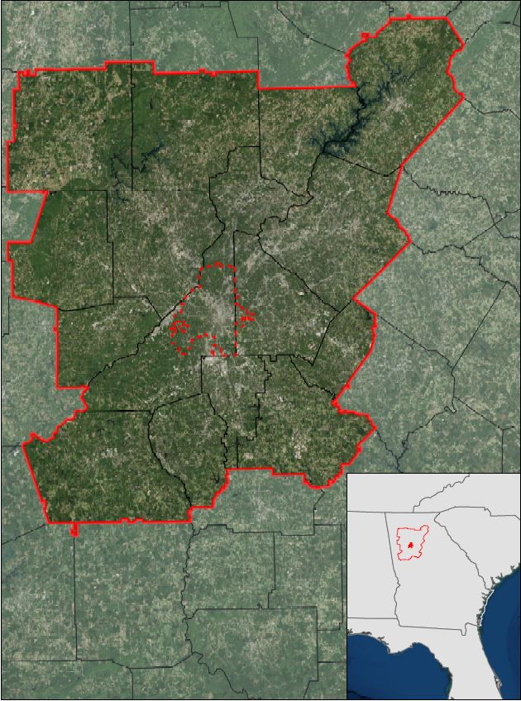

**N**

0

300

60

Km

MNGWPD

Atlanta

**Legend**

Figure 1. Study Area Map: The Metropolitan North Georgia Water Planning District (MNGWPD)

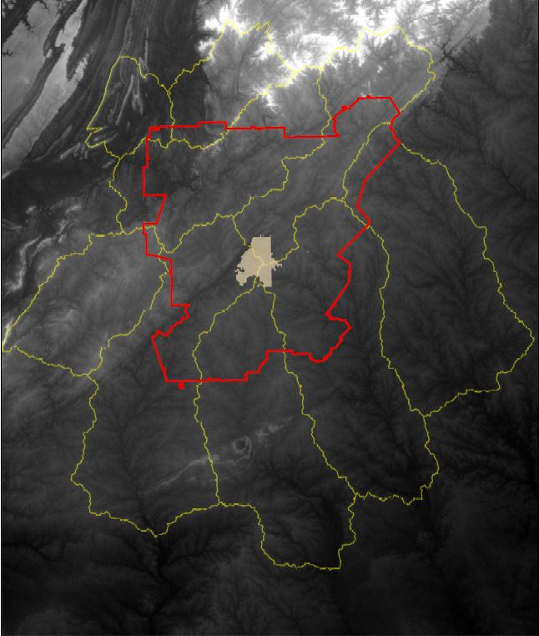

**N**

0

300

60

Km

MNGWPD

Watersheds

**Legend**

City of Atlanta

Middle

Chattahoochee

Ocmulgee

Upper Chattahoochee

Flint

Atlanta

Watersheds

MNGWPD

Etowah

Figure 2. Major watersheds of the MNGWPD

* 1. ***Project Partners & Objectives***

Project partners at The Nature Conservancy have been engaged in on-going work with local policy makers to promote reforestation and green infrastructure efforts in the Atlanta region as a means to reduce the flow of nutrient and sediment-laden runoff into local rivers. Currently, their work is focused on three primary goals: (1) implementing reforestation projects to capture and filter stormwater to provide benefits to local biodiversity and increase community resilience, (2) influencing local planning approaches so that they benefit conservation and socio-economic development, (3) encourage public dialogue and engagement to further educate citizens on their role in the surrounding natural environment, as well as foster support for participation in conservation actions. This work is part of a broader, nation-wide initiative to promote urban conservation practices.

The Nature Conservancy will use the results of this project to inform their work in Atlanta by identifying conservation targets based on a spatially-weighted analysis incorporating multiple factors. This project will be used as a means for The Nature Conservancy to identify critical, geographic relationships concerning the future expansion of green infrastructure and stormwater management in Atlanta. The Nature Conservancy will also use the results of this work as means to continue reforestation discussions with local policy makers and organizations such as Trees Atlanta and the Atlanta Regional Commission. The goal of this project is to help reduce nutrient-laden overland flow and sediment inputs into the regional watersheds by promoting green infrastructure with conservation and strategic reforestation.

This study addressed the NASA Applied Sciences Water Resources National Application Area by incorporating both Landsat 8 Operational Land Imager (OLI) and Terra Advanced Spaceborne Thermal Emission and Reflection Radiometer (ASTER) data into watershed-scale characterizations of land cover and water quality across the MNGWPD. This was accomplished using the SWAT and LUCIS models to identify areas associated with high stormwater runoff potential. Additionally, this study addressed the Ecological Forecasting Application Area by using the LUCIS model to identify potential reforestation and conservation zones within the MNGWPD to assist The Nature Conservancy’s efforts in developing an urban conservation program. The SWAT model was used to analyze the effects of land use on water quality in the MNGWPD. SWAT has been widely applied for modeling water-related processes in watersheds and quantifying the effect of land management on ecosystems to inform best management practices and policies (Francesconi et al., 2016; Neitsch et al., 2009; Santhi et al., 2006). All the datasets used in both the LUCIS and SWAT models are listed in Appendix A. By integrating the results of the SWAT model with LUCIS, this project created a comprehensive, watershed-scale assessment for The Nature Conservancy’s on-going work.

# 3. Methodology

***3.1 Data Acquisition***

Landsat 8 OLI provided 2015 imagery for current land use classification to use in the LUCIS model. Additionally, Terra ASTER 30 m resolution Digital Elevation Models (DEMs) provided the elevation data used in both the LUCIS and SWAT models. Both of these datasets were obtained through the United States Geologic Survey (USGS) EarthExplorer data download platform. Landsat OLI coverage for the MNGWPD corresponded to two scenes in path-rows 19-36 and 19-37. A total of 12 ASTER DEMs were downloaded to provide complete elevation data for the watersheds intersecting the MNGWPD.

Ancillary datasets used in the LUCIS and SWAT models were primarily provided by The Nature Conservancy, USGS, United States Department of Agriculture (USDA), Environmental Protection Agency (EPA), and the National Oceanic and Atmospheric Administration (NOAA). These included water bodies, rivers, urban developments, water quality, soils, and the 2001 National Land Cover Dataset (NLCD). All data provided by The Nature Conservancy was fitted to the project study region (Appendix A).

***3.2 Data Processing***

Landsat OLI imagery was mosaicked and atmospherically corrected in ENVI using its Quick Atmospheric Correction (QuAC) algorithm. The resulting image was then used for a supervised 2015 land cover classification following discussions of an appropriate classification scheme with The Nature Conservancy. The ASTER DEMs were also mosaicked to produce one continuous elevation data layer for the MNGWPD and surrounding watersheds.

All non-raster ancillary data were rasterized for use in the LUCIS model. This process included generating intermediate data layers, such as distance rasters, for spatial analysis and reclassification. These raster data layers were created and scored individually based on criteria and objectives defined within the LUCIS model. Throughout the processing stage, datasets were organized and divided based on the goals and objectives defined in the LUCIS criteria matrix (Appendix D).

For the SWAT analysis, several additional datasets were required and formatted appropriately for input to ArcSWAT within ArcMap. These included stream gage, climate, water quality, and soil datasets (Table 1). Some ancillary datasets were used as inputs for both SWAT and LUCIS but processed separately to ensure proper formatting and extraction of appropriate criteria.

|  |  |  |
| --- | --- | --- |
| **Dataset** | **Processing** | **Data Format** |
| USGS gSSURGO | * Reprojected to UTM 17N * Merged GA & AL datasets * Clipped to study area | Soil raster dataset for study area |
| NLCD 2001 and 2011 | * Reprojected to UTM 17N * Clipped to study area * Added ID field classes | Land cover raster dataset for study area |
| SWAT Global Weather Data | * Compiled for 2001 - 2011 | Gridded weather station data |
| ASTER DEM | * Reprojected to UTM 17N * Clipped to study area | DEM dataset for study area |
| USGS water data | * Reprojected to UTM 17N * Compiled for selected gages (HRU number list) | Hydrograph dataset for study area |

Table 1: Summary of data processing for SWAT model

Once processed in ArcSWAT, all estimated results were available for both calibration and validation in the Storm Water Calibration of Uncertainty program (SWAT-CUP). SWAT-CUP allows the user to select from a list of defined parameters of influence. These parameters are specific to water quality modeling and are meant to mimic the natural conditions of watersheds so to best fit Arc SWAT results with real world, observed conditions. Observed conditions being recorded results for in-stream gauges. Best-fitted estimates can then be associated with corresponding sub-basins for modelling in ArcMap. To choose which parameters of influence may contribute to observed results, our team chose 26 common parameters and corresponding values from case studies (Appendix C). It is important to note the best fit estimated results that SWAT-CUP uses a range of values, some of the values had to be adjusted to provide higher accuracy.

***3.3 Data Analysis***

The two major analyses in this study were the LUCIS and SWAT models. These were selected for identifying important sites for water quality improvement and conservation purposes. Figure 3 bellow illustrates the overall methodology for this study.

This project primarily used the LUCIS model developed by Carr and Zwick of the University of Florida. All ancillary and project-generated datasets (including the outputs of the SWAT models) were utilized in LUCIS based on goals and objectives corresponding to 3 primary land use types: urban, agriculture, and conservation. These three categories correspond to the major land use allocations reflecting conflicting interests in the study area. Each of the three LUCIS land use categories had an independent set of goals and objectives relating to water quality and reforestation. These goals and objectives were used to develop suitability criteria for each land use group and, ultimately, a suitability data layer. The resulting suitability data layers were generated through a weighted overlay based on input from The Nature Conservancy to produce a series of maps illustrating the three main goals for water quality and reforestation interests (Appendix D).

The SWAT model was used to assess the impact of different land management practices, pollutions sources, and contaminants on local watersheds. ArcSWAT, from the Texas A&M University website (ArcSWAT. Soil and Water Assessment Tool), was used for the five major watersheds within the MNGWPD: Upper Chattahoochee, Middle Chattahoochee, Ocmulgee, Flint and Etowah. The primary SWAT output of interest for this work was the estimated runoff for each watershed. All SWAT outputs were calibrated and validated using discharge data from USGS stream gages (USGS Current Water Data for the Nation). For calibration and validation purposes, we used SWAT-CUP downloaded from Texas A&M University website. As a first step of calibration and validation process, we performed a sensitivity analysis to identify key input parameters that contribute significantly to the output. The second step was calibrating the values of input parameters by comparing our simulated output from the SWAT model to observed data from USGS stream gages (Arnold et al., 2012). We used Nash-Sutcliffe Model Efficiency (NSE) as a measure of goodness-of-fit in order to evaluate SWAT model performance. The Nash-Sutcliffe model efficiency coefficient (NSE), given in Equation (1), can vary from −∞ to 1 where any negative value means that the observed mean is a better predictor than the model. The closer the NSE to 1, the more accurate the model is. For our project, we consider NSE = 0.75 as a good adjustment of the model (Rocha et al., 2012).

$E=1-\frac{\sum_{i=1}^{t}{{\left(O_{i}-S_{i}\right)}^{2}}}{\sum_{i=1}^{t}{{\left(O_{i}-\overline{O}\right)}^{2}}}$, Equation (1)

where $O_{i}$ = observed data at time *i*, $S_{i}$- simulated output at time *i*, $\overline{O}$ = average of observed data.

In previous studies, researchers attempted to quantify the effect of land use/land cover on runoff and sediment yield using remote sensing, GIS and SWAT (Santhi et al., 2006, Mishra et al., 2007, Xu et al., 2009, Tiebe et al, 2011). Information on land management practices collected from literature were used to determine the appropriate nutrient SWAT input data. The generated hydrographs for each basin were used to estimate the nutrient load in each watershed. The SWAT final outputs were the conditions of each watershed including surface runoff and estimated nutrient loadings.

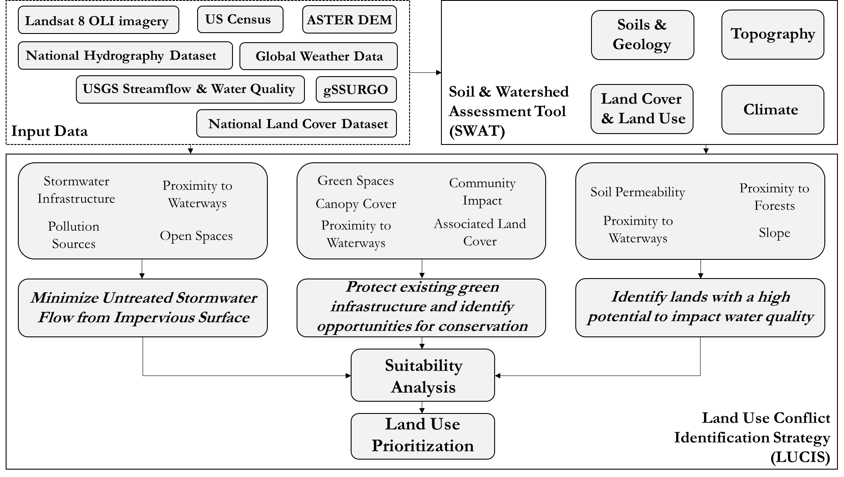

Figure 3: Summary of overall project methodology

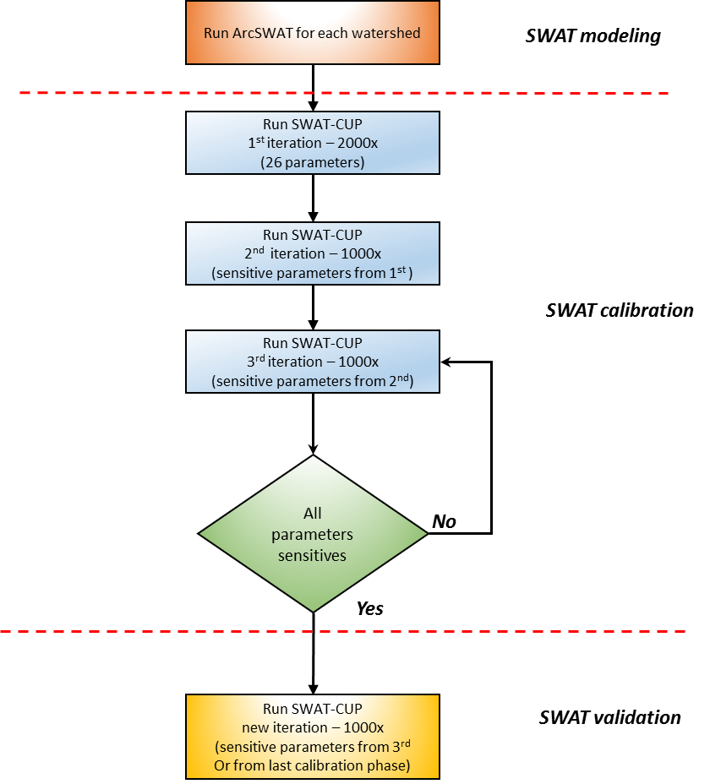

Figure 4: SWAT Methodology

# 4. Results & Discussion

***4.1. Land Cover Classification Results***

Accuracy assessment of the 2015 land cover classification (Table 3) suggested an 81% overall accuracy with a Kappa statistic of 0.75 (Table 3). A comparison of the 2001 and 2015 datasets showed an overall 32.79% change in land cover (Appendix B). Specifically, 47% of this observed change was deforestation (Table 4) and suggests that urbanization since 2001 has already had an effect on land cover in the MNGWPD.

|  |  |  |  |  |  |  |
| --- | --- | --- | --- | --- | --- | --- |
|  | **Urban** | **Agriculture** | **Water** | **Vegetation** | **Bare Land** | **User Accuracy** |
| **Urban** | **25** | 2 | 0 | 6 | 0 | 76% |
| **Agriculture** | 6 | **31** | 0 | 4 | 7 | 65% |
| **Water** | 0 | 0 | **6** | 0 | 0 | 100% |
| **Vegetation** | 2 | 1 | 0 | **57** | 1 | 93% |
| **Bare Land** | 0 | 1 | 0 | 0 | **2** | 67% |
| **Producer Accuracy** | 78% | 89% | 100% | 85% | 20% | **81%** |
|  |  |  |  |  | **Kappa** | **0.75** |

Table 3. Confusion matrix for 2015 land cover classification

|  |  |  |  |
| --- | --- | --- | --- |
| **Forest Land Cover Changes, 2001 to 2015** | | | |
| **2001 Land Cover** | **2015 Land Cover** | **Area (km2)** | **Land Cover (%)** |
| Forest | Urban | 1225.14 | 9.59 |
| Forest | Agriculture | 609.18 | 4.77 |
| Forest | Bare | 106.74 | 0.84 |
| Forest | Water | 26.12 | 0.20 |

Table 4. Forested land cover change from 2001 to 2015

***4.2. Conservation Suitability and Land Use Prioritization Results***

The goal of the agricultural land use assessment was to identify agricultural (or managed) lands with a high potential to impact local water quality and stormwater runoff. The agriculture suitability map was able to identify open land in the northwest region of the study area with a high potential to impact water quality (Figure 5). Impermeable soils, mild slopes, and close proximity to waterways characterize the northwest region of the MNGWPD. The combination of these factors presents a high risk of runoff from agriculture lands into the surrounding Atlanta watershed. This region is also cause for concern since it has the potential to degrade downstream water quality.

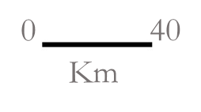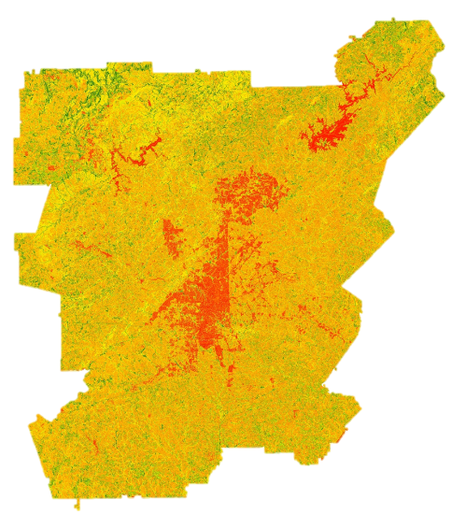Figure 5. Agricultural lands with potential to affect local water quality

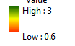

Highest Potential

Lowest Potential

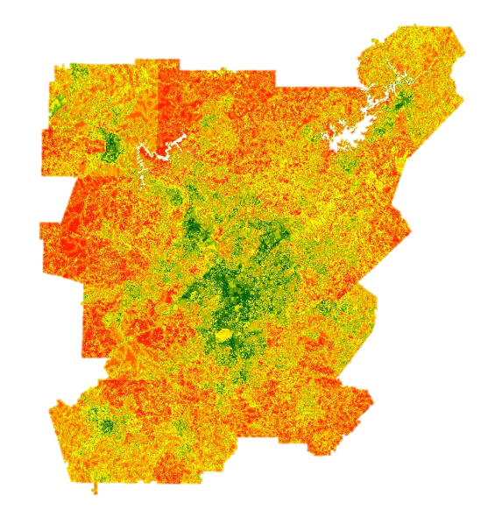The goal of the urban land use assessment was to minimize untreated stormwater flow from impervious surfaces by identifying features which increase the potential for higher stormwater flow. The most concentrated of high suitability values are associated with the city of Atlanta and Fulton County (Figure 6). Locations of lower suitability are those with greater amount of natural land cover, especially those with established forests. Areas of intermediate suitability are dispersed away from urban cores and correspond to more suburban areas. The combination of urban land cover, neighborhood age, proximity to waterways, areas identified by the Environmental Protection Agency as National Pollution Discharge Elimination Sites, Superfund locations, and areas with higher potential for annual flooding suggest that the city of Atlanta is a primary area of concern for stormwater runoff mitigation.

Figure 6. Urban areas with potential to influence water quality



Highest Potential

Lowest Potential

The goal of the conservation land use assessment was to protect existing green infrastructure and identify opportunities to increase green spaces through reforestation. The highest potential areas of interest identified by this analysis correspond to locations in close proximity to both existing protected areas and streams (Figure 7). Areas with the lowest potential to meet this goal are those with high impervious surface cover and far from forests, waterways, and protected areas. High potential areas exist both near and far from Atlanta and its suburbs, suggesting opportunities across the MNGWPD.

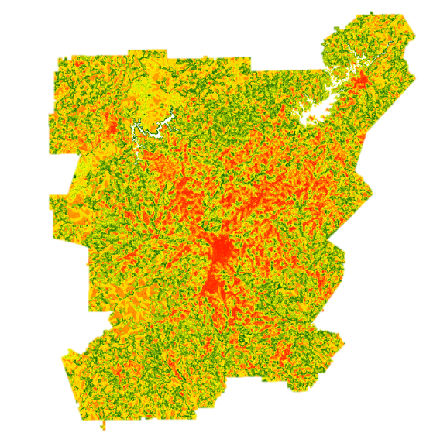Figure 7. Conservation lands with a high potential to impact water quality



Highest Potential

Lowest Potential

Combining the three previous suiabtility layers with equal wegithing produced a preliminary land use prioritization map showing locations that maximize greenspace allocation and minimize untreated stormwater flow from impervious surfaces across the study area (Figure 8). This result integrates all of the previous datasets used to generate the individual suitability layers. The prioritization results show both high and low potential areas to address these parallel water resource management goals.

|  |
| --- |
| Lowest Potential  Highest Potential |

Figure 8. Land Use Prioritization

|  |
| --- |
| ***4.3. SWAT Calibrated Outputs***  SWAT is a watershed-level modeling that accounts for natural hydrological processes in the watershed. Streamflow is a primary driver for sediment and nutrient transport. Calibrating streamflow is required before calibrating sediment and nutrient loadings. Figure 9 compares the measured and estimated monthly flow in 2004 – 2011 for the Upper and Middle Chattahoochee. The Upper Chattahoochee results had an R2 of 0.66 and NSE of 0.64 while the Middle Chattahoochee had an R2 of 0.62 and NSE of 0.59).  UppOcmul_Iter2.PNG  Cubic Meters per Second  (a) |
| midchatt_Iter2.PNG  Cubic Meters per Second  (b) |

Figure 9. Simulated vs. Observed Streamflow with 95% Confidence Level during calibration period of

2004-2011 for: (a) Upper Chattahoochee; (b) Middle Chattahoochee.

The two graphs in Figure 9 show temporal monthly flow in Upper and Middle Chattahoochee. In months 70-75 (year 2009), both watershed underwent similar pattern where 2009 becomes the year that produced the highest flow, followed by year 2005 (months 15-20).

***4.4. Spatial and Temporal Distribution of SWAT Output for Upper Chattahoochee Watershed***

Figure 10 shows spatial distribution of annual average levels of surface runoff contribution, sediment yield, nitrate and soluble phosphorus transported in the Upper Chattahoochee Watershed in 2011. From Figures 10 (a) and 10 (d) we can notice that larger values of surface runoff and phosphorus are observed in the northern and southern parts of Upper Chattahoochee watershed wherein smaller values of surface runoff and phosphorus are observed in the middle part of the watershed. Additionally, sediment yield and nitrate levels have an increasing trend as we move from northern part to southern part of the watershed toward the City of Atlanta (Figure 10 (b) and 10 (c), respectively).

|  |  |
| --- | --- |
| (a) | (b) |
| (c) | (d) |
| Figure 10. Spatial distribution for SWAT estimated outputs in Upper Chattahoochee watershed for 2011: (a) Spatial distribution of surface runoff (mmH2O), (b) sediment yield (tons/ha), (c) N loading (kg N/ha) and (d) P loading (kg P/ha) | |

Figure 11 plots the temporal distribution of SWAT estimated outputs during the calibration period of 2004-2011 for Upper Chattahoochee watershed. Figure 11 (a) visualizes temporal changes of surface runoff and sediment yield transported; Figure 11 (b) represents trends of nitrate and phosphorus yield in Upper Chattahoochee watershed. From the graphs, we can notice that 2006, 2007, and 2010 had the least amount of surface runoff and phosphorus whereas 2008 and 2009 had the highest amount of runoff and phosphorus. Sediment yield had the highest levels in 2005 and 2007 whereas nitrate had highest levels in 2006 and 2009.

|  |  |
| --- | --- |
| (b)  (a) |  |

Figure 11. SWAT results for Upper Chattahoochee Watershed during 2004-2011:

1. Surface runoff (mm H2O) and sediment yield (kg/ha); (b) Nitrate loading (kg N/ha) and Phosphorus loading (kg P/ha)

***4.5. Spatial and Temporal Distribution of SWAT Output for Middle Chattahoochee Watershed***

The Middle Chattahoochee is a watershed with diverse land cover. Spatial distribution of flow, sediment, and associated nutrients shows patterns that appear to reflect changing local land cover in 2011 (Figure 12). The top part of watershed appears to be the hotspots for these entities. In the middle portion of this watershed runoff is relatively lower than in the upper reaches, except for within the lower-most reaches, where high runoff, sediment and nutrient loadings were observed. In 2011, the distribution of flow, P, and N are spatially correlated to one another, but not with the sediment distribution. The lower portion of this watershed shows two sub-basins having much higher sediment yield, indicating erosion hotspots. Further efforts are needed to investigate the possible causes for this condition.

|  |  |
| --- | --- |
| (a) | (b) |
| (c) | (d) |
| Figure 12. Spatial distribution for SWAT estimated outputs in Middle Chattahoochee watershed for 2011:  (a) Spatial distribution of surface runoff (mmH2O), (b) sediment yield (tons/ha), (c) N loading (kg N/ha) and  (d) P loading (kg P/ha) | |

|  |  |
| --- | --- |
| **Average sediment yield (kg/ha)**  (b)  (a) |  |

Figure 13. SWAT results for Middle Chattahoochee Watershed during 2004-2011:

(a) Surface runoff (mm H2O) and sediment yield (kg/ha); (b) Nitrate loading (kg N/ha) and Phosphorus loading (kg P/ha)

Figure 13 illustrates the temporal variations of SWAT Outputs from 2004 to 2011. In general, the sediment, P and NO3 follow well the pattern of surface runoff, confirming the flow as the main driver of these outputs. Drought occurring in 2007 appears to be the cause of low flow periods when surface runoff reached the lowest point. On the contrary, 2009 became the year with highest flow with storms happening in 2009 might induced the increased runoff.

***4.4. Future Work***

The remaining focus of this project will involve the continuation of the SWAT model calibration for nutrients in all five watersheds of interest. This will provide a detailed analysis of the hydrologic processes related to surface water flow, nutrient accumulation, and sediment loading. Once this is complete, these results will be combined with the LUCIS model to provide The Nature Conservancy with a comprehensive analysis of water quality across the Atlanta metropolitan region.

# 5. Conclusions

NASA satellite imagery was successfully integrated into three primary water resource management goals in the greater Atlanta region. The Landsat 8 and Terra datasets were crucial to the creation of our land cover classification and LUCIS suitability assessments. The LUCIS suitability maps identified areas with high potential to affect local water resources in our study area by incorporating a wide variety of input datasets. These suitability maps have been combined to provide a land-use prioritization map. The SWAT model will be used to refine the results from the LUCIS model and provide our partners with a more comprehensive analysis of the region. Estimates of Discharge, Total Suspended Sediments, Nitrogen, and Phosphorous in all five study area watersheds were produced using ArcSWAT. The calibration and validation of water quality parameters from SWAT will help improve the sensitivity of our LUCIS model to accurately incorporate these criteria. Preliminary results for the Upper and Middle Chattahoochee suggest that the largest concentration of loads for sediment and nutrients being present in close proximity to the city of Atlanta, showing the impact of urbanization on local waterways. The SWAT-CUP processing and calibration for the following term is expected to improve our results meeting the needs of our project partners, The Nature Conservancy, while also demonstrating the versatility of processed NASA based satellite data’s inclusion into a land use prioritization model. The SWAT results will be integrated with the results of the previously term to create additional scenarios for conservation and reforestation strategies in regards to water resource management. Our project partners will be able to use our end products to assist them with making science-based decisions on water management policy in the greater Atlanta region.

# 6. Acknowledgments

We would like to thank our science advisors Drs. Rosanna Rivero and Marguerite Madden at UGA. We would also like to acknowledge our partners at The Nature Conservancy, Sara Gottlieb, Whitney Palanci, and Myriam Dormer, for their involvement with the project and communication during the term. Additionally, our team would like to thank Dr. Adam Milewski of the UGA Geology Department for his expertise on the SWAT model and UGA Center Lead Caren Remillard for her support.

Any opinions, findings, and conclusions or recommendations expressed in this material are those of the author(s) and do not necessarily reflect the views of the National Aeronautics and Space Administration.

This material is based upon work supported by NASA through contract NNL11AA00B and cooperative agreement NNX14AB60A.

# 7. References

ArcSWAT. Soil and Water Assessment Tool. Last accessed on June 29, 2016, from http://swat.tamu.edu/software/arcswat/.

Arnold, J. G., Moriasi, D. N., Gassman, P. W., Abbaspour, K. C., White, M. J., Srinivasan, R., Santhi, C., Harmel, R.D., Van Griensven, A., Van Liew M.W. & Kannan, N. (2012). SWAT: Model use, calibration, and validation. *Transactions of the ASABE*, *55*(4), 1491-1508.

Bernhardt, E. S., Band, L. E., Walsh, C. J., & Berke, P. E. (2008). Understanding, managing, and minimizing urban impacts on surface water nitrogen loading. Annals of the New York Academy of Sciences, 1134(1), 61-96.

Francesconi, W., Srinivasan, R., Pérez-Miñana, E., Willcock, S. P., & Quintero, M. (2016). Using the Soil and Water Assessment Tool (SWAT) to model ecosystem services: A systematic review. *Journal of Hydrology*, *535*, 625-636.

McMahon, E.T. (2000). Green Infrastructure. Planning Commissioners Journal, 37.

Mishra, A., Kar, S., & Singh, V. P. (2007). Prioritizing structural management by quantifying the effect of land use and land cover on watershed runoff and sediment yield. *Water Resources Management*, *21*(11), 1899- 1913.

Neitsch, S. L., Williams, J. R., Arnold, J. G., & Kiniry, J. R. (2011). *Soil and water assessment tool theoretical documentation version 2009*. Texas Water Resources Institute.

Rocha, E. O., Calijuri, M. L., Santiago, A. F., de Assis, L. C., & Alves, L. G. S. (2012). The contribution of conservation practices in reducing runoff, soil loss, and transport of nutrients at the watershed level. *Water resources management*, *26*(13), 3831-3852.

Santhi, C., Srinivasan, R., Arnold, J. G., & Williams, J. R. (2006). A modeling approach to evaluate the impacts of water quality management plans implemented in a watershed in Texas. *Environmental Modelling & Software*, *21*(8), 1141-1157.

Schoonover, J. E., & Lockaby, B. G. (2006). Land cover impacts on stream nutrients and fecal coliform in the lower Piedmont of West Georgia. Journal of hydrology, 331(3), 371-382.

SWAT-CUP. Soil and Water Assessment Tool. Last accessed on June 29, 2016, from http://swat.tamu.edu/software/swat-cup/.

Tibebe, D., & Bewket, W. (2011). Surface runoff and soil erosion estimation using the SWAT model in the Keleta watershed, Ethiopia. *Land Degradation & Development*, *22*(6), 551-564.

Tzoulas, K., Korpela, K., Venn, S., Yli-Pelkonen, V., Kaźmierczak, A., Niemela, J., & James, P. (2007). Promoting ecosystem and human health in urban areas using Green Infrastructure: A literature review. Landscape and urban planning, 81.

USGS Current Water Data for the Nation. Last accessed on June 29, 2016, from http://waterdata.usgs.gov/nwis/rt.

Xu, Z. X., Pang, J. P., Liu, C. M., & Li, J. Y. (2009). Assessment of runoff and sediment yield in the Miyun Reservoir catchment by using SWAT model.*Hydrological processes*, *23*(25), 3619-3630.

# 8. Content Innovation

**Content Innovation #1: AudioSlides**

2016Sum\_UGA\_AtlantaWaterII\_AudioSlides.pptx

**Content Innovation #2: Glossary**

2016Sum\_UGA\_AtlantaWaterII\_Glossary.docx

**Content Innovation #3: VPS**

2016Sum\_UGA\_AtlantaWaterII\_VPS.mp4

# Appendices

Appendix A: Ancillary Data

|  |  |
| --- | --- |
| **Dataset** | **Source** |
| Protected Areas of Georgia | The Nature Conservancy |
| City of Atlanta Streams | Atlanta Regional Commission |
| City of Atlanta Watersheds | Atlanta Regional Commission |
| Lakes, Ponds, Reservoirs, and Swamps Atlanta Region | Atlanta Regional Commission |
| SE Aquatic Connectivity Assessment Project | The Nature Conservancy |
| National Hydrography Dataset Plus V2.1 | US EPA |
| Water Quality in Georgia | GA EPD |
| Gridded Soil Survey (gSSURGO) | USDA |
| Developments of Regional Impact | Atlanta Regional Commission |
| Toxic Release Inventory | US EPA |
| SLEUTH Projected Urban Growth | NC State University and USGS |
| Streamflow, water quality, and gauges | USGS Water Resources |
| Weather data (Precipitation, Temperature, Wind, Solar Radiation and Relative Humidity) | SWAT Global Weather Data |
| Land Cover 2001 and 2011 | National Land Cover Dataset |
| Population & development density | US Census Data |
| County and state boundary | US Census Data |
| Watershed boundaries | USGS Water Resources |

Appendix B: Land Cover Change Data

|  |  |  |  |
| --- | --- | --- | --- |
| **MNGWPD Land Cover Change, 2001 to 2015** | | | |
| 2001 Land Cover | 2015 Land Cover | Area (km2) | Land Cover (%) |
| Forest | Agriculture | 609.18 | 4.77 |
| Agriculture | Agriculture | 878.69 | 6.88 |
| Agriculture | Forest | 228.70 | 1.79 |
| Urban | Agriculture | 599.37 | 4.69 |
| Forest | Forest | 5052.84 | 39.56 |
| Urban | Forest | 877.60 | 6.87 |
| Forest | Urban | 1225.14 | 9.59 |
| Agriculture | Urban | 261.26 | 2.05 |
| Urban | Urban | 2416.50 | 18.92 |
| Urban | Bare | 23.31 | 0.18 |
| Agriculture | Bare | 39.12 | 0.31 |
| Forest | Bare | 106.74 | 0.84 |
| Water | Forest | 29.90 | 0.23 |
| Water | Urban | 53.35 | 0.42 |
| Forest | Water | 26.12 | 0.20 |
| Water | Water | 231.93 | 1.82 |
| Bare | Forest | 19.28 | 0.15 |
| Bare | Urban | 57.86 | 0.45 |
| Water | Agriculture | 5.98 | 0.05 |
| Urban | Water | 2.00 | 0.02 |
| Bare | Agriculture | 15.27 | 0.12 |
| Bare | Bare | 2.98 | 0.02 |
| Urban | Water | 5.42 | 0.04 |
| Bare | Water | 2.09 | 0.02 |
| Water | Bare | 0.51 | 0.00 |
|  | **Total Area** | **12771.16** |  |

Appendix C: SWAT parameters used for calibration

|  |  |  |  |  |
| --- | --- | --- | --- | --- |
| **Parameter number** | **Parameter** | **Name** | **min** | **max** |
| 1 | CN2 | Curve Number | -0.2 | 0.2 |
| 2 | SFTMP | Snow fall temperature | -5.0 | 5.0 |
| 3 | SURLAG | Surface runoff lag coefficient | 0.1 | 24.0 |
| 4 | SMTMP | Maximum Canopy Storage (mmH2O) | -5.0 | 5.0 |
| 5 | TIMP | Snow pack temp lag factor | 0.0 | 1.0 |
| 6 | ESCO | Soil evaporation compensation factor | 0.001 | 1.0 |
| 7 | EPCO | Plant intake compensation | 0.0 | 1.0 |
| 8 | SMFMX | Melt factor for snow in June 21 (mm H20)/C/day | 1.7 | 8.0 |
| 9 | SMFMN | Melt factor for snow in December 21 (mm H20)/C/day | 1.7 | 8.0 |
| 10 | CH(N2) | Manning’s n for the main channel | 0.0 | 0.3 |
| 11 | CHN(1) | Manning’s n for the tributary channels | 0.0 | 0.5 |
| 12 | CHK(2) | Effective hydraulic conductivity in the main channel alluvium (mm/hr) | 0.0 | 130 |
| 13 | CHK(1) | Effective hydraulic conductivity (mm/hr) | 0.0 | 300 |
| 14 | ALPHA-BF | Baseflow alpha factor (1/days) | 0.0 | 1.0 |
| 15 | GW\_DELAY | Threshold depth of water in the shallow aquifer for “revap” or percolation (mm H20) | 0.0 | 500 |
| 16 | GWQMN | Threshold depth of water in the shallow aquifer to return flow to occur (mm H20) | 0.0 | 1000 |
| 17 | GW\_REVAP | Groundwater “revap” coefficient | 0.0 | 0.2 |
| 18 | GW\_SPYLD | Specific yield of the shallow aquifer | 0.0 | 0.4 |
| 19 | RCHRG\_DP | Deep aquifer percolation fraction | 0.0 | 0.2 |
| 20 | REVAPMN | Threshold depth of water in the shallow aquifer for “revap” or percolation (mm H20) | 0.0 | 500 |
| 21 | ALPHA\_BNK | Base Flow alpha factor for bank storage | 0.0 | 1.0 |
| 22 | ALPHA-BF | Baseflow alpha factor (1/days) | -0.1 | 0.1 |
| 23 | SOL\_AWC | Available water capacity in the soil layer (mm H20/mm soil) | -0.2 | 0.4 |
| 24 | SOL\_K | Saturated Hydraulic conductivity (mm/Hr) | -0.8 | 0.8 |
| 25 | SOL\_BD | Moist bulk density (mg/m3) | -0.5 | 0.6 |
| 26 | SNOCOVMX | Minimum snow water content | 0.0 | 500 |

Appendix D: LUCIS Criteria Matrix

|  |  |  |  |  |  |
| --- | --- | --- | --- | --- | --- |
| **Goal** | **Objective/Criteria** | **Weight** | **Method** | **Data** | **Source** |
| Minimize Untreated Stormwater Flow from Impervious Surface | Identify location of stormwater retention ponds and outfalls (into the river) | 20 | Calculate retention pond density and outfall density | NPDES; point file of additional Waste Treatment plants not listed on NPDES; Stormwater overflows; Retention Ponds; Watershed Boundaries (HUC) | EPA; ARC; USGS |
| Identify Location of Brownfields, Abandoned, and open bare land | 20 | Suitability ranking of parcels as potential construction/future expansion sites. Higher weights will be assigned to large, open areas. | Brownfield locations; Superfund site locations; 2015 Land Cover Classification | EPA; Atlanta Water Resources Team Spring 2016 |
| Identify existing areas of high impervious surface not currently being served by Green Infrastructure | 20 | Reclassification of urban land cover based on presence of near-by forested land/green spaces | Protected Areas of Georgia; 2015 Land Cover Classifcation | Atlanta Water Resources Team Spring 2016 |
| Identify regions that are in close proximity to streams | 20 | Distance analysis to measure proximity between developed land and waterways. Reclassification according to ranking system. | NHD Plus; ASTER DEM; 2015 Landcover | EPA; NASA; Atlanta Water Resources Team Spring 2016 |
| Identify locations (that are currently un-developed and not protected) of greater preference or suitability for construction | 20 | Weighted overlay of the associated subcriteria. | Parcel data; Floodplains; Housing characteristics | ARC |

|  |  |  |  |  |  |
| --- | --- | --- | --- | --- | --- |
| **Goal** | **Objective/Criteria** | **Weight** | **Method** | **Data** | **Source** |
| Identify agricultural lands with a high potential to impact local water quality and stormwater runoff | Identify regions that are in close proximity to streams/waterways | 25 | Distance analysis to measure proximity between agricultural land and waterways. Reclassification according to ranking system. | Streams; ASTER DEM | NASA |
| Identify regions with high topographic gradient | 25 | Slope analysis of elevation data | ASTER DEM | NASA |
| Identify areas with soils with lower permeability | 25 | Ranking of mapped soil series based on hydrologic soil group | Gridded Soil Survey (gSSURGO) | USDA |
| Identify agricultural land in close proximity to forests | 25 | Measure proximity between agricultural land and waterways. Reclassification according to ranking system. | NHD Plus; ASTER DEM | EPA; NASA |

|  |  |  |  |  |  |
| --- | --- | --- | --- | --- | --- |
| **Goal** | **Objective/Criteria** | **Weight** | **Method** | **Data** | **Source** |
| Protect existing green infrastructure and identify opportunities to increase/expand green spaces through reforestation in metro Atlanta | Identify existing protected areas and green spaces | 25 | Rank existing protected areas (of all ownership types) based on GAP ranking score (1-4) | Protected Areas | The Nature Conservancy |
| Analyze existing proportions of local vegetation and forests (including proportions, size) | 25 | Extract forest/vegetation patches from 2015 land cover classification and perform focal statistics | Landsat 8-based supervised land cover classification, 2015 | Atlanta Water Resources Team Spring 2016 |
| Identify associated land cover types for potential reforestation areas | 25 | Perform majority focal statistics on land cover classes other than forest | Landsat 8-based supervised land cover classification, 2015 | Atlanta Water Resources Team Spring 2016 |
| Identify regions that are in close proximity to streams/waterways | 25 | Distance analysis to measure proximity between forested land and waterways. Reclassification according to ranking. | NHD Plus; ASTER DEM; 2015 Landcover | EPA; NASA; Atlanta Water Resources Team Spring 2016 |
| Prioritize reforestation targets based on: Adjacent land cover change type, proximity to water/river, public vs private ownership, population density of surrounding area, topography, protection status | N/A | Weighted overlay of the associated subcriteria. | Land cover classification, 2015; 2001 NLCD; nhdflowline; US\_Census2010; ASTER DEM; Protected Areas | Atlanta Water Resources Team Spring 2016; USGS; US EPA; NASA; The Nature Conservancy |