**Andes Mountains Disasters Tutorials**

**QUick Atmospheric Correction (QUAC) in ENVI Classic**

1. Open data file (if it is not stacked, then it would be best to do so before running QUAC)

2. After making the data into TOA_Reflectance, you may need to assign reflectance values to each band

3. You can check the reflectance values by:

a. Right-clicking on the data file you are working with located in the “Available Bands List”

b. Go to “Edit Header”

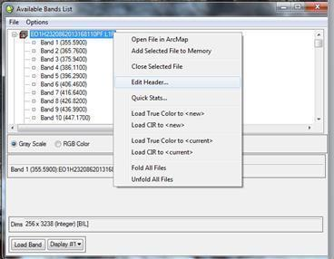

c. A new window pops up

d. Go to the drop-down menu “Edit Attributes”

e. Find “Wavelengths” and click on it

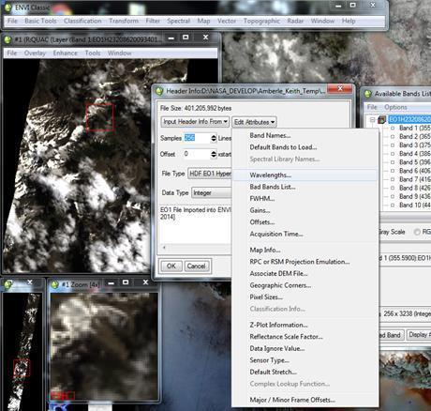

f. Another will appear titled “Edit Wavelength Values”

g. You will need to manually put in each band’s spectral value and designate the units (usually micrometers)

h. These values were calculated from the Landsat wavelength list located here:<http://landsat.usgs.gov/band_designations_landsat_satellites.php>

i. Note that to get these values, the range was added, then divided by 2. EX: Band 2 (Landsat 8) has a range of 0.45-0.51 micrometers (µm). This is calculated as: (0.45+0.51)/(2) = 0.48 µm

j. Here are the Landsat 7 ETM+ values: B1= 0.485; B2=0.56; B3=0.66; B4=0.835; B5=1.65; B6i=11.45; B6ii=11.45; B7=2.22; B8=0.71

k. Here are the Landsat 8 OLI values: B1=0.44; B2=0.48; B3=0.56; B4=0.655; B5=0.865; B6=1.61; B7=2.2; B8=0.59; B9=1.37

l. To input the values, select the first select on the top band (may be Band 9). This will highlight the band.

m. In the box below you will type in the spectral value here.

n. After you have entered the value, hit “Enter” to move to the next band.

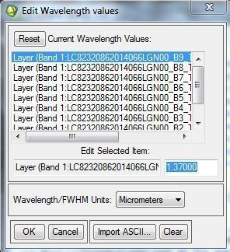

o. Hit “Okay” and “Okay”

p. Your bands should now have their spectral values appear under the “Available Bands List”

q. 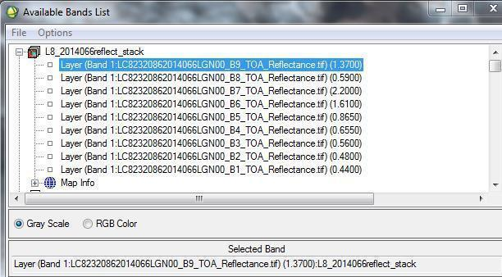

4. Go to “Basic Tools”

5. Locate “Preprocessing”

6. Then go to “Calibration Utilities”

7. Here you can locate “QUick Atmospheric Correction (QUAC)” tool. Select it.

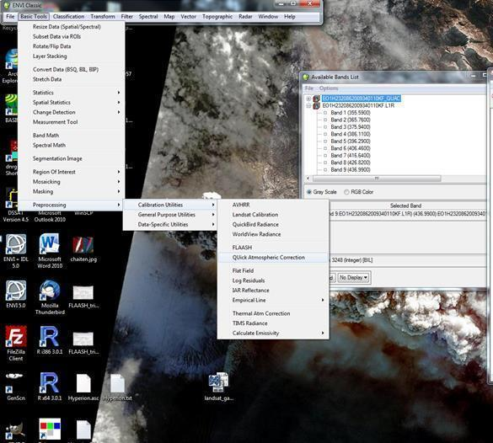

8. Now you will have the option of selecting the file you’d like to atmospherically correct.

9. Select the file you want. (Note: you may need to do a spectral subset depending on your data. For Landsat 8 you may need to exclude bands such as 8, 9, 10, or 11. Only do this if the final QUAC dataset comes out all black.)

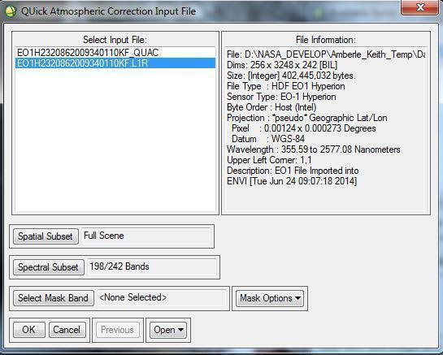

10. Hit “Okay”

11. A new window will pop up.

12. Select the sensor type. It will be missing Landsat 7 and 8, but using the Landsat TM selection should treat the data the same.

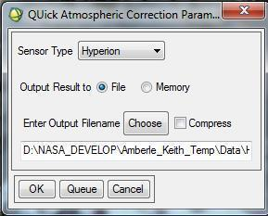

13. Now hit “Choose” and navigate where you want your data output to be stored and give the output data a name. Ex: L82014059_QUAC

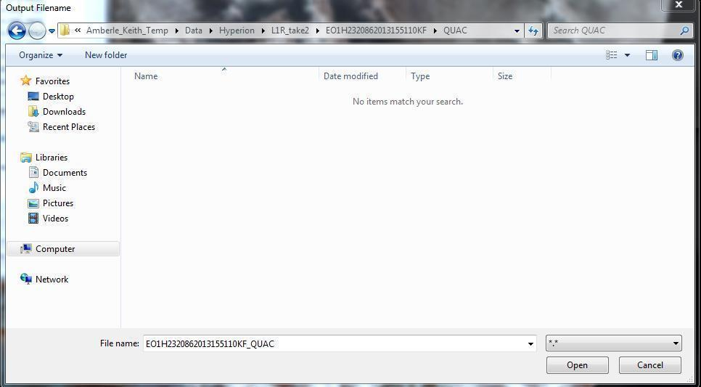

14. Hit “Okay” and run.

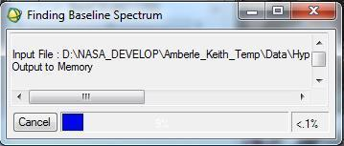

15. The new QUAC file will now appear in the “Available Bands List”

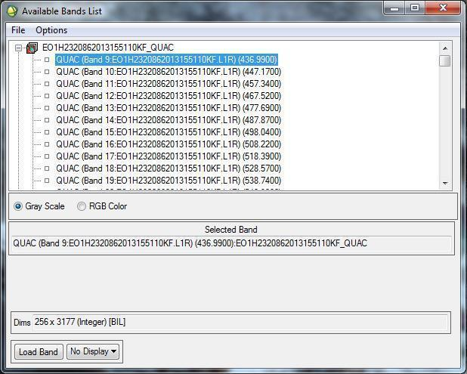

**Converting Digital Numbers to Reflectance for Landsat 4, 5 and 7**

1. Before you begin, you must have a few extensions in order to run the script. You may need to add Numpy and SciPy, which can be found at:<http://www.lfd.uci.edu/~gohlke/pythonlibs/>. It should be noted that ArcGIS 10 uses Python 2.6 and ArcGIS 10.1 uses Python 2.7. When installing the extensions you should choose your installer accordingly.

2. Addition extensions may need to be added such as HDF5 (<http://www.hdfgroup.org/HDF5/release/obtain5.html>) or H5py (<https://code.google.com/p/h5py/>)

3. Open ArcGIS and Arc Toolbox

4. Right-click the top ArcToolbox and select “Add Toolbox”

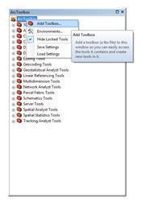

5. Navigate to where the scripts are stored and select the script that corresponds to the version of ArcGIS you have (10.0 or 10.1) and click “Open.” Note that this tool is written in Python.

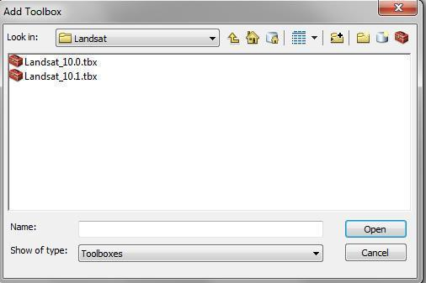

6. The toolbox will now be added to the list in ArcToolbox

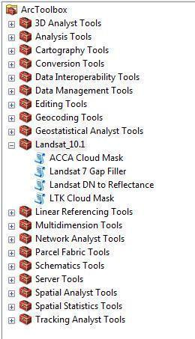

7. Expand the Landsat toolbox and select “Landsat DN to Reflectance” by double clicking it

8. A new window appears and the fields must be populated. For “Landsat Bands” navigate to the folder where the Landsat 4, 5, or 7 data is located and insert the bands. You can choose to do all of the bands or only the ones you think you will need.

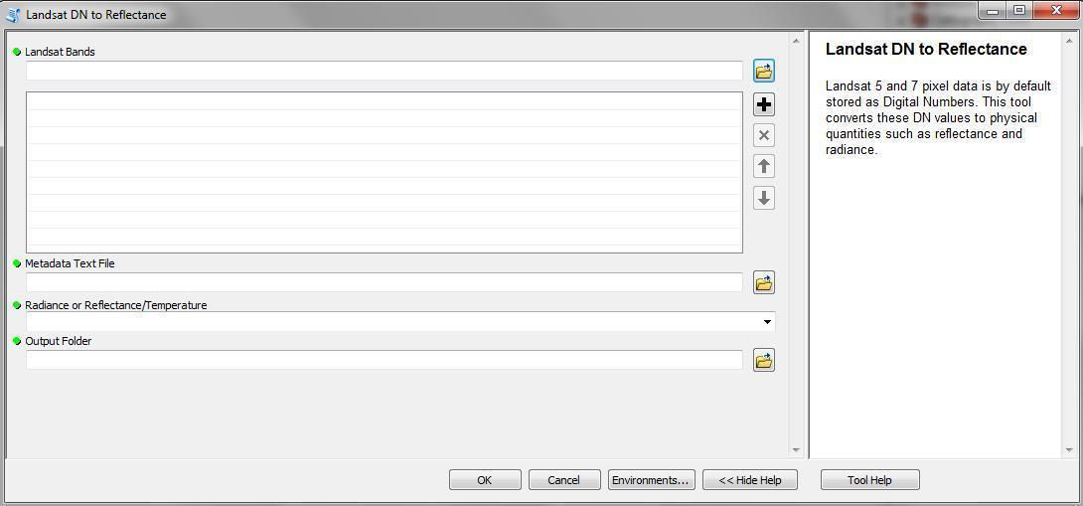

9. Under the “Metadata Text File” navigate to the data folder again and select the file with the extension name ending in “.MTL.txt”

10. Next, choose “Reflectance/Temperature” from the drop-down list

11. Finally, choose a folder to save the output files and give it a name

12. Hit the “OK” button

13. Repeat these steps for all of the Landsat 4, 5, and 7 data as necessary

**Converting Digital Numbers to Reflectance for Landsat 8**

1. Before you begin, you must have a few extensions in order to run the script. You may need to add Numpy and SciPy, which can be found at:<http://www.lfd.uci.edu/~gohlke/pythonlibs/>. When installing the extensions you should choose your installer accordingly.

2. You will also need to use GDAL-1.10.1win-amd64-py2.7 or the equivalent GDAL for your operating system. You will also need the gdal_calc file as well. These two items must be stored with the data you are processing!

3. Open the file where the data and Stennis_Team4 code are stored. Again, the GDAL and gdal_calc files should be here as well.

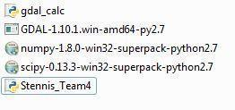 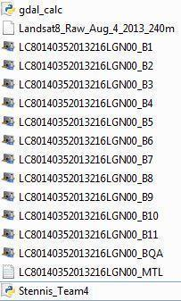

4. Right-click on the Stennis_Team4 code and select “Edit in IDLE”

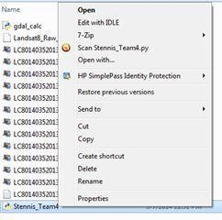

5. The script will come up in a Python window.

6. You will need to put in the file path for each data folder to run the data. This can be done by simply clicking on the path name, copying it, and pasting it into the script. You will paste the path name under “folder = ‘ ‘”

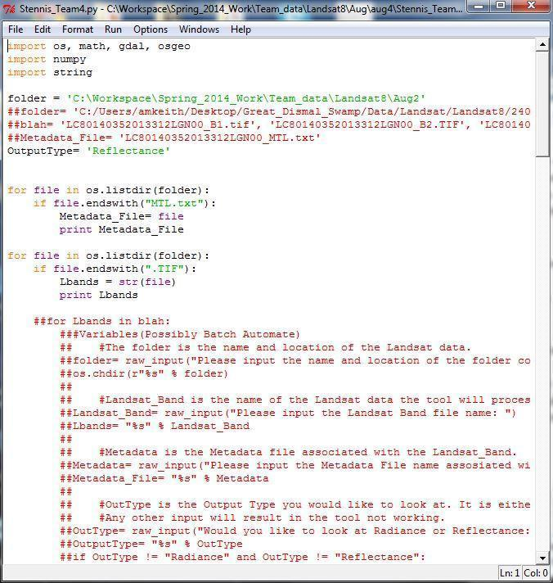

Example: folder = ‘C:\Users\Desktop\Andes_Disasters\Data\Landsat\Landsat8\April\April13’

7. Once the folder path has been populated, save the script. If you need a version of the script for different data sets, then you can rename the script, but it must end as .py (EX: Stennis_Team.v5.py)

8. Next, under the “Run” menu, find “Run Script” and click it

9. The script will now begin to run. Two new windows will pop up; a python shell that states everything the code is processing and the command window which will do a count. This may take a few minutes to complete.

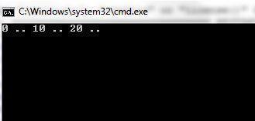

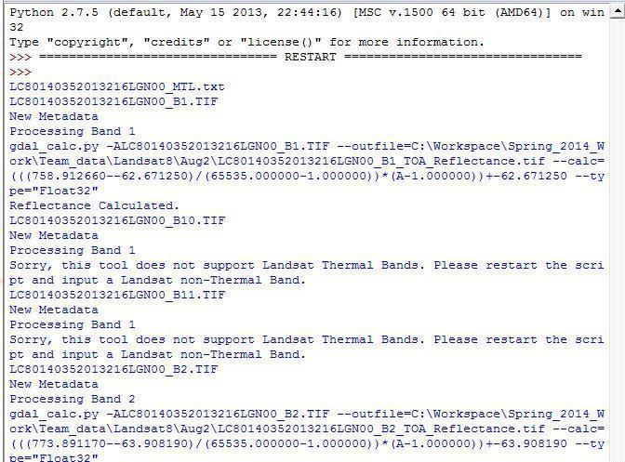

10. Once the script has finished running, it is safe to close the script. The second python shell will should show that the bands were converted up to Band 8.

11. Note that an error may come up at the end of the code regarding Bands 9, 10, and 11. This error is fine and can be ignored since the script can’t change these bands into reflectance.

12. The data will be stored in the file path that was designated at the beginning of the script.

