Nevada & Oregon Ecological Forecasting

Employing NASA Earth Observations to Create Enhanced Bare Ground Layers for Invasive Species Habitat Suitability Modeling

 **Technical Report**

Final Draft - April 4th, 2019

Nicole Pepper (Project Lead)

Sophia Leiker

Anastasia Kunz

Rebecca Girma

Dr. Paul Evangelista, Colorado State University, Natural Resource Ecology Laboratory (Science Advisor)

Dr. Catherine Jarnevich, United States Geological Survey, Fort Collins Science Center (Science Advisor)

Tony Vorster, Colorado State University, Natural Resource Ecology Laboratory (Science Advisor)

Nicholas Young, Colorado State University, Natural Resource Ecology Laboratory (Science Advisor)

# 1. Abstract

Invasive species threaten the ecological integrity of a region. Such threats have further implications that can affect regional economies and, in some cases, human health. Organizations including the National Parks Service (NPS) and the United States Geological Survey (USGS) are dedicated to the early detection of and rapid response to invasive species of high concern, like medusahead (*Taeniatherum caput-medusae*). To improve these efforts, our team partnered with researchers from the NPS Exotic Plant Management Team and the USGS Fort Collins Science Center. Our partners currently rely on habitat suitability models to discern the geographic range of invasive species. They identified regions with low vegetation and exposed bare ground to be at higher risk of invasion. However, the USGS and NPS are not using the most detailed resolution available for this bare ground variable. Research shows that the incorporation of high-resolution spectral information can improve the precision of habitat suitability models. To test this, our team focused on enhancing our partner’s bare ground data (250-meter resolution) by utilizing Earth observations from NASA’s Landsat 8 Operational Land Imager (30-meter resolution) and the European Space Agency’s Sentinel-1 C-Band Synthetic Aperture Radar (10-meter resolution). We found that overall model performance was not significantly altered by the incorporation of higher resolution bare ground variables, however, these soil layers did allow for higher resolution spatial outputs. With more precise habitat suitability models, our partners’ management practices can be more time efficient and cost effective, thus allowing them to scale up the methodology geographically and expand it to other invasive species.

**Keywords**

habitat suitability models, invasive species, risk assessment, ecological forecasting, ensemble modeling

# 2. Introduction

* 1. ***Background Information***

The spread of plant species outside of their native ranges has become more common due to an increase in global travel and trade (National Invasive Species Council, 2016). Although some of these species can serve as new agricultural and economic resources, not all species introductions are beneficial. Invasive species are defined as organisms that are not native to a region and are harmful to the ecosystem where they are introduced (National Invasive Species Council, 2016). Outside of their native habitat, these species often do not have predators or competitors, giving them an advantage over native species. Invasive species are usually generalist or early successional species, which allows them to quickly spread to disturbed or open areas where there is not already an established plant community (Simberloff, 2010). Once these invasive species dominate an area, it is difficult for native plants to remain or re-establish themselves. Invasive species are often introduced unintentionally, and when improperly managed, the associated impacts related to these non-native plants can negatively affect ecosystem functions, further impacting regional economies, and in some cases, human health (National Invasive Species Council, 2016).

The United States spends over 120 billion USD per year on damages and other costs associated with the spread of invasive plant species (Pimentel, Zuniga, & Morrison, 2005). Control methods involving biological and chemical treatments can be costly while physical removal requires intensive labor and significant allocations of time (Appendix A; Simberloff, 2010; Stone, 2017). These high costs of removal highlight the importance of early detection and rapid response to predict the geographic distribution of invasive species (West, Evangelista, Jarnevich, & Schulte, 2018).

Habitat suitability models (HSMs) are a widely used method to predict the geographic range of invasive species. Research shows that the incorporation of high-resolution spectral imagery in HSMs can greatly improve their precision. This is because spectral data have a greater variation between pixel to pixel values when compared to other topographic or climatic variables (West et al., 2018). For this reason, the incorporation of spectral data enables HSMs to capture a more complex environmental profile of where a species can thrive (West et al., 2017). The accuracy of HSMs is largely limited to available data and the explanatory power of the specific environmental variables that are included.

This project served as a case study to assess how integrating high-resolution bare ground layers improved the precision of the United States Geological Survey’s HSMs for our focal invasive species, medusahead (*Taeniatherum caput-medusae)*,across Nevada and Oregon. Medusahead is a generalist and early successional species, putting regions with bare ground at particular risk of invasion. This species is known to disrupt grazing behavior in the region, causing stress on both the ecology and economy (Archer, 2001).

In order to effectively direct risk management and mitigation efforts of adaptable species, accurate and detailed HSMs are needed. Such HSMs would benefit from the incorporation of high-resolution satellite imagery to help users better understand the patterns that drive invasive species spatial and temporal distributions. Several satellite-derived bare ground layers have been developed to address this issue. The bare ground layers we incorporated into this study include Normalized Difference Bareness Index (NDBaI) (Li et al., 2017), the Normalized Difference Bare Land Index (NBLI) (Li et al., 2017), Bare Soil Index (BSI) (Kumar et al., 2016), the Soil Adjusted Vegetation Index (SAVI) (Dematte et al., 2009), and the Synthetic Aperture Radar (SAR) Vertical and Horizontal (VH) polarization.

* 1. ***Project Partners***

Our team partnered with the United States Geological Survey (USGS) and the National Parks Service (NPS) Exotic Plant Management Team, both of which are tasked with managing invasive species across the nation. HSMs are used by these partners to direct their management efforts, but many of their current models are derived from coarse climatic and remotely sensed spectral variables. Some of these employed variables currently have a spatial resolution from 250 m up to 1,000 m. This results in coarse, generalized model output maps that make it difficult to assess the best locations on the ground to target mitigation strategies. The NPS Exotic Plant Management Team specifically provides over 290 National Parks with professional expertise on invasive species, and early warning and detection strategies require an ongoing monitoring program (National Park Service, 2018). For this reason, HSMs are important tools to help direct these monitoring efforts.

Under Executive Order 13112, invasive species are designated as significant contributors to ecosystem change. Therefore, all federal land management agencies must address issues related to the introduction and spread of harmful invasive species (National Park Service, 2017). This project supported these partners by exploring approaches to develop regional-scale, high-resolution (30 m) remotely sensed layers that can be used to enhance existing predictive models. Enhanced HSMs can provide our partners with a better understanding of areas that are most at risk and lead to more cost and time efficient strategies for invasive species mitigation and prevention efforts.

* 1. ***Objectives***

Our first objective was to utilize NASA Earth observations to provide the USGS and NPS with increased 30-meter resolution bare ground data layers that will enhance our partners’ ongoing monitoring efforts of invasive species. Our second objective was to run habitat suitability models integrating bare ground layers and evaluate the model performance. Our third objective was to create habitat suitability maps based on updated bare ground data for medusahead across the states of Nevada and Oregon. Lastly, we aimed to forecast the habitat suitability of medusahead for the year 2050 by incorporating NASA climate predictions.

# 3. Methodology

***3.1 Study Area & Period***

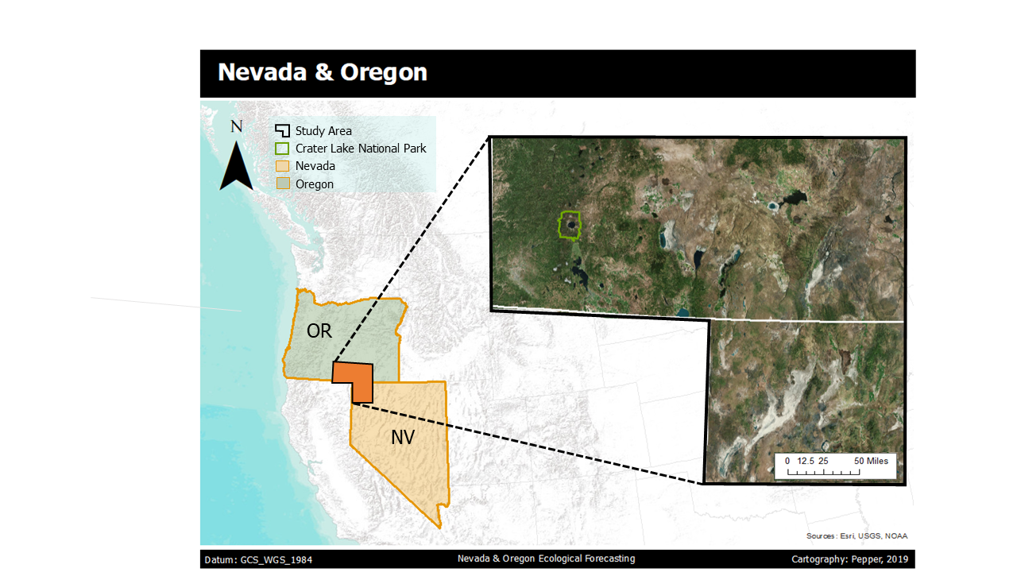

*Figure 1*. The study area spans southeast Oregon and northwest Nevada (black border). Crater Lake National Park is highlighted in the northwest section of the study area, outlined in green.

This study region spans across southeast Oregon and northwest Nevada (*Figure 1*). The majority of the region in this study area is public land managed by the Bureau of Land Management (BLM). Our study area encompasses parks and reserves that are of specific interest to our partners, such as Crater Lake National Park (183,224 acres) and the Sheldon National Antelope Refuge (572,896 acres). The vegetation classes that dominate this area include sagebrush, cheatgrass, and other shrubs. In both of these regions, there is concern regarding the encroachment of invasive species into native plant ecosystems. The full study area ranges from 481 m to 2,865 m in elevation. The western portion of our study area, including Crater Lake National Park, experiences higher levels of precipitation than the eastern region of this extent. Lying in the rain shadow of the Sierra Nevada mountain range, eastern Oregon and Nevada are characterized by arid, to semi-arid climate conditions.

***3.2 Data Acquisition & Processing***

The USGS shared its predictor layers specific to medusahead with the team. These layers include climatic, anthropogenic, and other environmental variables; the complete list, descriptions, and sources for these variables are included in Appendix B. They also provided our team with field presence data for our focal species, medusahead. In this dataset, there are 11,176 recorded presence points with latitude and longitude coordinates. These presence points within our study area were used to train and test our HSMs in the Software for Assisted Habitat Modeling (SAHM). To validate the accuracy of our bare ground layers, we used field bare ground data from the BLM’s Assessment Inventory and Management program (AIM), which measures vegetation composition and bare ground (US Department of the Interior, BLM, 2018). These AIM data are available for BLM lands, which mostly covers the western US for the years 2011 to 2018.

Bare ground data processing & acquisition were performed in Google Earth Engine (GEE), an online cloud-computing software with pre-processed geospatial data products. All ground data products used in this study were compiled and exported from GEE and then later used as input variables in SAHM. After we loaded the Landsat 8 Operational Land Imager (OLI) Level 1 image collection, we clipped the extent to our study area and filtered the collection dates to 2018. We then derived several bare ground indices from Landsat 8 data, including the NDBaI, NBLI, BSI, and SAVI (Table 1). In GEE, we also imported the Sentinel-1 C-Band Synthetic Aperture Radar (C-SAR) image collection, clipped the collection to our study area, and created a median composite from the years 2016 to 2018. Next, we filtered this composite image to represent the Vertical-Horizontal (VH) transmitter polarization. This polarization is particularly helpful in comparing areas with smooth surfaces and rough surfaces, allowing us to differentiate between the bare ground and vegetated areas. Lastly, we used an existing bare ground dataset from the National Landcover Database (NLCD), a USGS product derived from Landsat 8 OLI.  We filtered the NLCD dataset for land cover class 3. This class is described as “Barren land (rock/sand/clay): areas of bedrock, desert pavement, scarps, talus, slides, volcanic material, glacial debris, sand dunes, strip mines, gravel pits, and other accumulations of earthen material. Generally, vegetation accounts for less than 15% of total cover” (Homer et al., 2015).

Table 1

*Derived**Bare Ground Layers*

|  |  |  |  |
| --- | --- | --- | --- |
| **Name** | **Formula** | **Scale** | **Scale Interpretation** |
| NDBaI: Normalized Difference Bareness Index | NDBaI = (SWIR1 - TIR) / (SWIR1 + TIR) | -1 to 1 | High values indicate bare ground |
| NBLI: Normalized Difference Bare Land Index | NBLI = (Red - TIR) / (Red + TIR) | -1 to 1 | High values indicate bare ground |
| BSI: Bare Soil Index | BSI = [((Red + Green) - (Red + Blue)) / ((NIR + Green) + (Red + Blue))]* 100 + 100 | 0 to 200 | High values indicate bare ground |
| SAVI: Soil Adjusted Vegetation Index | SAVI= [(IR - Red) / (IR + Red + 0.5)] * 1.5 | -1 to 1 | Lower values (more negative) indicate bare ground |
| C-SAR: Synthetic Aperture Radar | Backscatter values in the Vertical-Horizontal polarization | -27.8 to -9.6  (Specific to our study area) | Lower values (more negative) indicate bare ground |

***3.3 Habitat Suitability Modeling***

In order to mirror the USGS’s modeling techniques, our team incorporated a replica of their workflow into SAHM to carry out all of our HSM runs. We ran a total of 6 model variations by replacing the USGS bare ground layer (250 m resolution) with our five derived layers (30 m and 10 m resolution). This process is outlined in *Figure 2*.

**Modeling**

**Model Outputs**

**Environmental Layers**

**Bare Ground layers**

**Habitat Suitability Model**

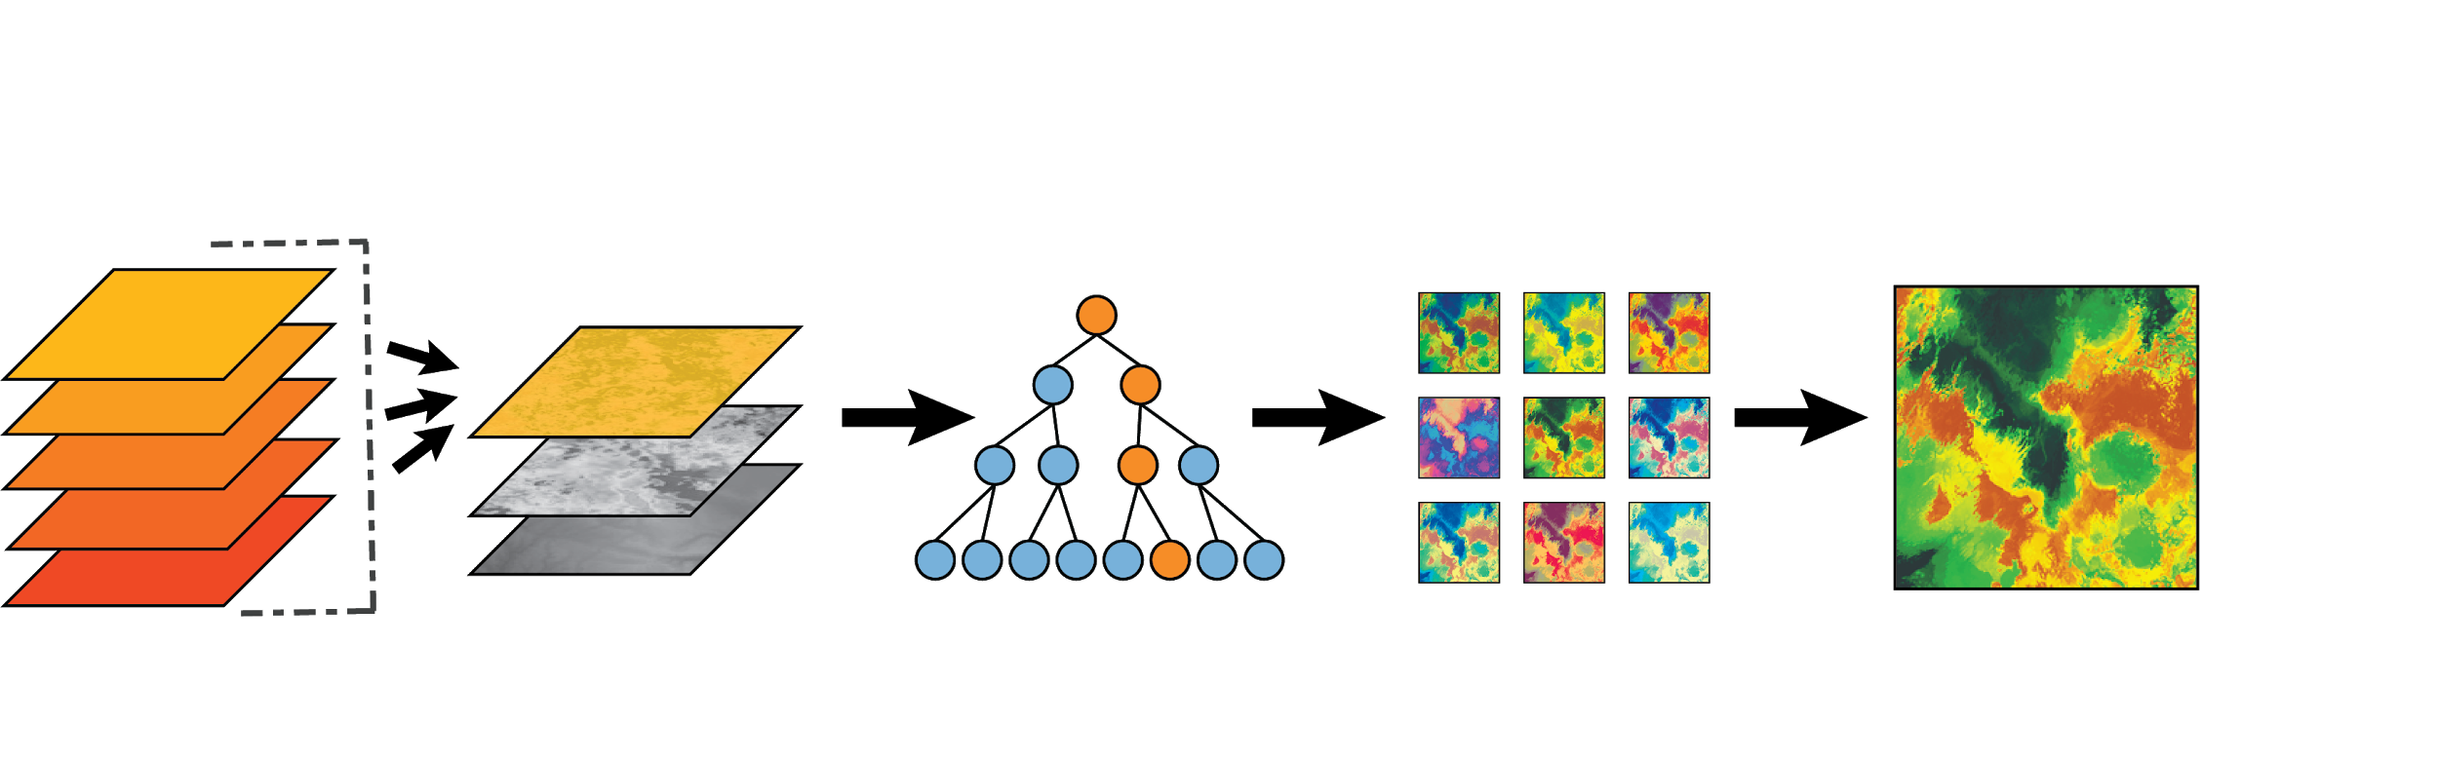

**SAHM**

**Google Earth Engine**

*Figure 2.*Infographic depicting the conceptual methodology progression beginning with deriving our various bare ground layers, incorporating them into modeling, and arriving with a final habitat suitability map.

The SAHM workflow is composed of various customizable modules. Through this workflow, SAHM set a uniform study area extent and a uniform projection to our data, then tested for variable correlation, and produced modeling outputs using random forest (RF), maximum entropy (MaxEnt), and generalized linear model (GLM) classification methods. For each model iteration, we provided a predictors list file, a template layer, and presence and background data for our focal species. The predictor list outlines file pathways for each input variable used in the SAHM modeling process. Our template layer defined our study area, designating how SAHM formats, clips, resamples, and projects all subsequent raster layers to match an extent. The presence locations were then used to train the model to determine which habitats were most suitable for our focal species based on the values of the input predictor variables at these locations. We generated background points using the kernel density estimation (KDE) method in the ‘Background Surface Generator’ module. We then input these background points into the species presence file (|presence| = 1, |absence| = 0).  We used this workaround to generate the points because there was an error in our ‘Background Surface Generator’ module, where the module was successful in creating the background points but would fail in the ‘Covariate Selection’ module where it returned the entire predictor list with zero deviance explained values. This is a common issue in SAHM that the USGS is currently working on fixing.

In the variable selection phase for our 2018 models, we used the ‘Covariate Selection’ module to identify the top predictor variables and to remove any highly correlated variables (|r|> 0.70). If two variables were considered highly correlated, we kept the variable that had a higher deviance explained value and removed the latter variable. After the variable selection phase, we selected the variable list that we would use for all of our models and then performed iterations by substituting the bare ground data layers. This approach produced model statistics and map outputs for each repetition. For our final medusahead distribution map, we created an ensemble model in ESRI ArcMap that takes the binary map outputs (defined by SAHM) and then added the binary classifications for each model. This raster calculation results in a map that identifies regions with a high model agreement, areas that are the most suitable habitat, versus areas with low to no model agreement, indicating less suitable habitat.

***3.4 Independent Validation of Bare Ground Layers***

We used in-field measurements of bare ground from the BLM AIM strategy to validate our team’s derived bare ground indices. In this validation process, we included a total of 378 points from the years 2016 and 2017. The AIM field data measurements were collected within a 55 m radius using the line point intercept method with 150 points on three transects per plot to calculate percent bare ground. In R, we overlaid each of these points within our bare ground layers and placed a 55 m buffer around them to mirror how the field data were collected. We averaged the values of all the pixels intersecting these buffered zones. We then pulled out the averaged values for our derived bare ground layers (e.g. NBLI and SAVI) at each of these points in order to compare it to the AIM field bare ground measurements. *Figure 5*, in the results section, shows the derived and observed values at the training points.

***3.5 Future Forecasting***

To create a habitat suitability map across Nevada and Oregon for the year 2050, our team incorporated future climate projections taken from WorldClim datasets (Hijmans, Cameron, Parra, Jones & Jarvis, 2005). These data are based on the Representative Concentration Pathway (RPC) 8.5 run by the GISS-E2-R model from NASA’s Goddard Institute for Space Studies. We removed all current climate data and any indices pertaining to human influence on the land from our predictor variables. Our model incorporated 5 variables in total, two being future climate variables (BIO7 and BIO18), along with the BSI index and two original USGS environmental layers (percent clay and depth to restriction). We selected BSI as our bare ground index for this future modeling because we saw that it had the highest agreement with the AIM data, indicating it as one of our most accurate indices.

# 4. Results

***4.1 Bare Ground Layer Comparison***

*Figure 3* shows derived bare ground layers around the Goose Lake area near the southeast border of Oregon. White indicates areas with high levels of bare ground, orange indicates a mixture of bare ground and vegetation, and green indicates high levels of vegetation. Visually, the Moderate Resolution Imaging Spectroradiometer (MODIS) layer has a less detailed resolution in relation to the Landsat-derived indices, while the SAR-VH layer has the highest resolution.

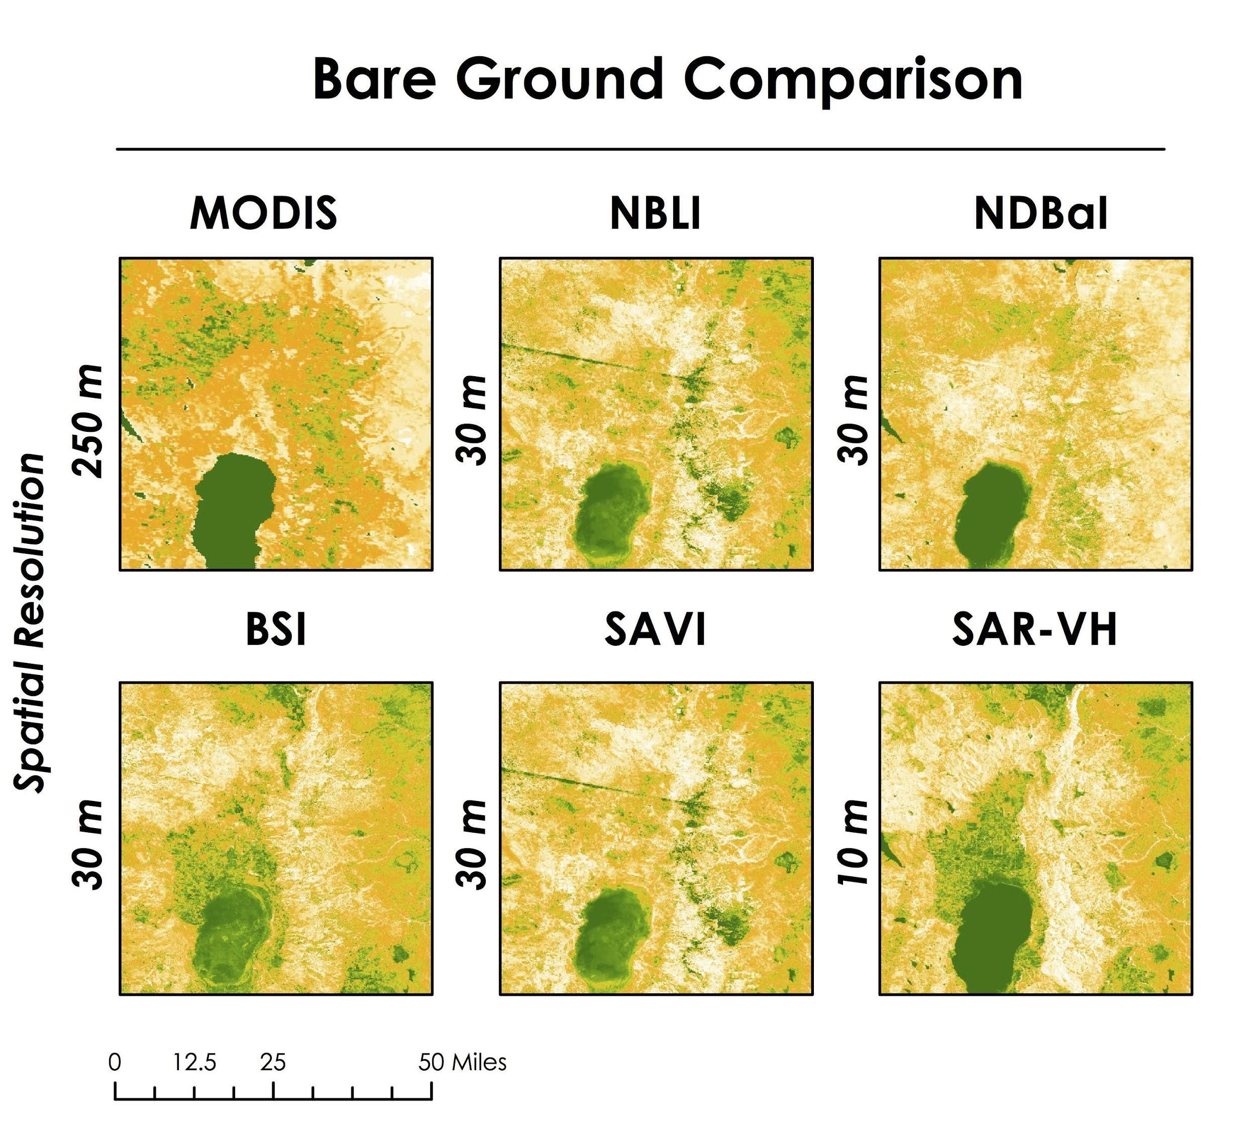

**Low**

**Bare Ground**

**High**

*Figure 3.*Spatial outputs of our bare ground layers (30 m & 10 m) in comparison to the current USGS 250 m bare ground layer.

*Figure 4* shows the spread of the calculated bare ground from the AIM data compared to our calculated bare ground indices. Some of the layers have positive relationships and other layers have negative relationships with the AIM data due to their own value scales. The percent bare ground of the field data is based on our team’s extrapolation of the bare ground data recorded in each AIM transect. The assessment of our bare ground indices through this independent dataset showed slight variations between R-squared (R2) values. BSI, followed by NBLI, had the most agreement with the AIM data out of all of the derived indices.

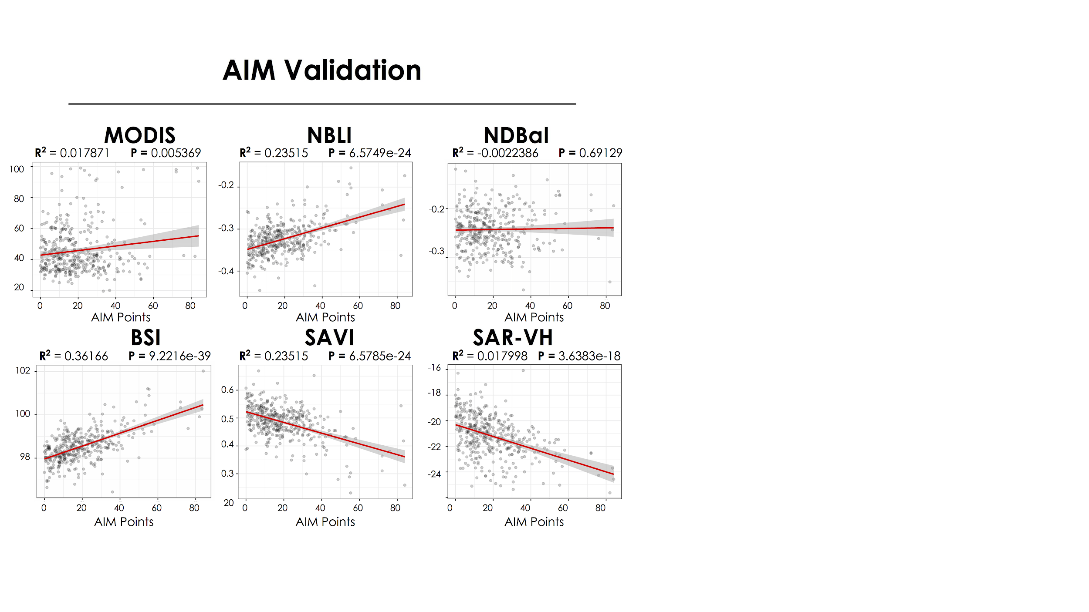

*Figure 4.*Plots illustrating the relationship between the bare ground percentage (0-100%) from the AIM field data and our derived bare ground indices.

***4.2 Medusahead Habitat Suitability***

The top two input variables that consistently outperformed other variables in our habitat distribution models were the depth to restriction layer at 21.6 percent deviance explained and the March/Spring mean precipitation ratio at 16.9 percent deviance explained. The bare ground layer with the highest percent deviance explained was NDBaI at 12.84 percent, followed by MODIS (current USGS layer) at 12.29 percent. The majority of the other bare ground layers (NBLI, BSI, SAVI, SAR_VH) were slightly lower at 9 percent plus or minus 0.09 deviance explained (*Figure 5*).

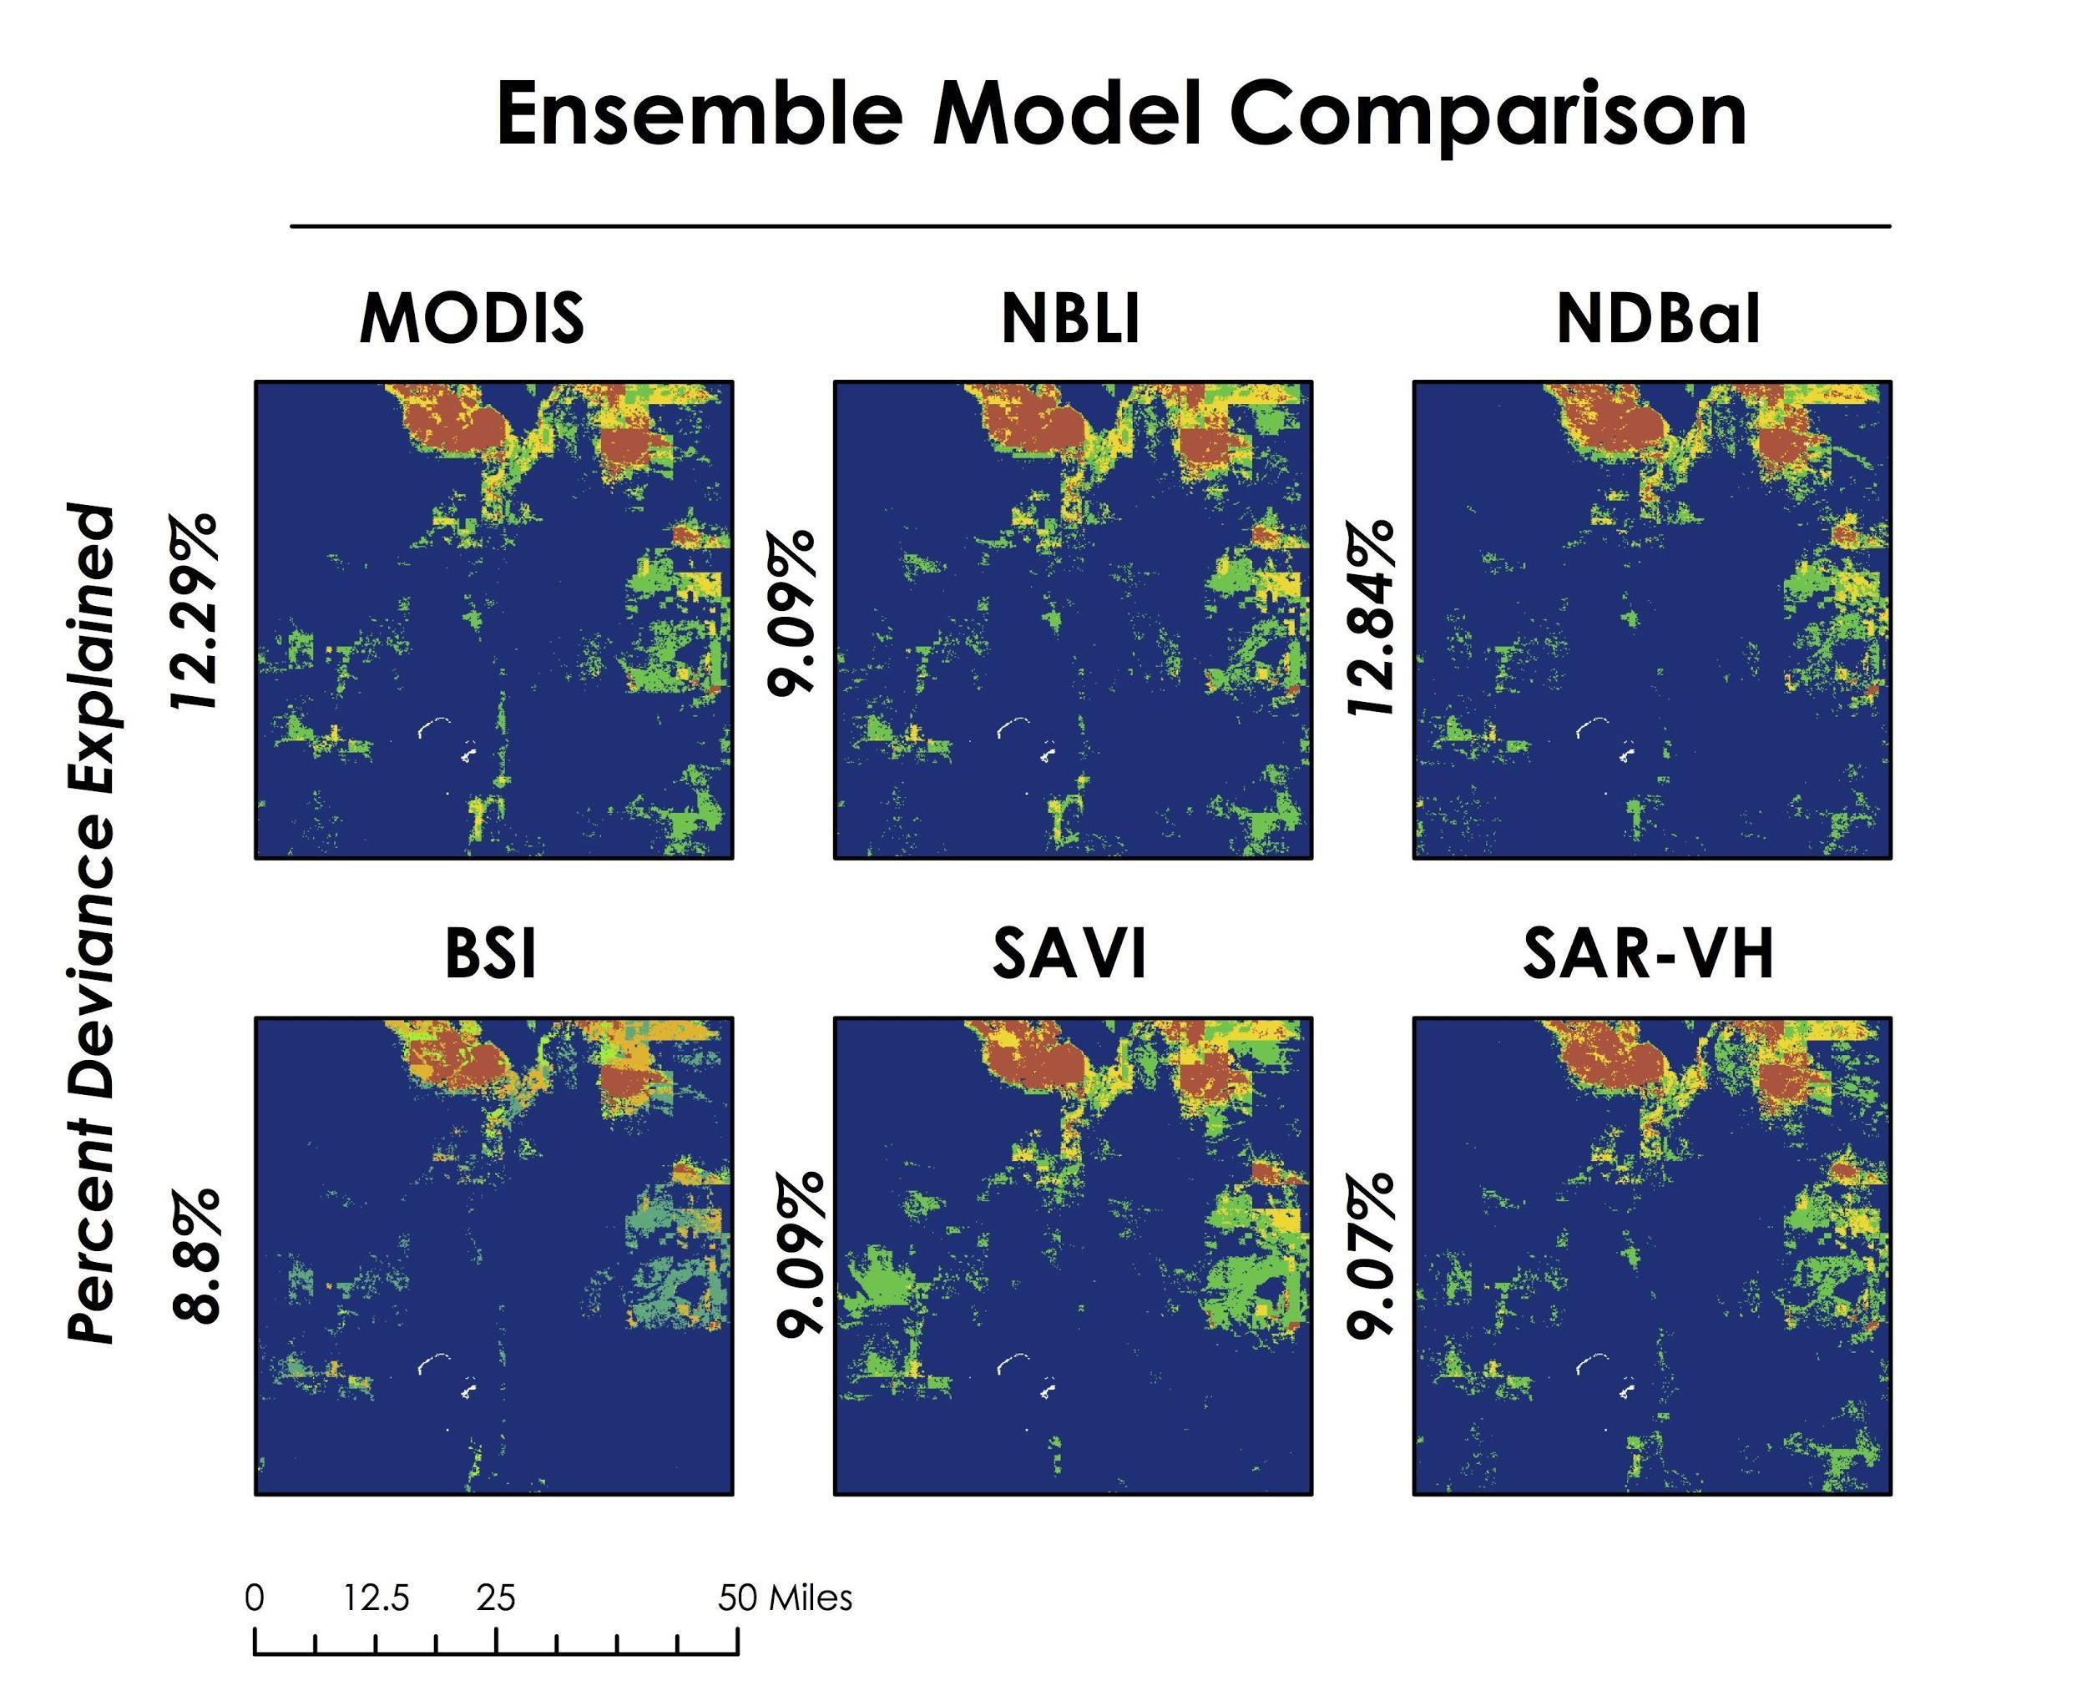

**Model Agreement**

**0**

**1**

**2**

**3**

*Figure 5.*An ensemble model assessing model agreement between our output habitat suitability maps (RF, MaxEnt, GLM) for each bare ground index.

Orange indicates all three models agree in designating the habitat as suitable for that pixel, yellow indicates two models are in agreement, green indicates only one model, and blue indicates that no models designated the habitat as suitable. The threshold for suitability classification was set where the specificity is equal to the sensitivity of the model. Specificity is the ability of a model to correctly classify a pixel as *not suitable* habitat and sensitivity is the ability of a model to correctly classify a pixel as *suitable* habitat.

The habitat suitability model for medusahead incorporated the BSI layer into an random forest model (*Figure 6*). We felt that the BSI bare ground layer and the random forest model were the most well suited for mapping habitat for our focal species over the Nevada and Oregon study area. Values range from low habitat suitability, in dark blue, to green, then yellow increasing in suitability up to red for the habitat that is designated as most suitability for our focal species. This model had an area under the curve (AUC) value of 0.98 and correctly classified 96.19 percent of suitable habitat for medusahead.

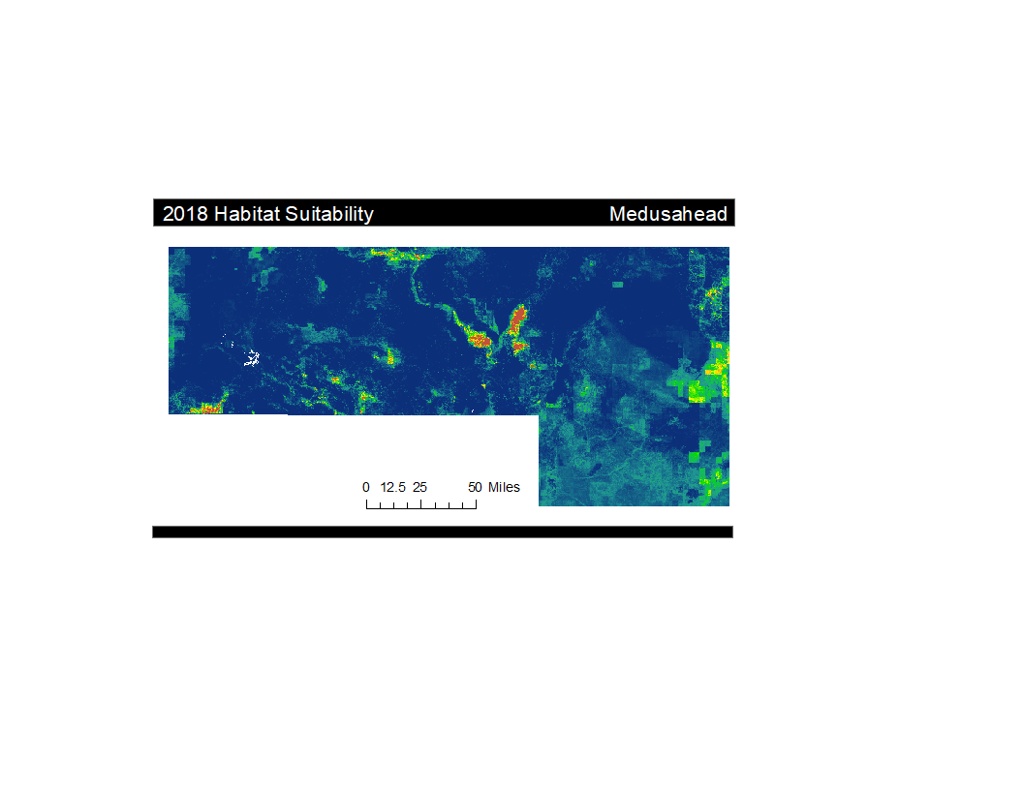

**Low**

**High**

**Probability**

*Figure 6.*Final habitat suitability map denoting areas of high suitability in red, and low suitability in blue. This model incorporated our BSI index into a random forest classification model.

***4.3 Forecasted Medusahead Habitat Suitability for 2050***

Our random forest classification model forecasted the distribution of medusahead using the BSI bare ground layer for 2050 (*Figure 7*). This model resulted in an AUC of 0.935. It correctly classified 90.25 percent of suitable habitat.

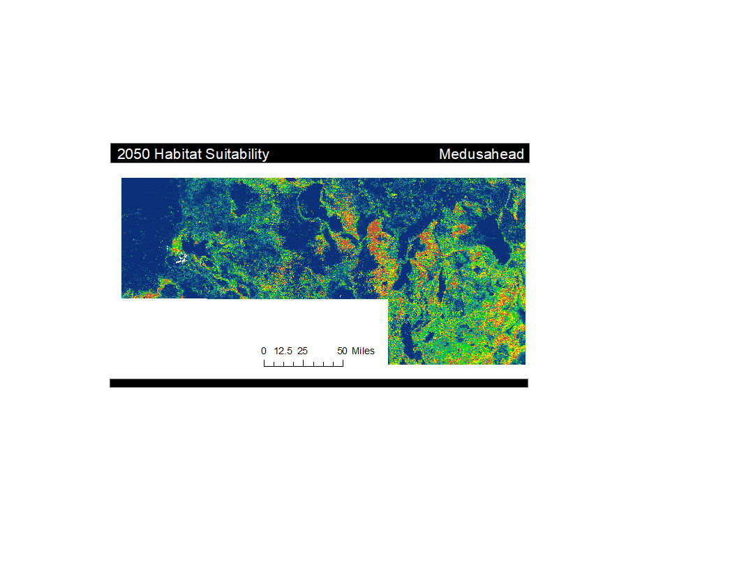

**Low**

**High**

**Probability**

*Figure 7.*Final habitat suitability map denoting areas of high suitability in red, and low suitability in blue. This model incorporated our BSI layer into an random forest classification model.

# 5. Discussion

***5.1 Bare Ground Layer Interpretation***

Each of our layers exhibited a higher spatial resolution than the MODIS bare ground layer that our partners currently use. The C-SAR layer from Sentinel-1 derived layer was particularly interesting as it enhanced the resolution down to 10 m, which is a drastic increase in detail compared to the 250 m MODIS layer. In general, our derived bare ground indices produced geospatially similar outputs in the locations that they were picking up bare ground. However, with greater variance in pixel to pixel values, models can have a better understanding of surface characteristics on a smaller scale.

While there are slight variations between our bare ground indices (*Figure 3*), we cannot directly compare their numerical values as each of the layers are based on different numerical scales. For this reason, we relied on visual analysis of the layers when comparing model outputs. We focused on the state of Nevada because it had the greatest bare ground variation within our study area. NDBaI had the greatest propensity for classifying bare ground, followed by BSI. NDBaI had a majority of its values falling into the upper range, therefore classifying more pixels as bare ground when compared to the other indices. This differs from BSI, which had fewer values in the upper range but a greater density of low-value bare ground pixels. SAVI and NBLI were very similar in their classification of bare ground and had a lower tendency for bare ground classification when compared to NDBaI and BSI. SAR-VH had the lowest propensity for detecting bare ground. Our partner’s MODIS bare ground layer lies in the middle of our indices, with a higher tendency for bare ground classification compared to NBLI, SAVI, and SAR-VH but a lower tendency to classify bare ground in relation to BSI and NDBaI. With this understanding, users can select bare ground layers based on model desires, whether a bare ground layer is more sensitive to vegetation or more sensitive to the bare ground would be more desirable.

***5.2 Independent Validation***

In our independent bare ground validation, BSI and NBLI showed the highest level of agreement with the AIM dataset. However, our predictor with the highest deviance explained, NDBaI, had little correlation to the AIM dataset. While the AIM validation was an interesting step in determining the validity of our indices, it should not be taken as a complete assessment of index success as there were also discrepancies between the date range of our derived indices and the available AIM data

***5.3 Habitat Suitability Model & Ensemble Model Interpretation***

The medusahead habitat suitability models all showed relatively similar spatial and statistical outputs. This result is further indicative that bare ground was not the central driver in mapping potential habitat for this species. The deviance explained for all of our bare ground indices ranged between 12.84 percent and 8.8 percent, and while it still can be an important variable for the successful mapping of medusahead, it is not prominent enough for the small variations between layers to significantly alter entire assessment outcomes. However, it is important to note that while the higher resolution layers did not manipulate the statistical outputs, it can have an impact on the overall pixel to pixel variations within our probability map outputs if other input variables’ resolutions are also increased. This can aid in further specifying areas that are at high risk of invasion, which will save the USGS and NPS time and money when focusing management efforts on mitigation and prevention.

Most changes in the ensemble map outputs can be attributed to the discrepancy between bare ground indices as each model iteration included consistency in all the other incorporated variables. All variables, field data, and background points were kept the same, allowing the bare ground indices to be the only dynamic aspect in determining habitat suitability. As seen in *Figure 4*, even with moderate explanatory power, small changes in the classification of bare ground can result in alterations of what is designated as suitable habitat for medusahead.

Across all indices, the random forest was consistently our best performing model when looking at the cross-validation split AUC values as well as the percent correctly classified (PCC) (Appendix C). The regularity of these results indicates that our indices did well in picking up bare ground consistently across our study area. Comparing model outputs incorporating MODIS (used by USGS) and BSI bare ground layers, we can see that they are similar in most areas in classifying suitability of medusahead habitat. We see a bigger variation between the two model outputs is in Nevada.

***5.4 Future Forecast Interpretation***

Our forecast model implies that in 2050, suitable habitat for medusahead will expand when compared to our 2018 habitat suitability maps. This may be largely attributed to the increased temperature and changes in precipitation level according to the GISS-E2-R model. This ecological forecasting component can serve as an important product for the NPS Exotic Plant Management Team because with these future models, they can be more effective in focusing preventative measures. Since the costs associated with fighting invasive species are much higher than the costs needed for prevention strategies, this should also help the NPS save money. However, it must be noted that this model excludes important predictors used in the current suitability model. This is because many of these predictors are measurements of anthropogenic impact, and it would be inaccurate to include them in a future forecast.

***5.5 Limitations and Future Work***

We found that carrying out the median reducer in a study area encompassing multiple Landsat scenes prior to the index calculations resulted in distorted imagery along the borders of overlapping Landsat scenes. This may skew some of the results calculated along this edge, such as our bare ground indices. In order to mitigate these errors, calculating the indices before performing the median reducer lessens the distortion in these regions.

In future habitat suitability models studying invasive species, it might be better to narrow down our imagery to just the growing season rather than looking at an entire year for calculating bare ground indices. Additionally, it is important to consider how our models change when focusing on a few months of the year or a growing season instead of the entire year. The calculations of our bare ground indices will likely change with the incorporation of seasonality and vegetation variability, therefore affecting the output of our final habitat suitability models.

Our team experienced issues with the background surface generator module in SAHM. We were unable to generate background points and successfully incorporate them into the model through the module itself, and instead, we relied on inputting the background points directly into our field data CSV file. While this workaround was doable for our purposes and study area in this project, it will be more efficient to fix this error in order to apply this workflow to other species and across a wider study area.

One limitation to the validation of our bare ground indices was the lack of updated field data for our study area and study period. The BLM AIM data used to validate the bare ground layers were collected in the years 2016 and 2017 while our study period focused on the year 2018. Due to this discrepancy, the validation may not be as accurate because some land use and vegetation cover have likely changed over this time period. For this reason, in order to get a more accurate assessment of our indices, it will be necessary to update the field data used to validate our bare ground layers to the same time period (2018).

Currently, SAR data are not as commonly used within habitat suitability models in comparison to other Landsat-derived indices. With increased research and further refinement, there is a huge potential to employ this approach to increase the resolution of not only bare ground layers but also other surface-based indices. SAR is increasingly being used to pick up information relating to land surface roughness, vegetation structure, and general wetland habitat composition, so our team was curious to see how the use of SAR can be applied to habitat suitability modeling.

As this project fits into the larger mission of the USGS to expand their invasive species habitat suitability models from the state to the national level, it is important that the methods we present are scalable. Future work will include continuing to improve the resolution of other variables employed by the USGS for habitat suitability modeling (climate, environmental, and anthropogenic). Due to future climate variables and the limited number of other variables used in our forecasting model, our 2050 HSM is imprecise. So as the precision of future climatic variables increases, so will the accuracy of predictive suitability models. In addition to that, finding additional indices that will not have anthropogenic impacts to incorporate into future HSMs will also be noteworthy.

# 6. Conclusions

This project achieved our main objective of providing the USGS with a portfolio of higher resolution (30 m) bare ground layers in order to further refine their habitat suitability models for medusahead. Each of these layers detects bare ground differently, but all of them improve the precision of model outputs when compared to what is currently being employed at the USGS. We found that exchanging our partner’s bare ground variable with higher resolution layers did not result in a significant change in model outputs geographically and statistically. This trend could be attributed to the relatively low importance of bare ground in their habitat suitability models.

We also produced current and future habitat suitability maps for medusahead over our study area. These models incorporated BSI as a bare ground layer because, while all of our bare ground layers performed similarly, this layer had the most agreement in our independent validation with AIM bare ground dataset. Our forecasting map shows that the geographic distribution of habitat fit for medusahead is expected to increase by the year 2050. Incorporating higher resolution layers into habitat suitability models can facilitate more targeted and cost-effective management strategies for land managers. These strategies can help mitigate current and prevent future impacts of medusahead.

# 7. Acknowledgments

The Nevada & Oregon Ecological Forecasting team would like to thank our advisors and mentors – Dr. Catherine Jarnevich, Dr. Paul Evangelista, Nicholas Young, Tony Vorster, and Kristen Dennis – who provided their support and time in order to make this project successful. We would also like to extend our gratitude to our partners at the United States Geological Survey and National Park Service – Terri Hogan and Dr. Catherine Jarnevich.

This material contains modified Copernicus Sentinel data (2016-2018), processed by ESA.

Any opinions, findings, and conclusions or recommendations expressed in this material are those of the authors and do not necessarily reflect the views of the National Aeronautics and Space Administration.

This material is based upon work supported by NASA through contract NNL16AA05C.

# 7. Glossary

**Early successional species** – Generally herbaceous annual and perennial plant species that quickly occupy disturbed sites (e.g. those affected by wildfire) and reproduce seeds that are disturbance-adapted or can be widely dispersed by wind, water, or animals

**Earth observations** – Satellites and sensors orbiting earth that collect information about the Earth’s physical, chemical, and biological systems over space and time

**Generalist species** – Species that are able to thrive in a wide variety of environmental conditions and can make use of a variety of different resources

**HSMs** – Habitat Suitability Models

**NASA** – National Aeronautics and Space Administration

**NPS** –National Park Service

# USGS – United States Geological Survey

# 8. References

Archer, A. J. (2001). Taeniatherum caput-medusae. *Fire Effects Information System*. U.S. Department

of Agriculture, Forest Service, Rocky Mountain Research Station, Fire Sciences Laboratory.

Retrieved 14 February 2019 from <https://www.fs.fed.us>/database/feis/plants/graminoid/taecap/all.html

Dematte, J. A., Huete, A. R., Ferreira Jr, L. G., Nanni, M. R., Alves, M. C., & Fiorio, P. R. (2009). Methodology for bare soil detection and discrimination by Landsat TM image. *The Open Remote Sensing Journal,* *2*, 24-35. doi:10.2174/1875413901002010024

Hijimans, R., Cameron, S.E., Parra, J.L., Jones, P.G., Jarvis, A. (2005). Very high resolution interpolated climate surfaces for global land areas. *International Journal of Climatology*, *25*(15), 1965-1978

Homer, C., Dewitz, J., Yang, L., Jin, S., Danielson, P., Xian, G.,…Megown, K. (2015). Completion of the 2011 National Land Cover Database for the conterminous United States - representing a decade of land cover change information. *Photogrammetric Engineering and Remote Sensing, 81*(5), 346-354. doi: 10.14358/PERS.81.5.345

Kumar, P., Pandey, P. C., Singh, B.K., Katiyar, S., Mandal, V.P., Rani, M.,…Patairiya, S. (2016). Estimation of accumulated soil organic carbon stock in tropical forest using geospatial strategy. *Egyptian Journal of Remote Sensing and Space Science,* *19*(1), 109-123. doi:10.1016/j.ejrs.2015.12.003

Li, H., Wang, C., Zhong, C., Su, A., Xiong, C., Wang, J., & Liu, J. (2017). Mapping urban bare land automatically from Landsat imagery with a Simple Index. *Remote Sensing,* *9*(3), 249. doi:[10.3390/rs9030249](https://dx.doi.org/10.3390/rs9030249)

NASA Goddard Space Flight Center, Ocean Ecology Laboratory, Ocean Biology Processing Group. Moderate-resolution Imaging Spectroradiometer (MODIS) Aqua. Data; NASA OB.DAAC, Greenbelt, MD, USA. doi: 10.5067/AQUA/MODIS/L2/IOP/2018

National Invasive Species Council. (2016). *Management plan: 2016–2018.* Washington, DC: Department of the Interior. Retrieved from <https://www.doi.gov/sites/doi.gov/files/uploads/2016-2018-nisc-management-plan.pdf>

National Parks Service. (2017, April 20). Invasive species, national parks, and you. Retrieved February 11th, 2019, from <https://www.nps.gov/articles/invasive-species.htm>

National Parks Service. (2018, May 22). Exotic Plant Management Teams. Retrieved February 14th, 2019, from <https://www.nps.gov/orgs/1103/epmt.htm>

Pimentel, D., Zuniga, R., & Morrison, D. (2005). Update on the environmental and economic costs associated with alien-invasive species in the United States. *Ecological Economics,* *52*(3), 273-288. <https://doi.org/10.1016/j.ecolecon.2004.10.002>

Simberloff, D. (2010). Invasive species. In Navjot S. Sodhi and Paul R. Ehrlich (Eds.), *Conservation biology for all* (131-151). New York: Oxford University Press Inc. Retrieved from https://conbio.org/publications/free-textbook/

Stone, G. (2017, March 10). Detecting invasive species: Medusahead. Retrieved from <https://cropwatch.unl.edu/2017/detecting-invasive-species-medusahead>

United States Geological Survey Earth Resources Observation and Science Center. (2014). Landsat 8 OLI Level-2 Surface Reflectance (SR) Science Product, Surface Reflectance Level-2 Data, accessed February 20th, 2019. U.S. Geological Survey. <https://doi.org/10.5066/f78s4mzj>

United States Department of Interior, Bureau of Land Management. (2018, September 6th). *BLM AIM TerrADat RemoteSensing point* [Data File]. Retrieved March 14th, 2019 from <https://landscape.blm.gov/geoportal/catalog/search/resource/details.page?uuid=%7BC1BA9ED7-7D9B-48D9-94DC-63C8A859D2BD%7D>

Victoria State Government. (2017, May 8). *Invasive plants and animals policy framework*. Agriculture Victoria. Retrieved February 20th, 2019 from <http://agriculture.vic.gov.au/agriculture/pests-diseases-and-weeds/protecting-victoria-from-pest-animals-and-weeds/invasive-plants-and-animals/invasive-plants-and-animals-policy-framework>

West, A. M., Evangelista, P. H., Jarnevich, C. S., Kumar, S., Swallow, A., Luizza, M. W., & Chignell, S. M. (2017). Using multi-date satellite imagery to monitor invasive grass species distribution in post- wildfire landscapes: An iterative, adaptable approach that employs open-source data and software. *International Journal of Applied Earth Observations and Geoinformation, 59*, 135-146. <https://doi.org/10.1016/j.jag.2017.03.009>

West, A. M., Evangelista, P. H., Jarnevich, C. S., & Schulte, D. (2018). A tale of two wildfires; testing detection and prediction of invasive species distributions using models fit with topographic and spectral indices. *Landscape Ecology, 33*(6), 969-984. <https://doi.org/10.1007/s10980-018-0644-x>

# 10. Appendices

**Appendix A.** Invasive species cost curve.

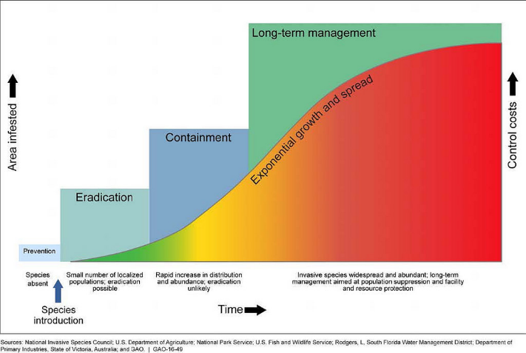

*Figure A1.* As seen in the invasive species invasion curve, the control costs of early detection and removal are drastically lower than the following steps of eradication, containment, and long-term asset-based protection and management (Victoria State Government, 2017).

**Appendix B**. Medusahead predictor variables.

|  |  |  |
| --- | --- | --- |
| **Name** | **Resolution** | **Description** |
| Mean diurnal range (BIO2) | 800 m | Mean of all the averaged, monthly temperature extremes whose inputs are monthly mean maximum and minimum temperatures; calculated by finding the difference between the maximum and minimum temperature for each month, and then averaging these values |
| Temp annual range (BIO7) | 800 m | A measure of temperature variation over a given period calculated by subtracting the minimum temperature of the coldest month (BIO 6) from the maximum temperature of the warmest month (BIO5) |
| Precip of warmest quarter (BIO18) | 800 m | Approximates total precipitation that prevails during the warmest season; calculated by identifying the warmest quarter of the year (the average temperatures of each month in the quarter are summed; the quarter with the highest value is selected), and the precipitation values for the three months in this quarter are then summed |
| Min temp winter | 4000 m | Minimum temperature of winter months (December through February) is the monthly mean minimum temperature over the given time period |
| Mean temp spring | 4000 m | Mean temperature of spring months (March through June) |
| Mean PET: Oct-Jun | 4000 m | Potential water deficit of fall to spring months; calculated by averaging potential evapotranspiration subtracted from precipitation over a given time period |
| Mean precip March/mean precip spring | 4000 m | Mean precipitation of March divided by Mean precipitation of spring months (March through June) |
| Evapotranspiration Mar-Jun | 1000 m | Mean monthly evapotranspiration of spring months (March through June) |
| Landscape condition model | 90 m | Identifies human land uses (built infrastructure, agriculture, vegetation alteration, and et cetera) |
| Western human footprint | 180 m | Identifies anthropogenic changes to the landscape and the cumulative impacts of human presence and actions; incorporates 14 landscape structure and anthropogenic features |
| Percent clay (0-5 cm) | 100 m | Mean percent clay cover in the first 0-5 cm of the soil horizon |
| Available water content (depth, cm) | 100 m | The variance of available water content in the first 0-5 cm of the soil horizon |
| Available water content (depth, cm) | 100 m | Mean available water content in the first 0-5 cm of the soil horizon |
| Depth to restriction layer (mean) | 100 m | Mean depth to restriction layer |
| Remoteness (night lights) | 250 m | Nighttime lights of 2011; cloud-free composites use visible and infrared sensors to capture imagery |
| Bare ground standard deviation | 250 m | The standard deviation of percent cover of the bare ground over the given time period |

**Appendix C.** Medusahead habitat suitability model output statistics.

