**NASA DEVELOP National Program**



NASA Langley Research Center

*Summer 2017*

Miami Beach Water Resources

Assessing the Feasibility of Using NASA Earth Observations to Monitor Trends in Runoff and Storm Water Discharge of the Biscayne Bay and Miami Beach Vicinity

 **Technical Report**

Final Draft – August 10, 2017

Pamela Kanu (Project Lead)

Danielle Quick

Randolph Colby

Dr. Kenton Ross, NASA Langley Research Center (Science Advisor)

# 1. Abstract

Submerged Aquatic Vegetation (SAV) is an important component of coastal ecosystems, and is vulnerable to increased turbidity in the water column. It provides stability and protection to sediment deposits, and offers food and shelter to economically valuable species of marine life. Recent urban development and population growth in the Miami area have resulted in an increase in stormwater discharge connected to changing water quality in Biscayne Bay. The project used Earth observation data from a suite of sensors including Landsat 8 OLI, Landsat 7 ETM+, Landsat 5 TM, and Sentinel-2 MSI in conjunction with *in situ* water quality monitoring data. Turbidity and chlorophyll-A concentration data were used to develop a tool to view both historic and current water quality parameters in Biscayne Bay. The results of this project will assist the Miami Beach Public Works Department in decision making and predicting future water quality trends in Biscayne Bay and the surrounding area.

**Keywords**

Landsat, turbidity, Submerged Aquatic Vegetation (SAV), stormwater, Sentinel-2, ACOLITE, Biscayne Bay

# 2. Introduction

* 1. ***Background Information***

Biscayne Bay is an estuary with an average depth of 1.8 meters and roughly 700 square kilometers in area (Caccia, 2005), stretching from Miami Beach to Key Largo, Florida. The Bay is habitat for a host of wildlife including dolphins, manatees, American crocodiles, bald eagles, and a variety of economically important fisheries resources such as the pink shrimp, gray snapper, spotted seatrout, and pinfish (Lirman, 2014). Submerged Aquatic Vegetation (SAV) play a key role in Bay health and provide primary sustenance to the Bay’s ecosystem. Three species of SAV are predominant throughout the Bay and include turtlegrass (*Thalassia testudinum*), shoalweed (*Halodule wrightii*), and manatee grass (*Syringodium filiforme*) (Lirman, 2003).

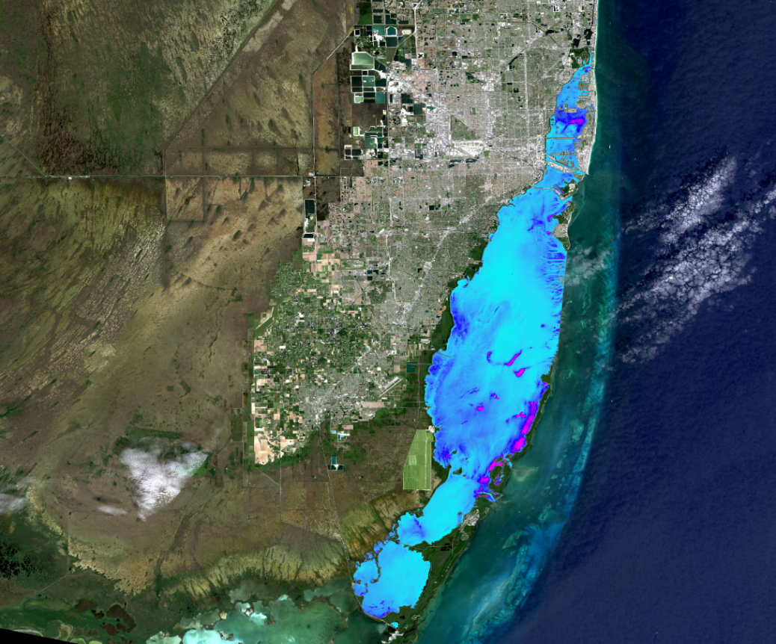

*Figure 1*. Biscayne Bay, Florida. A.I. Dogliotti Turbidity formula from ACOLITE

SAV responds rapidly to changes in water quality parameters as evidenced in the mass mortality event where 4,000 hectares of turtlegrass died-off in nearby Florida Bay starting in 1987. Approximately 1,500 kilometers of canals currently manage freshwater conveyance into the Bay’s coastal habitats, controlling salinity levels throughout the Bay. The Comprehensive Everglades Restoration Project (CERP) plans to restore the natural hydrology of the Bay and surrounding Everglades by increasing the freshwater inputs from upland sources to re-establish estuarine conditions along nearshore environments (Lirman, 2003).

Due to extensive growth of urban development in Miami and Miami Beach, there have been marked changes to the Bay’s ecosystem (Caccia, 2005). This study uses NASA Earth observations to evaluate changes in water quality of the Biscayne Bay from January 1995 through December 2016. Landsat 5 Thematic Mapper (TM), Landsat 7 Enhanced Thematic Mapper Plus (ETM+), and Landsat 8 Operational Land Imager (OLI) images were used for turbidity analysis to generate a snapshot of water clarity. Landsat 8 OLI were also used to examine chlorophyll-A concentrations. This project analyzed the European Space Agency’s (ESA) Copernicus Sentinel-2 MultiSpectral Imager (MSI) data for turbidity and chlorophyll-A to generate trend maps throughout the Bay, with a focus on the recent changes to factors influencing SAV growth and die-off throughout the northern Bay.

* 1. ***Project Partners & Objectives***

The Miami Beach Water Resources Team partnered with the Public Works Department of the City of Miami Beach to provide information about water quality within the past twenty-two years to better understand how increased pumping requirements and stormwater runoff might affect the SAV in the Bay. The Public Works Department and surrounding municipalities will use this information to better predict the impacts of stormwater management practices and plan future practices with minimal impact to the Bay’s ecosystem. Because water quality and seagrass health in the Bay play important roles in supporting Miami Beach’s economy through creating tourism appeal and through supporting economically-important species of marine life, this project will assist the City of Miami Beach in maintaining a strong economy as the future brings increased stormwater pumping requirements.

This project fits in NASA’s Applied Sciences Water Resources area, as it concentrates on remote monitoring of water quality. Within this application area, this project fits the functional theme of water quality, as the threat to SAV driving the project is tied directly to water quality. The objectives for this project were to produce wet season trend maps of water quality, assess feasibility of using NASA remote sensing data for water quality monitoring in Biscayne Bay and develop correlations using *in situ* data and coefficient of variance of averaged wet season turbidity.

# 3. Methodology

***3.1 Data Acquisition***

The Landsat Surface Reflectance High Level GeoTIFF data product for Landsat 5 Thematic Mapper (TM), Landsat 7 Enhanced Thematic Mapper Plus (ETM+), Landsat 8 Operational Land Imager (OLI), and Sentinel-2 MultiSpectral Instrument (MSI) were downloaded for WRS-2 path 15, row 42 from the United States Geological Survey (USGS) Earth Explorer portal. Imagery with minimal cloud cover in the study area was captured between May and September, the optimal inundation months due to wet season trends for Biscayne Bay. Exact dates are listed in Appendix A. Bathymetric data were provided by the City of Miami Beach Public Works Department and have depths up to 16 meters and a spatial resolution of 10 meters. *In situ* turbidity and chlorophyll-A concentration were derived from sonde data for the Bay and provided by the City of Miami Beach Public Works Department.

***3.2 Data Processing***

All project-specific data are converted into the projected coordinate system:

NAD_1983_StatePlane_Florida_East_FIPS_0901_Feet. The project Well Known ID (WKID) is 2236. ESRI ArcGIS 10.5 Projection tools were used with the transformations for converting WGS 1984 to NAD_1983. Data in the WGS84 projection were projected using NAD_1983_To_WGS_1984_1. The WKID is 1188. The data are within a 2 m (6.56 ft.) accuracy.

Imagery products were atmospherically corrected and converted to surface reflectance using the open source program ACOLITE v.201701163.0 for Landsat 8 OLI and Sentinel-2A MSI, and ACOLITE v.20170718.0 for Landsat 7 ETM+ and Landsat 5 TM. The following parameters were then used to produce water leaving radiance imagery in ACOLITE:

*Table 1*

*NASA Earth observation platforms, data products, ACOLITE parameters, spatial resolution, and number of images.*

|  |  |  |  |  |
| --- | --- | --- | --- | --- |
| **Platform & Sensor** | **Product** | **ACOLITE**  **Parameters** | **Spatial Resolution** | **Number of Images** |
| Landsat 5 TM, Landsat 7 ETM+,  Landsat 8 OLI | Turbidity  Index | Dogliotti, RRS | 30 m | 200 |
| Sentinel-2 MSI | Turbidity | Dogliotti, RRS | 10 m | 31 |
| Sentinel-2 MSI | Chlorophyll-A | CHL_RE_  MOSES3B | 10 m | 31 |
| Landsat 8 OLI | Chlorophyll-A | CHL_OC3 | 30 m | 32 |

Atmospherically corrected imagery from ACOLITE were exported as a netCDF that was converted into a raster using a proprietary script from the Water Resources Integration Toolbox, a compilation of tools generated by the NASA DEVELOP Miami Beach Water Resources team. The scripts and tools were created using Python 2.7 and the ArcPy module. The project programming encompasses batch methods for generating, converting, and processing data including ArcGIS procedures such as rotating, georeferencing, and defining a projection. The tools include methods for estimating bottom surface reflectance, sand, and turbidity.

The Dogliotti algorithm identified areas of high turbidity (low water clarity) from Landsat 5 TM, Landsat 7 ETM+, Landsat 8 OLI, and Sentinel-2 MSI imagery. Turbid waters commonly occur during the rainy season (April-September), when a high volume of total suspended materials is in the water due to runoff from inland areas. The turbidity was identified by correlating a limited amount of water quality *in situ* samples provided by the partner. Bottom effects and highly turbid areas were identified by correlating the coefficient of variance calculated from the average wet season turbidity.

Randomly distributed points were generated and clipped to the study area to calculate chlorophyll-A and turbidity wet season averages. The features generated from the imagery collected during the years 1995 to 2016 were used to detect trends by classifying turbidity. The areas with a standard deviation were calculated between 0.25 to 0.50 Formazin Nephelometric Units (FNU) were extracted and converted to a polygon feature class indicating turbid areas.

Areas with bottom effects registering as turbidity were identified by the standard deviation for turbidity lower than 9 FNU. Areas with bright, sandy bottoms causing bottom effects consistently register as high turbidity, leading to a low standard deviation. Areas of turbid water are expected to have varying turbidity levels with rainfall events, leading to a higher standard deviation.

 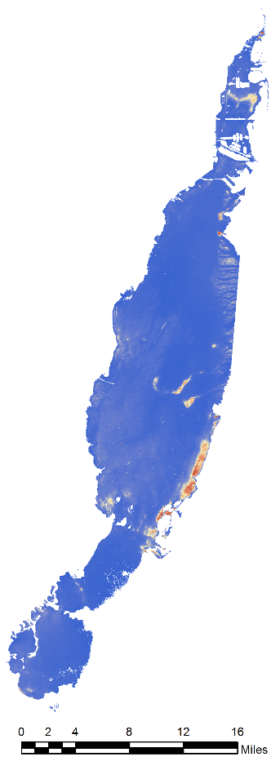

Turbidity

FNU

N

High: 75

Low: 0

*Figure 2*. Biscayne Bay, Florida. A.I. Dogliotti Turbidity formula from ACOLITE

ACOLITE was also used to generate maps of chlorophyll-A concentration from Landsat 8 OLI and Sentinel-2 MSI data. The CHL_RE_MOSES3B parameter in ACOLITE was used for Sentinel-2 imagery, and the CHL_OC3 parameter was used for Landsat 8 imagery. Corrected turbidity and chlorophyll-A ACOLITE products were averaged over April – September to produce wet-season annual average maps.

***3.3 Data Analysis***

The *in situ* data provided by the City of Miami Beach Public Works Department were used to identify historical and current trends by correlating the processed images to the water samples. The images were captured by the sensors between 11 a.m. to 3 p.m. EDT. The *in situ* data were filtered between 5 a.m. to 9 p.m., a 16 hour window to associate the relationship and patterns between both data for distinguishing trends.

A regression analysis was used to calculate the correlation between the *in situ* data and the extracted turbidity value from the imagery using Dogliotti’s turbidity formula provided through ACOLITE. Because *in situ* data collection dates did not coincide with satellite overpass, there was not enough data to generate validation between the two products.

# 4. Results & Discussion

***4.1 Analysis of Results***

*Table 2. Averaged turbidity per sensor for the wet season (April-September)*

Overall, the NASA Earth observing systems and ESA Sentinel-2 yielded similar ranges of turbidity for Biscayne Bay. Annual mean wet season turbidity was found to be highly influenced by the specific date of sampling, as this metric is usually based on five or six cloud-free scenes. A sampling date with highly turbid waters skews the yearly average much above what it would normally be. For example, in 1999 Landsat 5 measured Biscayne Bay on September 22, a very turbid day, but Landsat 7 did not measure the Bay until September 30, by which time most of this turbidity had cleared away. This is in part responsible for the marked difference between the mean wet season turbidity for Landsat 5 TM and Landsat 7 ETM+ in 1999.

*Table 3. Comparison of Landsat 7 ETM+ and Landsat 8 OLI turbidity measurements*

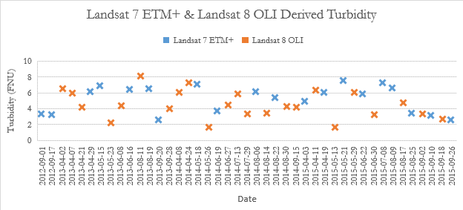

The ACOLITE derived turbidity from Landsat 7 ETM+ and Landsat 8 OLI trace similar patterns when viewed together, and have similar ranges. This further supports the idea that differences in annual mean wet season turbidity are due to actual differences in turbidity on imaging dates rather than a fundamental difference between the sensors.

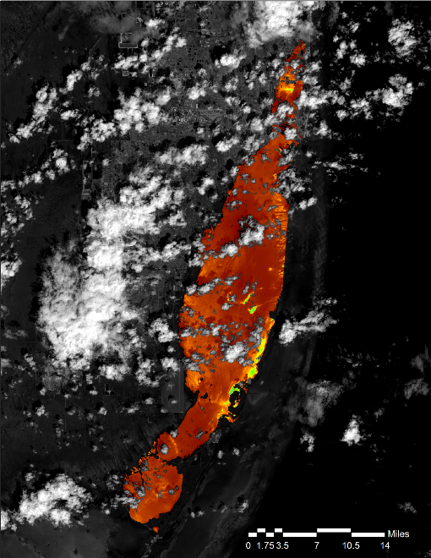 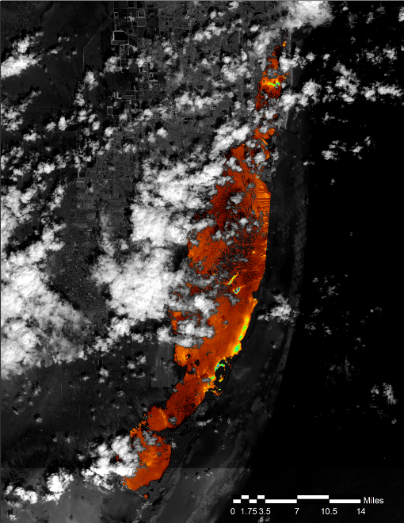

Turbidity

FNU

High: 75

Low: 0

Turbidity

FNU

High: 75

Low: 0

N

N

*Figure 3*. ACOLITE derived turbidity from Landsat 8 OLI (left) and Sentinel-2 MSI (right) on 10/04/2015. Turbidity from Landsat 8 was on average 0.06 FNU higher than that from Sentinel, with a standard deviation of 2.69.

Sentinel-2 MSI and Landsat 8 OLI both collected imagery of Biscayne Bay on October 04, 2015, allowing a unique opportunity to compare the two sensors. The average turbidity for Biscayne Bay was only different by 0.06 FNU, indicating that both satellites can be useful as part of the same monitoring program.

Biscayne Bay’s shallow, sandy bottom and clear water caused some light that was reflected from the seafloor to be picked up by the satellites’ sensors. This bottom reflectance skewed the results of the turbidity algorithm, causing the Bay’s shallow areas to consistently appear more turbid than they actually were.

*Table 4. Comparison of Landsat 8 OLI and Sentinel-2 MSI Chlorophyll-A concentration outputs from ACOLITE*

|  |  |  |  |  |
| --- | --- | --- | --- | --- |
| **Year** | 2013 | 2014 | 2015 | 2016 |
| **Landsat 8 OLI Mean Chlorophyll-A Concentration (mg/m3)** | 3.20 | 4.73 | 4.11 | 5.50 |
| **Sentinel-2 MSI Mean Chlorophyll-A Concentration (mg/m3)** |  |  |  | -295.87 |

Landsat 8 OLI images processed through ACOLITE with the CHL_OC3 algorithm yielded similar ranges of chlorophyll-A concentrations to *in situ* data, and is a good candidate for monitoring this water quality parameter once enough *in situ* data is collected to establish correlations. In contrast, Sentinel-2 MSI imagery processed through ACOLITE with the CHL_RE_MOSES3B algorithm yielded negative values, often of far greater magnitude than the positive values given by *in situ* data. As negative chlorophyll-A concentrations are impossible and even positive average chlorophyll-A concentrations do not approach 295 mg/m3 in Biscayne Bay, ACOLITE processed Sentinel-2 imagery using the Moses Chlorophyll-A algorithm is a poor option for monitoring chlorophyll-A concentrations.

***4.2 Future Work***

Future project work can focus on creating tutorials and methodologies for the City of Miami Beach Public Work Department to enable them to continue to benefit from the project beyond the given study period. Future studies can also enhance the reliability of the current analysis by validating current work using *in situ* data from monitoring stations in Biscayne Bay. SeaDAS software has the potential of allowing for the use of Aqua MODIS and Terra MODIS data to validate, which would expand the depth of the project analysis. The MODIS data should be compared to the Landsat 8 OLI and Sentinel-2 MSI images that were processed using the turbidity classification tool developed by the Miami Beach Water Resources team. Further work in any of these areas will allow the City of Miami Beach to better understand what specific trends and factors affect the seagrass communities within the Bay, and more efficiently devote their resources towards conservation efforts.

# 5. Conclusions

*In situ* data did not coincide with the dates of satellite acquisition often enough to establish validation between the *in situ* and imagery. Continuation on this project should focus on acquiring more timely *in situ* data in order to validate observations. Future teams should also focus on the use of Terra MODIS and Aqua MODIS for validation where *in situ* data are not available. Other variables such as Total Suspended Sediment, and Ocean Color generated and compared to *in situ* data to create a more solid snapshot of Biscayne Bay’s health would strengthen Miami Beach Public Works’ understanding of factors that cause SAV die-off.

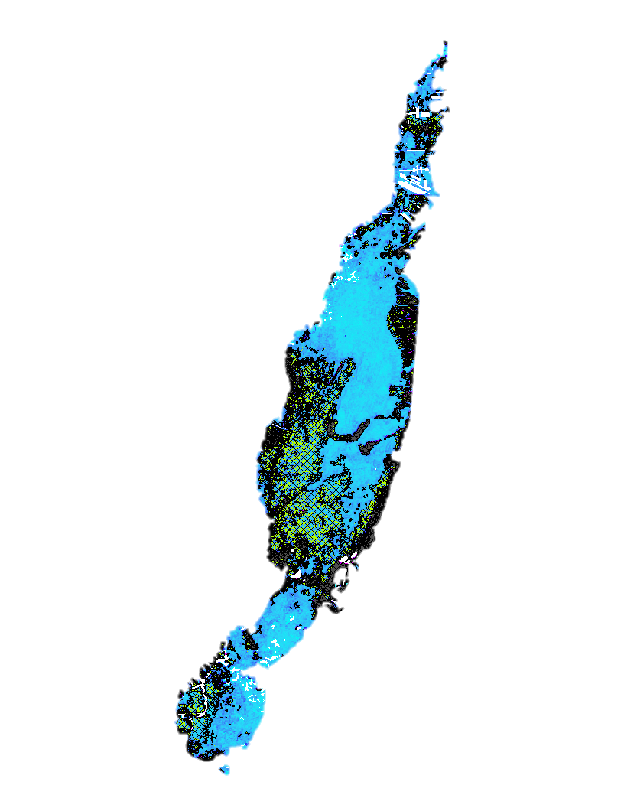Using the coefficient of variance of wet seasoned turbidity, correlations were able to be drawn from alike features—bottom reflectance, sand, and possible turbid areas. Below are the results from 2013-2016:

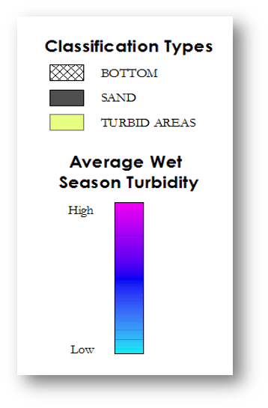

*Figure 4*. Biscayne Bay, Florida.

Bottom Reflectance, Sand and Turbid Areas

The Royal Belgian Institute of Natural Sciences’ ACOLITE software is powerful tool for use in marine remote sensing due to its capabilities in applying atmospheric correction and formulae from peer-reviewed articles that process water quality parameters. There are some difficulties that arise with the use of ACOLITE; however, the team generated an ArcGIS toolbox with tools to work around the issues that were encountered.

The toolbox developed by the Miami Beach Water Resources team include several tools useful to water resources projects that use ACOLITE for atmospheric corrections. These tools include a means to batch convert netCDF files generated in ACOLITE to raster layers, a means to adjust errors in georeferencing when converting ACOLITE’s netCDF output into a raster layer in ArcGIS, a means to classify turbidity and areas of clear shallow water that the team believes is bottom reflectance throughout the bay.

This analysis will help the City of Miami Beach and the surrounding municipalities determine the amount that SAV has decreased over a 22-year span, and will help them monitor and understand water quality to support better decision making in water quality.

# 6. Acknowledgments

The Miami Beach Water Resources team would like to thank the following people for making this project possible:

Science Advisor:

Dr. Kenton Ross, NASA Langley Research Center

Partner:

Francisco D’Elia, City of Miami Beach, Public Works Department

Others:

Emily Gotschalk, NASA DEVELOP National Program, Center Lead Langley Research Center

Any opinions, findings, and conclusions or recommendations expressed in this material are those of the author(s) and do not necessarily reflect the views of the National Aeronautics and Space Administration.

This material is based upon work supported by NASA through contract NNL16AA05C and cooperative agreement NNX14AB60A.

# 7. Glossary

**Earth observations** – Satellites and sensors that collect information about the Earth’s physical, chemical, and biological systems over space and time

**ETM+** – Landsat 7 Enhanced Thematic Mapper Plus; Earth observation sensor onboard Landsat 7

**FNU** – Formazin Nephelometric Units

**MSI** – MultiSpectral Instrument

**OLI** – Landsat 8 Operational Land Imager; Earth observation sensor onboard Landsat 8

**SAV** – Submerged Aquatic Vegetation; includes seagrass and macroalgae

**SeaDAS** – Software used to analyze Aqua MODIS data

**TM** – Landsat 5 Thematic Mapper; Earth observation sensor onboard Landsat 5

# 8. References

Caccia, V. G., & Boyer, J. N. (2005). Spatial patterning of water quality in Biscayne Bay, Florida as a function of land use and water management. *Marine Pollution Bulletin, 50(11)*, 1416-1429.

Dogliotti, A. I., Ruddick, K. G., Nechad, B., Doxaran, D., & Knaeps, E. (2015). A single algorithm to retrieve turbidity from remotely-sensed data in all coastal and estuarine waters. *Remote Sensing of Environment*, *156*, 157-168.

European Space Agency. (2015). Sentinel-2 Data (Version 1.0). Geoscience Australia. https://doi.org/10.4225/25/566a407cd2e2b

Lirman, D., & Cropper, W. P. (2003). The influence of salinity on seagrass growth, survivorship, and distribution within Biscayne Bay, Florida: field, experimental, and modeling studies. *Estuaries and Coasts*, *26*(1), 131-141.

Lirman, D., Thyberg, T., Santos, R., Schopmeyer, S., Drury, C., Collado-Vides, L., & Serafy, J. (2014). SAV communities of western Biscayne Bay, Miami, Florida, USA: Human and natural drivers of seagrass and macroalgae abundance and distribution along a continuous shoreline. *Estuaries and Coasts*, *37*(5), 1243-1255.

Moses, W. J., Gitelson, A. A., Berdnikov, S., Saprygin, V., & Povazhnyi, V. (2012). Operational MERIS-based NIR-red algorithms for estimating chlorophyll-A concentrations in coastal waters—The Azov Sea case study. *Remote Sensing of Environment*, *121*, 118-124.

U.S. Geological Survey (2012). U.S. Geological Survey Earth Resources Observation and Science Center. Provisional Landsat TM Surface Reflectance. https://doi.org/10.5066/f7kd1vz9

U.S. Geological Survey (2012). U.S. Geological Survey Earth Resources Observation and Science Center. Provisional Landsat ETM+ Surface Reflectance. https://doi.org/10.5066/f7q52mnk

U.S. Geological Survey (2014). U.S. Geological Survey Earth Resources Observation and Science Center. Provisional Landsat OLI Surface Reflectance. U.S. Geological Survey. <https://dx.doi.org/10.5066/F78S4MZJ>

# 9. Appendices

**APPENDIX A: Reference Maps**

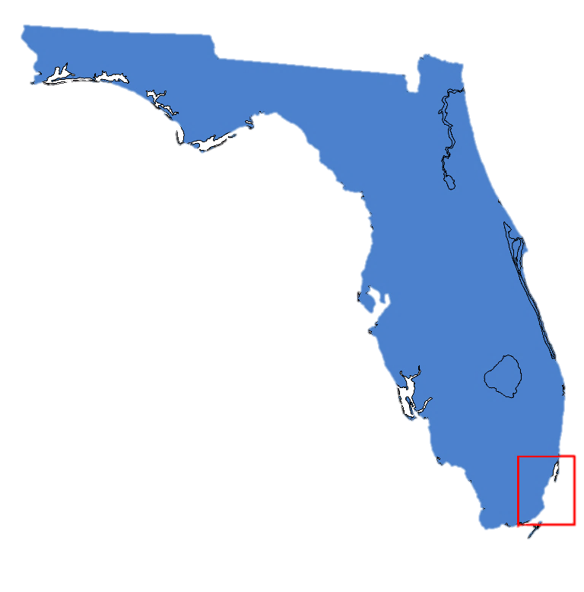

*Figure A1. Florida and outline of study area (in red)*

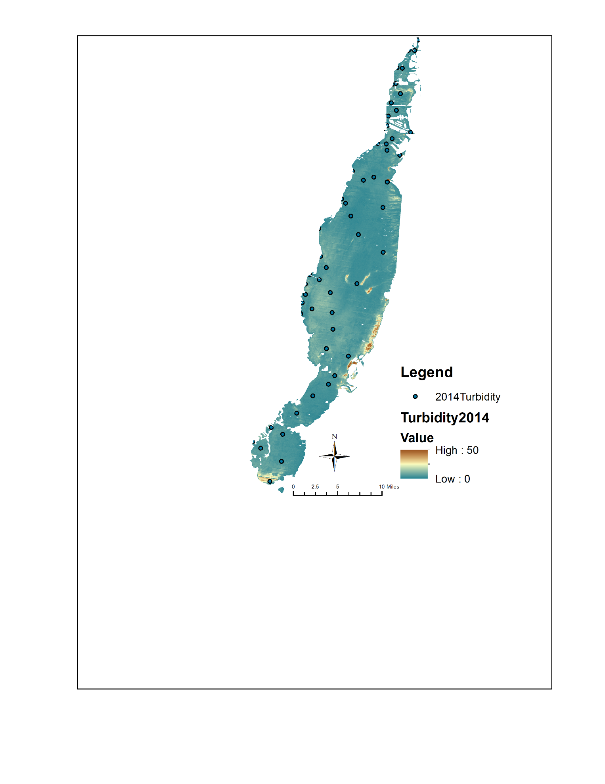

*Figure A2. Biscayne Bay study area turbidity for 2014 and continuous monitoring station locations*

**APPENDIX B: Data Acquisition and processing**

*Table B1. Imagery Dates*

|  |  |
| --- | --- |
| Landsat 5 TM | 4/04/1995, 4/20/1995, 5/06/1995, 5/22/1995, 7/09/1995, 8/10/1995, 9/11/1995, 9/27/1995, 4/06/1996, 4/22/1996, 5/08/1996, 6/09/1996, 6/25/1996, 7/11/1996, 7/27/1996, 8/12/1996, 9/13/1996, 9/29/1996, 5/27/1997, 7/14/1997, 7/30/1997, 9/16/1997, 4/12/1998, 4/28/1998, 5/14/1998, 6/15/1998, 7/17/1998, 9/03/1998, 4/15/1999, 5/01/1999, 5/17/1999, 9/06/1999, 9/22/1999 |
| Landsat 7 ETM+ | 7/12/1999, 7/28/1999, 8/13/1999, 8/29/1999, 9/30/1999, 4/09/2000, 4/25/2000, 5/11/2000, 5/27/2000, 6/12/2000, 6/28/2000, 7/14/2000, 8/15/2000, 8/31/2000, 4/12/2001, 5/14/2001, 6/15/2001, 7/01/2001, 7/17/2001, 8/18/2001, 9/03/2001, 4/15/2002, 5/01/2002, 5/17/2002, 6/02/2002, 7/04/2002, 8/21/2002, 4/02/2003, 4/18/2003, 5/04/2003, 5/20/2003, 7/23/2003, 8/08/2003, 8/24/2003, 4/04/2004, 4/20/2004, 5/22/2004, 6/23/2004, 7/09/2004, 7/25/2004, 8/10/2004, 8/26/2004, 9/11/2004, 9/27/2004, 4/07/2005, 4/23/2005, 5/09/2005, 5/25/2005, 7/12/2005, 7/28/2005, 8/13/2005, 8/29/2005, 9/14/2005, 9/30/2005, 4/26/2006, 5/12/2006, 5/28/2006, 6/13/2006, 6/29/2006, 7/15/2006, 7/31/2006, 8/16/2006, 9/01/2006, 9/17/2006, 4/13/2007, 4/29/2007, 7/02/2007, 7/18/2007, 8/03/2007, 8/19/2007, 9/04/2007, 9/20/2007, 4/15/2008, 5/01/2008, 5/17/2008, 7/20/2008, 9/06/2008, 9/22/2008, 4/02/2009, 4/18/2009, 5/04/2009, 6/05/2009, 7/07/2009, 7/23/2009, 8/08/2009, 8/24/2009, 9/09/2009, 9/25/2009, 4/05/2010, 5/07/2010, 5/23/2010, 6/08/2010, 6/24/2010, 7/10/2010, 7/26/2010, 8/11/2010, 8/27/2010, 9/12/2010, 4/08/2011, 4/24/2011, 5/10/2011, 5/26/2011, 6/11/2011, 7/13/2011, 7/29/2011, 8/14/2011, 9/15/2011, 4/10/2012, 4/26/2012, 5/12/2012, 5/28/2012, 6/13/2012, 6/29/2012, 7/31/2012, 8/16/2012, 9/01/2012, 9/17/2012, 4/29/2013, 5/15/2013, 6/16/2013, 8/19/2013, 9/20/2013, 5/18/2014, 6/19/2014, 8/06/2014, 8/22/2014, 4/03/2015, 4/19/2015, 5/21/2015, 6/22/2015, 7/08/2015, 8/09/2015, 8/25/2015, 9/10/2015, 9/26/2015 |
| Landsat 8 OLI | 4/02/2013, 4/07/2013, 4/21/2013, 5/23/2013, 6/08/2013, 8/11/2013, 9/28/2013, 4/08/2014, 4/24/2014, 5/26/2014, 6/27/2014, 7/13/2014, 7/29/2014, 8/14/2014, 8/30/2014, 9/15/2014, 4/11/2015, 4/27/2015, 5/13/2015, 5/29/2015, 6/30/2015, 8/17/2015, 9/02/2015, 9/18/2015, 4/13/2016, 4/29/2016, 5/15/2016, 6/16/2016, 7/18/2016, 8/19/2016, 9/04/2016, 9/20/2016 |
| Sentinel-2 MSI | 4/01/2016, 5/01/2016, 5/21/2016, 6/10/2016, 6/30/2016, 7/20/2016, 8/29/2016, 9/18/2016 |

*Table B2. Formulae used from ACOLITE processing*

|  |  |  |
| --- | --- | --- |
| Landsat 5 TM  Landsat 7 ETM+  Landsat 8 OLI | Turbidity Blended algorithm (Dogliotti et al.2015) | T=(1−w)⋅T645+w⋅T859 where T645 is turbidity calculated from the 655 mn band and T859 is the turbidity calculated using the 865 mn band in the following equation: $$\text{T=}\frac{{\text{A}}_{\text{T}}^{\text{λ}}{\text{ρ}}_{\text{W}}\text{(}\text{λ)}}{\left(\text{1-}\frac{{\text{ρ}}_{\text{W}}\text{(}\text{λ)}}{{\text{C}}^{\text{λ}}}\right)}$$ |
| Sentinel-2 MSI | Turbidity Blended algorithm (Dogliotti et al.2015) | T=(1−w)⋅T645+w⋅T859 where T645 is turbidity calculated from the 664 mn band and T859 is the turbidity calculated using the 865 mn band in the following equation: $$\text{T=}\frac{{\text{A}}_{\text{T}}^{\text{λ}}{\text{ρ}}_{\text{W}}\text{(}\text{λ)}}{\left(\text{1-}\frac{{\text{ρ}}_{\text{W}}\text{(}\text{λ)}}{{\text{C}}^{\text{λ}}}\right)}$$ |
| Sentinel-2 MSI | Chlorophyll-A Moses advanced three-band NIR-Red algorithm (Moses et al. 2012) | $$\text{Chl}\text{ a=[113.36 ×\{(}{\text{R}}_{\text{665}}^{\text{-1}}\text{-}{\text{R}}_{\text{708}}^{\text{-1}}\text{)×}{\text{R}}_{\text{753}}\text{\}}\text{+16.45}{\text{]}}^{\text{1.124}}$$ |
| Landsat 8 OLI | Chlorophyll-A OC2 (NASA Ocean Biology Processing Group) | $${\text{log}}_{\text{10}}\text{(}\text{chlorophyll-A}\text{)}\text{=}{\text{a}}_{\text{0}}\text{+}\sum_{\text{i}\text{=}\text{1}}^{\text{4}}{{\text{a}}_{\text{i}}{\text{log}}_{\text{10}}{\left(\frac{{\text{R}}_{\text{rs}}\text{(}{\text{λ}}_{\text{blue}}\text{)}}{{\text{R}}_{\text{rs}}\text{(}{\text{λ}}_{\text{green}}\text{)}}\right)}^{\text{i}}}$$ |

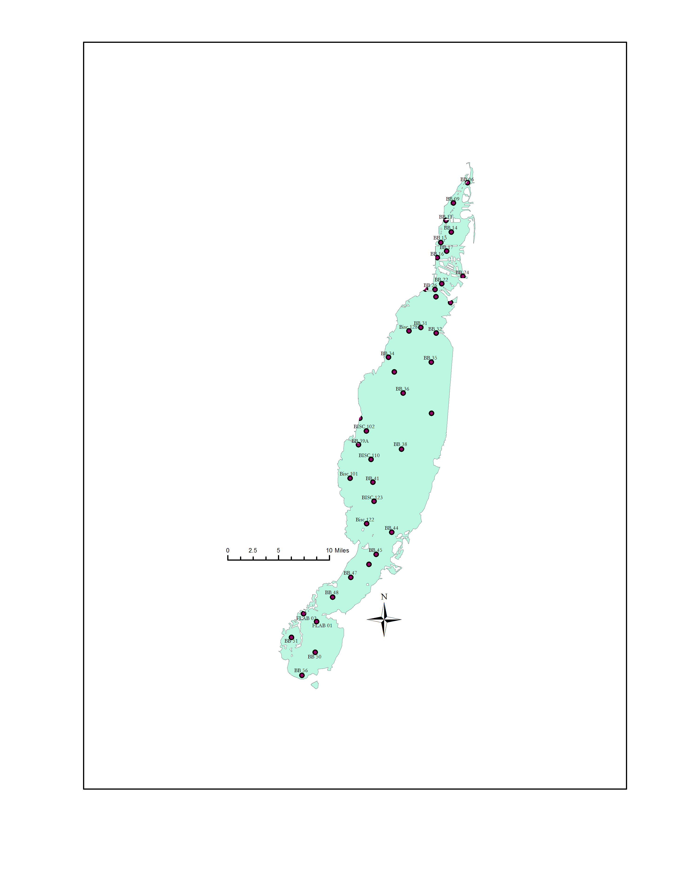

*Figure B3. Landsat 8 Turbidity from 2014 showing station names and locations*