**Project Strength Index Survey Help Guide**

This is a brief guide to completing the Project Strength Index (PSI) Survey.

Table of Contents

**WHAT IS THE NEW PROJECT STRENGTH INDEX?..................................................................................1**

**ANSWERING THE QUESTIONS……………………………………………………………………………………………..…………...1**

Project Details……………………………………………………………………………………………………………………………………1

Policy & Partner Section Score ………………………………………………………………………………………………………….3

Platform & Science Strength Score…………………………………………………………………………………………………….4

Comments, Concerns, Suggestions…………………………………………………………………………………………………….5

**FOLLOW-UP PSI QUESTIONS……………………………………………………………………………………………………………..5**

Policy & Partner………………………………………………………………………………………………………………………………..5

Platform & Science……………………………………………………………………………………………………………………………6

How the Answers Are Collected………………………………………………………………………………………………………..6

**HOW THE SCORES ARE CALCULATED…………………………………………………………………………………………………7**

**DISSEMINATION OF THE SCORES……………………………………………………………………………………………………….8**

# WHAT IS THE NEW PROJECT STRENGTH INDEX?

DEVELOP projects have consistently improved and matured over the Program’s last 15+ years. In 2014, the Project Strength Index was created to provide an objective measure of the projects based on the overall Applied Science and Capacity Building’s doctrine which places an emphasis on partner relationships and building higher capacity for the uses of NASA resources for the betterment of society. However, several of the questions in the old PSI did not accurately measure a project’s progress. To improve the objectivity of the PSI, a new set of questions have been created as of summer 2016.

**Sections**

There are two sections of the PSI. The first is Policy & Partner, which evaluates partner involvement and how well the partner’s capacity was built. The second part is Platform & Science, which assesses how the project used NASA Earth observations and how rigorous the science was for the project.

**Timeline**

The PSI survey is sent out at the end of each term, and collected by an Impact Analysis (IA) Fellow 3-4 weeks later. The original PSI contained four questions concerning how the end-user’s used the project’s results and whether the project was published or presented. These questions are invaluable, but they cannot be answered in four weeks. In order to obtain accurate results, the IA Fellow will collect the answers to these follow-up questions during the next interim (e.g. if a project was completed in the summer, the follow-up questions will be collected after the fall term). The P&S answers will be taken from the quadchart; and the P&P answers will be given by the Center Leads (See the “Follow-up PSI Questions” section on page 5).

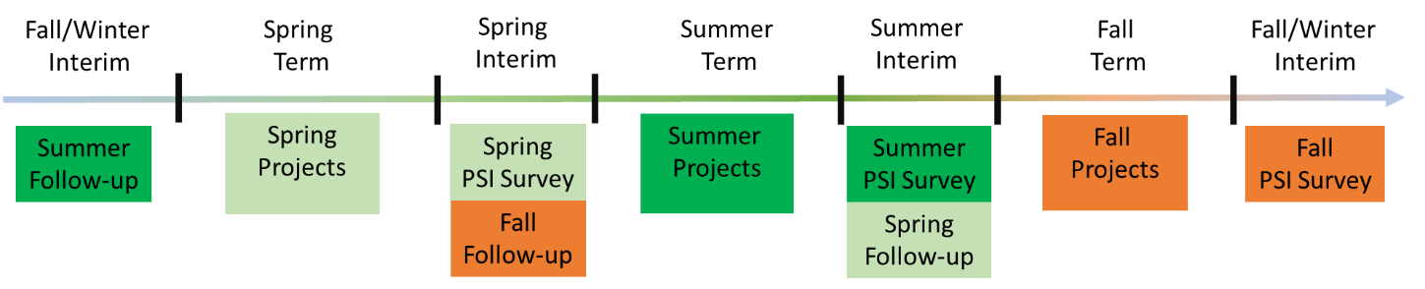

**Timeline for PSI Surveys and Follow-up Questions (IA Fellow takes care of Follow-up questions)**

# ANSWERING THE QUESTIONS:

**Attention!** – If you have any questions about how to complete a project’s PSI, please do not hesitate to ask! Also note that you should refer back to your node’s past PSI scores for continued projects to answer some of the questions.

**Project Details** – This gives the most basic information about the project

**Q1) DEVELOP Node Location**

*Check all node locations at which the project was conducted.*

* ARC
* AZ
* ID
* FC
* GSFC
* JPL
* LaRC
* MCHD
* MSFC
* NCEI
* UGA
* WC

**Q2) Full Project Short Title**

*Write ONLY the project short title. Include the continued number if applicable (Ex: Project App Area III)*

Examples:

* Chile Water Resources
* Navajo Nation Climate II
* Colombia Ecological Forecasting III

**Q3) Project’s Term Being Reported**

*This is for the term the project was conducted. Everyone should be reporting for the term that just finished.*

* Summer 2015
* Fall 2015
* Spring 2016
* Summer 2016

**Q4) Is the project a continuation project?**

*This question is asking if the project was being continued from a previous term. Was it a continuation at the time (term) that you are reporting for?*

Example:

* Arizona Climate is planned to be a two-term project. It began in Summer 2016. For the summer 2016 reporting, it would be selected as “No, it began in the term being reported. After Arizona Climate II was conducted in Fall 2016, it would then be selected as “Yes, it bean in Summer 2016.”

Options:

* No, it began in the term being reported
* Yes, began in Spring 2016
* Yes, began in Fall 2015
* Yes, began in Summer 2015
* Yes, began in Spring 2015
* Yes, began in Fall 2014
* Yes, began in Summer 2014
* Yes, began in Spring 2014
* Yes, began in Fall 2013
* Yes, began in Summer 2013
* Other:

**Policy & Partner Section Score**

*Note: The term “end-user” is NOT an umbrella term! The question is NOT asking about collaborators, but rather the partner (end-user) who will be using the end-products.* ***IMPORTANT NOTE FOR CONTINUING PROJECTS:*** *Answer the questions for the current term, unless the question’s instructions say “answers carry over from the first term.”*

**Q5) Did the end-user directly request this project?**

*The answer to this question can be found in the project proposal under the “Source of Project Idea” section. If this project is a continuation, the answer carries over from term 1.*

* 0=No
* 1=Yes

**Q6) Did the project work with a new end-user or a new POC?**

*If this project is a continuation, the answer should carry over from the first term.*

* 0=No
* 1=Yes

**Q7) Does this project introduce end-user(s) to NASA Earth observations to enhance their decision making process?**

*If this project is a continuation, the answer carries over from the first term, unless a new end-user is added that would result in a higher score.*

* 0=Nothing new was introduced
* 1=End-user is familiar with the NASA Earth observations used and has previously used them
* 2=End-user is familiar with NASA Earth observations, but has never actually applied them in their decision making process
* 3=End-user was introduced to NASA Earth observations and their capabilities to enhance their decision making process for the first time

**Q8) How involved was the end-user in the project?**

*This question allows for more than one option to be selected. Please select all that apply. One point will be awarded for each option that applies. If an end-user was not involved, please explain why in the comments section.*

* 0= End-user was not involved
* 1= End-user communicated regularly (e.g. weekly/bi-weekly meetings)
* 1= End-user provided data collection, field work, etc.
* 1= End-user sent a letter of support/thank you (before or after)
* 1= End-user attended closeout

**Q9) What was the level of engagement with the partner during the hand-off?**

*This question seeks to determine if anything was handed off to the project’s partner(s) and how it was done.* ***This question is asking about hand-offs to end- users and boundary organizations.***

***Notes:*** *If a hand-off has not happened at the time of submitting the PSI scores and is set for a later date, then select “No hand-off yet, but it is planned” and note in the comments sections when this is expected to occur.*

* 0= No hand-off
* 0= No hand-off yet, but it is planned
* 1= One-way hand-off (e.g. e-mail, OR the participants did all the talking)
* 2= Interactive hand-off (i.e. meaningful exchange of dialogue between partners and participants)
* 3= The team was invited by the partner to present the project at a partner event or the team led a workshop

**Q10) How well did the project meet the end-user’s needs?**

* 0= The project addressed no end-user requirements
* 1= The project had results, but many of the partner requirements could not be met
* 2= The project addressed partner requirements, but with a few issues
* 3= The project successfully addressed partner requirements

**Platform & Science Strength Score**

**Q11) Innovation relating to the EO utilized?**

**How was this project innovative in its use of EO?**

*Select all that apply. NCEI projects may answer this question for CDR’s instead of EO. If one of the options does not cover what was achieved with the project, select “None” and note it in the comments section.*

* 1= An under-utilized sensor’s data was substantially applied (Under-utilized = NOT Landsat, MODIS, or ASTER)
* 1= Data from a newly-launched sensor was substantially applied (launched in the last twelve mos.)
* 1= Simulated/proxy data for a future NASA sensor was substantially applied in the project
* 1= A suite of three or more sensors’ data were integrated into the project
* 1= A live feed of real-time / near real-time data was incorporated, or a model that predicts a near real-time occurrence
* 1= A model was used that incorporated Earth observations and successfully produced end results
* 0= None of these were accomplished

**Q12) How complex were the end-products?**

*If the project had multiple end-products, answer this question for the product with the highest score*

* 0= There were no end-products
* 1= Single-use product that does not increase partner capacity for future EO use (e.g. static map or time series)
* 2= Increases partner capacity for future EO use (e.g. automated tool, tutorial, or web interface)

**Q13) How elaborate was the scientific process involved in the NASA Earth observation use?**

*NCEI projects may substitute EO with CDR.*

* 1= Relatively simple methodology that was done before (ex. Simple NDVI time series or land use classification)
* 2= Adapted methodologies from a peer-reviewed publication
* 3= Attempted to develop a new methodology or tool

**Q14) Did the team conduct an accuracy/uncertainty/error assessment or validation?**

*Quantitative assessment means a statistical analysis was conducted (e.g. correlation coefficient). A “sanity check” would simply be a visual inspection of the results*

* 0= No
* 1= Yes, but not quantitatively assessed, however results are reasonable (sanity check complete)
* 2= Yes, quantitatively assessed

**Q15) Was scientific guidance given on a regular basis?**

*If more than one answer applies, select the answer with the highest point value*

* 0= No
* 1= Yes, but the advisor/partner was not a specialist in the project’s topic’s field
* 2= Yes, and the advisor/partner was a specialist in the project’s topic’s field

**Comments, Concerns, Suggestions**

*This section has been added so that you can report any concerns or justifications for your answers. This section can also be used to mention any important dates (e.g. future hand- offs).*

**Q16) Please feel free to include any additional thoughts, clarifications or justifications related to the project**

# FOLLOW-UP PSI QUESTIONS:

Several questions in the original PSI were concerned with things that happen after a project has finished. These questions cannot be accurately answered in the 3-4 week time frame that Center Leads are given to complete the survey. Therefore, they have been moved to a follow-up PSI. **The Policy & Partner questions are answered by the Center Lead and the Platform & Science questions will be collected by the IA Fellow.**

\*\**The PSI is calculated after each term of a project. However, the Follow-Up PSI is only calculated after a project is complete (i.e. for a three-term project, the PSI is calculated three times, but the Follow-Up is only done once, after the third term is complete*\*\*

**Policy & Partner**

*Currently, a post-project partner form is sent to end-users at the end of a project. In order to examine longer-term outcomes of the project, TWO follow up questions will be sent out to CLs by the IA Fellow during the second interim after a project ends (i.e. for a project ending in the spring, the follow up questions would be sent during the interim after the summer term). If the CL does not already know the answer to Q2 at the time, the CL should reach out to the end-user. These questions are an effort to 1) track end-user use of end-products 2) maintain communication and relationships with end-users after a project ends. Understanding which end-users are using results will better enable DEVELOP to follow-up with them for outcomes and success stories.*

**Q1) Did end-user communication continue after the project?**

* 0= No
* 1= Yes

**Q2) Is the end-user actually using the project products and/or methodologies in their decision-making activities?**

* 0= There was no end-user or could not get in contact with end-user
* 0= Results were not shared with end-user yet
* 1= End-user sees value in the product and/or methodology but does not plan to apply it to their decision-making process
* 2= End-user sees value in the product and/or methodology and plans to apply it to their decision-making process, but has not at this time
* 3= Project products and/or methodologies were disseminated within the end-user organization and/or published by them
* 4= Products and/or methodologies used in an official capacity to make a decision, but not sustainably
* 5= End-user incorporated products/methodologies into routine operations and/or continues using DEVELOP project products/methodologies for making decisions

**Platform & Science**

*The answers will be taken from quadcharts*

**Q3) Did the project culminate in a written publication?**

*This includes EOX and does NOT include the DEVELOP website*

* 0= No
* 0= Not at this time, but it is planned
* 1= Yes, in an online magazine, newsletter, blog, local node publication, partner website, etc. (e.g. Earthzine, Directions, The Earth Observer, etc.)
* 2= Yes, in a conference proceedings paper
* 3= Yes, accepted or published in a peer-reviewed journal publication

**Q4) Was the project presented at a conference or panel?**

* 0= No
* 1= Yes, by poster presentation
* 2= Yes, by oral presentation
* 3= Yes, by oral presentation and poster presentation

**How the Answers Are Collected**

The answers to these questions will be collected during second interim after the project. The Policy & Partner questions will be answered from Center Leads, and the Platform & Science questions will be answered using the publications and presentations reported in past quadcharts.

**Example:** For a 2016 Summer project, the answers to the follow-up questions will be collected in after the 2016 Fall term by the IAFellow, and the final PSI score will be calculated at that time.

# HOW THE SCORES ARE CALCULATED:

For each section of the PSI, the Policy & Partner and the Platform & Science, there is a potential score of 0-21 (15 points per section are possible in the initial survey, and 6 more per section are possible with the follow-up questions). The results of the survey and follow-up questions are scored from each category and then are placed on the index to obtain its current stage of 1-5 (see Figure 1).

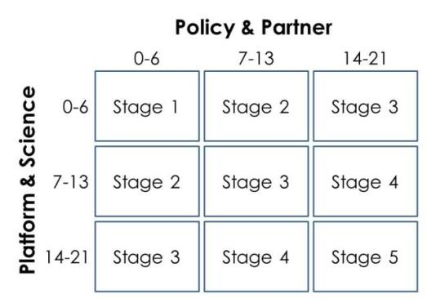

Figure 1: This index is used to determine a project's current stage.

There are five project stage classifications. **Stage 1** is categorized as “Basic Research.” This is the lowest stage possible for a project, and is obtained with a score of 0-6 in both sections. **Stage 2** is determined to as “Application Concept Complete.” A project receives a Stage 2 ranking when one section earns a score of 0-6, while the other section earns a score of 7-13. **Stage 3** is considered as “Application Demonstration Successful.” Most of DEVELOP’s projects will fall into this stage. There are two ways for a project to obtain a Stage 3 ranking. The first is for one section to receive a score between 14 and 21, while the other scores between 0-6. The second possibility is a project scored between 7 and 13 for both sections of the PSI. **Stage 4** is the “Application Verified/End-user Engaged.” This stage indicates that a project was strong in both sections of the PSI. A project earns a stage 4 ranking when one section falls between 7 and 13 and the other falls between 14 and 21. The final stage is **Stage 5**, “Transition to End-User/Decision Enhanced.” This stage is the hardest to achieve, and while it is the goal of all projects, it is only achievable if both sections earn a score between 14 and 21.

**Example:** If a project scored a 13 in the Policy & Partner section and a 14 in the Platform & Science section, the project would be classified as a Stage 4.

Figure 2 shows an example of how many projects during a past term received a certain score and where on the PSI matrix the projects fall under. This matrix helps determine the distribution of projects overall.

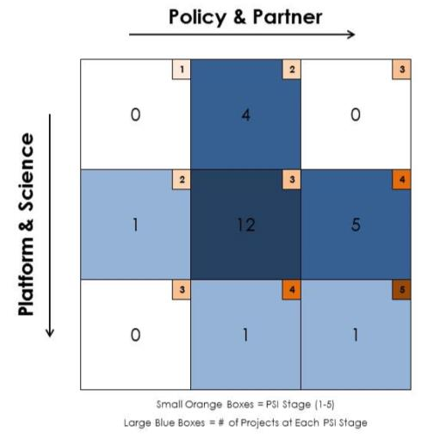

Figure 2: Chart that indicates how many projects rank in each stage.

# DISSEMINATION OF THE SCORES:

# Once project scores are calculated for the nodes, the scores are recorded in an Excel document. There are two ways the PSI scores are disseminated – 1) Individual nodes receive only their scores and 2) an Excel document compiles all of DEVELOP’s PSI scores.

# For the first option, each node receives its own compiled scores document that is divided into four tabs.

# 1) List of PSI Questions – The first tab provides a list of the PSI Questions along with the possible answers. This is provided in the event that someone from the node needs to refer back to the questions and possible answers.

# 2) Summary – The second tab summarizes the PSI scores from the projects reported from that node organized by term and project name. The right-side of the Summary page will also organize the node’s scores on the PSI matrix so that the node can see visually where most of the projects fall in the matrix.

# 3) Continued Projects – The third tab displays continued projects from that node based on project name. This page allows for nodes to track the success of a project from start to completion. Ideally, a continued project should progressively improve on its PSI score rather than decline.

**4) Report Raw** – The fourth and final tab provides a node the reported raw data that was submitted for each project by the Center Lead. This section includes all previously submitted answers from previous terms; not just the most recent term. This has been provided in the event that a node has any question as to how and why a project received a score that it did. The raw data has also been provided so as to provide a more consistent reporting for continued projects from term to term and Center Lead to Center Lead.

The second way of reporting the PSI scores for projects is a compiled list of all of the projects conducted by DEVELOP that is organized by term and by node. This is a growing Excel document that acts as the master copy. For each term that nodes report project scores, another tab is added to the master copy that neatly reports the scores as well as includes the reported raw scores. It should be noted that for the raw scores, any modification to a score is noted with an explanation as to why a score was changed. Most instances of a score being modified are due to a project being reported to have won the VPS session, but didn’t win. Once the document has been updated during the interim, it is submitted to NPO to report the scores of the projects.